Nutritive Value of Fish Waste Silage Meal
ABSTRACT
The Fish Waste Silage Meal (FWSM) was prepared using fish offals, Lactobacillus plantarum culture (10⁸ cfu/ml), jaggery and De-Oiled Rice Bran (DORB). Fish waste silage (FWS) was prepared by incubating minced and autoclaved fish offal slurry with 10 percent jaggery and 5 percent Lactobacillus plantarum culture (10⁸ cfu/ml) in an anaerobic condition for 14 days at room temperature (37°C) with occasional mixing. After the fermentation period, the FWS was mixed with DORB (Slurry: DORB, 7:1) uniformly and sun-dried for 3-4 days for the production of FWSM, 0.72 kg FWSM was produced from 1.0 kg of FWS. The FWSM was analysed for its nutritive value, the FWSM contains 10.8% moisture, 27.5% crude protein (CP), 4.97% crude fiber, 14.01% ether extract and 17.09% total ash. Since FWSM is prepared from inedible parts of the fish; FWSM was screened for major pathogenic microorganisms’ viz.,
E. coli, Salmonella and Clostridium and found negative. Further, FWSM is analyzed for five common mycotoxins (Aflatoxin (B₁, B₂, G₁ and G₂), Ochratoxin, T-2 toxin, Citrinin and Zearalenone) and found negative. The transformation of fish waste into FWSM not only produces a highly nutritious end product but also offers an alternative and beneficial means of utilization. The FWSM contains 27.5% CP, which is almost equal to the 50% CP value of soybean meal, thus it can be used as a feed ingredient in animal feed preparation.

Keywords: Fish, Meal, Offals, Silage, Waste
INTRODUCTION
Feed is a major component in animal farming since it accounts for 60–80% of production costs. The quality and degree of incorporation of the proteinaceous feed ingredient in the diet determine the feed cost per kilogram. Ozyurt et al. (2017) mentioned that the primary constraint in animal husbandry is the lack of protein, which is mostly because it is expensive and scarce.
Kim and Ester, (2001) reported that animal-derived proteins have shown great promise, while plant-based protein sources often lack some important amino acids (Vidotti et al., 2003). Hauzoukim et al. (2021) mentioned that animal protein sources have certain advantages over vegetable proteins, such as balanced amino acid composition and low levels of anti-nutritional substances which have the potential to interfere with the digestion and absorption of other nutrients.
Utilizing fish waste as an alternate protein source is one of the options. Making use of the offals obtained from fish processing facilities has the possibility of substituting the high-protein supplements. The traditional method of fishmeal production that has been used for many years in India has resulted in rising feed costs over time because the process is complex and requires a large amount of energy, capital, and manpower. This can be replaced by "FISH WASTE SILAGE," which is a simple and affordable substitute. Encouraging the conversion of fish waste into silage using an inexpensive technique such as lactic acid fermentation may help address the issue of limited protein sources for animal feed.
Zynudheen et al. (2017) suggested that fish ensiling has been proposed as an alternative method to enhance the utilization of fish waste and fishery by-products as a high-quality source of protein for animal feeding. Fish silage is a liquified product made from whole fish or parts of fish through acid preservation (Tatterson and Windsor, 1974), fermentation of lactic acid bacteria, or both (Raa et al., 1982), which improves the action of enzymes in the fish to break down tissues and limits the growth of pathogenic bacteria. Vazquez et al. (2011) reported that using acids (especially organic acids) is more expensive and mimics the bio-conversions that lactic acid bacteria (LAB) fermentation could carry out.
Fish waste ensiling is a classical technique for preserving organic matter against deterioration and can be utilized as a probiotic ingredient for poultry feeding (Hammoumi et al., 1998). Tropea et al. (2021) proposed that, among the various microbes used, lactic acid bacteria have an advantage over other microbes for fermentation because they are generally recognized as safe. Further, the final fermented product is low in spoilage microorganisms and high in beneficial microorganisms, indicating a safe and nutritious final substrate enhanced with added value. Furthermore, the products of Lactobacillus fermentation have been reported to have additional beneficial effects on the intestines of various aquatic animals (anti-microbial properties, anti-oxidative properties), making them ideal for food/feed applications. Indeed, they are ideal for use as probiotic aquaculture feeds as they adapt well to the gut environment of both aquatic and domestic animals.

MATERIALS AND METHODS
Preparation of Fish Waste Silage (FWS)
The Lactobacillus plantarum (MTCC 2621) culture for the preparation of FWS was obtained as a freeze-dried culture from Microbial Type Cell Culture (MTCC), Chandigarh and it was revived using deMan, Rogosa, Sharpe (MRS) broth. The desired quantity of 10⁸ colony-forming units (cfu/ml) was obtained with serial dilution in physiological saline (0.9%) and cultured in MRS Agar.
Fish wastes for silage production were procured from the local fish market, Orathanadu, Thanjavur. It primarily consists of the head, tail, fins, scales, viscera, gut contents and body trimmings of various fishes like Sardine, Mackerel, Common carp, Tilapia, Red snapper, Murrel, Silver scabbard and Silver pomfret.
To proceed with the preparation of silage (FWS), fish offals were ground and autoclaved (121ºC under 15 lbs) for 15 minutes to make a slurry and allowed to cool down to room temperature. The cooled slurry was transferred into a plastic container and 10% jaggery and 5% Lactobacillus plantarum culture containing 10⁸cfu/ml were added and mixed uniformly and sealed air tightly to facilitate the anaerobic fermentation for 14 days at room temperature (37°C) with occasional mixing of contents. After 14 days of anaerobic fermentation, the fermented silage was opened and pH content of the silage was measured using a pH meter and strips. The entire procedure was adopted for the preparation of five different FWSs at different durations.
Location of the Research – TANUVAS, Veterinary College and Research Institute, Orathanadu, Thanjavur, Tamil Nadu – 614 625
Preparation of Fish Waste Silage Meal (FWSM)
After the fermentation period, the FWS was mixed with DORB (Slurry: DORB, 7:1) uniformly and sun-dried for 3-4 days for the production of FWSM, the dried material was ground to get a homogenized particle size and then stored in an air-tight container for the future use. The entire procedure adopted for the preparation of five different FWSMs at different durations is given below:
Figure 1. Fish waste silage and Fish Waste Silage Meal preparation steps

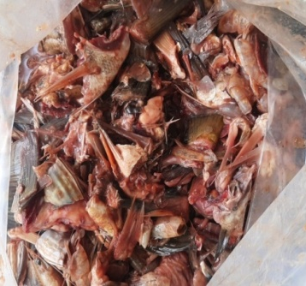 | 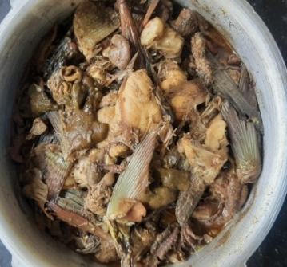 | 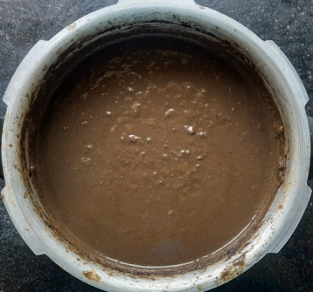
Fig. 1a. Fish waste | Fig. 1b. Fish waste - Cooked | Fig. 1c. Fish waste - Slurry
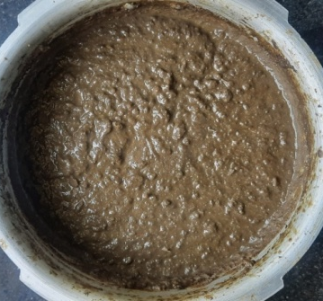 | 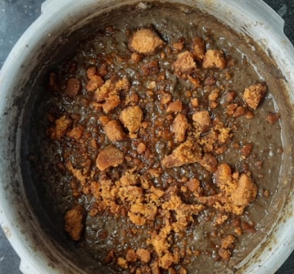 | 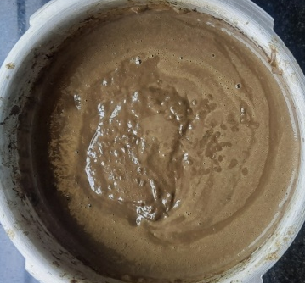
Fig. 1d. Autoclaved – FW slurry | Fig. 1e. Addition of 10% jaggery | Fig. 1f. Addition of 5% of Lactobacillus plantarum culture containing 10⁸cfu/ml
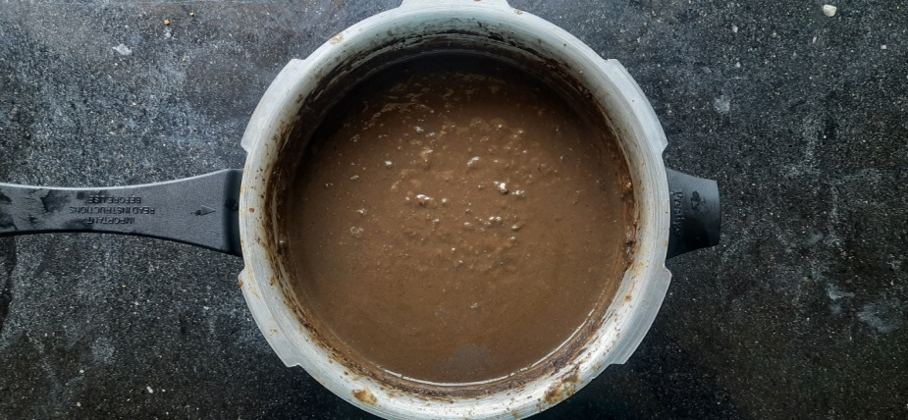 | 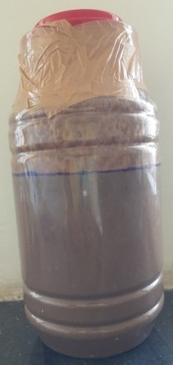 | 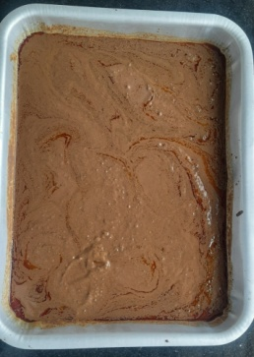
Fig. 1g. Culture and Jaggery mixed FW slurry | Fig. 1h. Anaerobic fermentation of FW slurry for 14 days | Fig. 1i. Fermented FW slurry
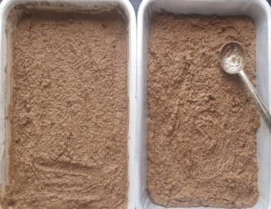 |  | 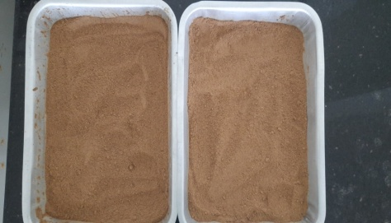
Fig. 1j. Mixing of DORB  (Slurry: DORB, 7:1) | Fig. 1k. Sun drying of FWSM | Fig. 1l. Final FWSM after sun drying

pH of FWS
The pH content of the FWS was estimated using pH meter and strips.
Microbial and Mycotoxin analysis of FWS and FWSM
The presence of pathogenic microorganisms was done by streaking FWSM liquid (prepared by adding 1 g FWSM in 9 ml of sterile peptone water) on sterile Eosin Methylene Blue (EMB) agar, Salmonella Shigella (SS) agar and MRS agar for the identification of Escherichia coli, Salmonella, and Lactobacillus respectively and inoculated in Robertson Cooked Meat (RCM) broth for Clostridium (Hassan and Heath, 1986).
The FWSM samples were sent to AFAQAL, Namakkal for mycotoxin ((Aflatoxin (B₁, B₂, G₁ and G₂), Ochratoxin, T-2 toxin, Citrinin and Zearalenone) analysis.
Nutritive value of FWSM
The proximate composition of FWSM was analysed as per the guidelines of AOAC (2000). For the estimation of crude protein, ether extract and crude fibre, the following instruments were used Kel Plus, SOCS PLUS and Fibertec (Model No. 1030), respectively. The yield of silage was calculated by the difference (before and after drying) in weight.
Statistical analysis
Each silage was considered as an experimental unit for data analysis. All the data obtained from the study were subjected to statistical analysis. All the data were analyzed using Statistical Package SPSS (version 20.0).

RESULTS AND DISCUSSION
The consistency of the silages varies from liquid to semisolid and it appears to be light brown to dark brown in colour with acceptable odour. An average 0.72 kg FWSM was produced from 1.0 kg of FWS. The nutritive value, pH, microbial and mycotoxin levels of produced FWSM were presented in Table 1. The average pH content of the silage is 4.0±0.16, the silage is quite acidic, which guarantees fermentation and it is essential for the preservation and inhibition of the growth of undesirable microorganisms during the ensiling process (Raa et al., 1982). Similar to the current finding, several authors have also reported that the pH content of silage ranges from 3.2 - 4.7 (Kjos et al.,1999; Collazos and Guio, 2007; Gullu et al., 2015;). The changes in the protein fraction indicate that variations in the liquefaction process can be influenced by low pH which enhances the action of endogenous proteases enzyme (Alwan et al., 1993).

Table 1. Chemical composition (% on DM basis) of FWSM
Attributes (%) | FWSM
Moisture | 10.80 ± 0.39
Dry matter | 89.20 ± 0.39
Organic matter | 82.91 ± 0.96
Crude protein | 27.57 ± 0.90
Ether Extract | 14.01 ± 1.50
Crude fiber | 4.97 ± 0.65
Total ash | 17.09 ± 0.96
Acid insoluble ash | 2.13 ± 0.09
Nitrogen free extract | 36.36 ± 1.54
Gross energy (kcal/kg) | 5804.81 ± 229.11

The moisture content in FWSM samples ranges from 9.79 to 13.47% (avg. 10.80%). A similar kind of finding was reported by Yathavamoorthi et al. (2015), who reported that the moisture content of co-dried silage with various filler materials varies between 3 to 10 percent, this indicates the effective moisture removal (Ologhobo et al., 1988; Babu et al., 2005; Vijayan et al., 2009). Low moisture content is essential for preserving the silage and preventing the growth of spoilage microorganisms and facilitates easy handling, transportation and storage (Vijayan et al., 2009).
The total ash content in the FWSM samples varies from 13.17 to 22.28% (avg. 17.09%). The total ash content of co-dried silage with various filler materials varies between 5 to 15 percent (Babu et al., 2005; Vijayan et al., 2009; Yathavamoorthi et al., 2015). The high bone content in the raw materials (Alwan et al., 1993; Hammoumi et al., 1998) or contaminants in the carbohydrate source used for fermentation (Ali and Sahu, 2002; Pagarkar et al., 2006) could be the cause of the higher ash content. The total ash content of co-dried silage with various filler materials varies between 5 to 15 percent (Babu et al., 2005; Vijayan et al., 2009; Yathavamoorthi et al., 2015).
The average crude protein content of the FWSM samples was measured as 24.42 to 31.15% (avg. 27.57%). Compared to the current finding, a wider CP range (26-60%) was reported (Vijayan et al., 2009; Yathavamoorthi et al., 2015) in the co-dried fish silage, this higher CP level could be due to the use of whole fish for silage preparation, in the present study we used fish offals for the silage preparation.
The crude fibre content of the samples ranges from 2.5 to 8.25% (avg. 4.97%). Although the fiber content of fish waste was relatively low (Hammoumi et al., 1998; Vijayan et al., 2009), the fiber content of DORB (13–15%), which was used as a co-dried material to obtain the final dried product in the present study, maybe the cause of the rise in fibre content of the FWSM.
The ether extract content in the FWSM samples varies from 8.29% to 19.72%. The lipid content of fish meal was lower than the fish silages because of cooking and subsequent pressing, which might remove a certain amount of lipid along with the stick water. The lipid content of fermented silage was higher than acid silage and fish meal may be due to extraction of lactic acid as well along with fats during ether extraction (Ali and Sahu, 2002). In contrast, Babu et al. (2005) documented that the fat content of fermented silage was significantly lower (1%), than the acid silage (3-5%) which may be due to the effective trapping of oil within the microbial silage, which is facilitated by the strong binding capacity of the added polysaccharide. Here the increase in fat content may attributed to the variation in crude fat levels of fish used as raw materials and the efficiency of the defatting process during production as proposed by Johnsen and Skrede (1981). Vidotti et al. (2002) also mentioned that the nutritional composition of silage can be easily influenced by the composition of raw materials used for production.
The average NFE content of the FWSM is 36.36%, this value was higher than the value reported by Pagarkar et al. (2006). Pagarkar et al. (2006) estimated the NFE content of bio-fermented silage was higher (10.36%) in comparison with 4% sulfuric acid (7.2%) and 4% organic acid (8.1%). The higher NFE content in the present study could be due to the addition of DORB for co-drying.
The average GE content of the FWSM is 5804.81± 229.11 kcal/kg. Similarly, Gullu et al. (2015) calculated the GE content of different silages prepared such as whole pearl millet silage, silage made from the fish processing industry and silage mixture (30% whole pearl millet silage and 70% processing wastes silage) and found that the GE contents were 4805 kcal/kg, 5034 kcal/kg and 5312 kcal/kg, respectively. The GE content of co-dried silage produced with various proportions of maize, cassava, groundnut meal and wheat offal ranges between 4000-4200 kcal/kg (Ologhobo et al., 1988).
Since FWSM is prepared from inedible parts of the fish; FWSM was screened for major pathogenic microorganisms’ viz., E. coli, Salmonella and Clostridium and found negative. Further, FWSM is analyzed for five common mycotoxins (Aflatoxin (B₁, B₂, G₁ and G₂), Ochratoxin, T-2 toxin, Citrinin and Zearalenone) and found negative (Table 2).
Table 2. Microbial and Mycotoxin Analysis of Fish Waste Silage Meal (FWSM)
Microorganism | Indication
Escherichia coli | Nil
Salmonella | Nil
Clostridium | Nil
Mycotoxins
Aflatoxin (B₁, B₂, G₁ and G₂) | Nil
Ochratoxin | Nil
T-2 toxin | Nil
Citrinin | Nil
Zearalenone | Nil

Figure 2. Microbial Analysis of Fish Waste Silage Meal (FWSM)

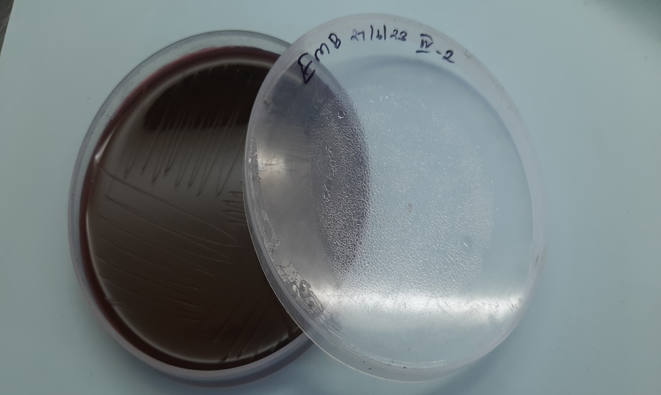 | 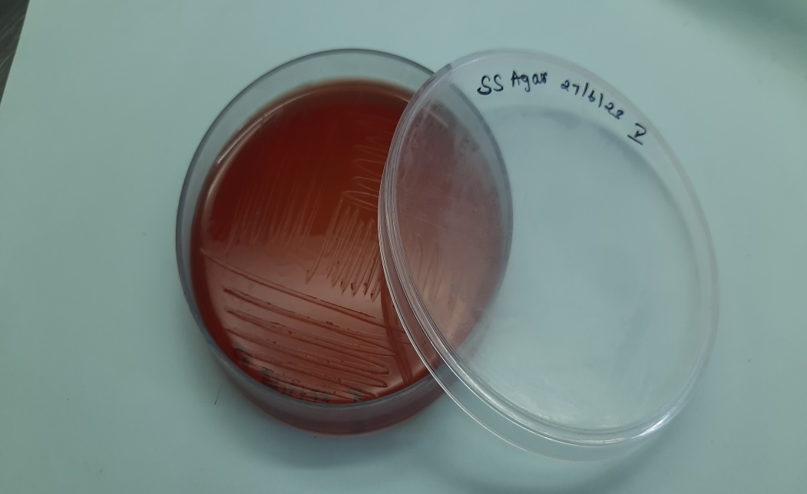 | 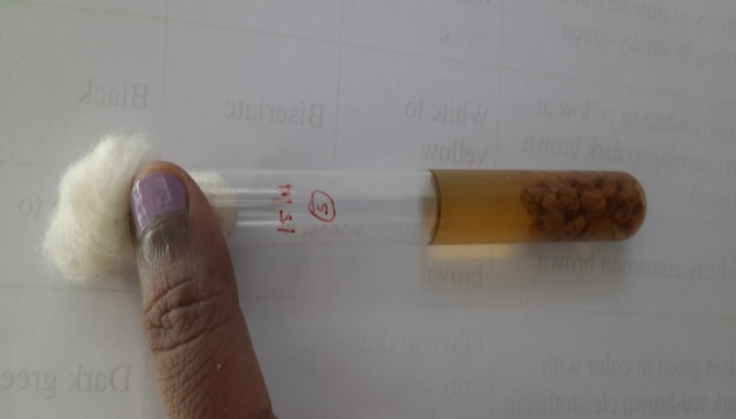 | 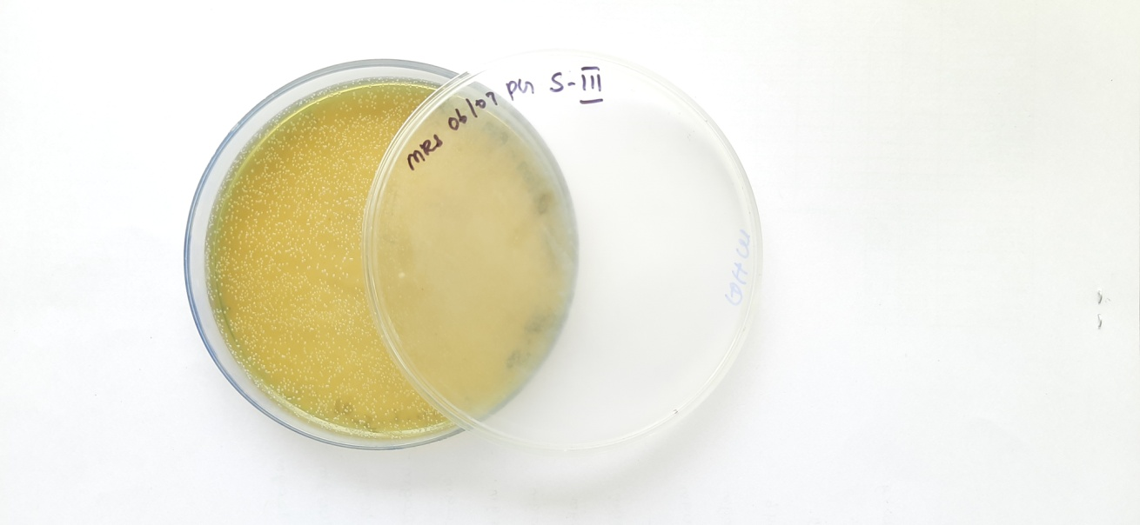
Fig. 2a. E. coli negative on EMB agar | Fig. 2b. Salmonella negative on SS agar | Fig. 2c. Clostridium negative on RCM broth | Fig. 2d. Lactobacillus positive on MRS agar

The nutritional composition of Fish Waste Silage Meal (FWSM) shows variability across different samples. Since the fish waste used for the preparation of FWSM is related to different types of fishes, the nutritive value of invidivial species varies, which may be a reason for the variation in the nutritive content of different silages. Each sample offers unique nutritional characteristics, and the selection of FWSM should be based on the specific dietary requirements of the target animal species. Regular monitoring and analysis of FWSM will ensure that they meet the nutritional needs of the intended livestock or aquaculture species, promoting optimal growth and overall health.
Conclusion
In conclusion, fish waste silage meal (FWSM) production presents a promising and sustainable solution for utilizing discarded fish by-products. The FWSM contains 27.5% CP, which is almost equal to the 50% CP value of soyabean meal, thus it can be used as a feed ingredient in animal feed preparation. This innovative technique not only aids in waste management but also contributes to a circular economy by converting fish waste into valuable resources of animal feed. Through a well-structured process that involves cooking, autoclaving, fermentation, and sun drying, fish waste is transformed into a nutrient-rich silage with excellent nutritional value. The incorporation of jaggery and Lactobacillus plantarum culture during fermentation ensures a safe and hygienic final product, free from harmful bacteria and toxins. The nutritional analysis of the fish waste silage reveals a high protein content, making it a valuable feed supplement for animals.
This eco-friendly approach aligns with the principles of sustainability and resource conservation, reducing the environmental burden associated with fish processing industries. Further research and development in this area can unlock even greater benefits, making fish waste silage a vital component of a more sustainable and environmentally conscious future.

References:
Ali S, Sahu NP. Response of Macrobrachium rosenbergii (de Man) juveniles to fish silages as substitutes for fish meal in dry diets. Asian Fisheries Science. 2002;15(1):61-71.
Alwan SR, Buckley DJ, O’Connor TP. Silage from Fish Waste: Chemical and Microbiological Aspects. Irish Journal of Agricultural and Food Research. 1993;32(1):75–81.
AOAC. Official Methods of Analysis, 17th ed. Association of Official Analytical Chemists Inc., Maryland, USA; 2000.
Babu, USJ, Rao BM, Khasim DI, Nair KGR. Biochemical and microbiological quality of formic acid silage and lactobacillus fermented silage. Fishery Technology. 2005;42(2):163-170.
Candido RS, Watanabe PH, Oliveira PJ, Angelim AL, Siqueira AD, Ximenes JC, Normando LR, Melo JM, Freitas ER. Meat quality and performance of pigs fed diets with fish silage meal. Pesquisa Agropecuaria Brasileira. 2017;52(10):905-913.
Collazos H, Guio C. The effects of dietary biological fish silage on performance and egg quality of laying japanese quails (Coturnix coturnix japonica). In: 16th European symposium on poultry nutrition; 2007. 37-40.
Ennouali M, Elmoualdi L, Labioui H, Ouhsine M, Elyachioui M. Biotransformation of the fish waste by fermentation. African Journal of Biotechnology. 2006;5(19):1733-1737.
Gullu K, Guzel S, Tezel R. Producing silage from the industrial waste of fisheries. Ekoloji. 2015;24(95):40-48.
Hammoumi A, Faid M, El Yachioui M, Amarouch H. Characterization of fermented fish waste used in feeding trials with broilers. Process Biochemistry. 1998;33(4):423-427.
Hasan B. Fermentation of fish silage using Lactobacillus pentosus. Jurnal Natur Indonesia. 2003;6(1):11-15.
Hassan TE, Heath JL. Biological fermentation of fish waste for potential use in animal and poultry feeds. Agricultural Wastes. 1986;15(1):1-15.
Hauzoukim, Ghosh SK, Swain S, Roy A, Swain S, Prakasan S. Shelf-life study of fish silage prepared from freshwater fish waste. Biological Forum – An International Journal. 2021;13(3):695-700.
Johnsen F, Skrede A. Evaluation of fish viscera silage as a feed resource: Chemical characteristics. Acta Agriculturae Scandinavica. 1981;31(1):21-28.
Kim SW, Easter RA. Nutritional value of fish meals in the diet for young pigs. Journal of Animal Science. 2001;79(7):18-29.
Kjos NP, Skrede A, Overland M. Effects of dietary fish silage and fish fat on growth performance and sensory quality of growing-finishing pigs. Canadian Journal of Animal Science. 1999;79(2):139-147. Ologhobo AD, Balogun AM, Bolarinwa BB. The replacement value of fish silage for fish meal in practical broiler rations. Biological waste. 1988;25:117-125.
Ozyurt G, Ozkutuk AS, Boga M, Durmus M, Boga EK. Biotransformation of seafood processing wastes fermented with natural lactic acid bacteria; the quality of fermented products and their use in animal feeding. Turkish Journal of Fisheries and Aquatic Sciences. 2017;17(3):543-555.
Pagarkar AU, Basu S, Mitra A, Sahu NP. Preparation of bio-fermented and acid silage from fish waste and its biochemical characteristics. Asian Journal of Microbiology Biotechnology and Environmental Sciences. 2006;8(2):382-387.
Raa J, Gildberg A, Olley JN. Fish silage: A review. C R C Critical Reviews in Food Science and Nutrition. 1982;16(4):383-419.
Tatterson IN, Windsor ML. Fish silage Journal of the Science of Food and Agriculture. 1974;25(4):369-379.
Tropea A, Potortì AG, Lo Turco V, Russo E, Vadalà R, Rando R, Di Bella G. Aquafeed production from fermented fish waste and lemon peel. Fermentation. 2021;7(4):272-281.
Vazquez JA, Nogueira M, Duran A, Prieto MA, Rodríguez-Amado I, Rial D, González MP, Murado MA. Preparation of marine silage of swordfish, ray and shark visceral waste by lactic acid bacteria. Journal of Food Engineering. 2011;103(4):442-448.
Vidotti RM, Carneiro DJ, Viegas EMM. Acid and fermented silage characterization and determination of apparent digestibility coefficient of crude protein for pacu Piaractus mesopotamicus. J World Aquacult Soc. 2002;33(1):57-62.
Vidotti RM, Viegas EMM, Carneiro DJ. Amino acid composition of processed fish silage using different raw materials. Animal Feed Science and Technology. 2003;105:199-204.
Vijayan H, Joseph I, Raj RP. Biotransformation of tuna waste by co-fermentation into an aquafeed ingredient. Aquaculture Research. 2009;40(9):1047-1053.
Yathavamoorthi R, Nithin CT, Ananthanarayanan TR, Mathew S, Bindu J, Anandan R, Gopal TK. Utilization of tuna waste silage as a novel pig feed ingredient. Fishery Technology. 2015;52:118-122.
Zynudheen AA, Anandan R, Nair KGR. Effect of dietary supplementation of fermented fish silage on egg production in Japanese quail (Coturnix coromandelica). Advances in Aquaculture and Fisheries Management. 2017;5:001-005.

