THE EXPORT TRENDS AND MARKET POTENTIAL OF GUJARAT'S DAIRY INDUSTRY
ABSTRACT
Gujarat's dairy industry, established in 1940, is a vital pillar of India's agricultural economy, strengthened by a strong cooperative model, with Amul serving as a prime example. Despite challenges such as trade regulations, quality standards and fluctuating global demand, the state is still a major dairy exporter. A detailed study examined Gujarat's dairy export performance over a 20-year period (2005-2025), using secondary data from the Director General of Foreign Trade (DGFT) and the Agricultural and Processed Food Products Export Development Authority (APEDA). The study found an alarming rise in dairy exports in all importing regions, with North America, East Asia (Oceania), East Africa and West Africa as key markets with the highest positive growth rate since 2005. Furthermore, NE Asia, West Africa and North America showed strong export retention capacities, indicating stable demand in these regions. Forecasts for 2026-2028 predict continued growth in exports to West Asia-GCC, East Asia (Oceania), Northeast Asia, South Asia and North America. ASEAN, on the other hand, is expected to experience a slow downturn, whereas West Africa is expected to decline and East Africa would fluctuate. These trends highlight the dynamic nature of Gujarat's trade movements, emphasizing the critical need for strategic initiatives to improve trade resilience and market reach.
Key words: Dairy, Export, Growth, Markov-chain, Transition, Retention, etc.
INTRODUCTION
Milk production in India is essential for meeting nutritional needs, creating rural jobs and developing the rural economy. India currently has undeniably the world's largest dairy industry in terms of milk production. With an estimated 216.5 Million Metric Tons (MMT) of milk output in 2025, India is expected to continue to be the world's largest producer (Bhogal, 2024). The dairy sector has been poised for fierce competition as a result of its commercialization and the presence of a 893 billion dollar global market (Sarkar et al., 2024). Furthermore, India produces more milk than the US and the EU combined, accounting for 31% of global milk production (Singh, 2024). Because of growing domestic demand, growing herd size and government assistance, the nation's dairy industry is still expanding. Uttar Pradesh (15%), Rajasthan (14%), Madhya Pradesh (8%), Gujarat (7%) and Andhra Pradesh (6%) are India's largest milk production regions (Anonymous, 2024a).
Gujarat's dairy industry is a pillar of India's agricultural economy. The establishment of the Drain Item Cooperatives Society at Choryasi taluka, Surat, in 1940 marked the beginning of Gujarat's dairy sector (Parmar, 2024). The industry is powered by a strong cooperative model and innovative dairy farming practices. The state is home to Amul (Anand Milk Union Limited), one of the world's largest dairy cooperatives, which played an important role in India's White Revolution. Amul has a brand worth over $3 million US Dollars, making it one of the world's most valuable brands (Bhatia & Shah, 2024). Gujarat's dairy sector has grown at an exemplary rate, resulting in increased milk production, per capita milk availability, and a stronger contribution to India's dairy economy (Modi et al., 2025). Thus, Gujarat is also guaranteeing self-sufficiency in milk production.
Gujarat's dairy business is growing due to a strong supply network, government backing and a commitment to sustainability. The National Dairy Development Board (NDDB), Anand, Gujarat, has already implemented the National Dairy Plan (NDP-I), Dairy Entrepreneurship Development Schemes, Dairy Infrastructure Development Scheme (DIDF), Animal Husbandry Infrastructure Development Fund (AHIDF) and other initiatives (Gurjar et al., 2023). The NDDB also promotes ethno-veterinary practices (EVP), including the use of health-promoting herbs in feed and primary veterinary care (Le, 2024). A recent survey of Gujarat exports conducted by the Gujarat Industrial Technical Consultancy Organization (GITCO) estimated that in 2000-01, Gujarat contributed Rs. 495 billion (or 20.8%) of total national exports of Rs. 2,385 billion (Dholakia, 2003). Gujarat remains a dominant force in India's export market. Gujarat continued to be India's leading exporting state in 2023-24, accounting for 30.75% of total exports (FIEO, 2024). Thus, with the strong government support, the state leads in dairy production. This, in turn, makes the state a major dairy exporter, contributing to India's global commerce in milk and milk-derived goods. However, challenges such as trade regulations, quality standards and fluctuating global demand impact export performance. This study examined Gujarat state’s dairy performance and growth in the global market.
METHODOLOGY
The study focused on the dairy products export performance from Gujarat. Secondary data for 20 years from 2005 to 2025 were collected from the Director General of Foreign Trade (DGFT) and the Agricultural and Processed Food Products Export Development Authority (APEDA). Based on the reports of DGFT and APEDA, the dairy products from Gujarat were exported to 20 regions of the world. Among all, West Asia - GCC (Gulf Cooperation Council), North America, ASEAN (Association of Southeast Asian Nations), East Asia (Oceania), North East (NE) Asia, East Africa, South Asia and West Africa were the eight regions that imported dairy products consistently. Thus, minor importers were grouped as ‘Others’.
Compound Annual Growth Rate (CAGR): To understand the trend in the dairy products export from Gujarat, CAGR (Audichy et al., 2017; Nidhishree & Deka, 2024) was calculated, keeping the base year as 2005 and the recent year as 2025. The growth rate was calculated from the exponential function given below;
Y = ab^{t}_{e}
Log y = Log a + t Log b
CAGR (%) = (Antilog b – 1) *100
Where, CAGR = Compound Annual Growth Rate; t = Time period in years; y = Export quantity in Metric Tons; a & b = Regression parameters.
Prediction of future dairy exports: Based on the previous 20 year’s data, the Transitional Probability Matrix (TPM) was constructed using LPSolve IDE software version 5.5.2.11. The Markov chain was developed based on the matrix value using Python software. The constructed matrix was then used to predict dairy products export quantities from Gujarat. The export quantities were forecasted for the following years (2026, 2027 and 2028) (Kusuma and Basavaraja, 2014; Khorajiya et al., 2018). Markov analysis is a technique used to forecast the value of a variable whose anticipated value is impacted simply by its present status, and not by any earlier action. The basic property of a Markov chain is that only the most recent point in the trajectory affects what happens next.
It means that X_{t+1} depends upon X_{t}, but it does not depend upon X_{t−1}. . . X₁, X₀.
We formulate the Markov Property in mathematical notation as follows:
P (X_{t+1} = s | X_{t}= s_{t}, X_{t−1} = s_{t−1} …X₀ = s₀) = P (X_{t+1} = s | X_{t}= s_{t}),
For all t = 1, 2, 3 . . . and for all states s₀, s₁. . . s_{t}, s.
The off-diagonal component A_{ij} (i≠j), shows the probability of the i^{th} state moving to the j^{th} state. While the diagonal element A_{ij} (i=j) shows the probability of holding in the current state (Powrel & Mishra, 2024).
RESULTS AND DISCUSSION
The global economy is in a state of flux. Increased trade tensions, combined with policy uncertainty, have considerably harmed the global economic outlook for 2025(United Nations, 2025). Fig 1 shows the volume of dairy exports from Gujarat between 2005-06 and 2024-25, categorized by destination region. The overall trajectory was one of tremendous growth punctuated by notable fluctuations, with total exports peaking around 2013-14, followed by an even stronger spike in 2018-19, and reaching a record high of more than 1,00,000 units in 2021-22. West Africa has consistently emerged as a key export market, contributing significantly to the peaks, particularly in 2021-22. South Asia and East Africa also made important contributions, with export volumes following the overall upward trend. The Organisation for Economic Cooperation and Development (OECD) had reported that the total dairy consumption in Africa, Southeast Asian countries, and the NENA (Near East and North Africa) grew faster than production, leading to an increase in dairy imports (OECD/FAO, 2023). In contrast, regions such as North America, ASEAN, East Asia (Oceania), and Northeast Asia regularly accounted for far smaller shares of exports. The abrupt spikes and subsequent drops might be due to the impact of dynamic global market conditions, such as shifting demand in importing regions, changes in supply from the exporting regions and evolving international trade rules or agreements (Anonymous, 2024b). As the industry heads toward 2026, these trends will shape both opportunities and challenges in Gujarat’s dairy markets.
The table 1 shows the Compound Annual Growth Rate (CAGR) of Gujarat's dairy exports to various global regions between 2005 and 2025. North America had the highest growth rate (42.15%), indicating strong demand, followed by "Others" (39.56%) and East Asia (Oceania) (29.00%). West Asia-GCC (12.37%) and South Asia (12.65%) showed moderate growth, while ASEAN (4.45%) expanded slowly. Exports were seen stable in Northeast Asia (8.61%) and West Africa (21.62%). Statistical significance identifies regions with consistent export trends, which helps shape future market strategies. It was found from the study that, except for South Asia, all other regions showed a significant rise in the import of dairy products from Gujarat. A similar study was carried out by Boopathi et al., in 2024 at the macro level and found that the growth of dairy product export from India between 2003-04 and 2022-23 was increasing at the rate of 4.4 per cent.

Fig 1: Trend in dairy exports from Gujarat
Table 1: Compound Annual Growth Rate of top dairy importers from Gujarat (2005-2025)
Regions | CAGR (%)
West Asia- GCC | 12.37***
North America | 42.15***
ASEAN | 4.45*
East Asia (Oceania) | 29.00**
NE Asia | 8.61**
East Africa | 28.66*
South Asia | 12.65
West Africa | 21.62*
Others | 39.56*
Total | 9.76**
***, ** and * indicates the significance at 1 %, 5 % and 10 % probability level, respectively.
Fig 2 is a network diagram illustrating the transitions and retentions of global regions like East Africa, West Africa, ASEAN, East Asia, West Asia, North East Asia, South Asia, North America and others in dairy importing from the state of Gujarat, India. Each region is represented by a coloured circle, with lines connecting them to show their transitions and retentions. The thickness of the lines signifies relationship strength (like 0.797 between ASEAN and West Africa, which indicates a 79.7% probable transition in the export of Gujarat’s dairy products from West Africa to ASEAN regions). Meanwhile, the line connecting itself represents the retention capacity (like, ASEAN region (0.786), having a higher probability of retention of dairy products imported from Gujarat). By analysing these connections, one can gain insights into import-export dynamics that shape international relationships and influence decision-making.
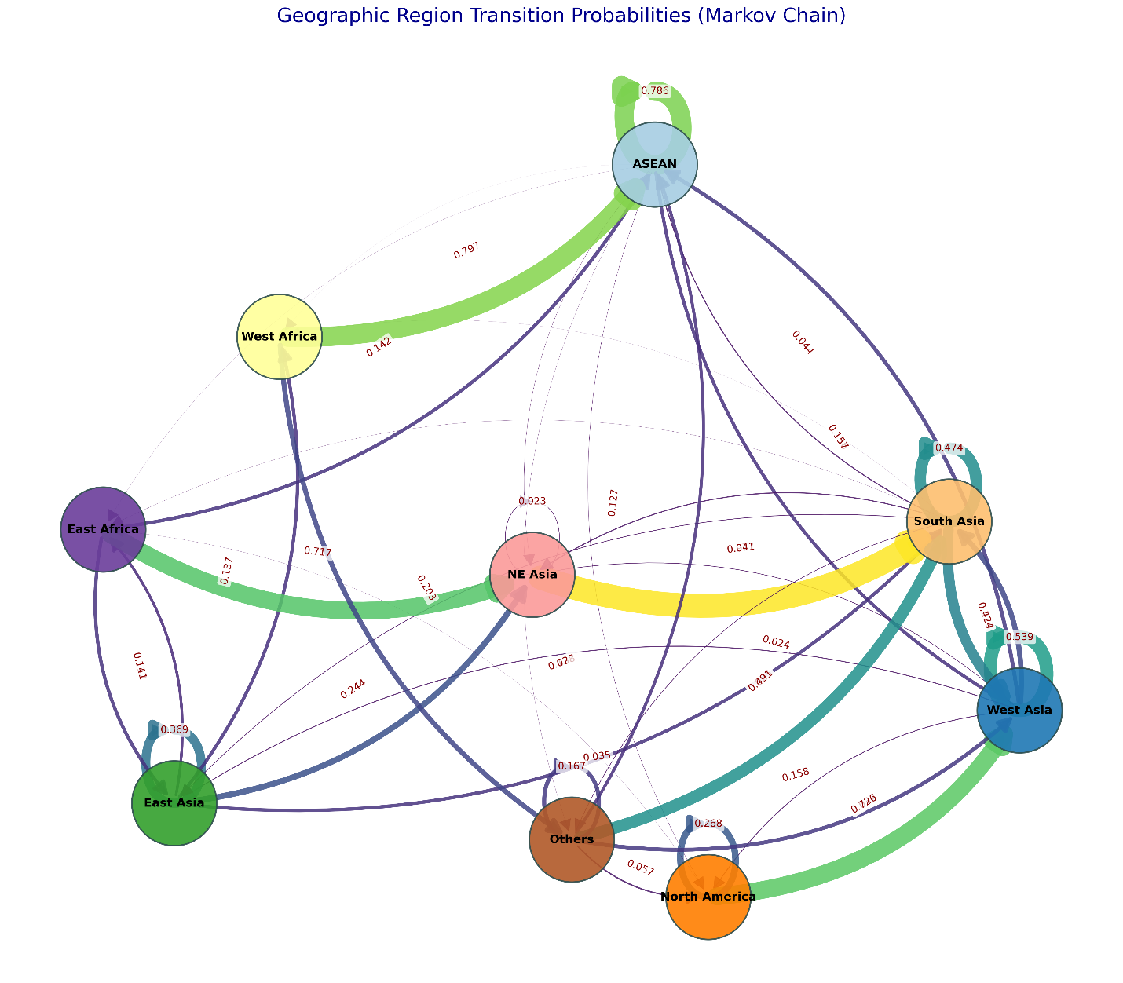

Fig 2: Geographic Region Transition Probabilities (Markov Chain)

The Transition Probability Matrix (TPM) (Table 2) in Markov chain analysis shows the export retention and transition of Gujarat dairy products across global areas. Retention capacity, which measures the probability of exports remaining within the same region, was highest in Northeast Asia (0.977), West Africa (0.797), and North America (0.726), indicating strong internal demand. Gujarat's dairy sector, integrated by the Gujarat Cooperative Milk Marketing Federation (GCMMF), operates under a well-established cooperative framework that provides consistent quality and supply (Anonymous, 2024c). This technique has also helped Gujarat maintain its competitive advantage in international markets. ASEAN (0.786) and East Africa (0.717) also showed significant retention, although regions such as "Others" (0.167) and East Asia (Oceania) (0.369) had a high tendency for exports to move elsewhere.
Transition capacity, which measures the likelihood of trade migration, varied significantly from ASEAN to West Asia-GCC (0.136) and South Asia (0.044), West Asia-GCC to NE Asia (0.213), and East Asia (Oceania) to ASEAN (0.244) and NE Asia (0.138). South Asia shifted considerably to ASEAN (0.424), and North America redirected some exports to ASEAN (0.268). The "Others" category illustrated a variety of shifts, particularly toward Northeast Asia (0.491) and ASEAN (0.158). This distribution highlighted Gujarat's export stability in some locations, while others showed dynamic trade movement, providing important insights for market expansion, trade resilience, and sustainability plans. Thapa (2024) stated that Gujarat, although being an industrially developed state, lags behind other states in terms of SEZ performance. Thus, for its future improvement, Gujarat's Ministry of Commerce & Industry must review its policy framework and the stakeholders' implementation role.
Table 3 shows a projected export volume (In Metric Tons) of Gujarat dairy products across various regions from 2026 to 2028. ASEAN was likely to have a slow downturn, indicating future market changes. West Asia-GCC, East Asia (Oceania), Northeast Asia, and South Asia all exhibited a continuous increase, indicating rising demand. North America also grew, stressing closer trade ties. East Africa swung, with a fall in 2027 before increasing again, whilst West Africa declined over time, indicating lower market activity. The Others category expanded to represent more diverse export outlets. Higher retention in some regions highlights stronger trade ties. Infrastructure and policy support remain crucial for market adaptation (Gondalia, 2020; Modi et al., 2025). This trend research is essential for strategic trade planning and market adaptation.
Table 2: Transition Probability Matrix (TPM)
TPM | ASEAN | West Asia- GCC | East Asia (Oceania) | NE Asia | South Asia | North America | East Africa | West Africa | Others
ASEAN | 0.786 | 0.136 | 0.000 | 0.010 | 0.044 | 0.012 | 0.004 | 0.001 | 0.007
West Asia- GCC | 0.157 | 0.539 | 0.035 | 0.024 | 0.213 | 0.032 | 0.000 | 0.000 | 0.000
East Asia (Oceania) | 0.000 | 0.000 | 0.369 | 0.244 | 0.138 | 0.000 | 0.112 | 0.137 | 0.000
NE Asia | 0.000 | 0.000 | 0.000 | 0.023 | 0.977 | 0.000 | 0.000 | 0.000 | 0.000
South Asia | 0.000 | 0.424 | 0.027 | 0.041 | 0.474 | 0.000 | 0.006 | 0.003 | 0.025
North America | 0.000 | 0.726 | 0.000 | 0.000 | 0.000 | 0.268 | 0.005 | 0.000 | 0.000
East Africa | 0.142 | 0.000 | 0.141 | 0.717 | 0.000 | 0.000 | 0.000 | 0.000 | 0.000
West Africa | 0.797 | 0.000 | 0.000 | 0.000 | 0.000 | 0.000 | 0.000 | 0.000 | 0.203
Others | 0.127 | 0.158 | 0.000 | 0.000 | 0.491 | 0.057 | 0.000 | 0.000 | 0.167

Table 3: Forecasted export of dairy products from Gujarat (In Metric Tons)
Regions | 2026 | 2027 | 2028
ASEAN | 8019.55 | 6954.25 | 6193.61
West Asia- GCC | 3677.96 | 3816.07 | 3950.13
East Asia (Oceania) | 2056.25 | 2506.08 | 2896.38
NE Asia | 633.66 | 1892.32 | 2626.88
South Asia | 1921.33 | 2643.81 | 3125.45
North America | 2552.18 | 3369.60 | 3685.85
East Africa | 2480.45 | 1881.10 | 2696.23
West Africa | 7661.96 | 6821.02 | 6160.13
Others | 2114.62 | 3041.79 | 3484.35

CONCLUSION
Gujarat's dairy exports have increased significantly, with a peak in 2021-22. North America, East Asia (Oceania), East Africa and West Africa were the regions that imported dairy products from Gujarat significantly. The Transition Probability Matrix analysis shows that Northeast Asia (0.977), West Africa (0.797) and North America (0.726) have strong export retention capacity. In contrast, regions such as "Others" (0.167) and East Asia (Oceania) (0.369) demonstrated a greater tendency for exports to shift elsewhere. Forecasts for 2026-2028 predict continuous increases in exports to West Asia-GCC, East Asia (Oceania), Northeast Asia, and South Asia, as well as growth in North America. However, ASEAN is expected to experience a slow downturn, as in West Africa, with East Africa fluctuating. To sustain and enhance export growth, Gujarat's government, through its Ministry of Commerce & Industry, should review and refine its policy framework, it should align with the Centre's Foreign Trade Policy. Strategic trade planning should focus on regions with high retention capacity, such as Northeast Asia and North America, while also developing targeted market expansion strategies for dynamic trade movement areas and those expected to decline, such as ASEAN and West Africa.
References:
Anonymous. 2024a. Global Dairy Market Outlook: Trends in Production, Consumption, and Trade. DairyNews.today. [cited 2025 Jun 7]. Available from: https://dairynews.today/news/global-dairy-market-outlook-trends-in-production-consumption-and-trade.html
Anonymous. 2024b. Dairy Products. Agricultural and Processed Food Products Export Development Authority. [cited 2025 Jun 7]. Available from: https://apeda.gov.in/apedawebsite/SubHead_Products/Dairy_Products.htm
Anonymous. 2024c. Gujarat's Dairy Dominance: A Model of Cooperative Success. Devdiscourse News Desk. [cited 2025 Jun 7]. Available from: https://www.devdiscourse.com/article/business/2836240-gujarats-dairy-dominance-a-model-of-cooperative-success
Audichy R, Thakar KP, Burark SS, Arha A. Production and export performance of Indian groundnut. International Journal of Agriculture Sciences. 2017;9(4):3724-7.
Bhatia H, Shah K. 2024. Comparison of dairy units of Punjab using various financial health indicators. International Journal of Research and Analytical Reviews. 11(1):18-31.
Bhogal. 2024. Dairy and Products Annual. United States Department of Agriculture, IN2024-0049:1-18.
Boopathi Raja A, Naveen Kumar P, Felix KT, Minithra R, Harishankar K, Sathaiah M, Gogoi J, Tyngkan H. 2024. Export performance of India's dairy products—An economic analysis. African Journal of Biological Sciences. 6(15):4338-4351.
Dholakia RH. 2003. Exports of agri-products from Gujarat: Problems and prospects. Vikalpa. 28(4):41-52.
FIEO. 2024. Federation of Indian Export Organisations report. Available from: Gujarat_2024.pdf.
Gondalia VK, Shaikh AS, Jadav KS. 2020. Growth and Prospects of Export of Dairy Products from India. Department of Agricultural Economics & WTO Cell B. A. College of Agriculture, Anand Agricultural University. Available from: research_bullettin_dairy_export_2020.pdf.
Gurjar MD, Makwana AK, Prajapati MC, Kamani KC. 2023. Dairy entrepreneurship scenario in Gujarat state. The Pharma Innovation Journal. 12(2):1090-1094.
Khorajiya M, Shiyani RL, Ardeshna NJ, Dhandhalya MG, Swaminathan B. 2018. Compositional Shift Analysis of Gujarat Livestock Population. Indian Journal of Economics and Development. 14(2):348-353.
le Roux-Pullen L, Zambrano TM, Nair MB, Liu C. 2024. Case study description: Small-holder dairy farming in Gujarat, India. Wageningen University & Research. Available from: https://edepot.wur.nl/691930.
Modi Z, Gurjar M, Don P. 2025. Milk Production Trends in Gujarat and India: A Comparative Analysis of the Last Two Decades. Journal of Scientific Research and Reports. 31(4):445-457.
Nidhishree R, Deka N. Agricultural Performance Across Assam: Examining the Interplay of Cropping Intensity, Irrigation, and Productivity. Indian Journal of Economics and Development. 2024;20(4):243-52.
OECD/FAO. 2023. OECD-FAO Agricultural Outlook. OECD Agriculture statistics (database). [cited 2025 Jun 7]. Available from: http://dx.doi.org/10.1787/agr-outl-data-en.
Parmar S. A study on gross profit ratios of leading dairies of Gujarat. A Global Journal of Social Sciences. 2024;7(2):43-7.
Powrel PJ, Mishra S. 2024. Competitiveness, Specialization, and Structural Shifts in India's Honey Exports: An Analysis of Global Market Dynamics From 2003 to 2022. Agribusiness.
Sarkar A, Gupta H, Dutta A. 2024. Sustainable dairy sector of an emerging economy: An empirical quest based on India. Agricultural Systems. 218:103970.
Singh RR. 2024. Animal Husbandry Statistics 2024. Department of Animal Husbandry and Dairying. [cited 2025 Jun 7]. Available from: https://dahd.nic.in/sites/default/files/BAHS-2024.pdf
Thapa PM. Special Economic Zone in Gujarat: An Analysis of Exports Growth. International Journal of Innovative Science and Research Technology. 2024;9(7):2531-9.
United Nations. 2025. World Economic Situation and Prospects as of mid-2025. E/2025/65. New York. [cited 2025 Jun 7]. Available from: https://www.un.org/development/desa/dpad/publication/world-economic-situation-and-prospects-as-of-mid-2025/

