***Short communication***

**The Supershear Earthquake (M 7.7) in Mandalay, Myanmar on 28th March, 2025**

**ABSTRACT**

On 28th March 2025, at 12:50:52 p.m. Myanmar local time, a moment magnitude earthquake M 7.7 earthquake struck near the city of Mandalay in Upper Myanmar for 85 seconds, epicenter is at latitude 21.996° N longitude 95.926°E, the depth of 10km. After 12 seconds another earthquake with magnitude 6.4 occurred on the same day of 28th March earthquake 2025. These two earthquakes both took place on the Sagaing fault within the Sagaing fault zone. The earthquake caused catastrophic damage across central Myanmar. Dozens of aftershocks followed the following days. Another earthquake of M 5.1 occurred on 30th March, 2025.The study on source characteristics of all these earthquakes can serve to better understand their earthquake mechanism. The features of the causative fault of these earthquakes are identified by using remote sensing satellite image together with analysis of seismicity, fault plain solution and active tectonics in the area. The result shows that the epicenter lies in an area of well-developed tectonic lake Yega Inn. The Yega Inn is a pull-apart basin. The Sagaing fault bounds the eastern margin of the Inn as a right-stepping segment of the Sagaing fault. Such features are developed by extensional faulting with a small amount of strike-slip components. The Mw 7.7 earthquake is associated with amplification by a ringing resonance in lake-bed sediments.

*Keywords: earthquake, remote sensing, tectonic lake, amplification, sedime*

**1.INTRODUTION**

Myanmar is composed of two different evolving continents: The Burma plate and the Sunda plate. The Sagaing Fault is interpreted as an active dextral strike slip fault and a continental transform plate boundary that separates the Burma plate from the Sunda plate (Curray et al., 1979; Le Dain et al., 1984; Yeats et al., 1997; Curray, 2005). The Sagaing Fault is linked with Central Andaman spreading center to the south (Curray et al., 1979). The Andaman Sea was formed by seafloor spreading along short ENE-striking spreading ridges that are offset by NNW-striking transform faults (Curray et al., 1978; Eguchu et al., 1979). The southern end of the Sagaing Fault would be the northern most part of these transform fault. Extension and rifting in the Central Andaman Basin began at around 11Ma and extension and sea floor spreading has been ongoing since 4-5 Ma (Khan & Chakraborty, 2005). That is consequently the best estimate for the age of the Sagaing Fault. Spreading in a 335° (N 25° W) direction, relative to present N, is at an average rate of 30 mm/yr and the northward component is 27 mm/yr (Curray, 2005The average trend of the Sagaing Fault is 351° (N9°W) and the Sagaing Fault accommodates part of the motion while the remainder of the motion is distributed on other faults within a fault zone (Vigny et al., 2003). The NW-SE-oriented seafloor spreading direction agrees with the average trend of the Sagaing Fault. Moreover, the Sagaing Fault is the transform plate boundary with right-lateral motion. Most of the motion is accommodated by faults that form a series of en echelon step-over within a narrow, 3 to 5 km wide transform valley.

**2. TECTONIC GEOMORFOLOGY OF THE SAGAING FAULT**

The Sagaing fault runs through the land of Myanmar from north to south for more than 1000 km and has created a series of sag ponds, pull-apart basins, pressure ridges and scarps along the fault zone. Large-scale topographic maps, SRTM-DEM-based shaded relief maps and Landsat 7 band combination 742 as RGB (2003) and 1: 24,000 scale aerial photographic maps are used for interpretation of the morphological features of the Sagaing fault and related tectonic structures. Numerous small fault segments have been identified in map view which conveys an impression of en echelon pattern. Geomorphic observations and previous documentation suggest that such type of investigation is a key for a better understanding of active tectonics and seismic hazards of the Sagaing fault. The Sagaing fault is clearly visible on the satellite image from the northern terminus in Kachin State to Mandalay in the south for about 450 km. The Sagaing fault is composed of numerous fault segments arranged in right-stepping or left-stepping en echelon pattern. The most striking feature of the Sagaing fault zone is perhaps its remarkably straight and distinct appearance on satellite images extending for 1000 km across much of the length of Myanmar. Most of the stretch along its course, the fault zone is clearly defined by both tectonic and topographic features. Motion is transferred across the gaps between the fault segments resulting in zones of localized extension and compression. The crustal extension has created normal faults and periodic movement along these normal faults has given rise to seismicity in the area. The ENE-WSW trending faults are the transfer faults connecting the two adjacent NNW-SSE trending fault segments. Hence they are short and extend from NNW-SSE trending fault segment to the other. Many localized pull-apart basins and localized uplifted areas occurred between these segments within the Sagaing fault zone. These fault segments are easy to find when the individual earthquake struck on each fault segment. Geomorphic observations and previous documentation suggest that such type of investigation is a key for a better understanding of active tectonics and seismic hazards of the Sagaing fault.

**3. TECTONIC LANDFORM OF THE SAGAING FAULT**

Tectonic lakes along the Sagaing fault are: (1 ) at about latitude 25°N, right-stepping fault segments form an extensional pull-apart basin called the Lake Indawgyi. (2) at 24°N, north of Hti-chaing, there is another fault segment forming a sag pond called Indaw Lake. at 23°N, west of Htichaing there is also a sag pond.(3) Immediately north of Mandalay, at latitudes between 22°35’N and 22°45’N, the Singu basin with 1.5 km wide and 2 km long is observed. (4) at latitude 21° 58’N, at 10km north of Sagaing, right-stepping fault segments form an elongated basin called Yega Inn. Yega Inn is one of pull-apart basins with 1 km long and 500m wide, formed within the Sagaing fault zone. (5) The Shwedan Inn (Inn is Myanmar word for lake), at 17°26’N is a tectonic depression or sag pong on the down-thrown side of the fault. The height of the fault scarp near the northern end of the Shwedan Inn is about 2.8m. A clear west-facing fault scarp extends south of Shwedan village. (6) North and south of the Paingkyun Chaung, an elongated linear de­pression about 10 m wide and l m deep extends along the fault. (7) Farther south, the Sagaing Fault bounds the eastern mar­gin of the Zwegaik Inn at 17°01’N. The Kabauk Inn at 17°N is a pull-apart basin located at a right step of the Sagaing Fault (Tsutsumi et al., 2009).

All these small and large basins that are located along the 1000 km stretch of the Sagaing fault characterize a step-over where the intervening region has been thrown into tension. Their elongate shape in the direction with the fault trend indicates the lateral motion and their width takes the vertical displacement within the intervening gap between the right step-over. A large earthquake tends to nucleate from the tip of the fault segment and then propagate along the fault plane where the accumulated stress is high enough to cause slip on the fault plane. Seismicity is consistent with the transfer of slip on one fault zone onto another segment on the right within the fault zone (Aung,2011). Repeated earthquake events during thousands of year increase the size of these basins and will continue to in the future.

. Most of the segments along its length have ruptured in the past century, generating historical earthquakes. From the result of this study, step-overs that are observed along the Sagaing fault from south to north are described with its corresponding earthquake are: at latitude 17° N, Kabauk In (1930 Bago Eq.); latitude17° 10’N, Zwedaik In; latitude17° 27’N, Shwedan In; Latitude 21° 58N, Yega In ( 1839 Eq.,1956 Eq.); latitude 22° 30N, a sag pond south of Singu plateau; latitude 23° N, a narrow fault gorge (2012 Thabeikkyin Eq.); latitude 24° N, a sag pond west of Hti-chaing (1949,1991 Tagaung Eq.); latitude 25.67°N-96° 15’E, Indawgyi lake(1931 Kamaing Eq. Mw=7.6, Depth 35km). Releasing/restraining bends are at latitude 18° 30N to 19° 35N (1930 Phyu Eq. /1931 Pyinmana Eq.); latitude 17° 05N to 17° 20’N and latitude 16°50’N96°31’ E. Study of earthquake events over the world indicates that magnitude of an earthquake depends on the length of fault segment (Fig.1).

**4. METHODOLOGY**

**4.1 Damages caused by the March, 2025 Mandalay earthquake: Supershear earthquake**

A strong earthquake with M 7.0 occurred on 16th July 1956 at 9:40 pm on the northern part of the Sagaing fault. The epicentral location is 21°58’ N, 95°50’ E (USGS, NEIC), north of Sagaing. The epicenter is in the place of Yega In and the event was named after the nearest town Sagaing**.** The area has historical background of many earthquakes which include 23th March, the Ava (Inwa) earthquake of 1839. The earthquake caused great loss of life about 300 to 400 people killed in 1839 and 40 to 50 person killed in 1956 respectively. The mechanism of this devastating earthquake is right-lateral strike-slip faulting on the Sagaing fault and the extensional normal faulting at the occurrence of tectonic geomorphic feature of a sag pond or a pull-apart basin near the epicenter of the earthquake.On 28th March 2025, at 12:50:52 p.m. Myanmar local time, an earthquake with a moment magnitude Mw 7.7 struck near the city of Mandalay in Upper Myanmar for 85 seconds. The epicenter is at latitude 21.996°N and longitude N 95.926° E, at the depth of 10km. The area of 400 km stretch along Mandalay-Sagaing-Naypyidaw situated very close to the Sagaing fault was severely damaged by the Mandalay earthquake. Location of each earthquake and location of Yega In are: 1839 Ava (Inwa) earthquake 21.9° N-96.0°E, 1956 Sagaing earthquake 21° 58᾽ N-95° 50᾽ E, 2025 Mandalay earthquake 21° 996᾽ N95° 926᾽ E, and location of Yega In is 19° 35᾽N-96° 16᾽ E respectively (Fig.2).

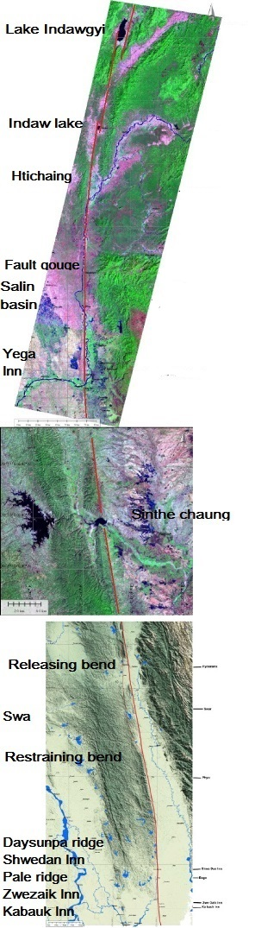 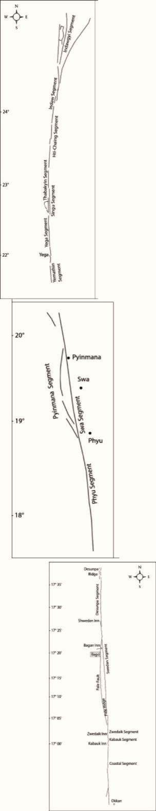

(a) (b)

Fig.1. Landsat TM images of the Sagaing Fault. (a) A mosaic of satellite images of Sagaing fault zone along the length, showing tectonic geomorphic features developed by differential motion of Sagaing fault. (b) Line drawing of the Sagaing fault showing structural features at different location along its length The fault can be divided into 3 parts of upper, middle and lower, based on long-term geomorphic and structural features of the fault zone. In the upper part, these segments are as follow (from north to south):the Indawgyi, Indaw, Htichaing, Thabeikkyin ,Singu and Yega segments. These segments, each 50-180 km long and a half kilometer to 5 km wide are linked by step-overs or bends with 125 km long. The satellite image shows a series of tectonic lakes developed between these segments: Lake Indawgyi, Indaw Lake, Singu sag pond and Yega Inn and many other features in the northern part of Myanmar.

(a) 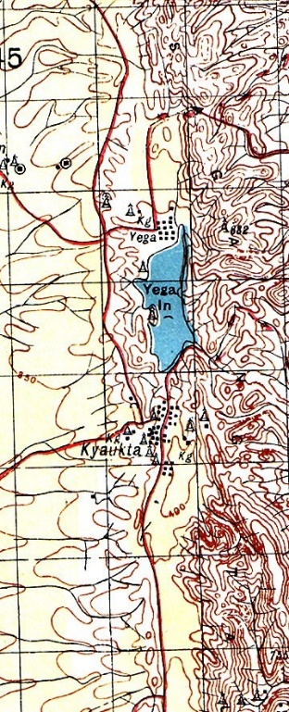 (b) 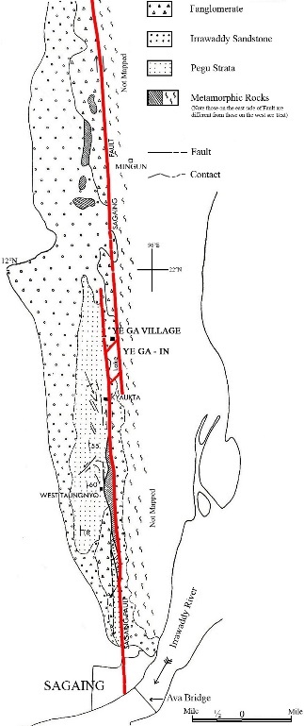 (c) 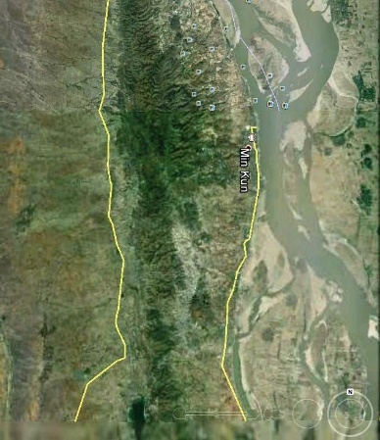

Fig.2 (a)Location of Yega In on topographic map (b) Lithology in the environ of Yega In

(c) Satellite image of Yega In

Many old buildings, houses, high-rise buildings, monasteries, pagodas and religious buildings were destroyed. There were causalities and fatalities, injured and missing people according to the government report on April, 2025. In seismology, a supershear earthquake is called when the propagation of the rupture along the fault surface occurs at speeds in excess, of the seismic shear wave (S wave) velocity. Systematic studies indicate that supershear rupture is common in large strike-slip earthquakes (https://en.wikipedia.org).

**4.2** **Active Deformation of the Sagaing fault**

The Sagaing fault zone illustrates many of the physiographic and structural features that are common to extensional step-overs and a series of contractional step-over. Tectonic-geomorphic features and seismic activity along the Sagaing Fault characterize the fault segments. These segments each 50-180 km long and a half kilometer -5 km wide are linked by step-over or bends with 125 km long. Many localized pull-apart basins and localized areas of uplift occur between these faults segments within the Sagaing fault zone. These studies of local tectonic geomorphic features and local geological structures show that all the historical earthquakes were associated with seismic amplification by small-scale topographic features such as localized scarps and localized basins. The length of fault segment controls earthquake magnitude. If a fault is 100km long, the earthquake would be closer to magnitude 7.5 (Hough, 2004) and it is important for modern earthquake assessment. There is a formula between the magnitude and fault length: log (L) =0.66 M -2.83 (Utsu, 1961), based on the length of five earthquakes (Hurukawa et al., 2011). There are at least a series of fifteen fault segments within the Sagaing fault zone, most of which had ruptured in the last century. The Sagaing Fault accommodates part of the motion while the remainder of the motion is distributed on other faults within a fault zone.

The tectonic setting of the Sagaing fault has the potential to produce large earthquakes. Remote sensing images are used for interpretation of the morphological features of the Sagaing Fault and related tectonic structures. Numerous small fault segments have been identified in map view which conveys an impression of en echelon pattern. These intervening parts of the Sagaing fault continue to accumulate strain energy making them potential sites for the future great earthquakes. This intervening part of Yega Inn have been now suddenly released by the strong earthquake of the 28th March, 2025 with many aftershocks that followed till today. The fault is presently an active fault as indicated by clustering of previous earthquake epicenter along its length. In the last 85 years (1929-2012), 8 major earthquakes of M >7.0 occurred on various segments of the Sagaing fault with severe damage and loss of lives.

**5. CONCLUTION**

The Sagaing Fault is a result of shear between the Burma and Sunda plate. The Sagaing Fault is a major right-lateral strike-slip fault which has long and straight traces along the entire length of Myanmar for more than 1000km. Moreover, the Sagaing Fault is the transform plate boundary with right-lateral motion. The rate of motion of the Burma plate with respect to the Sunda plate has a rate of 18-25mm/yr towards the north (Socquet et al. 2006). The Sagaing Fault accommodates part of the motion while the remainder of the motion is distributed on other faults within a fault zone. The tectonic setting of the Sagaing fault has the potential to produce large earthquakes. Remote sensing images are used for interpretation of the morphological features of the Sagaing Fault and related tectonic structures. Numerous small fault segments have been identified in map view which conveys an impression of en echelon pattern. These intervening parts of the Sagaing fault continue to accumulate strain energy making them potential sites for the future great earthquakes. The fault is presently an active fault as indicated by clustering of earthquake epicenter along its length.

Tectonic deformation has been taking place throughout the Miocene to the present. Structural analysis along the Sagaing Fault reveals several folds and faults, in varied orientations occurring along the fault, of which the NNW-direction is the most prominent. Some of them show considerable seismic activity as evident by epicentral location of earthquakes along the Sagaing Fault. From studies of fault characteristics within the Sagaing fault zone, the faults record both strike-slip deformation and dip-slip displacements and structures along the Sagaing Fault strongly reflect two distinct tectonic regimes. The first involved a combination of strike-slip motion and extension on north-northwest trending faults, leading to the formation of localized pull-apart basins. The second involved strike-slip motion and folding, possibly as a result of a change in the direction of motion in the transform regime.

**6. REFERENCES**

1. Bender, F. (1983). *Geology of Burma*, Gebruder Borntraeger, Berlin, Stuttgart, 293 pp.
2. Chhibber, H. L. (1934). *The Geology of Burma* Macmillan and Co., London, 538 pp.
3. Chamot-Rooke, N., C. Rangin, C. Nielsen, (2001). Timing and kinematics of Andaman basin opening. Eos Transactions Supplement 82 (20).
4. Curray, J.R. (2005). Tectonics and history of the Andaman Sea region, J. Asian Earth Sci. 25, 187-232.
5. Curray, J.R.,D.G. Moore, L.A. Lawver, F.J. Emmel, R.W. Raitt, M. Henry, and R. Kieckhefer (1979). Tectonics of the Andaman Sea and Burma, in Geological and Geophysical Investigations of Continental Margins, J.S. Watkins, L. Montadert, and P.W. Dickerson (Editors), American Association of Petroleum Geologists Memoir, 29, 189-198.
6. Curray, J.R., F.J. Emmel, D.G. Moore, R.W. Raitt, (1982). Structure, tectonics and geological history of the northeastern Indian Oceanan. In: Nairn, A.E.M., Stehli, F.G. (eds.), the Ocean Basins and Margins. The Indian Ocean, vol.c. Plenum Press, New York, 399-450.
7. Dey, B.P. (1968). Aerial photo interpretation of a major lineament in the Yamethin-Pyawbwe quadrangles, *Union of Burma J. Sci. Tech.* 1, 431-443.
8. Engdahl, E.R.,R.D. Van der Hilst, and R.P.Buland, (1998) Global teleseismic earthquake relocation with improved travel times and procedures for depth determination, Bull. Seism. Soc. Amer., 88, 722-743.
9. Gorshkov, G.P., (1959). *Problems of Seismotectonics & Seismicity Zoning of the T erritory of the Union of Burma.* Unpublished report. Department of Geological Survey & Mineral Exploration, Rangoon.

10.Harding, T.P., (1985). Seismic characteristics and identification of negative flower structures, positive flower structures, and positive structural inversion. American Association of Petroleum Geologists, Bulletin 69, 582-600.

11.Hla Hla Aung, Reinterpretation of Historical Earthquakes for the period (1929-1931), Myanmar, Advances in Geosciences, vol.31, Solid Earth Section, (2011). [www.asiaoceania.org](http://www.asiaoceania.org)

12. Hla Hla Aung. Dynamic evolution of the Sagaing fault, 9th AOGS Conference paper,2012

13. Hough,S.E.,(2004), Finding Faults in California: an earthquake tourist guide, Mountain Press Publishing Company, Missoula, Montana

14. Hough, S.E., Earthquakes News Scientist, weekly 7 january 2012

15.Hurukawa, N., (2011(, Two seismic gaps on the Sagaing fault, Myanmar, derived from relocation of historical earthquake since (1918), Geophysical Research Letters,vol.38, pp.1-5.

16.Jeen-Hwa Wang, Evolution of the coseismic pore fluid pressure on the thrust fault, Advances in Geosciences vol.13 (SE 2007)

17.Kearey, P.(2009). Global Tectonics, John Wiley & Sons, The Atrium, Southern Gate, Chichester, West Sussex, PO 198SQ, UK

18.Khan P.K.&Chakraborty P.P.,(2005) Two-phase opening of Andaman Sea:A new seismotectonic insight .Earth and Planetary Seience letters 229,259-71

19.Le Dain, A. Y., P. Tapponnier, and P. Molnar (1984). Active faulting and tec­tonics of Burma and surrounding regions, J. Geophys. Res***.*** 89,453-472.

20. Liu,G.P. and Fu,Z.X., (1999) Acta Seismologica Sinica, 21, 250

21.Mark Van der Meijde and Muhammad Shafique (2010), The Importance of Topography in seismic Amplification, ITC News, pp. 2-4, 2010**-**2**.**

22.Nielsen, C., N. Chamot-Rooke and C. Rangin the ANDAMAN Cruise Team (2004). From partial to full strain partitioning along the Indo-Burmese hyper-oblique subduction, *Mar. Geol*. **209**, 303-327, doi: 10.1016/j.margeo. 2004.05.001.

23.Pivnik, D.A., J. Nahm, R.S. Tucker, G.O. Smith, K. Myeni, M. Nyunt, and P.H. Maung, (1998). Polyphase Deformation is a Fore-Arc/Back-Arc Basin, Salin Subbasin, Myanmar (Burma), AAPG Bulletin, 82, 10, 1937-1856.

24.Qiong Wang et al., Research on stress triggering of the Yutian Ms7.4 earthquake of March.21,2008,Xinjiang, Advances in Geosciences vol.26 (SE2010)

25.Satyabala, S.P. (2002), The historical earthquakes in India, in International Handbook of Earthquakes and Engineering Seismology, Int. Geophys.Ser.,vol.81, edited by W.H.K.Lee et al., chap.48.3,pp.797-798,Academic, New York.

26.Scholz,C.H.,2002. The mechanics of earthquakes and Faulting. Cambridge, Univ.Press, New York

27.Schorlemmer, d.,Wiemer,S., Wyss,M.,2005. Variation in earthquake-size distribution across different stress regimes, Nature 437,539-542

28.Socquet, A., C. Vigny, N. Chamot-Rooke, C. Rangin, W. Simons, C. Rangin, and B.Ambrosius (2006), Indian and Sunda Plates motion and deformation along their boundary in Myanmar determined by GPS, J. Geophys. Res., 111,B05406. doi: 10.1029/2005JB003877.

29.Stein, R.S.; Barka, A.A.; Dieterich, J.H. (1997). "Progressive failure on the north Anatolian fault since 1939 by earthquake stress triggering". *Geophysical Journal International***128**: 594–604. [doi](https://en.wikipedia.org/wiki/Digital_object_identifier):[10.1111/j.1365-246x.1997.tb05321.x](https://dx.doi.org/10.1111%2Fj.1365-246x.1997.tb05321.x).

30.Stein,S. & Wysession, M., 2003, 2004, An Introduction to Seismolgy, Earthquake, and Earth structure Blackwell Publishing Ltd., Victoria 3050, Australia

31.Seth Stein and Michael Wysession Introduction to Seismology, Earthquake, and Earth structure, (2003, 2004) Blackwell Publishing Ltd. Victoria 3050, Australia.

32.Sushil Kumar et al., Fractal Dimension and b-value mapping in the NW Himalya and Adjoining regions, India, Advances in Geosciences vol.26(SE2010)

33.Tankard, A.J., H.R. Balkwill, A. Mehra, Aung Din, (1998). Tertiary wrench fault tectonics and sedimentation in the central basin of Burma. AAPG bulletin 78**,** 1165 (Abstr).

34.Tsutsumi, H., and T. Sato (2009), Tectonic geomorphology of the sothernmost Sagaing Fault and Surface rupture associated with the May 1930 Pegu (Bago) earthquake, Myanmar, Bull. Seisomol. Soc. Am., 99, 2155-2168, doi: 10.1785/0120080113.

35. Utsu,T. (1992), Destructive earthquakes in the world, 1500-1992, in Earthquake Disaster Reduction Handbook, pp.1-24, Bldg.Res.Inst. Tsukuba, Japan

36. Vigny, C., A. Socquet, C. Rangin, N. Chamot-Rooke, M. Pubellier, M.-N. Bouin, G. Bertrand, and M. Becker, (2003). Present-day crustal deformation around Sagaing Fault, Myanmar. *J. Geophys. Res.,* 108 (B11),2533, doi: 10.1029/2002 JB001999.

37. Yeats, R.S.,and C. R. Allen (1997). The Geology of Earthquakes, Oxford University Press, New York, 568 pp.