Original Research Article

Seed priming with potassium nitrate improves germination and physiological performance by ameliorating metabolic process and vigour in carrot

Introduction: In order to energize the seeds, accelerate the germination process, and lessen environmental stress, a range of physiological and non-physiological treatments are available. Seed priming is one of these. It's an inexpensive, effective hydration technique that speeds up germination by increasing the pre-germinative metabolic process through controlled drying and hydration.
Aims: The main aim was to evaluate effect of halo-priming with KNO₃ on germination and vigour of seed.
Materials and Methods: In the present study, which was conducted with three carrot genotypes and varying halo-priming concentrations and durations were employed. A completely randomized design with three replications was used. Three genotypes were Carrot Florence (G₁), Deb Kuroda-1 (G₂) and Deb Kuroda-3 (G₃) with various concentrations and duration of KNO₃ for halo priming viz. 2% for 24 hrs (T₂), 2% for 18 hrs (T₃), 3% for 24 hrs (T₄), 3% for 18 hrs (T₅), 4% for 24 hrs (T₆), 4% for 18 hrs (T₇) and non-primed seeds (T₁). The different seed quality parameters such as Time to 50% germination, Mean germination time (MGT), Germination index, Germination Energy (%), root length, shoot length, fresh weight, dry weight, germination percentage and vigor index were recorded.
Results: The findings of the experiment depict that, treatments over genotypes, 3% KNO₃ for 24 hours duration had the best results, with compared to seeds treated with different priming concentrations and durations, those treated with this treatment showed notably greater potential. Deb Kuroda-3 was the best genotype over all treatments. The seed quality parameters, such as germination energy (36.177), seedling vigour index-I (543.886), and germination index (5.910) showed noticeably the best results after primed with 3% KNO₃ for 24 hours.
Discussion: Seed priming is a practical and affordable way to guarantee consistent seed development in field crops. It improves germination, vigour, nutrient uptake, water use efficiency, and the release of photo- and thermo-dormancy.
Conclusion: Deb Kuroda-3 was the best genotype over all treatments. Consequently, 3% KNO₃ pre-sowing treatment for 24 hours is advised for carrot seed in order to improve seedling establishment and vigour.
Keywords: Germination, potassium nitrate, priming, vigour.
1. INTRODUCTION
Carrots (Daucus carota L.) are one of India's most important cool season vegetable crops (2n=18). This plant belongs to the Apiaceae family and is biannual. Its rich nutritional content and several health advantages make it extremely popular. Seed is an essential part of crop production as a successful stand establishment requires optimal seed germination. But, these days, a number of abiotic and environmental stressors have a detrimental effect on the seed germination, seedling emergence, and vigour of seedlings, which ultimately results in low agricultural output. Therefore, a variety of physiological and non-physiological treatments are available to invigorate the seeds, speed up the germination process, and reduce environmental stress. Among these is seed priming. It’s a low-cost, efficient hydration method that uses regulated drying and hydration to boost the pre-germinative metabolic process and promote quick germination. The theory of seed priming was proposed by Heydecker in 1973. According to Basu (1976) and Chakraborty and Bordolui (2021a), seed priming can expedite germination, shorten germination times, and enhance crop performance under stress. Halo priming involves seeds which are immersed in different salt solutions which facilitate the process of seed germination and subsequent seedling emergence even under adverse environmental conditions. During this pre-germinative phase, critical enzymes are activated, DNA repair starts, and antioxidants accumulate. This primes the seed to germinate more quickly and uniformly once it’s sown. The salt solution creates a mild osmotic stress, prompting the seed to adjust by accumulating compatible solutes (like proline or sugars). This prepares the seed for better stress tolerance after planting. This also can improve ion transport mechanisms and membrane stability. For small seeds, seed priming works very well. Seed priming is a practical and affordable technique used to achieve consistent seed development in field crops. It has positive effects on crop yield, maturity, release of photo- and thermo-dormancy, nutrient uptake, and water use efficiency. In light of the aforementioned considerations, the current study examined the effects of KNO₃ seed priming on vigour status, seedling growth, and germination in a laboratory setting at varying doses and times, using dry seeds as a control.
2. MATERIALS AND METHODS
The present investigation was conducted with three carrot genotypes viz, Carrot Florence (G₁), Deb Kuroda-1 (G₂) and Deb Kuroda-3 (G₃) with various concentrations and duration of KNO₃ for halo priming viz. 2% for 24 hrs(T₂), 2% for 18 hrs(T₃), 3% for 24 hrs(T₄), 3% for 18 hrs(T₅), 4% for 24 hrs(T₆), 4% for 18 hrs(T₇) and non-primed seeds (T₁) at Seed Testing Laboratory, Department of Seed Science and Technology, BCKV, Mohanpur, Nadia, West Bengal during, 2021-22. The seeds were collected from AICRP on Vegetable.
2.1 Time to 50% germination
The number of seeds that sprouted each day was recorded using the AOSA method. Time of 50% germination (T₅₀) was shown using the following formula from Coolbear et al. (1984), which Farooq et al. (2005) modified.
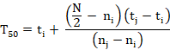
Where ni, nj, and N are the total number of seeds germinated by adjacent counts at times ti and tj when ni< N/2 <nj, and N is the final number of germination.
2.2 Mean germination time (MGT)
The mean germination time was determined using the Ellis and Roberts (1981) equation.
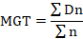
Where n is the number of seeds that germinated on day D and D is the number of days measured from the starting of germination.
2.3 Germination index (GI)
This formula was used to determine the germination index (GI), per AOSA (1990).
2.4 Germination Energy
The germination energy (GE) was recorded on the fourth day following the actual planting. It is the proportion of seeds that germinated four days after planting, relative to the total number of seeds tested (Ruan et al., 2002).
2.5 Germination percentage
There was blotting paper on the cotton after it had been submerged in the petridish. Distilled water was then used to wet it. Following preparation, the seeds were placed on the blotting paper and sealed with a lid. For every genotype and lot, eight petridish pairs were maintained in the germinator. After fourteen days, the petridishes were taken out of the seed germinator, and the quantity of healthy seedlings was tallied. Germination = number of normal seedlings X 100/ total seedlings.
2.6 Seedling parameters: A scale and graph paper were used to measure the root and shoot lengths of ten seedlings using the glass plate method in the lab at 14 days after germination. The average length was then calculated and expressed in centimeters (cm). Ten seedlings were measured for fresh weight using a digital balance. The seedlings were dried for two hours at 60 to 70 degrees Celsius in a hot air oven before being weighed with a digital balance. The seedlings' fresh and dry weights were expressed in grams (g).
2.7 Vigour index: The formula recommended by Abdul-Baki and Anderson (1973) was used to calculate the Vigour Index (VI). VI= G X L Where, ‘G’ stands for germination percentage and ‘L’ denotes average seedling length (cm).
3. RESULTS AND DISCUSSION
3.1 Time of 50% Germination (Days)
Time of 50% germination was observed lowest in T₄ over genotypes, preceded by T₅ and T₆ whereas maximum was in T₁ (7.383) followed by T₇, T₂, and T₃. Lee et al. (1997) reported reduction in time of 50% germination of capsicum when KNO₃ was used to prime seeds. Over the treatments, G₁ had the highest mean germination time (6.983), and G₃ had lowest mean germination time (6.319). Though G₂ and G₃ over treatment were non-significantly differ. The interaction between genotypes and treatments were non-significant variation. Among the interaction G₁T₃ showed highest value (7.950) for this parameter. A similar outcome was observed in carrots primed with Ag-nano particles by Kundu and Bordolui (2023).

Table 1. Effect of halo-priming on Time of 50% Germination (days) of carrot genotypes
 | T₁ | T₂ | T₃ | T₄ | T₅ | T₆ | T₇ | Mean T
G₁ | 7.950 | 7.300 | 6.967 | 6.100 | 6.300 | 6.633 | 7.633 | 6.983
G₂ | 7.333 | 6.433 | 6.350 | 5.267 | 6.167 | 6.253 | 6.700 | 6.358
G₃ | 6.867 | 6.567 | 6.267 | 5.633 | 5.900 | 6.167 | 6.833 | 6.319
Mean G | 7.383 | 6.767 | 6.528 | 5.667 | 6.122 | 6.351 | 7.056
 |  | G | T | GXT
SEm (±) |  | 0.068 | 0.103 | 0.179
LSD (0.05) |  | 0.194 | 0.296 | NS
Note: G = Genotypes, G₁ = Carrot Florence, G₂ = Deb Kuroda-1, G₃ = Deb Kuroda-3
T = Treatment, T₁ = Control, T₂= 2% KNO₃ for 24 hrs, T₃= 2% KNO₃ for 18 hrs, T₄= 3% KNO₃ for 24 hrs, T₅=3% KNO₃ for 18 hrs, T₆= 4% KNO₃ for 24 hrs and T₇= 4% KNO₃ for 18 hrs.

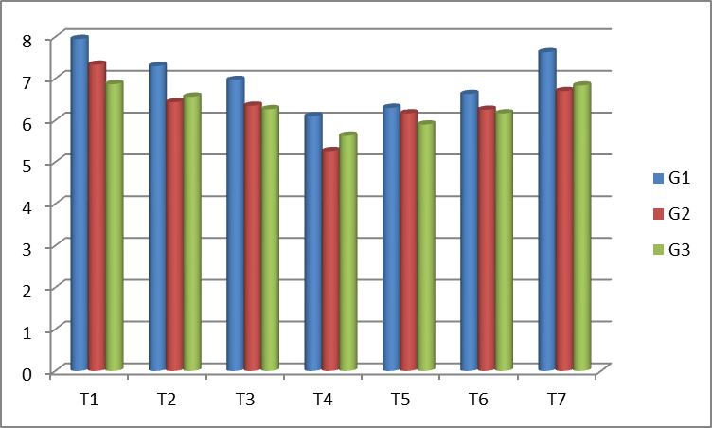

Fig. 1. Graphical representation of Time of 50% Germination (days)

3.2 Mean Germination Time (Days)
In treatment over genotypes T₄ observed the lowest mean germination time preceded by T₅ and T₆ whereas T₁ (8.840) took the highest mean germination time, followed by T₇, T₂, and T₃. El-Sanatawy et al. (2021)) found that halo priming with KNO₃ improve the mean germination time in maize. Over the treatments, G₃ (8.444) had taken the lowest mean germination time and G₁ had highest mean germination time (7.775). When the interaction effect of genotypes and seed treatments were taken into consideration, G₁T₁ (9.407) showed highest value for this parameter but they were non-significantly differ with each other. Similar findings were made by Ray and Bordolui (2022a) in tomatoes.
Table2. Effect of halo-priming on Mean Germination Time (days) of carrot genotypes
 | T₁ | T₂ | T₃ | T₄ | T₅ | T₆ | T₇ | Mean T
G₁ | 9.407 | 8.757 | 8.390 | 7.557 | 7.783 | 8.090 | 9.127 | 8.444
G₂ | 8.790 | 7.923 | 7.807 | 6.767 | 7.623 | 7.710 | 8.200 | 7.831
G₃ | 8.323 | 8.020 | 7.723 | 7.107 | 7.357 | 7.623 | 8.270 | 7.775
Mean G | 8.840 | 8.233 | 7.973 | 7.143 | 7.588 | 7.808 | 8.532
 |  | G | T | GXT
SEm (±) |  | 0.070 | 0.107 | 0.186
LSD (0.05) |  | 0.201 | 0.307 | NS
Note: G = Genotypes, G₁ = Carrot Florence, G₂ = Deb Kuroda-1, G₃ = Deb Kuroda-3
T = Treatment, T₁ = Control, T₂= 2% KNO₃ for 24 hrs, T₃= 2% KNO₃ for 18 hrs, T₄= 3% KNO₃ for 24 hrs, T₅=3% KNO₃ for 18 hrs, T₆= 4% KNO₃ for 24 hrs and T₇= 4% KNO₃ for 18 hrs

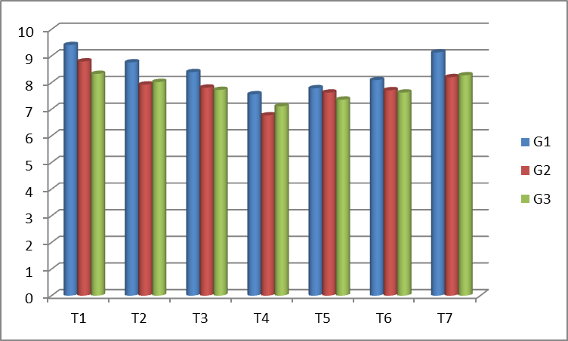

Fig. 2. Graphical representation of Mean Germination Time (days)

3.3 Germination index

T₄ produced the highest germination index (6.468) over genotypes, followed by T₅, T₆, and T₃, whereas T₁ had the least germination index, preceded by T₂ and T₃. El-Sanatawy et al. (2021)) found that halo priming with KNO₃ improve the germination index in maize. Over the treatments, G₃ had the highest germination index (5.910), and G₁ had the lowest germination index (5.139). When the interaction effect of genotypes and seed treatments were taken into consideration, G₃T₄ showed highest value (6.650) for this parameter. Here, G₁T₁, G₂T_{1;} G₂T₅, G₂T₆ and G₃T₅, G₃T₆ were statistically at per.

Table 3.Effect of halo-priming on Germination index of carrot genotypes
 | T₁ | T₂ | T₃ | T₄ | T₅ | T₆ | T₇ | Mean T
G₁ | 2.187 | 5.250 | 5.433 | 6.287 | 6.000 | 5.600 | 5.217 | 5.139
G₂ | 2.240 | 6.227 | 6.273 | 6.467 | 6.433 | 6.353 | 6.173 | 5.738
G₃ | 2.500 | 6.367 | 6.467 | 6.650 | 6.597 | 6.563 | 6.227 | 5.910
Mean G | 2.309 | 5.948 | 6.058 | 6.468 | 6.343 | 6.172 | 5.872
 |  | G | T | GXT
SEm (±) |  | 0.014 | 0.021 | 0.037
LSD (0.05) |  | 0.040 | 0.061 | 0.106
Note: G = Genotypes, G₁ = Carrot Florence, G₂ = Deb Kuroda-1, G₃ = Deb Kuroda-3
T = Treatment, T₁ = Control, T₂= 2% KNO₃ for 24 hrs, T₃= 2% KNO₃ for 18 hrs, T₄= 3% KNO₃ for 24 hrs, T₅=3% KNO₃ for 18 hrs, T₆= 4% KNO₃ for 24 hrs and T₇= 4% KNO₃ for 18 hrs

3.4 Germination Energy (%)
Over genotypes, T₄ (39.000) produced the shoots with the highest germination energy followed by T₅, T₆, and T₃, whereas T₁ had the least length, preceded by T₂ and T₃. Over the treatments, G₃ had the highest germination energy (36.177), and G₁ had the lowest germination energy (33.515). For interaction effect of genotypes and seed treatments were non-significantly differ but G₃T₄ (40.500) showed highest value for this parameter.

Table 4. Effect of halo-priming on Germination Energy (%) (tr value) of carrot genotypes
 | T₁ | T₂ | T₃ | T₄ | T₅ | T₆ | T₇ | Mean T
G₁ | 21.000 (27.260) | 35.367  (36.476) | 34.500  (35.956) | 37.333  (37.647) | 36.840  (37.355) | 36.200  (36.974) | 33.367  (35.064) | 33.515  (35.277)
G₂ | 22.000  (27.960) | 36.450  (37.123) | 35.473  (36.540) | 39.167  (38.727) | 37.367  (37.667) | 36.717  (37.282) | 34.680  (36.064) | 34.550  (35.909)
G₃ | 23.167  (28.760) | 37.900  (37.982) | 37.200  (37.982) | 40.500  (39.508) | 39.333  (38.825) | 38.573  (37.379) | 36.567  (37.193) | 36.177  (36.888)
Mean G | 22.056  (27.993) | 36.572  (37.194) | 35.724  (36.688) | 39.000  (38.627) | 37.847  (37.949) | 37.163  (37.545) | 34.871  (36.888)
 |  | G | T | GXT
SEm (±) |  | 0.062 | 0.095 | 0.165
LSD (0.05) |  | 0.178 | 0.273 | NS
Note: G = Genotypes, G₁ = Carrot Florence, G₂ = Deb Kuroda-1, G₃ = Deb Kuroda-3
T = Treatment, T₁ = Control, T₂= 2% KNO₃ for 24 hrs, T₃= 2% KNO₃ for 18 hrs, T₄= 3% KNO₃ for 24 hrs, T₅=3% KNO₃ for 18 hrs, T₆= 4% KNO₃ for 24 hrs and T₇= 4% KNO₃ for 18 hrs

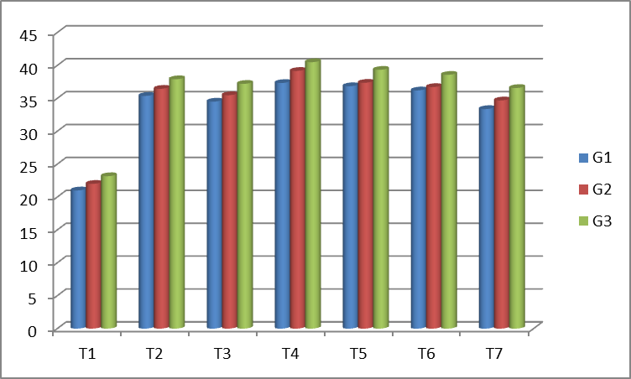

Fig. 3. Graphical representation of Germination Energy (%)

3.5 Shoot Length (cm)
The longest magnitude of shoot length was recorded in T₄ (3.317) over genotypes, followed by T₆, T₅, and T₂, whereas T₁ had the least length, preceded by T₃ and T₇. . El-Sanatawy et al. (2021)) found that halo priming with KNO₃ improve the shoot length in maize. Over the treatments, G₃ (3.302) had the highest shoot length and G₁ (2.771 cm) had the smallest shoot length. Though over treatment G₁ and G₂ were non-significantly differ with each other. When the interaction effect of genotypes and seed treatments were taken into consideration, G₃T₄ (3.583 cm) showed highest value for this parameter. Here, G₂T₁, G₁T_{7;} G₂T₂, G₂T₁ and G₂T₅, G₂T₆ were statistically at par. Using sodium molybdate (Na₂MoO₄) nutri-priming to lengthen shoots, Choudhury and Bordolui (2022a) observed similar results in Bengal gram.

Table 5. Effect of halo-priming on Shoot Length (cm) of carrot genotypes
 | T₁ | T₂ | T₃ | T₄ | T₅ | T₆ | T₇ | Mean T
G₁ | 2.133 | 2.867 | 2.633 | 3.133 | 2.900 | 2.933 | 2.800 | 2.771
G₂ | 2.287 | 3.133 | 2.267 | 3.233 | 3.100 | 3.150 | 2.963 | 2.876
G₃ | 2.380 | 3.483 | 3.367 | 3.583 | 3.483 | 3.517 | 3.300 | 3.302
Mean G | 2.267 | 3.161 | 2.756 | 3.317 | 3.161 | 3.200 | 3.021
 |  | G | T | GXT
SEm (±) |  | 0.018 | 0.027 | 0.046
LSD (0.05) |  | 0.050 | 0.077 | 0.133
Note: G = Genotypes, G₁ = Carrot Florence, G₂ = Deb Kuroda-1, G₃ = Deb Kuroda-3
T = Treatment, T₁ = Control, T₂= 2% KNO₃ for 24 hrs, T₃= 2% KNO₃ for 18 hrs, T₄= 3% KNO₃ for 24 hrs, T₅=3% KNO₃ for 18 hrs, T₆= 4% KNO₃ for 24 hrs and T₇= 4% KNO₃ for 18 hrs

3.6 Root length (cm)
The longest root length over genotypes was observed to produce by T₄ (3.002) on an average followed by T₆, T₅, and T₂ whereas T₁ had the least length, preceded by T₃ and T₇. El-Sanatawy et al. (2021)) found that halo priming with KNO₃ improve the root length in maize. Highest root length (2.872 cm) was observed for G₃ and shortest root length was recognized for G₁ (2.554 cm) over treatments. The interaction effect of genotypes and seed treatments were non-significantly differ but G₃T₄ (3.173 cm) showed highest value for this parameter. Choudhury and Bordolui (2022b) observed a similar type of outcome in Bengal gram using potassium nitrate.
Table 6. Effect of halo-priming on Root length (cm) of carrot genotypes
 | T₁ | T₂ | T₃ | T₄ | T₅ | T₆ | T₇ | Mean T
G₁ | 1.833 | 2.557 | 2.453 | 2.867 | 2.733 | 2.760 | 2.677 | 2.554
G₂ | 2.200 | 2.720 | 2.620 | 2.967 | 2.833 | 2.813 | 2.697 | 2.693
G₃ | 2.283 | 2.857 | 2.750 | 3.173 | 3.067 | 3.103 | 2.870 | 2.872
Mean G | 2.106 | 2.711 | 2.608 | 3.002 | 2.878 | 2.892 | 2.748
 |  | G | T | GXT
SEm (±) |  | 0.018 | 0.027 | 0.047
LSD (0.05) |  | 0.051 | 0.077 | NS
Note: G = Genotypes, G₁ = Carrot Florence, G₂ = Deb Kuroda-1, G₃ = Deb Kuroda-3
T = Treatment, T₁ = Control, T₂= 2% KNO₃ for 24 hrs, T₃= 2% KNO₃ for 18 hrs, T₄= 3% KNO₃ for 24 hrs, T₅=3% KNO₃ for 18 hrs, T₆= 4% KNO₃ for 24 hrs and T₇= 4% KNO₃ for 18 hrs

3.7 Seedling length (cm)
T₁ (4.372 cm) generated seedlings with the shortest lengths over genotypes, which were preceded by T₃ and T₇ while T₄ (6.319 cm) produced seedlings with highest length of, followed by T₆, T₅, and T₂. G₂ (6.174 cm) had the longest seedlings and G₁ (5.326 cm) had the shortest seedlings over treatments. Here, G₂ and G₃ were non- significantly differ. When the interaction effect of genotypes and seed treatments were taken into consideration, G₃T₄ showed highest value (6.757 cm) for this parameter. Here, G₂T₅, G₂T_{6;} G₁T₅, G₁T₅; G₃T_{7,} G₃T₄ were statistically at par.
Table 7. Effect of halo-priming on Seedling length (cm) of carrot genotypes
 | T₁ | T₂ | T₃ | T₄ | T₅ | T₆ | T₇ | Mean T
G₁ | 3.967 | 5.423 | 5.087 | 6.000 | 5.633 | 5.693 | 5.477 | 5.326
G₂ | 4.487 | 5.853 | 4.887 | 6.200 | 5.933 | 5.963 | 5.660 | 5.569
G₃ | 4.663 | 6.340 | 6.117 | 6.757 | 6.550 | 6.620 | 6.170 | 6.174
Mean G | 4.372 | 5.872 | 5.363 | 6.319 | 6.039 | 6.092 | 5.769
 |  | G | T | GXT
SEm (±) |  | 0.031 | 0.047 | 0.081
LSD (0.05) |  | 0.088 | 0.135 | 0.233
Note: G = Genotypes, G₁ = Carrot Florence, G₂ = Deb Kuroda-1, G₃ = Deb Kuroda-3
T = Treatment, T₁ = Control, T₂= 2% KNO₃ for 24 hrs, T₃= 2% KNO₃ for 18 hrs, T₄= 3% KNO₃ for 24 hrs, T₅=3% KNO₃ for 18 hrs, T₆= 4% KNO₃ for 24 hrs and T₇= 4% KNO₃ for 18 hrs

3.8 Germination percentage
The highest germination percentage over genotypes was observed to produce by T₄ (89.430) on an average followed by T₅, T₆, and T₇, whereas T₁ had the least length, preceded by T₃ and T₂. El-Sanatawy et al. (2021)) found that halo priming with KNO₃ improve the germination percentage in maize. Highest germination percentage (87.838) was observed for G₂ and lowest germination percentage (85.969) was recognized for G₁ over treatments. Though G₁ and G₃ over treatment were non-significantly differ. When the interaction effect of genotypes and treatments were taken into consideration, they were statistically at par but G₃T₄ (88.983) showed highest value for this parameter. An analogous result was found in tomatoes by Ray and Bordolui (2022b).

Table 8. Effect of halo-priming on Germination percentage (tr value) of carrot genotypes
 | T₁ | T₂ | T₃ | T₄ | T₅ | T₆ | T₇ | Mean T
G₁ | 81.927  (64.817) | 85.703  (67.761) | 85.187  (67.337) | 88.667  (70.306) | 87.633  (69.388) | 86.670  (68.559) | 85.993  (67.995) | 85.969  (68.023)
G₂ | 84.033  (66.422) | 87.000  (68.847) | 87.383  (69.168) | 90.640  (72.159) | 89.333  (70.911) | 88.833  (70.451) | 87.640  (69.402) | 87.838  (69.623)
G₃ | 82.733  (65.423) | 87.350  (69.139) | 86.723  (68.604) | 88.983  (70.596) | 88.067  (69.772) | 87.667  (69.415) | 86.767  (68.645) | 86.899  (68.799)
Mean G | 82.898  (65.554) | 86.684  (68.582) | 86.431  (68.370) | 89.430  (71.020) | 88.344  (70.024) | 87.723  (69.475) | 86.800  (68.680)
 |  | G | T | GXT
SEm (±) |  | 0.119 | 0.182 | 0.315
LSD (0.05) |  | 0.341 | 0.521 | NS
Note: G = Genotypes, G₁ = Carrot Florence, G₂ = Deb Kuroda-1, G₃ = Deb Kuroda-3
T = Treatment, T₁ = Control, T₂= 2% KNO₃ for 24 hrs, T₃= 2% KNO₃ for 18 hrs, T₄= 3% KNO₃ for 24 hrs, T₅=3% KNO₃ for 18 hrs, T₆= 4% KNO₃ for 24 hrs and T₇= 4% KNO₃ for 18 hrs

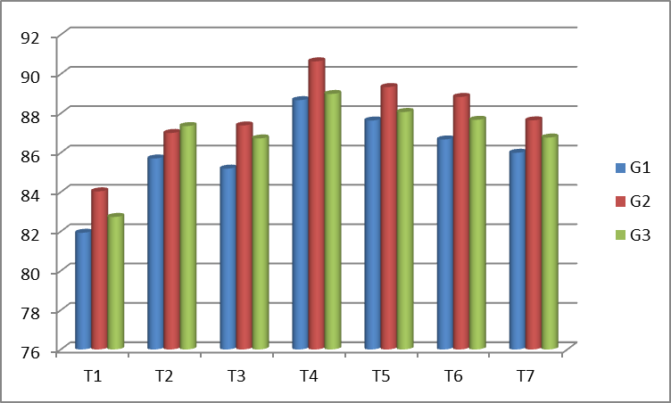

Fig. 4. Graphical representation of Germination percentage

3.9 Vigour Index-I

Considering vigour index-I over genotypes, maximum value was calculated for T₄, i.e., 554.172 followed by T₅, T₆, and T₃; minimum vigour index was noted for T₁, i.e., 409.564 preceded by T₂ and T₃. El-Sanatawy et al. (2021) found that halo priming with KNO₃ improve the vigour index in maize. Over the treatments, G₃ (543.886) recorded the highest vigour index and G₁ showed the lowest vigour index (461.719). Though G₁ and G₃ over treatment were non-significantly differ. The interaction between genotypes and seed treatments non-significantly variation but G₃T₄ (593.810) showed highest value for this parameter.

Table 9. Effect of halo-priming on Vigour Index-I of carrot genotypes
 | T₁ | T₂ | T₃ | T₄ | T₅ | T₆ | T₇ | Mean T
G₁ | 376.942 | 454.719 | 463.274 | 517.267 | 495.613 | 487.659 | 436.561 | 461.719
G₂ | 419.037 | 478.763 | 476.347 | 551.439 | 527.113 | 522.345 | 462.354 | 491.057
G₃ | 432.713 | 545.381 | 554.988 | 593.810 | 576.872 | 568.067 | 535.373 | 543.886
Mean G | 409.564 | 492.954 | 498.203 | 554.172 | 533.200 | 526.023 | 478.096
 |  | G | T | GXT
SEm (±) |  | 9.141 | 13.964 | 24.186
LSD (0.05) |  | 26.225 | 40.059 | NS
Note: G = Genotypes, G₁ = Carrot Florence, G₂ = Deb Kuroda-1, G₃ = Deb Kuroda-3
T = Treatment, T₁ = Control, T₂= 2% KNO₃ for 24 hrs, T₃= 2% KNO₃ for 18 hrs, T₄= 3% KNO₃ for 24 hrs, T₅=3% KNO₃ for 18 hrs, T₆= 4% KNO₃ for 24 hrs and T₇= 4% KNO₃ for 18 hrs

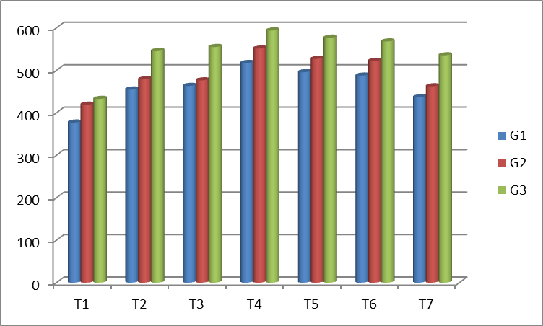

Fig. 5. Graphical representation of Vigour Index-I
3.10 Fresh weight (mg) of 10 Seedlings
Over genotypes T₄ (106.444) produced the highest fresh weight of ten seedlings T₆, T₅ and T₂; in contrast, T₁ (control) produced the lowest fresh weight preceded by T₃ and T₇. El-Sanatawy et al. (2021)) found that halo priming with KNO₃ improve the fresh weight in maize. Comparing Ag nano priming to other treatments, Chakraborty and Bordolui (2021b) found that it increased the fresh weight of green grams seedlings. Genotype over treatments, G₃ showed the highest fresh weight (97.476) and G₁ (89.476) had the lowest fresh weight. When seed treatments and genotype interactions were taken into account, G₃T₄ (109.000) displayed the highest value for this parameter.
Table 10. Effect of halo-priming on seedling fresh weight (mg) of carrot genotypes (10 seedlings)
 | T₁ | T₂ | T₃ | T₄ | T₅ | T₆ | T₇ | Mean T
G₁ | 62.333 | 92.333 | 85.667 | 102.333 | 95.000 | 99.667 | 89.000 | 89.476
G₂ | 66.000 | 97.000 | 90.000 | 108.000 | 100.333 | 104.333 | 93.000 | 94.095
G₃ | 68.333 | 101.667 | 95.333 | 109.000 | 103.333 | 106.000 | 98.667 | 97.476
Mean G | 65.556 | 97.000 | 90.333 | 106.444 | 99.556 | 103.333 | 93.556
 |  | G | T | GXT
SEm (±) |  | 0.233 | 0.356 | 0.617
LSD (0.05) |  | 0.668 | 1.021 | 1.768
Note: G = Genotypes, G₁ = Carrot Florence, G₂ = Deb Kuroda-1, G₃ = Deb Kuroda-3
T = Treatment, T₁ = Control, T₂= 2% KNO₃ for 24 hrs, T₃= 2% KNO₃ for 18 hrs, T₄= 3% KNO₃ for 24 hrs, T₅=3% KNO₃ for 18 hrs, T₆= 4% KNO₃ for 24 hrs and T₇= 4% KNO₃ for 18 hrs

3.11 Dry Weight (mg) 10 Seedlings
The highest dry weight over genotypes was observed to produce by T₄ (11.826) followed by T₆, T₅ and T₂; while it was of lowest dry weight in T₁ (control) preceded by T₃ and T₇. El-Sanatawy et al. (2021) found that halo priming with KNO₃ improve the dry weight in maize. Highest dry weight (10.831) was observed for G₃ and lowest dry weight (9.941) was recognized for G₁, over treatments. Kundu and Bordolui (2025) found a similar result in carrots after osmo-priming. Though G₂ and G₃ over treatment were non-significantly differ. The interaction between genotypes and seed treatments G₃T₄ (12.110) showed highest value for this parameter but G₁T₂, G₂T₇ and G₂T₆, G₂T₅ were statistically at par.
Table 11. Effect of halo-priming on Seedling Dry Weight (mg) of carrot genotypes (10 seedlings)
 | T₁ | T₂ | T₃ | T₄ | T₅ | T₆ | T₇ | Mean T
G₁ | 6.927 | 10.257 | 9.517 | 11.367 | 10.557 | 11.073 | 9.890 | 9.941
G₂ | 7.330 | 10.780 | 10.000 | 12.000 | 11.147 | 11.597 | 10.333 | 10.455
G₃ | 7.593 | 11.293 | 10.597 | 12.110 | 11.480 | 11.780 | 10.963 | 10.831
Mean G | 7.283 | 10.777 | 10.038 | 11.826 | 11.061 | 11.483 | 10.396
 |  | G | T | GXT
SEm (±) |  | 0.026 | 0.040 | 0.069
LSD (0.05) |  | 0.074 | 0.114 | 0.197
Note: G = Genotypes, G₁ = Carrot Florence, G₂ = Deb Kuroda-1, G₃ = Deb Kuroda-3
T = Treatment, T₁ = Control, T₂= 2% KNO₃ for 24 hrs, T₃= 2% KNO₃ for 18 hrs, T₄= 3% KNO₃ for 24 hrs, T₅=3% KNO₃ for 18 hrs, T₆= 4% KNO₃ for 24 hrs and T₇= 4% KNO₃ for 18 hrs

4. CONCLUSIONS
The treatment over genotypes with the significantly lowest mean germination time was 3% KNO₃ for 24 hours (7.143), and Deb Kuroda-3 (8.444) had the lowest mean germination time over the treatments. In case of the germination index, 3% KNO₃ for 24 hours duration produced the highest (6.468) over genotypes and over the treatments; Deb Kuroda-3 had the highest germination index (5.910). Over genotypes, 3% KNO₃ for 24 hours duration (39.000) produced the shoots with the highest germination energy and over the treatments, Deb Kuroda-3 had the highest germination energy (36.177). The significantly highest germination percentage over genotypes was observed to be produced by T₄ (89.430). The highest germination percentage (87.838) was observed for Deb Kuroda-1, and lowest germination percentage (85.969) was recognized for Carrot Florence (G₁) over treatments. Though G₁ and G₂ over treatment were non-significantly differ. Considering vigour index-I over genotypes, a significant maximum value was observed for 3% KNO₃ for 24 hours duration, i.e., (554.172). Over the treatments, Deb Kuroda-3 (543.886) recorded the highest vigour index-I. So, it can be concluded that, over the genotypes, T₄ i.e. 3% KNO₃ for 24-hour duration, is the best pre-sowing treatment among all concentrations and durations, and in the case of genotypes, Deb Kuroda-3 is considered the best genotype over the treatments.
DISCLAIMER (ARTIFICIAL INTELLIGENCE): The authors hereby affirm that no generative AI tools, including text-to-image generators and large language models (ChatGPT, COPILOT, etc.), were used in the composition or editing of this work.
REFERENCES
- Abdul-Baki, A., & Anderson, J. D. (1973). Vigor Determination in Soybean Seed by Multiple Criteria. Crop Science, 13:630-633
- Basu, R. N. (1976). Physico-chemical control of seed deterioration. Seed Research, 4(1), 15-23.
- Chakraborty, A., & Bordolui, S. K. (2021a). Impact of seed priming with Ag-nanoparticle and GA3 on germination and vigour in green gram. International Journal of Current Microbiology and Applied Sciences, 10(3), 941-950. https://doi.org/10.20546/ijcmas.2021.1003.119
- Chakraborty, A., & Bordolui, S. K. (2021b). Standardization of the appropriate doses of GA₃ and Ag-nanoparticle in green gram for quality seed production. International Journal of Environmental & Agriculture Research, 7(4), 1-11.
- Choudhury, A., & Bordolui, S. K. (2022a). Seed invigoration treatment with sodium molybdate (Na₂MoO₄) nutri-priming for improvement of quality performance of Bengal gram (Cicer arietinum L.). The Pharma Innovation Journal, 11(12), 3381-3386.
- Choudhury, A., & Bordolui, S. K. (2022b). Inducement of seed priming with potassium nitrate on quality performance of chickpea (Cicer arietinum L.). Biological Forum – An International Journal, 14(4), 779-783.
- Coolbear, P., Francis, A., & Grierson, D. (1984). The effect of low temperature pre-sowing treatment on the germination performance and membrane integrity of artificially aged tomato seeds. Journal of Experimental Botany. 35(11), 1609-1617.
- Ellis, R. H., & Roberts E. H.(1981).The quantification of ageing and survival in orthodox seeds. Seed Science and Technology. 9: 373-409.
- El-Sanatawy, A. M., Salwa, M. A. I., Shormillesy, A. Qabil, N., Awad, M. F., & Mansour, E. (2021). Seed Halo-Priming Improves Seedling Vigor, Grain Yield, and Water Use Efficiency of Maize under Varying Irrigation Regimes. Water, 13:2115.
- Farooq, M., Basra, S. M. A., Ahmad, N., & Hafeez, K. (2005). Thermal hardening: A new seed vigor enhancement tool in rice. Journal of Integrative Plant Biology, 47(2):187-193.
- Kundu, E., & Bordolui S. K. (2025). Osmopriming with polyethylene glycol (PEG-6000) improves the action of seed germination, growth, and physiology in carrot. International Journal of Plant & Soil Science. 37(1): 525-35. https://doi.org/10.9734/ijpss/2025/v37i15293.
- Kundu, E., & Bordolui, S. K. (2023). Silver nanoparticles-mediated seed priming improves germination and physiological performance in carrot. Biological Forum – An International Journal, 15(10), 1079-1085.
- Lee, J. W., Kim, K. Y., & Chung J. H. (1997). Studies on priming condition PTO and priming method for bulk treatment of hot pepper seeds. Hortscience. 39(1):1–8.
- Ray, J., & Bordolui, S. K. (2022a). Effect of seed priming as pre-treatment factors on germination and seedling vigour of tomato. International Journal of Plant & Soil Science, 34(20), 302-311.
- Ray, J., & Bordolui, S. K. (2022b). Seed quality deterioration of tomato during storage: Effect of storing containers and conditions. Biological Forum – An International Journal, 14(2), 137-142.
- Ruan, S., Xue, Q., & Tylkowska, K. (2002). The influence of priming on germination of rice Oryza sativa L. seeds and seedling emergence and performance in flooded soil. Seed Sci Tech, 30: 61-67.

