Case Report

Refractory Trigeminal Neuralgia to Medical Treatment with Positive Response to Microvascular Decompression – Case Report

ABSTRACT

|  |
| --- |
| **Objective:** Report a case of trigeminal neuralgia (TN) refractory to medication, resolved with microvascular decompression (MVD). **Case:** A 64-year-old woman with right-side TN (V2–V3) had severe pain unresponsive to carbamazepine, lamotrigine, and clonazepam. MVD via retrosigmoid approach revealed double neurovascular compression (superior cerebellar artery and transverse pontine vein). Both compressions were grade 2. An autologous muscle graft (AMG) was used instead of Teflon. **Discussion:** Venous compression is underdiagnosed and may coexist with arterial. AMG reduces inflammatory risks. **Conclusion:** MVD with AMG was safe and effective, providing immediate and lasting symptom relief. High-resolution MRI was essential for diagnosis and surgical planning. |

*Keywords: Trigeminal Neuralgia, Microvascular Decompression, Neurovascular Compression e Autologous Muscle Graft*

1. INTRODUCTION

Trigeminal Neuralgia (TN) is a neurological disorder causing intense, brief facial pain triggered by mild stimuli like chewing or brushing. The pain is paroxysmal, electric shock-like, and lasts seconds to two minutes (IHS, 2018; Bendtsen et al., 2020). Prevalence ranges from 4 to 13 per 100,000 people, with higher incidence in women (Villegas Díaz et al., 2024; Kumar et al., 2013). Secondary TN, linked to conditions like multiple sclerosis or tumors, may present bilaterally (Houshi et al., 2022). Chronic TN impacts sleep, mood, and relationships, highlighting the need for multidisciplinary management (Bendtsen et al., 2019; Villegas Díaz et al., 2023).

The primary cause of classic TN is neurovascular compression, often caused by compression of the superior cerebellar artery, leading to demyelination of the nerve root and neuronal hyperexcitability (Benoliel et al., 2019). The International Headache Society (IHS) classifies TN as idiopathic, classic, or secondary, based on clinical and imaging findings (Benoliel et al., 2019; Bendtsen et al., 2019).

Initial treatment is pharmacological, with carbamazepine, oxcarbazepine, gabapentin, and lamotrigine. However, refractory patients become candidates for surgery (Villegas Díaz et al., 2023). Microvascular decompression (MVD) is the surgical technique of choice, with an initial success rate of up to 92.7%, a mortality rate of 0.7%, and an annual recurrence rate of 2% (Gusmão et al., 2003).

This case highlighted a rare double compression of the trigeminal nerve by the superior cerebellar artery and the transverse pontine vein. Autologous muscle grafting was chosen for interposition, resulting in complete remission of the pain. This report emphasizes the importance of recognizing anatomical variants and less conventional surgical approaches.

2. case report

A 64-year-old female, normotensive, was diagnosed with trigeminal neuralgia (TN) affecting the maxillary (V2) and mandibular (V3) branches on the right side. The patient reported recurrent, intense, paroxysmal, lancinating pain triggered by chewing and tooth brushing. Initial pharmacological treatment with carbamazepine (800 mg/day), clonazepam (2 mg/day), and lamotrigine (100 mg/day) failed to control the pain. Due to the lack of response, microvascular decompression (MVD) surgery was chosen.

The surgery was performed under general anesthesia via a retrosigmoid approach with the patient in a left lateral decubitus position. After shaving and disinfecting the retroauricular area, an "S" shaped incision was made to access the subcutaneous, muscular, and periosteal layers. Craniotomy was performed, and the dura mater was opened for enhanced exposure of the trigeminal nerve.

Two vascular compressions were identified: the superior cerebellar artery compressing the nerve at the superomedial portion and the transverse pontine vein, a rare compression, at the superolateral portion (Fig 1). Both compressions were classified as grade 2 (Bendtsen et al., 2020). Careful dissection was carried out to avoid damaging the fragile transverse pontine vein. Autologous muscle grafting was performed to separate the trigeminal nerve from the compressed vessels (Fig 2). This method was preferred over Teflon due to the risk of rigidity with Teflon that could cause further compression. After decompression, hemostasis was ensured, and the dura mater was closed with epicranial flaps and biological glue. Suturing was done in anatomical layers without the need for drainage, and a compressive dressing was applied. Postoperatively, the patient remained pain-free and off medication. The pain, previously triggered by chewing and tooth brushing, completely ceased, and the patient had a successful recovery.

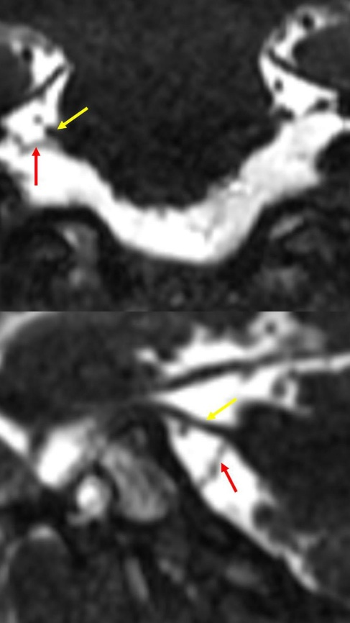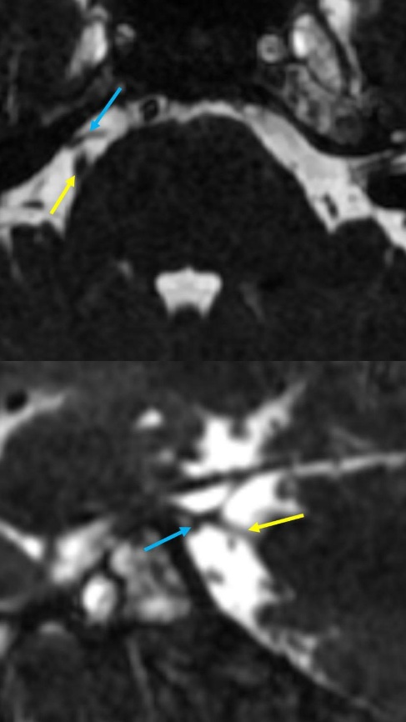

**Fig. 1:** Magnetic resonance imaging. Yellow arrow: trigeminal nerve; Red arrow: superior cerebellar artery; Blue arrow: transverse pontine vein

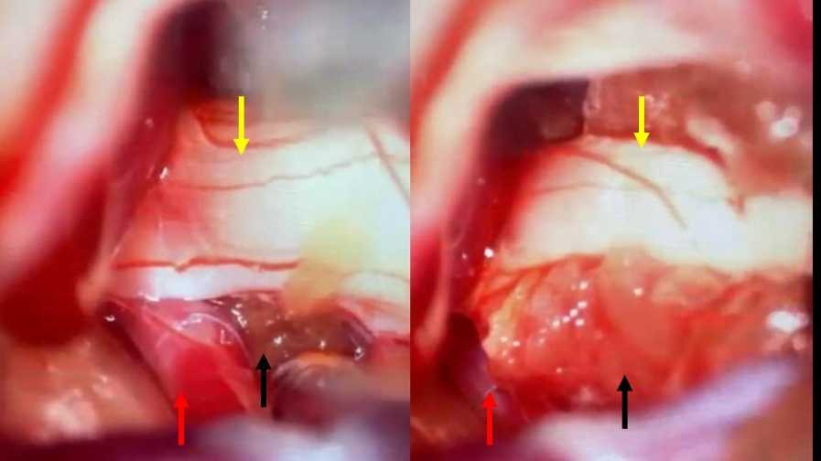

**Fig. 2:** Transsurgical image.Yellow arrow: trigeminal nerve; Red arrow: superior cerebellar artery; Black arrow: Autologous muscle grafting separating the trigeminal nerve from the compressed vessels.

3. discussion

The present clinical case of trigeminal neuralgia shows a rare double compression of the trigeminal nerve by the superior cerebellar artery and the transverse pontine vein. Based on MRI images, microvascular decompression (MVD) was chosen using autologous muscle grafting (AMG) for interposition, resulting in complete remission of the pain. Trigeminal Neuralgia (TN) is a neurological condition characterized by intense, brief facial pain triggered by trivial stimuli, such as tooth brushing or chewing. Neurovascular compression, primarily by the superior cerebellar artery, is the main cause of classic TN. However, venous compression, which is less recognized, is rarely diagnosed. In a study of 5,271 patients undergoing MVD, 600 cases had isolated venous compression, representing 11.4% (Yamaki, 2021).

Although less frequent, venous compression can be also treated with MVD, resulting in pain relief rates up to 82.3%, but with a higher chance of recurrence compared to arterial compression (Alzeeralhouseini et al., 2022). This highlights the importance of detailed intraoperative evaluation, especially when preoperative imaging does not clearly reveal the compressive vessel. In this case, AMG was chosen during MVD. Studies show that using AMG provides complete pain relief in up to 93.2% of cases, with immediate relief in 91.3%, results comparable to synthetic materials like Teflon (Bezerra et al., 2023).

Although effective, Teflon is associated with a higher risk of complications, such as granulomas and chemical meningitis (Jagannath et al., 2012), while AMG, being autologous, offers a lower risk of inflammatory and infectious complications (Jagannath et al., 2012). Recurrence rates for AMG are 6.2% at 6 months, 10.5% at 12 months, and 10.3% at 36 months (Bezerra et al., 2023), suggesting good long-term efficacy.

High-resolution MRI is effective in identifying trigeminal nerve atrophy, a sign of neurovascular compression, and aids in surgical planning. In a study with 60 patients, a reduction in TGN volume correlated with the severity of intraoperative vascular compression and favorable clinical outcomes (Cheng et al., 2023). A 2024 meta-analysis reinforced the usefulness of MRI in identifying relevant neurovascular compressions, especially at the nerve root entry zone (Zhao et al., 2024).

According to the European Academy of Neurology, the initial treatment for TN should be pharmacological, using carbamazepine, oxcarbazepine, gabapentin, and lamotrigine. However, many patients do not achieve satisfactory relief and become candidates for MVD (Bendtsen et al., 2019). Prolonged use of carbamazepine and oxcarbazepine can lead to significant side effects, such as hyponatremia, sedation, and severe skin reactions, particularly in elderly patients (Gambeta et al., 2023).

Clinical observations suggest a female predominance in TN cases with venous compression, possibly due to hormonal factors affecting the sensitivity of trigeminal nerve fibers. Chronic pain also significantly impacts patients' quality of life, often leading to the development of depression and anxiety, highlighting the importance of emotional support in their treatment (Alzeeralhouseini et al., 2022).

4. Conclusion

Microvascular decompression (MVD) with muscle interposition proved to be an effective approach for treating trigeminal neuralgia that did not respond to medication. The removal of vascular adhesions and the protection of the trigeminal nerve with muscle tissue led to lasting pain relief, avoiding the risks of complications associated with synthetic materials. While postoperative follow-up is crucial to monitor possible muscle atrophy, the patient had a successful recovery, remaining pain-free and without the need for medication, significantly improving her quality of life. The technique was effective in decompressing all affected areas, providing a long-term and safe solution for refractory cases.

References

1. Bendtsen L, Zakrzewska JM, Heinskou TB, Hodaie M, Leal PRL, Nurmikko T, Obermann M, Cruccu G, Maarbjerg S. Advances in diagnosis, classification, pathophysiology, and management of trigeminal neuralgia. Lancet Neurol. 2020;19:784–96.
2. International Headache Society. Headache classification committee of the international headache society (IHS). The international classification of headache disorders, 3rd edition. Cephalalgia. 2018;38:1–211.
3. Villegas Díaz D, Guerrero Alvarado G, López Medina A, Gómez Clavel JF, García Muñoz A. Trigeminal neuralgia: therapeutic strategies to restore quality of life. J Clin Neurosci. 2024;75:35–45.
4. Kumar S, Rastogi S, Kumar S, Mahendra P, Bansal M, Chandra L. Pain in trigeminal neuralgia: neurophysiology and measurement: a comprehensive review. J Med Life. 2013;6:383–8.
5. Chakraborty AR, Sunshine K, Miller JP, Sweet JA. Current applications of ablative therapies for trigeminal neuralgia. Neurosurg Clin N Am. 2023;34:285–90.
6. Houshi S, Tavallaei MJ, Barzegar M, Afshari-Safavi A, Vaheb S, Mirmosayyeb O, et al. Prevalence of trigeminal neuralgia in multiple sclerosis: a systematic review and meta-analysis. Mult Scler Relat Disord. 2022;57:103472.
7. Bendtsen L, Zakrzewska JM, Abbott J, Braschinsky M, Di Stefano G, Donnet A, Eide PK, Leal PRL, Maarbjerg S, May A, Nurmikko T, Obermann M, Jensen TS, Cruccu G. European Academy of Neurology guideline on trigeminal neuralgia. Eur J Neurol. 2019;26:831–49.
8. Benoliel R, Svensson P, Evers S, et al. The IASP classification of chronic pain for ICD-11: chronic secondary headache or orofacial pain. Pain. 2019;160:60–8.
9. Bendtsen L, Zakrzewska JM, Abbott J, et al. European Academy of Neurology guideline on trigeminal neuralgia. Eur J Neurol. 2019;26:831–49.
10. Gusmão S, Magaldi M, Arantes A. Trigeminal radiofrequency rhizotomy for the treatment of trigeminal neuralgia: results and technical modification. Arq Neuropsiquiatr. 2003;61:434–40.
11. Yamaki T. Venous compression as an etiology of trigeminal neuralgia: Systematic review and meta-analysis. J Neurosurg. 2021;134(4):1100–7. doi:10.3171/2021.1.JNS202072.
12. Alzeeralhouseini A, Moisak G, Labzina E, Rzaev J. Trigeminal neuralgia caused by venous compression: a comprehensive literature review. Neurosurg Rev. 2022;45:1029–40.
13. Bezerra GMS, Leal PRL, Cavalcante-Neto JF, Rivera A. Microvascular decompression using autologous muscle graft for trigeminal neuralgia: a case series and meta-analysis. Acta Neurochir (Wien). 2023;165(12):3833–43. doi:10.1007/s00701-023-05871-5.
14. Jagannath PM, Venkataramana NK, Bansal A, Ravichandra M. Outcome of microvascular decompression for trigeminal neuralgia using autologous muscle graft: a five-year prospective study. Asian J Neurosurg. 2012;7(3):125–30.
15. Cho D-Y, Chang CG-S, Wang Y-C, Wang F-H, Shen C-C, Yang D-Y. Repeat operations in failed microvascular decompression for trigeminal neuralgia. Neurosurgery. 1994;35(4):665–70.
16. Megerian CA, Busaba NY, McKenna MJ, Ojemann RG. Teflon granuloma presenting as an enlarging, gadolinium enhancing, posterior fossa mass with progressive hearing loss following microvascular decompression. Am J Otol. 1995;16(6):783–6.
17. Cheng J, Meng J, Liu W, Zhang H, Hui X, Lei D. Nerve atrophy in trigeminal neuralgia due to neurovascular compression and its association with surgical outcomes after microvascular decompression. J Neurosurg. 2023;139(2):402–9.
18. Zhao W, Yin C, Ma L, Ding M, Kong W, Wang Y. Predictive value of MRI for identifying symptomatic neurovascular compressions in classical trigeminal neuralgia: a PRISMA-compliant meta-analysis. BMC Neurol. 2024;24:466.
19. Gambeta E, Chichorro JG, Zamponi GW. Trigeminal neuralgia: An overview from pathophysiology to pharmacological treatments. Front Neurol. 2023;14:0001–15