Awareness and Adoption of UPI Facilities among Working-Class Women in An Academic Institution

Abstract

The rapid expansion of digital payment systems in India has significantly transformed the financial landscape, with the Unified Payment Interface (UPI) playing a pivotal role in enabling seamless transactions. However, disparities in awareness and usage persist, particularly among certain demographic groups. This study explores the awareness, usage patterns, and perceptions of UPI services among working-class women at Assam Agricultural University, Jorhat. A random sample of 50 respondents was surveyed using a structured questionnaire, and data were analyzed using descriptive statistics, t-tests, and Garret ranking techniques. Findings reveal that although the majority of respondents owned Android smartphones and maintained savings accounts, only 42% had installed banking applications. Awareness of mobile banking services was limited to 56%, and concerns about online security were common—49% were aware of internet fraud, while 5% had experienced financial losses due to cyber incidents. UPI usage was primarily confined to mobile recharges, DTH payments, grocery shopping, and small transactions, with limited use for larger expenses like utility bills, rent, or investments. Educational level was found to have no significant influence on UPI adoption. The study highlights the urgent need for targeted digital literacy programs, simplified user interfaces, and trust-building measures to enhance financial inclusion and empower women in the digital economy.
Key Words
Digital Payments, Unified Payment Interface (UPI), Financial Inclusion, Working Women, Digital Literacy, Mobile Banking
Introduction
As of March 2022, India's currency in circulation (CIC) reached Rs. 31.33 lakh crore, accounting for 13.7% of its GDP. This increase from Rs. 13 lakh crore in 2014 indicates a substantial rise in cash usage over the years. India's CIC at 13% of GDP reflects a moderate reliance on cash transactions—higher than in some developed countries but lower than in others like Japan. Japan’s higher CIC, despite being a technologically advanced nation, represents a cultural preference for cash.
Broad Money includes not just currency in circulation but also various types of deposits and liquid assets. As of 2021, India’s Broad Money (M3) stood at approximately 82.1% of its Gross Domestic Product (GDP), according to the World Bank. This suggests a moderate level of financial depth, indicating the total amount of money—cash, demand deposits, and other liquid assets—circulating within the economy. For comparison, this figure was around 71% in 2006–07, showing steady growth.
Understanding these monetary indicators helps contextualize India’s financial structure relative to other nations, reflecting variations in economic systems, cultural practices, and levels of financial inclusion. A high dependency on cash brings with it several challenges, such as production and storage costs, risks associated with counterfeit currency, and, most importantly, the lack of a digital transaction trail—contributing to tax evasion. These issues are expected to be further magnified as the economy continues to grow (Gochhwal, 2017).
Recent data continue to show India’s reliance on cash, with CIC hovering around 13% of GDP—especially in rural and informal sectors. This is significantly higher than in many developed countries, such as the UK and Canada, where CIC typically ranges between 3–5%, largely due to widespread adoption of digital payment platforms. In contrast, Japan remains an outlier among developed nations, with a CIC close to 18% of GDP due to persistent cultural preferences. While CIC measures only physical currency, Broad Money (M3)—which includes deposits and liquid assets—offers a more comprehensive view of monetary liquidity. For instance, China’s Broad Money exceeds 220% and Brazil (111.5%) of GDP, highlighting its highly monetized and banking-centric economy. In contrast, India’s Broad Money has gradually climbed to 85–90%, indicating improving but still moderate financial inclusion (World Bank, 2023; Reserve Bank of India, 2023).
To modernize the payment landscape and reduce cash reliance, the Reserve Bank of India (RBI) has introduced several initiatives promoting digital payments. Among the most impactful was the establishment of the National Payments Corporation of India (NPCI), tasked with developing affordable retail digital payment systems. In August 2016, NPCI launched the Unified Payments Interface (UPI)—a mobile-based payment platform that enables real-time bank transfers. UPI takes advantage of India’s high mobile penetration by transforming smart phones into digital wallets for consumers and merchants, thereby advancing the goal of universalizing digital payments.
India is rapidly progressing toward digitization, particularly after the announcement of demonetization on 8 November 2016. This policy shift significantly accelerated the adoption of digital payments, offering fintech companies an unprecedented opportunity to expand their market presence. UPI is widely regarded as a convenient and user-friendly method for online transactions, especially among youth and students (Kolte & Humbe, 2019). Multiple factors have contributed to the rise of digital payments: increased smartphone penetration, support from non-banking financial institutions, simplified payment interfaces, the growth of the fintech sector, and government incentives such as tax breaks and digital literacy campaigns. These developments have collectively fostered a favourable environment for digital payment adoption in India (Neema & Neema, 2016). The present study seeks to understand the
- Level of awareness and actual usage of UPI services among working women belonging to various age and income groups at Assam Agricultural University, Jorhat.
- To examine the challenges and perceptions related to the safety, accessibility, and usability of UPI services among the respondents
3. Methodology
The study employed a random sampling method to select 50 working-class women from various departments of Assam Agricultural University, Jorhat. Data were collected through a structured questionnaire comprising sections on demographic information, awareness, usage patterns, and perceptions of UPI services. The collected data were analyzed using descriptive statistics, t-tests, and the Garret ranking method to identify preferences and challenges associated with UPI usage.
4. Results
4.1 Demographic Profile of Respondents
Age Distribution: The majority of respondents (47%) were aged between 35–45 years, followed by 33 per cent in the 25–35 age group, and 20 per cent in the 45–55 age group (Fig.1). Educational Qualification: About 56.66 per cent of respondents had education up to high school. Graduates and postgraduates accounted for 13.33 per cent each, while 6.66 per cent had completed higher secondary education, and another 6.66 per cent were uneducated (Fig 2).
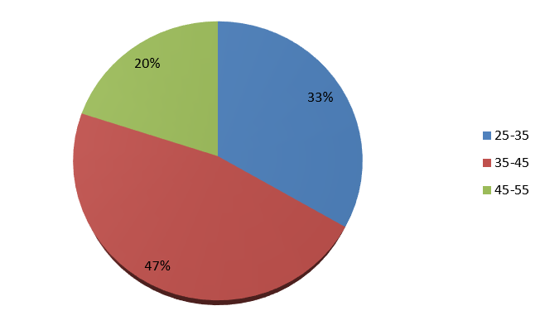 | 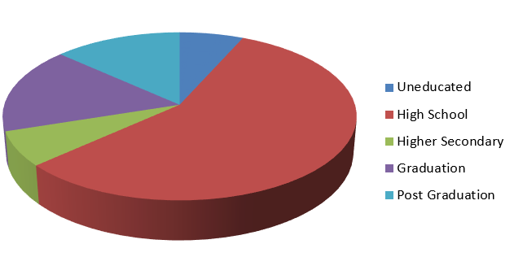
Figure 1. The age group of the respondents | Figure 2. The educational level of the respondents
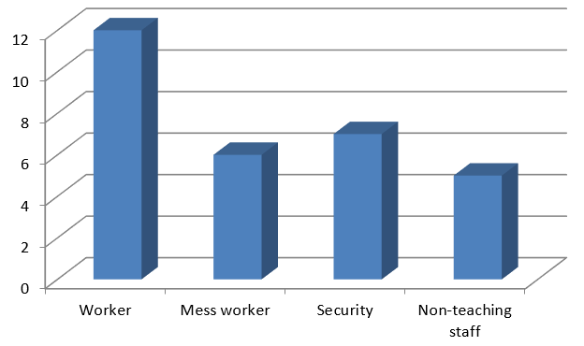 | 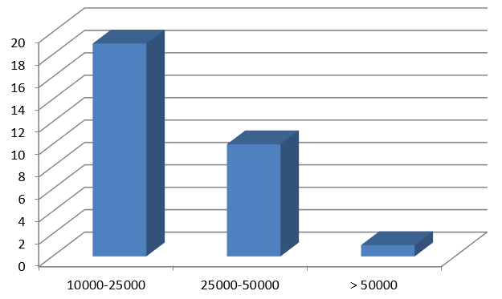
Figure 3. Occupation of the respondents | Figure 4. Monthly Income of the respondents
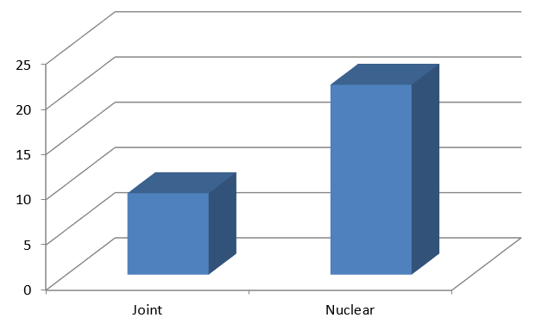
Figure 5. The family type of the respondents

Occupation: Respondents were engaged in various roles – 40 per cent as general workers, 23.33 per cent in security services, 20 per cent as mess workers, and 16.66 per cent as clerical staff (Fig 3). Regarding monthly income of the respondents showed that a significant portion (63.33%) earned between ₹10,000–₹25,000 monthly, 33.33 per cent earned ₹25,000–₹50,000, and 3.33 per cent earned above ₹50,000 (Fig 4). Family Type: The majority (70%) belonged to nuclear families, while 30 per cent were from joint families (Fig 5).
4.2 Awareness and Usage of UPI
Analysis of data in Table 1 revealed that, 90 per cent of respondents owned Android smart phones. Only 42 per cent had installed banking applications. About 56 per cent were aware of mobile banking services. Almost half of the respondent’s i.e 49 per cent of respondents was aware of internet frauds and a very meager per cent (5%) had experienced financial losses due to cyber incidents. UPI usage was primarily for mobile recharges, DTH payments, grocery shopping, and small transactions. Usage for large expenses like rent, utility bills, and investments was minimal.
Table 1. Knowledge of respondents on UPI payment facility
Statement | Yes | No
Do you have an Android phone | 45  (90.00) | 5  (10.00)
Do you know how to use an android phone | 41  (82.00) | 9  (18.00)
Is any banking app installed | 21  (42.00) | 29  (58.00)
Are you aware of mobile banking services | 28  (56.00) | 22  (44.00)
Do you think mobile banking is safe | 24  (48.00) | 26  (52.00)
Do you think mobile banking benefits you | 26  (52.00) | 24  (48.00)

4.3 Statistical Analysis
Educational Level and UPI Usage: The t-test showed no significant difference in UPI usage between respondents with lower education levels and those with higher qualifications (Table 2). Preference for UPI Usage (Table 3): Garret ranking revealed mobile recharge as the top use, followed by DTH payments, grocery shopping, general shopping, vegetable purchases, rent payments, electricity bills, and loan repayments.
Table 2. t-test value for usage of UPI payment facility
Details | Mean | S.D | t-value
Low/No Education | 9.80 | 3.302 | 0.166^{N.S}
Higher Education | 9.60 | 2.633

Table. 3 Preference of UPI for different payment purposes
Payment type | Mean | Rank
DTH | 66.13793 | 2
Mobile Recharge | 68.4139 | 1
Grocery payment | 65.31034 | 3
Vegetable payment | 63.55172 | 5
Electric bill | 61.58621 | 7
Shopping | 63.75862 | 4
Loan | 60.55172 | 8
House rent | 62 | 6

5. Discussion
The demographic data suggest that the study sample comprised primarily middle-aged individuals from nuclear families, with a moderate level of education and income. These characteristics likely influenced their comfort with digital payment systems like UPI.
The high rate of smartphone ownership (90%) indicates strong potential for digital banking. However, the comparatively low usage of banking apps (42%) and moderate awareness of mobile banking (56%) reflect a gap between technological access and digital financial adoption. This suggests the need for more targeted digital literacy initiatives, especially focusing on financial technologies. Security concerns are significant barriers to adoption. With 49 per cent aware of cyber threats and 5 per cent having experienced financial fraud, apprehensions about online transactions may be discouraging wider UPI use. Trust-building measures and consumer protection mechanisms must be emphasized to improve uptake. The statistical analysis confirms that education level does not significantly impact UPI usage—implying that even individuals with minimal formal education can adopt digital payments if they are properly guided. The Garret ranking emphasizes the use of UPI for low-risk, everyday expenses like recharges and groceries, while more sensitive or high-value payments such as rent and loans are less commonly transacted digitally. This reflects both behavioral caution and limited confidence in digital financial tools for high-stakes transactions. Addressing these trust deficits and improving user experience can help expand the functional scope of UPI usage.
5. Conclusion
Digitalization has transformed financial transactions by offering convenience, speed, and transparency. This study highlights that while UPI usage is growing, particularly for minor and retail payments, working-class women still face barriers due to limited awareness, safety concerns, and low confidence in digital platforms. A study by Chaudhuri, (2023), affirms that despite infrastructural readiness (bank accounts and mobile phones), psychological and social barriers continue to hinder UPI adoption among women
Although most respondents possess bank accounts and mobile phones, a significant proportion remains hesitant to engage fully with UPI due to fear of fraud and lack of support in financial decision-making. Thus, the study draws attention to the "last-mile" gap in digital literacy and security awareness, especially among marginalized groups, aligning with concerns raised by the World Bank (2022) about unequal digital access.
The study concludes that trust, awareness, and user education are keys to increasing UPI adoption among women. Strengthening cyber security, improving user experience, and launching targeted training programs can empower women to make informed digital transactions. In a study, Bansal & Ghosh (2022) asserted that digital financial inclusion is not merely about access but about capability and trust echoing observations regarding women’s confidence and safety concerns.
Moreover, enhancing financial inclusion through digital literacy not only benefits individual users but also contributes to broader economic development. To ensure that no group is left behind in India’s digital transformation, dedicated outreach and support for working-class women are vital.
References
- Chaudhuri, A., 2023. Trust and technology: Factors influencing digital payment adoption among Indian women. Economic and Political Weekly, 58(4), pp.36–42.
- Bansal, S. and Ghosh, S., 2022. Understanding digital finance usage among rural women in India: Barriers and enablers. Journal of Financial Inclusion, 9(2), pp.112–126.
- Gochhwal, R. (2017). Unified payment interface—An advancement in payment systems. American Journal of Industrial and Business Management, 7(10), 1174–1191. https://doi.org/10.4236/ajibm.2017.710083
- Kapri, A., & Karna, N. (2023). Unified Payment Interface: A way towards a cashless journey. E-Commerce for Future & Trends, 10(1), 35–39.
- Khan, S., & Jain, S. (2018). A study on the usage of e-payments for sustainable growth of online business. IOSR Journal of Business and Management (IOSR-JBM), 20(5), 74–81.
- Kolte, A., & Humbe, A. V. (2019). Digital payment and customer perception: A study of college students. International Journal of Trend in Scientific Research and Development, 3(3), 325–329.
- Kumar, P. A. (2022). A study on customer satisfaction of using UPI apps & transactions & payments (BBA Project). Sathyabama Institute of Science and Technology, Chennai.
- Mahesh, A., & Bhat, G. (2021). Digital payment service in India—A case study of Unified Payment Interface. International Journal of Case Studies in Business, IT, and Education, 5(1), 256–265. https://doi.org/10.47992/IJCSBE.2581.6942.0113
- Neema, K., & Neema, A. (2016). UPI (Unified Payment Interface)–A new technique of digital payment: An explorative study. International Journal of Current Research in Multidisciplinary, 3(10), 1–10.
- Narayanan, J. (2021). A study on growth of UPI apps in India after COVID outbreak. International Journal of Emerging Technologies and Innovative Research, 8(9), c333–c338.
- Reserve Bank of India. (2023). Handbook of Statistics on the Indian Economy 2022–23. Retrieved from https://www.rbi.org.in
- World Bank, 2022. The Global Findex Database 2021: Financial Inclusion, Digital Payments, and Resilience in the Age of COVID-19. Washington, DC: World Bank. Available at: https://globalfindex.worldbank.org/ [Accessed 22 May 2025].
- World Bank. (2023). Broad money (% of GDP). Retrieved from https://data.worldbank.org/indicator/FM.LBL.BMNY.GD.ZS
Appendix

Structured Questionnaire
Background details:-
Name: Age:
Sex: Education:
Occupation: Family type:
No.of members: Income:

PART - Ι
- Do you have android phone
a)Yes b) No
- Do you know how to use android phone
a)Yes b) No
- Is any banking app installed
a)Yes b) No
- Are you aware of mobile banking services
a)Yes b) No
- Do you think mobile banking is safe
a)Yes b) No
- Do you think mobile banking benefits you
a)Yes b) No

PART - ΙΙ.
- Are you familiar with UPI payment?

- Yes b) No

- Do you know about UPI online transaction?

- Yes b) No

- Have you transferred money using UPI payment facility?

- Yes b) No

- Which type of UPI payment have you used?

- Yes b) No

- UPI payment facility is very reliable

- Yes b) No

- Do you know how to check your balance through UPI?

- Yes b) No

- Do you think, UPI is useful to everyone?

- Yes b) No

Payment type | Strongly agree | Agree | Neutral | Disagree | Strongly disagree
DTH
Mobile recharge
Grocery payment
Vegetable payment
Electric bill
Shopping
Loan
House rent

