# FORMULATION AND EVALUATION OF HERBAL LOZENGES FROM VASAKA LEAF FOR SORE THROAT

# ABSTRACT

The study concentrated on creating and assessing herbal lozenges with extracts from the vasaka leaf (*adhatoda vasica*), which has been traditionally used to heal sore throats. Vasaka leaves are excellent for relieving the symptoms of a sore throat because they are high in vasacin and vasinone, which have strong anti tussive, antibacterial, mucolytic, and anti- inflammatory, In order to assure efficacy, a concentrated extract from the extraction process was prepared and added to the formulation of lozenges together with suitable excipients. The physicochemical characteristics of several formulations, such as thickness hardness, and disintegration time, were tested. The improved formulation showed great therapeutic promise and offered a safe, natural substitute for sore throat relief. The study found that combining vasaka leaf extract with other ingredients to make lozenges would result in a workable and advantageous herbal remedy for sore throats.

**Keywords:** Vasaka, lozenges, throat, disintegration, mucolytic

### INTRODUCTION

The oral route is the most preferred method of administration among the available options due to a number of factors, including ease of ingestion, adaptability, and patient compliance in particular. [1]. Many non-identical routes are there in which drugs can be administered and create its pharmacological effects. There are many ways to deliver drugs into the body like oral (through swallowing), sub mucosal (through sublingual mucosa), parenteral (through injection), transdermal (through the skin).The oral route of administration is considered as the accepted route because of its convenience. This approach has a major drawback for elderly and pediatric patients who have trouble swallowing. Approximately 35% of patients, especially elderly and pediatric patients, suffer from dysphagia, which increases treatment resistance and treatment inadequacies. [2] Children frequently experience difficulties with swallowing due to their underdeveloped neurological and muscular systems. Patients with tremors in their extremities, individuals with intellectual disabilities, non-causable patients, patients with reduced fluid admission plans, and patients experiencing nausea are additional categories that may also have difficulty swallowing standard oral dosage forms. Inflammation of the sore throat characterized by symptoms including runny nose, cough, headache, difficulty swallowing, swollen lymph nodes, and raspy voice is known as sore throat or pharyngitis. Usually, a bacterial, fungal, or viral infection is to blame. [3] the most common microorganism responsible for sore throats is streptococci. In addition, postnasal trickling caused by hypersensitivities and mouth breathing, smoking, air pollution, agitation, and irritation can all contribute to a sore throat. [4] formulators have made great efforts to develop a novel type of tablet dosage form for the oral route—one that degrades and breaks up quickly in salivation without requiring swallowing the dosage form whole—in order to combat problems like difficulty swallowing and ailments like sore throats. These are lozenges that dissolve in between 15s and 2 minutes. As medicine wears off, absorption and the start of clinical effect occur more quickly. The majority of lozenges are available without a prescription and function by progressively dissolving in the mouth as you suck them, lubricating the coating on your throat, and reducing throat dryness, irritation, and inflammation. Adhatoda vasica nees (family acanthaceae), commonly known as vasaka or arusha. The vasaka plant is an evergreen perennial that has many branches, a bad taste, and an awful odor. It may survivefor several seasons and keeps its leaves all year round. [5] In the flowers triterpines (aamirine), flavonoids (apigenin, astragalin, quercetin, vitexin). [6]

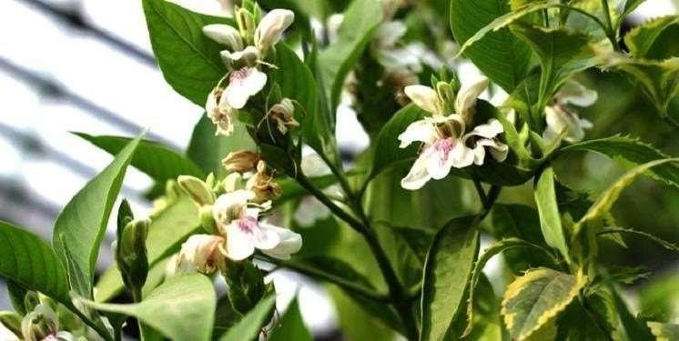

**Figure 1: *Adhatoda vasica* (Vasaka) plant**

**Lozenges:** Lozenges are flavored medicinal dosage forms with a sweetened basis that are meant to be sucked and retained in the mouth or pharynx. They typically contain one more medications. Lozenges are designed to treat or pharyngeal symptoms, which are frequently brought on by local infections. If the medication is adequately absorbed Through the buccal linings or when it is eaten, they may also have a systemic effect. [7]

**Herbal Lozenges:** Herbal lozenges are solid medications used to treat mouth and throat conditions, releasing active therapeutic ingredients gradually as they dissolve in the tongue. They are particularly effective for treating coughs, sore throats, and mild respiratory issues when used locally. Herbal lozenges are small, disc-shaped tablets that dissolve in the mouth, releasing active herbal ingredients to relieve coughing, sore throats, and other respiratory conditions. These lozenges typically contain plant extracts,

Essential oils, and other medicinally beneficial substances, including typical herbs. [8]

## Composition of Herbal Lozenges: [9]

#### Active Herbal Ingredients:

1. **Medicinal Plant Extracts:** These are the primary therapeutic agents in herbal lozenges. Commonly used herbs include:
   1. **Vasaka (***Adhatoda vasica***):** This substance is known for its expectorant, anti- inflammatory. And making it beneficial for respiratory conditions.
   2. **Echinacea:** This substance is known for enhancing the immune system and aiding inthe fight against infections.
   3. **Licorice (***Glycyrrhiza glabra***):** This substance offers soothing effects and aids inreducing inflammation.
   4. **Ginger (***Zingiber officinale***):** The substance has been found to possess anti- inflammatory and analgesic properties.
   5. **Honey:** This substance provides soothing and antimicrobial benefits and is frequentlyused as a sweetener.

**Uses of Lozenges: -** Lozenges provide gradual oral treatments, saturating throat tissues with drug solutions, and are suitable for patients unable to swallow solid doses. Common medications include corticosteroids, decongestants, and demulcents. [10]

**Advantages of Lozenges:** It is simple to provide to older and pediatric patients alike. It tastes good and will prolong the amount of time a medicine is in the mouth long enough to cause local action. Drug systemic absorption through the buccal cavity is conceivable. Sweeteners and flavors added to the formulation help cover up the taste of the medications.[11]

**Disadvantage of Lozenges: -** Parents should avoid combining medications with candy and keep it out of children's reach. Heat-stable drugs are suitable, and lozenges should be used safely with children over six. [12]

## Evaluation Parameter:

1. **Organoleptic Properties:** the organoleptic properties test evaluates the sensory qualities of tablets using human senses like sight, taste, smell, touch, and sound, assessing their general acceptance and quality, and highlighting their responsibilities.[13]
2. **Thickness:** The tablet thickness test is a crucial quality control procedure in pharmaceutical tablet production, ensuring consistency and uniformity in size measurement.[14]
3. **Hardness:** A hardness test evaluates a tablet's mechanical strength and resistance to breaking or crushing, crucial for pharmaceutical tablets to meet quality standards and ensure smooth handling and shipping.[15]
4. **Disintegration time:** the disintegration time test is a crucial pharmaceutical quality control test that measures the time it takes for a tablet to break down into smaller pieces when submerged in a specific liquid media, ensuring its effective dissolution and release upon swallowing.[16]

### Significance of Lozenges: [17]

Lozenges, also known as troches or pastilles, are solid dosage forms used to dissolve slowly in the mouth to release medication or active ingredients.

* + **Local treatments:** Lozenges are commonly used to treat localized oral and throat issues like mouth ulcers, coughs, and sore throats by slowly dissolving active chemicals in the mouth, thereby relieving symptoms.

[18]

* + **Controlled release:** Lozenges' gradual dissolution regulates medication release over time, maintaining therapeutic concentrations in the oral cavity, resulting in long-lasting symptom relief. [19]
  + **Ease of administration:** Lozenges are convenient and easy to use, suitable for home, work, and travel, and do not require water for administration, making them beneficial for individuals with dry mouth or swallowing issues[20]
  + **Taste-masking:** Lozenges are sweetened and flavored to mask bitter or disagreeable flavors, making them more enjoyable and appealing, particularly for young people or those with delicate palates. [21]
  + **Non-invasive:** Lozenges are well-tolerated, non-invasive dosing forms suitable for various ages, including toddlers and the elderly, unlike suppositories or injections.[22]

## 

## Types of lozenges:

1. **Hard candy lozenges:** Hard candy lozenges are medicated candy that combine the qualities of hard candy and lozenges, often used to relieve symptoms like coughing, sore throat, and respiratory infections, as well as related pain.[23]

**Example:** Clotrimazole troches

1. **Chewy or caramel base lozenges:** Chewy or caramel-flavored lozenges are pharmaceutical candy designed to alleviate symptoms of respiratory infections and other diseases, being chewier and softer. [24]

**Example:** Strepsils.

1. **Soft lozenges:** Soft lozenges are a type of pharmaceutical candy that alleviate symptoms ofrespiratory infections and other ailments, resembling gummy candies or fruit snacks, due to their soft, dissolvable texture, distinguishing them from hard or chewy lozenges. [25]

**Example:** Honey anti-bacterial lozenges

**Methodology**

### Plant material

Vasaka plant (*justicia adhatoda* l) family – *acanthaceae*. The study were collected from the Garhwal region Uttarakhand and were authenticated by botanical survey of India northern regional center 192-kaulagarh road Dehradun Uttarakhand with transaction ref.no. - 1504240067038. The freshly collected leaves of vasaka (leaves). [26]

**Chemical constituents of *Adhatoda Vasica* (Vasaka)**

Vasaka leaves contain quinazoline derivatives such as vasicine,vasicinone and 6hydroxyl vasicine the drug also contains volatile oil, betain and vasakin, adatodic acid.[27]

## Leaves

* Quinazoline alkaloids
* vasicine - 45-95% (the mucolytic drug bromhexine was developed from this alkaloid)
* n-oxides of vasicinevasicinone
* Deoxyvasicine
* Oxyvasicinine
* Maiontone
* Essential oil the leaf extract, is considered safe and the oil has low toxicity.[28]

## Procedure of Extraction:

The leaves are shade dried for 7 day at room temperature and were made into fine powder. After making. Powder, the powdered sample was weighed and it was found to be 53.40g. Water used as a solvent by the decoction method (drug weight: 26g and water: 250 ml). After that it was filtered and the extract was collected in a china dish

.then it was heated till the mass was cooled and forma powder mass

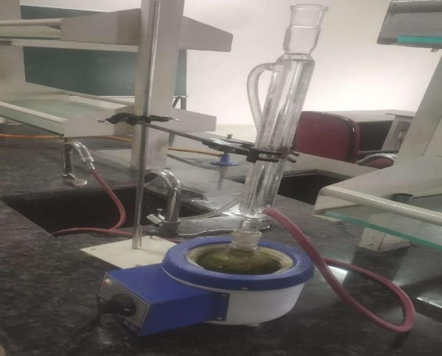

**Figure 2: Extraction of Vasaka**

## Procdure of Lozenges:

Lozenges were prepared by molding techniques. Required quantity of sugar syrup was prepared mixing sugar and water. Dextrose was dissolved in small quantity of water and heated it to 110°C till dextrose dissolves completely forming as clear viscous syrup. Then the dextrose solution was poured into the sugar syrup and heated to 160°C c till the color changes to golden yellow. The temperature was bought down to 90°C and drug, polymer and other ingredients were added. The solution was poured into the mould having 2.8cm diameter and 6.5mm thickness. The prepared tablets were stored wrapped in aluminum foil and stored in desiccators to prevent moisture uptake. The final weight of each lozenge is 5gms. [30]

**Table 1: Formulations Table**

|  |  |  |  |  |
| --- | --- | --- | --- | --- |
| **Ingredients** | **F1** | **F2** | **F3** | **F4** |
| **Drug** | 0.25mg | 0.25mg | 0.25mg | 0.25mg |
| **Dextrose** | 1.5mg | 1.5mg | 1.5mg | 1.5mg |
| **Distilled Water** | 15ml | 15ml | 15ml | 15ml |
| **Sorbitol** | 2ml | 2ml | 2ml | 2ml |
| **Calcium Carbonate** | 90mg | 90mg | 90mg | 90mg |
| **Steric Acid** | 0.3mg | 0.3mg | 0.3mg | 0.3mg |
| **Acacia** | 0.6mg | 0.6mg | ----- | ----- |
| **Peppermint** | 0.1ml | 0.1ml | 0.1ml | 0.1ml |
| **Gelatin** | ---- | ---- | 0.6mg | 0.6mg |
| **Honey** | 0.5ml | 0.5ml | 0.5ml | 0.5ml |

#### Method for preparation [31].

Combine Sugar, Corn Syrup and Water by Heating

Add Of Drug in Solvent

Add Of Polymer, Color, and Flavor Etc.

Poured Into Mold of Desired Shape and Size to Forming a Candy

Sealing And Wrapping Of Candy in Polyethylene Wrapping

## Evaluation Parameter

1. **Organoleptic properties [32]:** The prepared lozenges were evaluated for its organoleptic properties like taste, odor, color, softness, and shape. Organoleptic properties refer to the sensory characteristics of a substance that can be perceived by the human senses, particularly taste, smell, texture, and appearance. These properties are often used to evaluate the quality of food, beverages, and other substances. For example, the flavor, aroma, color, and texture of a food item are all organoleptic properties that can influence its overall appeal and consumer satisfaction.
2. **Thickness:** Thickness of the lozenges were measured using vernier calipers. The thickness of a lozenge tablet refers to the distance between its two opposite surfaces, usually measured in millimeters. [33] It is an important parameter in pharmaceutical manufacturing because it can affect factors such as disintegration rate, ease of swallowing, and overall stability of the tablet. [34] The thickness of lozenge tablets is determined during the manufacturing process and is controlled to meet specific requirements set by regulatory agencies or product specifications. The test was performed for three lozenges and standard deviation was calculated. [35]
3. **Hardness:** Using a Pfizer pill hardness tester, the result was ascertained. Three lozenges were tested, and the standard deviation was determined. [36]
4. **Disintegration time:** Lozenges were taken and put into a disintegrator. The disintegration time was determined in pH6.8 artificial saliva fluid at 37ºc and 100 rpm [37]. Disintegration time was found to be in the range of 16 min and 59 min. The disintegration time of lozenge tablets refers to the period it takes for the tablet to break down into smaller particles or to dissolve completely when placed in a suitable medium, typically water or saliva. This parameter is crucial in pharmaceutical manufacturing as it directly impacts the efficacy and

Bioavailability of the active ingredients in the tablet. Faster disintegration times generally mean quicker release of the active ingredients, which can be advantageous for medications designed for rapid onset of action, such as Pain relievers or cough suppressants. Regulatory authorities often specify disintegration time requirements for tablets to ensure their quality and effectiveness. In the united states pharmacopeia (USP 35), the disintegration time of nystatin lozenges is 90 minutes.[38]

# RESULT AND DISCUSSION

Lozenges in 4 different doses and were successfully prepared with the blank ones by using molding and F3 is best. All the formulations showed good physical appearance. The gelatin used in the molding method as binder enabled the lozenges containing low-dose bentonite to keep their shape due to its gelling feature.

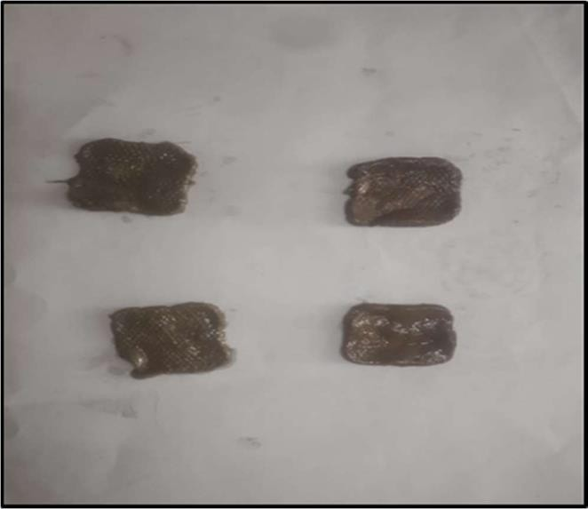

**Figure 3: Lozenges**

**Organoleptic properties:** The prepared lozenges' taste, odor, color, softness, and shape are all designed to fulfill specific purposes. The patient finds the organoleptic qualities to be at an acceptable level. Organoleptic properties is the results are given in Table 2.

## Table 2: Organoleptic properties of lozenges:

|  |  |  |  |  |
| --- | --- | --- | --- | --- |
| **Organoleptic Properties** | **F1** | **F2** | **F3** | **F4** |
| **Taste** | Sweet | Sweet | Sweet | Sweet |
| **Odor** | Mint | Mint | Mint | Mint |
| **Color** | Brown | Brown | Brown | Brown |
| **Softness** | Soft | Soft | Soft | Soft |

|  |  |  |  |  |
| --- | --- | --- | --- | --- |
| **Shape** | Square | Square | Square | Square |

**Thickness, hardness, and disintegration time**: The hardness, thickness and disintegration time of lozenges were evaluated and the results are given in Table 3.

**Table 3: Evaluation parameter of lozenges:**

|  |  |  |  |  |
| --- | --- | --- | --- | --- |
| **Parameter** | **F1** | **F2** | **F3** | **F4** |
| **Thickness(mm)** | 4.1 | 4.1 | 3.6 | 3.6 |
| **Hardness (Kg/Cm2)** | 5 | 4.5 | 2.5 | 3 |
| **Disintegration Time (min)** | 59 | 59 | 16 | 16 |

# CONCLUSION

In conclusion, the herbal lozenges using vasaka leaf extraction for sore throat has shown promising results. The vasaka leaf, known for its cough, bronchitis, asthma, anti- inflammatory and antimicrobial properties and has been successfully incorporated into lozenges to provide an effective and natural remedy for sore throats. The study successfully assessed various parameters such as Organoleptic propertied, thickness, hardness and disintegration time with formulation F3 demonstrating the best overall performance. The research highlights the importance of developing alternative dosage forms such as lozenges, particularly for patients who have difficulty swallowing standard oral medications, such as elderly and pediatric patients. The use of herbal extract of vasaka leaf is safe and natural substitute for sore throat relief with potential therapeutic benefits. Overall, this study showcases the potential of herbal lozenges as an effective treatment option for sore throats, with further scope for exploring additional herbal ingredients and formulations. The incorporation of natural remedies into convenient and patient-friendly dosage forms like lozenges offers a promising direction for addressing common health concerns. These findings underscore the significance of herbal remedies in modern pharmaceutical formulations, paving the way for continued research and development in this area

# REFERENCE:

1. Walsh J, Ranmal SR, Ernest TB, Liu F (2018). Patient acceptability, safety and access: A balancing act for selecting age-appropriate oral dosage forms for paediatric and geriatric populations. International journal of pharmaceutics; 536(2):547-62.
2. Rathaur H, Gnanarajan G (2018). Review On: Sublingual Route for Systemic Drug Delivery. Indo American Journal of Pharmaceutical Sciences.1;5(1):453-62.
3. Almond S, Allott L, Hall K (1994). 30 Feeding Children with Neurodisabilities. Clinical Paediatric Dietetics: 566.
4. O’Handley JG, Tobin EJ, Shah AR (2012). Otorhinolaryngology. Textbook of family medicine: 300.
5. Amin AH, Mehta DR (1959). A bronchodilator alkaloid (vasicinone) from Adhatoda vasica Nees. Nature; 184(4695):1317-.
6. Jha DK, Panda L, Lavanya P, Ramaiah S, Anbarasu A (2012). Detection and confirmation of alkaloids in leaves of Justicia adhatoda and bioinformatics approach to elicit its anti- tuberculosis activity. Applied biochemistry and biotechnology; 168:980-90.
7. Choursiya S, Andheriya D (2018). Review on lozenges. Journal of Drug Delivery and Therapeutics; 8(6-A):124-8.
8. White LB, Foster S (2013). The herbal drugstore: the best natural alternatives to over- the-counter and prescription medicines. Rodale;
9. Sharma D, Kumar D, Singh G (2021). Recent Developments in Medicated Lozenges: A Promising Dosage Form for the Effective Delivery of Therapeutic Agents. Drug Delivery Letters; 11(2):97-109.
10. De Villiers MM (2021). Oral conventional solid dosage forms: powders and granules, tablets, lozenges, and capsules. In Theory and Practice of Contemporary Pharmaceutics (pp. 279-331). CRC press.
11. Satoskar RS, Bhandarkar SD (2020). Pharmacology and pharmacotherapeutics. Elsevier India;
12. Wilkerson R, Northington L, Fisher W (2005). Ingestion of toxic substances by infants and children: what we don’t know can hurt. Critical care nurse; 25(4):35-44.
13. Goodwin DJ, Van Den Ban S, Denham M, Barylski I (2018). Real time release testing of tablet content and content uniformity. International Journal of Pharmaceutics; 537(1-2):183-92.
14. Patel S, Kaushal AM, Bansal AK (2006). Compression physics in the formulation development of tablets. Critical Reviews™ in therapeutic drug carrier systems. 23(1).
15. Sierra-Vega NO, Román-Ospino A, Scicolone J, Muzzio FJ, Romañach RJ, Méndez R (2019). Assessment of blend uniformity in a continuous tablet manufacturing process .International journal of pharmaceutics. 560:322-33.
16. Hofmanová JK. Sensory assessment and acceptability of coated tablets relationship between instrumental methods and human data (Doctoral dissertation, University of Birmingham).
17. Low a, Kok SL, Khong Y, Chan SY, Gokhale R (2015). Pharmaceutics, drug delivery and pharmaceutical technology: A new test unit for disintegration end-point determination of orodispersible films. Journal of pharmaceutical sciences; 104(11):3893-903.
18. Conway BR (2008). Solid dosage forms. John Wiley & Sons, Inc.: Hoboken, NJ, USA;
19. Mizrahi B, Domb AJ (2008). Mucoadhesive polymers for delivery of drugs to the oral cavity. Recent patents on drug delivery & formulation. 2(2):108- 19.
20. Blenkinsopp A, Duerden M, Blenkinsopp J (2022). Symptoms in the pharmacy: a guide to the management of common illnesses. John Wiley & Sons;.
21. Faisal W, Farag F, Abdellatif AA, Abbas A (2018). Taste masking approaches for medicines. Current drug delivery. 15(2):167-85.
22. Linakis MW, Roberts JK, Lala AC, Spigarelli MG, Medlicott NJ, Reith DM, Ward RM, Sherwin CM (2016). Challenges associated with route of administration in neonatal drug delivery. Clinical pharmacokinetics; 55:185-96.
23. Macknin ML, Piedmonte M, Calendine C, Janosky J, Wald E (1998). Zinc gluconate lozenges for treating the common cold in children: a randomized controlled trial. Jama; 279(24):1962-7.
24. Cohen M, Hartel R (2023). Candy Texture (Sugar Confectionery). Infood Texturology: Measurement and Perception of Food Textural Properties. (pp. 373-391). Cham: Springer International Publishing.
25. Marianski S, Marianski A (2011). Making healthy sausages. Bookmagic LLC.
26. Dukre TP, Ambre SP, Walunj JJ, Jadhav GR (2023). Pharmacognostic and Physicochemical Appraisal of Vasaka (Justicia adhatoda Linn.) Leaf. Health. 3:44-52.
27. Gandhi SJ, Ahire RD, Sanap MD, Chavhan AB, Chudhari JS, Ahirrao RA (2015). Standardization of amla and vasaka. Pharma Science Monitor; 6(2).
28. Ashwini PB. A REVIEW ON LOZENGES.
29. Babu AK, Kumaresan G, Raj VA, Velraj R (2018). Review of leaf drying: Mechanism and influencing parameters, drying methodsand mathematical models. Renewable and sustainable energy reviews; 90:536-56.
30. Özakar RS, Kara M, Maman A (2020). Preparation, characterization, and radiation absorption study of bentonite clay included soft chewable lozenge formulations. Journal of Pharmaceutical Technology; 1(3):54-9.
31. Pundir S, Verma AM (2014). Review on lozenges. Journal der pharmazie Forschung.; 2(1):1-0.
32. Pothu R, Yamsani MR (2014). Lozenges formulation and evaluation: A review. Ijapr.; 1:290-4.
33. Pothu R, Aparna A, Rao YM(2015). Development and in-vitro evaluation of chlorhexidine and flurbiprofen hard candy lozenges. International Journal of Pharmaceutical Sciences and Research; 6(8):3380.
34. Khudhair DB, Ali WK (2020). Formulation and evaluation of Acyclovir compressed lozenges. Al Mustansiriyah Journal of Pharmaceutical Sciences;

20(4):35-44.

1. Budiman A, Sofian FF, Santi NM, Aulifa DL (2020). The formulation of lozenge using black mulberries (Morus nigra L.) Leaf extract as a α-glucosidase inhibitor. Journal of Pharmacy and Bioallied Sciences; 12(2):171-6.
2. Singh S, Virmani T, Virmani R, Mahlawat G, Kumar P(2018). Fast dissolving

drug deliver Systems: formulation, preparation techniques and evaluation. Universal Journal of Pharmaceutical Research..

1. Özakar RS, Kara M, Maman A(2020). Preparation, characterization, and radiation absorption study of bentonite clay included soft chewable lozenge formulations. Journal of Pharmaceutical Technology; 1(3):54-9.
2. Nithya S. Formulation Development and Evaluation of Metoclopramide Hydrochloride Medicated Hard Candy Lozenges (Doctoral dissertation, College of Pharmacy, Madras Medical College, Chennai).