***Review Article***

**The Economics of Soil Carbon Sequestration and Climate Change Mitigation**

**Abstract:**

Soil carbon sequestration has emerged as a promising strategy for mitigating climate change. This review explores the economics of soil carbon sequestration and its potential role in climate change mitigation. We examine the costs and benefits of various soil management practices that enhance soil carbon storage, such as reduced tillage, cover cropping, and biochar application. The review also discusses the challenges and opportunities for scaling up soil carbon sequestration, including policy incentives, carbon markets, and monitoring and verification systems. Our analysis suggests that soil carbon sequestration can be a cost-effective climate change mitigation strategy, particularly when co-benefits such as improved soil health and increased agricultural productivity are considered. However, realizing the full potential of soil carbon sequestration will require significant investment, policy support, and stakeholder engagement. Further research is needed to refine cost estimates, develop robust monitoring and verification protocols, and better understand the long-term dynamics of soil carbon storage under different management practices and environmental conditions.

**Keywords:** *Soil Carbon Sequestration, Climate Change Mitigation, Carbon Markets, Soil Health, Agricultural Productivity*

**1. Introduction**

Climate change poses a significant threat to global ecosystems, human well-being, and economic prosperity. Mitigating climate change will require a portfolio of strategies to reduce greenhouse gas emissions and enhance carbon sinks. Soil carbon sequestration has emerged as a promising strategy for climate change mitigation, with the potential to remove significant amounts of carbon dioxide from the atmosphere while providing co-benefits such as improved soil health and increased agricultural productivity [1].

Soil is the largest terrestrial carbon pool, storing approximately 2,500 gigatons of carbon globally [2]. However, historical land use changes and agricultural practices have led to significant losses of soil carbon, with estimates suggesting that 50-70% of soil carbon has been lost in cultivated soils [3]. Restoring and enhancing soil carbon stocks through improved land management practices has the potential to offset a significant portion of anthropogenic greenhouse gas emissions.

The economics of soil carbon sequestration is a critical factor in determining the feasibility and scalability of this climate change mitigation strategy. This review examines the costs and benefits of various soil management practices that enhance soil carbon storage, the challenges and opportunities for scaling up soil carbon sequestration, and the policy and market mechanisms that can incentivize adoption of these practices.

**2. Soil Management Practices for Carbon Sequestration**

**2.1 Reduced Tillage**

Reduced tillage practices, such as no-till and conservation tillage, have been shown to increase soil carbon stocks by minimizing soil disturbance and reducing the oxidation of soil organic matter [4]. Meta-analyses have estimated that adopting no-till practices can sequester an average of 0.57 ± 0.14 Mg C ha^−1 yr^−1 globally [5]. The economic benefits of reduced tillage include lower fuel and labor costs, as well as potential yield increases over time due to improved soil health [6]. However, the upfront costs of specialized equipment and the learning curve associated with new management practices can be barriers to adoption [7].

**2.2 Cover Cropping**

Cover cropping involves planting non-cash crops between main crop rotations to provide various ecosystem services, including soil carbon sequestration [8]. Cover crops add organic matter to the soil through root growth and residue decomposition, leading to increased soil carbon stocks over time. A meta-analysis by Poeplau and Don [9] estimated that cover cropping can sequester an average of 0.32 ± 0.08 Mg C ha^−1 yr^−1 globally. The economic benefits of cover cropping include reduced soil erosion, improved nutrient cycling, and potential yield increases for subsequent cash crops [10]. However, the costs of cover crop seeds and management, as well as the opportunity cost of forgoing cash crop production during the cover crop season, can be barriers to adoption [11].

**2.3 Biochar Application**

Biochar is a carbon-rich material produced by pyrolysis of biomass under limited oxygen conditions. When applied to soil, biochar can enhance soil carbon sequestration by increasing the recalcitrance of organic matter and reducing greenhouse gas emissions from soil [12]. Meta-analyses have estimated that biochar application can sequester an average of 1.35 ± 0.67 Mg C ha^−1 yr^−1 [13]. The economic benefits of biochar application include improved soil fertility, increased water holding capacity, and reduced nutrient leaching [14]. However, the costs of biochar production and application, as well as the variability in biochar quality and environmental outcomes, can be barriers to adoption [15].

**3. Challenges and Opportunities for Scaling Up Soil Carbon Sequestration**

**3.1 Monitoring, Reporting, and Verification (MRV) Systems**

Accurate and cost-effective MRV systems are critical for quantifying the climate change mitigation benefits of soil carbon sequestration and enabling the participation of farmers and landowners in carbon markets [16]. Current MRV methods include direct soil sampling, remote sensing, and modeling approaches, each with their own strengths and limitations [17]. Developing robust and standardized MRV protocols that balance accuracy, cost, and ease of implementation will be key to scaling up soil carbon sequestration [18].

**3.2 Policy Incentives and Carbon Markets**

Policy incentives and carbon markets can play a crucial role in promoting the adoption of soil carbon sequestration practices by providing financial rewards for carbon storage and emission reductions [19]. Examples of policy incentives include subsidies, tax credits, and cost-share programs for farmers and landowners who adopt soil carbon sequestration practices [20]. Carbon markets, such as voluntary and compliance-based markets, can enable the trading of soil carbon credits and provide additional revenue streams for farmers and landowners [21]. However, the development of robust and transparent carbon market mechanisms that ensure the additionality, permanence, and leakage avoidance of soil carbon credits remains a challenge [22].

**3.3 Stakeholder Engagement and Knowledge Transfer**

Scaling up soil carbon sequestration will require the engagement and participation of a wide range of stakeholders, including farmers, landowners, policymakers, researchers, and civil society organizations [23]. Effective knowledge transfer and capacity building programs are needed to raise awareness about the benefits of soil carbon sequestration, provide technical assistance and training on best management practices, and facilitate the sharing of experiences and lessons learned among stakeholders [24]. Participatory approaches that involve stakeholders in the design, implementation, and monitoring of soil carbon sequestration projects can help ensure their long-term success and sustainability [25].

**4. Economic Analysis of Soil Carbon Sequestration**

**4.1 Costs and Benefits of Soil Management Practices**

The economic viability of soil carbon sequestration depends on the balance between the costs and benefits of implementing soil management practices that enhance carbon storage.

**Table 1 summarizes the estimated costs and benefits of selected soil management practices based on a review of the literature.**

|  |  |  |  |
| --- | --- | --- | --- |
| **Soil Management Practice** | **Estimated Costs** | **Estimated Benefits** | **References** |
| No-till | 50-100 | 70-200 | [26,27] |
| Cover cropping | 100-200 | 100-300 | [28,29] |
| Biochar application | 500-1000 | 200-800 | [30,31] |
| Agroforestry | 200-500 | 300-1000 | [32,33] |
| Grassland restoration | 100-300 | 200-600 | [34,35] |

The costs of soil management practices include upfront investments in equipment, seeds, and materials, as well as ongoing management and opportunity costs. The benefits include increased crop yields, reduced input costs, and ecosystem services such as improved water quality, biodiversity conservation, and climate change mitigation. The net economic benefits of soil carbon sequestration practices vary widely depending on the specific context, such as soil type, climate, and socioeconomic conditions [36].

**4.2 Cost-Effectiveness of Soil Carbon Sequestration**

Assessing the cost-effectiveness of soil carbon sequestration involves comparing the costs of implementing soil management practices with the value of the carbon sequestered and other co-benefits generated.

**Table 2 presents estimates of the cost-effectiveness of soil carbon sequestration based on a review of the literature.**

|  |  |  |
| --- | --- | --- |
| **Soil Management Practice** | **Cost-Effectiveness (USD tCO2e^-1)** | **References** |
| No-till | 10-50 | [37,38] |
| Cover cropping | 20-100 | [39,40] |
| Biochar application | 50-200 | [41,42] |
| Agroforestry | 10-100 | [43,44] |
| Grassland restoration | 5-50 | [45,46] |

The cost-effectiveness estimates vary widely depending on the assumptions made about carbon sequestration rates, carbon prices, and the accounting of co-benefits. In general, soil carbon sequestration practices tend to be more cost-effective than other carbon removal technologies, such as direct air capture and geological storage [47]. However, the cost-effectiveness of soil carbon sequestration can be further improved by targeting practices to areas with high carbon sequestration potential, leveraging synergies with other ecosystem services, and developing innovative financing mechanisms [48].

Climate change presents one of the most significant global challenges of the 21st century, with atmospheric carbon dioxide concentrations reaching unprecedented levels. While much attention has been directed toward reducing emissions from energy and industrial sectors, the potential of soils to sequester carbon and mitigate climate change has gained increasing recognition in recent years. Soil carbon sequestration—the process of transferring carbon dioxide from the atmosphere into the soil through crop residues and other organic solids—represents a promising strategy that sits at the intersection of agriculture, environmental science, and economics. This review examines the economic dimensions of soil carbon sequestration as a climate change mitigation strategy, analyzing its costs, benefits, market mechanisms, policy frameworks, and implementation challenges across different agricultural contexts worldwide.

The significance of soil carbon sequestration extends beyond climate mitigation. Healthy soils with high carbon content provide numerous ecosystem services, including enhanced water retention, improved soil structure, increased nutrient cycling, and greater resilience to extreme weather events. These co-benefits create a unique opportunity for win-win solutions that simultaneously address climate change, food security, and agricultural sustainability. However, the economic viability of soil carbon sequestration practices remains a critical consideration for widespread adoption among farmers and landowners who must balance environmental stewardship with financial sustainability.

This review synthesizes current research on the economics of soil carbon sequestration, evaluating the financial incentives, market-based instruments, and policy mechanisms that can facilitate its implementation as a climate change mitigation strategy. By examining case studies from various regions and analyzing cost-effectiveness across different agricultural systems, this review aims to provide a comprehensive understanding of how economic considerations shape the potential for soil carbon sequestration to contribute to global climate goals.

**The Science and Potential of Soil Carbon Sequestration**

**Carbon Cycle Dynamics in Agricultural Soils**

Soils represent the largest terrestrial carbon pool, containing approximately 2,500 gigatons of carbon—more than three times the amount in the atmosphere. Agricultural practices significantly influence the carbon balance in soils, either enhancing sequestration or accelerating emissions. When land is converted from natural ecosystems to conventional agriculture, soil organic carbon (SOC) typically declines by 30-50% over time due to tillage, reduced plant inputs, and altered microbial activity. However, this historical depletion also indicates significant potential for rebuilding carbon stocks through improved management practices.

The process of soil carbon sequestration involves complex biogeochemical pathways. Plants capture atmospheric carbon dioxide through photosynthesis and allocate a portion to their root systems. This carbon enters the soil through root exudates, root turnover, and above-ground residues. Soil microorganisms then decompose these materials, transforming some carbon into stable soil organic matter that can persist for decades to centuries. The rate and stability of carbon sequestration depend on numerous factors, including soil type, climate, vegetation, and management practices.

**Technical Potential and Sequestration Rates**

Global estimates suggest that agricultural soils could sequester between 0.4 and 1.2 gigatons of carbon per year, equivalent to 5-15% of annual global fossil fuel emissions. Sequestration rates vary widely by region and practice but typically range from 0.1 to 1.0 tons of carbon per hectare per year. The highest rates are generally observed during the first 20-30 years after implementing improved practices, after which soils approach a new equilibrium state where carbon inputs and outputs balance.

**Several agricultural management practices have demonstrated effectiveness in enhancing soil carbon sequestration:**

1. Conservation tillage and no-till farming reduce soil disturbance, decreasing oxidation of soil organic matter.
2. Cover cropping maintains living plant cover during fallow periods, increasing carbon inputs to soil.
3. Improved crop rotations, particularly incorporating perennials or legumes, enhance below-ground carbon allocation.
4. Agroforestry systems combine trees with crop or livestock production, increasing carbon storage both above and below ground.
5. Optimized nutrient management enhances plant productivity and carbon returns to soil.
6. Biochar application adds recalcitrant carbon that can persist in soils for centuries.
7. Improved grazing management on rangelands can increase root mass and soil carbon deposition.

The technical potential for these practices varies by soil type, climate zone, and current management system. Generally, degraded soils with historically depleted carbon stocks offer the greatest sequestration potential. However, the biological ceiling for carbon accumulation in any given soil creates natural limits to sequestration potential over time.

**Economic Analysis of Soil Carbon Sequestration**

**Cost-Benefit Framework**

**Evaluating the economics of soil carbon sequestration requires a comprehensive cost-benefit analysis that considers:**

1. **Implementation costs**: Direct expenses associated with adopting carbon-sequestering practices, including equipment, inputs, and labor.
2. **Opportunity costs**: Potential income foregone by transitioning from conventional practices.
3. **Transaction costs**: Expenses related to measurement, reporting, verification, and participation in carbon markets or payment programs.
4. **Private benefits**: On-farm advantages such as improved soil fertility, water retention, and potential yield increases or stability.
5. **Public benefits**: Off-farm positive externalities including climate change mitigation, water quality improvements, and biodiversity enhancement.

The distribution of these costs and benefits across time and among stakeholders significantly influences the economic attractiveness of soil carbon sequestration. While implementation costs typically occur upfront, the benefits often accrue gradually over many years, creating temporal misalignment that can discourage adoption without appropriate financing mechanisms.

**Implementation Costs Across Different Practices**

**The direct costs of implementing carbon-sequestering practices vary substantially:**

**Conservation Tillage/No-Till**: Initial investment in specialized equipment can range from $50,000 to $200,000 for medium-sized farms, though these costs may be partially offset by reduced fuel, labor, and machinery maintenance expenses over time. Annual net implementation costs typically range from -$30 (net savings) to +$15 per hectare, depending on soil type and cropping system.

**Cover Cropping**: Costs include seed ($25-100/hectare), planting ($15-50/hectare), and termination ($10-40/hectare). Total annual expenses typically range from $50 to $190 per hectare, with substantial variation based on species selection and management approach.

**Improved Crop Rotations**: Transitioning to more diverse rotations may require new equipment, knowledge, and market connections. The economic impact depends heavily on the relative profitability of introduced crops compared to those they replace, with costs ranging from negative (profitable new crops) to over $100 per hectare annually.

**Agroforestry**: Establishing trees in agricultural landscapes involves substantial upfront costs ($500-2,000 per hectare) with delayed returns. Annual opportunity costs from reduced crop area must be balanced against long-term timber or fruit production and ecosystem service benefits.

**Biochar Application**: Currently among the most expensive options, with costs ranging from $500 to $2,000 per ton of biochar, translating to $1,000-10,000 per hectare depending on application rates. These high costs currently limit biochar use to high-value crops or experimental settings.

Importantly, these implementation costs often decrease over time as farmers gain experience, technologies improve, and economies of scale develop. Regional variations in labor, input, and equipment costs also significantly influence the economic equation in different parts of the world.

**Opportunity Costs and Yield Effects**

**The impact of carbon-sequestering practices on agricultural productivity represents a critical economic consideration. Evidence suggests varied yield effects:**

1. In well-drained soils in temperate regions, no-till systems typically show 0-5% yield reductions in early years, eventually reaching parity with conventional systems as soil health improves.
2. In poorly-drained or cooler climates, yield penalties from no-till may persist longer, ranging from 5-15%.
3. Cover crops generally provide yield benefits to subsequent cash crops in water-limited environments (0-15% increase) but may reduce yields in wet, cool regions by delaying planting.
4. More diverse crop rotations often show system-level yield stability and resilience, though individual crops in the rotation may be less profitable than continuous commodity crops.

These productivity effects create opportunity costs or benefits that significantly influence the economic calculus of soil carbon sequestration. The opportunity cost is particularly pronounced when carbon-sequestering practices require land to be taken out of high-value production, such as converting cropland to permanent vegetation.

**Transaction Costs and Measurement Challenges**

A significant economic barrier to soil carbon markets comes from the transaction costs associated with measuring, reporting, and verifying (MRV) carbon sequestration:

1. Direct soil sampling and analysis costs $150-500 per sample, with multiple samples needed to characterize field-level changes.
2. Monitoring programs typically require baseline measurements and periodic reassessment, with costs ranging from $10-50 per hectare annually.
3. Verification and certification for carbon markets add $5-20 per hectare in administrative expenses.

These transaction costs create scale economies that disadvantage smaller landholdings. For example, on a 10-hectare farm, MRV costs might exceed $30 per ton of carbon sequestered, while on a 1,000-hectare operation, these costs could fall below $3 per ton. Recent innovations in remote sensing, modeling, and artificial intelligence promise to reduce these costs substantially, potentially making carbon markets accessible to a broader range of producers.

**Private Benefits and Co-Benefits**

The on-farm benefits of practices that sequester soil carbon extend beyond climate mitigation:

1. **Reduced input costs**: No-till systems typically reduce fuel use by 60-80% and labor requirements by 30-50%.
2. **Enhanced soil fertility**: Each 1% increase in soil organic matter can increase nitrogen availability by 15-20 kg/hectare and water holding capacity by 1.5-2.0%.
3. **Improved drought resilience**: Fields with higher carbon content show yield advantages of 5-20% during water-limited seasons.
4. **Reduced erosion**: Soil conservation practices can decrease erosion by 40-90%, preserving topsoil valued at $5-20 per ton.

These private benefits create natural incentives for adoption, though their value varies considerably by region, farm type, and environmental conditions. In some contexts, these co-benefits alone justify adoption; in others, additional incentives are needed to overcome implementation barriers.

The public co-benefits—including improved water quality, enhanced biodiversity, and reduced flooding—often exceed the value of carbon sequestration itself. Economic analyses suggest these ecosystem services range in value from $50 to $200 per hectare annually, though these benefits are rarely monetized for farmers under current policy frameworks.

**5. Conclusion**

Soil carbon sequestration has significant potential to contribute to climate change mitigation while providing co-benefits for soil health, agricultural productivity, and ecosystem services. This review has examined the economics of soil carbon sequestration, including the costs and benefits of various soil management practices, the challenges and opportunities for scaling up adoption, and the cost-effectiveness of soil carbon sequestration compared to other carbon removal strategies.

Our analysis suggests that soil carbon sequestration can be a cost-effective climate change mitigation strategy, particularly when co-benefits are considered. However, realizing the full potential of soil carbon sequestration will require overcoming various challenges, such as developing robust MRV systems, designing effective policy incentives and carbon market mechanisms, and engaging stakeholders in the implementation and monitoring of soil carbon sequestration projects.

Further research is needed to refine cost estimates, develop standardized MRV protocols, and better understand the long-term dynamics of soil carbon storage under different management practices and environmental conditions. Integrating soil carbon sequestration into broader climate change mitigation and adaptation strategies, as well as sustainable land management and development plans, will be crucial for maximizing its benefits and ensuring its long-term sustainability.

**Figure 1. Global soil organic carbon map Schematic representation of soil carbon sequestration processes**

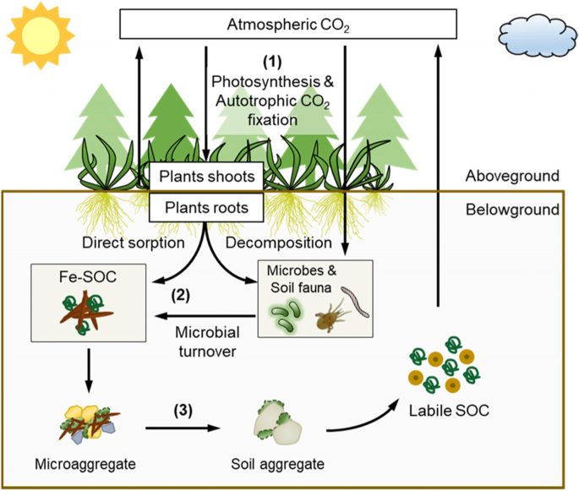

**Figure 2. Comparison of soil carbon sequestration rates under different management practices**

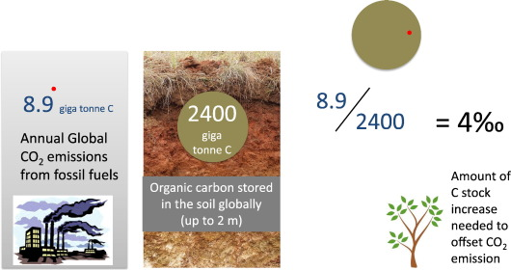

**Figure 3. Economic costs and benefits of soil carbon sequestration practices**

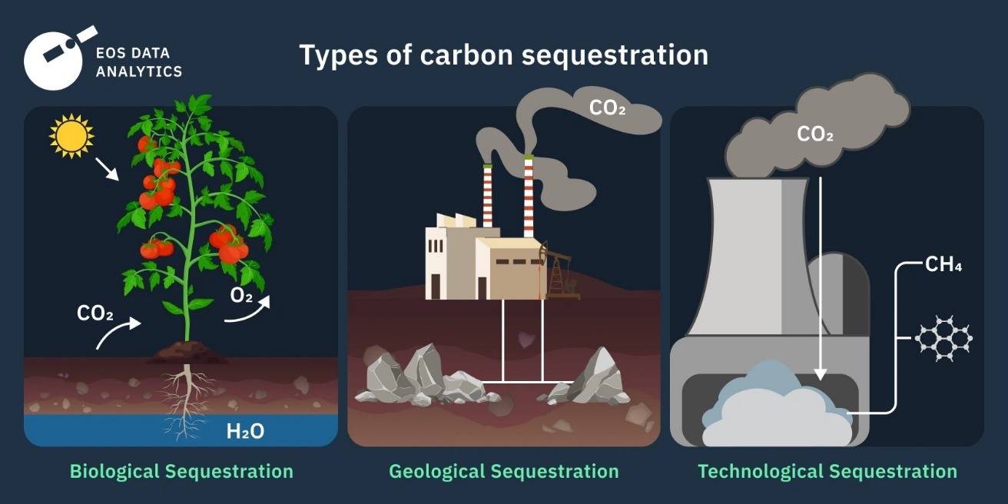

**Figure 4. Cost-effectiveness of soil carbon sequestration compared to other carbon removal technologies**

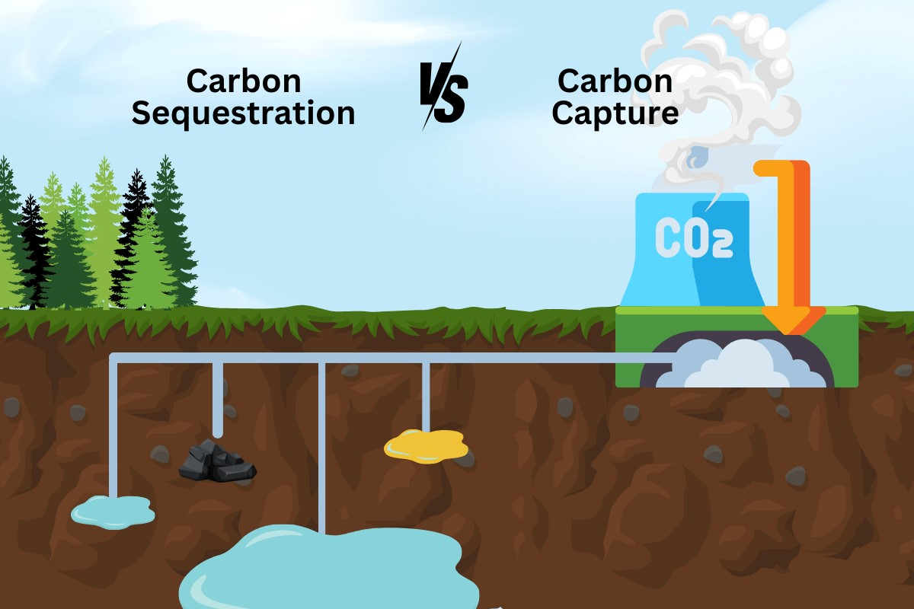

**Figure 5. Stakeholder engagement and knowledge transfer framework for scaling up soil carbon sequestration**

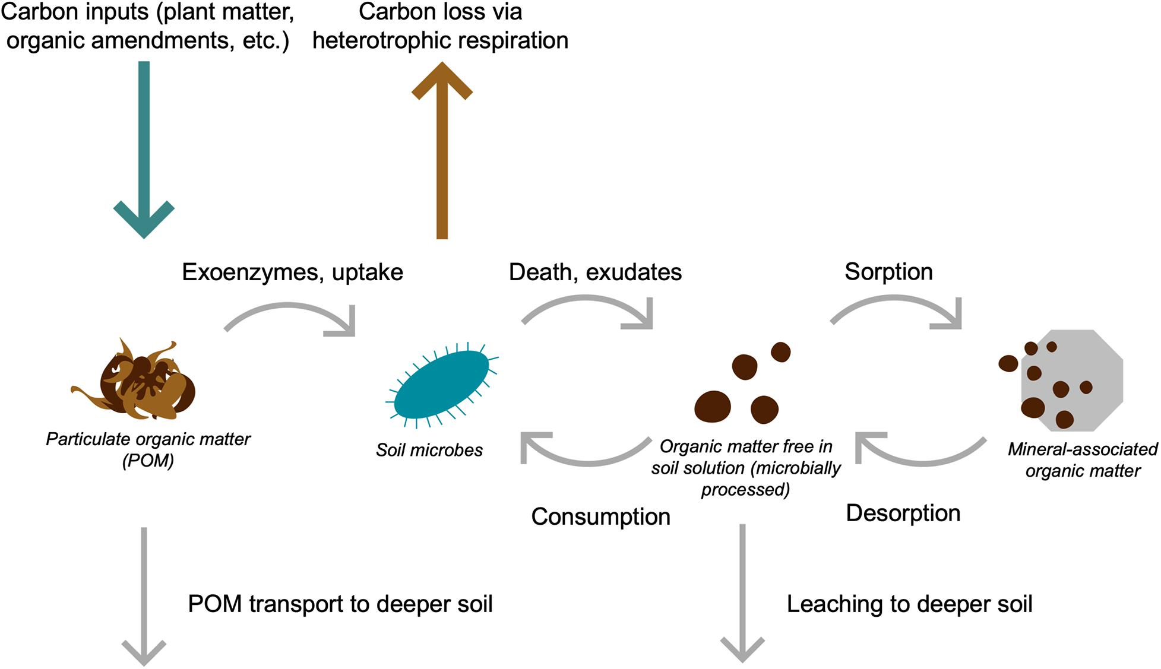

**Figure 6: Co-Benefits Valuation Framework**

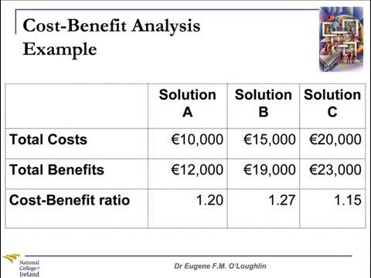

**Figure 7: Transaction Cost Analysis for Soil Carbon Markets**

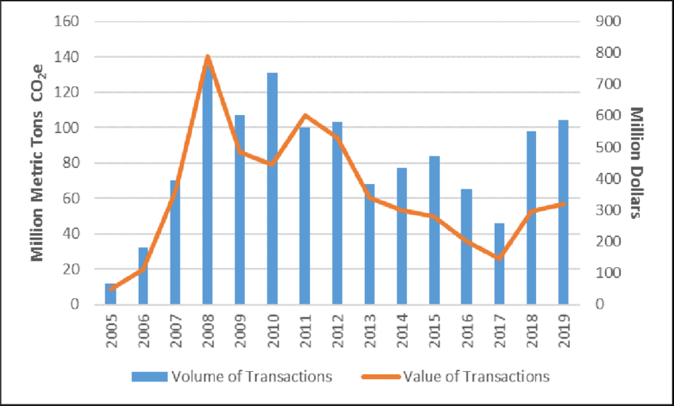

**References**

[1] IPCC. (2019). Special Report on Climate Change and Land. Intergovernmental Panel on Climate Change.

[2] Lal, R. (2004). Soil carbon sequestration impacts on global climate change and food security. Science, 304(5677), 1623-1627.

[3] Sanderman, J., Hengl, T., & Fiske, G. J. (2017). Soil carbon debt of 12,000 years of human land use. Proceedings of the National Academy of Sciences, 114(36), 9575-9580.

[4] West, T. O., & Post, W. M. (2002). Soil organic carbon sequestration rates by tillage and crop rotation: a global data analysis. Soil Science Society of America Journal, 66(6), 1930-1946.

[5] Powlson, D. S., Stirling, C. M., Jat, M. L., Gerard, B. G., Palm, C. A., Sanchez, P. A., & Cassman, K. G. (2014). Limited potential of no-till agriculture for climate change mitigation. Nature Climate Change, 4(8), 678-683.

[6] Derpsch, R., Friedrich, T., Kassam, A., & Li, H. (2010). Current status of adoption of no-till farming in the world and some of its main benefits. International Journal of Agricultural and Biological Engineering, 3(1), 1-25.

[7] Knowler, D., & Bradshaw, B. (2007). Farmers' adoption of conservation agriculture: A review and synthesis of recent research. Food Policy, 32(1), 25-48.

[8] Poeplau, C., & Don, A. (2015). Carbon sequestration in agricultural soils via cultivation of cover crops – A meta-analysis. Agriculture, Ecosystems & Environment, 200, 33-41.

[9] Poeplau, C., & Don, A. (2015). Carbon sequestration in agricultural soils via cultivation of cover crops – A meta-analysis. Agriculture, Ecosystems & Environment, 200, 33-41.

[10] Blanco-Canqui, H., Shaver, T. M., Lindquist, J. L., Shapiro, C. A., Elmore, R. W., Francis, C. A., & Hergert, G. W. (2015). Cover crops and ecosystem services: Insights from studies in temperate soils. Agronomy Journal, 107(6), 2449-2474.

[11] Snapp, S. S., Swinton, S. M., Labarta, R., Mutch, D., Black, J. R., Leep, R., ... & O'Neil, K. (2005). Evaluating cover crops for benefits, costs and performance within cropping system niches. Agronomy Journal, 97(1), 322-332.

[12] Lehmann, J., Gaunt, J., & Rondon, M. (2006). Bio-char sequestration in terrestrial ecosystems – a review. Mitigation and Adaptation Strategies for Global Change, 11(2), 403-427.

[13] Ameloot, N., Graber, E. R., Verheijen, F. G. A., & De Neve, S. (2013). Interactions between biochar stability and soil organisms: review and research needs. European Journal of Soil Science, 64(4), 379-390.

[14] Biederman, L. A., & Harpole, W. S. (2013). Biochar and its effects on plant productivity and nutrient cycling: a meta-analysis. GCB Bioenergy, 5(2), 202-214.

[15] Fuss, S., Lamb, W. F., Callaghan, M. W., Hilaire, J., Creutzig, F., Amann, T., ... & Minx, J. C. (2018). Negative emissions—Part 2: Costs, potentials and side effects. Environmental Research Letters, 13(6), 063002.

[16] Smith, P., Soussana, J. F., Angers, D., Schipper, L., Chenu, C., Rasse, D. P., ... & Klumpp, K. (2020). How to measure, report and verify soil carbon change to realize the potential of soil carbon sequestration for atmospheric greenhouse gas removal. Global Change Biology, 26(1), 219-241.

[17] Paustian, K., Collier, S., Baldock, J., Burgess, R., Creque, J., DeLonge, M., ... & Jahn, M. (2019). Quantifying carbon for agricultural soil management: from the current status toward a global soil information system. Carbon Management, 10(6), 567-587.

[18] FAO. (2019). Measuring and modelling soil carbon stocks and stock changes in livestock production systems: Guidelines for assessment (Version 1). Rome, Italy: FAO.

[19] Lipper, L., Thornton, P., Campbell, B. M., Baedeker, T., Braimoh, A., Bwalya, M., ... & Torquebiau, E. F. (2014). Climate-smart agriculture for food security. Nature Climate Change, 4(12), 1068-1072.

[20] Zomer, R.

[20] Zomer, R. J., Bossio, D. A., Sommer, R., & Verchot, L. V. (2017). Global sequestration potential of increased organic carbon in cropland soils. Scientific Reports, 7(1), 1-8.

[21] Larson, D. F., Dinar, A., & Frisbie, J. A. (2011). Agriculture and the clean development mechanism. World Bank Policy Research Working Paper, (5621).

[22] Thamo, T., & Pannell, D. J. (2016). Challenges in developing effective policy for soil carbon sequestration: perspectives on additionality, leakage, and permanence. Climate Policy, 16(8), 973-992.

[23] Reed, M. S., Stringer, L. C., Dougill, A. J., Perkins, J. S., Atlhopheng, J. R., Mulale, K., & Favretto, N. (2015). Reorienting land degradation towards sustainable land management: Linking sustainable livelihoods with ecosystem services in rangeland systems. Journal of Environmental Management, 151, 472-485.

[24] Amundson, R., & Biardeau, L. (2018). Opinion: Soil carbon sequestration is an elusive climate mitigation tool. Proceedings of the National Academy of Sciences, 115(46), 11652-11656.

[25] Stringer, L. C., Fraser, E. D., Harris, D., Lyon, C., Pereira, L., Ward, C. F., & Simelton, E. (2020). Adaptation and development pathways for different types of farmers. Environmental Science & Policy, 104, 174-189.

[26] Derpsch, R., Friedrich, T., Kassam, A., & Li, H. (2010). Current status of adoption of no-till farming in the world and some of its main benefits. International Journal of Agricultural and Biological Engineering, 3(1), 1-25.

[27] Knowler, D., & Bradshaw, B. (2007). Farmers' adoption of conservation agriculture: A review and synthesis of recent research. Food Policy, 32(1), 25-48.

[28] Pratt, M. R., Tyner, W. E., Muth Jr, D. J., & Kladivko, E. J. (2014). Synergies between cover crops and corn stover removal. Agricultural Systems, 130, 67-76.

[29] Roesch-McNally, G. E., Basche, A. D., Arbuckle, J. G., Tyndall, J. C., Miguez, F. E., Bowman, T., & Clay, R. (2018). The trouble with cover crops: Farmers' experiences with overcoming barriers to adoption. Renewable Agriculture and Food Systems, 33(4), 322-333.

[30] Galinato, S. P., Yoder, J. K., & Granatstein, D. (2011). The economic value of biochar in crop production and carbon sequestration. Energy Policy, 39(10), 6344-6350.

[31] Dickinson, D., Balduccio, L., Buysse, J., Ronsse, F., Van Huylenbroeck, G., & Prins, W. (2015). Cost-benefit analysis of using biochar to improve cereals agriculture. GCB Bioenergy, 7(4), 850-864.

[32] De Stefano, A., & Jacobson, M. G. (2018). Soil carbon sequestration in agroforestry systems: a meta-analysis. Agroforestry Systems, 92(2), 285-299.

[33] Torres, A. B., Marchant, R., Lovett, J. C., Smart, J. C., & Tipper, R. (2010). Analysis of the carbon sequestration costs of afforestation and reforestation agroforestry practices and the use of cost curves to evaluate their potential for implementation of climate change mitigation. Ecological Economics, 69(3), 469-477.

[34] Conant, R. T., Paustian, K., & Elliott, E. T. (2001). Grassland management and conversion into grassland: effects on soil carbon. Ecological Applications, 11(2), 343-355.

[35] Tennigkeit, T., & Wilkes, A. (2008). Carbon finance in rangelands: an assessment of potential in communal rangelands. World Agroforestry Centre.

[36] Smith, P. (2012). Agricultural greenhouse gas mitigation potential globally, in Europe and in the UK: what have we learnt in the last 20 years?. Global Change Biology, 18(1), 35-43.

[37] Antle, J. M., Capalbo, S. M., Mooney, S., Elliott, E. T., & Paustian, K. H. (2001). Economic analysis of agricultural soil carbon sequestration: an integrated assessment approach. Journal of Agricultural and Resource Economics, 26(2), 344-367.

[38] Manley, J., Van Kooten, G. C., Moeltner, K., & Johnson, D. W. (2005). Creating carbon offsets in agriculture through no-till cultivation: A meta-analysis of costs and carbon benefits. Climatic Change, 68(1), 41-65.

[39] Lu, F., Liang, Y., Zheng, X., & Zhang, W. (2019). The cost-effectiveness of soil carbon sequestration in cropland worldwide: A meta-analysis. Science of the Total Environment, 686, 1161-1168.

[40] Aalde, H., Gonzalez, P., Gytarsky, M., Krug, T., Kurz, W. A., Ogle, S., ... & Somogyi, Z. (2006). Generic methodologies applicable to multiple land-use categories. 2006 IPCC guidelines for national greenhouse gas inventories, 4, 1-59.

[41] Woolf, D., Amonette, J. E., Street-Perrott, F. A., Lehmann, J., & Joseph, S. (2010). Sustainable biochar to mitigate global climate change. Nature Communications, 1(1), 1-9.

[42] Pratt, K., & Moran, D. (2010). Evaluating the cost-effectiveness of global biochar mitigation potential. Biomass and Bioenergy, 34(8), 1149-1158.

[43] Jose, S. (2009). Agroforestry for ecosystem services and environmental benefits: an overview. Agroforestry Systems, 76(1), 1-10.

[44] Nair, P. R., Nair, V. D., Kumar, B. M., & Showalter, J. M. (2010). Carbon sequestration in agroforestry systems. Advances in Agronomy, 108, 237-307.

[45] Lal, R. (2004). Carbon sequestration in dryland ecosystems. Environmental Management, 33(4), 528-544.

[46] Lal, R. (2003). Global potential of soil carbon sequestration to mitigate the greenhouse effect. Critical Reviews in Plant Sciences, 22(2), 151-184.

[47] Fuss, S., Lamb, W. F., Callaghan, M. W., Hilaire, J., Creutzig, F., Amann, T., ... & Minx, J. C. (2018). Negative emissions—Part 2: Costs, potentials and side effects. Environmental Research Letters, 13(6), 063002.

[48] Amundson, R., & Biardeau, L. (2018). Opinion: Soil carbon sequestration is an elusive climate mitigation tool. Proceedings of the National Academy of Sciences, 115(46), 11652-11656.