**Interactive GIS-Based Flood Risk Assessment for Illinois: Enhancing Preparedness, Planning, and Public Awareness**

**Abstract**

Flooding is the most common and damaging natural disaster in Illinois, largely due to climate change and human activities. This study explores the integration of Geographic Information Systems (GIS) in flood risk management across the state, focusing on the mapping of high-risk areas along major river corridors such as the Mississippi and Illinois Rivers. By utilizing data drawn from federal and state agencies participating in the Illinois Silver Jackets program, the research develops an interactive GIS-based flood map that visualizes vulnerable communities and supports dynamic spatial analysis. The tool serves several functions: identifying flood-prone zones, enhancing emergency preparedness, informing land use and infrastructure planning, and improving public risk communication. Its real-time, user-friendly interface enables both technical and non-technical stakeholders to easily engage with flood data, fostering community resilience and informed decision-making. The findings highlight the value of collaborative, data-driven approaches in advancing proactive flood mitigation strategies throughout Illinois.

**Keywords**: Flood Risk, GIS, Illinois, Emergency Planning, Land Use, Public Awareness, Interactive Map, Silver Jackets Program, Flood Mitigation, Spatial Analysis.

1. **Introduction**

Globally, flooding has continued to pose serious threat to lives and properties due to the continued change in climatic and human factors. Flood is the most prevalent natural disaster in Illinois, and it accounts for well over 90% of the state's declared disasters [1]. There are many factors that can influence flood occurrence, but an effective tool to manage the event of flooding would rely on predictive measures which are complemented with the application of Geographic Information System (GIS) to create maps of flood risk zones. The application of GIS in flood mitigation also involves tweaking of collected data and using mapping too(ls) to determine whether a dam is necessary, the soil type as a factor, tracking sewer lines that need maintenance, town planning, and forecasting a flood emergency.

Mapping the major rivers in Illinois as part of this study highlights the region’s most vulnerable to flooding. In recent years, increased rainfall and extreme weather events have caused these rivers to exceed their natural capacities, resulting in overflow into nearby cities [2]. This has led to widespread destruction of homes, critical infrastructure, and disruption of communities, emphasizing the urgent need for improved flood management and mitigation strategies. The two major rivers in Illinois are the Mississippi river which runs from the northwest of the state to the southwest, and the Illinois river which is a major tributary of the Mississippi river [3]. These rivers receive their water from the local watershed and drainage systems within the state [3].

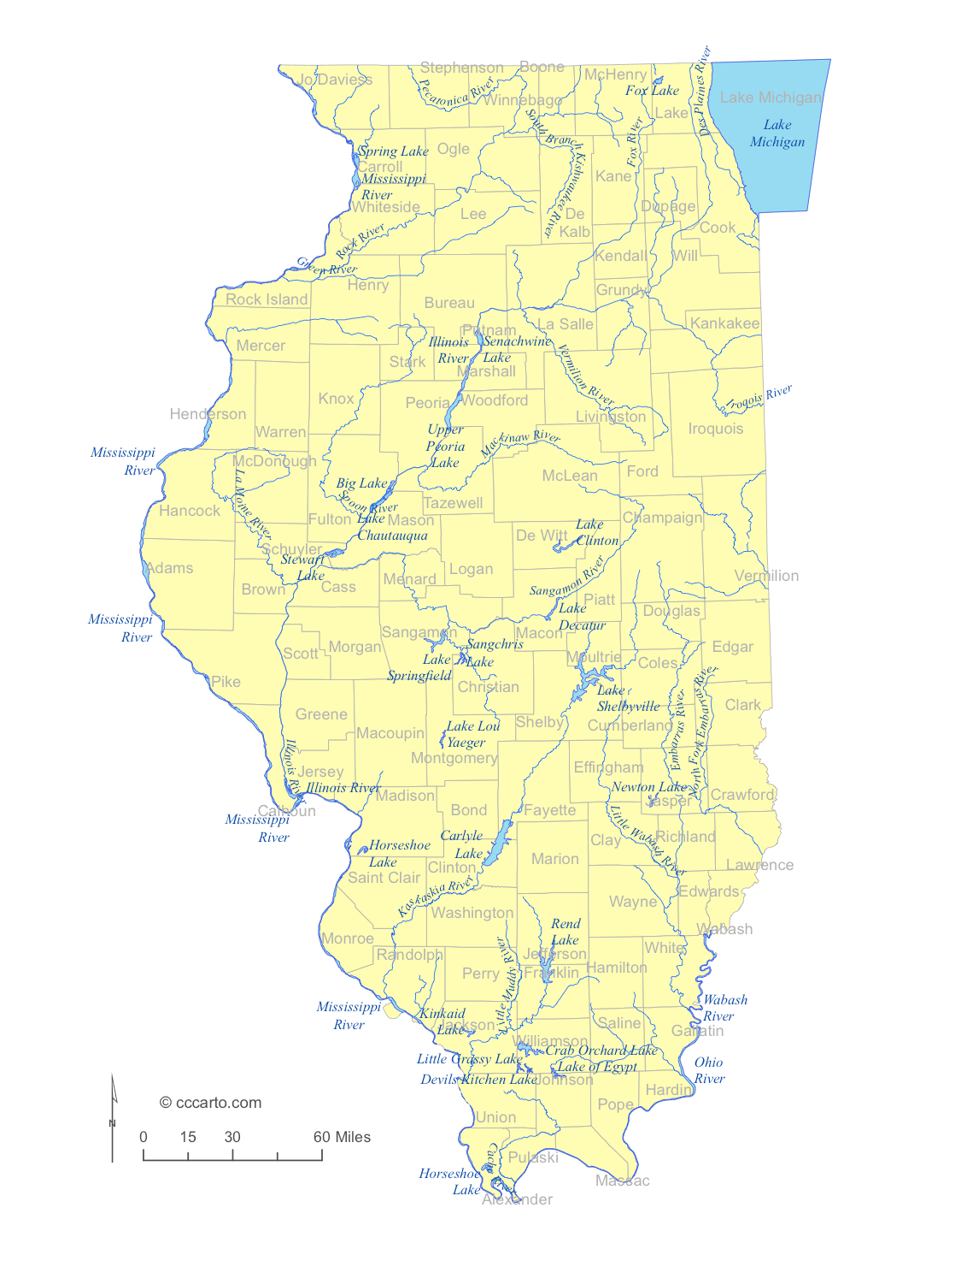

**Figure 1.** Illinois Watershed Map [3]

For a long time, structural embankments, dams and other structures have been used to mitigate flooding in Illinois; but these methods have proved to be inefficient in an event of flooding or managing it. The destruction of lives and properties can be prevented and minimized through informing the public about flood risk, using flood risk maps [4].

This research focuses on the significance of applying GIS software in Illinois for flood mitigation. As the most frequent natural disaster in the state, accounting for the major destruction to lives and properties, effective flood management increasingly relies on predictive tools and GIS mapping. GIS helps identify flood-prone areas, assess soil and infrastructure conditions, and support emergency planning. Mapping major rivers like the Mississippi and Illinois Rivers, which are key contributors to flooding in the state and reveals vulnerable regions often impacted by heavy rainfall and overflow.

1. **Methodology**

The motivation behind this research is the Illinois silver jacket program, which is a flood mitigation program involving the Federal government (U.S. Army Corps of Engineers (USACE), Federal Emergency Management Agency (FEMA), National Weather Service (NWS), U.S. Geological Survey (USGS), National Resources Conservation Services (NRCS), U.S. Environmental Protection Agency (EPA)), all 50 U.S. states and their agencies, local and tribal communities [5]. In Illinois, State agencies include the Illinois Emergency Management Agency (IEMA), Illinois Department of Natural Resources/ Office of Water Resources (IDNR/OWR), Illinois State Water Survey (ISWS), Illinois Department of Transportation (IDOT), Illinois Environmental Protection Agency (IEPA), and the Illinois Department of Agriculture. The essence of partnering and leveraging multiple programs is that no single agency has all the solutions or data required to manage the problems of flooding statewide or nationwide.

The data used in this research are collected from the USACE, which shows flood regions in Illinois is divided into five districts as seen in Table 1 below. The six districts include Upper Mississippi River (Upper MS), Middle Mississippi Phase 1 (MiddleMSPh), Middle Mississippi Phase 2 (MidlleMSPh2), Illinois River (IL River), Middle Fork [5].

**Table 1.** Flood-Prone Regions in Illinois [5]

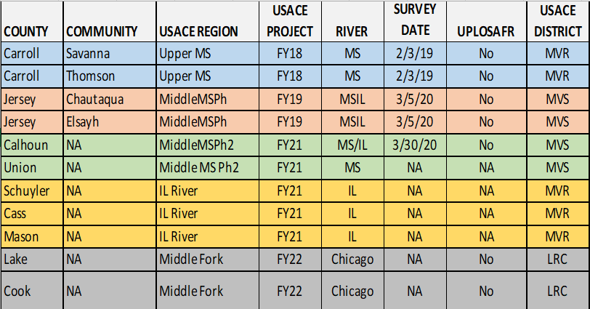

Table 1, shows some of the communities, and counties in Illinois, their survey data, and the river/rivers in those communities. The USACE Project represents the year those communities were added to the Silver Jacket Project/Program [5]. The communities and counties in this Silver Jacket project will be categorized based on the USACE region. Since 2022, the participating communities are about 28 and this project will help mitigate flooding issues and educate the communities about flooding [5]. With this data the IDNR - Office of Water Resources can reach out to homeowners in the USACE regions, especially those regions with a high risk of flooding or during flooding to support them with buyouts.

With the application of ArcGIS, the data from the table above is used to create a flood map which can also be considered an interactive map for public use. The map is useful because it allows the digitization of the flood prone areas and calculation of the cost of loss, causes and predictive prevention of flooding, determination of affected population and communities/cities affected.

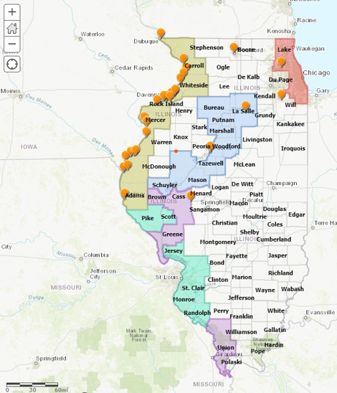

**Figure 2.** Flood Prone Regions in Illinois Map

The flood prone areas in Figure 2 are divided into five areas (Upper Mississippi, Middle Mississippi Phase 1, Middle Mississippi Phase 2, IL River, and Middle Fork). Some flood prone areas cover both counties and communities. The pop up for the counties (five color shade) and communities (points). The pop-up shows details from

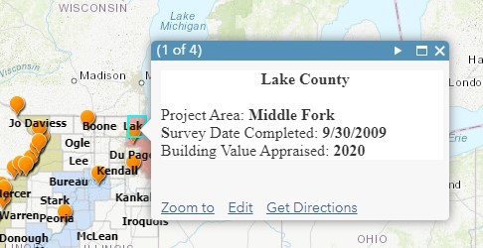

**Figure 3.** Pop-up Details for County in Flood Prone Zone

From figures 2 and 3 above, the map shows the digital map as being interactive because it allows the users to engage with it by clicking, zooming, or hovering to reveal more information, and add more information like population of the city, community or county.

1. **Discussion**

The information on this map can be applied in environmental planning by the EPA, IDNR/OWR, county and city council and as a risk-assessment tool by USACE, FEMA, and other agencies along river corridors in Illinois. The combination of color shading and interactive points gives users access to granular data, helping agencies and communities make informed decisions regarding flood mitigation, infrastructure planning, and public safety. The application of GIS technology in determination of flood inundation will be beneficial in many ways and a few will be described below.

* 1. **Identification of High-Risk Areas**

One of the most significant advantages of employing GIS in flood mitigation lies in its capacity to accurately identify high-risk flood zones. In this study, the integration of historical flood records allowed for the development of an interactive map that not only visualizes flood-prone areas, but also supports dynamic querying and spatial analysis. This tool proves especially valuable for local planners, emergency managers, and residents who need to understand their exposure to flood risks in real time.

The spatial precision of GIS enables high-resolution delineation of floodplains, identifying micro-topographic features such as low-lying neighborhoods, drainage basins, and flow accumulation paths that traditional paper-based floodplain maps may overlook [6]. By overlaying historical flood data and river discharge information with elevation surfaces, the model created in this study was able to highlight regions where inundation is most likely under various rainfall and river overflow scenarios. This mirrors findings from [7], who demonstrated that GIS-based models significantly improve flood risk visualization compared to static cartographic approaches. This level of detail supports evidence-based decision-making, allowing city planners to prioritize interventions, such as green infrastructure or zoning changes, in areas where flood exposure is highest.

The value of such GIS-based mapping is evident in existing flood risk management strategies across Illinois. For example, the Illinois State Water Survey utilizes similar GIS tools to support community engagement and hazard mitigation planning [1]. By replicating these techniques in this study, we contribute not only to the academic understanding of flood mapping, but also offer a practical tool that can be adapted and applied by local governments and agencies participating in programs like Silver Jackets and FEMA’s Community Rating System (CRS).

* 1. **Enhanced Emergency Planning and Response**

Another critical application of the interactive flood map developed in this study is its role in enhancing emergency planning and response efforts. The tool enables emergency managers to anticipate flood-affected areas with spatial precision, allowing for proactive and data-driven decision-making during all phases of disaster management—mitigation, preparedness, response, and recovery.

Incorporating layers such as road networks, population density, critical infrastructure, and historical flood extents, the map facilitates scenario-based evacuation planning. Emergency planners can simulate flood events under various rainfall intensities or river levels and visualize the resulting inundation in real time. This capacity is essential for identifying safe evacuation routes, temporary shelter locations, and at-risk communities, especially in densely populated or infrastructurally complex areas. The interactive map supports real-time allocation of emergency services. During an active flood event, decision-makers can quickly assess which areas are most impacted and direct first responders, accordingly, thereby improving response time and reducing casualties. Application of GIS in flood inundation, enhances situational awareness for emergency responders by providing an up-to-date visual representation of hazard spread and resource availability [8].

In Illinois, where flash floods and riverine flooding can escalate quickly, especially along rivers like the Des Plaines or Mississippi, such real-time, spatially aware tools can be lifesaving [9]. Agencies like the Illinois Emergency Management Agency (IEMA) have already begun integrating GIS platforms into their response protocols, and the outcomes from this study reinforce the value of such integration.

* 1. **Land Use Planning**

The flood map developed in this study also plays a critical role in supporting informed infrastructure design and land use planning, particularly in flood-prone areas of Illinois. Effective flood mitigation requires not only reactive emergency response, but proactive, long-term planning that integrates hydrological realities into urban development decisions. The mapping tool allows stakeholders such as city planners, engineers, zoning boards, and environmental agencies to visualize and assess flood risks spatially, thereby informing the siting, design, and reinforcement of infrastructure and urban layouts.

Using spatial overlays of flood hazard zones, population density, transportation networks, and utility infrastructure, the map helps identify where development should be avoided or modified to reduce exposure. This is particularly important for critical infrastructure such as hospitals, power stations, and schools. Integrating hazard maps into urban planning helps prevent the “reconstruction of vulnerability” by steering new developments away from high-risk zones [10].

The tool also strengthens land use regulation enforcement, such as maintaining floodplain buffers or limiting high-density development in vulnerable areas. Illinois, through the Illinois Department of Natural Resources (IDNR) and local zoning ordinances, has implemented regulations aligned with FEMA’s National Flood Insurance Program (NFIP) [11]. The GIS application developed here can be directly used to support compliance by enabling local governments to track encroachment into regulated flood zones.

* 1. **Public Awareness and Risk Communication**

This is a critical yet often underemphasized component of flood mitigation. In this study, the development of an interactive map was designed not only for technical analysis but also for broad public accessibility, enabling residents, local organizations, and non-specialists to visualize and understand the flood risks in their communities.

Effective risk communication is a cornerstone of disaster preparedness, particularly in areas susceptible to recurrent flooding, such as those along the Illinois, Des Plaines, and Mississippi Rivers. By presenting flood risk data through an intuitive and interactive platform, GIS can translate complex hydrological information into actionable insights for the public. Individuals are more likely to adopt protective behaviors when risk is communicated clearly and perceived as both credible and personally relevant [12]. The map developed in this research addresses that need by allowing users to enter specific locations (e.g., home addresses, cities) and instantly view the associated flood hazard level.

Community engagement is further strengthened when GIS platforms are incorporated into public outreach efforts, such as town hall meetings, school education programs, or neighborhood preparedness workshops. The interactive tool developed in this study is especially valuable in this regard, as it supports two-way communication: not only does it deliver information to the public, but it also provides a space for feedback and local knowledge to be integrated into hazard planning.

Importantly, the public use of GIS tools also supports equity in flood risk awareness, ensuring that vulnerable or historically underserved populations are not left out of preparedness efforts. By offering a web-based and mobile-accessible interface, this study's map aims to overcome barriers to risk information access, such as limited technical literacy or geographic isolation.

1. **Conclusion**

This study demonstrates the powerful applicability of Geographic Information Systems (GIS) in flood risk management across the state of Illinois. Through the development of an interactive GIS-based map, the research successfully illustrates how spatial data can be transformed into a dynamic decision-support tool for federal, state, and local stakeholders. The ability of the map to identify high-risk flood zones, inform infrastructure and land use planning, enhance emergency response, and engage the public serves as a multi-faceted solution to a multi-dimensional problem.

Flooding, being the most prevalent natural disaster in Illinois, poses ongoing threats exacerbated by climate variability and urban expansion. Traditional structural mitigation methods, though still relevant, are insufficient alone. The interactive flood risk map developed in this study enables a shift from reactive to proactive management by offering real-time spatial insights that support predictive planning and immediate crisis response. It allows agencies such as FEMA, IEMA, USACE, and IDNR to efficiently allocate resources, assess vulnerabilities, and enforce floodplain regulations based on accurate, up-to-date, and granular data.

The accessibility of this tool extends its benefits beyond institutional actors to the public, empowering residents with the knowledge needed to understand and respond to flood risks in their immediate environments. This transparency and inclusivity are essential for building community resilience and trust in government led mitigation strategies. It is also crucial to know that by integrating the priorities of the Illinois Silver Jackets program and leveraging inter-agency collaboration, this research contributes to ongoing efforts to coordinate flood management across jurisdictions. Moving forward, continued investment in data integration, public education, and real-time system updates will be essential to maximizing the impact of this tool and ensuring safer, more informed communities across Illinois.

**References**

1. Illinois State Water Survey (ISWS). (2023). *Flood Risk Management and Mapping Projects*. Retrieved from <https://www.isws.illinois.edu>
2. Ahmad, Md. Karar. “Application of remote sensing and GIS for Flood Hazard Management: A case study of bihar (India).” *Contemporary Social Sciences*, vol. 27, no. 2, 1 Apr. 2018, pp. 69–77, https://doi.org/10.29070/27/57466.
3. CCCarto.com. “Illinois Lakes, Rivers - CCCARTO.” *CCCarto Web Site*, [www.cccarto.com/statewaters/illinois/](http://www.cccarto.com/statewaters/illinois/) . Accessed 28 Apr. 2023.
4. Gupta, Laxmi, and Jagabandhu Dixit. “A GIS-based flood risk mapping of Assam, India, using the MCDA-AHP approach at the regional and administrative level.” *Geocarto International*, vol. 37, no. 26, 19 Apr. 2022, pp. 11867–11899, https://doi.org/10.1080/10106049.2022.2060329.
5. *Rock Island District*, www.mvr.usace.army.mil/Missions/Flood-Risk-Management/Silver-Jackets/. Accessed 25 Apr. 2023.
6. National Research Council (NRC). (2009). *Mapping the Zone: Improving Flood Map Accuracy*. Washington, DC: The National Academies Press.
7. Merwade, V., Cook, A., & Coonrod, J. (2008). *GIS techniques for floodplain mapping*. Environmental Modelling & Software, 23(10-11), 1300–1311.
8. Zerger, A., & Smith, D. I. (2003). *Impediments to using GIS for real-time disaster decision support*. Computers, Environment and Urban Systems, 27(2), 123–141.
9. Illinois Emergency Management Agency (IEMA). (2023). *Emergency Preparedness and Response Tools*. Retrieved from <https://www2.illinois.gov/iema>
10. Burby, R. J., Deyle, R. E., Godschalk, D. R., & Olshansky, R. B. (2000). Creating Hazard Resilient Communities Through Land-Use Planning. Natural Hazards Review, 1(2), 99–106.
11. Illinois Department of Natural Resources (IDNR). (2023). Floodplain Management Resources. Retrieved from https://dnr.illinois.gov
12. Lindell, M. K., & Perry, R. W. (2004). *Communicating Environmental Risk in Multiethnic Communities*. Sage Publications.