***Case report***

**Tuberculous Constrictive Pericarditis Presenting with Isolated Pleural Effusion: Diagnostic Value of Transthoracic Echocardiography**

**Abstract**

**Aims:** To highlight the diagnostic role of transthoracic echocardiography (TTE) in tuberculous constrictive pericarditis (CP) presenting atypically as isolated pleural effusion, and to emphasize the importance of early multimodal imaging in TB-endemic regions.

**Presentation of Case**: A 36-year-old man with no comorbidities presented with progressive dyspnea and bilateral pleural effusion. Initial workup (CT, pleural biopsy) was inconclusive. TTE revealed classic CP features: pericardial thickening, septal bounce, and hepatic vein expiratory reversal. Cardiac MRI confirmed the diagnosis. Following clinical improvement with anti-tuberculosis therapy, the patient was referred for elective pericardiectomy.

**Discussion:** CP remains a diagnostic challenge due to nonspecific symptoms. In TB-endemic areas, tuberculosis is a leading cause. TTE’s Mayo Clinic criteria (septal shift, medial e′ ≥ 9 cm/s, hepatic vein reversal) achieved 97% specificity, obviating invasive tests. MRI further differentiated CP from restrictive cardiomyopathy.

**Conclusion:** CP should be considered in patients with unexplained pleural effusion in TB-endemic regions. TTE is a critical first-line tool, and early intervention improves outcomes.

*Keywords: Constrictive pericarditis, tuberculosis, pleural effusion, echocardiography, cardiac MRI*

1. **Introduction**

Constrictive pericarditis (CP) results from long-standing inflammation of the pericardium, leading to pericardial thickening, fibrosis, and sometimes calcification, which restricts diastolic filling of the heart. Clinically, CP mimics other causes of right-sided heart failure, particularly restrictive cardiomyopathy, posing diagnostic challenges [1], [2]. The gold standard for confirming CP remains cardiac catheterization, although non-invasive imaging—especially transthoracic echocardiography (TTE) and cardiac MRI—plays a critical role in early detection and assessment of hemodynamic impact [3]. Common causes in developed countries include prior cardiac surgery, radiation therapy, and idiopathic pericarditis. In contrast, tuberculosis (TB) remains a predominant cause in low- and middle-income countries [4].

1. **Case Presentation**

A 36-year-old man, without known comorbidities, The patient presented with progressive exertional dyspnea (NYHA Class II to III over 12 months) and three distinct patterns of intermittent chest discomfort: (1) brief (<30 sec) left parasternal stabbing pain exacerbated by inspiration (likely pericardial irritation), (2) retrosternal pressure (3/10 severity) triggered by moderate exertion (≥2 flight stairs), and (3) postprandial epigastric burning radiating to the xiphoid (occurring 20-40 min after meals) – all evolving insidiously over 14 months. He also reported chronic fatigue but denied fever, weight loss, or night sweats.

Physical examination showed elevated jugular venous pressure and decreased breath sounds bilaterally. There was no peripheral edema or ascites.

A chest X-ray showed bilateral pleural effusion (Figure 1), and ECG was unremarkable.

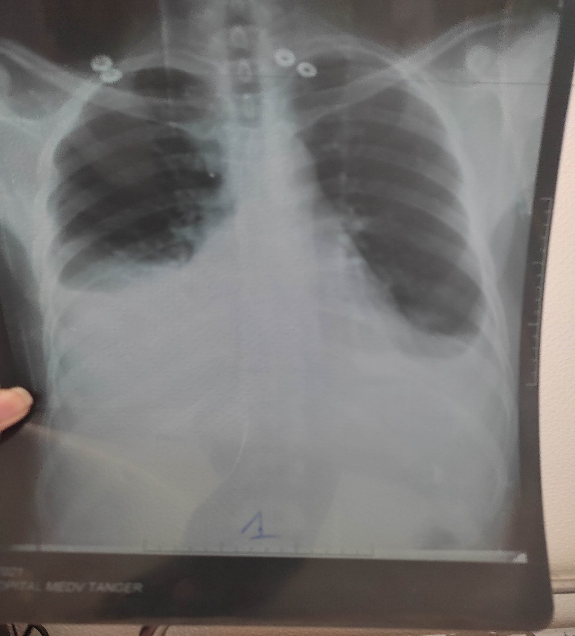

Figure 1: Chest X ray showing bilateral pleural effusion

Blood tests showed normal inflammatory markers and no evidence of active infection. Pleural fluid analysis demonstrated transudative characteristics and extensive tuberculosis evaluation yielded negative results across all modalities:

* Three sputum samples: GeneXpert MTB/RIF Ultra-negative (detection limit 16 CFU/ml)
* Pleural fluid: Adenosine deaminase (ADA) 28 U/L (indeterminate range), no acid-fast bacilli on Ziehl-Neelsen staining
* No mycobacterial growth in Löwenstein-Jensen cultures after 8 weeks (performed retrospectively)

Thoracic CT scan, bronchoscopy, and pleural biopsy yielded no conclusive diagnosis. Despite symptomatic treatment, the patient's dyspnea persisted. A cardiology referral was made for further evaluation.

Transthoracic echocardiography (TTE) demonstrated multiple features consistent with chronic constrictive pericarditis (Figure 2: A, B):

* Pericardial thickening,
* Respiratory variation in mitral and tricuspid inflow velocities (>25%),
* Septal bounce,
* Preserved medial mitral annular e′ velocity,
* Expiratory diastolic flow reversal in hepatic veins.

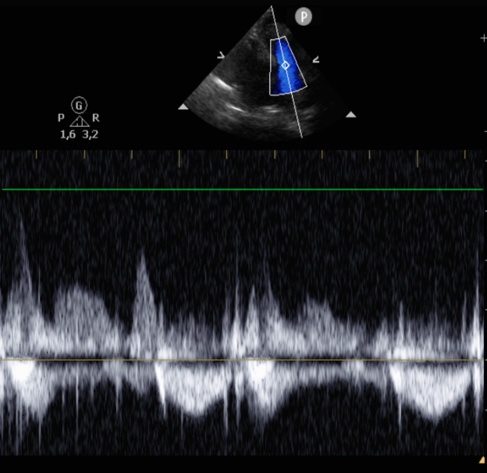 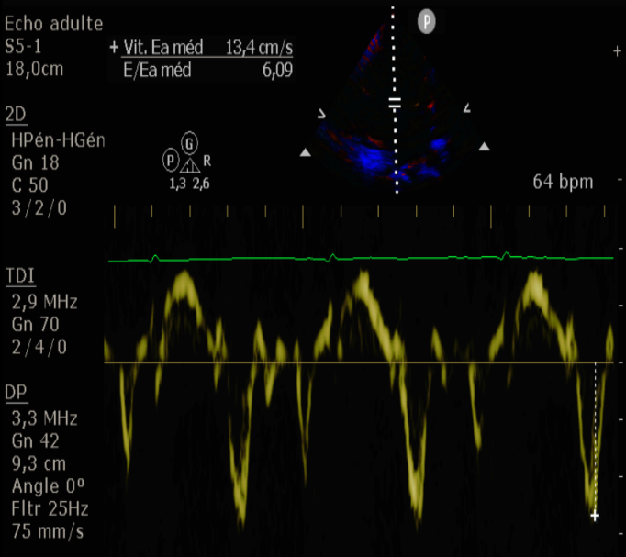

**B**

**A**

Figure 2: TTE images: (A) Hepatic vein expiratory diastolic flow reversal; (B) Preserved medial mitral annular e′ velocity.

Cardiac MRI confirmed the echocardiographic findings, showing a thickened pericardium with constrictive physiology and no myocardial infiltration or fibrosis.

The patient was started on anti-tuberculosis therapy along with corticosteroids, resulting in significant clinical improvement. He was referred then for elective pericardiectomy.

1. **Discussion**

Constrictive pericarditis (CP) is an uncommon but potentially reversible cause of heart failure. It is characterized by a restrictive, inelastic pericardium that limits cardiac filling, resulting in signs and symptoms of right heart failure such as dyspnea on exertion, increased venous pressure, and peripheral edema [1], [2]. Diagnosing CP remains challenging due to its nonspecific symptoms and similarities with other conditions like restrictive cardiomyopathy, pulmonary hypertension, and hepatic cirrhosis [2].

**Spectrum and Natural History of TB Pericarditis**

In tuberculosis-endemic areas, autopsy studies suggest that pericardial involvement occurs in approximately 1%–2% of patients with pulmonary TB [5]. Tuberculous pericarditis most often presents as effusive or effusive-constrictive pericarditis, resulting from a robust immune response to mycobacterial antigens in the pericardium[5]. The pericardial fluid is typically lymphocyte-rich, paucibacillary, and proteinaceous, containing a high concentration of proinflammatory and profibrotic cytokines. This leads to gradual pericardial effusion, causing heart failure symptoms in most patients, tamponade in some, and spontaneous resolution in a minority [5].

In immunocompromised patients (e.g., with advanced HIV), higher mycobacterial loads and systemic dissemination may occur. The fibrin-rich inflammatory nature of TB pericardial effusion helps explain its wide clinical spectrum [5]:

* Effusive pericarditis
* Effusive-constrictive pericarditis
* Transient constrictive pericarditis (responsive to anti-TB therapy)
* Constrictive pericarditis with adhesive effusion
* Chronic fibrotic constrictive pericarditis (with or without calcification)

Despite appropriate treatment, tuberculous pericarditis remains associated with considerable mortality and morbidity[6]. Mortality generally occurs early in the disease course, with reported rates ranging from 8% to 17% in HIV-negative individuals, and up to 34% in HIV-positive patients[6]. While chronic constrictive pericarditis is relatively rare overall, it represents the leading cause of CP in tuberculosis-endemic regions such as Africa and Asia [4], [6].

Our case reflects this complexity, illustrating how tuberculous pericarditis may present atypically, with minimal or absent pericardial effusion and misleading symptoms such as isolated pleural effusion.

**Etiology and Atypical Presentation**

In TB-endemic regions, tuberculosis remains a leading cause of CP, whereas idiopathic, post-surgical, and radiation-induced causes predominate in developed countries [4]. Our patient presented atypically, with chronic bilateral pleural effusion as the main manifestation. While pleural effusions in CP are classically exudative, transudative effusions may occur as a result of elevated right atrial pressure impairing lymphatic drainage [7]. This underscores the need for cardiac evaluation in cases of recurrent, unexplained, or bilateral pleural effusion.  
The atypical nature of our patient’s presentation, with isolated bilateral pleural effusion and no overt signs of pericardial disease, contributed to a diagnostic delay of nearly one year. Multiple pulmonary investigations were performed, including pulmonary CT, pleural biopsy, and bronchoscopy, all of which were inconclusive. The pleural fluid was transudative, inflammatory markers were negative, and microbiologic analysis for tuberculosis in both sputum and pleural fluid was negative. This highlights the diagnostic challenge posed by subacute or silent constrictive pericarditis, and the need to consider it in the differential diagnosis of chronic pleural effusion of unknown cause, especially in TB-endemic areas.

**Diagnostic Challenges and Role of Imaging**

On physical examination, jugular venous distension was noted, a hallmark of systemic venous congestion, though no peripheral edema or ascites were present. This variability in clinical expression reflects differences in disease chronicity, pericardial compliance, and right ventricular adaptation [8].

Transthoracic echocardiography (TTE) was pivotal in our diagnostic process. It revealed the following features:

* Pericardial thickening,
* Respiratory variation in mitral and tricuspid inflow velocities,
* Septal bounce,
* Preserved or increased medial mitral annular e′ velocity,
* Expiratory diastolic flow reversal in hepatic veins.

These findings align with the Mayo Clinic diagnostic criteria [9], which include:

1. Respiration-dependent septal shift,
2. Medial mitral e′ velocity ≥ 9 cm/s,
3. Hepatic vein diastolic reversal ratio ≥ 0.79.



Table 1: The Mayo clinic TTE diagnostic criteria of CP

Meeting any two of these criteria yields a sensitivity of 87% and specificity of 91%. When all three are present, specificity rises to 97%, though sensitivity decreases to 64% [9]. Our patient fulfilled all three criteria.

Additional echocardiographic findings in CP include pericardial calcification, dilated hepatic veins, distended inferior vena cava with blunted respiratory variation, and in some cases, premature pulmonic valve opening due to elevated right ventricular early diastolic pressure [10, ~~p. 1627~~].

Cardiac MRI (CMR) provided additional confirmation of pericardial thickening and constrictive physiology, with no signs of myocardial infiltration or fibrosis. CMR is especially valuable for differentiating CP from restrictive cardiomyopathy and detecting active pericardial inflammation, guiding the therapeutic decision between medical therapy and surgical intervention [11].

**Differential Diagnosis and Management**

The main differential diagnosis is restrictive cardiomyopathy, which may closely mimic CP. However, key differentiators include:

* Preserved or increased medial mitral annular e′ velocity in CP (reduced in restrictive cardiomyopathy) [12],
* Respiratory variation in mitral inflow velocities (present in CP, absent in restrictive forms) [8], [10], [13].

For our clinical case, three additional diagnoses were initially considered given the presentation with isolated pleural effusion:

* Malignant pleural effusion.
* Hepatic hydrothorax.
* Tuberculous pleuritis.

The clinical evolution (persistent effusions despite diuretics) and complementary exams (classic TTE findings of CP, CMR showing pericardial thickening) ultimately dismissed those diagnosis and confirmed tuberculous constrictive pericarditis as the definitive diagnosis.

**Treatment Approaches**  
The management of constrictive pericarditis depends largely on its etiology and stage—whether inflammatory or fibrotic. In tuberculous pericarditis, standard anti-tuberculosis therapy remains the cornerstone of treatment, and corticosteroids may be added in selected cases, particularly in HIV-negative patients, to reduce inflammation and prevent progression to constriction [4], [8]. When the disease becomes chronic and fibrotic, surgical pericardiectomy is the definitive therapy, ideally performed before irreversible myocardial damage occurs. Total or subtotal pericardiectomy via median sternotomy is generally preferred, although surgery carries higher risk in patients with advanced heart failure or myocardial atrophy, emphasizing the importance of early referral [8], [9], [14]. In our case, the patient responded favorably to medical therapy, suggesting a subacute inflammatory phase of tuberculous pericarditis, he then was deferred for subtotal pericardiotomy.

**Clinical Implications**

This case highlights the importance of a multimodal diagnostic approach, with echocardiography as the first-line tool, supported by CMR in ambiguous or complex cases. In TB-endemic regions, clinicians should maintain a high index of suspicion for CP in patients with atypical signs of right heart failure. Early recognition and appropriate management are crucial to avoid misdiagnosis, prevent progression, and improve patient outcomes. Our patient was successfully managed with anti-tuberculosis therapy along with corticosteroids, resulting in significant clinical improvement. He was subsequently referred for elective pericardiectomy.

**Limitations and Future Directions**  
This case has three notable limitations:

1. Single-center experience limits generalizability
2. Unavailability of pericardial biopsy for TB confirmation
3. Lack of strain imaging data

**Future research should explore:**  
• Biomarkers (e.g., pericardial ADA levels) to improve early detection  
• AI-assisted echocardiography for automated CP pattern recognition  
• Randomized trials of pericardiectomy timing in TB-associated CP

1. **Conclusion**

In tuberculosis-endemic regions, constrictive pericarditis (CP) should be considered in patients presenting with unexplained pleural effusion, even in the absence of overt pericardial signs. This case underscores the inherent diagnostic challenges of CP due to its nonspecific symptoms and atypical presentations. Transthoracic echocardiography (TTE) remains a critical and accessible first-line tool, offering specific diagnostic features that can guide early diagnosis and obviate invasive tests. Furthermore, multimodal imaging, particularly Cardiac MRI, provides essential confirmation and aids in differentiating CP from mimicking conditions like restrictive cardiomyopathy. Ultimately, this case highlights the paramount importance of clinical vigilance and the diagnostic power of non-invasive imaging in recognizing this challenging entity. Early identification and timely, appropriate management—both medical (anti-tuberculosis therapy) and surgical (pericardiectomy) —are crucial to prevent progression and significantly improve prognosis in such complex presentations of CP.

**CONSENT**

All authors declare that ‘written informed consent was obtained from the patient (or other approved parties) for publication of this case report and accompanying images. A copy of the written consent is available for review by the Editorial office/Chief Editor/Editorial Board members of this journal.

Disclaimer (Artificial intelligence)

Author(s) hereby declare that NO generative AI technologies such as Large Language Models (ChatGPT, COPILOT, etc.) and text-to-image generators have been used during the writing or editing of this manuscript.

References

[1] M. T. Brown, A. C. McDowell, S. D. Clements, and D. D. Dressler, “Here’s the rub: A case of constrictive pericarditis in an adult with cystic fibrosis,” *Respir. Med. Case Rep.*, vol. 33, p. 101434, Jan. 2021, doi: 10.1016/j.rmcr.2021.101434.

[2] W. C. Little and G. L. Freeman, “Pericardial Disease,” *Circulation*, vol. 113, no. 12, pp. 1622–1632, Mar. 2006, doi: 10.1161/CIRCULATIONAHA.105.561514.

[3] T. D. Welch and J. K. Oh, “Constrictive Pericarditis: Old Disease, New Approaches,” *Curr. Cardiol. Rep.*, vol. 17, no. 4, p. 20, Apr. 2015, doi: 10.1007/s11886-015-0576-x.

[4] B. M. Mayosi, L. J. Burgess, and A. F. Doubell, “Tuberculous Pericarditis,” *Circulation*, vol. 112, no. 23, pp. 3608–3616, Dec. 2005, doi: 10.1161/CIRCULATIONAHA.105.543066.

[5] M. Ntsekhe, “Pericardial Disease in the Developing World,” *Can. J. Cardiol.*, vol. 39, no. 8, pp. 1059–1066, Aug. 2023, doi: 10.1016/j.cjca.2023.05.005.

[6] P. Howlett *et al.*, “The immunopathogenesis of tuberculous pericarditis,” *Microbes Infect.*, vol. 22, no. 4, pp. 172–181, May 2020, doi: 10.1016/j.micinf.2020.02.001.

[7] C Kyriakakis, P Herbst, and A Doubell, “Constrictive pericarditis – prevalence, causes and clinical presentation.” Accessed: Jun. 13, 2025. [Online]. Available: https://www.escardio.org/Journals/E-Journal-of-Cardiology-Practice/Volume-15/Constrictive-pericarditis-prevalence-causes-and-clinical-presentation

[8] M. Imazio, A. Brucato, R. Trinchero, and Y. Adler, “Diagnosis and management of pericardial diseases,” *Nat. Rev. Cardiol.*, vol. 6, no. 12, pp. 743–751, Dec. 2009, doi: 10.1038/nrcardio.2009.185.

[9] T. D. Welch *et al.*, “Echocardiographic Diagnosis of Constrictive Pericarditis,” *Circ. Cardiovasc. Imaging*, vol. 7, no. 3, pp. 526–534, May 2014, doi: 10.1161/CIRCIMAGING.113.001613.

[10] P. Libby *et al.*, Eds., *Braunwald’s heart disease: a textbook of cardiovascular medicine*, 12.th Edition. Philadelphia, PA: Elsevier, 2022.

[11] J. Bogaert and M. Francone, “Cardiovascular magnetic resonance in pericardial diseases,” *J. Cardiovasc. Magn. Reson.*, vol. 11, no. 1, p. 14, Jan. 2009, doi: 10.1186/1532-429X-11-14.

[12] P. P. Sengupta *et al.*, “Disparate Patterns of Left Ventricular Mechanics Differentiate Constrictive Pericarditis From Restrictive Cardiomyopathy,” *JACC Cardiovasc. Imaging*, vol. 1, no. 1, pp. 29–38, Jan. 2008, doi: 10.1016/j.jcmg.2007.10.006.

[13] F. F. Syed, H. V. Schaff, and J. K. Oh, “Constrictive pericarditis—a curable diastolic heart failure,” *Nat. Rev. Cardiol.*, vol. 11, no. 9, pp. 530–544, Sep. 2014, doi: 10.1038/nrcardio.2014.100.

[14] M. Schwefer, R. Aschenbach, J. Heidemann, C. Mey, and H. Lapp, “Constrictive pericarditis, still a diagnostic challenge: comprehensive review of clinical management,” *Eur. J. Cardiothorac. Surg.*, vol. 36, no. 3, pp. 502–510, Sep. 2009, doi: 10.1016/j.ejcts.2009.03.004.