***Case report***

**Combined Bipolar Hemiarthroplasty with Lateral Plate and Cable Fixation in Ipsilateral Femoral Neck and Subtrochanteric Fracture: A Case Report**

**Abstract**  
**Introduction**  
Femoral neck following with subtrochanteric fracture still rare and challenging to manage. In elderly, this injury related with low energy trauma due to the low bone density. With significant complications such as vascular necrosis, non-union and malunion, potentially greater than those associated with single fractures. However, reviews regarding the treatment of this fracture pattern are still limited.

**Case Presentation**

83 years old female present with ipsilateral femoral neck and subtrochanteric fracture after slipped at her home without any history of trauma. From physical examination patient presented with shortening and external rotation of right lower extremity. Patient was planned for bipolar hemiarthroplasty using long stem cemented and open reduction with internal fixation of plate screws and wiring and early mobilization after surgery with non-weight bearing mobilization for 3 months. On follow-up, patient was found with improvement in subtrochanteric abductor insufficiency and functional outcome of Harris Hip Score.

**Discussion**

Concomitant ipsilateral femoral neck and subtrochanteric fracture is a rare injury pattern. It's particularly frequent in osteoporotic people who have low energy falls. Close study of radiographs is thus required to ensure that more minor fractures are not discovered and that the injury is handled properly. Primary open reduction and internal fixation with the prosthesis left in place is the most acceptable method for keeping the stem securely secured. To accomplish firm fixation, plate fixation must include proximal cable connection points and distal screws. Early mobilization was found beneficial in improving functional outcomes.

**Conclusion**

Arthroplasty and osteosynthesis with plate and wire fixation in simultaneous ipsilateral femoral neck and subtrochanteric fractures in the elderly can result in good clinical results when combined with early mobilization. Additional research with bigger cohorts is required to validate and enhance current treatment techniques.

Keywords: femoral neck fracture; subtrochanteric fracture; hemiarthroplasty bipolar; plate and screw wire fixation

**INTRODUCTION**

In older people, femoral neck fracture is the most common type of traumatic injury leading to disability. The incidence of femoral fracture is predicted to continue to increase from 6.3 to 8.2 million cases by 2050 (1). The incidence of femoral neck fracture is quite frequent with a figure of almost 90% of all proximal fracture cases. However, this is different from subtrochanteric fracture (2). Subtrochanteric fracture is defined as a proximal femur fracture that occurs within 5 cm of the lesser trochanter (3). Compared to femoral neck fracture, subtrochanteric fracture is relatively rare with a prevalence of 5-10% or estimated at around 15-20 out of 100,000 people (4). The prevalence of femoral neck following with subtrochanteric fracture is currently still rare. However, this type of fracture generally affects older women due to traumatic etiology such as low energy trauma due to low bone density (5).

Multiple proximal femoral fractures such as sub trochanter and femoral neck fractures can lead to various complications if not treated properly. Complications such as nonunion, malunion, infection, pulmonary complications, and vascular injury leading to avascular necrosis are higher than in individuals with single fractures. Therefore, this type of fracture can cause significant long-term disability (6). To prevent long-term disability, optimal treatment is needed in dealing with femoral neck following with subtrochanteric fractures. Handling this type of fracture is said to be a challenge for orthopedic surgery. Many types of internal fixation devices are used to treat this type of proximal femoral fracture due to the high complications that occur. However, there are still shortcomings regarding the surgical treatment of this type of fracture so that proper treatment is still being optimized (7).

Bipolar hemiarthroplasty is currently the main choice in cases of femoral neck fractures, especially in patients over 75 years of age who have lower physical demands to achieve satisfactory functional recovery (8). Meanwhile, lateral plate and cable fixation options can be used in the management of sub trochanter femur. Cable fixation is said to have higher mechanical strength and has better fixation compared to other modalities (9). Its combination with a lateral plate is stated as an effective treatment in fracture stabilization so that the results will be more stable and reduce the risk of malunion or (10).

Given the various advantages provided by the combination of bipolar hemiarthroplasty with lateral plate and cable fixation in cases of femoral neck and subtrochanteric fractures, a case study on this treatment should be conducted. With its rare prevalence, studies discussing the combination of modalities in multiple proximal femoral fractures are still rare. This study will discuss a case report on bipolar hemiarthroplasty with lateral plate and cable fixation in a case of femoral neck following with subtrochanteric fracture.

**Case Illustration**

Female, 83 years old, Indonesian citizen and is a retirement, escorted by her family to the emergency room with the main complaint of pain on her right thigh after slipped in her house while walking to the bathroom. Patient had history of taking hypertensive medication due to hypertension stage II. On examination, patient’s right thigh was swollen with external rotation and shortening (LLD= 2cm) with good sensory and distal range of motion within normal limits. Before the accident, patient was able to walk without any aids. Patient also denied of having any trauma before the accident.

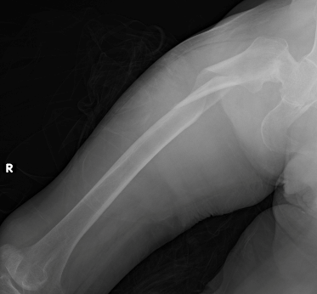From radiography **Figure 1 (A)**, patient was found with closed ipsilateral neck and subtrochanteric femoral fracture and osteopenia. Patient was then decided to undergo elective urgent surgery for bipolar hemiarthroplasty and ORIF with Plate and Screws.

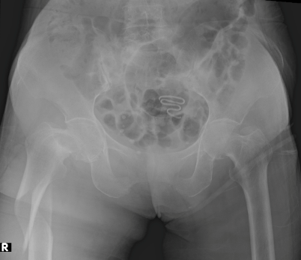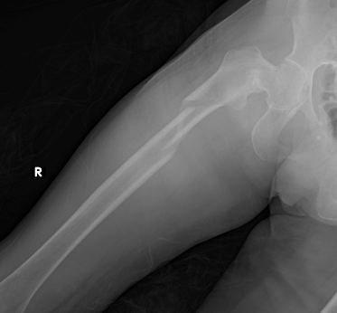

Figure 1 (A) Radiographs show Ipsilateral Right Femoral Neck Fracture Garden Type 3 (Basicervical Type) and Right Femoral Subtrochanteric Fracture Russel-Taylor Classification Type 1A

Surgical Approach

**Femur:** The patient is positioned in the Left Lateral Decubitus position. A posterior approach incision is made and extended to the proximal femur with a lateral approach. **Superficial Dissection found** fat, fascia, and gluteus maximus. **Deep Dissection:** Internal rotation of the hip is performed, identification of the short External Rotator, stay suture is applied to the SER tendon, followed by dissection, the joint capsule is identified, and a posterior capsulotomy is performed with an inverted T shape, a fracture is found on the femoral neck, femoral head extraction is performed, and osteotomy of the remaining femoral neck is done. **Lateral Approach Incision:** The incision is deepened layer by layer until the fascia of the vastus lateralis muscle is identified. An incision is made 1 cm above the greater trochanter, and a split is made in the vastus lateralis muscle until the femur is reached. Seen a subtrochanteric femur fracture with a long oblique configuration is identified. Temporary reduction is performed using a narrow plate and two circlage wires tied to the plate. **Neck Femur:** Reaming of the medullary canal is done, followed by the insertion of a trial femoral component size 2. Limb length and stability are evaluated (flexion, extension, internal rotation, adduction, and telescoping). The femoral stem is then cemented in size 9, with a femoral head diameter of 28/0 mm and a bipolar head of 42/28 mm. **Femur: Shown in Figure 2.** The narrow plate used for temporary fixation at the beginning is removed, and reduction and fixation are performed using a broad 14-hole non-locking plate with 9 screws and 2 circlage wires on the proximal part of the plate. Limb length and stability are re-evaluated and found to be stable. The capsule, gluteus medius, vastus lateralis, and fascia are sutured, and a drain is placed. The fat, subcutaneous tissue, and skin are sutured. The operation is complete, **Blood loss during the operation:** 1200cc.

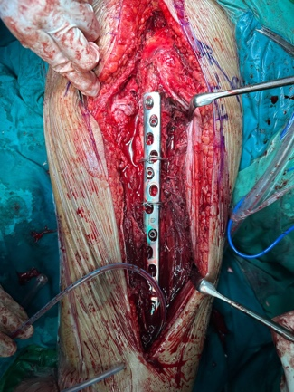

Figure 2. Intraoperative approach

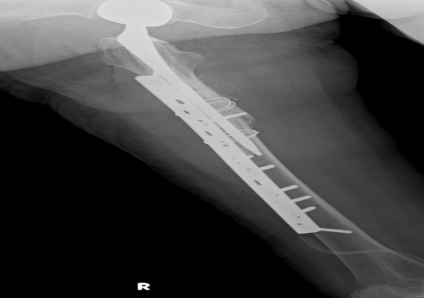

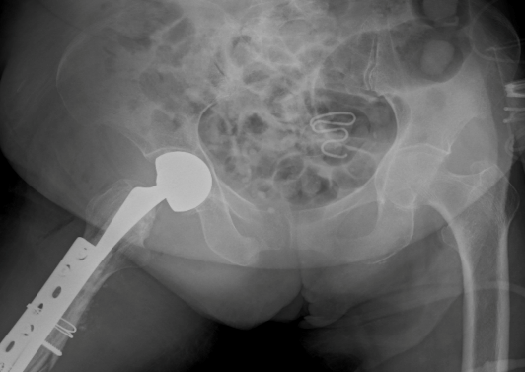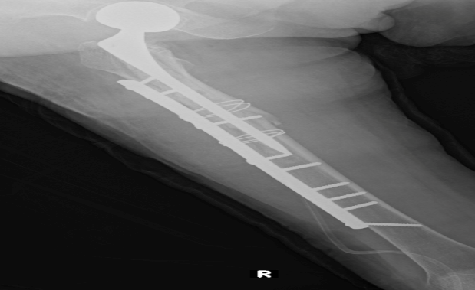

Figure 3. Post-Operative X-Ray

Discussion:

Ipsilateral femoral neck and subtrochanteric fractures are rare and complex injuries, often resulting from high-energy trauma. The management of such fractures requires careful consideration of the patient's age, bone quality, and functional demands. In this case, a combined approach of bipolar hemiarthroplasty with lateral plate and cable fixation was employed, demonstrating favourable outcomes. Concomitant fractures of the femoral neck and subtrochanteric region present significant challenges. The femoral neck fracture typically requires early fixation to prevent complications such as avascular necrosis, while the subtrochanteric fracture needs robust fixation to ensure stability during the healing process. The combination of these fractures complicates the clinical approach, making it difficult to achieve optimal results using traditional treatment methods (11).

Bipolar hemiarthroplasty is often considered in elderly patients with displaced femoral neck fractures, especially when the femoral head is comminuted or when there is a high risk of non-union. This procedure provides pain relief and restores hip function, allowing for early mobilization. However, it is important to note that in elderly patients with intertrochanteric fractures, bipolar hemiarthroplasty may not be the primary treatment option due to potential complications and functional outcomes (12). The use of lateral plate and cable fixation for the subtrochanteric fracture offers several advantages. This method provides stable fixation, which is crucial for the healing of subtrochanteric fractures. The lateral plate offers good mechanical stability, while the cable fixation serves to hold the bone fragments in place, reducing the chance of displacement during healing. This combined approach has been associated with good clinical results following two-level proximal femoral fractures in elderly patients (11).

The combined approach resulted in satisfactory functional outcomes for the patient, with stable fixation and restoration of limb length. Although the recovery process was lengthy, the decision to use both the hemiarthroplasty and the plate and cable fixation ensured that both fractures were adequately managed. This case highlights the importance of individualized treatment strategies for complex fractures involving the proximal femur. Furthermore, it emphasizes the need for careful planning when dealing with fractures in patients with poor bone quality or multiple concurrent injuries (11). This case underscores the need for a multimodal approach when treating ipsilateral femoral neck and subtrochanteric fractures. Surgeons should be aware of the potential for complications such as implant failure, infection, or complications related to the surgery. Regular follow-up and radiographic monitoring are crucial to ensure that the fractures heal properly and that the patient’s functional outcomes are maximized. More studies and case reports are necessary to better understand the long-term outcomes of this combined approach and to refine surgical techniques for similar fractures (10) (11).

Conclusion

In conclusion, the combination of bipolar hemiarthroplasty with lateral plate and cable fixation provides a viable and effective treatment for complex femoral fractures, particularly in patients with severe or multiple fractures of the femur. This case report contributes to the growing body of knowledge regarding the management of these challenging injuries, offering insights into both the surgical technique and potential outcomes.

Disclaimer (Artificial intelligence)

Option 1:

Author(s) hereby declares that NO generative AI technologies such as Large Language Models (ChatGPT, COPILOT, etc.) and text-to-image generators have been used during the writing or editing of this manuscript.

Option 2:

Author(s) hereby declares that generative AI technologies such as Large Language Models, etc. have been used during the writing or editing of manuscripts. This explanation will include the name, version, model, and source of the generative AI technology and as well as all input prompts provided to the generative AI technology

Details of the AI usage are given below:

1. None of them

2.

3.

References

1. V DMKR, G DG, Gandra DA, Shah DR. Clinical profile of patients with acute fracture neck of femur. Int J Orthop Sci. 2019;5(2):1142–4.

2. Filipov O. Femoral Neck Fractures – Biological Aspects and Risk Factors. J IMAB - Annu Proceeding (Scientific Pap. 2014;20(4):513–5.

3. Joglekar SB, Lindvall EM, Martirosian A. Contemporary Management of Subtrochanteric Fractures. Orthop Clin North Am [Internet]. 2015;46(1):21–35. Available from: http://dx.doi.org/10.1016/j.ocl.2014.09.001

4. Dell RM, Adams AL, Greene DF, Funahashi TT, Silverman SL, Eisemon EO, et al. Incidence of atypical nontraumatic diaphyseal fractures of the femur. J Bone Miner Res. 2012;27(12):2544–50.

5. Napoli N, Schwartz A V., Palermo L, Jin JJ, Wustrack R, Cauley JA, et al. Risk factors for subtrochanteric and diaphyseal fractures: The study of osteoporotic fractures. J Clin Endocrinol Metab. 2013;98(2):659–67.

6. Walter N, Szymski D, Kurtz S, Alt V, Lowenberg DW, Lau E, et al. Factors associated with mortality after proximal femoral fracture. J Orthop Traumatol [Internet]. 2023;24(1):23–5. Available from: https://doi.org/10.1186/s10195-023-00715-5

7. Krishna V, Venkatesan A, Singh AK. Functional and Radiological Outcomes of Unstable Proximal Femur Fractures Fixed With Anatomical Proximal Locking Compression Plate. Cureus. 2022;14(5).

8. Liu B, Li A, Wang J, Wang H, Zhai G, Ma H, et al. Cemented versus uncemented hemiarthroplasty for elderly patients with displaced fracture of the femoral neck: A PRISMA-compliant meta-analysis of randomized controlled trial. Med (United States). 2020;99(33):E21731.

9. Moon NH, Shin WC, Do MU, Kang SW, Lee SM, Suh KT. High conversion rate to total hip arthroplasty after hemiarthroplasty in young patients with a minimum 10 years follow‐up. BMC Musculoskelet Disord. 2021;22(1):1–8.

10. Zhang L, Tang P, Hu F, Shen J, Zhang L. Proximal femoral nail antirotation versus hemiarthroplasty: A study for the treatment of intertrochanteric fractures. Injury [Internet]. 2012;43(6):876–81. Available from: http://dx.doi.org/10.1016/j.injury.2011.11.008

11. Vluggen TPMJ, Van Vugt R, Boonen B, Keulen MHF. Management of two-level proximal femoral fractures. BMJ Case Rep. 2021;14(5):1–9.

12. Huang J, Shi Y, Pan W, Wang Z, Dong Y, Bai Y, et al. Bipolar Hemiarthroplasty should not be selected as the primary option for intertrochanteric fractures in elderly patients. Sci Rep. 2020;10(1):1–5.