**Insilico docking analysis of antimalarial and anticancer potentials of a hydrazone derivative of 2-amino-4-thiazoleacetic acid hydrazide**

**Abstract**

2-amino-4-thiazoleacetic acid hydrazide (ATAH) was prepared from the reaction of ethyl-2-amino-4-thiazoleacetate with hydrazine hydrate. The hydrazone derivative, 2-(2-amino-1,3-thiazol-4-yl)-*N*'-[(*E*)-(4-methoxyphenyl)methylidene]acetohydrazide (ATAPH) was synthesized by the condensation reaction of 2-amino-4-thiazoleacetic acid hydrazide (ATAH) with 4-methoxybenzaldehyde. The synthesized compounds were characterized using spectro-analytical methods. The Insilico docking studies of the synthesized compound were performed against some antimalarial targets; P.falciparum lactate dehydrogenase (PfLDH) (PDB ID: 1U5A), P.falciparum dihydrorotate dehydrogenase (PfDHODH)(PDB ID: 3UM8), P.falciparum dihydrofolate reductase (PfDHFR)(PDB ID: 6155)and some anticancer targets; Epidermal Growth Factor Receptor (EGFR) (PDB ID: 3POZ), Selective Androgen Receptor Modulator (SARM) (PDB ID: 3V49), and Abl-Tyrosine kinase (Abl) (PDB ID: 1IEP). The insilico docking studies revealed that the antimalarial activity was higher than the anticancer activity. ATAPH exhibited better binding affinity compared to ATAH indicating its potential as a promising antimalarial and anticancer agents. The physicochemical properties revealed the drug-likeness ability of the compounds.

**Keywords:** Hydrazone, Insilico studies, Molecular docking, 2-amino-4-thiazoleacetic acid hydrazide,

4-methoxybenzaldehyde

**Introduction**

Heterocyclic compounds constitute most areas of medicinal and organic chemistry. Most drugs possess therapeutic activity because of the presence of heterocyclic moiety which forms part of their structure. A moderate change in the structure of the heterocyclic moieties may result in a major or minor change in the therapeutic response of the drug candidate. Among all heterocyclic compounds, the compounds containing nitrogen and sulfur atoms serve as a unique resource for drug development such as 2-aminothiazoles ([Singh](https://pubmed.ncbi.nlm.nih.gov/?term=Singh+H&cauthor_id=35616666) et al., 2023). 2-aminothiazoles constitute a significant class of organic medicinal compounds utilized as starting material for the synthesis of diverse range of heterocyclic compounds. Ethyl-2-amino-4-thiazoleacetate is a thiazole derivative with significant biological activity. It plays role as an intermediate in the synthesis of antibiotics. It acts as a potential therapeutic agent against various diseases. This compound has gained attention due to its diverse applications especially in the fields of pharmacology and medicinal chemistry.

Hydrazone moiety plays an important key role in heterocyclic chemistry (Turan-Zitouni et al., 2001; Gao & Wei, 2013; Pal Samudranil & Rao, 2013; Chang et al., 2013; Lamaty et al., 2013; Hu et al., 2012; Jacobsen & Eric Tan, 2007). Hydrazone is a class of organic compounds with structure R1R2C=NNH2. They are related to ketones and aldehydes by the replacement of the oxygen with the NNH2 functional group. They are formed usually by the action of hydrazine on ketones or aldehydes (Stork & Benaim, 1988; Day & Whiting, 1970). Hydrazide-hydrazones are a family of organic molecules containing the hydrazone functionality attached to a carbonyl group (−C=N−NH−CO). These molecules are extremely versatile and can be obtained from modular reactions between hydrazides and aldehydes or ketones, Recently, hydrazide-hydrazones have gained great importance due to their diverse biological properties including anti-inflammatory, antibacterial, antifungal, antituberculosis, antimalarial and anticonvulsant activities.

Cancer is a set of fatal diseases that cause death and is considered a serious global health concern. Many factors which can be environmental, physical, chemical, and genetic factors stimulate and induce the onset and progression of cancer. Radiation and surgery are the main traditional therapies used in the treatment of most cancer diseases and the prevention of its recurrence. Various conservative therapies are dependent on synthetic anticancer drugs, including chemotherapy and targeted therapies (Arora et al., 2022; An et al., 2022).Malaria is a disease of public health importance, particularly in sub-Saharan Africa. Most malaria control efforts are faced with the challenge of antimalarial drug resistance. New treatment methods are required to combat the threat of drug resistance, especially in developing countries.

Computer-aided drug design (CADD) techniques are required to identify new compounds that can target important parasite genes such as P. falciparum lactate dehydrogenase (PfLDH) (Saxena et al., 2019; Joshi et al., 2022), P. falciparum dihydroorotate dehydrogenase (PfDHODH) (Owoloye et al., 2020; Ibrahim et al, 2022) and P. falciparum dihydrofolate reductase (PfDHFR) (Ojo, 2021; Balogun, et al., 2020) as well as cancerous cells and diseases. Consequently, researchers focus their interests on discovering and developing novel, safe, and effective compounds for cancer therapy as well as malaria treatment with minimum side effects.

**Materials and Methodology**

Ethyl-2-amino-4-thiazoleacetate, hydrazine hydrate and 4-methoxybenzaldehyde were obtained from Sigma-Aldrich Chemical Company Ltd. All were used without further purification. Melting points were determined by using Gallenkamp model melting point apparatus. Characterization of the synthesized compounds was made through spectrophotometric analysis; UV-Vis (Aquamatic Scientificspectrophotometer 4.6.0 in DMF solution in the range 240-600 nm) and FT-IR (Agilent spectrophotometer in KBr pellets in the range 4000 – 400cm-1), 1H NMR (Nanalysis-X685 using DMSO).

**Preparation of 2-amino-4-thiazoleacetic acid hydrazide (ATAH)**

2-amino-4-thiazoleacetic acid hydrazide was prepared from 1 mol of hydrazine hydrate and 1 mol of ethyl-2-amino-4-thiazoleacetate using standard method as in literature (Nwabueze, 1992). 4.88ml (0.10 mol) of hydrazine hydrate was added to 18.63 (0.10 mol) of ethyl-2-amino-4-thiazoleacetate dissolved in 200 ml of absolute ethanol. The solution was refluxed for four hours. It was left for three days to crystallize. The light brown crystals obtained were filtered, recrystallized from ethanol and dried over silica gel in a desiccator. Yield 71%, m.p. 88 – 90 °C; UV-visible (kmax, DMF, nm): 326; IR (KBr) cm−1: 3343–3276 (N–H), 3116 (C–H), 1714 (C=O), 1520 (C=C); 1H NMR (DMSO, δ ppm): 3.44 (s, 2H, CH2),1.17 (t, 3H, CH3), 6.30 (s, 1H, Thiazole), 6.84 (s, 2H, NH2); Elemental analysis: C5H8N4OS, Calculated: C 34.87%, H 4.68%, N 32.54%, O 9.29%, S 18.62%.

Fig. 1 Scheme of reaction for the synthesis of 2-amino-4-thiazoleacetic acid hydrazide (ATAH)



**Preparation of 2-(2-amino-1,3-thiazol-4-yl)-*N*'-[(***E***)-(4-methoxyphenyl)methylidene]acetohydrazide (ATAPH)**

2-(2-amino-1,3-thiazol-4-yl)-*N*'-[(*E*)-(4-methoxyphenyl)methylidene]acetohydrazide (ATAPH) was synthesized using a modified method as in the literature (Enedoh et al., 2016). 4.5 ml (0.04 mol) of 4-methoxybenzaldehyde was added to 6.89g (0.04 mol) of 2-amino-4-thiazoleacetic acid hydrazide (ATAH) dissolved in 150ml ethanol. The solution was refluxed for four hours. It was left for twenty-four hours to crystallize. The light yellow crystals obtained were filtered, recrystallized from ethanol and dried over silica gel in a desiccator. Yield 65%, m.p. 182 – 184 °C; UV-visible (kmax, DMF, nm): 318 ; IR (KBr) cm−1 : 3360–3287 (N–H), 3119 (C–H), 1915 (C=O), 1658 (C=N), 1528 (C=C); 1H NMR (DMSO, δ ppm): 3.79 (s, 4H, CH2), 6.27 (s, 1H, Thiazole), 7.20 (m, 4H, Ar), 9.47 (s,1H, H–C=N-N), 11.22 (d,1H, NH); Elemental analysis: C13H14N4O2S, Calculated: C 53.78%, H 4.86%, N 19.30%, O 11.02%, S 11.04%.

## Fig. 2 Scheme of reaction for the synthesis of 2-(2-amino-1,3-thiazol-4-yl)-N'-[(*E*)-(4-methoxyphenyl)

methylidene]acetohydrazide (ATAPH)

**Insilico docking analysis** The Insilico docking analysis was carried out using AutoDock 1.5.7 (Trott & Olson, 2010).The three-dimensional (3D) structure of the hydrazide, 2-amino-4-thiazoleacetic acid hydrazide(ATAH) and the E, Z isomers of the hydrazone derivative, ATAPH was drawn using ACD/ChemSketch (https://www.acdlabs.com) and saved in sdf format before being converted to pdb files. The 3D dimensional structure of the anti-malarial protein targets (PDB ID: 6155, 1U5A, 3UM8), and anti-cancer protein targets (PDB ID:3POZ, 1IEP, 3V49) were retrieved from the protein data bank (<https://www.rcsb.org/>). Ligand files in the pdb format were prepared by AutoDockTools (mgltools.scripps.edu). Atomic charges and hydrogen atoms were merged to the target protein. Kollman and Gasteiger charges were also added. The pdb files of the ligands and receptor were converted to pdbqt formats. The receptor-binding site was defined by a grid box with the size of 60, 60 and 60 Å. The grid box was centered on the coordinates (x, y and z, respectively); 31.584, 64.828 and 52.587 (PDB 1D; 6I55); 25.822, 26.832, 9.351(PDB 1D; 1U5A); 36.673, 11.361, 37.754 (PDB 1D; 3UM8); 19.543, 24.708, 15.191(PDB 1D; 3POZ), 21.701, 4.707, 9.929 (PDB 1D; 3V49) and 12.332, 54.45, 22.147 (PDB 1D; 1IEP). A set of grid maps was created. The default docking parameters of AutoDock 1.5.7 were utilized except for the number of Lamarckian Genetic Algorithm (LGA) runs, which was set to 10 runs. Insilico docking simulations were executed. The scoring function was utilized to predict the binding affinity of the receptor-ligand interaction. The most suitable conformation with the lowest binding energy was chosen. Docking results were visualized using Discovery Studio Visualizer (<https://www.3ds.com>). 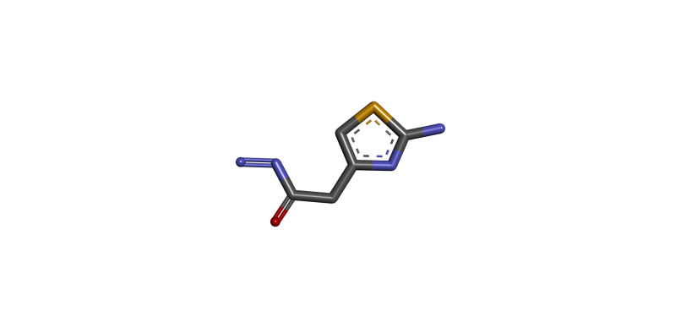

Fig. 3 3D diagram of the hydrazide, 2-amino-4-thiazoleacetic acid hydrazide (ATAH)  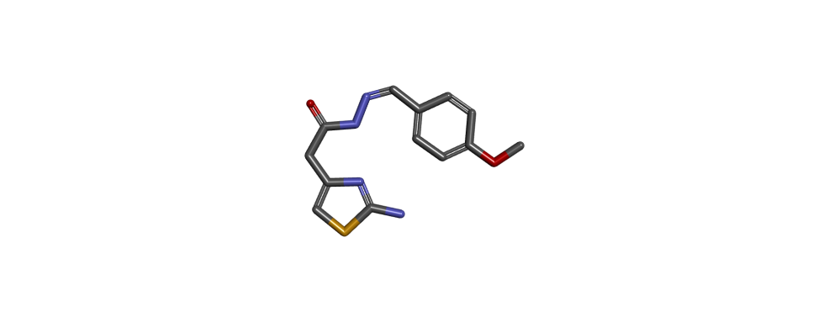

E-ATAPH Z-ATAPH

2-(2-amino-1,3-thiazol-4-yl)-*N*'-[(*E*)-(4-methoxy 2-(2-amino-1,3-thiazol-4-yl)-*N*'-[(*Z*)-(4-phenylmethylidene]acetohydrazide (E-ATAPH) methoxyphenyl)methylidene]acetohydrazide

(Z-ATAPH)

Fig. 4 3D diagram of E and Z isomers of the hydrazone derivative of 2-amino-4-thiazoleacetic acid hydrazide.

**Drug-likeness properties**

The drug-likeness properties of the hydrazide, ATAH and hydrazone derivative, ATAPH were determined with some physicochemical parameters using the SwissADME software (Daina et al., 2017). The physicochemical parameters determined were molecular weight (MW), hydrogen bond acceptor (HBA), hydrogen bond donor (HBD), topology polar surface area (TPSA), lipophilicity parameter (log P) and number of rotatotable bonds (NoRB). The Lipinski’s rule of five was used to investigate the drug-likeness property (Lipinski, 2000). Lipophilicity (log P) was used to measure how a compound can readily be absorbed through biological membranes and also move through the body to enhance its efficacy. The oral bioavailability of the synthesized compounds was determined using topology polar surface area (TPSA).

**Result and discussion**

**Chemistry**

2-amino-4-thiazoleacetic acid hydrazide (ATAH) was synthesized by reacting ethyl-2-amino-4-thiazoleacetate and hydrazine hydrate. The synthesized hydrazide was collected as light brownish crystals. The hydrazone derivative, 2-(2-amino-1,3-thiazol-4-yl)-*N*'-[(*E*)-(4-methoxyphenyl)methylidene]acetohydrazide (ATAPH) was obtained by reacting 2-amino-4-thiazoleacetic acid hydrazide with 4-methoxybenzaldehyde. The hydrazone, ATAPH was collected as light yellowish solids. Purity of the synthesized compounds was ensured by recrystallization in appropriate solvents.

Table 1 Physical data of synthesized compounds (ATAH and ATAPH)

|  |  |  |  |  |  |  |  |  |  |  |  |
| --- | --- | --- | --- | --- | --- | --- | --- | --- | --- | --- | --- |
| Synthesized  Compound | | Molecular formula | MWcalculated (g/mol) | | M.P (°C) | | Physical state | | Color | | % Yield |
| ATAH | C5H8N4OS | | | 172.21 | 88 – 90 | crystal | | light brown | | 71 | |
| ATAPH | C13H14N4O2S | | | 290.34 | 182 – 184 | solid | | light yellow | | 65 | |

The UV spectra experienced a hypsochromic shift from 326 nm (ATAH) to 318 nm (ATAPH) which is attributed to n → π* transition of the azomethine group. This indicates that the hydrazone azomethine group was formed. The FTIR spectrum of the synthesized compounds, ATAH and ATAPH revealed the presence of characteristic absorption bands at 3343-3276 cm−1 and 3336-3287cm−1respectively which was attributed to the NH group. In ATAPH, the absence of band for C=O stretching vibrations around 1714 cm−1 and the presence of a band for the C=N group around 1658 verified the formation of the compound. 1H NMR spectrum of ATAH showed singlet of amine and thiazole proton at 6.84 ppm and 6.30 ppm. Moreover, singlet and triplet of CH2 and CH3 was observed 3.44 ppm and 1.17 ppm respectively. Singlets of H–C=N-N imine at 9.47ppm and thiazole proton at 6.27 ppm were observed for ATAPH. Moreover, quartet and multiplet of CH2 and C6H6 were observed at 3.79 ppm and 7.20 ppm respectively.

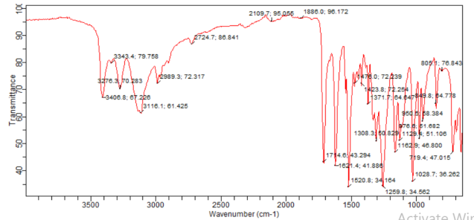 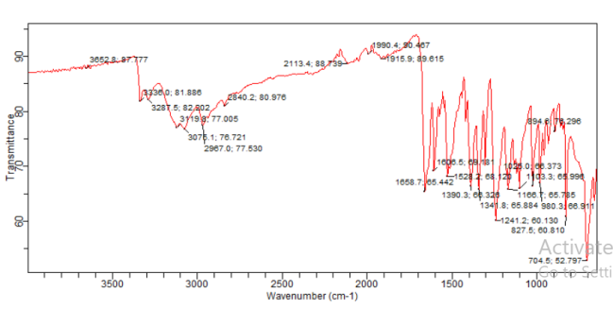

Fig. 5 Infra-red spectra of ATAH and ATAPH

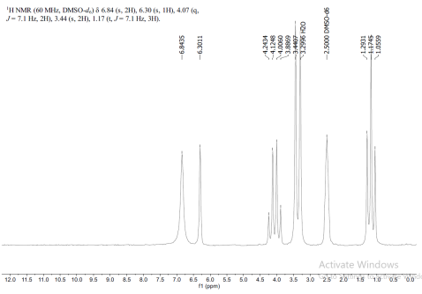 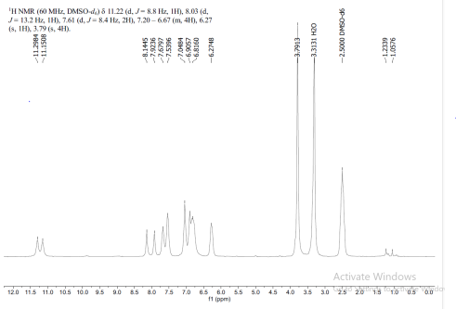

Fig. 6 1HNMR Spectra of ATAH and ATAPH

**Insilico study result**

Insilico docking analysis was used to determine how amino acid residues of the target proteins interact with the hydrazide and hydrazone derivative. The binding energies and the protein-ligand interactions of three antimalarial targets, and three anticancer targets with the synthesized compounds were obtained. The binding free energy were summarized in Table 2-7 while the 2D and 3D protein-residue interaction shown in Fig. 7-18.

**Binding free energy**

Among the synthesized compounds, E-ATAPH exhibited the highest binding energy to PfLDH with a ΔG value of -7.07 kcal/mol. All the compounds had lower binding energy compared to the co-crystallized ligand which had a binding energy of -7.56 kJ/mol. The binding affinity of the compounds after docking on the protein increased in the order; ATAH (–-5.41kcal/mol) < Z- ATAPH (– 6.5 kcal/mol) < E-ATAPH (– 7.07kcal/mol) < co-crystallized ligand (-7.56 kcal/mol).

**Molecular interaction**

While interacting with the amino acid residues in the ligand-binding domain of PfLDH, E-ATAPH and ATAH formed hydrogen bond interactions with GLY 196, ASN 140, HIS 195 and ASN 197, VAL 144 respectively. There was no hydrogen bond interaction in Z-ATAPH and co-crystallized ligand but other interactions such as carbon-hydrogen bond, alkyl, and van der Waals interactions, pi-alkyl, pi-sigma and pi-cation were observed.

Table 2 Binding energy and protein-residue interaction of ATAH, E-ATAPH and Z-ATAPH with p. falciparum lactase dehydrogenase (pfLDH) inhibitor (PDB ID: 1U5A)

|  |  |  |  |  |
| --- | --- | --- | --- | --- |
| Compound | Binding  Energy (kJ/cal) | Hydrogen Bond | Van der Waal | Other interactions |
| ATAH | -5.41 | ASN 197  VAL 144 | LYS 198, GLU 321, VAL 142  THR 322 | carbon-hydrogen bond: GLY 196  pi-alkyl: ALA 194, MET 325, PRO 141 |
| E-ATAPH | -7.07 | GLY 196  ASN 140  HIS 195 | ARG 171, VAL 142, ASP 143  THR 322, LEU 163, ILE 31  VAL 138 | pi-alkyl: PRO 246, PRO 250, ALA 236, PRO 141, ALA 194  alkyl:PRO 141, MET 325,VAL 144  pi-sigma: LEU 167  pi-suphur: HIS 195 |
| Z-ATAPH | -6.90 | - | ALA 194,VAL 142, ASN 140  ASN 234,VAL 233, THR 235  ARG 171,THR 232, GLY 196  MET199, ASP 168, ASP 143 | carbon-hydrogen bond: HIS 195, THR 322  alkyl: MET 325  pi-alkyl: PRO 141, VAL 144  pi-sigma: ALA 236 |
| Co-ligand | -7.56 | - | ALA 253, GLU 256,VAL 166 ASN 188, VAL 187, PRO 184  SER 170, LEU 167, ALA 249  ALA 252 | carbon-hydrogen bond: ARG 185, LYS 173  pi-alkyl: LYS 173  pi-cation: ARG 185 |

**Binding energy**

Z-ATAPH exhibited the highest binding energy to PfDHFR with a ΔG value of -9.10 kJ/cal compared to the co-crystallized ligand which has a binding energy of -8.83 kcal/mol. ATAH exhibited the lowest binding energy of -6.58 kcal/mol. The binding affinity of the compounds after their docking on the protein increased in the order; ATAH (-6.58 kcal/mol) < E-ATAPH (-8.54 kcal/mol) < co-crystallized ligand (-8.83 kcal/mol) < Z-ATAPH (–9.10 kcal/mol)

**Molecular interaction**

The highest binding compound against PfDHFR is Z-ATAPH which formed hydrogen bond with HIS 185. ATAH and E-ATAPH exhibited hydrogen bond interaction with GLY 478, ILE 508 and SER 477, GLY 507, ASN 342 respectively. Furthermore, the co-crystallized ligand formed hydrogen bond with SER 529. Carbon-hydrogen bond, pi-donor hydrogen bond, pi-pi T-shaped, pi-sigma, pi-sulphur, pi-alkyl and alkyl interactions were also observed.

Table 3 Binding energy and protein-residue interactions of ATAH, E-ATAPH and Z-ATAPH with p. falciparum dihydrofolate reductase (pfDHFR) inhibitor (PDB ID: 6155)

|  |  |  |  |  |
| --- | --- | --- | --- | --- |
| Compound | Binding  Energy (kJ/cal) | Hydrogen Bond | Van der Waal | Other interactions |
| ATAH | -6.58 | GLY 478  ILE 508 | PHE 509, CYS530, GLN526, SER 505, TYR 52 , GLY 506,  THR 459, LEU 481 | carbon-hydrogen bond: SER 529, SER 477  pi-donor hydrogen bond: GLY 507 |
| E-ATAPH | -8.54 | SER 477  GLY 507  ASN 342 | ASN 458,ASN 274, LYS 429, THR 459, SER 505, GLN 526,  PHE 278, GLY 226, LEU 481, GLY 248, LEU 481, GLY 478, ILE 508 | carbon-hydrogen bond: SER 529, ILE 508  pi-donor hydrogen bond: GLY 506  alkyl : LEU 527, CYS 530  pi-pi T-shaped: TYR 528 |
| Z-ATAPH | -9.10 | HIS 185 | GLY 535, CYS 184, HIS 185, GLY 181, ARG265, GLU 182,  1LE 272, ASN 274 | pi-sigma : PHE 188, ILE 263  pi-pi T-shaped: PHE 188  pi-sulphur : TYR 528 |
| Co-ligand | -8.83 | SER 529  GLY 478 | LYS 229, ALA 225, GLY 226  ASN 274, SER 477, GLY 507  ILE 508, LEU 529, GLN 526, ALA 224, SER 505, THR 459, LYS 429, ASN 458, GLY 226 | carbon-hydrogen bond: GLY 507,  GLY 506  pi-donor hydrogen bond: SER 477  pi-alkyl : ILE 272 |

**Binding energy**

Furthermore, all the synthesized compounds; ATAH, E-ATAPH and Z-ATAPH exhibited better binding affinities with ΔG values of-5.40 kJ/cal, -7.16 kJ/cal and -6.87 kJ/cal respectively compared to the co-crystallized ligand with binding energy of -5.31 kJ/cal. This finding reveals the potential of the synthesized compounds as PfDHODH inhibitors. The binding affinity of the compounds after their docking on the protein increased in the order; co-crystalIized ligand (-5.31kcal/mol) <ATAH (-5.40 kcal/mol) < Z-ATAPH (-6.87kcal/mol) < E-ATAPH (-7.16kcal/mol).

**Molecular interaction**

In the characteristic binding to the ligand-binding site of PfDHODH, ATAH formed hydrogen bond interactions with TYR 365. E-ATAPH and Z-ATAPH formed hydrogen bond with TYR 365, VAL 213, GLN 327 and TYR 365 respectively. The amino acid, TYR 365 is common to the three synthesized compounds and can be regarded as an active site for protein-ligand interaction. Also, the co-crystalized ligand formed hydrogen bond interactions with TYR 322, ASP 212 and ASP 361. There were other hydrophobic interactions such as carbon-hydrogen bond, pi-donor hydrogen bond,pi-alkyl, pi-anion, amide-pi stacked and Sulphur –X.

Table 4 Binding energy and protein-residue interaction of ATAH, E-ATAPH and Z-ATAPH with p. falciparum dihydrorotate dehydrogenase (pfDHODH) inhibitor (PDB ID: 3UM8)

|  |  |  |  |  |
| --- | --- | --- | --- | --- |
| Compound | Binding  Energy kJ/cal | Hydrogen Bond | Van der Waal | Other interactions |
| ATAH | -5.40 | TYR 365 | THR 220, THR 215, GLN 364  LEU 362, PHE 366, THR 219  THR 573, ASN 218, LYS 575 | Sulphur –X : LEU 574 |
| E-ATAPH | -7.16 | TYR 365  VAL 213  GLN 327 | GLN 542, PHE 360, LYS 359  TYR 322, LYS 321, ASN 330  TYR 326, HIS 323, PRO 324  GLN 364 | pi-anion: ASP 361, ASP 212 |
| Z-ATAPH | -6.87 | TYR 365 | GLN 542, ASN 330, TYR 326  LYS 321, TYR 322, GLN 327  LYS 359, PHE 360, GLN 364  ASP 212, VAL 213 | carbon-hydrogen bond: HIS 323  pi-alkyl: TYR 214, PRO 324  pi-anion: ASP 361 |
| Co-ligand | -5.31 | TYR 322  ASP 212  ASP 361 | HIS 323, TYR 365, GLN 542  PHE 360, ASN 330 | carbon-hydrogen bond: TYR 365, LYS 321, GLN 327, TYR 322  pi-donor hydrogen bond: LYS 359  pi-alkyl: PRO 324  amide-pi stacked: TYR 326 |

**Binding energy**

The co-crystallized ligand exhibited the strongest interaction with EGFR with binding energy of -10.65kcal/mol. The binding energy of E-ATAPH is -7.92kcal/mol. Other compounds, ATAH and Z-ATAPH exhibited binding energies of-7.48kJ/mol and -5.65kJ/mol respectively. The binding affinity of the compounds increased in the order; ATAH (-5.65kcal/mol) < Z- ATAPH (– 7.48 kcal/mol) < E-ATAPH (– 7.92kcal/mol) < co-crystallized ligand (-10.65 kcal/mol).

**Molecular interaction**

While interacting with the amino acid residues in the ligand-binding domain of EGFR, E-ATAPH and Z-ATAPH formed hydrogen bond interactions with MET 793, THR 854, CYS 775, MET 766 and CYS 775, MET 766, LYS 745 respectively. ATAH had hydrogen bond interaction on MET 766, LEU 788, ALA 743. The amino acid MET 766 was common to all of them indicating its significance as an active site for protein-residue interaction. Co-crystalized ligand exhibited hydrogen bonds with MET 793, ASN 842, ARG 841, THR 854, LEU 777. Other interactions such as carbon-hydrogen bond, pi-alkyl, pi-sigma, pi-pi T-shaped, pi-sulphur, pi-donor hydrogen bond, alkyl were observed.

Table 5 Binding energy and protein-residue interaction of ATAH, E-ATAPH and Z-ATAPH with Epidermal Growth Factor Receptor (EGFR) (PDB ID: 3POZ)

|  |  |  |  |  |
| --- | --- | --- | --- | --- |
| Compound | Binding  Energy kJ/cal | Hydrogen Bond | Van der Waal | Other interactions |
| ATAH | -5.65 | MET 766  LEU 788  ALA 743 | ASP 855, LEU 858, THR 854  ILE 789, ILE 744, LYS 745  CYS 775, ARG 776 | pi-alkyl: LEU 77  pi-sigma: PHE 856  pi-pi T-shaped: MET 766  pi-sulphur: PHE 856 |
| E-ATAPH | -7.92 | MET 793  THR 854  CYS 775  MET 766 | GLY 796, GLN 791, THR 790  ARG 776, ASP 855, LEU 788  LYS 745, VAL 726 | pi-alkyl: LEU 718, LEU 792, LEU 1001  alkyl: ALA 743, LEU 777  pi-pi T-Shaped: PHE 856  pi-sulphur: PHE 856 |
| Z-ATAPH | -7.48 | CYS 775  MET 766  LYS 745 | LEU 844, ILE 744, ILE 789, ARG 776, LEU 788, ASN 842 | pi-donor hydrogen bond: THR 854  pi-alkyl: ALA 743, LEU 777, VAL 726  pi-pi T-shaped: PHE 856  pi-sigma: MET 766 |
| Co-ligand | -10.65 | MET 793  ASN 842  ARG 841  THR 854  LEU 777 | ILE 789, ILE 744, LEU 1001  GLY796, CYS 797, ASP 855,  THR 790 | carbon-hydrogen bond: GLN 791  alkyl: MET 766, LYS 745, ALA 743  pi-alkyl: PHE 856, VAL 726, LEU 788, LYS 745, LEU 858, LEU 718, LEU 792, ALA 743, LEU 849  pi-sigma: LEU 844  halogen (fluorine) – ARG 779, CYS 775, MET 766 |

**Binding energy**

The binding energy of E-ATAPH and Z-ATAPH were -8.93 kcal/mol and -8.74 kcal/mol respectively. ATAH had a binding energy of -6.18 kcal/mol. The co-crystallized ligand exhibited the strongest interaction with ILEP with a binding energy of -12.97 kcal/mol. The binding affinity of the compounds after docking studies increased in the order; ATAH (-6.18kcal/mol) < Z- ATAPH (– 8.74 kcal/mol) < E-ATAPH (– 8.93kcal/mol) < Co-crystallized ligand (-12.97kcal/mol).

**Molecular interaction**

It was observed that ATAH, E-ATAPH and Z-ATAPH binds to protein target, Abl by forming hydrogen bonds with the amino residues: HIS 295 and GLN 300, GLN 300 and GLN 300 respectively. The synthesized compound binds to the amino acid residue, GLN 300 indicating its function as an active site. The interaction of Abl with the co-crystallized ligand involved the formation of hydrogen bonds with the amino acids; GLU 286, MET 290 and MET 318 and other interactions such as carbon-hydrogen bond, pi-alkyl, pi-sigma, pi-sulphur, pi-pi stacked, pi-pi T-shaped.

Table 6 Binding energy and protein-residue interaction of ATAH, E-ATAPH and Z-ATAPH with Abl-Tyrosine Kinase (Abl) (PDB ID: 1IEP)

|  |  |  |  |  |
| --- | --- | --- | --- | --- |
| Compound | Binding  Energy kJ/cal | Hydrogen Bond | Van der Waal | Other interactions |
| ATAH | -6.18 | HIS 295  GLN 300 | LEU 301, LYS 378, PRO 296  LYS 294 | pi-alkyl: ILE 293, LEU 298  pi-sulphur: MET 290 |
| E-ATAPH | -8.93 | GLN 300 | HIS 361, ASP 381, MET 290  PRO 296, LYS 378, VAL 299  LEU 298, ALA 380, LEU 298  ALA 380, LEU 298, ALA 380  LEU 301, VAL 379, VAL 289  PHE 359 | carbon-hydrogen bond: HIS 295  pi-alkyl: LEU 354, ILE 293  pi-sigma: LYS 294 |
| Z-ATAPH | -8.74 | GLN 300 | VAL 379, ASP 381, ALA 380  MET 290, THR 315, VAL 299  ILE 360 | alkyl: HIS 361, LEU 354  pi-alkyl: LEU 298  pi-sigma: LYS 294, GLN 300, ILE 293  sulphur-X: HIS 295 |
| Co-ligand | -12.97 | GLU 286  MET 290  MET 318 | GLY 321, ALA 380, VAL 299  ILE 293, VAL 289, ILE 360  ARG 362, HIS 361, ILE 313  THR 315, PHE 382 | alkyl:ALA 269, VAL 256, LYS 271  pi-alkyl: LEU 370, MET 290, VAL 256, ALA 269, LYS 271  pi-sigma: LEU 248, VAL 256  pi-pi stacked: PHE 317  pi-pi T-shaped: TYR 253 |

**Binding energy**

The co-crystallized ligand hadthe strongest interaction with the protein target, SARM where it gave the binding energy of -10.79 kcal/mol. The binding energy of E-ATAPH and Z-ATAPH are -9.11 kcal/moland-8.38 kcal/mol. respectively. ATAH exhibited binding energyof-5.77 kcal/mol. The binding affinity of the compounds after docking on the protein increased in the order; ATAH (-5.77kcal/mol) < Z-ATAPH (–8.38 kcal/mol) < E-ATAPH (-9.11 kcal/mol) < co-crystallized ligand (-10.79 kcal/mol).

**Molecular interaction**

The co-crystallized ligand and E-ATAPH had hydrogen bond interactions with HIS 874 and ARG 752. While ATAH and Z-ATAPH formed hydrogen bonds with HIS 874 only. The amino acid, HIS 874 is common to all of them. It signifies that compounds and co-crystallized ligand interacted with the same amino acid as active site. Other interactions such as carbon-hydrogen bond, alkyl, pi-alkyl, pi-pi T-shaped, pi-sulphur, pi-donor hydrogen bond were observed as well.

Table 7 Binding energy and protein-residue interaction of ATAH, E-ATAPH and Z-ATAPH with Selective Androgen Receptor Modulators (SARM) (PDB ID: 3V49)

|  |  |  |  |  |
| --- | --- | --- | --- | --- |
| Compound | Binding  Energy kJ/cal | Hydrogen Bond | Van der Waal | Other interactions |
| ATAH | -5.77 | HIS 874 | VAL 903, MET 742, LEU 704  ASN 705, TRP 741, THR 877  ILE 899, PHE 878, LEU 873  PHE 891 | pi – alkyl: MET 895 |
| E-ATAPH | -9.11 | HIS 874  ARG 752 | ASN 705, LEU 704, GLN 711  PHE 764 | carbon-hydrogen bond: THR 877  GLY 708  alkyl: ALA 748  pi-alkyl: LEU 707, MET 749, ILE 899, MET 895  pi-pi T-shaped: MET 742, MET 745pi-sulphur: TRP 741 |
| Z-ATAPH | -8.38 | HIS 874 | LEU 873, VAL 903, LEU 704  ASN 705, GLN 711, GLY 708 | pi-alkyl: ILE 899, LEU 707  alkyl: MET 749, VAL 746, MET 787, PHE 764  pi-sigma: MET 745, THR 877, MET 742  pi-pi T-shaped: PHE 764  pi-sulphur: TRP 741, MET 895, HIS 874 |
| Co-ligand | -10.79 | ARG 752  HIS 874 | MET 787, MET 780, LEU 873  GLN 711, GLY 708, VAL 903  ASN 705, MET 780, MET 787 | carbon-hydrogen bond: GLN 708  pi-donor hydrogen bond: THR 877  alkyl: MET 749, VAL 746, LEU 701, LEU 704, PHE 764  pi-alkyl: LEU 707, ILE 899  pi-sigma: MET 745, MET 742  pi-pi T-shaped: PHE 764, TRP 741 |

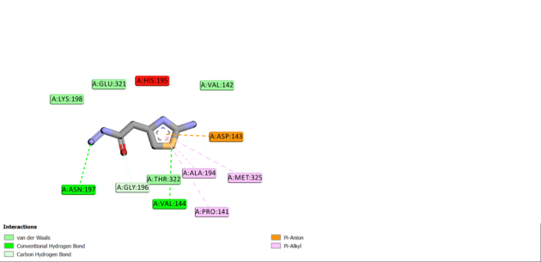 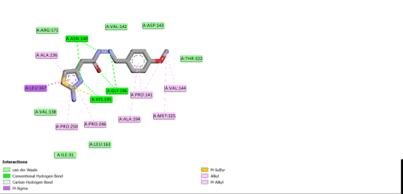

Fig. 7 2D diagram of the interaction of 1U5A with ATAH and E-ATAPH

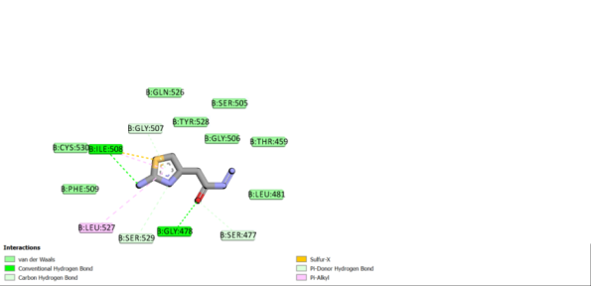 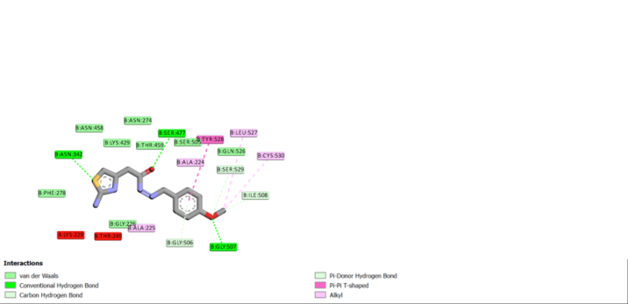

Fig. 8 2D diagram of the interaction of 6155 with ATAH and E-ATAPH

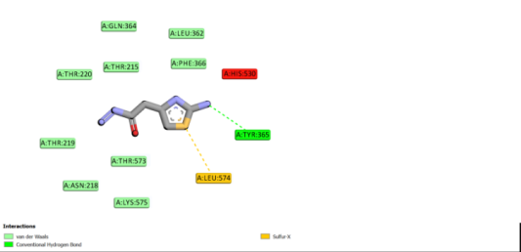 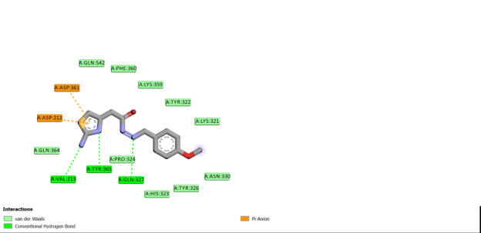

Fig. 9 2D diagram of 3UM8 with ATAH and E-ATAPH

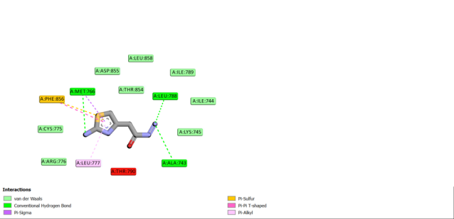 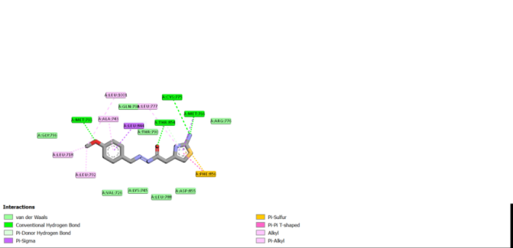

Fig. 10 2D diagram of 3POZ with ATAH and E-ATAPH   
 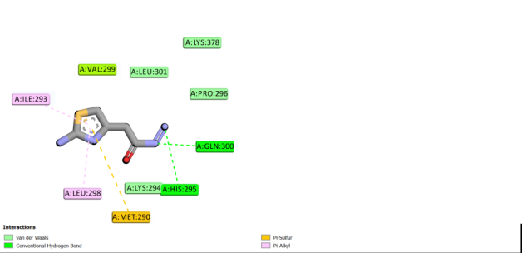 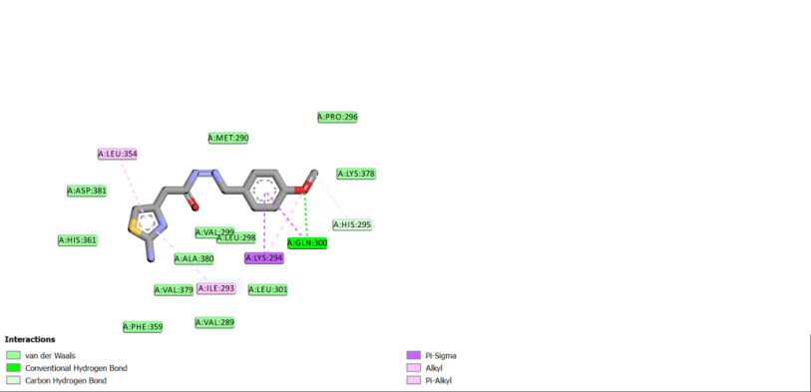

Fig. 11 2D diagram of ILEP with ATAH and E-ATAPH

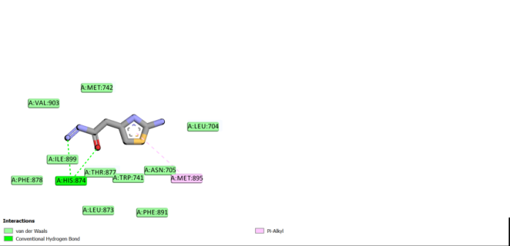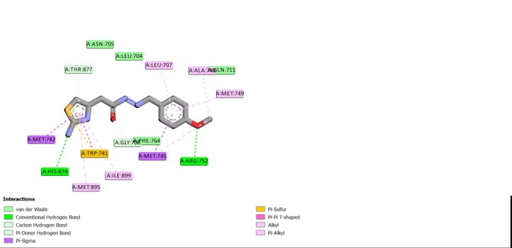

Fig. 12 2D diagram of 3V49 with ATAH and E-ATAPH

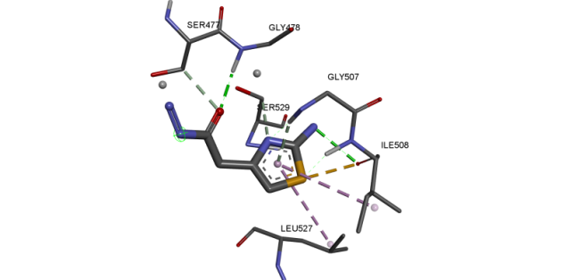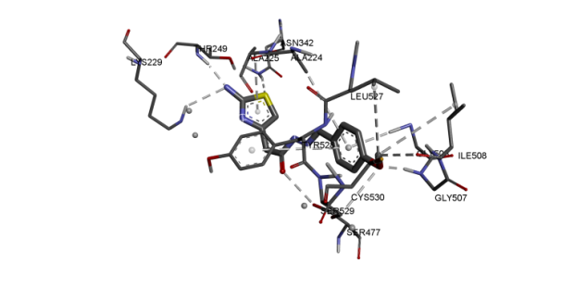

Fig. 13 3D diagram of the interaction of 6155 with ATAH and E-ATAPH

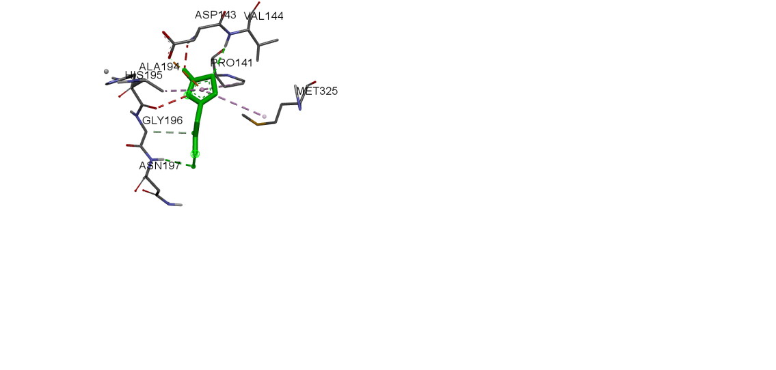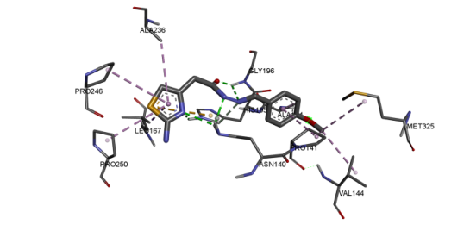

Fig.14 3D diagram of IU5A with ATAH and E-ATAPH

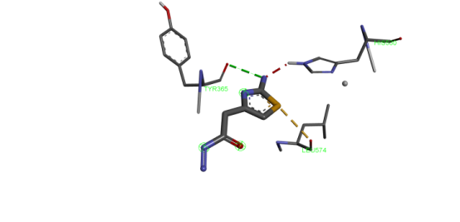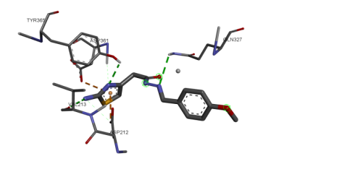

Fig. 15 3D diagram of 3UM8 with ATAH and E-ATAPH

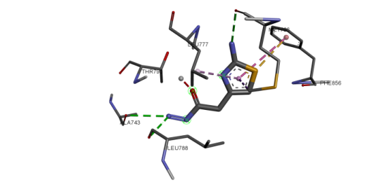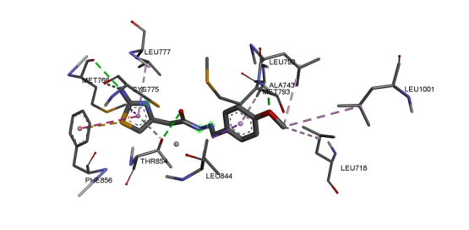

Fig. 16 3D diagram of 3POZwith E-ATAPH

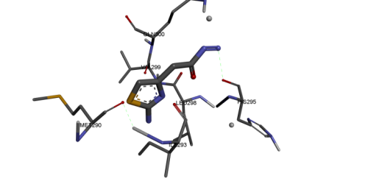 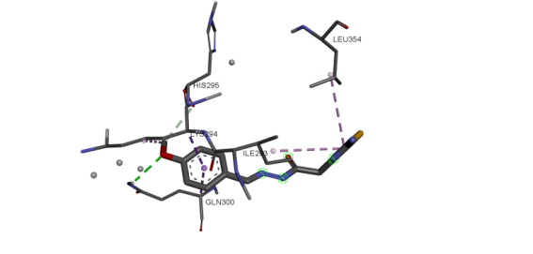

Fig. 17 3D diagram of ILEP with ATAH and E-ATAPH

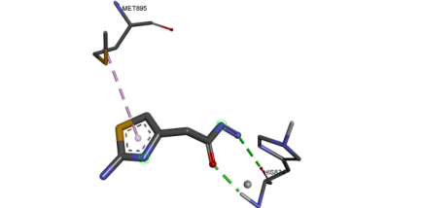 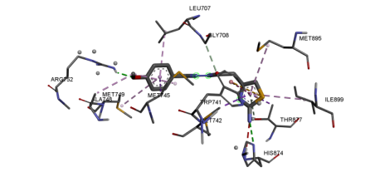

Fig. 18 3D diagram of 3V49 with ATAH an E-ATAPH

**Drug-likeness and physicochemical parameters**

The oral bioavailability and drug-like properties of the compounds were determined using Lipinski rule of 5 (RO5) which states the determinants are Molecular weight ≤ 500, Number of hydrogen bond acceptors ≤ 10, Number of hydrogen bond donor ≤ 5, Calculated n-octanol-water partition coefficient (Clog P) <5.The drug-likeness evaluation for the synthesized compounds indicates favorable physicochemical properties and good lipophilicity as shown in Table 8. ATAH has a molecular weight of 172.21, 3 hydrogen bond donors (HBD), 3 hydrogen bond acceptors (HBA) and log P of – 0.58. ATAPH has a molecular weight of 290.34, 2 hydrogen bond donor (HBD), 4 hydrogen bond acceptor (HBA) and log P of 1.61.The number of rotatable bonds (NRB) for ATAH and ATAPH is 3 and 6 respectively. Topological polar surface area (TPSA) of 122.27 and 117.84 indicate good permeability and absorption.

Table 8 Drug-likeness evaluation result

|  |  |  |  |  |  |  |  |
| --- | --- | --- | --- | --- | --- | --- | --- |
| Compound | MW (g/mol) | HBD | HBA | LogP | NRB | Lipinski  Rule | TPSA |
| ATAH | 172.21 | 3 | 3 | -0.58 | 3 | 0 | 122.27 |
| ATAPH | 290.34 | 2 | 4 | 1.61 | 6 | 0 | 117.84 |

MW = Molecular Weight HBD = Hydrogen Bond Donor HBA = Hydrogen Bond Acceptor

NRB = No of Rotatable Bonds TPSA = Topological Polar Surface Area.

**Conclusion**

In this study, a hydrazide, ATAH and a hydrazone derivative, ATAPH were synthesized and characterized. The insilico potential as antimalarial agents and anticancer agents was studied on some protein targets. Among the three antimalaria protein targets, the synthesized compounds exhibited higher binding affinity to PfDHODHcompared to the co-crystalized ligand. Their potential as anticancer agents revealed that the hydrazone derivative, ATAPH exhibited higher anticancer activity than the hydrazide, ATAH. But the co-crystallized ligands had better binding affinity compared to the synthesized compounds. The synthesized compounds exhibited higher antimalaria activity in comparison to the anticancer activity.The physicochemical parameters supports the synthesized compounds’ potential as a candidate for further drug development studies.Further in vitro and in vivo analysis of these compounds should be carried out to validate these findings.

**Disclaimer (Artificial intelligence)**

Author(s) hereby declare that NO generative AI technologies such as Large Language Models (ChatGPT, OPILOT, etc) and text-to-image generators have been used during writing or editing of manuscripts.

**REFERENCES**

An, J., Peng, C., Xie, X., & Peng, F. (2022) New Advances in Targeted Therapy of HER2-Negative Breast Cancer.

*Front. Oncol.* 12, 828438.

Arora, S., Narayan, P., Osgood, C.L., Wedam, S., Prowell, T.M., Gao, J.J., Shah, M., Krol, D., Wahby, S., Royce,

M., Ghosh, S., Philip, R., Ison, G., Berman, T., Brus, C., Bloomquist, E.W., Fiero, M.H., Tang, S., Pazdur, R., Ibrahim, A., Amiri-Kordestani, L., & Beaver, J.A. (2022) U.S. FDA Drug Approvals for Breast Cancer: A Decade in Review. Clin Cancer Res., 28(6):1072-1086. DOI: 10.1158/1078-0432.CCR-21-2600..

Balogun, T.A., Omoboyowa, D.A. & Saibu, O.A. (2020) In silico anti-malaria activity of quinolone compounds

against Plasmodium falciparum dihydrofolate reductase (PfDHFR), *International Journal of Biochemistry Research & Review*, 29(8), 10–17. DOI: 10.9734/IJBCRR/2020/v29i830208.

Chang, J., Huang, G., Liu, H., Yu, W., Zhang, Y., Chang, J., Dong, L., Li, Y., & Yu, X. (2013) I2-Mediated

Oxidative C-O Bond Formation for the Synthesis of 1,3,4-Oxadiazoles from Aldehydes and Hydrazides, *Journal of Organic Chemistry,* 78, 10337 – 103431.

Daina, A., Michielin, O. &Zoete, V. (2017) SwissADME: a free web tool to evaluate pharmacokinetics, drug-

likeness and medicinal chemistry friendliness of small molecules. *Sci Rep* **7**, 42717 DOI: 10.1038/srep42717

Day A. C. & Whiting M. C. (1970) “Synthesis of some 4-oxobenzotriazolo hydrazones”, Org. Synth., 6, 10.

Enedoh, M.C, Ibeh, F. C. & Ebosie, N. P. (2016) Complexes of 2-amino-4-thiazoleacetic acid hydrazide(ATAH),

salicylaldehyhde-2-amino-4- thiazoleacetic acid hydrazone (ATASH) And acetone-2-amino-4-thiazoleacetic acid hydrazone(ATAAH) each with nickel(II)sulphate As proposed drugs, *African Journal of Education, Science and Technology*,3(1), 143 – 146.

Gao, P. & Wei, Y.(2013) Efficient oxidative cyclization of N-acylhydrazones for the synthesis of 2,5-disubstituted

-3,4-oxadiazoles using t-BuOI under neutral conditions,*Heterocyclic Communications*, 19, 2,113 – 119.

Hu, Y., Lu, X., Chen, K., Yan,R.,Li, Q.,& Zhu, H. (2012) Design, synthesis, biological evaluation and molecular

modeling of 1,3,4-oxadiazoline analogs of combretastatin-A4 as novel antitubulin agents, *Bioorg. Med. Chem*., 20, 903 – 909.

Ibrahim, Z.Y., Uzairu, A., Shallangwa, G.A., Abechi, S.E.,& Isyaku, S. (2022) Virtual screening and molecular

dynamic simulations of the antimalarial derivatives of 2-anilino 4-amino substituted quinazolines docked against a *Pf*-DHODH protein target. *Egypt J Med Hum Genet.*, 23(1):119. DOI: 10.1186/s43042-022-00329-2.

Jacobsen, N., & Eric Tan, L. K. (2007) Indium-mediated asymmetric allylation of acylhydrazones using a chiral

urea catalyst,*Angewandte Chemie* - International Edition., 46, 1315 – 13171.

Joshi, N., Hada, R., Gupta, S., Khan, J., Dobrowolski, J., Dhar, P.K., Kumar, N., & Singh, S. (2022) Highly potent

anti-malarial activity of benzopyrano(4,3-b)benzopyran derivatives and in silico interaction analysis with putative target *Plasmodium falciparum* lactate dehydrogenase. *J Biomol Struct Dyn.*, 40(11):5159-5174. DOI: 10.1080/07391102.2020.1868336.

Lamaty, F., Martin, C., Martinez, J., & Nun, P. (2013) Solvent-free synthesis of hydrazones and their subsequent

N-alkylation in a Ball-mill,*Tetrahedron*., 67, 8187 -8194.

Lipinski, C.A. (2000) Drug-like properties and the causes of poor solubility and poor permeability. *J. Pharmacol.*

*Toxicol. Meth.* 44(1), 235-249.

Nwabueze, J. (1992) “Studies on some metal (II) sulphate chelates of acetone benzoyl and acetone salicyloyl

hydrazones” *Journal of the Chemical Society of Nigeria*, 17, 41.

Ojo, O. A. (2021) Exploring the potentials of selected bioactive compounds isolated from Piper guineense

Schumach. Ans Thonn. leaf toward identification of novel PfDHFR and PfDHODH inhibitors as antimalaria agents;*Journal of Applied Pharmaceutical Science*, 11(4), 153–8. DOI: [10.7324/JAPS.2021.110418](https://dx.doi.org/10.7324/JAPS.2021.110418)

Owoloye, A., Enejoh, O.A., Akanbi, O.M., & Bankole, O.M. (2020) Molecular docking analysis of Plasmodium

falciparum dihydroorotate dehydrogenase towards the design of effective inhibitors. *Bioinformation*, 16(9):672-678. DOI: 10.6026/97320630016672.

Pal, Samudranil, A.R. & Rao, B.(2013) Regioselective cyclometallation of 4-R-1-naphthaldehyde

benzoylhydrazones: Palladium(II) complexes with CNO pincer like ligands, *Journal of Organometallic Chemistry.*, 731, 67 – 72.

Saxena, S, Durgam, L, & Guruprasad, L. (2019) Multiple e-pharmacophore modelling pooled with high-

throughput virtual screening, docking and molecular dynamics simulations to discover potential inhibitors of Plasmodium falciparum lactate dehydrogenase (PfLDH). *J Biomol Struct Dyn.*, 37(7):1783-1799. DOI: 10.1080/07391102.2018.1471417.

[Singh](https://pubmed.ncbi.nlm.nih.gov/?term=Singh+H&cauthor_id=35616666), H., [Kumar](https://pubmed.ncbi.nlm.nih.gov/?term=Kumar+R&cauthor_id=35616666), R.,  [Yadav](https://pubmed.ncbi.nlm.nih.gov/?term=Yadav+RK&cauthor_id=35616666), R. K., [Mazumder](https://pubmed.ncbi.nlm.nih.gov/?term=Mazumder+A&cauthor_id=35616666), A.,  [Salahuddin](https://pubmed.ncbi.nlm.nih.gov/?term=Salahuddin&cauthor_id=35616666), [Chauhan](https://pubmed.ncbi.nlm.nih.gov/?term=Chauhan+B&cauthor_id=35616666), B, & [Abdullah](https://pubmed.ncbi.nlm.nih.gov/?term=Abdullah+MM&cauthor_id=35616666), M.M.(2023) Insight

into the Synthesis, Biological Activity, and Structure-activity Relationship of Benzothiazole and Benzothiazole-hydrazone Derivatives: *A Comprehensive Review Mini Rev Med Chem.*, 23(5), 537-575. DOI: 10.2174/1389557522666220523110521.

Stork, G. &Benaim, J. (1988) Monoalkylation of α,β-unsaturated ketones *via* metalloenamines: 1-butyl-10-

methyl-δ1(9)-2-octalone,*Organic Syntheses*, 6, 242. DOI:10.15227/orgsyn.057.0069.

Trott, O., &Olson, A.J. (2010) AutoDock Vina: improving the speed and accuracy of docking with a new scoring

function, efficient optimization, and multithreading. *J Comput Chem.*, 31(2):455-61.DOI: 10.1002/jcc.21334.

Turan-Zitouni, G., Blache, Y. & Güven, K. (2001)Synthesis and antimicrobial activity of some imidazo-[1,2-

a]pyridine-2- carboxylic acid arylidenehydrazide derivatives, *Boll. Chim.Farm.,* 140 (6), 397-400.

.