Original Research Article

Strategic Development of Mangrove Ecotourism in Tanjung Rejo Village, Deli Serdang Regency: A SWOT-Based Community-Centered Approach

Abstract

Mangrove ecotourism offers a sustainable alternative for coastal development by integrating conservation, community participation, and local economic empowerment. This study explores strategic development opportunities for mangrove ecotourism in Tanjung Rejo Village, Deli Serdang Regency, Indonesia, an area recently designated as a mangrove tourism village. Using a mixed-method approach, data were collected through structured questionnaires, stakeholder interviews, and field observations. A SWOT analysis, supported by the Internal Factor Evaluation (IFE) and External Factor Evaluation (EFE) matrices, was applied to identify internal strengths and weaknesses, as well as external opportunities and threats. Results indicate that Tanjung Rejo possesses strong ecological assets and growing tourism interest but faces limitations in infrastructure, institutional coordination, and promotional efforts. The analysis revealed the most strategic quadrant to be Strengths–Opportunities (SO), suggesting an aggressive strategy is appropriate. Recommended strategies include improving tourism amenities, leveraging government and NGO partnerships, and strengthening community-based management practices. The findings underscore the importance of aligning ecotourism development with sustainable regional planning, particularly in environmentally sensitive coastal zones. This study contributes to the growing literature on community-based ecotourism in Southeast Asia and offers practical guidance for policymakers, planners, and local stakeholders aiming to balance economic benefits with mangrove conservation.

Keywords: Mangrove ecotourism, strategic planning, SWOT analysis, community-based tourism, Deli Serdang, sustainable development.

- Introduction

Mangrove forests represent one of the most vital ecosystems in tropical coastal areas. In Indonesia, they cover over 3.3 million hectares and contribute to coastal protection, biodiversity conservation, and carbon sequestration (Alfiandri et al., 2024). Despite their significance, these ecosystems face increasing pressure from aquaculture, coastal development, and unsustainable tourism. Ecotourism has gained global traction as a sustainable alternative that merges conservation with socio-economic development. In particular, community-based mangrove ecotourism offers an integrated model for local empowerment and environmental stewardship (Triyanti et al., 2025).
The community-based tourism (CBT) approach promotes inclusive participation in tourism development by involving local residents as stakeholders and beneficiaries. Compared to conventional tourism, CBT enhances local ownership, preserves cultural identity, and supports environmental conservation (Izudin & Aditya, 2025). In Indonesia, several coastal villages have successfully implemented CBT to transform underutilized mangrove areas into sustainable tourism destinations. Triyanti et al. (2025) found that such transitions also promote local leadership and environmental education.
Indonesia’s vast coastline and ecological diversity make it an ideal site for mangrove ecotourism. However, many potential locations remain underdeveloped due to weak planning frameworks, insufficient promotion, and lack of stakeholder coordination (Ampou et al., 2024). Prasetia et al. (2024) emphasized the importance of multi-sectoral collaboration and structured strategic planning to unlock ecotourism potential. Tools like SWOT analysis can help identify key development priorities and guide policy directions.
One area with promising ecotourism potential is Tanjung Rejo Village in Deli Serdang Regency, North Sumatra. Designated as a mangrove tourism village, it boasts rich biodiversity and strategic location. Yet, its development faces challenges such as limited infrastructure, lack of marketing, and poor coordination among tourism actors. A structured strategy is urgently needed to optimize the ecological and economic value of the area. Community empowerment must also be central to the development process (Hatani et al., 2024).
Globally, sustainable tourism development aligns with the principles of social equity, environmental integrity, and economic viability. In their study of Mina-Minanga Beach, Hatani et al. (2024) illustrated how integrating local wisdom, spatial planning, and participatory governance can revitalize degraded coastal areas. The case of Tanjung Rejo similarly requires a strategic development plan that blends local participation with regional policy alignment. This includes the integration of environmental safeguards and inclusive benefit-sharing mechanisms.
The SWOT (Strengths, Weaknesses, Opportunities, Threats) framework is widely used in ecotourism planning to evaluate both internal and external factors. In Karangsong, West Java, Khuluq et al. (2025) used SWOT analysis to create adaptive strategies for community-based mangrove tourism, highlighting the need to convert ecological advantages into sustainable income streams. Similarly, Islam (2024) applied SWOT to examine socio-environmental risks in Pamekasan mangrove ecotourism. The method's flexibility makes it suitable for bottom-up tourism planning, especially in rural areas.
In Tanjung Rejo, applying SWOT analysis can uncover valuable insights regarding the village’s ecotourism readiness. Strengths include biodiversity and landscape appeal, while weaknesses involve limited infrastructure and marketing. Opportunities are found in government support and global interest in green tourism, while threats include environmental degradation and tourism seasonality (Trianto & Adnan, 2024). Addressing these factors systematically will inform practical and sustainable strategies.
A study by Izudin and Aditya (2025) cautioned that ecotourism efforts without proper local engagement often result in resource exploitation and community exclusion. Hence, the success of mangrove tourism depends on capacity-building, shared governance, and benefit redistribution. In Tanjung Rejo, where the local population already engages in mangrove stewardship, expanding their role through participatory strategic planning could significantly enhance conservation outcomes.
The alignment of ecotourism with the United Nations Sustainable Development Goals (SDGs) further emphasizes its role in holistic development. Ecotourism initiatives contribute directly to SDG 11 (sustainable cities), SDG 13 (climate action), and SDG 15 (life on land). According to Elfina et al. (2025), CBT programs integrated with SDG metrics are more likely to attract international funding and achieve long-term success. Tanjung Rejo’s development strategy should consider this global framework to maximize impact and ensure sustainability.
Given this background, the present study aims to develop a strategic plan for mangrove ecotourism in Tanjung Rejo Village using SWOT analysis supported by community perception data. This approach combines qualitative and quantitative insights to guide ecotourism development in a participatory and sustainable manner. The findings are expected to inform policymakers, local stakeholders, and researchers in advancing community-based ecotourism models in Indonesia. Ultimately, this research contributes to both practical tourism planning and academic literature on sustainable development.

II. Research Method

2.1 Study Area
This research was conducted in Tanjung Rejo Village, located in Percut Sei Tuan District, Deli Serdang Regency, North Sumatra, Indonesia. The village has been identified by local authorities as a potential mangrove ecotourism destination due to its ecological richness and existing community activities involving mangrove planting and conservation. The geographical area includes coastal zones with mangrove coverage and access routes frequently used by visitors and local fishermen. The study area represents a typical Indonesian coastal village with socio-ecological features suitable for community-based tourism development.

2.2 Research Approach
The study employed a mixed-method approach, combining qualitative and quantitative data collection techniques to ensure a comprehensive understanding of the issue. Primary data were gathered through questionnaires, interviews, and field observations, while secondary data were obtained from government documents, statistical records, and tourism development plans. A SWOT analysis was used as the central strategic planning tool to identify internal strengths and weaknesses as well as external opportunities and threats facing ecotourism development in the study area.

2.3 Population and Sampling
The population targeted in this study consisted of local community members, stakeholders involved in mangrove conservation, and visitors familiar with the area. A total of 100 respondents were selected using a combination of purposive sampling and proportional area sampling, ensuring representation across different groups, including residents, small business owners, and tourism facilitators. The inclusion criteria were: individuals aged 18 and above, residents of Tanjung Rejo for at least five years, and those actively engaged in or aware of ecotourism activities in the village.

2.4 Data Collection Techniques
- Observation
Direct observations were conducted to evaluate the condition of tourism facilities, mangrove density, visitor flow, and ongoing conservation activities.
- Questionnaires
Structured, close-ended questionnaires were distributed to 100 local stakeholders to assess their perceptions of tourism strengths, weaknesses, opportunities, and threats.
- Interviews
Semi-structured interviews were held with local leaders, tourism officers, and conservation volunteers to gather in-depth insights on the challenges and aspirations for mangrove ecotourism.
- Documentation
Government reports, tourism development plans, village maps, and environmental data were reviewed to support contextual analysis.

2.5 SWOT Analysis Procedure
The SWOT (Strengths, Weaknesses, Opportunities, Threats) framework was used to formulate strategic directions for mangrove ecotourism development. Internal and external factors were identified through a synthesis of primary and secondary data. An Internal Factor Evaluation (IFE) matrix was developed to weigh and score strengths and weaknesses, while an External Factor Evaluation (EFE) matrix was constructed to assess opportunities and threats. Total weighted scores from IFE and EFE were plotted on a SWOT quadrant matrix to determine the most suitable strategic position (i.e., SO, WO, ST, or WT strategy types).

2.6 Data Analysis
Quantitative data from questionnaires were analyzed using descriptive statistics, particularly frequency distributions and mean scores. SWOT matrix values were normalized and weighted according to stakeholder input. For qualitative data (interview transcripts and field notes), thematic coding was conducted to identify recurring patterns. The data triangulation method was applied to validate findings across multiple sources.

Fig .1

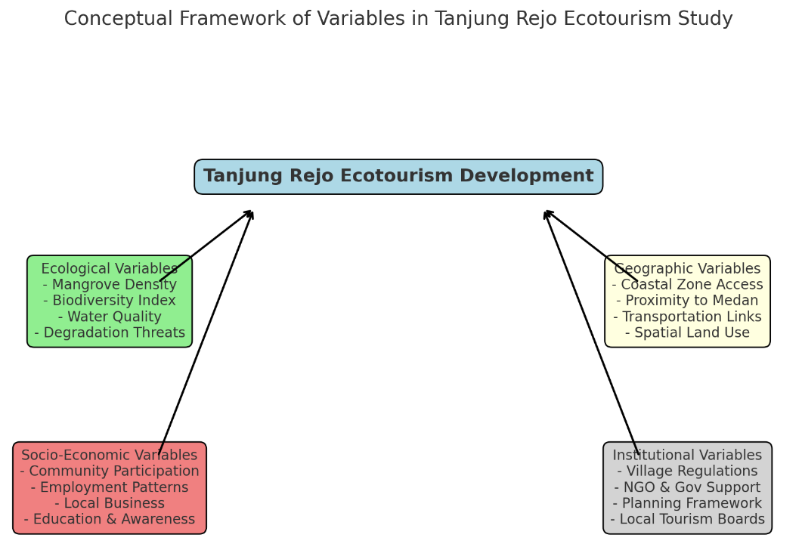

III. Result

3.1 Research Location

Tanjung Rejo Village is situated in Percut Sei Tuan District, part of Deli Serdang Regency, within the province of North Sumatra, Indonesia. This area lies along the eastern coastline, facing the Malacca Strait, and includes a significant mangrove forest ecosystem along its estuarial and coastal zones. The village is accessible via land and river transport, which supports both tourism and local livelihoods, particularly fisheries. This geographical location places Tanjung Rejo at the intersection of land and sea resources—an ideal scenario for ecotourism development based on marine and coastal biodiversity

The ecological richness of Tanjung Rejo is evident in its diverse mangrove species, which function as breeding grounds for fish, crabs, and mollusks. These ecosystems provide natural coastal barriers, supporting climate resilience and biodiversity conservation. Key environmental variables in this context include:

- Mangrove density and diversity (e.g., Rhizophora spp., Avicennia spp.),
- Water quality and sedimentation patterns,
- Biodiversity indexes, and
- Environmental degradation threats such as illegal logging or pollution.
These ecological attributes serve as natural capital that can be leveraged for sustainable tourism.

3.2 Population
The target population for this study consisted of residents of Tanjung Rejo Village who:
- Are aged 18 years and above,
- Have resided in the village for at least five years,
- Are involved either directly or indirectly in mangrove tourism, fisheries, or conservation activities.
Based on local demographic records and field estimates, the eligible population was approximately 2,500 individuals.

The study employed purposive sampling in combination with proportional area sampling, ensuring a balanced representation of key social groups:
- Active fishermen
- Tourism-related entrepreneurs and vendors
- Community leaders and administrators
- Youth and ecotourism awareness groups (e.g., Pokdarwis)
To determine sample size, Slovin’s formula was applied:
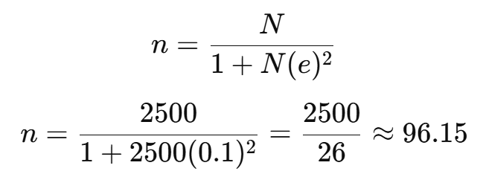
Rounding up, a total of 100 respondents were surveyed, exceeding the minimum to improve representation and statistical reliability.

3. Respondent Distribution

Table 1. The demographic breakdown of the sample is as follows:
Category | Number | Percentage (%)
Active fishermen | 30 | 30%
Tourism vendors / local businesses | 25 | 25%
Community leaders / RT-RW heads | 20 | 20%
Youth tourism groups (Pokdarwis) | 15 | 15%
General residents | 10 | 10%
Total | 100 | 100%

This stratified composition ensures that perspectives are balanced across stakeholder groups, enabling more nuanced analysis in the SWOT process. To assess the reliability of generalizing from this sample, a margin of error was calculated using the standard formula:
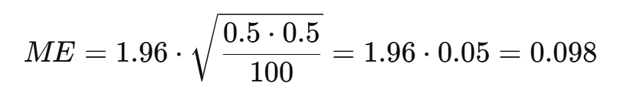
So, the margin of error is approximately ±9.8% at a 95% confidence level. This is acceptable for exploratory, community-scale research.

3.3 Internal Factor Evaluation (IFE) Matrix

The IFE matrix identifies internal strengths and weaknesses affecting the potential of mangrove ecotourism in Tanjung Rejo. Scores are derived by multiplying each factor's weight with a rating on a scale from 1 (major weakness) to 4 (major strength). The results are shown below:

Table 2. Internal Factors Evaluation (IFE) Matrix
Internal Factors | Weight | Rating | Score
Rich biodiversity in mangrove ecosystem | 0.20 | 4 | 0.80
Scenic natural beauty | 0.15 | 3 | 0.45
Lack of tourism infrastructure | 0.25 | 2 | 0.50
Limited promotion and marketing | 0.25 | 2 | 0.50
Insufficient waste management | 0.15 | 1 | 0.15
Total | 1.00 | — | 2.40

The total IFE score of 2.40 indicates a slightly below-average internal position, meaning weaknesses are prominent, but some strengths exist to build upon.

3.2 External Factor Evaluation (EFE) Matrix

The EFE matrix evaluates opportunities and threats from external environments. A similar weighting and rating system was used.

Table 3. External Factors Evaluation (EFE) Matrix
External Factors | Weight | Rating | Score
Government support for ecotourism | 0.25 | 4 | 1.00
Rising demand for nature-based tourism | 0.20 | 3 | 0.60
Environmental degradation risk | 0.20 | 2 | 0.40
Illegal mangrove logging | 0.20 | 2 | 0.40
Lack of inter-agency coordination | 0.15 | 2 | 0.30
Total | 1.00 | — | 2.70

The total EFE score of 2.70 suggests that external opportunities moderately outweigh threats, providing room for strategic development.

3.3 SWOT Quadrant Analysis
The IFE and EFE total scores were plotted in a SWOT quadrant to determine the strategic position:
- IFE Total: 2.40
- EFE Total: 2.70
This combination places the strategy in Quadrant I (SO strategy), where internal strengths can be leveraged to take advantage of external opportunities.

Fig .2
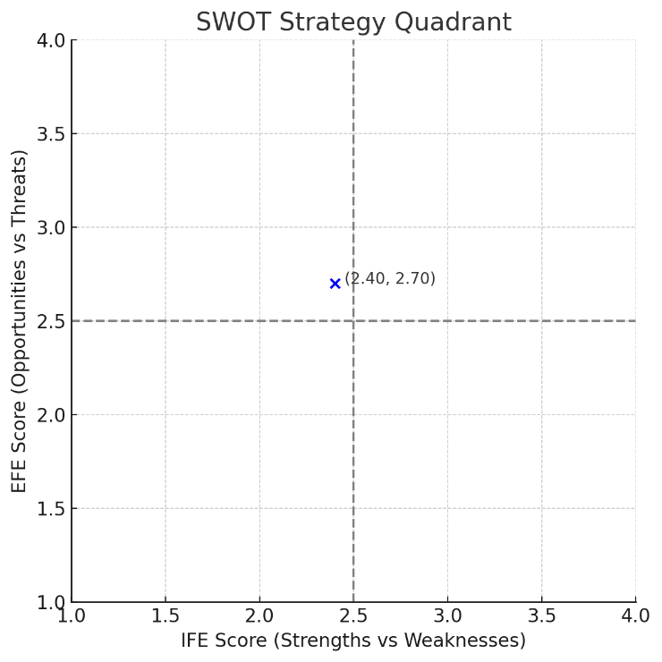

3.4 Strategic Implications
The SO quadrant emphasizes aggressive strategies that capitalize on strengths and market trends. Recommended strategies include:
- Developing ecotourism infrastructure while preserving environmental integrity.
- Enhancing marketing through social media and tourism partnerships.
- Conducting community training programs on sustainable tourism and conservation.
- Collaborating with government agencies for funding and capacity building.
These strategies align with global best practices for ecotourism and local empowerment, ensuring that conservation and economic development proceed hand in hand.

4 Discussion

The results of the SWOT analysis place Tanjung Rejo in the Strength–Opportunity (SO) quadrant, suggesting an aggressive growth strategy is most suitable. This implies that the village should capitalize on its natural and cultural strengths, such as mangrove biodiversity and scenic beauty, while simultaneously harnessing external opportunities like increased government support and ecotourism demand. The presence of an active community engaged in mangrove planting and awareness initiatives further strengthens the village’s position to adopt sustainable tourism practices that are locally managed and environmentally responsible.
A major insight from the community perception data is the recognition of ecological assets as core tourism strengths. Respondents across different social categories consistently highlighted the area's biodiversity and coastal landscape as appealing features. However, these strengths are undermined by infrastructure gaps and weak promotion channels. As highlighted by Triyanti et al. (2025), similar cases in northern Java have shown that community-based tourism initiatives can only thrive when they are paired with logistical investments and visibility strategies. Thus, local and regional planning must address these operational bottlenecks to realize the full tourism potential of Tanjung Rejo.
In terms of threats, the risk of environmental degradation, such as illegal mangrove cutting and waste mismanagement, was considered significant by the respondents. This aligns with findings from Khuluq et al. (2025), which stressed that without proper zoning and monitoring, mangrove ecotourism can become ecologically exploitative. Tanjung Rejo, therefore, needs a formal conservation framework integrated with tourism development plans. Empowering local monitoring groups and incorporating environmental education in tourist activities could offer dual benefits—raising awareness while enforcing sustainability.
An additional concern raised during qualitative interviews was the lack of coordination among institutions. While government programs and NGOs occasionally provide support, there is no consistent or unified management structure overseeing tourism activities. This fragmentation results in overlapping roles, inefficient resource use, and reduced accountability. As emphasized by Izudin & Aditya (2025), successful ecotourism initiatives require clear governance models, often in the form of village-level tourism committees or cooperative management units.
Interestingly, respondents showed a high willingness to participate in ecotourism-based economic activities—from homestay management to guiding and product sales. However, most lacked formal training and access to capital. This gap reveals a missed opportunity for targeted interventions, such as microfinance schemes, vocational training, and market linkage programs. Strengthening human capital and entrepreneurship at the grassroots level can ensure that tourism income remains within the community, thereby fulfilling the principles of community-based tourism (CBT).
Finally, the findings confirm that a participatory and strategic approach—grounded in SWOT analysis and community insight—is not only methodologically sound but also practically effective for small-scale ecotourism planning. Tanjung Rejo serves as a microcosm of many rural Indonesian coastal villages, where tourism, conservation, and development intersect. Lessons learned here can inform broader policies and programs aimed at promoting decentralized, sustainable tourism models in other ecologically sensitive regions.

IV. Conclusions and Recommendations

This study explored the strategic development potential of mangrove ecotourism in Tanjung Rejo Village through SWOT analysis supported by community perception data. The findings place the village in a Strength–Opportunity quadrant, indicating readiness for an aggressive development strategy that leverages its ecological richness and growing tourism interest. However, the analysis also revealed critical internal weaknesses, including inadequate infrastructure and promotional activities, and external threats such as environmental degradation and governance fragmentation. These results affirm the value of integrating local stakeholder input with structured planning tools to ensure sustainable and community-centered tourism growth.
Based on these findings, several strategic recommendations are proposed. First, local authorities and partners should invest in basic tourism infrastructure—such as signage, sanitation, and access paths—while maintaining ecological sensitivity. Second, training programs in hospitality, conservation, and entrepreneurship should be launched to empower community members and diversify local income sources. Third, an institutional framework for collaborative governance involving local leaders, NGOs, and government agencies must be established to ensure coherent planning and monitoring. Finally, tourism development should be integrated with broader environmental education and conservation efforts to reinforce Tanjung Rejo’s identity as a responsible, nature-based tourism destination.

COMPETING INTERESTS DISCLAIMER:
Authors have declared that they have no known competing financial interests OR non-financial interests OR personal relationships that could have appeared to influence the work reported in this paper.

Disclaimer (Artificial intelligence)
Option 1:
Author(s) hereby declare that NO generative AI technologies such as Large Language Models (ChatGPT, COPILOT, etc.) and text-to-image generators have been used during the writing or editing of this manuscript.

References

- Alfiandri, A., Prasojo, E., Salomo, R. V., & Wicaksono, A. (2024). Beyond volatility: Harnessing VUCA methodology for sustainable collaboration in Bintan Island’s mangrove ecotourism governance. Danube, 12(1). https://sciendo.com/pdf/10.2478/danb-2024-0010
- Ampou, E., Prasetia, I. N. D., Amelia, J. M., & Sitepu, G. S. B. R. (2024). Assessment of coastal resources in Sumberkima Village, Bali: A foundation for sustainable aquaculture-based minatourism. ResearchGate. https://www.researchgate.net/publication/387137664
- Elfina, Y., Sukendi, S., & Efriyeldi, E. (2025). Community-based mangrove forest development as an ecotourism area to improve community welfare. E3S Web of Conferences. https://www.e3s-conferences.org/articles/e3sconf/pdf/2025/11/e3sconf_iseep2025_04001.pdf
- Hatani, L., Madi, R. A., & Ittaqullah, N. (2024). Sustainable ecotourism development strategy for Mina-Minanga Beach in North Buton. Journal of Tourism and Environment, 6(1). https://journal.mediadigitalpublikasi.com/index.php/apollo/article/view/327
- Islam, D. (2024). Government policy, empowerment and community participation in sustainable tourism development in ecotourism mangrove Lembung. Jurnal IBIK, 6(2). https://jurnal.ibik.ac.id/index.php/jimkes/article/view/2987
- Izudin, A., & Aditya, R. (2025). Reappraisal of ecotourism development in Karangsong communities in Indonesia: Debates on conservation and touristification. Tourism in Marine Environments. https://www.ingentaconnect.com/content/cog/tme/pre-prints/content-time_2480928_khuluq
- Khuluq, L., Izudin, A., & Aditya, R. (2025). Conservation and ecotourism synergy in Karangsong mangrove forest. Tourism in Marine Environments. https://www.ingentaconnect.com/content/cog/tme/pre-prints/content-time_2480928_khuluq
- Prasetia, I. N. D., Amelia, J. M., & Sitepu, G. S. B. R. (2024). Coastal minatourism development in North Bali. ResearchGate. https://www.researchgate.net/publication/387137664
- Trianto, M., & Adnan, B. A. (2024). Analysis of local community ecological knowledge on mangrove ecotourism in Central Sulawesi. Interdisciplinary International Journal of Coastal Communities, 2(1). https://www.ojs.unigal.ac.id/index.php/iijcc/article/view/4062
- Triyanti, R., Wijaya, R. A., & Priyatmoko, R. (2025). Transformation of community-based mangrove conservation into coastal tourism in northern Java. International Journal of Conservation Science, 25(1). https://ijcs.ro/public/IJCS-25-01_14_Triyanti.pdf

