Cosmetic Fillers and Immune Responses: A Clinical Perspective

ABSTRACT
Understanding the immunological responses to hyaluronic acid (HA) as cosmetic fillers is essential for optimizing patient safety and outcomes. Although HA closely resembles endogenous human HA, variations in molecular size, source, and potential contaminants can provoke both innate and adaptive immune response. HA injections have the potential to activate both short-term and long-term immune system reactions. The immune reaction ranging from mild, self-limited swelling to severe delayed inflammatory responses. The biofilm-forming skin bacteria and the proinflammatory properties of low-molecular-weight HA can complicate the clinical picture. Therefore, careful patient selection, pre-injection sensitivity assessment, and adherence to meticulous injection techniques by trained specialists are crucial. Ongoing research into the mechanisms of immune activation and improved diagnostic strategies will enhance the safe use of cosmetic fillers and help clinicians effectively manage and prevent adverse reactions. Hyaluronic acid fillers closely resemble natural HA but can still trigger serious immune responses but the delayed-type hypersensitivity reported to be the most common consequences. To minimize risks and ensure patient safety, specialists should perform injections with prior sensitivity testing.

Keywords: hyaluronic acid, innate, adaptive, immune response, inflammation, pathogens.

INTRODUCTION
The human immune system is an intricate network of lymphoid organs, immune cells, immune proteins, and chemical products that work together to protect the body against microbial invasion such as bacteria, viruses, and parasites, and their toxic effects as well as abnormal cells such as tumours and transplanted tissues (Kivity et al., 2009). These components coordinate to recognize the body's own cells and minimize self-damage while mounting protective responses. Effective immunity relies on the interaction between the innate and adaptive immune systems. The innate immune system, present from birth, provides immediate, non-specific defence and does not adapt to specific pathogens during infection. In contrast, adaptive immunity is characterized by the ability of specialized cells-mainly T and B lymphocytes undergo genetic changes in response to particular antigens, allowing for a targeted and memory-based response (Abbas et al., 2017). Antigen can be defined as any molecular structure that can bind to a specific antibody or T-cell receptor. Antigens can be proteins, peptides, polysaccharides, lipids, or nucleic acids (Aristizábal & González, 2013). Antigens activate the immune response through two distinct receptor pathways, pattern recognition receptors (PRRs), that initiate innate immune responses, and antigen-specific receptors including B-cell and T-cell receptors produced via gene rearrangement after antigen exposure, which mediate adaptive immunity (Li & Wu, 2021). The immune responses activated by pattern recognition receptors (PRRs), such as Toll-like receptors (TLRs), synergize with those triggered by antigen-specific receptors such as T-cell receptors. This interplay is epitomized by dendritic cells, which depend on PRR-mediated signals to mature. Once matured, these cells prime lymphocytes by presenting antigens via their antigen-specific receptors, bridging innate and adaptive immunity (Takeuchi & Akira, 2010).
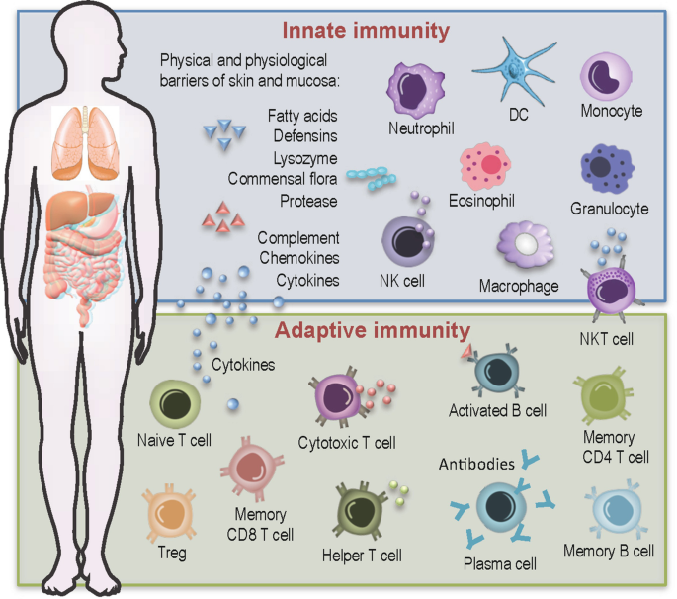
Figure 1. The human immune system composition (Ernst et al., 2021)

Cosmetic Hyaluronic Fillers
Over time, the human face naturally reveals signs of aging due to gravity, sun exposure, and repeated facial movements such as smiling, chewing, and squinting. These visible changes often motivate individuals to seek ways to enhance their appearance and maintain youthful-looking skin. This might require cosmetic surgery or dermal injections. In terms of chemical composition, the molecule of HA consists of alternating units of N-acetyl-D-glucosamine and glucuronic acid, which are members of the polysaccharides family that is a part of almost every tissue in vertebrates, as shown in Figure 2 (Sodhi & Panitch, 2021). Naturally, HA is found in human tissue but the injectable HA are obtained from different sources such as animal or bacterial.
At physiologic pH, HA binds water extensively, providing fullness in the injected tissue
(Ucm et al., 2022). HA fillers are often chemically cross-linked to enhance structural integrity, improving resistance to mechanical stress and slowing enzymatic breakdown in the body. This cross-linking prolongs the filler’s duration by delaying degradation. However, while products specify HA concentration, the ratio of soluble (unbound) HA to cross-linked (insoluble) HA varies across products (Wongprasert et al., 2022). Soluble HA, which is quickly degraded by hyaluronidases, does not sustain the filler’s volumizing effect. Consequently, the stated HA concentration may not accurately predict clinical outcomes, as only the insoluble fraction contributes meaningfully to long-term efficacy (Rohrich et al., 2019).

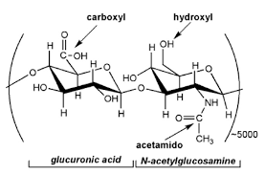
Figure 2. The structure of the disaccharide repeating unit of HA (Sodhi & Panitch, 2021).

Immune Reaction to HA
HA is typically synthesized through bacterial fermentation using strains like Streptococcus zooepidemicus. While this method lowers immunogenicity risks compared to older animal-derived sources, trace contaminants such as bacterial proteins, nucleic acids, or stabilizers may remain. These residual components can act as antigens, potentially triggering immune-mediated hypersensitivity reactions to HA-based products (Owczarczyk-Saczonek et al., 2021). Even if HA is considered as the safest synthetic filler, the number of complications after HA injection were reported particularly severe complications requiring aggressive treatment and leaving permanent sequelae. The immune-mediated delayed hypersensitivity reactions were the most probable cause (Homsy et al., 2017).
Injected HA fillers may stimulate both immediate and delayed immune responses. Delayed-type hypersensitivity (type IV) reactions, mediated by T-cells, typically manifest days to months post-injection and may present as swelling, erythema, nodules, or granulomas (Rowland‐Warmann, 2021; Wang & Jung, 2023). Similar immune reactions have been reported following systemic triggers like viral infections or vaccinations, notably COVID-19 vaccines, which may activate immune memory cells primed by previous HA exposure (Neamatallah, 2023). The Complication Assessment and Risk Evaluation (CARE) identified three etiological hypotheses that associated to rare late-onset reactions (LORs). Firstly, the physicochemical structure of the filler, particularly low molecular weight HA, which may trigger an immune response. Secondly, infection, potentially introduced during injection or by dormant biofilm activation. Finally, an imbalance in the host immune system, caused by factors like autoimmune diseases or viral infections, may lead to extended foreign body reactions, delayed type IV hypersensitivity, or adjuvant-based reactions (Baranska-Rybak et al., 2024).
The degradation of cross-linked HA into low-molecular-weight fragments can also promote proinflammatory signaling, further contributing to immune activation (Sanchez et al., 2023). The biological effects of HA vary significantly depending on its molecular weight. HA can exhibit both pro- and anti-inflammatory properties, stimulate or suppress cell migration, and either activate or inhibit cellular proliferation and differentiation. However, the scientific community lacks a standardized classification system for defining HA categories based on molecular size, leading to inconsistencies in research and clinical applications.

Size of the Molecule
In some situations, Low-molecular-weight hyaluronic acid (LMW-HA) exhibits proinflammatory properties and can trigger hypersensitivity reactions. It accumulates at sites of tissue breakdown, such as post-injury, where it activates Toll-like receptors (TLR2 and TLR4), initiating inflammatory responses. This activation stimulates dendritic cell maturation and promotes the secretion of proinflammatory cytokines-including IL-1β, IL-6, IL-12, TNF-α, and TGF-β-by various cell types (Hoarau et al., 2022). Additionally, LMW-HA modulates chemokine expression and cellular migration. Functioning as a danger-associated molecular pattern (DAMP), LMW-HA activates innate immunity pathways akin to bacterial proteins or heat-shock proteins that initiating inflammatory cascades (Ferreira et al., 2022).
LMW-HA also interacts with CD44, a ubiquitous cell surface receptor involved in pattern recognition and immune regulation (Chaudhry et al., 2021). CD44 binds LMW-HA and other ligands such as osteopontin, collagen and matrix metalloproteinases (MMPs), facilitating extracellular matrix (ECM) remodelling and amplifying inflammation (Ruppert et al., 2014). CD44-MMP interactions degrade collagen, angiogenesis in chronic inflammation and promoting tissue invasion. In contrast, metabolic disorders, elevated circulating LMW-HA acts as a DAMP, activating TLR4/NF-κB pathways in leukocytes and driving inflammation (Romo et al., 2022). Similarly, in psoriasis and dermatitis, LMW-HA fragments induce keratinocyte activation and β-defensin production via TLR2 and TLR4 signalling as a self defence mechanism against LMW-HA fragments (Gariboldi et al., 2008) as shown in Figure 3.

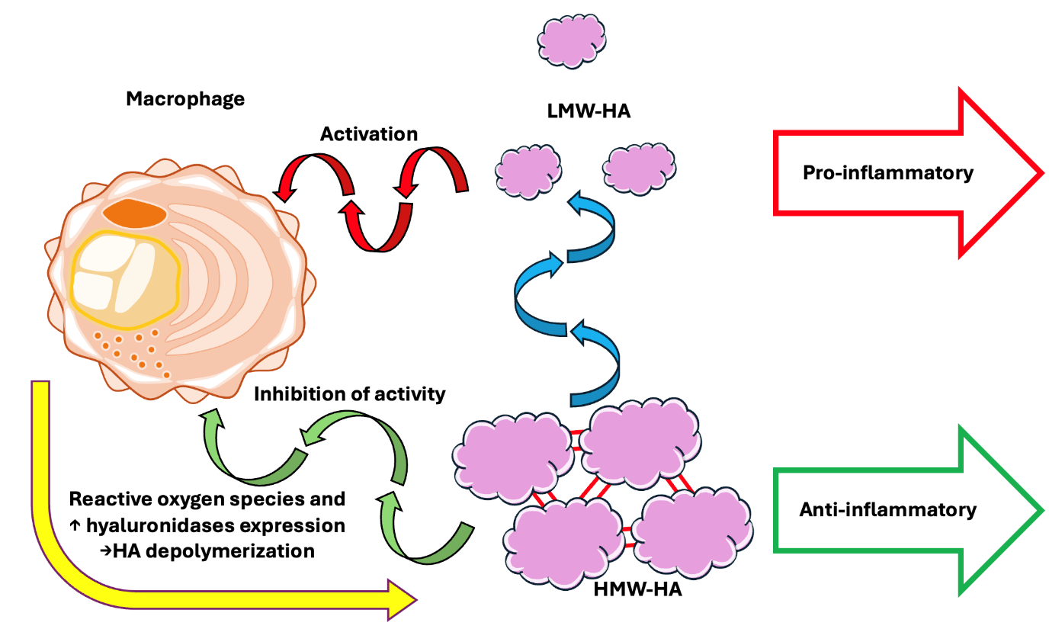
Figure 3. Immune Response to HA.

Following the resolution of inflammation and macrophage-mediated clearance of tissue debris, LMW-HA fragments are removed via CD44-dependent endocytosis, a critical step in restoring tissue homeostasis. Chronic inflammatory conditions are characterized by persistent LMW-HA accumulation, positioning HA fragments as natural biosensors reflecting ongoing tissue damage (Lee-Sayer et al., 2015). The pivotal role of CD44 in inflammation regulation is evident in in vivo models: anti-CD44 interventions suppressed collagen-induced arthritis and ameliorated dermal lesions in murine atopic dermatitis, highlighting its therapeutic potential.
After injection in healthy tissues, high-molecular-weight HA (HMW-HA) can lead to potent anti-inflammatory effects. HMW-HA suppresses proinflammatory mediators such as IL-1β, IL-8, IL-17, TNF-α, and matrix metalloproteinases (MMPs) by inhibiting TLR signalling and NF-κB activation (Petrey & de la Motte, 2014). It also modulates macrophage polarization, promoting an anti-inflammatory (M2) phenotype characterized by reduced TNF-α and IL-6 secretion and enhanced tissue repair functions. Conversely, LMW-HA fragments activate TLR4/MyD88 pathways, driving proinflammatory (M1) macrophage activation and perpetuating inflammation. Thus, the balance between HMW-HA and LMW-HA is crucial for immune regulation. While HMW-HA maintains tissue integrity and resolves inflammation, LMW-HA accumulation signals tissue disruption and fuels chronic inflammatory responses (Oates et al., 2024).

Biofilm Components
Establishing microbial biofilm suggests another way to evoke the immune response to HA leading to introduced inflammation into tissues during injection. Biofilms contain of microbial cells, nutrients, and metabolic products. Promoting microbial biofilms may formed by non-pathogenic species that naturally inhabit healthy skin and mucous membranes-such as Cutibacterium acnes, Streptococcus oralis, and Staphylococcus epidermidis (Dumitraşcu & Georgescu, 2013). Identifying the causative pathogen using classical laboratory technique such as culturing is often challenging due to the organisms' slow growth rates and their propensity to form small colony variants. Developing pathogenic biofilms significantly enhances microbial ability to evade the effects of antibiotics. Extracellular matrix production composed of exopolysaccharides such as HA acts as a protective mechanism against clearance of microbial pathogens via phagocytis, enabling certain bacteria to facilitate body invasion. These microorganisms can later be reactivated by external stimuli, triggering inflammatory cascades. Macrophages and multinucleated giant cells are typically observed near these pathogens, where they may be quickly mobilized to initiate inflammatory responses. Reactivation can occur through molecular mimicry of biofilm components by similar bacterial strains or via iatrogenic triggers such as subsequent cosmetic filler injections, which disrupt tissue integrity and reignite latent microbial activity (Hee & Messina, 2022).

Patho-mechanism
Delayed inflammatory reactions (DIR) to injected tissue with fillers can be developed during two to four weeks or directly after an HA injection. The clinical manifestations occur in the form of recurrent episodes of localized solid oedema with erythema and tenderness, or subcutaneous nodules can be observed at HA injection sites, often presenting as warm swellings with surrounding skin that appears purple or brown.
Notably, these reactions frequently occur simultaneously at multiple injection sites, even in patients with prior HA treatments, regardless of filler type or the number of injections. Individuals who previously received larger HA volumes are more prone to these lesions. Additionally, associated swelling is typically most pronounced upon waking and tends to diminish as the day progresses. Around 40% of affected patients may also experience systemic, flu-like symptoms (Michon, 2021). These adverse reactions may be linked to contaminants such as residual DNA, proteins, or bacterial endotoxins in HA fillers, even at trace concentrations. In genetically susceptible individuals, LMW-HA could also act as an immune adjuvant, either directly or through interactions with microbial components like biofilms. However, the emergence of inflammatory nodules distant from the injection site, their resistance to prolonged antibiotic therapy, and negative microbial cultures/PCR tests challenge the biofilm hypothesis. Instead, the efficacy of hyaluronidase (which degrades HA) and the correlation with higher filler volumes suggest a delayed-type hypersensitivity mechanism. Additionally, systemic triggers such as infections or tissue injury may elevate interferon levels, potentially exacerbating pre-existing subclinical inflammation at filler sites. (Cassuto et al., 2021). Safety should be considered at any stage before and after injection even by specialised trained injectors due to occur chances for potential serious healthy complications such as mild swelling and bruising can be expected; persistent swelling rarely occurs, particularly in the lower orbital area
(De Boulle & Heydenrych, 2015). When proper injection techniques are employed, the occurrence of palpable lumps, nodules, and granulomas is uncommon. However, more severe complications can arise if fillers are inadvertently injected into blood vessels, potentially leading to serious outcomes such as tissue necrosis or even blindness. The FDA has recently issued a warning highlighting these risks. Therefore, it is essential for practitioners administering fillers to have a thorough understanding of the specific anatomy of the treatment area to reduce the likelihood of intravascular injection and associated complications (Vedamurthy, 2018).
To ensure safe injection practices, it is recommended to avoid sites with major blood vessels, use a blunt cannula rather than a sharp needle, when possible, aspirate the syringe before injecting, and administer the filler slowly while monitoring for signs such as tissue blanching. If intra-arterial injection occurs-often indicated by sudden skin blanching and sometimes pain-prompt intervention is crucial. Despite these precautions, there remains a risk of skin and soft tissue necrosis.

Conclusion
There is a chance of using HA as a dermal filler as almost tend to have a similar structure to the cells HA. Should a specialist perform the injection based on the anatomical structure of the host. The clinician must check the host's dermal sensitivity to HA before doing injections. A serious immune response to the injected HA might lead to a critical health consequence.

Disclaimer (Artificial intelligence)
Option 1:
Author(s) hereby declare that NO generative AI technologies such as Large Language Models (ChatGPT, COPILOT, etc.) and text-to-image generators have been used during the writing or editing of this manuscript.

References
Abbas, A., Lichtman, A., & Pillai, S. (2017). Cellular and molecular immunology (9th ed.). West B. Saunders Company.
Aristizábal, B., & González, Á. (2013). Innate immune system. In Autoimmunity: From Bench to Bedside [Internet]. El Rosario University Press. https://www.ncbi.nlm.nih.gov/books/NBK459455/
Baranska-Rybak, W., Lajo-Plaza, J. V., Walker, L., & Alizadeh, N. (2024). Late-Onset Reactions after Hyaluronic Acid Dermal Fillers: A Consensus Recommendation on Etiology, Prevention and Management. Dermatology and Therapy, 14(7), 1767–1785. https://doi.org/10.1007/s13555-024-01202-3
Cassuto, D., Bellia, G., & Schiraldi, C. (2021). An Overview of Soft Tissue Fillers for Cosmetic Dermatology: From Filling to Regenerative Medicine. Clinical, Cosmetic and Investigational Dermatology, 14, 1857–1866. https://doi.org/10.2147/CCID.S276676
Chaudhry, G.-S., Akim, A., Naveed Zafar, M., Safdar, N., Sung, Y. Y., & Muhammad, T. S. T. (2021). Understanding Hyaluronan Receptor (CD44) Interaction, HA-CD44 Activated Potential Targets in Cancer Therapeutics. Advanced Pharmaceutical Bulletin, 11(3), 426–438. https://doi.org/10.34172/apb.2021.050
De Boulle, K., & Heydenrych, I. (2015). Patient factors influencing dermal filler complications: Prevention, assessment, and treatment. Clinical, Cosmetic and Investigational Dermatology, 8, 205–214. https://doi.org/10.2147/CCID.S80446
DUMITRAŞCU, D. I., & GEORGESCU, A. V. (2013). The management of biofilm formation after hyaluronic acid gel filler injections: A review. Clujul Medical, 86(3), 192–195.
Ernst, L. M., Casals, E., Italiani, P., Boraschi, D., & Puntes, V. (2021). The Interactions between Nanoparticles and the Innate Immune System from a Nanotechnologist Perspective. Nanomaterials, 11(11), Article 11. https://doi.org/10.3390/nano11112991
Ferreira, N. D. R., Sanz, C. K., Raybolt, A., Pereira, C. M., & DosSantos, M. F. (2022). Action of Hyaluronic Acid as a Damage-Associated Molecular Pattern Molecule and Its Function on the Treatment of Temporomandibular Disorders. Frontiers in Pain Research (Lausanne, Switzerland), 3, 852249. https://doi.org/10.3389/fpain.2022.852249
Gariboldi, S., Palazzo, M., Zanobbio, L., Selleri, S., Sommariva, M., Sfondrini, L., Cavicchini, S., Balsari, A., & Rumio, C. (2008). Low Molecular Weight Hyaluronic Acid Increases the Self-Defense of Skin Epithelium by Induction of β-Defensin 2 via TLR2 and TLR4. The Journal of Immunology, 181(3), 2103–2110. https://doi.org/10.4049/jimmunol.181.3.2103
Hee, C. K., & Messina, D. J. (2022). In vitro inflammatory and immune response to uncrosslinked hyaluronic acid (HA) and HA fillers. Journal of Immunology and Regenerative Medicine, 17, 100065. https://doi.org/10.1016/j.regen.2022.100065
Hoarau, A., Polette, M., & Coraux, C. (2022). Lung Hyaluronasome: Involvement of Low Molecular Weight Ha (Lmw-Ha) in Innate Immunity. Biomolecules, 12(5), Article 5. https://doi.org/10.3390/biom12050658
Homsy, A., Rüegg ,Eva Meia, Jandus ,Peter, Pittet-Cuénod ,Brigitte, & and Modarressi, A. (2017). Immunological reaction after facial hyaluronic acid injection. Case Reports in Plastic Surgery and Hand Surgery, 4(1), 68–72. https://doi.org/10.1080/23320885.2017.1356202
Kivity, S., Agmon-Levin, N., Blank, M., & Shoenfeld, Y. (2009). Infections and autoimmunity – friends or foes? Trends in Immunology, 30(8), 409–414. https://doi.org/10.1016/j.it.2009.05.005
Lee-Sayer, S. S. M., Dong, Y., Arif, A. A., Olsson, M., Brown, K. L., & Johnson, P. (2015). The Where, When, How, and Why of Hyaluronan Binding by Immune Cells. Frontiers in Immunology, 6. https://doi.org/10.3389/fimmu.2015.00150
Li, D., & Wu, M. (2021). Pattern recognition receptors in health and diseases. Signal Transduction and Targeted Therapy, 6(1), Article 1. https://doi.org/10.1038/s41392-021-00687-0
Michon, A. (2021). Hyaluronic acid soft tissue filler delayed inflammatory reaction following COVID‐19 vaccination – A case report. Journal of Cosmetic Dermatology, 20(9), 2684–2690. https://doi.org/10.1111/jocd.14312
Neamatallah, T. (2023). Delayed inflammatory reaction to hyaluronic acid lip filler after the Pfizer-BioNTech COVID-19 vaccine: A case report. Heliyon, 9(7), e18274. https://doi.org/10.1016/j.heliyon.2023.e18274
Oates, T. C., Boyd, J., Dolan, L., Kergariou, C. de, Toye, A., Perriman, A. W., & Boussahel, A. (2024). The Immobilization of Hyaluronic Acid in 3D Hydrogel Scaffolds Modulates Macrophage Polarization. 2024.04.10.588451. https://doi.org/10.1101/2024.04.10.588451
Owczarczyk-Saczonek, A., Zdanowska, N., Wygonowska, E., & Placek, W. (2021). The Immunogenicity of Hyaluronic Fillers and Its Consequences. Clinical, Cosmetic and Investigational Dermatology, 14, 921–934. https://doi.org/10.2147/CCID.S316352
Petrey, A. C., & de la Motte, C. A. (2014). Hyaluronan, a Crucial Regulator of Inflammation. Frontiers in Immunology, 5. https://doi.org/10.3389/fimmu.2014.00101
Rohrich, R. J., Bartlett, E. L., & Dayan, E. (2019). Practical Approach and Safety of Hyaluronic Acid Fillers. Plastic and Reconstructive Surgery Global Open, 7(6), e2172. https://doi.org/10.1097/GOX.0000000000002172
Romo, M., López-Vicario, C., Pérez-Romero, N., Casulleras, M., Martínez-Puchol, A. I., Sánchez, B., Flores-Costa, R., Alcaraz-Quiles, J., Duran-Güell, M., Ibarzábal, A., Espert, J. J., Clària, J., & Titos, E. (2022). Small fragments of hyaluronan are increased in individuals with obesity and contribute to low-grade inflammation through TLR-mediated activation of innate immune cells. International Journal of Obesity, 46(11), 1960–1969. https://doi.org/10.1038/s41366-022-01187-z
Rowland‐Warmann, M. (2021). Hypersensitivity reaction to Hyaluronic Acid Dermal filler following novel Coronavirus infection – a case report. Journal of Cosmetic Dermatology, 20(5), 1557–1562. https://doi.org/10.1111/jocd.14074
Ruppert, S. M., Hawn, T. R., Arrigoni, A., Wight, T. N., & Bollyky, P. L. (2014). Tissue integrity signals communicated by high-molecular weight hyaluronan and the resolution of inflammation. Immunologic Research, 58(0), 186–192. https://doi.org/10.1007/s12026-014-8495-2
Sanchez, B., Ferraro, S., Josset-Lamaugarny, A., Pagnon, A., Hee, C. K., Nakab, L., Sigaudo-Roussel, D., & Fromy, B. (2023). Skin Cell and Tissue Responses to Cross-Linked Hyaluronic Acid in Low-Grade Inflammatory Conditions. International Journal of Inflammation, 2023, 3001080. https://doi.org/10.1155/2023/3001080
Sodhi, H., & Panitch, A. (2021). Glycosaminoglycans in Tissue Engineering: A Review. Biomolecules, 11(1), Article 1. https://doi.org/10.3390/biom11010029
Takeuchi, O., & Akira, S. (2010). Pattern Recognition Receptors and Inflammation. Cell, 140(6), 805–820. https://doi.org/10.1016/j.cell.2010.01.022
Ucm, R., Aem, M., Lhb, Z., Kumar, V., Taherzadeh, M. J., Garlapati, V. K., & Chandel, A. K. (2022). Comprehensive review on biotechnological production of hyaluronic acid: Status, innovation, market and applications. Bioengineered, 13(4), 9645–9661. https://doi.org/10.1080/21655979.2022.2057760
Vedamurthy, M. (2018). Beware What You Inject: Complications of Injectables—Dermal Fillers. Journal of Cutaneous and Aesthetic Surgery, 11(2), 60–66. https://doi.org/10.4103/JCAS.JCAS_68_18
Wang, H., & Jung, J. A. (2023). Recurrent delayed hypersensitivity reaction to a hyaluronic acid soft-tissue filler following COVID-19 vaccination: A case report. Archives of Aesthetic Plastic Surgery, 29(1), 55–58. https://doi.org/10.14730/aaps.2022.00696
Wongprasert, P., Dreiss, C. A., & Murray, G. (2022). Evaluating hyaluronic acid dermal fillers: A critique of current characterization methods. Dermatologic Therapy, 35(6), e15453. https://doi.org/10.1111/dth.15453

