Review Article

PATTERNS OF BACTERIAL ISOLATION, IDENTIFICATION, AND ANTIBIOTIC SUSCEPTIBILITY ASSOCIATED WITH INFECTED WOUNDS – A PROSPECTIVE STUDY

ABSTRACT
Aims: To isolate and identify bacteria from infected wounds and determine their patterns of antibiotic susceptibility in order to understand their role in delayed wound healing and overall impact on patient quality of life.
Study design: Descriptive cross-sectional study.
Place and Duration of Study: Vivek Laboratories, Nagercoil, Kanyakumari District, Tamil Nadu, India; study conducted over the period of 1 year from July 2023 to June 2024.
Methodology: A total of 606 wound swab and pus samples were collected from patients presenting for medical care. Samples were cultured, and bacterial isolates were identified using standard biochemical tests. Antibiotic susceptibility testing was performed using the Kirby-Bauer disk diffusion method.
Results: Out of 606 wound samples, 286 showed bacterial growth, indicating a 47% infection rate. Among the isolates, Pseudomonas aeruginosa was the most common (31.81%), followed by Staphylococcus aureus (20.9%), Escherichia coli (17.13%), and Klebsiella pneumoniae (13.98%). Infection was more common in males (59%) than females (41%), with the highest prevalence in the 41–60 age group (41%) and the lowest in the 01–20 age group (4%). No significant association was observed between infection and potential risk factors (p > 0.05). All isolates were 100% susceptible to vancomycin and 100% resistant to penicillin. Ofloxacin was found to be the most effective first-line treatment. Staphylococcus aureus emerged as the predominant pathogen.
Conclusion: Wound infections are predominantly caused by Staphylococcus aureus and Pseudomonas aeruginosa, with a high level of resistance to penicillin and full susceptibility to vancomycin. Early identification and targeted therapy can help improve patient outcomes and wound healing.
Keywords: Wounds Infections; Bacterial pathogens; Antibiotics Susceptibility; MDR
- INTRODUCTION
A wound is the result of physical disruption of biological tissue, including skin, mucous membranes, and organ tissues that include laceration or breaking of a skin. It ranges from acute surgical wounds, traumatic wounds such as those that occur following an accident, burn wounds or chronic wounds such as diabetic foot, leg and pressure ulcers. Wounds can be classified according to their time frame of healing. Acute wounds are caused by external damage to intact skin and include surgical wounds, bites, burns, minor cuts and abrasions, and more severe traumatic wounds such as lacerations (Yousef et al., 2022). Contrastingly, chronic wounds are most commonly caused by endogenous mechanisms associated with an incline condition that ultimately compromises the integrity of dermal and epidermal tissue. In addition, a complicated wound is a special entity and is defined as a combination of an infection and a tissue defect. A wide range of bacteria invade wounds, and in some people, one or more of these organisms multiply there and may cause tissue damage, inflammation, and host reaction, or clinical infection (Alshara, 2018).
It has been noted that wound infection causes severe impact in the population health, reducing morbidity and improving function and quality of life. Various factors such as critical bacterial load, synergic associations between bacterial species and the presence of specific pathogens are proposed as indicators of infection. Several bacteriological studies have reported that it is worldwide and that the bacterial types varied with geographical site, bacteria dweller on the body skin, clothing at the place of wound, time between wounds and examination post operative conditions (Olukitibi et al., 2017). All wounds are contaminated with both pathogens and body commensals that are part of the saprophytic microflora of the skin including aerobic microorganism include Staphylococcus aureus, Coagulase-negative staphylococci (CoNS), Enterococci sp., Escherichia coli, Pseudomonas aeruginosa, Klebsiella pneumoniae, Enterobacter sp., Proteus mirabilis, Candida albicans and Acinetobacter (KirtiMalpekar et al., 2022). According to Bhujugade et al. (2024), wound infections can be caused by both gram-positive and gram-negative bacteria, including coagulase-positive Staphylococcus aureus, Enterococcus faecalis, Enterococcus faecium, and others, as well as gram-negative bacteria E. coli, Klebsiella spp., Pseudomonas aeruginosa, Proteus mirabilis, Acinetobacter spp., and Enterobacter. Many studies revealed that the initial stage of wound infections may occur with the Gram-positive bacteria including S. aureus followed by the Gram-negative bacteria, such as P. aeruginosa and A. Baumannii that provoking sepsis later when they enter the lymphatic system and blood vessels. Thus, both gram positive and negative bacteria are caused wound infection that may become infected by one or more bacterial spp.
Moreover, the major part of open injury colonization is polymicrobial including a variety of microorganisms that are potentially pathogenic. On the other hand, twisted opinion of experts showed that high-impact or facultative pathogens, for example, Staphylococcus aureus, Pseudomonas aeruginosa a, and beta-hemolytic Streptococci and discharge framing pathogens like Enterococcisp, Escherichia coli, Klebsiella sp., and Proteus sp. are the vital drivers of postponed recuperating and disease in both intense and constant injuries.
Under stressful conditions, microorganisms cooperate together and communicate among them for the development biofilm matrix. It protects microorganisms from the action of antimicrobial drugs, as well as the host immune system. It is also recognized as one of the most complicated factors in wounds healing and emerging of “superbugs” or multi-drug resistant strains, represents a public health concern. Non-healing of wound is associated with a bacterial load of more than 10⁵ bacteria / gram of tissue. It accounts for the 50% of wound infections coupled with E. coli, K. pneumoniae, S. aureus and P. aeruginosa exhibited resistance against the most effective antibiotics including third-generation cephalosporin. Moreover, the multi-drug resistant bacteria continue to develop as a result of extensive prophylactic antibiotic use and secondary bacterial contamination in surgical wounds. They also demand the rising costs of finding effective antimicrobial agents and the slowing rate of new medication development. Thus the management of wound infection care is necessary to review the exact type of antibiotics and the suitable attentions to be used at the time of the antibiotic treatment.
Therefore, it is very essential to make a constant surveillance and update of antibiotic resistance pattern of micro-organisms in connection with the wound infection control programs and provide accurate antibiotic treatment. The present prospective study was aimed to investigate the bacteriological profile of wound infection and to assess their antimicrobial susceptibility pattern presented by patients from who swab samples were collected and analyzed at Vivek Laboratories, Nagercoil, Kanyakumari District, Tamil Nadu, Accredited with NABL with the intention of offering the suggestion to the clinicians in making informed decisions regarding antibiotic therapy.

- MATERIAL AND METHODS

  - Study Location, Design and Period
This prospective analysis was conducted by using wound swab samples that arrived at the Microbiology laboratory of Vivek laboratories running under Vivek Institute of Laboratory Medicine, which is located in Nagercoil town, Kanyakumari District, TamilNadu over the period of 1 year from July 2023 to June 2024. Many individuals from the surrounding zones visit to the laboratory for various medical cares. In this study, wounds with a variety of aetiologies (mostly pressure ulcers, diabetic foot ulcers, and leg ulcers), locations, and progression times (both acute and chronic) were taken into account. Sample of wounds from surgery were not included. Over the period of this examination, 606 wound samples were collected. Age, sex, and antibiotic history were also collected for each patient prior to sampling. The protocol of this study was approved by the Institutional Ethical Committee with reference no. VI /22/6-2022, and each participant signed an informed consent declaration.
  - Sample Collection, Processing, and Culture Method
Specimens were aseptically obtained by zigzag-swiping a sterile swab across a 1 cm2 area of the wound from the centre to the exterior margin after the wound was thoroughly cleaned with normal saline (Lucinda et al., 2015). After taking extra precautions to keep skin commensals from contaminating the samples, the specimens were immediately brought to the microbiology lab for further culture analysis. The pus sample was streaked onto blood agar and MacConkey agar plates, which were subsequently incubated for 24 to 48 hours at 37°C with 5% CO2. After incubation, bacterial colonies exhibiting different characteristics were selected for further study. In accordance with CLSI guidelines, the colonies were identified using Gram staining, which distinguishes between gram-positive and negative bacteria, and then biochemical tests such as urease, citrate, methyl red, oxidase test, coagulase, catalase, Indole, and Voges-Proskauer, Coagulase, Mannitol saltagar, Oxidase, andTriple sugar iron test etc. The catalase test can be employed to distinguish between colonies of Streptococci and Staphylococci. Coagulase-negative S. epidermis and S. saprophyticus can be distinguished from coagulase-positive S. aureus using the coagulase test. Using the oxidase test, Enterobacteriaceae and other Gram negative bacteria were identified. In this bacteriological examination, all manufacturer instructions regarding the materials, medium, and reagents were strictly adhered to. Culture medium was inoculated with a specific stock culture to enable the development of common organisms that lead to wound infections. As quality control strains, Staphylococcus aureus ATCC* 25923 and Escherichia coli ATCC* 25922 were used. If there is no growth on the blood agar and MacConkey agar media after 48 hours of incubation, the sample is considered negative.

  - Antibacterial Agents Used
Gram negative bacterial isolates of wound infections were tested with antibiotic discs such as Ampicillin (10 mcg), Cefazolin (30 mcg), Gentamycin (10 mcg), Tobramycin (30 mcg), Amikacin (30 mcg), Amoxyclav (20\30 mcg), Ampicillin+Sulbactam (10/10mcg), Piperacillin+Tazobactam (100\10 mcg), Cefuroxime (30 mcg), Cefepime (30 mcg), Cefoxitin (30 mcg), Cefotaxime (30 mcg), Ceftrioxone (30 mcg), Ciprofloxacin (5 mcg), Levofloxacin (5 mcg), Imipenem (10 mcg), Meropenem(10 mcg), Co-trimoxazole (1.2/23.15 mcg), Aztreonam(30 mcg), Chloramphenicol (30 mcg), and Tetracycline (30 mcg).
Gram positive bacterial isolates of wound infections were tested with antibiotic discs such as Azithromycin (15 mcg), Clarithromycin (15 mcg), Erythromycin (15 mcg), Clindamycin (2 mcg), Cefoxitin (30 mcg), Penicillin-G (10 mcg), Co-trimoxazole (1.2/22.75 mcg), Linezolid (30 mcg), Doxycycline (30 mcg), Minocycline (30 mcg), Tetracycline (30 mcg), Chloramphenicol (30 mcg), Ciprofloxacin (5 mcg), Levofloxacin (5 mcg), Moxifloxacin (5 mcg), Gentamycin (10 mcg), Ampicillin (10 mcg), Vancomycin (30 mcg), Cefepime (30 mcg),Cefotaxime (30 mcg), and Ceftrioxone (30 mcg).

  - Antibacterial Susceptibility Testing
The antibiotic susceptibility test was conducted using Kirby-Bauer's technique in accordance with the guidelines provided by the Clinical and Laboratory Standards Institute (CLSI). An inoculum was produced by matching the turbidity of each bacterial isolate to the 0.5 McFarland standards. This inoculum was then spread to a Mueller-Hinton agar (MHA) plate (Kaminiet al., 2023). Over the MHA plate, a paper disc containing antibiotics was placed, and it was incubated for 24 hours at 37°C. Based on the CLSI M100 Guideline 2022, the antibiotics tested were categorized as sensitive, intermediate, or resistant based on the size of the zones of inhibition.

  - Statistical Analysis

The statistical software SPSS for Windows version 20 was used to evaluate the data; a P value of less than 0.05 was considered statistically significant, whereas one greater than 0.05 was considered insignificant.

- RESULTS

A total of 606 individuals, ranging in age from one year to more than 60 years, were observed over a period of one year, from July 2023 to June 2024. A high of 40.59% of these individuals were between the ages of 41 and 60, followed by 27.55% of those over 60, 22.1% of those between the ages of 21 and 40, and 8% of those between the ages of 1 and 20 (Table 1 & Fig.1). There were 310 males and 296 females among the 606 patients. Male accounted for 51.15 percent and female for 48.8 percent. Thus, the majority of patients were male (Table 2). Of the 606 patients, 286 (47.19%) had positive culture growth, whereas the remaining 320 (52%) had negative growth, or no growth. Of those with positive cultures, 41.2% were between the ages of 41 and 60, followed by those over 60 (32.5%), those between 21 and 40 (22.2%), and those under 20 (4.1%) (Table 2 & Fig. 2). Therefore, there was no correlation between the age group of the patient and the dehiscence of the wound.
Among 606 wound samples examined, microbiological analysis showed 47.19% positivity; bacteriological study of positive wound samples revealed the occurrence of both Gram positive (30.41%) and Gram negative organisms (69.58%), respectively (Table 3). The number of Gram-negative isolates almost exceeded that of Gram-positive pathogens. Pseudomonas aeruginosa (31.81%), Escherichia coli (17.13%), Klebsiella pneumoniae (13.98%), Proteus mirabilis (4.19%), Proteus vulgaris (0.6%), and Acenetobacter sps., (1.7%) were among the Gram-negative bacterial species (Table 4). The most common pathogen found in all observations was Pseudomonas aeruginosa (31.81%), followed by Staphylococcus aureus (20.9%), Escherichia coli (17.13%), and Klebsiella pneumoniae (13.98%). Most of the bacterial isolates showed resistance to antibiotics, according to the pattern of antibacterial susceptibility among isolated. It was found that 87 (30.4%) of the tested isolates were resistant to six or more antimicrobial classes. A total of 58 (66.6%) Gram-negative and 29 (33.3%) Gram-positive bacterial isolates were identified as MDR organisms. The findings consequently showed that the isolates were Proteus mirabilis (5.7%), Staphylococcus aureus (33.3%), Klebsiella pneumoniae (20.6%), Escherichia coli (36.78%), and Pseudomonas aeruginosa (3.4%) (Table 7). The isolates of MDR S. aureus exhibited resistance to ciprofloxacin, minocycline, gentamicin, tetracycline, doxifloxacin, erythromycin, clindamycin, penicillin-G, co-trimoxazole, doxycycline, chloramphenicol, and ciprofloxacin.

Table 1.Frequency of Culture positivity of wound infections

S.No. | Period of Study | Total no. of samples  Tested | Total No, of samples showing culture positive | Number of samples showing culture negative
1. | July 2023  To September 2023 | 192  (32%) | 84  (29%) | 108  (34%)
2. | October 2023  To December 2023 | 123  (20%) | 71  (25%) | 52  (16%)
3. | January 2024  To March 2024 | 145  (24%) | 72  (25%) | 73  (23%)
4. | April 2024  To June 2024 | 146  (24%) | 59  (21%) | 87  (27%)
Total |  | 606 | 286 | 320

Table 2.Characterization of wound infection cases by age and gender

S.No. | Particulars | Sub  Category | Study Period  July 2022 to June 2024 |  |  | Chi square Value
S.No. | Particulars | Sub  Category | No. of Cases Infected  (%) | No. of Cases Not infected  (%) | Total No. of Samples Tested  (%) | Chi square Value
1. | Gender | Male | 168  (59%) | 142  (44%) | 310  (51%) | 8.741
1. | Gender | Female | 118  (41%) | 178  (56%) | 296  (49%) | 8.741
Total |  |  | 286 | 320 | 606
2. | Age  (in Years) | 0 to 20 | 12  (4%) | 37  (12%) | 49  (18%) | 87.231
2. | Age  (in Years) | 21 to 40 | 63  (22%) | 71  (22%) | 134  (22%) | 87.231
2. | Age  (in Years) | 41 to 60 | 118  (41%) | 128  (40%) | 246  (41%) | 87.231
2. | Age  (in Years) | Above 60 | 93  (33%) | 84  (26%) | 177  (29%) | 87.231
Total Samples tested |  |  | 286 | 320 | 606

Inferences: The chi square goodness of fit test results show that there was a significantly more positive cases in males than females (chi square value=8.741, P<0.05). The chi square goodness of fit test results shows that there was a significantly more positive cases recorded in 41-60 years age groups (chi square value= 87.231).

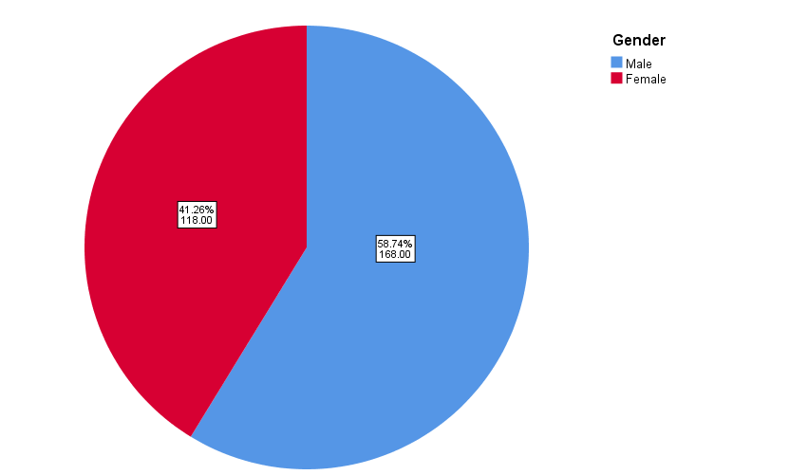
Fig. 1. Gender wise distribution of wound infection

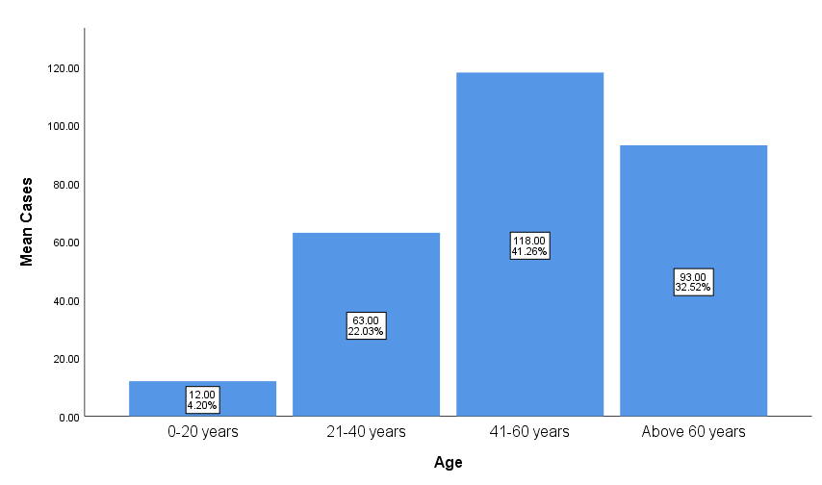
Fig. 2.Age-wise distribution of positive wound infection cases.

Table 3.Distribution of Gram-positive and Gram-negative bacterial pathogens by percentage in wound infections during various study periods
S.No. | Study Period | Bacterial isolates |  | Total No.  of bacterial Isolates
S.No. | Study Period | No. of Gram-positive  (%) | No. of  Gram-negative  (%) | Total No.  of bacterial Isolates
1. | July 2023  To September 2023 | 27 (31%) | 57 (29%) | 84 (29%)
2. | October 2023  To December 2023 | 19 (22%) | 52 (26%) | 71 (25%)
3. | January 2024  To March 2024 | 25 (29%) | 47 (23%) | 72 (25%)
4. | April 2024  To June 2024 | 16 (18%) | 43 (22%) | 59 (21%)
Total |  | 87 | 199 | 286

Table 4.Dispersion of different bacterial pathogens isolated from wound infections

S.No. | Bacterial Isolates | Study Period  July 2023 to June 2024 |  | Chi square Value | P Value
S.No. | Bacterial Isolates | Organism Isolated | Total No.  of Isolates  (%) | Chi square Value | P Value
1. | Gram-positive isolates | S. aureus | 60 (21%) | 230.01 | 0.000
1. | Gram-positive isolates | Streptococcus sps. | 7 (2%) | 230.01 | 0.000
1. | Gram-positive isolates | S. pyogens | 5 (2%) | 230.01 | 0.000
1. | Gram-positive isolates | Enterococcus | 15 (5%) | 230.01 | 0.000
2. | Gram-negative isolates | P. aeruginosa | 91 (32%) | 230.01 | 0.000
2. | Gram-negative isolates | E. coli | 49 (17%) | 230.01 | 0.000
2. | Gram-negative isolates | K. pneumoniae | 40 (14%) | 230.01 | 0.000
2. | Gram-negative isolates | P. mirabilis | 12 (4%) | 230.01 | 0.000
2. | Gram-negative isolates | P. vulgaris | 2 (1%) | 230.01 | 0.000
2. | Gram-negative isolates | Acinetobactersps | 5 (2%) | 230.01 | 0.000
Total bacterial pathogens |  |  | 286 | 230.01 | 0.000

Inferences:The Chi square good ness of fit test results show that there was a significantly more isolates observed in Pseudomonas aeruginosa and the number of isolates vary among the pathogens (Chi square value = 230.1, P<0.05).

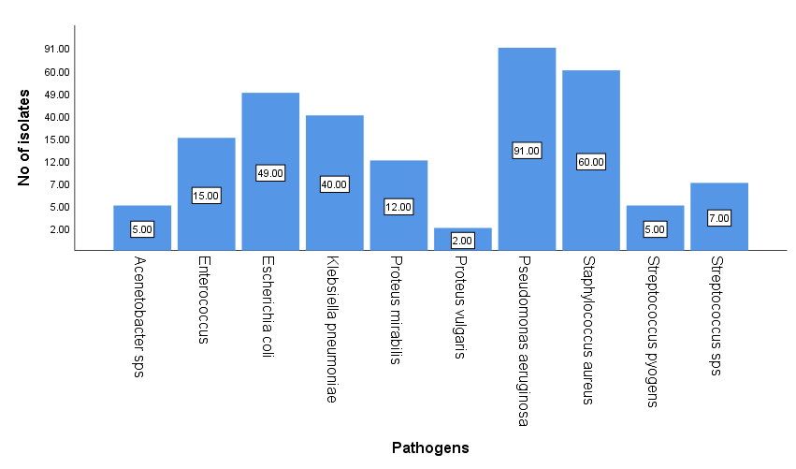
Fig. 3. Distribution of the Bacterial Population by Percentage during the Study period

Table 5.Antibiotic-resistant patterns in Gram-positive bacteria from infections in wounds
S.No. | Antibiotics Tested | Gram-positive Pathogens
S.No. | Antibiotics Tested | S. aureus  (n=60) | S. pyogens (n=05) | Streptococcus sps.  (n=07) | Enterococcus (n=15)
 | AZM | 28 (47%) | - | - | -
 | CLR | 28 (47%) | - | - | -
 | E | 29 (48%) | 0 | 0 | -
 | CD | 27 (45%) | 2 (40%) | 0 | -
 | CX | 0 | - | - | -
 | P | 38 (63%) | 3 (60%) | 3 (43%) | 11 (73%)
 | COT | 16 (27%) | - | - | -
 | LZ | 26 (43%) | 0 | 0 | 0
 | DOX | 26 (43%) | - | - | -
 | MI | 26 (43%) | - | - | -
 | TE | 19 (32%) | - | - | -
 | C | 26 (43%) | 3 (60%) | 2 (29%) | -
 | CIP | 28 (47%) | - | - | -
 | LE | 27 (45%) | 1 (20%) | 0 | -
 | MO | 28 (47%) | - | - | -
 | GEN | 27 (45%) | - | - | -
 | AMP | - | 3 (60%) | 3 (43%) | 11 (73%)
 | VA | - | 0 | 1 (14%) | 0
 | CPM | - | 2 (40%) | 2 (29%) | -
 | CTX | - | 2 (40%) | 1 (14%) | -
 | CTR | - | 2 | 2 | -

Note: AZM: Azithromycin; CLR: Clarithromycin; E: Erythromycin; CD: Clindamycin; CX: Cefoxitin; P: Penicillin; COT: Co-trimoxazole; LZ: Linezolid; DOX: Doxycycline; MI: Minocycline; TE: Tetracycline; C: Chloramphenicol; CIP: Ciprofloxacin; LE: Levofloxacin; MO: Moxifloxacin; GEN: Gentamycin; AMP: Ampicillin; VA; Vancomycin; CPM: Cefepime; CTX: Cefotaxime; CTR: Ceftriaxone

Table 6. Patterns of antibiotic resistance in Gram-Negative bacteria from wound Infections

S.No. | Antibiotics  Used | E.coli  (n= 49) | P. aeruginosa  (n= 91) | K. pneumoniae  (n=40) | P.  Mirabilis  (n=12) | P.  Vulgaris  (n=02) | Acenetobactersp.  (n= 05)
 | AMP | 40 (82%) | - | 40 (100%) | 8 (67%) | 1 (50%) | -
 | CZ | 40 (82%) | - | 29 (73%) | 8 (67%) | 1 (50%) | -
 | GEN | 1 (2%) | 10 (11%) | 20 (50%) | 6 (50%) | 0 | 3 (60%)
 | TOB | 1 (2%) | 5 (5%) | 20 (50%) | 6 (50%) | 0 | 3 (60%)
 | AK | 33 (67%) | 16 (18%) | 20 (50%) | 5 (42%) | 0 | 1 (20%)
 | AMC | 33 (67%) | - | 20 (50%) | 3 (25%) | 0 | -
 | AS | 33 (67%) | - | 0 | 0 | 0 | -
 | PIT | 7 (14%) | 3 (3%) | 21 (53%) | 4 (33%) | 0 | 1 (20%)
 | CXM | 33 (67%) | - | 27 (68%) | 8 (67%) | 1 (50%) | -
 | CPM | 33 (67%) | 35 (38%) | 30 (75%) | 8 (67%) | 1 (50%) | 3 (60%)
 | CX | 33 (67%) | - | 29 (73%) | 8 (67%) | 1 (50%) | -
 | CTX | 32 (65%) | - | 9 (23%) | 8 (67%) | 1 (50%) | 1 (20%)
 | CTR | 33 (67%) | - | 27 (68%) | 4 (33%) | 1 (50%) | 4 (80%)
 | CIP | 1 (2%) | 7 (8%) | 14 (35%) | 0 | 0 | 1 (20%)
 | LE | 0 | 23(25%) | 13 (33%) | 0 | 0 | 1 (20%)
 | IPM | 0 | 0 | 0 | 0 | 0 | 0
 | MRP | 0 | 0 | 0 | 0 | 0 | 0
 | COT | 1 (2%) | - | 13 (33%) | 5 (42%) | 0 | 4 (80%)
 | AT | 1 (2%) | 40 (44%) | 22 (55%) | 5 (42%) | 0 | 1 (20%)
 | C | 32 (65%) | - | 17 (43%) | 5 (42%) | 0 | -
 | TE | 32 (65%) | - | 16 (40%) | 5 (42%) | 0 | -
 | CAZ | 1 (2%) | 39 (43%) | 22 (55%) | 5 (42%) | 0 | 3 (60%)
 | DO | - | - | - | - | - | 1 (20%)
 | MI | - | - | - | - | - | 1 (20%)

NOTE: AMP: Ampicillin; CZ: Cefazolin; GEN: Gentamycin; TOB: Tobramycin; AK: Amikacin; AMC: Amoxyclav; AS: Ampicillin-Sulbactam; PIT: Piperacillin-tazobactam; CXM: Cefuroxime; CPM: Cefepime; CX: Cefoxitin; CTX: Cefotaxime; CTR: Ceftriaxone; CIP: Ciprofloxacin; LE: Levofloxacin; IPM: Imipenem; MRP: Meropenem; COT: Co-trimoxazole; AT; Aztreonam; C: Chloramphenicol; TE: Tetracycline; CAZ: Ceftazidime; DO: Doxycycline; MI: Minocycline.

Table 7.Prevalence of multiple drug resistance in different bacterial isolates from wound infections

S.No. | Type of Bacterial Isolates | Isolate Name | R1 to R3  (%) | R4  (%) | R5  (%) | R6 & above  (%) | Antibiotics tested
1. | Gram Negative | P.aeruginosa | 26 | 4 | 2 | 3 | Ampicillin, Cefazolin, Amikacin, Ceftazidime, Cefepime, Co-trimoxazole, Ceftazidime, Amikacin, Aztreonam, Gentamicin, Tobramycin, Ciprofloxacin, Levofloxacin, Piperacillin+ TazobactamAmoxyclav, Chloremphenicol, Tetracycline,Cefazolin,
2. | Gram Negative | E. coli | 4 | - | - | 32
3. | Gram Negative | K. pneumoniae | - | - | - | 18
4. | Gram Negative | P. mirabilis | 4 | - | 1 | 5
5. | Gram Negative | P. vulgaris | 4 | - | - | -
6. | Gram Negative | Acinetobacter sps | - | 2 | - | -
7. | Gram Positive | S. aureus | 1 | - | 1 | 29 | Ampicillin\ Penicillin-G,  Co-trimoxazole,  Tetracycline, Cefepime, Cefotaxime, Ceftriaxone, Chloremphenicol, Azithromycin, Erythromycin, Clindamycin, Doxycycline, Minocycline, Ciprofloxacin, Levofloxacin, Moxifloxacin, Gentamycin
8. | Gram Positive | Streptococcus sps | - | 1 | - | -
9. | Gram Positive | S. pyogens | - | - | - | -
10. | Gram Positive | Enterococcus | - | - | - | -
Note: R0: Sensitive against all selected antimicrobials classes; R1-R3: Resistant to one to three antimicrobials classes; R4: Resistant to four antibiotic classes; R5: Resistant to five antibiotic classes; R6: Resistant to six antibiotic classes;; MDR: Resistant to more than 3 antimicrobial types.

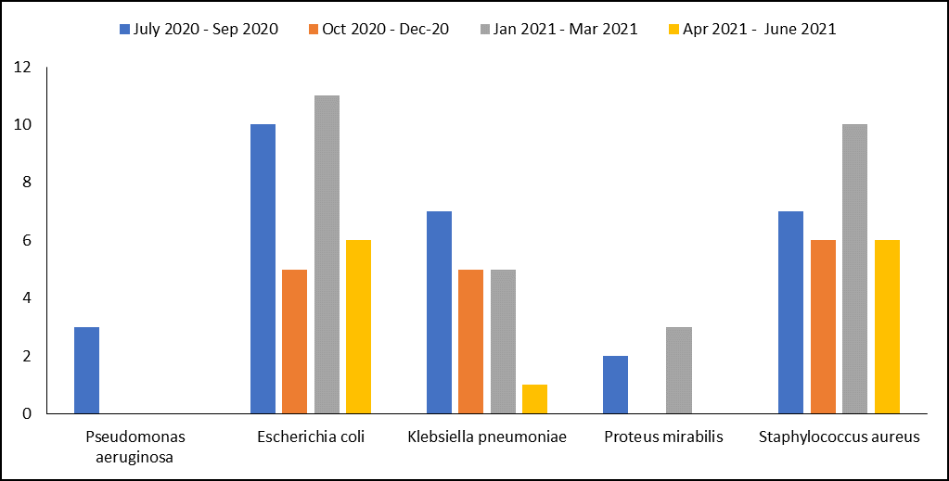
Fig. 4: Multidrug-resistant bacterial isolates from wound infections during the study period from July 2023 to June 2024

- DISCUSSION
The objective of the present prospective examination was to screen for the presence of the antibiotic resistance profiles of bacterial isolates from individuals who had wound infections. In microbiology labs, routine testing has mostly relied on culture techniques that enable the detection and isolation of possible infections from swabs and pus to identify the species and ascertain the susceptibilities of antimicrobials as a guide for a therapeutic treatment. Out of the individuals with different wounds examined, 606 wound bacterial isolates were found. Out of all the culture-positive samples, 168 (58.7%) were from male patients and 118 (41.2%) from female cases that correlate with the studies of Rai et al. (2017) with 59% positive cultures. The results were less than those obtained by Kemebradikumo et al. (2013), and Khalim et al. (2022), who reported 81.1%, and 92 % respectively. The variation could be explained by the cause of the wound infections that the samples were collected. More exposure to the environment, a higher chance of accidents while working, and social conduct where men are viewed as superior to women and get favorable bias are probably the causes. Of the total species isolated, P. aeruginosa was the most frequently observed (31.8%). The second and third most common bacterial pathogens were S. aureus and E. coli, with corresponding frequencies of 20.9% and 17.13% respectively. According to a study by Bankar et al. (2018), Gram negative bacterial incidence was 51.97%, whereas Gram positive bacteria were 47.36%.The current findings are consistent with study conducted by Trojan et al. (2016), Bankar et al. (2018), Sudhaharan et al. (2018), and Singh et al. (2019), which found that the most common bacterial isolates in wound infection cases were E. coli (GNB) and S. aureus (The GPB). The risk of a wound being infected with Staphylococcus aureus is more important since the skin is an ideal habitat for staphylococcus species (Abdullahi and Lawal, 2024). In addition, S. aureus is provided with a wide range of virulence characteristics that enhance its capacity to cause infections in contrast to other bacteria. However, S. aureus infections were fairly common in India, ranking second only to Pseudomonas species (Dash et al., 2013; Singh et al., 2003). Pseudomonas aeruginosa infections in wounds have been demonstrated to be caused by unfavorable environmental circumstances (MonsiTombari et al., 2025). There was no isolation of Coagulase Negative Staphylococci (CONS) from wounds in the present study. These organisms are often discovered to be pollutants of wounds, according to many investigations. Their absence in this investigation has demonstrated that all methods used in the research were deemed to be satisfactory.
Antibiotics are compounds produced by microorganisms that can either kill or specifically inhibit the growth of other germs. The most commonly found bacteria in diabetic wounds were Enterococcus, possibly as a result of their opportunistic pathogen behavior given that diabetes is related to impaired immune responses (Nancy et al., 2017). The results of the antimicrobial susceptibility test showed that the gram negative bacteria had the lowest resistance frequency to Meropenem, Imepinem, and Ciprofloxacin, while the gram positive cocci had the lowest resistance frequency to Ciprofloxacin, Clarithromycin, and Erythromycin. In addition, low resistance to carbapenemase (Meropenem, Imepinem) and quinolones (levofloxacin and ciprofloxacin) was noted, with 100% and 80%, respectively. Ampicillin had the greatest level of resistance; 85.5% of isolates exhibited resistance. Resistance to Cefazolin, amoxiclavin, and Cefepime followed next; 104 wound isolates (75%, 56.3%, and 55.2%) showed resistance to each of these drugs. Additionally, sixty percent of the wound isolates were resistant to penicillin. As these findings were compared to those of another study carried out in Nigeria (Mohammad ShahidRaza et al., 2013), it was discovered that the resistance to Amoxyclav and Cefepime, which were 56.3% and 55.2%, respectively, in this study was much lower than that of the other study (62%). High antibiotic resistance in the isolates may result from self-medication, a lack of diagnostic laboratory services, or a lack of guidelines for drug selection, all of which can contribute to improper antibiotic usage.
Antimicrobial susceptibility testing of the 87 recovered Gram-positive isolates in this research study revealed that the lowest resistance was to meropenem, doxycycline, and amikacin. In the meanwhile, the highest resistance was found to clindamycin and erythromycin, with 20 isolates (16.9%) resistant to each. Clarithromycin resistance emerged next; 17 isolates (14.4%) had this feature. Next, cefadroxil and Azithromycin resistance: 15 isolates (12.7%) had each of these resistances. In contrast, the Gram-positive isolates obtained for the present study showed a limited degree of resistance. The results of Bibi et al. (2012), Gelaw et al. (2011), and Shamsuzzaman et al. (2003) revealed that the gram-positive isolates in their study are 100% sensitive to the antibiotics used in the present study. The 117 Gram-negative wound isolates were then tested for antibacterial susceptibility, and the results showed that amikacin, Azithromycin, and meropenem had the lowest resistance. Clindamycin had the highest level of resistance, with 88 bacterial isolates (75.2%) exhibiting resistance. Amoxicillin resistance emerged next; 84 isolates (71.7%) had this resistance. Following that, cefuroxime resistance; 82 isolates, or 70%, exhibited resistance. Gram-negative rods were the most common and important source of wound infections in our study. Our findings were contrasted with the results of another research by Ram et al. (2018), which showed a lower degree of resistance to co-trimoxazole (52.1% vs. 79.4%) and amikacin (11.9% against 20.9%). These results are consistent with earlier research in Asia and other African contexts. This may be due to Gram-negative bacteria exhibit higher levels of antibiotic resistance than Gram-positive isolates, which may elucidate why they survive in infected wounds. Muluet al. (2012) revealed that the average resistance of gram-positive cocci isolates (100%) and gram-negative bacilli isolates (95.5%) was identical to our study conducted in Ethiopia.
Out of the wound bacterial isolates, 62 isolates (26.4%) were determined to be resistant to six or more antimicrobial agents from more than two antimicrobial classes; nine isolates (14.5%) were Gram-positive, and 53 isolates (85.5%) were Gram-negative. It was quite alarming that over 53% of the MDR isolates exhibited resistance to eleven of the tested antimicrobial drugs include amoxicillin, cefadroxil, Cefepime, ceftriaxone, cefuroxime, ciprofloxacin, Clarithromycin, clindamycin, co-amoxiclavin, co-trimoxazole and erythromycin. In a study of wound infection isolates from India, almost all of them were resistant to four or more antimicrobials (Kłoset al., 2021). In contrast, 92.2% of the isolates in another study carried out in Sudan were MDR, and 53.3% of them were resistant to more than seven antimicrobials (Pirvanescu et al., 2014). Thus, the findings of this study were compared to those of other developing nations in order to determine the extent of antibiotic overuse together with inadequate hygiene standards. Antibiotic overuse results in considerably increased levels of resistance and the emergence of MDR pathogens, which severely restricts the available treatment alternatives. Long-term antibiotic usage also causes multidrug-resistant (MDR) bacteria to evolve, which exacerbates problems and leads to treatment failure. In order to reduce the high rate of antibiotic abuse and to emphasize the need of hygienic habits, public awareness campaigns should also be launched successfully. Additionally, the automated technique for identifying bacterial wound isolates and assessing the isolates' susceptibility to antibiotics by providing accurate test results was followed in this study.

- CONCLUSION
Wound infection occurs when microbes enter a wound in the skin and multiplies, leading to inflammation and delayed healing. It can develop in any type of wound such as surgical incisions, cuts, abrasions, or pressure ulcers. Present study reported that S. aureus was the most frequently isolated bacteria, followed by E. coli,Proteus species, K. pneumoniae, Enterococcussps, and P. mirabilis. A high prevalence of resistance to Ampicillin\Penicillin-G, Co-trimoxazole, Tetracycline, Cefepime, Cefotaxime, Ceftriaxone was observed in these isolates. Most of the isolates were shown to be resistant to widely used drugs. Thus, periodic surveillance and monitoring of antibiotic susceptibility testing is necessary for effective wound infection control. Therefore, the current study demonstrated that the irrational use of antibiotics or the alteration or evolution of bacteria throughout time is the causes of the rise in bacterial resistance when compared to several earlier researches.

COMPETING INTERESTS DISCLAIMER:
Authors have declared that they have no known competing financial interests OR non-financial interests OR personal relationships that could have appeared to influence the work reported in this paper.

References

Abdullahi, B., &Lawal, F. B. (2024). Isolation, identification and antibiotic susceptibility patterns of bacteria associated with wound of patients attending Ahmadu Bello University Teaching Hospital, Shika, and Zaria-Nigeria. Science World Journal, 19(3).
https://dx.doi.org/10.4314/swj.v19i3.4

Akinjogunla, O. J., &Enabulele, I. O. (2010). Virulence factors, plasmid profiling and curing analysis of multidrug resistant Staphylococcus aureus and coagulase negative Staphylococcus spp. isolated from patients with acute otitis media. Journal of American Science, 6, 1022–1033.

Alshara, J. M. R. (2018). Isolation and identification of bacterial wound infection isolates and their antibiotic susceptibility pattern.Al-Kufa University Journal for Biology, 10(2).

Ayub, M., Rizwan, H., Siddique, S., & Maryam, U. (2015). Isolation of pathogens causing sepsis, pus and infected wounds from critical care unit: A retrospective study. Annals of Clinical and Laboratory Research, 4, 1–7.

Bankar, N., Wankhade, A., Brahmane, R. B., Hathiwala, R., &Chandi, D. H. (2018). Bacteriological profile of pus/wound swab and antimicrobial susceptibility of Staphylococcus aureus isolated from pus and wound swab of indoor patients of tertiary care hospital, Drug, Chhattisgarh, India. International Journal of Innovative Research in Medical Science, 3(4), 1–5.

Bhujugade, S. R., Geeta, K., &Satish, P. (2024). Bacteriological profile and antibiogram pattern of wound infection in a tertiary care hospital. Cureus, 16(10), e72185.https://doi.org/10.7759/cureus.72185

Bibi, S., Channa, G. A., Siddiqui, T. R., & Ahmed, W. (2012).Pattern of bacterial pathogens in postoperative wounds and their sensitivity patterns. Journal of Surgery Pakistan (International), 17(4), 164–167.

Dash, M., Mishra, P., &Routray, S. (2013). Bacteriological profile and antibiogram of aerobic burn wound isolates in a tertiary care hospital, Odisha, India. International Journal of Medical Sciences, 3, 460–463.

Gelaw, A. (2011). Isolation of bacterial pathogens from patients with postoperative surgical site infections and possible sources of infections at University of Gondar Hospital, Northwest Ethiopia. Retrieved from

Kamini, R., Sonia, J., &Anju, G. (2023). Identification of bacterial isolates and their antimicrobial susceptibility pattern from wound/pus sample in a tertiary care hospital, Gwalior, India. Annals of the National Academy of Medical Sciences (India), 59(2).

Kemebradikumo, P., Beleudanyo, G. F., &Oluwatoyosi, O. (2013). Current microbial isolates from wound swabs, their culture and sensitivity pattern at the Niger Delta University Teaching Hospital, Okolobiri, Nigeria. Tropical Medicine and Health, 41(2), 49–53.
https://doi.org/10.2149/tmh

Khalim, W., James, M., Martin, T., &Silvano, T. S. (2022). Chronic wound isolates and their minimum inhibitory concentrations against third generation cephalosporins at a tertiary hospital in Uganda. Scientific Reports, 12, 1195.
https://doi.org/10.1038/s41598-021-04722-6

Malpekar, K., Lakshita, M., & Kishore, B. (2022). Bacterial etiology and antibiogram of surgical wound infection at a tertiary care hospital, Western India. International Journal of Academic Medicine and Pharmacy, 4(4), 370–374.

Kłos, M., Pomorska-Wesołowska, M., Romaniszyn, D., Wo´jkowska-Mach, J., &Chmielarczyk, A. (2021). Antimicrobial resistance in Enterobacterales bacilli isolated from bloodstream infection in surgical patients of Polish hospitals. International Journal of Microbiology, 7.https://doi.org/10.1155/2021/6687148
Lucinda, J. B., Paolo, F., Mara, D. G., &Cellin, L. (2015). Bacterial isolates from infected wounds and their antibiotic susceptibility pattern: Some remarks about wound infection. International Wound Journal, 12, 47–52.

Tombari, P. M., Ekwusa, V. O., Adebayo, O. A., &Chinwebudu, M. M. (2025). Prevalence and antibiogram of bacterial pathogens associated with wounds in patients attending University of Harcourt Teaching Hospital. Acta Scientific Microbiology, 8(2), 23–34.

Mulu, W., Kibru, G., Beyene, G., &Damtie, M. (2012). Postoperative nosocomial infections and antimicrobial resistance pattern of bacteria isolates among patients admitted at FelegeHiwot Referral Hospital, Bahirdar, Ethiopia. Ethiopian Journal of Health Sciences, 22(1), 7–18.

Kassam, N. A., Damian, J., Debora, K., Balthazar, N., Gibson, S., &Kibiki, G. (2017). Spectrum and antibiogram of bacteria isolated from patients presenting with infected wounds in a tertiary hospital, northern Tanzania. BMC Research Notes, 10, 757.
https://doi.org/10.1186/s13104-017-2802-2

Pîrvãnescu, H., Bãlãæoiu, M., Ciurea, M. E., Bãlãæoiu, A. T., &Mãnescu, R. (2014). Wound infections with multi-drug resistant bacteria. Chirurgia, 109(1), 73–79.

Rai, S., Yadav, U. N., & Pant, N. D. (2017). Bacteriological profile and antimicrobial susceptibility patterns of bacteria isolated from pus/wound swab samples from children attending a tertiary care hospital in Kathmandu, Nepal. International Journal of Microbiology, 17, 1–5.

Ram, H. D., Dhiraj, &Chaudhary, K. (2018). Microbial infections and antimicrobial resistance in Nepal: Current trends and recommendations. The Open Microbiology Journal, 12, 230–242.

Seyi, S. E., Adeolu, S. O., John, O. O., Richard, Y. A., Stanley, O. U., Ileoma, E., Comfort, B. E., &Rukayah, O. T. (2020). Assessment of oral bacterial profile and antibiogram of patients attending dental clinic of a private tertiary hospital in Ogun State, Nigeria. Saudi Journal of Oral and Dental Research, 5(1), 11–23.

Shamsuzzaman, A., Sirajee, A., Rahman, M., Miah, A., &Hossain, M. (2003).Pattern of aerobic bacteria with their drug susceptibility of surgical inpatients.Mymensingh Medical Journal, 12(2), 98–103.

Singh, A., Verma, V., & Singh, R. (2019). Antibiotic sensitivity pattern of pathogens isolated from pus culture—A tertiary care hospital based study. Journal of Nepalgunj Medical College, 17(2), 70–74.

Sudhaharan, S., Kanne, P., Chavali, P., &Vemu, L. (2018). Aerobic bacteriological profile and antimicrobial susceptibility pattern of pus isolates from tertiary care hospital in India. Journal of Infection in Developing Countries, 12(10), 842–848
https://doi.org/10.3855/jidc.10640

T.A. Olukitibi, T. Adebolu T. (2017). Antibiogram of Bacteria Isolated from Post - Operative Wounds of Mothers WHO Underwent Caesarean Section at the Mother and Child Hospital, Akure, Ondo State. Asian Journal Research Medicinal Pharmaceutical Science 18;2 (3):1-9. https://journalajrimps.com/index.php/AJRIMPS/article/view/51

Trojan, R., Razdan, L., & Singh, N. (2016). Antibiotic susceptibility patterns of bacterial isolates from pus samples in a tertiary care hospital of Punjab, India. International Journal of Microbiology, 16, 1–4.
https://doi.org/10.1155/2016/9302690

Yousef AAB, Alawkally NAM, Elasmer AO, Tahir MFA, Abouserwel A, Fakron A, El-Warred S, Ali MAD. (2022). Susceptibility and Resistance Patterns of Bacteria Isolated from Infected Wounds, Burn, Medical Device Tips and Blood to Doxycycline and Septrin from Patients in the City of Benghazi. Journal of Pharmaceutical Research International. 34 (54A): 16-25. https://journaljpri.com/index.php/JPRI/article/view/7236

