Assessment of Microbial Contamination in Over-the-Counter (OTC) Drugs: A review

Abstract
This review aims to assess the extent of microbial contamination in over-the-counter (OTC) drugs, highlighting the importance of quality control in the pharmaceutical industry. Microbial contamination in OTC drugs poses significant risks to public health, particularly as these products are widely available for self-administration without healthcare supervision. It explores the common sources of contamination, including manufacturing practices, storage conditions, and packaging materials. The review further examines regulatory guidelines from organizations such as the WHO, USP, and BP, which set acceptable microbial limits for pharmaceuticals. A comprehensive search was conducted across multiple databases, including PubMed, Google Scholar, ScienceDirect, and JSTOR. Various microbial testing methods, including traditional techniques such as Total Viable Count (TVC) and newer rapid testing methods, are discussed as tools for ensuring the microbiological safety of OTC products. Additionally, the review addresses case studies of contaminated OTC drugs, identifying factors contributing to contamination and their public health impact. Finally, emerging technologies and strategies for minimizing microbial contamination are explored, with a focus on advancements in filtration, nanotechnology, and regulatory enforcement. The review concludes by emphasizing the need for stringent quality control measures, robust microbial testing, and continued innovation to safeguard public health and improve the safety of OTC drugs.
Keywords: Microbial contamination, Over-the-counter drugs, Quality control, pharmaceutical safety, Microbial testing, Good Manufacturing Practices (GMP), OTC drug contamination
1 Introduction
Pharmaceutical products are manufactured purposely with the intention to treat a target medical condition. Nevertheless, several factors could compromise this goal, one of them being possible contamination with pathogenic and non-pathogenic microorganisms (Okunlola et al., 2007; Mukhtar et al., 2019). Pharmaceutical surveillance is playing an important role to help out for the avoidance from patients at risk due to inadequate safety, efficacy, and quality of pharmaceuticals and ensure they are fit for use. Many studies show that drug-borne diseases worldwide are associated with contaminated pharmaceutical dosage forms (Długaszewska et al., 2008; Salem et al., 2021). Microbial contamination in pharmaceutical products poses a significant threat to public health, especially in over-the-counter (OTC) drugs which are widely accessible and often self-administered without medical supervision. The risk of contamination is particularly concerning in non-sterile formulations such as syrups, creams, and tablets, where microbial presence can lead to reduced drug efficacy, spoilage, and in severe cases, infections or toxic reactions in vulnerable populations. Regulatory bodies including the U.S. Food and Drug Administration (FDA), World Health Organization (WHO), and European Medicines Agency (EMA) have continually emphasized the importance of good manufacturing practices (GMP) to control microbiological hazards during drug production (FDA, 2009; WHO, 2011a; EMA, 2022).
Microorganisms may infiltrate pharmaceutical products at various stages of production, including during raw material handling, manufacturing processes, packaging, or storage. These contaminants, which may include bacteria, fungi, and spores, can originate from poorly sanitized equipment, water systems, personnel, or the surrounding environment (WHO, 2011b; EMA, 2017). While sterile products undergo rigorous aseptic processing, non-sterile OTC drugs are more prone to microbial infiltration due to less stringent environmental controls, making GMP compliance even more critical in their manufacturing (FDA, 2004; CDSCO, 2019).
The FDA’s guidance on microbiological quality for non-sterile drug manufacturing highlights acceptable microbial limits and outlines risk-based approaches for ensuring microbial control (FDA, 2009). These guidelines stress the need for validated cleaning procedures, controlled HVAC systems, and routine microbial monitoring to minimize the chances of contamination. Similarly, WHO’s technical guidelines advocate for rigorous environmental and personnel hygiene measures, even in non-sterile facilities, to prevent the introduction and proliferation of harmful microorganisms (WHO, 2006a; WHO, 2006b).
One of the main challenges in non-sterile OTC drug manufacturing is maintaining microbiological quality during large-scale production. Contaminants such as Pseudomonas aeruginosa, Escherichia coli, and Staphylococcus aureus are frequently detected in improperly handled formulations, leading to recalls and adverse health outcomes (FDA, 2016; EMA, 2016). To mitigate such risks, manufacturers are required to implement process validation strategies that include microbiological testing of raw materials, in-process materials, and finished products (WHO, 2021; EMA, 2020). Failure to adhere to these standards has been linked to several high-profile contamination incidents involving OTC products.
GMP frameworks outlined by international agencies ensure that manufacturers apply quality systems that encompass validation, personnel training, equipment sterilization, and robust documentation (CDSCO, 2018b; WHO, 2011a). The EMA’s Annex 15 and the FDA’s cGMP regulations emphasize the importance of qualification and validation processes, which are essential in preventing microbial contamination in both sterile and non-sterile drug forms (EMA, 2020; FDA, 2024). These practices are crucial in OTC drug production due to the high volumes and broad demographic of end-users, including children and the elderly.
Furthermore, specialized microbiological laboratories play a critical role in quality control by ensuring the detection, identification, and quantification of microbial contaminants (WHO, 2011b; FDA, 2011). WHO’s Annex 2 outlines good practices for such laboratories, including the use of validated culture media and proficiency testing. These labs contribute to maintaining consistency in product quality and ensuring that any potential microbial breaches are swiftly identified and addressed through corrective actions.
2 Methodology
Search Strategy
The search strategy for this review article involved a systematic search of relevant literature on microbial contamination in over-the-counter (OTC) drugs, focusing on quality control, testing methods, and regulatory guidelines. A comprehensive search was conducted across multiple databases, including PubMed, Google Scholar, ScienceDirect, and JSTOR. Keywords used in the search included terms such as “microbial contamination,” “OTC drugs,” “pharmaceutical quality control,” “microbial testing in pharmaceuticals,” “Good Manufacturing Practices,” and “microbial contamination in over-the-counter drugs.” The search was limited to articles published from 2015 to 2024 to ensure the inclusion of the most recent research findings. Only peer-reviewed articles, government reports, and regulatory documents were considered to maintain the scholarly quality of the review.
The initial search yielded a large number of articles, from which studies focusing on microbial contamination in OTC drugs and their associated quality control practices were selected. Articles discussing laboratory testing methods, case studies of contamination incidents, and regulatory frameworks for OTC drug safety were prioritized. Additional relevant studies were identified through reference chaining from the initial set of articles.
Selection Criteria
The selection criteria for the studies included the following:
Inclusion Criteria:
Studies published between 2015 and 2024, ensure the review includes the most current research.
Peer-reviewed journal articles, conference papers, and official regulatory guidelines provide valuable insights into microbial contamination in OTC drugs.
Studies focusing on microbial contamination in OTC drugs specifically, including liquid formulations, topical creams, tablets, and supplements.
Articles that discuss quality control methods, microbial testing techniques, or regulatory standards related to OTC drugs.
Case studies and empirical research related to microbial contamination incidents in OTC products.
Exclusion Criteria:
Studies not focused on OTC drugs or only discussed prescription medications.
Articles that were not peer-reviewed or lacked sufficient scientific rigour.
Studies that did not provide direct evidence or case studies related to microbial contamination in OTC drugs.
Non-English language articles, as the search was conducted only in English.
The inclusion of studies was further narrowed by their relevance to the scope of the review, which focused on microbial contamination, testing methods, regulatory compliance, and the public health implications of contaminated OTC drugs.
Table1: Inclusion and Exclusion Criteria for searching review paper
Search Database | Keywords | Time Frame | Inclusion Criteria | Exclusion Criteria
PubMed | "microbial contamination", "OTC drugs", "pharmaceutical quality control", "microbial testing in pharmaceuticals", "Good Manufacturing Practices", "microbial contamination in over-the-counter drugs" | 2015-2024 | Peer-reviewed articles, studies on OTC drugs, microbial contamination, quality control, testing methods, case studies | Non-peer-reviewed articles, studies not focused on OTC drugs or pharmaceutical quality.
Google Scholar | "microbial contamination in OTC drugs", "microbial testing methods", "pharmaceutical contamination", "OTC drug microbial quality control" | 2015-2024 | Peer-reviewed articles, case studies, research on OTC drug contamination, regulatory standards | Studies not related to OTC drugs, irrelevant to microbial contamination in OTC drugs.
ScienceDirect | "microbial contamination in OTC drugs", "pharmaceutical testing", "quality control OTC drugs", "pharmaceutical microbiology" | 2015-2024 | Peer-reviewed journals, articles discussing OTC drug safety, microbial contamination, testing methods, quality control | Non-English language articles, articles without sufficient scientific rigour
JSTOR | "microbial contamination in pharmaceuticals", "microbial contamination in OTC drugs", "public health risk OTC drugs" | 2015-2024 | Articles related to microbial contamination in OTC products, regulatory guidelines, testing methods | Non-peer-reviewed, articles focused on non-OTC drugs or unrelated pharmaceutical areas.

3 Result and Discussion
a Sources of Microbial Contamination in OTC Drugs
Microbial contamination in OTC drugs can arise from various sources throughout the drug's life cycle. One of the primary sources is raw materials. Inadequately sterilized or contaminated raw materials, such as excipients, can introduce microorganisms into the formulation from the very start of production. These contaminants can be bacteria, fungi, or viruses that are not removed during the manufacturing process (Santos, Jimenez and Hamdy, 2023). Poor quality control at the raw material procurement stage can result in contamination that affects the entire product batch.
Another significant source of microbial contamination is the manufacturing process itself. During the production of OTC drugs, improper sanitation of equipment and surfaces can lead to cross-contamination between batches. For instance, poorly cleaned tanks, mixing vessels, and bottling machines can introduce microorganisms into the drug formulation, even if the raw materials were initially free from contamination (Roy, Majumder, Deb & Choudhury, 2023). Consistent cleaning protocols and effective sterilization methods are critical in preventing such contamination.
Packaging materials can also contribute to microbial contamination in OTC drugs. If the packaging is not sterile or if it is not sealed properly, it may allow microorganisms to enter the product during storage or transportation. Packaging materials, especially those that are not airtight, can become a conduit for contaminants. Microbial ingress through these materials can lead to the proliferation of microorganisms in the product before it even reaches the consumer (ISPE, 2023).
Storage conditions, such as temperature and humidity, play a vital role in microbial contamination. If OTC drugs are stored in environments that do not meet the recommended guidelines, such as excessively high humidity or fluctuating temperatures, microbial growth can occur. Certain pathogens, including mould and bacteria, thrive in warm and humid environments, leading to contamination of the drugs (Jimenez, 2019). Ensuring that drugs are stored at the proper temperature and humidity levels is essential to prevent such microbial growth.
Inadequate handling during transportation can also introduce microbial contamination. Improper storage in transit, such as exposure to extreme weather conditions or improper stacking in storage facilities, can result in the breakdown of packaging or introduce contaminants into the product. This is particularly concerning for OTC drugs that are shipped over long distances, where they may be exposed to varying environmental conditions (Jimenez, 2019).
Finally, human handling during the production, packaging, and distribution stages is an often-overlooked source of microbial contamination. Workers who handle the drug products may unknowingly transfer microorganisms onto the drugs if proper hygiene and protective measures are not observed. This underscores the importance of implementing strict hygiene practices, such as handwashing, wearing gloves, and using face masks, to minimize the risk of contamination (FDA, 2021). Training personnel in good hygiene practices is a key preventive measure.
b Microbial Testing Methods for OTC Drugs
Microbial testing methods are essential in ensuring that OTC drugs are free from harmful microorganisms. One of the most widely used methods for microbial testing is the Total Viable Count (TVC), which quantifies the number of living microorganisms in a given sample. TVC is a traditional method that involves culturing a sample on an agar plate and counting the resulting colonies. This method is relatively simple, but it can be time-consuming, as it requires several days to obtain results (Jimenez, 2019).
Membrane Filtration is another traditional microbial testing method commonly used for OTC drug products. In this method, a liquid sample is passed through a filter membrane that captures any microorganisms present. The membrane is then placed on an agar plate, where microbial growth can be observed. This method is particularly useful for testing liquid formulations like syrups and suspensions (Song et al., 2024a). Although it is effective, membrane filtration also has its limitations, including the potential for false negatives if the filter is not properly handled.
Recent advancements in microbial testing have led to the development of rapid detection techniques. Polymerase Chain Reaction (PCR)--based methods, for instance, allow for the amplification of microbial DNA, enabling the identification of specific pathogens within hours. PCR can detect a wide range of microorganisms, including bacteria, fungi, and viruses, making it a versatile tool for microbial testing (Ekeleme et al., 2024). Rapid tests like PCR significantly reduce the time needed for microbial analysis, enabling quicker identification of contaminated products.
Automated microbial detection systems have also gained popularity in the pharmaceutical industry. These systems use advanced technology to detect microbial growth in drug samples in real time. Such systems are often based on methods like light scattering or fluorescence, which allow for the detection of microbial activity without the need for traditional culture methods (Troja, 2020). Automated systems provide more accurate and quicker results, reducing the risk of contamination and improving the efficiency of quality control processes.
In addition to traditional and rapid methods, newer technologies like biosensors and microfluidic devices are emerging in microbial testing. Biosensors use biological materials, such as enzymes or antibodies, to detect microbial contamination by measuring changes in electrical signals or optical properties. Microfluidic devices allow for the analysis of smaller samples using integrated fluid systems, offering the possibility of on-site testing with minimal equipment (Patil & Naik, 2020). These technologies hold promise for more efficient, cost-effective, and portable microbial testing solutions.
The increasing reliance on rapid and automated microbial testing methods has prompted pharmaceutical companies to adopt these technologies to enhance their quality control systems. The integration of these advanced methods ensures that OTC drugs are consistently monitored for microbial contamination throughout the production process, leading to safer products reaching consumers. These technologies are also crucial in reducing testing turnaround times, allowing for faster decision-making when it comes to product release or recall (Microbial Contamination in Pharmaceutical Manufacturing, 2024).
c Regulatory Guidelines and Standards
Regulatory guidelines are crucial for maintaining the microbiological safety of OTC drugs. The United States Pharmacopeia (USP) sets comprehensive standards for the quality, purity, and safety of pharmaceuticals, including OTC drugs. The USP outlines microbial limits for non-sterile products, specifying the maximum allowable levels of microorganisms in these products. These standards help ensure that OTC drugs meet minimum safety requirements before they are sold to consumers (Microbial Contamination in Pharmaceutical Manufacturing, 2024).
The World Health Organization (WHO) also plays a critical role in regulating the microbiological safety of OTC drugs on a global scale. The WHO's guidelines for good manufacturing practices (GMP) include specific provisions for microbial control during drug production. These guidelines emphasize the importance of clean manufacturing environments, proper equipment sterilization, and appropriate testing procedures to prevent contamination (Troja, 2020). The WHO's guidelines provide a framework for ensuring the safety of OTC drugs, particularly in developing countries where regulatory enforcement may be less stringent.
In addition to the WHO and USP, national regulatory bodies such as the European Medicines Agency (EMA) and the Medicines and Healthcare Products Regulatory Agency (MHRA) set similar standards for microbial contamination in OTC drugs. These organizations issue guidelines that specify the allowable limits for various types of microorganisms, depending on the type of product and its intended use. Adherence to these guidelines is necessary for obtaining marketing authorization and ensuring consumer safety (Patil & Naik, 2020).
The European Union (EU) has also developed specific regulations for microbial testing in OTC drugs, particularly in terms of the stability of the products under various environmental conditions. For example, EU regulations outline the testing procedures for microbial contamination in products such as creams, ointments, and oral liquids, focusing on the potential risks to human health posed by microbial contamination (Jimenez, 2019). These regulations require manufacturers to conduct stability studies to evaluate the effects of storage conditions on microbial contamination over time.
While regulatory guidelines set the framework for microbial contamination control, the effectiveness of these guidelines relies on their implementation and enforcement by national health authorities. The monitoring of compliance with microbial limits is essential to preventing contaminated OTC drugs from entering the market. Regular inspections, audits, and product testing are vital components of the regulatory process, ensuring that manufacturers adhere to established microbial safety standards (Jimenez, 2019).
Finally, manufacturers must stay updated on changes to regulatory standards and guidelines to ensure continuous compliance. The evolving nature of regulatory requirements means that pharmaceutical companies must adapt their quality control practices to meet new microbial testing and contamination limits. This proactive approach helps safeguard public health and ensures that OTC drugs maintain the highest safety standards throughout their lifecycle (Hashim and Celiksoy, 2025).
d Case Studies of Contaminated OTC Drugs
Several case studies highlight the significant risks posed by microbial contamination in OTC drugs. One of the most well-known incidents involved the contamination of a widely used over-the-counter cough syrup with Pseudomonas aeruginosa, a harmful bacterium. The contamination led to several hospitalizations and ultimately a recall of the product. This case demonstrated the severe consequences of insufficient microbial testing and the failure to detect contamination before it reached consumers (Jimenez,20198). It emphasized the need for stringent quality control measures in the manufacturing process.
Another notable case occurred with a batch of topical ointments that was found to be contaminated with fungal spores, particularly Aspergillus species. The contaminated ointment caused skin infections in several individuals, leading to a public health scare. This incident underscored the importance of proper microbial testing in non-sterile products, especially for those intended for use on open wounds or damaged skin, where pathogens can enter the body more easily (Jimenez, 2019).
In another example, a popular over-the-counter oral supplement was recalled due to contamination with Salmonella bacteria, which caused foodborne illness in a significant number of consumers. The contamination was traced back to improper handling during the packaging process, where workers did not follow appropriate hygiene protocols. This case demonstrated the critical need for strict hygiene and sanitation practices throughout the manufacturing process to prevent contamination (Patil & Naik, 2020).
A more recent case involved a contamination incident in a batch of eye drops sold over the counter. The product was found to contain Bacillus cereus, a bacterium that can cause eye infections, including endophthalmitis. The contamination was linked to poor quality control measures during the production process, leading to an FDA recall. This case highlights the vulnerability of OTC drugs to contamination, particularly those used in sensitive areas such as the eyes (Song et al., 2024b).
The recall of contaminated OTC drugs often involves significant financial losses for manufacturers and damage to their reputations. In addition to financial implications, the public health consequences of such contamination can be severe, especially when vulnerable populations are affected. For instance, children and the elderly are more susceptible to infections caused by contaminated OTC products. As a result, public health authorities must remain vigilant and act swiftly to prevent further harm (Jimenez, 2019).
Finally, these case studies underscore the importance of rigorous microbial testing and the need for continuous improvement in quality control practices. Manufacturers must prioritize the implementation of best practices to prevent contamination and ensure that their products meet regulatory standards. The lessons learned from past contamination incidents can inform future practices, leading to safer OTC products and better protection for public health (Microbial Contamination in Pharmaceutical Manufacturing, 2024).
e Factors Contributing to Microbial Contamination
Microbial contamination in OTC drugs can occur due to several factors during the drug production process. One of the key factors is inadequate manufacturing practices. This includes improper sterilization of equipment and facilities, as well as poor cleaning protocols. Manufacturing environments that are not sufficiently sanitized can allow microbial contamination to enter the drug product, making it unsafe for consumers (Ekeleme et al., 2024). Implementing strict sanitation and sterilization procedures is crucial in preventing contamination at the source.
Another contributing factor is the improper storage of OTC drugs. Drugs that are stored in environments that do not meet the recommended temperature and humidity conditions are more likely to experience microbial growth. Excessive humidity and high temperatures can encourage the growth of fungi and bacteria, particularly in products that contain water or other moisture-sensitive ingredients (Hashim and Celiksoy, 2025). Adhering to proper storage conditions is vital to prevent microbial contamination from occurring post-production.
The use of contaminated raw materials is another common source of microbial contamination. Raw materials, such as excipients, active pharmaceutical ingredients, and water, must be tested for microbial contamination before they are used in the production process. If any raw material is found to be contaminated, it can lead to the contamination of the final product, even if the rest of the manufacturing process is conducted under sterile conditions (Troja, 2020). Quality control measures during the raw material procurement phase are essential to mitigate this risk.
Packaging materials, which come into direct contact with the drug product, can also be a source of microbial contamination. If packaging is not properly sealed or sterilized, it can allow microorganisms to enter the product during storage or transportation. Furthermore, packaging materials that are not compatible with the drug formulation may degrade, creating openings for contaminants (Jimenez, 2019). Ensuring the use of high-quality, sterile packaging materials is critical to preventing contamination.
Human factors, including the lack of proper hygiene practices, are a significant contributor to microbial contamination. Workers who handle drug products must follow stringent hygiene protocols, such as handwashing, wearing protective clothing, and using gloves and face masks. Without these practices, microorganisms from human hands can easily transfer to the product, leading to contamination. Training personnel in proper hygiene practices is essential to reducing human-related contamination risks (Jimenez, 2019).
Lastly, inadequate quality control procedures throughout the production process can contribute to microbial contamination. Without proper testing at every stage of production, from raw material inspection to final product testing, it becomes more difficult to identify contamination before the product reaches consumers. Regular microbial testing and adherence to Good Manufacturing Practices (GMP) are necessary to ensure product safety and mitigate contamination risks (Microbial Contamination in Pharmaceutical Manufacturing, 2024).
f Emerging Solutions and Technologies for Contamination Control
Emerging technologies offer innovative solutions for controlling microbial contamination in OTC drugs. One of the most promising developments is the use of antimicrobial coatings for packaging materials. These coatings contain substances that actively inhibit the growth of microorganisms on the surface of the packaging, preventing contamination before the product is even opened (Song et al., 2024a). This innovation can be particularly valuable for products that are stored for long periods before use.
Another emerging solution is the integration of nanotechnology in pharmaceutical formulations. Nanoparticles can be used to enhance the antimicrobial properties of OTC drugs, either by adding them to the formulation or applying them as coatings on the packaging. Nanoparticles have the ability to disrupt microbial cell membranes, preventing the growth of harmful microorganisms (Patil & Naik, 2020). Nanotechnology has the potential to revolutionize microbial contamination control in OTC drugs, ensuring products remain safe for extended periods.
Advanced filtration systems are also being developed to reduce microbial contamination risks in pharmaceutical production environments. These systems use high-efficiency particulate air (HEPA) filters to remove airborne contaminants and ensure that the manufacturing environment is free from harmful microorganisms. This technology is particularly useful in ensuring the sterility of non-sterile OTC drugs during the production and packaging processes (ISPE, 2023).
In addition to physical technologies, digital technologies are making an impact on microbial contamination control. Automated microbial detection systems allow for continuous, real-time monitoring of drug samples for microbial contamination. These systems use sensors to detect microbial activity, providing faster results than traditional culture-based methods. Automated systems reduce the chances of human error and provide more accurate, timely data for quality control (Song et al., 2024a).
The use of biosensors in microbial testing is another promising technology. Biosensors are devices that use biological components, such as enzymes or antibodies, to detect microbial contamination. They offer rapid, cost-effective testing with high sensitivity and specificity. Biosensors can be incorporated into the manufacturing process, enabling on-site microbial testing with minimal equipment (Jimenez, 20191). This innovation could help pharmaceutical companies detect contamination faster, ensuring timely interventions.

Table 2: Key finding, Challenges and Recommendations for Assessment of Microbial Contamination
Sub-section | Key Findings | Challenges | Recommendations | References
Sources of Microbial Contamination in OTC Drugs | Microbial contamination arises from raw materials, manufacturing, packaging, storage conditions, and human handling. | Microbial contamination can occur at various points in production and distribution, with inadequate sanitation. | Implement robust quality control measures, improve hygiene protocols, and ensure proper storage conditions. | Jimenez, 2019, FDA, 2021
Microbial Testing Methods for OTC Drugs | TVC and Membrane Filtration are traditional methods; PCR and automated systems are emerging technologies. | Traditional methods are time-consuming; new technologies need high investment and integration into systems. | Adopt rapid detection technologies and automate microbial testing for quicker results and improved safety. | (Santos, Jimenez, & Hamdy, 2023)  (Hashim & Celiksoy, 2025)(ISPE, 2023
Regulatory Guidelines and Standards | Regulatory bodies like WHO, USP, and BP set microbial limits for OTC drugs. Enforcement is critical for safety. | Ensuring global compliance is challenging due to varying standards and enforcement mechanisms. | Strengthen regulatory compliance, enforce GMP, and stay updated with regulatory changes. | (Hashim & Celiksoy, 2025)(Song et al. 2024a)(ISPE, 2023)
Case Studies of Contaminated OTC Drugs | Case studies show real-world contamination leading to recalls and public health issues. | Incidents reveal gaps in microbial testing and quality control; timely recalls are crucial. | Enhance microbial testing and develop proactive recall strategies. | (Song et al., 2024b; Ekeleme et al., 2024; Hashim & Celiksoy, 2025)
Factors Contributing to Microbial Contamination | Causes include inadequate manufacturing, improper storage, contaminated raw materials, packaging, and human handling. | Prevention requires quality control and compliance across multiple production stages. | Focus on GMP, regular inspections, and investment in proper storage conditions. | (Myemba et al., 2022; ISPE, 2023; Hashim & Celiksoy, 2025)
Emerging Solutions and Technologies for Contamination Control | Technologies like antimicrobial coatings, nanotechnology, advanced filtration, automated systems, and biosensors are emerging solutions. | Integrating these innovations into established systems can be difficult.

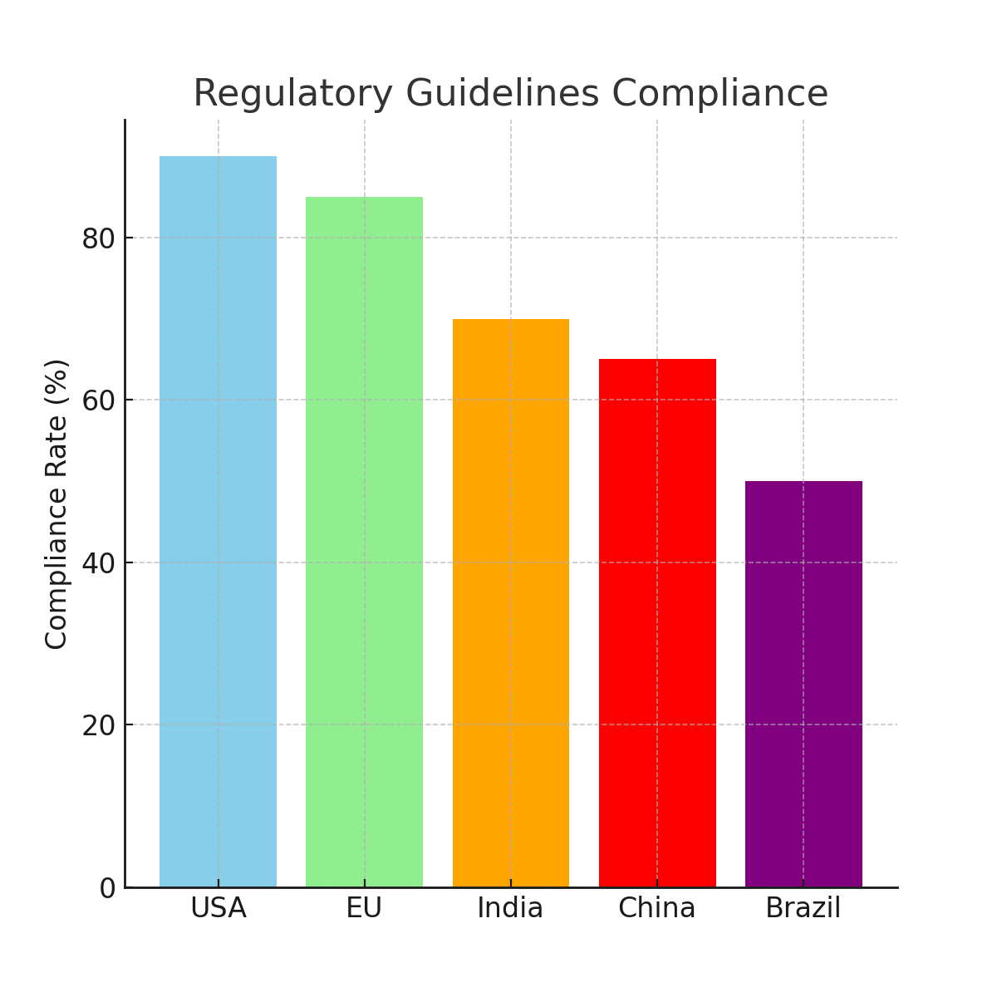
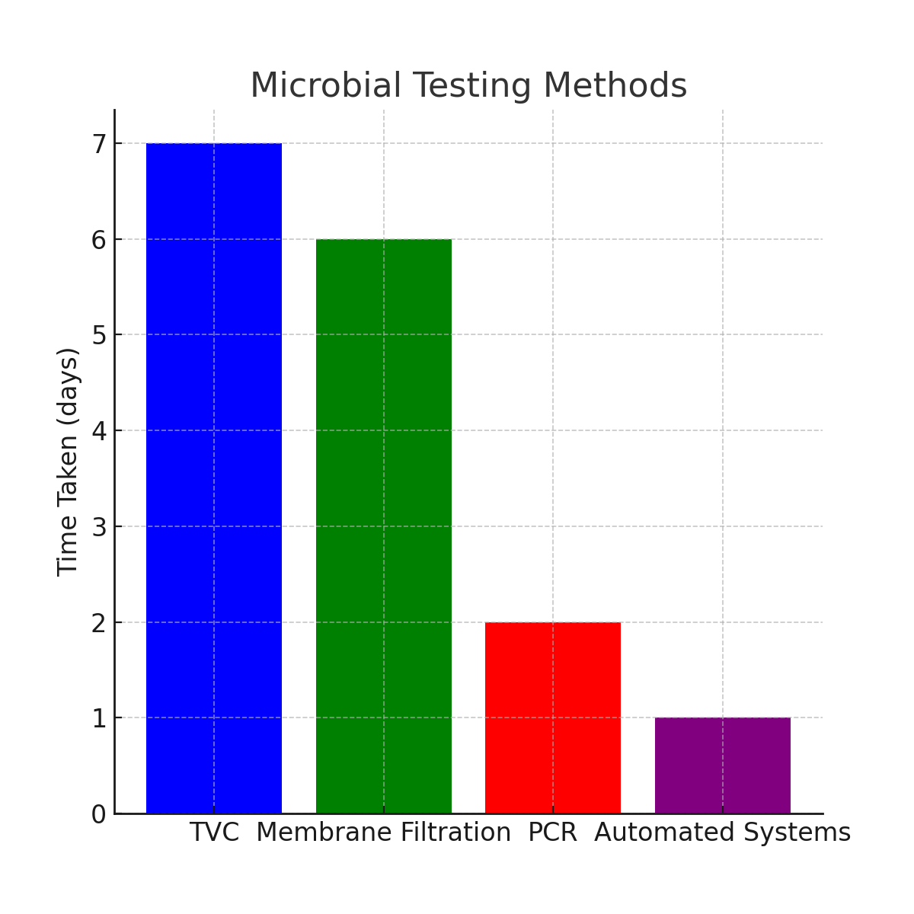
Fig 1: Regulatory Guidelines Compliance
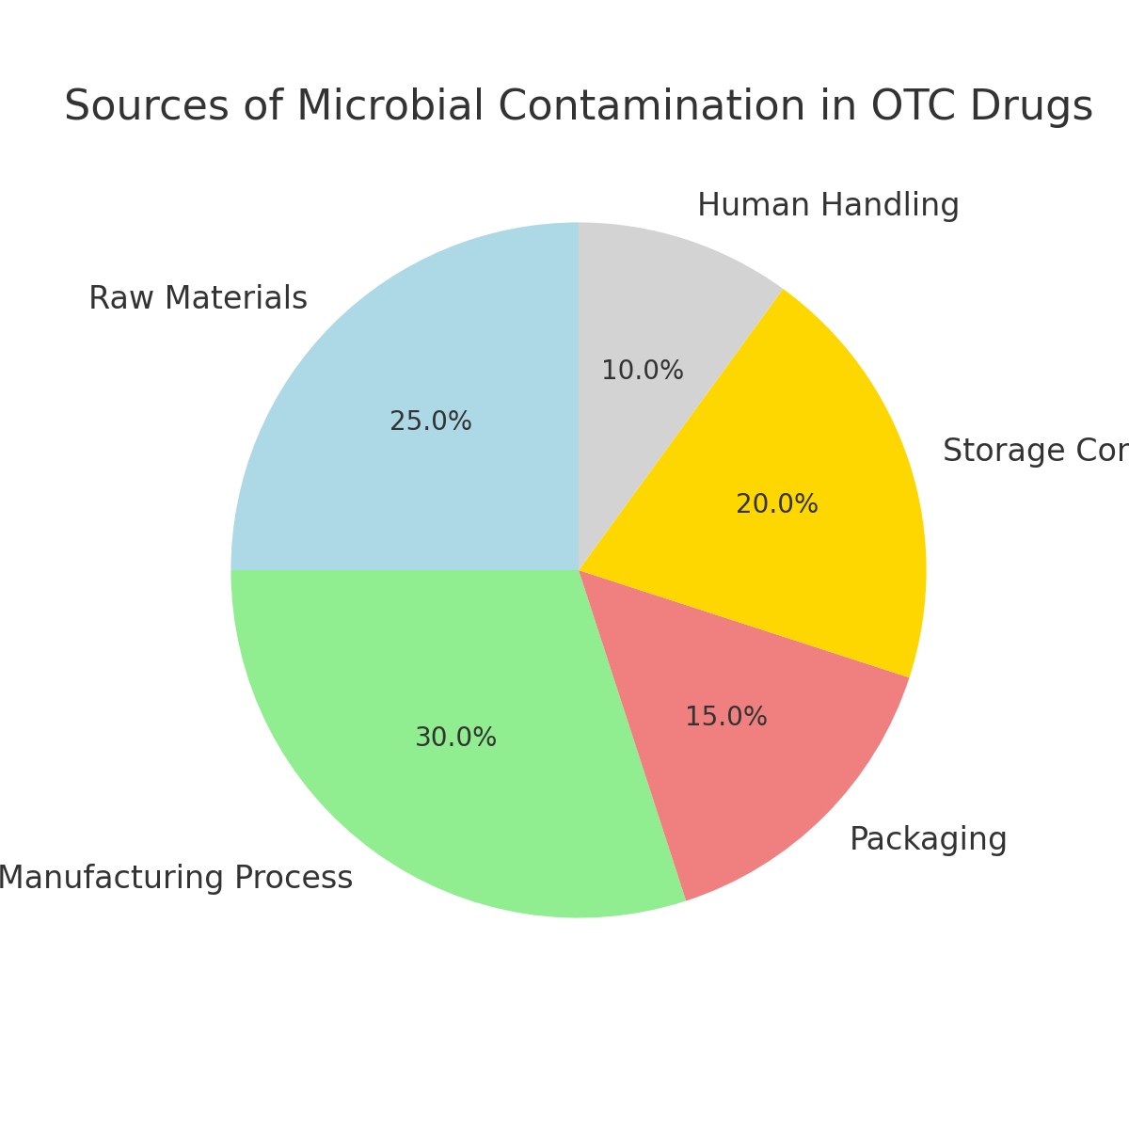
Fig 2: Microbial Testing Method
Fig 3: Source of Microbial Contamination in OTC drugs
4 Policy Implications, Future Directions, and Conclusion
Policy Implications
The findings from this review have significant policy implications for both regulatory bodies and pharmaceutical manufacturers. Regulatory agencies, including the WHO, USP, and national health authorities, must strengthen enforcement of microbial contamination standards for OTC drugs. Stringent monitoring, regular inspections, and improved testing procedures should be mandated to ensure compliance with microbiological safety standards. Moreover, guidelines should be updated regularly to account for emerging risks and advancements in microbial testing technologies. Policies must encourage the adoption of rapid microbial detection systems and ensure that manufacturers implement Good Manufacturing Practices (GMP) to minimize contamination risks throughout the production and distribution processes.
For manufacturers, there is a need for more comprehensive quality control systems that integrate microbial testing at every stage of the drug production process. Policies should promote the training of personnel in microbiological safety, sanitation protocols, and proper storage conditions. Furthermore, there should be incentives for manufacturers who implement innovative technologies, such as antimicrobial coatings and nanotechnology, to reduce microbial risks in OTC drugs. Governments and regulatory bodies must provide guidance and funding to encourage the development and adoption of such technologies.
In addition, governments should prioritize public health campaigns that educate consumers on the risks associated with contaminated OTC drugs and the importance of adhering to safe storage practices. This will empower consumers to make informed choices and help reduce the public health burden caused by contaminated products.
Conclusion
Microbial contamination in over-the-counter (OTC) drugs is a significant public health concern that requires immediate attention from both regulatory authorities and pharmaceutical manufacturers. This review has highlighted the key sources of contamination, including raw materials, manufacturing processes, packaging, and storage conditions. It has also discussed various microbial testing methods and regulatory guidelines aimed at ensuring the safety of OTC products. Despite existing regulations, gaps in enforcement and quality control still allow for microbial contamination to occur, putting consumers at risk.
The findings suggest that both the pharmaceutical industry and regulatory bodies must strengthen their efforts to combat microbial contamination. Manufacturers should adopt state-of-the-art technologies, implement robust quality control systems, and adhere to regulatory guidelines to minimize contamination risks. On the other hand, regulatory bodies must enforce these standards more rigorously and update guidelines to incorporate emerging technologies and new research findings.
As the demand for OTC drugs continues to rise globally, it is essential to continuously innovate in the areas of microbial testing and contamination control. The future direction of microbial contamination control in OTC drugs will be shaped by advances in rapid detection technologies, nanotechnology, and improved regulatory frameworks. By embracing these innovations and implementing comprehensive policies, the pharmaceutical industry can ensure that OTC drugs remain safe for consumers, minimizing the public health risks associated with microbial contamination.
Future Directions
The future of microbial contamination control in OTC drugs lies in the integration of emerging technologies and improved regulatory frameworks. The adoption of rapid testing methods, such as PCR-based techniques and automated microbial detection systems, will likely become the industry standard, ensuring quicker and more accurate detection of contaminants. Future research should focus on optimizing these technologies to improve their affordability, accessibility, and integration into existing quality control processes.
There is also a growing need for research into the development of novel antimicrobial materials for packaging and drug formulations. Nanotechnology holds great promise in creating self-sterilizing drug packaging and drug formulations with enhanced resistance to microbial growth. Future studies should explore the potential of nanomaterials in reducing contamination risks while maintaining the safety and efficacy of OTC drugs.
Further exploration into the use of biosensors and microfluidic devices for real-time microbial testing is another exciting avenue for research. These technologies offer the potential for on-site testing, which would significantly reduce testing turnaround times and improve the efficiency of microbial monitoring in OTC drug manufacturing.
Additionally, more research is needed to investigate the long-term effects of microbial contamination in OTC drugs, particularly in vulnerable populations such as children, the elderly, and immuno compromised individuals. Understanding the full scope of health risks posed by contaminated OTC drugs will help inform policy decisions and regulatory standards.

Disclaimer (Artificial intelligence)
Option 1:
Author(s) hereby declare that NO generative AI technologies such as Large Language Models (ChatGPT, COPILOT, etc.) and text-to-image generators have been used during the writing or editing of this manuscript.
Option 2:
Author(s) hereby declare that generative AI technologies such as Large Language Models, etc. have been used during the writing or editing of manuscripts. This explanation will include the name, version, model, and source of the generative AI technology and as well as all input prompts provided to the generative AI technology
Details of the AI usage are given below:
1.
2.
3.

References
Central Drugs Standard Control Organization. (2018a). Good Manufacturing Practices for Pharmaceuticals. Retrieved from https://www.cdsco.gov.in/
Central Drugs Standard Control Organization. (2018b). Guidelines for the Manufacture of Sterile Pharmaceutical Products. Retrieved from https://www.cdsco.gov.in/
Central Drugs Standard Control Organization. (2018c). Indian Pharmacopoeia. Retrieved from https://www.ipc.gov.in/
Central Drugs Standard Control Organization. (2019). Good Manufacturing Practices for Non-Sterile Pharmaceutical Products. Retrieved from https://www.cdsco.gov.in/
European Medicines Agency. (2016a). Guideline on Sterilisation of the Medicinal Product, Active Substance, Excipient and Primary Container. Retrieved from https://www.ema.europa.eu/en/documents/scientific-guideline/guideline-sterilisation-medicinal-product-active-substance-excipient-and-primary-container_en.pdf
European Medicines Agency. (2016b). Q7A Good Manufacturing Practice Guidance for Active Pharmaceutical Ingredients. Retrieved from https://www.ema.europa.eu/en/documents/scientific-guideline/q7a-good-manufacture
European Medicines Agency. (2017). Annex 1: Manufacture of Sterile Medicinal Products. Retrieved from https://health.ec.europa.eu/document/download/6eaee230-0dde-4bd2-b4b8-4f248be26d13_en
European Medicines Agency. (2020). Annex 15: Qualification and Validation. Retrieved from https://www.ema.europa.eu/en/documents/scientific-guideline/annex-15-qualification-validation_en.pdf
European Medicines Agency. (2022). EU GMP Guide Part I: Basic Requirements for Medicinal Products. Retrieved from https://health.ec.europa.eu/system/files/2022-08/20220825_gmp-an1_en_0.pdf
Hashim, Z. A., & Celiksoy, V. (2025). Pharmaceutical products microbial contamination; approaches of detection and avoidance. Microbes and Infectious Diseases, 6(1), 159-170.
International Society for Pharmaceutical Engineering (ISPE). (2023). Contamination trends & proposed solutions. Pharmaceutical Engineering, March–April 2023. Retrieved from https://ispe.org/pharmaceutical-engineering/march-april-2023/contamination-trends-proposed-solutions
Jimenez, L. (2019). Analysis of FDA enforcement reports (2012–2019) to determine the microbial diversity in contaminated non-sterile and sterile drugs. American Pharmaceutical Review, 22(6). Retrieved from https://www.americanpharmaceuticalreview.com/Featured-Articles/518912-Analysis-of-FDA-Enforcement-Reports-2012-2019-to-Determine-the-Microbial-Diversity-in-Contaminated-Non-Sterile-and-Sterile-Drugs/
Myemba, D. T., Bwire, G. M., & Sangeda, R. Z. (2022). Microbiological quality of selected local and imported non-sterile pharmaceutical products in Dar es Salaam, Tanzania. Infection and Drug Resistance, 15, 1641–1651. https://doi.org/10.2147/IDR.S355331
Song, M., Li, Q., Liu, C., Wang, P., Qin, F., Zhang, L., ... & Yang, M. (2024). A comprehensive technology strategy for microbial identification and contamination investigation in the sterile drug manufacturing facility—A case study. Frontiers in Microbiology, 15, 1327175.
U.S. Food and Drug Administration. (2004). Aseptic Processing—Current Good Manufacturing Practice. Retrieved from https://www.fda.gov/media/71026/download
U.S. Food and Drug Administration. (2009). Microbiological Quality Considerations in Non-Sterile Drug Manufacturing. Retrieved from https://www.fda.gov/regulatory-information/search-fda-guidance-documents/microbiological-quality-considerations-non-sterile-drug-manufacturing
U.S. Food and Drug Administration. (2011). Sterilization of Medical Devices: Process Validation Guidance. Retrieved from https://www.fda.gov/media/70793/download
U.S. Food and Drug Administration. (2016). Guidance for Industry: Sterile Drug Products Produced by Aseptic Processing—Current Good Manufacturing Practice. Retrieved from https://www.fda.gov/media/71032/download
U.S. Food and Drug Administration. (2021). Microbiological Quality Considerations in Non-Sterile Drug Manufacturing. Retrieved from https://www.fda.gov/regulatory-information/search-fda-guidance-documents/microbiological-quality-considerations-non-sterile-drug-manufacturing
U.S. Food and Drug Administration. (2024). Questions and Answers on Current Good Manufacturing Practice Regulations. Retrieved from https://www.fda.gov/drugs/guidances-drugs/questions-and-answers-current-good-manufacturing-practice-regulations-production-and-process
World Health Organization. (2006a). Annex 4: Supplementary Guidelines on Good Manufacturing Practices: Validation. In WHO Technical Report Series, No. 937. Retrieved from https://www.who.int/docs/default-source/medicines/norms-and-standards/guidelines/production/trs937-annex4-validation.pdf
World Health Organization. (2006b). Annex 8: Good Manufacturing Practices for Heating, Ventilation and Air-Conditioning Systems for Non-Sterile Pharmaceutical Products. In WHO Technical Report Series, No. 937. Retrieved from https://www.who.int/docs/default-source/medicines/norms-and-standards/guidelines/production/trs937-annex8-gmp-heating-ventilation-air-conditioning.pdf
World Health Organization. (2011a). Annex 2: Good Practices for Pharmaceutical Microbiology Laboratories. In WHO Technical Report Series, No. 961. Retrieved from https://www.who.int/docs/default-source/medicines/norms-and-standards/guidelines/quality-control/trs961-annex2-goodpractices-pharmaceutical-microbiology-laboratories.pdf
World Health Organization. (2011b). Annex 6: Good Manufacturing Practices for Sterile Pharmaceutical Products. In WHO Technical Report Series, No. 961. Retrieved from https://www.who.int/docs/default-source/medicines/norms-and-standards/guidelines/production/trs961-annex6-gmp-sterile-pharmaceutical-products.pdf
World Health Organization. (2021). Annex 4: Guidelines on the Manufacture of Sterile Pharmaceutical Products. In WHO Technical Report Series, No. 1027. Retrieved from https://www.who.int/docs/default-source/medicines/norms-and-standards/guidelines/production/trs1027-annex4-gmp-sterile.pdf
Okunlola, A., Adewoyin, B. A., & Odeku, O. A. (2007). Evaluation of pharmaceutical and microbial qualities of some herbal medicinal products in southwestern Nigeria. Tropical Journal of Pharmaceutical Research, 6(1), 661-670.
Mukhtar, G. L., Mukhtar, M. D., & Magashi, A. M. (2019). Microbiological quality of over-the-counter (OTC) oral drug preparations obtained from some retail pharmacies in Katsina State, Nigeria. Nigerian Journal of Microbiology, 33(2), 4732–4741
Song, Y., Zhang, Z., Liu, Y., Peng, F., & Feng, Y. (2024b). Enhancement of anaerobic treatment of antibiotic pharmaceutical wastewater through the development of iron-based and carbon-based materials: A critical review. Journal of Hazardous Materials, 135514.
Ekeleme, U. G., Ikwuagwu, V. O., Chukwuocha, U. M., Nwakanma, J. C., Adiruo, S. A., Ogini, I. O., & Ude, I. U. (2024). Detection and characterization of micro-organisms linked to unsealed drugs sold in Ihiagwa community, Owerri, Imo State, Nigeria. Access Microbiology, 6(2), 000752-v3.
Murtaza, G., Khan, M. A., Nissa, Z. –Un, Alam, S., Murad, M., Rizvi, M., Shahnaz, S., Ali, S. I., Ghayas, S., & Suri, S. (2022). Microbial and Physicochemical Analysis of Non-sterile Pharmaceutical Liquid Products in Karachi Pakistan. Journal of Pharmaceutical Research International, 34(27A), 11–18. https://doi.org/10.9734/jpri/2022/v34i27A35989
Długaszewska, J., Muszynski, Z., & Ratajczak, M. (2008). Microbiological purity of oral drugs manufactured in industrial and pharmacy environment. In 26th Congress of the Polish Society of Microbiologists: Microbes–Challenges and Hopes. Conference Materials. Szczecin (pp. 4-7).
Salem, N. M. A., Elbarrawy, M. A., & Azzam, N. F. A. E. M. (2021). Microbiological quality of non-sterile pharmaceuticals in Egypt. Beni-Suef University Journal of Basic and Applied Sciences, 10(1), 38.

