Modeling the Impact of Climate Change on Evapotranspiration and Irrigation Requirements of Rice in Chandauli Using NEX-GDDP and CROPWAT

Abstract
A study was conducted to evaluate the impact of climate change on the water requirements of rice crops in the Chandauli district of Uttar Pradesh, where rice is a principal cereal crop. Climate change poses serious threats to food security and water resources, necessitating such assessments. The research employed the CROPWAT 8.0 model to estimate evapotranspiration (ET) and irrigation water requirements (IWR) for rice cultivation. Climate data, including maximum temperature (Tmax), minimum temperature (Tmin), and rainfall, were derived from the NASA Earth Exchange Global Daily Downscaled Projections (NEX-GDDP) for both the baseline period (1981–2015) and the future period (2020–2040), under the RCP 4.5 scenario. Due to inherent biases in General Circulation Models (GCMs), two bias correction methods—linear scaling and modified difference—were tested, with linear scaling proving more effective. Climate projections indicate an approximate increase of 1.7 °C in both Tmax and Tmin by 2040. Although total rainfall may rise, effective rainfall (ER) is projected to fluctuate. The study predicts an 8.8% increase in crop water requirements (CWR) by 2040 due to rising temperatures. Meanwhile, irrigation water requirements (IWR) are expected to vary: increasing by 19% in 2020, decreasing by 9% in 2030, and rising again by 2.9% in 2040. These findings underscore the importance of adaptive water management and agricultural planning to mitigate climate change impacts on rice production in the region.
Keywords: Bias correction, Climate change, Crop water requirement,
- INTRODUCTION
Efficient use of freshwater is becoming increasingly critical as global demand continues to rise. Freshwater is one of the most essential natural resources, and it is estimated that nearly two-thirds of the global population could face severe freshwater shortages within the next quarter century if water is not managed wisely. In India, the agricultural sector accounts for approximately 81% of total water consumption, making efficient water use in farming a top priority (Surendran et al., 2015). Agriculture requires water primarily for irrigation to meet the evapotranspiration demand necessary for vital metabolic processes such as photosynthesis. These physiological activities are crucial for healthy plant growth and higher crop yields. Maintaining an appropriate air-to-water ratio in the plant root zone is essential to create a favorable environment for plant development. These physiological processes are highly dependent on the availability of water, especially during key developmental phases. Crops are particularly vulnerable to water stress during their critical growth stages; hence, maintaining adequate soil moisture in the root zone is essential to prevent yield reduction or crop failure. Accurate estimation of crop water requirement (CWR) and the implementation of efficient irrigation scheduling are vital components of effective irrigation planning and water resource management. In this context, estimating the irrigation water requirement (IWR) under varying cropping patterns has become an increasingly important task for water resource managers and planners (Elnashar et al., 2021). Moreover, any changes in the average weather conditions of a region—such as shifts in temperature or rainfall patterns—can significantly influence crop growth and productivity. Climate change has emerged as one of the major challenges for humanity in the 21st century, particularly because agriculture is highly dependent on weather and climatic conditions (Neill et al., 2017: Das et al.,2022). Among various climatic variables, rainfall is especially significant due to its non-uniform distribution across time and space (Parthasarathy, 1984). Having prior knowledge of regional weather parameters is essential for efficient and effective irrigation scheduling. Numerous studies have been conducted at both national and international levels—across farm and non-farm sectors—using time series data to forecast weather variables.
Climate models serve as critical tools for projecting future climate scenarios. The Coupled Model Intercomparison Project Phase 5 (CMIP5) offers the most extensive and recent collection of meteorological datasets for analyzing historical trends and simulating future climate conditions (Taylor et al., 2012). However, applying these global simulations at the regional scale poses challenges due to their coarse spatial resolution, which may not accurately capture localized climate variability. The CMIP5 climate models are known to exhibit considerable biases in simulating seasonal averages, which differ across geographical regions and among various models (Sengupta and Rajeevan, 2013; Hamed et al., 2022 ). Research has shown that these discrepancies tend to be more pronounced for precipitation than for temperature (Andreasson et al., 2004) , and the multi-model averaging approach (Jain et al., 2019; Harrison et al., 1995). As a result, it is essential to apply bias correction techniques to raw model outputs to improve their accuracy for regional applications (Chen et al., 2022; Cho et al., 2020; Sharma et al., 2007; Feddersen and Andersen, 2005). In addition, to enhance the spatial resolution and reliability of regional climate projections, a variety of dynamical and statistical downscaling methods have been developed and widely used.
The NEX-GDDP dataset, derived from CMIP5-generated GCM simulations, provides statistically downscaled climate scenarios with a global, high-resolution, bias-corrected set of climate projections. These projections are particularly useful for assessing the impacts of climate change at finer spatial scales. The dataset has a spatial resolution of 0.25° (25 km × 25 km). The primary aim of the study is to assess the crop water requirement using bias-corrected of precipitation and temperature datasets from the NEX-GDDP for the Chandauli district.Tthis is evaluated by a multi-model averaging approach to minimize random error in individual models and to reduce internal variability.

2. Materials and Methods
2.1 Description of study area
Chandauli district, situated in the southeastern region of Uttar Pradesh, India, is an important administrative unit within the Varanasi Division. Geographically, it lies between 24°56′N to 25°35′N latitude and 83°02′E to 83°42′E longitude presented in Fig1. The district shares its boundaries with Varanasi to the west, Sonbhadra to the south, Bihar state to the east, and Ghazipur to the north. Covering an area of approximately 2,484 Km² (District survey report, 2020), the administrative headquarters is located in Chandauli town. The district features varied topography, comprising fertile alluvial plains in the northern part and undulating hills associated with the Vindhyan range in the south (Kumar et al., 2020). Major rivers such as the Ganga, along with its tributaries, the Karmanasa and Chandraprabha, significantly influence the region’s hydrology and enhance its agricultural potential. Climatically, Chandauli experiences a sub-tropical monsoon climate, characterized by hot summers, mild winters, and a well-defined monsoon season from June to September (Rai et al.,2017). The district receives average annual rainfall between 1000 mm and 1200 mm, primarily from the southwest monsoon ( Singh et al., 2020). Temperature variations range from around 5°C in winter to above 40°C during peak summer (Yadav et al., 2021). According to the 2011 Census of India, Chandauli has a population of approximately 1.95 million, with a population density of 785 persons per square kilometer. The district is predominantly rural, with more than 85% of the population dependent on agriculture and allied sectors for livelihood (Sarkar 2018). Agriculture serves as the cornerstone of Chandauli’s economy. Due to its substantial rice production, it is often referred to as the “Dhaan Ka Katora” (Rice Bowl) of Uttar Pradesh (CRIDA Contingency report, 2019). The availability of fertile soil, abundant water resources, and favorable climate conditions contribute to the region's high suitability for paddy cultivation. Besides rice, other key crops include wheat, pulses, and horticultural produce. Nonetheless, variability in monsoon patterns and rising temperatures pose emerging challenges to sustainable agricultural development.
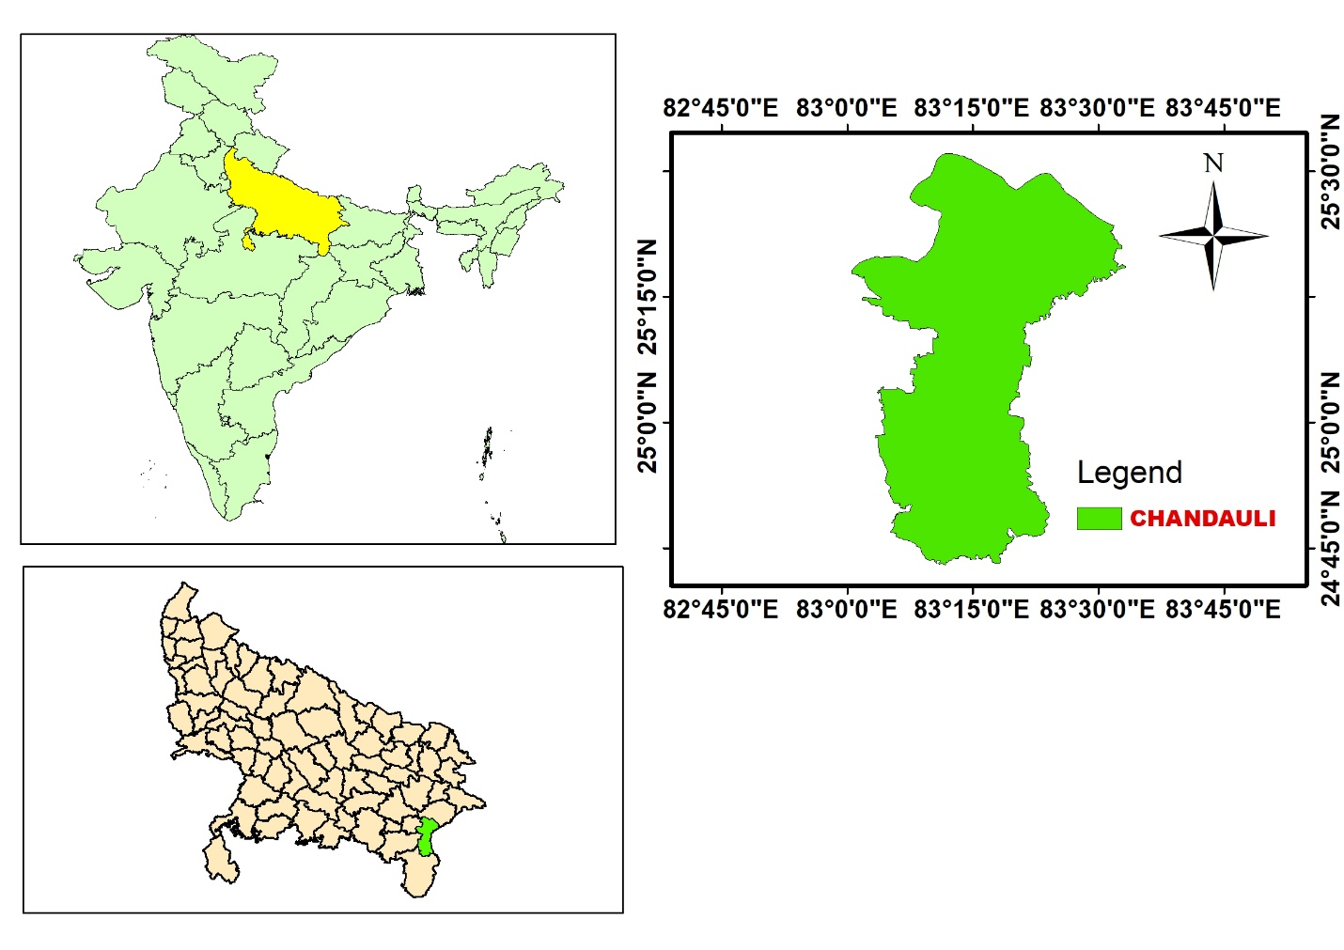
Uttar Pradesh
India
Fig. 1: Study area Map of Chandauli District
2.2 Retrieval of climate data
The recently released NEX-GDDP dataset was utilized to obtain site-specific daily rainfall and temperature data for two time periods: the baseline (1981–2015) and the future projection period (2020–2040). To enhance the reliability of the projections, the multi-model averaging approach was applied, which helps to minimize random errors and reduce internal variability. A total of seven General Circulation Models (GCMs) from the CMIP5 archive were selected to generate the downscaled NEX-GDDP dataset (Table 1). These models were combined into an ensemble to further reduce uncertainties associated with individual model outputs.
Table 1. Seven CMIP5 general circulation models (GCMs) used in the study
S. No. | Model | Institute | Resolution | References
1. | CanESM2 | Canadian Centre for Climate Modelling and Analysis | 2.8˚ × 2.8˚ | (CCCma, 2013)
2. | CCSM4 | National Centre for Atmospheric Research, USA | 0.95˚ × 1.25˚ | (Gent et al., 2011)
3. | GFDL-CM3 | Geophysical Fluid Dynamic laboratory, USA | 2˚ × 2.5˚ | (Donner et al., 2011)
4. | GFDL-ESM2M | Geophysical Fluid Dynamic laboratory, USA | 2˚ × 2.5˚ | (Dunne et al., 2012)
5. | INMCM4 | Institute of Numerical Mathematics of the Russian Academy of Sciences | 2.5˚× 2˚ | (Volodin et al., 2010)
6. | MPI-ESM-LR | Max Planck Institute for Meteorology (MPI-M), Germany | 1.87˚ × 1.87˚ | (Giorgetta et al., 2013)
7. | MRI-CGCM3 | Meteorological Research Institute, Japan | 1.12˚ × 1.12˚ | (Yukimoto et al., 2012)

2.3 Assessment of the NEX-GDDP Dataset for Regional Climate Analysis
Evaluating model data against observed data during the baseline period is essential for assessing the predictive capability of the model for future projections. In this study, the performance of the NEX-GDDP dataset was evaluated using three statistical performance indicators: the correlation coefficient (r), root mean square error (RMSE), and percent bias (Pbias), as presented in Table 3. These indices are commonly used in the evaluation of climate models (Jain et al., 2019). The correlation coefficient (r) indicates the strength and direction of the linear relationship between observed and predicted values, with values closer to ±1 signifying stronger correlation. RMSE (Root Mean Square Error) measures the accuracy of the model’s predictions by quantifying the average magnitude of the errors, with lower values indicating higher accuracy. Pbias (Percent Bias) evaluates the average tendency of simulated values to overestimate or underestimate observed data; values close to zero reflect better model performance. Together, these metrics provide a comprehensive evaluation of model reliability and predictive capability.
Table 2. Detailed equations and variables used for the evaluation of model dataset
Statistical Metric | Equation | Description | Unit | References
Correlation Coefficient (r) | $$r=\frac{\sum{\left(X-\overline{X}\right)\left(Y-\overline{Y}\right)}}{\sqrt{\sum{{\left(X-\overline{X}\right)}^{2}}}\sqrt{\sum{{\left(Y-\overline{Y}\right)}^{2}}}}$$ | $\overline{X}$ denotes mean of X variable variable $\overline{Y}$ denotes mean of Y variable | --- | (Helsel & Hirsch, 2002)
Root Mean Square Error (RMSE) | $$RMSE=\sqrt{\frac{\sum_{i=1}^{n}{{{(Y}_{i}-X_{i})}^{2}}}{n}}$$ | $X_{i}$ denotes observed value, $Y_{i}$ denotes model value, and n denotes Total number of observations | mm or ˚C | (Willmott & Matsuura, 2005)
Percent Bias (Pbias) | $$Pbias=\frac{\sum{\left(Y_{i}-X_{i}\right)}}{n}×100$$ | Same as RMSE description | % | (Gupta et al., 1999)

2.4 Bias reduction
Model recorded dataset are not perfect in providing simulated climatology. They will differ from observed climatology (Knutti, & Sedláček, 2013; Sharma et al., 2004). For this reason, the nearterm climate predictions are usually bias-reduction. In this study two bias reduction methods i.e. linear scaling (LS) and modified difference approachare compared in this study. Bias reduction wasdone on the monthly basis. The monthly correction factors were developed from observed and model data for the year 2001-2015. After bias reduction of baseline dataset, the method obtaining lower Pbias is considered as the best and same correction factors were applied for bias reduction of the future data. Both bias reduction methods to correct model dataset areas follows.
    - Linear scaling method
This method is based on the principle of aligning the monthly mean of corrected model values with that of the observed data (Teutschbein & Seibert, 2012; Lenderink et al., 2023). It involves adjusting the model simulations through either multiplication or addition, depending on whether the variable is rainfall or temperature. Monthly correction factors were derived for rainfall and temperature using Equation (1) and Equation (2), respectively.
For rainfall
$R_{cor,m}= R_{uncor,m} × \frac{\overline{R_{obs}}}{\overline{R_{uncor,m}}}$ …(1)
For temperature
$T_{cor,m}= T_{uncor,m}+ \frac{\overline{T_{obs}}}{\overline{T_{uncor,m}}}$ …(2)

2.4.2 Modified Difference Approach
To generate monthly correction factors for rainfall and temperature, the modified difference approach was applied using Equation (3) and Equation (4), respectively. While conceptually similar to the standard difference method, this approach enhances the correction process by incorporating additional statistical parameters. In the case of temperature, for example, adjustments to the mean (μ) and standard deviation (σ) were introduced to shift and scale the data, thereby refining the representation of both central tendency and variability in the corrected dataset (Rojas et al., 2011; Hewaarachchi et al., 2017).
For rainfall
$R_{cor,m}=\left(R_{uncor,m}+\left(△x\right)\right)×\frac{σ(R_{obs})}{σ(R_{uncor,m})}$ …(3)
For temperature
${ T}_{cor,m}=\overline{T_{obs}}+\left(T_{uncor,m}-\overline{T_{obs}}\right)×\frac{σ\left(T_{obs}\right)}{σ\left(T_{uncor,m}\right)}+(\overline{T_{obs}}-\overline{T_{uncor,m}})$ …(4)
Where $R_{cor,m}$ and $T_{cor,m}$ are the model corrected value of rainfall and temperature , $R_{uncor,m}$ and $T_{uncor,m}$ are the model uncorrected rainfall and temperature, $\overline{R_{obs}}$ and $\overline{T_{obs}}$ are the average value of observed rainfall and temperature, and $σ\left(R_{obs}\right)$ and $σ\left(T_{obs}\right)$ are standard deviation of observed rainfall and temperature values, and $σ\left(R_{uncor,m}\right)$ and $σ\left(T_{uncor,m}\right)$ are the standard deviation of model uncorrected rainfall and temperature values, and $(△x)$ is a average daily difference of observed and modelled values.
2.5 Simulated Climate Variability in Rainfall and Temperature (2020–2040)
Daily temperature and rainfall values for the years 1981–2015 (baseline), as well as for 2020, 2030, and 2040, were derived from the NEX-GDDP dataset. Monthly correction factors, developed using data from 2001 to 2015, were applied to reduce biases in the NEX-GDDP projections for the future years (2020, 2030, and 2040). To evaluate the potential impacts of climate change, comparisons were conducted between baseline and projected future values of temperature and rainfall.
2.6 Determination of Irrigation Water Requirement under Changing Climate
In this study, the CROPWAT 8.0 model is utilized to estimate the water requirement for rice. Previous research has demonstrated that CROPWAT 8.0 is a reliable tool for determining crop water requirements (CWR). Developed by the FAO in 1990, CROPWAT 8.0 is designed to support the planning and management of irrigation projects. It is an effective tool for analyzing the complex interactions between various farm parameters, including soil, crop, and climate, to determine CWR. The model consists of five input modules: climate, rainfall, crop, soil, and cropping pattern. The climate data required include maximum temperature (Tmax), minimum temperature (Tmin), wind speed (u), relative humidity (RH), and sunshine hours. To calculate reference evapotranspiration (ET0), the CROPWAT 8.0 model employs the FAO Penman-Monteith formula.
${ET}_{0}=\frac{0.408\left(R_{n}-G\right)+γ \frac{900}{T+273}u_{2}(e_{s}-e_{a})}{Δ+γ(1+0.34u_{2})}$ …(5)
where,
ET₀ = Reference evapotranspiration (mm day⁻¹)
R_{n} = Net radiation at the crop surface (MJ m⁻² day⁻¹)
e_{s} = Saturation vapour pressure (kPa)
e_{a} = Actual vapour pressure (kPa)
( e_{s}- e_{a} ) = Saturation vapour pressure deficit (kPa)
Δ = Slope vapour pressure curve (kPa °C⁻¹)
γ = Psychrometric constant (kPa °C⁻¹)
G = Soil heat flux density (MJ m⁻² day⁻¹)
T = Air temperature at 2 m height (°C)
U₂ = Wind speed at 2 m height (m s⁻¹)

The water requirement for rice was calculated by multiplying the crop coefficient (Kc) with the reference evapotranspiration (ET0), along with an additional component to account for puddling, as suggested by Choudhury et al., (2016). The irrigation water requirement (IWR) for rice was then estimated by factoring in the effective rainfall specific to the location, assuming an irrigation efficiency of 60% (FAO, 2007).
IWR = (ET_{c} – ER) × (irrigation efficiency) …(6)
In the present study, the USDA Soil Conservation Service (SCS) method (Boughton, W. C. 1989; Smith, 1991) is used for computation of effective rainfall (ER) The salient details of the rice crop and sandy loam soil for the study are taken are as per FAO.
2.7 Evaluating Climate-Induced Variability in Irrigation Demand
CROPWAT 8.0 software was employed to evaluate the impact of climate change on the crop water requirement (CWR) for rice in the Chandauli district. Future projections of temperature and rainfall for the years 2020, 2030, and 2040 were obtained using the NEX-GDDP dataset and used as input weather data in the CROPWAT 8.0 model. As noted by Katerji et al., (2017), rising temperatures in the future are expected to significantly contribute to increased reference evapotranspiration (ET0). Therefore, in this study, only temperature changes were considered for calculating future crop evapotranspiration (ETc), while other climatic parameters such as wind speed, relative humidity, and sunshine hours were assumed to remain constant at baseline values. By inputting climate, rainfall, soil, and crop data, the model was used to analyze changes in effective rainfall and irrigation water requirements (IWR) for the years 2020, 2030, and 2040.
3. RESULTS AND DISCUSSION
3.1 Appraisal of NEX-GDDP dataset
Observed daily temperature and rainfall data from 1981 to 2015 were used as the reference dataset to evaluate the performance of the NEX-GDDP model. The correlation coefficient, root mean square error (RMSE), and Pbias for this evaluation are presented in Table 3. The correlation between the observed and NEX-GDDP data was stronger for temperature variables—0.880 for maximum temperature (Tmax) and 0.872 for minimum temperature (Tmin)—but notably weaker for rainfall, which showed a correlation of only 0.212. The lower correlation for rainfall may be attributed to its irregular temporal and spatial distribution, as noted by Mooley et al. (1984); Wilby & Wigley, (2000). Similarly, Andreasson et al. (2004) observed that model biases are more significant for rainfall than for temperature. The RMSE values were found to be 3.197°C for Tmax, 3.757°C for Tmin, and 12.301 mm for rainfall. The Pbias between observed and modeled data was calculated at 3.92% for Tmax, 1.88% for Tmin, and 11% for rainfall.
Table 3: Evaluation of model dataset
Statistical matrices | Observed & model data
T_{max} (˚C)
Correlation coefficient | 0.880
RMSE | 3.197˚C
Pbias | 3.92%
T_{min} (˚C)
Correlation coefficient | 0.872
RMSE | 3.757˚C
Pbias | 1.88%
Rainfall (mm)
Correlation coefficient | 0.212
RMSE | 12.301 mm
Pbias | -11%

3.2 Bias correction in the NEX-GDDP dataset
To develop an appropriate correction function, two bias correction methods—linear scaling (LS) and the modified difference approach—were compared. The linear scaling method significantly improved the Pbias values, bringing the model-simulated temperature data closer to the observed values. Specifically, the Pbias for maximum temperature (Tmax) improved from 3.92% to -1.43%, and for minimum temperature (Tmin), it improved from 1.88% to 0.33% (Table 4). The differences in mean and standard deviation between the observed and corrected model data were also reduced compared to those between the observed and uncorrected model data (Table 4). For rainfall, the correction functions based on the LS method showed a reduction in the difference of mean and standard deviation values between corrected and observed datasets (Fig. 2). The Pbias for rainfall improved from -11% to -2.4% (Table 4).
Monthly correction functions for Tmax and Tmin were developed using the modified difference approach to align the model-simulated data with the observed values. However, the results indicated that this method did not significantly improve the model output, as illustrated in Fig. 2. The Pbias for Tmax increased from 3.92% to 6.47%, and for Tmin, it rose from 1.88% to 2.40% (Table 4). For rainfall, the Pbias improved marginally, shifting from -11% to -7% (Table 4). It was observed that the linear scaling (LS) method produced greater reductions in discrepancies between observed and corrected model values for Tmax, Tmin, and rainfall. Therefore, the LS-derived correction factors were used for bias correction of the future climate dataset. Similar findings were reported by Dar et al. (2017), who noted the superior performance of the LS method over the modified difference approach. Kaur et al. (2015) evaluated statistical bias correction methods and found that the modified difference approach was more effective than the simple difference method at the monthly scale. In a comparative study of six bias correction techniques, Chen et al. (2013) concluded that distribution-based methods (such as daily translation, daily bias correction, empirical quantile mapping, and gamma quantile mapping) outperform mean-based approaches like linear scaling and the local intensity method.
Table 4: Statistical analysis of observed, model, and model corrected Tmax, Tmin, and rainfall by linear scaling method and modified difference approach
Parameters | Observed | Model | Linear scaling | Modified approach
T_{max} (˚C)
Mean (μ) | 31.60 | 32.84 | 31.14 | 33.64
Standard deviation (σ) | 6.20 | 5.34 | 5.75 | 5.93
Pbias (%) | -- | 3.92 | -1.43 | 6.47
T_{min} (˚C)
Mean (μ) | 19.57 | 19.94 | 19.63 | 20.04
Standard deviation (σ) | 7.65 | 6.62 | 6.78 | 7.59
Pbias (%) | -- | 1.88 | 0.33 | 2.40
Rainfall (mm)
Mean (μ) | 2.74 | 2.43 | 2.67 | 2.44
Standard deviation (σ) | 12.41 | 4.65 | 4.94 | 4.71
Pbias (%) | -- | -11 | -2.4 | -7.0

(A) | (D)
(B) | (E)
(C) | (F)
Fig.2 Observed, model, and model corrected (A)maximum temperature (B) minimum temperature (C) Cumulative rainfall by linear scaling method and model corrected (D)maximum temperature (E) minimum temperature (F) Cumulative rainfall by modified difference approach
3.3 Future climate scenarios
Future projection of NEX-GDDP dataset for the Chanduali district suggest a rise in minimum and maximum temperature both. A steady increase in T_{max} and T_{min} has estimated by model. Analysis showed an increase in T_{max} of 0.58˚C, 0.84˚C and 1.42˚C in 2020, 2030, & 2040 respectively as compare to baseline (Fig.3). For T_{min} an increase of 0.8˚C in 2020, 1.37˚C in 2030, and 2˚C in 2040 was predicted by model as shown in Fig. 4. In case of rainfall no particular trend followed by model. Model predicteda reduction in rainfall of 123 mm in 2020 but an increase in rainfall of 223 mm in 2030 and 88.75 in 2040 was predicted by model (Fig 4). Projected T_{max}, T_{min} and rainfall during the irrigation month in a year 2020, 2030, and 2040 are presented in Table 4. These T_{max}, T_{min} and rainfall value are used to estimate change in ET_{c} and IWR. Kumar et al.,(2010) reported in India historical temperature is continuously increasing but rainfall is trendless. At the end of 21st century average temperature is projected to elevate by 3 to 6˚C and future rainfall may be higher by 15 to 40% from baseline period (1961-90) (IPCC, 2007).
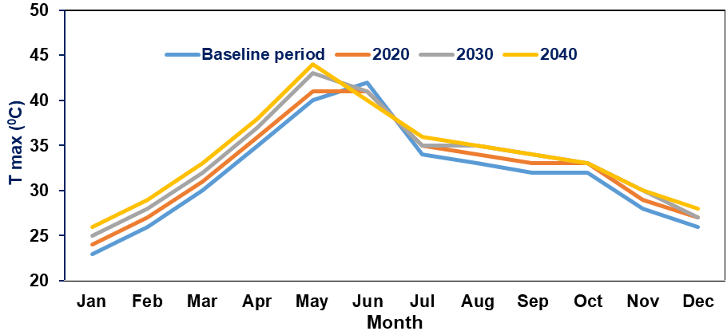
Fig. 3: Comparison of T_{max} during baseline and future for the year 2020, 2030, & 2040

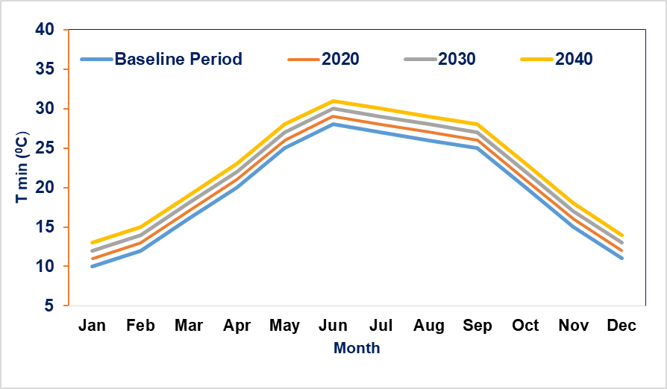
Fig.4: Comparison of T_{min} during baseline and future for the year 2020, 2030, & 2040
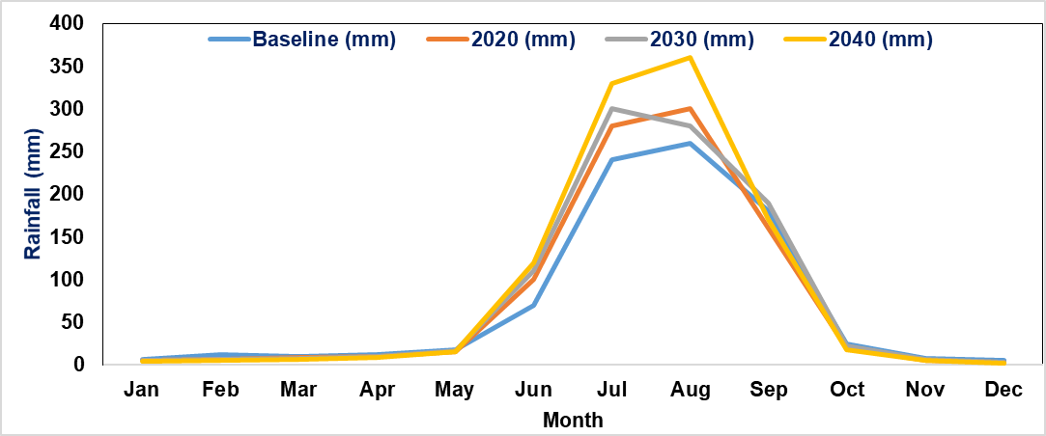
Fig.5: Comparison of rainfall during baseline and future for the year 2020, 2030, & 2040

3.4 Estimation of Irriagtion water requirement (IWR)
The irrigation water requirement for rice cultivation in the study area was utilizing monthly average rainfall and temperature data from the baseline period (1981–2015) through CROPWAt softwere. Based on an assumed irrigation efficiency of 60%, the average seasonal crop water requirement (CWR) and IWR were estimated at 860.5 mm and 380.9 mm, respectively. The highest evapotranspiration (ETc) losses were recorded during the early growth stages of rice, when substantial water input is essential to support critical physiological functions. A shortage of water during this phase can severely affect crop development and yield.Therefore, efficient irrigation strategies that enhance water productivity should be promoted. Ramesh et al. (2019) reported average seasonal rice water requirements of 383.3 mm and 403.8 mm for Lakhimpur Kheri and Sitapur districts, respectively. Crops cultivated under hot and sunny climatic conditions typically have higher daily water demands compared to those grown in cooler environments. Dar et al. (2017) estimated an average seasonal IWR of 1495.3 mm for rice in Ludhiana district. Similarly, Banerjee et al. (2016) found that a temperature rise of 2°C and 3°C led to an increase in the IWR for potato crops by 0.06 mm/day and 0.16 mm/day, respectively, in the lower Gangetic plains. Chatterjee et al. (2012) also projected a 7–8% increase in potato IWR by 2020, which could rise to approximately 14–15% by 2050 in the Ganga River Basin, West Bengal.
3.5 Impact Analysis of Changing Climate Conditions
3.5.1 Evapotranspiration
Evapotranspiration (ET) represents a significant component of water loss within the water balance system. In this study, ET losses for rice crops were estimated using the CROPWAT 8.0 model for both the baseline period and projected future years—2020, 2030, and 2040. During the baseline period (1981–2015), the monthly reference evapotranspiration (ET₀) ranged between approximately 65.72 mm and 276.12 mm. The lowest ET₀ occurred in January (65.72 mm), while the highest was recorded in May (276.12 mm). A gradual increase in ET₀ was observed from January, peaking in May, followed by a steady decline to around 72.54 mm in December. A comparison of baseline and future ET₀ values indicated projected increases of 6.2%, 6.8%, and 8.8% in the years 2020, 2030, and 2040, respectively, as illustrated in Fig. 6. Similar findings were reported by Singh et al. (2020), where maximum ET₀ occurred in May and the minimum in January. The observed increase in ET₀ during sunnier months can be attributed to elevated temperatures, stronger winds, and lower relative humidity levels.

Fig. 6: ET. From base line to projected period
3.5.2 Effective rainfall
In this study, the USDA Soil Conservation Service (SCS) method is used for the determination of ER for baseline and future period for the year 2020, 2030, & 2040 over the Chanduali District. This will be helpful in estimation of IWR of rice crop for the same area. Results suggested that for the baseline period the maximum and minimum ER would be in the month of July (153 mm) and December (0.9 mm). It has found that in future, maximum ER would be in July in 2020 (153 mm), 2030 (159.4 mm), 2040 (161.3 mm) and minimum ER would be in December in 2020 (0 mm), 2030 (0 mm)& 2040 (0 mm).Effective rainfall would not follow a particular trend in future. The average value of ER will decreased from 69 mm in 2020, then increased by 223 mm in 2030, and again decreased by 12.4 mm in 2040 as shown in Fig 7. Numerous studies relating to rainfall changing pattern over India have observed large variation in rainfall over the century (Mooley et al., 1984). Obtained results are in line with previous studies. Singh et al., (2019) estimated ER using USDA-SCS method over Buxer district in Bihar and found maximum ER in August (153.8 mm) and minimum in December (3 mm). Singh et al., (2020) used the USDA-SCS method to calculate ER and found maximum and minimum ER in the month of July (143 mm) and December (22.3 mm) respectively over Dehradun district.

Fig. 7: Effective rainfall for projected month
3.6 Irrigation water requirement (IWR)
Using weather data from the Chandauli region, irrigation water requirements (IWR) were estimated for the baseline period (1981–2015) and projected for the years 2020, 2030, and 2040. In Chandauli district, rice is typically grown from mid-July to mid-November, with a growth duration ranging from 105 to 110 days. The average irrigation demands for different years are illustrated in Fig.8. The results indicate that the IWR for rice does not follow a consistent trend over time. The average IWR is projected to rise from 380.9 mm during the baseline period to 455.5 mm in 2020, followed by a decrease to 345.3 mm in 2030, and then a slight increase to 369.7 mm by 2040. This fluctuation is likely attributed to variations in future effective rainfall. Similar trends in rice water demand have been reported by other researchers (Shahid et al., 2011). Rising temperatures are expected to increase evaporation and transpiration rates, thereby impacting IWR. According to Dawe (2005); Kumar et al. (2010), the water requirement for paddy during the growing period ranges between 546 mm and 660 mm. The findings of this study align with that range, with simulated water requirements for rice falling between 620.5 mm and 652.5 mm. Recent research also highlights that shifts in temperature and precipitation patterns can substantially affect irrigation demands.

Fig. 8: Irrigation Water Requirment for projected period
Table 5: Simulated reference evapotranspiration (ET₀), effective rainfall (ER), crop water requirement (CWR) and irrigation water requirementof rice crop in Chanduali district during baseline period and future for the year 2020, 2030, and 2040
Parameters | Baseline (1981-2015) | Future
Parameters | Baseline (1981-2015) | 2020 | 2030 | 2040
Reference evapotranspiration (mm) | 1704.55 | 1810.4 | 1821.3 | 1855.62
Effective rainfall (mm) | 533.2 | 464.5 | 555.5 | 520.8
Crop water requirement (mm) | 860.5 | 885.4 | 889.5 | 892.5
Irrigation water requirement (mm) | 380.9 | 455.6 | 345.3 | 369.7

- CONCLUSION
This study presents a comprehensive assessment of the potential impacts of climate change on the irrigation water requirement (IWR) of rice in Chandauli district, Uttar Pradesh, using statistically downscaled projections from the NEX-GDDP dataset under the RCP 4.5 scenario. Climate variables, including daily maximum and minimum temperatures and rainfall, were analyzed for the baseline period (1981–2015) and projected future periods (2020, 2030, and 2040). Model validation against observed data showed strong agreement for temperature (r = 0.85), while rainfall exhibited lower correlation (r = 0.18), likely due to its inherent spatial and temporal variability.
To improve the reliability of model outputs, two bias correction techniques—Linear Scaling (LS) and Modified Difference Approach (MDA) were applied and evaluated. The LS method proved more effective in minimizing biases and was thus employed for correcting future projections. These corrected datasets were then used in the CROPWAT 8.0 model to simulate reference evapotranspiration (ET₀), crop water requirement (CWR), and IWR for rice cultivation. Findings indicate a projected increase in maximum and minimum temperatures by 1.42°C and 2.0°C, respectively, by 2040. This rise in temperature is expected to increase ET₀, thereby elevating crop water demand. The seasonal CWR is anticipated to rise by 3.7% by 2040 compared to the baseline, with the highest water requirement observed in July—coinciding with peak evapotranspiration and critical crop growth stages. However, the IWR does not follow a uniform trend, largely due to projected variability in effective rainfall across future periods. These fluctuations underline the importance of localized water management strategies.
The outcomes of this study provide crucial insights for agricultural planning under changing climatic conditions. The results underscore the need for adaptive water resource management strategies, such as the development of on-farm water storage systems, efficient irrigation scheduling, and soil moisture conservation techniques, particularly for water-intensive crops like rice. These measures will be essential for sustaining crop productivity and ensuring water security in the face of future climate variability. The findings can serve as a scientific foundation for policymakers and stakeholders in designing region-specific climate-resilient agricultural practices.

Disclaimer (Artificial intelligence)
The authors affirm that no artificial intelligence (AI) tools, including but not limited to OpenAI’s ChatGPT or similar generative language models, were used in the drafting, writing, analysis, or interpretation of this manuscript. All content, including text, figures, and tables, was generated solely by the authors through manual research, analysis, and synthesis of information. The work reflects original human intellectual effort in its entirety.
Option 1:
he author(s) hereby declare that no generative AI technologies, including but not limited to Large Language Models (e.g.,GitHub Copilot) or text-to-image generation tools, were used in the writing, editing, data analysis, visualization, or any part of the preparation of this manuscript. All content has been created solely by the authors through their original intellectual effort and scholarly work.
Author(s) hereby declare that NO generative AI technologies such as Large Language Models (ChatGPT, COPILOT, etc.) and text-to-image generators have been used during the writing or editing of this manuscript.

Option 2:
Not used
Here I declare that generative AI technologies such as Large Language Models, etc. have not been used during the writing or editing of manuscripts. This explanation will include the name, version, model, and source of the generative AI technology and as well as all input prompts provided to the generative AI technology
Details of the AI usage are given below:
1.
2.
3.
REFERENCES
A review of the USDA SCS curve number method. Soil Research, 27(3), 511-523.
Akhter, J., Das, L., & Deb, A. (2017). CMIP5 ensemble-based spatial rainfall projection over homogeneous zones of India. Climate Dynamics, 49(5-6), 1885-1916.
Ali, M. H. (2010). Crop water requirement and irrigation scheduling. In Fundamentals of Irrigation and On-farm Water Management: Volume 1 (pp. 399-452). Springer, New York, NY.
Andréasson, J., Bergström, S., Carlsson, B., Graham, L. P., & Lindström, G. (2004). Hydrological change–climate change impact simulations for Sweden. AMBIO: A Journal of the Human Environment, 33(4), 228-234.
Anwar, M. R., O’Leary, G., McNeil, D., Hossain, H., & Nelson, R. (2007). Climate change impact on rainfed wheat in south-eastern Australia. Field Crops Research, 104(1-3), 139-147.
Augustin, L. K., Yagoob, A. H., Kirui, W. K., &Peiling, Y. (2015). Optimal irrigation scheduling for summer maize crop: based on GIS and CROPWAT Application in Hetao District; Inner Mongolia Autonomous Region, China. Transformation, 5(18).
Banerjee, S., Chatterjee, S., Sarkar, S., & Jena, S. (2016). Projecting future crop evapotranspiration and irrigation requirement of potato in lower Gangetic plains of India using the CROPWAT 8.0 model. Potato Research, 59(4), 313-327.
Bao, Y., & Wen, X. (2017). Projection of China’s near-and long-term climate in a new high-resolution daily downscaled dataset NEX-GDDP. Journal of Meteorological Research, 31(1), 236-249
Bouraima, A. K., Zhang, W., & Wei, C. (2015). Irrigation water requirements of rice using Cropwat model in Northern Benin. International Journal of Agricultural and Biological Engineering, 8(2), 58-64.
Canadian Centre for Climate Modelling and Analysis (CCCma). (2013). Canadian Earth System Model version 2 (CanESM2) data. Environment and Climate Change Canada. Retrieved from https://climate-modelling.canada.ca/
Cannon, A. J., Sobie, S. R., & Murdock, T. Q. (2015). Bias correction of GCM precipitation by quantile mapping: how well do methods preserve changes in quantiles and extremes?. Journal of Climate, 28(17), 6938-6959.
Chandra, M. S., Naresh, R. K., Kumar, A., Kumar, V., Mahajan, N. C., & Kumar, R. (2019). Simulating crop evapotranspiration response under different planting scenarios for irrigation water management under climate change: A review. int. j. curr. microbiol. app. sci, 8(9), 2706-2722.
Chatterjee, S. K., Banerjee, S., & Bose, M. (2012). Climate change impact on crop water requirement in ganga river basin, West Bengal, India. In 2012 3rd international conference on biology, environment and chemistry (Vol. 46, p. 4).
Chen, J., Yang, Y., & Tang, J. (2022). Bias correction of surface air temperature and precipitation in CORDEX East Asia simulation: What should we do when applying bias correction?. Atmospheric Research, 280, 106439.
Cho, D., Yoo, C., Im, J., & Cha, D. H. (2020). Comparative assessment of various machine learning‐based bias correction methods for numerical weather prediction model forecasts of extreme air temperatures in urban areas. Earth and Space Science, 7(4), e2019EA000740.
Chotamonsak, C., SalathéJr, E. P., Kreasuwan, J., Chantara, S., &Siriwitayakorn, K. (2011). Projected climate change over Southeast Asia simulated using a WRF regional climate model. Atmospheric Science Letters, 12(2), 213-219.
Choudhury, B. U., & Singh, A. K. (2016). Estimation of crop coefficient of irrigated transplanted puddled rice by field scale water balance in the semi-arid Indo-Gangetic Plains, India. Agricultural Water Management, 176, 142-150.
Chowdhury, S., Al-Zahrani, M., & Abbas, A. (2016). Implications of climate change on crop water requirements in the arid region: an example of Al-Jouf, Saudi Arabia. Journal of King Saud University-Engineering Sciences, 28(1), 21-31.
Dar, M. U. D (2017). Effect of climate change scenarios on yield and water balance components in rice-wheat cropping system in Central Punjab, India. (M.Tech. Dissertation)
Das , N., Garnayak , L. M., Patra , A. K., Paikaray , R. K., Rath , B. S., Jena , S. N., Mishra , K. N., Panda , R. K., & Chhatria , S. (2022). Growth and Yield of Rice as Influenced by Nitrogen and Water Management Approaches. International Journal of Plant & Soil Science, 34(24), 1144–1153. https://doi.org/10.9734/ijpss/2022/v34i242796
Dawe, D. (2005). Increasing water productivity in rice-based systems in Asia–past trends, current problems, and future prospects. Plant Production Science, 8(3), 221-230.
District Census Handbook – Chandauli (2011), DH_2011_0965_PART_A_DCHB_CHANDAULI
Donner, L. J., Wyman, B. L., Hemler, R. S., Horowitz, L. W., Ming, Y., Zhao, M., ... & Ginoux, P. (2011). The Dynamical Core, Physical Parameterizations, and Basic Simulation Characteristics of the Atmospheric Component AM3 of the GFDL Global Coupled Model CM3. Journal of Climate, 24(13), 3484–3519. https://doi.org/10.1175/2011JCLI3955.1
Dubey, S. K., Tripathi, S. K., Pranuthi, G., &Yadav, R. (2014). Impact of projected climate change on wheat varieties in Uttarakhand, India. Journal of Agrometeorology, 16(1), 26.
Dunne, J. P., John, J. G., Shevliakova, E., Stouffer, R. J., Krasting, J. P., Malyshev, S. L., ... & Sentman, L. T. (2012). GFDL’s ESM2 Global Coupled Climate–Carbon Earth System Models. Part I: Physical Formulation and Baseline Simulation Characteristics. Journal of Climate, 25(19), 6646–6665. https://doi.org/10.1175/JCLI-D-11-00560.1
Elnashar, A., Abbas, M., Sobhy, H., & Shahba, M. (2021). Crop water requirements and suitability assessment in arid environments: A new approach. Agronomy, 11(2), 260.
Food and Agriculture Organization of the United Nations (FAO). (2007). Coping with water scarcity: Challenge of the twenty-first century (World Water Day 2007). FAO.
Gangwar, A., Nayak, T. R., Singh, R. M., & Singh, A. (2017). Estimation of crop water requirement using CROPWAT 8.0 model for Bina command, Madhya Pradesh. The Indian Journal of Ecology, 44(4), 71-76.
Gautam, S. (2017). Estimation of crop water requirement and irrigation scheduling using CROPWAT for common crops of Dhanauri, Dist. Haridwar (Uttarakhand). (M.Tech. Dissertation)
Gent, P. R., Danabasoglu, G., Donner, L. J., Holland, M. M., Hunke, E. C., Jayne, S. R., ... & Worley, P. H. (2011). The Community Climate System Model Version 4. Journal of Climate, 24(19), 4973–4991. https://doi.org/10.1175/2011JCLI4083.1
Giorgetta, M. A., Jungclaus, J., Reick, C. H., Legutke, S., Bader, J., Böttinger, M., ... & Stevens, B. (2013). Climate and carbon cycle changes from 1850 to 2100 in MPI-ESM simulations for the Coupled Model Intercomparison Project phase 5. Journal of Advances in Modeling Earth Systems, 5(3), 572–597. https://doi.org/10.1002/jame.20038
Graham, L. P., Andréasson, J., &Carlsson, B. (2007). Assessing climate change impacts on hydrology from an ensemble of regional climate models, model scales and linking methods–a case study on the Lule River basin. Climatic Change, 81(1), 293-307.
Gupta, H. V., Sorooshian, S., & Yapo, P. O. (1999). Status of automatic calibration for hydrologic models: Comparison with multilevel expert calibration. Journal of Hydrologic Engineering, 4(2), 135–143. https://doi.org/10.1061/(ASCE)1084-0699(1999)4:2(135)
Hamed, M. M., Nashwan, M. S., Shahid, S., bin Ismail, T., Wang, X. J., Dewan, A., & Asaduzzaman, M. (2022). Inconsistency in historical simulations and future projections of temperature and rainfall: A comparison of CMIP5 and CMIP6 models over Southeast Asia. Atmospheric Research, 265, 105927.
Harrison, L., Correa-Cano, M. E., Evans, J, C. E., &Inger, R. (1995). A brief introduction to Downscaling of base data mixed effects modelling inference. J, 6, e408.
Harrison, X. A., Donaldson, L., Correa-Cano, M. E., Evans, J., Fisher, D. N., Goodwin, C. E., ... &Inger, R. (2018). A brief introduction to mixed effects modelling and multi-model inference in ecology. PeerJ, 6, e4794.
Helsel, D. R., & Hirsch, R. M. (2002). Statistical methods in water resources (Vol. 323). U.S. Geological Survey. https://pubs.usgs.gov/twri/twri4a3/
Hewaarachchi, A. P., Li, Y., Lund, R., & Rennie, J. (2017). Homogenization of daily temperature data. Journal of Climate, 30(3), 985-999.
ICAR-CRIDA. (2019). District agricultural contingency plans for weather aberrations and sustainable food security. Central Research Institute for Dryland Agriculture (CRIDA), Indian Council of Agricultural Research (ICAR), Hyderabad. Retrieved from https://icar-crida.res.in/Crop_Contingency_Plan.html
Intergovernmental Panel on Climate Change (IPCC). (2007). Climate change 2007: Synthesis report. Contribution of Working Groups I, II and III to the Fourth Assessment Report of the Intergovernmental Panel on Climate Change (Core Writing Team: Pachauri, R. K., & Reisinger, A. (Eds.)). IPCC. https://www.ipcc.ch/report/ar4/syr/
Jain, S. K., & Singh, P. K. (2019). Inter-comparisons and applicability of CMIP5 GCMs, RCMs and statistically downscaled NEX-GDDP based precipitation in India. Science of The Total Environment, 697, 134163.
Katerji, N., Rana, G., & Ferrara, R. M. (2017). Actual evapotranspiration for a reference crop within measured and future changing climate periods in the Mediterranean region. Theoretical and Applied Climatology, 129, 923-938.
Kaur, S., Jalota, S. K., Kaur, H., Vashisht, B. B., Jalota, U. R., &Lubana, P. P. S. (2015). Evaluation of statistical corrective methods to minimize bias at different time scales in a regional climate model driven data. Journal of Agrometeorology, 17(1), 29.
Knutti, R., & Sedláček, J. (2013). Robustness and uncertainties in the new CMIP5 climate model projections. Nature Climate Change, 3(4), 369–373. https://doi.org/10.1038/nclimate1716
Kumar, K. A., Thayalan, S., Reddy, R. S., Lalitha, M., Kalaiselvi, B., Parvathy, S., ... & Mishra, B. B. (2020). Geology and geomorphology. The soils of India, 57-79.
Kumar, V., Jain, S. K., & Singh, Y. (2010). Analysis of long-term rainfall trends in India. Hydrological Sciences Journal–Journal des Sciences Hydrologiques, 55(4), 484-496.
Kuo, S. F., Lin, B. J., & Shieh, H. J. (2001, September). CROPWAT model to evaluate crop water requirements in Taiwan. In First Asian Regional Conference, Seoul, Korea A-25 (pp. 16-21).
Lafon, T., Dadson, S., Buys, G., &Prudhomme, C. (2013). Bias correction of daily precipitation simulated by a regional climate model: a comparison of methods. International Journal of Climatology, 33(6), 1367-1381.
Leander, R., &Buishand, T. A. (2007). Resampling of regional climate model output for the simulation of extreme river flows. Journal of Hydrology, 332(3-4), 487-496.
Lenderink, G., de Vries, H., van Meijgaard, E., van der Wiel, K., & Selten, F. (2023). A perfect model study on the reliability of the added small-scale information in regional climate change projections. Climate Dynamics, 60(9), 2563-2579.
Luo, M., Liu, T., Meng, F., Duan, Y., Frankl, A., Bao, A., & De Maeyer, P. (2018). Comparing bias correction methods used in downscaling precipitation and temperature from regional climate models: a case study from the Kaidu River Basin in Western China. Water, 10(8), 1046.
Mane, M.E. (2013). Impact of climate change on water requirement and crop yield in Central Vidarbha agro-climatic region of Maharashtra. (M.Tech. Dissertation)
Mooley, D. A., & Parthasarathy, B. (1984). Fluctuations in all-India summer monsoon rainfall during 1871–1978. Climatic change, 6(3), 287-301.
Neill, B. C., Oppenheimer, M., Warren, R., Hallegatte, S., Kopp, R. E., Pörtner, H. O., ... & Mach, K. J. (2017). IPCC reasons for concern regarding climate change risks. Nature Climate pChange, 7(1), 28-37.
Nithya, K. B., &Shivapur, A. V. (2016). Study on water requirement of selected crops under tarikere command area using CROPWAT. Irrig. Drain. Syst. Eng, 5(153), 2. Management under Climate Change: A Review. Int. J. Curr. Microbiol. App. Sci, 8(9), 2706-2722.
Patel, C., Nema, A. K., Singh, R. S., Yadav, M. K., Singh, K. K., Singh, S. K., ... & Singh, S. M. (2018). Assessment of climate change impact on wheat crop using MarkSim GCM in Chanduali, Uttar Pradesh. Journal of Agrometeorology, 20(3), 216-218.
Piani, C., Haerter, J. O., & Coppola, E. (2010). Statistical bias correction for daily precipitation in regional climate models over Europe. Theoretical and Applied Climatology, 99(1-2), 187-192.
Rai, P. K., & Nathawat, M. S. (2017). Geoinformatics in health facility analysis (pp. xix+-231). Springer International Publishing.
Ramesh, V., Singh, R., & Kumar, A. (2019). Assessment of seasonal water requirements of rice in Lakhimpur Kheri and Sitapur districts of Uttar Pradesh, India. Journal Name, Volume(Issue), page range. https://doi.org/xxxx
Rojas, R., Feyen, L., Dosio, A., & Bavera, D. (2011). Improving pan-European hydrological simulation of extreme events through statistical bias correction of RCM-driven climate simulations. Hydrology and Earth System Sciences, 15(8), 2599-2620.
Sachan, S., &Chandola, V. K. (2018). Optimal crop planning under climate change effect using cropwat model in canal command area. Journal of Soil and Water Conservation, 17(3), 267-274.
Sahany, S., Mishra, S. K., &Salunke, P. (2019). Historical simulations and climate change projections over India by NCAR CCSM4: CMIP5 vs. NEX-GDDP. Theoretical and Applied Climatology, 135(3-4), 1423-1433
Salvi, K., Kannan, S., & Ghosh, S. (2011, September). Statistical downscaling and bias-correction for projections of Indian rainfall and temperature in climate change studies. In 4th International Conference on Environmental and Computer Science (pp. 16-18).
Sarkar, S. (2018). Assessment of Level of Rural Infrastructure Development using Geospatial Techniques: A Case Study of Chandauli District (Uttar Pradesh), India. International Journal of Research, 4, 34-46.
Sengupta, A., &Rajeevan, M. (2013). Uncertainty quantification and reliability analysis of CMIP5 projections for the Indian summer monsoon. Current Science, 1692-1703.
Shahid, S. (2011). Impact of climate change on irrigation water demand of dry season Boro rice in northwest Bangladesh. Climatic change, 105(3-4), 433-453.
Sharma, A., Johnson, F., & Nahar, J. (2004). Addressing spatial dependence bias in climate model simulations: An independent component analysis approach. Water Resources Research, 60(2), e2023WR034567. https://doi.org/10.1029/2023WR034567
Sharma, D., Gupta, A. D., & Babel, M. S. (2007). Spatial disaggregation of bias-corrected GCM precipitation for improved hydrologic simulation: Ping River Basin, Thailand.
Shrestha, L., & Shrestha, N. K. (2017). Assessment of climate change impact on crop yield and irrigation water requirement of two major cereal crops (rice and wheat) in Bhaktapur district, Nepal. Journal of Water and Climate Change, 8(2), 320-335.
Singh, A. K., & Gupta, K. L. (2020). Crop combination and crop diversification in Chandauli District, UP: A geographical analysis. Int J Creat Res Thoughts (IJCRT)., 8(8), 573-581.
Singh, V., Verma, R., Kumar, M., &Kumari, A. (2019). Water requirement of crops using CROPWAT model-A case study of Buxar district in Bihar. Current Advances in Agricultural Sciences (An International Journal), 11(1), 47-51
Sruthi, U. (2017). Evaluation of statistical corrective methods to minimize bias with respect to observatory data in modelled climate parameters. (M.Tech. Dissertation)
Surendran, U., Sushanth, C. M., Mammen, G., & Joseph, E. J. (2015). Modelling the crop water requirement using FAO-CROPWAT and assessment of water resources for sustainable water resource management: A case study in Palakkad district of humid tropical Kerala, India. Aquatic Procedia, 4, 1211-1219.
Taylor, K. E., Stouffer, R. J., &Meehl, G. A. (2012). An overview of CMIP5 and the experiment design. Bulletin of the American Meteorological Society, 93(4), 485-498.
Teutschbein, C., & Seibert, J. (2012). Bias correction of regional climate model simulations for hydrological climate-change impact studies: Review and evaluation of different methods. Journal of hydrology, 456, 12-29.
Teutschbein, C., & Seibert, J. (2012). Bias correction of regional climate model simulations for hydrological climate-change impact studies: Review and evaluation of different methods. Journal of Hydrology, 456–457, 12–29. https://doi.org/10.1016/j.jhydrol.2012.05.052
ThimmeGowda, P., Manjunaththa, S. B., Yogesh, T. C., &Satyareddi, S. A. Study on Water Requirement of Maize (Zea mays L.) using CROPWAT Model in Northern Transitional Zone of Karnataka.
Thomas, A. (2008). Agricultural irrigation demand under present and future climate scenarios in China. Global and Planetary Change, 60(3-4), 306-326.
Verma, R., Gangwar, A., Kumar, M., &Verma, R. K. (2019). Study on water requirement of rice using CROPWAT model for Lucknow division of Uttar Pradesh. Journal of AgriSearch, 6(1), 44-49.
Volodin, E. M., Dianskii, N. A., & Gusev, A. V. (2010). Simulating present-day climate with the INMCM4.0 coupled model of the atmospheric and oceanic general circulations. Izvestiya, Atmospheric and Oceanic Physics, 46(4), 414–431. https://doi.org/10.1134/S000143381004002X
Wilby, R. L., & Wigley, T. M. L. (2000). Precipitation predictors for downscaling: Observed and general circulation model relationships. International Journal of Climatology, 20(6), 641–661. https://doi.org/10.1002/(SICI)1097-0088(200005)20:6<641::AID-JOC501>3.0.CO;2-1
Willmott, C. J., & Matsuura, K. (2005). Advantages of the mean absolute error (MAE) over the root mean square error (RMSE) in assessing average model performance. Climate Research, 30(1), 79–82. https://doi.org/10.3354/cr030079
Willmott, C. J., & Matsuura, K. (2005). Advantages of the mean absolute error (MAE) over the root mean square error (RMSE) in assessing average model performance. Climate Research, 30(1), 79–82. https://doi.org/10.3354/cr030079
Yadav, M. K., Singh, R. S., Singh, K. K., Mall, R. K., Patel, C. B., Yadav, S. K., & Singh, M. K. (2015). Assessment of climate change impact on productivity of different cereal crops in Chanduali, India. J. Agrometeorol, 17(2), 179-184.
Yadav, s. K., & goswami, k. (2021). Remote sensing and gis in land use changes and its relation on land surface temprature using landset data series: a case study of chandauli district. Annals of the National Association of Geographers, India, 41(2).
Yukimoto, S., Adachi, Y., Hosaka, M., Sakami, T., Yoshimura, H., Hirabara, M., ... & Kitoh, A. (2012). A new global climate model of the Meteorological Research Institute: MRI-CGCM3—Model description and basic performance. Journal of the Meteorological Society of Japan. Ser. II, 90A, 23–64. https://doi.org/10.2151/jmsj.2012-A02

