Probabilistic Rainfall Assessment and Climate-Resilient Crop Strategies for North Bihar's Zone II Wetlands

Abstract: This research investigates the long-term rainfall behaviour across Zone II of North Bihar by analysing historical data spanning a century. Employing probability distribution methods and regression modelling, the study explores the variability of rainfall across seasonal intervals winter, pre-monsoon, monsoon, and post-monsoon. The outcomes reveal significant inconsistencies in rainfall patterns, influencing water availability and agricultural planning. Based on these findings, season-specific adaptive cropping strategies are proposed for wetlands that remain non-submerged, aiming to improve agricultural resilience amid climatic uncertainties. The wetlands of Zone II in North Bihar are facing increasing climatic challenges, especially erratic rainfall patterns, which critically affect agriculture. This study analyzes 30 years (1991–2020) of daily rainfall data from Muzaffarpur, Samastipur, and Darbhanga to determine monthly and seasonal variability and identify probabilistic rainfall thresholds useful for crop planning. Statistical tools including mean, standard deviation, and coefficient of variation (CV) were used to assess variability. At a 75% probability level, June rainfall was below 90 mm at all locations, suggesting limited reliability for rice sowing. In contrast, July rainfall exceeded 210 mm at a 50% probability level, making it suitable for transplanting rice or introducing medium-duration crops. The rainfall in September dropped below 150 mm at 50% probability, posing risks to rice maturity and harvest. Based on these probabilistic thresholds, crop planning was formulated: short-duration pulses and oilseeds are suggested for early kharif, while flood-tolerant paddy or jute is proposed for mid-season sowing. This approach promotes adaptive crop strategies and supports climate-resilient farming practices in the wetland ecosystems of North Bihar.
Keywords: Rainfall trends, probability analysis, adaptive cropping, Zone II, wetlands, seasonal rainfall, resilient agriculture.

- Introduction
The Zone II of North Bihar is characterized by wetlands that are temporarily free from prolonged inundation but remain sensitive to erratic rainfall and climatic stress. The region's agriculture is highly dependent on the monsoon, with frequent challenges from unpredictable weather conditions. Given the susceptibility of these wetlands to both excess rainfall and dry periods, it becomes essential to evaluate historical rainfall data to develop context-specific agricultural responses. This study focuses on understanding temporal rainfall dynamics in Zone II to inform more robust and resilient crop planning strategies tailored to its unique hydrological and agro-ecological conditions. In the context of growing climatic uncertainties and food security challenges, contingency planning has become increasingly relevant in agriculture. This approach involves preparing for a range of possible future scenarios rather than reacting to events as they occur. Rhinehart et al. (2021) discussed the importance of planning conditional actions in dynamic environments, which is equally applicable to agricultural systems affected by unpredictable climatic behavior. As the global population is expected to reach approximately nine billion by the mid-21st century, the demand for food and nutrition is projected to rise by nearly 60%. Achieving this target is particularly difficult in the face of persistent environmental issues such as land degradation, water scarcity, and pollution, all of which negatively affect the productivity of agricultural systems. Climate change compounds these problems by increasing the frequency and intensity of environmental stresses. Both biotic factors, like pest outbreaks, and abiotic pressures, including drought and temperature extremes, are becoming more severe. These stresses pose a major threat to global food production and compromise food security, particularly in regions where farming is already vulnerable. Raza et al. (2025) point out that without significant adaptation measures, climate-related disruptions could offset decades of agricultural progress. Moreover, conventional food production and consumption patterns contribute to greenhouse gas emissions and ecological degradation, creating a feedback loop that further endangers agricultural sustainability. Benitez-Alfonso et al. (2023) have noted that environmental changes, especially erratic rainfall and extreme temperatures, are expected to have lasting impacts on farming systems. There is, therefore, a pressing need to enhance the resilience of crops to climate-related stress while ensuring that agricultural practices remain sustainable. Adaptation strategies should prioritize small and marginal farmers who are often the most affected but least equipped to cope. According to Baraj et al. (2024), building a framework that integrates climate risk assessment with on-ground action is essential. Their work also stresses the value of community awareness and institutional support in promoting resilient practices.The adoption of climate-resilient agricultural technologies (CRAT) offers a viable pathway toward this goal. Jat et al. (2025) emphasize the need for location-specific interventions that consider regional vulnerabilities. Similarly, Sahoo et al. (2024) advocate for strengthening research on Climate resilient agriculture (CRA) practices tailored to distinct agro-ecological contexts. Strengthening the resilience of agriculture will depend not only on technical innovation but also on policy, extension, and collaboration across disciplines. Recognizing these vulnerabilities and complexities, the present investigation seeks to analyse century-scale rainfall variability and devise seasonally adaptive crop planning frameworks that enhance climate resilience in the temporally non-submerged wetlands of Zone II in North Bihar.
2. Materials and Methods

2.1 Study Area
The study focuses on Zone II of North Bihar, encompassing districts like Purnia, Katihar, Araria, Kishanganj, Supaul, Saharsa, Madhepura, and Khagaria. These areas are agriculturally rich but frequently affected by climate extremes such as flooding and unseasonal droughts. The region's wetlands, while largely non-submerged for most of the year, remain sensitive to rainfall anomalies, affecting sowing windows and crop choices fig 1.
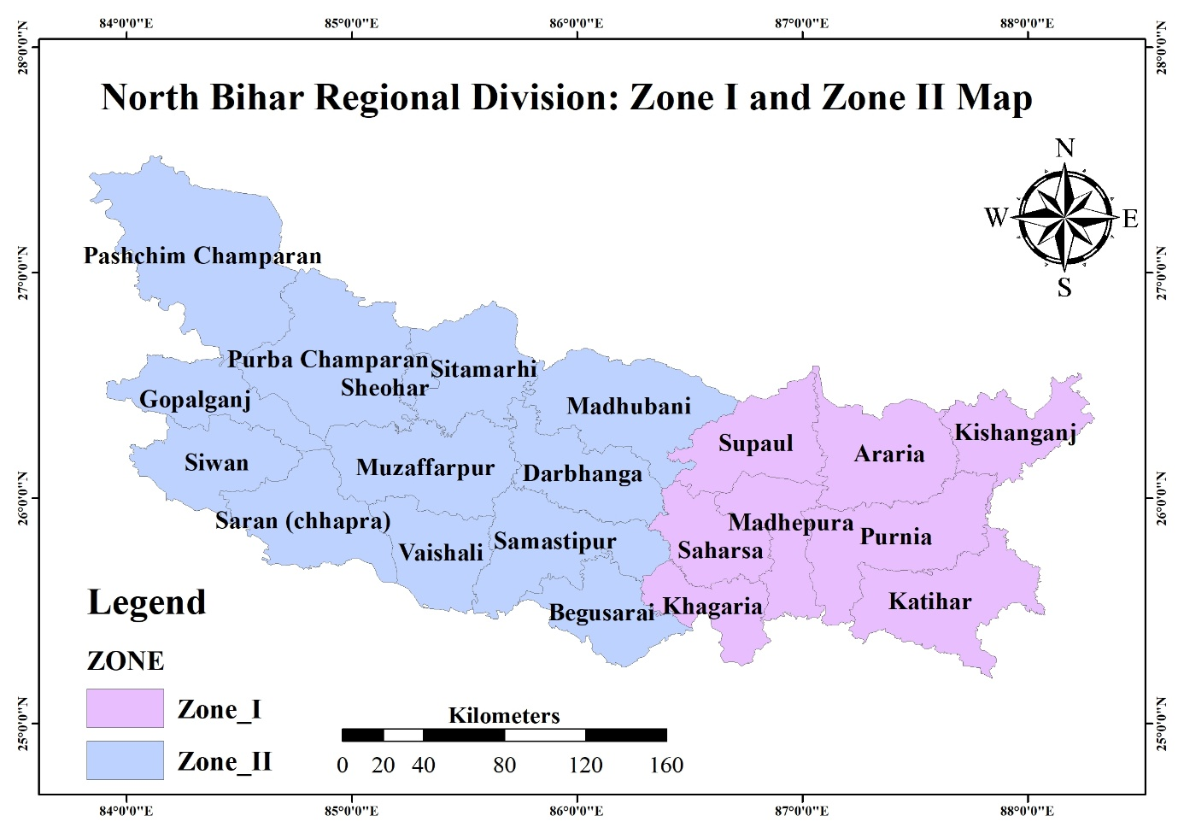
Fig 1. North Bihar Regional Division: Zone I and Zone II Map

2.2 Data Acquisition
Rainfall records from 1923 to 2022 were collected from regional meteorological sources. The dataset was organized into four seasonal categories:
- Winter (January–February)
- Pre-Monsoon (March–May)
- Monsoon (June–September)
- Post-Monsoon (October–December)
These categories helped isolate seasonal behaviours and trends for targeted analysis.

2.3 Analytical Techniques
- Probability Distribution (Weibull Method): Rainfall probabilities at 50%, 70%, and 90% levels were estimated, along with return periods to understand frequency and intensity of wet/dry spells. According to Cousineau et al. (2009), the Weibull distribution performs well across a variety of sample sizes and distribution shapes. When applying parameter estimation methods, the weighted maximum likelihood approach is generally effective. However, if the shape parameter is known to exceed 1, the maximum product of spacing (MPS) method yields more accurate results. In contrast, when the shape parameter is less than or equal to 1, a hybrid or mixed method is more appropriate for achieving reliable estimates.
- Trend Analysis (Regression Models): Seasonal and annual rainfall trends were analysed using linear regression, supported by R² values to evaluate trend strength. “Generally, logistic regression is well suited for describing and testing hypotheses about relationships between a categorical outcome variable and one or more categorical or continuous predictor variables. In a basic linear regression scenario involving one continuous predictor-such as a child's standardized reading test score-and a binary outcome, like whether the child is recommended for remedial reading classes or not, the resulting scatter plot typically displays two horizontal or nearly parallel lines. Each line corresponds to one of the two categories of the outcome variable, illustrating the limitation of using linear regression for binary outcomes (Peng et al., 2002).
3. Results and Discussion
3.1 Rainfall Estimation Using Weibull's Method
The Table 1 shows the estimated rainfall values at different probabilities. Rainfall decreases with increasing probability levels, indicating higher chances of low rainfall events. Table 2 provides probable rainfall for selected return periods.
Table 1: Estimated rainfall at different probabilities
Target Probability | Estimated Rainfall (cm)
50% | 333.00
70% | 295.30
90% | 268.10
Table 2 probable rainfall for selected return periods.
Return Period (Years) | Probable Rainfall (mm)
25 | 414.425
75 | 603.535
100 | 698.09
This figure 2 demonstrates the rainfall trends in Zone II using Weibull’s probability distribution method. The analysis captures significant temporal rainfall variations, underlining the climatic instability in the region over the past century. It provides a scientific basis for assessing flood and drought vulnerability in Zone II. Several probability distributions have been employed to model wind speed frequency, including the gamma, lognormal, three-parameter beta, Rayleigh, and Weibull distributions. Among these, the Weibull distribution has gained significant prominence in recent years due to its flexibility and accuracy in representing wind speed characteristics. It has become the preferred choice for estimating wind energy potential and is widely integrated into commercial wind energy assessment tools such as the Wind Atlas Analysis and Application Program (WAsP) (Akdag et al., 2009).
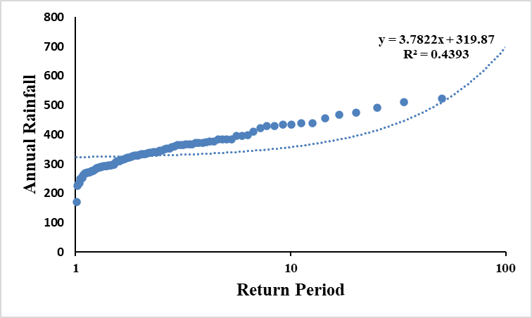
Figure 2. Weibull's Rainfall Analysis for 100 Years for Zone II
3.2 Regression Analysis of Rainfall Trends
These results reflect moderate variability in seasonal rainfall, with the pre-monsoon phase showing the most positive trend. Summary of regression equation with corresponding R² value during 1923-2022 for Zone II was furnished in table 3. Correlation analysis involves evaluating the strength and direction of a relationship between two variables using the correlation coefficient “r,” a unitless value that ranges from −1 to +1. A coefficient close to −1 suggests a strong negative (inverse) relationship, while a value near +1 indicates a strong positive association. When the data follow a normal distribution, Pearson’s correlation coefficient is typically applied. However, for data that do not meet normality assumptions, Spearman’s rank correlation is more appropriate (Kumari et al., 2018).
Table.3 Summary table of regression equation with corresponding R2 value during 1923-2022 for Zone II
Temporal Phases | Regression equation | R² | Trend
Winter | y = 95.35x10²-0.04x | 0.034 | Slight decrease
Pre-Monsoon | y = 2.73x10²+0.17x | 0.05 | Increasing
Monsoon | y = 7.52x10²-0.21x | 0.008 | Stable
Post-Monsoon | y = 4.72x10²-0.17x | 0.014 | Slight decrease
Annual Average | y = 2.62x10²-0.07x | 0.008 | Minimal change

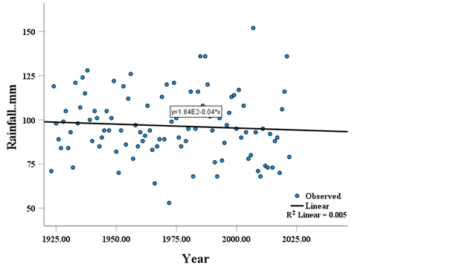
Figure 3: Regression Analysis Using Curve Estimation for Zone I (Annual Rainfall vs. Year)
This figure 3 the plot between Annual Rainfall vs Year of 100 years in Zone I represents the annual rainfall trends in Zone I over a century. The regression analysis reveals a slight decline in rainfall, with an R² value of 0.005, indicating minimal explanatory power of the trendline for the observed data. Despite the weak trend, this figure emphasizes the importance of understanding long-term rainfall variability in the region. Fitting complex models that account for spatial effects generally incurs minimal computational cost, especially when weighed against the risk of overlooking significant spatial autocorrelation in model residuals. Since spatial and non-spatial models produce equivalent results when no spatial autocorrelation is present, it is advisable-under the precautionary principle-to default to spatial models to avoid misinterpretation or biased inference in spatial data analysis (Beale et al., 2010).
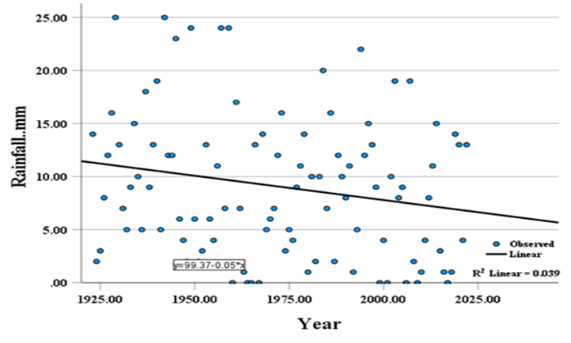
Figure 4: Winter Rainfall vs. Year for Zone I
This figure 4 the plot between Winter Rainfall vs Year of 100 years in Zone I plots winter rainfall against years for Zone I. The regression equation indicates a slight decrease in rainfall over time, with an R² value of 0.039, suggesting weak but noticeable changes in winter rainfall patterns. This has implications for rabi crop cultivation in North Bihar. Bihar's annual rainfall demonstrates significant interannual variability, with a general declining trend observed throughout most of the state, ranging from approximately −3.5 mm/year to −2.8 mm/year. This downward trend is especially notable in the eastern districts. Among Bihar’s 38 districts, only three-Purnea, Paschim Champaran, and Lakhisarai-exhibited a positive trend in annual precipitation, with increases between 0.2 mm/year and 2.18 mm/year (Sharma & Priya, 2023).

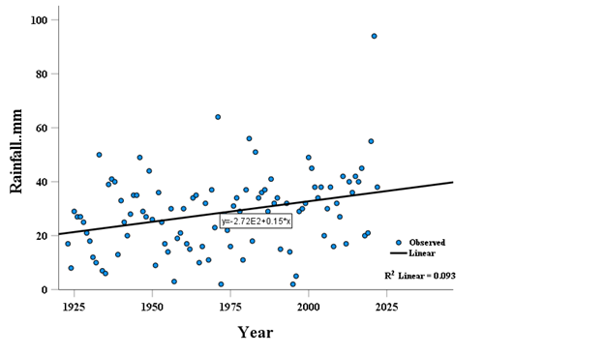
Figure 5. Pre-Monsoon Rainfall vs. Year for Zone I
This fig 5 shows the plot between Pre-Monsoon Rainfall vs Year of 100 years in Zone I shows pre-monsoon rainfall trends in Zone I over a century. The regression analysis highlights an increasing trend, with a higher R² value of 0.093, indicating some significance. The upward trend in pre-monsoon rainfall suggests changing climatic conditions that could influence kharif crop sowing periods.
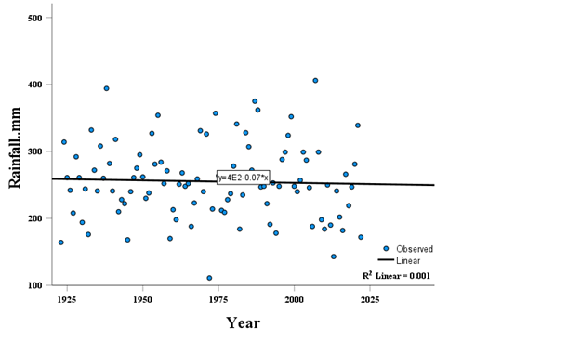
Figure 6. Monsoon Rainfall vs. Year for Zone I
This figure 6 shows the plot between Monsoon Rainfall vs Year of 100 years in Zone I captures monsoon rainfall variations in Zone I. The regression analysis reveals minimal change, with an R² value of 0.001, suggesting no significant trend. Monsoon rainfall remains a critical factor for agricultural productivity and flood occurrence in the region. To forecast rainfall patterns effectively, the SARIMA (Seasonal Autoregressive Integrated Moving Average) model was chosen due to its capacity to account for temporal dependencies in the data. One of the primary reasons for selecting this model is its strength in capturing seasonal patterns commonly present in rainfall datasets, which often reflect periodic behavior influenced by climatic and meteorological cycles. SARIMA incorporates seasonal autoregressive and moving average terms, making it particularly well-suited for modeling such recurring fluctuations. Moreover, the model is capable of addressing both trend and seasonality within the data. Rainfall records frequently demonstrate long-term increasing or decreasing tendencies, which SARIMA accommodates through appropriate differencing techniques. This makes the model robust for handling complex structures in hydrological time series (Banik & Biswas, 2025).
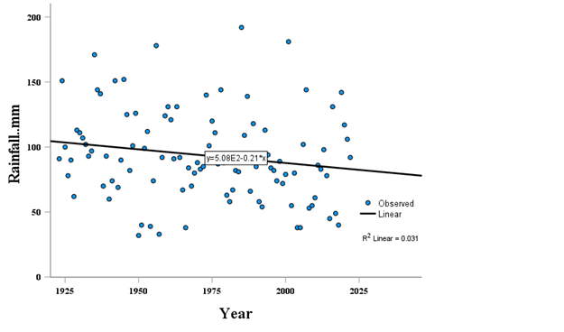
Figure 7 Post-Monsoon Rainfall vs. Year for Zone I
This figure 7 shows the plot between Post-Monsoon Rainfall vs Year of 100 years in Zone I illustrates post-monsoon rainfall trends for Zone I, with a regression analysis showing a slight decrease in rainfall and an R² value of 0.031. Post-monsoon rainfall impacts water availability and winter cropping systems. Crop management encompasses a broad spectrum of approaches, ranging from time-tested traditional techniques to contemporary scientific interventions. These methods often involve modifying specific plant traits or adapting cultivation strategies to enhance productivity, ensure healthy growth, and respond to changing environmental conditions. A key aspect of this adaptive strategy is the development and dissemination of improved crop varieties. Since its establishment, the Indian Council of Agricultural Research (ICAR) has introduced over 6,100 such varieties, including approximately 1,622 specifically bred to withstand climate-related stresses (Goswami et al., 2023). These climate-resilient cultivars play an increasingly vital role in sustaining agricultural output amid fluctuating weather patterns and emerging challenges posed by climate change.
3.2 Adaptive Crop Planning Strategies
Winter Season (Rabi Period):
- Encourage timely planting of cereals and oilseeds like wheat and mustard by utilizing conserved soil moisture.
- Promote conservation agriculture practices such as reduced tillage to minimize water loss.
- Facilitate access to supplementary irrigation via on-farm water storage systems or shallow bore wells.
- Liquid fertilizers are well-suited for fertigation; however, in India, their limited availability and high cost hinder widespread use. Therefore, selecting an appropriate fertigation system for delivering fertilizers with irrigation water becomes essential. Available equipment includes Venturi injectors, fertilizer injector pumps, and fertilizer tanks. Among these, the Venturi injector is most commonly used in drip irrigation due to its simplicity, ease of operation, and low cost (Singh et al., 2018).
Pre-Monsoon Period:
- Support the cultivation of short-duration legumes such as mung bean and urad during early summer showers.
- Recommend moisture-preserving approaches including organic mulching and minimum soil disturbance.
- Integrate multi-purpose tree species along field boundaries to diversify income and improve microclimate.
- The 27th–38th weeks emerge as the most reliable period for rainfed crop production, with high-probability rainfall events supporting agricultural activities (Janghel et al., 2025)
Rainy Season (Kharif Period):
- Advocate for climate-resilient, fast-maturing rice cultivars that can escape late-season flooding.
- Design localized emergency crop response plans at the panchayat or block level.
- Integrate animal husbandry with cropping systems to spread climatic risk and stabilize farm income.
Post-Monsoon Period:
- Recommend pulses and oilseeds that can thrive on declining residual moisture during late autumn.
- Employ precision irrigation methods like drip or sprinklers to optimize limited water resources.
- Encourage sowing of green manure and legume-based cover crops to enhance soil organic matter and prevent erosion.
- Climate variability poses a significant threat to agricultural sustainability, particularly for small and marginal farmers, where the failure of even a single crop can result in severe consequences such as malnutrition or food insecurity for the household. Early-season stress often damages standing crops at initial growth stages, but timely re-sowing can sometimes offset the loss. However, in many cases, farmers may lack sufficient seed reserves to undertake re-sowing, further compounding their vulnerability (Maheswari et al., 2019).

3.3 Resilience Measures for Flood-Impacted Regions
Site-Specific Interventions:
- Deploy submergence-tolerant rice varieties such as ‘Sahbhagi Dhan’ in areas with frequent inundation.
- Utilize elevated planting platforms or furrow-bed systems to reduce crop damage during waterlogging.
- After flood recession, recommend quick-sown direct-seeding options to restore cropping cycles rapidly.
- Establish decentralized, farmer-led seed reserves equipped with stress-adapted genetic materials.
- Upgrade canal systems, check dams, and farm-level irrigation networks to ensure water availability and drainage.
- Build capacity of farming communities through participatory training on adaptive agricultural techniques.
- Deliver timely agro-climatic advisories using ICT tools and community-based dissemination platforms.
4. Conclusion
The probabilistic assessment of historical rainfall data from 1991 to 2020 revealed that June, July, and August exhibit the highest rainfall probabilities, with July showing a peak probability of over 70% at the 20 mm threshold, and August showing over 60% probability at the 30 mm threshold.The analysis of historical rainfall data in Zone II of North Bihar reveals notable seasonal fluctuations and long-term variability, posing challenges to traditional agricultural practices in temporarily non-submerged wetland areas. By applying probabilistic methods and trend analysis, this study has identified critical insights into rainfall distribution patterns across different seasons. Based on these findings, targeted crop planning and adaptive strategies have been formulated to optimize water use, reduce climate-related risks, and improve farm productivity. These measures are intended to strengthen the region’s agricultural resilience and support sustainable livelihoods for farming communities under increasing climatic uncertainty. The analysis indicated that more than 60% rainfall occurrence during these months can support the planning of short-duration, water-tolerant crops suited for the wetland ecology. The seasonal classification confirmed the predominance of the south-west monsoon, contributing over 70% of the total annual rainfall. This analysis provides critical insights for selecting and adjusting cropping calendars in wetland conditions, particularly for temporally non-submerged areas. The study’s output supports the development of adaptive crop strategies, which are crucial for enhancing resilience against rainfall variability and for improving food security in North Bihar's flood-prone agro-ecosystems.

Disclaimer (Artificial intelligence)
Option 1:
Author(s) hereby declare that NO generative AI technologies such as Large Language Models (ChatGPT, COPILOT, etc.) and text-to-image generators have been used during the writing or editing of this manuscript.
Option 2:
Author(s) hereby declare that generative AI technologies such as Large Language Models, etc. have been used during the writing or editing of manuscripts. This explanation will include the name, version, model, and source of the generative AI technology and as well as all input prompts provided to the generative AI technology
Details of the AI usage are given below:
1.
2.
3.
References
Akdag, S. A., & Dinler, A. (2009). A new method to estimate Weibull parameters for wind energy applications. Energy conversion and management, 50(7), 1761-1766.
Banik, R., & Biswas, A. (2025). Rainfall prediction for climate-resilient agriculture: a robust ensemble with SARIMA and LightGBM. Paddy and Water Environment, 23(2), 263-275.
Baraj, B., Mishra, M., Sudarsan, D., da Silva, R. M., & Santos, C. A. G. (2024). Climate change and resilience, adaptation, and sustainability of agriculture in India: A bibliometric review. Heliyon.
Beale, C. M., Lennon, J. J., Yearsley, J. M., Brewer, M. J., & Elston, D. A. (2010). Regression analysis of spatial data. Ecology letters, 13(2), 246-264.
Benitez-Alfonso, Y., Soanes, B. K., Zimba, S., Sinanaj, B., German, L., Sharma, V., ... & Foyer, C. H. (2023). Enhancing climate change resilience in agricultural crops. Current Biology, 33(23), R1246-R1261.
Cousineau, D. (2009). Fitting the three-parameter Weibull distribution: Review and evaluation of existing and new methods. IEEE Transactions on Dielectrics and Electrical Insulation, 16(1), 281-288.
Goswami, M., Gupta, A. K., Kishan, R., Baidya, S., Khan, Y. I., Prakash, S., ... & Nautiyal, S. (2023). An evaluation of climate resilient agricultural practices in India: a narrative synthesis of literature. Environmental Sustainability, 6(1), 7-23.
Janghel, Y., Kanchibhotla, G. V., & Unjan, D. (2025). Temporal Distribution of Rainfall in Northern Hilly Region of Chhattisgarh, India: A Crop Planning Approach. International Journal of Environment and Climate Change, 15(5), 51-57.

Jat, R. K., Meena, V. S., Durgude, S., Sohane, R. K., Jha, R. K., Kumar, A., ... & Lenka, A. K. (2025). Bridging the gap: challenges and adoption of climate-resilient agriculture technologies in agricultural landscapes across agro-climatic zones of Bihar, India. Frontiers in Sustainable Food Systems, 8, 1504388.
Kumari, K., & Yadav, S. (2018). Linear regression analysis study. Journal of the practice of Cardiovascular Sciences, 4(1), 33-36.
Maheswari, M., Sarkar, B., Vanaja, M., Srinivasa Rao, M., Prasad, J. V. N. S., Prabhakar, M., ... & Alagusundaram, K. (2019). Climate resilient crop varieties for sustainable food production under aberrant weather conditions. ICAR-Central Research Institute for Dryland Agriculture, Natural Resource Management Division, Indian Council of Agriculture Research.
Peng, C. Y. J., Lee, K. L., & Ingersoll, G. M. (2002). An introduction to logistic regression analysis and reporting. The journal of educational research, 96(1), 3-14.
Raza, A., Khare, T., Zhang, X., Rahman, M. M., Hussain, M., Gill, S. S., ... & Varshney, R. K. (2025). Novel Strategies for Designing Climate‐Smart Crops to Ensure Sustainable Agriculture and Future Food Security. Journal of sustainable agriculture and environment, 4(2), e70048.
Rhinehart, N., He, J., Packer, C., Wright, M. A., McAllister, R., Gonzalez, J. E., & Levine, S. (2021, May). Contingencies from observations: Tractable contingency planning with learned behavior models. In 2021 IEEE International Conference on Robotics and Automation (ICRA) (pp. 13663-13669). IEEE.
Sahoo, S., Singha, C., Govind, A., & Moghimi, A. (2024). Review of Climate-Resilient Agriculture for Ensuring Food Security: Sustainability Opportunities and Challenges of India. Environmental and Sustainability Indicators, 100544.
Sharma, M. R., & Priya, S. (2023). Long-term assessment of precipitation behaviour in Bihar (1901–2021): patterns, trends and observed variability. Curr World Environ 18 (2): 662–673.
Singh, B. G., Babu, G. R., Kumar, K., Babu, R. G., & Edukondalu, L. (2018). Performance evaluation of different fertigation equipment and hydraulic performance of drip fertigation system. Andhra Agric. J, 65-658.

