Socio-Economic and Impact Assessment of Edible Oilseed Crops (Soybean and Groundnut) in Sagar District of Madhya Pradesh, India

ABSTRACT

This study delves into the socio-economic dynamics of soybean and groundnut cultivation in the Sagar District of Madhya Pradesh during the agricultural year 2023–24, with the primary objective of analyzing the economic status and the influence of various socio-economic factors on farming practices across different farm size categories—marginal, small, medium, and large. A total of 300 farmers were selected through a multistage random sampling method from 10 villages in Khurai and Khimlasa blocks to ensure diverse and representative data. The results indicate that marginal farmers make up the majority (55%) of the sample population, while large farmers enjoy higher annual incomes due to better access to capital, technology, and markets. It was found that income generation is not solely dependent on farming; only 40% of income was derived from agricultural activities, while a substantial 60% came from non-farm sources, highlighting the increasing reliance on alternative livelihood options for rural households. Socio-economic variables such as family size, gender, age, education level, land tenure status, and occupation were identified as significant factors influencing farmers' participation and performance in agricultural activities, as confirmed by chi-square tests (p < 0.05). These findings underscore the complexity of rural livelihoods and the interplay between social and economic factors in shaping agricultural outcomes. The study offers critical insights for policymakers, suggesting the need for tailored interventions that address the disparities among different farmer groups, promote inclusive growth, strengthen non-farm income avenues, and enhance the overall productivity and sustainability of the oilseed farming sector in Madhya Pradesh.
Keywords- socio-economic, significant, marginal, livelihoods, influencing.
1.Introduction
Edible oilseeds occupy a pivotal role in the global agricultural system, serving as indispensable sources of oils that are widely utilized in culinary, food processing, and diverse industrial sectors. Among the numerous oilseed crops, soybean (Glycine max) and groundnut (Arachis hypogea) emerge as two of the most economically influential, celebrated not only for their substantial oil content but also for their exceptional nutritional profile (Miah et al., 2015). Soybean, a leguminous plant indigenous to East Asia, has become a staple crop globally, renowned for its high oil yield and its dual utility as a potent source of protein, essential fatty acids, and numerous industrial derivatives. Groundnut, or peanut, is a versatile crop predominantly cultivated in tropical and subtropical climates, providing a vital source of edible oil, protein, and energy, thereby contributing significantly to food security and agricultural economies worldwide (Kichonge & Kivevele, 2023).
In recent decades, the global cultivation of these oilseeds has seen marked expansion, driven by their economic viability and the burgeoning global demand for vegetable oils, which are central to both food and biofuel industries (Van Eijck et al., 2014). The increasing focus on sustainable agricultural practices, coupled with the urgency to address the nutritional needs of a rapidly expanding global population, has stimulated significant research and innovation aimed at optimizing the yield, oil content, and overall quality of these crops. As pivotal components of the agricultural economy, both soybean and groundnut play an essential role in supporting the livelihoods of millions of farmers, while also providing the raw materials required for the burgeoning oil extraction industries that fuel global markets (Bohra et al., 2018).
This paper endeavours to delve into the multifaceted characteristics, cultivation methodologies, and economic significance of soybean and groundnut, examining their agronomic attributes, oil composition, and the complex challenges encountered in their production. By exploring the potential avenues for enhancing cultivation techniques and optimizing the utilization of these oilseeds, this study aims to illuminate strategies that can bolster their productivity and contribute to meeting the ever-evolving demands of the global edible oil market.
In the Indian context, edible oilseeds are of paramount importance due to their significant contribution to agricultural GDP, nutritional security, and rural employment. India is one of the leading producers of oilseeds globally, yet it remains one of the largest importers of edible oil due to the gap between domestic demand and supply (Patel et al., 2020). Soybean and groundnut together contribute a substantial share to the country's oilseed output, with Madhya Pradesh emerging as a major soybean-producing state and Gujarat leading in groundnut production. These crops are not only essential for oil extraction but also serve as important components in crop rotation systems, contributing to soil health and long-term farm sustainability (Sharma & Meena, 2019).
Despite their potential, the production of soybean and groundnut is often challenged by factors such as climatic variability, pest infestations, and limited access to quality seeds and advanced technology. In addition, market fluctuations and inadequate post-harvest infrastructure hinder the income stability of smallholder farmers (Kumar et al., 2021). Therefore, a deeper understanding of the socio-economic dimensions, along with technical interventions in cultivation and marketing, is essential to improve yield, profitability, and resilience. This study seeks to address these gaps by analyzing the production dynamics and socio-economic implications of these two oilseed crops in Sagar district, aiming to generate insights that can inform both policy and practice.

1.1 Research Objective
- To study socio-economic profile of oilseed crop growers in different size of farm groups in study area.
2. RESEARCH METHODOLOGY
2.1 Sampling Design
Samples were selected by using a multi-stage sampling technique for the selection of districts, blocks, villages, (respondents). Groundnut and soybean growers.
2.2 Selection of the Study Area
Madhya Pradesh, a major agricultural state in central India, was selected for this study due to its significant contribution to the country’s oilseed production, particularly soybean & groundnut. Within the state, Sagar district was purposively chosen for its high concentration of oilseed farmers and its economic relevance. From the district's eleven blocks, Khimlasa and Khurai were selected based on the even distribution of soybean & groundnut growers across different farm sizes. A total of 10 villages—Dhanora, Nardha, Ghorat, Talapar, Tewra, Bhugawli, Basari, Halau, Madana, and Pathariya—were randomly selected from these blocks, representing 5% of the total villages, to serve as the sample area for the study.
2.3 Data Collection
Primary data for this study was collected from 300 randomly selected soybean farmers in the Sagar district of Madhya Pradesh during the agricultural years 2023–2024. Data was gathered through structured personal interviews aimed at addressing the specific objectives of the research. The information collected included cropping patterns, land utilization, area under soybean cultivation, production levels, and post-harvest losses. Supplementary data and regional agricultural statistics were obtained from the Madhya Pradesh Agriculture Department and the District Statistical Department to support and validate the primary findings.
District | Blocks | Villages | Marginal | Small | Medium | Large | Total
Sagar | Khurai | Dhanora | 11(10) | 8(8.60) | 6(9.3) | 3(9.0) | 28(9.3)
Sagar | Khurai | Nardha | 9(8.1) | 7(7.5) | 5(7.8) | 4(12.12) | 25(8.3)
Sagar | Khurai | Ghorat | 13(11.81) | 12(12.9) | 8(12.5) | 2(6.06) | 35(11.6)
Sagar | Khurai | Talapar | 12(10.90) | 10(10.75) | 6(9.3) | 5(15.15) | 33(11)
Sagar | Khurai | Tewra | 10(9.0) | 9(9.96) | 7(10.9) | 3(9.0) | 29(9.6)
Sagar | Khimlasa | Bhugawali | 13(11.81) | 11(11.82) | 8(12.5) | 3(9.0) | 35(11.6)
Sagar | Khimlasa | Basari | 10(9.0) | 9(9.6) | 7(10.9) | 2(6.06) | 28(9.3)
Sagar | Khimlasa | Halau | 9(8.18) | 8(8.6) | 6(9.3) | 3(9.0) | 26(8.6)
Sagar | Khimlasa | Madana | 11(10) | 9(9.6) | 5(7.8) | 4(12.12) | 29(9.6)
Sagar | Khimlasa | Pathariya | 12(10.90) | 10(10.75) | 6(9.3) | 4(12.12) | 32(10.6)
Total no of farmers in different categories |  |  | 110(100) | 93(100) | 64(100) | 33(100) | 300(100)
Table 1. Allocation of Respondents from different villages.
I have selected these 300 farmers from a total of 2960 farmers across all the villages.
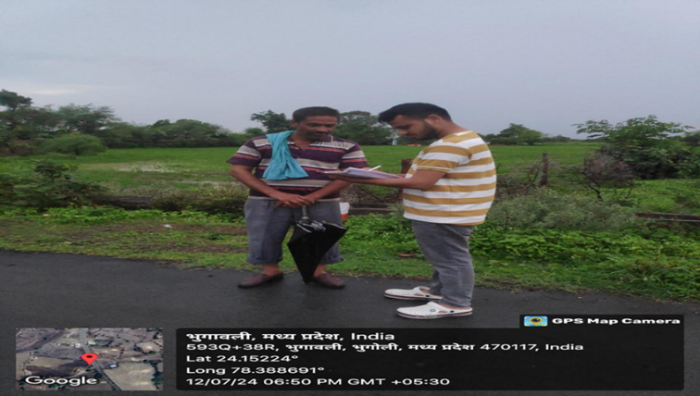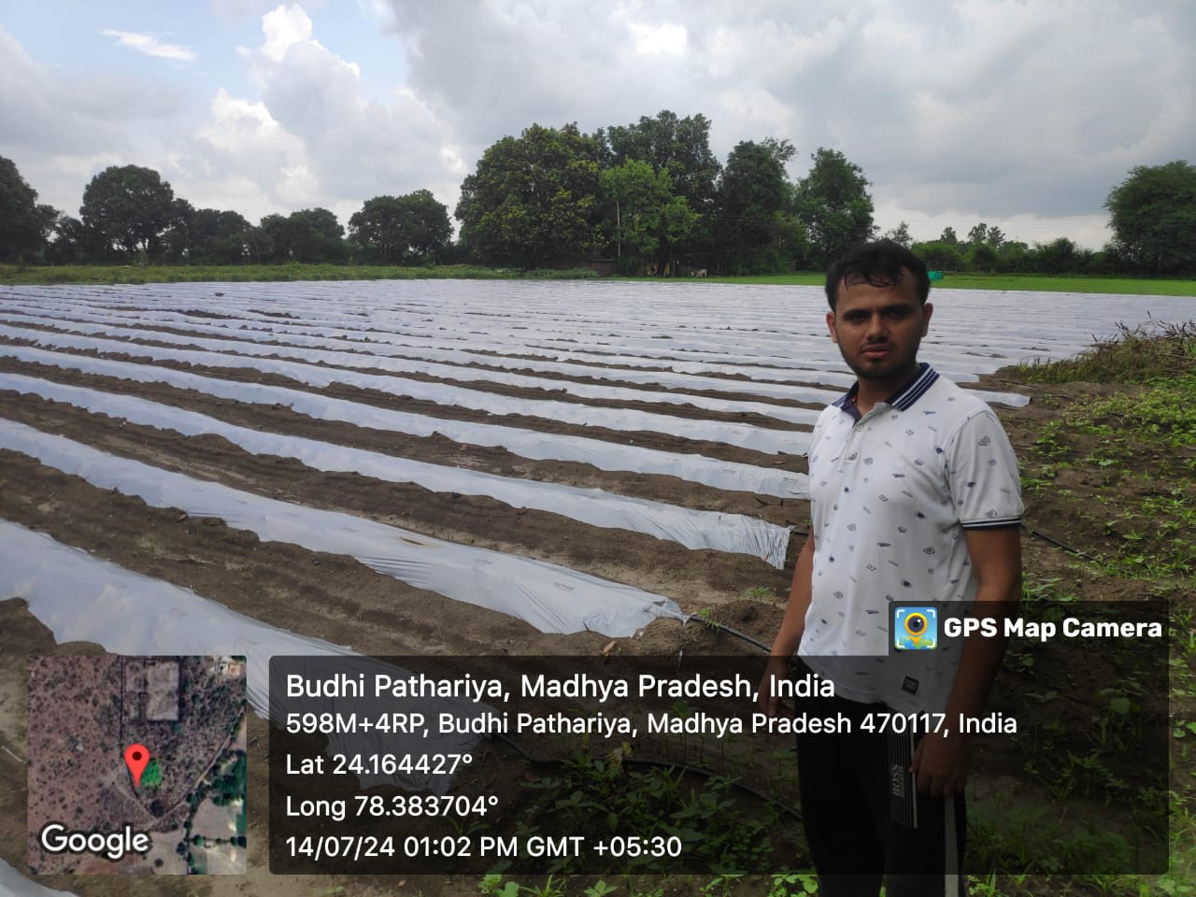Pic 1: Data collection from respondents' fields of soybean and groundnut was carried out during the study as shown in the photographs.

3. Analytical Tools used
The following mathematical and statistical tools have been employed in the Research work to analyse the various aspects of the study in order to fulfil the objective:
  - Chi – square Test:
Chi – Square test of independence is used to analyse and determine inter-reliability of two variables.
$$χ^{2}=∑ \frac{{(O_{i}- E_{i })}^{2}}{E_{i }}$$
Here,
O_{i} = Observed Value
E_{i} = Expected Value
χ² = Chi – squared value

  - Percentage:
$$P= \frac{X}{Y}*100$$
Here,
P = Percentage value
X = number of farmers falling into the specific category to be measured
Y = Total number of farmers

  - Arithmetic Mean:
$$X= \frac{Σ X_{i}}{N}$$
Here,
X = arithmetic mean
Σ X_{i} = Sum of observations
N = total number of observations

4. RESULTS & DISCUSSION
Table 2. Overall representation of socio-economic factors:
Sl. No. | Socio-Economic factors | Category of farmers |  |  |  | Total | Chi-square value (χ²) | p-value | Decision
Sl. No. | Socio-Economic factors | Marginal | Small | Medium | Large
1. | Family Size: |  |  |  |  |  | 3.27 | 0.0077 | Significant
1. | < 6 | 62 | 54 | 35 | 15 | 166 | 3.27 | 0.0077 | Significant
1. | 6 – 8 | 38 | 27 | 21 | 12 | 98 | 3.27 | 0.0077 | Significant
1. | > 8 | 10 | 12 | 8 | 6 | 36 | 3.27 | 0.0077 | Significant
2. | Gender: |  |  |  |  |  | 11.65 | 0.0086 | Significant
2. | Male | 70 | 68 | 46 | 31 | 215 | 11.65 | 0.0086 | Significant
2. | Female | 40 | 25 | 18 | 2 | 85 | 11.65 | 0.0086 | Significant
3. | Age: |  |  |  |  |  | 11.33 | 0.0076 | Significant
3. | < 30 years | 32 | 28 | 17 | 1 | 78 | 11.33 | 0.0076 | Significant
3. | 30 – 50 years | 55 | 46 | 34 | 25 | 160 | 11.33 | 0.0076 | Significant
3. | > 50 years | 23 | 19 | 13 | 7 | 62 | 11.33 | 0.0076 | Significant
4. | Tenure status: |  |  |  |  |  | 10.27 | 0.0016 | Significant
4. | Owner-cum-tenant | 86 | 70 | 53 | 33 | 242 | 10.27 | 0.0016 | Significant
4. | Pure tenant | 24 | 23 | 11 | 0 | 58 | 10.27 | 0.0016 | Significant
5. | Educational status: |  |  |  |  |  | 68.15 | 0.0071 | Significant
5. | Illiterate | 53 | 51 | 24 | 5 | 133 | 68.15 | 0.0071 | Significant
5. | Primary & Middle School | 49 | 37 | 31 | 12 | 129 | 68.15 | 0.0071 | Significant
5. | Matriculation | 8 | 4 | 6 | 7 | 25 | 68.15 | 0.0071 | Significant
5. | Higher Secondary | 0 | 1 | 2 | 8 | 11 | 68.15 | 0.0071 | Significant
5. | Graduation | 0 | 0 | 1 | 1 | 2 | 68.15 | 0.0071 | Significant
6. | Occupation: |  |  |  |  |  | 24.94 | 0.0030 | Significant
6. | Only farming | 60 | 56 | 24 | 7 | 147 | 24.94 | 0.0030 | Significant
6. | Both farming/ off-farm | 34 | 19 | 28 | 20 | 101 | 24.94 | 0.0030 | Significant
6. | Owner | 16 | 18 | 12 | 6 | 52 | 24.94 | 0.0030 | Significant
(α = 0.05)
When the p-value from a chi-square test is less than 0.05, it means the results are statistically significant, and we reject the null hypothesis (H₀), which assumes no relationship between the variables. Instead, we accept the alternative hypothesis (H₁), suggesting there is a real association. In my case, since all p-values are below 0.05, it shows that factors like gender, family size, education, tenure, and occupation are meaningfully linked to farming participation, and these results are unlikely to be due to random chance.
4.1Possession of livestock:
Livestock plays an important role among the farming population in our country, serving as both a source of food and a means of livelihood. Cows and buffaloes are kept for milk, poultry birds for eggs, and goats for milk and meat. As shown in Table 3, marginal farmers own the most livestock, with over 550 animals and an average of 5 animals per farmer, followed by small farmers with 493 animals, medium farmers with 276, and large farmers with 207. Among all types of livestock, poultry is the most commonly owned, followed by cows, buffaloes, and goats being the least.
Table 3 Possession of livestock
 | Marginal  (n=110) | Small  (n=93) | Medium  (n=64) | Large  (n=33)
Cow | 155 | 134 | 75 | 62
Buffalo | 125 | 112 | 52 | 54
Goat | 90 | 83 | 47 | 15
Poultry | 180 | 164 | 102 | 76
TOTAL: | 550 | 493 | 276 | 207
MEAN: | 5 | 5.30 | 4.31 | 6.27
[Total Respondents – 300]
Source: Primary probe
- Graphical Representation:

Fig. 1 : Livestock possession
4.2.Agricultural equipment possessions:
Implements are essential for timely agricultural work. As seen in Table 4, medium and large farmers mostly own farmhouses, tractors, and harvesters. All farmers, regardless of their category, own livestock and therefore have cattle sheds and bullock carts. Basic agricultural tools like harrows, levellers, pump sets, threshers, and sprayers are available to all. On average, marginal farmers own 5.44 pieces of equipment, small farmers 8.84, medium farmers 12.97, and large farmers 17.30. Overall, medium and large farmers have the most agricultural equipment.
Table 4 Agricultural equipment possessions:
Agri. Equipment possessions: | Marginal  (n=110) | Small  (n=93) | Medium  (n=64) | Large  (n=33)
Farm house | 0 | 0 | 35 | 52
Cattle shed | 130 | 112 | 62 | 30
Bullock cart | 95 | 93 | 31 | 25
Wooden/Iron plough | 110 | 108 | 162 | 72
Harrows | 52 | 93 | 65 | 40
Hoes | 0 | 93 | 64 | 33
Leveller | 98 | 98 | 74 | 98
Pump sets | 22 | 74 | 79 | 45
Thresher | 24 | 82 | 67 | 24
Sprayer | 67 | 69 | 72 | 67
Tractor | 0 | 0 | 55 | 37
Harvester | 0 | 0 | 64 | 48
Total equipment’s: | 598 | 822 | 830 | 571
Avg. equipment possession: | 5.44 | 8.84 | 12.97 | 17.30
Source: Primary probe
4.3 Size of farms:
It can be seen from table 5 that the average cultivated area for marginal farmers is 0.82 ha, for small farmers 2.09 ha, for medium 6.13 ha and for large farmers it is 12.52 ha. Net area cultivated under soyabean is 705 ha of which marginal farmers (46 ha), small farmers (112 ha), medium farmers (257 ha) and large farmers (290 ha.). Similarly, net area cultivated under groundnut is 252 ha of which marginal farmers (22 ha), small farmers (54 ha), medium farmers (87 ha) and large farmers (89 ha). About 64.74 % and 23.14 % of total cultivated area is occupied by soybean and groundnut respectively.

Table 5 Size of farms
Size of farms: | Marginal | Small | Medium | Large | TOTAL
No. of selected farms | 110 | 93 | 64 | 33 | 300
Total cultivated area (ha) | 90 | 194 | 392 | 413 | 1089
Avg. cultivated area (ha) | 0.82 | 2.09 | 6.13 | 12.52 | 3.63
Area cultivated under soybean (ha) | 46 | 112 | 257 | 290 | 705
% of total cultivated area | 51.11 | 57.73 | 65.56 | 70.22 | 64.74
Avg. area under soybean (ha) | 0.42 | 1.20 | 4.02 | 8.79 | 2.35
Area cultivated under groundnut (ha) | 22 | 54 | 87 | 89 | 252
% of total cultivated area | 24.44 | 27.84 | 22.19 | 21.55 | 23.14
Avg. area under groundnut (ha) | 0.20 | 0.58 | 1.36 | 2.70 | 0.84
Source: Primary probe
4.4 Cropping pattern of farmers:
The cropping pattern across three seasons is shown in Table 6 Major Kharif crops include soybean, maize, arhar, moong, urad, sorghum, millet, and groundnut, while main Rabi crops are wheat, gram, peas, lentil, and mustard, along with some bitter gourd and fodder crops. The total cropped area is 1089 ha, with marginal farmers covering 90 ha, small farmers 194 ha, medium farmers 392 ha, and large farmers 413 ha. Most farming activity happens in the Kharif season, followed by the Rabi season. Soybean and groundnut are the most important crops, grown on 705 ha and 252 ha respectively.
Table 6 Cropping pattern of farmers
Cropping pattern:  (Area in ha) | Marginal | Small | Medium | Large
Kharif:
Soybean | 46 | 112 | 257 | 290
Maize | 0 | 0 | 4 | 4
Arhar | 2 | 1.5 | 5 | 3.7
Moong | 1 | 5.4 | 8 | 1
Urad | 0 | 3 | 4.4 | 2
Sorghum | 0 | 0 | 2 | 0
Millet | 0 | 0 | 2 | 0
Groundnut | 22 | 54 | 87 | 89
Rabi:
Wheat | 5.6 | 5 | 9.2 | 10
Gram | 0 | 1 | 2.4 | 0
Peas | 5.5 | 3 | 5 | 5.3
Lentil | 2.5 | 2 | 3 | 3
Mustard | 3.4 | 3 | 0 | 2
Zaid:
Bitter gourd | 2 | 2 | 2 | 2
Fodder crops | 0 | 1.6 | 1 | 1
TOTAL CROPPED AREA (ha): | 90 | 194 | 392 | 413
Source: Primary probe
Conclusion
This study highlights the critical influence of socio-economic factors on the farming practices and economic outcomes of oilseed crop growers, particularly soybean and groundnut farmers in Sagar District, Madhya Pradesh. The analysis reveals that variables such as family size, gender, age, education, land tenure, and occupation significantly impact farming participation and income levels across different farm sizes. Large farmers tend to have higher incomes and better access to advanced agricultural inputs, credit facilities, and market linkages, enabling them to adopt improved technologies. In contrast, marginal and small farmers often struggle with limited resources, inadequate institutional support, and lower bargaining power, which hinders their productivity and profitability despite owning sizeable landholdings in some cases.
The study also highlights the growing importance of non-farm income sources, such as wage labour or small businesses, in ensuring household financial stability, especially for vulnerable groups. These findings underscore the need for inclusive and differentiated policy interventions that cater to the specific needs of various farmer categories. Support in the form of training, credit access, input subsidies, and infrastructure development could help bridge the productivity and income gaps. Ultimately, by fostering sustainable development in the soybean and groundnut sectors through evidence-based strategies, this research aims to improve farmer livelihoods and make a meaningful contribution to the broader agricultural economy of Madhya Pradesh.

Disclaimer (Artificial intelligence)
Option 1:
Author(s) hereby declare that NO generative AI technologies such as Large Language Models (ChatGPT, COPILOT, etc.) and text-to-image generators have been used during the writing or editing of this manuscript.

REFERENCES
- Tiwari, S. P. (2022). Emerging trends in soybean industry. arXiv preprint arXiv:2202.08590.
- Sen, P. K. (2013). Profitability of different value added products of Soybean: A case study of Kota district in Rajasthan. MBA (ABM) Thesis submitted to Acharya NG Ranga Agricultural University, Hyderabad.
- Saha, J. C. (2023). A study on oilseed economy of India. Indian Journal of Agricultural Marketing, 37(1), 74-94.
- Rameshrao, M. P. Y. (2024). RESOURCE USE EFFICIENCY AND YIELD GAP ANALYSIS OF SOYBEAN IN AMRAVATI DISTRICT OF MAHARASHTRA (Doctoral dissertation, DEPARTMENT OF AGRICULTURAL ECONOMICS POST GRADUATE INSTITUTE, MAHATMA PHULE KRISHI VIDYAPEETH).
- Payasi, D. K., Garg, D., & Payasi, S. (2024). Preharvesting processing of linseed crop. In Linseed (pp. 21-45). Academic Press.
- Parmar, N. (2019). Profitability and Constraints Analysis of Soybean Crop Production in Sehore District of Madhya Pradesh (Doctoral dissertation, Rajmata Vijayaraje Scindia Krishi Vishwa Vidyalaya).
- Mythili, T. (2023). Value Chain Analysis of Groundnut in Chittoor District of Andhra Pradesh (Doctoral dissertation, University of Agricultural Sciences, GKVK, Bangalore).
- Kichonge, B., & Kivevele, T. (2023). Viability of non‐edible oilseed plants and agricultural wastes as feedstock for biofuels production: A techno‐economic review from an African perspective. Biofuels, Bioproducts and Biorefining, 17(5), 1382-1410.
- Van Eijck, J., Romijn, H., Balkema, A., & Faaij, A. (2014). Global experience with jatropha cultivation for bioenergy: an assessment of socio-economic and environmental aspects. Renewable and Sustainable Energy Reviews, 32, 869-889.
- Bohra, B., Sharma, N., Saxena, S., Sabhlok, V., & Ramakrishna, Y. B. (2018). Socio-economic impact of biofuel agroforestry systems on smallholder and large-holder farmers in Karnataka, India. Agroforestry Systems, 92, 759-774.
- Miah, M. M., Shiblee, S. M. A., & Rashid, M. A. (2015). Economic Impacts of oilseed research and development in Bangladesh. The Bangladesh Development Studies, 38(1), 1-31.

