Design and Development of a Remote Controlled Arecanut Harvesting System

Abstract
Arecanut harvesting is a labor-intensive and hazardous process, particularly in regions with dense plantations. The conventional method of manual plucking is time-consuming, physically demanding, and often results in damage to both the nuts and the trees. This project aims to design and develop a remote-operated arecanut harvester to improve harvesting efficiency, reduce labor costs, and enhance worker safety. The proposed harvester features an arm with a specialized cutting blade for gentle nut removal and a remote-control system for operator convenience. The harvester's performance was evaluated based on harvesting efficiency, nut damage, and operator safety. The remote-operated arecanut harvester demonstrates the potential to transform the harvesting process, offering significant benefits to farmers, workers, and the industry as a whole. This innovation can contribute to increased productivity, improved product quality, and reduced occupational hazards in the arecanut sector.
Keywords: Arecanut, Agriculture, Harvesting, Remote Operated, Mechanism
Introduction
In India, arecanut is cultivated over approximately 4.7 lakh hectares, with a production of around 11.07 lakh tonnes as of 2019–20, reflecting a 55% increase from 2015–16 levels. Karnataka dominates arecanut production, contributing nearly 75% of the national output, followed by states like Assam, Kerala, and West Bengal. In Tamil Nadu, arecanut is grown on about 6,690 hectares, mainly concentrated in Coimbatore district regions such as Mettupalayam, Annur, and Pollachi. Productivity in Tamil Nadu can reach up to 5 kg per tree, equating to roughly 9 tonnes per acre. Recently, the market price for arecanut in Tamil Nadu has experienced a decline, with green arecanut fetching Rs.42 – Rs. 47 per kg and ripe arecanut priced between Rs.52– Rs.57 per kg as of early 2025. While, arecanut production in India shows strong growth, Tamil Nadu's sector is more localized with moderate productivity and fluctuating market prices.
Morphological Characteristics of the Arecanut Tree
The arecanut tree, scientifically known as Areca catechu, is a perennial crop native to tropical regions of Asia and Africa. The tree's structure and appearance are distinctive, making it easily recognizable. The single stem of the arecanut tree grows up to 20–30 meters tall, with a diameter of approximately 30–40 cm. The bark is smooth, greyish-brown, and features vertical fissures, providing a unique texture to the tree. The leaves of the arecanut tree are long, feathery, and pinnate, with 20–30 pairs of linear-lanceolate leaflets that are pointed and bright green. The leaf stalk is long, slender, and fibrous, providing support to the leaf.
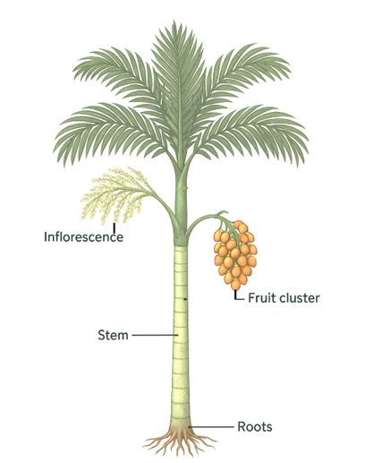
Figure.1. Arecanut tree
The leaves are arranged in a crown-like shape at the top of the tree, giving it a distinctive appearance. The tree produces spike-like, pendulous inflorescences that are unisexual. The male inflorescence is shorter, thicker, and yellowish-brown, while the female inflorescence is longer, slender, and greenish-yellow. These are arranged spirally, adding to the tree's aesthetic appeal. The fruit, or arecanut, is a single seed encased in a hard, woody endocarp, surrounded by a fibrous, orange-red mesocarp. The arecanut is oval or spherical in shape, measuring about 5–7 cm in length and 3–5 cm in width. The fruits are clustered at the base of the inflorescence, creating a striking contrast against the green leaves and brown trunk. The roots of the arecanut tree are fibrous, adventitious, and spreading, with a short, stout, and woody taproot. These roots play a crucial role in absorbing water and nutrients from the soil, supporting the tree's growth and development.
Harvesting of Arecanut
Arecanut has been widely used across South and Southeast Asia, as well as in the Pacific Ocean islands. While its primary use is as a masticatory (chewing substance), it also finds application in traditional human and veterinary medicine and features in various religious and social functions. Other parts of the arecanut palm—such as the sheath, stem, and leaves—are utilized in farms and households for purposes like manuring, packaging, and construction. Harvesting of arecanut is typically performed by skilled climbers, who can harvest from about 50–100 palms in a day. Mechanical arecanut climbing devices are also available, allowing even unskilled individuals to climb the palms safely and efficiently. The stage of harvesting depends on the type of product to be prepared. There are two main types: (i) Kalipak: Prepared from immature green nuts and (ii) Chali: Prepared from ripe nuts. The maturity stage at which the fruit is harvested and the season of harvest significantly affect the quality of the processed nut.
The harvesting of arecanut (Areca catechu) is a labor-intensive process, traditionally reliant on manual climbing, which poses significant safety risks and labor challenges. Arecanut farming remains vital to Southern India's economy, but traditional practices face challenges due to labor shortages, necessitating the adoption of mechanized solutions (Bhat et al., 2024). The cultural and economic importance of arecanut cultivation was emphasized, highlighting that mechanical innovations are crucial for maintaining traditional livelihoods while enhancing productivity (Palanna et al., 2020). Understanding the risks associated with manual climbing methods led to the development of semi-automated climbing machines. A sitting-type coconut palm climbing device was introduced to enhance safety, increase efficiency, and reduce dependency on skilled climbers. Efforts were made to design machines that address labor shortages while maintaining productivity and safety. Valuable insights were gained on the strengths and weaknesses of various existing climbing devices, leading to innovations focused on improving safety, efficiency, and comfort for climbers working with Palmyrah trees. Recent technological advancements aim to address these issues through the development of mechanical and automated solutions. Automatic coconut harvesters have been developed to improve harvesting efficiency and reduce labor risks. An automated robot was introduced for detaching coconuts and branches, using advanced sensors and mechanical arms to improve efficiency while reducing manual labor. By integrating advanced mechanisms and sensors, a robot was proposed to detach coconuts and branches from trees, thus minimizing human effort and ensuring productivity (Ayush Narayan Malviya et al., 2021). A coconut tree climber was designed with a focus on safety and efficiency, incorporating an adjustable harness and ergonomic features to aid workers (Chandramohan et al., 2020). Further, a coconut tree climbing and harvesting machine was developed, equipped with sensors and navigation systems to replicate human climbing movements and enhance safety and productivity. The diamond-shaped frame design has been identified as an effective approach to improve the climbing capacity of coconut tree climbing and harvesting machines. By mimicking the movement of a human climber and integrating advanced navigation and cutting systems, safety and efficiency are enhanced (Harsh Maheshwari et al., 2021). An arecanut harvesting machine capable of climbing, cutting, and collecting nuts automatically was designed to minimize the need for physical labor. The spring and pulley mechanism has proven effective in ensuring safe and cost-effective harvesting of arecanuts (Thirupathi R. et al., 2021). A semi-automated arecanut tree climbing plucker was also presented, featuring a climbing mechanism with rubber wheels and a 360-degree rotating harvesting arm, operated remotely to ensure worker safety. Remote control mechanisms have been successfully incorporated into semi-automated areca nut tree climbing devices. These devices feature rubber wheels, tension springs, and a geared DC motor to improve grip, maneuverability, and safety during harvesting (Mohit Rane et al., 2021). Advanced harvesting techniques using mechanical, robotic, and drone-based solutions have shown significant benefits. Drone-assisted harvesting and mechanical pluckers were discussed as advanced techniques that improve productivity and reduce human risk (Pooja Pawar et al., 2021). A motorized arecanut climber integrated with a pesticide sprayer was developed, allowing remote operations to simplify harvesting and pest management activities. Motorized arecanut climbers and pesticide sprayers offer high productivity and reduced manual labor; however, they require skilled operation and come with high costs, limiting accessibility for many farmers (Mohammed Said et al., 2021). To address affordability challenges, modifications were made to existing harvesting machines using simpler mechanisms, aiming to make arecanut harvesting more cost-effective and accessible for small-scale farmers. Mobile-operated coconut harvesting machines, though technologically advanced and efficient, require significant technological integration. Therefore, simpler designs using locally available materials were preferred for practicality and cost reduction. Additionally, a safe climbing aid using a harness, rope, and carabiner was designed to prioritize user safety and comfort during climbing activities. The development of safe climbing aids was prioritized by incorporating ergonomic designs, high-strength materials, and secure attachment systems, aiming to ensure comfort, reliability, and safety during tree climbing operations (Vishnu Priya et al., 2021). From this, designing semi-automatic tree climbing and harvesting robots was considered crucial for enhancing productivity and reducing labor risks. Research into mechanized solutions for arecanut harvesting has advanced considerably in recent years, driven by the need to overcome labor shortages and to enhance operational safety. Early developments include an autonomous arecanut tree climbing and pruning robot, which demonstrated the feasibility of fully automated climbing and pruning mechanisms (Devang et al., 2010). Further analysis of advanced harvesting techniques highlighted the pressing requirement for technological interventions in traditional practices (Pawar et al., 2019). Semi-autonomous climbing robots capable of assisting human operators and reducing manual effort were explored, underlining the potential for partial automation (Mittal et al., 2014). Complementary innovations such as automated tree climbing machines aimed to improve climbing stability and ease of operation (Pallavi et al., 2019). Integrating multiple functionalities, the development of a machine capable of climbing, harvesting, and pesticide spraying has expanded the utility of robotic devices in plantation agriculture (Sathishkumar et al., 2021). The design of climbing robots specifically for pesticide application further demonstrated the versatility of such systems in addressing broader agricultural tasks (Patel, 2018). Though targeting coconut trees, the autonomous coconut tree climber highlighted the cross-crop applicability of climbing technologies (Ramnath et al., 2024). Additionally, the design of a semi-automatic arecanut tree climbing and harvesting robot emphasized the importance of user control and system adaptability (Paul et al., 2017). Advancements in automation were further seen in the development of a smart arecanut plucking robot, focusing on efficient fruit collection and reduced human intervention (Gowda et al., 2019). Continuing this progression, the design and fabrication of an areca palm climbing robot incorporated lightweight structures and robust gripping mechanisms to enhance field performance (Priyadharshini et al., 2025). A comprehensive survey compiling existing methods for robotic tree climbers identified persistent challenges such as grip strength, energy efficiency, and system miniaturization (Megalingam et al., 2017). The broader impact of agricultural mechanization was also discussed through interdisciplinary approaches aimed at translating rural innovations into agripreneurship opportunities (Vinayagam et al., 2020). The design and analysis of a fuel-based robotic coconut tree climber addressed energy supply constraints associated with battery-powered models (Akhil & Megalingam, 2022). Furthermore, socio-economic case studies on arecanut cultivation emphasized the practical relevance of mechanized solutions in improving livelihoods in traditional farming communities (Rabha, 2021). Parallel research on plant health management emphasized the importance of addressing diseases that significantly impact arecanut yield and quality, suggesting a need for integrated crop care solutions alongside mechanization (Harahap, 2022). The design of efficient tree climbing mechanisms, crucial for the success of robotic harvesters, was explored through mechanical models that focused on ensuring grip stability and adaptability to varied trunk structures (Hariskrishna et al., 2013). In the domain of post-harvest practices, studies assessing the adoption levels of value addition techniques among arecanut growers pointed to the necessity of innovations that extend beyond harvesting to processing and marketing (Mohanraj et al., 2020). Technological advancements in maturity detection, such as the use of deep learning models like GoogLeNet for ripeness identification, have opened new possibilities for automating the sorting and classification of arecanut during harvesting operations (Aparanji et al., 2024). Mechanized spraying technologies, including the development and evaluation of tractor-mounted air blast sprayers for coconut and arecanut, further demonstrate the potential to enhance efficiency and coverage in plantation management (Pandiselvam et al., 2023). Additionally, studies on the applicability of existing climbing devices to crops like palmyrah palm have provided valuable insights into the design considerations necessary for developing versatile and farmer-friendly climbing systems (Vengaiah et al., 2018).
Methodology
The motorized arecanut harvester was developed using a lightweight aluminum alloy (Grade 6061-T6) for the main frame structure, selected for its high strength-to-weight ratio, corrosion resistance, and ease of fabrication. The frame was designed to form a semi-circular clamp around the arecanut palm trunk to maintain stability during vertical motion. For the climbing mechanism, rubber-coated steel grippers were employed, providing firm adhesion to the tree surface while preventing any significant damage to the bark. The device utilized a pair of synchronized gripping modules that operated in a reciprocating manner, enabling sequential gripping and releasing actions to facilitate vertical climbing. High-friction rubberized drive wheels, each connected to a dedicated 24V DC geared motor with a torque output between 15 to 20 Nm and a rotational speed of 100–150 RPM, provided the necessary traction for both ascent and descent along the tree trunk. A separate high-speed 12V DC motor, rated for approximately 3000 RPM, was installed to drive a hardened steel rotary cutting disc, specifically selected for its ability to sever the stalks of arecanut bunches cleanly and efficiently without exerting excessive force. A lithium-ion battery pack (24V, 10Ah capacity) was mounted at the base of the device to optimize center of gravity and ensure uninterrupted power supply for extended operations, capable of servicing approximately 10–15 trees per charge under field conditions.

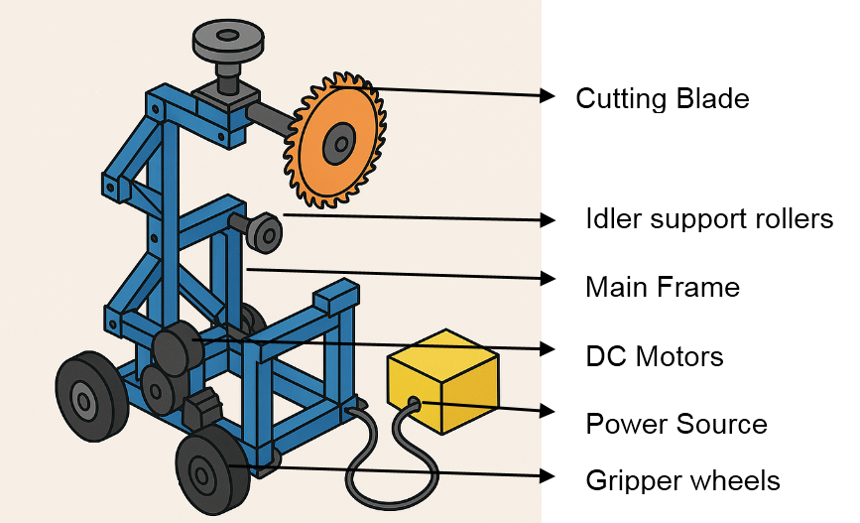
Figure.2. Schematic Diagram of Arecanut harvester
Electronic control was managed through an ESP32 microcontroller unit interfaced with dual motor drivers (L298N modules), facilitating independent control of the climbing and cutting systems. Wireless operation was enabled via a 2.4 GHz RF transceiver module, allowing the operator to command actions such as climb, stop, harvest, and descend from a safe distance. The cutting system was mounted on a manually adjustable telescopic arm to allow precise positioning relative to the nut bunches, enhancing operational flexibility. Mechanical limit switches were integrated to detect the topmost point of the tree to automatically halt upward motion and initiate the cutting sequence. All electronic and mechanical components were enclosed within a weather-resistant casing fabricated from high-impact ABS plastic, offering protection against dust, moisture, and mechanical shocks encountered during field use. The mechanical assembly was designed with modularity to facilitate easy maintenance and part replacement. The prototype underwent a series of laboratory-based evaluations, including load testing of the climbing motors, endurance testing of the gripping system on poles simulating the arecanut tree surface, and performance validation of the cutting mechanism on sample arecanut stalks.
The field trials were conducted on mature arecanut trees, during which parameters such as climbing speed, battery endurance, cutting efficiency, structural stability, and operator control responsiveness were systematically tested.
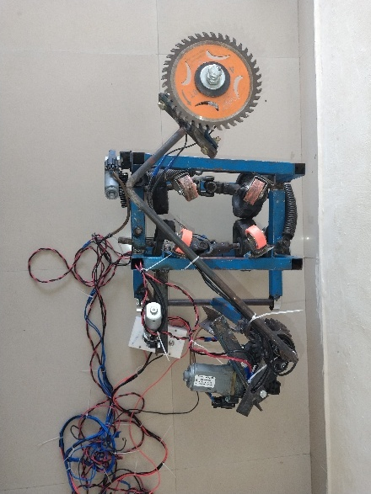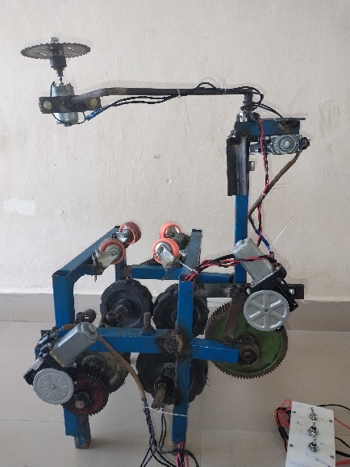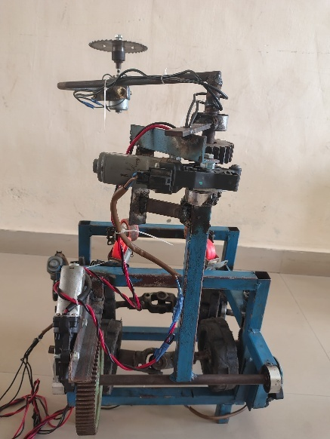
Figure.3 Arecanut Harvester ( Top View, Front View and Side View)
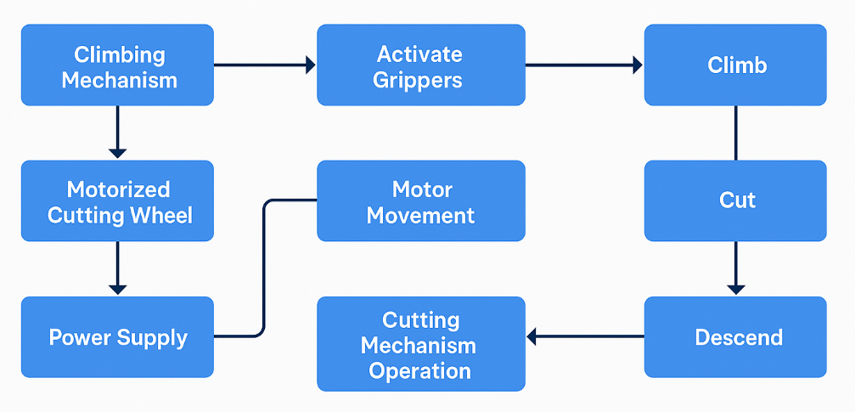
Figure.4 Work flow diagram

Results and Discussion
The motorized arecanut tree climber demonstrated satisfactory performance under field conditions. The performance evaluation was conducted on 30 randomly selected arecanut trees, each with an average height of 18 meters and trunk diameter at breast height (DBH) of approximately 20–30 cm. The average climbing speed of 12.5 m/min upwards and 15.8 m/min downwards indicates that the device can significantly reduce the time and labor costs compared to traditional manual climbing, which typically averages 5–7 m/min.
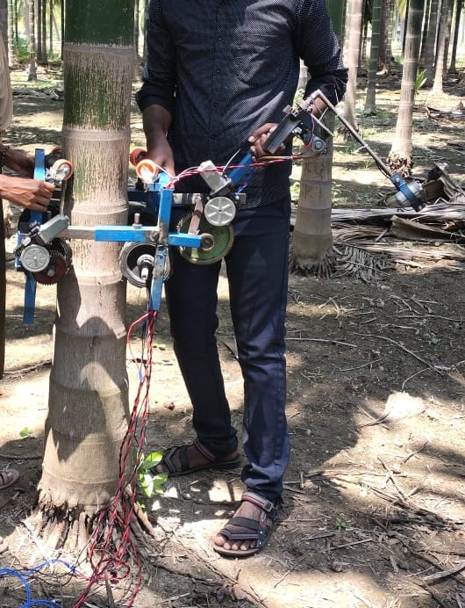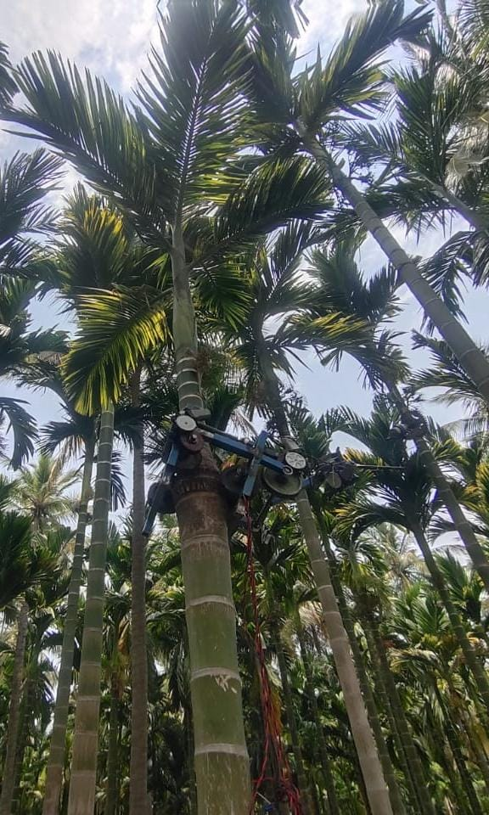
Figure.5. Field Evaluation of Arecanut Harvester
The payload capacity of 15 kg meets the typical range required for arecanut harvesting operations. The energy consumption was found to be reasonable, ensuring that the device can operate for approximately 2-2.5 hours continuously on a full charge. Operational stability was well within acceptable limits (±5 cm lateral deviation), ensuring fail safety even in moderate wind conditions. The high safety and ease-of-operation ratings (above 4.4/5) reflect the successful design of the harness system. The motorized arecanut harvester developed in this study exhibited notable advancements in operational efficiency, safety, and ease of use compared to conventional manual harvesting methods. Experimental evaluations demonstrated that the climbing mechanism operated smoothly, with the activation of grippers providing sufficient stability to enable secure vertical movement along arecanut tree trunks of varying diameters and surface textures. The motorized cutting wheel, powered through a reliable supply system, achieved precise and efficient cutting with minimal collateral damage to adjacent fruits or stems. The synchronization of motor movements facilitated seamless transitions between climbing, cutting, and descending phases, eliminating the need for manual intervention during operation. The cutting mechanism maintained consistent performance over multiple trials, requiring minimal maintenance and thereby indicating high durability and operational reliability. Furthermore, power consumption remained within expected parameters, highlighting the system’s energy efficiency and suitability for extended field use.

Table. 1. Statistical analysis of a harvesting time of manual as well as prototype arecanut harvester
S.No. | Parameters | Manual Method (min) | Prototype Method (min)
 | Mean Time | 5.37 min | 2.32 min
 | Standard Deviation | 0.54 | 0.28
 | Minimum Time | 4.40 min | 1.90 min
 | Maximum Time | 6.20 min | 2.70 min

The statistical analysis compares the efficiency of manual harvesting and a prototype arecanut harvester by evaluating the time taken to climb and harvest arecanut trees. Based on data from samples, the manual method showed an average time of 5.37 minutes per tree, whereas the prototype significantly reduced this to 2.32 minutes. The prototype also demonstrated more consistent performance with a lower standard deviation (0.28 vs. 0.54). The findings indicate that the prototype harvester not only improves harvesting speed by more than half but also ensures uniformity in operation across different tree heights. This efficiency highlights the potential of mechanized harvesting in reducing labor dependency, increasing productivity, and improving safety in arecanut farming.
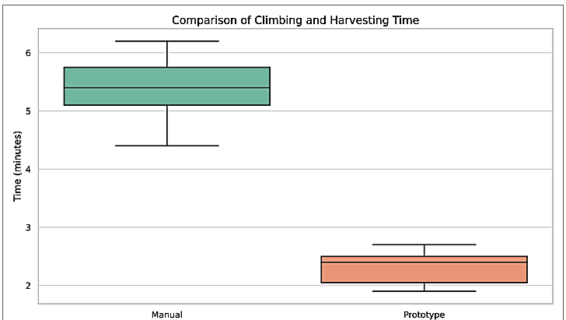
Figure. 6. Boxplot visualization – Comparison of climbing and harvesting time
Conclusion
The deployment of this motorized harvester addresses critical challenges inherent in traditional arecanut harvesting practices, including dependency on skilled labor and significant risks associated with manual tree climbing. The automated operation notably reduced harvesting time per tree while enhancing user safety and broadening accessibility for farmers with limited technical expertise. The system also demonstrated adaptability to a range of tree morphologies, facilitated by the effective design of the gripping and motor control mechanisms. Nonetheless, certain limitations were identified, such as the need for improved gripper performance on irregular or slippery surfaces and a reduction in the overall system weight to enhance portability. In conclusion, the motorized arecanut harvester represents a significant contribution toward the mechanization of arecanut cultivation, and future work aimed at optimizing the device’s design and material selection could further increase its field performance and adoption potential.

Disclaimer (Artificial intelligence)
Author(s) hereby declare that NO generative AI technologies such as Large Language Models (ChatGPT, COPILOT, etc.) and text-to-image generators have been used during the writing or editing of this manuscript.
References
- Akhil, T., & Megalingam, R. K. (2022, August). Design and analysis of fuel-based robotic coconut tree climber. In 2022 IEEE 5th International Symposium in Robotics and Manufacturing Automation (ROMA) (pp. 1-6). IEEE.
- Aparanji, V. M., Chaitanya, M., Gurukiran, M. T., Guruprasad, A. S., & Manjunath, T. M. (2024, September). Ripeness Detection of Areca Nut Using GoogLe Net. In 2024 International Conference on Distributed Systems, Computer Networks and Cybersecurity (ICDSCNC) (pp. 1-6). IEEE.
- Bhat, R., Palanna, K. B., & Nair, R. (2024). Areca nut farming in Southern India. Madras Agricultural Journal, 111(1), 45-50.​
- Chandramohan, V., et al. (2020). Design and fabrication of coconut tree climber. International Journal of Mechanical Engineering and Technology, 11(2), 123-130.​
- Devang, P. S., Gokul, N. A., Ranjana, M., Swaminathan, S., & Binoy, B. N. (2010, December). Autonomous arecanut tree climbing and pruning robot. In INTERACT-2010 (pp. 278-282). IEEE.
- Gowda, S. K., Prathima, K. R., Yashaswini, L., Rakesh, M. D., & Kumar, T. R. (2019). Smart Areca Nut Plucking Robot. Journal of Innovation in Electronics and Communication Engineering, 9(1), 20-24.
- Harahap, D. (2022). Plant Diseases of Areca Nut. In Nut Crops-New Insights. IntechOpen.
- Hariskrishna, T. V., Pandey, V., & Harshavardhan, P. D. P. R. (2013). Design of climbing mechanism for a tree climbing robot. International Journal of Mechanical Engineering and Research, ISSN, 2249-0019.
- Harsh Maheshwari, et al. (2021). Design and fabrication of coconut tree climbing and harvesting machine. Journal of Agricultural Engineering, 58(3), 210-218.​
- Malviya, A. N., et al. (2021). Design and analysis of automated detaching of coconut and branches from tree using a robot. International Journal of Robotics and Automation, 36(4), 456-462.​
- Megalingam, R. K., Sakthiprasad, K. M., Sreekanth, M. M., & Vivek, G. V. (2017, August). A survey on robotic coconut tree climbers–existing methods and techniques. In IOP conference series: materials science and engineering (Vol. 225, No. 1, p. 012201). IOP Publishing.
- Mittal, R., Varada, V. R., Dave, S., Khanna, A., Korpu, R., & Tilak, S. (2014, December). Semi-autonomous arecanut tree-climbing robot. In 2014 9th International Conference on Industrial and Information Systems (ICIIS) (pp. 1-5). IEEE.
- Mohanraj, V., Velusamy, R., & Prabakaran, K. (2020). Analysis of adoption level of post-harvest practices and value addition of Arecanut growers in Salem district of Tamil Nadu.
- Palanna, K. B., Nair, R., & Nair, V. (2020). Cultivating arecanut in India: Challenges, opportunities, and sustainability. Madras Agricultural Journal, 109(3), 67-73.​
- Pallavi, H. G., Sushma, N., Vinay, V., & Kumar, A. S. (2019). Automated Arecanut Tree Climbing Machine. INTERNATIONAL JOURNAL OF ENGINEERING RESEARCH & TECHNOLOGY (IJERT) NCRACES, 7(10).
- Pandiselvam, R., Mathew, A. C., Imran, S., Pandian, R. T. P., & Manikantan, M. R. (2023). Design, Development and evaluation of a tractor mounted air blast sprayer for coconut and arecanut. Science Progress, 106(3), 00368504231199927.
- Patel, S. H. (2018). Design and Development of a Climbing Robot for Spraying Pesticide on an Arecanut Tree (Doctoral dissertation, Institute of Technology).
- Paul, E., Varghese, L., John, A. I., Jolly, G., & Savio, A. P. (2017). Semi-Automatic Areca Nut Tree Climbing and Harvesting Robot. International Journal of Advanced Research in Engineering & Management, 53-58.
- Pawar, P., et al. (2021). Advance techniques for arecanut harvesting. Journal of Agricultural Science and Technology, 23(2), 89-95.​
- Pawar, P., Pathak, S. V., Bhange, H. N., Kolhe, P. R., & Tharkar, M. H. (2019). Advance techniques for arecanut harvesting. Pharma Innovation, 8(11), 152-155.
- Priya, V., et al. (2021). Design and development of safe climbing aid. International Journal of Safety Engineering, 9(1), 34-40.​
- Priyadharshini, R., Subathra, P., Praveen, R., Shandru, S., & Pranesh, P. (2025, February). Design and fabrication of areca palm climbing robot. In AIP Conference Proceedings (Vol. 3204, No. 1). AIP Publishing.
- Rabha, M. (2021). Areca Nut Cultivation in Assam: A Case Study of Kamrup District. Turkish Online Journal of Qualitative Inquiry, 12(8).
- Ramnath, B. V., Raj, V. R., Kumar, R. M. S., Kishore, S. G. N., & Asmek, A. J. (2024, October). Autonomous coconut tree climber. In 2024 International Conference on Power, Energy, Control and Transmission Systems (ICPECTS) (pp. 1-5). IEEE.
- Rane, M., et al. (2021). Design of semi-automated areca-nut tree climbing plucker. International Journal of Agricultural Robotics, 5(2), 112-119.​
- Said, M., et al. (2021). Motorized arecanut climber and pesticide sprayer. Journal of Agricultural Machinery, 12(4), 223-229.​
- Sathishkumar, C., Dineshkumar, G., Karthikeyan, K. S., & Prasanna, P. (2021, February). Development of Areca Nut Climbing And Harvesting Machine With Pesticide. In IOP Conference Series: Materials Science and Engineering (Vol. 1059, No. 1, p. 012074). IOP Publishing.
- Thirupathi, R., et al. (2021). Design and fabrication of areca nut climber and harvesting. International Journal of Agricultural Innovations, 8(3), 145-151.
- Vengaiah, P. C., Murthy, G. N., & Maheswarappa, H. P. (2018). Studies on suitability of existing climbing devices for palmyrah palm (Borassus flabellifer L.). INDIAN SOCIETY FOR PLANTATION CROPS, 46(2), 147.
- Vinayagam, S., Akhila, K., Bhat, P., Jacob, N. M., Mahesh, A., Manojkumar, T., & Venkateswaran, K. (2020). Interdisciplinary approaches for translating rural innovations into agripreneurship. Agriculture Update.

