Post-Fire Hydrological Impacts and Water Storage Changes in the Forests of Uttarakhand, India

ABSTRACT
Forest fires are frequent and intense phenomena caused due to climate change and long-standing fire suppression practices, but their impact on hydrological processes, such as changes in water storage, remains underexplored. We conducted the research in the fire-prone region of Uttarakhand, India, on the southern slopes of the Himalayas. A total of 42 burnt sites from the 2019 forest fire season, spanning five major forest types and identified by the Forest Research Institute (FRI), Dehradun, were identified for the present study. Thornwaite-Mather Water Balance (TMWB) method to evaluate the impact of forest fires on water balance. Change in water storage was determined by integrating precipitation data from CHIRPS, runoff was estimated using the SCS Curve Number method, and actual evapotranspiration (ETa) from GLDAS AET Version 2.1. The finding revealed a consistent post-fire decline in water storage, the most significant reduction in storage was observed at site S35 in the STP forest (-59.85%) and the smallest reduction at site S26 in the TOF forest (-4.08%). This decline is due to reduced infiltration, soil degradation, and vegetation loss that regulate hydrological balance. These findings underscore the importance of forests in sustaining water resources and emphasize the need for integrated fire and water management strategies. This research highlights the hydrological consequences of forest fires and supports the development of climate-resilient policies and restoration efforts to protect ecosystems and dependent communities.

Keywords: Evapotranspiration; Changing in Storage; Runoff; Forest Fire; Water Storage

- INTRODUCTION
Forest fires are becoming more frequent across the globe, driven by both climate change and longstanding fire suppression practices (Littell et al., 2016; Pechony and Shindell, 2010; Westerling et al., 2006; Wotton et al., 2010). Fire disturbances lead to long-term shifts in plant communities and large-scale ecological effects, such as loss of biodiversity, reduced forest cover, soil degradation, enhanced greenhouse gas emissions, and enhance desertification. They also alter ecosystem water balance by lowering vegetation and surface cover, impacting runoff and evapotranspiration (Keeley, 2009; Poon & Kinoshita, 2018). Evapotranspiration (ETa) is one of the most responsive hydrologic processes to disturbances of vegetation (DeBano et al., 1998). In addition to impacting ETa, wildfires also influence several key physical processes on the landscape that affect water movement along hillslopes, such as precipitation, throughfall, infiltration rates, snowmelt dynamics and sub storage change (Hallema et al., 2017). When vegetation is significantly disturbed by fire, transpiration can decrease sufficiently to outweigh any increase in evaporation driven by altered surface energy dynamics, and this can result in a net decrease in actual net evapotranspiration (ETa) (Biederman et al., 2014; Tague et al., 2019). Such a reduction in ETa, due to loss of vegetation, can have a direct effect on the alteration in water storage under post-fire conditions. The change in storage can be estimated using the water balance method developed by Thornthwaite and Mather (1955, 1957), which quantifies the relationship between key hydrological components. According to Eagleson (2005), the water balance framework focuses on long-term averages of precipitation, runoff, evapotranspiration, and change in storage components that play a central role in the hydrological cycle. Several studies have observed water balance techniques and hydrologic impact, emphasizing their importance in managing water resources. Atchley et al. 2018; Venkatesh et al. 2019 studied the relationship between infiltration, runoff, precipitation, streamflow and evapotranspiration highlighting how all these factors affect overall hydrologic behaviour. The Thornthwaite and Mather water balance method was applied across various region and its practical applications (Ensafi Moghaddam and Mohammadkhan, 2017; Nugroho et al., 2019; Mammoliti et al., 2021). Collar et al. 2024 study focused on the long-term effect of wildfire on hydrology and ETa. These studies determine importance of water balance approach for a better understanding change in storage and water resource in the face of environmental and climatic changes.

MATERIAL AND METHOD

Study Area
The study was conducted in Uttarakhand, India, located on the southern slopes of the Himalayas, covering 53,483 km² between latitudes 28°44′ and 31°28′N and longitudes 77°35′ and 81°01′E. Geographically, the state includes the Terai, Siwaliks, and Himalayan zones, with predominantly hilly terrain and steep slopes. Climate varies from subtropical in the foothills to cool temperate in higher altitudes. The average annual rainfall is 1,547 mm (ICFRE, 2013). Forests cover 45.44% of the state’s area, with 6,482 km² classified as open forest, 12,768 km² as moderately dense, and 5,055 km² as very dense (FSI, 2021). Forest types include 34 categories across eight groups, such as subtropical pine and Himalayan moist temperate forests (Champion and Seth, 1968). A net 2% forest cover change was recorded, indicating dynamic forest conditions and the need for ongoing monitoring and management. This study carried out by considering 42 selected polygons in Uttarakhand across the 2019 forest fire provided by FRI, Dehradun. The study area was further classified based on fire severity classification by ICFRE, Dehradun so that the study sites selected represent the typical physiographic, vegetation and FF intensity (low and medium) across the state. The study area is classified into five distinct forest types, each comprising a different number of fire-affected sites. The Subtropical Pine Forest (STP) includes 20 burnt sites, the Himalayan Moist Tropical Forest (HMT) includes 11 sites, the Tropical Moist Deciduous Forest (TMD) comprises 6 sites, the Trees Outside Forest (TOF) category includes 3 sites, and the Tropical Dry Deciduous Forest (TDD) consists of 2 sites.
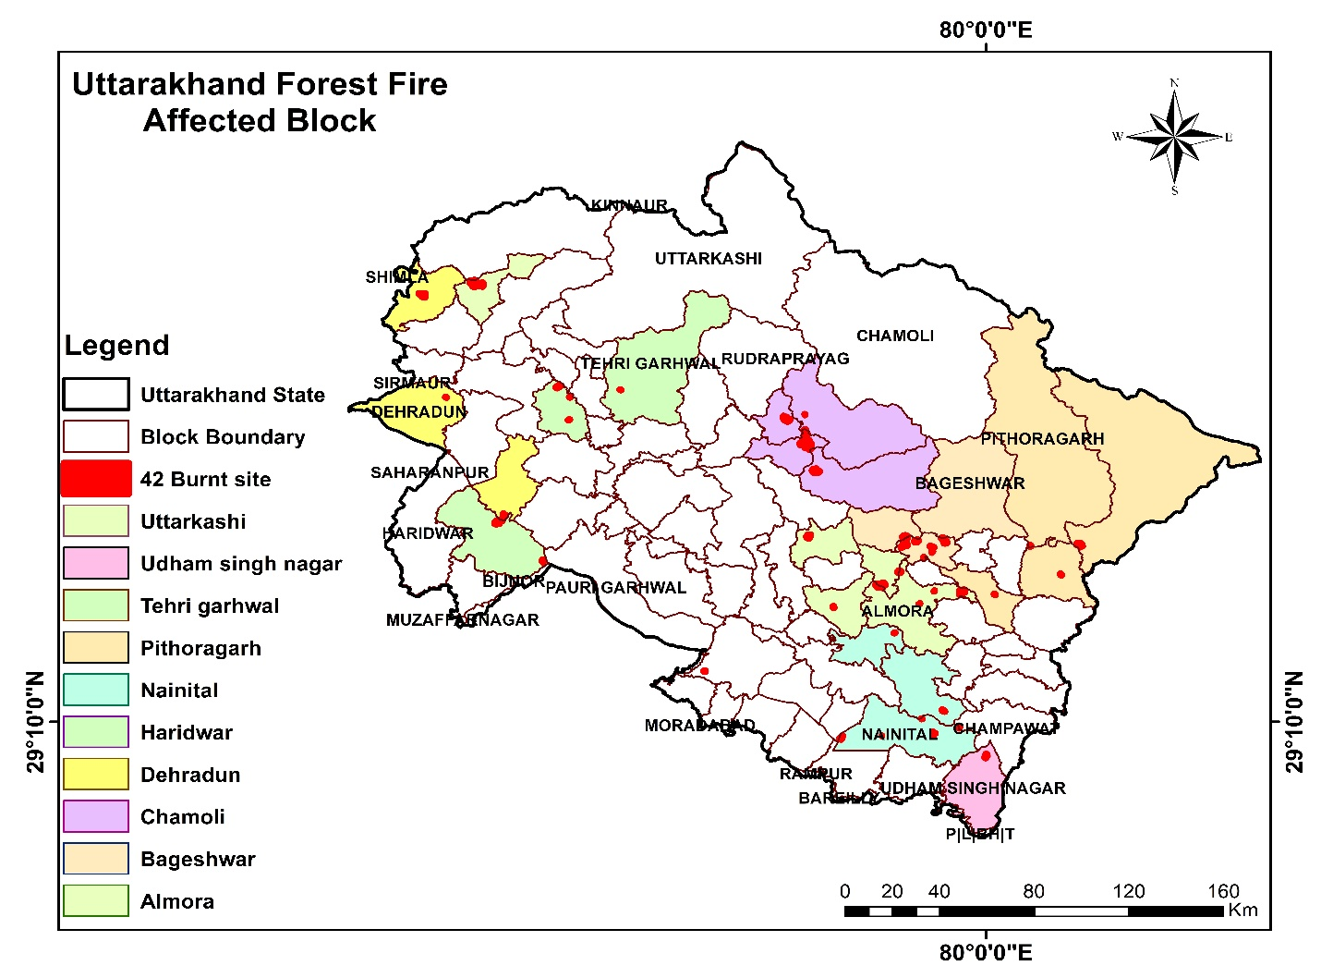Fig. 1 Map of Uttarakhand showing the locations of the 42 burn sites categorized by block
The area lies within a subtropical monsoon zone and receives an average annual rainfall of around 1,547 mm, with over 81% of the precipitation falling during the months of July and August. The climate in the catchment area varies from humid continental to tropical, depending on altitude and season. The southern foothills have a subtropical climate, with summer temperatures averaging around 30°C and winter temperatures near 18°C. In contrast, the Middle Himalayan valleys experience a warm temperate climate, with summer temperatures reaching about 25°C and relatively mild winters. In the highest regions of the Middle Himalayas, cool temperate weather predominates. Summer temperatures often range from 15°C to 18°C, while winter temperatures fall below freezing.
2.2 Assessment of water balance

2.2.1 Computation of Hydrological Water Balance
Water balance is based on law of conservation of mass and this method is used to calculate ET. Thornthwaite-Mather Water Balance Approach
$P=RO+AET+ Change in sub-storage (SM)$ Equation (1)
Where, P = Rainfall; RO = Runoff; AET = Actual evapotranspiration; SM = Change in soil moisture.

2..2.2 Precipitation Data
For this study, rainfall data was obtained using CHIRPS dataset which is developed in collaboration with the USGS EROS center for the purpose of early warning systems (eg. Trend analysis, monitoring of seasonal droughts). CHIRPS integrates data from terrain-based precipitation models, ground station observations, and satellite-based precipitation products from NASA and NOAA to provide high-resolution (0.05°) gridded climatological data. Because of the relatively small scale of our forest fire-affected study area, CHIRPS data is considered suitable for our analysis. The data for rainfall from June 2019 to May 2020 was employed in the present study.

2.2.3 Assessment of Change in Runoff
The SCS-CN method is a conceptual approach for modelling the hydrologic abstraction of storm rainfall, grounded in empirical observations Initially developed for predicting runoff in small agricultural watersheds for individual rainfall events, the SCS-CN method has undergone multiple revisions and has been expanded to encompass rural, forest, and urban watersheds. It is now widely utilized in various environments, including applications such as soil erosion studies and water quality modelling (Mishra et al., 2006; Singh et al., 2010; Singh, 2013). For estimating runoff in these small burnt sites in forest areas, where data availability is a major issue, this method is best suited as it requires only four easily identifiable catchment properties: soil type, land use/treatment, surface condition, and antecedent moisture condition.

2.2.3.1 Soil Conservation Service Curve Number (SCS-CN) Method
The SCS-CN method estimates direct runoff from storm rainfall using a curve number (CN), based on empirical data. It relies on the water balance and two key assumptions:
(a) Water balance equation
$P=I_{a} +F +Q$ Equation (2)
(b) Water balance equation
$\frac{Q}{P – I_{a}} = \frac{F}{S}$ Equation (3)
(c) I_{a}S relationship (second hypothesis)
$I_{a}= λS$ Equation (4)
Where P is total rainfall, I_{a} is initial abstraction, F is infiltration (excluding I_{a}), Q is direct runoff, and S is maximum potential retention.
The first assumption (Equation 2) uses proportionality, and the second (Equation 4) defines a linear link between I_{a} and S. Combining them gives:
$Q = \frac{{\left(P- I_{a}\right)}^{2}}{P- I_{a} +S}$ For P ≥ I_{a}, otherwise 0 Equation (5)
General form of the popular SCS-CN method is equation (Equation 5) and is valid for P ≥ I_{a}; Q = 0 otherwise. For λ = 0.2, the coupling of (Equation 4) and (Equation 5) results in:
$Q = \frac{{\left(P- I_{a}\right)}^{2}}{P+ 0.8S}$ Equation (6)
Equation (6) is widely acknowledged as a commonly used form of the established SCS-CN method. Consequently, the standard SCS-CN method with λ = 0.2 serves as a single-parameter model for calculating surface runoff from daily storm rainfall, offering significant importance, practicality, and extensive unexplored potential.

2.2.4 Assessment of Evpotranspiration
Evapotranspiration estimation is challenging for very small areas, especially in remote forest fire regions where data is not accessible; therefore, we relied on global datasets for our research. For water balance analysis, this study uses GLDAS datasets for the pre-fire condition, which provide terrestrial hydrologic data, including AET. The GLDAS AET (Version 2.1), available from 2000 to present, is measured of water loss and derived by NASA using the Noah Land Surface Model (NLSM) with satellite and ground-based observations (Khan et al., 2018). It has been demonstrated in several studies (e.g., Singh et al., 2022; Pal et al., 2021; Zhan et al., 2019) that that GLDAS AET products hold significant potential for global, regional or local scale, especially in data-scarce regions like India. For the pre-fire condition GLDAS AET dataset was utilized, and based on earlier research, it was found that ETa decreases after the forest fire and for the post-fire condition, 15% reduction in ETa was considered for this study (collar et al., 2023).

3 Results and discussion
The result indicates that ETa and change in storage during monsoon season (covering the four months from June to September) was calculated based on forest type. Five forest types with varying numbers of burnt sites were considered: the first forest type, Subtropical Forest type (STP), includes 20 sites, the second Himalayan Moist Tropical Forest (HMT), include 11 sites, the third Tropical Moist Deciduous Forest TMD, includes 4 sites, Tree outside forest (TOF), include 3 sites and the fifth tropical deciduous forest included had the least, 2 sites.

3.1 Monsoon Evapotranspiration Variations in Burnt and Unburnt Sites
The results shows that highest ET values for each forest type at specific sites are as follows: in the STP forest type, sites S20 and S21 recorded the highest ET at 382.45 mm; in the HMT forest type, site S41 recorded 372.57 mm; in the TMD forest type, site S31 recorded 393.32 mm; in the TOF category, sites S26 and S32 recorded 389.19 mm; and in the TDD forest type, site S3 recorded 379.06 mm. The calculated ET for both pre- and post-fire conditions, based on forest type and corresponding burnt sites, is presented in the graph below.

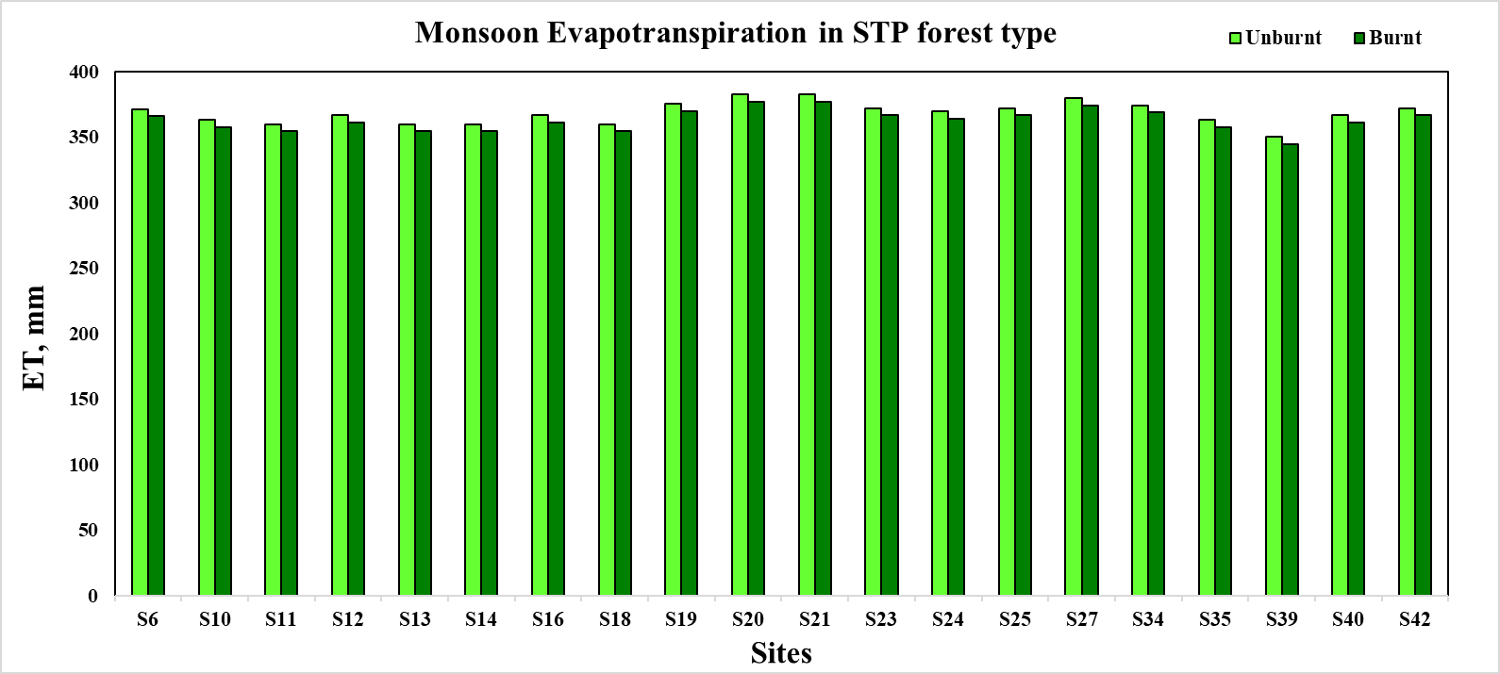
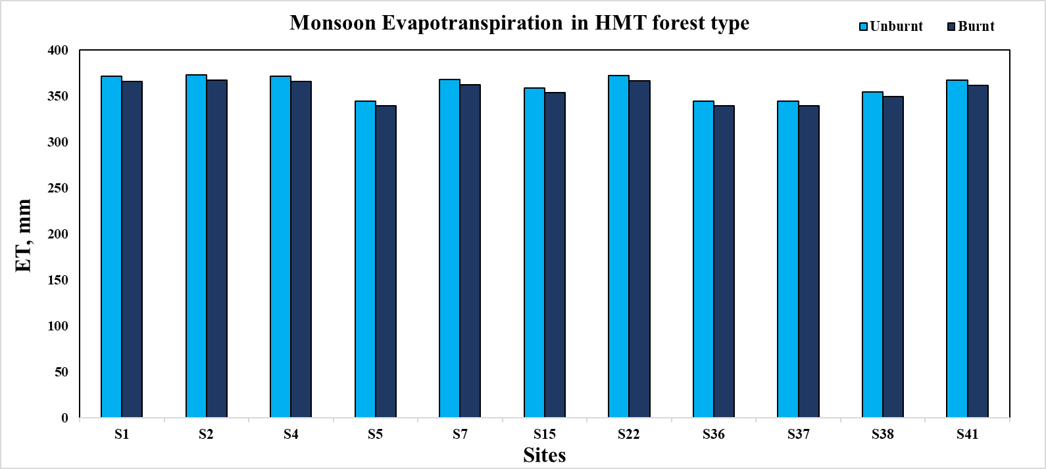
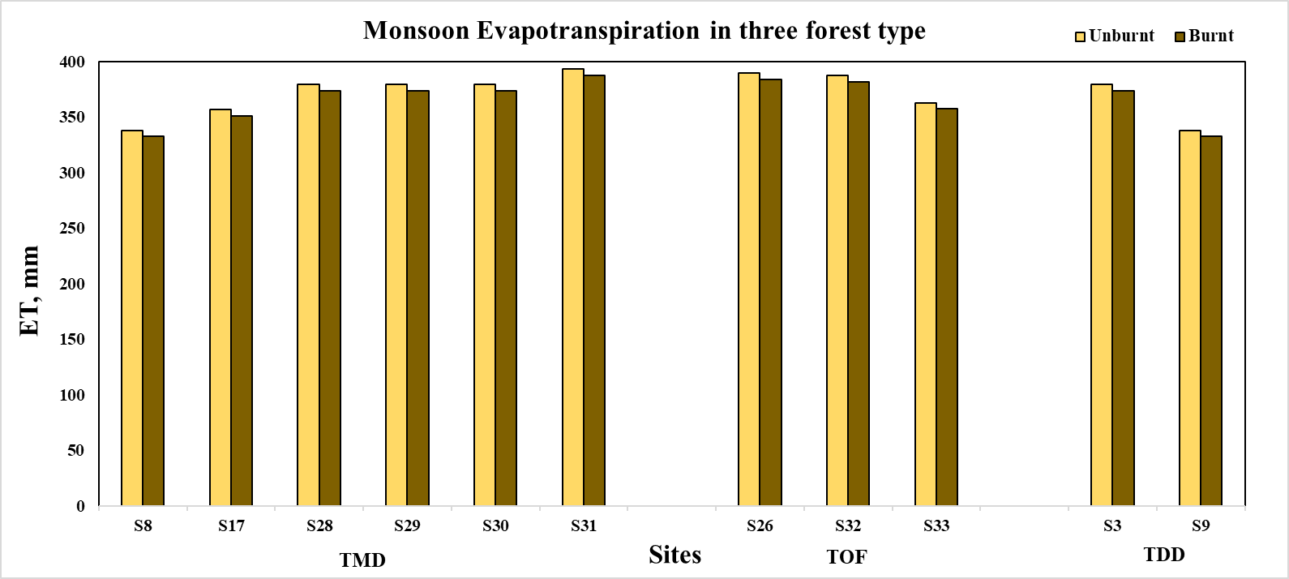

Fig. 2 Monsoon Evapotranspiration variations in burnt and unburnt sites across 5 forest types

3.2 Monsoon Δ Storage Variations in Burnt and Unburnt Sites
The analysis was carried out for each specific site and the results indicate reduction in change in storage at every site which reflect the seasonal variation of the hydrological regime. In the STP forest type (20 sites), the most pronounced decrease in change in storage was found at site S35, with a reduction of -59.85%, while the smallest decline was found at site S12 with a decline of -7.44%. In the HMT forest type, the greatest reduction of -58.49% was found at site S4, whereas the least decline of -14.09% was at site S7. For the TMD forest type, the highest decline was at site S30 with a reduction of -34.26% and the smallest decline was at site S8 with a reduction of -19.4%. In the TOF forest type, storage decreased most significantly at site S33 with a decline of -21.00%, while site S26 experienced a least decline of -4.08%. In the TDD forest type, the greatest reduction of -34.04% occurred at site S3, and the least of -22.72% was observed at site S9. These enhances the spatial variability of the reduction of storage during the monsoon period, apparently due to variations in soil properties, vegetation cover and hydrological processes between the forest types.

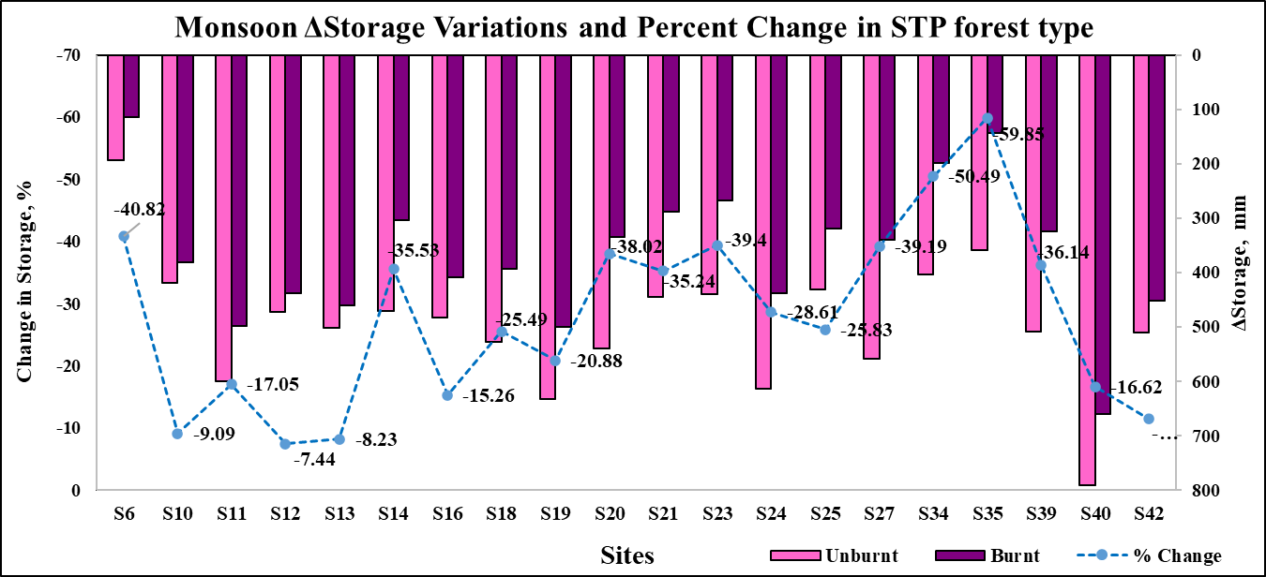
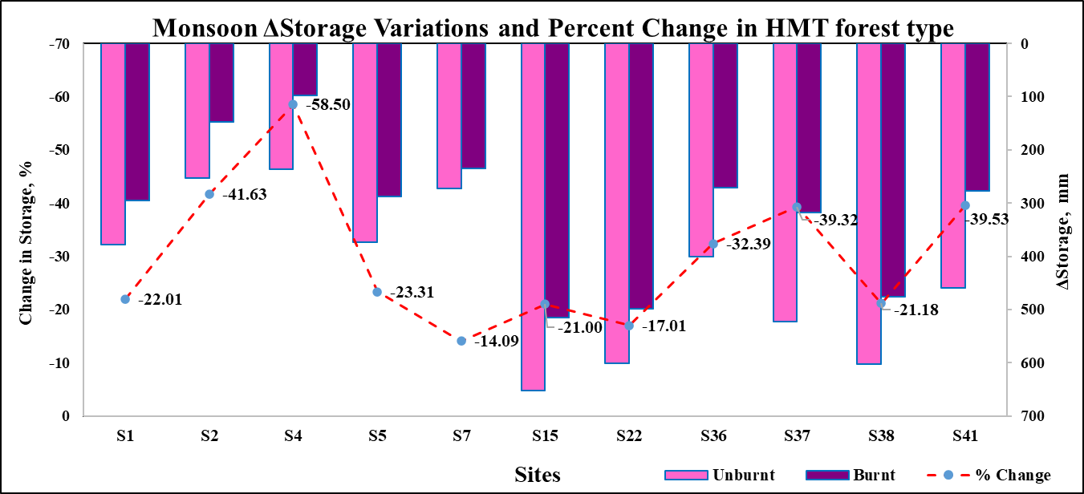
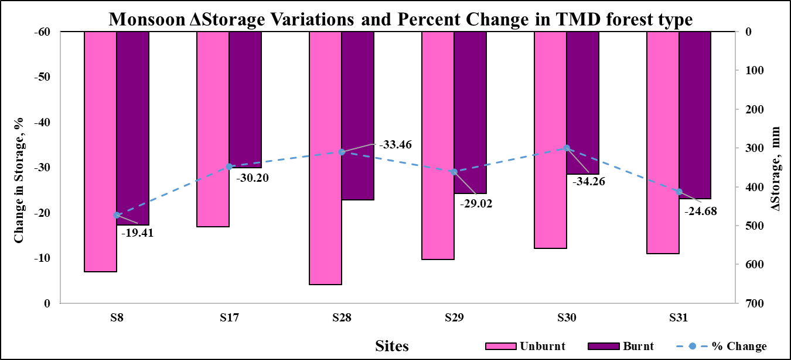
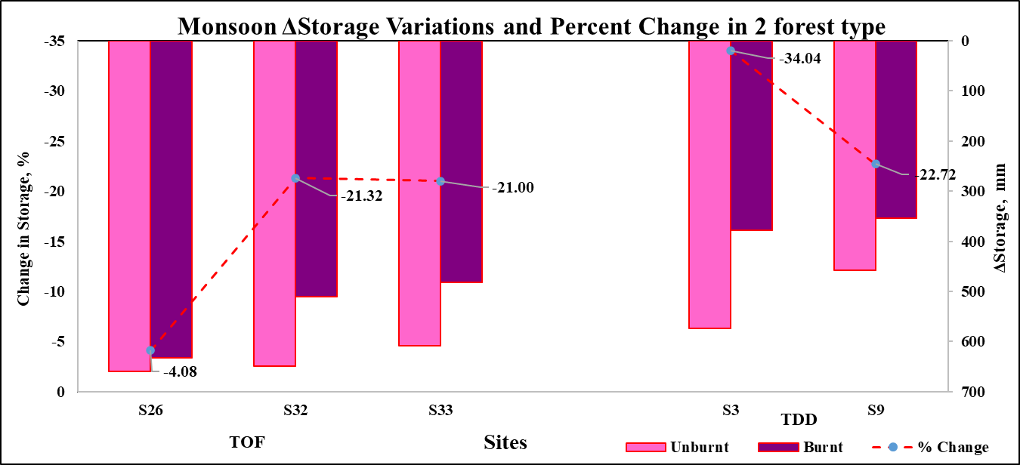

Fig. 3. Monsoon change in storage variations with percent change in burnt and unburnt sites across 5 forest types

4. CONCLUSION
The present study conclusively demonstrates a consistent decline in water storage across all 42 study sites following forest fire events. This decline underscores the substantial hydrological impact of forest fires on terrestrial ecosystems. The highest actual evapotranspiration (ETa) values recorded post-fire for each forest type are as follows: STP forest sites S20 and S21 (382.45 mm), HMT forest site S41 (372.57 mm), TMD forest site S31 (393.32 mm), TOF forest sites S26 and S32 (389.19 mm), and TDD forest site S3 (379.06 mm). Despite these relatively high ET values, the overall trend was a significant reduction in change in storage across the landscape. The most pronounced reduction occurred at site S35 in the STP forest, with a decline of -59.85%, while the smallest decrease was observed at site S26 in the TOF forest (-4.08%). The reduction in water storage is primarily attributed to decreased infiltration capacity and fire-induced changes in soil structure and composition. The loss of vegetation further exacerbates this condition by diminishing canopy interception and root-mediated soil stability, both of which are critical for maintaining infiltration and soil moisture retention. These findings emphasize the important influence of forest fires on hydrological dynamics, particularly in fragile forest ecosystems. It also emphasizes the role of forest cover in controlling water storage, as well as the long-term consequences of fire disturbances on ecosystem water balance. It underlines the significance of integrated forest and water resource management approaches that include fire impacts, facilitate post-fire restoration, and enhance long-term ecosystem resilience.

Disclaimer (Artificial intelligence)
Author(s) hereby declare that NO generative AI technologies such as Large Language Models (ChatGPT, COPILOT, etc.) and text-to-image generators have been used during the writing or editing of this manuscript.

REFERENCES
Atchley, A. L., Albright, T. P., & Riffell, S. K. (2018). Effects of fire severity on hydrologic processes in forests: Implications for water management. Forest Ecology and Management, 429, 78-89.
Atchley, A.L., Kinoshita, A.M., Lopez, S.R., Trader, L., Middleton, R., (2018). Simulating surface and subsurface water balance changes due to burn severity. Vadose Zone Journal 17 (1), 1–13.
Bart, R.R., Tague, C.L., (2017). The impact of wildfire on baseflow recession rates in California. Hydrological Processes 31 (8), 1662–1673.
Biederman, J.A., Harpold, A.A., Gochis, D.J., Ewers, B.E., Reed, D.E., Papuga, S.A., Brooks, P.D., (2014). Increased evaporation following widespread tree mortality limits streamflow response. Water Resources Research 50 (7), 5395–5409.
Champion, H. G., & Seth, S. K. (1968). A revised survey of the forest types of India. Manager of publications.
Collar, N. M., Ebel, B. A., Saxe, S., Rust, A. J., & Hogue, T. S. (2023). Implications of fire-induced evapotranspiration shifts for recharge-runoff generation and vegetation conversion in the western United States. Journal of Hydrology, 621, 129646.
DeBano, L. F., Neary, D. G., & Ffolliott, P. F. (1998). Fire effects on ecosystems. John Wiley & Sons.
Eagleson, P. S. (2005). Ecohydrology: Darwinian expression of vegetation form and function. Cambridge University Press.
Ebel, B. A. (2013). Wildfire and aspect effects on hydrologic states after the 2010 Fourmile Canyon Fire. Vadose Zone Journal, 12(1), vzj2012-0089.
Ensafi Moghaddam, T., & Mohammadkhan, S. (2017). An estimation of Thornthwaite monthly water-balance in Mighan sub-basin. Natural Environment Change, 3(1), 71-80.
Forest Survey of India. (2021). India State of Forest Report. MOEF, Govt. of India.
Goeking, S. A., & Tarboton, D. G. (2020). Forests and water yield: A synthesis of disturbance effects on streamflow and snowpack in western coniferous forests. Journal of Forestry, 118(2), 172-192.
Hallema, D. W., Sun, G., Bladon, K. D., Norman, S. P., Caldwell, P. V., Liu, Y., & McNulty, S. G. (2017). Regional patterns of postwildfire streamflow response in the Western United States: The importance of scale‐specific connectivity. Hydrological Processes, 31(14), 2582-2598
ICFRE, (2013). Forest Types of India: Revisited, Indian Council of Forestry Research and Education, Dehradun, India, pp. 484
Keeley, J. E. (2009). Fire intensity, fire severity and burn severity: a brief review and suggested usage. International journal of wildland fire, 18(1), 116-126.
Khan, M. S., Liaqat, U. W., Baik, J., & Choi, M. (2018). Stand-alone uncertainty characterization of GLEAM, GLDAS and MOD16 evapotranspiration products using an extended triple collocation approach. Agricultural and Forest Meteorology, 252, 256-268.
Littell, J. S., Peterson, D. L., Riley, K. L., Liu, Y., & Luce, C. H. (2016). A review of the relationships between drought and forest fire in the United States. Global change biology, 22(7), 2353-2369.
Mammoliti, E., Fronzi, D., Mancini, A., Valigi, D., & Tazioli, A. (2021). WaterbalANce, a WebApp for Thornthwaite–Mather Water Balance Computation: comparison of applications in two European watersheds. Hydrology, 8(1), 34.
Mishra, S. K., Sahu, R. K., Eldho, T. I., & Jain, M. K. (2006). An improved I_{a}S relation incorporating antecedent moisture in SCS-CN methodology. Water Resources Management, 20, 643-660.
Mishra, S. K., Singh, V. P., & Singh, P. K. (2018). Revisiting the soil conservation service curve number method. In Hydrologic Modeling: Select Proceedings of ICWEES-2016 (pp. 667-693). Springer Singapore.
Nugroho, A. R., Tamagawa, I., Riandraswari, A., & Febrianti, T. (2019). Thornthwaite-Mather water balance analysis in Tambakbayan watershed, Yogyakarta, Indonesia. In MATEC Web of Conferences (Vol. 280, p. 05007). EDP Sciences.
Pal, L., Ojha, C. S. P., & Kumar, A. (2021). Characteristics of Gldas Evapotranspiration and Its Response to Climate Variability Across Ganga Basin, India. Climate Change Impacts on Water Resources: Hydraulics, Water Resources and Coastal Engineering, 241-251.
Pechony, O., & Shindell, D. T. (2010). Driving forces of global wildfires over the past millennium and the forthcoming century. Proceedings of the National Academy of Sciences, 107(45), 19167-19170.
Perry, T. D., & Jones, J. A. (2017). Summer streamflow deficits from regenerating Douglas‐fir forest in the Pacific Northwest, USA. Ecohydrology, 10(2), e1790.
Poon, P. K., & Kinoshita, A. M. (2018). Spatial and temporal evapotranspiration trends after wildfire in semi-arid landscapes. Journal of hydrology, 559, 71-83.
Singh, V. P. (2013). SCS-CN method revisited using entropy theory. Transactions of the ASABE, 56(5), 1805-1820.
Singh, V., Singh, P. K., Jain, S. K., Jain, S. K., Cudennec, C., & Hessels, T. (2022). Examining evaporative demand and water availability in recent past for sustainable agricultural water management in India at sub-basin scale. Journal of Cleaner Production, 346, 130993.
Tague, C. L., Moritz, M., & Hanan, E. (2019). The changing water cycle: The eco‐hydrologic impacts of forest density reduction in Mediterranean (seasonally dry) regions. Wiley Interdisciplinary Reviews: Water, 6(4), e1350.
Thornthwaite, C. W. (1955). The water balance. Public. in Climatol., 8(1), 1-104.
Thornthwaite, C. W., & Mather, J. R. (1957). Instructions and tables for computing potential evapotranspiration and the water balance.
Venkatesh, C., Shivanand, T. R., & Srikant, B. B. (2019). Impact of periodic wildfires on hydrology and landscape of Kudremukh National Park, Western Ghats, India. Environmental Monitoring and Assessment, 191(10), 651.
Westerling, A. L., Hidalgo, H. G., Cayan, D. R., & Swetnam, T. W. (2006). Warming and earlier spring increase western US forest wildfire activity. science, 313(5789), 940-943.
Wotton, B. M., Nock, C. A., & Flannigan, M. D. (2010). Forest fire occurrence and climate change in Canada. International Journal of Wildland Fire, 19(3), 253-271.
Zhan, S., Song, C., Wang, J., Sheng, Y., & Quan, J. (2019). A global assessment of terrestrial evapotranspiration increase due to surface water area change. Earth's future, 7(3), 266-282.

