Evaluation of different extraction techniques and solvents on yield of polyphenolic compounds from pomegranate peel (lat. Punica granatum)

.
ABSTRACT
In this study, polyphenolic compounds from pomegranate peel (Punica granatum) were extracted using different extraction methods. Three techniques were applied for polyphenol extraction: Soxhlet extraction, ultrasound-assisted extraction, and maceration. These methods varied in the time required for extraction and the yield of dry extract. For Soxhlet and ultrasound-assisted extraction, two solvents were used: methanol and ethanol. While maceration is simple and cost-effective, it was found to be the least efficient method for extraction. The removal of ethanol and methanol from the extracts was successfully achieved through evaporation, ensuring the purity of the extracts. The results obtained showed that Soxhlet extraction with methanol gave the highest yield of 33.5% compared to the ethanol solvent with 30.45%.Ultrasound-assisted extraction also yielded significant results, but the difference in yield was more pronounced depending on the solvent used. The goal of this study was to determine and present the efficiency of each extraction method. Further research will focus on assessing the antioxidant capacity of the extracted polyphenolic compounds.

Keywords: Extraction; polyphenolic compounds; Punica granatum; Soxhlet extraction; ultrasound-assisted extraction; maceration.

1. INTRODUCTION

For several years, attention has been focused on natural antioxidants, organic components that are important for human health. Pomegranate (Punica granatum) peel is rich in antioxidants, polyphenols, dietary fiber, and vitamins, all of which contribute to its remarkable bioactivity (Kyriakidou, 2021). Pomegranate peel extracts are currently used for treatment of respiratory diseases and in the preparation of tincture, cosmetics and other therapeutic formula. (Kushwaha et al, 2015). The major polyphenols in pomegranate peel are punicalagin and ellagic acid, with punicalagin being the primary contributor to its antioxidant activity (Xie, 2019; Ranjha, 2020).These bioactives have demonstrated enzyme inhibition activity. (Basu & Penugonda, 2009).The Punica granatum, known as the pomegranate, can be divided into several anatomical parts, including the seed, juice, peel, leaf, flower, bark, and root. Each of these parts has interesting pharmacological and toxicological properties (Rahimi et al, 2012). Since pomegranate peels naturally contain bioactive components, there is a great chance to use them as functional ingredients, maximizing the potential of by-product resources and enhancing the overall value of the pomegranate (Azmat et al, 2024). The reddish fruit has a peel consisting of an outer hard structure called the pericarp. Inside, there is a spongy mesocarp where the juice-filled arils are attached, especially in mature fruits. (Singh et al, 2019). Punicalin is a natural organic compound, molecular formula C₃₄H₂₂O₂₂ and mass of 782.53 g/ mol and ellagic acid (C₁₄H₆O₈) as a derivative of gallic acid, natural antioxidant properties shown in the picture (Figure 1).
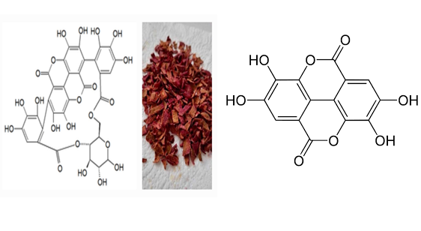
a) b)

Figure 1. Chemical structure of a) punicalin and b) ellagic acid

The qualitative and quantitative studies of bioactive compounds from plant materials mostly rely on the selection of proper extraction method. Extraction is the first step of any medicinal plant study, plays a significantand crucial role on the final result and outcome. Extraction methods are sometimes referred as ‘‘sample preparation techniques’’. Extraction of plant materials can be done by various extractionprocedures. Non-conventional methods, which are more environmental friendly due to decreased use of synthetic and organic chemicals, reduced operational time, and better yield and quality of extract, have been developed during the last 50 years. To enhance overall yield and selectivity of bioactive components from plant materials, ultrasound, pulsed electric field, enzyme digestion, extrusion, microwave heating, ohmic heating, supercritical fluids, and accelerated solvents have been studied as non-conventional methods. At the same time conventional extraction methods, such as Soxhlet is still considered as one of the reference method to compare success of newly developed methodology. It is only possible to conduct further separation, identification,and characterization of bioactive compounds followed by an appropriate extraction process. Different extraction techniques should be used in diverse conditions for understanding the extraction selectivity from various natural sources. Different techniques, many of themremain almost same through hundreds of years; can also be used to extract bioactive compounds (Azmir et al, 2013). The traditional techniques of solvent extraction of plant materials are mostly based on the correct choice of solvents and the use of heat and/or agitation to increase the solubility of the desired compounds and improve the mass transfer. Usually the traditional techniques require longer extraction time, thus running a severe risk of degradation for most of the phyto-constituents (Patil et al, 2012). Efficient extraction of valuable compounds from pomegranate peel depends on several factors, including the extraction method and the type of solvent used. Organic polar solvents such as ethyl acetate, ethanol, methanol, and acetone are commonly employed for extracting polyphenols (Ross, 2009; Ranjha, 2020). This study focuses on three extraction techniques: maceration, Soxhlet extraction, and ultrasound-assisted extraction (UAE), also known as sonication. Maceration is a traditional, simple, and cost-effective extraction method that only requires a basic container for the extraction process. However, it typically demands a long extraction time. Despite its simplicity, maceration is widely used for extracting active compounds because it can be performed almost anywhere (Tambun, 2021).
In Soxhlet extraction, the process usually takes between 6 to 24 hours for a sample mass of approximately 10 g. The solvent-to-sample ratio for solvents like toluene and methanol is typically 10:1 (vol/vol). The Soxhlet process involves heating, and although it is sequential, it can be operated continuously in larger setups. This method requires minimal equipment and operator skills, but the extraction time is relatively long. On the other hand, ultrasound-assisted extraction (sonication) is a faster method compared to Soxhlet extraction. For sample masses ranging from 2 to 30 g, the extraction time is typically 3 to 5 minutes per sample. All solvent combinations are used in equal proportions. Like Soxhlet extraction, the ultrasound-assisted method also benefits from low development time, minimal equipment requirements, and less operator expertise (Patel, 2019).The aim of this research is to evaluate how different extraction techniques and solvents affect the yield of polyphenols from pomegranate peel, and to estimate their polyphenol content.
- material and methods

The pomegranate was purchased in a grocery store nearby Tuzla in Bosnia and Herzegovina, and carefully selected to ensure optimal quality—fresh, ripe, and free from visible damage.

Preparation and drying of pomegranate peel

Several researchers have reported the biological activities and functions of pomegranate peel. However, the drying methods are significant factors for drying products to remove water and reduce the chemical reaction or enzymatic activities. The drying methods can affect the quality attributes such as color, nutritional, and, phytochemical activities of products. Various drying methods such as sun-drying, vacuum-drying, freeze-drying, oven-drying, air-drying, etc. are used to dry the products. Furthermore, freeze-drying is a potential method for extraction and higher recovery of bioactive compounds and other phytochemicals from natural plant sources compared to other drying methods; however, the freeze-drying method is expensive compared to others but retains the higher quality of the products. (Kumar et al, 2022).

To preserve its valuable bioactive compounds, a precise preparation process was followed, beginning with a thorough washing in clean water. This step was essential to remove any impurities, dust, or potential pesticide residues from the peel. Once washed, the pomegranate was gently wiped with a clean cloth and left to air dry completely, preventing excess moisture that could interfere with further processing. The fresh pomegranate was then peeled, and the outer rind was carefully separated from the fruit. The peel was cut into smaller pieces to increase the surface area, allowing for more efficient drying and extraction of beneficial compounds.
The crushed peel was then subjected to natural air drying. It was spread out in a well-ventilated but dark space, where it remained for 3 to 4 days. The chosen drying environment was crucial—proper airflow prevented mold formation, while the absence of direct light helped preserve delicate bioactive compounds such as polyphenols and vitamins, which degrade when exposed to light. After completing the drying process, the pomegranate peel was prepared for maceration and extraction.

The extraction of bioactive compounds from pomegranate peel requires a careful selection of techniques to maximize the yield and quality. (Singh et al, 2013) In addition to the extraction method and solvent type, factors such as temperature, extraction time, and particle size of the plant material can significantly influence extraction efficiency (Pandey & Tripathi, 2014).

  - Ultrasound – assisted extraction of polyphenol compounds from pomegranate peel
The UAE method is used to improve the extraction performance of polysaccharides and oils from plant tissues, mainly through the phenomenon of “cavitation”. The effect of the ultrasound extraction method is that it accelerates more efficient compounds released from plant tissue due to cell wall destruction, enhancing mass transfer, and easier access of solvent to plant cell content.(Mason, 2011; Vinatoru, 1999). In ultrasonic extraction, the sample is placed with a suitable organic solvent in the ultrasound device. (Lampakis et al, 2021). Ultrasound-assisted extraction (UAE) is one of the key techniques for the extraction of the bioactive compounds from plant materials. It involves the use of ultrasound waves in the frequency range of 20 kHz to 2 MHz for disruption of the plant matrix and improving the penetration of solvents (Huang, 2025) (Panja, 2018). Basically, this method relies on sonication, including the creation and collapse of cavitation bubbles near the plant matrix give rise to high-pressure, high-temperature microjets. These microjets crash onto the surface of the plant with great force, breaking up its matrix and ensuring that the solvent comes into direct contact with the active ingredients of the cell, thereby enhancing their leaching into the solvent more effectively (Huang, 2025,Chemat, 2011).

    - Detailed steps of extraction and solvent removal
- Pulverization of plant material (lat. Punica granatum peel). 2.5 grams of pulverized plant material were weighed andplaced into two flat-bottomed flasks. Each flask wasthen mixed with solvents (methanol, 96% ethanol). The flasks were sealed with parafilm to prevent evaporation and contamination during the extraction process.

- The samples were subjected to extraction in an Bandelin Sonorex ultrasonic bath for 35 minutes on room temperature. During the extraction large amounts of energy are generated. To maintain the desired temperature, ice was used to cool the samples and prevent overheating.

- After completed extraction, the samples were filtered through filter paper (Macherey – Nagel MN 617 filter paper). The filtrates were collected in porcelain lab bowls. First 5 mL of filtrates were collected in small lab beaker and discarded from further analysis.

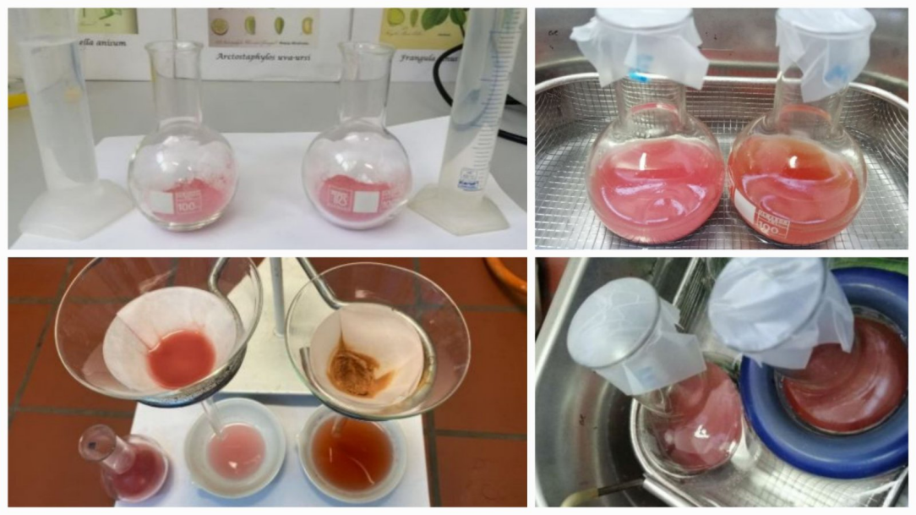
Figure 2. Ultrasound-assisted extracts

4. Removal of ethanol and methanol solvents

Large laboratory beaker was filled halfway with water and heated to boiling. Once water vapor began to form, a porcelain lab bowl containing the filtrate was placed over the beaker. The ethanol evaporated from the extract due to the heat from the water vapor. After the ethanol was completely removed, the dry pomegranate extract was carefully removed from the porcelain lab bowl, stored in paper, and then transferred to sterile cups for further use. For the methanol solvent, the porcelain dish containing the methanol extract filtrate was left overnight in a laboratory fume hood. As methanol evaporates at room temperature, it was completely removed from the extract. Once the methanol had evaporated, the dry pomegranate extract was carefully removed from the porcelain bowls, stored in paper, and then transferred to sterile cups for further use.
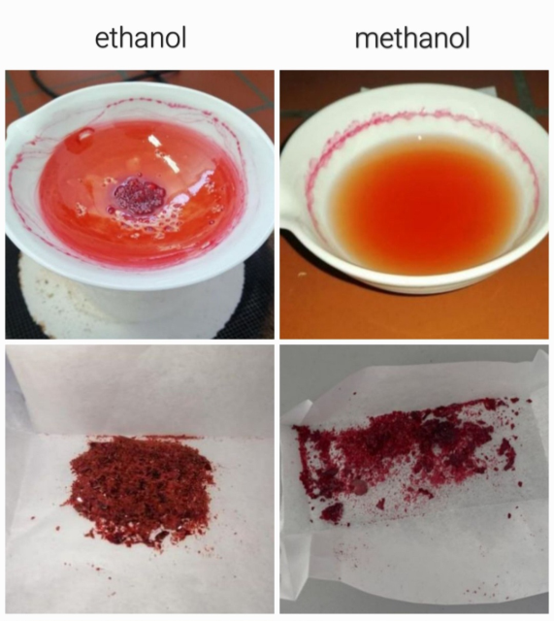

Figure 3. Ultrasound-assisted dry extracts

  - Soxhlet extraction of polyphenol compounds from pomegranate peel
Franz Ritter von Soxhlet is credited with inventing the extraction technique that bears his name in 1879. The method was a significant advance in the isolating of solutes from difficult-to-extract solid samples. For well over 100 years, Soxhlet extraction was considered the gold standard in the analytical extraction of solids. (Raynie, 2019).
Soxhlet extraction is a laboratory technique used for the extraction of compounds from solid materials. It involves the continuous washing of the sample with a solvent, through a cycle of boiling and condensation, enabling efficient extraction of the desired compounds into the solvent(Ultrasonic Soxhlet Extraction).
Soxhlet extraction has been a well-established technique which possesses a great performance as compared to other conventional extraction methods except that it is well applied to the extraction of thermolabile Likewise, when comparing this method to other conventional methods, the larger yields can be extracted with a much smaller quantity of solvent (Alara, Abdurahman & Ukaegbu, 2018).
The advantages and shortcomings of soxhlet extraction have been used as starting points for the development of a variety of modifications intended to alleviate or suppress the latter while keeping or even improving the former. Most of the modifications reported over the last few decades have been aimed at bringing Soxhlet closer to that of more recent techniques for solid sample preparation by shortening leaching times, using auxiliary energies, and automating the extraction assembly.The most outstanding advantages of conventional Soxhlet extraction are: (1) the sample is repeatedly brought into contact with fresh portions of the extractant, thereby helping to displace the mass transfer equilibrium; (2) the temperature of the system remains relatively high since the heat applied to the distillation flask reaches the extraction cavity to some extent; (3) no filtration is required after the leaching step; and (4) sample throughput can be increased by simultaneous parallel extraction because thebasic equipment is inexpensive. (López-Bascón, 2020).

Conventional soxhlet extraction has been the most used extraction technique worldwide for a number of decades, surpassing the performance of other extraction alternatives and being used as an efficiency reference for the comparison of its conventional and new counterparts. (Ahmad et al, 2010).

The most serious drawbacks of Soxhlet extraction as compared to other conventional techniques for solid sample preparation are: (1) the long time required for extraction and the large amount of extractant waste, which is not only expensive to dispose of, but which can itself cause additional environmental problems; (2) samples are usually extracted at the boiling point of the extractant for a long period of time and the possibility of thermal decomposition of thermolabile compounds cannot be ignored; (3)the conventional Soxhlet extractor is unable to provide agitation, which would accelerate the step; (4) because of the large amount of solvent used, an evaporation/concentration step after extraction is mandatory; and (5) the technique is restricted to solvent selectivity and is not easily automated. (López-Bascón, 2020).

Thermal degradation is the most common explanation for the degradation of polyphenols. This may be the case for specific or sub-groups of phenolic acids. The different extraction temperatures may have also impacted the types of polyphenols extracted. At high extraction temperatures, the formation of new compounds known as Maillard reaction products may also influence the extracted polyphenols. (Anthony & Farid, 2022).

    - Detailed steps of extraction and solvent removal

- Sample preparation: Accurately weighs 20 grams of finely ground plant material (Cortex Punica granatum). Place it into a filter paper thimble and seal it with cotton wool.
- Sample placement: Insert the prepared thimble into the extraction chamber of the Soxhlet apparatus.
- Solvent addition: Add 200 mL of solvent (methanol or 96% ethanol) to the apparatus through the funnel above the condenser.
- Heating: Position the flask in a water bath and heat it, maintaining a temperature between 60 and 80°C.
- Extraction process: The extraction proceeds for 6 hours, during which the solvent evaporates, condenses, and percolates through the sample, dissolving the target compounds.
- Extract isolation: Upon completion, transfer the alcoholic extract into a porcelain dish and remove the solvent by evaporation, leaving behind the pure extract.

- Ethanol removal

A large laboratory beaker was filled halfway with water and heated to boiling. Once water vapor began to form, a porcelain lab bowl containing the filtrate was placed over the beaker. The ethanol evaporated from the extract due to the heat from the water vapor. After the ethanol was completely removed, the dry pomegranate extract was carefully removed from the porcelain lab bowl, stored in paper, and then transferred to sterile cups for further use.

- Methanol removal

The porcelain lab bowl containing the methanol extract was left overnight in a laboratory fume hood. As methanol evaporates at room temperature, it is completely removed from the extract. Once the methanol had evaporated, the dry pomegranate extract was carefully removed from the porcelain lab bowl, stored in paper, and then transferred to sterile cups for further use.

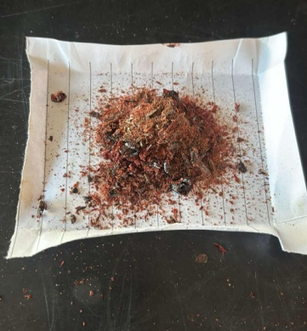
Figure 4. Extract obtained by Soxhlet extraction

  - Maceration extraction of polyphenol compounds from pomegranate peel
Maceration is one of the most commonly used methods for extracting bioactive compounds from plant material. In this process, the plant material is soaked in an organic solvent at room temperature, allowing the solvent to penetrate the plant cells and dissolve the active substances within. Maceration is favored due to its simplicity and low cost, as it requires only basic laboratory equipment, making it accessible for a variety of experiments. (Huang, 2025) While maceration is a straightforward method, it has the disadvantage of a long extraction time. It is particularly suitable for the extraction of thermo-labile compounds. Since the system remains stationary during the maceration process, extraction occurs through molecular diffusion, which is a time-consuming process. This results in the dispersal of concentrated solution around the surface of the particles, bringing fresh solvent to the surface for further extraction. (Patel, 2019)

    - Detailed steps of extraction and solvent removal
- Preparation of plant material
Cleaned and air dried crushed plant material, 1.5 g pomegranate peel (lat. Punica granatum peel), is dipped in 15 mL of a solvent called menstruum (96% ethanol) in a laboratory baker.

- Enabling optimal conditions
The laboratory beaker is closed with a watch glass and allowed to stand still under complete steady state at room temperature.

- Concentration equalization
The content is stirred periodically during 3 days.

- Filtration
The damp solid material is first decanted and then filtered using filter paper (Macherey – Nagel MN 617 filter paper). The filtrates were collected in porcelain lab bowls.

- Ethanol removal
Large laboratory beaker was filled halfway with water and heated to boiling. When water vapor begins to form, we place a porcelain lab bowl with filtrate on the glass. Ethanol evaporates from the extract. Dry pomegranate extract was removed from the porcelain lab bowl and stored in paper and then in sterile cups.

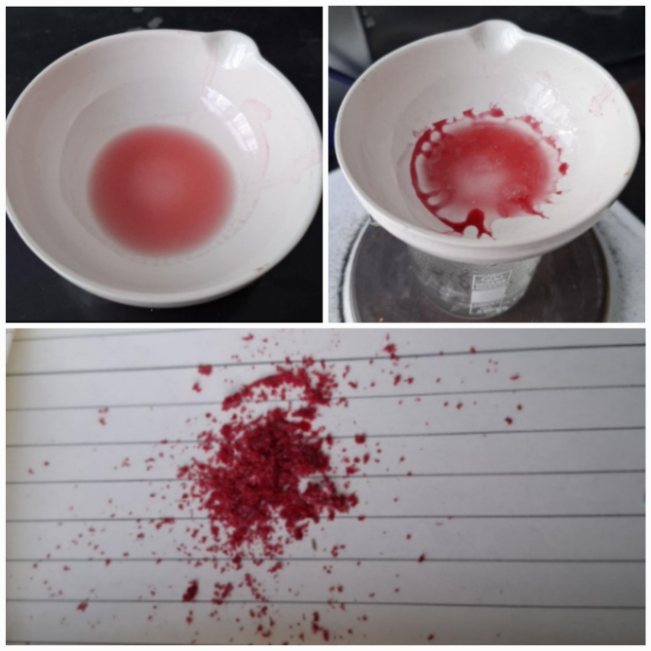
Figure 5. Extract obtained by maceration

3. results and discussion

Based on experimental research, yield results are presented in Table 1 for the extraction methods used from pomegranate peel. The calculation of the yield of the obtained extract is shown in the following formula.
Extract or percentage yield was calculated by using the following formula:

$$\text{Percentage yield=}\frac{\text{Weight of extract sample (g)}}{\text{Initial weight of sample (g)}}\text{×100\%}$$

Table 1. Extraction types and percentage yield
Extraction types | Extract sample | Initial weight of sample (g) | Weight of extract sample (g) | Percentage yield (%)
Ultrasonic extraction | Methanol extract | 2.50 | 0.82 | 32.8
Ultrasonic extraction | Ethanol (96%) extract | 2.50 | 0.43 | 17.2
Soxhlet extraction | Methanol extract | 20.00 | 6.70 | 33.5
Soxhlet extraction | Ethanol (96%) extract | 20.00 | 6.09 | 30.45
Maceration extraction | Ethanol extract | 1.50 | 0.11 | 7.33

Ethanol extraction of natural products is effective due to its broad solubility range as a neutral solvent, capable of extracting a wide variety of compounds, including both hydrophilic components soluble in water and lipophilic components like fats. Its antimicrobial properties contribute to reducing contamination risks and preserving the quality of extracts. Ethanol is considered relatively safe and economical, as it evaporates quickly after extraction, which aids in the concentration process. These properties make ethanol widely used for extracting bioactive compounds, especially those with high antioxidant activity. In solvent extraction, the choice of solvent is critical, depending on factors like selectivity. Common solvents for extraction include ethanol, methanol, and water. Depending on the type of compound to be isolated and extracted, different solvents can be combined and used. Ethanol, being a polar solvent, is highly effective in extracting both polar and nonpolar compounds. It is particularly useful for extracting bioactive substances such as phenolic compounds, lipids, fatty acids, and terpenoids, and it has the added advantage of being safe for use in pharmaceuticals. On the other hand, methanol is a polar solvent with high solubility, which is also effective for extracting various polar compounds. Despite its high extraction efficiency, methanol's toxicity requires careful handling. In addition to phenolic compounds, lipids, and fatty acids, methanol is also used to extract anthocyanins, terpenoids, lignans, polysaccharides, and proteins (Lee, 2024).
The significantly higher yield obtained with methanol compared to ethanol is consistent with the solvent polarity principle—methanol, having a higher polarity index, is more effective in extracting polar phytochemicals such as phenolics and flavonoids, which are abundant in pomegranate peel. (Fawole et al., 2012).
The results show that ultrasonically assisted extraction (UAE) with methanol gave a higher yield compared to ethanol, which confirms its greater efficiency in the extraction of polyphenolic compounds from pomegranate peel. This can be attributed to cavitation effects that enhance solvent penetration and disrupt plant cell walls. (Toma et al., 2001) According to Chemat et al. (2017), this method enhances cell wall disruption through cavitation, facilitating faster release of intracellular compounds without significantly affecting their chemical integrity. The UAE method proved to be a fast and economical alternative, allowing for relatively high yields in a significantly shorter period of time.

Soxhlet extraction, although time-consuming and more demanding in terms of solvent quantity, gave the highest overall extract yield. The difference between methanol and ethanol in this method is smaller than in UAE, which indicates the high efficiency of both solvents in this procedure.According to Azwanida (2015), Soxhlet extraction is particularly effective for obtaining thermally stable compounds because it enables complete exhaustion of the plant matrix.
Maceration gave the lowest extract yield, but remains suitable for the extraction of thermosensitive compounds due to the mild nature of the process. The low yield obtained from maceration using ethanol may be due to the lower temperature and static nature of the extraction, leading to limited mass transfer. (Dai & Mumper, 2010) This supports the general consensus that maceration, while simple and safe, is less efficient in terms of time and yield.
The results indicate the importance of choosing the appropriate extraction method depending on the specific requirements of the analysis and the type of bioactive compounds to be isolated.

4. Conclusion

The goal of this study was to determine and present the efficiency of each extraction method. The results indicated that the Soxhlet extraction method using methanol as the solvent provided the highest yield. After selecting the most effective method based on the yield of the desired compounds, further research will focus on determining the antioxidant activity of the key compounds. Although Soxhlet extraction provided the highest yields, ultrasonic extraction with methanol would be preferred for future studies due to its shorter extraction time. Also, maceration is a method that is significant in many studies due to its simplicity and low cost, and that is precisely why it is included in this research. Antioxidants, which are natural organic compounds, are crucial for human health and are becoming an increasingly important area of scientific research.

Competing interests
Authors have declared that no competing interests exist.

Authors’ Contributions

This work was carried out in collaboration among all authors.
All authors read and approved the final manuscript.

References

- Kyriakidou, A., Makris, D.P., Lazaridou, A., Biliaderis, C.G. and Mourtzinos, I.(2021).
Physical Properties of Chitosan Films Containing Pomegranate Peel Extracts Obtained by Deep Eutectic Solvents.Foods. 10(6), 1262; https://doi.org/10.3390/foods10061262

- Kushwaha, S.C., M.B. Bera, and P. Kumar. (2015). Extraction of polyphenols from fresh pomegranate peel using response surface methodology. Asian J. Chem. 27(12):4320–4326. https://doi.org/10.14233/ajchem.2015.19051

- Z, Li X, Tang R, et al. (2019). Reactions of polyphenols in pomegranate peel with nitrite under simulated stomach conditions. Food Sci. Nutr. 7(9):3103-3109.
https://pubmed.ncbi.nlm.nih.gov/31572603/

- Basu, A., & Penugonda, K. (2009). Pomegranate juice: A heart-healthy fruit juice. Nutrition Reviews, 67(1), 49–56. https://doi.org/10.1111/j.1753-4887.2008.00133.x

- Ranjha, M. M. A. N., et al. (2020). Extraction of Polyphenols from Apple and Pomegranate Peels Employing Different Extraction Techniques for the Development of Functional Date Bars. International Journal of Fruit Science. 20(sup3), S1201–S1221.

- Rahimi, H. R., Arastoo, M., and Ostad, S. N. (2012). A Comprehensive Review of Punica granatum (Pomegranate) Properties in Toxicological, Pharmacological, Cellular and Molecular Biology Researches. Iranian journal of pharmaceutical research: IJPR, 11(2), 385–400. https://pubmed.ncbi.nlm.nih.gov/24250463/

- Azmat F, Safdar M, Ahmad H, et al. (2024). Phytochemical profile, nutritional composition of pomegranate peel and peel extract as a potential source of nutraceutical: A comprehensive review. Food Sci Nutr. 12(2):e3777. https://doi.org/10.1002/fsn3.3777

- Singh, B., J.P. Singh, A. Kaur, and N. Singh.(2019). Antimicrobial potential of pomegranate peel: A review. Int. J. Food Sci. Technol. 54(4):959–965.
https://doi.org/10.1111/ijfs.13964

- Azmir J., Zaidul I.S.M,Rahman M.M,Sharif K.M,Mohamed A., Sahena F., Jahurul M.H.A.,Ghafoor K.,Norulaini N.A.N, Omar A.K.M.(2013). Techniques for extraction of bioactive compounds from plant materials: A review, Journal of Food Engineering 4, 117(4):426-436 https://doi.org/10.1016/j.jfoodeng.2013.01.014

- Patil A.G., Koli SP., Patil D.A. and Phatak A.V.(2012). Evaluation of Extraction Techniques with various solvents to determine Extraction Efficiency of selected Medicinal Plants. International Journal of Pharmaceutical Sciences and Research. 3(8): 2607-2612.

- Ross, K.A., T. Beta, and S.D. Arntfield. (2009). A comparative study on the phenolic acids identified and quantified in dry beans using HPLC as affected by different extraction and hydrolysis methods. Food Chem. 113(1):336-344.
https://doi.org/10.1016/j.foodchem.2008.07.064

- Tambun, R., Alexander, V. and Ginting, Y. (2021). Performance comparison of maceration method, soxhletation method, and microwave-assisted extraction in extracting active compounds from soursop leaves (Annona muricata): A review, IOP Conference Series: Materials Science and Engineering.1122,012095. doi: 10.1088/1757-899X/1122/1/012095

- Patel, K., Panchal, N. and Ingle, P. (2019). Review of Extraction Techniques: Extraction Methods: Microwave, Ultrasonic, Pressurized Fluid, Soxhlet Extraction, Etc., International Journal of Advanced Research in Chemical Science (IJARCS). 6(3),pp.6-21. doi:10.20431/2349-0403.0603002

- Kumar N, Pratibha, Neeraj, Sami R, Khojah E, Aljahani AH, Al-Mushhin AAM. (2022). Effects of drying methods and solvent extraction on quantification of major bioactive compounds in pomegranate peel waste using HPLC. Scientific Reports 12(1):8000. https://doi.org/10.1038/s41598-022-11881-7

- Singh Jyoti, Hamita Preet Kaur, Anjali Verma, Arshminder Singh Chahal, Kaushal Jajoria, Prasad Rasane et al. (2023). Pomegranate Peel Phytochemistry, Pharmacological Properties, Methods of Extraction, and Its Application: A Comprehensive Review, 39(8), 35425-35469 https://doi.org/10.1021/acsomega.3c02586

- Pandey, A., & Tripathi, S. (2014). Concept of standardization, extraction and pre phytochemical screening strategies for herbal drug. Journal of Pharmacognosy and Phytochemistry, 2(5), 115–119.

- Mason J. T., Chemat, F., & Vinatoru, M. (2011). The extraction of natural products using ultrasound or microwaves. Current Organic Chemistry, 15(2), 237-247.

- Vinatoru, M., Toma, M., & Mason, T. J. (1999). Ultrasonically assisted extraction of bioactive principles from plants and their constituents. Advances in sonochemistry, 5, 209-248.

- Lampakis D, Skenderidis P, Leontopoulos S. (2021).Technologies and Extraction Methods of Polyphenolic Compounds Derived from Pomegranate (Punica granatum ) Peels. A Mini Review 9(2):236. https://doi.org/10.3390/pr9020236

- Huang Z, Foo SC, Choo WS. (2025). A review on the extraction of polyphenols from pomegranate peel for punicalagin purification: techniques, applications, and future prospects. RSC.3, 396-413 doi: 10.1039/D4FB00304G

- Panja P. (2018). Green extraction methods of food polyphenols from vegetable materials. Current Opinion in Food Science.23: 173-182. https://doi.org/10.1016/j.cofs.2017.11.012.

- Chemat F, Huma Z, Khan MK. (2011). Applications of ultrasound in food technology: Processing, preservation and extraction, Ultrasonics Sonochemistry. Science Direct. 18(4):813-835. https://doi.org/10.1016/j.ultsonch.2010.11.023.

- Raynie, Douglas E. (2019). Looking at the past to understand the future: Soxhlet extraction. LCGC North America: 37(8), pp.510-513.
https://www.chromatographyonline.com/view/looking-past-understand-future-soxhlet-extraction

- Alara OR, Abdurahman NH, Ukaegbu CI. (2018). Soxhlet extraction of phenolic compounds from Vernonia cinerea leaves and its antioxidant activity. J Appl Res Med Aromat Plants. 11:12-17. https://doi.org/10.1016/j.jarmap.2018.07.003

- López-Bascón, M. A., & De Castro, M. L. (2020). Soxhlet extraction. In Liquid-phase extraction (pp. 327-354). Elsevier

- Ahmad A., Alkarkhi A., Hena S., Siddique B., Dur K. (2010). Optimization of Soxhlet Extraction of Herba Leonuri Using Factorial Design of Experiment. International Jurnal of Chemistry, 1(1), 198-204. DOI: 10.5539/ijc.v2n1p198

- Antony A, Farid M. (2022) Effect of Temperatures on Polyphenols during Extraction. Applied Sciences; 12(4):2107. https://doi.org/10.3390/app12042107

- Lee, J.-E., et al. (2024). The influence of solvent choice on the extraction of bioactive compounds from Asteraceae: A comparative review. Foods. 13, p.3151.

- Fawole, O. A., Makunga, N. P., & Opara, U. L. (2012). Antibacterial, antioxidant and tyrosinase-inhibition activities of pomegranate fruit peel methanolic extract. BMC Complementary and Alternative Medicine, 12(1), 200. https://doi.org/10.1186/1472-6882-12-200

- Toma, M., Vinatoru, M., Paniwnyk, L., & Mason, T. J. (2001). Investigation of the effects of ultrasound on vegetal tissues during solvent extraction. Ultrasonics Sonochemistry, 8(2), 137–142.https://doi.org/10.1016/S1350-4177(00)00070-X

- Chemat, F., Rombaut, N., Meullemiestre, A., Turk, M., Perino, S., Fabiano-Tixier, A. S., & Abert-Vian, M. (2017). Review of green food processing techniques. Preservation, transformation, and extraction. Innovative Food Science & Emerging Technologies, 41, 357–377. https://doi.org/10.1016/j.ifset.2017.03.006

- Azwanida, N. N. (2015). A review on the extraction methods use in medicinal plants, principle, strength and limitation. Medicinal & Aromatic Plants, 4(3), 196. https://doi.org/10.4172/2167-0412.1000196

- Dai, J., & Mumper, R. J. (2010). Plant phenolics: Extraction, analysis and their antioxidant and anticancer properties. Molecules, 15(10), 7313–7352. https://doi.org/10.3390/molecules15107313

- https://sh.wikipedia.org/wiki/Punikalin#/media/Datoteka:Punicalin.png
- https://sh.wikipedia.org/wiki/Elaginska_kiselina

