Review Article

Prospects of Vegetables as an Integrated Component in Aquaponics

ABSTRACT
Due to the growing population, urbanization, and industrialization, agricultural land has become limited, which increases the potential for aquaponics to improve food security. Aquaponics is an innovative and quickly growing sustainable farming technology that merges aquaculture (fish farming) with hydroponic systems (soil-less culture) to cultivate both fish and vegetables within a self-sustaining water ecosystem. It acts as a bio-integrated model for producing food sustainably. It minimizes the use of fertilizers and the release of water, making it a recommended sustainable venture. These systems utilize nutrient-dense water from aquaculture fish tanks as a natural fertilizer for growing vegetables without soil (hydroponics). The plants absorb nutrients, and the microbial process of nitrification allows for the recycling of the water in the fish tanks. This is an efficient technology that provides a symbiotic environment for producing both fish and vegetables. Therefore, integrating vegetables into aquaponics shows promise for addressing food security challenges through eco-efficient farming practices.
Keywords: aquaponics, hydroponics, aquaculture, vegetables, fish, soil-less cultivation
- INTRODUCTION

The increasing population is leading to concerns about food security, and the Food and Agriculture Organization (FAO, 2018) estimates that 60 percent more food will be needed by 2050 to feed a global population of 9.7 billion. Meeting this challenge of sustainable food production with limited natural resources for future generations is a significant issue. Aquaponics has demonstrated itself to be a viable and sustainable method for producing high-quality local food around the world, gaining attention as a bio-integrated model for sustainable food production (Diver, 2006; Rakocy et al., 2006).
Aquaponics is a food production system that integrates fish and hydroponic vegetable crops (Yep and Zheng, 2019). It maximizes the efficiency of land, water, and nutrient use, providing an advantage in areas with scarce water or poor soil and high demand for both fish and vegetables. Most aquaponics systems function using a single-loop layout that recirculates water and nutrients between fish tanks, filters, and the vegetable production bed (Pinho et al., 2021). In this system, fish waste is decomposed by microorganisms, and the by-products created provide nutrients that support plant growth in the hydroponic setup. As the plants absorb nutrients, they help purify the water for the fish, creating a natural microbial process that maintains the health of both the fish and the plants. This integrated system reduces the cost of effluent discharge from aquaculture and the use of chemical fertilizers in hydroponic systems.
Aquaponics is currently recognized as a novel and developing sector within the global agricultural production landscape, featuring different technological variations that combine fish farming and aquatic plant cultivation under the aquaponics label (Knaus and Palm, 2017). Aquaponics aims to integrate aquaculture with hydroponic vegetable production by using various methods to share water and nutrients between the main components, aiming to produce commercially saleable fish and vegetables.
- HISTORY OF AQUAPONICS
The origins of aquaponics can be traced back to the medieval Aztecs, who lived in central Mexico around 1000 AD (Shabeer, 2016). It is believed that these Aztecs developed the first version of aquaponics in response to the limited land available for food cultivation. To address this shortage, they created an innovative solution by constructing rafts covered with soil for planting vegetable crops. These distinct structures were referred to as “floating farms” and are considered as some of the earliest examples of aquaponics systems used for food production (Jones, 2002). The integration of fish rearing with crop cultivation emerged in Southeast Asia and the floating island farming known as 'Chinampas' developed in South America (Komives and Junge, 2015). Fish were not intentionally introduced to rice paddy fields until the 19th century (Halwart and Gupta, 2004), and their occurrence in low numbers did not significantly enhance the growth of the plants. Chinampas were traditionally constructed on lakes in Mexico, benefiting from the nutrient-rich sediments of the lakes instead of relying on a specific fish production system.
The modern practice of aquaponics originated in the United States during the 1970s and was promoted by several organizations dedicated to sustainable agriculture. Numerous researchers have made important advancements in aquaponics, but the pioneering efforts of James Rakocy and his colleagues at the University of the Virgin Islands (UVI) during the early 1980s are regarded as the foundation for almost all modern aquaponics (Lennard, 2017). The term "aquaponics" was first introduced in 1970. A survey by Love et al. (2014) shows that the popularity of aquaponics production systems has significantly increased since the 1980s, highlighting its growing importance in enhancing food security through innovative methods.
Recent developments in aquaponics studies have revealed fresh possibilities, with various stakeholders creating diverse and inventive operational frameworks for efficient food production (Graber & Junge, 2009; La Crosse et al., 2017). Given the urgent need to feed a rapidly expanding global population (Mancuso, 2014; FAO, 2016; Chan et al., 2017; Junge et al., 2017), aquaponics is anticipated to be a key factor in addressing the increasing demand for fish. Additionally, as average incomes increase, vegetable consumption is also anticipated to rise (Smith, 2010). Moreover, the growing awareness of the health benefits associated with consuming vegetables, paired with a shift towards lowering red meat intake, suggests that many countries are expected to see a rise in the average consumption of vegetables and fish over the next few decades (FAO, 2019).

- PRINCIPLE OF AQUAPONICS
Apart from plants and fish, aquaponics involves an additional crucial element: bacteria, which cannot be seen with the naked eye. In aquaponics, fish, plants, and bacteria work together and support each other to create a healthy growing environment, as long as the system is properly balanced (fig.1). In this ecosystem, fish eat food and generate waste, mainly ammonia, which can be toxic to fish even in minimal amounts (0.04 mg/l), with the level of toxicity increasing with temperature and pH. Bacteria break down fish waste, rotting plant matter, and leftover food. Beneficial bacteria known as Nitrosomonas convert ammonia (NH3 or NH₄ ⁺) into nitrite (NO₂⁻), which is also detrimental to fish. Subsequently, another type of helpful bacteria, Nitrobacter, changes nitrite into nitrate (NO₃⁻). Nitrate acts as a key source of nutrients for plants and is therefore eliminated from the water in which the fish reside (Wongkiew et al., 2017).
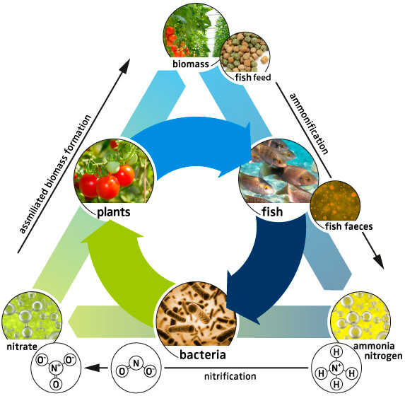
Fig. 1. Principle of a balanced aquaponics system.
- ESSENTIAL COMPONENTS OF AQUAPONICS
The key components of an aquaponics system include a fish tank, a mechanical and biological filter, a hydroponic unit, and a sump tank equipped with an air pump and aerator or blower (fig.2).
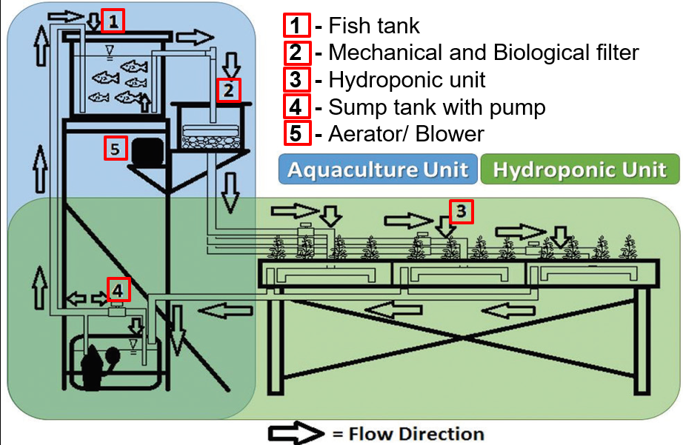
Fig. 2. The arrangement of essential components in an aquaponics unit
4.1 Fish tank
A fish tank is a place where fish is raised and fed. Round, oval, square, and rectangular tanks are most common. Round tanks with flat bases are suggested because they facilitate the removal of solid waste, as it doesn't adhere to corners and allows for effective water circulation. They are usually made of inert plastic or fiberglass, low-density polyethylene (LDPE) materials as they are light in weight, easy to move, and cheap. It should be waterproof, strong, and toxic-free. Light-colored or white tanks are favored as they make it simpler to observe the fish. Additionally, white tanks reflect sunlight, which helps maintain a cooler water temperature.
4.2 Mechanical and biological filter
Mechanical filters (clarifiers) remove the heavy solids (uneaten foods, detached biofilms) from the water stream leaving the fish tank on its way into the biofilter. Biological filter or biofilter is an area where bacteria can change ammonia and waste into nitrates that plants can use as nutrients. Bioballs are the medium used in biofilters.
4.3 Hydroponic unit
The hydroponic unit serves as the plant-growing area, where plants are nurtured using excess nutrients found in the water.
4.4 Stump tank with air pump
In an aquaponics setup, the sump tanks are situated at a lower level than the grow beds, which drain into them before being pumped back to the fish tank.
4.5 Aerator/ Blower
An aerator or blower is used for aeration in aquaponics. Airlift pumps, water sprays, compressors, etc. are used. They all use more electricity to create the same level of dissolved oxygen in the water.

- BIOLOGICAL OR LIVING COMPONENTS OF AQUAPONICS
5.1 Fish
Not all fish species are suitable for aquaponic systems, as their suitability depends on their biology, behavior, and tolerance for water conditions. Factors that influence the choice of fish for the system include seasonal air temperatures, stocking density, and water quality parameters. Fish species like tilapia, various types of carp (including common, koi, silver, and grass), barramundi, jade perch, flathead mullet, channel catfish, African catfish, trout, salmon, largemouth bass, and Giant River prawn have shown superior growth in aquaponics (Somerville et al., 2014).
    - Criteria for selection of fish
- Faster growth rate
- Resistance to diseases
- Good feed conversion ratio (FCR)
- Tolerance to fluctuation of water quality parameters
- Tolerance to crowding

5.1.2 Fish feed
Commercial fish feed pellets are advised for aquaponics, as they provide the appropriate ratio of proteins, carbohydrates, fats, vitamins, and minerals essential for fish health. Avoid overfeeding the fish and take away any leftover food after 30 minutes to minimize the chances of ammonia or hydrogen sulfide toxicity.
5.2 Vegetables
In various commercial aquaponic setups, the cultivation of vegetables tends to yield greater profits than that of fish. Nevertheless, there are instances where certain farmers earn more from high-value fish. Estimates from commercial aquaponic operations in the Western world suggest that plant production can contribute to as much as 90 percent of the overall financial profits. A key factor for this is the faster turnover rate of vegetables in comparison to fish (Somerville et al., 2014).
Not all types of plants are ideal for aquaponic systems, yet approximately 150 varieties of vegetables, herbs, flowers, and small trees have been effectively cultivated for research, home use, and commercial applications. Both leafy greens and fruits can be harvested from aquaponic setups (Azad et al., 2016). Leafy herbs and vegetables flourish in aquaponics. The choice of plant species appropriate for hydroponic growth in aquaponics system is affected by the fish tank stocking density and the associated nutrient levels in aquaculture effluent (Diver, 2006). Commonly utilized plants in aquaponic systems include lettuce, spinach, chives, and basil, which have low to medium nutrient needs, along with cabbage, carrots, and okra (Salam et al., 2013; Azad, 2015). Large fruit-bearing vegetables such as tomatoes, peppers, eggplants, cucumbers, peas, and beans, which require high nutrition levels, thrive better in well-established aquaponic systems with elevated fish stocking densities (Diver, 2006). Root vegetables and tubers are not frequently grown and require special care.
Lettuce (Lactuca sativa) is the most commonly grown crop in aquaponics. It is commonly grown in various types, including crisphead (iceberg), butterhead, romaine, and loose-leaf lettuce. These varieties thrive at cooler night temperatures ranging from 3 to 12°C and warmer day temperatures between 17 and 28°C (Somerville et al., 2014). Numerous experiments in aquaponics have been conducted with lettuce (Rakocy, 1989). Likewise, Goddek and Vermeulen (2018) assessed the growth of lettuce in conventional and recirculating aquaculture systems (RAS) and discovered that lettuce cultivated with aquaculture-based supplemented water outperformed that grown in a traditional hydroponic setup. Lennard and Leonard (2006) cultivated lettuce alongside Murray Cod (Maccullochella peelii). In a separate study, Lorena et al. (2008) grew lettuce with a sturgeon hybrid known as 'bester,' which is a cross between the female Huso huso and the male Acipenser ruthenus. Additionally, Pantanella (2012) cultivated Nile tilapia (Oreochromis niloticus) with lettuce.
Tomato (Solanum lycopersicon) is considered an 'exceptional summer fruiting vegetable' well-suited for aquaponics, able to tolerate full sunlight and temperatures below 40°C, depending on the variety (Somerville et al., 2014). Earlier studies primarily concentrated on comparing the cultivation of this plant to traditional field production. Lewis et al. (1978) noted that aquaponics resulted in nearly twice the yield of tomatoes compared to field farming and tackled iron deficiency problems by employing ethylene diamine tetra-acetic acid. In recent decades, tomatoes have been cultivated in different aquaponic systems, as shown by Sutton and Lewis (1982), who obtained favorable plant yields at water temperatures of up to 28 °C alongside Channel catfish (Ictalurus punctatus). Additionally, Watten and Busch (1984) utilized tilapia in their growing methods.
5.3 Bacteria
Bacteria play a vital role in aquaponics by connecting fish waste to plant fertilizer. They transform toxic wastes into accessible plant nutrients, forming a biological engine.
5.3.1 The beneficial bacteria consist of two types:
a. Nitrifying bacteria – These bacteria convert fish waste, mainly in the form of ammonia, into nitrate, which serves as a fertilizer for the plants. This conversion occurs in two distinct stages and involves two different groups of bacteria. The initial stage consists of converting ammonia to nitrite, a process carried out by ammonia-oxidizing bacteria (AOB), typically known as Nitrosomonas. The subsequent stage involves changing nitrite into nitrate, which is executed by nitrite-oxidizing bacteria (NOB), commonly referred to as Nitrobacter.
b. Heterotrophic bacteria – These bacteria metabolize solid waste through mineralization, making essential micronutrients available for plants.
6. BALANCING OF AQUAPONICS
The concept of balancing in aquaponics involves the actions taken by a farmer to maintain a dynamic equilibrium within the ecosystem of fish, plants, and bacteria. This equilibrium depends on the proportions of fish, plants, and the biofilter (bacteria). There are specific ratios, determined through experimentation, that dictate the relationship between the size of the biofilter, the density of plants, and the density of fish in aquaponics (table 1). It is not recommended to function beyond these ideal ratios, as doing so might lead to severe repercussions for the overall aquaponic system. Although seasoned practitioners are urged to try new approaches and modify these ratios, beginners are advised to follow these recommendations when initiating their aquaponic journey (Somerville et al., 2014).
Table 1. Requirements for balancing aquaponics
Parameters | Requirements
Planting density | 20 to 25 plants/m² (Leafy greens)  4 to 8 plants/m² (Fruiting vegetables)
Feed rate ratio | 40 to 50 g/m²/day (Leafy greens)  50 to 80 g/m²/day (Fruiting vegetables)
Fish feeding rate | 1 to 2 % of their body weight/day
Stocking density of fish | 10 to 20 kg/1000 litres of water
Grow bed to fish tank volume ratio | 2:1 (3:1 or 1:1)
Grow bed depth | 30 cm

- WATER QUALITY OF AQUAPONICS
Water plays a crucial role in an aquaponic system by transporting essential nutrients to the plants and providing oxygen to the fish. Five key parameters for water quality include dissolved oxygen (DO), pH, temperature, total nitrogen, and water alkalinity. Each of these factors influences the fish, plants, and bacteria within the system, making it crucial to understand their effects. Although managing water quality and chemistry in aquaponics may appear complicated, it can be managed effectively with the help of straightforward test kits. Conducting regular water tests is essential for ensuring good water quality in the system (Singh et al., 2021). The optimal water quality parameters needed for all the organisms in aquaponics are presented in table 2.
Table 2. The optimal water quality parameters for all the organisms in aquaponics
Dissolved Oxygen (mg/litre) | pH | Temperature (°C) | Ammonia (mg/litre) | Nitrite (mg/litre) | Nitrate (mg/litre)
>5 | 6–7 | 18-30 | < 1 | < 1 | 5-150

- TYPES OF AQUAPONIC SYSTEM
  - Types of aquaponic systems based on different hydroponic beds
8.1.1 Media-Based System (MBS):
It is one of the most basic aquaponic systems, sometimes known as a flood and drain system or gravel-based system. Fiberglass, plastic, or a wooden frame covered with polyethylene or rubber sheeting that is waterproof can be used to make media beds. In this setup, fish tank water is periodically pumped into a container filled with substrate (gravel, lava rock, clay pebbles, or locally accessible media), and the ammonia-free water is then emptied back into the fish tank. Media bed units are easy and effective since the substrate in the container supports the plants and serves as a bio-filter. Water flow can be regulated using a timer or automatic siphon mechanism. It's noted that MBS is not ideal for commercial production (Singh et al., 2021). When fish stocking densities go beyond the bed's capacity to support them, the media may become blocked, and additional filtration might be required. And, media beds with more exposed surface area may experience higher water evaporation, and some media types can be quite heavy.
In a study conducted by Azad et al. (2018), the performance of different bedding media in a tilapia-okra aquaponic system was assessed. It was found that the combination of gravel and coconut husk (1:1) resulted in increased growth and production of okra and tilapia compared to using each medium individually. Similarly, Jordan et al. (2018) investigated how several substrates, including expanded vermiculite, phenolic foam, and coconut fiber, affected lettuce yield in hydroponic and aquaponic systems. Higher yields were obtained in both aquaponic (2.88 kg m⁻²) and hydroponic (2.58 kg m⁻²) systems, following the study's conclusion that the coconut fiber substrate was better suited for growing lettuce. With yields of 1.94 kg m⁻² for aquaponic systems and 2.15 kg m⁻² for hydroponic systems, respectively, the use of phenolic foam as a growing substrate led to decreased average crop yields in both production methods examined.
8.1.2 Deep Water Culture (DWC):
Deep water culture (DWC), also known as deep flow technique (DFT), is a method of cultivating plants on floating or suspended surfaces (such as rafts, panels, or boards) in reservoirs filled with 10–20 cm of nutrient solution (Van Os et al., 2008). It offers a large water holding capacity, with the water beneath the raft providing ample space for beneficial bacteria. Proper filtration and aeration are essential to prevent solid waste from entering the plant bed and to maintain adequate oxygen levels for plant roots and bacteria. DWC is more productive than MBS and is widely used for large-scale vegetable production (Singh et al., 2021).
In deep water systems, plant aeration can be either active or passive. In the Root Floating Technique (RAFT), active aeration is achieved by bubbling air into the nutrient solution of hydroponic tanks using air diffusers. On the other hand, the Dynamic Root Floating Technique (DRFT) utilizes passive aeration. It creates an air space between the platform supporting the plants and the nutrient solution. The roots in the air space above the solution are called oxygen roots and their primary function is to oxygenate the plants. DRFT eliminates or reduces the need for active aeration in hydroponic systems, resulting in lower energy requirements (air pump) and reduced costs.
8.1.3 Nutrient Film Technique (NFT):
This method is widely practiced and known as the traditional hydroponic growing system in which a nutrient solution flows through troughs with a 1-2 cm layer of water (Van Os et al., 2008; Jensen and Collins, 1985; Cooper, 1979). The plants grow on the surface of shallow horizontal channels. Like DWC, NFT requires effective solid filtration to avoid root contamination. In contrast to DWC, NFT systems need a separate biological filter since the channels don't provide enough surface area for nitrifying bacteria to thrive properly (Singh et al., 2021).
8.1.4 Wicking Bed System:
This system has the advantage of needing water only once a week during the peak of summer and just once a month in the winter. A slotted pipe allows water from the fish tank to flow down and gradually move up through capillary action, feeding the plant roots from below. It is utilized for cultivating carrots, beets, and potatoes (Datta, 2016).
8.1.5 Vertical System:
In this arrangement, vertical columns positioned above the fish tank are used to grow vegetables without the use of soil. Water that is rich in nutrients is drawn from the fish tank by a little pump and sent to the tops of the vertical columns. As the water returns to the tank, it absorbs oxygen from the air as it passes through the roots of the plant. This enclosed system produces very little trash and does not require pesticides or fertilizer. It's an efficient way to conserve water and save space for gardening and fish farming. There's little need to frequently clean the fish tank in this system. Within this system, tilapia and trout are raised alongside leafy vegetables, tomatoes, and herbs (Datta, 2016).
8.1.6 Dutch Bucket System
This approach involves linking two or more growing containers to the same irrigation and drainage systems. It is an extremely water- and nutrient-efficient technique, perfect for cultivating plants with high nutrient demands and vining characteristics, such as tomatoes, peppers, and eggplants (Schmautz et al., 2016).
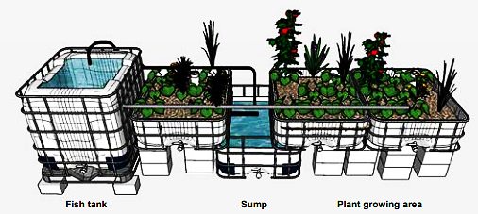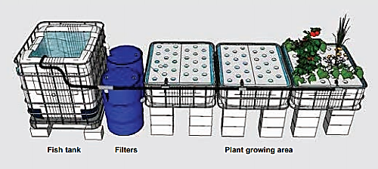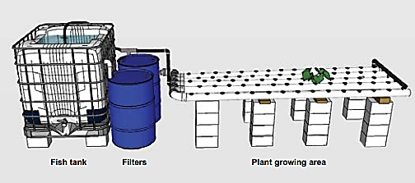
(B)
(C)
(A)

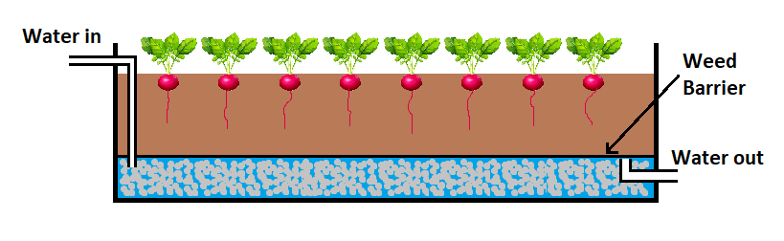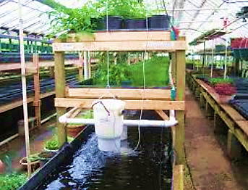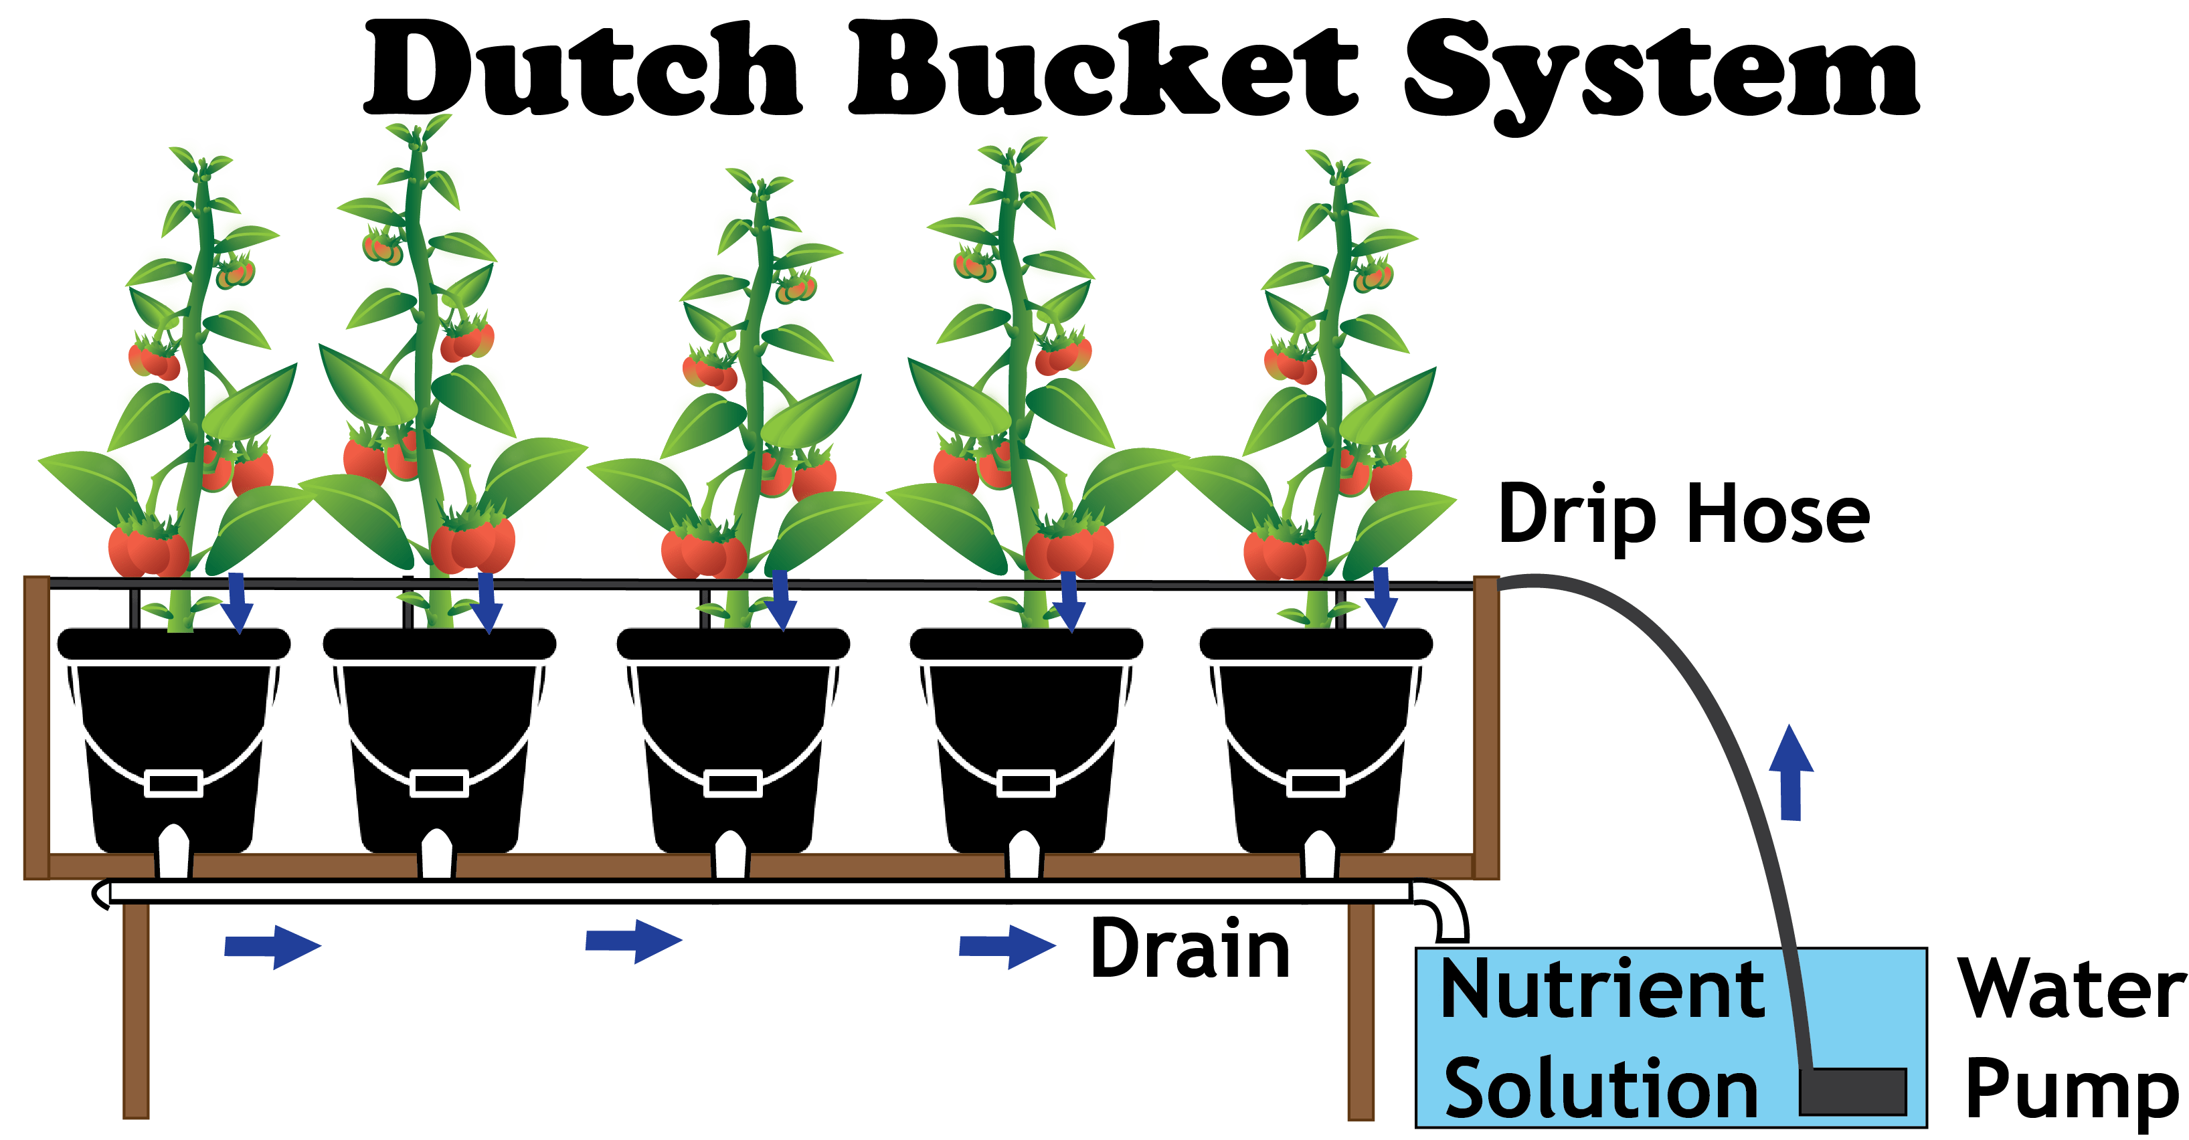
(D)
(E)
(F)
F)

Fig. 3. Types of aquaponics systems based on different hydroponics beds A) Media-Based System; B) Deep Water Culture; C) Nutrient Film Technique; D) Wicking Bed System; E) Vertical System; F) Dutch Bucket System.
8.2 Types of aquaponic systems based on water cycle is closed or not
8.2.1 Coupled aquaponics:
In this system (fig. 4a), aquaculture and hydroponic systems are integrated into a single closed-loop framework. Conventional designs for single-loop aquaponics systems involve the circulation of water between aquaculture and hydroponics units. It becomes essential to control the pH, temperature, and nutrition levels of both subsystems in these common setups (Kloas et al. 2015; Goddek et al. 2015). The water quality will be uniform for both fish and plants, leading to the necessity of making concessions regarding the optimal specific rearing conditions.
8.2.2 Decoupled aquaponics
In this setup (fig.4b), aquaculture and hydroponic units are set up in separate loop systems, allowing for optimal conditions for both fish and vegetables without any need for compromise. Each unit can have its own nutrient solution management, including adding fertilizers in aquaponics, regulating pH, and adjusting the temperature. By separating the components, a decoupled aquaponics system can avoid trade-offs and optimize the conditions in each subsystem. To enhance efficiency through the recycling of solid waste, it is essential to utilize sludge digesters (Monsees et al. 2016; Emerenciano et al., 2017; Goddek et al. 2018).
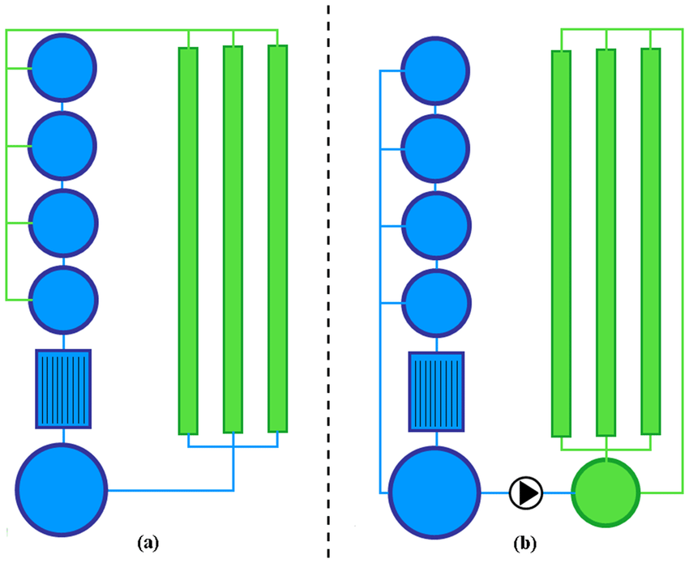
(b)
(a)
Fig. 4. Coupled (a) and decoupled (b) aquaponics systems.
- AQUAPONICS vs. CONVENTIONAL HYDROPONICS IN VEGETABLE PRODUCTION
Aquaponics and conventional hydroponics are two innovative methods for growing vegetables, each with its own advantages and disadvantages. Recognizing the differences between these two systems can help in making wise choices about vegetable production. Aquaponics is a hybrid of hydroponics (growing plants in water without soil) and aquaculture (rearing fish). In this arrangement, the plants filter and purify the water for the fish, and the fish waste supplies the plants with vital nutrients. This creates a sustainable, symbiotic environment. On the other hand, conventional hydroponics relies on nutrient solutions added to the water to support plant growth, without any fish involved. This method allows precise control over nutrient levels but does not offer the added benefits of a fish component. Both systems have their unique challenges and require different management strategies. Various studies on the yield potential of vegetable crops grown in aquaponics and conventional hydroponics system are given in table 3.
Table 3. Yield potential of vegetables grown in aquaponics and conventional hydroponics system
Sl. No. | Vegetable crops | Yield of vegetable crops in |  | Sources
Sl. No. | Vegetable crops | Aquaponics | Hydroponics | Sources
1 | Lettuce | 2.88 kg/m² | 2.58 kg/m² | Jordan et al., 2018
2 | Tomato | 29.38 kg/m² | 31.64 kg/m² | Suhl et al., 2016
3 | Tomato | 2.239 kg/plant | 2.802 kg/plant | Madusanka et al., 2023
4 | Lettuce | 2.71 kg/m² | 2.84 kg/m² | Pantella et al., 2010
5 | Lettuce | 80.55 g/plant | 98.17 g/plant | Dealide et al., 2016
6 | Lettuce var. Edina | 109.04 g/plant | 190.13 g/plant | Mada et al., 2019
7 | Lettuce | 309.48 g/plant | 286.83 g/plant | Goddek and Vermeulen, 2018
8 | Lettuce var. Explore | 293.78 g/plant | 211.86 g/plant | Lennard and Ward,2019
9 | Lettuce | 129.4 g/plant | 142.5 g/plant | Azvedi et al., 2023
- ADVANTAGES OF AQUAPONICS
- It uses a single supply of nitrogen (fish feed) to create two agricultural products: vegetables and fish.
- It is highly efficient in water and nutrient usage.
- The system is eco-sustainable as it avoids the use of fertilizers or chemical pesticides.
- No soil is required for plant growth.
- Higher yields and higher-quality products are the outcomes.
- A greater degree of biosecurity lowers the dangers posed by outside pollutants.
- Enhanced production control leads to lower losses.
- Suitable for non-arable land, including deserts, damaged soil, and salty, sandy islands.
- It generates minimal waste.
- The system follows organic-like management and production techniques.
- Soil-borne infections do not occur.
- It saves labor.
- The method enables cost-effective production of family food and cash crops in multiple places.
- DISADVANTAGES OF AQUAPONICS
- Initial costs are higher compared to traditional soil-based vegetable production.
- To succeed in aquaponics, farmers must understand fish, bacteria, and plant production.
- Aquaponic systems require constant monitoring of water quality parameters.
- It's essential to have dependable access to both fish seeds and plant seeds.
- Fish and plant requirements may not always align perfectly in aquaponic systems.
- Aquaponic systems have a high electricity consumption.
- Aquaponic systems may not be suitable for areas with insufficient temperature ranges to support fish and plants.
- Mistakes or accidents in aquaponic systems might lead to catastrophic system failures.

- FUTURE CONCEPTS IN AQUAPONICS

- Growing upwards like dedicated sky scraper farms can make use of limited space availability
- Growing indoors – underground and indoors can be used through artificial lighting
- Use of technologies like smart phone applications, pipe blockage warning, system automation etc.

- CONCLUSION
Aquaponics is an eco-friendly method of food production that combines aquaculture (fish farming) with hydroponics (soil-less plant cultivation). It utilizes fish feed as a single nutrient source to grow both fish and vegetables. Despite the numerous advantages of the aquaponics system, farmers encounter several challenges due to its complexity. Major challenges include a lack of technical expertise, inadequate research and government regulations, financial limitations, and reliance on electricity. To support the widespread adoption of aquaponics, it is essential to have established government policies, prioritize research that meets practical needs, and create training programs for outreach and education.

Disclaimer (Artificial intelligence)
Author(s) hereby declare that NO generative AI technologies such as Large Language Models (ChatGPT, COPILOT, etc.) and text-to-image generators have been used during the writing or editing of this manuscript.

REFERENCES
- FAO [Food and Agriculture Organization]. (2018). The future of food and agriculture – Alternative pathways to 2050. Rome, Italy, 228p.
- Diver, S. (2006). Aquaponics - integration of hydroponics with aquaculture. Amy Smith, Production. A Publication of ATTRA— National Sustainable Agriculture Information Service. Available online: www.attra.ncat.org.
- Rakocy, J. E., Masser, M. P., & Losordo, T. M. (2006). Recirculating aquaculture tank production systems: Aquaponics- integrating fish and plant culture. SRAC publication - Southern Regional Aquaculture Center, 454, 16.
- Yep, B., & Zheng, Y. (2019). Aquaponic trends and challenges – a review. Journal of Cleaner Production, 228, 1586–1599.
- Pinho, S. M., David, L. H., Garcia, F., Keesman, K. J., Portella, M. C. & Goddek, S. (2021). South American fish species suitable for aquaponics: a review. Aquaculture International, 29, 1427–1449.
- Knaus, U., & Palm, H. W. (2017). Effects of the fish species choice on vegetables in aquaponics under spring-summer conditions in northern Germany (Mecklenburg Western Pomerania). Aquaculture, 473, 62-73.
- Shabeer, M. S. (2016). Isolation and characterization bacteria related to aquaponics for testing its bio potential. B.Tech Biotechnology thesis, National Institute of Technology, Calicut, 60 p.
- Jones, S. (2002). Evolution of aquaponics. Aquaponics Journal, 24, 14–17.
- Komives T & Junge, R. (2015). On the “Aquaponic Corner” section of our Journal. Ecocycles 1(2), 1-2.
- Halwart, M. & Gupta, M. V. (2004). Culture of fish in rice fields. FAO and The World Fish Center, Penang.
- Lennard, W. (2017). Commercial aquaponic systems: integrating recirculating fish culture with hydroponic plant production. Aquaculture, 375 p.
- Love, D. C., Fry, J. P., Genello, L., Hill, E. S., Frederick, J. A., Li, X., & Semmens, K. (2014). An international survey of aquaponics practitioners. PLoS One, 9(7), e102662. https://doi.org/10.1371/journ al.pone.0102662
- Graber, A., & Junge, R. (2009). Aquaponic systems: Nutrient recycling from fish wastewater by vegetable production. Desalination, 246(1–3), 147–156. https://doi.org/10.1016/j.desal.2008.03.048
- La Crosse, Wi, & Chicago. (2017). Fishing for a Better Farming Solution: Family- Owned Aquaponics Operation Advances with Energy Efficient Heating System. http://ecowboy.com/2017/05/18/fishing-for-a better- farming- solution- family- owned - aquaponics - operation- advances-with-energy-efficient-heating-system.
- Mancuso, M. (2014). Aquaculture advancement. Journal of Aquaculture Research & Development, 5(1), 1.
- FAO. (2016). Global per capita fish consumption rises above 20 kilograms a year. http://www.fao.org/news/story/en/item/421871/icode.
- Chan, C. Y., Tran, N., Dao, D. C., Sulser, T. B., Phillips, M. J., Batka, M., & Preston, N. (2017). Fish to 2050 in the ASEAN region. World Fish Center and International Food Policy Resource Institute.
- Junge, R., König, B., Villarroel, M., Komives, T., & Jijakli, M. H. (2017). Strategic points in aquaponics. Water, 9(3), 182.
- Smith, R. (2010). Cilantro production in California. Plant Pathology, (12), 1–4.
- FAO Fisheries Department, Fishery Information, Data and Statistics Unit. (2019). FishStatJ, a tool for fishery statistics analysis, release: 3.5.0, universal software for fishery statistical time series. Global aqua culture production: Quantity 1950– 2017; Value 1950– 2017; Global capture production (pp. 1950– 2017). FAO.
- Wongkiew, S., Huz, Chandran, K., Lee, J. W., & Khanal, S. K. (2017). Nitrogen transformations in aquaponic systems: a review. Aquacultural Engineering, 76, 9-19.
- Somerville, C., Cohen, M., Pantanella, E., Stankus, A., & Lovatelli, A. (2014). Small-scale aquaponic food production. Integrated fish and plant farming. FAO Fisheries and Aquaculture Technical Paper No. 589. Rome, FAO. 262 pp.
- Azad, K. N., Salam, M. A., & Azad, K. N. (2016). Aquaponics in Bangladesh: current status and future prospects. Journal of Bioscience and Agriculture Research, 7(2), 669-677.
- Salam, M. A., Asadujjaman, M., & Rahman, M. S. (2013). Aquaponics for improving high density fish pond water quality through raft and rack vegetable production. World Journal of Fish and Marine Sciences, 5 (3), 251-256.
- Azad, K. N. (2015). Comparative study of okra production using different bedding media in aquaponic system. MSc. (Agri) thesis, Bangladesh Agricultural University.
- Rakocy, J. E. (1989). Hydroponic lettuce production in a recirculating fish culture system. In: Island perspectives. Agricultural experiment station, University of the Virgin Islands, 3, 5–10.
- Delaide, B., Goddek, S., Gott, J., Soyeurt, H., & Jijakli, M. (2016). Lettuce (Lactuca sativa L. var. Sucrine) growth performance in complemented aquaponic solution outperforms hydroponics. Water, 8, 467.
- Goddek, S. & Vermeulen, T. (2018). Comparison of Lactuca sativa growth performance in conventional and RAS-based hydroponic systems. Aquaculture International, 26, 1377–1386.
- Lennard, W. A., & Leonard, B. V. (2006). A comparison of three different hydroponic sub-systems (gravel bed, floating and nutrient film technique) in an aquaponic test system. Aquaculture International, 14 (6), 539–550.
- Lorena, S., Cristea, V., & Oprea, L. (2008). Nutrients dynamic in an aquaponic recirculating system for sturgeon and lettuce (Lactuca sativa) production. Lucrări Științifice-Zootehnie și Biotehnologii, Universitatea de Științe Agricole și Medicină Veterinară a Banatului Timișoara, 41 (2), 137–143.
- Pantanella, E. (2012). Nutrition and quality of aquaponic systems. Ph.D. thesis. Università degli Studi della Tuscia. Viterbo, Italy. 124 p
- Lewis, W. M., Yopp, J. H., Schramm, H. L., & Brandenburg, A. M. (1978). Use of hydroponics to maintain quality of recirculated water in a fish culture system. Transactions of American Fisheries Society, 107 (1), 92–99.
- Sutton, R. J., & Lewis, W. M. (1982). Further observations on a fish production system that incorporates hydroponically grown plants. Progress Fish Culture, 44 (1), 55–59.
- Watten, B. J., & Busch, R. L. (1984). Tropical production of tilapia (Sarotherodon aurea) and tomatoes (Lycopersicon esculentum) in a small-scale recirculating water system. Aquaculture, 41 (3), 271–283.
- Singh, J., Narayan, N., Rafique, M. I., Sarma, K., Kumar, T., Ahirwal, S. K., & Bharti, V. (2021). Aquaponics: Towards a sustainable multi-trophic production of fish and vegetables. Food and Scientific Reports, 2 (6), 46-49.
- Azad, N. K., Salam, M. A., & Hossain, M. Z. (2018). Performance evaluation of different bedding media in aquaponic system for growth and production of okra and tilapia. International Journal of Engineering Research and Science, 4(9), 14-25.
- Jordan, A. R., Ribeiro1, E. F., de Oliveira, F. C., Geisenhoff, L. O. & Martins, E. A. S. (2018). Yield of lettuce grown in hydroponic and aquaponic systems using different substrates. Revista Brasileira Engenharia Agrícola e Ambiental, 22 (8), 525-529.
- Van Os, E. A., Gieling, T. H., & Lieth, J. H. (2008). Technical equipment in soilless production systems. In: Raviv, Lieth (eds) Soilless culture, theory and practice. Elsevier, Amsterdam, pp. 157–207.
- Cooper, A. (1979). The ABC of NFT. Grower Books, London.
- Jensen, M. H. & Collins, W. L. (1985). Hydroponic vegetable production. Horticultural Reviews, 7, 483–558.
- Datta, S. (2016). Aquaponics- A modern tool for integrating fish farming with agriculture. Proceedings of an international conference of Aquatic resources and sustainable management, 17 February 2016, Kolkata, India, pp. 58-64.
- Schmautz, Z., Loeu, F., Liebisch, F., Graber, A., Mathis, A., Bulc, T. G. & Junge, R. (2016). Tomato productivity and quality in aquaponics: Comparison of three hydroponic methods. Water, 8 (11), 533.
- Goddek, S., Delaide, B., Mankasingh, U., Ragnarsdottir, K., Jijakli, H. & Thorarinsdottir, R. (2015). Challenges of sustainable and commercial aquaponics. Sustainability, 7, 4199-4224.
- Kloas, W., Groß, R., Baganz, D., Graupner, J., Monsees, H., Schmidt, U., et al. (2015). A new concept for aquaponic systems to improve sustainability, increase productivity, and reduce environmental impacts. Aquaculture Environment Interactions, 7, 179–1.
- Monsees. H., Kloas, W., & Wuertz, S. (2016). Comparison of coupled and decoupled aquaponics - Implications for future system design. In Proceedings of European Aquaculture Society - Meeting Abstract, Aquaculture Europe, Edinburgh, Scotland.
- Emerenciano, M., Carneiro, P., Lapa, M., Lapa, K., Delaide, B., & Goddek, S. (2017). Mineralizacão de sólidos. Aquaculture Brasil, 21–26p.
- Goddek, S., Delaide, B., Joyce, A., Wuertz, S., Jijakli, M. H., Gross, A., et al. (2018). Nutrient mineralization and organic matter reduction performance of RAS-based sludge in sequential UASB-EGSB reactors. Aquacultural Engineering, 83, 10-19.
- Suhl, B. J., Dannehl, D., Kloas, W., Baganz, D., Jobs, S., Scheibe, G., et al. (2016). Advanced aquaponics: Evaluation of intensive tomato production in aquaponics vs. conventional hydroponics. Agricultural Water Management, 178, 335–344.
- Pantanella, E., Cardarelli, M., Colla, G., Rea, E., & Marcucci, A. (2010). Aquaponics vs. hydroponics: production and quality of lettuce crop. In XXVIII International Horticultural Congress on Science and Horticulture for People (IHC2010): International Symposium on 927 (pp. 887–893).
- Madar, A. K., RubóczkI, T., & Hájos, M.T. (2019). Lettuce production in aquaponic and hydroponic systems. Acta Universitatis Sapientiae Agriculture and Environment, 11 51−59.
- Lennard, W., & Ward, J. (2019). A comparison of plant growth rates between an NFT hydroponic system and an NFT aquaponic system. Horticulturae, 5(2), 27.
- Avedzi, J. K., Tadesse, A. & Asimenu, S. (2023). A Comprehensive Comparison of Lettuce Yield and Quality in Hydroponic and Aquaponic Systems: A Systematic Review and Meta-Analysis. Aquaponics, 3(2), 1–22. https://doi.org.10.5281/zenodo.8196953

