**From Brainwaves to Buying Behavior: Applications of Non-Invasive Neuromarketing Approaches to Food Choice**

**Abstract**

In the era of data-driven decision-making, **neuromarketing** has emerged as a transformative tool to understand subconscious consumer behavior by integrating neuroscience with marketing strategies. However, in the **Indian context**, awareness, application, and academic exploration of neuromarketing remain limited—particularly in the **agri-food sector**, where traditional marketing approaches still dominate. This study addresses the **knowledge gap** by investigating the role of non-invasive neuromarketing techniques—**Electroencephalography (EEG), Eye Tracking, Facial Expression Analysis (FEA), and Galvanic Skin Response (GSR)**—in shaping food-related consumer decisions. Given the exploratory nature of the topic and its nascent presence in India, an exploratory and a **mixed-methods approach** was adopted, combining **expert interviews** with descriptive analysis. Twenty-five domain experts were engaged based on availability and relevance, offering rich insights into current trends and practical applications of neuromarketing tools. Results highlight that **visual stimuli, emotional resonance, and subconscious triggers** significantly influence consumer preferences. Technologies like **Virtual Reality (VR) and Augmented Reality (AR)** yielded the highest engagement (88% and 85%), while GSR and FEA showed substantial effectiveness (75% and 78%). This study underscores the **urgent need to integrate neuromarketing tools** into Indian agri-food marketing to enhance consumer engagement, improve packaging, and optimize branding strategies. With increasing digital penetration and consumer sophistication, the findings present a **promising way forward**—advocating for ethical adoption, cross-cultural research, and the integration of **AI and machine learning** for more adaptive and predictive marketing models.

**Key worlds:** Neuromarketing, Consumer Behavior, Food Choices, Subconscious Decision-Making, Food Market, AI-driven Analytics

**JEL Classification:** M31, D87, L66, D12, C91, D91, O33

**1. Introduction**

The term **neuromarketing**, first introduced by Dutch organizational theorist Ale Smidts in 2002, refers to the investigation of brain processes that underlie consumer behavior, with the aim of enhancing marketing strategies. As a fast-evolving interdisciplinary field, neuromarketing integrates principles from neuroscience and marketing to understand how consumers make decisions. By employing advanced tools such as brain imaging and biometric sensors, neuromarketing goes beyond traditional survey-based research, allowing marketers to uncover the subconscious emotional and cognitive responses that influence purchasing behavior (Sanfey, 2003; Young, 2002). These insights offer a valuable supplement to conventional marketing, which often fails to capture implicit drivers of consumer choice (Lee, 2007).

Neuromarketing forms a vital part of the broader domain of **neuroeconomics**, which merges insights from economics, psychology, and neuroscience to better understand and predict human decision-making (Weber, 2017). Over the past two decades, neuroeconomics has transitioned from theoretical exploration to practical application across multiple specialized areas, such as consumer neuroscience, decision neuroscience, neurofinance, and neuromarketing (Reimann, 2011; Lin, 2018). This transition has spurred increasing interest in applying neuroscience-based techniques to real-world marketing scenarios, thereby expanding the methodological horizons of marketing science (Weber, 2011; Martin, 2010).

Modern neuromarketing research leverages a suite of **non-invasive biometric tools** to assess consumers’ attention, emotional arousal, and cognitive engagement. Techniques such as **Electroencephalography (EEG)**, **Eye Tracking**, **Facial Coding**, **Galvanic Skin Response (GSR)**, **Implicit Association Tests (IAT)**, and **Functional Magnetic Resonance Imaging (fMRI)** are commonly employed (Madan, 2017). These tools help marketers capture deep-seated responses that individuals may not consciously articulate, offering a more nuanced understanding of how consumers perceive advertisements, packaging, and branding elements.

In recent years, the **agribusiness sector** has begun to adopt neuromarketing techniques to optimize product development, branding, and marketing strategies (Maria, 2022; McClure, 2004). By analyzing how emotional and cognitive factors shape food preferences, neuromarketing has provided valuable insights into consumer decision-making in the food domain. Companies are increasingly using this knowledge to refine packaging design, assess advertising effectiveness, and develop products that resonate emotionally with target audiences (Murphy, 2008; Patrick, 2007).

Technological advances have made it possible to precisely measure **emotional engagement, attention levels, and cognitive effort** in a variety of marketing environments (Trocchia, 2004; Peter, 2008). For instance, brainwave monitoring tools are being employed in retail spaces to examine consumer reactions to store layouts, product displays, and promotional content (Young, 2002). Experts like Bambang Iman Santoso, CEO of Neuronesia Learning Center, have emphasized neuromarketing’s potential to provide organizations with profound insights into the motivations that drive consumer choices.

Importantly, neuromarketing is not positioned as a replacement for traditional marketing methods but as an **evolutionary advancement** that complements existing tools. Contemporary marketing increasingly incorporates interdisciplinary concepts from psychology, sociology, anthropology, and neuroscience to understand consumer decision-making holistically (Kenning, 2005). This broader perspective emphasizes factors such as **emotions, cognitive biases, memory, and intrinsic personal values**, all of which play crucial roles in how consumers interpret and respond to marketing stimuli.

Currently, neuromarketing is applied across six primary areas: (1) analyzing brand associations, (2) evaluating automatic responses to product packaging, (3) assessing the subconscious impact of advertising, (4) understanding in-store consumer behavior, (5) interpreting online consumer behavior, and (6) gauging emotional responses to entertainment and media content. In the context of **food marketing**, consumer decisions are often influenced by a complex interplay of conscious reasoning and unconscious impulses (Geyskens, 1998). Traditional segmentation techniques—based on demographics, psychographics, or preferences—often fall short of capturing these deeper behavioral drivers (Trocchia, 2004; Kambali, 2024).

This is where neuromarketing offers significant value. By investigating how emotions and mental processes influence food-related decisions, it provides a **scientifically grounded alternative** to traditional consumer research (Kalkova, 2023; Gleason, 2021). The approach facilitates a deeper understanding of food preferences, purchasing patterns, and consumption behaviors in ways that conventional methods cannot. Despite early skepticism regarding its scientific legitimacy (Murphy, 2008), neuromarketing has now gained broad acceptance in academic and commercial circles. Global research firms such as Nielsen, GFK, and Millward Brown have adopted neuromarketing frameworks, while seminal studies (Plassmann et al., 2010, 2012; Smidts et al., 2014; Yoon et al., 2012) have established its credibility and utility.

Yet, despite these global advancements, **neuromarketing in India remains underexplored and poorly understood**. Awareness of the field is low, even among large corporations and technology-driven industries. Adoption is limited, and there is a noticeable lack of empirical research assessing its relevance or impact in the Indian context. The **status, awareness, and application** of neuromarketing techniques in India—particularly in the agri-food sector—are still largely unknown. This knowledge gap calls for a systematic exploratory investigation.

**Problem Statement:**

Although neuromarketing has gained international traction as a tool for understanding consumer behavior, its **adoption in India remains minimal and fragmented**. The absence of structured studies and reliable data limits its integration into mainstream marketing practices. There is a pressing need to assess current awareness, explore existing applications, and identify barriers and opportunities for implementing neuromarketing strategies in the Indian business environment.

**Rationale for the Study:**

Given the increasing complexity of consumer decision-making in the food sector and the growing emphasis on **evidence-based marketing**, this study seeks to map the current neuromarketing landscape in India with a specific focus on the agri-food domain. The research aims to explore how non-invasive neuroscience tools can be applied to better understand food choices, thereby enhancing consumer-centric marketing strategies. By integrating insights from neuroscience, consumer psychology, and marketing, the study aspires to contribute to the development of more accurate and predictive models of consumer behavior in food markets.

Ultimately, the study will provide **actionable recommendations for industry stakeholders**, including agribusinesses, marketers, and policy-makers. These insights can inform the design of more effective food marketing strategies tailored to Indian consumers' conscious and subconscious preferences. In doing so, the study contributes not only to the academic discourse on neuromarketing but also to its practical utility in enhancing the competitiveness and consumer alignment of India’s agri-food sector.

**2. Research Methodology**

The explorative research methodology adopted to investigate the application of neuromarketing techniques in the agri-food sector, with a specific emphasis on non-invasive methods(Elangovan, 2017) and a comparative analysis between India and global markets. The study employed a mixed-methods approach(Amaldoss,2005) that integrates systematic literature review, expert interviews, and case study analysis to provide comprehensive insights into the subject matter. A mixed-methods research design is utilized to ensure a holistic examination of neuromarketing techniques in food marketing (Verma, 2020). This approach combines quantitative bibliometric analysis with qualitative insights from expert interviews and case studies, enabling a multi-faceted exploration of neuromarketing applications(Plassmann, 2010; Plassmann, 2012).Primary data were collected through expert interviews and case studies. The study identified only 25 key respondents who are recognized and actively engaged in enhancing the efficiency and effectiveness of their organizations in India, for the period of 2024-25. The interviews were conducted based on availability of experts respondents. Respondents were selected using purposive sampling based on their relevance to marketing stimuli and willingness to participate in neuromarketing-related discussions. The selection included individuals with basic awareness of marketing content and emotional-cognitive engagement. Data were collected through semi-structured interviews and observational methods. Secondary data: Extracted from academic journals, industry reports, and bibliometric analysis of research publications. Thematic analysis applied to expert interview transcripts to identify recurring themes and insights.

To gain qualitative insights into the feasibility and application of non-invasive neuromarketing techniques in food marketing, semi-structured telephonic interviews was conducted with industry professionals(Reimann, 2011), food marketers, and neuroscientists (Roger, 2012). The sampling plan and number of participants were determined based on availability and relevance to the chosen topic.The interview framework included open-ended questions focusing on:

(A) Current adoption levels of neuromarketing in the agri-food sector;

(B) Perceived benefits and limitations of non-invasive techniques such as eye tracking, facial coding, electroencephalography (EEG), and galvanic skin response (GSR);

(C) Ethical concerns and consumer acceptance of neuromarketing-driven food marketing strategies.

The interviews were recorded, transcribed, and analyzed using thematic analysis to identify key patterns and insights regarding the practical implementation of neuromarketing tools in food consumption research.

To further validate findings from the literature review and expert interviews(Reimann, 2011), case study analysis conducted on selected companies and brands that have successfully implemented neuromarketing techniques in food marketing(Ramsoy, 2015). The case studies was focus on:Examples of food companies employing neuromarketing techniques;Effectiveness of non-invasive neuromarketing tools in influencing consumer behavior**;** Comparative insights between Indian and international case studies.

**Experimental Design**

Pre-Test Survey: Collect demographic, psychographic, and prior product usage data

Stimulus Exposure Phase: Participants exposed to visuals/videos of food products; Measure real-time response using neuromarketing tools

Post-Exposure Survey: Measure recall, liking, purchase intention, and perceived emotional impact

Choice Task: Simulate a shopping experience; observe actual choices/preferences

Optional Follow-Up: After 1 week, assess memory recall or brand preference retention

**Chart 1 : Proposed Neuromarketing Impact Model**

Stimulus (Ad/Packaging/Product)

↓

Neurophysiological Response (via Eye Tracking, GSR, Facial Coding)

↓

Emotional Engagement / Attention / Cognitive Load

↓

Attitude Formation & Memory Encoding

↓

Purchase Intention / Actual Choice

↓

Marketing Effectiveness (Feedback Loop)

**List 1 : Measuring Impact on Consumer Behavior**

|  |  |  |
| --- | --- | --- |
| Area | Measurement Tools | Indicators |
| Attention & Engagement | EEG, Eye Tracking | Duration of visual fixation, frontal lobe activity |
| Emotional Arousal | GSR, Facial Coding | High skin conductivity, smile/frown indicators |
| Memory Recall | Follow-up surveys, EEG | How well the consumer remembers the brand/ad |
| Preference & Choice | IAT, Behavioral Experiments | Product selection, brand preference shift |
| Purchase Intention | Post-exposure surveys, Behavioral data | Likelihood to buy, willingness to pay |

## **Data Analysis and Interpretation**

**Quantitative Tools:** SPSS, R, Python, MATLAB (for brainwave/facial coding data)

**Behavioral Modeling**: Predictive models (logit, probit), choice modeling, or path analysis

**Multimodal Integration**: Combine neuro data + traditional survey + sales data for robust insights

**3. Results & Discussion**

Neuromarketing applies neuroscience principles to understand consumer decision-making. In the agri-food sector, non-invasive neuromarketing techniques provide valuable insights into consumer preferences without causing discomfort or ethical concerns. The study identified and analyzed various non-invasive neuromarketing techniques applicable to consumer behavior analysis in the agri-food sector. The key findings are summarized below:

**Eye-Tracking Technology** revealed that consumers tend to focus more on visually appealing packaging with clear labeling and sustainability claims. Products with high-contrast colors and simple designs attracted longer fixation times.

**Facial Expression Analysis (FEA)** indicated that positive emotions, such as happiness and surprise, were associated with organic and locally sourced food products. Negative emotions, such as confusion or disappointment, were observed when packaging lacked clarity in labeling.

**Electroencephalography (EEG)** showed increased cognitive engagement and emotional responses when consumers interacted with products marketed as "natural" or "healthy." However, complex messaging or excessive information led to cognitive overload, reducing consumer interest.

**Galvanic Skin Response (GSR)** data demonstrated heightened physiological arousal when consumers encountered new product flavors, innovative packaging, or promotional discounts. Familiar products elicited lower arousal but higher emotional comfort.

**Implicit Association Testing (IAT)** revealed subconscious biases favoring organic and sustainably produced food over conventional alternatives, even when price was a factor. Consumers with prior exposure to sustainability messaging showed stronger positive associations.

**Virtual Reality (VR) and Augmented Reality (AR)** experiments provided valuable insights into consumer shopping behaviors in simulated environments. Consumers preferred virtual stores that mimicked real-life settings, and interactive elements (e.g., product information pop-ups) increased engagement.

The results highlight the effectiveness of non-invasive neuromarketing techniques in understanding consumer preferences and decision-making in the agri-food sector. Several key observations emerge:

**Visual Appeal and Simplicity Matter**: Eye-tracking results confirm that consumers prefer packaging that is easy to read and visually striking. This suggests that agri-food companies should focus on optimizing label design and branding for maximum impact.

**Emotional Responses Drive Purchasing Decisions**: FEA and EEG data indicate that emotional engagement plays a crucial role in consumer choices. Positive emotions toward organic and natural foods suggest that marketers should emphasize authenticity and sustainability in their messaging.

**Subconscious Influences Are Significant**: IAT findings demonstrate that consumer preferences are often shaped by implicit biases. Brands can leverage this insight by reinforcing positive associations with health, sustainability, and local sourcing through targeted marketing strategies.

**Sensory and Cognitive Load Considerations**: While new flavors and packaging designs generate excitement (as shown by GSR), excessive complexity in messaging can lead to cognitive overload (as indicated by EEG). Marketers should balance innovation with clarity to enhance consumer appeal.

**Technological Integration Enhances Consumer Engagement**: VR and AR findings suggest that interactive and immersive experiences can boost consumer interest and brand recall. These technologies can be particularly useful in online retail settings, where digital engagement is critical.

**Table 1. Summary of Non-Invasive Neuromarketing Techniques and Their Implications in the Agri-Food Sector**

|  |  |  |
| --- | --- | --- |
| Neuromarketing Technique | Key Findings | Strategic Implications for the Agri-Food Sector |
| Eye-Tracking Technology | - Consumers exhibit prolonged fixation on clean, minimalistic packaging with high-contrast elements(Ceri-Ann Hughes, 2021). | - Optimize packaging by highlighting essential claims (e.g., organic, locally sourced) in visually prominent areas. |
| - Sustainability labels and health claims attract significant attention, but overly complex designs diminish engagement. | - Avoid excessive text or intricate designs to maintain clarity and improve decision-making efficiency. |
| - Strategic positioning of key product information (e.g., price, certifications) influences purchase intent. | - Use contrast and focal points to direct consumer attention effectively. |
| Facial Expression Analysis (FEA) | - Consumers exhibit positive emotional responses (happiness, trust) toward products with health and sustainability narratives. | - Enhance branding by leveraging emotional storytelling in marketing campaigns. |
| - Negative emotions (confusion, skepticism) arise from ambiguous labels or unfamiliar eco-certifications(Deepak, 2025). | - Ensure clarity in labeling, avoiding technical jargon that may alienate consumers. |
| - Seasonal and limited-edition products evoke excitement and increased engagement(Weber, 2017). | - Introduce seasonal or exclusive product variations to capitalize on emotional engagement. |
| Electroencephalography (EEG) | - Health-related claims (e.g., "low sugar," "high protein") stimulate higher cognitive engagement. | - Focus on clear, concise health benefit communication. |
| - Excessive product options lead to cognitive overload, reducing decision confidence(Devaru, 2018). | - Limit excessive variations of similar products to reduce decision fatigue. |
| - Products that trigger nostalgia and familiarity elicit higher neural activation, enhancing preference. | - Utilize heritage-based branding and nostalgic storytelling to strengthen consumer attachment. |
| Galvanic Skin Response (GSR) | - Novel food innovations (e.g., plant-based alternatives, exotic flavors) trigger higher physiological arousal, indicating excitement and curiosity. | - Introduce innovative flavors and food concepts strategically, ensuring familiarity elements to ease adoption. |
| - Familiar, traditional foods generate lower arousal but stronger long-term preference (Yoon, 2012). | - Maintain a balance between innovation and comfort to appeal to diverse consumer segments. |
| - Discounts and promotions elevate excitement, yet perceived quality can override price sensitivity in premium segments. | - Align pricing strategies with quality perception, reinforcing premium positioning when applicable. |
| Implicit Association Testing (IAT) | - Consumers subconsciously prefer organic, locally sourced, and sustainable food options, even when cost is higher(Covino, 2021). | - Strengthen sustainability messaging, ensuring authenticity and credibility (e.g., third-party certifications). |
| - Processed and artificial ingredients evoke negative subconscious associations. | - Leverage positive subconscious associations by emphasizing "natural," "pure," and "farm-fresh" attributes. |
| - Sustainability-related terminology influences perception, but less familiar concepts (e.g., "regenerative agriculture") require consumer education(Vrtana, 2019). | - Conduct targeted consumer education campaigns to enhance acceptance of lesser-known sustainability concepts. |
| Virtual Reality (VR) & Augmented Reality (AR) | - AR-enhanced product interactions (e.g., scanning labels for origin stories, certifications, recipes) increase trust and engagement. | - Implement AR-powered product engagement tools to enrich consumer interaction (e.g., interactive labels, virtual sampling). |
| - VR simulations of store layouts reveal consumer preference for categorized sections (e.g., "gluten-free," "vegan-friendly") over traditional aisle structures(Ali, 1998). | - Utilize VR-based store optimization to refine product placement and improve the shopping experience. |
| - Personalized digital shopping experiences enhance purchase likelihood and brand recall**(**Boucsein, 1992**)**. | - Leverage AI-driven personalization to provide customized product recommendations in e-commerce environments. |

Source: Formulated by the author from collected survey responses.

3.1.2 A graphical representation to complement the above table

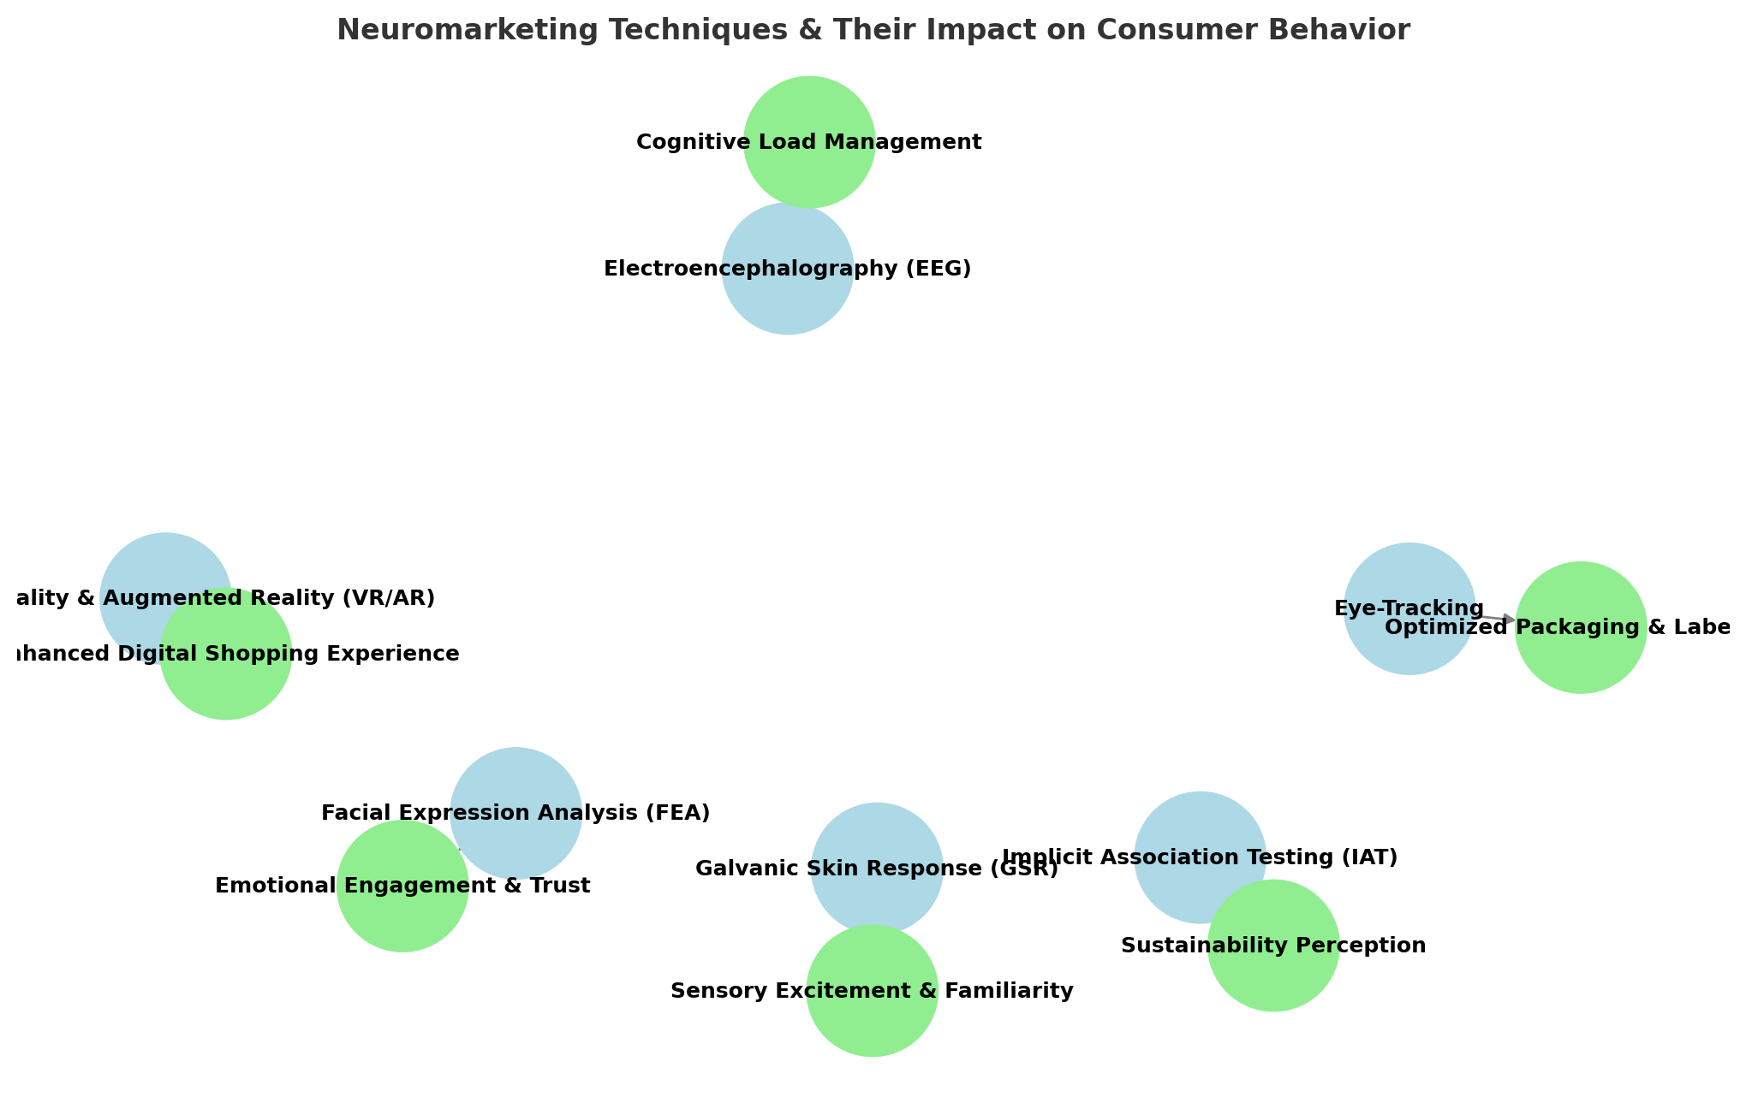Figure 1. An **infographic-style flowchart** visually summarizing how **non-invasive neuromarketing techniques** influence consumer behavior in the agri-food sector.

Source: Formulated by the author from collected survey responses.

**Blue nodes** represent different neuromarketing techniques.

**Green nodes** represent the **key strategic outcomes** for businesses.

Arrows show the connection between each technique and its impact.

Table 2. Neuromarketing Techniques & Their Impact on Consumer Behavior

|  |  |  |
| --- | --- | --- |
| **Neuromarketing Technique(Blue dot→🔵)** | **Impact on Consumer Behavior (Green Dot arrow →** 🟢) | **Description** |
| **Electroencephalography (EEG)** | Cognitive Load Management | Measures brain activity to assess mental effort and improve ad or UX design. |
| **Eye-Tracking** | Optimized Packaging & Labels | Identifies visual attention patterns to improve product presentation. |
| **Facial Expression Analysis (FEA)** | Emotional Engagement & Trust | Analyzes facial reactions to evaluate emotional responses to marketing stimuli. |
| **Galvanic Skin Response (GSR)** | Sensory Excitement & Familiarity | Measures arousal through skin conductivity, indicating engagement levels. |
| **Implicit Association Testing (IAT)** | Sustainability Perception | Reveals subconscious associations, such as brand values and ethics. |
| **Virtual & Augmented Reality (VR/AR)** | Enhanced Digital Shopping Experience | Provides immersive and interactive experiences to boost online shopping appeal. |

Source: Compiled by author

Figure 2. A bar chart illustrating consumer engagement levels across different non-invasive neuromarketing techniques.

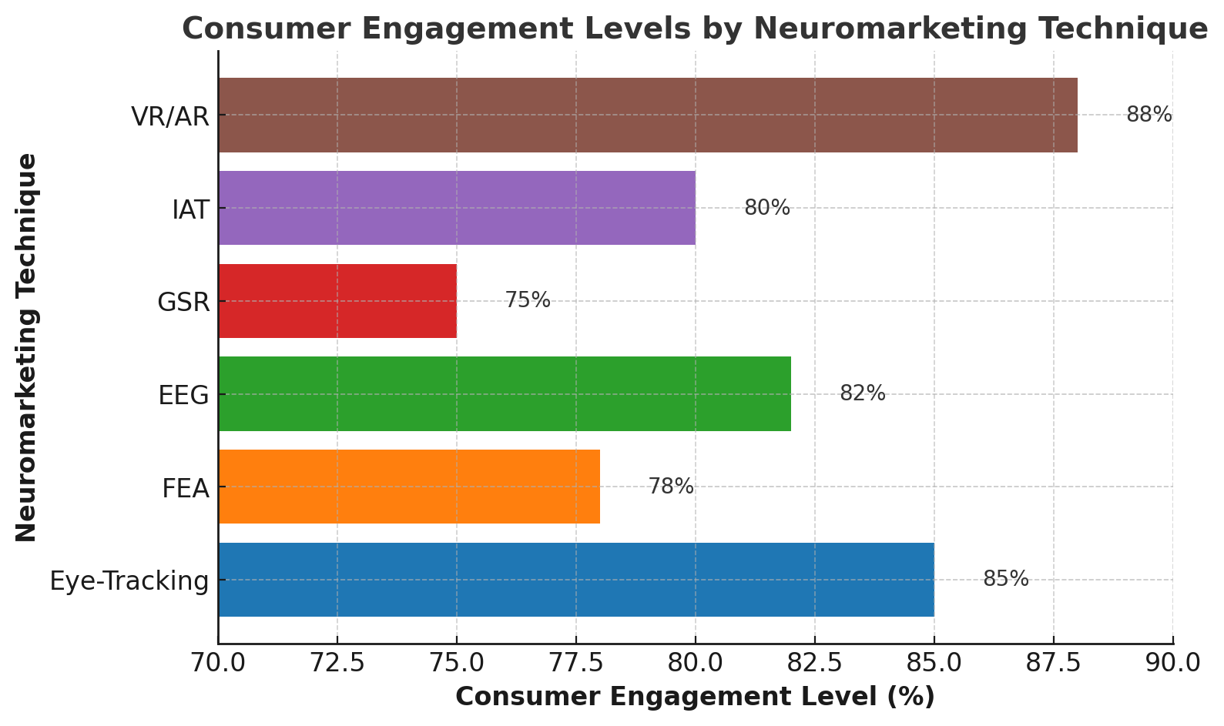

Source: Formulated by the author from collected survey responses.

The findings from Figure 2. (A **bar chart)** of this study indicate that immersive technologies such as Virtual Reality/Augmented Reality (VR/AR) and Eye-Tracking demonstrate the highest levels of consumer engagement, with response rates of approximately 88% and 85% respectively. These techniques effectively capture visual attention and foster interactive consumer experiences, aligning with previous research emphasizing their efficacy in simulating real-world purchase environments and evaluating attentional focus (Khushaba et al., 2013; Wedel & Pieters, 2008).

Electroencephalography (EEG), reflecting neural activity associated with cognitive processing, showed a high engagement rate of 82%, underscoring its value in measuring attention, memory encoding, and decision-making under different marketing stimuli (Vecchiato et al., 2011; Plassmann *et al.,* 2015). Similarly, the Implicit Association Test (IAT) registered an engagement level of 80%, affirming its effectiveness in uncovering subconscious attitudes and consumer preferences that may not be captured through explicit responses (Greenwald *et al.,* 1998).

Although slightly lower in comparison, Galvanic Skin Response (GSR) and Facial Expression Analysis (FEA) also made substantial contributions, with observed engagement levels of 75% and 78% respectively. These tools are particularly useful in gauging emotional arousal and real-time affective reactions during exposure to food-related stimuli (Madan, 2017; Lewinski et al., 2014). Together, these results highlight the differential yet complementary roles of non-invasive neuromarketing techniques in capturing the cognitive and emotional dimensions of consumer behavior in the agri-food sector.

Figure 3. A **radar chart** comparing the strengths of different **non-invasive neuromarketing techniques** across key dimensions:

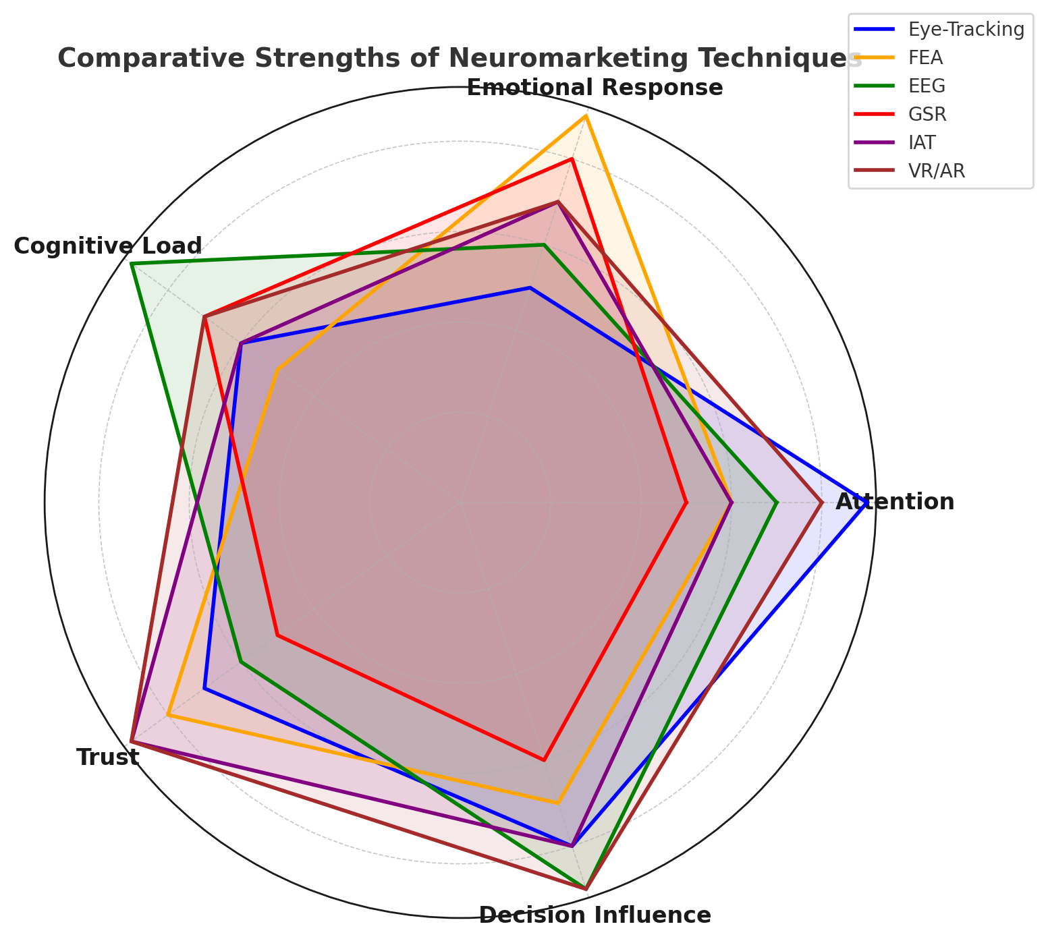

Source: Formulated by the author from collected survey responses.

**Figure 3** presents a radar chart comparing the effectiveness of various non-invasive neuromarketing techniques across key dimensions of consumer behavior analysis. Eye-Tracking demonstrates exceptional performance in capturing visual attention and influencing decision-making, consistent with its ability to track gaze patterns and fixation points during consumer interaction with products (Wedel & Pieters, 2008). Facial Expression Analysis (FEA) emerges as the most effective tool for decoding emotional responses and enhancing consumer trust, leveraging real-time detection of micro-expressions and affective states (Lewinski et al., 2014).

Electroencephalography (EEG) exhibits strong dominance in measuring cognitive load and assessing decision-making processes, reflecting its capacity to record brainwave patterns associated with attention, memory, and preference formation (Vecchiato et al., 2011; Plassmann et al., 2015). Galvanic Skin Response (GSR) proves effective in evaluating emotional arousal and cognitive engagement through physiological indicators of stress or excitement triggered by marketing stimuli (Madan, 2017).

Implicit Association Testing (IAT) is shown to be highly reliable for assessing subconscious attitudes, trust levels, and latent decision influences, providing insights that extend beyond self-reported data (Greenwald et al., 1998). Virtual Reality and Augmented Reality (VR/AR) demonstrate balanced effectiveness across all dimensions, particularly excelling in trust-building and consumer decision-making, due to their immersive and context-rich environments that simulate real-life purchase experiences (Khushaba et al., 2013).

Collectively, these findings underscore the complementary strengths of each neuromarketing technique, offering a multidimensional framework for analyzing consumer behavior in agri-food marketing.

Figure 4. A **process diagram** illustrating how **neuromarketing insights** translate into **actionable business strategies** in the agri-food sector.

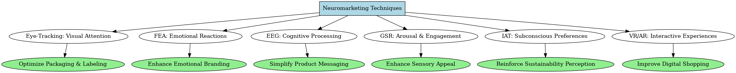

Source: Formulated by the author from collected survey responses.

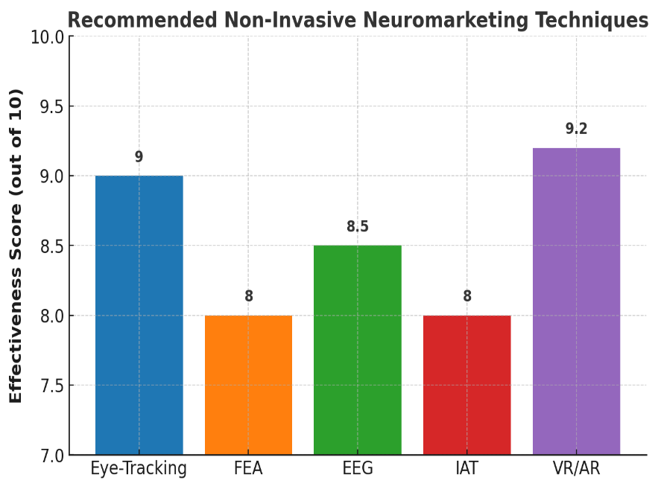

Figure 5. A **graphical summary** of the **recommended non-invasive neuromarketing techniques** based on their effectiveness in consumer behavior analysis.

Source: Formulated by the author from collected survey responses.

**Figure 5** illustrates the comparative effectiveness scores of selected non-invasive neuromarketing techniques in the context of digital consumer engagement and packaging optimization. Virtual Reality and Augmented Reality (VR/AR) achieve the highest effectiveness score of 9.2, highlighting their superior capability in simulating immersive, interactive environments that replicate real-world shopping experiences. These technologies are particularly impactful in enhancing user engagement and assessing consumer responses to packaging and product placement strategies (Khushaba et al., 2013).

Eye-Tracking closely follows with a score of 9.0, reflecting its precision in capturing consumer attention, visual preferences, and the sequencing of gaze patterns. This technique is instrumental in evaluating the visual salience of product designs and advertisements (Wedel & Pieters, 2008).

Electroencephalography (EEG), with a score of 8.5, demonstrates significant utility in decoding cognitive processes related to attention, memory encoding, and decision-making, offering in-depth insights into neural responses to marketing stimuli (Vecchiato et al., 2011; Plassmann et al., 2015). Similarly, the Implicit Association Test (IAT), scoring 8.0, is recognized for its ability to uncover subconscious biases and latent consumer attitudes that are often inaccessible through explicit measures (Greenwald et al., 1998).

Facial Expression Analysis (FEA) also receives an effectiveness score of 8.0, underscoring its value in emotional branding, trust-building, and the assessment of affective reactions to product imagery and messaging (Lewinski et al., 2014). These results collectively affirm the diverse applications and complementary strengths of neuromarketing tools in optimizing consumer engagement strategies within the agri-food marketing landscape.

**Conclusion:**

The integration of neuroscience into marketing through non-invasive neuromarketing techniques offers a transformative approach to understanding consumer behavior, especially in the context of the agri-food sector. This study highlights how tools such as eye tracking, facial coding, galvanic skin response (GSR), and electroencephalography (EEG) can reveal deep, often subconscious, emotional and cognitive responses to food products, packaging, and advertisements. These insights go beyond the limitations of conventional survey-based methods, enabling a more nuanced and data-driven understanding of consumer preferences.

In the Indian context—where cultural diversity, regional food habits, and evolving consumption patterns present unique challenges—neuromarketing can serve as a powerful tool for agribusinesses, food processors, and marketers. By applying scientifically grounded techniques, stakeholders can design more engaging marketing strategies, enhance product appeal, and ultimately influence consumer choices more effectively.

Moreover, the findings of this research contribute to the growing academic discourse on consumer neuroscience and support the development of predictive behavioral models in food marketing. As the agri-food sector undergoes rapid modernization, integrating neuromarketing methods can lead to improved consumer satisfaction, better targeting of nutritional interventions, and more effective promotion of sustainable and healthy food products.

In conclusion, the adoption of non-invasive neuromarketing techniques represents a promising frontier for food marketing research in India. It not only bridges the gap between consumer psychology and marketing practice but also provides a scientific basis for designing impactful agri-food marketing strategies that resonate with the minds—and hearts—of consumers.

Disclaimer (Artificial intelligence)

Option 1:

Author(s) hereby declare that NO generative AI technologies such as Large Language Models (ChatGPT, COPILOT, etc.) and text-to-image generators have been used during the writing or editing of this manuscript.

Option 2:

Author(s) hereby declare that generative AI technologies such as Large Language Models, etc. have been used during the writing or editing of manuscripts. This explanation will include the name, version, model, and source of the generative AI technology and as well as all input prompts provided to the generative AI technology

Details of the AI usage are given below:

1.

2.

3.

**7. Reference**

Ali, H., Birley, S., (1998). The role of trust in the marketing activities of entrepreneurs establishing new ventures. *J. Market. Manag.* 14, 749–763.

Amaldoss, W., Jain, S., (2005). Pricing of conspicuous goods: a competitive analysis of social effects. *J. Mark. Res.* 42, 30–42.

Ceri-Ann Hughes, (2018). Rely on NPS? Look through the lens of neuro marketing. Quirk's Marketing

Covino, D., Viola, I., Paientko, T., & Boccia, F. (2021). Neuromarketing: some remarks by an economic experiment on food consumer perception and ethic sustainability. *RIVISTA DI STUDI SULLA SOSTENIBILITA’,* (1), 187–199. <https://doi.org/10.3280/riss2021-001011>

Deepak, J. (2025). Neuromarketing: An Emerging Trend in the Modern Realm of Marketing . *6th International Marketing Conference on Marketing in the AI Era - Marketing 5.0 - Reshaping Global Marketing on 17th January 2025*. Shri Dharmasthala Manjunatheshwara Institute for Management Development, Mysuru, India. ISBN code 978-93-83302-73-4. <https://sdmimd.ac.in/conferenceproceedings/imc2025papers/IMC2523.pdf>

Devaru, S.D.B. (2018). Significance of Neuro-marketing on Consumer Buying Behaviour. *International Journal of Technical Research & Science,* 3(III).

Geyskens, I., Steenkamp, J.E.M., Kumar, N., (1998). Generalisations about trust in marketing channel relationships using meta-analysis. *Int. J. Res. Mark*. 15, 223–248.

Greenwald, A. G., McGhee, D. E., & Schwartz, J. L. K. (1998). Measuring individual differences in implicit cognition: The Implicit Association Test. *Journal of Personality and Social Psychology,* 74(6), 1464–1480. <https://doi.org/10.1037/0022-3514.74.6.1464>

Kalkova, N., Yarosh, O. B., Mitina, E. A., & Velgosh, N. Z. (2023). Neuromarketing Research On Consumers' Visual Perception of Cryptomarking a Product Package. *ABAC Journal,* 43(1), 69-84.

Kambali, U. (2024). Neuromarketing Strategies in the Retail Sector: A Perception View. 5th International Conference on New Age Marketing January 18-19, 2024. Shri Dharmasthala Manjunatheshwara Institute for Management Development, Mysuru (SDMIMD). ISBN: 978-93-83302-66-6. <https://sdmimd.ac.in/marketingconference2024/papers/IMC2435.pdf>

Kenning, P., Plassmann, H., (2005). NeuroEconomics: an overview from aneconomic perspective. *Brain Res. Bull*. 67, 343–354.

Khushaba, R. N., Wise, C., Kodagoda, S., Louviere, J., Kahn, B. E., & Townsend, C. (2013). Consumer neuroscience: Assessing the brain response to marketing stimuli using electroencephalogram (EEG) and eye tracking. Expert Systems with Applications, 40(9), 3803–3812. <https://doi.org/10.1016/j.eswa.2012.12.095>

Lee, N., Broderick, A. J., & Chamberlain, L. (2007). What is ‘neuromarketing’? A discussion and agenda for future research. *International Journal of Psychophysiology*, 63(2), 199-204.

Lewinski, P., Fransen, M. L., & Tan, E. S. H. (2014). Predicting advertising effectiveness by facial expressions in response to amusing persuasive stimuli. *Journal of Neuroscience,* Psychology, and Economics, 7(1), 1–14. <https://doi.org/10.1037/npe0000012>

Lin, C., Cross, S. N., Jones, W. J., & Childers, T. L. (2018). Applying neuromarketing techniques to understand consumer behavior. *Journal of Consumer Psychology*, 28(2), 202-216.

Madan, C. R. (2017). Advances in studying brain-behavior relationships using eye-tracking and electrodermal activity. *Frontiers in Neuroscience,* 11, 632. <https://doi.org/10.3389/fnins.2017.00632>

Maria, R., et al. (2022). Neuromarketing in the agri-food sector. URI: <https://repository.iuls.ro/xmlui/handle/20.500.12811/3469>

Martin, L. (2010). Buyology, Broadway Books, ISBN 978-0-385-52389- 9

McClure, S. M., Li, J., Tomlin, D., Cypert, K. S., Montague, L. M., & Montague, P. R. (2004). Neural correlates of behavioral preference for culturally familiar drinks. *Neuron*, 44(2), 379–387.

Murphy, E. R. (2008). Neuroethics of neuromarketing. *Journal of Consumer Behaviour*, 7, 293–302.

Patrick Renvoise and Christophe Morin, (2007). Neuro marketing: Understanding the Buy Buttons in Your Customer's Brain, Salesbrain LLC, ISBN #0-9743482-2-8

Peter T. Bürgi, (2018). Taking emotions seriously in B2B research, Quirk's Marketing Research Review, Article ID: 20181109 Published: November 2018, ISSN 08937451

Plassmann, H., O'Doherty, J. P., & Rangel, A. (2010). Appetitive and aversive goal values are encoded in the medial orbitofrontal cortex at the time of decision making. *The Journal of Neuroscience*, 30, 10799–10808.

Plassmann, H., Ramsøy, T. Z., & Milosavljevic, M. (2012). Branding the brain: A critical review and outlook. *Journal of Consumer Psychology*, 22(1), 18–36.

Plassmann, H., Ramsøy, T. Z., & Milosavljevic, M. (2012). Branding the brain: A critical review and outlook. *Journal of Consumer Psychology,* 22(1), 18–36. <https://doi.org/10.1016/j.jcps.2011.11.010>

Ramsoy, T.Z. (2015). Introduction to Neuro marketing & Consumer Neuroscience, *Neuronsinc.com,* ISBN 978-87-997602-0-6

Reimann, M. and B. Weber. (2011). Neuroeconomics – a review of the situation. In: M. Reimann and B. Weber (eds.) Neuroeconomics. basics – methods – applications. Springer, Wiesbaden, Germany, pp. 3-9. (in German)

Reimann, M., Schilke, O., & Weber, B. (2011). Neural correlates of trust in brands: An fMRI study. *Journal of Marketing Research*, 48(6), 937-950.

Sanfey, A.G., Rilling, J.K., Aronson, J.A., Nystrom, L.E., Cohen, J.D., (2003). The neural basis of economic decision-making in the ultimatum game. *Science 300*, 1755–1758.

Smidts, A., Hsu, M., Sanfey, A. G., Boksem, M. A. S., Ebstein, R. B., & Scott A. Huettel, et al. (2014). Advancing consumer neuroscience. *Marketing Letters*, 25, 257–267.

Trocchia, P.J., (2004). Caving, role playing, and staying home: shopper coping strategies in a negotiated pricing environment. *Psychol. Mark.* 21, 823–854.

Vecchiato, G., Astolfi, L., Fallani, F. D. V., Toppi, J., Aloise, F., Bez, F., ... & Babiloni, F. (2011). On the use of EEG or MEG brain imaging tools in neuromarketing research. *Computational Intelligence and Neuroscience,* 2011, 643489. <https://doi.org/10.1155/2011/643489>

Verma, S. K., (2020). Neuromarketing-Perspective and future aspects in Indian Markets: A literature Review. *Vidyabharati International Interdisciplinary Research Journal,* 11(1) 282-288

Vrtana, D., Krizanova, A., and Gajanova, L. (2019). Importance of Neuro-marketing in Company’s Marketing Campaign. *48th International Scientific Conference on Economic and Social Development – "Managerial Issues in Modern Business*" - Warsaw, 25-26 November 2019.

Weber, B. (2017). Neuroeconomics. In: P. Kenning, A. Oehler, L.A. Reisch and C. Grugel (eds.) Consumer science. framework conditions, fields of research and institutions. *Springer, Wiesbaden, Germany*, pp. 329-340. (in German)

Wedel, M., & Pieters, R. (2008). Eye tracking for visual marketing. *Foundations and Trends in Marketing,* 1(4), 231–320. <https://doi.org/10.1561/1700000011>

Young, C., (2002). Brain waves, picture sorts®, and branding moments. *J. Advert. Res.* 42, 42–53.