Constraints and Suggestions on Recommended Potato Cultivation in Hassan District, India: Voices from the Field

ABSTRACT
The potato cultivation in Hassan district faces several significant challenges. One of the primary issues is the unavailability of quality potato seed, which hampers crop productivity and yield. Additionally, there is a notable lack of technical know-how regarding advanced potato production technologies among farmers, further affecting efficiency and output. The high cost of potato cultivation adds financial strain, while the dependence on only a few potato varieties limits genetic diversity and resilience. This situation is exacerbated by the crop's susceptibility to diseases and pests, which can lead to significant losses. Moreover, farmers often struggle with limited market access and fluctuating prices, making it difficult to achieve stable income. The availability of irrigation facilities is also constrained, which impacts crop growth, especially during dry seasons and the limited use of technology and mechanization also hinder the potential for improved agricultural practices, leaving many farmers unable to optimize their production. A total of 120 respondents, comprising 60 farmers each from Hassan and Arakalgud taluks of Hassan district of Karnataka were selected for the study.
Key words: Potato growers; Constraints, suggestions, Cultivation , Field

- INTRODUCTION
Potato (Solanum tuberosum L.) is a significant vegetable crop in India, often called the “poor man's food”. It is quite a cheap food providing whole some diet for human beings. It is consumed by over a billion people across more than 100 countries. As per FAOSTAT data for the year 2021, India with 54.23 million tonnes is ranked second in potato production in the world, only behind China with 94.36 million tonnes. During 2023-24 about 23.26 lakh ha of land in India was under potato with production of about 56.76 million tonnes and yield of 24.40 t/ha (Anonymous, 2023). In Karnataka, major potato-growing districts include Hassan, Kolar, Chikkaballapur, Chikkamagaluru, and Belgaum. Though Karnataka's potato production is smaller compared to other states, it stands out for its harvest timing and quality of tubers, covering 26,745 ha with 2,34,838 tonnes produced. Hassan leads with 9,995 ha and 68,921 tonnes (Anonymous, 2022).
Low productivity is often due to the high cost and lack of quality seed tubers. One of the major reasons for low productivity is non availability of quality seed tubers and its high cost. In India, severity of late blight that is caused by Phytophthora infestans varies from region to region, being more severe in temperate highlands than in the sub-tropical plains with an average of 15.00 per cent crop losses annually (Collins, 2000). In case of late blight, the effect of climate change on the most dreaded disease of potato in India also, could be mixed. Seed production mainly takes place in northern states like Punjab, led by skilled growers. However, climate change could influence late blight outbreaks, particularly in Punjab and western Uttar Pradesh, potentially affecting seed production. Potato cultivation plays a key role in supporting farmers' livelihoods, food security, employment, and agricultural sustainability.
Objective of the study
To identify the major constraints in potato production and to seek suggestions from potato growers
- METHODOLOGY
The study was conducted in Hassan district of Karnataka, during the year 2023-24. Out of 8 taluks of the Hassan district, Hassan and Arakalgud taluks were selected purposively for the study because a maximum number of potato growers were living in these taluks and six villages from each taluk were randomly selected. 60 farmers from each taluk were selected for the study. In the present investigation, ex-post facto research design with simple random sampling technique was used. This design was considered appropriate, as it is a systematic empirical enquiry for measuring the phenomenon, which has already occurred and is continuing. The researcher has no control on independent variables as their manifestation has already occurred or they are inherent and non-manipulative. The personal interview schedule was prepared in the light of decided objectives and variables undertaken. Constraints and suggestions were measured by close-ended responses of the respondents with the help of a pre-tested schedule developed for the purpose. The data were collected through personal interviews with the help of a survey schedule. The data were analyzed and find out the percentage, mean and rank order.
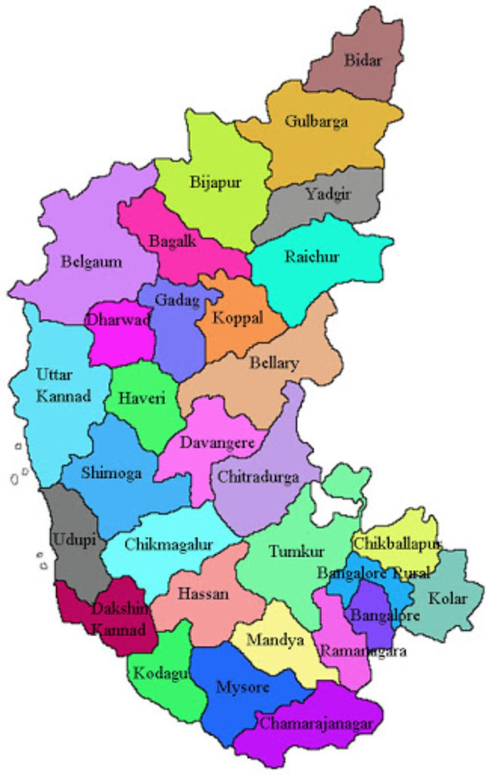
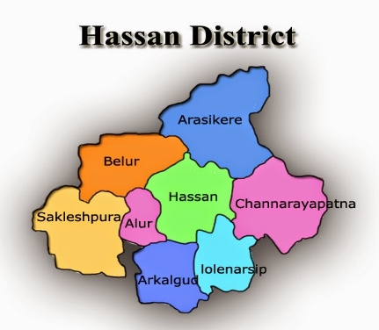
Fig. 1: Map showing the study area
- RESULTS AND DISCUSSION
The constraints faced by potato growers which had 4 components like production constraints, marketing constraints, technical constraints and financial constraints which were expressed by the potato growers.
3.1 Production constraints perceived by potato growers
The Table-1 indicates, that the rank order of production constraints viz., occurrence of pest and diseases ranked I with a mean score 2.87 followed by high wages (ranked II) with a mean score 2.68 whereas, uneven distribution of rainfall ranked III with mean score 2.28, while timely unavailability of irrigation was ranked IV with a mean score 2.23 followed by lack of awareness about recommended cropping sequences with a mean score of 1.55, low fertility status ranked VI with mean score 1.50. Among Arakalgud taluk potato growers, occurrence of pest and diseases ranked I with a mean score of 2.87 followed by high wages with a mean score of 2.82 whereas, timely unavailability of irrigation ranked III with mean score 2.80, while uneven distribution of rainfall ranked IV with a mean score 2.78 followed by lack of awareness about recommended cropping sequences with a mean score of 1.83, low fertility status ranked VI with mean score 1.78. With regards to overall, occurrence of pest and diseases ranked I with a mean score 2.93 followed by high wages (ranked II) with a mean score 2.75 whereas, uneven distribution of rainfall ranked III with mean score 2.53, while timely unavailability of irrigation was ranked IV with a mean score 2.52 followed by lack of awareness about recommended cropping sequences with a mean score of 1.69 (ranked V), low fertility status ranked VI with mean score 1.64. These findings are in accordance with the findings of Raval et al. (2023) and Uikey et al. (2018).
Disease and pest incidence was ranked as the most serious production constraint, as it leads to major crop losses and is difficult to manage effectively. High wages came next, making farm operations costly and limiting farmers' ability to hire labor when needed. Uneven rainfall distribution and the timely unavailability of irrigation were also major concerns, as they directly impact crop growth and yields. Lack of awareness about recommended cropping sequences and low soil fertility were ranked lower, indicating that while important, farmers perceive immediate threats like diseases, pests and water issues as more critical.

Table 01: Production constraints perceived by the potato growers
Sl.  No. | Production Constraints | Hassan  (n₁=60) |  | Arakalgud (n₂=60) |  | Total  (n=120)
Sl.  No. | Production Constraints | Mean score | Rank | Mean score | Rank | Mean score | Rank
1 | Wages are high | 2.68 | II | 2.82 | II | 2.75 | II
2 | Low soil fertility status | 1.50 | VI | 1.78 | VI | 1.64 | VI
3 | Lack of awareness about recommended cropping sequences | 1.55 | V | 1.83 | V | 1.69 | V
4 | Uneven distribution of rainfall | 2.28 | III | 2.78 | IV | 2.53 | III
5 | Timely unavailability of irrigation | 2.23 | IV | 2.80 | III | 2.52 | IV
6 | Disease and pest incidence | 2.87 | I | 2.98 | I | 2.93 | I
3.2 Marketing constraints perceived by the potato growers
It is evident from the Table 02 that major marketing constraints expressed by the potato growers are low price for the produce ranked I with the mean score of 2.67. The other constraints ranked based on the mean scores were price fluctuation (2.62) ranked II, exploitation by middlemen in the market (2.48) ranked III, lack of transportation (2.28) ranked IV, lack of timely market information (2.20) ranked V and lack of storage facility (1.45) ranked VI, respectively. With respect to Arakalgud taluk potato growers, both price fluctuation and low price for the produce stands I with the mean score of 2.87. Further, exploitation by the middlemen in the market stands II with mean score of 2.53, lack of transportation stands III with mean score of 2.42 followed by lack of transportation (2.35) stands IV and lack of storage facility stands V (1.62).

Table 02: Marketing constraints perceived by the potato growers
Sl.  No. | Marketing Constraints | Hassan  (n₁=60) |  | Arakalgud (n₂=60) |  | Total  (n=120)
Sl.  No. | Marketing Constraints | Mean score | Rank | Mean score | Rank | Mean score | Rank
1 | Lack of storage facility | 1.45 | VI | 1.62 | VI | 1.53 | VI
2 | Lack of timely market information | 2.20 | V | 2.42 | IV | 2.31 | V
3 | Lack of transportation | 2.28 | IV | 2.35 | V | 2.32 | IV
4 | Price fluctuation | 2.62 | II | 2.87 | I | 2.74 | II
5 | Low price for the produce | 2.67 | I | 2.87 | I | 2.77 | I
6 | Exploitation by middlemen in the market | 2.48 | III | 2.53 | III | 2.51 | III
Overall, the marketing constraints expressed by the potato growers are low price for the produce ranked first with the mean score of 2.77. The other constraints ranked based on the mean scores were price fluctuation (2.74) ranked second, exploitation by middlemen in the market (2.51) ranked third, lack of transportation (2.32) ranked fourth, lack of timely market information (2.31) ranked fifth and lack of storage facility (1.53) ranked sixth respectively. These findings are line with Shiralasetti and Mahesh (2016) and Ravi et al. (2017).
Low price for the produce was ranked as the most serious marketing constraint, as farmers often do not receive fair returns for their hard work, discouraging continued production. Price fluctuations were another major issue, creating uncertainty and making it difficult for farmers to plan their sales and incomes. Exploitation by middlemen ranked third, with farmers losing a significant portion of their earnings to intermediaries who control pricing and market access. Lack of transportation facilities also emerged as an important problem, as it limits farmers' ability to access better markets and forces them to sell locally at lower prices. Lack of timely market information affects farmers' ability to make informed decisions about where and when to sell their produce. Although lack of storage facility was ranked lowest, it still matters because without proper storage, farmers are often forced to sell immediately after harvest when prices are low.
3.3 Technical constraints perceived by the potato growers
The data from Table 03 revealed that, the technical constraints expressed by Hassan taluk growers are non-availability of quality inputs like seeds, pesticides and insecticides at right time ranked first with mean score of 2.82 followed by lack of technical guidance about production techniques (1.92) ranked second and lack of relevant literature in local language ranked third with mean score of 1.27 respectively. While, the constraints expressed by Arakalgud taluk potato growers are non-availability of quality inputs like seeds, pesticides and insecticides at right time ranked first with mean score of 2.73 followed by lack of technical guidance about production techniques (2.00) ranked second and lack of relevant literature in local language ranked third with mean score of 1.07. With regards to overall potato growers, non-availability of quality inputs like seeds, pesticides and insecticides at right time ranked first with mean score of 2.78 followed by lack of technical guidance about production techniques (1.96) ranked second and lack of relevant literature in local language ranked third with mean score of 1.17 respectively. These findings are in accordance with the findings of Reema et al. (2020).
Farmers have encountered with the form of a shortage of quality inputs at the right time and at a reasonable cost to a greater degree. This challenge blow the effect on their production activities, as it affects the quality and quantity of inputs they can access, which in turn influences the overall success of their potato cultivation. Further, difficulties stemming from a lack of technical guidance regarding production technologies was notable but appears to have a relatively lesser impact compared to the problem of input availability and affordability. Whereas, availability of relevant literature in their local language somewhat less pronounced as problem.

Table 03: Technical constraints perceived by the potato growers
Sl.  No. | Technical Constraints | Hassan  (n₁=60) |  | Arakalgud (n₂=60) |  | Total  (n=120)
Sl.  No. | Technical Constraints | Mean score | Rank | Mean score | Rank | Mean score | Rank
1 | Non-availability of quality inputs like seeds, pesticides and insecticides at right time | 2.82 | I | 2.73 | I | 2.78 | I
2 | Lack of technical guidance about production techniques | 1.92 | II | 2.00 | II | 1.96 | II
3 | Lack of relevant literature in local language | 1.27 | III | 1.07 | III | 1.17 | III

3.4 Financial constraints perceived by the potato growers
It is clearly noted from table 4 that, the primary financial constraint faced by potato growers in Hassan taluk is the high cost of production, which ranks first with a mean score of 2.15. This is followed by both the lack of credit availability and the lack of incentives and subsidies, each with a mean score of 2.12. Similarly, in Arakalgud taluk, the high cost of production is also ranked first, with a mean score of 2.43, followed both lack of credit availability with mean score 2.25 and lack of incentives and subsidies with mean score of 2.22 respectively. For overall potato growers, the high cost of production is ranked first, with a mean score of 2.29. This is followed lack of credit availability, with a mean score of 2.18 and lack of incentives and subsidies, with a mean score of 2.17, respectively. These findings are line with Mishra et al. (2019)
Limited credit availability restricts farmers' access to necessary funds for purchasing inputs like seeds, fertilizers, and machinery, making it harder to scale production. The lack of incentives and subsidies further discourages investment in modern farming techniques or improvements, reducing the overall efficiency and yield. High production costs also strain farmers financially, as they must invest heavily in labor, inputs, and maintenance without guaranteed returns, further exacerbating the challenges they face in growing and marketing potatoes profitably.
Table 04: Financial constraints perceived by the potato growers
Sl.  No. | Financial Constraints | Hassan  (n₁=60) |  | Arakalgud (n₂=60) |  | Total  (n=120)
Sl.  No. | Financial Constraints | Mean score | Rank | Mean score | Rank | Mean score | Rank
1 | Lack of credit availability | 2.12 | II | 2.25 | II | 2.18 | II
2 | High cost of production | 2.15 | I | 2.43 | I | 2.29 | I
3 | Lack of incentives and subsidies | 2.12 | II | 2.22 | III | 2.17 | III

3.5 Suggestions expressed by potato growers to overcome constraints
Suggestions expressed by potato growers are observed in table 5. Nearly cent per cent (98.33 %) of the potato growers in Hassan taluk expressed there should be research efforts are needed for the development of cost effective simple technologies for late blight disease management. Majority of them expressed ensuring quality seed tubers (91.67 %) as a major suggestion, need for improved variety (86.67 %), timely & adequate information regarding availability of inputs, prices, arrivals (63.33 %), creating awareness on the use of climate smart technologies (55.00 %), protection from exploitation by middlemen (35.00 %), providing loan at lower interest rate (11.67 %) and provision for suitable market infrastructure viz. transportation, storage, weighment facilities (10.00 %).
While cent per cent of Arakalgud taluk potato growers expressed there should be research efforts are needed for the development of cost effective simple technologies for late blight disease management. Majority of them expressed ensuring quality seed tubers (90.00 %) as a major suggestion, followed by need for improved variety (83.33 %), creating awareness on the use of climate smart technologies (73.33 %), protection from exploitation by middlemen (61.67 %), timely & adequate information regarding availability of inputs, prices, arrivals (56.67 %), provision for suitable market infrastructure viz. transportation, storage, weighment facilities (26.67 %) and providing loan at lower interest rate (26.67 %).
Nearly cent per cent (99.17 %) of overall potato growers expressed there should be research efforts are needed for the development of cost effective simple technologies for late blight disease management. Majority of them expressed ensuring quality seed tubers (90.83 %) as a major suggestion, need for improved variety (85.00 %), creating awareness on the use of climate smart technologies (64.17 %), timely & adequate information regarding availability of inputs, prices, arrivals (60.00 %), protection from exploitation by middlemen (48.33 %), providing loan at lower interest rate (19.17 %) and provision for suitable market infrastructure viz. transportation, storage, weighment facilities (18.33 %).
Table 05 : Suggestions expressed by potato growers to overcome constraints
Sl. No. | Suggestions | Hassan  (n₁=60) |  | Arakalgud  (n₂=60) |  | Total (n=120)
Sl. No. | Suggestions | Yes | % | Yes | % | Yes | %
1 | Ensuring quality seed tubers | 55 | 91.67 | 54 | 90.00 | 109 | 90.83
2 | Need for improved variety | 52 | 86.67 | 50 | 83.33 | 102 | 85.00
3 | Research efforts are needed for the development of cost effective simple technologies for late blight disease management. | 59 | 98.33 | 60 | 100.00 | 119 | 99.17
4 | Creating awareness on the use of climate smart technologies | 33 | 55.00 | 44 | 73.33 | 77 | 64.17
5 | Timely and adequate information regarding availability of inputs, prices, arrivals etc., | 38 | 63.33 | 34 | 56.67 | 72 | 60.00
6 | Providing loans at lower interest rate | 07 | 11.67 | 16 | 26.67 | 23 | 19.17
7 | Provision for suitable market infrastructure viz. transportation, storage, weighment facilities | 06 | 10.00 | 16 | 26.67 | 22 | 18.33
8 | Protection from exploitation by middlemen | 21 | 35.00 | 37 | 61.67 | 58 | 48.33

POLICY IMPLICATIONS
- Potato growers confront numerous challenges in production and marketing, including high labor costs, a high incidence of pests and diseases, irregular rainfall patterns, a low price for products, and price variations. The main problem with the potato growers in the study area was crop loss due to heavy rainfall and late blight disease. This induced farmers to shift from potato cultivation to other crops like maize and finger millet. So, compensation may be given to the affected potato farmers in order to promote potato production. Creating awareness among the farmers to take up potato crop insurance to protect against financial losses arising from unforeseen act which is beyond their control.
- Farmers should be provided with the necessary quantity of inputs at a fair price at the appropriate time during cropping seasons through RSK and societies.
- Majority of the growers expressed that high cost of production in potato production. Many governments, recognizing the economic and food security importance of potatoes, are rolling out various initiatives to support potato farmers. These programs often include subsidies for seed tubers, fertilizers, and irrigation equipment, as well as training programs to encourage the adoption of modern farming techniques. Governments may also provide market access support, price stabilization measures, and crop insurance to protect farmers from risks. By creating enabling environments through policies and frameworks, governments play a crucial role in enhancing the sustainability and profitability of potato farming.

CONCLUSION
It may be concluded that majority of the potato growers reported that in production constraints, the biggest issues are occurrence of pest and diseases mainly late blight of potato incidence. In marketing constraints, low price for the produce and price fluctuation are the top concerns respectively. For technical constraints, the non-availability of quality inputs was the major issue. In financial constraints, high cost of production was the most significant issue. Therefore, majority of the potato growers suggested that the research efforts are needed for the development of cost effective simple technologies for the late blight disease management, ensuring quality seed tubers and need for improved variety are the uncontested foremost concerns among all potato growers.
Disclaimer (Artificial intelligence)
Option 1:
Author(s) hereby declare that NO generative AI technologies such as Large Language Models (ChatGPT, COPILOT, etc.) and text-to-image generators have been used during the writing or editing of this manuscript.
Option 2:
Author(s) hereby declare that generative AI technologies such as Large Language Models, etc. have been used during the writing or editing of manuscripts. This explanation will include the name, version, model, and source of the generative AI technology and as well as all input prompts provided to the generative AI technology
Details of the AI usage are given below:
1.
2.
3.

REFERENCE
AKASH, KUMAR, A., CHAUHAN, M., RAM, L. AND SINGH, A. K., 2024, Exploring the Socio-economic Conditions of Potato Farmers in Farrukhabad District of Uttar Pradesh, India. AJAEES., 42(11):162-7.
ANONYMOUS, 2022, Directorate of economics & statistics, DAC & FW (DES). 2022, Agricultural statistics at a glance. Department of agriculture, cooperation and farmers welfare, ministry of agriculture and farmers welfare. Government of India.
ANONYMOUS, 2023, Agricultural statistics at a Glance. Department of Agriculture & Farmers Welfare (DA&FW), Ministry of Agriculture & Farmers Welfare, Government of India, New Delhi.
COLLINS, W. W., 2000, The global initiative on late blight-alliance for the future, Potato Global Research and Development. Indian Potato Asso., CPRI, Shimla, India. 24 (1): 513-524.
MARABI GHASI., SURYAWANSHI, D. K., CHATURVEDI, M. K. AND NIRALA SINGH PARIVESH., 2022, Problem experienced by the kharif potato growers during adoption of recommended potato production technology and their suggestions to overcome the problems. The Pharma Innovation Journal., 11(12): 740-741.
MISHRA, A. K., DOHREY, R. K., KUMAR., ROOP., PANDEY., RAVINDRA., KUMAR. AND AKSHAY, K., 2019, Constraints faced by the farmers and their remedies in technological adoption of potato production in Farrukhbad District (Uttar Pradesh). Asian J. Agric. Ext. Eco. Socio., 33 (3): 1-4.
RAVAL, K. N., PATEL, J. K. AND CHAUDHARY, K. V., 2023, Constraints faced by potato growers in adoption of production technology and marketing of potato. The Pharma Innovation Journal, 12 (4): 2087-2089.
RAVI SINGH GURJAR., GOUR, C. L., DEEPAK, DWIVEDI. AND BADODIYA, S. K., 2017, Entrepreneurial Behavior of Potato Growers and Constraints faced by Farmers in Production and Marketing of Potato and their Suggestion. Plant Archives., 17(1): 427-432.
REEMA., AWASTHI., NIMISHA, SINGH., POONAM. AND SINGH, A. K., 2020, Constraints faced by potato farmers in district Kannauj (U.P.). Indian J. of Ext. Edu., 56 (2): 31-34.
SHARMA, ASHUTOSH. AND SHARMA, M. L., 2016, Assessment of Knowledge Level and Gap in Potato Cultivation Practices at Hilly Areas of Chhattisgarh. International Journal of Agriculture Sciences., 8(60): 3388-3390.
SHIRALASETTI, A. S. AND MAHESH HADAPAD., 2016, Constraints of grape cultivators in Karnataka: A study in Bijapur distict. Ind. J. Appl. Res., 6 (1): 44-48.
SINGH, D.P., KUMARI, A. R. AND TIWARI, T., 2018, Knowledge and Adoption Level of Potato Growers and their Constraints Related to Potato Production Technology. Int. J. Pure App. Biosci., 6(3): 786-791.
UIKEY, G., GURJAR, R., AND PATEL, M., 2018, Analysis of technological gap in potato production technology. Journal of Pharmacognosy and Phytochemistry., 7(1):2428-2432.

