***Original Research Article***

**Spatiotemporal Analysis of Rainfall Variability and Drought in Western Madhya Pradesh**

ABSTRACT

The present study investigates the rainfall variability and drought characteristics across 16 districts in the western part of Madhya Pradesh, India, using long-term rainfall records from 1980 to 2023. A combination of statistical techniques, including homogeneity testing (Pettitt’s test), randomness and autocorrelation testing (Durbin-Watson statistics), rainfall variability analysis, standardized rainfall anomaly (SRA) assessment, and rainfall departure and probability distribution analysis, was employed to evaluate the spatial and temporal distribution of rainfall and drought events. The results indicated that while most districts exhibited homogeneous and random rainfall patterns, a few stations demonstrated significant non-homogeneity and negative autocorrelation. Spatial variability analysis revealed that the Malwa Plateau region received relatively less rainfall and exhibited greater variability compared to the Nimar Valley and Jhabua Hills regions. The frequency and severity of droughts were found to be higher in the Malwa region, with drought return periods as short as two to three years, while the southern districts experienced fewer and less severe drought events. This study highlights the pressing need for region-specific drought mitigation strategies and better water resource management practices to enhance climate resilience in western Madhya Pradesh. The findings offer valuable insights for policymakers and stakeholders involved in sustainable agricultural and water management planning.

*Keywords: Rainfall variability, Drought assessment, Standardized Rainfall Anomaly (SRA), Homogeneity test, Rainfall departure.*

# INTRODUCTION

Rainfall variability refers to the fluctuations in the amount, intensity, timing, and distribution of rainfall over time and space. It is one of the most critical aspects of climate that directly affects agricultural production, water resources, and ecosystem stability [1]. The unpredictable nature of rainfall, including times of excess (floods) or shortage (droughts), both within and between years, is captured by variability, as opposed to average annual rainfall [2]. In many regions of the world, especially those dependent on rainfed agriculture, rainfall variability can be more consequential than long-term changes in mean rainfall, leading to significant challenges in food security, water management, and rural livelihoods [3,4,5].

India’s rainfall regime is primarily governed by the southwest monsoon, which contributes nearly 75%–80% of the annual precipitation between June and September [6,7]. Despite being a monsoon-dominated country, India exhibits significant spatial and temporal rainfall variability. Some regions receive more than 2,000 mm of annual rainfall (like the Western Ghats and northeastern states), while others, such as Rajasthan and parts of Gujarat, receive less than 500 mm [8,9]. However, the average figures mask a deeper issue—the high variability in rainfall across different time scales, including seasonal, annual, and decadal fluctuations. Rainfall variability in India manifests through delayed onset or early withdrawal of the monsoon, prolonged dry spells during the cropping season, uneven distribution across regions, and sudden intense rainfall events [10]. These inconsistencies have become more prominent in recent decades, influenced by factors such as land use changes, urbanization, deforestation, and global warming. The erratic nature of rainfall creates challenges in planning and managing irrigation, crop calendars, water harvesting, and flood control. In rainfed regions, which constitute nearly 60% of India's net sown area, the consequences of rainfall variability are particularly severe [11,12]. It leads to increased risk of crop failure, food insecurity, groundwater depletion, and rural distress. Therefore, understanding and analyzing rainfall variability at both national and regional levels is essential for developing resilient agricultural systems and water resource policies tailored to local conditions.

Madhya Pradesh (MP) is a crucial region in India where variations in rainfall have a significant impact on water management and agriculture. Madhya Pradesh, often referred to as the "heart of India," is geographically diverse, comprising plateaus, river basins, and hilly terrains. The state receives an average annual rainfall of approximately 1,000 mm, with around 90% of it concentrated during the southwest monsoon season (June–September) [13,14,15,16]. However, the distribution of rainfall is highly uneven across its different agro-climatic zones, ranging from the high rainfall areas of eastern MP to the relatively drier western and central regions [17,18]. Rainfall variability in MP is characterized by delayed or erratic monsoon onset, uneven intra-seasonal distribution, and an increasing number of dry spells during critical crop growth stages. [19,20] Studies have indicated that while the average annual rainfall in MP has remained somewhat stable over long periods, its temporal variability has intensified, leading to more frequent droughts, flood events, and challenges in water resource management. The rainfed agricultural systems, covering a large portion of the state, are highly vulnerable to these variations, impacting crop yields, food security, and rural incomes [21].

The Malwa region, situated in the western part of Madhya Pradesh, is one of the most agriculturally important yet rainfall-sensitive areas. This plateau region includes districts such as Indore, Ujjain, Dewas, Mandsaur, Neemuch, Ratlam, and Shajapur. The Malwa Plateau is characterized by fertile black cotton soils (Vertisols) that are highly suitable for growing soybean, pulses, wheat, and other important crops. The region receives average annual rainfall ranging from 800 mm to 1,200 mm, with the majority of precipitation concentrated during the monsoon months. However, the variability of rainfall within the Malwa region is pronounced and has increased in recent decades. Patterns such as delayed monsoon arrival, reduction in the number of rainy days, increase in high-intensity short-duration rainfall events, and prolonged mid-season dry spells are becoming more common [22,23]. This irregularity directly impacts crop productivity, groundwater recharge, and the sustainability of traditional water storage systems like tanks and ponds.

Rainfall variability in western MP not only affects agriculture but also triggers a chain of environmental and socio-economic problems. Years with deficient rainfall often lead to agricultural droughts, forcing farmers to either abandon crops or incur heavy losses. Excess rainfall within short periods leads to soil erosion, flooding, and sometimes crop destruction. Furthermore, the region has seen a growing dependency on groundwater for irrigation, which is increasingly stressed due to irregular recharge caused by variable rainfall. Traditional rainwater harvesting structures, once effective under more predictable rainfall regimes, are struggling to cope with the new patterns of precipitation. Given the crucial role of rainfall in sustaining agriculture and rural livelihoods in the western Madhya Pradesh, a comprehensive understanding of its variability is essential. This research aims to assess of the rainfall variability using standard statistical indicator and quantification of droughts using rainfall departure analysis, in order to obtain a better knowledge of drought frequency, drought prone districts and probability distribution analysis of drought in the western Madhya Pradesh.

# STUDY AREA

The study area encompasses the western part of Madhya Pradesh, covering three agro-climatic regions: the Malwa Plateau, Nimar Valley, and Jhabua Hills. It includes 16 districts: Agar Malwa, Dewas, Dhar, Indore, Mandsaur, Neemuch, Rajgarh, Ratlam, Shajapur, and Ujjain from the Malwa Plateau; Badwani, Burhanpur, Khandwa, and Khargone from the Nimar Valley; and Alirajpur and Jhabua from the Jhabua Hills. Geographically, the region lies between 22°25′N to 24°00′N latitude and 75°00′E to 76°25′E longitude, spanning an area of 72,291 sq. km. It is centrally located in India, just below the Indo-Gangetic plain and north of the Vindhyan mountain ranges. The terrain varies from plateau lands in Malwa to valleys and hills in Nimar and Jhabua.

The average annual rainfall varies between 650 mm and 1018 mm and about 90% of it occurs during the south-west monsoon. The rainfall pattern is erratic and uncertain with very high variability. Maximum temperature of 480 C is recorded in Badwani district and minimum temperature of 60 C is recorded in Ratlam district. The map showing the study area is given in Figure 1.

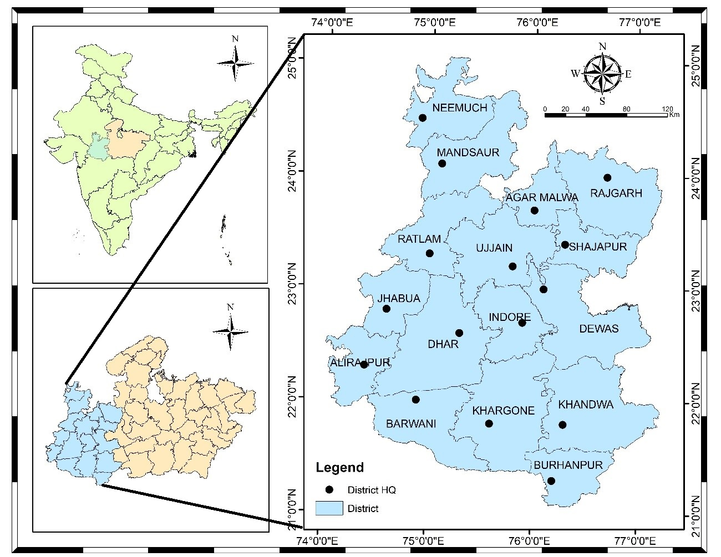

**Figure 1. Map of Western Madhya Pradesh**

There are various rivers which egresses from this plateau and they are: Mahi, Chambal, Gambhi, Kshipra, Kalisindh, Parvati etc. All the above rivers flow from west to east direction due to the physical Slope of India. Western part of MP is drained by two river systems belonging to The Arabian Sea and The Bay of Bengal. Most of the areas (including north, north-west, central, northeast and east) of the region is drained by Chambal, Sindh and Betwa with their tributaries belonging to the Bay of Bengal drainage system while the rest of the area (south-east, south-west and southern) is drained by Mahi, Tapi and Narmada with their tributaries belonging to the Arabian Sea drainage system.

Most of the part of western MP is covered by black soil which is formed due to erosion of basalt rocks of Deccan Traps. It is popularly known as "Black Cotton Soil" because of its dark brown color and suitability for growing cotton. It is very fertile soil which is, in India, also known as ‘regur’ soil. It is mostly clay soil and form deep cracks during dry season. An accumulation of time is generally noticed at varying depths. Regur soil is deficient in nitrogen, phosphoric acid and organic matter but rich in calcium, potash and magnesium.

### Data collection

# The daily rainfall data for 16 districts of western Madhya Pradesh was collected by India meteorological department, Pune. At a resolution of 0.25*0.25, the rainfall gridded data was downloaded in grd format for the years 1980–2023 [24]. On the other hand, the analysis for the years 1980 to 2023 in this study was done using the grd format. IMD grid extractor software was used to extract the data.

# METHODOLOGY

This section includes the description about the study area, collection of required data, statistical analysis of data and methods used to achieve research objective. The study involves the examination of rainfall variability using statistical tests, coefficient of variation, standard deviation, estimation of meteorological drought by rainfall departure analysis its characteristics as per their classification, at the end of the chapter, Drought frequency and severity analysed and the spatial representation of these analysis in the study area have done in this chapter.

### Homogeneity, Randomness and Autocorrelation Test

A homogeneity test for rainfall data is essential in hydrological and climatological investigations to confirm the data's dependability and consistency throughout time. Rainfall data, which is commonly collected over extended periods of time, can be influenced by a variety of factors, including changes in measuring techniques, the relocation of weather stations, and environmental changes. These factors might cause non-climatic movements or trends in the data, leading to incorrect conclusions if not discovered and corrected. In the present study non-parametric Pettitt’s test was carried out at 95% level of significance (alpha=0.05) to test the homogeneity in the annual rainfall time series of 16 district of western MP. Assume that the null hypothesis at the time of applying this test is homogenous data over the entire period. If the computed "p" value is larger than the significance level alpha=0.05, the null hypothesis (H0) cannot be rejected. The alternative hypothesis (Ha) should be accepted and the null hypothesis (H0) should be rejected if the computed p-value is less than the significance level alpha = 0.05. The formulas involved in the Pettitt test are as follows.

* **Rank the data:**

Rank the data point X1, X2,……,Xn in the time series.

* **Calculate the rank sum Rt :**

For the data point t, calculate the rank sum of the first t data points,

$R_{t}=\sum_{i=1}^{t}{R(X_{i})} …(1)$

where R(Xi) is the rank of the ith observation in the entire series.

* **Compute the Test Statistic Ut :**

For each time point t, compute the Pettitt test statistic.

$$U_{t}=2R_{t}-t\left(n+1\right) …(2)$$

where n is the total number of observations

* **Identify the Change Point (k):**

The test statistic k is defined as the maximum absolute value of Ut​.

The Durbin-Watson test is a widely used statistical test to detect the presence of autocorrelation in the residuals from a regression analysis. Autocorrelation, particularly in time series data like rainfall, can indicate that the residuals (errors) are not independent, which violates one of the key assumptions of ordinary least squares regression. In the present study, the Durbin-Watson autocorrelation test was used to test the presence of autocorrelation or randomness in the data set. The autocorrelations near-zero or zero indicates the presence of randomness in the data set and when the autocorrelations are significantly non-zero indicate the non-random or auto correlated data set. The Durbin-Watson statistic ranges from 0 to 4, where a value near 2 suggests no autocorrelation, a value close to 0 indicates positive autocorrelation, and a value approaching 4 indicates negative autocorrelation. A thumb rule is that test statistic values in the range of 1.5 to 2.5 are relatively normal [25]. A normally auto correlated rainfall data was found more suitable for the analysis as it reduces the variability and improve predictive power of the results. A negative correlation may lead to bias in trend analysis, misleading statistical significance, and greater variability during statistical analysis which may be taken care during interpretation of results. The Durbin-Watson statistic‘d’ is calculated using the following Equation (4)

$$d= \frac{\sum_{t=2}^{n}{{\left(e_{t}-e_{t-1}\right)}^{2}}}{\sum_{t=1}^{n}{e_{t}^{2}}} …(4)$$

Where,

et is the residual (difference between observed and predicted values) at time t

n is the number of observations.

### Rainfall Variability Assessment

Rainfall variability refers to the inconsistencies in rainfall patterns observed over different timescales, ranging from short-term fluctuations (such as daily or monthly changes) to long-term trends (annual or decadal variations). These variations include differences in the quantity, intensity, duration, and timing of rainfall. Factors like geographic location, atmospheric conditions, and climate change significantly influence rainfall variability [26]. Understanding and managing rainfall variability is crucial for ensuring sustainable development in this vulnerable area. The area has seen enormous variations in precipitation in recent years, from severe droughts to flooding. As per study [27], the growing fluctuations in rainfall have intensified the scarcity of water and decreased crop production, impacting the means of subsistence for smallholder farmers, who make up the bulk of the population in western MP. To assess the spatial and temporal variability associated with the rainfall in 16 districts of western MP, the statistical analysis of annual, pre-monsoon, monsoon, post-monsoon, and winter rainfall as well as rainy days were carried out to compute the mean, standard deviation, coefficient of variation.

### Statistical Mean

The average or mean used to determine the central tendency of the data is called the statistical mean. Equation (5) is used to compute it by adding up all of the data points in a population and dividing the result by the total number of data points.

$$\overline{X}=\frac{\sum_{i=1}^{N}{X_{i}}}{N} …(5)$$

where,

$\overline{X}$ is the mean value of observations

Xi is the ith data value

N is the total number of data

### Standard Deviation

The standard deviation, which expresses the dispersion of the dataset with relation to its mean, is the square root of the variance.A low standard deviation suggests values are close to the sample mean, while a high standard deviation shows values are spread out over a larger range. The variance and standard deviation have been calculated using Equations (6 and 7)

$$S^{2}= \frac{\sum_{i=1}^{n}{{\left(x_{i}-\overline{x}\right)}^{2}}}{\left(n-1\right)} …(6)$$

$$SD=\sqrt{\frac{\sum_{i=1}^{n}{{\left(x_{i}-\overline{x}\right)}^{2}}}{\left(n-1\right)}} …(7)$$

where,

S2 is the sample Variance

SD is the Standard Deviation

xi is the observation value

$\overline{x}$ is the mean value of observations

n is the number of observations

### Coefficient of Variation (CV)

A standardized measurement of the dispersion of a probability or frequency distribution is the coefficient of variation, sometimes referred to as the relative standard deviation. The standard deviation to mean ratio is used to express it. The coefficient of variation is a dimensionless quantity that is computed using Equation (8) and is commonly given as a percentage. By comparing two data sets according to the degree of variance, it is possible to comprehend the intricate picture of rainfall variability throughout location and time.

$$CV=\frac{SD}{\overline{X}}×100 …(8)$$

where,

CV is the coefficient of variation

SD is the Standard Deviation

$\overline{X}$ is the mean of the observation value

### Extreme values of climatic parameters

To evaluate the features linked to rainfall and temperature extremes, statisticians must determine sample maximum and minimum values of climatic variables that differ from location to location and season to season. The maximum and minimum values of various temperature and rainfall statistics from every station were used in the analysis for this study.

### Seasonal rainfall contribution and Precipitation Concentration Index (PCI)

The Precipitation concentration index is used as statistical descriptors of rainfall variability. The PCI values are calculated as given by Oliver (1980) and are described in equation…..

$$PCI=100*\left[\sum{\frac{{Pi}^{2}}{{\left(\sum{Pi}\right)}^{2}}}\right] ...(9)$$

Where,

Pi= The rainfall of the ith month

∑= Summation over the 12 months

According to Oliver (1980), the PCI values of the less than 10 indicates the uniform monthly distribution of rainfall, the values between 11 to 20 indicate high concentration, and the values above 21 indicate very high concentration.

### Standardized Rainfall Anomalies (SRA)

Standardized Rainfall Anomalies(SRA) were calculated and graphically presented to evaluate inter-annual fluctuations of rainfall in the study area over the period of observation. It is described by the equation below:

$$SRA=\frac{\left(P_{t}-P_{m}\right)}{s} ….(10)$$

Where,

SRA= Standardized rainfall anomaly

Pt= Annual rainfall in t year

Pm= The long-term mean annual rainfall over the period of observation

S= The standard deviation of annual rainfall over the period of observation

The drought severity classes are extreme drought (SRA<-1.65), Severe drought (-1.28>SRA>-1.65), moderate drought (-0.84>SRA>-1.28) and no drought (SRA>-0.84).

### Rainfall Departure Analysis

The measurement of actual rainfall variations from long-term averages is a critical process in rainfall departure analysis, which is useful for planning agricultural impacts, managing water resources, and comprehending hydrological patterns. In this research work drought frequency, return period, and severity have all been assessed using the rainfall departure analysis of yearly rainfall. If the annual rainfall shortfall is more than or equal to 25% of the long-term norm, the year is deemed to be in a drought [28,29]. Droughts are further categorized based on how severe they are: a moderate drought occurs when the annual rainfall shortfall falls between 25% and 50%, while a severe drought occurs when the rainfall deficit exceeds 50%. The researcher [30,31], have carried out an analysis to identify droughts, their frequency and magnitudes in selected areas of western MP and India. To diagnose meteorological drought, it's important to include region-specific atmospheric conditions, as precipitation deficits vary greatly among regions (NDMC). In this study, drought years were identified using at more than 25% deficiency of annual and seasonal rainfall departure (D) which have been calculated using Equation (11). The frequency and return period of droughts were calculated for further analysis using Equations (12 and 13).

$$Rainfall Departure \left(D\right)=\left(\frac{X_{i}-X_{m}}{X_{m}}\right)*100 …(11)$$

where Xi and Xm are annual rainfall and mean annual rainfall respectively.

$$Frequency \left(F\right)= \frac{Total No. of drought in the period}{Total No. of year} …(12)$$

$$Return period=\frac{Total No. of year}{Total No. of drought in the period } …(13)$$

### Probability distribution analysis

The probability distribution analysis of rainfall is very important for the investigation of extreme events occurrence. An area can be considered drought-prone if the probability of exceedance 75% of normal rainfall is less than 80% [32]. Researcher [33] have carried out studies to identify drought-prone areas in Madhya Pradesh at 75% of average annual rainfall and in western MP, [34] has carried out study to identify drought prone area at 80% of average annual rainfall to assessment of drought proneness. For computing the probability of exceedance (P), Weibull’s distribution was fitted to the ranked annual rainfall data using Equation (14).

$$P= \left(\frac{M}{N+1}\right)*100 …(14)$$

Where, M is the rank and N is the number of years of data used.

# RESULTS AND DISCUSSION

The analysis has been carried out to assess rainfall variability and drought characteristics of 16 districts western part Madhya Pradesh state using long-term rainfall data with the help of statistical tests, Rainfall Departure analysis and Probability Distribution analysis.

### Homogeneity, Randomness and Autocorrelation Test of rainfall data

Climate data homogenization is crucial because non-climatic variables that are included in the data collecting process during monitoring could lead to data that is not reflective of the real climate, which could have an impact on the findings of hydrological and climatic studies. The Pettitt’s test has been applied for assessment of homogeneity and Durbin-Watson test statistics has been applied for assessment of randomness and autocorrelation in the data set of 16 stations of western part Madhya Pradesh and results are shown in Table 1.

**Table 1: Durban-Watson statistics and Pettitt’s test of rainfall of western MP**

|  |  |  |  |  |  |  |
| --- | --- | --- | --- | --- | --- | --- |
| **Agro-climatic Zones** | **District** | **Annual RF (mm)** | **Randomness & Autocorrelation** | | **Homogeneity** | |
|  |  |  | **D-W Test statistics** | **Interpretation** | **Pettitt's Test statistics** | **Interpretation** |
| **Malwa Plateau** | **Agar Malwa** | 1001 | 1.79 | PA | 0.55 | H |
| **Dewas** | 908 | 2.23 | NA | 1.00 | H |
| **Dhar** | 941 | 2.17 | NA | 0.31 | H |
| **Indore** | 991 | 2.31 | NA | 0.77 | H |
| **Mandsaur** | 824 | 2.10 | NA | 0.12 | H |
| **Neemuch** | 867 | 1.65 | PA | 0.00 | NH |
| **Rajgarh** | 974 | 1.97 | PA | 0.11 | H |
| **Ratlam** | 1018 | 2.05 | NA | 0.24 | H |
| **Shajapur** | 1006 | 2.11 | NA | 0.25 | H |
| **Ujjain** | 986 | 2.19 | NA | 0.29 | H |
| **Nimar Valley** | **Badwani** | 653 | 1.92 | PA | 0.80 | H |
| **Burhanpur** | 807 | 1.30 | PA | 0.12 | H |
| **Khandwa** | 979 | 1.02 | PA | 0.00 | NH |
| **Khargone** | 786 | 2.07 | NA | 0.71 | H |
| **Jhabua Hills** | **Alirajpur** | 838 | 1.89 | PA | 0.17 | H |
| **Jhabua** | 892 | 1.77 | PA | 0.03 | NH |

*H= Homogeneous, NH = Non-Homogeneous, PA = Positive Autocorrelated, NA = Negative Autocorrelated*

Based on the results presented in Table 1, the annual rainfall data from 1980 to 2023 was found to be homogeneous across most stations, except in Neemuch, Khandwa, and Jhabua, where the p-values were below the significance level (α = 0.05), indicating heterogeneity. The rainfall time series exhibited near-normal distribution in most districts, with Durbin-Watson (D-W) statistics ranging between 1.5 and 2.5. Negative autocorrelation was observed at most stations, as the D-W values exceeded 2, except in Agar Malwa, Neemuch, Rajgarh, Badwani, Burhanpur, Khandwa, Alirajpur, and Jhabua, where the statistics were below 2. Normally autocorrelated rainfall data is considered more suitable for analysis, as it reduces variability and enhances the reliability of predictive models. In contrast, negative autocorrelation can introduce bias in trend analysis, distort statistical significance, and increase variability, which should be carefully considered during result interpretation.

### Variability Analysis of rainfall

Rainfall variability refers to the fluctuations in rainfall patterns across various timescales, from short-term (daily or monthly) to long-term (annual or decadal) changes. These variations may involve differences in rainfall amount, intensity, duration, and timing, influenced by geographic factors, atmospheric conditions, and climate change. In western Madhya Pradesh, rainfall variability plays a critical role in shaping agricultural productivity, water resource planning, and overall socio-economic conditions. To analyze this variability, statistical analysis was conducted using 44 years of rainfall data from 16 districts. The study assessed the mean, standard deviation, and coefficient of variation to examine both temporal and spatial changes in rainfall and rainy days across different seasons—monsoon, post-monsoon, winter, pre-monsoon, and annual. The findings are summarized in Table 2, while spatial patterns and variability are illustrated through maps in Figures 2 to 4.

|  |  |  |  |  |  |  |  |  |  |  |  |  |  |  |  |  |  |  |  |  |  |  |  |
| --- | --- | --- | --- | --- | --- | --- | --- | --- | --- | --- | --- | --- | --- | --- | --- | --- | --- | --- | --- | --- | --- | --- | --- |
| **Agro-climatic Zones** | **District** | **Annual** | | | | **Pre-monsoon** | | | **Monsoon** | | | | **Post-monsoon** | | | | **Winter rain** | | | | **Rainy Day** | | |
| **Avg** | **Std Dev** | **CV** | **PCI** | **Avg** | **Std Dev** | **CV** | **Avg** | **Std Dev** | **CV** | **PCI** | **Avg** | **Std Dev** | **CV** | **Avg** | | **Std Dev** | **CV** | **Avg** | | **Std Dev** | **CV** |
| **Malwa Plateau** | **Agar Malwa** | 1001.4 | 330.2 | 33.0 | 32.14 | 13.6 | 25.3 | 185.5 | 940.1 | 319.8 | 34.0 | 35.9 | 38.8 | 60.4 | 155.6 | 8.9 | | 21.9 | 245.8 | 39.1 | | 8.2 | 21.0 |
| **Dewas** | 907.9 | 241.7 | 26.6 | 31.69 | 4.9 | 12.3 | 251.6 | 854.2 | 239.7 | 28.1 | 34.6 | 43.6 | 54.9 | 126.0 | 5.3 | | 15.7 | 296.0 | 42.0 | | 9.6 | 22.9 |
| **Dhar** | 940.6 | 257.3 | 27.4 | 30.14 | 9.3 | 20.8 | 223.8 | 877.4 | 260.8 | 29.7 | 33.8 | 48.9 | 53.3 | 109.1 | 5.0 | | 11.2 | 222.3 | 45.7 | | 9.9 | 21.8 |
| **Indore** | 990.7 | 246.2 | 24.8 | 29.21 | 16.8 | 15.8 | 94.0 | 913.2 | 229.4 | 25.1 | 33.7 | 51.2 | 55.1 | 107.5 | 9.5 | | 15.5 | 163.7 | 46.0 | | 9.7 | 21.0 |
| **Mandsaur** | 823.9 | 231.5 | 28.1 | 32.81 | 10.4 | 13.5 | 129.2 | 770.7 | 233.1 | 30.2 | 37 | 35.4 | 47.8 | 135.0 | 7.3 | | 15.7 | 214.1 | 37.8 | | 9.0 | 23.9 |
| **Neemuch** | 866.7 | 311.3 | 35.9 | 35.08 | 12.5 | 21.2 | 170.2 | 807.1 | 295.7 | 36.6 | 39.5 | 41.2 | 57.1 | 138.3 | 5.8 | | 9.8 | 168.6 | 41.0 | | 13.2 | 32.1 |
| **Rajgarh** | 974.1 | 331.1 | 34.0 | 32.54 | 18.0 | 22.7 | 126.6 | 891.1 | 308.9 | 34.7 | 38.2 | 47.8 | 77.3 | 161.7 | 17.3 | | 26.1 | 150.3 | 42.8 | | 10.5 | 24.5 |
| **Ratlam** | 1018.1 | 334.5 | 32.9 | 34.54 | 4.3 | 15.8 | 367.1 | 966.9 | 331.7 | 34.3 | 37.7 | 45.4 | 66.4 | 146.3 | 1.5 | | 5.1 | 342.2 | 43.6 | | 10.4 | 23.8 |
| **Shajapur** | 1006.1 | 287.2 | 28.5 | 30.34 | 19.7 | 26.5 | 134.4 | 928.8 | 283.1 | 30.5 | 35 | 43.8 | 57.8 | 132.0 | 13.8 | | 21.3 | 154.4 | 47.8 | | 7.9 | 16.5 |
| **Ujjain** | 986.0 | 297.2 | 30.1 | 30.03 | 17.7 | 25.6 | 145.0 | 911.1 | 299.9 | 32.9 | 34.8 | 44.2 | 56.8 | 128.5 | 13.1 | | 21.3 | 163.1 | 41.3 | | 9.8 | 23.8 |
| **Average** | 951.6 | 286.8 | 30.1 | 31.9 | 12.7 | 20.0 | 182.7 | 886.1 | 280.2 | 31.6 | 36 | 44.0 | 58.7 | 134.0 | 8.8 | | 16.4 | 212.1 | 42.7 | | 9.8 | 23.1 |
| **Nimar Valley** | **Badwani** | 652.7 | 281.6 | 43.1 | 28.98 | 10.2 | 23.4 | 229.8 | 598.6 | 266.6 | 44.5 | 33 | 41.8 | 59.0 | 141.1 | 2.1 | | 5.1 | 242.5 | 36.3 | | 12.5 | 34.4 |
| **Burhanpur** | 807.5 | 289.4 | 35.8 | 28.39 | 15.7 | 25.0 | 159.3 | 726.3 | 262.6 | 36.2 | 33.9 | 55.4 | 54.9 | 99.0 | 10.1 | | 17.6 | 174.4 | 42.5 | | 10.9 | 25.7 |
| **Khandwa** | 978.6 | 408.4 | 41.7 | 28.1 | 16.8 | 27.4 | 163.1 | 885.3 | 405.3 | 45.8 | 33.1 | 63.8 | 61.2 | 95.9 | 12.8 | | 24.9 | 194.7 | 44.5 | | 8.7 | 19.5 |
| **Khargone** | 786.4 | 253.9 | 32.3 | 27.3 | 13.8 | 23.4 | 169.6 | 708.7 | 253.5 | 35.8 | 32.8 | 56.6 | 50.3 | 88.8 | 7.3 | | 11.6 | 158.3 | 40.3 | | 8.7 | 21.6 |
| **Average** | 806.3 | 308.3 | 38.3 | 28.2 | 14.1 | 24.8 | 180.5 | 729.7 | 297.0 | 40.6 | 33.2 | 54.4 | 56.3 | 106.2 | 8.1 | | 14.8 | 192.5 | 40.9 | | 10.2 | 25.3 |
| **Jhabua Hills** | **Alirajpur** | 838.1 | 317.0 | 37.8 | 31.69 | 9.5 | 27.7 | 289.9 | 787.7 | 308.4 | 39.1 | 35.4 | 39.0 | 39.5 | 101.3 | 1.9 | | 4.1 | 216.7 | 41.1 | | 9.3 | 22.7 |
| **Jhabua** | 892.3 | 296.2 | 33.2 | 31.21 | 6.4 | 19.8 | 311.3 | 841.6 | 306.2 | 36.4 | 34.5 | 42.3 | 48.6 | 114.9 | 2.1 | | 5.6 | 268.8 | 40.0 | | 10.0 | 25.0 |
| **Average** | 865.2 | 306.6 | 35.5 | 31.4 | 8.0 | 23.8 | 300.6 | 814.7 | 307.3 | 37.8 | 34.9 | 40.6 | 44.0 | 108.1 | 2.0 | | 4.9 | 242.7 | 40.6 | | 9.7 | 23.9 |

**Table 2. Descriptive Statistics of Rainfall in 3 Agro climatic Zones of Western Madhya Pradesh**

Table 2 presents a detailed overview of rainfall patterns across the 16 districts of western Madhya Pradesh, categorized into three agro-climatic regions: Malwa Plateau, Nimar Valley, and Jhabua Hills. This region is geographically bounded by the Vindhya Range (specifically the Bhander Chains) to the north, the Aravali Range to the west, and the Bundelkhand region to the east. Among all districts, Ratlam (Malwa Plateau) recorded the highest average annual rainfall, while Badwani (Nimar Valley) received the lowest. Pre-monsoon rainfall was most prominent in Shajapur (19.4 mm) and least in Ratlam (4.3 mm), whereas monsoon rainfall ranged from 966.9 mm (Ratlam) to 598.6 mm (Badwani). The highest post-monsoon rainfall occurred in Khandwa (63.8 mm), and the lowest in Mandsaur (35.4 mm). Winter rainfall peaked in Rajgarh (17.3 mm) and was minimal in Ratlam (1.5 mm). Rainy days were most frequent in Shajapur (48 days) and least in Badwani (36 days). The Precipitation Concentration Index (PCI), based on monthly data from 1980 to 2023, showed annual values between 27.3% and 35.1%, and monsoon PCI between 32.8% and 39.5%. Higher PCI values, indicating greater rainfall irregularity, were observed in the northern and northeastern districts, while the southern and southwestern districts exhibited lower PCI values (~33.0%). These results highlight a significantly uneven and variable rainfall distribution across the region in both annual and monsoonal contexts.

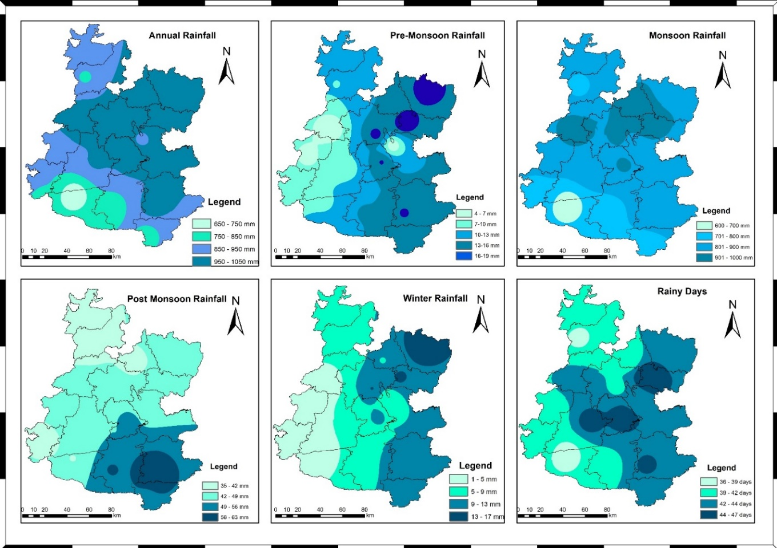

**Figure. 2. Average rainfall distribution in Western Madhya Pradesh for the period of 1980-2023**

Figure 2 shows that the northeastern part of western Madhya Pradesh receives the highest average rainfall during the annual, pre-monsoon, and monsoon seasons, while the northern regions receive the least. The southern part experiences the highest post-monsoon rainfall, whereas the northern areas receive the least. Winter rainfall is lowest in the western part of the region, including districts like Ratlam, Jhabua, Alirajpur, and parts of Dhar and Barwani, while it is highest in the eastern areas, particularly in Rajgarh and parts of Shajapur. Additionally, the northern and western regions of western Madhya Pradesh experience fewer rainy days, in contrast to the southern and eastern areas, which have more.

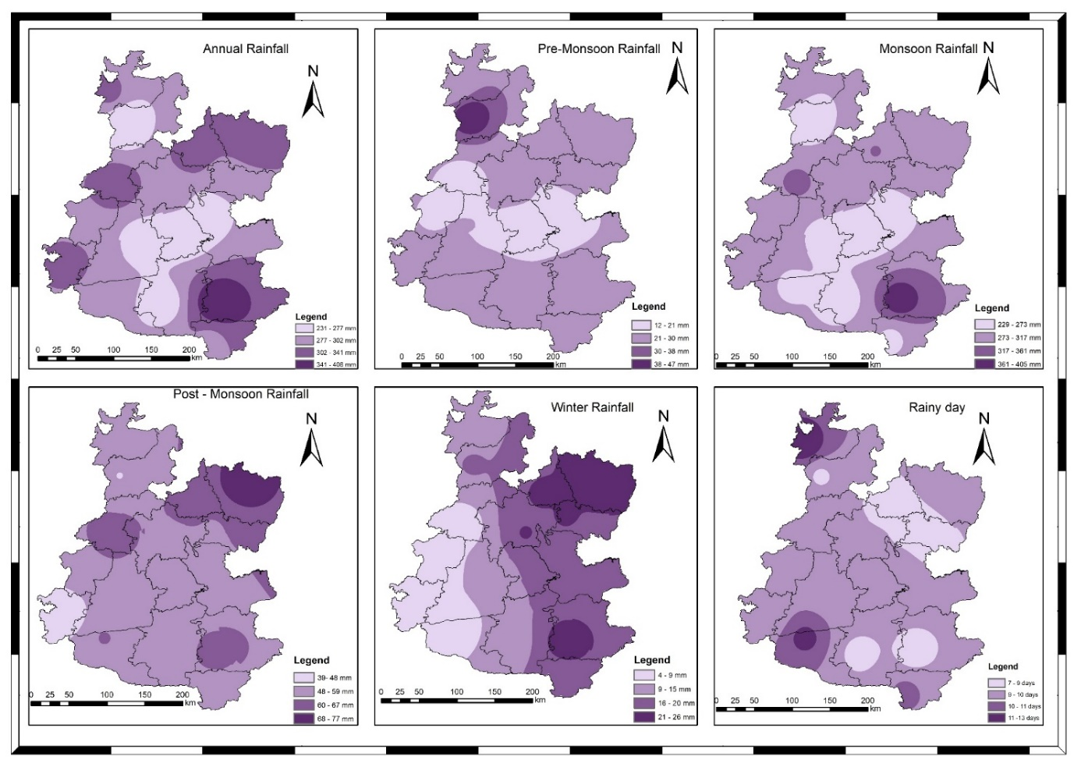

**Figure.3. Average Standard deviation distribution in Western Madhya Pradesh for the period of 1980-2023**

Important statistical indicators that offer insights into rainfall patterns both spatially and temporally are the Standard Deviation (SD), which measures the dispersion within the dataset, and the Coefficient of Variation (CV), which reflects inter-annual rainfall variation. These indicators are detailed in Table 2, with their spatial distribution shown in Figures 3 and 4. The SD of average annual rainfall was highest in Khandwa (408.4 mm) and lowest in Mandsaur (231.5 mm). The CV for average annual rainfall was highest in Badwani (43.1%) and lowest in Indore (24.8%). For pre-monsoon rainfall, the highest SD was observed in Alirajpur (27.7 mm), while the highest CV (367.1%) was recorded in Ratlam. Dewas showed the lowest SD (12.3 mm), and the lowest CV was observed in Indore (94%) for pre-monsoon rainfall. In terms of monsoon rainfall, Ratlam exhibited the highest SD (966.9 mm), and Khandwa had the highest CV (45.8%). The lowest SD was observed in Indore (229.4 mm), and the lowest CV (25.1%) was also in Indore. For post-monsoon rainfall, Rajgarh had the highest SD (77.3 mm) and CV (161.7%), while Alirajpur had the lowest SD (39.5 mm) and Khargone the lowest CV (88.8%). Winter rainfall analysis revealed that Rajgarh had the highest SD (26.1 mm), while Ratlam had the highest CV (342.2%). The lowest SD and CV were found in Alirajpur (4.1 mm) and Rajgarh (150.3%), respectively. Regarding the number of rainy days, Shajapur had the lowest SD (7.9 days) and CV (16.5%), while Neemuch had the highest SD (13.2 days), and Badwani had the highest CV (34.4%).

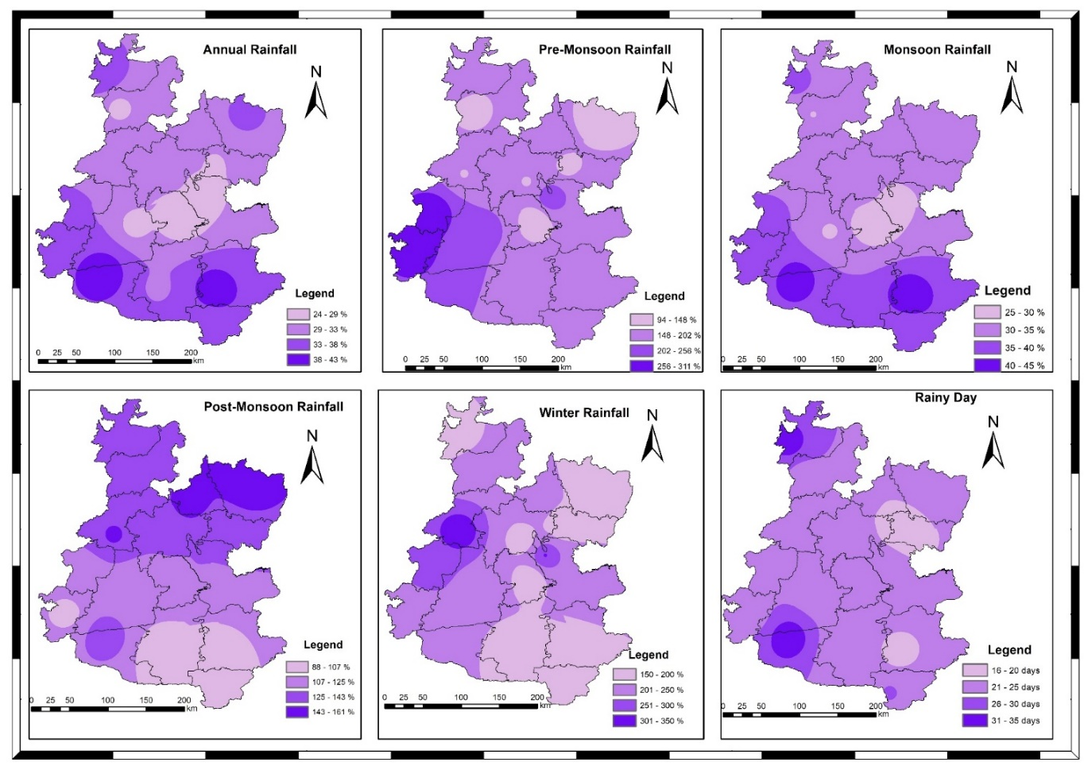

**Figure. 4. Average coefficient of Variance distribution in Western Madhya Pradesh for the period of 1980-2023**

Figure 3 shows that the southern part of western Madhya Pradesh exhibits the highest standard deviation, indicating greater variability in rainfall in this region. In contrast, the central area of western Madhya Pradesh experiences lower rainfall variability due to its topography, which lacks hills or other features that could generate orographic precipitation. According to Figure 2, the southwestern region of western Madhya Pradesh receives the least rainfall, with both the lowest standard deviation and coefficient of variation. The southwestern part also shows a relatively higher coefficient of variation, while the central part displays a lower value. Additionally, the SD of rainy days is highest in the northern and southern parts of the region, decreasing as one moves eastward.

### Standardized Rainfall Anomalies (SRA)

The Standardized Rainfall Anomalies (SRA) for the Malwa region reveal that Khandwa district experienced its driest year in 1992, with an SRA of -1.2%, followed by another dry year in 2000, also with an SRA of -1.2%. Figure 3.7 illustrates the standardized anomaly of annual rainfall for stations with the highest SRA values within each agro-climatic zone. Table 3.7 lists the driest and wettest years based on the analysis of SRA values for annual rainfall across the 16 districts. Negative SRA values correspond to dry years, while positive values indicate wet years. The lowest SRA, representing the highest negative anomaly, was recorded at Rajgarh in the Malwa Plateau with -2.5. Other districts like Rajgarh and Khandwa also showed significant negative anomalies. The highest positive SRA anomalies were observed at Mandsaur, Badwani, and Agar Malwa, with values reaching 4.0. Other districts such as Khandwa, Indore, and Badwani also exhibited higher positive SRAs, spread across different agro-climatic zones. Rainfall in Madhya Pradesh displays considerable decadal variability, showing persistence, where a year with a negative anomaly is more likely to be followed by another dry year, and similarly, a year with a positive anomaly tends to be followed by another wet year.

The Standardized Rainfall Anomaly (SRA) values were calculated for the Malwa region to analyze inter-annual rainfall variability. Table 3 outlines the driest and wettest years across the 16 districts based on the SRA analysis. Negative SRA values correspond to dry years, while positive values indicate wet years. The most extreme negative anomaly, with an SRA of -2.5, occurred at Rajgarh in the Malwa Plateau. Other districts, including Rajgarh and Khandwa, also exhibited significant negative anomalies. In contrast, the highest positive SRA value of 4.0 was recorded in Mandsaur, Barwani, and Agar Malwa. Elevated positive anomalies were also observed in Khandwa, Indore, and Barwani, distributed across various agro-climatic zones. Overall, rainfall in Madhya Pradesh shows considerable decadal variability, with a persistent pattern where a year with a negative anomaly is likely followed by another dry year, and similarly, a year with a positive anomaly tends to be followed by another wet year. The Standardized Rainfall Anomaly is also depicted graphically in Figure 5 (a&b) for Khandwa and Rajgarh districts.

**Table 3 Standardized Rainfall Anomaly for 16 district of Malwa region**

|  |  |  |  |  |  |  |  |  |
| --- | --- | --- | --- | --- | --- | --- | --- | --- |
| **District** | **1st driest year** | **SRA** | **2nd driest year** | **SRA** | **1st wettest year** | **SRA** | **2nd wettest year** | **SRA** |
| **Agar Malwa** | 2001 | -1.6 | 1989 | -1.3 | 2015 | 3.3 | 2006 | 2.3 |
| **Dewas** | 2005 | -1.9 | 1989 | -1.7 | 2013 | 1.9 | 2019 | 1.6 |
| **Dhar** | 1991 | -1.3 | 1987 | -1.3 | 2022 | 2.0 | 1994 | 2.0 |
| **Indore** | 2000 | -1.5 | 2001 | -1.4 | 2022 | 3.0 | 2013 | 2.3 |
| **Mandsaur** | 2000 | -1.8 | 2020 | -1.7 | 2019 | 4.0 | 2023 | 1.9 |
| **Neemuch** | 1986 | -1.9 | 1988 | -1.6 | 2019 | 3.2 | 2006 | 1.7 |
| **Rajgarh** | 1989 | -2.5 | 2005 | -2.2 | 2011 | 1.9 | 2019 | 1.6 |
| **Ratlam** | 2014 | -1.7 | 2001 | -1.6 | 2006 | 3.0 | 2013 | 1.7 |
| **Shajapur** | 2005 | -1.5 | 2000 | -1.3 | 2015 | 2.9 | 2006 | 2.4 |
| **Ujjain** | 1991 | -1.8 | 1985 | -1.7 | 2006 | 2.3 | 2015 | 2.1 |
| **Badwani** | 2018 | -1.4 | 2012 | -1.1 | 2022 | 3.5 | 1994 | 2.3 |
| **Burhanpur** | 2009 | -1.7 | 2008 | -1.6 | 1993 | 2.4 | 1988 | 1.7 |
| **Khandwa** | 1992 | -1.2 | 2000 | -1.2 | 2019 | 3.2 | 2013 | 2.4 |
| **Khargone** | 1995 | -1.7 | 2005 | -1.6 | 1988 | 2.0 | 1981 | 0.0 |
| **Alirajpur** | 1985 | -1.4 | 1991 | -1.3 | 2006 | 2.5 | 2006 | 2.0 |
| **Jhabua** | 1985 | -2.0 | 2000 | -1.8 | 2006 | 2.7 | 2004 | 1.8 |

**Figure 5(a). Standardized Rainfall Anomalies of Khandwa district**

**Figure 5(b). Standardized Rainfall Anomalies of Rajgarh district**

### Drought assessment

In this study, the drought assessment has been carried out using rainfall departure analysis and probability distribution analysis approach in 16 districts of western part of Madhya Pradesh which is discussed in details in this section.

### Rainfall Departure Analysis

A departure analysis of annual and monsoon rainfall was conducted for the 16 districts in the western part of Madhya Pradesh to evaluate drought frequency, return periods, and drought severity/vulnerability. These characteristics were further assessed using drought indices. The district-wise drought frequency analysis based on annual and monsoon rainfall departures at a 75% threshold is presented in tabular form. The rainfall departure analysis revealed that the northern part of the region, particularly the Malwa Plateau, experienced more significant rainfall deficits compared to the southern regions, including the Nimar Valley and Jhabua Hills, due to the presence of the Vindhyan Hill sub-division. Figures 6 to 8 illustrate the rainfall departure at key stations across different districts. Notably, Rajgarh district recorded the highest annual rainfall departure of -85.59% in 1989, along with the highest monsoon rainfall departure of -86.02% in the same year. Burhanpur district experienced the highest annual rainfall departure of -53.7% and the highest monsoon rainfall departure of -55.9% in 1989. In Dewas district, the highest annual and monsoon rainfall departures were -51.47% and -48.42%, respectively, observed in 2005.

**Figure 6. Annual and monsoon rainfall departure at Rajgarh district**

**Figure 7. Annual and monsoon rainfall departure at Burhanpur district**

**Figure 8. Annual and monsoon rainfall departure at Dewas district**

### Analysis of drought characteristics for annual and monsoon season

The India Meteorological Department states that when the annual or seasonal rainfall deficit exceeds 25% of the long-term normal rainfall, the year can be classified as a drought year. The drought frequencies evaluated using annual and monsoon rainfall at all districts of Western Madhya Pradesh has been shown in Table 4 and the spatial representation has been shown in Figure 10.

**Table 4. Annual and monsoon drought return period and frequency**

|  |  |  |  |  |  |  |  |
| --- | --- | --- | --- | --- | --- | --- | --- |
| **Physical Range** | **District** | **Annual rainfall based analysis** | | | **Monsoon rainfall based analysis** | | |
| **Return Period** | **Drought Frequency** | **Drought Vulnerability** | **Return Period** | **Drought Frequency** | **Drought Vulnerability** |
| **Malwa Plateau** | **Agar Malwa** | 4.0 | 25 | 74.7 | 4.9 | 20.5 | 83.4 |
| **Dewas** | 3.7 | 27.3 | 76.8 | 3.4 | 29.5 | 77.3 |
| **Dhar** | 3.1 | 31.8 | 78.4 | 3.7 | 27.3 | 76.5 |
| **Indore** | 4.4 | 22.7 | 81.7 | 4.9 | 20.5 | 82.7 |
| **Mandsaur** | 5.5 | 18.2 | 88.8 | 4.0 | 25.0 | 88.3 |
| **Neemuch** | 3.1 | 31.8 | 74.8 | 3.1 | 31.8 | 76.6 |
| **Rajgarh** | 3.4 | 29.5 | 75.1 | 3.7 | 27.3 | 74.6 |
| **Ratlam** | 2.9 | 34.1 | 78.3 | 3.7 | 27.3 | 76.8 |
| **Shajapur** | 4.0 | 25.0 | 73.8 | 3.4 | 29.5 | 80.5 |
| **Ujjain** | 3.4 | 29.5 | 75.3 | 3.4 | 29.5 | 77.5 |
| **Average** | 3.76 | 27.50 |  | 3.81 | 26.82 |  |
| **Nimar Valley** | **Badwani** | 2.2 | 45.5 | 65.6 | 2.2 | 45.5 | 56.2 |
| **Burhanpur** | 3.7 | 27.3 | 77 | 4 | 25 | 73.7 |
| **Khandwa** | 2.4 | 40.9 | 63.1 | 2.3 | 43.2 | 66.3 |
| **Khargone** | 3.1 | 31.8 | 74.7 | 3.7 | 27.3 | 72.3 |
| **Average** | 2.86 | 36.36 |  | 3.05 | 35.23 |  |
| **Jhabua Hills** | **Alirajpur** | 2.4 | 40.9 | 67.1 | 2.6 | 38.6 | 67.2 |
| **Jhabua** | 3.7 | 27.3 | 81.0 | 3.7 | 27.3 | 77.2 |
| **Average** | 3.06 | 34.09 |  | 3.13 | 32.95 |  |

The analysis revealed that the drought return period for annual rainfall was shortest in Badwani district, with a drought event occurring once every 2 to 3 years, indicating a high likelihood of drought in this region. The highest drought frequency, recorded at 45.45%, was observed in Badwani district, as shown in Table 3. Other districts such as Dewas, Dhar, Neemuch, Rajgarh, Ujjain, Burhanpur, Khargone, and Jhabua experience one drought event every 3 to 4 years. For monsoon rainfall, Badwani, Khandwa, and Alirajpur districts exhibited the shortest drought return periods, with one drought occurring every 2 to 3 years, and their respective drought frequencies were 45.45%, 43.18%, and 2.59%. Indore district had the longest drought return period, with a drought event occurring every 5 years, and the drought frequency in this district was 22.73%.

To assess the severity of drought, districts were classified as either normal or drought-prone. A district is considered drought-prone if its rainfall deficit exceeds 25%, while it is categorized as normal if it receives more than 75% of its average rainfall. Table 5 provides an analysis of drought severity for both annual and monsoon rainfall.

**Table 5. Drought severity of western Madhya Pradesh**

|  |  |  |  |  |  |  |  |
| --- | --- | --- | --- | --- | --- | --- | --- |
| **Physical Range** | **District** | **Annual rainfall based analysis** | | | **Seasonal rainfall based analysis** | | |
|  |  | **75% of Annual RF** | **Probability of Exceedance of 75% of Annual RF** | **Station Characteristics** | **75% of Annual RF** | **Probability of Exceedance of 75% of Annual RF** | **Station Characteristics** |
| **Malwa Plateau** | **Agar Malwa** | 751.07 | 80.24 | Normal | 705.07 | 83.43 | Normal |
|  | **Dewas** | 680.95 | 76.79 | Drought Prone | 640.62 | 77.30 | Drought Prone |
|  | **Dhar** | 705.46 | 78.41 | Drought Prone | 658.02 | 76.47 | Drought Prone |
|  | **Indore** | 743.02 | 81.72 | Normal | 684.89 | 82.73 | Normal |
|  | **Mandsaur** | 617.90 | 88.77 | Normal | 578.02 | 88.27 | Normal |
|  | **Neemuch** | 650.01 | 74.78 | Drought Prone | 605.34 | 76.63 | Drought Prone |
|  | **Rajgarh** | 730.61 | 75.06 | Drought Prone | 668.31 | 74.57 | Drought Prone |
|  | **Ratlam** | 763.60 | 78.33 | Drought Prone | 725.19 | 76.77 | Drought Prone |
|  | **Shajapur** | 754.61 | 79.60 | Drought Prone | 696.63 | 80.47 | Normal |
|  | **Ujjain** | 739.52 | 75.34 | Drought Prone | 683.32 | 77.55 | Drought Prone |
|  | **Average** | 713.67 | 78.90 | Drought Prone | 664.54 | 79.42 | Drought Prone |
| **Nimar Valley** | **Badwani** | 489.54 | 65.57 | Drought Prone | 448.94 | 56.17 | Drought Prone |
|  | **Burhanpur** | 605.60 | 77.02 | Drought Prone | 544.70 | 75.27 | Drought Prone |
|  | **Khandwa** | 733.93 | 63.14 | Drought Prone | 663.95 | 66.33 | Drought Prone |
|  | **Khargone** | 589.80 | 74.74 | Drought Prone | 531.49 | 72.28 | Drought Prone |
|  | **Average** | 604.72 | 70.12 | Drought Prone | 547.27 | 67.51 | Drought Prone |
| **Jhabua Hills** | **Alirajpur** | 628.61 | 67.10 | Drought Prone | 590.80 | 67.24 | Drought Prone |
|  | **Jhabua** | 669.25 | 80.98 | Normal | 631.19 | 77.23 | Drought Prone |
|  | **Average** | 648.93 | 74.04 | Normal | 611.00 | 72.23 | Drought Prone |

According to Table 5, it was observed that twelve out of the sixteen districts were identified as drought-prone, while the remaining four districts were classified as normal. Specifically, the drought-prone districts—Dewas, Dhar, Neemuch, Rajgarh, Ratlam, Ujjain, Badwani, Burhanpur, Khandwa, Khargone, Alirajpur, and Jhabua—were determined based on the analysis of monsoon rainfall. The other four districts—Agar Malwa, Indore, Mandsaur, and Shajapur—were found to be in normal condition. Figure 9 (a & b) shows the typical annual and monsoon rainfall probability distribution for Rajgarh district, while Figure 10 provides a spatial representation of the rainfall probability distribution across Western Madhya Pradesh.

**Figure 9 (a). Annual Rainfall probability distribution graph at Rajgarh district**

**Figure 9 (b). Monsoon Rainfall probability distribution graph at Rajgarh district**

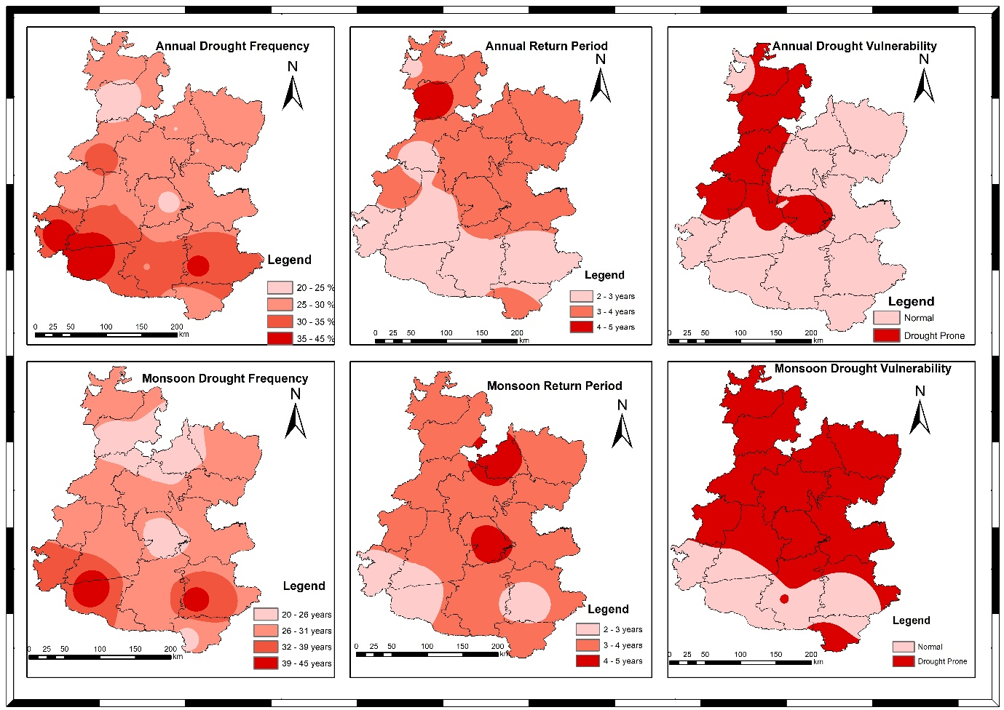

**Figure 10. Drought Frequency, Return Period and Drought vulnerability of both Annual and Monsoon distribution in Western Madhya Pradesh for the period of 1980-2023**

According to Figure 10, the northern part of Western Madhya Pradesh, specifically the Malwa region, is characterized by the shortest drought return period due to its flat landscape and the absence of mountains, which results in lower rainfall. In contrast, the southern part, including the Nimar Valley and Jhabua Hills, experiences the longest drought return periods due to the presence of the Vindhyan mountain subdivision. This indicates that districts in the Malwa region experience more frequent drought events compared to those in the Nimar Valley and Jhabua Hills. Drought frequency was found to be lowest in the southern part of the Nimar Valley and Jhabua Hills, while it was higher in the northern areas. Drought severity analysis showed that drought-prone districts were primarily located in the northern part of the region, specifically the Malwa region, as depicted in Figure 10.

# SUMMARY AND CONCLUSION

The study assessed the rainfall variability and drought characteristics across 16 districts in the western part of Madhya Pradesh using 44 years of rainfall data (1980–2023). The analysis incorporated various statistical methods, includi homogeneity, randomness, and autocorrelation tests, rainfall variability analysis, standardized rainfall anomaly (SRA) assessments, rainfall departure analysis, and drought frequency and severity studies. The homogeneity and randomness tests revealed that most districts had homogeneous and randomly distributed rainfall data, with a few exceptions like Neemuch, Khandwa, and Jhabua. Negative autocorrelation was observed in several districts, implying variability in trend detection. The rainfall variability analysis showed significant spatial and temporal variations across the region. The highest annual rainfall was recorded in Ratlam, while Badwani recorded the lowest. The coefficient of variation (CV) for rainfall indicated that Badwani had the highest inter-annual variability, highlighting its vulnerability to irregular rainfall.

Spatial patterns demonstrated that the northern and eastern parts received more rainfall compared to the western and southern parts. The Standardized Rainfall Anomalies (SRA) analysis indicated frequent negative anomalies (deficit rainfall) in the Malwa Plateau (northern region), whereas Nimar Valley and Jhabua Hills (southern regions) exhibited relatively better rainfall stability, likely due to the presence of orographic features like the Vindhya ranges. The rainfall departure and drought analysis revealed that the Malwa region experiences higher drought frequency and shorter return periods, suggesting that drought events occur more frequently (every 2–3 years) compared to Nimar Valley and Jhabua Hills. Districts like Badwani, Dewas, Dhar, and Rajgarh emerged as highly drought-prone. Conversely, Indore, Agar Malwa, Mandsaur, and Shajapur were categorized as relatively normal districts based on rainfall deficit thresholds. Spatial mapping of drought severity and frequency confirmed that the northern plain areas of Malwa Plateau are more drought-prone, while the southern regions, protected by the Vindhya hills' sub-division, experience fewer droughts. Malwa region emerges as the most vulnerable zone to rainfall variability and droughts within western Madhya Pradesh. These findings underline the critical need for targeted drought mitigation strategies, sustainable water resource management, and climate-resilient agricultural practices in the region. Future planning and policy interventions must prioritize these vulnerable districts to enhance their resilience against the increasing challenges posed by climate variability and change.

**Disclaimer (Artificial intelligence)**

Author(s) hereby declare that NO generative AI technologies such as Large Language Models (ChatGPT, COPILOT, etc.) and text-to-image generators have been used during the writing or editing of this manuscript.

# REFERENCES

1. Gadgil, S., & Srinivasan, J. (2021). *Monsoon variability and climate change in India*. Current Science, 120(3), 449-457.
2. Galkate, R. V., Pandey, R. P., & Yadava, S. (2022, December). Assessment of Rainfall Variability and Drought Features in Bundelkhand Region of Madhya Pradesh, India. In 5th World Congress on Disaster Management: Volume II (pp. 278-289). Routledge.
3. Dhruw, G., Agrawal, N., & Jaiswal, R. K. (2024). Rainfall-runoff Modelling Using MIKE11 NAM Model for Ravishankar Sagar Catchment, Chhattisgarh, India. International Journal of Environment and Climate Change, 14(4), 719-738.
4. Dhankar, Bhupendra, Jitendra Sinha, and Rahul Kumar Jaiswal. 2025. “Assessment of Rainfall-Runoff Using HEC-HMS in Ravishankar Sagar Reservoir, Dhamtari, Chhattisgarh, India”. International Journal of Environment and Climate Change 15 (4):1-15.
5. Kumari, P., Jaiswal, R. K., & Singh, H. P. (2024). Assessing climate change impacts on irrigation water requirements in the Lower Mahanadi Basin: A CMIP6-based spatiotemporal analysis and future projections. Journal of Water and Climate Change, jwc2024152.
6. Galkate, R. V., Yadav, S., Jaiswal, R. K., & Yadava, R. N. (2020). Trend analysis of river flow and groundwater level for Shipra river basin in India. Arabian Journal of Geosciences, 13(3), 1-9.
7. Jaiswal, R. K., Tiwari, H. L., & Lohani, A. K. (2017). Assessment of climate change impact on rainfall for studying water availability in upper Mahanadi catchment, India. Journal of Water and Climate Change, 8(4), 755-770.
8. Singh, A., Kumar, R., & Das, S. (2021). *Climate change and its impact on rainfall patterns in North-East India*. Journal of Climatology and Weather Forecasting, 9(2), 45-53.
9. Krishna Kumar, K., Rajagopalan, B., & Cane, M. A. (2021). *Climate change and the weakening of the Indian summer monsoon rainfall*. Science, 347(6227), 728-731.
10. Patel, A., Thomas, T., Singh, R. M., Yadav, V. S., Kumar, D., & Kaushal, A. (2025). Assessment of Climatic Variables for the Mahi River Basin in Western India. International Journal of Environment and Climate Change, 15(4), 287–303.
11. Saha, S. K., Nair, A. R., & Goswami, B. N. (2023). *Regional disparities in Indian monsoon rainfall and implications for agriculture*. Climate Dynamics, 60(1), 29-43.
12. Jaiswal, R. K., Lohani, A. K., & Tiwari, H. L. (2015). Statistical analysis for change detection and trend assessment in climatological parameters. Environmental Processes, 2, 729-749.
13. Mishra, V., Tiwari, A. D., & Shah, R. D. (2022). *Extreme weather events and rainfall variability in India under climate change*. Weather and Climate Extremes, 35, 100384.
14. Patel, A., Kumar, D., Yadav, V. S., Harode, P. K., & Kaushal, A. (2025). Comparison of Aridity Indices in Mahi River Basin under Climate Change Scenarios. Journal of Experimental Agriculture International, 47(4), 234–257.
15. Singh, D., Swain, D. L., & Horton, D. E. (2021). *Rising extreme rainfall events over central India and their association with climate change*. Geophysical Research Letters, 48(7), e2020GL090902
16. Galkate, R. V., Pandey, R. P., Thomas, T., Jaiswal, R. K., & Nayak, T. R. (2015). Meteorological and hydrological aspects of drought in central Indiapreparedness and management of water related disasters’, 3rd India Water Week 2015, water Management for Sustainable Development, 13–17 January 2015. New Delhi.
17. Kumar, M., Tripathi, S. K., & Singh, A. (2022). *Socio-economic implications of drought and rainfall variability in Bundelkhand region*. Journal of Climate Change, 8(2), 15-28.
18. Pai, D. S., & Rajeevan, M. (2020). *Observed changes in the Indian summer monsoon rainfall patterns*. Theoretical and Applied Climatology, 141(3-4), 1297-1308.
19. Jaiswal, S., Galkate, R., Chandola, V. K., Singh, P., & Thakur, A. (2019). Assessment of drought in Shipra River Basin, Madhya Pradesh. Journal of Soil and Water Conservation, 18(2), 188.
20. Chowdary, V. M., Rao, V. U. M., & Sikka, A. K. (2023). *Strategies for managing climate-induced rainfall variability in Indian agriculture*. Agricultural Systems, 205, 103556.
21. Panda, S., Tripathi, V. K., & Yadav, V. S. (2025). A synergetic approach for multidimensional drought assessment in the Indian agro-climatic zone using coherency, propagation and AHP techniques. *Environmental Science and Pollution Research*, 1-18.
22. Mall, R. K., Srivastava, R. K., & Banerjee, T. (2022). *Climate change, extreme events and agriculture: Adaptation perspectives from India*. Regional Environmental Change, 22(1), 12.
23. Yadav, V. S., Galkate, R. V., Chandola, V., Panda, S., & Patel, A. (2024). Trend Analysis and Change Point Detection of Climatic Parameters in Ambedkar Nagar District of Uttar Pradesh, India. *International Journal of Environment and Climate Change*, *14*(9), 578–605.
24. Pai, D. S., Rajeevan, M., Sreejith, O. P., Mukhopadhyay, B., & Satbha, N. S. (2014). Development of a new high spatial resolution (0.25× 0.25) long period (1901-2010) daily gridded rainfall data set over India and its comparison with existing data sets over the region. Mausam, 65(1), 1-18.
25. Yadav, V. S., Galkate, R. V., Chandola, V. K., Patel, A., Panda, S., Kaushal, A., & Ahirwar, H. R. (2025). Evaluation of Rainfall Variability and Meteorological Drought in Bundelkhand Region, India. Journal of Experimental Agriculture International, 47(4), 181–200.
26. Joseph, S., Sahai, A. K., & Goswami, B. N. (2021). *Increasing trend of extreme rainfall events over the Western Ghats of India*. International Journal of Climatology, 41(4), 2315-2330.
27. Doe, J., & Smith, A. (2024). Understanding rainfall variability and its implications. *Climate Research Journal, 35*(4), 215-230.
28. Gupta, A. K., Nair, S. S., Ghosh, O., Singh, A., & Dey, S. (2014). Bundelkhand drought: retrospective analysis and way ahead. *National Institute of Disaster Management, New Delhi*, *148*.
29. Ramaraj, A. P., Kokilavani, S., Manikandan, N., Arthirani, B., & Rajalakshmi, D. (2015). Rainfall stability and drought valuation (using SPI) over southern zone of Tamil Nadu. Current World Environment, 10(3), 928.
30. Yaseen, K., AL-Timimi & AL-Jiboori. (2013). Assessment of spatial and temporal drought in Iraq during the period 1980-2010. International Journal of Energy and Environment, 4(2): 291-302.
31. Singh, R., Kumar, M., & Tripathi, S. (2020). Rainfall variability and its impact on agriculture in Bundelkhand. Climate Change Journal, 15(2), 157-172.
32. India Meteorological Department. (2002). End of season report [Online]. Southwest monsoon. Available: 〈http://www.imd.gov.in/section/nhac/dynamic/mid1.htm〉; 4 October 2002 Accessed February 2013
33. Wilhite, D. A. (Ed.). (2012). *Drought assessment, management, and planning: theory and case studies: theory and case studies* (Vol. 2). Springer Science & Business Media.
34. Meena, P. K., Khare, D., Chandniha, S. K., & Harithalekshmi, V. Spatial and Temporal Trend Analysis of Precipitation and Temperature Data in Malwa Region of Kshipra River Basin, India.