SCREENING OF GLADIOLUS CULTIVARS FOR TOLERANCE TO ROOT-KNOT NEMATODE (Meloidogyne incognita)

ABSTRACT
The study aimed to find out the source of resistance against root-knot nematode, Meloidogyne incognita in different gladiolus cultivars. The experiment was conducted in the nursery of Plantation Crop Garden, Biswanath College of Agriculture, AAU, Biswanath Chariali, Assam during rabi season 2023. Plastic pots of 1000 cm³ capacity were filled with sterilized soil, sand and cow dung mixture in the ratio of 2:1:1. After filling of pots a single corm of eight different gladiolus cultivars were planted in each pot. The pots were arranged in completely randomized design with five replications for each cultivar. Fifteen day after planting each plant was inoculated with freshly hatched second stage juveniles of M. incognita @1 J₂/cm³ soil. Upon observation two months after inoculation results showed that three cultivars viz. Arka Amar, Suchitra and Pusa Suhangini were recorded as susceptible and other five cultivars viz. Red Candiman, American Beauty, Arka Arti, Arka Darshan and White Prosperity were recorded as moderately resistant. From this experiment it can be concluded that no one cultivar found to be resistant against root-knot nematode. Five cultivars were found to be moderately resistant and others were recorded as susceptible. In absence of resistant cultivars, moderately resistant cultivars can be planted in root-knot nematode endemic areas as alternative to susceptible cultivars.

Key words: Cultivar, gladiolus, resistant, root-knot nematode, susceptible

- INTRODUCTION

Gladiolus (Gladiolus grandiflorus L.), is a perennial herbaceous flowering plant. It is cultivated commercially in India as cut flowers, due to its beautiful and attractive flower spikes, excellent vase life, captivating flower colors and their high feasibility (Bose et al., 2003). Gladiolus belongs to the family Iridaceae contains about 260 species (Singh, 2014; Abdel-Kader et al., 2020). In Europe it is commonly known as ‘sward lily’ and ‘corn flag’ due to its sward shaped foliage. They are used as landscape plants in the home gardens, as specimens for exhibition, and as cut flowers. Domestic as well as international market gladiolus is a popular cut flower (Singh and Sisodia, 2017). Among cut flowers gladiolus occupies fifth place in the international floriculture trade and 4th position in bulbous flower trade (Kumar et al., 2007; Balaram and Janakiram, 2009). Gladiolus is very easy to grow under open field condition. In India gladiolus is commercially cultivated in several states like West Bengal, Maharashtra, Uttarakhand, Assam, Madhya Pradesh, Chhattisgarh, Karnataka, Haryana, Uttar Pradesh, Sikkim, Manipur, Delhi, Goa, Telangana, Gujarat etc.
Gladiolus plant is very much prone to attack by several pests and diseases. Among the various limiting factors in commercial cultivation of gladiolus, the plant parasitic nematodes are presently considered to be the most important one. Out of several pathogenic nematodes, the root-knot nematode is considered as one of the most important pathogen of gladiolus (Devappa et al., 2012) causing a significant decline in the flower quality (Hasan and Khan, 2004) and causing damage to corms and cormels (Khanna and Chandel, 1997). Several species of root-knot nematode viz., Meloidogyne incognita, M. incognita acrita, M. arenaria, M. javanica, M. hapla and M. thamesi not only attack roots of gladiolus during the growing season, but also invade the daughter corm, stolons, and cormels as these appear during crop development (Overman, 1985). The symptoms of root-knot nematode infestation include stunted growth, wilting, yellowing of leaves, and root galling (Fig 1). In addition to causing direct damage infection of roots by root-knot nematodes predisposes plants to infection by soil-borne root-infecting fungi- Fusarium. oxysporum f.sp. gladioli resulting in extensive financial loss to the growers (Chandel and Bhardwaj, 2000). Several research findings indicate that root-knot nematode infecting gladiolus can effectively be managed by various methods (Ravishankar and Singh, 2005; Abo-Korah, 2021) but very limited information is available regarding resistant cultivars of gladiolus against root-knot nematode (Khanna et al, 1998; Sakhuja et al., 2000) as host plant resistance is effective nematode management tool and considered as economically feasible and environmentally safe method as compared to chemical nematicides (Mukhtar et al, 2017; Yadav et al, 2023) and these cultivars can be incorporated in integrated nematode management schedule with other management practices( Divya et al., 2021). Keeping these facts in view, the present investigation has been undertaken to screen out gladiolus cultivars for their reactions to root-knot nematode, M. incognita.

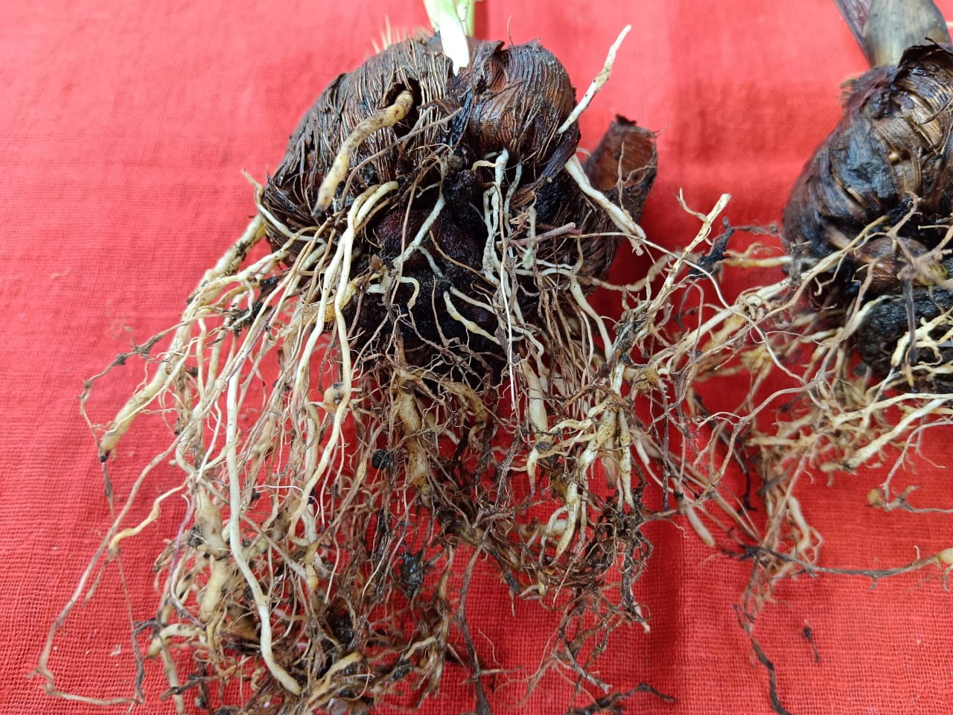.
Fig. 1. Galling on roots of gladiolus
2. MATERIALS AND METHODS
A pot experiment was conducted in the Nursery facility of Plantation Crop Garden, Biswanath College of Agriculture. The facility is located at 26.7° (26°42’) N latitude, 93.5° (93°30’) E longitude and altitude 105m amsl, AAU, Biswanath Chariali, Assam, India. The trial was conducted during rabi season of 2023 to assess the performance of some gladiolus cultivars for tolerance to root-knot nematode (M. incognita). Corms of eight gladiolus cultivars were collected from the Instructional cum Research Farm, Department of Horticulture, Biswanath College of Agriculture, AAU, Biswanath Chariali, Assam and AAU-Horticultural Research Station, Kahikuchi, Assam. Plastic pots of 1000 cm³ capacity were filled with sterilized soil, sand and cow dung mixture in the ratio of 2:1:1. After filling of pots a single corm of different gladiolus cultivars were planted in each pot. The pots were arranged in completely randomized design with five replications for each cultivar. At 15 days after planting the growing seedlings were inoculated with freshly hatched second stage juveniles of M. incognita @ 1000J₂ per plant per pot. Regular watering was done till the terminations of the experiment. At two months after inoculation the plants were carefully uprooted and the roots were properly washed under running tap water to remove the adhering soil particles in them. Observations on number of galls, eggmasses per root system and root-knot index were recorded. The varieties were categorized as highly resistant (HR), resistant(R), moderately resistant (MR), susceptible(S) and highly susceptible (HS) on the basis of number of galls per plant following the 1-5 gall index scale by Taylor and Sasser, (1978)
Table 1. Gall index (1to 5scales)
Scale | Particulars | Reaction
1. | No gall, no eggmass | Highly Resistant(HR)
2. | 1-10 galls with eggmasse per plant | Resistant (R)
3. | 11-30 galls with eggmasses per plant | Moderately Resistant(MR)
4. | 31-100 galls with eggmasses per plant | Susceptible (S)
5. | Above 101 galls with eggmasses per plant | Highly Susceptible(HS)

Data were analyzed statistically using analysis of variance and Fisher’s least significant difference (FLSD) was calculated for separation of mean. The analysis was carried out in OPSTAT 1.0.2 version statistical software. The statistical software had provided the results of separation of means for comparison purposes.

- RESULTS AND DISCUSSION
Data presented in Table 2 showed that out of eight cultivars screened against M. incognita, three cultivars viz. Arka Amar, Suchitra and Pusa Suhangini were found to be susceptible and other five cultivars viz. Red Candiman, American Beauty, Arka Arti, Arka Darshan and White Prosperity were found to be moderately resistant. Among the screened cultivars, number of galls produced per root system ranged from 24.6 to 33.9. Maximum numbers of galls were recorded in the cultivar Pusa Suhangini (33.90), followed by Suchitra (33.20), while cultivar Arka Darshan recorded the lowest of 24.60. This finding is in conformity with the findings of Khan et al. (2017), who reported that gladiolus cultivar White Prosperity was found to be moderately tolerant against F. oxysporum and cultivar American Beauty was found to be moderately tolerant against M. incognita. Similarly, Mahalik and Mahapatra (2020) screened fifteen gladiolus cultivars against root-knot nematode and none were found to be resistant. However, the cultivar Precilla and Pink dream were recorded as moderately resistant and all others were classified as susceptible. In the present study considerable variation was found regarding galls in the roots due to infestation of root-knot nematode in different cultivars of gladiolus. This variability in tolerance to the root-knot nematode might be influenced by host plant genetics and prevailing environmental conditions (Kadam et al., 2014; Negi et al., 2014; Rani et al., 2007). Presence of nematode resistance genes makes the plant root less attractive for attack by plant parasitic nematodes. Resistance and susceptibility to plant parasitic nematodes reflect the effect of the plant on the nematode’s ability to reproduce (Sharma et al., 2006). Resistant and moderately resistant cultivar reduces nematode reproduction and development thereby directly affects the residual nematode population density under field conditions (Cook and Evans, 1987). Breeding programs for resistance to root-knot nematodes would be best served by selecting resistant genotypes based on root-knot index in preliminary evaluations, followed by selection based on nematode reproduction in advanced evaluations (Hussey and Janssen, 2004). Thus, the use of resistant cultivar is very important component for the management of root- knot nematode population in horticultural crops as these crops are very vulnerable to attack by root-knot nematode. Commercial cultivation of varieties resistant to root-knot nematode developed through various breeding program will ultimately lead to reduction of yield losses caused by root-knot nematode.

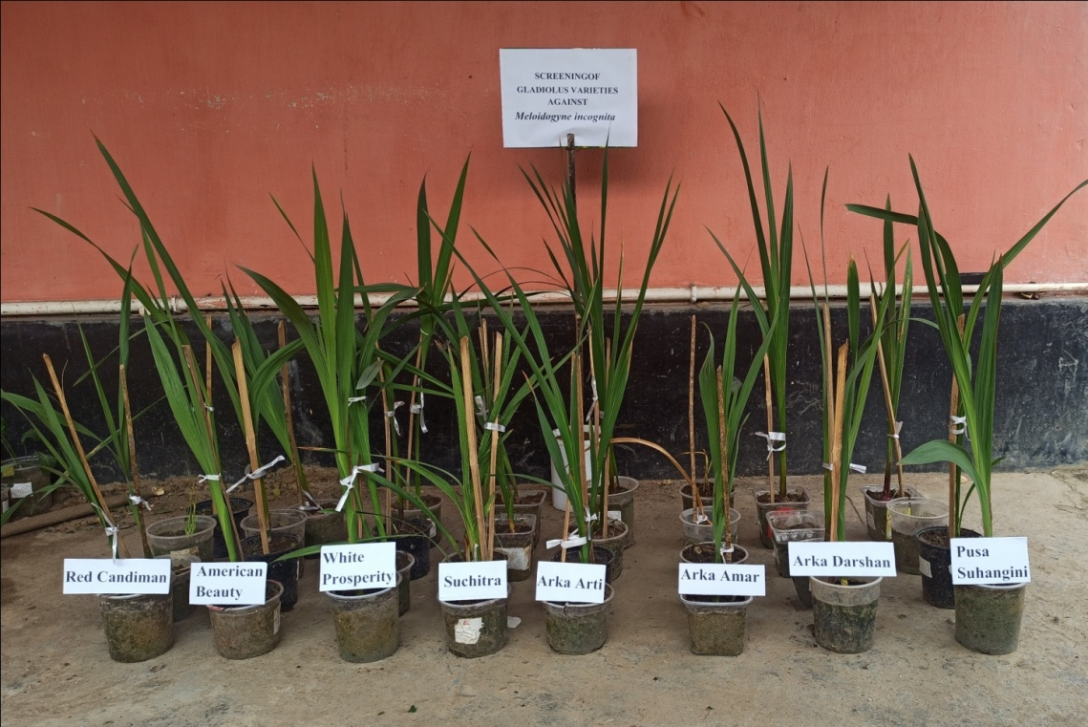
Fig. 2. View of the experiment
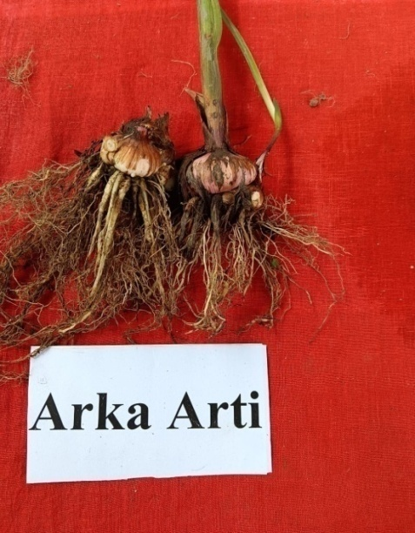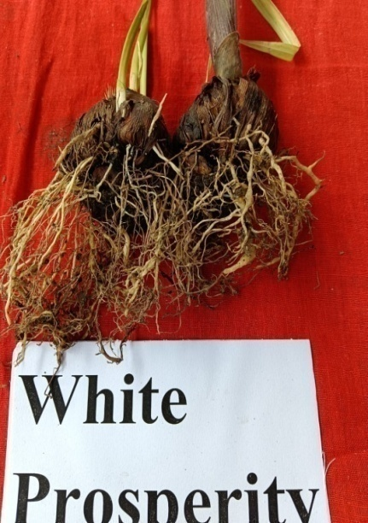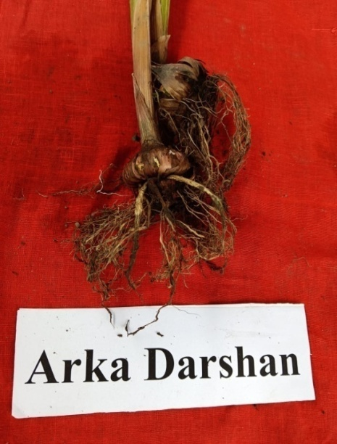
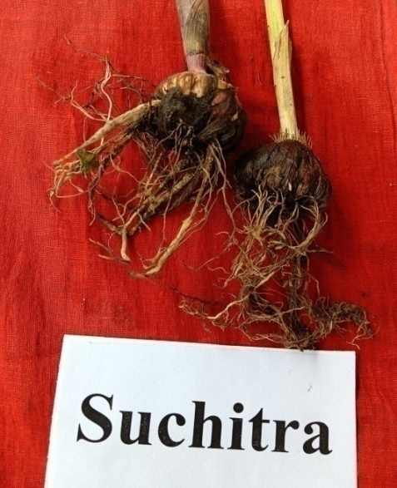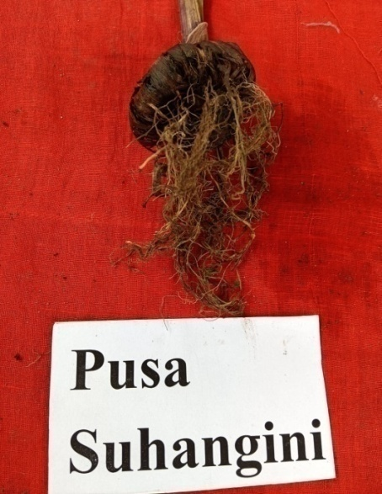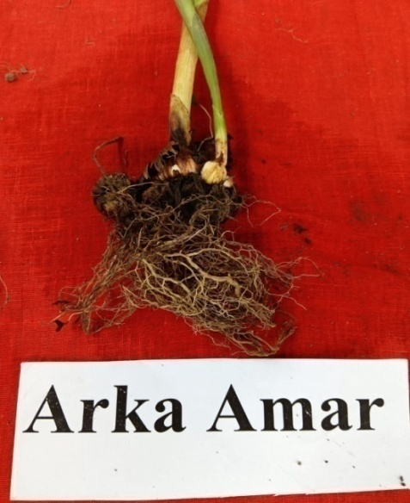
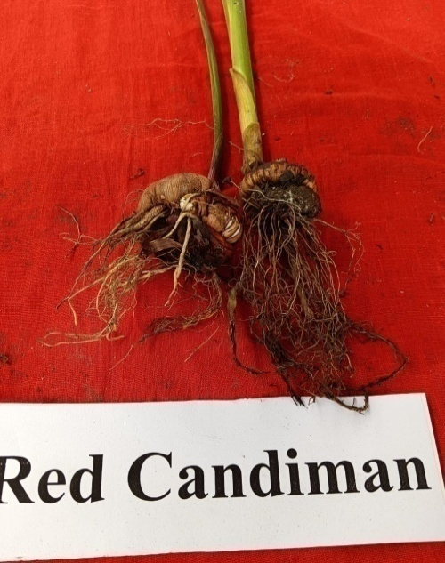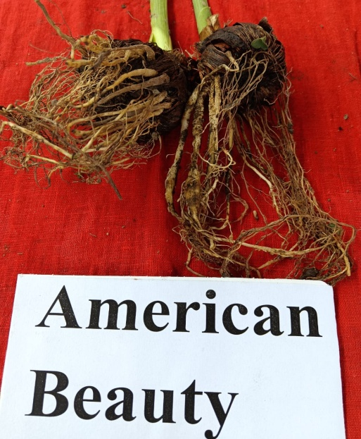
Fig.3. Galls on the roots of different gladiolus cultivars
Table 2. Mean numbers of galls, eggmasses and root-knot index measured in gladiolus cultivars

Cultivars | Number of galls/plant | Number of eggmasses/plant | Root-knot index | Reaction
Arka Arti | 26.20 | 28.40 | 3.00 | Moderately resistant
Arka Darshan | 24.60 | 26.00 | 3.00 | Moderately resistant
Arka Amar | 32.00 | 34.20 | 3.60 | Susceptible
White Prosperity | 26.60 | 29.20 | 3.00 | Moderately resistant
Suchitra | 33.20 | 36.00 | 3.60 | Susceptible
Red Candiman | 28.80 | 30.40 | 3.00 | Moderately resistant
Pusa Suhangini | 33.90 | 37.20 | 3.80 | Susceptible
American Beauty | 26.40 | 29.80 | 3.00 | Moderately resistant
SE(d) | 2.29 | 1.41 | 0.19
CD(0.05) | 4.72 | 2.91 | 0.39
* SE (d): Standard error deviation * CD: Critical difference

- CONCLUSION
Results from the experiment it was found that no cultivars showed resistant reaction against root-knot nematode. Five cultivars viz. Red Candiman, American Beauty, Arka Arti, Arka Darshan and White Prosperity were found to be moderately resistant. In absence of resistant cultivars, these moderately resistant cultivars may be recommended for plantation instead of susceptible cultivars in root-knot nematode infested areas to get economic yield.
5. FUTURE SCOPE
To search the source of resistance in future it is necessary to screen more gladiolus cultivars against root-knot nematode as root-knot nematode is a serious threat in gladiolus cultivation.
DISCLAIMER (ARTIFICIAL INTELLIGENCE
Author(s) hereby declare that NO generative AI technologies such as Large Language Models (ChatGPT, COPILOT, etc.) and text-to-image generators have been used during the writing or editing of this manuscript.
ACKNOWLEDGEMENTS
The authors extend their sincere gratitude to Dr. Supriya Langthasa, Professor, Department of Horticulture, Biswanath College of Agriculture, AAU, Biswanath Chariali, Assam and Dr. S. K. Bora, Principal Scientist, AAU-Horticultural Research Station, Kahikuchi, Assam for providing gladiolus corm for the experiment.

COMPETING INTERESTS
Authors have declared that no competing interests exist.

REFERENCES
Abdel-Kader, H.H., El-Saady, W.A. & Zaky, H.A. (2020). Effect of magnetized water and NPK
fertilization treatments on growth and field performance of gladiolus. Journal of Plant Production, 11(7), 627–632.
Abo-Korah, M.S.(2021). Application of nematophagous fungi and salicylic acid as biological
control agents against root-knot nematode, Meloidogyne incognita infected gladiolus: a
valuable export plant. Egypt. J. Agronematol., 20(2), 53-63.
Balaram, M.V. & Janakiram, T. (2009). Genetic variability in gladiolus genotypes for corm
characters. Journal of Ornamental Horticulture, 12 (2), 123-126.
Bose, T. K., Yadav, L. P., Pal, P., Parthasarathy, V. A. & Das, P. (2003). Commercial Flowers.
Naya Udyog, Kolkata, India. (Research Report) 2, 137-140.
Chandel, S. S. & Bhardwaj, L. N. (2000). Effect of sowing dates and fungicidal treatment on the
management of fusarium wilt of gladiolus. Plant Dis. Res., 151, 24-27.
Cook, R. & Evans, K.(1987). Resistance and Tolerance. In: Principles and Practices of
Nematode Control in Crops (Eds. Brown, R.H. and Kerry, B.R.). Marrickville,
NSW, Australia: Academic Press, pp. 179-231.
Devappa V., Khan, M.R., Jahagirdar, S.& Shrikant, K.(2012). Nematode infestation in
Carnation, Crossandra, Chrysanthemum, Gladiolus, Jasmine, Rose and Tuberose. In:
Nematode Infestation Part III: Horticulture Crops. ( Eds. Khan, M.R. and Jairajpuri,
M.S.), National Academy of Sciences, India, pp. 445-463.
Divya, T.S., Nisha, M.S., Anitha, A.& Paul, A.(2021). Integrated management of root-knot
nematode, Meloidogyne incognita(Kofoid and White) Chitwood in cowpea. Indian
Journal of Nematology, 51(1), 74-80.
Hasan, A. & Khan, M.N. (2004). Interaction of root-knot nematode, VAM fungus and neem cake
in amended soils on gladiolus. Nematol. medit. 32, 95-99.
Hussey, R.S & Janssen, G.J.W. (2004). Root-knot Nematode: Meloidogyne Species. In: Plant
Resistance to Parasitic Nematodes (Eds. Starr, J.L., Cook, R. and Bridge, J.), New York:
CABI Publishing, pp. 43-70.
Kadam, G. B., Kumar, G., Saha, T. N., Tiwari, A. K.,& Kumar, R. (2014). Varietal evaluation
and genetic variability studies on gladiolus. Indian Journal of Horticulture, 71(3), 379-
384.
Khan, M.R., Shahid, S., Mohidin, F.A. & Mustafa, U.(2017). Interaction of Fusarium oxysporum
f.sp.gladioli and Meloidogyne incognita on gladiolus cultivars and its management
through corm treatments with biopesticides and pesticides. Biological Control, 115, 95-
104.
Khanna, A.S. & Chandel, S.S. (1997). Damage potential of Meloidogyne incognita in gladiolus
cv. Sylvia. Indian Journal of Nematology, 27, 253-254.
Khanna, A.S., Chandel, S.S.& Malhotra, R. (1998). Evaluation of varietal resistance in gladiolus
to Meloidogyne incognita (race2). Pest Management and Economic Zoology, 6(1), 27-30.
Kumar, P., Dubey, R.K., Singh, R.S. & Kumar, R. (2007). Effect of Trichoderma viride and
Pseudomonas fluorescence on corm and cormel production in gladiolus. Journal of
Ornamental Horticulture, 10(3), 184-186.
Mahalik, J.K. & Mahapatra, S.N. (2020). Pathogenicity and resistance reaction of gladiolus
varieties against Meloidogyne incognita (Race-2). Annals of Plant Protection Sciences,
28(2), 180.
Mukhtar, T., Hussain, M.A. &Kayani, M.Z.(2017). Yield responses of 12 okra cultivars to
southern root-knot nematode(Meloidogyne incognita). Bragantia, 75, 108-112.
Negi, R., Kumar, S. & Dhiman, S. R.(2014). Evaluation of different cultivars of gladiolus
(Gladiolus grandiflorus L.) suitable for low hills of Himachal Pradesh. Indian Journal of
Scientific Research and Technology, 2(6), 6-11.
Overman, A.J.(1985). Root-knot nematode in gladiolus corm. Nematology Circular No. 123,
Florida Department of Agriculture and Consumer Services, Division of Plant Industry.
Rani, R., Prasad, K. K.& Ranjan, R.(2007). Study of varietal performance in gladiolus.
Orissa Journal of Horticulture, 35(2), 35-38.
Ravishankar, M. & Singh, R.V. (2005). Effect of carbosulfan (25 STD) and neem seed kernel
powder as corm dressing for the management of root-knot nematode (Meloidogyne
incognita) infecting gladiolus. Indian Journal of Nematology, 35(1), 53-55.
Sakhuja, P.K., Briar, S.S., Singh, I. & Arora, J.S. (2000). Screening of gladiolus varieties against
root-knot nematode, Meloidogyne incognita. Plant Disease Research, 15(2), 215-216.
Sharma, A., Akhtar, H.& Syed, A. (2006). Screening of field pea (Pisum sativum) selections for
their reactions to root-knot nematode (Meloidogyne incognita). Journal of Zhejiang
University Science B, 7(3), 209-214.
Singh, A.K. (2014). Breeding and Biotechnology of Flowers: Commercial flowers. New India
Publishing Agency, New Delhi. p.705.
Singh, A.K. & Sisodia, A. (2017). Textbook of Floriculture and Landscaping. New India
Publishing Agency, New Delhi. p.432.
T.S. Divya et al.
74
Integrated Management of Root-Knot Nematode, Meloidogyne incognita
(Kofoid and White) Chitwood in Cowpea
T.S. DIVYA*, M.S. NISHA, N. ANITHA AND AMBILY PAUL
Department of Nematology, College of Agriculture, Vellayani, Kerala, India
*Corresponding author; E-mail: divyats3001@gmail.com
Received on 25-05-2021 and Accepted on 10-06-2021
ABSTRACT: Pot culture experiment was carried out under glass house condition to evaluate the resistance/tolerance of seven
varieties of vegetable cowpea against Meloidogyne incognita. The variety Kadakkal local found as resistant with gall index 1 and all
other varieties were highly susceptible to M. incognita. A field experiment was carried out to study the comparative effect of bio agents
(Purpureocillium lilacinum and Stenotrophomonas maltophilia) and organic amendment (neem cake) in comparison with chemicals
fluopyram and carbosulfan for the management of M. incognita in cowpea. All the treatments increased yield and reduced nematode
population compared to untreated. Among the treatments, P. lilacinum cfu 2×106 @ 10 g/m2 in combination with neem cake @ 50
g/m2 and fluopyram 400 SC @ 250 g a.i./ha were statistically on par in increasing yield (53.70-54.63 %) and reducing nematode
population in soil (93.03-94.27 %) and root (86.94-88.31 %).
Key Words: Meloidogyne incognita, cowpea, neem cake, Purpurocillium lilacinum, fluopyram
Vo
T.S. Divya et al.
74
Integrated Management of Root-Knot Nematode, Meloidogyne incognita
(Kofoid and White) Chitwood in Cowpea
T.S. DIVYA*, M.S. NISHA, N. ANITHA AND AMBILY PAUL
Department of Nematology, College of Agriculture, Vellayani, Kerala, India
*Corresponding author; E-mail: divyats3001@gmail.com
Received on 25-05-2021 and Accepted on 10-06-2021
ABSTRACT: Pot culture experiment was carried out under glass house condition to evaluate the resistance/tolerance of seven
varieties of vegetable cowpea against Meloidogyne incognita. The variety Kadakkal local found as resistant with gall index 1 and all
other varieties were highly susceptible to M. incognita. A field experiment was carried out to study the comparative effect of bio agents
(Purpureocillium lilacinum and Stenotrophomonas maltophilia) and organic amendment (neem cake) in comparison with chemicals
fluopyram and carbosulfan for the management of M. incognita in cowpea. All the treatments increased yield and reduced nematode
population compared to untreated. Among the treatments, P. lilacinum cfu 2×106 @ 10 g/m2 in combination with neem cake @ 50
g/m2 and fluopyram 400 SC @ 250 g a.i./ha were statistically on par in increasing yield (53.70-54.63 %) and reducing nematode
population in soil (93.03-94.27 %) and root (86.94-88.31 %).
Key Words: Meloidogyne incognita, cowpea, neem cake, Purpurocillium lilacinum, fluopyram
Vo
Taylor, A.L & Sasser, J.N. (1978). Biology, identification and control of root-knot nematodes
(Meloidogyne spp.) North Carolina State University and United States Agency for
International Development Raleigh, N.C. USA. p.3.
Yadav, R., Bhatia, A.K., Arora, I., Rahul & Kumar, A.(2023).Screening of tomato genotypes
against root-knot nematode (Meloidogyne incognita) under screen-house conditions.
International Journal of Advanced Biochemistry Research, SP-7(1), 19-21.

