Techno-Economic Evaluation of Power Operated Ouat Finger Millet Thresher: A Case Study in Chhattisgarh, India
Abstract
Finger millet is a nutritionally important and drought-tolerant crop widely cultivated across India, yet its traditional processing remains labor-intensive and time-consuming. This research addresses the need for mechanized solutions by evaluating a finger millet thresher (OUAT model) at KVK Kanker, IGKV. The investigation began with a comprehensive analysis of the physical and engineering properties of finger millet, which are critical for the effective design and development of threshing machinery. The tested thresher is an axial-flow driven by a 1 hp single-phase electric motor, and is equipped with a semi-circular concave, shaker mechanism, sieves, and an aspirator blower. Peg and canvas type threshing mechanism was used for threshing finger millet. To optimize operational performance and assess the influence of key parameters, Response Surface Methodology (RSM) was employed. the research determined that a 100 kg/h feed rate, 12 m/s peripheral speed, and 14% moisture content yielded maximum threshing efficiency (98.3%), while maximum cleaning efficiency (98.9%) was achieved at 60 kg/h feed rate, 7.5 m/s peripheral speed, and 10% moisture content, and the lowest broken grain percentage (1.3%) occurred at 120 kg/h feed rate, 12 m/s peripheral speed, and 14% moisture content; these findings offer valuable insights for enhancing farmer livelihoods.
Keywords: Mechanization, Post-harvest processing, Threshing efficiency, Cleaning efficiency, Broken grain, Operating parameters, Response Surface Methodology (RSM),

Introduction
India actively promoted the cultivation and consumption of millets in 2018, culminating in the declaration of 2023 as the International Year of Millets. Government initiatives during this period aimed to increase public awareness and farmer participation in millet production. Millets, including finger millet (Eleusine coracana L.), are small-seeded grasses known for their high nutritional value, resilience to harsh climates, and suitability for diverse culinary applications. Finger millet serves as a staple food in several regions of Africa and Asia, particularly in India, and is predominantly cultivated in tribal and hilly areas of the country (Gbabo et al., 2013). It is especially valued for its ability to thrive under adverse environmental conditions, making it an important crop for food and livelihood security in marginal farming systems. Finger millet is grown on 2.65 million hectares in India, with a total yield of around 2.9 million tons. (Anonymous, 2019). In Chhattisgarh it is grown over an area of 0.06 lakh hectares with the production of 0.02 lakh tons hectare. The major finger millet growing districts are Baster, Narayanpur, Bijapur, Sarguja and Koriya
Despite its agronomic and nutritional importance, post-harvest processing of finger millet especially in regions like Chhattisgarh—remains largely dependent on traditional, labor-intensive techniques. These include beating the panicles against hard surfaces, trampling underfoot, or using bullocks, stone rollers, or even bare tractors for threshing (Kumar et al., 2013; Pradhan et al., 2015; Hanumantharaju et al.,., 2017; Power et al., 2019;). Such methods are time-consuming, physically exhausting, and result in low recovery rates, grain breakage, unhygienic outputs, and degraded seed quality. Moreover, their economic inefficiency severely limits scalability and profitability, especially for smallholder and marginal farmers.
In contrast, power-operated threshers present a practical and efficient alternative by drastically reducing labor requirements, improving threshing and cleaning efficiency, and minimizing grain damage. These machines also enhance the quality and market value of the produce, offering a sustainable solution to post-harvest challenges. Recognizing this potential, the present study aims to evaluate the performance of a finger millet thresher in the context of small- and medium-scale farming systems in Chhattisgarh. The objectives is to support the mechanization of millet processing, reduce drudgery, and contribute to the economic upliftment of farming communities engaged in finger millet cultivation (Singh et al., 2015).

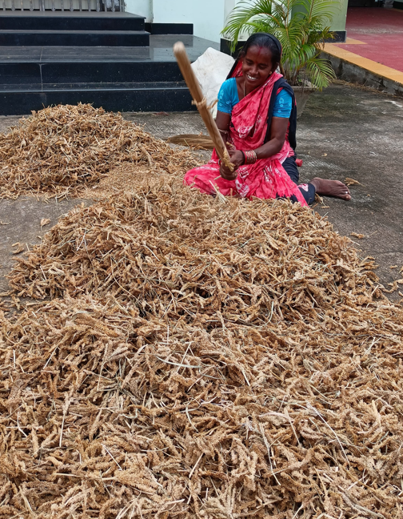 | 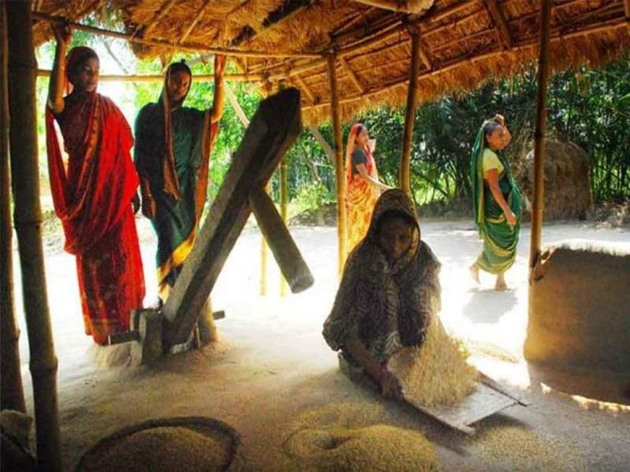  Fig.1 Traditional method of threshing finger millet

2. Material and Methods

2.1 Study Area
The evaluation was conducted in Krishi Vigyan Kendra, Kanker districts of Chhattisgarh, where finger millet is widely cultivated by tribal farmers.
2.2 Components and working of the OUAT Finger Millet Thresher
The OUAT finger millet thresher was developed in year 2021.It comprises a feeding chute, threshing unit, oscillating sieve assembly, aspirator, and power transmission system. The feeding chute delivers finger millet panicles to the threshing cylinder, which utilizes stud-type and canvas-type threshing components. The oscillating sieve assembly, with two mild steel screens, separates threshed material, while an aspirator removes lighter florets and stalks. The power transmission system includes a series of spur gears, gearboxes, shafts, and a belt and pulley arrangement, driven by a 1 hp motor. The finger millet thresher employs an axial flow design with a threshing cylinder, concave, aspirator, and reciprocating sieve, powered by a 1 hp electric motor. A belt and pulley system drives the thresher, with the threshing cylinder, blower, and aspirator rotating simultaneously. Dry finger millet panicles are fed into the threshing cylinder, where threshing occurs through impact and shearing by stud-type and canvas-type components. The threshed crop moves axially, with straw exiting through the main outlet. Grains, florets, and small straws pass through the concave to the oscillating sieves for separation. The aspirator removes remaining lightweight florets, while clean grains are collected from the bottom sieve.
The technical details of thresher are presented in table 1 and the photographs of the components are shown in fig. 2 .
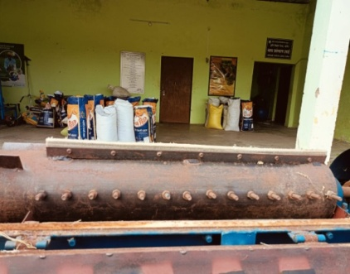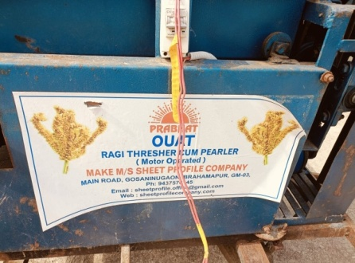 | 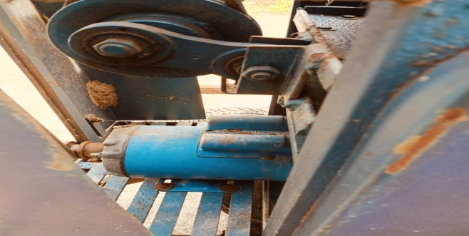 | 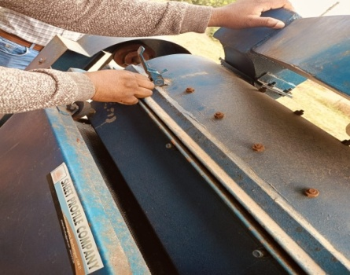
 | 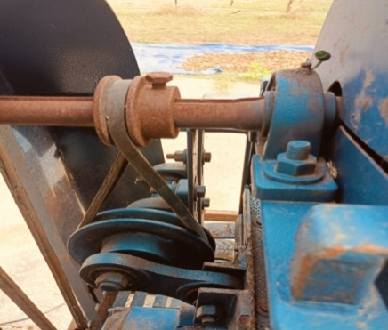 | 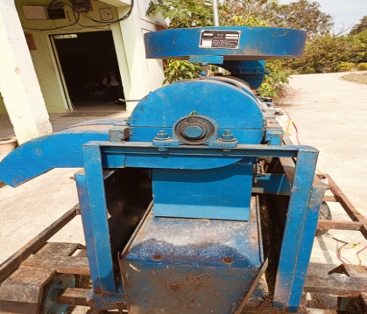
Fig. 2 Components of finger millet thresher

Table 1 Dimensions of main components of thresher
Particulars | Detail specifications
Type | Finger millet thresher
Power source | Electric power , 1 hp motor
- Mainframe (L×W×H) mm | 150×500×905
- Feeding chute (L×W×t×D) mm | 450 ×310× 2 ×170
- Threshing unit
Type of threshing cylinder | Peg and canvas type.
Description | Diameter 175 mm , Thickness 5 mm.  14 pegs (3nos. rows), total 42 pegs, 5 knives at alternate side of peg row, Material MS, Peg height- 37 mm,Dia 12 mm.
Length of the cylinder | 750 mm
Peripheral speed | 7.34-9.00 m/sec
Concave type | Semi-cylindrical having 75mm width and 700mm length
Recommended concave clearance | 12 mm (Average)
Constructional features | 26 nos. of 10 mm mild steel rods with 3 mm gaps are welded axially above 3 nos. support of MS flats (25 x 5) mm in a semi-circular shape
- Cleaning unit
Oscillating sieve  Upper (L×W) mm  Lower(L×W) mm | Punctured GI sheet, 2 nos Size (mm)  765×340 , 2.75 mm hole  1270×340, 1 mm hole
Sieve slope | Upper: 30 degrees (fixed)  Lower: 30 degrees (fixed)
Blower nos and type | One, Centrifugal-Aspirator type
Number of blades & Size of blades | 4 blades, 115 x 115 x 2, depth- 20 mm

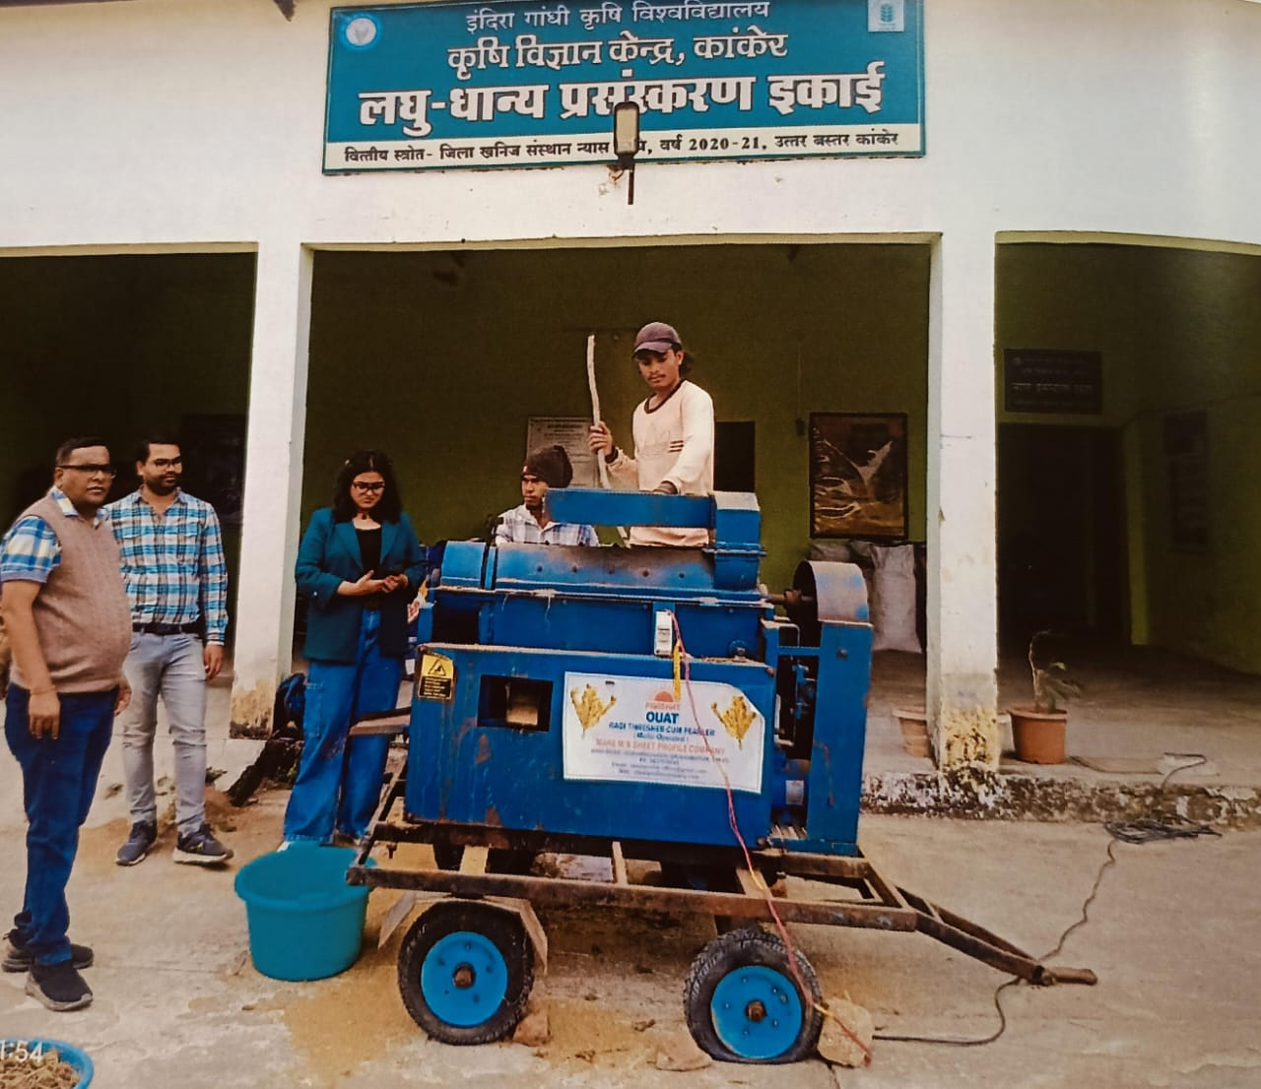
Fig 3 Performance evaluation of OUAT finger millet thresher at KVK, Kanker
The common varieties of finger millet (Indira Ragi-1, Chhattishgarh-1 and GPU 28) were collected from KVK, Kanker.These varieties are prominently cultivated by farmers of that local zone of Chhattisgarh in recent years. The selected varieties were used to determine the physical properties. The physical properties of selected finger millet variety were taken ( Patel et al., 2021 and Patel et al., 2022) before the performance evaluation of the machine.
The machine was evaluated under field conditions using test protocols outlined by the Bureau of Indian Standards (IS: 6284-1985). The details of independent parameters each five levels and dependent parameters are presented in table 2. The following are the parameters were recorded:
$$Output capacity\left(\frac{kg}{h}\right)=\frac{Weight of grain threshed(kg)}{Time taken (h)}$$
$$Threshing efficiency\left(\%\right)=\left(\frac{Total threshed grain}{Total grain input}\right)×100$$
$$Cleaning efficiency\left(\%\right)=\left(\frac{Clean grain collected }{Total threshed grain}\right)×100$$
$$Grain damage\left(\%\right)=\left(\frac{Damaged or broken grain collected }{Total threshed grain}\right)×100$$
The response surface methodology (RSM) was employed to model and analyze the process, identifying the relationship between independent variables (moisture content, feed rate, and peripheral speed) and dependent parameters (output capacity, threshing efficiency, cleaning efficiency, pearling efficiency, and broken grain). Statistical models (linear, quadratic, 2FI, or cubic) were used to analyze the experimental data, and the best-fit model.
3. Result and Discussion
Optimizing parameters of finger millet thresher using Response Surface Methodology (RSM)

Threshing efficiency of the OUAT finger millet thresher was varied in the ranged from 82.2% to 98.3%. The optimal performance was observed at lower moisture content i.e. 14% db, mc and a feed rate of 100 kg/h. It may be due to better grain detachment. The cleaning efficiency was observed in the range of 91.3% to 98.9%. Moisture content significantly impacted cleaning, with lower moisture content (around 10%) leading to better cleaning due to easier glume removal.Peripheral speed had a less pronounced effect. .Pearling efficiency ranged from 83.2% to 90.2%. Higher feed rates initially increased pearling efficiency up to a point (around 140 kg/h), after which it decreased. Lower moisture content (14%) and a feed rate of 80kg/h resulted in higher pearling efficiency. The type of threshing cylinder significantly affected pearling. Broken grain percentage varied from 1.3% to 4.7%. Higher moisture content (18%) increased breakage. Lower feed rates (60 kg/h) also increased broken grain, possibly due to repetitive impacts. Output capacity ranged from 32.8 kg/h to 61.9 kg/h. The highest output was observed at a feed rate of 120kg/h, peripheral speed of 9.5 m/s and moisture content of 12%. The lowest output was observed at a feed rate of 60 kg/h, peripheral speed of 7.5 m/s and moisture content of 10%. Higher feed rates generally led to increased output, while the effect of peripheral speed and moisture content seems to be more complex and requires further analysis.The graphs and the optimization resultsclearly demonstrate the interplay between the input parameters and the performance of the finger millet thresher. The study successfully identified a parameter combination that maximizes efficiency across multiple metrics while minimizing broken grain percentage. The chosen solution represents a well-balanced configuration that offers high performance under the tested conditions.

Table 2 Effect of independent parameters on dependent parameters
Std | Run | Feed rate,  kg/h | Peripheral speed,  m/s | Moisture content,  % | Threshing efficiency,  % | Cleaning efficiency,  % | Pearling efficiency,  % | Broken grain,  % | Output capacity ,kg/h
9 | 1 | 120 | 9.5 | 14 | 98.2 | 97.4 | 89.4 | 2.1 | 61.9
2 | 2 | 140 | 7.5 | 10 | 86.2 | 94.2 | 90.2 | 3.6 | 49.6
18 | 3 | 100 | 9.5 | 16 | 95.3 | 95.4 | 85.7 | 2.5 | 47.5
15 | 4 | 100 | 9.5 | 14 | 96.1 | 98.2 | 86.2 | 1.8 | 43.9
10 | 5 | 80 | 9.5 | 16 | 96.2 | 96.3 | 87.3 | 2.2 | 44.6
8 | 6 | 140 | 11.5 | 18 | 88.3 | 93.5 | 83.2 | 4.4 | 46.8
19 | 7 | 100 | 9.5 | 14 | 97.6 | 97.9 | 88.4 | 2.5 | 45.7
12 | 8 | 100 | 12 | 14 | 98.3 | 98.5 | 87.4 | 1.3 | 48.7
1 | 9 | 60 | 7.5 | 10 | 97.8 | 98.9 | 88.5 | 2.5 | 32.8
7 | 10 | 60 | 11.5 | 18 | 94.3 | 96.3 | 84.6 | 4.7 | 35.6
14 | 11 | 100 | 9.5 | 18 | 90.4 | 94.6 | 83.2 | 4.3 | 44.3
5 | 12 | 60 | 7.5 | 18 | 97.6 | 94.7 | 88.9 | 2.3 | 34.7
17 | 13 | 120 | 9.5 | 14 | 97.9 | 97.6 | 85.7 | 3.5 | 60.2
16 | 14 | 120 | 9.5 | 14 | 97.8 | 97.7 | 88.2 | 2.3 | 60.3
20 | 15 | 120 | 9.5 | 14 | 98.2 | 97.6 | 89.4 | 2.1 | 60.9
11 | 16 | 100 | 8.5 | 10 | 96.3 | 98.9 | 87.2 | 2.5 | 49.3
6 | 17 | 140 | 7.5 | 18 | 93.5 | 91.3 | 84.1 | 4.5 | 46.4
13 | 18 | 120 | 8.5 | 12 | 97.6 | 98.4 | 87.6 | 2.8 | 49.1
4 | 19 | 140 | 11.5 | 10 | 82.2 | 93.9 | 86.3 | 4.1 | 50.4
3 | 20 | 60 | 11.5 | 10 | 98.3 | 98.5 | 89.4 | 1.9 | 34.3

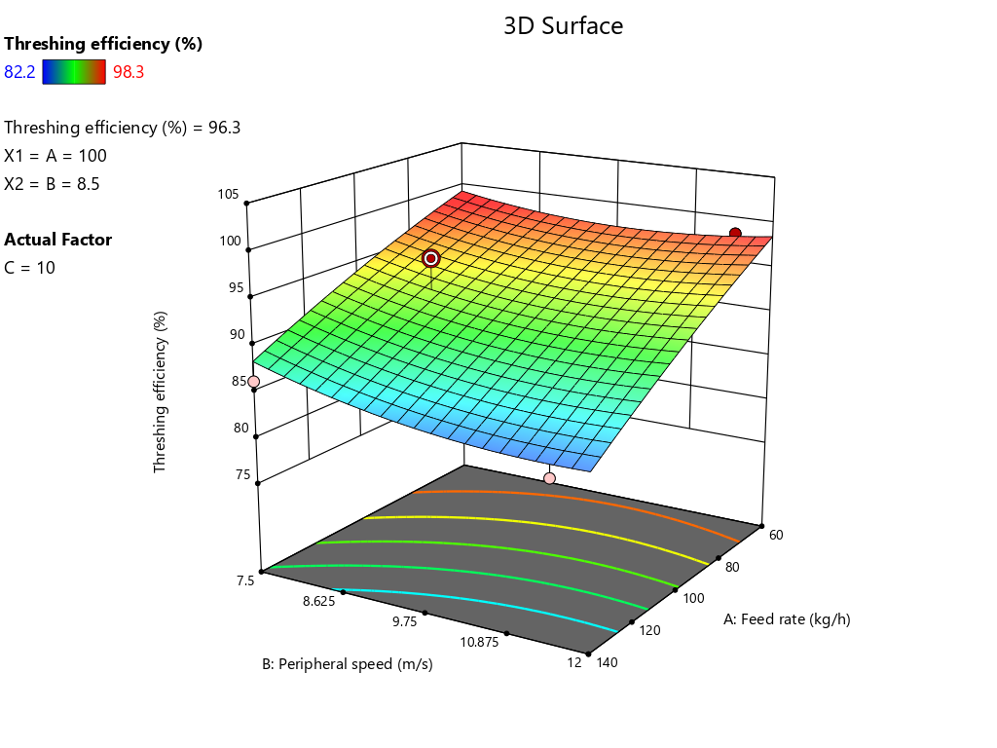 | 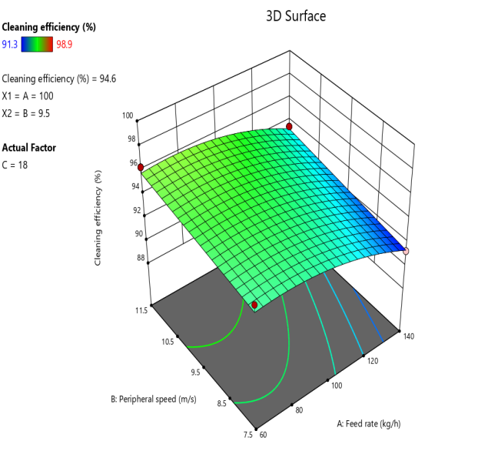
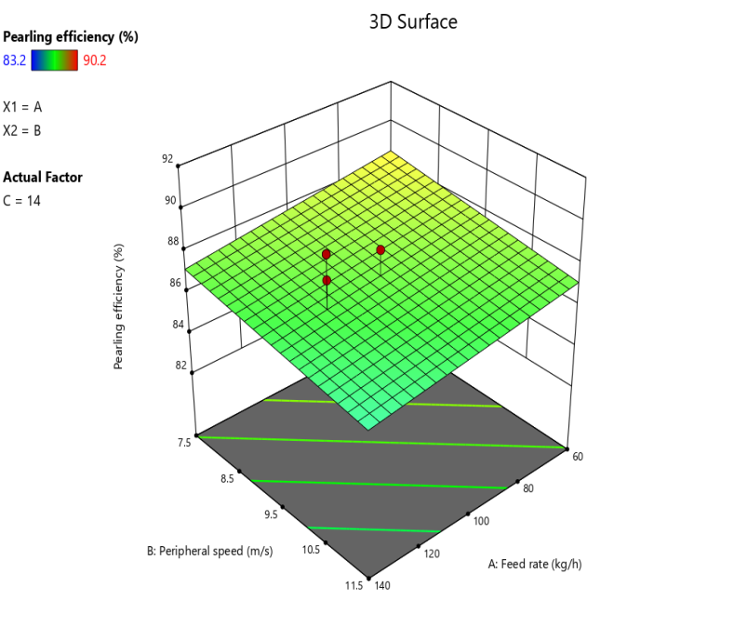 | 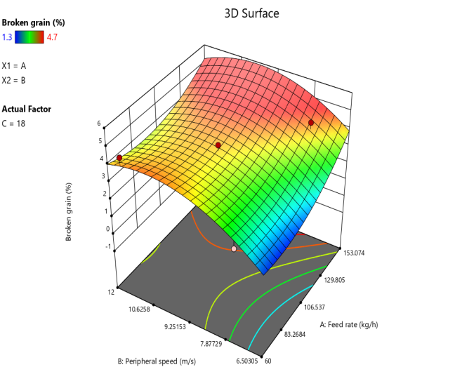
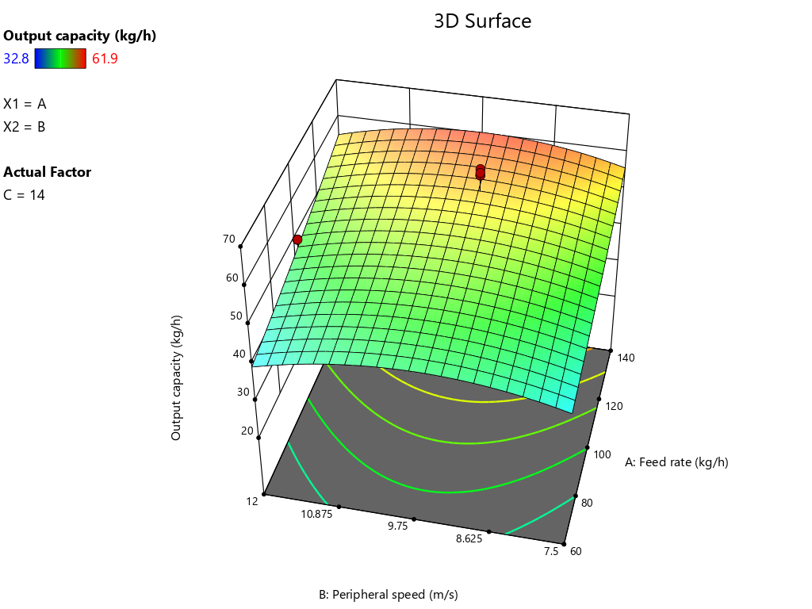 | Fig.4 3D graph of effect of independent parameter(feed rate, peripheral speed and moisture content) on dependent parameter (threshing efficiency,cleaning efficiency, pearling efficiency, broken grain, output capacity) through Response Surface Methodology

- Ergonomic assessment through BPDS and Postural analysis tools

Ergonomic assessments revealed significant postural stress and musculoskeletal disorder risks for thresher operators. RULA scores (5-6) indicated a need for investigation and immediate changes, while REBA scores (9-10) also suggested necessary changes. Goniometric measurements showed that operators' postures, particularly in the upper limbs, neck, and trunk, contribute to these risks. Elevated heart rates (83-98 bpm) indicate the task's physiological demands and potential for fatigue. The findings suggest that the thresher's design and/or work practices should be modified to mitigate identified ergonomic risks and reduce operator strain.

Table 3.Drudgery analysis through body part discomfort score chart
S.No. | Body parts | Manual Hand Beating | OUAT Thresher | IGKV Thresher
1 | Neck | 7.00 | 5.50 | 3.00
2 | Clavicle left | 6.85 | 1.25 | 5.25
3 | Clavicle right | 7.12 | 3.51 | 5.70
4 | Left shoulder | 4.80 | 3.50 | 4.80
5 | Right shoulder | 4.80 | 6.98 | 4.80
6 | Left arm | 4.70 | 2.35 | 4.70
7 | Right arm | 6.40 | 6.49 | 6.40
8 | Left elbow | 6.20 | 6.20 | 4.39
9 | Right elbow | 6.60 | 6.32 | 4.57
10 | Left forearm | 5.25 | 3.54 | 3.89
11 | Right forearm | 7.30 | 5.69 | 4.17
12 | Left wrist | 5.30 | 5.38 | 3.30
13 | Right wrist | 6.30 | 5.97 | 4.53
14 | Left palm | 5.50 | 3.50 | 3.50
15 | Right palm | 6.74 | 3.60 | 3,59
16 | Upper back | 6.50 | 5.30 | 3.18
17 | Middle back | 6.20 | 5.85 | 2.16
18 | Lower back | 8.20 | 4.49 | 3.19
19 | Buttocks | 8.95 | 3.58 | 1.38
20 | Left thigh | 7.90 | 6.98 | 3.19
21 | Right thigh | 8.30 | 7.18 | 3.12
22 | Left knee | 7.56 | 8.39 | 5.80
23 | Right knee | 8.98 | 8.43 | 5.79
24 | Right leg | 8.12 | 5.32 | 4.34
25 | Left leg | 7.60 | 4.65 | 4.58
26 | Left foot | 7.50 | 5.34 | 3.51
27 | Right foot | 7.60 | 4.30 | 3.46
 | Total score | 191.27 | 139.59 | 106.70
 | ODR | 7.08 | 5.17 | 3.95
Table 4. Performance comparison with other finger millet threshing method
Particular | Manual hand beating | Manual foot trampling method | IGKV developed finger millet thresher | Finger millet thresher  (OUAT Model)
Output capacity(kg/h) | 6.4 | 7.05 | 116 | 60
Threshing efficiency (%) | 95.58 | 97.72 | 98 | 97
Broken grain (%) | 3.49 |  | 1.5 | 2.2
Cost of operation (Rs. /kg) | 5.2 | 4.3 | 1.23 | 4.49

- Conclusion

Performance evaluation of the developed OUAT finger millet thresher, using RSM, identified optimal operating parameters (feed rate, peripheral speed, and moisture content) to maximize threshing and cleaning efficiencies while minimizing broken grain. Ergonomic and physiological assessments revealed potential risks associated with thresher operation, highlighting the need for design modifications and improved work practices to enhance operator safety and comfort. This research contributes information’s to improve finger millet processing technologies, offering potential benefits to small and medium farmers in Chhattisgarh by increasing efficiency, reducing labor, and improving grain quality.

Acknowledgement. The authors Acknowledged AICRP on FIM for providing necessary funds and facilities for the research work.

Disclaimer (Artificial intelligence)
Author(s) hereby declare that NO generative AI technologies such as Large Language Models (ChatGPT, COPILOT, etc.) and text-to-image generators have been used during the writing or editing of this manuscript.
7.Reference

Anonymous. 1985. Indian Standard Test Code for power thresher for cereals. Indian Standard Institution, Manak Bhavan, 9 Bahadur Shah Zafar Marg, New Delhi 110002.6284: 1-28.
Anonymous. 1986. Specification for power thresher- spike tooth type. Indian Standard Institution, Manak Bhavan, 9 Bahadur Shah Zafar Marg, New Delhi 110002. IS 11691.
Anonymous. 2019. Area, production and yield statistics millets, millet stats, Directorate of Economics and Statistics, Ministry of Agriculture and Farmers’ Welfare, Government of India, https://milletstats.com/apy-stats/.
Bansal, N.K. and Lohan, S.K. (2009). Design and development of an Axial flow thresher for seed crops. Journal of Agricultural Engineering, 46(1):1-8
Chaturvedi, S. and Rathore,F. 2018. Development of threshing cylinder for small millets. Agric. Sci. Digest., 38(3) 2018: 178-182.
Gbabo, A., Gana, I.M. and Amoto, M.S. 2013. Design, fabrication and testing of a millet thresher. Net Journal of Agricultural Science, 1(4):100-106.
Hanumantharaju, K.N., Poornima, D.S., Ramya, H.N. and Ashok S.B.S. 2019. Development and performance evaluation of whole crop finger millet thresher. Multilogic in Science, 9(31):32-36.
Hota, S., Mishra, J. N., Mohanty, S. K., and Khadatkar, A. (2017). Design and development of pedal operated Ragi thresher for tribal region of Odisha, India. Agricultural Mechanization in Asia, Africa and Latin America, 48(4), 71-75.
Joshi, P., Jethi, R., Chandra, N., Roy M.L., Kharbikar, H.L. and Atheequlla, G. 2015. Ergonomics assessment of post harvest finger millet threshing for reducing women drudgery. Indian Research Journal Extension Education, 15(1):25-30.
Kumar, N., Kumar, D. B., Prasanna, A., Kumar, H. S., Sandeep, T. N., and Sudhadevi, G. (2013). Efficiency of mechanical thresher over the traditional method of finger millet threshing. International Journal of Agriculture Engineering, 6, 184–188.
Ojediran, O.J.,Adamu, M.A. and Jim-George, D.L. 2010. Some physical properties of pearl millet (Pennisetum glaucum) seeds as a function of moisture content. African Journal of General Agriculture, 6(1):39-56.
Olaoye, J.O., Oni, K.C. and Olaoye, M.O. 2011. Computer applications for selecting operating parameters in a stationary grain crop thresher. Journal of Agricultural Technology, 7(1):39-56.
Parihar, D.S., Shrivastava, A.K., Singh, A.K., Singh, N.K., Mahadik, A.S. and Awasthi,V.J. 2022. Optimization of operational parameters for axial flow paddy thresher using rsm. International Journal of Environment and Climate Change, 12(9):253-263.
Parmanand,Verma, A. and Guru. P.K. 2015. Ergonomic evaluation of developed pedal operated millet thresher for threshing of finger millet. International Journal of Agricultural Science and Research, 5(6):15-24
Patel, G., Naik, R.K. and Dewangan, S.K, (2024).Study on different threshing technology and factor influencing threshing of linseed for the development of linseed thresher ; A review. International journal of advanced biochemistry research, 8(8);321-326.
Patel, G., Naik, R.K. and Dewangan, S.K, (2024)Design optimization of linseed thresher for higher efficiency. International Journal of Manufacturing and Production Engineering (IJMPE), 2(2):24-32.
Patel, G., Naik, R.K. and Patel, K.K. (2021). Studies on Some Physical and Engineering Properties of Linseed. Biological Forum – An International Journal, 13(3):303-308.
Patel, G., Naik, R.K., Dewangan, S.K. and Tuteja, H.S.(2024). Studies on design parameters for development of head cut type linseed thresher. International Journal of Research in Agronomy,7(9):435-440.
Patel, K. K., Naik, R.K., Patel, G. and Pandey, S. (2022) Studies on some Physical and Engineering Properties of Finger Millet for Designing Thresher. Biological Forum – An International Journal, 14(4): 387-393.
Powar, R. V., Aware, V. V., & Shahare, P. U. (2019a). Optimizing operational parameters of finger millet threshing drum using RSM. Journal of Food Science and Technology, 56, 3481–3491.
Powar, R. V., Aware, V. V., Patil, S. B., & Shahare, P. U. (2019b). Development and evaluation of finger millet thresher-cum-pearler. Journal of Biosystems Engineering, 44, 194–206.
Pradhan, A., Nag, S. K., and Patil, S. K. (2015). Traditional methods of harvesting and processing for small millet in the tribal region of Bastar. Indian Journal of Traditional Knowledge, 9, 681–663
Sial, S. K. (2018). Development and evaluation of ragi thresher-cum-pearler operated by bullock power in rotary mode (Doctoral dissertation, CAET, OUAT).
Sial, S.K., Swain, S.K., Behera, D., Mohapatra, P.M., Mohapatra A.K., and Dash, A.K. 2019. Moisture related engineering properties of different OUAT released varieties of ragi. Green Farming, 10(3): 341-345
Singh, K. P., Poddar, R. R., Agrawal, K. N., Hota, S., & Singh, M. K. (2015). Development and evaluation of multi millet thresher. Journal of Applied and Natural Science, 7(2), 939–948.
Tiwari, P., 2019. M. Tech. thesis. Ergonomical assessment of selected farming operations in Bastar Plateau Zone. Indira Gandhi Krishi Viswavidyalaya, Raipur.
Tiwari,P.,Shrivastav,A.K.andDave,A.K.,2022.Ergonomicalassessmentofpedal operated thresher for tribal women of Bastar plateau zone of Chhattisgarh.
Tiwari,P.,Shrivastav,A.K.andDave,A.K.,2022.Ergonomicalassessmentof pedal operated thresher for tribal women of Bastar plateau zone of Chhattisgarh.
Verma, S.S., Singh, A. and Shahi, N.C. 2012. Response Surface Methodology for selection of machine parameters for enhancing pearling efficiency of finger millet dehuller-cum-pearler. International Journal of Science and Research (IJSR), 3(10):1469-1472.

