SUSTAINABLE BIO-BASED APPROACHES TO FOOD WASTE MANAGEMENT IN QUALITY CONTROL LABORATORIES

ABSTRACT

Objective: This study investigates the application of bioreactor technology for sustainable waste management in food testing laboratories. This research explores how organic lab waste can be converted into bioenergy and reusable materials by analyzing different bioreactor configurations, including anaerobic digesters and microbial fuel cells.
Study Design: A detailed review of existing literature, case studies, and industry reports between 2018 and 2025 was carried out to assess the recent trends and impact in the adoption of bioreactors systems..
Methodology: The research draws from peer-reviewed journal articles, government reports, and Food industry analyses. It follows a qualitative review approach, including data visualization to highlight the need, use and impact of sustainable systems such as bioreactors.
Results: Findings indicate that integrating bioreactors into laboratory waste management systems reduces environmental impact and offers a cost-effective solution for food safety laboratories. This research provides a framework for adopting sustainable practices in food quality assurance facilities, contributing to the circular economy and environmental conservation efforts.
Conclusions: This review focuses on how different systems like anaerobic digesters, microbial fuel cells, and membrane bioreactors can convert lab-generated waste into useful products such as bioenergy, clean water, and nutrient-rich materials. Anaerobic digesters are particularly effective for handling large amounts of biodegradable waste, making them highly suitable for this purpose. Using these systems well can greatly reduce environmental impact, cut down on operating costs, and support more sustainable processes in food labs. For the future, it's important to research how to design reactors more cheaply, automate them, and use digital tools to monitor them effectively. By doing this, more people and companies might start using these systems. Additionally, trying out projects in growing economies and getting regulatory support will be crucial for using bioreactors more widely in real-world labs.

.

Keywords: Bioreactors, Food Safety, Circular Economy, Food Wastage, Food Loss, Food Laboratory

- INTRODUCTION

Waste is defined as ‘abandoned materials’ that are discarded as to no longer have a functional use or economic value [1]. "Food" is any item that could be raw, semi-processed, or processed that is majorly intended for the purpose of human (or any other animal) consumption. "Food" is often found with its associated counter “inedible parts,” which are/might not be suitable for utilization. [2].
Over time, food waste and food loss are two terms that have been used interchangeably. However, they are quite different; "food loss" refers to the unintentional loss or deterioration of quality and/or quantity of the food as a result of food spills, spoilage, bruising, and other damages caused due to limitations and impediments that occur during harvesting, processing, distribution, storage, etc. [3], while "food wastage" means any food or edible parts of food that are removed, disposed of, or discarded from the food supply chain before they can be consumed. [4].

According to the United Nations Food and Agriculture Organization, gross food waste accounts for nearly one-third of total world food production, leaving nearly 690 million people hungry worldwide. Consequently, as per reports made in the year 2014, approximately 1.3 billion metric tonnes of food were calculated to be wasted worldwide. [5]. Also, the Food and Agriculture Organization of the United Nations (FAO) and the World Health Organization (WHO) estimate that each year about 600 million, almost 1 in 10, people worldwide become ill after eating contaminated food, and 420,000 of them die [6]. This high food wastage and food safety hazards recorded highlight the need for sustainable approaches to food waste management and food quality control.

Circular economy approaches have been gaining attention as a solution to the problem of food waste in recent years. These approaches offer a way to address the problem of food waste by emphasizing the reuse and recycling of materials and resources. One can discover innovative methods for reducing food waste and losses by adopting circular approaches, such as reusing and recovering resources rather than devaluing them. For instance, food waste can be composted, repurposed as animal feed, utilized for energy recovery, converted into biofuels, and even used to produce biomaterials. [7].

Bioreactor technology presents a solution for the sustainable management of laboratory waste. They play a key role in managing waste and recovering resources, which in practicality is the concept of a circular economy. This means they help in making sure that materials are reused and recycled rather than being thrown away, reducing waste and making the most out of these resources. Bioreactors can significantly reduce the environmental footprint of food testing laboratories. Implementing eco-friendly technologies such as this will not only tackle pollution but also contribute to the generation of renewable energy and valuable byproducts, thereby supporting the transition towards more sustainable and resilient food systems. A recently conducted study highlights the use of a laboratory-scale anaerobic filter to treat wastewater from fish markets. The anaerobic filter achieved significant removal efficiencies, including up to 85% nitrate removal and 82% chemical oxygen demand (COD) reduction, demonstrating its potential for managing organic waste in food-related laboratories. [8]. Another notable case study was a small-scale study that tested using both traditional wastewater treatment methods and a membrane bioreactor system to clean wastewater from a food and beverage company. The results showed that the system was very good at removing organic pollutants from the water. This suggests that using bioreactors can greatly improve how we clean wastewater in food quality control laboratories. [10].
This review explains how bioreactor technologies can be used for sustainable waste management in labs that handle food quality checks. This area is becoming more important due to new rules and environmental concerns. The review fills a gap in studies by linking circular economy ideas with practical lab systems. It includes real examples and applications, which help in promoting environmental conservation, keeping food safe, and supporting low-carbon progress. The study's results offer ways for researchers, lab managers, and policymakers to make lab operations more eco-friendly.
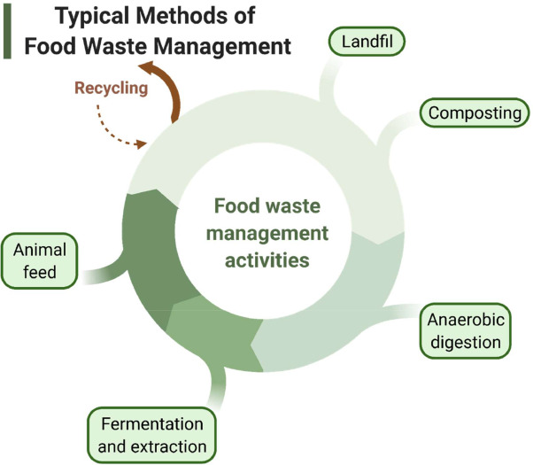
Fig 1: Types of Food Waste Management [28]

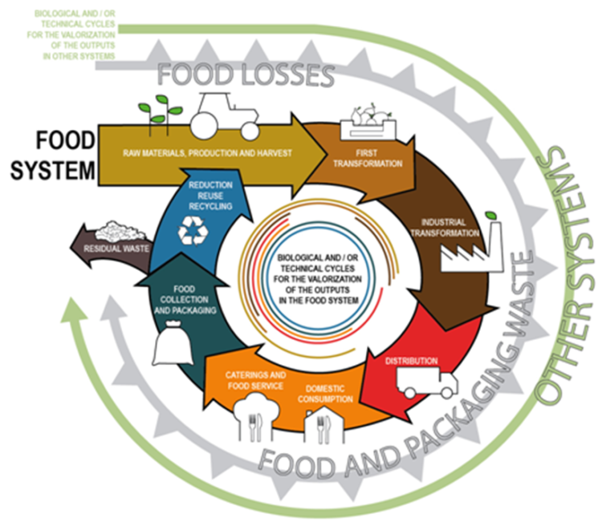
Fig 2: Areas circular economy can be implemented in the food system [9]

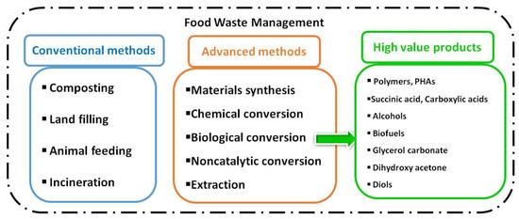
Fig 3: Technical valorization of food wastes for the preparation of high value products [30].
- METHODOLOGY
This research employs a systematic literature review approach to explore the application of bioreactor technologies as sustainable waste management solutions in food quality control laboratories. The objective of this study is to explore sustainable approaches to Food waste management, such as bioreactor technology and how it can help manage waste created by food quality control laboratories. The research checks how different bioreactor setups perform to create a plan for using good waste management in these labs. practice.
An extensive search of a variety of academic databases was carried out. The following digital repositories, including ScienceDirect, PubMed, SpringerLink, IEEE Xplore, Scopus, Web of Science, Google Scholar, and Wiley Online Library, were searched. The purpose was to find peer-reviewed articles, reports, and white papers from the years 2018 to 2025. This effort aimed to collect the latest information on the use of bioreactors in both laboratories and the food industry. To guide the search, different combinations of search terms were used along with operators like AND and OR. Some of these terms were “bioreactor AND laboratory waste.” “food quality control lab AND waste management,” “anaerobic digestion AND food testing labs” “microbial fuel cells AND organic waste reuse,” “circular economy AND laboratory sustainability,” “bioenergy recovery AND bioreactor,” and “biohazard waste treatment AND food safety labs.” Specific filters were used to focus only on full-text articles written in English.
To ensure relevance and quality, the following inclusion criteria were applied: Only articles focusing on bioreactor technologies (anaerobic digesters, microbial fuel cells, composting systems) applied to organic, laboratory, or food-related waste; studies on circular economy and the implications of bioreactor usage in food or laboratory contexts; real-life case studies in food safety labs, universities, and quality assurance facilities. Excluded were articles published before 2018 and studies not involving any form of organic or bio-waste reuse and non-peer-reviewed content such as blog posts and opinion pieces.
A shortlist of 50 papers for full-text review was done, duplicates were removed, titles and abstracts were screened for relevance to the topic, and then a final 25 studies having met all inclusion criteria were grouped into thematic categories: Types of Bioreactor Technology (anaerobic digesters, MFCs, aerobic composters) Types of food waste (lab-generated waste, food processing byproducts, mixed organic waste), the output metrics (bioenergy generation, pollutant removal, nutrient recovery), and sustainability outcomes (GHG reduction, water/energy savings).
It is important to note that, while the approach used ensured a rigorous and high-quality examination of the current literature, there were certain limitations to be observed, such as the reliance on only English-language sources, which may have excluded relevant research published in other languages, and the relatively low number of studies included in the final evaluation, which restricts the generalizability of the findings. Also, some of the most important studies may be paywalled or not available in publicly accessible databases. However, even then, this study remains a detailed and organized examination of sustainable approaches to food waste management in food laboratories.
The three technologies discussed in this article are anaerobic digesters, microbial fuel cells, and membrane bioreactors, all examined within food quality control laboratories. These labs include public laboratories under agencies FDA in the USA, internal quality control labs in food and beverage companies, and academic research labs studying food microbiology or bioprocessing. The waste produced in these labs is primarily organic, biodegradable, and active with microbes.
The types of waste included are spoiled food samples from contamination tests, expired growth mediums and agar plates , rinse water with glucose, proteins, and microbial residues, small amounts of leftovers from tests like spectroscopy or chemical analysis although these waste streams may not be large in volume, they contain a high amount of organic matter and nutrients. This makes them ideal for conversion into energy, clean water, or nutrient-rich byproducts. Introducing bioreactor systems in these labs helps manage waste and recover resources, supporting circular economy practices in laboratory settings. This approach offers a clear context by defining waste types and explaining the benefits of integrating bioconversion technologies in managing waste effectively.

- RESULTS AND DISCUSSION
Bioreactors are indispensable tools in modern biotechnology, enabling the production of a wide range of high-value-added products. This manuscript presents a comprehensive review of fundamental concepts and types as well as the challenges associated with adopting bioreactors. [26]
There are some well-known bioreactors, such as rotating biological contactor (RBC), packed bed reactor (PBR), fluidized bed reactor (FBR), continuous stirred tank bioreactor (CSTR), up-flow anaerobic sludge blanket reactor (UASB), membrane bioreactor (MBR), dynamic membrane bioreactor (DMBR), membrane distillation bioreactor (MDBR), aerated membrane bioreactor (IAMBR), enhanced membrane bioreactor (EMBR) and photobioreactor. [29].
Types of Bioreactors and their Laboratory Waste Suitability
While there are quite a number of Bioreactors, there are three important bioreactor systems that could be very helpful for sustainable waste management in food quality control labs. These are Anaerobic Digesters (ADs), Microbial Fuel Cells (MFCs), and Membrane Bioreactors (MBRs). Each system has its own unique design, how it works, and what it produces. But when used together, they offer practical ways to manage various types of organic waste that are commonly found in labs that work on food safety.
Anaerobic Digesters (ADs)
Anaerobic digesters are enclosed systems designed to break down organic materials without oxygen. This process produces biogas, which mainly contains methane and carbon dioxide, and a nutrient-rich mixture called digestate. These digesters are very effective with waste that is high in carbohydrates, proteins, and fats, materials often found in leftover food and culture media used in microbiology labs. There's an interesting study from Maiti and others, where they tested an anaerobic filter reactor to treat wastewater from fish markets. This type of water is similar to what comes from food quality labs because it’s full of organic materials and microbes. The test showed that the system removed 82% of Chemical Oxygen Demand (COD) and 85% of nitrates. This demonstrates that anaerobic systems can significantly reduce pollution and also generate energy through the production of biogas. [8].
Anaerobic digestion happens in four steps: hydrolysis, acidogenesis, acetogenesis, and methanogenesis. These steps are very effective for treating lab waste that can naturally decompose. During this process, methane gas is produced. In small lab experiments with food-based organic waste, you can get between 0.2 and 0.35 m³ CH₄/kg VS of methane for each kilogram of waste. This process works well in lab settings where there is a lot of waste that can be turned into energy. [10].
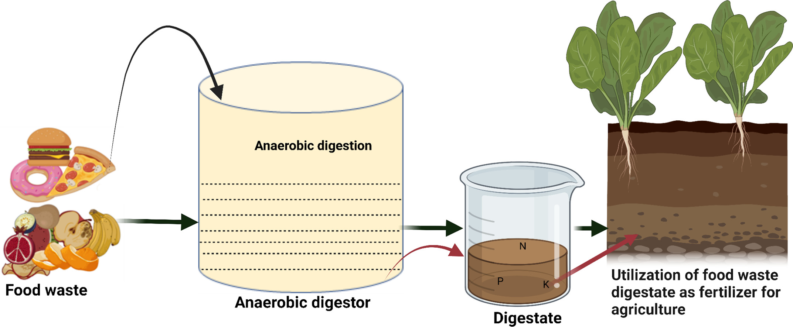
Fig 4: Use of anaerobic digester in food waste management [27]

Microbial Fuel Cells (MFCs)
Microbial Fuel Cells (MFCs) are a type of bioreactor system that takes advantage of certain bacteria to convert organic waste into electricity. These bacteria are naturally capable of helping chemical processes that release energy. When they break down the waste, they generate a small amount of electrical power. This process not only helps clean up waste but also produces renewable energy. MFCs are particularly beneficial for small labs that might not have access to large power networks. They provide a way to manage waste effectively while at the same time generating electricity. This makes them a dual-purpose technology that is useful in decentralized settings.
In a study led by Mohanty in 2022, the scientists experimented with microbial fuel cells (MFCs). They used synthetic wastewater made from glucose, similar to the waste found in labs with lots of organic material. The results were impressive, as the MFCs generated power up to 420 mW/m². They also maintained a steady voltage ranging from 0.4 to 0.6 volts. These results are promising for food labs that frequently discard sugars, starches, and protein substrates in microbial media or spoiled food samples. [11]
Furthermore, MFCs have shown high COD removal efficiency (60–85%), depending on the nature of the feedstock and the electrode material used [12]. Their compact design, low operating cost, and potential integration into existing wastewater treatment chains make them ideal for pilot projects in lab-based waste energy recovery.
Membrane Bioreactors (MBRs)
Membrane Bioreactors (MBRs) are systems that combine two main processes: breaking down of waste with active microorganisms, known as activated sludge, and then further cleaning the water using special filters called membranes. This process results in very clean water that can either be reused or safely released into the environment. One of the benefits of MBRs is that they do not require a lot of space. They are also capable of dealing with different amounts of waste, which makes them especially useful in laboratory settings where space is limited and having dependable equipment is very important.
A study that evaluated the treatment efficiency of a pilot-scale MBR plant in a fruit processing industry showed that the removal efficiency for COD, BOD5, total nitrogen, and total phosphorus was 97.1%, 98.7%, 95.7%, and 53.5%, respectively. It also showed of a complete removal of both total coliform and E. Coli at the inlet and outlet of the system [13]

Bioreactor Type | Best For | Output | Suitability for Food Labs
Anaerobic Digester | Bulk biodegradable waste (spoiled food, agar, expired samples) | Methane, digestate | Highly suitable; Effective for bulk biodegradable waste with high organic content
Microbial Fuel Cell | Glucose/protein-base waste (microbial media, rinse fluids) | Electricity, treated water | Moderately suitable; Compact, but still experimental; good for pilot/demo labs
Membrane Bioreactor | Mixed effluent with solids and microbes |  | Highly suitable; Ideal for labs with hygiene-sensitive waste and space constraints
  High-quality effluent
Table 1: Bioreactor Types and Lab Suitability Table [8] [11] [12] [13] [14]

Aerobic granular sludge
Similar to Bioreactors in functionality is Aerobic granular sludge. Both anaerobic granular sludge (AGS) and bioreactors are systems that help treat organic waste, especially in cleaning wastewater and dealing with sludge. They both rely on the action of microorganisms to break down organic materials; both of them also contribute to resource recovery through the treatment process. Both systems contribute to the circular economy by converting waste into valuable products and helping reduce environmental impacts.

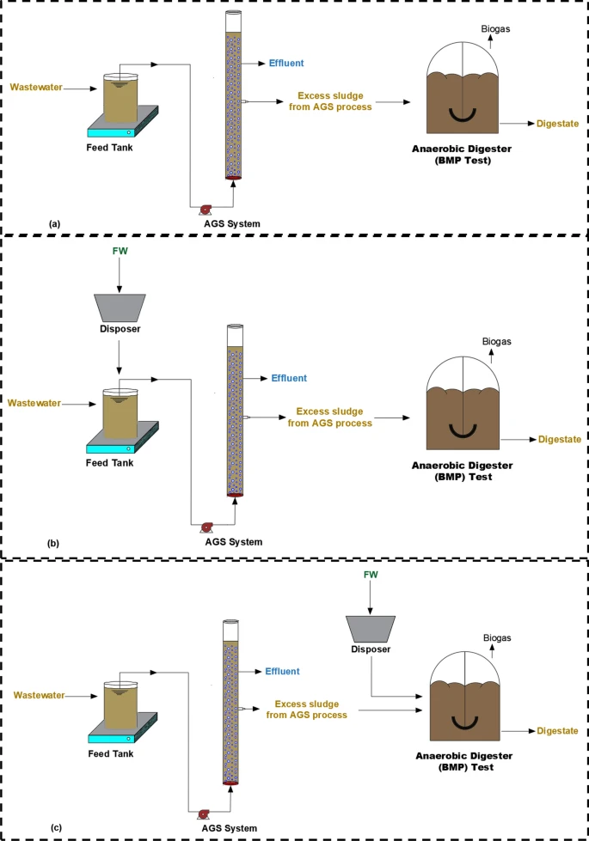

Fig 5: Use of Aerobic Granular Sludge in Waste water treatment [15]

Environmental Performance and Sustainability Outcomes
 | Reported Efficiency
  Outcome
GHG Emissions Reduction | Up to 70%
COD Removal | 75–95%
Heavy Metal Removal | 60–80%
Water Reuse Potential | High (MBR-treated water)
Table 2: Environment Impact and advantage of adopting on-site bioreactor systems in labs [16]
Some notable real-world Application of Bioreactors in Food Quality Control Laboratories
- Treatment of Slaughterhouse Effluent with Upflow Anaerobic Sludge Blanket (UASB) Reactors: A study demonstrated that UASB reactors achieved average Chemical Oxygen Demand (COD) removal efficiencies of 33% and Biological Oxygen Demand (BOD) removal efficiencies of 37% when treating slaughterhouse wastewater. [17] [18].
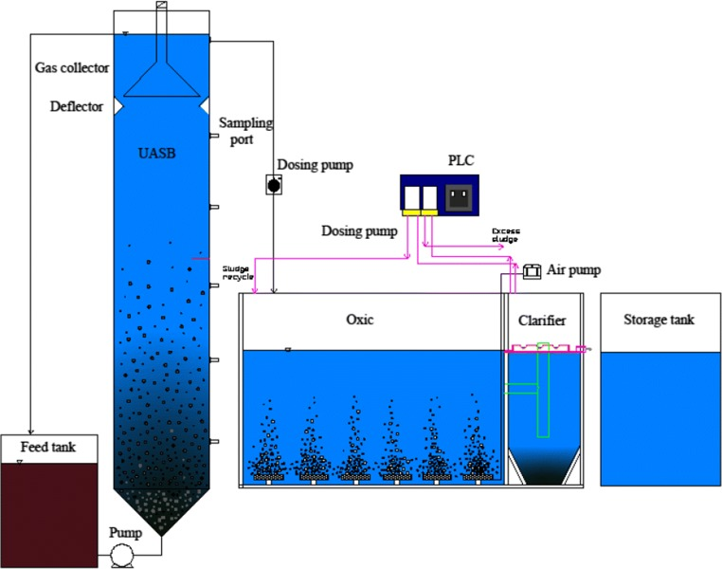
Fig 6: A Schmatic diagram of UASB Reactor [17]
- Membrane Bioreactor Systems in Food and Beverage Industry: This study compares the performance of the Hollow Fiber (HF) and Flat Sheet (FS) types of membrane bioreactors (MBRs) for the treatment of food and beverage (F&B) industry wastewater in a pilot-scale study of a wastewater treatment plant (WWTP). HF and FS membrane configurations were evaluated at two different Mixed Liquor Suspended Solid (MLSS) levels: 6000 mg/L and 12,000 mg/L. The performance of each configuration was evaluated in terms of Chemical Oxygen Demand (COD) and Total Suspended Solid (TSS) removals for effluent quality measurement. The transmembrane pressure (TMP), flux rate, and silt density index (SDI) were monitored and calculated for membrane fouling assessment. The results show that the rejection rates of COD and TSS for HF and FS membrane types were more than 84% for the two different MLSS levels. [19].
Source  Wastewater | Membrane Type | Pore Size (µm) | Membrane  Surface Area (m2) | Capacity  (L) | Removal  Efﬁciency (%) | Country
F&B  processing plant | HF | 0.04 | 74 | 1500 | ≈99% COD | Europe
Beverage processing | HF | 0.4 | 0.92 | 40 | ≈94% COD | Croatia
F&B processing plant | HF | 0.036 | 0.046 | 50 | ≈91–98% COD | USA
Soft drink processing | HF | 0.2-0.4 | 0.058 | 30 | ≈83.9% COD | South Africa
Dairy and Soy processing | HF | 0.5 | 0.044 | 10 | ≈93.1% TSS  ≈99% COD | New Zealand

Table 3: The summary of MBR treatment for food and beverage industry wastewater [19]
- Sequencing Batch Reactors for Poultry Slaughterhouse Wastewater: A sequential batch reactor (SBR) with different types of fibers was employed for the treatment of poultry slaughterhouse wastewater. Three types of fibers, namely, juite fiber (JF), bio-fringe fiber (BF), and siliconised conjugated polyester fiber (SCPF), were used. Four SBR experiments were conducted, using the fibers in different reactors, while the fourth reactor used a combination of these fibers. The treatment efficiency of the different reactors with and without fibers on biochemical oxygen demand (BOD), chemical oxygen demand (COD), ammonia-nitrogen (NH₃-N), phosphorus (P), nitrite (NO₂), nitrate (NO₃), total suspended solids (TSS), and oil-grease were evaluated. The removal efficiency for the reactors with fibers was higher than that of the reactor without fibers for all pollutants. The treated effluent had 40 mg/L BOD₅ and 45 mg/L COD with an average removal efficiency of 96% and 93%, respectively, which meet the discharge limits stated in the Environmental Quality Act in Malaysia.[20].
Challenges to the Adoption of Bioreactors
- Space Constraints: Many labs struggle with not having enough space, which makes it hard to set up bioreactor systems. These bioreactors, particularly the ones meant for continuous or semi-continuous use, take up a lot of room because they are big and need specific equipment to work. This problem can get in the way of fitting these systems into already existing lab setups.
- Skill Gap: Operating bioreactors necessitates specialized knowledge in microbiology, bioprocess engineering, and environmental management. [21]. Bioreactor systems are complicated machines that require skilled people to operate them properly. Experts are needed to observe, manage, and improve how these systems work. Without enough trained staff, it becomes difficult to effectively use and oversee bioreactor systems in laboratory settings.
- Cost Intensive: The upfront costs associated with acquiring and installing bioreactor systems, such as Membrane Bioreactors (MBRs) or Microbial Fuel Cells (MFCs), can be substantial. These expenses encompass equipment procurement, installation, and the development of supporting infrastructure. For many laboratories, especially those with limited budgets, these costs can be a significant barrier to adopting bioreactor technologies.[22].
While these barriers pose serious threats, there are some practical steps experts and scientists have suggested to reduce the friction and challenges of Adoption.
- Policy Incentives: Government interventions, like the financial incentives, are crucial in promoting the adoption of advanced technologies, including bioreactors. Studies have shown that subsidies and grants can significantly lower the financial barriers associated with implementing such systems. For instance, a 2023 study discusses how policy incentives, including subsidies, have successfully encouraged the adoption of climate-smart agricultural practices among smallholders.[21]
- Training Programs: To solve the persistent issues of skill gap a structured and comprehensive training is essential to equip laboratory personnel with the necessary skills to operate complex bioreactor systems effectively. Research highlights that training and information dissemination can significantly influence the adoption of new technologies. For example, a 2024 study emphasizes the role of training facilities in enhancing the capacities of health workers, suggesting that similar training programs could be beneficial in laboratory contexts. [23]
- Financial Support and Incentives: Financial aid such as grants, tax incentives, and subsidies, play a pivotal role in offsetting the initial costs of bioreactor systems. Studies have shown that the right financial support can enhance the economic feasibility of adopting anaerobic digestion systems. A 2025 study discusses designing optimal policies for low-carbon technology adoption, highlighting the importance of financial incentives in reducing costs and encouraging investment in such technologies. [24]
- CONCLUSION
This review highlights how bioreactor technologies can help food quality control labs manage waste sustainably. Anaerobic digesters are effective in processing large amounts of organic waste and producing bioenergy. Microbial fuel cells are promising for handling waste and generating electricity, especially in labs with limited resources. Though more costly, membrane bioreactors excel when hygiene and water reuse are crucial.
Each technology has a specific role. Choosing the right one depends on the lab's size, waste type, goals, and resources. As these technologies evolve, combining systems like using Microbial Fuel Cells with Anaerobic Digesters or Membrane Bioreactors could further improve efficiency and flexibility.
I recommend future efforts should focus on designing compact, modular units for small labs and implementing digital tools, like IoT sensors, for automatic bioreactor monitoring. By using circular economy principles, food labs can transform from waste producers into resource recovery hubs.
However, despite all of the aforementioned advantages, some challenges prevent it’s general adoption. Some of these limitations are infrastructure, knowledge gaps, and the high costs associated with initial setup. To overcome these barriers and challenges, there should be supportive policies, comprehensive training programs, and targeted financial investments to accelerate the shift of food testing laboratories toward practices that generate no waste and emit low emissions.
A project carried out in Northeast Brazil, where a membrane bioreactor was used to treat wastewater from a fruit processing facility. This project removed over 95% of BOD and total nitrogen from the wastewater, demonstrating that such systems are feasible and effective even in areas with limited resources [25]. For continuous developments and advancements, efforts should concentrate on large-scale pilot projects, developing partnerships across various disciplines, and creating waste-to-resource models that are in line with global sustainability targets.
Disclaimer (Artificial intelligence)
Option 1:
Author(s) hereby declare that NO generative AI technologies such as Large Language Models (ChatGPT, COPILOT, etc.) and text-to-image generators have been used during the writing or editing of this manuscript.
Option 2:
Author(s) hereby declare that generative AI technologies such as Large Language Models, etc. have been used during the writing or editing of manuscripts. This explanation will include the name, version, model, and source of the generative AI technology and as well as all input prompts provided to the generative AI technology
Details of the AI usage are given below:
1.
2.
3
REFERENCES
- Starovoytova D (2018). Solid Waste Management (SWM) at a University Campus (Part 1/10): Comprehensive Review on Legal Framework and Background to Waste Management in a Global Context. J. Environ. Earth Sci. 2225-0948.
- A. Lahiri, S. Daniel, R. Kanthapazham, R. Vanaraj, A. Thambidurai, and L. S. Peter, “A critical review on food waste management for the production of materials and biofuel,” Journal of Hazardous Materials Advances, vol. 10, p. 100266, Feb. 2023, doi: 10.1016/j.hazadv.2023.100266.
- Kennard, N.J. (2020). Food Waste Management. In: Leal Filho, W., Azul, A.M., Brandli, L., Özuyar, P.G., Wall, T. (eds) Zero Hunger. Encyclopedia of the UN Sustainable Development Goals. Springer, Cham. https://doi.org/10.1007/978-3-319-95675-6_86
- Lam, C.-.M., Yu, I.K.M., Hsu, S.-.C., Tsang, D.C.W., Chapter 18 - Life-cycle assessment of food waste recycling, in: T. Bhaskar, A. Pandey, E.R. Rene, D.C.W.B.T.-W.B. Tsang (Eds.), Elsevier, 2020: pp. 481–513. doi:10.1016/B978-0-12-818228-4.00018-6.
- Jain, S., Newman, D., Cepeda-Márquez, R., & Zeller, K. (2018). Global food waste management: an implementation guide for cities.https://www.worldbiogasassociation.org/wp-content/uploads/2018/05/Global-Food-Waste-Management-Full-report-pdf.pdf
- WFS (World Food Safety Day 2021 Facts), 2021. Available at: https://hygienefoodsafety.org/world-food-safety-day-2021/, Access
- Onyeaka H. & Chukwugozie D. C. (2023). Closing the Loop: How Circular Economy Approaches Can Tackle Food Waste and Promote Sustainability. SustainE. 1(1), 151-162. https://doi.org/10.55366/suse.v1i1.9
- Maiti, M., Roy, A., Mukherjee, S. (2025). A Laboratory-Scale Anaerobic Filter Study for Treatment of Fish Market Wastewater. In: Roshan Dash, R., Mohapatro, S., Behera, M. (eds) Pollution Control for Clean Environment—Volume 1. ICPCCE 2023. Lecture Notes in Civil Engineering, vol 415. Springer, Singapore. https://doi.org/10.1007/978-981-97-7842-3_31
- Fassio, F., & Tecco, N. (2019). Circular Economy for Food: A Systemic Interpretation of 40 Case Histories in the Food System in their Relationships with SDGs. Systems, 7(3), 43.
- V. Ashokkumar et al., “Recent advances in lignocellulosic biomass for biofuels and value-added bioproducts - A critical review,” Bioresource Technology, vol. 344, p. 126195, Oct. 2021, doi: 10.1016/j.biortech.2021.126195.
- A. Nawaz et al., “Microbial fuel cells: Insight into simultaneous wastewater treatment and bioelectricity generation,” Process Safety and Environmental Protection, vol. 161, pp. 357–373, Mar. 2022, doi: 10.1016/j.psep.2022.03.039.
- A. Mukimin and H. Vistanty, “Low carbon development based on microbial fuel cells as electrical generation and wastewater treatment unit,” Renewable Energy Focus, vol. 44, pp. 132–138, Dec. 2022, doi: 10.1016/j.ref.2022.12.005.
- Morais, C.E.P. de, Awater, L.C., Athayde Júnior, G.B., Sena, R.F. de, Martí-Calatayud, M.C., & Bohner, C. (2021). Membrane Bioreactor Applied to the Treatment of a Fruit Processing Industry Wastewater in Northeast Brazil. Revista AIDIS de Ingeniería y Ciencias Ambientales: Investigación, Desarrollo y Práctica.
- Majed Alsubih, Rachida El Morabet, Roohul Abad Khan, Nadeem A. Khan, Amadur Rahman Khan, Saimah Khan, Nazneen Mushtaque, Arshad Hussain and Mahmood Yousefi Journal: Arabian Journal of Chemistry, 2022, Volume 15, Number 12, Page 104344 DOI: 10.1016/j.arabjc.2022.104344
- B. Cicekalan et al., “Impact of food waste addition in energy efficient municipal wastewater treatment by aerobic granular sludge process,” Environmental Science and Pollution Research, vol. 31, no. 20, pp. 29304–29320, Apr. 2024, doi: 10.1007/s11356-024-32997-5.
- C-M. Lam, I. K. M. Yu, S.-C. Hsu, and D. C. W. Tsang, “Life-cycle assessment of food waste recycling,” in Elsevier eBooks, 2020, pp. 481–513. doi: 10.1016/b978-0-12-818228-4.00018-6.
- M. B. Fard, S. A. Mirbagheri, A. Pendashteh, and J. Alavi, “Biological treatment of slaughterhouse wastewater: kinetic modeling and prediction of effluent,” Journal of Environmental Health Science and Engineering, vol. 17, no. 2, pp. 731–741, Jul. 2019, doi: 10.1007/s40201-019-00389-4.
- A. D. Shende, S. Dhenkula, N. N. Rao, and G. R. Pophali, “An improved primary wastewater treatment system for a slaughterhouse industry: a full-scale experience,” Water Science & Technology, vol. 85, no. 5, pp. 1688–1700, Feb. 2022, doi: 10.2166/wst.2022.041.
- S. N. M. Ng, S. Idrus, A. Ahsan, T. N. T. M. Marzuki, and S. B. Mahat, “Treatment of Wastewater from a Food and Beverage Industry Using Conventional Wastewater Treatment Integrated with Membrane Bioreactor System: A Pilot-Scale Case Study,” Membranes, vol. 11, no. 6, p. 456, Jun. 2021, doi: 10.3390/membranes11060456.
- H. A. Aziz, N. N. A. Puat, M. Y. D. Alazaiza, and Y.-T. Hung, “Poultry slaughterhouse wastewater treatment using submerged fibers in an attached growth sequential batch reactor,” International Journal of Environmental Research and Public Health, vol. 15, no. 8, p. 1734, Aug. 2018, doi: 10.3390/ijerph15081734.
- K. Totlani, R. J. Van Tatenhove‐Pel, M. T. Kreutzer, W. M. Van Gulik, and V. Van Steijn, “Microbioreactors for nutrient‐controlled microbial cultures: Bridging the gap between bioprocess development and industrial use,” Biotechnology Journal, vol. 18, no. 6, Mar. 2023, doi: 10.1002/biot.202200549.
- M. C. Deprá, R. R. Dias, L. Q. Zepka, and E. Jacob-Lopes, “Tackling old challenges in microalgal biotechnology: The role of photobioreactors to advance the technology readiness level,” Processes, vol. 13, no. 1, p. 51, Dec. 2024, doi: 10.3390/pr13010051.
- Okafor, E., Idogho, O., Anyanti, J. et al. Scaling training facilities for patent and proprietary medicine vendors in Nigeria: insights and lessons learned for policy implication and future partnerships. Health Res Policy Sys 22, 97 (2024). https://doi.org/10.1186/s12961-024-01186-8
- T. Savage, A. Del Rio Chanona, and G. Oluleye, “Robust Market Potential Assessment: Designing optimal policies for low-carbon technology adoption in an increasingly uncertain world,” arXiv (Cornell University), Jan. 2023, doi: 10.48550/arxiv.2304.10203.
- C. E. P. De Morais, L. C. Awater, G. B. A. Júnior, R. F. De Sena, M. C. Martí-Calatayud, and C. Bohner, “MEMBRANE BIOREACTOR APPLIED TO THE TREATMENT OF a FRUIT PROCESSING INDUSTRY WASTEWATER IN NORTHEAST BRAZIL,” Revista AIDIS De Ingeniería Y Ciencias Ambientales Investigación Desarrollo Y Práctica, vol. 14, no. 3, p. 1156, Dec. 2021, doi: 10.22201/iingen.0718378xe.2021.14.3.75884.
- F. Palladino et al., “Bioreactors: Applications and Innovations For A Sustainable And Healthy Future—A Critical Review,” Applied Sciences, vol. 14, no. 20, p. 9346, Oct. 2024, doi: 10.3390/app14209346.
- P. Sharma et al., “Food waste digestate as biofertilizer and their direct applications in agriculture,” Bioresource Technology Reports, vol. 23, p. 101515, Jun. 2023, doi: 10.1016/j.biteb.2023.101515.
- E. Sufficiency, S. A. Qamar, L. F. R. Ferreira, M. Franco, H. M. N. Iqbal, and M. Bilal, “Emerging biotechnological strategies for food waste management: A green leap towards achieving high-value products and environmental abatement,” Energy Nexus, vol. 6, p. 100077, Apr. 2022, doi: 10.1016/j.nexus.2022.100077.
- M. Meena, G. Yadav, P. Sonigra, and M. P. Shah, “A comprehensive review on application of bioreactor for industrial wastewater treatment,” Letters in Applied Microbiology, vol. 74, no. 2, pp. 131–158, Sep. 2021, doi: 10.1111/lam.13557.
- S. K. Karmee, “Moving towards the Application of Biocatalysis in Food Waste Biorefinery,” Fermentation, vol. 9, no. 1, p. 73, Jan. 2023, doi: 10.3390/fermentation9010073.

