Original Research Article

Dynamics of Agricultural input use in India: Trends and Structural Shifts

Abstract
The inputs of agriculture sector play an important role in substantial growth. For a period of four decades, the growth rate was negative for cultivable land (-0.09%) and cultivated land (-0.03%). The land area under total cereals and total foodgrains witnessed a negative growth rate of -0.02 per cent and -0.06 per cent respectively. Agricultural labourers witnessed a growth of 2.68 per cent. The machinery involved in agriculture was positive and it was 7.66 per cent in diesel engine pumpset, 5.88 per cent in electric pumpset, 10.71 per cent in power tillers and 16.03 per cent in tractors. Electricity consumption faced a growth rate of 6.40 per cent in agriculture and share of agricultural electricity consumption in total consumption witnessed a negative growth rate of -0.03 per cent. Economic development has been seen as both a cause and an outcome of structural transformation.
Key words: Agricultural Inputs, Land, Labor, Electricity, Machinery, Coppock’s Instability
Introduction
In India, agriculture influences economic change and development through its connections with factor and product markets and inputs form the backbone of agriculture in India [1]. Indian agriculture’s production and productivity depends substantially on input kind and level. Numerous studies have shown that agricultural growth is influenced by inputs and modern technologies [2,3,4,5]. It had been seen that during the times of green revolution, major role in increasing the production, productivity of resources was played by HYV seeds, fertilizers, irrigation etc. Rising population has resulted in scarcity of natural resources basically including inputs. This scarcity coupled with rising population and income has been the major drivers of mechanization of agriculture in India [4]. The constraint of land area as a source of production growth has led to substantial dependence on yield increase for raising agricultural production. This has led to bring our intense focus on the input change in Indian agriculture and their trends alongwith changing scenario. Various inputs that are involved in agriculture are land, labour, seeds, fertilizers, pesticides, electricity, machinery etc. Moreover, Indian economy has drastically changed since it gained its independence. Moreover, Indian economy has drastically changed since it gained its independence. From a time of grain scarcity, we are now experiencing surpluses. This modification reflects the structural changes India has undergone. Crop diversification, which involves growing high-value crops in addition to traditional ones, plays a key role in the structural transformation of the Indian economy. By enhancing farm incomes and reducing poverty, it supports the broader economic shift from agriculture to other sectors, reflecting changes in economic structure and development [6,7]. In fact, every country in the world has gone through or will go through this process. The Indian economy has experienced a structural transformation, with agriculture's contribution to the gross domestic product (GDP) decreasing more rapidly than its share of the workforce. However, this trend differs across various subnational regions [8]. The structural transformation of a country occurs as it progresses on the path of development. The process of structural transformation is referred to as the reallocation of economic activity across the broad sectors of economy especially agriculture.
Methodology
The secondary time series data for forty years were collected from various sources viz. Department of statistics and economics; Ministry of Agriculture and Farmers’ Welfare, GOI; National Sample Survey Organization (NSSO); Central Statistics Office (CSO); Agricultural Statistics 2020-21 [9,10,11].Various concepts were worked out using analytical tools for various concepts:
- Per cent annual Growth rate:
AGR (%) = 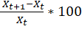
- Compound Annual Growth Rate:
Log Log a + t Log b
b = (1+r)/100
where,
= Variable
time element which takes the values 1,2,3,……,n
= intercept
regression coefficient
CAGR (%) = (antilog b-1)*100
- Coefficient of variation (CV):
CV = ( 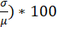
- Coppock’s Instability Index (CII):
Trend free measure of variability which is a close approximation of average year to year percentage variation adjusted by trend [12,13,14].
Vlog =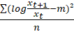

CCI = Antilog (
Where,
t = number of years
m = mean of difference between logs of
Log V = logarithmic variance of the series.
- Cropping intensity (%):
CI (%) = (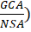 *100
Where, GCA= Gross Cropped Area
NSA = Net Sown Area
- Irrigation Intensity (%):
II (%) = (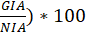
Where, GIA = Gross Irrigated Area
NIA = Net Irrigated Area
- Percent Net Area Irrigated (%):
AI (%) = (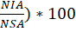
Where, NIA = Net Irrigated Area
NSA = Net Sown Area
- Percent Gross Area Irrigated (%):
AI (%) = (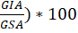
Where, GIA = Gross Irrigated Area
GSA = Gross Sown Area
Results and discussion
The basic modern world inputs involved in agriculture are: land, labour, machinery and electricity. The data was analysed and computed using various tools and tables are framed. The growth rates for each and every input were calculated for forty years as well as annually. The instability was computed using Coppock’s Instability Index (CII) for these main agricultural inputs in order to record the trends and changing scenario of these input.
Table 1: Trends in land area in agriculture in India (1980-1 to 2020-21)
(‘000 hectares)
Years | Geo. area | Cultivable land | Cultivated land | NCA | GCA | Area smto | GIA
1980-81 | 328726 | 185156 | 155114 | 140288 | 172630 | 32342 | 49775
1985-86 | 328726 | 185127 | 155795 | 140901 | 176330 | 37563 | 54281
1990-91 | 328726 | 185187 | 156710 | 142870 | 185742 | 42872 | 63203
1995-96 | 328726 | 183623 | 156028 | 142197 | 180053 | 45274 | 71352
2000-01 | 328726 | 183455 | 156113 | 141336 | 185340 | 44005 | 76187
2005-06 | 328726 | 182686 | 155375 | 141162 | 192756 | 51575 | 84280
2010-11 | 328726 | 182012 | 155839 | 141563 | 198969 | 56000 | 88887
2015-16 | 328726 | 181840 | 154625 | 142825 | 199026 | 57620 | 89502
2020-21 | 328726 | 181702 | 154125 | 143523 | 199563 | 58906 | 90532
Growth Rate (%)
1980-81 to 2020-21 | 0.00 | -0.09 | -0.03 | 0.11 | 0.73 | 3.04 | 3.04
1980-81 to 1990-91 | 0.00 | 0.00 | 0.10 | 0.18 | 0.73 | 2.86 | 2.42
1990-91 to 2000-01 | 0.00 | -0.09 | -0.04 | -0.11 | -0.02 | 0.26 | 1.89
2000-01 to 2010-11 | 0.00 | -0.08 | -0.02 | 0.02 | 0.71 | 2.44 | 1.55
2010-11 to 2020-21 | 0.00 | -0.02 | -0.11 | 0.14 | 0.03 | 0.51 | 0.18
Source: Department of Agriculture, Cooperation and Farmers Welfare, Ministry of Agriculture, Government of India, 2020-21
Where, Geo. Area – Geographical area, NCA – Net Cropped area, GCA – Gross Cropped Area, Area smto – area sown more than once, GIA – Gross irrigated area
During last so many years, the amount of fallow land grew because of inadequate irrigation facilities [15]. Table 1 shows that there has been a growth in the land area under agriculture. If we notice the growth rates, it can be concluded that during 1980-81 to 2020-21, a negative growth was in cultivable land area (-0.09%) and cultivated land area as well (-0.03%). The geographical area remained constant. The decadal growth was negative in case of cultivated land area except for 1980-81 to 1990-91 (0.10%). The decadal growth rates were fluctuating for all particulars.

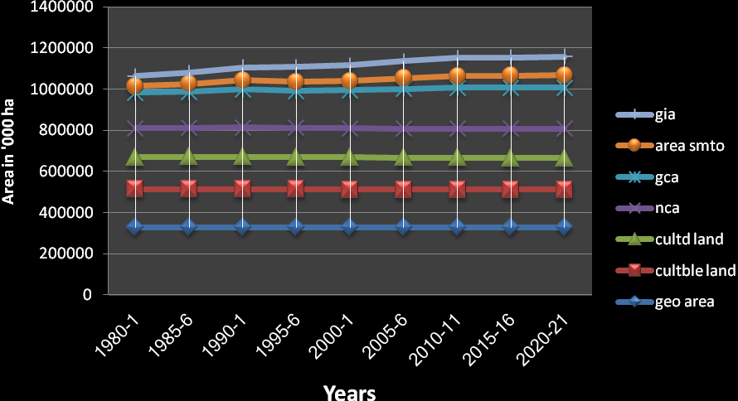
Figure 1. Growth in cropped or cultivated area
Table 2: Land area under different crops (In’000 hectare)
(‘000 ha)
Years | Rice |  | Wheat | Total cereals | Total Pulses | Total Food grains | Total Food Crops | Total oil seeds | Total Non Food Crops | GCA
1980-81 | 40237 |  | 22225 | 100867 | 22708 | 127608 | 137591 | 15698 | 34955 | 172546
1985-86 | 41220 |  | 23179 | 101121 | 24437 | 128756 | 139932 | 19435 | 38521 | 178453
1990-91 | 42744 |  | 24046 | 100693 | 24883 | 127918 | 141031 | 25152 | 44711 | 185742
1995-96 | 43016 |  | 25105 | 98040 | 23637 | 123463 | 138276 | 27945 | 49195 | 187471
2000-01 | 44761 |  | 25797 | 99905 | 21325 | 122680 | 138493 | 24628 | 47327 | 185820
2005-10 | 43660 |  | 26484 | 99208 | 22391 | 121599 | 141172 | 27861 | 51584 | 192756
2010-11 | 42862 |  | 29069 | 100269 | 26402 | 126771 | 146265 | 27228 | 52703 | 198968
2015-16 | 43460 |  | 31250 | 99058 | 24063 | 122536 | 143216 | 27465 | 56302 | 199518
2020-21 | 44256 |  | 32006 | 100263 | 25908 | 124563 | 144036 | 28603 | 58623 | 202659
Growth Rate (%)
1980-81 to 2020-21 |  | 0.24 | 0.92 | -0.02 | 0.33 | -0.06 | 0.11 | 1.51 | 1.30 | 0.40
1980-81 to 1990-91 |  | 0.61 | 0.79 | -0.02 | 0.92 | 0.02 | 0.25 | 4.83 | 2.49 | 0.74
1990-91 to 2000-01 |  | 0.46 | 0.71 | -0.08 | -1.53 | -0.42 | -0.18 | -0.21 | 0.57 | 0.00
2000-01 to 2010-11 |  | -0.43 | 1.20 | 0.04 | 2.16 | 0.33 | 0.55 | 1.01 | 1.08 | 0.69
2010-11 to 2020-21 |  | 0.32 | 0.97 | 0.00 | -0.19 | -0.18 | -0.15 | 0.49 | 1.07 | 0.18
Source: Report of Ministry of Agriculture and Farmers Welfare, Government of India, 2020-21
Table 2 reflects the area cropped with various crops from 1980-81 to 2020-21. It can be concluded that not much fluctuations were seen in the data. For the forty years, total cereals witnessed a negative growth of 0.02 per cent alongwith total foodgrains (-0.06%). For the case of decadal growth rate, rice faced positive growth rate for all the four decades except for 2000-01 to 2010-11 (-0.43%). No growth was seen in total cereals for 20010-11 to 2020-21 and for gross cropped area during 1990-91 to 2000-01.
Table 3: Population and Agricultural workers in India
(in millions)
Year | Total population | Rural population | Agricultural workers-cultivators | Agri workers-labourers | Total Agri workers
1981 | 683.3 | 526 | 93 | 56 | 149
1991 | 846.4 | 631 | 111 | 75 | 186
2001 | 1028.7 | 743 | 127 | 107 | 234
2011 | 1210.6 | 834 | 119 | 144 | 263
2021 | 1449.5 | 956 | 115 | 161 | 276
Growth Rate (%)
1981-2021 | 1.90 | 1.50 | 0.53 | 2.68 | 1.55
1981-1991 | 2.16 | 1.84 | 1.79 | 2.96 | 2.24
1991-2001 | 1.97 | 1.65 | 1.36 | 3.62 | 2.32
2001-2011 | 1.64 | 1.16 | -0.65 | 3.01 | 1.18
2011-2021 | 1.82 | 1.37 | -0.34 | 1.12 | 0.48
Source: NSSO data, 2020-21
It can be inferred from table 3 that a positive growth rate has been noticed incase of total population, maximum being in 1981-1991. There has been a positive growth rate in cultivators for various decadal periods except for 2001-2021 (-0.65%). During the whole period of forty years, maximum growth was in the number of labourers in agriculture i.e. 2.68 per cent. This number of agricultural labourers was maximum in 1991-2001 (3.62%).
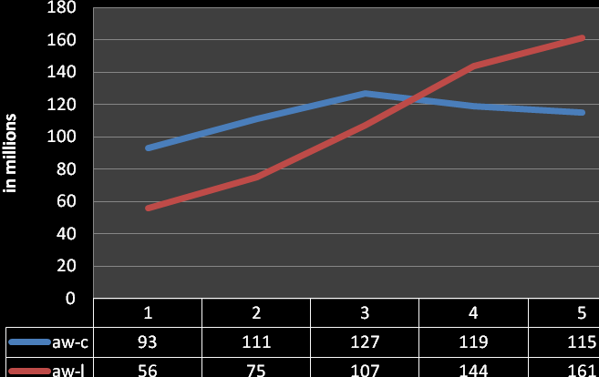
Figure 2. Trends in agricultural workers
Table 4. Agricultural and non agricultural workforce from 1999-2000 to 2020-21
(in millions)
Year | Total Workforce | Agri Workforce | Non agri workforce | Share Agri Labour Force
1999-2000 | 397 | 238 | 159 | 59.95
2009-2010 | 460 | 245 | 215 | 53.26
2019-2020 | 520 | 254 | 275 | 48.85
Growth Rate (%)
1999-20 to 2019-20 | 1.36 | 0.33 | 2.78 | -1.02
1999-20 to 2009-10 | 1.48 | 0.29 | 3.06 | -1.18
2009-10 to 2019-20 | 1.23 | 0.36 | 2.49 | -0.86
Source: Report of Ministry of agriculture, Government of India, 2020-21
Table 4 shows that there has been an increase in all the parameters, from 1999-2000 till 2019-20. It can be seen in the figure 3 that the share of agri labour force was negative for 1999-20 to 2019-20 (-1.02%). The maximum growth rate was for non- agricultural workforce that is 2.78 per cent.
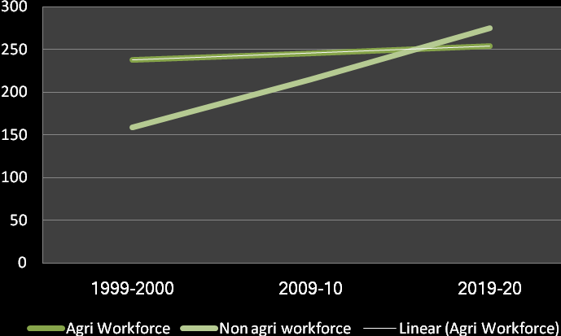
Figure 3. Agricultural and Non agricultural work force
Table 5. Estimated number of operational holdings using agricultural machinery
(in Thousands)
Year | Power Operated Equipmets
 | Diesel engine pumpset | Electric pumpset | Power tiller | Tractor
1980-81 | 3353 | 3977 | 273 | 489
1985-86 | 5968 | 6347 | 701 | 1582
1990-91 | 6892 | 9326 | 1071 | 3574
1995-96 | 8890 | 9165 | 1697 | 6799
2000-01 | 14261 | 18445 | 3265 | 15502
2005-06 | 13180 | 12714 | 2897 | 31279
2010-15 | 30082 | 22761 | 7954 | 61133
2015-16 | 39283 | 26706 | 8105 | 69523
2020-21 | 41023 | 28532 | 8952 | 70251
Growth Rate (%)
1980-81 to 2020-21 | 6.46 | 5.05 | 9.12 | 13.22
1980-81 to 1990-91 | 7.47 | 8.9 | 14.65 | 22.01
1990-91 to 2000-01 | 7.54 | 7.06 | 11.79 | 15.8
2000-01 to 2010-11 | 7.75 | 2.12 | 9.31 | 14.71
Source: Agricultural Statistics and CSO data, 2020-21
Table 5 tells about the agricultural machinery. Maximum growth rate for the forty year period was observed in tractors (13.22%), followed by Power tillers (9.12%). No negative growth rate in machinery was observed.
Table 6. Consumption of electricity from 1980-1 to 2020-21
(in Gigawatts)
Years | Cons for agril purpose | Total consumption | % (agril consumption in total)
1980-81 | 14489 | 82367 | 17.59
1985-86 | 23422 | 122999 | 19.04
1990-91 | 50321 | 190352 | 26.44
1995-96 | 85732 | 277029 | 30.95
2000-01 | 84729 | 316600 | 26.76
2005-06 | 90292 | 411887 | 21.92
2010-11 | 126377 | 694392 | 18.20
2015-16 | 169960 | 952308 | 17.85
2020-21 | 173562 | 999006 | 17.37
Growth Rate (%)
1980-18 to 2020-21 | 6.40 | 6.44 | -0.03
1980-81 to 1990-91 | 13.26 | 8.74 | 4.16
1990-91 to 2000-01 | 5.35 | 5.22 | 0.12
2000-01 to 2010-11 | 4.08 | 8.17 | -3.78
2010-11 to 2020-21 | 3.22 | 3.70 | -0.46
Source: Agricultural Statistics, 2020-21
The consumption of electricity increased from 1980-21 to 2020-21. So, the growth rate was positive for consumption of electricity for agriculture as well as total consumption. However, there is a negative growth rate in the share of consumption in agriculture to total consumption in 2000-01 to 2010-11 (-3.78%) and in2010-11 to 2020-21 (-0.46%)
Table 7: Cuppock’s Instability Indices for various major inputs of agriculture.
(%)
Sr. No. |  | Particulars | Instability Index (%)
1. |  | Land Area | 36.79
a) |  | Cultivable area | 35.85
b) |  | Cultivated area | 36.70
c) |  | Gross cropped area | 36.86
d) |  | Gross irrigated area | 36.90
2. |  | Labour
a) |  | Total population | 37.07
b) |  | Rural population | 36.90
c) |  | AW- Cultivator | 36.8
d) |  | AW-Labourers | 38.23
3. | Machinery
a) | DEP |  |  | 58.58
b) | Electric pumpset |  |  | 44.13
c) | Power Tiller |  |  | 252.83
d) | Tractors |  |  | 807.85
4. | Electricity
a) | Agricultural use |  |  | 171.78
b) | Total consumption |  |  | 181.89
c) | % share of agri. Con. |  |  | 100.23

Table 7 shows the values of Cuppock’s instability index for major inputs – Land, labour, water, fertilizers, pesticides, seeds, machinery and electricity. For land, it was seen that steady values were there with little or no changes. Fluctuations were not much in case of land. If we talk about labour, it increased from time to time. In case of irrigation source, instability was seen for private tanks (42.85%). For NPK (fertilizers), there was instability in all the nutrients- N, P and K. N showed almost six times increase from 1980-81 to 2020-21 with an instability index of 40.09 per cent. Similary, in P, a five times increased was observed for forty years time explaining instability of 42.73 per cent. For potassium (K), instability of 41.78 per cent was calculated.
The instability in case of certified quality seeds in various crops was calculated. It was observed that maximum instability was in pulses (132.54%), oilseeds (61.80%) and fibres (49.70%). Cereals and potato recorded similar instability index of 49.23 per cent and 49.70 per cent respectively. Due to mechanization in modern times, the instability index was recorded to be high. The maximum instability index was in tractors (807.85%), followed by Power tillers (252.83%), Diesel engine pumpset (58.58%) and Electric pumpset (44.13%). Then for the next input that is electricity, it was seen that maximum instability index was in electricity contributed to agriculture (171.9%) and percent share of electricity use in agriculture was having instability index of 100.23 per cent.
Conclusion
This study offers an in-depth analysis of the trends and effects of various agricultural inputs on the development and productivity of Indian agriculture over the past four decades. The findings emphasize the critical importance of inputs like land, labor, machinery and electricity in influencing agricultural progress in India. Significant structural shifts have taken place in Indian agriculture, driven by factors such as population growth, mechanization and resource scarcity [16]. The analysis highlights a consistent reduction in cultivable and cultivated land areas, underlining the challenges posed by limited land availability in sustaining agricultural growth. Nevertheless, the increase in gross cropped and irrigated areas reflects a shift towards more intensive land use. The trends in agricultural labor show a decline in the number of cultivators, coupled with a rise in agricultural laborers, reflecting broader changes in the rural economy and increased mechanization. The data also indicate significant growth in the use of machinery, particularly tractors and power tillers, which have experienced the highest growth rates among all inputs, helping to offset the declining labor force and boost productivity. Electricity consumption for agriculture has also grown, although its proportion of total electricity consumption has decreased in recent years. This suggests an area for policy focus to ensure the agricultural sector's energy needs are met. The Coppock’s Instability Index values for various inputs highlight the variability and fluctuations in their availability and usage over time. The high instability observed in machinery and electricity inputs indicates the need for more consistent and reliable access to these resources to sustain agricultural productivity. While Indian agriculture has achieved considerable progress since the Green Revolution, it continues to face challenges related to land scarcity, labor dynamics, and resource management [17,18]. Future growth will depend on the ongoing adoption of modern technologies, improved resource management, and policies that address the evolving needs of the agricultural sector. The findings of this study provide valuable insights for policymakers, researchers, and practitioners aiming to promote sustainable agricultural development in India.
Disclaimer (Artificial intelligence)
Option 1:
Author(s) hereby declare that NO generative AI technologies such as Large Language Models (ChatGPT, COPILOT, etc) and text-to-image generators have been used during writing or editing of this manuscript.
References

[1] Radhakrishna R. 2020. Towards inclusive agricultural development: growth performance, welfare challenges and policy innovations. Indian Journal of Agricultural Economics 75 (01):1-28.
[2] Mellore. 1958. Production: Primary, secondary and tertiary. The Economic Journal 15(1): 24-38.
[3] Gandhi, Zhou and Mullen. 2004. The 'V - factor' distribution, timing and correlates of Great Indian growth turnaround. Journal of Development Economics 99(1): 58-67.
[4] Ganesh. 2014. Structural change and growth in India. Economic Letters 110: 178-181.
[5] Mehrotra S and Jajati JK. 2021. Stalled Structural Change Brings an Employment Crisis in India. The Indian Journal of Labour Economics 64: 281–308.
[6] Dev SM and Pandey VL. 2013. Performance and Key Policy Issues of Indian Agriculture. India Development Report No. 2012–13, Oxford University Press, New Delhi.
[7] Birthal PS, Roy D and Negi DS. 2015. Assessing the impact of crop diversification on farm poverty in India. World Development 72: 70-92.
[8] Pandey G, Khan R and Kumari S. 2019. Pathways of agricultural transformation: a comparative analysis of Punjab and Bihar. Agricultural Economics Research Review 32: 1-11.
[9] Anonymous. 2021. Department of Statistics and Economics, Ministry of Agriculture and Framers’ Welfare. https://agricoop.nic.in/sites/default/files/FirstEstimate2020-21.pdf
[10] Anonymous. 2021. Annual Report, National Statistical Commission, GOI, NSSO. https://mospi.gov.in/documents/213904/0/Eng+version_NSC+Annual+Report_2020-21
[11] Central Statistics Office. 2021. https://www.cso.ie/en/databases/
[12] Kaur and Singhal. 1998. An empirical investigation of the nature and causes for growth and instability in Indian agriculture: 1950-80. Indian Journal of Agricultural Economics 38(4): 459-474.
[13] Sharma HR, Singh K and Kumari S. 2006. Extent and source of instability in food grains production in India. Indian Journal of Agricultural Economics 61(4): 648-666.
[14] Anjum S and Tarique M. 2017. Agriculture and poverty reduction in India: An empirical study. Asian Journal of Research in Social Sciences and Humanities 7(9): 35 – 48.
[15] Pandey G and Ranganathan T. 2018. Changing land-use pattern in India: has there been an expansion of fallow lands?. Agricultural Economics Research Review 31(01): 113-122.
[16] Chenery HB and T Lance. 1968. Development patterns: Among countries and over time. Review of Economics and Statistics 50(4): 391– 416.
[17] Mkhize HPB and D’Souza A. 2015. Agricultural Performance at State level in India: 1980-2010. Agricultural Economic Research Review 28(1): 27-38.
[18] Timmer P. 2009. The Structural transformation as a pathway out of poverty: Analytics, empirics and politics. Working Paper No.150, Center for Global Development. Victor, R.F., 1968. The service economy. National Bureau of Economic Research New York.

