Climate Trend Analysis and Implications for Water Management in the Upper Bhavani Region, Coimbatore (1995-2021)

ABSTRACT:
This study tried to point out the trends of climate in the Upper Bhavani Region of Coimbatore, India, from 1995 to 2021. Mann-Kendall tests have been applied to the trends of some key climate variables. Our analysis returned significant changes for climate parameters during 26-year period. As such, rainfall trends were mixed, although only that for December revealed a significant increasing trend: Z = 2.251466, p < 0.05, Several months of the groundwater level time series showed significant increasing trends, most of which occurred in the second half of the year. The largest increases occurred in November, Z = 3.043649, p < 0.05, and in May, Z = 2.918567, p < 0.05. Wind speeds showed a decreasing trend, especially the minimum wind speeds. There were significant decreases in all months except October and December with p < 0.05, while in April, there was a maximum wind speed decrease statistically (Z = -2.043, p < 0.05). The highly increasing trends of minimum temperatures were indicated in several months, with the largest increases in November, with Z = 3.127036 and p < 0.05, and December, yielding Z = 3.001955 and p < 0.05. Maximum temperatures showed no significant trends. Results for relative humidity and soil moisture did not show any significant trend in the observed period, thus underlining the real complexity of relationships occurring within the local climatic system. The findings indicate that the Upper Bhavani Region is undergoing process of climatic change characterized by warmer nights, increased groundwater levels, and reduced wind speeds.
KEYWORDS: Climate Change, Groundwater Levels, Mann-Kendall Trend Test, Meteorological Parameters, Upper Bhavani Region
HIGHLIGHTS:
• Steep rise of minimum temperatures and groundwater levels from 1995-2021 in the Upper Bhavani Region, Coimbatore.
• Decreasing wind speed and variable rainfall trends detected with implication on local agriculture and water management.
INTRODUCTION
Climate change has turned out to be one of the toughest environmental issues in the 21st century and has caused significant damage to ecosystems, agriculture, water resources, and human societies worldwide. The Upper Bhavani Region in Coimbatore is well known for its core biodiversity and the agricultural productivity it produces, so it does not stand as an exception either. Thus, understanding the local trends in climate and their implications assumes significance in developing proper adaptation and mitigation strategies. Trend analysis of meteorological parameters is quite important in recognizing the vital change and taking action accordingly. Meteorological parameters are very important in identifying any trend, which is vital for future planning, as supported by Hirsch et al. (1982) and Mondal et al. (2012).One of the most commonly used non-parametric statistical tests is the Mann-Kendall trend test, robust for detecting a trend in environmental data. The meteorological parameters on rainfall, relative humidity, soil moisture, groundwater level, wind speed, and temperature trends of the data from 1995 to 2021 were analysed in this research using the Mann-Kendall test.
The present study will help policymakers, resource managers, and researchers by bringing out the significant trends and their implications while formulating plans on sustainable development and climate resilience strategies for the region.
REVIEW OF LITERATURE
Attention to climate trend analysis has been enormous in the past few decades as a method for understanding and establishing predictions of changes in climatic patterns. The Mann-Kendall trend test is substantially used in detecting the trends in meteorological and hydrological data, since it is a non-parametric statistical test. These pioneering studies by Kendall and Mann laid the base for this methodology and established its robustness and reliability for detecting a trend. Several studies have used the Mann-Kendall test in rainfall trend analysis. For instance, Mondal et al. studied the trends of rainfall in West Bengal, India, and found that there were significant seasonal variations impacting agricultural productivity under changing monsoon patterns. Similarly, Gocic and Trajkovic (2013) have conducted a rainfall trend analysis over the whole Serbian area, showing spatial and temporal variability of precipitation. Many studies have been made about temperature trends using the Mann-Kendall test. Vincent et al. (2012) surveyed the trends in temperature series from the Canadian Arctic, showing significant warming trends mainly in the Time series. This finding concurs with the global warming observation documents put forward by the Intergovernmental Panel on Climate Change, IPCC (2021), which suggests overall increases in global temperatures, with maximum intensification at polar and high-altitude regions. Important elements governing the hydrological cycle include soil moisture and groundwater levels, through which agricultural productivity and management of water resources are controlled. Seneviratne et al. (2010) commented on the key role of soil moisture for climate variability and extreme weather events. Investigations by Taylor et al. (2013) have underlined how climate change could affect groundwater resources, highlighting the necessity of adequate management policies in a context of change in precipitation and rising water demand. The wind speed trend is relevant for important implications in agriculture, energy, and urban planning sectors. McVicar et al. (2012) assessed the trends of wind speed globally and observed a declining trend in terrestrial wind speed, Such a phenomenon has far-reaching ramification in fields like pollutant dispersion, renewable energy production, and agricultural practices. Under such conditions in the Upper Bhavani Region, localized studies become essential due to its peculiar climatic and geographical features to understand the specific impacts of climate change. To this end, this work has the objective of filling this gap by making an in-depth trend analysis of the meteorological key parameters contributing to the required knowledge body for effective adaptation strategies in this region.
METHODOLOGY:
Mann-Kendall Test Statistic (S): S = ∑∑ sign (x_{j} - x_{i}) i<j
Where:
• X_{i} and xj are data values at times i and j (j > i) respectively
• sign (x_{j} - x_{i})

Fig: 1 Methodology of trend Analysis using man Kendal
In the Mann-Kendall trend test, the test statistic, S, is an important indicator of the trend direction in a dataset. To be specific, if S is greater than zero, then it indicates an increasing trend, meaning the variable under study at any moment in consideration shows a rising pattern over time. On the other hand, if it is less than zero, it indicates a decreasing trend, indicating a downward trajectory. A zero value for ( S ) indicates no apparent trend. Then this ( S ) statistic is standardized to a Z-value and the critical values from the standard normal distribution are used to check the significance of the trend. If the value of Z falls outside a certain threshold, then the trend is said to be either statistically significantly increasing or decreasing depending on the sign of. This provides a robust and non-parametric approach toward detecting a trend in environmental and meteorological data.

Results and Discussion

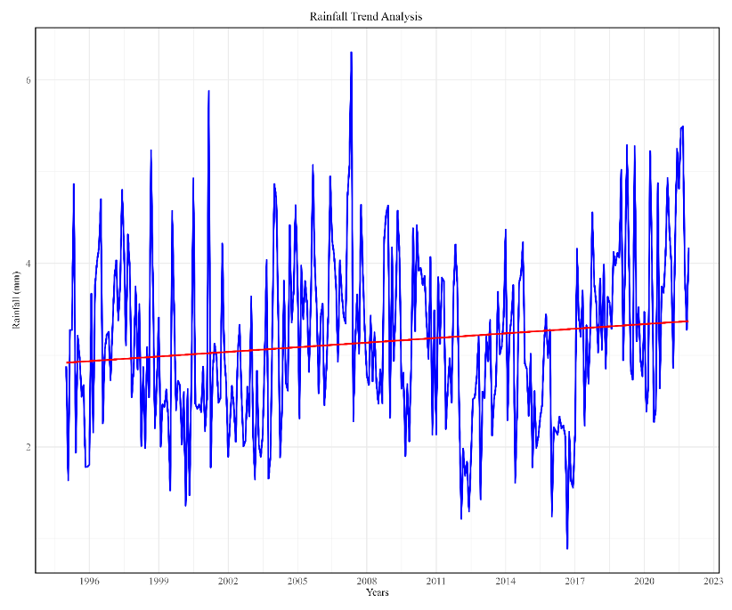 | 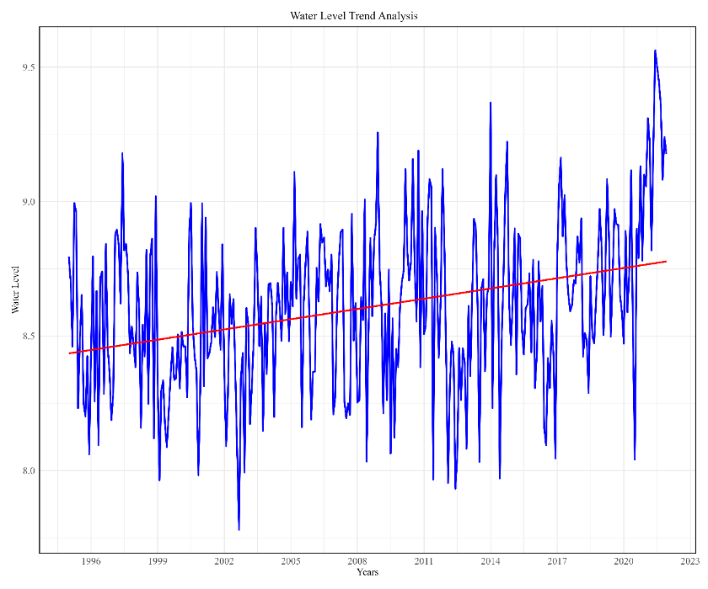
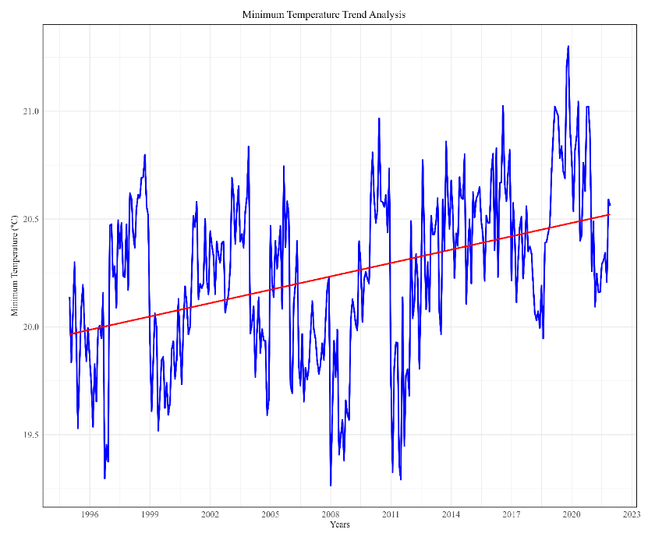 | 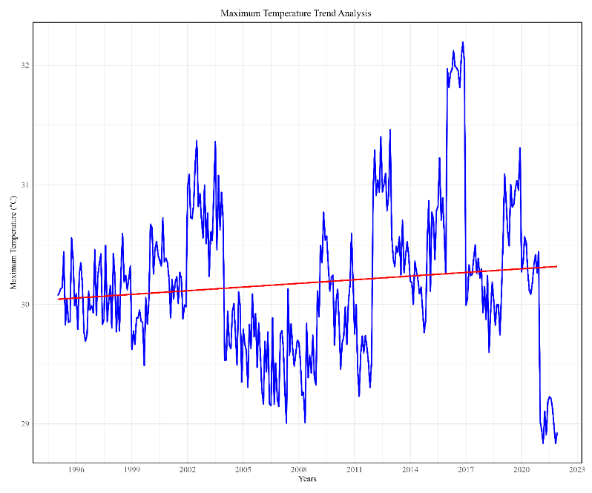
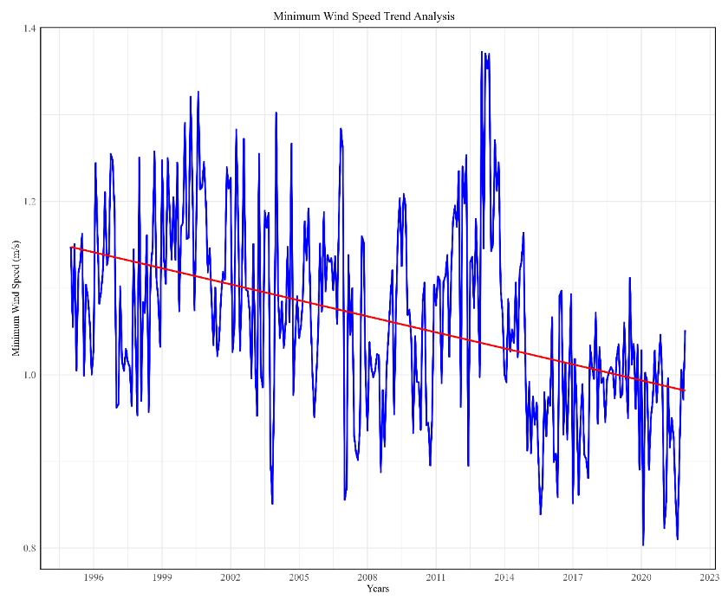 | 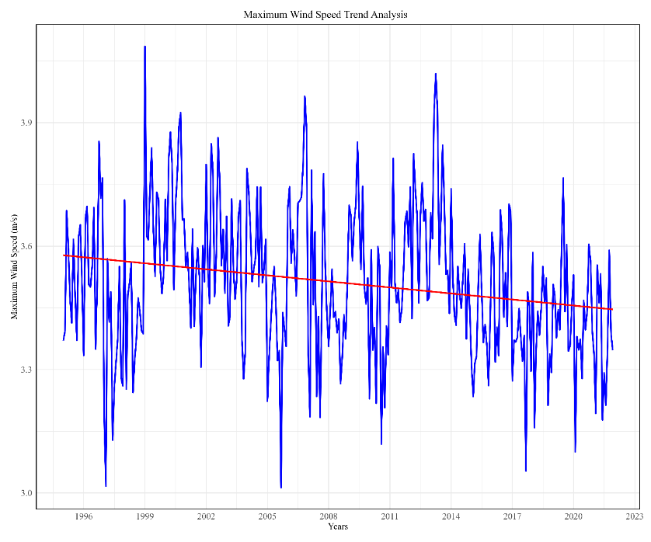
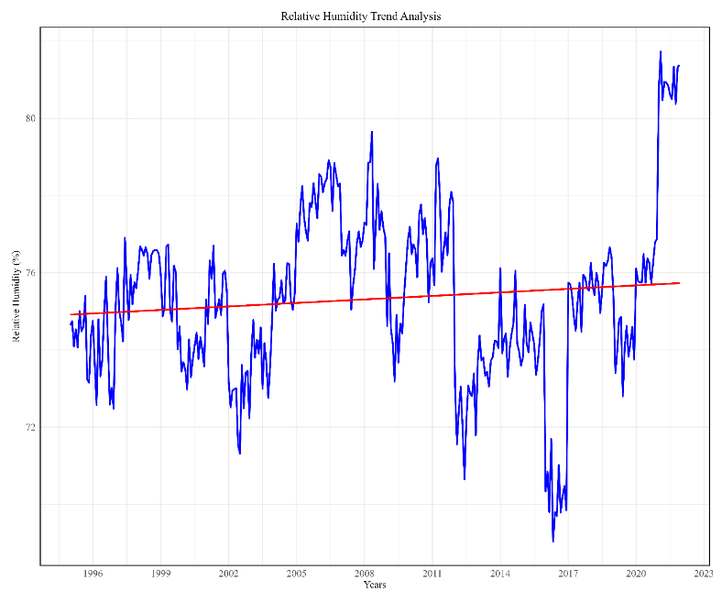 | 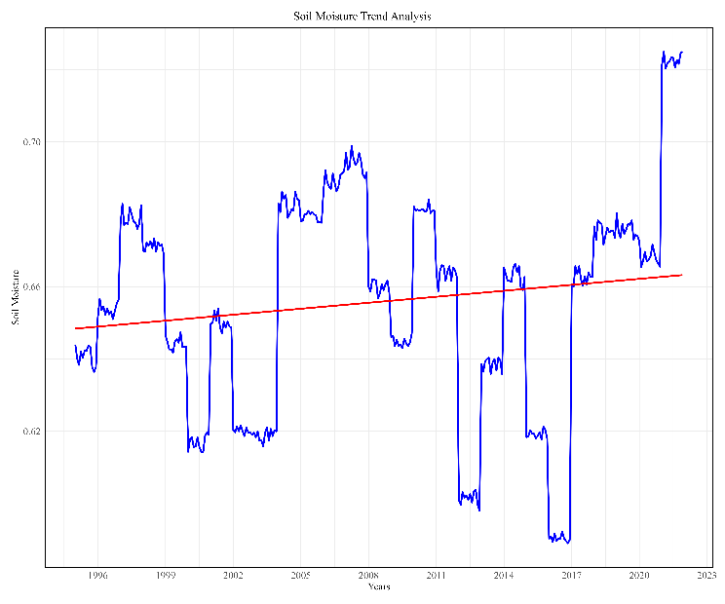

Fig 2: Trend Analysis of parameters

According to the Mann-Kendall test, various climate variables across the Upper Bhavani Region were found to have several significant trends. The results indicated that during the period from 1995 to 2021, different meteorological parameters exhibited stable and changing patterns.

Table 2:Trend analysis of Relative Humidity using Man Kendal
Month | MK_Statistic | P_Value | Trend | Significance
1 | 0.792183 | 0.428254 | Increasing | No
2 | 0.208469 | 0.834863 | Increasing | No
3 | 0.833876 | 0.404351 | Increasing | No
4 | 0.250163 | 0.802461 | Increasing | No
5 | 0.54202 | 0.587805 | Increasing | No
6 | -0.16678 | 0.867547 | Decreasing | No
7 | 0.416938 | 0.676724 | Increasing | No
8 | 0 | 1 | No Trend | No
9 | 0.125081 | 0.900459 | Increasing | No
10 | 1.125733 | 0.260278 | Increasing | No
11 | 1.292508 | 0.196181 | Increasing | No
12 | 1.084039 | 0.278347 | Increasing | No

Table 1: Trend analysis of Rainfall(m) using Man Kendal
Month | MK_Statistic | P_Value | Trend | Significance
1 | 0.87557 | 0.381264 | Increasing | No
2 | 0.833876 | 0.404351 | Increasing | No
3 | 0.041694 | 0.966743 | Increasing | No
4 | 1.667753 | 0.095365 | Increasing | No
5 | 0.54202 | 0.587805 | Increasing | No
6 | -0.29186 | 0.770396 | Decreasing | No
7 | -1.3759 | 0.168854 | Decreasing | No
8 | 1.584365 | 0.113111 | Increasing | No
9 | 0.041694 | 0.966743 | Increasing | No
10 | 1.375896 | 0.168854 | Increasing | No
11 | 1.626059 | 0.103937 | Increasing | No
12 | 2.251466 | 0.024356 | Increasing | Yes

Table 3:Trend analysis of Soil moisture using Man Kendal
Month | MK_Statistic | P_Value | Trend | Significance
1 | 0.813206 | 0.4161 | Increasing | No
2 | 0.708795 | 0.478452 | Increasing | No
3 | 0.750489 | 0.45296 | Increasing | No
4 | 0.688098 | 0.491391 | Increasing | No
5 | 0.751142 | 0.452567 | Increasing | No
6 | 0.625407 | 0.531704 | Increasing | No
7 | 0.792527 | 0.428053 | Increasing | No
8 | 0.750489 | 0.45296 | Increasing | No
9 | 0.792183 | 0.428254 | Increasing | No
10 | 0.667101 | 0.504708 | Increasing | No
11 | 0.688098 | 0.491391 | Increasing | No
12 | 0.646395 | 0.518024 | Increasing | No

Table 4: (iv)Trend analysis of Ground Water Level (m) using Man Kendal
Month | MK_Statistic | P_Value | Trend | Significance
1 | 1.834528 | 0.066576 | Increasing | No
2 | 0.87557 | 0.381264 | Increasing | No
3 | 1.584365 | 0.113111 | Increasing | No
4 | 1.626059 | 0.103937 | Increasing | No
5 | 2.918567 | 0.003516 | Increasing | Yes
6 | -0.6671 | 0.504708 | Decreasing | No
7 | -0.83388 | 0.404351 | Decreasing | No
8 | 2.334854 | 0.019551 | Increasing | Yes
9 | 0.667101 | 0.504708 | Increasing | No
10 | 2.83518 | 0.00458 | Increasing | Yes
11 | 3.043649 | 0.002337 | Increasing | Yes
12 | 2.376548 | 0.017476 | Increasing | Yes

Table 5:Trend analysis of Maximum Wind Speed using Man Kendal
Month | MK_Statistic | P_Value | Trend | Significance
1 | -0.87557 | 0.381264 | Decreasing | No
2 | -1.3759 | 0.168854 | Decreasing | No
3 | -1.95961 | 0.050041 | Decreasing | No
4 | -2.043 | 0.041053 | Decreasing | Yes
5 | -1.95961 | 0.050041 | Decreasing | No
6 | 0.208469 | 0.834863 | Increasing | No
7 | -0.54202 | 0.587805 | Decreasing | No
8 | -0.95896 | 0.33758 | Decreasing | No
9 | -0.91726 | 0.359004 | Decreasing | No
10 | -1.75114 | 0.079922 | Decreasing | No
11 | -1.16743 | 0.243038 | Decreasing | No
12 | -1.62606 | 0.103937 | Decreasing | No
Table 6:Trend analysis of Minimum Wind Speed using Man Kendal
Month | MK_Statistic | P_Value | Trend | Significance
1 | -2.37655 | 0.017476 | Decreasing | Yes
2 | -2.41824 | 0.015596 | Decreasing | Yes
3 | -2.37655 | 0.017476 | Decreasing | Yes
4 | -2.58502 | 0.009737 | Decreasing | Yes
5 | -2.48132 | 0.01309 | Decreasing | Yes
6 | -2.0013 | 0.04536 | Decreasing | Yes
7 | -2.73154 | 0.006304 | Decreasing | Yes
8 | -2.043 | 0.041053 | Decreasing | Yes
9 | -2.58502 | 0.009737 | Decreasing | Yes
10 | -1.66775 | 0.095365 | Decreasing | No
11 | -2.08469 | 0.037097 | Decreasing | Yes
12 | -1.54267 | 0.122911 | Decreasing | No

Table 7:Trend analysis of Maximum Temperture using Man Kendal
Month | MK_Statistic | P_Value | Trend | Significance
1 | 0.416938 | 0.676724 | Increasing | No
2 | 0.792183 | 0.428254 | Increasing | No
3 | 1.000652 | 0.316995 | Increasing | No
4 | 0.125081 | 0.900459 | Increasing | No
5 | -0.20847 | 0.834863 | Decreasing | No
6 | 1.042345 | 0.297252 | Increasing | No
7 | 0.625407 | 0.531704 | Increasing | No
8 | 0.333551 | 0.738719 | Increasing | No
9 | 0.958958 | 0.33758 | Increasing | No
10 | 0.750489 | 0.45296 | Increasing | No
11 | 0.250163 | 0.802461 | Increasing | No
12 | 0.792183 | 0.428254 | Increasing | No

Table 8:Trend analysis of Minimum Temperature using Man Kendal
Month | MK_Statistic | P_Value | Trend | Significance
1 | 2.334854 | 0.019551 | Increasing | Yes
2 | 2.126385 | 0.033471 | Increasing | Yes
3 | 1.667753 | 0.095365 | Increasing | No
4 | 2.084691 | 0.037097 | Increasing | Yes
5 | 1.917916 | 0.055122 | Increasing | No
6 | 1.375896 | 0.168854 | Increasing | No
7 | 1.834528 | 0.066576 | Increasing | No
8 | 1.917916 | 0.055122 | Increasing | No
9 | 1.563858 | 0.117851 | Increasing | No
10 | 2.376548 | 0.017476 | Increasing | Yes
11 | 3.127036 | 0.001766 | Increasing | Yes
12 | 3.001955 | 0.002683 | Increasing | Yes

1. Rainfall
There was a large increasing trend in December (p < 0.05, Z = 2.251466), which perhaps may indicate a possible shift in winter monsoon patterns. If this is the case, such an increase in December rainfall will have key implications for winter crops and water management practices. This lack of significant trends in all other months further shows that even if the total amount of annual rainfall may not change, the intra-annual distribution will have changed enough to impact agricultural planning or water resource management.
2. Relative Humidity
There were no significant trends noted for relative humidity in any month. Here is the background: this constancy of RH despite changes in other climatic variables needs to be considered against the backdrop of intricate interactions between temperature, rainfall, and atmospheric moisture in the region. Indeed, comprehending these interactions assumes real importance in the exercise of projecting future climate scenarios and adapting to the same.
3. Soil Moisture
No significant trends in soil moisture could be detected with the Mann-Kendall test. Such stability may suggest that the level of soil moisture has been maintained, either by effective practices in water retention within the soil or due to proper land management strategies. However, soil moisture may vary greatly within small spatial scales, and further localized studies are needed to confirm these findings and understand the underlying causes.
4. Groundwater Level
It had witnessed high increasing trends in May with Z = 2.918567, p < 0.05, August with Z = 2.334854, p < 0.05, October with Z = 2.83518, p < 0.05, November with Z = 3.043649, p < 0.05, and December with Z = 2.376548, p < 0.05. These trends, very marked during the second half of the year, may be a consequence of changes in precipitation patterns, reduced extraction, or increased glacial melt in the region's water sources. The effect on water resource management and ecosystem health could be enormous, and further research is needed on how to manage groundwater sustainably.
5. Wind Speed
Maximum Wind Speed: In April, there was a significant decreasing trend with Z = -2.043, p < 0.05.
Minimum Wind Speed: The trend graphs for all months except October and December were significantly decreasing at p < 0.05.

The general decline in wind speed, especially the minimum wind speed, will more likely have implications for local weather, pollutant dispersion, and agriculture. Low wind speeds can alter evapotranspiration rates and the pollination of wind-pollinated crops, thereby impacting agricultural productivity and microclimate conditions.
6. Temperature
Maximum Temperature: The detected trends were not significant.
Minimum Temperature: January (Z = 2.334854, p < 0.05), February (Z = 2.126385, p < 0.05), April (Z = 2.084691, p < 0.05), October (Z = 2.376548, p < 0.05), November, and December (Z = 3.127036 and Z = 3.001955 respectively) are those months which show significant increasing trends.
The increase in minimum temperatures, more pronounced during the winter months, is compatible with trends of global warming reported by the IPCC (2021), and it might ultimately cause shifts in growing seasons of crops and increases in water demand, thus changing the local ecosystems. The effect on the local climates and agriculture from narrowing diurnal temperature range reasons that have been globally observed because of climate change could also take place.
Implications and Further Research
These results suggest that the climate change pattern in the Upper Bhavani Region is pretty complex. Increases in minimum temperatures without corresponding increases in maximum temperatures could be narrowing the diurnal temperature range, which is in keeping with what takes place in other parts of the world due to climate change. Although this amount of precipitation has not changed that much over the years, the rising groundwater levels reflect changes in the use of water or land-use changes affecting runoff, or increased glacier melt in regional water sources. Though this may potentially help in the availability of water, it calls for careful monitoring to ensure its sustainable management. The variable implications of declining wind speeds, especially the minimum wind speed, can be many. Lower wind speeds would impact local microclimate and could enhance the urban heat island effect within areas that have been developed. This may impact natural ventilation or pollutant dispersion with health-related implications. In agriculture, changes in the wind pattern may alter evapotranspiration rates and the pollen receipt of wind-pollinated crops. Given that most variables change independently, there is little trend in relative humidity or soil moisture, which identifies complex interactions within the local climatic system. This may indicate resilient response to those components of the local environment, but continued monitoring is important. Further research is needed to understand the drivers of these trends and to estimate their possible long-term impacts on the local ecosystem and economy. This includes more detailed spatial analysis, investigation of land-use changes, and future scenario modelling based on the trends observed.
Conclusion
The present research concludes with evidence of significant climate changes in the Upper Bhavani Region during the last 26 years. This complex pattern of changes underlines the requirement of local scale studies on climate change to help formulate pragmatic climatic change adaptations and mitigation strategies. This research can act as a vital input to the policymakers, resource managers, and researchers working toward meeting the challenges of sustainable development in a changing climate.

Disclaimer (Artificial intelligence)
Option 1:
Author(s) hereby declare that NO generative AI technologies such as Large Language Models (ChatGPT, COPILOT, etc) and text-to-image generators have been used during writing or editing of manuscripts.
Option 2:
Author(s) hereby declare that generative AI technologies such as Large Language Models, etc have been used during writing or editing of manuscripts. This explanation will include the name, version, model, and source of the generative AI technology and as well as all input prompts provided to the generative AI technology
Details of the AI usage are given below:
1.
2.
3.

REFERENCES

- Gocic, M., & Trajkovic, S. (2013). Analysis of changes in meteorological variables using Mann-Kendall and Sen's slope estimator statistical tests in Serbia. Global and Planetary Change, 100, 172-182.
- Hirsch, R. M., Slack, J. R., & Smith, R. A. (1982). Techniques of trend analysis for monthly water quality data. Water Resources Research, 18(1), 107-121.
- Intergovernmental Panel on Climate Change (IPCC). (2021). Climate Change 2021: The Physical Science Basis. Contribution of Working Group I to the Sixth Assessment Report of the Intergovernmental Panel on Climate Change. Cambridge University Press.
- Kendall, M. G. (1975). Rank Correlation Methods. Charles Griffin.
- Mann, H. B. (1945). Nonparametric tests against trend. Econometrica: Journal of the Econometric Society, 13(3), 245-259.
- McVicar, T. R., Roderick, M. L., Donohue, R. J., Li, L. T., Van Niel, T. G., Thomas, A., ... & Murray, W. (2012). Global review and synthesis of trends in observed terrestrial near-surface wind speeds: Implications for evaporation. Journal of Hydrology, 416-417, 182-205.
- Mondal, A., Khare, D., & Kundu, S. (2012). Spatial and temporal analysis of rainfall and temperature trend of India. Theoretical and Applied Climatology, 112(3-4), 419-439.
- Seneviratne, S. I., Lüthi, D., Litschi, M., & Schär, C. (2010). Land-atmosphere coupling and climate change in Europe. Nature, 467(7318), 205-209.
- Taylor, R. G., Scanlon, B., Döll, P., Rodell, M., van Beek, R., Wada, Y., ... & Treidel, H. (2013). Ground water and climate change. Nature Climate Change, 3(4), 322-329.
- Vincent, L. A., Zhang, X., Bonsal, B. R., & Hogg, W. D. (2012). Homogenization of daily temperatures over Canada. Journal of Geophysical Research: Atmospheres, 117(D18).
- Gocic, M., & Trajkovic, S. (2013). Analysis of changes in meteorological variables using Mann-Kendall and Sen's slope estimator statistical tests in Serbia. Global and Planetary Change, 100, 172-182.

- Hirsch, R. M., Slack, J. R., & Smith, R. A. (1982). Techniques of trend analysis for monthly water quality data. Water Resources Research, 18(1), 107-121.

- Intergovernmental Panel on Climate Change (IPCC). (2021). Climate Change 2021: The Physical Science Basis. Contribution of Working Group I to the Sixth Assessment Report of the Intergovernmental Panel on Climate Change. Cambridge University Press.

- Kendall, M. G. (1975). Rank Correlation Methods. Charles Griffin.

- 5. Mann, H. B. (1945). Nonparametric tests against trend. Econometrica: Journal of the Econometric Society, 13(3), 245-259.

- 6. McVicar, T. R., Roderick, M. L., Donohue, R. J., Li, L. T., Van Niel, T. G., Thomas, A., ... & Murray, W. (2012). Global review and synthesis of trends in observed terrestrial near-surface wind speeds: Implications for evaporation. Journal of Hydrology, 416-417, 182-205.

- Mondal, A., Khare, D., & Kundu, S. (2012). Spatial and temporal analysis of rainfall and temperature trend of India. Theoretical and Applied Climatology, 112(3-4), 419-439.

- Seneviratne, S. I., Lüthi, D., Litschi, M., & Schär, C. (2010). Land-atmosphere coupling and climate change in Europe. Nature, 467(7318), 205-209.

- Taylor, R. G., Scanlon, B., Döll, P., Rodell, M., van Beek, R., Wada, Y., ... & Treidel, H. (2013). Ground water and climate change. Nature Climate Change, 3(4), 322-329.

- Vincent, L. A., Zhang, X., Bonsal, B. R., & Hogg, W. D. (2012). Homogenization of daily temperatures over Canada. Journal of Geophysical Research: Atmospheres, 117(D18).

