Current Status of Stem Cell Based Therapy

Abstract
Stem cell therapy is an innovative and promising branch of medicine in research nowadays. The therapy uses stem cells, which are capable of developing into different types of cells, to treat injuries and diseases. Stem cell therapy has become a revolutionary area in contemporary medicine, presenting possible treatments for a variety of diseases once deemed incurable. Investigations in this field have centered on comprehending the various categories of stem cells, such as embryonic, induced pluripotent, and mesenchymal stem cells, along with their uses in addressing conditions like neurodegenerative diseases, heart diseases, and cancer. Currently, scientists are using stem cells to regenerate tissues, treat autoimmune diseases, and create novel treatment strategies for cancer. Considerable progress has been achieved in stem cell research; however, there are still many ethical issues to solve, risks of tumor growth, and optimization of treatment procedures to be researched further. However, despite its potential, stem cell therapy encounters obstacles, including ethical dilemmas, the risk of immune rejection, and the necessity for standardized protocols to guarantee safety and effectiveness.

Keywords: stem cells, stem cell therapy, unipotent, multipotent, pluripotent, totipotent, Cell differentiation, tissue engineering, Regenerative medicine.

INTRODUCTION
“Stem cell-based therapies are defined as any treatment for a disease or a medical condition that fundamentally involves the use of any type of viable human stem cells including embryonic stem cells (ESCs), iPSCs and adult stem cells for autologous and allogeneic therapies” (1). Stem cells provide an ideal answer for cases requiring tissue and organ transplants due to their capability to transform into the particular cell types necessary for healing damaged tissues.
“Stem cells possess the remarkable ability to divide indefinitely and can differentiate into various cell types. Recently, they have become a primary resource in regenerative medicine, playing a crucial role in repairing tissue and organ abnormalities caused by congenital defects, diseases, and age-related changes” (2). “Stem cells serve as the fundamental building blocks for all tissues and organ systems within the body, playing a crucial role in disease progression, development, and the processes of tissue repair. Based on their ability to transdifferentiate, stem cells can be classified into four categories: unipotent, multipotent, pluripotent, and totipotent”(3).

Classification of stem cells
Stem cells can be categorized according to their ability to develop into various cell types, which include totipotent, pluripotent, multipotent, oligopotent, and unipotent stem cells.

Table 1. Types of stem cells and properties
Stem cells | Properties
Totipotent | These stem cells possess the ability to differentiate into any cell type. The cells generated during the initial divisions of the fertilized egg are referred to as totipotent. In contrast, embryonic stem cells are classified as pluripotent, as they lack the capacity to contribute to the extra-embryonic membranes or the placenta (4).
Pluripotent | These cells originate from a pre-implantation embryo at an early developmental stage. The pluripotent cells possess the ability to differentiate into nearly all cell types (5).
Multipotent | These cells possess the ability to develop into various types of cells within a closely associated family. For instance, mature hematopoietic stem cells can transform into red blood cells, white blood cells, or platelets (6).
Oligopotent | These can transform into several distinct cell types. Mature lymphoid or myeloid stem cells have the ability to differentiate in this manner (7).
Unipotent | Stem cells possess the unique ability to produce only their specific type of cells. Nonetheless, they are classified as stem cells due to their capacity for selfrenewal. An example of this is the muscle stem cells found in adults (8).
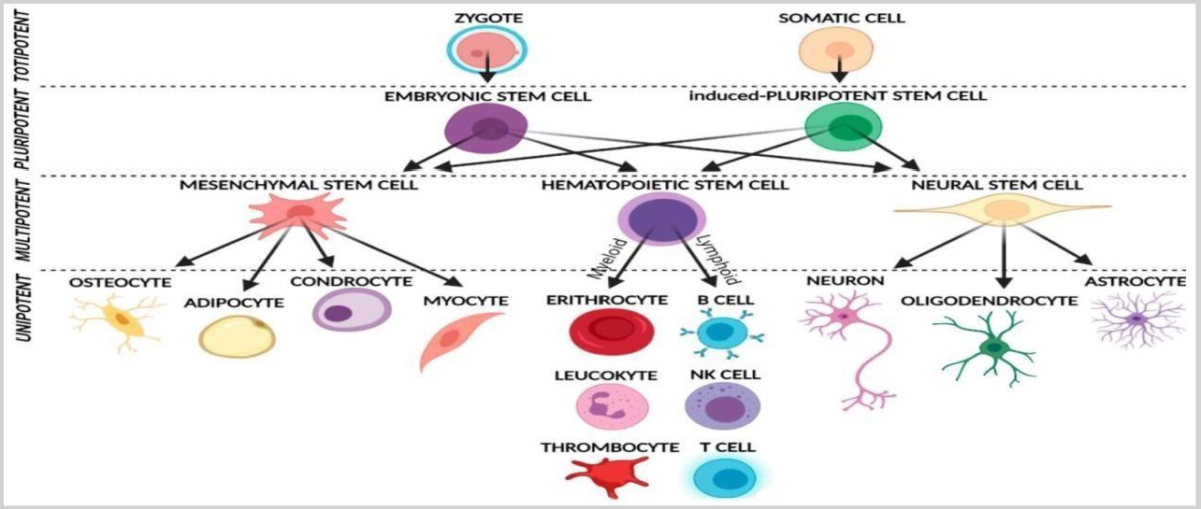

Fig.1: diagrammatic representation of stem cells.

Stem Cell Fates
Four possible outcomes for stem cells are as follows:
- Quiescence, where a stem cell remains inactive and preserves the stem cell population.

- Symmetric self-renewal, in which a stem cell divides to produce two daughter stem cells, thereby enlarging the stem cell population.
- Asymmetric self-renewal, where a stem cell divides into one differentiated daughter cell and one stem cell, thus sustaining the stem cell population.
- Symmetric division without self-renewal, resulting in a reduction of the stem cell population, while producing two differentiated daughter cells (9).
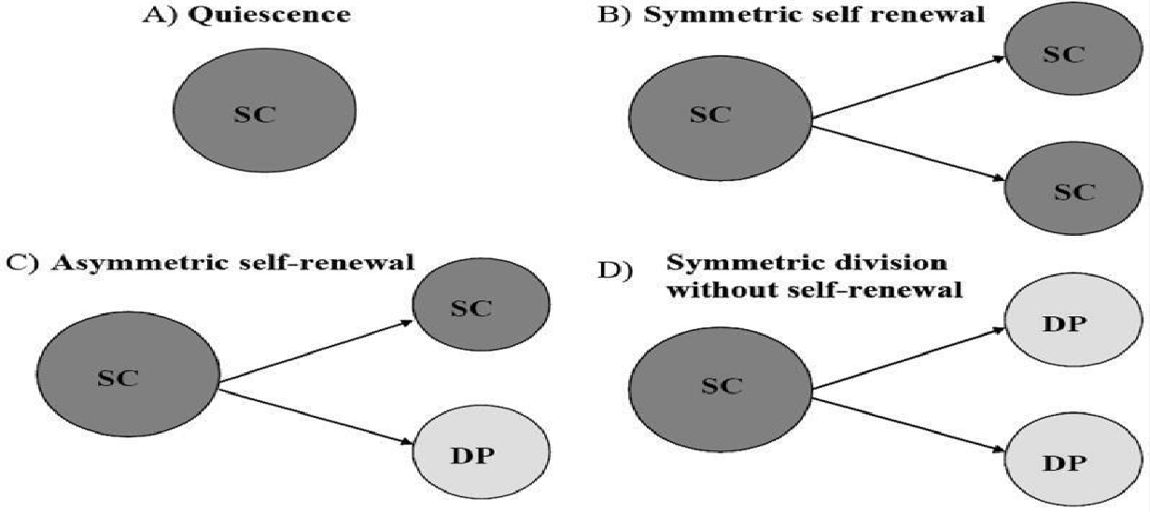

Fig.2: stem cell fate

OPPORTUNITIES, OBSTACLES, AND RISKS OF CELL THERAPY
Opportunities
- Promise for diseases with limited life expectancy: These therapies offer the ability to create treatments that can address numerous genes present in body.

Obstacles
  - Compatible donors. Just like in human organ transplants, there are immune barriers that necessitate a careful “matching” of the HSC donor and recipient to prevent severe complications due to immune system incompatibility.
  - Precision needed. Cell and gene therapies must ensure that the modified cells reach the appropriate tissue, at the correct dosage, and for the necessary duration.
  - Immune suppression. Before administering cell therapy, chemotherapy and other preparatory treatments are commonly given to avoid triggering an immune response.

Risks

  - Safety Concerns: Potential risks include immune reactions, tumor formation, and unintended genetic modifications.
  - Limited Accessibility: Due to high costs and complex logistics, many patients may not have access to these treatments.
  - Market Uncertainty: While promising, the long-term success of cell therapy depends on continued advancements and regulatory support.

TIME LINE OF STEM CELL BASED THERAPY
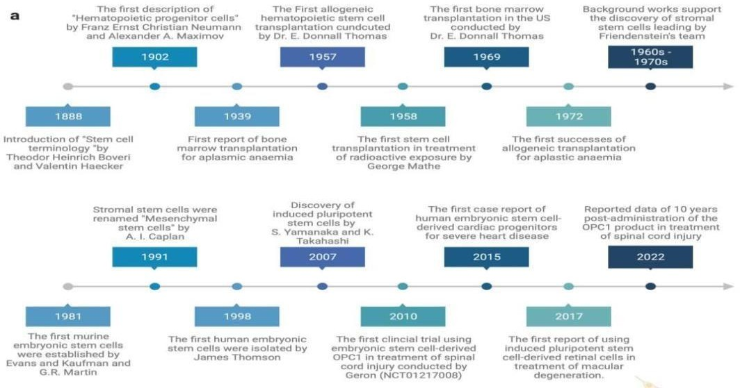

Fig.3: A chronological overview of significant breakthroughs and progress in fundamental research and clinical uses of stem cell therapy.

INVESTIGATIONS
Medical conditions and diseases for which the use of stem cell therapy is being explored include:

- Diabetes
- Androgenic Alopecia and hair loss
- Rheumatoid arthritis
- Parkinson's disease
- Alzheimer's disease
- Respiratory disease
- Osteoarthritis
- Spinal cord injury repair

LEUKEMIA
A diverse group of hematologic cancers known as leukemia are caused by the aberrant proliferation of leukocytes during their development. The rapidity of proliferation determines whether it is acute or chronic, and the cell of origin determines whether it is myelocytic or lymphocytic.
The four primary subtypes of leukemia are as follows:
- Acute lymphoblastic leukemia (ALL): When B and T cells undergo a blastic transformation, ALL results. Approximately 80% of cases in this age group are of this form of leukemia, while only 20% of cases in adults are. It is the most common type of leukemia in children. Adolescent and young adult treatment regimens are mostly based on pediatric strategies because they have higher rates of success.
- Acute myelogenous leukemia (AML): The most common acute leukemia diagnosis in adults is acute myeloid leukemia (AML), which is characterized by the presence of more than 20% myeloid blasts. The prognosis for this most aggressive type of cancer varies depending on the molecular subtype.
- Chronic lymphocytic leukemia (CLL): CLL originates from the proliferation of monoclonal lymphoid cells. Most instances are diagnosed in individuals aged between 60 and 70. Generally, CLL is regarded as an indolent disease, meaning that not all patients will require immediate treatment until they develop symptoms related to the disease.
- Chronic myelogenous leukemia (CML): “CML usually arises from a reciprocal translocation leading to the fusion of the BCR gene on chromosome 22 and the ABL1 gene on chromosome 9, which produces an abnormally active tyrosine kinase on chromosome 22 known as the Philadelphia (Ph) chromosome. This results in a monoclonal population of dysfunctional granulocytes, predominantly affecting neutrophils, basophils, and eosinophils” (10, 11, 12, 13).
“Normal stem cells are essential in cancer treatment because of their regenerative capabilities, their potential to develop into specialized cell types, and their ability to influence the tumor microenvironment” (14, 15). These characteristics enable them to aid in tissue regeneration, boost immune responses, and function as carriers for anticancer drugs, positioning them as promising options for novel cancer therapies. (Figure 4).

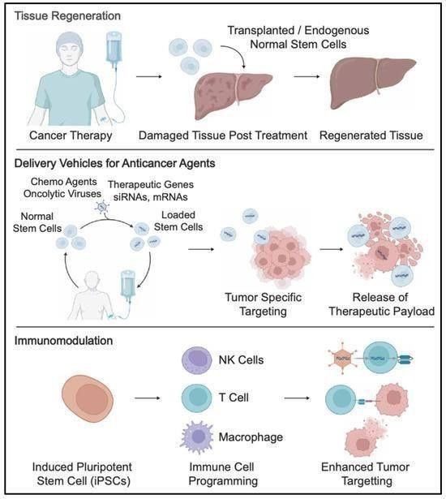
Fig.4: Normal stem cells in cancer therapy.

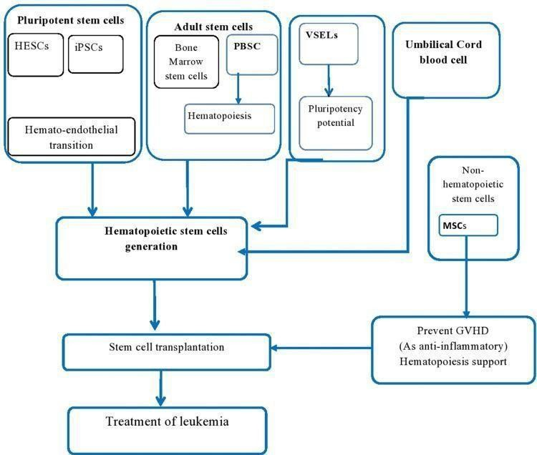

Fig.5: The function of various categories of SCs in SC transplantation.

Hematopoietic Stem-Cell Transplantation can be used to treat individuals with uncommon diseases, such as AML (16), ALL (17), CML, Burkitt’s lymphoma, HL, and NHL (18), and other hematologic malignancies (19). While it is considered an alternative approach to treatment, HSCT still carries a relapse risk ranging from 40% to 80% for those who receive it (20). Both autologous hematopoietic stem cell transplantation (auto-HSCT) and allogeneic hematopoietic stem cell transplantation (allo-HSCT) are key alternative cellular therapies for treating leukemia. Autologous HSCT is a suitable and viable treatment option for multiple myeloma (21, 22).
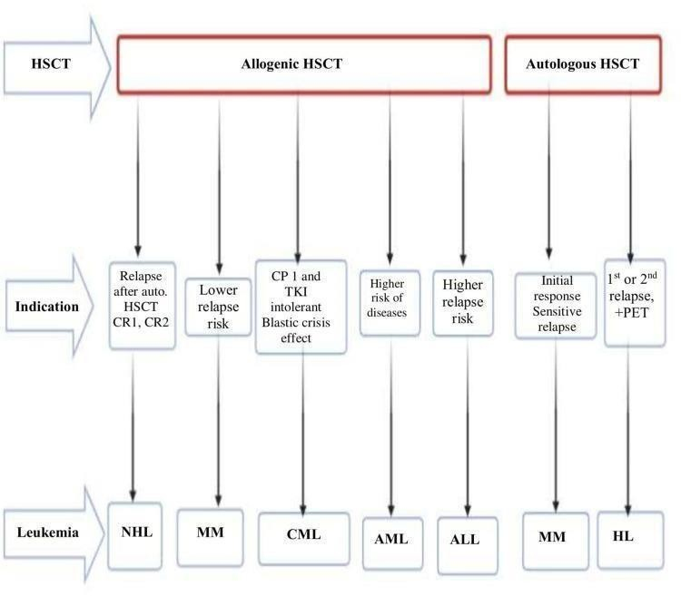
Fig.6: comparison between allogeneic and autologous stem cell transplantation in relation to hematologic conditions.
HSC Transplantation has mainly been recognized as a conventional method for addressing multiple myeloma, leukemia, and lymphomas following cycles of intensive radiotherapy or chemotherapy (23).
The administration of mesenchymal stem cells aids in preserving the homogeneous condition growth Hematopoietic Stem-Cell, which in turn improves the overall effectiveness of the treatment (24, 25, 26).

SPINAL CORD INJURY
“Spinal cord injuries (SCIs) are the most debilitating and life-altering medical conditions,leading to a significant decline in the quality of life and imposing immense physical, psychological, and economic burdens on affected individuals and their families” (27).
“Spinal cord injury (SCI) results in loss of nervous tissue and consequently loss of motor and sensory function.Stem cell therapy offers hope for patients suffering from SCI by harnessing the unique regenerative capabilities of stem cells” (28).
These cells have the potential to differentiate into various cell types (29), thereby replacing lost neurons, promoting axonal growth, remyelinating damaged axons, modulating immune response, and creating a permissive environment for functional recovery (30, 31, 32).
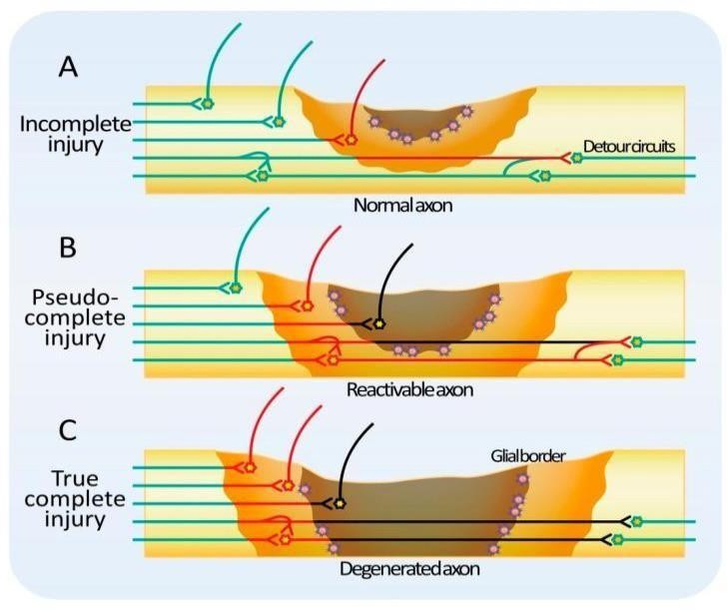
Fig.7: classification of SCI

The Potential of Different Stem Cell Types
Different categories of stem cells are currently investigated for spinal cord injuries. These cell types include embryonic stem cells, induced pluripotent stem cells, mesenchymal stem cells, and neural stem/progenitor cells, each presenting distinct benefits and obstacles within the realm of SCI therapy.

Table 2. Comparison of stem cell types for SCI treatment.
Stem Cell Type | Advantages
Embryonic Stem Cells (ESCs) | - Pluripotent  - Can differentiate into all adult cell types
Induced Pluripotent Stem Cells (iPSCs) | - Pluripotent  - Can differentiate into various cell types
Mesenchymal Stem Cells  (MSCs) | - Multipotent  - Immunomodulatory properties  - Secrete growth factors
Neural Stem/Progenitor Cells  (NSPCs) | - Inherent ability to generate neural cells  - Promote functional recovery and reduce lesion size in preclinical studies
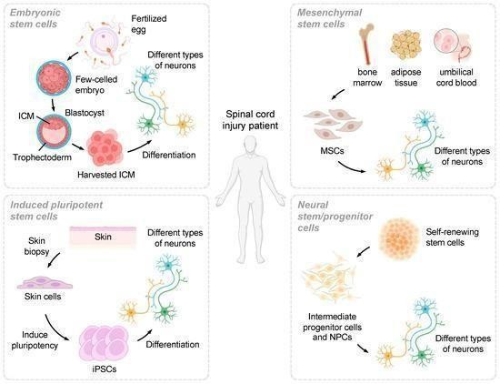
Fig.8: Overview of various stem cell types explored for their potential in SCI treatment.

NEURODEGENERATIVE DISEASES
Neurodegenerative disorders, such as Parkinson's disease, Alzheimer's disease, Huntington's disease, amyotrophic lateral sclerosis, and frontotemporal dementia, are characterized by

disruptions in protein balance, leading to the degeneration of particular groups of neurons and the formation of inclusion bodies made up of insoluble and misfolded proteins. So it results in the gradual deterioration of sensory perception, cognitive abilities, motor neurons, and an eventual onset of paralysis.
The "R3" strategies (Rejuvenation, Regeneration, and Replacement) can be utilized to address cellular senescence and assist in managing neurodegenerative diseases.
We particularly emphasize stem cell therapy and cellular reprogramming as key R3 approaches.
These techniques are designed to counteract the impacts of cellular aging by
- Revitalizing current cells
- Regenerating neural tissues by activating or introducing stem cells, or
- Replacing lost neuronal groups with fresh, functional cells.
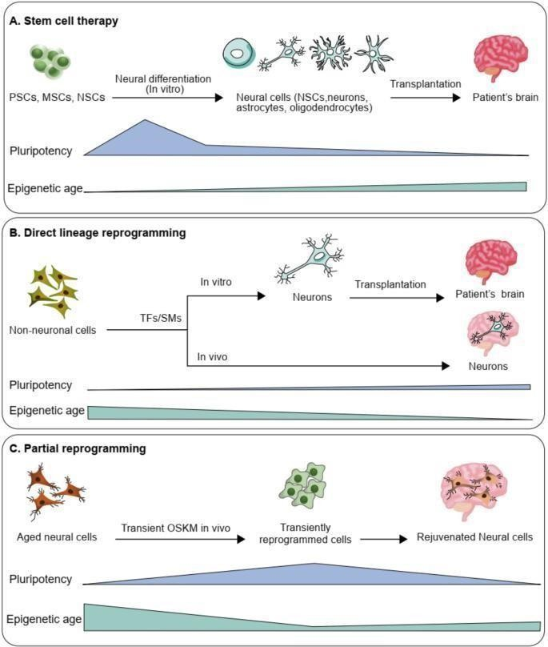

Fig.9: Summary of cell-oriented approaches for addressing neurodegenerative disorders.

  - Underlying mechanisms of stem cell treatments

The mechanisms that underlie stem cell therapy are intricate and multi-dimensional, including neuronal replacement, paracrine functions, immune system modulation, neurotrophic support, and mitochondrial transfer (33, 34).
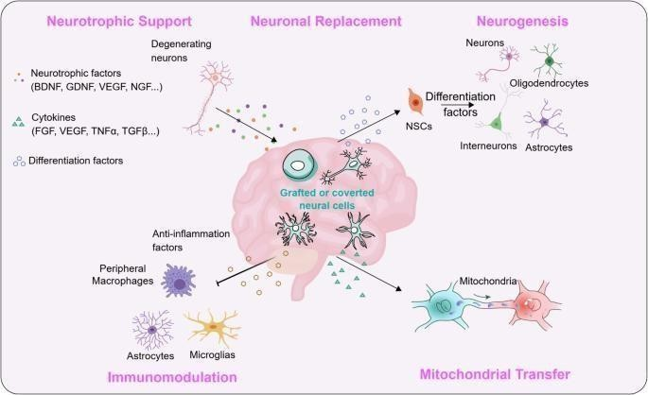
Fig.10: Possible mechanisms that support stem cell treatments.

OSTEOARTHRITIS (OA)
Osteoarthritis (OA) is a chronic degenerative joint disease. The articular cartilage damage could be induced by biomechanical, metabolic, biochemical, or genetic factors. Increased risk factors of OA are obesity, aging, direct joint injury, and/or a genetic predisposition. OA is a complex disease that activates all aspects of the immune system response.

Cell therapy:
This approach employed a blend of surgical and cell culture techniques necessitate binary phases of processes (35).
A cartilage biopsy was first obtained from the healthy area of the patient's articular cartilage. Following this, chondrocytes were extracted from the cartilage tissue through the use of collagenase. These chondrocytes were then cultured in a monolayer prior to their transplantation into the cartilage defect during the subsequent phase of the procedure. This transplantation was performed either in suspension beneath a periosteal flap or synthetic membr anes, or within three dimensional matrices (36).

MSCs based therapy:

MSCs are multipotent cells having ability to differentiate into cell types, such as chondrocytes, adipocytes, osteoblasts, as well as myogenic and neuronal cells (37, 38, 39, 40, 41).
Mesenchymal stem cells can be obtained from multiple sources, mainly including bone marrow, adipose tissue, dental pulp, placenta, and umbilical cord, as well as from skeletal tissues (42).
Alongside their remarkable tissue regeneration capabilities, the immunomodulatory effects of mesenchymal stem cells stand out as another significant attribute. This positions MSCs as a promising source of cells for repairing cartilage damage while simultaneously providing an immunomodulatory effect that helps alleviate inflammation associated with osteoarthritis (OA). Extensive research has focused on the role of MSCs in inflammation. MSCs react to inflammation by migrating injured tissues, modulating immune and inflammatory responses in affected areas, aiding in the fixing damaged tissues.

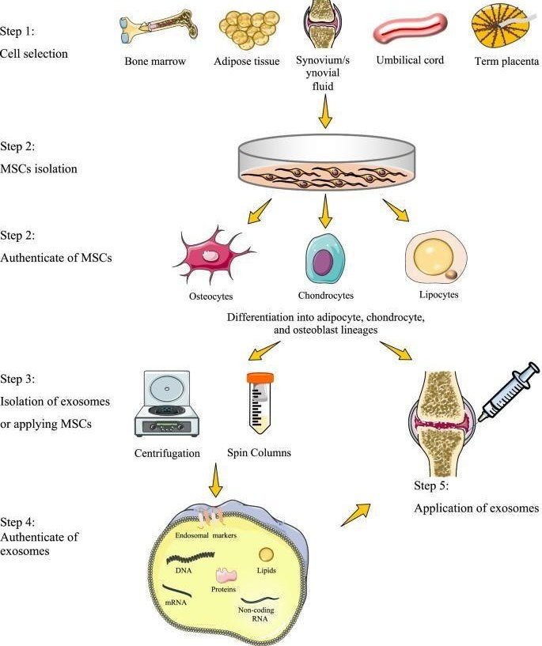
Fig.11: Flow chart of MSC therapy Mesenchymal stem cells are significant in this field and are essential for maintaining tissue balance, as well as for repair and regeneration. These cells are defined by their ability to selfrenew, their versatility, capacity to distinguish into specific categories of tissue cells, such as those found in cartilage and bone (43).

SOME CURRENT APPLICATIONS OF STEM CELLS
Stem cells are utilized in numerous applications, including the creation of artificial organs for both research and transplant purposes, as well as mitochondrial therapy. Some of these advancements include:

HSC transplantation
“Healthy HSCs can be transplanted into individuals with various bone marrow or blood conditions, such as leukemia, lymphoma, and tumors, to replace the impaired bone marrow cells. The transplantation can be autologous (cells sourced from the patient), allogeneic (cells sourced from a different individual), or syngeneic (cells sourced from identical twins)” (44). Bone marrow transplants have a rich history and have become a standard procedure in medicine (45).

HSC therapy (HSCT)
“Hematopoietic stem cell transplantation (HSCT) has been evaluated as a treatment for multiple sclerosis in various clinical studies. Multiple sclerosis is an autoimmune disorder that affects the central nervous system. The conventional method for managing multiple sclerosis involves disease-modifying therapy. DMT aims to modify the immune response by altering immune cell movement or decreasing the number of immune cells. However, this approach necessitates long- term use and may lead to significant adverse effects. Clinical trials assessing HSCT have shown more favorable outcomes compared to DMT”. (46).

Placental stem cell therapy
Placental stem cells have demonstrated encouraging outcomes and potential for treating and curing a range of ailments throughout the body, including Alzheimer’s disease, liver disorders, pancreatic conditions, heart attacks, muscular dystrophy, lung scarring, and large bone lesions. Additionally, they have uses in the field of tissue engineering. (47).

Autologous limbal stem cells (holoclar) transplantation
Autologous limbal cell culture consists of stem cells (holoclones) that can aid in the treatment of individuals experiencing the loss of corneal epithelium (48). Injuries to the eye can result in vision loss by damaging the limbus or leading to limbal stem cell deficiency (49). Holoclar has received official approval in Europe for managing moderate to severe limbal stem cell deficiency in adults (50).

Development toward artificial organ engineering
When stem cells are grown in a three-dimensional setting under favorable growth conditions without external factors, they proliferate and differentiate into formations resembling their original structure. These formations, termed "organoids," can imitate organs, including serving as

niches for stem cells. Organoids exhibit a degree of organization that current technology canno t replicate, although they display variability in size, shape, cellular composition, and other characteristics across different cultures. These organoids are utilized for a range of research purposes (51).

CURRENT LIMITATIONS
Several factors are currently impeding the progress of stem cell research, leading to its sluggish advancement. Some of these issues include challenges in culturing most stem cells (52), the high costs and inefficiencies associated with conventional 2D culturing methods for stem cells, the difficulties in replicating the stem cell niche, the loss of differentiation ability during the culturing process, the absence of standardized 3D culturing methods, and the lack of effective scaling techniques (53).
Pluripotent stem cells (PSCs) have the potential to give rise to teratomas (benign tumors that comprise tissues from all germ layers) when injected into a living organism (54).
Studies on placental stem cells often yield a heterogeneous mix of cell types; achieving high- purity specialized cell types sustainably poses a significant challenge (47).
Moreover, introducing stem cells into the body can trigger an immune reaction (55). Therefore, it is essential to develop improved and more effective therapies.

FUTURE PROSPECTS

Stem cells in gene editing
The integration of stem cell technology with gene editing techniques such as CRISPR-Cas9 opens new avenues for treating hereditary diseases and correcting genetic errors. Stem cells that have been gene-edited could be utilized to address genetic conditions and reduce the likelihood of harmful mutations being transmitted to subsequent generations.

Stem cells for autoimmune illnesses
Stem cells can be employed to manage the immune deficiencies associated with AIDS. They regulate the immune response and promote tissue repair, presenting possibilities for treating autoimmune diseases. Upcoming research will focus on developing safe and effective stem cell therapies for conditions like type 1 diabetes, rheumatoid arthritis, and multiple sclerosis.

Regenerative medicine
Regenerative medicine seeks to repair or replace damaged or diseased tissues and organs with healthy cells obtained from stem cells. This approach could transform the treatment landscape for ailments such as heart disease, Parkinson’s disease, spinal cord injuries, and others.

Personalized medicine
The development of induced pluripotent stem cells (iPSCs) allows for the generation of stem cells from a patient's own cells, creating an abundant supply of personalized cells for therapeutic applications. iPSCs can be genetically tailored to the individual, significantly minimizing the chances of immune rejection and enabling customized treatments for a variety of health issues.

Tissue engineering
Organoids can serve various purposes, including drug testing, disease modeling, and personalized medicine, leading to more accurate and effective forms of treatment.

Artificial organs and body parts
In the near future, we may see the production of fully functional artificial organs and body parts derived from stem cells. This advancement could help address the shortage of transplantable organs and offer personalized solutions for patients who require them.

CONCLUSION:
Stem cell therapy is a fast-developing field with great promise for treating various illnesses and injuries. Although it is still in the preliminary phases, it has demonstrated positive outcomes for specific conditions, and ongoing studies are investigating its capacity to tackle more intricate diseases.
Nevertheless, ethical issues and potential dangers continue to be subjects of active discussion and examination. As advancements in research occur and regulations change, stem cell therapy could transform healthcare.

Disclaimer (Artificial intelligence)
Option 1:
Author(s) hereby declare that NO generative AI technologies such as Large Language Models (ChatGPT, COPILOT, etc.) and text-to-image generators have been used during the writing or editing of this manuscript.
Option 2:
Author(s) hereby declare that generative AI technologies such as Large Language Models, etc. have been used during the writing or editing of manuscripts. This explanation will include the name, version, model, and source of the generative AI technology and as well as all input prompts provided to the generative AI technology
Details of the AI usage are given below:
1.
2.
3.

REFERENCES:

- Zhang FQ, Jiang JL, Zhang JT, et al. Current status and future prospects of stem cell therapy in Alzheimer’s disease. Neural Regen Res. 2020;15:242. doi:10.4103/1673-5374.265544.
- Mason C, Dunnill P. A brief definition of regenerative medicine. Regen Med. 2008;3(1):1–5. doi:10.2217/17460751.3.1.1.
- Fortier LA. Stem cells: classifications, controversies, and clinical applications. Vet Surg. 2005;34(5):415–423. doi:10.1111/j.1532-950x.2005.00063.x.
- Szilvassy SJ, Humphries RK, Lansdorp PM, Eaves AC, Eaves CJ. Quantitative assay for totipotent reconstituting hematopoietic stem cells by a competitive repopulation strategy. Proc Natl Acad Sci U S A. 1990;87(22):8736–8740. doi:10.1073/pnas.87.22.8736.
- Yu J, Vodyanik MA, Smuga-Otto K, et al. Induced pluripotent stem cell lines derived from human somatic cells. Science. 2007;318(5858):1917–1920. doi:10.1126/science.1151526.

- Zuk PA, Zhu M, Ashjian P, et al. Human adipose tissue is a source of multipotent stem cells. Mol Biol Cell. 2002;13(12):4279–4295. doi:10.1091/mbc.e02-02-0105.
- Majo F, Rochat A, Nicolas M, Jaoudé GA, Barrandon Y. Oligopotent stem cells are distributed throughout the mammalian ocular surface. Nature. 2008;456(7219):250–254. doi:10.1038/nature07406.
- Ko K, Tapia N, Wu G, et al. Induction of pluripotency in adult unipotent germline stem cells. Cell Stem Cell. 2009;5(1):87–96. doi:10.1016/j.stem.2009.05.025.
- Molofsky AV, Pardal R, Morrison SJ. Diverse mechanisms regulate stem cell self-renewal. Curr Opin Cell Biol. 2004;16(6):700–707.
- Arber DA, Orazi A, Hasserjian R, et al. The 2016 revision to the World Health Organization classification of myeloid neoplasms and acute leukemia. Blood. 2016;127(20):2391–2405.
- Vardiman JW. The World Health Organization (WHO) classification of tumors of the hematopoietic and lymphoid tissues: an overview with emphasis on the myeloid neoplasms. Chem Biol Interact. 2010;184(1–2):16–20.
- Yamamoto JF, Goodman MT. Patterns of leukemia incidence in the United States by subtype and demographic characteristics, 1997–2002. Cancer Causes Control. 2008;19(4):379–390.
- Siegel RL, Miller KD, Jemal A. Cancer statistics, 2017. CA Cancer J Clin. 2017;67(1):7–30.
- Abbott A. Stem cells head to the clinic: Treatments for cancer, diabetes and Parkinson’s disease could soon be here. Nature. 2025;637:18–20.
- Zhang CL, Huang T, Wu BL, He WX, Liu D. Stem cells in cancer therapy: Opportunities and challenges. Oncotarget. 2017;8:75756–75766.
- Kuruca SE, Çelik DD, Özerkan D, Erdemir G. Characterization and isolation of very small embryonic-like (VSEL) stem cells obtained from various human hematopoietic cell sources. Stem Cell Rev Rep. 2019;1–13. doi:10.1007/s12015-019-09900-7.
- Talleur AC, Flerlage JE, Shook DR, et al. Autologous hematopoietic cell transplantation for the treatment of relapsed/refractory pediatric, adolescent, and young adult Hodgkin lymphoma: a single institutional experience. Bone Marrow Transplant. 2020;1–10. doi:10.1038/s41409-020- 0897-1.
- Gyurkocza B, Rezvani A, Storb RF. Allogeneic hematopoietic cell transplantation: the state of the art. Expert Rev Hematol. 2010;3(3):285–299. doi:10.1586/ehm.10.21.
- Thomas ED, Blume KG. Historical markers in the development of allogeneic hematopoietic cell
transplantation. Biol Blood Marrow Transplant. 1999;5(6):341–346. doi:10.1016/S1083- 8791(99)70010-8.
- Khouri IF, Curbelo IF, Turturro F, et al. Ipilimumab plus lenalidomide after allogeneic and autologous stem cell transplantation for patients with lymphoid malignancies. Clin Cancer Res. 2018;24(5):1011–1018. doi:10.1158/1078-0432.CCR-17-2777.
- Hawsawi YM, Al-Zahrani F, Mavromatis C, Baghdadi MA, Saggu S, Oyouni AAA. Stem cell applications for treatment of cancer and autoimmune diseases: its promises, obstacles, and future perspectives. Technol Cancer Res Treat. 2018;17:1533033818806910. doi:10.1177/1533033818806910.

- Corradini P, Cavo M, Lokhorst H, et al. Molecular remission after myeloablative allogeneic stem cell transplantation predicts a better relapse-free survival in patients with multiple myeloma. Blood. 2003;102(5):1927–1929. doi:10.1182/blood-2003-010189.
- Copelan EA. Hematopoietic stem-cell transplantation. N Engl J Med. 2006;354:1813–1826. doi:10.1056/NEJMra052638.
- Le Blanc K, Ringdén O. Immunomodulation by mesenchymal stem cells and clinical experience.
J Intern Med. 2007;262:509–525. doi:10.1111/j.1365-2796.2007.01844.x.
- Sacchetti B, Funari A, Michienzi S, et al. Self-renewing osteoprogenitors in bone marrow sinusoids can organize a hematopoietic microenvironment. Cell. 2007;131:324–336. doi:10.1016/j.cell.2007.08.025.
- Méndez-Ferrer S, Michurina TV, Ferraro F, et al. Mesenchymal and haematopoietic stem cells form a unique bone marrow niche. Nature. 2010;466:829–834. doi:10.1038/nature09262.
- Badenhorst M. Life after the game: Consequences of acute spinal cord injuries in South African rugby union players [PhD thesis]. Cape Town: University of Cape Town; 2019.
- Madl CM, Heilshorn SC, Blau HM. Bioengineering strategies to accelerate stem cell
therapeutics. Nature. 2018;557:335–342.
- Rajabzadeh N, Fathi E, Farahzadi R. Stem cell-based regenerative medicine. Stem Cell Investig. 2019;6:19.
- Fischer I, Dulin JN, Lane MA. Transplanting neural progenitor cells to restore connectivity after spinal cord injury. Nat Rev Neurosci. 2020;21:366–383.
- Pajer K, Bellák T, Nógrádi A. Stem cell secretome for spinal cord repair: Is it more than just a random baseline set of factors? Cells. 2021;10:3214.
- Myatich A, Haque A, Sole C, Banik NL. Clemastine in remyelination and protection of neurons and skeletal muscle after spinal cord injury. Neural Regen Res. 2023;18:940–946.
- Fan XL, Zhang Y, Li X, Fu QL. Mechanisms underlying the protective effects of mesenchymal stem cell-based therapy. Cell Mol Life Sci. 2020;77:2771–2794.
- Zhao L, Liu JW, Shi HY, Ma YM. Neural stem cell therapy for brain disease. World J Stem Cells. 2021;13:1278–1292.
- Krill M, Early N, Everhart JS, Flanigan DC. Autologous chondrocyte implantation (ACI) for knee cartilage defects: A review of indications, technique, and outcomes. JBJS Rev. 2018;6:e5.
- Hinckel BB, Gomoll AH. Autologous chondrocytes and next-generation matrix-based
autologous chondrocyte implantation. Clin Sports Med. 2017;36:525–548.
- Pittenger MF, Mackay AM, Beck SC, et al. Multilineage potential of adult human mesenchymal stem cells. Science. 1999;284:143–147.
- Lanzillotti C, De Mattei M, Mazziotta C, et al. Long non-coding RNAs and microRNAs interplay in osteogenic differentiation of mesenchymal stem cells. Front Cell Dev Biol. 2021;9:646032.
- Li SN, Wu JF. TGF-beta/SMAD signaling regulation of mesenchymal stem cells in adipocyte commitment. Stem Cell Res Ther. 2020;11:41.

- Testa S, Riera CS, Fornetti E, et al. Skeletal muscle-derived human mesenchymal stem cells: Influence of different culture conditions on proliferative and myogenic capabilities. Front Physiol. 2020;11:553198.
- Badyra B, Sułkowski M, Milczarek O, Majka M. Mesenchymal stem cells as a multimodal treatment for nervous system diseases. Stem Cells Transl Med. 2020;9:1174–1189.
- Dominici M, Le Blanc K, Mueller I, et al. Minimal criteria for defining multipotent
mesenchymal stromal cells. The International Society for Cellular Therapy position statement. Cytotherapy. 2006;8:315–317.
- Vasanthan J, Gurusamy N, Rajasingh S, et al. Role of human mesenchymal stem cells in regenerative therapy. Cells. 2021;10:54.
- Khaddour K, Hana CK, Mewawalla P. Hematopoietic stem cell transplantation. In: StatPearls
[Internet]. Treasure Island (FL): StatPearls Publishing; 2023. Available from: https://www.ncbi.nlm.nih.gov/books/NBK536951
- Mayo Clinic Staff. Bone marrow transplant. Mayo Clinic; 2022. Available from: https://www.mayoclinic.org/tests-procedures/bone-marrow-transplant/about/pac-20384854
- Atkins H. Stem cell transplantation to treat multiple sclerosis. JAMA. 2019;321:153–155.
- Oliveira MS, Barreto-Filho JB. Placental-derived stem cells: Culture, differentiation and challenges. World J Stem Cells. 2015;7:769–775.
- Trounson A, McDonald C. Stem cell therapies in clinical trials: Progress and challenges. Cell Stem Cell. 2015;17:11–22.
- Rama P, Matuska S, Paganoni G, et al. Limbal stem-cell therapy and long-term corneal regeneration. N Engl J Med. 2010;363:147–155.
- Benstetter M. First stem-cell therapy recommended for approval in EU. Netherlands: European Medicines Agency; 2014 [cited 2023 Sep 1]. Available from: https://www.ema.europa.eu/en/news/first-stem-cell-therapy-recommended-approval-eu
- Brassard JA, Lutolf MP. Engineering stem cell self-organization to build better organoids. Cell Stem Cell. 2019;24:860–876.
- Choumerianou DM, Dimitriou H, Kalmanti M. Stem cells: Promises versus limitations. Tissue Eng Part B Rev. 2008;14:53–60.
- McKee C, Chaudhry GR. Advances and challenges in stem cell culture. Colloids Surf B Biointerfaces. 2017;159:62–77.
- Amariglio N, Hirshberg A, Scheithauer BW, et al. Donor-derived brain tumor following neural stem cell transplantation in an ataxia telangiectasia patient. PLoS Med. 2009;6:e1000029.
- Miller KK, Schrepfer S. Stem cell transplant immunology. In: Ieda M, Zimmermann WH, editors. Cardiac regeneration: Cardiac and vascular biology. Vol. 4. Cham: Springer; 2017.
- Gabriel KL, Sami M, Ijishakin O, Agyemang SF, Odugunwa MN, Miles DM, et al. Efficacy and safety of stem cell therapy in the treatment of fistulizing Crohn’s disease and the role of autologous stem cell transplantation: a systematic review. J Adv Med Med Res [Internet]. 2023 Nov 25 [cited 2025 May 5];35(23):189–201. Available from: https://www.journaljammr.com/index.php/JAMMR/article/view/5294

