Rapid Lymphatic Absorption of Orally Administered Low-Molecular-Weight Hyaluronic Acid: A Pathway to the Bloodstream via Mesenteric Nodes

.
ABSTRACT

Background
The 35 kDa low-molecular-weight hyaluronic acid (HA35) injection has shown efficacy in alleviating various types of pain, reducing inflammation and edema, and exhibiting potential in lipolysis and cosmetic applications. Compared to injectable forms, oral administration offers enhanced convenience and better patient compliance. However, the absorption mechanism of orally administered low-molecular-weight hyaluronic acid (LMWHA, <100 kDa) remains poorly understood. This study investigates the absorption pathways of two LMWHA—HA35 and HA70—which differ in their cellular binding affinity but have similar tissue permeability, with a particular focus on the role of the mesenteric lymphatic system.
Methods
Rats were administered high oral doses of HA35 and HA70. Blood and tissue samples were collected at predefined time points following administration. The concentrations of hyaluronic acid (HA) in serum, mesenteric lymph nodes, liver, and spleen were quantified using enzyme-linked immunosorbent assay (ELISA) to monitor absorption kinetics and tissue distribution.
Results
Both HA35 and HA70 were rapidly absorbed into the systemic circulation, predominantly via the mesenteric lymphatic pathway, bypassing the conventional intestinal absorption route through the portal vein and liver. HA levels in mesenteric lymph nodes increased significantly within 30 minutes post-administration and remained elevated over time. No significant increases in free HA were observed in the liver or spleen, reinforcing lymphatic uptake as the principal route of absorption.
Conclusion
In contrast to high-molecular-weight hyaluronic acid (HMWHA, >1000 kDa), which requires degradation prior to absorption, this study demonstrates for the first time that LMWHA molecules (HA35 and HA70, <100 kDa) can be directly absorbed through the intestinal lymphatic system. This alternative absorption route is significant, as it enables compounds to bypass hepatic first-pass metabolism, potentially enhancing bioavailability and prolonging systemic exposure. These findings provide new insights into the absorption mechanisms of LMWHA and suggest promising opportunities for developing oral therapeutics that leverage lymphatic transport pathways for improved delivery of bioactive macromolecules.

Keywords: Low molecular weight hyaluronic acid; oral administration; intestinal absorption; mesenteric lymph nodes; lymphatic system absorption.

1. INTRODUCTION
HA is a linear polysaccharide composed of repeating disaccharide units of D-glucuronic acid and N-acetylglucosamine. It is abundantly distributed in the skin, synovial fluid, and connective tissues, where it plays essential roles in maintaining tissue hydration, providing lubrication, and regulating cellular behavior [1]. At present, six categories of medical devices and pharmaceutical products based on HMWHA are commercially available. These include intra-articular injection formulations [2], viscoelastic agents for ophthalmic surgery [3], dermal fillers [4], anti-adhesion barriers for abdominal surgery [5], therapies for interstitial cystitis [6], and treatments for dry eye syndrome [7]. HMWHA and its degradation products interact with a range of cell surface receptors and calcium channels involved in pain signaling, such as CD44 [8], LYVE-1 [9], RHAMM [10], HARE [11], Siglec-9 [12], TLR2 [13], CEMIP [14], and TMEM2 [15]. The presence of these receptors underscores the diverse biological activities exerted by both HMWHA and its fragments in vivo. However, due to its large molecular size (>1000 kDa), HMWHA displays poor tissue permeability, and injectable administration does not achieve immediate tissue penetration required for therapeutic effects.
Following regulatory approval of HA as a food additive in countries including South Korea, Japan, and China, interest in the oral application of HA has grown substantially [16]. In particular, LMWHA has attracted increasing attention in recent years due to its enhanced bioavailability and potential for systemic biological effects. Our previous studies demonstrated that radiolabeled HA35 is rapidly absorbed via lymph nodes after subcutaneous injection, showing significant biological activity in clinical applications such as pain relief, anti-inflammatory therapy, and cosmetic facial contouring [17–25]. Unlike HMWHA, LMWHA is capable of absorption through the gastrointestinal tract into the systemic circulation, where it can exert various biological effects, including immunomodulation, anti-inflammatory actions, and improved skin hydration [26]. In contrast, orally administered HMWHA is predominantly degraded into smaller fragments such as disaccharides and tetrasaccharides, which have limited systemic distribution and reduced efficacy, particularly in skin-related applications [27]. Despite encouraging findings regarding the bioactivity of LMWHA, the precise mechanisms by which it is systemically absorbed remain incompletely understood. In particular, the contribution of the intestinal lymphatic system—a key component of the gut-associated immune network—in mediating the rapid absorption of LMWHA into the bloodstream has yet to be fully elucidated.
The intestinal lymphatic system plays a pivotal role in the absorption of certain macromolecules, including chylomicrons, fat-soluble vitamins, and select peptide molecules, enabling them to bypass hepatic first-pass metabolism via mesenteric lymphatics [28]. Prior research has indicated that LMWHA is more readily absorbed through intestinal tissues into the bloodstream compared to HMWHA [26]. Moreover, among LMWHA molecules, those approaching the 100 kDa molecular weight threshold tend to display greater cell-binding affinity and more pronounced biological effects [29]. Building on our previous findings that HA35 can rapidly enter the lymphatic system following subcutaneous injection [30–34], the present study investigates the absorption pathways of two LMWHA types, HA35 and HA70 (both <100 kDa), following high-dose oral administration in rats. A primary objective of this research is to determine whether these molecules are absorbed via the mesenteric lymph nodes and subsequently enter systemic circulation. To address this, we quantified the concentrations of HA35 and HA70 in serum and intestinal lymphatic tissues at various time points using ELISA. The outcomes of this study are expected to provide experimental evidence supporting the role of the intestinal lymphatic system in the oral absorption of LMWHA and offer a feasibility assessment for future high-dose oral clinical applications in humans [35].

2. material and methods

2.1 Production and Characterization of HA35 and HA70
HA35 was prepared by enzymatic degradation of high-molecular-weight hyaluronic acid (1600 kDa) using recombinant hyaluronidase PH20 expressed in CHO cells (purity: 99.0%). The enzymatic reaction was performed at 37 °C for 6 hours, with the pH maintained between 5.5 and 6.0 to optimize enzyme activity and control the resulting molecular weight distribution. After hydrolysis, an equal volume of absolute ethanol was added to precipitate proteins, followed by a second ethanol precipitation at 2.5 times the sample volume to further enhance product purity. The resulting precipitate was collected by centrifugation at 8000 g for 15 minutes, dried in a vacuum oven at 40 °C, and stored at –20 °C in a dry environment to prevent moisture absorption and degradation.
HA70 was obtained commercially (food-grade, purity >95%; Liyang Biotechnology Inc., Shandong, PRC). Upon receipt, the product was sealed and stored under appropriate conditions, with its purity and molecular weight distribution verified prior to experimental use.
The molecular weights of HA35 and HA70 were confirmed by agarose gel electrophoresis in both aqueous and lyophilized forms to ensure consistency with expected values. Samples were dissolved in 1× TAE buffer and subjected to 0.5% agarose gel electrophoresis at 120 V for 45 minutes. The gels were subsequently stained, and the molecular weight distributions were analyzed using a gel imaging system.

2.2 Animal Experimentation
A total of 48 male Wistar rats (6–8 weeks old, weighing 300–330 g) were obtained from Jinan Pengyue Laboratory Animal Breeding Co., Ltd. The animals were housed in a specific pathogen-free (SPF) facility under controlled environmental conditions (23 ± 1 °C, 50%–60% relative humidity, and a 12-hour light/dark cycle), with ad libitum access to sterile water and standard chow. Following a 7-day acclimation period, body weights were recorded on the day of administration. All animal procedures were approved by the Animal Care and Use Committee of Longcore Biotech (Qingdao) Co., Ltd., and conducted in accordance with national guidelines for the care and use of laboratory animals.
The rats were randomly assigned to two groups (n = 6 per time point): an HA35 group and an HA70 group, with each receiving a single oral gavage of the corresponding HA solution. Each group was further subdivided by sampling time points: 0 minutes (pre-gavage), and 30, 60, and 120 minutes post-gavage. HA35 and HA70 powders were dissolved in sterile water at a concentration of 100 mg/mL, sterilized by filtration through a 220-nm membrane, and administered orally at a dose of 0.4 g/kg body weight using a disposable gavage needle.
At each designated time point, rats were anesthetized with 10% chloral hydrate (3.5 mL/kg, intraperitoneally), and blood samples were collected from both the heart (5 mL) and the portal vein (3 mL) into serum separation tubes. Samples were allowed to clot at room temperature for 30 minutes, cooled to 4–12 °C, and centrifuged at 1000 g for 15 minutes. The resulting serum was aliquoted and stored at –20 °C until analysis.
Following euthanasia by cervical dislocation under anesthesia, tissue samples—including 3–4 mesenteric lymph nodes, one spleen, and one liver per rat—were collected, rinsed with PBS, and placed in sterile tubes. Samples were stored at 4–12 °C and processed on the same day. All biological waste was disposed of following standard biosafety procedures.

2.3 Quantification of HA35 and HA70 Concentrations
Tissues were weighed after the removal of surface blood and homogenized with PBS (1:16, w/v) using a glass homogenizer. The homogenates were sonicated at 40 kHz for 10 minutes to ensure adequate cell lysis, followed by centrifugation at 5000 g for 10 minutes. Supernatants were collected and stored at –20 °C pending analysis.
Concentrations of HA35 and HA70 in serum and tissue homogenates were determined using the Quantikine™ Hyaluronan Immunoassay Kit (R&D Systems, DHYAL0) according to the manufacturer’s instructions. Prior to assay setup, wash buffer and substrate solutions A and B were prepared, with substrate solutions protected from light exposure. The hyaluronan standard was reconstituted in 2 mL of Calibrator Diluent RD5-18 to yield a 40 ng/mL stock solution, followed by serial dilutions to produce a standard curve at concentrations of 20, 10, 5, 2.5, 1.25, 0.625, and 0 ng/mL.
For the assay, 50 μL of Assay Diluent RD1-14 and 50 μL of either standard or sample were added to each well. Plates were sealed and incubated at room temperature on a shaker at 500 rpm for 2 hours. After five washes with 400 μL of wash buffer per well, 100 μL of Hyaluronan conjugate was added to each well and incubated for an additional 2 hours. Following a second wash step, 100 μL of substrate solution was added and incubated in the dark for 30 minutes. The reaction was terminated by adding 100 μL of stop solution, and absorbance was measured at 450 nm with a reference wavelength of 540 or 570 nm.

2.4 Data Analysis
Data were analyzed using GraphPad Prism version 8.0.1 (GraphPad Software, San Diego, CA, USA) and are presented as means ± standard deviation (SD). Statistical comparisons between groups were performed using Student’s t-test. Differences were considered statistically significant at p < 0.05, p < 0.01, and p < 0.001.

3. results

3.1 Molecular Weight Analysis of HA35 and HA70 by Electrophoresis
To verify the molecular weight integrity of HA35 and HA70, both samples were filtered through a 220 nm membrane to remove potential production-related impurities. Both HA35 and HA70 passed through the filter smoothly, indicating effective impurity removal and suggesting good tissue permeability. Electrophoresis was subsequently employed to confirm their molecular weights (Fig. 1).
The electrophoretic profiles revealed that lane 1 (Enzyme-digested HA35) and lane 2 (HA35 powder re-dissolved after dry-baking) migrated to the same position on the gel, situated between the 10 kDa and 50 kDa molecular weight standards, with an estimated molecular weight of approximately 35 kDa. This result confirms that the dry-baking process did not cause noticeable degradation or polymerization of HA35. In contrast, lane 3 (HA70 powder) exhibited a molecular weight significantly higher than the 50 kDa marker, clearly distinguishing it from HA35. These findings align with the expected molecular weights of the samples [30,31].
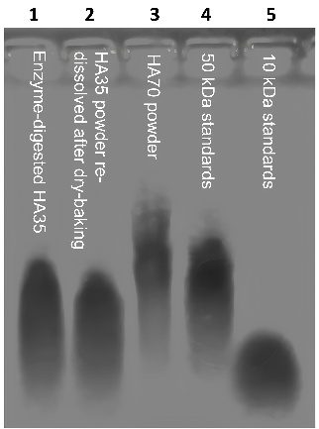
Fig. 1. Molecular weight of HA determined by gel electrophoresis
3.2 Changes in HA35 and HA70 Levels in Blood
To assess the absorption of orally administered HA35 and HA70, body weights of the experimental animals were recorded at each time point. No significant differences in body weight were observed between the HA35 and HA70 groups, both before and after gavage (P > 0.5), indicating that body weight did not serve as a confounding factor.
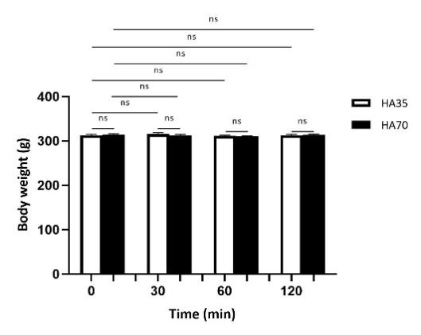
Fig. 2. Standard curves for HA detection
Serum samples from both the portal vein and cardiac blood were analyzed by ELISA. Sample types and dilution ratios are summarized in Table 1. The standard curves for the ELISA assay (Fig. 3A, B) demonstrated excellent linearity (R² = 0.99). Although potential interactions between HA and its binding partner Aggrecan may slightly influence detection sensitivity, statistical robustness was ensured by analyzing a large sample set.

Table 1. Sample collection and dilution conditions for portal and cardiac blood in rats

Group |  | HA35 (n=6) |  | HA70 (n=6)
Sample |  | Portal Vein Blood | Cardiac Blood | Portal Vein Blood | Cardiac Blood
Sample Detection Form |  | Serum | Serum | Serum | Serum
Sampling Volume (mL) |  | 3 | 6 | 3 | 6
Serum Separation Volume (mL) |  | 1 | 2 | 1 | 2
Detection Dilution Ratio | Blank Group | 8 | 8 | 8 | 8
 | 30min | 8 | 8 | 8 | 8
 | 1h | 8 | 8 | 8 | 8
 | 2h | 8 | 32 | 8 | 16
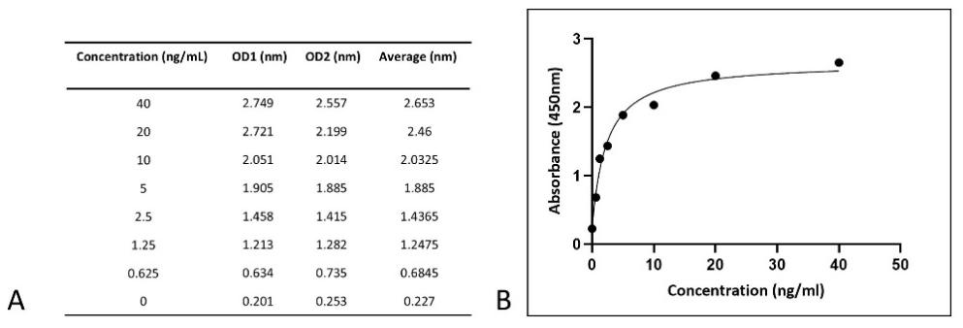
Fig. 3. Standard curves for HA detection
Note: A shows the OD values of the standard curve; B shows the curve derived from the OD values
The serum HA concentrations calculated from the standard curve are presented in Figs. 4 and 5. A time-dependent increase in HA levels was observed in both portal vein (Fig. 4) and cardiac blood (Fig. 5). However, no statistically significant differences were detected between the HA35 and HA70 groups at any individual time point. HA concentrations were consistently higher in cardiac blood than in portal vein blood, suggesting that HA is primarily absorbed into the systemic circulation via non-portal pathways. Further analysis showed a significant increase in HA levels in cardiac blood 30 minutes post-gavage compared to baseline (HA35: 129.84 ± 50.92 ng/mL, P < 0.01; HA70: 102.56 ± 50.78 ng/mL, P < 0.05). HA levels continued to rise at 60 minutes (HA35: 297.20 ± 123.87 ng/mL, P < 0.01; HA70: 255.36 ± 130.20 ng/mL, P < 0.05) and peaked at 120 minutes (HA35: 604.48 ± 269.37 ng/mL, P < 0.01; HA70: 567.84 ± 300.75 ng/mL, P < 0.01). These data indicate that both HA35 and HA70 are rapidly absorbed into the bloodstream following oral administration, predominantly via non-portal circulation.
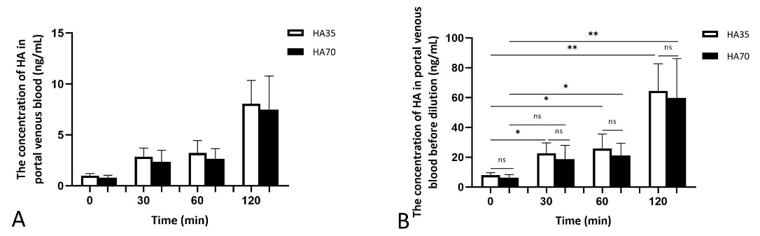
Fig. 4. HA concentration in rat portal vein blood
Note: A shows calculated concentrations from the standard curve; B shows original concentrations after multiplying by dilution factors.
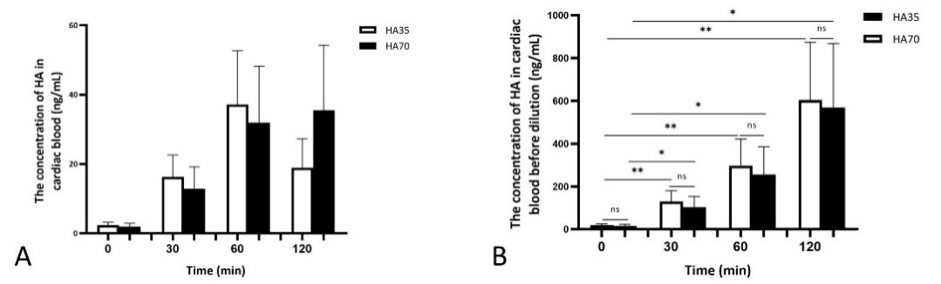
Fig. 5. HA concentration in rat cardiac blood
Note: A shows calculated concentrations from the standard curve; B shows original concentrations after multiplying by dilution factors.

3.3 Absorption of HA35 and HA70 in Tissues
To further investigate tissue-level absorption, HA concentrations were measured in the mesenteric lymph nodes, liver, and spleen. Tissue weights and corresponding dilution ratios are listed in Table 2, and HA distributions in various tissues are shown in Figs. 6 and 7. As shown in Fig. 6D, HA concentrations in the mesenteric lymph nodes significantly increased 30 minutes after oral administration (HA35: 17.94 ± 8.16 ng/mL, P < 0.01; HA70: 16.24 ± 8.00 ng/mL, P < 0.01) compared to pre-gavage levels (HA35: 0.87 ± 0.32 ng/mL; HA70: 0.73 ± 0.33 ng/mL). These results suggest that both HA35 and HA70 are effectively absorbed through the mesenteric lymphatic system.
In contrast, HA concentrations in the spleen (Fig. 7A) and liver (Fig. 7B) remained low and showed no significant differences before and after gavage (P > 0.05), indicating limited absorption into these organs. These findings support the hypothesis that oral HA is absorbed primarily via the intestinal lymphatic pathway, rather than undergoing first-pass hepatic metabolism.
Furthermore, no statistically significant differences were observed between the HA35 and HA70 groups in any of the tissues examined across all time points (P > 0.05), suggesting that tissue permeability and absorption through mesenteric lymph nodes are not strongly dependent on molecular size within the tested range.
Table 2. Weights and dilution conditions for mesenteric lymph nodes, liver, and spleen in rats
Group |  | HA35 (n=6) |  |  | HA70 (n=6)
Sample |  | Mesenteric Lymph Nodes | Spleen | liver | Mesenteric Lymph Nodes | Spleen | liver
Sample Detection Form |  | Tissue Fluid | Tissue Fluid | Tissue Fluid | Tissue Fluid | Tissue Fluid | Tissue Fluid
Sampling Weight | Blank Group | 0.2 | 0.8 | 1.0 | 0.1 | 0.9 | 1.0
 | 30min | 0.2 | 0.8 | 1.0 | 0.1 | 0.9 | 1.0
 | 1h | 0.2 | 0.8 | 1.0 | 0.1 | 0.9 | 1.0
 | 2h | 0.2 | 0.8 | 1.0 | 0.1 | 0.9 | 1.0
Tissue Volume for Dissolution and Extraction | Blank Group | 3.2 | 12.8 | 16 | 1.6 | 14.4 | 16
 | 30min | 3.2 | 12.8 | 16 | 1.6 | 14.4 | 16
 | 1h | 3.2 | 12.8 | 16 | 1.6 | 14.4 | 16
 | 2h | 3.2 | 12.8 | 16 | 1.6 | 14.4 | 16
Detection Dilution Ratio | Blank Group | 5 | 10 | 10 | 5 | 10 | 10
 | 30min | 50 | 10 | 10 | 25 | 10 | 10
 | 1h | 50 | 10 | 10 | 25 | 10 | 10
 | 2h | 50 | 10 | 10 | 25 | 10 | 10

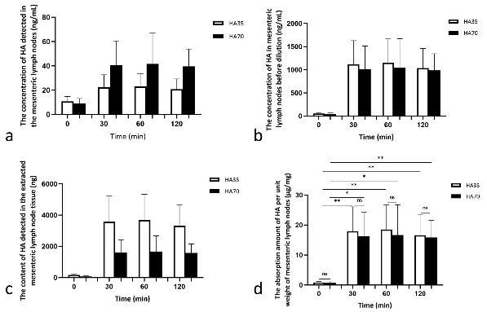

Fig. 6. HA concentration in mesenteric lymph nodes of rats.
Note: a = calculated from standard curve; b = total HA amount after multiplying by solution volume; c = HA concentration in dissolved tissue after multiplying by dilution factor; d = HA content per unit tissue weight.

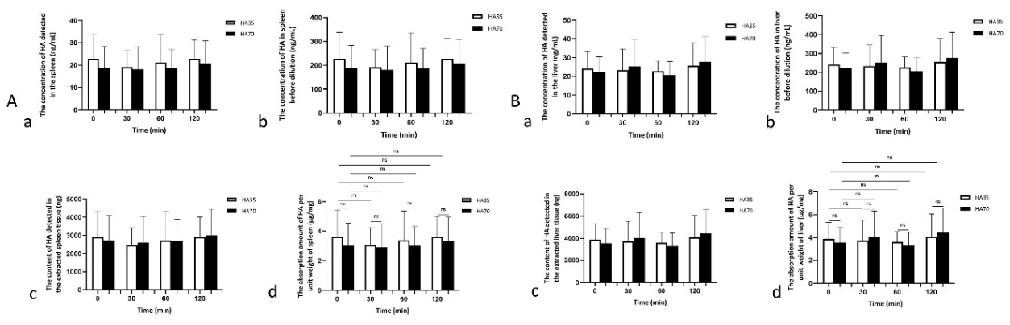
Fig. 7. HA concentration in rat spleen and liver of rats
Note: A = spleen; B = liver. a = calculated from standard curve; b = total HA amount after multiplying by solution volume; c = HA concentration in dissolved tissue after multiplying by dilution factor; d = HA content per unit tissue weight.

4. DISCUSSION
HA has gained widespread application in the cosmetics, food, and pharmaceutical industries owing to its remarkable moisturizing, anti-inflammatory, and tissue-reparative properties [36]. Among the available administration routes—topical, injectable, and oral—oral delivery has attracted increasing attention as a non-invasive and potentially effective strategy. However, the mechanisms governing the absorption of orally administered HA remain incompletely understood and continue to be debated in the literature. Kimura et al. proposed that high-molecular-weight HA (HMWHA) must undergo enzymatic degradation by gastric acid, digestive enzymes, and gut microbiota into smaller fragments prior to absorption [26,27]. In contrast, Sato et al. demonstrated that low-molecular-weight HA (LMWHA), particularly fragments of approximately 2000 Da, can be absorbed via both the portal vein and intestinal lymphatic pathways [36], providing valuable insights into potential absorption mechanisms for LMWHA.
In the present study, we first confirmed the molecular weights of HA35 and HA70 using agarose gel electrophoresis. Compared with viscosity-based methods typically applied to HMWHA, electrophoresis offers a direct and reliable means of characterizing LMWHA. Our results verified that both HA35 and HA70 exhibited molecular weights greater than 10 kDa. Building on prior work involving radiolabeled HA35 [31], we further explored whether these LMWHA compounds, when orally administered, follow a similar lymphatic absorption pathway or are predominantly absorbed through the portal circulation. To this end, we used ELISA to quantify HA concentrations in serum and various tissues after oral administration in rats. Consistent with previous injection studies, we observed a significant rise in HA levels within the mesenteric lymph nodes at 30 minutes post-gavage, which persisted at 60 and 120 minutes. In contrast, HA concentrations in portal vein blood increased modestly, suggesting that the primary route of absorption for HA35 and HA70 is via the mesenteric lymphatic system, rather than direct absorption through the intestinal mucosa into the portal circulation. The concurrent increase in HA concentrations in cardiac blood at 120 minutes further supports the hypothesis of lymphatic-mediated entry into the systemic circulation.
Interestingly, HA concentrations in the spleen and liver did not demonstrate significant changes following oral administration. This finding contrasts with previous studies involving radiolabeled HA, which showed accumulation of HA in these organs following injection [31]. This discrepancy likely reflects methodological differences: while radiolabeling detects both free and cell-associated HA, ELISA quantifies only unbound HA, potentially underestimating total tissue absorption. Accordingly, the ELISA-based findings presented here likely represent circulating, unbound HA35 and HA70. Additionally, no significant differences in absorption efficiency or tissue distribution were observed between HA35 and HA70, indicating that LMWHA fragments under 100 kDa can be effectively absorbed through the mesenteric lymphatic system, irrespective of minor differences in molecular size. Of note, Ma et al. (2025) reported that HA70 may exhibit enhanced biological activity in vitro, as evidenced by red blood cell physiology assays [36]. Beyond its role in lymphatic recirculation and immune modulation, absorbed HA may influence intestinal lipid absorption, metabolic homeostasis, and oral drug delivery processes mediated by the intestinal lymphatic system [16,37,38]. The mesenteric lymphatic network plays a crucial role in the transport of chylomicrons, fat-soluble vitamins, and specific peptide fragments, while also regulating lipid metabolism and systemic energy balance [28]. Recent studies have emphasized that lymphatic transport offers a valuable alternative route for bypassing hepatic first-pass metabolism, thereby enhancing systemic bioavailability and improving the oral delivery efficiency of macromolecules and lipophilic compounds [39–41]. By facilitating lymphatic absorption, HA35 and HA70 may consequently modulate lipid digestion, metabolic processes, and drug distribution.
Previous research has also suggested that HA35 improves intestinal barrier function, modulates the lipid microenvironment, and reduces adipose tissue inflammation, collectively contributing to enhanced lipolysis and lipid metabolism [42]. Anecdotal clinical reports indicate that high oral doses of HA35 and HA70 (Food Production License No.: SC10637028502320) may produce lipolytic and facial slimming effects, although the underlying mechanisms remain poorly elucidated. Future investigations should aim to clarify the effects of orally absorbed HA on lipid metabolism and assess its therapeutic potential in metabolic and inflammatory disorders. Moreover, the unique lymphatic absorption pathway of HA35 and HA70 presents promising opportunities for oral drug delivery applications. Overcoming hepatic first-pass metabolism remains one of the major challenges in oral pharmacology, as a considerable proportion of many therapeutic agents are rapidly metabolized in the liver before entering systemic circulation [43]. Lymphatic absorption offers an attractive strategy to circumvent this limitation and potentially enhance the bioavailability of orally administered compounds. Given their efficient lymphatic uptake, HA35 and HA70 may serve as novel carriers for the oral delivery of anti-inflammatory drugs or other macromolecular therapeutics. Future research should explore the potential of HA-based nanoparticles, HA-drug conjugates, or HA-derived delivery systems to enhance drug absorption, modulate lipid metabolism, and optimize pharmacokinetic profiles.
Despite the robust experimental evidence presented in this study, several limitations should be acknowledged. First, the ELISA method employed detects only free HA and cannot quantify cell-associated HA, which may result in underestimation of total tissue absorption. Incorporating isotopic labeling or advanced imaging techniques in future studies would provide a more comprehensive understanding of HA absorption, distribution, and retention. Second, this study was conducted in rat models, and the extent to which these findings can be extrapolated to human physiology remains to be determined. Accordingly, human clinical trials will be essential to validate the absorption kinetics and therapeutic potential of orally administered LMWHA. Lastly, the ELISA kit used in this study relies on HA–aggrecan binding, and the low solubility and extended incubation times required for aggrecan may influence the assay’s sensitivity and precision.
5. Conclusion
In conclusion, this study is the first to systematically demonstrate that LMWHA (<100 kDa), specifically HA35 and HA70, is primarily absorbed into systemic circulation via the mesenteric lymphatic immune system rather than through the traditional portal vein–liver route following oral administration. These findings offer new insights into the absorption mechanisms of orally delivered HA and pave the way for future clinical trials aimed at exploring its physiological functions and potential applications in metabolic health and drug delivery.

Ethical approval
The Animal Care and Use Committee of Longcore Biotech (Qingdao) Co., Ltd., approved the protocol of this study. All experimental animal tests were carried out according to the 2016 China Laboratory Animal Standards and other related regulations in the Animal Welfare Law.
Disclaimer (Artificial intelligence)
Author(s) hereby declare that NO generative AI technologies such as Large Language Models (ChatGPT, COPILOT, etc.) and text-to-image generators have been used during the writing or editing of this manuscript.
References
- Hargittai, I. (2010). Pioneer of hyaluronan structural chemistry and other studies of polysaccharides: Torvard C. Laurent (1930–2009). Structural Chemistry, 21(4), 471–480.
- Marshall, K. W. (1998). Viscosupplementation for osteoarthritis: Current status, unresolved issues, and future directions. Journal of Rheumatology, 25(11), 2056–2058.
- Huerta Angeles, G., & Neporova, K. (2021). Hyaluronan and its derivatives for ophthalmology: Recent advances and future perspectives. Carbohydrate Polymers, 259, 117697.
- Beasley, K. L., Weiss, M. A., & Weiss, R. A. (2009). Hyaluronic acid fillers: A comprehensive review. Facial Plastic Surgery, 25(2), 86–94.
- Kramer, K., Senninger, N., Herbst, H., et al. (2002). Effective prevention of adhesions with hyaluronate. Archives of Surgery, 137(3), 278–282.
- Sherif, H., Sebay, A., Kandeel, W., et al. (2018). Safety and efficacy of intravesical hyaluronic acid/chondroitin sulfate in the treatment of refractory painful bladder syndrome. Turkish Journal of Urology, 45(4), 296–301.
- Hynnekleiv, L., Magno, M., Vernhardsdottir, R. R., et al. (2022). Hyaluronic acid in the treatment of dry eye disease. Acta Ophthalmologica, 100(8), 844–860.
- Chaudhry, G. E., Akim, A., Naveed Zafar, M., et al. (2021). Understanding hyaluronan receptor (CD44) interaction, HA-CD44 activated potential targets in cancer therapeutics. Advanced Pharmaceutical Bulletin, 11(3), 426–438.
- Johnson, L. A., & Jackson, D. G. (2021). Hyaluronan and its receptors: Key mediators of immune cell entry and trafficking in the lymphatic system. Cells, 10(8), 2061.
- Messam, B. J., Tolg, C., McCarthy, J. B., et al. (2021). RHAMM is a multifunctional protein that regulates cancer progression. International Journal of Molecular Sciences, 22(19), 10313.
- Pandey, M. S., Harris, E. N., & Weigel, P. H. (2015). HARE-mediated endocytosis of hyaluronan and heparin is targeted by different subsets of three endocytic motifs. International Journal of Cell Biology, 2015, 524707.
- Mei, Y., Wang, X., Zhang, J., et al. (2023). Siglec-9 acts as an immune-checkpoint molecule on macrophages in glioblastoma, restricting T-cell priming and immunotherapy response. Nature Cancer, 4, 1273–1291.
- Jiang, D., Liang, J., Fan, J., et al. (2005). Regulation of lung injury and repair by Toll-like receptors and hyaluronan. Nature Medicine, 11(11), 1173–1179.
- Domanegg, K., Sleeman, J. P., & Schmaus, A. (2022). CEMIP, a promising biomarker that promotes the progression and metastasis of colorectal and other types of cancer. Cancers, 14(20), 5093.
- Tobisawa, Y., Fujita, N., Yamamoto, H., et al. (2021). The cell surface hyaluronidase TMEM2 is essential for systemic hyaluronan catabolism and turnover. Journal of Biological Chemistry, 297(5), 101281.
- Zheng, X., Wang, B., Tang, X., Mao, B., Zhang, Q., Zhang, T., Zhao, J., Cui, S., & Chen, W. (2023). Absorption, metabolism, and functions of hyaluronic acid and its therapeutic prospects in combination with microorganisms: A review. Carbohydrate Polymers, 299, 120153.
- Xu, F., Treger, D., Ma, X., et al. (2024). Local injection of a freshly manufactured 35 kDa hyaluronan fragment reduces neuropathic and inflammatory pain: A clinical study. European Journal of Inflammation, 22.
- Treger, D., Zhang, L., Jia, X., Hui, J. H., Gantumur, M. A., Hui, M., & Liu, L. (2024). A clinical study of the local injection of a freshly manufactured 35 kDa hyaluronan fragment for treating chronic wounds. International Wound Journal, 21(5), e14906.
- Dashnyam, K., Treger, D., Jia, X., et al. (2023). Injection of 35 kDa hyaluronan fragment alleviates pain associated with radiotherapy for treatment of colorectal and rectal cancer. [Journal Name], 1(1), 131–135.
- Zhang, Z., Jia, X., Treger, D., & Hui, M. (2024). Low molecular weight 35 kDa hyaluronan fragment HA35 in the treatment of bone metastasis pain: A case report. Medicine, 103(31), e39145.
- Hui, M., Hui, J., Gantumur, M., & Treger, D. (2024). Clinical functions and bioactivities of hyaluronan and its fragments: A minireview. Current Trends in Biomedical Engineering & Biosciences, 22(3), 556087.
- Purevsuren, E., Treger, D., Ma, Z., Jia, X., Ganbaatar, T., Gantumur, M., Hui, M., & Nkhtuvshin, D. (2025). Therapeutic effects of 35 kDa hyaluronan injection at trigger points in the treatment of myofascial pain syndrome. International Journal of Clinical Medicine, 16, 1–15.
- Zhang, H., Treger, D., Jia, X., Ma, Z., & Hui, M. (2024). Analgesic effect of 35 kDa hyaluronan fragment on vaginal oocyte retrieval operation-associated pain: A case report. Case Reports in Clinical Medicine, 13, 503–511.
- Xu, F., Treger, D., Jia, X., Hui, M., & Ma, Z. (2025). Analgesic and curative effects of 35 kDa hyaluronan fragment on zoster-associated pain: A case report of two patients. Pain Medicine Case Reports, 9(1), 51–54.
- Ding, M., Zhao, X., Jia, X., Shofaro, J. H., Ma, Z., & Hui, M. (2025). Exploratory study on 35 kDa hyaluronan with microneedling for skin concerns: A series of 16 cases. Journal of Dermatology & Skin Science, 7(1), 1–9.
- Marinho, A., Nunes, C., & Reis, S. (2021). Hyaluronic acid: A key ingredient in the therapy of inflammation. Biomolecules, 11(10), 1518.
- Kimura, M., Maeshima, T., Kubota, T., Kurihara, H., Masuda, Y., & Nomura, Y. (2016). Absorption of orally administered hyaluronan. Journal of Medicinal Food, 19(12), 1172–1179.
- Tso, P., Bernier-Latmani, J., Petrova, T. V., et al. (2025). Transport functions of intestinal lymphatic vessels. Nature Reviews Gastroenterology & Hepatology, 22, 127–145.
- Ma, X., Wang, X., Jia, X., Hui, J. H., Shofaro, J. H., Tao, R., & Hui, M. M. (2025). Size-dependent aggregation of erythrocytes by low molecular weight hyaluronic acids of different sizes: Bioactivity and quality control potential. Frontiers in Physiology, 16, 1527354.
- Jia, X., Shi, M., Wang, Q., Hui, J., Shofaro, J. H., Erkhembayar, R., Hui, M., Gao, C., & Gantumur, M. A. (2023). Anti-inflammatory effects of the 35 kDa hyaluronic acid fragment (B-HA/HA35). Journal of Inflammation Research, 16, 209–224.
- Gantumur, M. A., Jia, X., Hui, J. H., Barber, C., Wan, L., Furenlid, L. R., Martin, D. R., Hui, M., & Liu, Z. (2024). Characterization, bioactivity, and biodistribution of 35 kDa hyaluronan fragment. Life, 14(1), 97.
- Johnson, L. A., Banerji, S., Lagerholm, B. C., & Jackson, D. G. (2021). Dendritic cell entry to lymphatic capillaries is orchestrated by CD44 and the hyaluronan glycocalyx. Life Science Alliance, 4(5), e202000908.
- Stanly, T. A., Fritzsche, M., Banerji, S., Shrestha, D., Schneider, F., Eggeling, C., & Jackson, D. G. (2020). The cortical actin network regulates avidity-dependent binding of hyaluronan by the lymphatic vessel endothelial receptor LYVE-1. Journal of Biological Chemistry, 295(15), 5036–5050.
- Balogh, L., Polyak, A., Mathe, D., Kiraly, R., Thuroczy, J., Terez, M., Janoki, G., Ting, Y., Bucci, L. R., & Schauss, A. G. (2008). Absorption, uptake and tissue affinity of high-molecular-weight hyaluronan after oral administration in rats and dogs. Journal of Agricultural and Food Chemistry, 56(22), 10582–10593.
- Bellar, A., Kessler, S. P., Obery, D. R., Sangwan, N., Welch, N., Nagy, L. E., Dasarathy, S., & de la Motte, C. (2019). Safety of hyaluronan 35 in healthy human subjects: A pilot study. Nutrients, 11(5), 1135.
- Sato, Y., Joumura, T., Takekuma, Y., & Sugawara, M. (2020). Transfer of orally administered hyaluronan to the lymph. European Journal of Pharmaceutics and Biopharmaceutics, 154, 210–213.
- Pashkina, E., Bykova, M., Berishvili, M., Lazarev, Y., & Kozlov, V. (2025). Hyaluronic acid-based drug delivery systems for cancer therapy. Cells, 14(2), 61.
- Bokatyi, A. N., Dubashynskaya, N. V., & Skorik, Y. A. (2024). Chemical modification of hyaluronic acid as a strategy for the development of advanced drug delivery systems. Carbohydrate Polymers, 337, 122145.
- Zhang, Z., Lu, Y., Qi, J., Wu, W. (2021). An update on oral drug delivery via intestinal lymphatic transport. Acta Pharm Sin B, 11(8), 2449-2468.
- Yoshida, T., Kojima, H., Sako, K., Kondo, H. (2022). Drug delivery to the intestinal lymph by oral formulations. Pharm Dev Technol, 27(2), 175-189.
- Miao YB, Lin YJ, Chen KH, et al. (2021). Engineering Nano- and Microparticles as Oral Delivery Vehicles to Promote Intestinal Lymphatic Drug Transport. Adv Mater, 33(51), e2104139.
- Ray, S., Huang, E., McMullen, M. R., Jatana, S., de la Motte, C., & Nagy, L. E. (2025). 35 kDa specific-sized hyaluronan ameliorates high-fat diet-induced liver injury in murine model of moderate obesity. Matrix Biology, 136, 1–8.
- Azman, M., Sabri, A. H., Anjani, Q. K., Mustaffa, M. F., & Hamid, K. A. (2022). Intestinal absorption study: Challenges and absorption enhancement strategies in improving oral drug delivery. Pharmaceuticals, 15(8), 975.

