Estimation of Caffeine Content and Adulteration in Different Branded and Unbranded Tea Available in Local Market

Abstract
Green tea comes from the Camellia sinensis (L.) Kuntze tea plant, a member of the Theaceae family. In various traditional medicine systems such as Ayurveda, Unani, and homeopathy, it has been widely used for its therapeutic properties, including its astringent, diuretic, stimulant, and cardioprotective effects. Tea, one of the most widely consumed beverages globally, contains a variety of bioactive compounds including caffeine, polyphenols, and minerals, which contribute to its health benefits. With rising concerns over adulteration in widely consumed products like tea and coffee, this study aimed to assess the caffeine content and identify adulterants in different branded and unbranded tea samples from the Udupi district of Karnataka, India. Results revealed that branded teas generally had higher caffeine content and lower levels of adulteration compared to unbranded samples. Several unbranded teas were adulterated with harmful substances such as coal tar dye, iron filings, and leather flakes, posing potential health risks. This research underscores important public health concerns, particularly in regions with limited food safety regulations, and highlights the need for stricter quality control and consumer awareness.
Key words : Green tea, caffeine, Adulteration, Consumption, Determination .
Introduction:
Tea is among the most popular beverages globally, ranking as the second-most consumed drink after water. It is made from the leaves, buds, or tender stems of plants belonging to the genus Camellia. The plant species most commonly utilized for tea is Camellia sinensis (L.) Kuntze. Residents of Europe, particularly in Great Britain, are the highest consumers of tea (~540 mL) each day. On average, a person worldwide consumes about 120 mL of tea daily. Tea exists in three primary varieties—Green tea, oolong tea, and black tea—based on the level of antioxidants and the fermentation process. Historical records indicate that the Chinese began to drink tea as a beverage or medicine around 2737 BC. Currently, tea is enjoyed in nearly every country around the globe, with China, India, and Kenya being the top producers, though it is grown on six continents. Each year, approximately three billion kilograms of tea are both produced and consumed globally [1].
Tea is primarily made up of polyphenols, caffeine, minerals, and small quantities of vitamins, amino acids, and carbohydrates. The specific polyphenols found in tea will differ based on the degree of fermentation it has experienced. Green tea is primarily made up of catechins, while black tea is predominantly composed of tannins. Significantly, green tea is regarded as the leading source of catechins among all food sources, surpassing chocolate, red grapes, wine, and apples. The caffeine content in tea leaves varies from 2 to 5%, influenced by the leaf's age, with younger leaves containing a greater concentration. Tea is recognized for its ability to enhance the central nervous system and heart function in humans. Various minerals such as fluoride, manganese, chromium, selenium, calcium, magnesium, and zinc exist in tea leaves at varying levels, influenced by factors like the fermentation method, age, and size of the leaves [2].
Adulteration occurs when a substance that isn't listed as an ingredient is added to a product, either intentionally or accidentally. Foods, medications, and other items may include adulterants [3]. Adulteration might not only be expensive but also harmful to one's health. Diarrhoea, nausea, allergic responses, diabetes, and cardiovascular disease are just a few of the detrimental health repercussions that can result from eating contaminated food [12].
Typical tea adulterants include the following: Artificial coloring: Used to give tea, especially inferior tea, a deeper, darker appearance. Brown, Prussian Blue, indigo, coal tar dye, and artificial azo food coloring such as tartrazine, sunset yellow, carmoisine, are a few examples[13]. To increase the amount, starch or powdered materials are occasionally combined with tea. Sand, china clay, french chalk, iron fillings, chicory, soap flakes, caffeine, and catechu are some additional ingredients that can be added to tea . Tea's flavor, quality, and even health benefits can be compromised by adulterants. Using processed and colored tea, as well as used tea leaves, may increase your risk of liver disease and other health issues [4].
Literature Review :
The health advantages of green tea for numerous conditions, such as various cancers, heart problems, and liver issues, have been reported. Numerous positive impacts of green tea are associated with its catechin, especially (-)-epigallocatechin-3-gallate, levels[5]. In vitro and animal research provides evidence regarding the mechanisms of action of green tea catechins and their biological effects. Human studies have also been conducted on the use of green tea catechins for treating metabolic syndrome, including obesity, type II diabetes, and cardiovascular risk factors[6]. Prolonged intake of tea catechins may help combat obesity and type II diabetes caused by a high-fat diet and could lower the risk of coronary heart disease[7]. Additional studies adhering to global standards should be conducted to assess the pharmacological and clinical effects of green tea and to clarify its mechanisms of action[8].
Green tea has been studied by researchers as a possible cancer preventive. Studies on green tea in humans are the main topic of this review. Polyphenols, which are compounds found in green tea, are potent antioxidants[9]. Results from human and epidemiological studies have been inconsistent. Four reviews and thirty-one human studies were reviewed. Three of the five studies on colon cancer revealed an inverse connection, while one found a favourable one[10]. Two of the four studies found elevated risks for rectal cancer, whereas only one found an inverse connection. Two out of two studies indicate an inverse connection for bladder cancer. Six out of ten studies that look at the relationship between green tea and stomach cancer indicate an inverse relationship, while three show a positive correlation[11]. The most thorough of these investigations backs up the idea that green tea and stomach cancer are inversely related. Two out of three studies on pancreatic cancer suggest an inverse connection. Green tea was discovered to have a high negative correlation with esophageal cancer[14]. Studies on lung cancer have found an adverse relationship with Okinawan tea; nevertheless, another study found a slightly elevated risk. Despite the drawbacks of human research, the findings have justified additional investigation into the relationship between green tea and cancer[15].
Aim and Objectives :
Aim: To estimate the caffeine content and adulteration in different branded and un branded tea available in local market
1 To perform comparative study of caffeine present in branded and unbranded packaged tea in local market.
b. To determine the consumable amount of tested tea samples.
c. To test the adulterants present in branded and non-branded packed tea in local market
Materials of Methods :
Laboratory Setup:
The entire work has been performed in the laboratories of Bapatla college of pharmacy,
Bapatla.
Experimental Materials:
Chemicals:
- Sodium carbonate
- Chloroform
- Buffer tablets of pH 4 and pH 7
- Concentrated hydrochloric acid
- 10% Lead acetate solution
- Silver nitrate solution
Instrument: Hot air oven pH meter Digital balance Hot plate
Others: Filter paper Distilled water Magnets Spatula Separating funnel
Methodology :
- Raw material collection:
Ten distinct varieties of labelled and unbranded tea samples of black and green tea were bought from the Bapatla local market. A sample was gathered from various shops situated in various Bapatla neighbourhoods. Each sample weighed 100 grammes, and sampling was done using a basic random sampling technique[16].
- Determination of Moisture content:
A crucible spent an hour at 105°C in a hot air oven. Weighing was done. A tiny amount of tea was then added to the crucible, sealed with a lid, and weighed. For one hour, the crucible was dried in a hot air oven set to 105°C with the lid off. After being removed and promptly covered with the lid, the crucible was cooled in a desiccator and weighed.
Wt. of empty crucible = G
Wt. of crucible + tea (before heating) = B
Wt. of crucible + tea (after heating) = F
% of moisture content (M) = (B-F) *100/(B-G).

- Determination of pH:
Two grams of tea were placed into a beaker. To it, 100 ml of boiling distilled water was incorporated. The blend was permitted to sit for 5 minutes while being stirred. PH was assessed using a PH meter that was pre-calibrated in buffers 4 and 7 [17].
4 .Estimation of Caffeine Content:
Caffeine dissolves in the water together with tannins. These tannins are responsible for the dark color of the coffee. As we aim to isolate caffeine solely, the tannins must be eliminated. The inclusion of Na2CO3 interacts with the tannins to generate a salt[18]. These salts dissolve in water but do not dissolve in an organic solvent like chloroform. Although caffeine dissolves in water at a rate of 1 g per 46 ml, it is even more soluble in chloroform at a rate of 1 g per 10 ml[19]. Thus, caffeine can be isolated using chloroform from the water mixture, while the tannin salts remain. The evaporation of chloroform results in the remaining crude caffeine[20] .
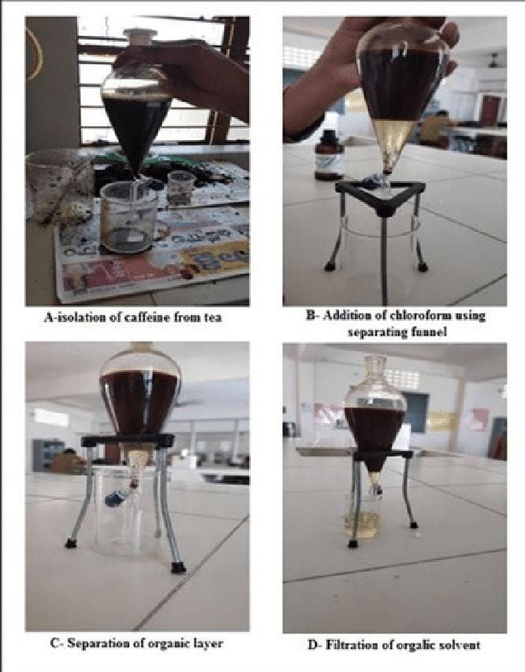
Fig 1-Pictures representing the procedure to extract caffeine
Determination of various not permitted ingredients with help of the different physical and chemical test:
- IRON FILLINGS TEST:
If we move a magnet over the tea dust containing iron powder in it, then the iron powder will get attracted towards the magnet. If this happens so, we can say that the tea dust is adulterated with iron powder. If not, then it is not adulterated with iron powder.

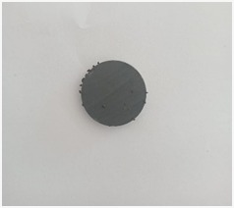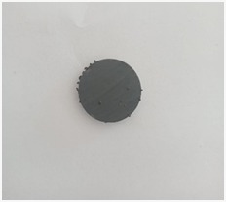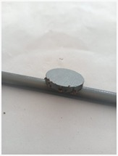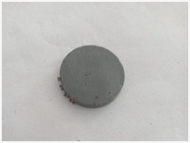
Sample 1 sample 2 sample 3 Gemini
Fig 2-Pictures Representing Iron Fillings Test
2.COAL TAR TEST:
Sample is melted in a test tube and 5 ml of dilute sulphuric acid or concentrated Hydrochloric acid to it , if Pink colour or crimson colour is produced then coal tar dye present . If not, then it is not adulterated with coal tar.
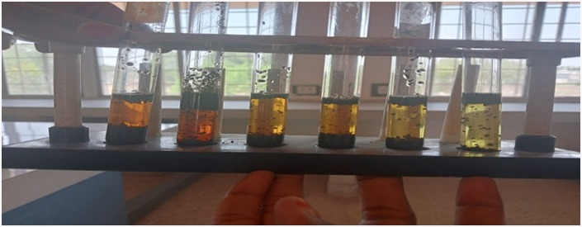
Fig 3-Coal Tar Test
3.CATECHU TEST:
Take small amount of the sample in a test tube and then add 5 ml of water and then add few drops of 10% aqueous lead acetate solution and then filter solution. Now, to the filtrate add few drops of silver nitrate solution, if grayish cloudiness appears then catechu is present in the tea.
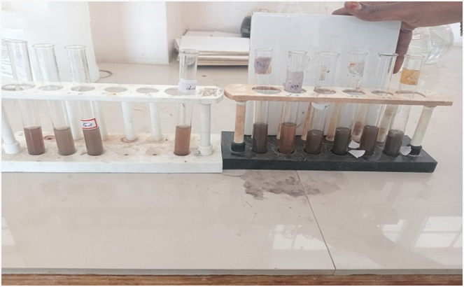
Fig 4-Catechu Test
- COLOUR TEST:
Take a glass of water. Add a spoon full of tea powder to it. In case there is no water-soluble additive, the water will stay clear. If the water turns slightly brown or if tea leaves emit colour into the water, there is an additive.
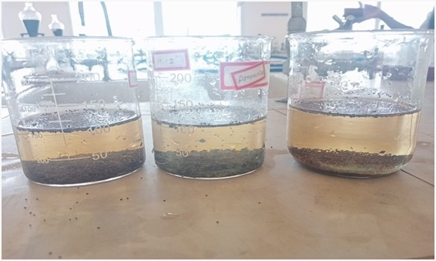
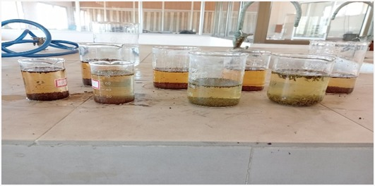
Fig 5-Pictures Representing Colour Test
- LEATHER FLAKES TEST:
Small quantity of tea sample was taken in spatula and burnt. If sample contain leather flakes it present emits an odour. If not, then it is not adulterated with leather flakes.

RESULT & DISCUSSION :
- Moisture content :
Taj Mahal tea has the lowest moisture content (3.20%), whereas sample 2 has the greatest moisture content (12.23%). The Department of Food Technology and Quality Control (DFTQC) states that tea must have a moisture level of less than 4%. Content of moisture in Red Label, Agni, Darbari, 3-Roses, Tetley, and Gemini It was discovered that tea differed somewhat from the DFTQC standard, however samples 1, 2, and 3 had higher moisture contents than the standard.
During the holding period between manufacturing and analysis, dried tea absorbed moisture, which could be the result of the processing environment's high humidity. A shorter drying time brought on by workers' negligence throughout the production process may also result in more moisture in the tea. An error in the packaging of tea may also contribute to the higher moisture content because it can absorb moisture through leaks while being stored .
Table 1- % Moisture content of observed tea samples
S.No | Sample | % Moisturecontent |  |  | Average  Moisture  Content
 |  | Trail 1 | Trail 2 | Trail 3
 | Gemini | 5.40 | 5.32 | 5.13 | 5.28
 | Darbari | 4.98 | 5.02 | 5.09 | 5.03
 | Red Label | 3.98 | 4.01 | 3.89 | 3.96
 | 3 Roses | 4.51 | 4.62 | 4.59 | 4.57
 | Tetley | 5.62 | 5.58 | 5.60 | 5.60
 | Agni | 4.89 | 4.98 | 4.92 | 4.93
 | Taj Mahal | 3.21 | 3.18 | 3.21 | 3.20
 | Sample 1 | 10.5 | 10.25 | 10.3 | 10.35
 | Sample 2 | 12.34 | 12.10 | 12.26 | 12.23
 | Sample 3 | 9.10 | 8.98 | 9.05 | 9.043

2. pH content :
According to the study's findings, sample 1 tea had the highest pH level (5.91), while sample 2 tea had the lowest (5.10). The pH of every tea sample is discovered to be nearly same. In general, teas have a slight acidity. It is evident from the foregoing data that sample -2 is acidic. Therefore, consuming high amounts of sample -2 may raise stomach acidity, leading to a variety of health issues.

Table 2-Acidity of different brands of tea powder
S.No | Sample Name | Acidity |  |  | AveragePh Value
 |  | TraiL 1 | TraiL 2 | TraiL 3
1. | Gemini | 5.57 | 5.58 | 5.58 | 5.57
2. | Darbari | 5.42 | 5.42 | 5.42 | 5.42
3. | Red Label | 5.57 | 5.57 | 5.58 | 5.57
4. | 3 Roses | 5.52 | 5.50 | 5.51 | 5.51
5. | Tetley | 5.62 | 5.64 | 5.64 | 5.63
6. | Agni | 5.58 | 5.57 | 5.56 | 5.57
7. | Taj Mahal | 5.56 | 5.56 | 5.56 | 5.56
8. | Sample 1 | 5.85 | 5.9 | 6 | 5.91
9. | Sample 2 | 5.09 | 5.10 | 5.11 | 5.10
10. | Sample 3 | 5.89 | 5.88 | 5.89 | 5.88

3.Caffeine content :
Table 3-Amount of caffeine present in tea sample
S.no | Sample | Type of Sample | Caffeine content (mg)
1. | Gemini | Manufactured | 140.5
2. | Darbari | Manufactured | 120.5
3. | Red Label | Manufactured | 106.4
4. | 3 Roses | Manufactured | 139.8
5. | Tetley | Manufactured | 111.9
6. | Agni | Manufactured | 129.0
7. | Taj Mahal | Manufactured | 115.56
8. | Sample 1 | Not manufactured | 80.9
9. | Sample 2 | Not manufactured | 89.5
10. | Sample 3 | Not manufactured | 70.8

4. Estimation of caffeine content :
Sample 3 tea has the lowest caffeine level (70.8 mg), whereas Gemini tea has the highest (70.25%). Tea must contain at least 2% caffeine by dry weight in order to meet the dftoc's obligatory criterion. Therefore, all of the tea sample's caffeine levels fall within the range of DFTQC for tea samples that were made, however values in non-manufactured samples showed deviations.
This could be because various teas require different growing and processing conditions. The reason for the variation in caffeine content in tea is that, according to research by Dias et al. (2019), the chemical composition is affected not only by variations in processing methods but also by factors such as the climate, soil, botanical variety, harvest time, horticultural practices, and even brewing conditions.
Table 4-Consumable quantity of caffeine

S.No | Sample | Consumable quantity in grams | Consumable quantity approximately in a cup/day
1. | Gemini | 21.39 | 2
2. | Darbari | 24.89 | 2
3. | Red Label | 28.19 | 2
4. | 3 Roses | 21.45 | 2
5. | Tetley | 25.02 | 2
6. | Agni | 23.25 | 2
7. | Taj Mahal | 25.96 | 2
8. | Sample 1 | 37.08 | 3
9. | Sample 2 | 33.51 | 3
10. | Sample 3 | 42.37 | 4

Wolde et al. (2014) state that 300 mg of caffeine per day is a safe amount. The caffeine consumption levels of various teas are computed and are displayed in a table based on the daily caffeine consumption criterion and the amount of caffeine in tea ascertained by this study.Based on caffeine intake, these results show that the maximum amount of Gemini tea that can be consumed daily is 21.39 grams.
In contrast, sample-land sample -3 consumes 37.08 and 42.37 grams daily, respectively. Ten grams of tea are typically brewed with 250 milliliters of water to make a cup of tea. We may therefore conclude that the greatest amount of Gemini, three roses, and agni tea that can be consumed in a single day is roughly two cups. In a similar vein, the daily consumption of Taj Mahal, Tetly, Darbari, and Red Label tea is roughly two and a half cups. Each day, four cups of sample -3, three and a half cups of sample -1, and three cups of sample -2 are maximum amount that can be consumed based on the amount of caffeine. The literature above discusses the different health issues that can arise from consuming more tea than this.
- Determination of various not permitted ingredients:
Table 5-Results of Aulterations test of Branded and non- Branded
S.No | Sample name | Iron filling Test | Coal tar test | Catechu Test | Colour test | Leather Test
1 | Gemini | Present | Present | Present | Present | Present
2 | Darbari | Absent | Absent | Absent | Absent | Absent
3 | Red Label | Absent | Absent | Absent | Absent | Absent
4 | 3 Roses | Absent | Absent | Absent | Absent | Absent
5 | Tetley | Absent | Absent | Absent | Absent | Absent
6 | Agni | Absent | Absent | Absent | Absent | Absent
7 | Taj Mahal | Absent | Absent | Absent | Absent | Absent
8 | Sample 1 | Present | Present | Present | Present | Present
9 | Sample 2 | Present | Present | Present | Present | Present
10 | Sample 3 | Present | Present | Present | Present | Present

After the tea samples were analyzed using physical and chemical tests, it was discovered that three non-branded samples—one and sample three—were tainted by coal tar, iron particles, catechu, leather, and color, while seven branded Gemini samples were tainted by iron particles and Agni by leather. Coal tar, iron particles, catechu, leather, and color are all present in sample 2.
Conclusion
Research data showed Gemini tea contained the highest caffeine amounts (140.25 mg) whereas Sample 3 contained the lowest (70.8 mg).
Consumers should consume between two and three and a half cups of specific tea types daily for caffeine safety purposes.
The adulteration assessment discovered that seven branded tea samples included one adulterated with leather and one with iron fillings. Each unbranded tea sample contained major adulterants made up of coal tar dyes and iron particles and catechu and leather as well as coloring agents.
The research shows unbranded tea powders have greater levels of adulteration thus people should use branded quality-assured tea products to reduce health hazards.
The research findings are relevant for public health because regions with weak food safety inspection systems need this information. Customers need to maintain awareness about harmful additives in tea since these substances create real health dangers.
The physical and chemical testing method discovered through this research can effectively teach product quality standards in educational sessions across various rural and urban communities. Basic adulteration tests taught to school and college students will equip them to protect their safety by holding companies responsible for their rights as consumers.
Disclaimer (Artificial intelligence)
Option 1:
Author(s) hereby declare that NO generative AI technologies such as Large Language Models (ChatGPT, COPILOT, etc.) and text-to-image generators have been used during the writing or editing of this manuscript.
Option 2:
Author(s) hereby declare that generative AI technologies such as Large Language Models, etc. have been used during the writing or editing of manuscripts. This explanation will include the name, version, model, and source of the generative AI technology and as well as all input prompts provided to the generative AI technology
Details of the AI usage are given below:
1.
2.
3.

References :
- Graham HN. Green tea composition, consumption, and polyphenol chemistry. Preventive medicine. 1992 May 1;21(3):334-50.
- Gardner EJ, Ruxton CH, Leeds AR. Black tea–helpful or harmful? A review of the evidence. European journal of clinical nutrition. 2007 Jan;61(1):3-18.
- Wierzejska R. Tea and health—A review of the current state of knowledge. Przegl Epidemiol. 2014 Jan 1;68(3):501-6.
- Yamamoto T., Juneja L.R., Chu D., Kim M. Chemistry and Applications of Green Tea. CRC Press; Boca Raton, FL, USA: 1997. pp. 6–34not
- Vuong QV. Epidemiological evidence linking tea consumption to human health: a review. Critical reviews in food science and nutrition. 2014 Jan 1;54 (4):523-36.
- Scharbert S, Jezussek M, Hofmann T. Evaluation of the taste contribution of theaflavins in black tea infusions using the taste activity concept. European Food Research and Technology. 2004 Apr;218:442-7.
- Vuong QV, Stathopoulos CE, Nguyen MH, Golding JB, Roach PD. Isolation of green tea catechins and their utilization in the food industry. Food Reviews International. 2011 Jul 1;27(3):227-47.
- Hayat K, Iqbal H, Malik U, Bilal U, Mushtaq S. Tea and its consumption: benefits and risks. Critical reviews in food science and nutrition. 2015 Jun 7;55(7):939-54.
- Wierzejska R. Tea and health—A review of the current state of knowledge. Przegl Epidemiol. 2014 Jan 1;68(3):501-6.
- Dufresne CJ, Farnworth ER. A review of latest research findings on the health promotion properties of tea. The Journal of nutritional biochemistry. 2001 Jul 1;12(7):404-21.
- Cabrera C, Artacho R, Giménez R. Beneficial effects of green tea—a review. Journal of the American College of Nutrition. 2006 Apr 1;25(2):79-99
- Rana B, Ghatge SV. Evaluation of Adulteration, Caffeine Content, and Antioxidant Activity in Different Black Tea Brands. Journal of Plant Science Research. 2023 Jan 1;39(1).
- Anita G, Neetu S. Hazards of new technology in promoting food adulteration. IOSR Journal of Environmental Science, Toxicology and Food Technology. 2013;5(1):08-10.
- . Prasanth MI, Sivamaruthi BS, Chaiyasut C, Tencomnao T. A review of the role of green tea (Camellia sinensis) in antiphotoaging, stress resistance, neuroprotection, and autophagy. Nutrients. 2019 Feb 23;11(2):474.
- Chacko SM, Thambi PT, Kuttan R, Nishigaki I. Beneficial effects of green tea: a literature review. Chinese medicine. 2010 Dec;5:1-9.
- World Health Organization. Quality control methods for medicinal plant materials. World Health Organization; 1998.
- Chaudhary NK, Thakur S, Budhathoki S, Baral D. pH profile and acidity analysis of some Nepalese tea brands: effects of tea type and temperature. BIBECHANA. 2024 Oct 3;21(3):321-7.
- Komes D, Horžić D, Belščak A, Ganič KK, Baljak A. Determination of caffeine content in tea and maté tea by using different methods. Czech J. Food Sci. 2009 Jan 1;27(1):S213-6.
- Baruah BD, Kalita D. Seasonal variation in catechin and caffeine content of tea (Camellia sinensis L.)

cultivars of Northeast India. Food Chemistry. 2021;338:127794.

.

- Shar Z, Shoaib H, Anwar H, Zubair M, Hussain A, Khan K. Spectrophotometric determination of caffeine in selected pakistani beverages. J Food Processing & Beverages. 2017;5(1):1-4.
- Tiwari BK, Kumar P, Kumar S, Singh A. Polyphenolic profiling and chemometric analysis for detection of adulterants in tea. Foods. 2023;12(7):1501.
- Sharma A, Singh S, Patel V. Toxins in adulterated tea may pose serious health risks: Experts. Times of India. 2025 [cited 2025 Apr 28]. Available from:
- Sakač MB, Sedej IJ, Mandić AI, Pestorić MB, Mišan AC, Torbica AM. Effect of water hardness on the extraction of bioactive compounds from green tea. Molecules. 2021;26(12):3485

