A rare case of Psoriasis vulgaris with Kaposi varicelliform eruptions secondary to second-degree syphilis

Abstract:

Psoriasis is an immune-mediated inflammatory skin disease that can cause sharply demarcated, erythematous, and scaly skin lesions often found on the surface of the skin.¹ Although the exact origins of the condition are unknown, environmental and genetic factors may play a role. Numerous genes, including human leukocyte antigen (HLA)-Cw6, loci for the T-helper type 2 and T-helper type 17 pathways, innate immune signaling pathways, and adaptive immune pathways involving CD8 T cells, have recently been identified as potentially linked to psoriasis.^{2,3} The incidence rate varies depending on the country-to-country basis, but it generally falls between 2% and 3%.⁴ Kaposi varicelliform eruptions (KVE) is a cutaneous infection that is generally caused by a variety of viruses such as herpes simplex virus types 1 and 2 and coxsackievirus A16 in patients with underlying dermatosis. Although the exact pathology of KVE is unclear, the breakdown of the body's defense mechanisms and altered skin barriers could be a potential factor.⁵ Antiviral medication with acyclovir is a treatment of choice that is generally combined with antibiotics. However, in some rare cases, mortality can also be reported in the case of systemic viremia.⁶ On the other hand, severe psoriasis can be life-threatening if an early diagnosis is not made and if associated with various other health issues. Since psoriasis cannot be cured, avoiding triggers, such as changing one's lifestyle and using moisturizers to prevent dry skin, is crucial. However, some of the treatment options available for psoriasis are phototherapy or systemic treatment, topical therapy, corticosteroid treatment, immunotherapy, and methotrexate.^{7,8} A 28-year-old male person was brought to the hospital with itchy skin and lesions all over the body. He was normal four months ago until he got several hyperpigmented papules on his left hand. These papules quickly spread to other parts of his body within four months, and he also experienced intermittent fever, gradual weight loss, and decreased hearing starting at three to four weeks. After the investigation, it was found that he was suffering from psoriasis vulgaris with Kaposi varicelliform eruptions secondary to second-degree syphilis.

Differential diagnosis: Pityriasis rosea, seborrheic dermatitis, eczema, rickettial infection, chickenpox

Key words: Psoriasis vulgaris, Kaposi varicelliform eruptions, syphilis, autoimmune disorder, dermatitis

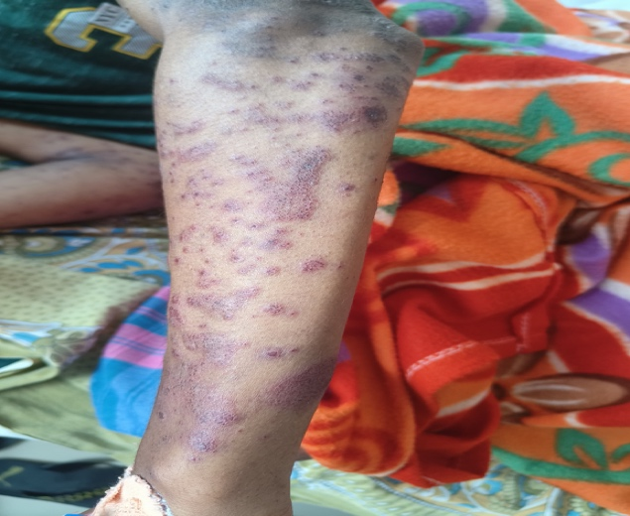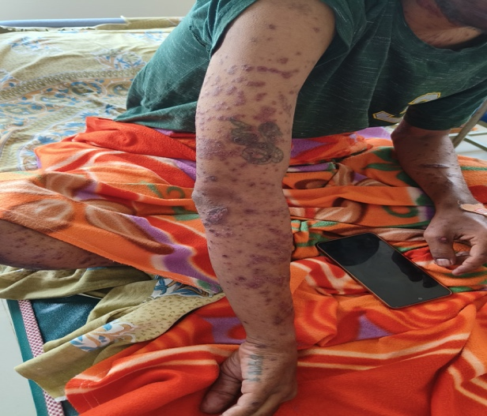

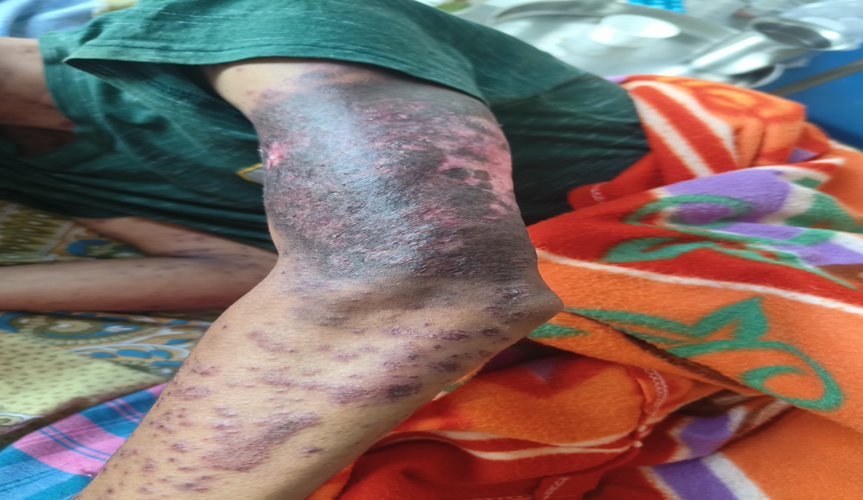

Figure 1: Multiple hyperpigmented erythematous papules and plaques in both hands

Conclusion:

Kaposi varicelliform eruptions are generally caused by a variety of viruses, but most often by herpes simplex in a patient with pre-existing dermatosis, and are mainly seen in adult’ patients. The transmission mainly occurs through contact with an infected person or primary or recurrent herpes. Generally, Kaposi varicelliform eruptions are triggered by total serum immunoglobulin E. Therefore. It is important to diagnose the case early with appropriate lab tests, which will help in timely intervention and cure.

Disclaimer (Artificial intelligence)
Option 1:
Author(s) hereby declare that NO generative AI technologies such as Large Language Models (ChatGPT, COPILOT, etc.) and text-to-image generators have been used during the writing or editing of this manuscript.
Option 2:
Author(s) hereby declare that generative AI technologies such as Large Language Models, etc. have been used during the writing or editing of manuscripts. This explanation will include the name, version, model, and source of the generative AI technology and as well as all input prompts provided to the generative AI technology
Details of the AI usage are given below:
1.
2.
3.

Reference:

- Nair PA, Badri T. Psoriasis. In: StatPearls. Treasure Island (FL): StatPearls Publishing; 2025 Jan-. Available from: https://www.ncbi.nlm.nih.gov/books/NBK448194/

- Chhabra S, Dogra S, Sharma K, Raychaudhuri SK, Raychaudhuri SP. Recent update on immunopathogenesis of psoriasis. Indian Journal of Dermatology. 2022;67(4):360–73.

- Li K, Huang CC, Randazzo B, Li S, Szapary P, Curran M, et al. HLA-C*06:02 Allele and Response to IL-12/23 Inhibition: Results from the Ustekinumab Phase 3 Psoriasis Program. Journal of Investigative Dermatology. 2016;136(12):2364–71.

- Damiani G, Bragazzi NL, Aksut CK, Wu D, Alicandro G, McGonagle D, et al. The Global, regional, and National Burden of Psoriasis: Results and Insights from the Global Burden of Disease 2019 Study. Frontiers in Medicine. 2021;8.

- Çakmak SK, Alli N, Yilmaz E, Artüz F. A Case of Kaposi’s Varicelliform Eruption in a Patient with Psoriasis Receiving Cyclosporine Therapy. Annals of Dermatology. 2015;27(3):345.

- Thappa D, Nath A, Sori T. A case series of Kaposi′s varicelliform eruption in dermatology in-patients in a tertiary care centre. Indian Journal of Dermatology. 2011;56(1):110.

- Raharja A, Mahil SK, Barker JN. Psoriasis: a brief overview. Clinical Medicine. 202;21(3):170–3.

- Psoriasis. Cleveland Clinic. 2025. Available from: https://my.clevelandclinic.org/health/diseases/6866-psoriasis

