***Telfairia occidentalis* seed extract and fractions mitigated liver and kidney injuries in rats with testosterone-induced benign prostatic hyperplasia**

**Abstract**

*Telfairia occidentalis* Hook (cucurbitaceae) seed, which is used in the preparation of soups and as medicine traditionally to treat various diseases by the Ibibios, was investigated for its effect on hematological parameters, liver and kidney functions, and histology in male Wistar rats with testosterone-induced benign prostatic hyperplasia (BPH). The effects of the extract and fractions of *T. occidentalis* seeds (138-553 mg/kg) on body weight, prostate weight and index, oxidative stress markers, hematological indices, liver and kidney functions, and histology were evaluated after 28 days of treatment with extract/fractions. The seeds extract/fractions were found to cause a significant (p<0.05- 0.01) decrease in prostate weights and indices, elevation of antioxidant enzymes (SOD, CAT, GPX) and molecule (GSH), and also reduce MDA level. The extract/fractions treatment further caused improvement in liver functions (AST, ALT, ALP, total and combined bilirubin, total protein, and albumin level) and kidney functions (urea, creatinine, and electrolytes) of the treated rats. Furthermore, treatment of the rats with the seed extract and fractions resulted in the reduction of pathological signs in the histology of these organs in the extract/fractions-treated rats. The seed extract/fractions did not affect the hematological indices of the rats significantly(p>0.05) when compared to the control. These results indicate that the seed extract and fractions of *T. occidentalis* possess liver and kidney protective potentials in rats with testosterone-induced BPH, which is due to the antioxidant activities of its phytochemical constituents.

***Keywords:*** antioxidative stress; hepatoprotective; medicinal plants; renoprotective; *Telfairia occidentalis*;Vegetables.

**Introduction**

Benign prostate hyperplasia (BPH) is a malignant proliferation of stromal and epithelial cells of the prostate gland making the gland to enlarge. This often may or may not be linked with lower urinary tract symptoms (Foo, 2017). BPH is seen mainly in older men between 51 and above and its percentage prevalence increases with age (Lim, 2017). The global burden of benign prostatic hyperplasia has been on the increase with statistics indicating that at age 60 more than half of the men have BPH while aged 85 and above have a prevalence of 90% (Madersbacher *et al*., 2019).

The prostate undergoes two antagonistic processes to maintain a normal size: cell proliferation and apoptosis. BPH is said to occur when an imbalance causes a considerably increased cell proliferation rate more than the rate of apoptosis (Minutoli *et al*., 2016). Currently, drugs used for the treatment of BPH are grouped into six categories: herbal agents, inhibitors of the enzyme 5 α-reductase, selective α-adrenergic blockers, β 3-adrenergic agonists, antimuscarinic agents and inhibitors of the enzyme phosphodiesterase type 5 (Nunes *et al*., 2017). Plants have been used since time immemorial to meet the primary healthcare needs of men in different parts of the world, especially in developing countries. In Nigeria, the majority of rural dwellers still rely on herbal medicine for their healthcare needs for one reason or the other (Anitha *et al.,* 2018). Good enough, the phytochemicals in these medicinal plants are discovered every day and have been explored as a major source of novel drugs (Anitha *et al.,* 2018).

*Telfairia occidentalis* Hook is a fluted pumpkin of the *Cucurbitaceae* family widely consumed as food in Nigeria (Okokon *et al*., 2009). It is a popular vegetable all over Nigeria, especially in the Niger Delta region and the Eastern part of the country; varieties of meals are prepared from the leaves, stems, and seeds of the plant (Usunobun and Okpiabhele 2023). The seeds are very nutritious and are eaten roasted or boiled. The seed has a history of being effective in the treatment and prevention of prostate disorders. The seed extract has been reported to exert antidiabetic (Eseyin *et al.*, 2007), cellular antioxidant, immunomodulatory, anticancer, anti-inflammatory (Okokon *et al.,* 2012a), antiplasmodial (Okokon *et al.,* 2009), antioxidant (Osukoya *et al,* 2016) and analgesic (Okokon *et al.*, 2012b; Osukoya *et al,* 2016), genotoxic and cytotoxic (Magnus *et al*., 2024), *in vivo* inhibitory, alpha amylase and alpha glucosidase effects (Enin *et al*., 2023). The leaf extract possesses antioxidant, antibacterial (Oboh *et al.,* 2010), hepatoprotective (Nwanna *et al*., 2007), antidiabetic (Nwozo *et al*., 2004), antiplasmodial (Okokon *et al.,* 2009), genotoxic and cytotoxic (Magnus *et al*., 2024) activities. Phytochemical studies of the extract have shown the presence of alkaloids, flavonoids, tannins, terpenes, saponins, and cardiac glycosides (Ebong *et al.,* 2020). Okokon *et al*. (2012a) reported the presence of compounds such as pentadecanoic acid, hexadecanoic acid; 16-octadecenoic acid methyl ester; 9, 12-octadecadienoyl chloride (Z,Z); 9- Octadecadienoic acid (Z)-, 2, 3-dihydroxypropyl ester; octadecanoic acid; hexadecanoic acid, 2,3-is[(trimethylsilyl) oxy] propyl ester, 2,4-heptadien-6-ynal,(E,E); benzoic acid; dodecanoic acid; linoleic acid ethyl ester; hexadecanoic acid, methyl ester; α-phellandrene; α-campholene aldehyde; terpinene-4-ol; trans-β-ocimene; borneol and stigmastan-3- ol, in the seed extract.

Previous study by Ajani and Akinyemi (2016) had suggested antiprostatic activity of the leaf extract. The present study was designed to evaluate the effect of seed extract and fractions of *T. occidentalis* on liver and kidney functions and histology of testosterone-induced benign prostatic hyperplasia in rats.

**Materials and Methods**

*Plant collection*

Fresh seeds of *Telfairia occidentalis* were purchased from the Itam market in Itu Local Government Area, Akwa Ibom State, Nigeria, in June 2023. The seeds were previously identified and authenticated by a taxonomist in the Department of Botany, University of Uyo, Uyo, Nigeria. Herbarium specimens (UUPH 1(b)) were deposited at the Department of Pharmacognosy and Natural Medicine Herbarium, University of Uyo.

The fresh seeds of the plant were dried on a laboratory table for 2 weeks and reduced to powder. The seeds powder (1 kg) was separately macerated in 50% ethanol (5000 mL) for 72 hours. The liquid filtrates obtained were concentrated at 40 °C and all the ethanol was completely removed. The crude extract (20 g) was dissolved in 500 mL of distilled water and partitioned with an equal volume of dichloromethane (DCM, 5 × 500 mL) till no colour change was observed, to obtain DCM and aqueous fractions. The extract and fractions were stored at 4 °C in a refrigerator until used for the experiment.

*Animals*

In this study, male albino Wistar rats (150-200 g) were used. The animals were sourced from University of Uyo Animal house and sheltered in plastic cages. The rats were fed with pelleted standard Feed (Guinea feed) and given unlimited access to water. The study was approved by College of Health Sciences Animal Ethics Committee, University of Uyo (UU/CHS/IHREC/24/VOL.1/56).

*Induction of Benign Prostatic Hyperplasia (BPH) in experimental rats*

Benign Prostatic hyperplasia (BPH) was induced in rats through daily subcutaneous injections (s.c.) of testosterone propionate (TP,3 mg/kg, dissolved in corn oil) for 28 days (Sasidharan *et al.,* 2022).

*Study design*

The rats were randomized into eight groups of 5 rats each; Group 1 received distilled water (control), Group 2 received TP injection along with distilled water and acted as a BPH-induced control, Group 3 received the standard drug, finasteride (5 mg/kg) and TP injection. Based on previously established LD50 (Okokon *et al.*, 2009), group 4 (low dose) was administered 138 mg/kg of the *T. occidentalis* seed extract and TP injection, group 5 rats were treated with 276 mg/kg and TP injection, while group 6 got 553 mg/kg and TP injection. Groups 7 and 8 were respectively treated with 276 mg/kg of aqueous and dichloromethane fractions concomitantly with TP injection. The weights of the rats were carefully recorded before and at the end of the experiments. All the test materials (*T. occidentalis* seed extract and fractions) were administered to the rats in the morning for 28 days. Following the final administration of test material and overnight fasting, the rats were anesthetized using light ethyl ether vapour. Blood samples were collected by cardiac puncture and used immediately. Blood samples were collected both into plain centrifuge tubes and EDTA bottles. The blood samples in the centrifuge tubes were centrifuged immediately at 2500 rpm for 15 min to separate serum at room temperature to avoid hemolysis and used for biochemical assays. The blood samples that were collected into EDTA bottles were used for hematological analysis. The kidney and liver tissues were dissected and weighed right away. They were fixed with formaldehyde (10%) for histopathological analysis.

*Body and prostate weights*

On the 29th day, the rats were anaesthetized with light ethyl ether vapour and blood was collected via cardiac puncture. Following blood collection, the rats were euthanized and prostate tissues harvested. The prostate index was calculated as the ratio of the prostate weight to the total body weight.

*Hematological analysis*

Blood samples were collected through cardiac puncture from each diethyl ether anaesthetized/sacrificed rat using 21gauge (21G) needles mounted on a 5 mL syringe (Hindustan Syringes and Medical Devices Ltd., Faridabad, India) into different EDTA-coated sample bottles. The blood samples were analysed for hematological indices (RBC, HGB, PCV, WBC, total and differentials – neutrophils, eosinophils, basophils, lymphocytes, and monocytes) These parameters were analysed using an automated Haematology analyser according to manufacturer’s protocols (Sysmex Hematology-Coagulation Systems®, Model KX-21N, Sysmex Incorporation, Kobe, Japan) at the University of Uyo Teaching Hospital.

*Assessment of the effect of the extract on liver function parameters of rats*

The collected sera samples were used for the estimation of liver function parameters such as total protein, albumin, total and direct bilirubin, aspartate aminotransferase (AST), alanine aminotransferase (ALT), alkaline phosphatase (ALP), total cholesterol. All biochemical parameters estimations were done using automated analysers and Fortress Diagnostic Kits® (Fortress Diagnostic Limited, UK) according to standard procedures of manufacturer’s protocols at University of Uyo Teaching Hospital.

*Assessment of the effect of the extract on kidney function indices of rats*

The levels of electrolytes (such as Na, K, Cl,), creatinine, and urea, were determined as markers of kidney function using diagnostic kits. All the kidney parameters were determined using automated analysers and Fortress Diagnostic Kits® (Fortress Diagnostic Limited, UK) according to standard procedures of the manufacturer’s protocols.

*Antioxidant enzymes (oxidative stress) estimation*

The sera samples collected from the rats were used for the determination of malondialdehyde (MDA) content (Weitner et al, 2016), superoxide dismutase (SOD) (Senthilkumar et al, 2021), catalase (CAT) (Wase et al, 2013), glutathione peroxidase (GPx) (Sedaghatfard et al, 2016) and reduced glutathione (GSH) (Alisik *et al.,* 2019).

*Histopathological studies*

The livers and kidneys of the animals were surgically removed, weighed, and fixed in 10% formaldehyde for histological processing. According to the Haematoxylin and Eosin method (Bancroft et al, 2019; Ma et al, 2024), the organs were carefully dissected out, trimmed of all fat, and blotted dry to remove any blood. They were then fixed in 10% formalin   (fixation). The fixed tissues were transferred to a graded series of ethanol (Dehydration). On day 1, they were placed in 70% alcohol for 7 hours, and then transferred to 90% alcohol and left in the latter overnight. On day 2, the tissues were passed through three changes of absolute alcohol for an hour each, then cleared in xylene (clearing). Once cleared, the tissues were infiltrated in molten paraffin wax in the oven at 58 oC. Three changes of molten paraffin wax (impregnation) at one-hour intervals were made, after which the tissues were embedded (embedding) in wax and blocked out. Serial vertical sections 5µm thick were obtained from a solid block of tissue (microtomy) fixed on clean albuminized slides to prevent sections from pulling off the slides and later stained with haematoxylin and eosin staining techniques. They were passed through grades of alcohol, cleared in xylene, and mounted in DPX (Distyrene - Plasticizer and xylene) mordant and observed under the digital light microscope at the Department of Chemical Pathology, University of Uyo Teaching Hospital, Uyo. Morphological changes were observed, and recorded and histologic micrographs were taken and interpreted by a histopathologist.



*Statistical analysis*

Data obtained from this work were analysed statistically using Graphpad Instat, (California, USA). ANOVA (one–way analysis of variance) followed by a post-test (Tukey-Kramer multiple comparison test) was used. Differences between means were considered significant at 5% and 1% levels of significance i.e., p≤ 0.05 and 0.01.

**Results**

*Effect on organ weights*

The effect of the administration of seed extract and fractions on testis and prostate weights of rats with testosterone-induced benign prostatic hyperplasia is shown in Table 1. The administration of testosterone (3 mg/kg/day) for 28 days caused a significant (p<0.01) increase in prostate weight of treated rats when compared to normal control. However, administration of the seed extract and fractions of *T occidentalis* did not cause any significant (p>0.05) effect on the weights of prostrate tissues of rats with testosterone-induced BPH when compared to normal control although there were considerable dose-dependent reductions in prostate weights of all the extract/fractions treated groups with the DCM fraction having the highest reduction. Finateride administration caused a significant (p<0.05) reduction in the prostate weights of the treated rats when compared to the testosterone-only treated group (Table 1). A similar trend was observed in prostate index as the testosterone-only treated group had the highest prostate index value compared to the normal control and all the extract/fractions treated groups with the finasteride and DCM fraction-treated groups having the lowest prostate index values (Table 1). However, treatment of rats with testosterone, finasteride, seed extract, and fractions of *T. occidentalis* did not cause any effect on the weights of livers and kidneys of the rats when compared to normal control (Table 1).

*Effect of seed extract and fractions of Telfairia occidentalis on hematological parameters of rats with testosterone-induced prostate benign hyperplasia*

The effect of seed extract and fractions of *T. occidentalis* on blood parameters of rats with testosterone-induced BPH is shown in Table 2. The administration of testosterone (5 mg/kg) to rats did not cause any significant (p>0.05) change in the levels of WBC, RBC, platelets count, hemoglobin concentration, and percentages of PCV, lymphocytes, eosinophils, basophils, and neutrophils when compared to normal control. Though there were observable decreases or increases of these parameters in extract/fractions-treated groups when compared to the control and testosterone only-treated groups, these changes were not statistically significant when compared to the control and testosterone-only-treated groups.

*Effect of seed extract and fractions of Telfairia occidentalis on liver function parameters of rats with testosterone-induced prostate benign hyperplasia*

Administration of testosterone (5 mg/kg, *i.p*) daily for 28 days to rats caused a significant (p<0.05-0.001) elevation in the level of AST, ALT, ALP, total and combined bilirubin and insignificant (p>0.05) decreases in total protein and albumin levels when compared to control. Concomitant administration of seed extract and fractions of *T.occidentalis* (138-553 mg/kg) with testosterone (5 mg/kg, subcutaneously) for 28 days caused prominent reductions in these enzyme activities (AST, ALT, ALP), total protein, and albumin which were significant (p<0.05) only in the low dose (138 mg/kg) in the activity of ALP when compared to testosterone only treated group. Significant (p<0.05-0.01) reductions in AST levels activity were recorded in all the extract-treated groups (138-553 mg/kg) and DCM fraction treated group when compared to the testosterone-only treated group. Total bilirubin was significantly (p<0.05-0.01) reduced in groups treated with higher doses of the extract (276 and 553 mg/kg) and DCM fraction-treated groups, while combined bilirubin levels were significantly (p<0.05-0.01) lowered in the groups treated with the middle dose (276 mg/kg) and DCM fraction when compared to testosterone only treated group. Total protein level was not significantly (p>0.05) affected by testosterone and extract/fractions-treatments when compared to the control group. However, the albumin level was only significantly (p<0.05) reduced in the high dose of the extract (553 mg/kg) treated group when compared to testosterone only treated group and in groups treated with the extract (138 and 553 mg/kg), aqueous and DCM fractions when compared to control group (Table 3).

*Effect of seed extract and fractions of Telfairia occidentalis on kidney function parameters of rats with testosterone-induced prostate benign hyperplasia*

Table 4 shows the effect of concomitant administration of seed extract/fractions of *T.* *occidentalis* and testosterone daily for 28 days on kidney function parameters of rats. Administration of testosterone (5 mg/kg) to rats caused significant (p<0.05-0.001) elevation of serum urea, creatinine, and electrolytes (K+ and Na+) and significant (p<0.05) decreases in HCO-3 level when compared to normal control. The Cl- level was not affected by testosterone administration. These increased levels of serum urea were significantly (p<0.05-0.01) reduced in groups treated with low dose (138 mg/kg), aqueous, and DCM fractions when compared to the testosterone-only treated group. The low and high doses of the extract (136 and 553 mg/kg), aqueous and DCM fractions had significantly (p<0.05) reduced creatinine and K+ levels when compared to the testosterone-only treated group. Na+ was onlysignificantly (p<0.05) reduced in the aqueous fraction treated group when compared to the testosterone-only treated group. The extract/fractions(138-553 mg/kg) and testosterone treatment on rats caused significantly (p<0.01) elevated levels of HCO-3 when compared to control (Table 4).

*Effect on oxidative stress markers*

The effect of administration of seed extract and fractions of *T. occidentalis* on oxidative stress markers of rats with testosterone-induced BPH is shown in Table 5. Treatment of rats with testosterone (3 mg/kg) daily for 28 days was found to decrease significantly (p>0.05) the levels of oxidative stress markers (CAT, SOD, GSH, GPX) and also increased significantly (p<0.05) the MDA level of rats when compared to normal control. However, concomitant administration of seed extract and fractions of *T. occidentalis* with testosterone was found to reverse these effects and caused marked elevations of the enzymatic and nonenzymatic endogenous antioxidants in the treated rats’ groups when compared to the testosterone-only groups. These elevations were not dose-dependent but were significant (p<0.05) in CAT levels of rats treated with low doses (138 and 276 mg/kg) as well as the aqueous fraction of the seed when compared to the testosterone-only treated group. Rats’ groups treated with high doses (553 mg/kg) of the extract as well as aqueous fraction exerted significant (p<0.05) elevation of GPx when compared to the testosterone-only treated group. Significant (p<0.05) elevations in GSH level were recorded in low and high doses (138 and 553 mg/kg), DCM fraction, and finasteride-treated rats’ group when compared to the testosterone-only treated group. MDA levels were only reduced significantly (p<0.05) in groups treated with middle dose (276 mg/kg), dichloromethane fraction, and finasteride when compared to testosterone-only treated group (Table 5).

*Effect of seed extract and fractions of Telfairia occidentalis on kidney histology of rats with testosterone-induced benign prostate hyperplasia*

Histological sections of kidneys of rats receiving various treatments at magnification (x100) stained with the H&E method revealed that Group 1 (normal control, CONT) treated with distilled water (10 mL/kg) had kidney sections that showed normal renal tubules and glomeruli, no evidence of pathology was seen (Figure 1). The group (Group 2, G2) treated with testosterone (5 mg/kg) alone showed abnormal glomeruli and renal tubules with areas of atrophying renal micro-architecture, having degenerating tubules with vacuolated ductal cells and tubular shrinking nuclei, areas of hemorrhagic blood vessels within the renal cortical matrix and widened bowman space depicting a severe effect. Group 3 (G3), treated with testosterone, (5 mg/kg) and standard drug, finateride (3 mg/kg) showed moderately affected glomeruli and renal tubule with few areas of having degenerating tubules with vacuolated ductal cells and tubular shrinking nuclei, areas of hemorrhagic blood vessels within the renal cortical matrix and widened bowman space depicting a moderate effect. Group 4 (G4), treated with a low dose of the extract (138 mg.kg) and testosterone (5 mg/kg) had kidney tissue showing a moderately protected renal micro-architecture, having degenerating tubules with vacuolated ductal cells and tubular shrinking nuclei, and areas of hemorrhagic blood vessels within the renal cortical matrix. Group 5 (G5) treated with a middle dose of the extract (276 mg.kg) and testosterone (5 mg/kg) had kidney tissue showing a severely affected renal micro-architecture, with areas of hemorrhagic blood vessels within the renal cortical matrix. Group 6 (G6) which was treated with a high dose of the extract (553 mg.kg) and testosterone (5 mg/kg) had kidney tissue showing a moderately affected renal micro-architecture, having degenerating tubules with vacuolated ductal cells and tubular shrinking nuclei within the renal cortical matrix. Group 7 (G7) and Group 8 (G8) rats respectively treated with aqueous fraction (276 mg/kg) and dichloromethane fraction (276 mg/kg) of the seed as well as with testosterone (5 mg/kg) had kidney tissues exhibiting a well-protected renal micro-architecture with well-presented glomeruli having glomerular cells with its bowman’s space, well-presented cells of the proximal convoluted tubules and the distal convoluted tubules within the renal cortical matrix (Figure 1).

*Effect of seed extract and fractions of Telfairia occidentalis on liver histology of rat with testosterone-induced benign prostate hyperplasia*

Histological sections of livers of rats receiving various treatments at magnification (x100) stained with the H&E method revealed that rats in group 1(normal control,) treated with distilled water (10 mL/kg) for 28 days had sections showing normal hepatic architecture with well protected portal vein, hepatic arteries, bile duct within the portal area, well-protected hepatocytes, presence of Kupffer cells and sinusoids within the hepatic lobules. Rats in group 2 (G2) treated with finasteride, 5 mg/kg, and testosterone, 3 mg/kg for 28 days had sections demonstrating protected hepatic histo-structure with decreased degenerated hepatocytes and proliferated Kupffer cells within the hepatic lobules. This was considered to be mildly affected. Group 3 (G3) rats administered with testosterone only, 3 mg/kg, had liver tissue demonstrating a severely altered hepato-architecture with areas of expressed degenerated hepatic cells, increased degenerating and vacuolated hepatocytes, widespread micro-vesicular steatosis within the hepatic lobules. Rats in group 4 (LD) treated with extract, 138 mg/kg, and testosterone, 3 mg/kg had moderately affected liver sections showing hepatic histo-structure with decreased degenerated hepatocytes, and proliferated kupffer cells within the hepatic lobules. Group 5 (MD) treated with extract, 276 mg/kg, and testosterone 3 mg/kg had sections showing moderate histo-architectural alteration, with areas of degenerated hepatic cells, increased degenerating and vacuolated hepatocytes, and widespread micro-vesicular steatosis within the hepatic lobules. Liver sections of rats in group 6 (G6) treated with extract, 553 mg/kg, and testosterone 3 mg/kg showed mild histo-architectural alteration, protected hepatic histo-structure with decreased degenerated hepatocytes, and proliferated kupffer cells within the hepatic lobules. Group 7 (G7) rats treated with aqueous fraction, 276 mg/kg and testosterone 3 mg/kg had liver sections showing severely altered hepato-architecture with areas of degenerated hepatic cells, increased degenerating and vacuolated hepatocytes, widespread micro-vesicular steatosis within the hepatic lobules, while group 8 rats treated with dichloromethane fraction 276 mg/kg and testosterone 3mg/kg had liver sections showing normal hepatic architecture with well protected portal vein, and bile duct, within the portal area, and well-protected hepatocytes, presence of Kupfer cells, and sinusoids within the hepatic lobules (Figure 2).

Table 1: Effect of seed extract and fractions of *Telfairia occidentalis* on body and organs weights of rats with testosterone-induced prostate benign hyperplasia

|  |  |  |  |  |  |  |
| --- | --- | --- | --- | --- | --- | --- |
| **PARAMETERS/TREATMENT** | **Dose**  **mg/kg** | **Prostrate**  **(mg)** | **Liver**  **(mg)** | **Kidney**  **(mg)** | **Body weight**  **(g)** | **Prostrate index** |
|  |  |
| Normal control | - | 0.50± 0.02 | 7.21±0.25 | 1.24±0.10 | 230.5±10.57 | 0.0021 |
| Testosterone only | 5 | 0.83± 0.02b | 7.86±0.19 | 1.79±0.04 | 236.25±24.68 | 0.0035 |
| Finasteride+TTT | 3 | 0.54± 0.05d | 7.66±0.90 | 1.47±0.14 | 230.0±17.17 | 0.0023 |
| Extract+TTT | 138 | 0.75±0.06 | 6.92±0.62 | 1.40±0.18 | 247.25± 17.24 | 0.0030 |
| 276 | 0.75±0.10 | 7.69±0.47 | 1.52±0.03 | 239.50± 9.04 | 0.0031 |
| 553 | 0.70±0.08 | 6.82±0.41 | 1.47±0.03 | 224.25± 13.62 | 0.0031 |
| Aqueous fraction+TTT | 276 | 0.73± 0.07 | 7.21±0.72 | 1.37±0.07 | 233.25±18.69 | 0.0031 |
| Dichloromethane fraction+TTT | 276 | 0.65± 0.09 | 7.11±0.39 | 1.40±0.06 | 230.0±12.15 | 0.0028 |

Data were expressed as mean ±SEM. Significant at dp<0.001 when compared to normal control; ap< 0.05, bp< 0.01, cp< 0.001 when compared to testosterone only control. n = 5.

Table 2: Effect of seed extract and fractions of *Telfairia occidentalis* on hematological parameters of rats with testosterone-induced prostate benign hyperplasia

|  |  |  |  |  |  |  |  |  |  |  |  |
| --- | --- | --- | --- | --- | --- | --- | --- | --- | --- | --- | --- |
| **Treatment/**  **Parameters** | **Dose**  **mg/kg** | **WBC**  **(×103/μL)** | **NEUT. (%)** | **LYM (%)** | **MONO (%)** | **ESINO (%)** | **BASO (%)** | **RBC (×106/μL)** | **HGB**  **(g/dL)** | **PCV (%)** | **PLATELETS. (×103/μL)** |
| Control | 10 | 8.19± 0.69 | 22.40±5.00 | 74.15±4.25 | 2.05±1.05 | 0.50± 0.10 | 0.80± 0.50 | 8.41± 0.08 | 14.90±0.40 | 53.90±2.40 | 771.5± 95.50 |
| Testosterone only | 5 | 5.23± 0.31 | 14.22± 6.29 | 70.62±4.96 | 13.50±3.56c | 1.10±0.93 | 0.55±0.15 | 8.69±0.50 | 14.10±1.01 | 55.57±3.66 | 705.25±60.21 |
| Finasteride +TTT | 3 | 6.22± 1.10 | 25.37± 6.29 | 61.57±8.65 | 1.25±0.61 | 1.37±0.49 | 0.42±0.06 | 6.46±1.29 | 13.97±1.04 | 50.27±2.19 | 683.75±36.20 |
| Crude extract+TTT | 138 | 6.02±0.57 | 12.80±1.85 | 57.27±6.08 | 19.70±2.58c | 0.55± 0.35 | 0.67± 0.31 | 9.10± 0.31 | 15.62±0.60 | 56.45±1.90 | 749.0± 30.87 |
| 276 | 5.49±0.29 | 19.17±4.03 | 67.72±0.60 | 11.45±5.13b | 1.07± 0.53 | 0.57± 0.04 | 8.52± 0.45 | 14.45±0.39 | 52.65±1.53 | 767.75± 31.69 |
| 553 | 5.29±0.48 | 21.82±4.70 | 55.47±5.83 | 20.97±7.22c | 0.95± 0.43 | 0.77± 0.16 | 7.83± 0.34 | 13.35±0.79 | 46.42±2.47 | 805.75±71.04 |
| Aqueous fraction +TTT | 276 | 10.49±2.08 | 26.80±11.06 | 54.44±2.89 | 17.36±8.31c | 0.56±0.18 | 0.86±0.12 | 6.99±0.43 | 11.80±0.65 | 42.60±2.20 | 920.0±35.90 |
| Dichloromethane fraction +TTT | 276 | 6.28± 1.62 | 13.302±3.32 | 71.30±4.61 | 14.37±5.75c | 0.30±0.14 | 0.72±0.16 | 8.51±0.18 | 14.70±0.46 | 53.87±3.05 | 908.5±84.94 |

Data are expressed as MEAN ± SEM, Significant at ap<0.05, bp<0.01, cp<0.001, when compared to control. (n=5).

Table 3: Effect of seed extract and factions of *Telfairia occidentalis* on liver function parameters of rats with testosterone-induced prostate benign hyperplasia

|  |  |  |  |  |  |  |  |  |
| --- | --- | --- | --- | --- | --- | --- | --- | --- |
| **Treatment** | **Dose**  **mg/kg** | **Total protein**  **(g/dL)** | **Albumin**  **(g/dL)** | **Total Bilirubin (µmol/L)** | **ALT (U/L)** | **ALP (U/L)** | **AST (U/L)** | **Combined Bilirubin**  **(µmol/L)** |
| Control | 10 | 64.50±1.84 | 44.50±0.50 | 31.72±1.44 | 12.5± 21.17 | 27.25± 18.63 | 22.0 ± 1.08 | 2.31± 0.23 |
| Testosterone only | 5 | 61.00±2.04 | 40.75±0.85 | 4.32±0.43c | 33.50±2.95b | 69.25± 22.29c | 44.0± 2.67c | 7.70± 0.40b |
| Finasteride +TTT | 3 | 61.25±1.49 | 41.50±1.19 | 3.02±0.50c | 19.5± 22.09 | 33.75± 36.96 | 23.25±2.31f | 3.15± 0.64 |
| Crude extract+TTT | 138 | 56.25±1.54 | 39.25±1.10a | 4.89±2.16c | 13.0± 8.13 | 44.75±22.99c,f | 28.0±4.08f | 3.05± 1.42 |
| 276 | 63.5±1.04 | 42.00±0.91 | 29.70±0.82f | 26.17±3.39b | 52.50± 26.38 | 10.35±2.16a,f | 4.12±1.80f |
| 553 | 60.25±1.25 | 36.25±1.49c,d | 15.25±4.08c,e | 20.50± 3.96a | 48.0± 19.27c | 21.0± 2.51f | 4.75± 0.69 |
| Aqueous fraction +TTT | 276 | 57.75±1.54 | 40.33±0.15a | 10.90±1.04c | 27.0± 3.24b | 48.25± 22.71 | 40.0 ± 5.18c | 1.67± 0.17 |
| Dichloromethane fraction +TTT | 276 | 54.25±0.62 | 39.50±1.19a | 27.07±3.59f | 11.75± 9.73 | 34.75± 6.53 | 24.0± 3.02f | 3.45±0.42e |

Data are expressed as MEAN ± SEM, Significant at ap<0.05, bp<0.01, cp<0.001, when compared to control; Significant at dp<0.05, ep<0.01, fp<0.001 compared to organotoxic group. (n=5)

Table 4: Effect of seed extract and fractions of *Telfairia occidentalis* on kidney function parameters of rats with testosterone-induced prostate benign hyperplasia

|  |  |  |  |  |  |  |  |
| --- | --- | --- | --- | --- | --- | --- | --- |
| **Treatment** | **Dose**  **mg/kg** | **Urea (mMol/L)** | **Creatinine**  **(µmol/L)** | **Chloride (mMol/L)** | **Potassium (mMol/L)** | **Sodium (mMol/L)** | **Bicarbonate (mMol/L)** |
| Control | 10 | 5.80± 0.32 | 90.75± 0.35 | 45.75±1.70 | 5.45± 0.43 | 127.25± 1.31 | 42.25± 1.65 |
| Testosterone only | 5 | 10.80±0.39c | 154.0±1.78c | 45.75±2.78 | 9.85± 0.49c | 145.50± 3.22c | 26.50± 0.95c |
| Finasteride +TTT | 3 | 5.82± 0.10f | 104.80±0.99f | 47.25±4.27 | 5.82± 0.08f | 136.50± 3.09 | 21.75± 0.85c |
| Crude extract+TTT | 138 | 7.32±0.90e | 124.50±5.25a | 42.75±4.90a | 5.17± 0.69f | 139.75±21.14a | 24.75± 1.97c |
| 276 | 9.87±0.95b | 147.75±3.63c | 47.75±1.65 | 8.27± 0.17b | 141.25± 4.49 | 26.50± 0.64c |
| 553 | 8.40±0.27b | 108.5± 5.63f | 49.75±2.78 | 7.57±0.64a,d | 136.5±3.22 | 24.0± 0.90c |
| Aqueous fraction +TTT | 276 | 6.15± 0.25f | 96.15±0.25f | 40.0±3.24 | 6.07± 1.23e | 132.0± 1.35e | 21.75± 0.85c |
| Dichloromethane fraction +TTT | 276 | 6.55± 2.31f | 94.55±2.31f | 48.0±2.64 | 5.27± 1.96f | 138.5± 3.30 | 27.75± 0.47c |

Data are expressed as MEAN ± SEM, Significant at ap<0.05, bp<0.01, cp<0.001, when compared to control; (n=5)

Table 5: Effect of seed extract and fractions of *Telfairia occidentalis* on serum oxidative stress markers of rats with testosterone-induced hyperplasia

|  |  |  |  |  |  |  |
| --- | --- | --- | --- | --- | --- | --- |
| **Treatment** | **Dose**  **mg/kg** | **SOD**  **(U/ml)** | **CAT**  **(U/g of protein)** | **GPx**  **(µg/ml)** | **GSH**  **(µg/ml)** | **MDA**  **(µMol/ml)** |
| Normal Control | - | 0.46± 0.01 | 3.35±0.01 | 0.067±0.002 | 1.49±0.04 | 0.23± 0.01 |
| Testosterone only | 5 | 0.35±0.01a | 1.54±0.04b | 0.036±0.0023c | 0.65±0.10b | 0.45± 0.01b |
| Finasteride +TTT | 3 | 0.46± 0.01 | 1.83±0.04a | 0.047±0.002c | 1.23±0.03e | 0.23± 0.01e |
| Crude extract+TTT | 138 | 0.41±0.02 | 2.24±0.07d | 0.043±0.001c | 1.32±0.16e | 0.36±0.02 |
| 276 | 0.50±0.05 | 4.88±0.09f | 0.047±0.002c | 0.95±0.04a | 0.32±0.01d |
| 553 | 0.39±0.021 | 1.54±0.18b | 0.053±0.002a,e | 1.33± 0.08f | 0.38±0.03 |
| Aqueous Fraction +TTT | 276 | 0.37±0.01 | 2.52±0.04d | 0.053±0.002a,e | 1.37±0.08f | 0.38± 0.02 |
| DCM fraction+TTT | 276 | 0.39±0.01 | 1.91±0.03a | 0.043±0.003c | 1.77± 0.13f | 0.28± 0.02e |

Data are expressed as MEAN ± SEM, Significant at ap<0.05, bp<0.01, cp<0.001, when compared to control;Significant at dp<0.05, ep<0.01, fp<0.001 compared to organotoxic group.. (n=6)

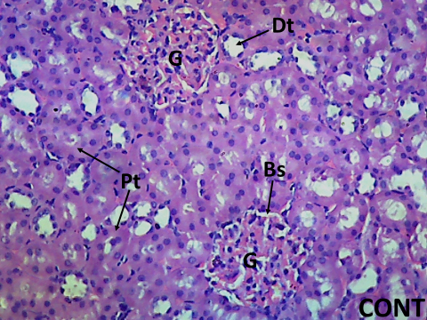 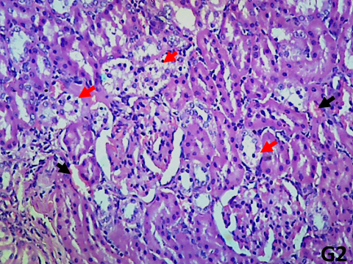

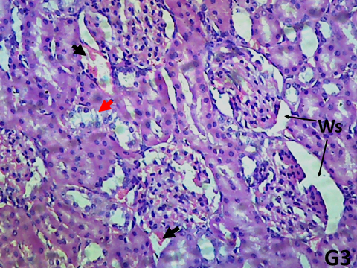 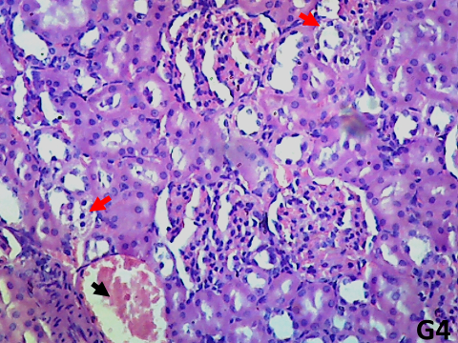

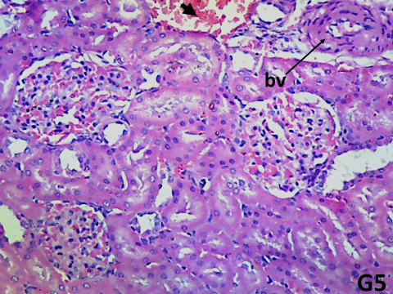 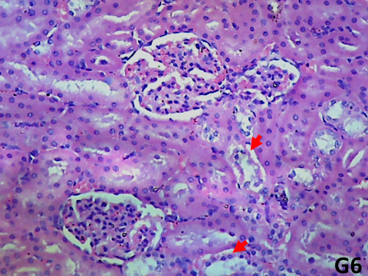

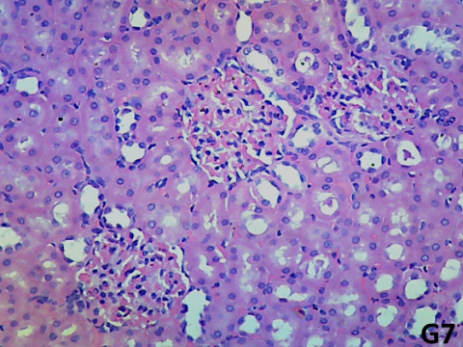 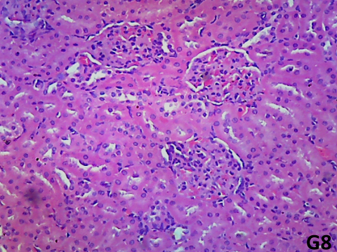

Figure 1: Kidney histological section of rat treated with distilled water, 10 mL/kg (**CONT**), Testosterone only, 3 mg/kg, (G2), finasteride, 5 mg/kg and testosterone, 3 mg/kg (G3), Extract, 138 mg/kg and testosterone, 3 mg/kg (G4), Extract 276 mg/kg and testosterone 3 mg/kg (G5), Extract 553 mg/kg and testosterone 3 mg/kg (G6), Aqueous fraction 276 mg/kg and testosterone 3 mg/kg (G7), dichloromethane fraction 276 mg/kg and testosterone 3 mg/kg (G8) showing well-presented glomeruli (G) having glomerular cells with its bowman’s space (Bs), proximal convoluted tubules (Pt) and the distal convoluted tubules (Dt), atrophying renal micro-architecture, having degenerating tubules with vacuolated ductal cells and tubular shrinking nuclei (red arrow), and areas of hemorrhagic blood vessels (black arrow) within the renal cortical matrix, widened bowman space (Ws)

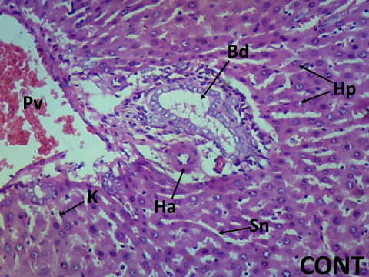 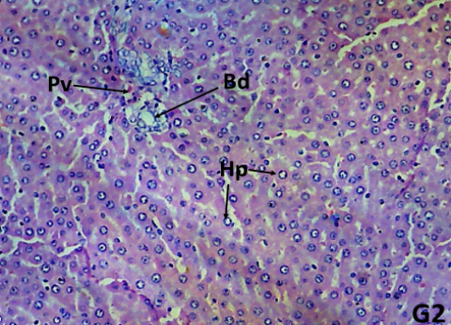

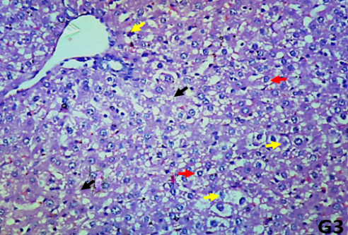 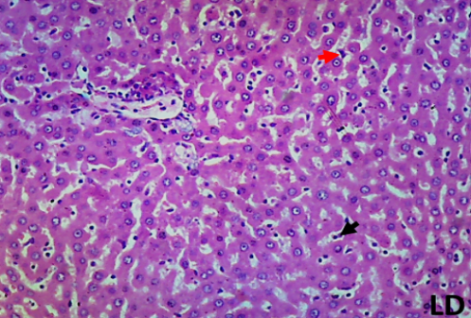

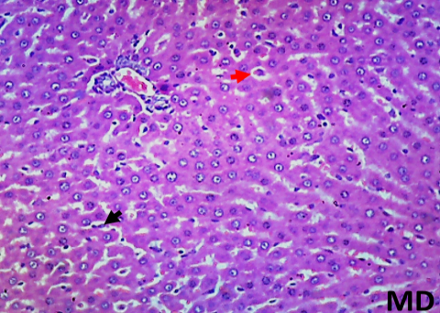 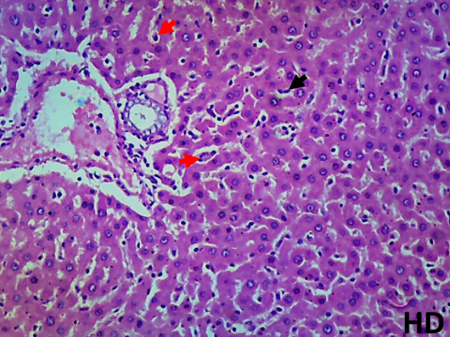

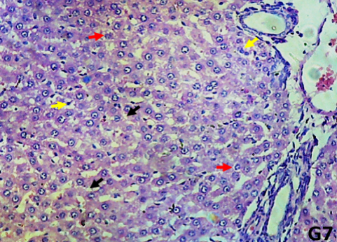 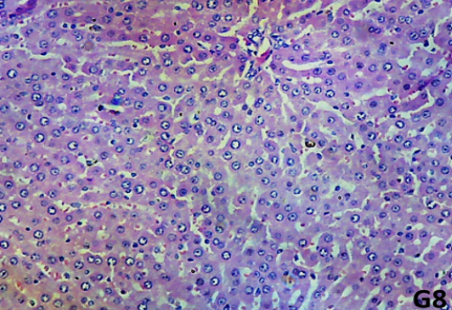

Figure 2: Liver histological section of rat treated with distilled water, 10 mL/kg (**CONT**), finasteride, 5 mg/kg and testosterone, 3 mg/kg (G2), Testosterone only, 3mg/kg (G3), Extract, 138 mg/kg and testosterone, 3 mg/kg (LD), Extract 276 mg/kg and testosterone 3 mg/kg (MD), Extract 553 mg/kg and testosterone 3mg/kg (HD), Aqueous fraction 276 mg/kg and testosterone 3 mg/kg (G7), dichloromethane fraction 276 mg/kg and testosterone 3mg/kg (G8) showing portal vein (Pv), hepatic arteries (Ha) and Bile duct (Bd), hepatocytes (Hp), Kupfer cells (K) and sinusoids (Sn), degenerated hepatocytes (red arrow), proliferated Kupfer cells (black arrow), areas of degenerated hepatic cells (yellow arrow) increased degenerating and vacuolated hepatocytes (red arrow), and widespread micro-vesicular steatosis (black arrow). (H&E x100).

**Discussion**

The seeds of *Telfairia occidentalis* which is used traditionally in the treatment of prostrate disorders were evaluated for effects on liver and kidney functions and histology of male rats with testosterone propionate-induced benign prostatic hyperplasia. The results of the study showed that seed extract and fractions of *T. occidentalis* significantly reduced the testosterone propionate elevated prostate tissue weights in male rats with the DCM fraction exerting the major effect.

The prostate weight is used as an important marker of BPH development (Lee *et al.,* 2012). Increased prostate weight is an indication of prostate disorder as reported in earlier published studies (Leje *et al.,* 2024). Prostate gland enlargement is defined by the proliferation of the gland's biological components, including stromal and epithelial cells (Kapoor, 2021). Based on the considerable increase of the prostate weight in the induced BPH rats, the results of this study validated the findings of previous research investigations that established an increase in prostate size as a critical predictor of BPH development (Shin *et al.*, 2012). Agents used in the treatment of BPH such as finasteride or other agents are known to decrease prostate weight. In this study, the male rats with untreated BPH were observed to show increased prostate weight compared to the control group. However, the seed extract/fractions treated animals were found to have reduced prostate weight compared to the testosterone-only treated BPH group. Also, seed extract/fractions treated animals were found to have lower prostate index values further supporting the anti-prostatic activity of the seed extract. These results indicate that *T. occidentalis* seed extract mitigated the prostatic growth and enlargement induced by testosterone. This could have resulted from the reported genotoxic and cytotoxic activities of *T. occidentalis* seed extract which demonstrate the ability of the extract to inhibit cell division and proliferation as well as cause cell death (Magnus *et al.*, 2024), highly supporting its previously reported anticancer activity (Okokon *et al.,* 2012a). These results suggested that *Telfairia occidentalis* seed extract/fractions possess the potential to inhibit the progression of BPH induced by testosterone.

The results of this study revealed that testosterone caused a significant increase in MDA and decreases in SOD, GPx, GSH, and catalase, which suggest oxidative stress conditions. Development and progression of BPH have been reported to involve oxidative stress mechanisms (Aryal *et al.*, 2007). The seed extract and fractions of *T. occidentalis* have been reported to exert cellular antioxidant, anticancer, and immunomodulatory (Okokon *et al.*,2012a) as well as *in vitro* antioxidant activities (Osukoya *et al.*, 2016). *T. occidentalis* seed extract/fractions administration in this study was found to significantly elevate the levels of SOD, GPx, GSH and catalase while decreasing MDA level. This could have been possible through the antioxidant potentials of the constituents of the extract/fractions as reported earlier by Okokon e*t al.* (2012a) and Osukoya *et al.* (2016), thereby attenuating oxidative stress conditions induced by testosterone. Moreso, inflammation has been implicated in the pathogenesis of prostatitis induced by testosterone propionate (Krušlin *et al.,* 2017). The observed prostate weight-reducing activities of the seed extract and fractions, as seen in the reduced weights of the prostate tissues, could have resulted from the anti-inflammatory, cellular antioxidant, and immunomodulatory activities of the seed extract and fractions as earlier reported by Okokon *et al.,* (2012a and 2012b). These actions may have contributed to the ameliorative/preventive activities of the seed extract/fractions of *T. occidentalis* against testosterone-induced BPH as evidenced in this study.

The hematopoietic system serves as a target for toxic compounds including toxic plant extracts (Emelike *et al.*, 2020). Therefore, an assay of the hematological parameters of the rats with testosterone-induced BPH was carried out to investigate the effect of *T. occidentalis* seed extract/fractions on the animals. The administration of testosterone (5 mg/kg) to rats did not cause any significant (p>0.05) change in the levels of WBC, RBC, platelets count, hemoglobin concentration, and percentages of PCV, lymphocytes, eosinophils, basophils, and neutrophils when compared to normal control. Moreover, the hematological parameters of the extract/fractions-treated groups were not different significantly when compared to the control and testosterone only-treated groups, suggesting that the seed extract/fractions did not affect the hematopoietic system.

Benign prostatic hyperplasia is often associated with other complications, especially in the renal and hepatic systems. There is a correlation between the kidney and benign prostate hyperplasia (BPH). BPH with urinary retention tends to result in kidney dysfunction and several risk factors associated with BPH might influence deterioration in kidney function (Zamzami *et al.,* 2021). These were also evaluated in this study. Elevated kidney function parameters resulting from testosterone propionate administration to male rats have been reported previously (Ugwu *et al.,* 2019). The extract and fractions were found, in this study, to reduce prominently the kidney function parameters (Urea, creatinine, and electrolytes) of the treated rats which were raised significantly by testosterone treatment, corroborating earlier report of Ugwu *et al.* (2019). This action portrayed kidney protective activity, as BPH complications often result in serious alterations and dysfunction of the renal system resulting in urine retention, kidney stones, and urinary tract infections. This observation was further supported by the histological findings which demonstrated significant protection of the kidneys of the extract/fractions-treated rats when co-administered with testosterone, compared to that of the testosterone-only treated animals. These findings suggest that *T. occidentalis* seed extract possesses nephroprotective potential against testosterone-induced BPH.

The liver is an organ for the detoxification of the body and is often susceptible to injurious effects of toxic substances like xenobiotics. Liver dysfunction was evident with significant increase in the studied liver function biomarkers of the BPH-induced untreated rats. Administration of testosterone, in this study, was found to raise liver function indices (ALT, AST, ALP, total protein, albumin, total and conjugated bilirubin) of the rats treated with it. These results corroborated earlier report of Enete *et al.,* (2023) on liver function indices of testosterone-induced BPH rats. However, concomitant administration of the *T. occidentalis* was found to significantly reduce the elevated levels of the liver function indices. This indicates that the extract/fraction possess liver protective property, which results from the activities of the phytochemical constituents of the seed extract.

The seed extract and fractions of *T. occidentalis* have been reported to contain some pharmacological active compounds such as pentadecanoic acid, hexadecanoic acid; 16-octadecenoic acid methyl ester; 9, 12-octadecadienoyl chloride (Z,Z); 9- Octadecadienoic acid (Z)-, 2, 3-dihydroxypropyl ester; Octadecanoic acid; hexadecanoic acid, 2,3-is[(trimethylsilyl) oxy] propyl ester, 2,4-heptadien-6-ynal,(E,E); benzoic acid; dodecanoic acid; linoleic acid ethyl ester; hexadecanoic acid, methyl ester; α-phellandrene; α-campholene aldehyde; terpinen-4-ol; trans-β-ocimene; borneol and stigmastan-3- ol,(Okokon *et al.*, 2012a; 2012b). which are likely to contribute to the observed activities in this study. Kumar *et al.,* (2010) had reported on the activities of some phyto-components with compound nature of flavonoids; palmitic acid (hexadecanoic acid ester and n-hexadecanoic acid), unsaturated fatty acid and linolenic acid (docosatetraenoic acid and octadecatrienoic acid) as anti-inflammatory, antioxidant, hypocholesterolemic, cancer preventive, hepatoprotective among others. These compounds could have contributed to the observed anti-prostatic, anti-inflammatory, antioxidant, renoprotective, and hepatoprotective activities of the seed extract observed in this study. Besides, antioxidant compounds such as borneol and terpene-4-ol (Chen *et al*., 2011; Wu *et al*., 2012), present in the extract may have played a role in the antioxidant/antioxidative stress activity observed in this study. Similarly, phytosterols such as stigmas-3-ol, 5-chloro-, acetate, (3a’, 5a’)-, present in this extract have been reported to have preventive effects on the development of diseases due to reactive oxygen species (Vivancos and Moreno, 2005). Moreover, Yoshida and Niki (2003) showed the antioxidant effects of the phytosterols against lipid peroxidation which was observed in the significantly reduced MDA level of the extract/fractions treated rats in this study. This radical scavenging activity of the phytochemical components of this extract could have accounted for the all activities observed in this study and may be the mechanism of action of the seed extract.

Monoterpenes are reported to inhibit lipoxygenase (LOX) (Wei and Shibamoto, 2010), which plays a role in inflammation. Terpinen-4-ol found in the seed extract has been reported to possess antiinflammatory activity by suppressing the production of prostaglandin and *in vitro* of TNF-α, IL-1β, as well as IL-8, IL-10, and PGE2 by LPS-activated human blood monocytes (Hart *et al.,* 2000; Miguel, 2010). This compound may in part be responsible for the observed anti-prostatic activity via anti-inflammatory mechanisms. Antioxidants are reported to prevent inflammation by scavenging radical oxygen species (Miguel, 2010) which are vital in the development and progression of BPH. The seed extract has been reported above to contain some anti-oxidant compounds. These compounds may have been responsible for the observed activity.

Moreover, a-phellandrene, an acyclic monoterpene is present in the hexane fraction and triterpene-fatty acid esters and free fatty acids (long chain C16-C20 unsaturated) in the dichloromethane fraction. These compounds are reported to have significant anti-inflammatory activity (Li *et al*., 2004; Lima *et al.,* 2012). Their presence in this extract might have contributed to the anti-inflammatory activity which resulted in the anti-prostatic activity observed against testosterone-induced BPH.

**Conclusion**

The results of this study suggest that *T. occidentalis* seed extract and fractions possess hepatoprotective and kidney protective potentials in rats with testosterone-induced benign prostatic hyperplasia which is attributed to the activities of the phytochemical compounds present.

**Ethical approval (for research involving animals or humans)**

Ethical clearance for the study was approved by College of Health Sciences Animal Ethics Committee, University of Uyo (UU/CHS/IHREC/24/VOL.1/56)

**References**

Ajani R S,& Akinyemi RA. (2016). “*Telfairia occidentalis* leaf and seed extracts as possible preventive and therapeutic agents for induced Benign prostatic Hyerplasia”. *European Journal of Medicinal Plants* 12(1): 1- 11.<https://doi.org/10.9734/EJMP/2016/22856>

Alisik, M., Neselioglu, S. and Erel, O. (2019). A colorimetric method to measure oxidized, reduced and total glutathione levels in erythrocytes. Journal of Laboratory Medicine, 43(5), pp.269-277

Anitha B, Ragbu N, Gopenath TS, Karthikeyan M, Gnanasekaran A, Chandrashekrappa GK, Basalingappa KM (2018). Medicinal uses of *Carica papaya*. *Journal of Natural and Ayurvedic Medicine* 2(6):1-11. *https://doi.org/*[*10.23880/jonam-16000144*](http://dx.doi.org/10.23880/jonam-16000144)

Aryal M, Pandeya A, Bas BK, Lamsal M, Majhi S, Pandit R, Agrawal CS, Gautam N, Baral N. (2007). Oxidative stress in patients with benign prostate hyperplasia. *JNMA Journal of Nepalese Medical Association* 46(167):103-106.

Bancroft, J. D., Layton, C., & Suvarna, S. K. (2019). Bancroft’s theory and practice of histological techniques (8th ed.). Churchill Livingstone. Pp 128

Chen L, Su J, Li L, Li B, Li W. (2011). A new source of natural D-borneol and its characteristics. *Journal of Medicinal Plants Research* 5: 3440-3447.

Drury RA, Wallington EA. (1980). *Carleton's Histological Techniques.* 5th Edition, Oxford University Press, New York, 195.

Ebong AS, Eseyin OA, Etim EI, Okokon JE, (2020). *Telfairia occidentalis* potentiates the antiplasmodial activity of artemisinin and amodiaquine combination therapy. *Anti-Infective Agents*. 18(2): 152-159. *https: //doi. org/* [*10.2174/2211352517666190206160812*](http://dx.doi.org/10.2174/2211352517666190206160812)

Ellman GL. (1959). Tissue sulfhydryl groups. *Archieves of Biochemistry and Biophysics.* 82: 70-77.

https://doi.org/10.1016/0003-9861(59)90090-6.

Emelike NJT, Achinewhu SC, and Ebere CO. (2020). Nutritional Composition, Functional and Organoleptic Properties of Breakfast Cereals Formulated from Acha,Wheat, Cashew Kernel and Prawn. *European Journal of Agriculture and Food Sciences 2(5):1-6. http://dx.doi.org/10.24018/ejfood.2020.2.5.ID*

Enete U, Ajah O, Nnaoma IE. (2023). Effects of methanol extract of *Allium sativa* (MEAS) on hepatic and renal function biomarkers and lipid profile of testosterone propionate induced Benign Prostatic Hyperplasia male Rats. *Saudi Journal of Medical and Pharmaceutical Sciences* 9(5): 287-296. *http://dx.doi.org/*[*10.36348/sjmps.2023.v09i05.003*](http://dx.doi.org/10.36348/sjmps.2023.v09i05.003)

Enin GN, Okokon JE, Odokwo BO, Antia BS. (2023). Preliminary phytochemical screening and i*n vivo* Inhibitory study of *Telfaira occidentalis* Hook f. seeds extract on alpha-amylase and alpha-glucosidase of rats. *Journal of Science and Technology Research* 5(4) : 26-35.*http://dx.doi.org/* [*10.5281/zenodo.10425980*](http://dx.doi.org/10.5281/zenodo.10425980)

Eseyin OA, Ebong P, Ekpo A, Igboasoiyi A, Oforah E. (2007). Hypoglycemic effect of the seed extract of *Telfairia occidentalis* in rat. *Pakistan Journal of Biological Science*s10(3): 498- 501.

*http://dx.doi.org/10.3923/pjbs.2007.498.501*.

Esterbauer H, Cheeseman KH. (1990). Determination of aldehydic lipid peroxidation products: malonaldehyde and 4-hydroxynonenal. *Methods in Enzymology.* 186: 407–421.*http://dx.doi.org/* *10.1016/0076-6879(90)86134-h.*

Foo KT. (2017). Pathophysiology of clinical benign prostatic hyperplasia. *Asian Journal of Urology,* 4(3): 152 – 157.*http://dx.doi.org/10.1016/j.ajur.2017.06.003.*

Hart PH, Brand C, Carson CF, Riley TV, Prager RH, Finlay-Jones JJ. (2000). Terpinen-4-ol, the main component of the essential oil of *Melaleuca alternifolia* (tea tree oil), suppresses inflammatory mediator production by activated human monocytes. *Inflammation Research* **9**: 19- 26.

*http://dx.doi.org/10.1007/s000110050639.*

Kapoor A. (2021). Benign prostatic hyperplasia management in the primary care setting. *Canadian Journal of Urology.* 19(1): 10–17. *PMID: 23089343.*

Krušlin B, Tomas D, Džombeta T, Milković-Periša M, Ulamec M. (2017). Inflammation in Prostatic Hyperplasia and Carcinoma-Basic Scientific Approach. *Frontal Oncology.* 7:77. *http://dx.doi.org/10.3389/fonc.2017.00077.*

Kumar PP, Kumaravel S, Lalitha C. (2010). Screening of antioxidant activity, total phenolics and GC-MS study of *Vitex negundo*. *African Journal of Biochemistry Researc*h **4**: 191-195.

Lawrence RA, Burk RF. (1976). Glutathione peroxidase activity in selenium- deficient rat liver. *Biochemistry and Biophysic Research Communication* 71: 952-958.

*http://dx.doi.org/10.1016/0006-291x(76)90747-6*

Lee M, Shin I, Seo C, Lee N, Ha H, Son J, Shin H (2012). Effects of *Melandrium firmum* methanolic extract on testosterone-induced benign prostatic hyperplasia inWistar rats.*Asian Journal of Andrology*  14: 320–324.

*http://dx.doi.org/* 10.1038/aja.2011.166.

Leje IU, Wali U, Yeldu MH, Alhassan HM, Wasagu IZ, Abubaka Ur, Abubakar BH, Bello M. (2024). “Effects of aqueous fruit extract of *Annona Muricata* on testosterone propionate induced benign prostate hyperplasia (BPH) in male Wistar rats”. *Asian Journal of Research in Biochemistry* 14 (4):72-83. https://doi.org/10.9734/ajrb/2024/v14i4295

Li, R. W., Leach, D. N., Myers, P., Leach, G. J., Lin, G. D., Brushett, D. J., and Waterman, P. G. (2004). Anti-inflammatory activity, cytotoxicity and active compounds of *Tinospora smilacina* Benth. *Phytotherapy Research* 18: 78-83. *https://doi.org/10.1002/ptr.1373.*

Lim KB. (2017). Epidemiology of clinical benign prostatic hyperplasia. *Asian Journal of Urology,* 4(3), 148 – 151. *http://dx.doi.org/* *10.1016/j.ajur.2017.06.004.*

Lima D F, Brando M S., Moura JB, Leitao JM, Carvalho FA, Miura L M, Leite JS, Sousa DP, Almeida FR. (2012). Antinociceptive activity of the monoterpene a phellandrene in rodents. *Journal of Pharmacy and Pharmacology.* 64: 283-292.

*https://doi.org/10.1111/j.2042-7158.2011.01401.x.*

Liu J, Fang T, Li M, Song Y, Li J, Xue Z, Li J, Bu D, Liu W, Zeng Q. (2019). *Pao Pereira* extract attenuates testosterone induced benign prostatic hyperplasia in rats by inhibiting 5α-reductase. *Scientific Report,* 9(1): 19703 – 19711. *https://doi.org/10.1038/s41598-019-56145-z*

Ma, Z.Y., Zhang, X.F., Hu, Y.Z., Zhu, M.D., Jin, J., Qian, P. (2024). Comparison of staining quality between rapid and routine hematoxylin and eosin staining of frozen breast tissue sections: an observational study. Journal of International Medical Research. 2024;52(6). doi:10.1177/03000605241259682

Madersbacher S, Sampson N and Culig Z., (2019). Pathophysiology of Benign prostatic hyperplasia and benign prostatic enlargement: A mini review. *Gerantology* 65: 458 – 464. *https://doi.org/10.1159/000496289.*

Magnus SP, Anagboso MO, Johnny II, Ise UP, Okokon JE. (2024). Evaluation of genotoxic and cytotoxic activities of leaf and seed extracts of *Telfairia occidentalis. Journal of Complementary and Alternative Medicine Research.* 25(3):7-16. *https://doi.org/*[*10.9734/JOCAMR/2024/v25i3521*](http://dx.doi.org/10.9734/JOCAMR/2024/v25i3521)

Marklund S, Marklund G. (1974). Involvement of superoxide anion radical in the autooxidation of pyrogallol and a convenient assay for superoxide dismutase. *European Journal of Biochemistry,* 47: 469 - 474.*https://doi.org/ 10.1111/j.1432-1033. 1974.tb03714.x*

Miguel MG. (2010). Antioxidant and anti-inflammatory activities of essential oils. *Molecules,* **15**: 9252-9287.*https://doi.org/* [*10.3390/molecules15129252*](https://doi.org/10.3390/molecules15129252)

Minutoli L, Rinaldi M, Marini H. (2016). Apoptic pathways linked to endocrine system as potential therapeutic targets for Benign Prostatic Hyperplasia. *International Journal of Molecular Sciences,* 17(8),1311. *https://doi.org/*[*10.3390/ijms17081311*](https://doi.org/10.3390/ijms17081311)

Nunes RV, Manzano J, Truzzi JC, Nard A, Silvinato A. and Bernardo, W. M. (2017). Treatment of Benign Prostatic hyperplasia. *Revista da Associacao Medica Brasileira,* 63(2), 95 – 99. *https://doi.org/* *10.1590/1806-9282.63.02.95.*

Nwanna E, Oboh G. (2007). Antioxidant and hepatoprotective properties of polyphenol extracts from *Telfairia occidentali*s (Fluted Pumpkin) leaves on acetaminophen induced liver damage. *Pakistan Journal of Biological Sciences* 10(16): 2682-2687. *https://doi.org/* *10.3923/pjbs.2007.2682.2687.*

Nwozo SO, Adaramoye OA, Ajaiyeoba EO. (2004). Anti-diabetic and hypolipidemic studies of *Telfairia occidentalis* on alloxan induced diabetic rabbits. *Nigerian Journal of Natural Products and Medicine* 8: 45-47. *https://doi.org/* [*10.4314/njnpm.v8i1.11814*](http://dx.doi.org/10.4314/njnpm.v8i1.11814)

Oboh G, Nwanna E, Elusiyan C. (2010). Antioxidant and antimicrobial properties of *Telfairia occidentalis* (Fluted pumpkin) leaf extracts. *Journal of Pharmacology and Toxicology* 5(8): 539-547. *https://doi.org/* [10.3923/jpt.2006.167.175](http://dx.doi.org/10.3923/jpt.2006.167.175)

# Okokon JE, Ekpo AJ , Eseyin OA (2009). Evaluation of in vivo antimalarial activities of ethanolic leaf and seed extracts of *Telfairia occidentalis. Journal of Medicinal Food,* 12(3):649-653.*https://doi.org/* 10.1089/jmf.2008.0099.

Okokon JE, Antia BS, Dar A., Choudhary MI. (2012a). Immunomodulatory, anticancer and antiinflammatory activities of *Telfairia occidentalis* seed extract and fractions. *International Journal of Food Nutrition and Safety* 2(2): 72 - 85.

Okokon JE, Dar A, Choudhary MI. (2012b). Chemical constituents and analgesic activity of *Telfairia occidentalis.* *Phytopharmacology* 3(2): 359 – 366.

Osukoya OA, Adegbenro D, Onikanni SA, Ojo OA, Onasanya A.(2016). Antinociceptive and antioxidant activities of the methanolic extract of *Telfairia occidentalis* Seeds. *Anc Science of Life.* 36(2):98-103. *https://doi.org/* [10.4103/asl.ASL_142_16](https://doi.org/10.4103/asl.ASL_142_16)

Sasidharan S, Srinivasakumar KP, Bhaumik A, Das SK,Hareebndran N J.(2022). Administration of *Caesalpinia bonduc* seed extracts ameliorates testosterone-induced benign prostatic hyperplasia (BPH) in male wistar rats. *Research and Reports in Urology* 14 :225–239.*https://doi.org/* *10.2147/RRU.S365598*.

Sedaghatfard, F., Razavi, S.A, Hedayati,M., Nematollah Razmi,N. & Rahnama,A. (2016). Glutathione Peroxidase Activity Assay with Colorimetric Method and Microplate Reading Format and Comparison with Chemiluminescence Method. European Online Journal of Natural and Social Sciences, 5(1):15-21.

Senthilkumar, M, Amaresan, N. & Sankaranarayanan, A. (2021). Estimation of Superoxide Dismutase (SOD). In: Plant-Microbe Interaction. Springer Protocols Handbooks. Humana, New York, NY Pp 117-118. Doi.org/ 10.1007/978-1-0716-1080-0_29.

Shin IS, Lee MY, Jung DY, Seo CS, Ha HK, Shin HK.(2012) Ursolic acid reduces prostate size and dihydrotestosterone level in a rat model of benign prostatic hyperplasia. *Food Chemistry and Toxicology.* 50(3-4):884-888. *https://doi.org/* *10.1016/j.fct.2012.01.007.*

Sinha AK. (1972). Colorimetric assay of catalase. *Analytical Biochemistry,* 47: 389 394. *https://doi.org/* *10.1016/0003-2697(72)90132-7.*

Ugwu M N, Asuk A A, Eteng M U. (2019). Toxicological evaluation of aqueous extract of *Ocimum gratissimum* on liver and kidney of testosterone and estradiol induced benign prostatic hyperplasia in adult male rats. *International Digital Organization for Scientific Research (IDOSR) Journal of Applied Sciences* 4(1) 114-122,

Usunobun U, Okpiabhele A.(2023). *Telfairia occidentalis* Hook f. mitigates Carbon Tetrachloride induced Nephrotoxicity in Rat. Journal of Research in *Applied and Basic Medical Sciences* 9 (3) :130-137.*https://doi.org/* [*10.61186/rabms.9.3.130*](http://dx.doi.org/10.61186/rabms.9.3.130)

Vivancos, M., and Moreno, J. J. (2005). β-sitosterol modulates antioxidant enzyme response in RAW264.7 macrophages. *Free Radical Biology and Medicine* 39: 91-97. *https://doi.org/* [*10.1016/j.freeradbiomed.2005.02.025*](https://doi.org/10.1016/j.freeradbiomed.2005.02.025)

Wase T, Tajima A, Sugimoto S, Okuda K, Hironaka I, Kamata Y, Takada K, Mizunoe Y. (2013). A simple assay for measuring catalase activity: a visual approach. Sci Rep. 3:3081. doi: 10.Med. J. Cairo Univ., Vol. 87, No. 3, June: 1497-1502, 2019

Wei A, Shibamoto T. (2010). Antioxidant/lipoxygenase inhibitory activities and chemical compositions of selected essential oils. *Journal of Agriculture and Food Chemistry* 58: 7218-7225. *https://doi.org/*[*10.1021/jf101077s*](https://doi.org/10.1021/jf101077s)

Weitner T, Inić S, Jablan J, Gabričević M, Domijan A. (2016). Spectrophotometric Determination of Malondialdehyde in Urine Suitable for Epidemiological Studies. Croat. Chem. Acta 89(1), 133–139.

Wu C, Chen Y, Chen J, Shieh J, Huang C, Lin P, Chang G, Chang J H, and Lin C. (2012). Terpinen-4-ol induces apoptosis in human nonsmall cell lung cancer in vitro and in vivo. *Evidence. Based International Journal of Food Nutrition and Safety.* 2(2): 72-85. *https://doi.org/*10.1155/2012/818261.

Yoshida Y, Niki E. (2003). Antioxidant effects of phytosterol and its components. *Journal of Nutritional Science and Vitamins* 49: 277-280. *https://doi.org/* *10.3177/jnsv.49.277.*

Zamzami Z, Rayendra H, Az-Zahra N. (2021). Associations between kidney dysfunction and risk factors in patients with transurethral resection of the prostate. *Research and Reports in Urology*. 13: 665-672. *https://doi.org/* [*10.2147/RRU.S326836*](https://doi.org/10.2147/RRU.S326836)