The Impact of Fe Doping on the Optical and Structural Properties of ZnFeS Fabricated by Electrodeposition Technique
Abstract
Dilute magnetic semiconductors (DMS) are semiconductor materials that are lightly doped with transition metals or rare earth metals. In this work, Fe doped ZnS thin films as a dilute magnetic semiconductor were successfully synthesized for different Fe concentration using electrodeposition technique. The precursor solution contains zinc acetate, thiourea and iron nitrate in the form Zn_{20-x}Fe_{x}S₂₀, where x=4ml, 6ml and 8ml for different variation of concentration for the dopant. The films were characterized using the X-Ray Fluorescence (XRF) spectrometer, UV-Vis spectrophotometer and X-ray diffraction technique to obtain the elemental composition, optical and structural properties respectively. The elemental composition shows the presence of Fe ion which indicated that ZnS was successfully doped with Fe. The average crystalline size from XRD data was found to be approximately 17nm and it was also observed that the films exhibit a crystalline structure evidenced from their sharp peaks. The band gaps of the materials were determined by drawing TAUC plots from their optical absorption spectra. The values of bandgaps obtained for Zn_{20-x}Fe_{x}S₂₀ (x=0ml, 4ml, 6ml and 8ml) corresponds to 3.07eV, 2.50eV, 2.80eV and 2.74eV respectively.
Keywords- Dilute magnetic semiconductor, doping, electrodeposition, ferromagnetism

Introduction
Dilute magnetic semiconductor (DMS) has attracted much interest because of the combination of both nonmagnetic semiconductors and magnetic elements within the same material [1]. They are the materials formed by replacing the cations of nonmagnetic semiconductors (III-V or II-VI) by magnetic ions such as transition metals (Mn, Fe, Cr, Ni, Cu and Co) ions or rare earth ions [2-4]. DMS materials have excellent magnetic, magneto-optic and magnetoelectronic properties, high data processing speed and have important applications in high-density non-volatile memory, magnetic inductors, optical isolators, semiconductor integrated circuits, semiconductor laser and spin quantum computers [5-7]. The discovery of carrier induced ferromagnetism in III-V DMSs makes them potentially useful materials in future spintronic devices [8-9]. The major limitation of these group of semiconductor material in spintronics is low curie temperatures [10-12]. Research have been geared towards DMSs offering Tc above room temperature. Tc of II-VI semiconductors (ZnS and CdS) based DMS is found to be very close to room temperature and can be adjusted by different synthesis parameter especially the dopant concentration [13]
Among the various II-VI semiconductor materials, ZnS has attracted much attention because it’s non-toxic wide band gap (3.6eV) material with high binding energy and is well adopted compound for the numerous applications such as spintronic, solar cell and other optoelectronic device [14,15]. In addition, the absorption edge of ZnS only allows high-energy light absorption because its absorption edge is shorter than 340nm. This absorption edge can be moved towards higher wavelengths, usually called being redshifted, by introducing the suitable dopant. If transition metals such as Ni, Fe, Mn and Co are doped in the semiconductor then it possesses wonderful characteristics because of spin-spin interaction [16-18].
In the fabrication of DMS, different fabrication techniques have been utilized to fabricate different DMS materials such as chemical bath deposition [13,19-20], sol-gel method [6,21-23], hydrothermal method [24, 25], electrochemical method [26-29], magnetron sputtering deposition [30-31], Combustion reaction method [5], have been successfully employed. These techniques have both merit and demerit peculiar to them. In this research, we aimed to synthesize and analyze DMS obtained by doping ZnS with Fe using electrodeposition technique.
Methodology
The synthesis of iron doped zinc sulphide films was done using electrodeposition technique. The substrates (FTO glass) were first cleaned with ethanol and rinsed with distilled water using an ultrasonicating device for 20 minutes respectively. The washed substrates were dried in the oven at 60ºC for 30 minutes. Appropriate quantities of zinc acetate, thiourea and iron nitrate were weighed according to the stoichiometry and dissolved in distilled water to make 1.0, 0.5, and 0.5 molar concentration of the solutions respectively.
During deposition, the precursor solution for the undoped film contains 20ml of zinc acetate and 20ml of thiourea. For the doped film, the precursor solution contains Zn_{20-x}Fe_{x}S₂₀, where x=4ml, 6ml and 8ml for different variation of concentration for the dopant. The deposited films were annealed at 100ºC for 10minutes
The phase and crystalline structure of the ZnFeS films were studied using X-ray diffractometer with Cu-Ka (=1.54056Ằ) radiation. The elemental composition of the films was obtained using X-ray fluorescence (XRF) spectrometer and the optical parameter (absorbance values) were also obtained using UV-Vis spectrophotometer
Results and discussion
Elemental composition
Using X-Ray Fluorescence (XRF) spectrometer, the elemental composition of the fabricated films was obtained as shown in figure 1. The result shows the presence of iron in the films indicating a successful doping.

(a) ZnFeS (4ml)  (b)ZnFeS (6ml) | (c)ZnFeS (8ml)
  El | % | +/- 3σ
  Fe | 0.106 | 0.032
  Zn | 0.210 | 0.022
  Sr | 0.004 | 0.001
  Zr | 0.003 | 0.001
  Sn | 0.082 | 0.014
  LE | 99.596 | 0.045
  El | % | +/- 3σ
  Cr | ND | <0.021
  Mn | ND | <0.020
  Fe | 0.115 | 0.033
  Cu | ND | <0.010
  Zn | ND | <0.012
  Sr | 0.004 | 0.001
  Zr | 0.003 | 0.001
  Sn | 0.090 | 0.015
  LE | 99.787 | 0.037
  EL | % | +/- 3σ
  Cr | ND | <0.027
  Mn | ND | <0.024
  Fe | 0.149 | 0.037
  Cu | ND | <0.011
  Zn | 0.194 | 0.021
  Sr | 0.005 | 0.001
  Zr | 0.003 | 0.001
  Sn | 0.082 | 0.014
  LE | 99.568 | 0.050
Figure 1: elemental composition of the ZnS doped with iron((a)ZnFeS (4ml), (b) ZnFeS (6ml), (c) ZnFeS (8ml)) as obtained by X-ray fluorescence (XRF) spectrometer
Optical characterization
The absorbance spectrum of the films was obtained using the UV-Vis spectrophotometer in the wavelength range of 300 – 1100nm. Other optical parameters were calculated
Figure 2-4 shows the absorbance, transmittance and reflectance of both the undoped and the doped films (ZnFeS). From the result analysis, the undoped film shows a relatively low absorbance compared to the doped films of 4ml and 6ml. from the transmittance spectra, the undoped ZnS has a good transmittance in the visible range (65% to 85%), however there’s a decrease in the transmittance of the doped samples of 4ml and 6ml which might be due to reduction of crystalline quantity as a result of doping. On the other hand, improved transmittance was observed for the doped films of 8ml. This high transmittance might be attributed to good crystalline structure which eliminate light scattering.
Figure 5 shows the variation of refractive index with photon energy for the ZnFeS films at different doping concentration. The graph shows that the films achieved a high refractive index and increases as the doping concentration increases except for ZnFeS (8ml) which exhibited the lowest range of refractive index. The high reflective index obtained is a property which showed that the films could be utilized in photovoltaic and anti-reflective coating applications.
The optical conductivity of Fe doped ZnS films at different concentration of Fe is shown in figure 6. The optical conductivity of all the films (doped and undoped) is lowest in the low energy region and increased steadily with photon energy along the visible region. It is observed that the optical conductivity of the films decreases as the doping concentration increases with ZnFeS (4ml) exhibiting the highest optical conductivity of approximately 8 x 10¹³S⁻¹ while ZnFeS (8ml) exhibited the lowest optical conductivity of approximately 1.8 x 10¹³S⁻¹ at 3.4eV.
The plot of extinction coefficient of the deposited films against photon energy is presented in figure 7. It can be observed that that the films generally have a low extinction coefficient at the lower photon energy region and increases steadily across the spectrum. The ZnFeS deposited at 4ml doping concentration of Fe exhibited the highest values in the range of 0.017 to 0.038 while ZnFeS film at 8ml doping concentration of Fe has the lowest value in the range of 0.003 to 0.010.
The dielectric constant is composed of two parts; the real and imaginary part of dielectric constant. The real part of the dielectric constant relates to the dispersion while the imaginary part provides a measure of dissipative rate of wave in the medium [32, 33]. Figure 8 shows the graph of real dielectric constant of ZnFeS films at different doping concentration. The result showed that the values obtained ranged from 3.3-6.2, 6.0-6.5, 5.3-6.9, and 2.4-4.5 for ZnS, ZnFeS (4ml), ZnFeS (6ml) and ZnFeS (8ml) respectively. The graph of imaginary dielectric constant against photon energy of ZnFeS films is shown in figure 8. The effect of doping concentration of Fe on the films were studied. It is observed that the imaginary dielectric constant increases along the visible region of the spectrum with ZnFeS at 4ml exhibiting the highest range of values. The values of imaginary dielectric constant obtained ranged from 0.02-0.09, 0.08-0.19, 0.06-0.16 and 0.01-0.04 for ZnS, ZnFeS (4ml), ZnFeS (6ml) and ZnFeS (8ml) respectively.

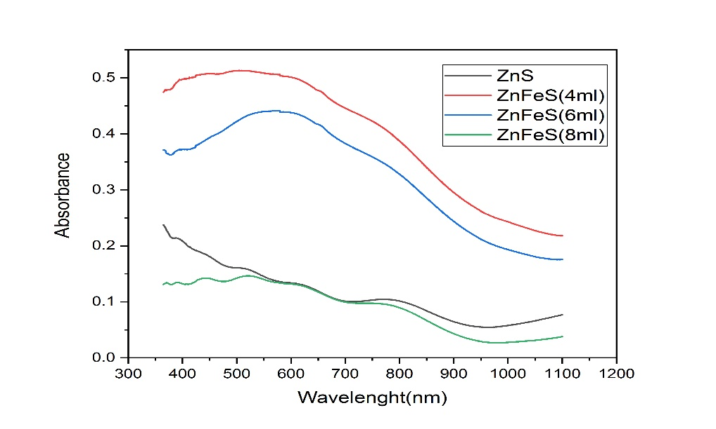
Figure 2: Absorption spectra Fe doped ZnS at different concentration of Fe

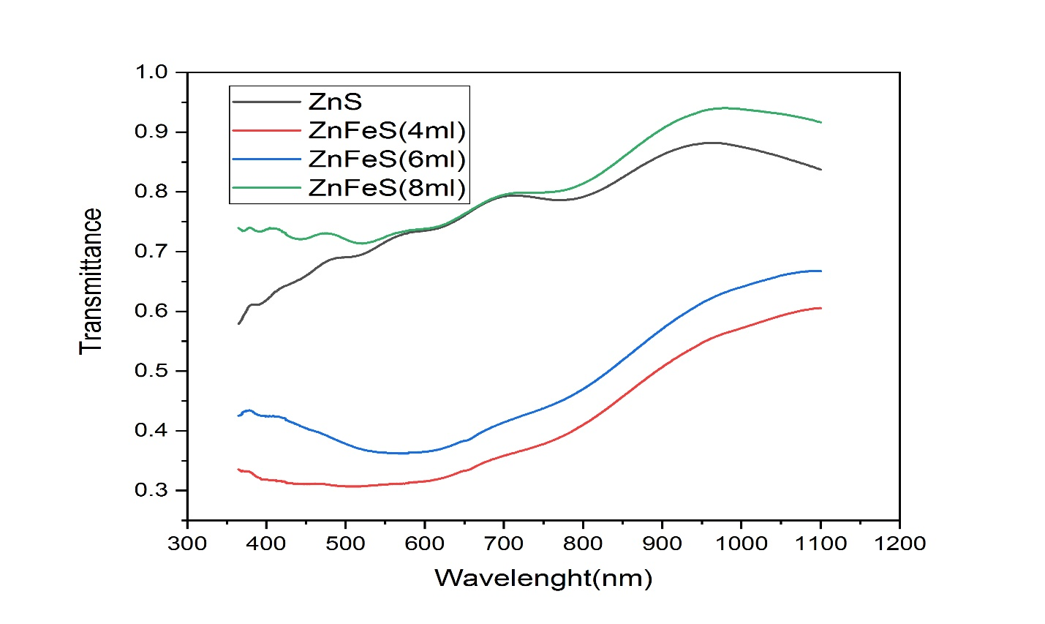

Figure 3: Transmittance spectra Fe doped ZnS at different concentration of Fe

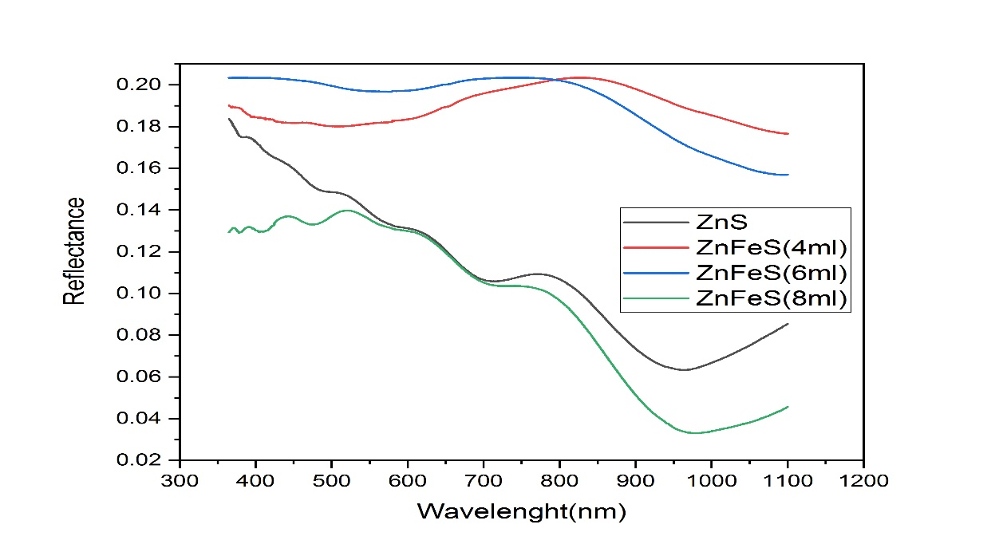
Figure 4: Reflectance spectra Fe doped ZnS at different concentration of Fe
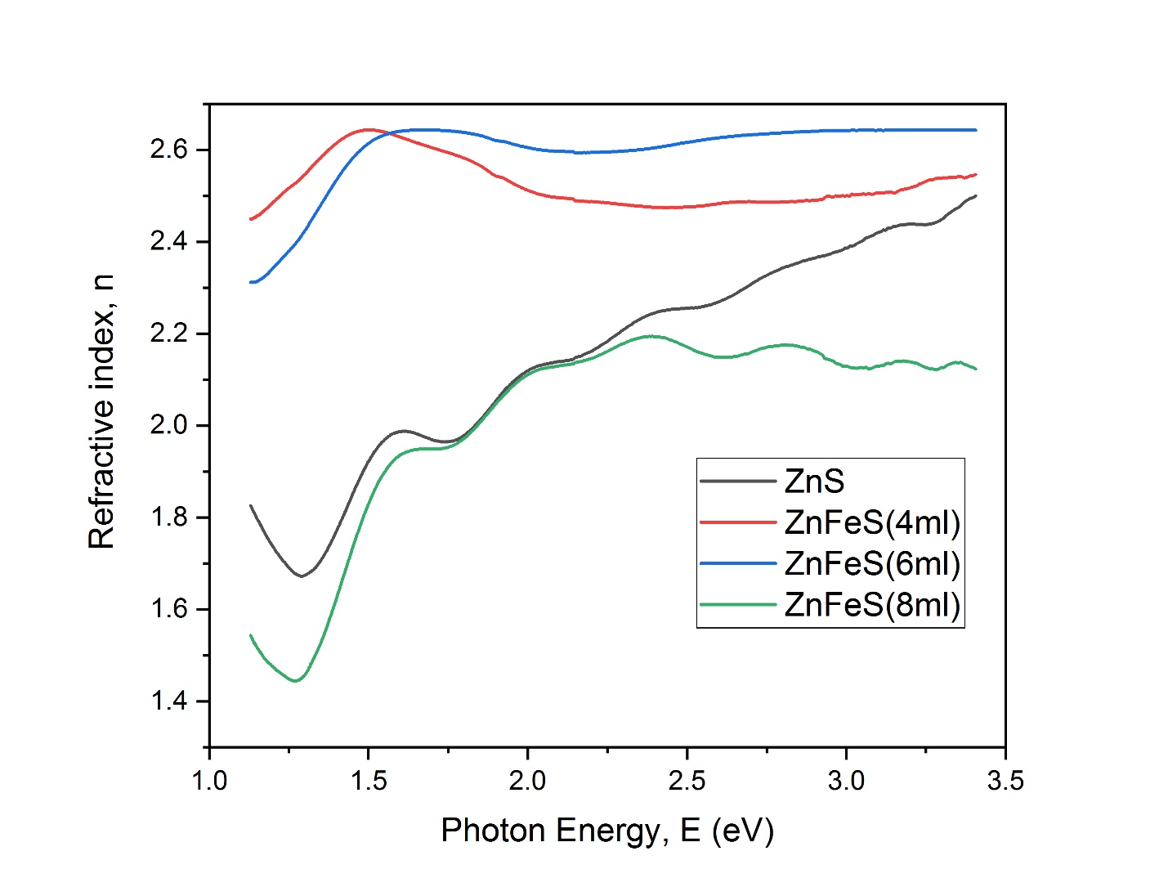
Figure 5: Refractive index of Fe doped ZnS films at different concentration of Fe

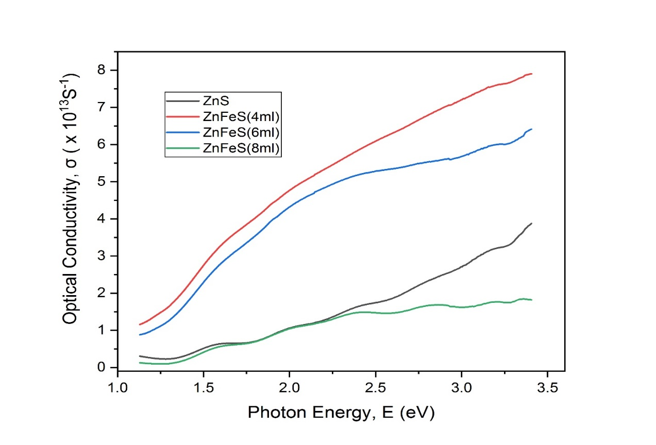
Figure 6: Optical conductivity of Fe doped ZnS films at different concentration of Fe
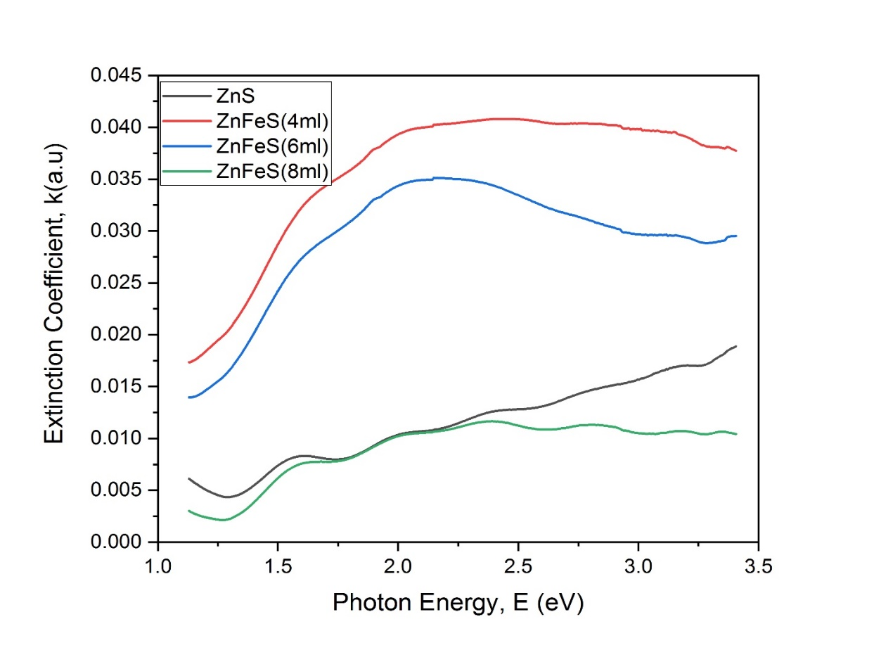
Figure 7: Extinction Coefficient of Fe doped ZnS films at different concentration of Fe

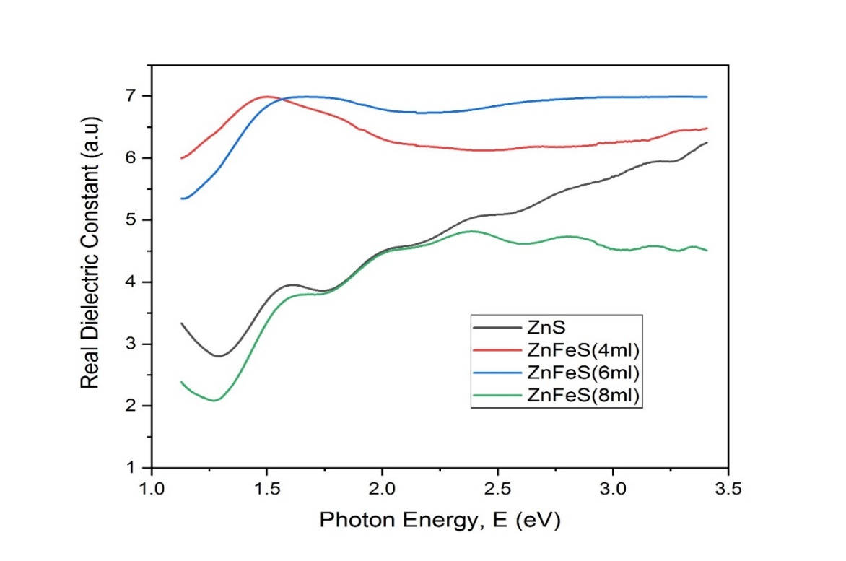
Figure 8: Real dielectric constant of Fe doped ZnS films at different concentration of Fe

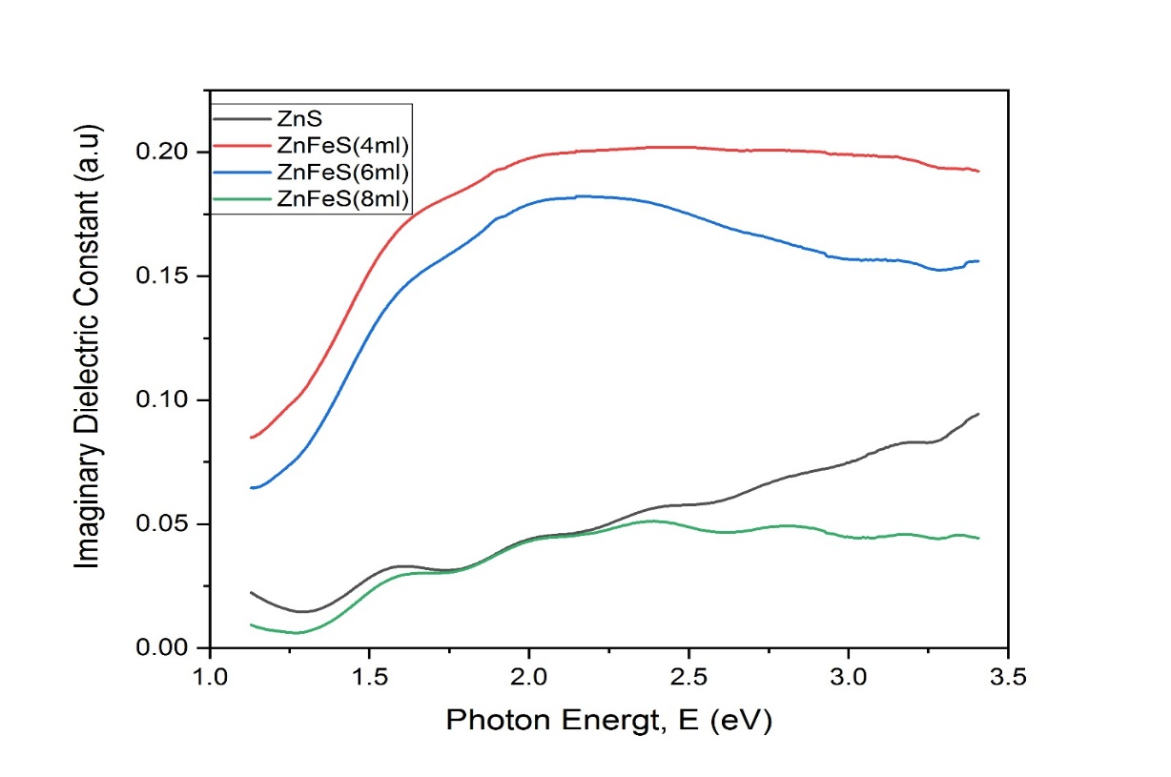
Figure 9: Imaginary Dielectric constant of Fe doped ZnS films at different concentration of Fe

Bandgap
From the UV-Vis result, the optical bandgaps of the films were obtained from the Tauc plot according to the relation;
$αhv={A(hv-E_{g})}^{n}$ (1)
Where α is the absorption coefficient, hv is the photon energy, A is a constant, E_{g} is the bandgap, and n is for modes of transition (1/2 for direct transition and 2 is for indirect transition) [20]
Figure 10(a-d) shows the Tauc plot and variation of bandgap with doping concentrations. The values of bandgaps obtained for Zn_{20-x}Fe_{x}S₂₀ (x=0ml, 4ml, 6ml and 8ml) corresponds to 3.07eV, 2.50eV, 2.80eV and 2.74eV respectively. From the obtained bandgaps it’s worth noting that the bandgaps of Fe doped ZnS is lower than that of the undoped samples. The lowest bandgap was obtained at ZnFeS (4ml). The observed low band gaps (red shift) may be due to sp-d spin exchange interactions. The correction probability of the positive and negative potential to the conduction band and the valence band edge may be enhanced, respectively, under the s-d and p-d exchange interactions, which results in bandgap narrowing [34].

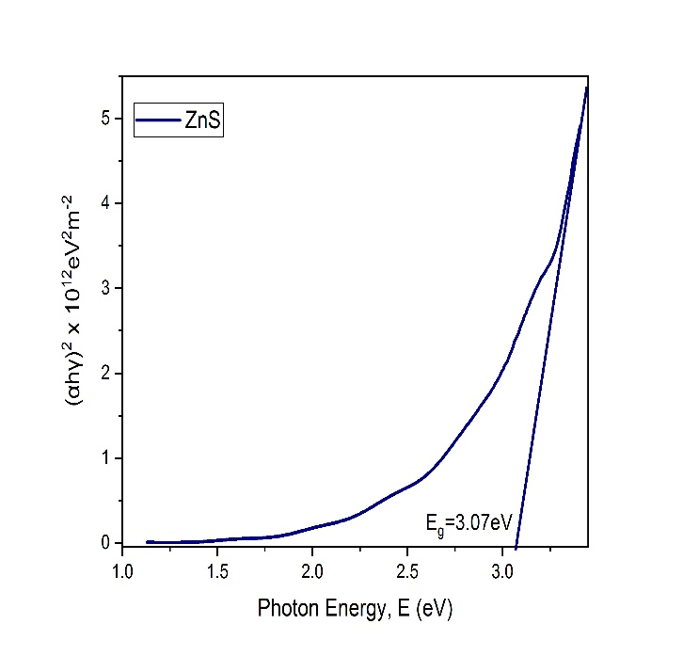  Fig 10a: Tauc plot for ZnS | 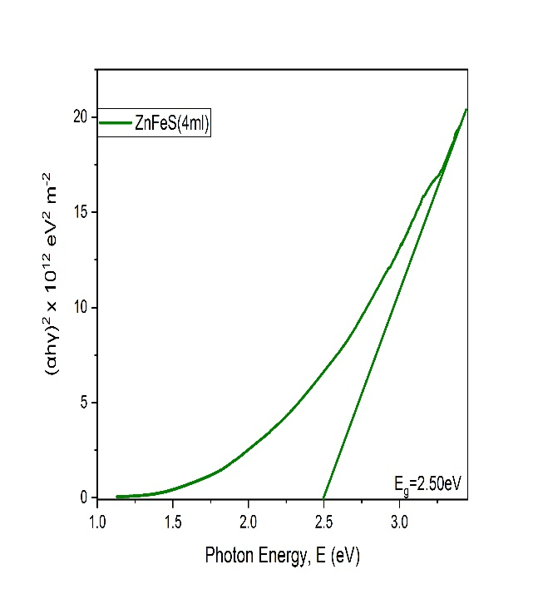  Fig 10b: Tauc plot for ZnSFeS(4ml)
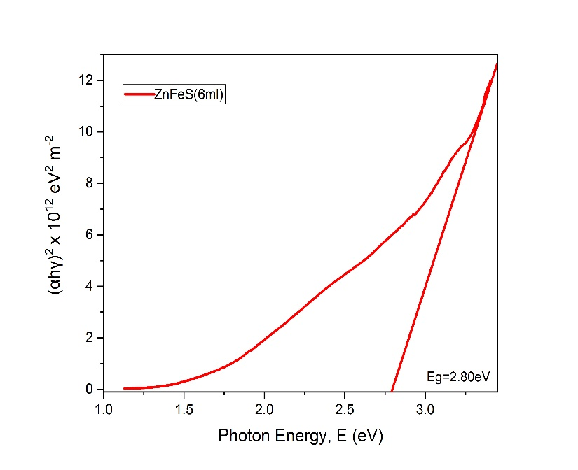  Fig 10c: Tauc plot for ZnSFeS(6ml) | 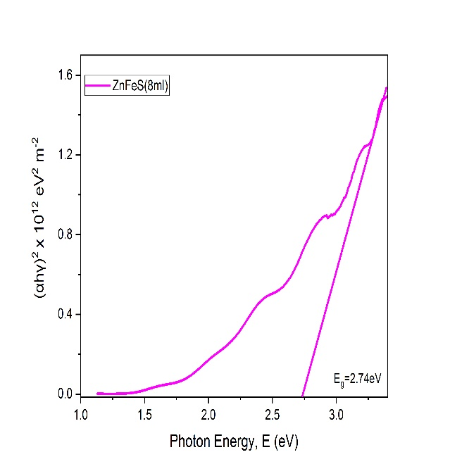  Fig 10d: Tauc plot for ZnSFeS(8ml)

Structural analysis
X-ray diffraction (XRD) technique was carried out on the doped samples in order to study the crystalline and phase properties. From figure 11, it can be clearly observed from the diffraction pattern that the diffraction peaks located at 26.73⁰, 33.93⁰, 37.93⁰, 51.73⁰ and 65.72⁰ for ZnFeS (4ml), also 26.69⁰, 33.91⁰, 37.94⁰, 51.72⁰, 59.92⁰, 65.73⁰ for ZnFeS (8ml) corresponds to (111), (210), (211), (311), (321) and (410) diffraction peaks respectively. The films exhibit a crystalline structure evidenced by their narrow and sharp peaks. All XRD pattern reflects the existence of ZnS following the presence of matching peaks as obtained by JCPDS data however new peaks were observed evidencing the presence of Fe⁺. It is also observed from figure 6 that some peaks are high in intensity due to the fact that there is more periodicity than the other directions. The difference in intensity can also be attributed to different atomic densities of that particular plane with the higher intensity exhibiting higher electron density.
The crystalline sizes of the film can be estimated from the XRD data using the Sherrer formular [35] given as
$D=\frac{kλ}{Bcosθ}$ (2)
λ=1.5406Ằ (wavelength of the incident ray)
D=crystalline size(nm)
K=0.89 (Sherrer constant)
B=full width half maximum (FWHM)
Θ=peak position or diffraction angle
Also, the microstructure such as the interplanar or d-spacing were estimated according to Bragg formula:
$nλ=2dsinθ$ (3)
$d=\frac{nλ}{2sinθ}$ (4)
d is the interplanar spacing, n=1 (order of diffraction) and θ is Bragg’s diffraction angle
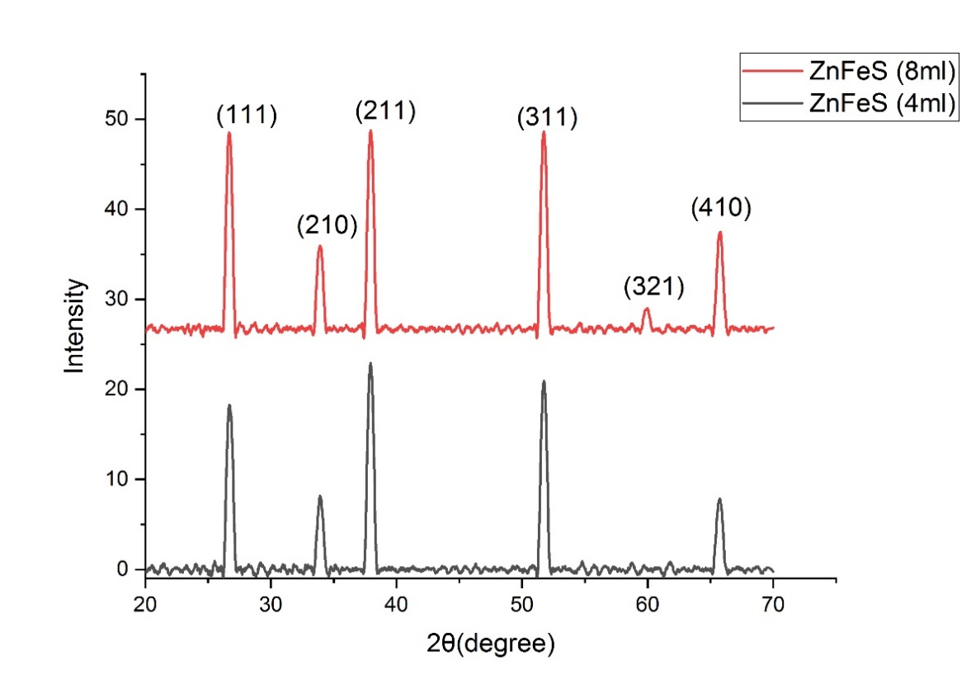
Figure 11: XRD pattern for ZnFeS (4ml) and ZnFeS (8ml)

2θ(⁰) | d-spacing(Ằ) | FWHM(⁰) | Crystalline size(nm) | Average crystalline size
26.73 | 3.332 | 0.521 | 15.498 | 17nm
33.93 | 2.640 | 0.500 | 16.427
37.94 | 2.370 | 0.520 | 15.980
51.73 | 1.766 | O.508 | 17.170
65.72 | 1.420 | 0.528 | 17.702
Table 1a: XRD data for ZnFeS(4ml) films
2θ(⁰) | d-spacing(Ằ) | FWHM(⁰) | Crystalline size(nm) | Average crystalline size
26.69 | 3.337 | 0.509 | 15.875 | 17nm
33.91 | 2.641 | 0.507 | 16.185
37.94 | 2.370 | 0.513 | 16.200
51.72 | 1.766 | 0.513 | 17.023
59.92 | 1.542 | 0.461 | 19.685
65.73 | 1.419 | 0.525 | 17.828
Table 1b: XRD data for ZnFeS(8ml) films
Conclusion
Zn_{20-x}Fe_{x}S (x=0ml, 4ml, 6ml and 8ml) dilute magnetic semiconductor have been successfully prepared using electrodeposition technique. Results from the XRF spectrometer shows the presence of Fe indicating a successful doping. XRD analysis of the films shows the nanocrystalline nature of the films and an average crystalline size of 17nm. From optical analysis, the bandgaps of the doped films were observed to be lower than the undoped film which indicated red shift phenomenon occurring.
Acknowledgment
The success of this work was supported and funded by Tertiary Education Trust Fund-National Research Fund (TETFUND-NRF) 2021, (No 6 Zambezi Crescent off Aguiyi Ironsi, Maitama, Abuja, Nigeria. www,tetfund.gov.ng) of federal Republic of Nigeria (Grant No: TETF/ES/DR&D-CE/NRF2021/SETI/ICT/00034/01/VOL.1)

Disclaimer (Artificial intelligence)
Author(s) hereby declare that NO generative AI technologies such as Large Language Models (ChatGPT, COPILOT, etc.) and text-to-image generators have been used during the writing or editing of this manuscript.

References
- Samaa S. and Erkan Y. (2021). Magnetic nanoparticle-based hybrid materials. Woodhead publishing series in electronic and optical materials, 139-182.
- Chen A. J., Wu X. M., Sha Z. D., Zhuge L. J., and Meng Y. D. (2006). Structure and photoluminescence properties of Fe-doped ZnO thin film. Journal of Physics D: applied Physics, 39(22), 4762.
- Reddy D. A., Murali G., Vijaylakshimi R. P., and Reddy B. K. (2011). Room temperature ferromagnetism in EDTA capped Cr-doped ZnS nanoparticles, Applied Physics A ,105, 119-124
- Pan F., Song C., Liu X. J., Yang Y. C., and Zeng F. (2008). Ferromagnetism and Possible application in spintronics of transition-metal-doped ZnO films. Material Science and Engineering: R: Reports, 62(1), 1-35.
- Torquato R. A., Shirsath S. E., Kiminami R.,H.,G.,A., and Costa A.C.F.M (2018). Synthesis and structural, magnetic characterization of nanocrystalline Zn_{1-x}Co_{x}O diluted magnetic semiconductors (DMS) synthesized by combustion reaction. Ceramics International, 44(4) 4126-4131
- Zhang Y., Liu J., and Gao Y. (2019). Preparation and magnetic properties of Fe doped ZnO thin films with Dilute Magnetic Semiconductors. International Journal of Nanoparticles and Nanotechnology, 5:028
- Elilarassi R., and Chandrasekaran G. (2012). Synthesis and Magnetic Characterization of Ni-Doped ZnO Diluted Magnetic Semiconductor. American Journal of Materials Science, 2(1), 46-50
- Ohno H., Shen A., Matsukura F., Oiwa A., Endo A., Katsumoto S., and Iye Y. (1996). (Ga, Mn)As: A new diluted magnetic semiconductor based on GaAs. Applied Physics Letters, 69()3.
- Merawi T. T. (2022). The Study of Diluted Magnetic Semiconductor: The case of Manganese Doped Gallium Nitride . World Journal of Applied Physics, 7, 1.
- Ando K. (2006). Seeking room temperature ferromagnetic semiconductors(Review). Science, 312(5782) 1883-1885.
- Zhao G., Deng Z., and Jin C. (2019). Advances in new generation diluted magnetic semiconductors with independent spin and charge doping. Journal of Semiconductors, 40, 081505.
- Coey J. M., Venkatesan M., Fitzgerald C. B. (2005) Donor impurity band exchange in dilute ferromagnetic oxides. Nature Materials, 4(2), 173-179.
- Akhtar M., Malik M., Alghamdi Y., Khuram A., Riaz S., and Naseem S. Chemical bath deposition of Fe-doped ZnS thin films: Investigations of their ferromagnetic and half-metallic properties. (2015). Material science in Semiconductor Processing, 39, 283-291.
- Poornaprakash B., Puneetha., Subramanyam K., Kwon M., Lee D., Reddy M., Sangaraju S., Bandar A., and Kim Y. (2023) Synthesis of diluted semiconductor ZnS: Cr and ZnS: (Cr+V) nanoparticles for spintronic applications. Material science in semiconductor processing. 161,107479.
- Ologundudu S. K., Ekpunobi A. J., Ikhioya I. L. (2022) Synthesis and Characterization of ZnS Nanoparticles by Ball Milling Technique. International Journal of Material Science and Engineering, 8(3) 6-13.
- Raza A., Noor h., Raiz S., and Naseem S. (2023) Modifying the optical properties of ZnS for optoelectronic applications. Engineering Proceedings, 32(1), 18.
- Lee G. J., and Wu J. J., (2017). Recent developments in ZnS photocatalysts from synthesis to photocatalytic application-A review. Powder Technology, 318, 8-22.
- Kim H. J., Kim J. H., Durga I. K., Punnoose D., Kundakarla N., Reddy A. E., and Rao S. S. (2016). Densely packed zinc sulpide nanoparticles on TiO₂ for hindering electron recombination in dye-sensitized solar cells. New Journal of Chemistry, 40. 9176-9186.
- Ottih I. E., Ekpunobi A. J, and Ekwo P. I. (2011). Structural and Optical properties of chemical bath deposited Zinc nickel sulphide (ZnNiS) thin films. Moldavian Journal of the Physical Science, 10(2), 194-200
- Jrad A, Naouai M., Ammar S., and Turki-Kamoun N., (2021) Chemical composition, structural, morphological, optical and luminescence properties of chemical bath deposited Fe:ZnS thin films. Optical materials, 123, 111851
- Ahmed Alshahrie (2016). Synthesis and characterization of dilute magnetic semiconductor based on Zn_{1-x}Mn_{x}O thin films prepared by 5-methyl-7-methoxyisoflavone modified sol-gel/spin coating technique, Materials Research Bulletin, 84, 382-387
- Siddheswaran R., Mangalaraja R. V., Eduardo P. T., Menchaca J., Melendrez M. F., Avila R. E., Jeyanthi E., and Gomez M. E. (2013). Fabrication and Characterization of a Diluted magnetic
- Mohammed A. W., Yakout S. M., Sheta M., Ahmed H., and Said M. (2024). Robust Ferromagnetic V0.05-xCoxZno.95(x=0.01, 0.02, 0.03, 0.04, 0.05) nano-compounds: New dilute magnetic semiconductors with tailored optical activity. Journal of Alloys and Compounds, 1003, 175503
- Wu M., Wei Z., Zhao W., Wang X., and Jiang J. (2017). Optical and Magnetic Properties of Ni Doped Diluted Magnetic Semiconductor Synthesizes by Hydrothermal method. Journal of Nanomaterials, 1, 1603450
- Salma M. H., Mukhlis M. I., and Sara F. G. (2021). Characteristics of diluted magnetic semiconductor based on Mn-d0ped TiO₂ nanorods array fims. Journal of Solid State Electrochemistry, 25, 435-443
- Emmanuel O. O., Innosobomeh L. I., and Azubuike J. E., (2024). Investigating the influence of precursor temperature on the bandgap energy, structural, and morphological features of Ti-doped barium sulphide material for photovoltaic application. PHYSICSAccess, 4(1), 64-74
- Tortosa M., Mollar M., and Mari B. (2008). Synthesis and structural studies of diluted magnetic semiconductor by electrodeposition. Physica Status Solidi C, 5(11), 3467-3470
- Nadarajah A. and Konenkamp R. (2010). Dilute magnetic semiconductors from electrodeposited ZnO nanowires. Physica Status Solidi B, 248(2), 334-338
- Emmanuel O. O., Innosobomeh L. I., and Azubuike J. E., (2024). Effect of precursor pH on the electrochemically synthesized barium titanium sulphide (BaTiS) material for photovoltaic application. Materials Research Innovations, DOI:10.1080/14328917.2024.2376377
- Asvarov A., Butashin A. V. Kanevsky V. M., Muslimov A. E., Perv N. S., and Chiolerio A. (2020). Structural, optical and magnetic properties of dilute magnetic semiconductor based on Ga-doped ZnO and Co. Semiconductor Science and Technology, 35, 105003.
- Duan J., Li Z., Begeza V., Ruan S., Yu-Jia Z., Tang W., and Hsu-Sheng T. (2024). Room-temperature ferromagnetic MnGa nanoparticles in dilute magnetic semiconductor (Ga, Mn)As thin film: preparation and characterization. Nanotechnology 36(5).
- Yakuphanoglu F., Barim G., and Erol. (2007) The effect of FeCl₃ on the optical constants and optical band gap of MBZMA-C0-MMA polymer thin films. Physica B, 391, 136-140
- Chiamaka P. O., Azubike J. E., Chiedozie E. O., and Lynda A. O. (2023). Optical properties of monazite nanoparticles prepared via ball milling, Asian Journal of Research and Reviews in Physics, 7(4), 17-29.
- Lee H., Huang Y., Horn M., and Feng S. (2018). Engineered optical and electrical performance of rf-sputtered undoped nickel oxide thin films for inverted perovskite solar cells. Journal of Material Chemistry A, 17(3), 9011-9019
- Bokuniaeva A. O. and Vorokh A. S. (2019). Estimation of particle size using the Debye equation and Sherrer formula for polyphasic TiO₂ powder. Journal of Physics: Conference Series, 1410, 012057.

