THERMAL AND STRUCTURAL ANALYSIS OF A SEMI-ADIABATIC DIESEL ENGINE (SADE) WITH AIR-GAP INSULATED PISTON OF AIRGAP THICKNESSES 2.6MM AND 2.8MM, FUELED WITH PLASTIC OIL BLENDS

.
ABSTRACT

Aims: To determine the amount of heat dissipated across an air-gap insulated piston with airgap thickness of 2.6mm (SADE-1) and 2.8mm(SADE-2) through steady state thermal analysis. The maximum von mises stress along with the maximum deflection of SADE-1 and SADE-2 are determined through static structural analysis.
Study design: To reduce the non-exhaust emissions and the heat dissipated to other parts of a piston in diesel engines fueled with alternative fuels, an air-gap insulation of specific thickness is created between the piston crown and the piston body which acts as a thermal barrier which is expected to reduce the amount of heat dissipated.
Methodology: An air-gap between the piston crown and the body is created by using an insert- which usually is known as a shim. Two shims of thickness 1.0mm and 1.2mm, made of stainless-steel are used to assemble the airgap insulated pistons of thicknesses 2.6mm (SADE-1) and 2.8mm (SADE-2) respectively. The 3-D models and the required air-gap piston assemblies is designed and exported to ANSYS workbench for thermal analysis. The analysis was performed by using the vertical sectional view of the 3-D models, as the effect of the air-gap insulation would be more clearly visible. The impact of the air-gap insulation on the structural integrity of the SADE is evaluated by determining the maximum deflection and the maximum von-mises stresses induced for each blend. The analysis results are then compared for the thickness of the airgap insulation in all blends.
Results: Heat dissipated across the piston and the maximum deflection were the lowest for the PBO30 blend. However, the maximum von-mises stress was marginally higher than the other blends.
Conclusion: PBO30 has the lowest heat dissipated rate among all the blends and hence can be used as a fuel to test the performance and emissions of the engine.

Keywords: Semi-adiabatic diesel engine, Air-gap insulated piston, ANSYS, % heat dissipated,
Steady-state thermal analysis, Static-structural analysis, Plastic oil blends.

1. INTRODUCTION

[1]. C. Dahal et al., The temperature analysis of IC engine piston was carried out. The value for all the heat flux is within the range of 2% error. The thermal stress distribution due to pressure force was carried out - The maximum temperature in piston was found to be in crown of piston with value of 196⁰C and the maximum deformation caused by this temperature was on crown of piston with the magnitude of 0.153 mm. The researchers have not considered the heat transfer due to lubricating oil, heat loss in coolant and heat transferred through piston fins. Further research work could be carried out by verifying the results with the experiments or using different numerical method for temperature estimation. [2]. M Frătia et al., concluded in their research that creating a piston by two different mechanical assembled materials increases the complexity of its design as well the complexity of manufacturing. According to the static structural analysis, it is necessary to consider the design of the piston pin boss reinforcement to reduce the stress concentrators. Also, the bimetal piston weight, for the analyzed piston, is lower by 299 grams, resulting lower inertial forces. Due to lower thermal conductivity coefficient of the steel, it can be used lower tolerance at the piston crown, resulting a much higher efficiency at cool start of the engine. Since the bimetal pistons have only the piston crown made of steel, it can be saved high-quality steel consumption. [3]. K. Vengatesvaran et. al., concluded from their analysis that the weight reduction have been achieved by both design and material optimization. The weight reduction that is been achieved by 26.59 %. From this analysis, we conclude that the best material for piston is silumin as it has low values of deformation. [4]. Pavani Kumari et al., presented that the thermal analysis on air gap insulated piston showed that the temperature is maintained high above the crown with very less amount of heat getting transmitted down than a conventional piston. Further, analysis using ANSYS software shows that by changing the material of piston crown will increases the insulation property of the air gap [6]. The average temperature of the combustion chamber is raised by 35. 97% for Stainless Steel and 32.09% for aluminum piston based on the software result than conventional piston [7,8]. The structural analysis on air gap insulated piston is compared with the conventional piston and the results are satisfactory. Even though the deviation is less, it increases the rigidity of the piston structure. An optimum air gap thickness has been designed for maximum insulation without sacrificing the structural rigidity. [5,9,10]. M. Selvendran et al., concluded from their thermal analysis on air gap insulated piston that the temperature is maintained high above the crown with very less amount of heat getting transmitted down than a conventional piston. Further, analysis using ANSYS software shows that of piston crown will increases the insulation property of the air gap. The average temperature of the combustion chamber is raised by 30 % for aluminum piston based on the software result than conventional piston. The structural analysis on air gap insulated piston is compared with the conventional piston and the results are satisfactory.

2. modelling airgap pistons And properties of plastic oil blends

2.1 3-D modelLING OF THE PISTON ASSEMBLY

3-D models of the Cast-iron piston assembly of bore 80mm and stroke 100mm for the Semi-adiabatic engine with an air-gap insulated piston of thickness 2.6mm designed in SolidWorks are exported to ANSYS workbench as a .STEP file. The dimensions of the parts required to design the piston assembly is shown in the figure1 below:

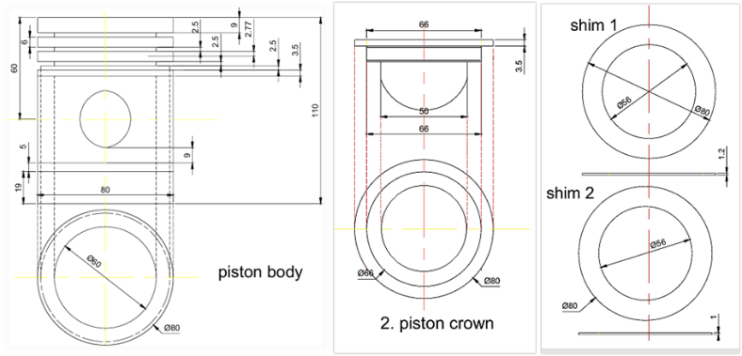

Figure 1. Part-drawings along with dimensions of piston body, crown and shim.
The 3-D models of the piston body, crown and the stainless-steel shims modelled using the dimensions (figure 1) are presented in the below figure 2 below

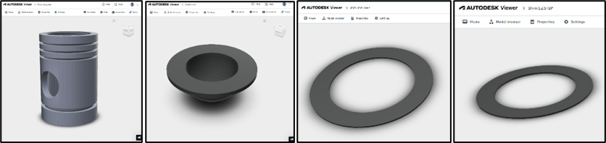

Figure 2. 3-D models of the stainless-steel shim, piston body and the piston crown

As the air-gap between the piston crown and the body is visible more clearly in a sectional view, sectional front view and sectional isometric view of the piston assembly of SADE-1 and SADE-2 are shown in figure 3 below:

Sectional Front View of SADE-1 Sectional Isometric View of SADE-1
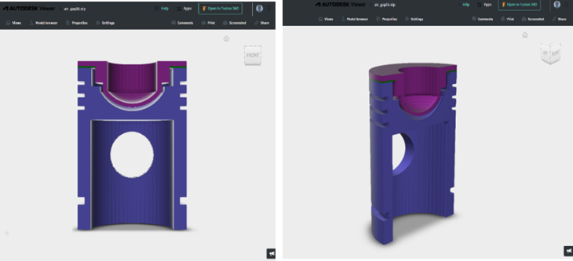

Sectional Front view of SADE-2 Sectional Isometric view of SADE-2
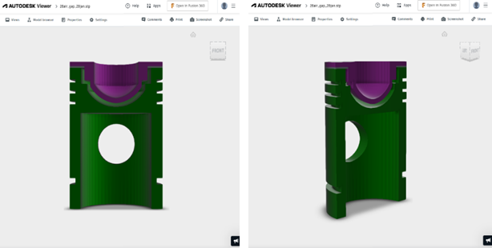

Figure 3. Sectional views of SADE-1 and SADE-2.
2.2. Composition and properties of Plastic oil blends

An initial blend of plastic oil was preparing by mixing equal volumes of plastic oil and diesel for a quantity of one litre, i.e., 50% Diesel and 50% Plastic oil and is named as PBO50. Further, Di-ethyl ether was added to the initial blend PBO50 at 10% and 20% - the blends prepared are named PBO40 and PBO30 respectively. The properties of plastic oil blends prepared are tabulated in table 1 shown below

Table 1. Properties of Diesel and Plastic oil blends.

Fuel | Density (in Kg, m-3) | Kinematic Viscosity (in Centistokes) | Absolute Viscosity (in Stokes) | Calorific value (in MJ, Kg-1)
Diesel | 834 | 3.38 | 2818.9 | 45.60
Plastic oil | 823 | 3.01 | 2469 | 43.37
PBO50 | 818 | 3.16 | 2584.8 | 41.11
PBO40 | 816 | 2.96 | 2415.3 | 46.38
PBO30 | 806 | 2.91 | 2345.4 | 46.51

It can be inferred from above data that plastic oil blends are a suitable alternative to diesel.

3. STEADY-STATE THERMAL AND STATIC-STRUCTURAL ANALYSIS

Steady-state thermal analysis and static-structural analysis are performed on SADE-1 and SADE-2 fueled with plastic oil blends, and the results are then compared for each blend. The table 2 and table 3 below show the input parameters for analysis of SADE-1 and SADE-2.

Table 2. Input parameters for Thermal and Structural Analysis of SADE-1

Parameter | Unit | PBO50 | PBO40 | PBO30
Temperature above piston crown | ⁰K | 1062.43 | 1080.87 | 1176
Approx. piston body temperature | ⁰K | 1010.70 | 992.01 | 989.63
Approx. temperature of piston wall | ⁰K | 694.35 | 681.60 | 662.91
Mean effective pressure (at full load) | MPa | 2.66 | 2.4 | 2.27

Table 3. Input parameters for Thermal and Structural Analysis of SADE-2

Parameter | Unit | PBO50 | PBO40 | PBO30
Temperature above piston crown | ⁰K | 1066.22 | 1082.1 | 1181
Approx. piston body temperature | ⁰K | 993.51 | 981 | 966
Approx. temperature of piston wall | ⁰K | 709.44 | 670.39 | 649.14
Mean effective pressure (at full load) | MPa | 2.38 | 2.63 | 2.59

3.1 Steady-state thermal analysis of SADE-1 and SADE-2 with plastic oil blends.

Steady-state thermal analysis was carried out to analyze the variation of temperature in SADE-1 and SADE-2. The analysis results are presented in figure 4 below
SADE-1 with PBO50 SADE-1 with PBO40 SADE-1 with PBO30
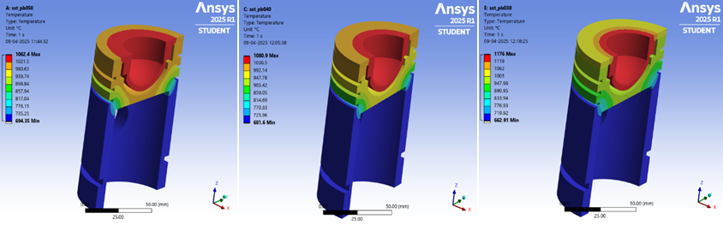
SADE-2 with PBO50 SADE-2 with PBO40 SADE-2 with PBO30
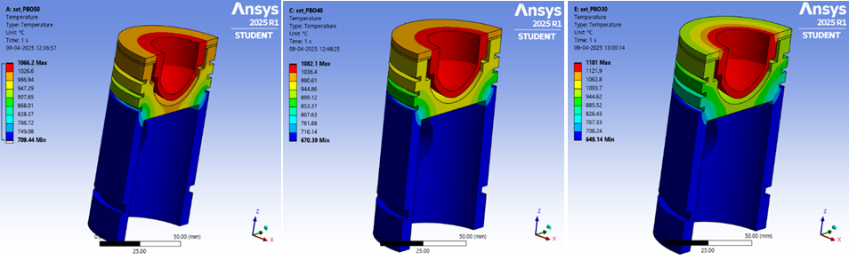
Figure 4. Steady-State thermal analysis of SADE-1 and SADE-2 with plastic oil blends.

3.2. Max. Von-mises stresses in SADE-1 and SADE-2 with plastic oil blends.
The Maximum Von-mises stresses (in KN/mm²) induced in SADE-1 and SADE-2 fueled with plastic oil blends are presented in the figure 5 below.

SADE-1 with PBO50 SADE-1 with PBO40 SADE-1 with PBO30
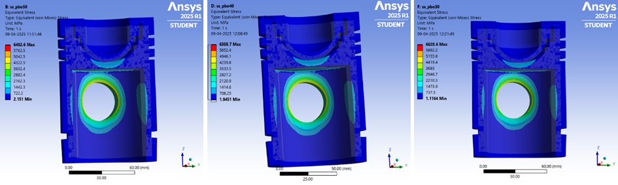
SADE-2 with PBO50 SADE-2 with PBO40 SADE-2 with PBO30
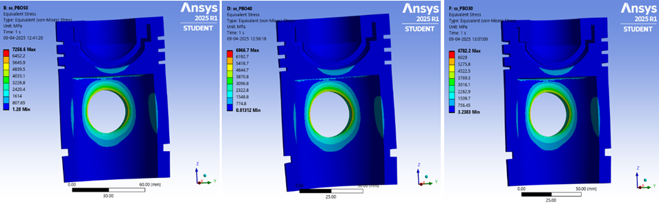
Figure 5. Maximum Von-Mises stresses in SADE-1 and SADE-2 with plastic oil blends.
3.3. Maximum deflection of SADE with plastic oil blends.

Total deformation determined through maximum deflection (in mm) in SADE-1 and SADE-2 with plastic oil blends are presented in the figure 6 below

SADE-1 with PBO50 SADE-1 with PBO40 SADE-1 with PBO30
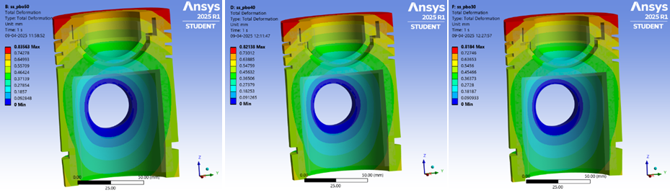
SADE-2 with PBO50 SADE-2 with PBO40 SADE-2 with PBO30
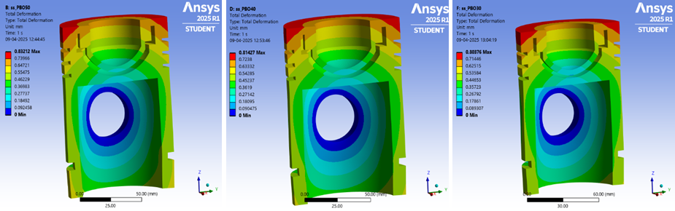
Figure 6. Maximum deflection in SADE-1 and SADE-2 with plastic oil blends.

4.results and discussionS

The results of the steady-state thermal analysis and the static structural analysis performed on SADE-1 and SADE-2 with plastic oil blends are presented in the table 4 below. A bar chart with these values is plotted to compare the results and are discussed in detail below.

Table 4. Comparison Steady-state thermal analysis results of SADE-1 and SADE-2

ENGINE VERSION | HEAT DISSIPATED (in %) ACROSS THE PISTON
ENGINE VERSION | PBO50 | PBO40 | PBO30
SADE-1 | 85.95 | 77.74 | 63.68
SADE-2 | 79.62 | 75.44 | 59.58

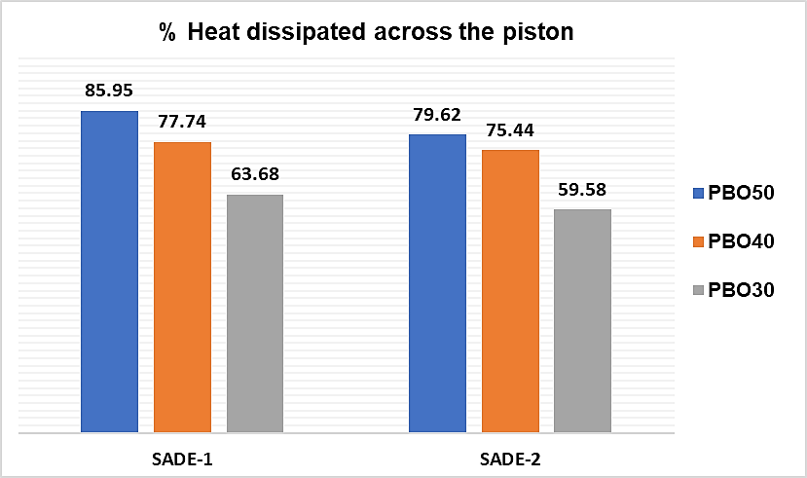

Figure 7. Analysis results comparison of SADE-1 and SADE-2 with plastic oil blends.

From the figure 7 and table 4, it can be inferred that the heat dissipated through the air-gap insulated piston decreased tremendously in SADE-2. Among all the blends, the % heat dissipated across the piston was the lowest in SADE-2 with PBO30 at 59.58% which is 6.7% lower than that of SADE-1 with PBO30, due to increasing the air-gap thickness from 2.6mm to 2.8mm. Further, in both PBO50 and PBO40 blends, the amount of heat dissipated was also lowest in SADE-2 at 79.62% and 75.44% which are 7.9% and 3% lower than that of SADE-1 with PBO50 and PBO40 respectively. Based on the results of the thermal analysis presented in the figure 4 in the earlier paragraphs and the table 3 above, it can be forecasted that the combustibility of the PBO30 was most favorable among all blends. Similarly, the amount of heat dissipated across the piston was the highest in PBO50 among all the blends, which is due to the higher hydrocarbons present in the blend. Further, while the addition of DEE to the blend (in PBO40) slightly improved the combustibility of the fuel, increasing the percentage of DEE added to the blend (in PBO30) drastically improved the combustibility which is manifested in terms of the minimum temperature in the piston assembly of SADE-1 and SADE-2 with PBO30 at 662.91K and 640.14K as obtained from the temperature distribution obtained from the thermal analysis depicted in the figure 3 in the previous paragraphs.

Table 5. Comparison Max. Von-mises stresses (in KN/mm²) of SADE-1 and SADE-2

ENGINE VERSION | MAXIMUM VON-MISES STRESS (in KN/mm²)
ENGINE VERSION | PBO50 | PBO40 | PBO30
SADE-1 | 6.482 | 6.358 | 6.628
SADE-2 | 7.258 | 6.966 | 6.782

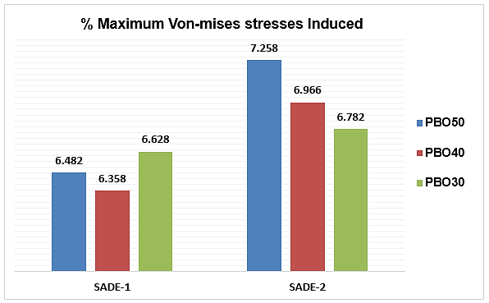

Figure 8. Max. Von-mises stress comparison of SADE-1, SADE-2 with plastic oil blends.

From the table 5 and the figure 8 above, it can be observed that the Max. Von-mises stress induced were the lowest in SADE-1, indicating that increasing the airgap thickness from 2.6mm to 2.8mm had a marginally negating effect in PBO30 blend but a considerably contrasting effect in PBO50 and PBO40 blends. In both PBO50 and PBO40, the stresses induced were the highest in SADE-2 at 7.258 and 6.966 KN/mm² respectively which were 10.9% and 8.7% higher than those of SADE-1 with PBO50 and SADE-1 with PBO40 respectively. While this is not a desired outcome, considering that the heat dissipation is favorable in SADE-2 in all blends, and that the increase in the max. von-mises stresses is marginal, SADE-2 with PBO30 can still be considered as the most viable alternative to CE with diesel. To further ensure this assumption to be true, the total deformation in the piston assembly determined through the maximum deflection obtained from the structural analysis results will be pivotal in determining if an airgap of 2.8mm can be considered to evaluate and compare the performance and exhaust emissions of the SADE-2 fueled with the plastic oil blends with that of SADE-1 with plastic oil blends and CE with diesel.

Table 6. Comparison Max. Von-mises stresses (in KN/mm²) of SADE-1 and SADE-2

ENGINE VERSION | MAXIMUM DEFLECTION (in MM)
ENGINE VERSION | PBO50 | PBO40 | PBO30
SADE-1 | 0.835 | 0.821 | 0.818
SADE-2 | 0.832 | 0.814 | 0.803
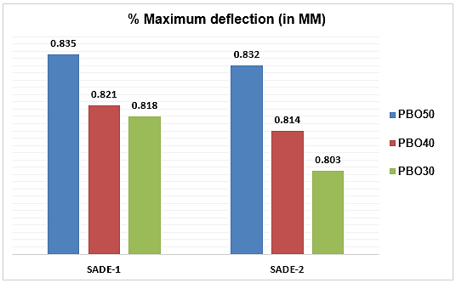

Figure 9. Total deformation (Max. deflection) of SADE-1, SADE-2 with plastic oil blends.

The total deformation evaluated through the maximum deflection (in MM) occurred throughout the piston with 2.6mm airgap in SADE-1 and 2.8mm airgap in SADE-2 is an indication of any change in the structural integrity. This is manifested by comparing the values of maximum deflection occurred in SADE-1 and SADE-2 when fueled with the plastic oil blends. The Maximum deflection is the lowest in SADE-2 with PBO30 at 0.803mm which is 1.8% lower than the Maximum deflection in SADE-1 with PBO30, which is rather a negligibly small value. However, the PBO50 blend had a deflection of 0.835mm in SADE-1 which was highest among both all versions and was particularly higher than the deflection of SADE-2 with PBO30 at 0.803mm, which is considerably higher which consequently translates into a harsher and noisy operation of the engine. This renders the PBO50 completely unfavorable for use as a fuel in the CI engine, either in a conventional engine without any air-gap, or SADE-1 and SADE-2. This establishes that providing an airgap insulation provides a wide range of opportunities in using various alternative fuels without compromising on the performance.

While it can be forecasted that SADE-2 with PBO30 can be a promising alternative to CE with diesel based on the results of the thermal and structural analysis, the data obtained from the experimental work performed so as to evaluate the performance and the exhaust emissions of SADE-1, SADE-2 with plastic oil blends can be validated with the simulation results and corelated with the results with those of CE with diesel at standard operating conditions.

5. ConclusionS

- The heat dissipated was the highest in SADE-1 with PBO50 at 85.95% which is 7.3% higher than that of SADE-2 with PBO50. Also, the % heat dissipated was the lowest in SADE-2 with PBO30 at 59.58%, which is 6.88% lower than that of SADE-1 with PBO30.

- Both Max. Von-mises stress were the lowest in SADE-2 with PBO30 at 6.78 KN/mm² which were 7% and 3.4% lower than those of SADE-2 with PBO50 and PBO40 respectively, and Max. deflection was the lowest in SADE-2 with PBO30 at 0.803mm which was 2.7% lower and 1.3% lesser than the max. deflection of SADE-2 with PBO50 and PBO40 respectively.

- Providing an airgap thickness drastically reduced the amount of heat dissipated across the piston assembly, without compromising the structural integrity of the engine.

COMPETING INTERESTS DISCLAIMER

Authors have declared that they have no known competing financial interests OR non-financial interests OR personal relationships that could have appeared to influence the work reported in this paper.

Disclaimer (Artificial intelligence)

Author(s) hereby declare that NO generative AI technologies such as Large Language Models (ChatGPT, COPILOT, etc.) and text-to-image generators have been used during the writing or editing of this manuscript.

References

- Chiranjivi Dahal, Shacheendra Kishor Labh, Dipendra Sah. (2023). Design and Thermal Analysis of Diesel Engine Piston. Nepal Engineers Association Gandaki Province Technical Journal, Vol-03, pp:01-13.

- M Frătița, F Popescu, K Uzuneanu, I V Ion and C M Angheluță. (2019). About Structural and Thermal Analysis of Diesel Engine Piston Using Ansys Software. IOP Conf. Series: Materials Science and Engineering 595. doi:10.1088/1757-899X/595/1/012041

- K. Vengatesvaran, N. Prithiviraj, and N. Periyasamy. (2018). Thermal analysis and material optimization of piston in IC engine. International journal of advance research and innovative ideas in education (IJARIIE), Vol-04, issue-03, pp: 153-170

- Pavani Kumari, Dr. Suneel Donthamsetty. (2015). Structural and thermal analysis of conventional and air gap Insulated piston for low heat-rejection engines. International journal of scientific engineering and technology research. Vol-05, Issue-05, pp: 0934-0938.

- M. Selvendran, P. Naveenchandran and C. Thamotharan. (2015). Structural and thermal analysis of a novel air gap insulated piston. International Conference on energy efficient technologies for automobiles, ISSN: 0974-2115.

- Prasad, R., & Samria, N. K. (1990). Heat transfer and stress fields in the inlet and exhaust valves of a semi-adiabatic diesel engine. Computers & structures, 34(5), 765-777.

- Beg, R. A., Rahman, M. S., Bose, P. K., & Ghosh, B. B. (2002). Performance studies on a semi-adiabatic diesel engine using vegetable oil as fuel (No. 2002-01-2692). SAE Technical Paper.

- Thummaluru, Y., & Athiimoulam, K. (2023). Comparative experimental study on performance and emission characteristics of ethanol–diesel blends fuelled semi-adiabatic diesel engine. International Journal of Ambient Energy, 44(1), 1864-1872.

- Jerome, S. M., & Sundararaj, S. (2017). Experimental Study on the Effect of Thermal Barrier Coating on Cylinder Head of a Semi-Adiabatic Diesel Engine (No. 2017-28-1978). SAE Technical Paper.

- Colaço, M. J., Teixeira, C. V., & Dutra, L. M. (2010). Thermal analysis of a diesel engine operating with diesel–biodiesel blends. Fuel, 89(12), 3742-3752.

Definitions, Acronyms, Abbreviations

Abbreviations:

- SADE – 1 : Engine with an air-gap insulated piston of 2.6mm airgap thickness
- SADE – 2 : Engine with an air-gap insulated piston of 2.8mm airgap thickness
- DEE : Di-ethyl Ether
- PBO50 : 50% Volume of diesel mixed with 50% of Plastic oil
- PBO40 : 50% diesel, 40% plastic oil and 10% di-ethyl ether
- PBO30 : 50% diesel, 30% plastic oil and 20% di-ethyl ether

