Pragmatic Approach to the removal of Cu(II)ions from Aqueous Solution using Silica: A kinetic, Isothermal and Thermodynamic study

Abstract: The main objective of this study was to investigate the removal of copper(II) ions [Cu (ii)] from aqueous solution by adsorption unto pure silica. The silica was characterized by using Fourier Transform Infra-Red (FT-IR) spectral analysis before and after adsorption of the metal ions. The optimum condition for the adsorption of Cu(II)ions was studied in a batch system by considering the extent of adsorption with respect to pH, contact time, initial copper(II) ion concentration and temperature. Maximum adsorption was recorded at a pH of 7.0 and equilibrium sorption was achieved within 50 minutes of the process. It was observed that the optimum amount of Cu(II)ions absorbed by pure silica was 91.3 mg/g representing 98.86 % at the optimum pH of 7.0. Three kinetic models: Elovich, Pseudo first-order and Pseudo second-order were applied in the analyses. Desorption studies showed that only 24.0 % of the metal ion was desorbed with appropriate eluting agents. The experimental results showed that pure silica is a good adsorbent for the removal of Cu(II)ions from aqueous solutions and may possibly be useful for treating industrial waste waters.
Key words: adsorption, Cu(II)ions, kinetic models, desorption, batch system.
INTRODUCTION
Many developing nations, Nigeria inclusive, have been faced with the challenge of heavy metal ion pollution because of increasing level of industrialization and urbanization (Briffa, Sinagra, and Blundell, 2020). “Unrestricted mining, industrial and commercial activities in most cities coupled with industrial wastes which are not properly treated before discharge pollute our environment with heavy metals, which eventually reach man through the food chain” (Onojake, Iwuoha and Osakwe, 2015).
“Many industrial processes such as mining, petroleum exploration and spillage, disposal of untreated and partially treated industrial effluents, indiscriminate use of metal containing fertilizers and pesticides in agricultural fields produce aqueous effluents containing metal contaminants such as aluminum, chromium, copper, cobalt, cadmium, manganese, iron, zinc, nickel, mercury and lead” (Rashid et al., 2023). “Traditional technologies available for the removal of heavy metals from aqueous solutions include oxidation and reduction, chemical precipitation, ion exchange, membrane separation, reverse osmosis, electrolysis, Phyto-extraction and use of adsorbents” (Castro et al.,2024).
However, the advantages and disadvantages of each of these methods have been extensively reviewed (Adebayo, Adegoke and Sidiq, 2016). Among these methods, adsorption has been found to be one of the most efficient processes for the removal of heavy metal ions from aqueous solution. Zhang et al., (2020) developed quartenized salicylaldehyde Schiff base modified SBA-15 mesoporous silica for detection, absorption and recovering of Cu²⁺ ions from water. Saddik et al., (2022) provided an adsorbent for the removal of Cu²⁺ ions from aqueous solutions, in the form of silica-based adsorbent functionalized by 2-phenylimidazo [1,3-a] pyridine-3-carbaldehyde, which showed high adsorbability of up to 100 mg/g at pH of 6 and at 25ºC. Bilgiç et al., (2022) also produced silica versus pillar [5] arene adsorbent for the removal of Cu²⁺ ions from aqueous solution, which presented maximum adsorption capacity of 79.3651 mg/g at 328 K. Qin et al., (2024) developed an adsorbent, by grafting glycidyl methacrylate onto polypropylene and animating it with N-methyl-D-glucamine, for the selective adsorption of boron amidst sodium, calcium and magnesium ions, which showed maximum adsorption capacity for boron of 18.03$±1$at pH 6.4. Yu et al., (2023) produced an adsorbent for boron by grafting glycidyl methacrylate onto PP melt-down fibre and reacting with N-methyl-D-glucosamine. The adsorbent (PP-g-GMA-NMDG gave adsorbent capacity of 41.65 mg/g for boron at pH 6. The work of Kanungo et al., (2023) is a review that discussed the methods to produce nanostructured materials to be used for drug delivery.
Zhang et al., (2020) prepared two adsorbents namely SBA-15 functionalized with N-propyl-2-pyridylamine and ethylenediaminepropyl-2-pirydylamine and used them for the adsorption of copper(II) and lead(II) ions from aqueous solutions at pH of 5.0 and obtained maximum adsorption values of 35.87 and 48.26 mg/g for copper(II) ions and 82.05 and 106.62 mg/g for Pb(ii) respectively. Humelnicu et al., (2022) determined the maximum adsorption capacities of silica SBA-15 and titanosilicate ETS-10 adsorbents for copper²⁺ ion removal from aqueous media at pH 5. ETS-10 adsorbent gave a higher adsorption value for cu²⁺ ions than SBA-15 as 172.53 mg/g and 52.71 mg/g respectively. Awual (2017) assessed the potential of silica conjugate nanomaterial for the removal of Cu²⁺ ions from environmental samples and obtained a maximum adsorption capacity of 183.81 mg/g. Ahmadpoor et al., (2019) synthesized a novel bead consisting of Fe₅C₂@SiO₂ nanoparticles and used it to remove copper(II) ions from aqueous solution at pH range of 3-4 at adsorbent concentration of 0.41 g/L and achieved adsorption of 97.4 %. Kukwa et al., (2020) extracted silica from rice husk, modified it with 1M trioxonitrate (V) acid, and applied it for the removal of copper(II), Zn(II), Mn(II) and Pb(II) ions from aqueous solution, within the temperature range of 28ºC to 43ºC and a pH of 8 and beyond. Their findings show an increase in the percentage removal of ions with an increase in adsorbent concentration up to 99.48 % with Cu(II)giving the best percentage in the order of removal. Abuhatab et al., (2020) assessed the removal of Zn²⁺, Cu²⁺, and Cr²⁺ ions from aqueous solution using NiO-MgO silica-based nanoparticles within the time interval of 60 minutes and a pH range of 7-11, achieving a maximum adsorption capacity of 37.69, 69.68 and 209.51 for zinc, copper and chromium ions respectively., and an increase in adsorption capacity was observed with increase in pH within the range studied.
Zafar et al., (2020) evaluated the removal of copper(II) ions with chemically treated rice hubs as adsorbate. The chemical treatment was carried out with sodium hydroxide, which enhanced the surface adsorption and increased the surface efficiency up to 97 % within 30 minutes. Mahatmanti et al., (2021) produced a good adsorbent for copper(II), Zinc(II) and Cd(II) ion removal, by treating chitosan with silica and adding polyethylene glycol plasticizer, to enhance the physical, mechanical strength and ease of diffusion of metal ions through the membrane surface. The results showed maximum adsorption for Cu(II)and Zn(II) ions at pH of 6. Wu et al., (2021) synthesized Schiff base functiionalized with polyamidoamine dendrimer, and utilized it to adsorb copper(II) and Ag (I) ions from aqueous solution and obtained maximum adsorption at pH of 6 for both ions at 180 and 150 minutes for Cu(II)and Ag (i) ions respectively. Humelnicu et al., (2022) investigated the removal of Cu(II)ions from water with silica SBA-15 and titanosilicate ETS-10 adsorbents and recorded maximum adsorption of 52.71 mg/g at pH 5 for SBA-15, and 172.53 mg/gnat pH 6 for ETS-10.
Also, Qin et al., (2018) assessed the removal of Ni(II), Cu(II), Zn(II) and Co(II) ions from simulated aqueous solution with calcium silicate powder (CSP), and obtained maximum adsorption capacity of 420.17, 680.93, 251.89 and 235.29 mg/g respectively at concentration of 100 mg/lL for CSP. Ahmadi et al., (2023) evaluated the efficacy of sorbents administered to rats in the reduction of heavy metal concentrations in rats. The use of Philipsite sorbent reduced the zinc and copper content in the blood of rat 1.6 times. This helps to achieve good health for human beings who will consume safe products. Simón et al., (2022) assessed mixture of agro waste products such as pine sawdust, sunflower and corn residues as adsorbents for nickel (II), Zinc(II) and Cadmium(II) ions from aqueous solution. These served as better alternatives to the synthetic adsorbents and gave maximum adsorption capacity of above 50%. Elgarahy et al., (2021) reviewed biosorbents as better alternatives than the conventional adsorbents for the removal of heavy metals from wastewater.
MATERIALS AND METHODS
Chemicals and Solutions
Pure chromatographic grade silica (mesh size 60-200 µm), 3-aminopropyl trimethoxy silane, Salicylaldehyde & Dichloroethane (Sigma-Aldrich Company, Darmstadt, Germany); cadmium (II) sulphate & chromium(III) nitrate purchased from BDH Limited, Poole, England; Ethanol (≥ 99.5 %, Sigma-Aldrich, Darmstadt, Germany), Methanol (≥ 99.9 %, Fisher Scientific, Massachusetts, USA); Acetic acid (Glacial, ≥ 99.7 %, Merck KGaA, Darmstadt, Germany); and distilled deionized water obtained using a Milli-Q® Water Purification System were used. The chemicals are of analytical grade.
Standard solution of 1000 mg/L of copper was prepared as stock solution from the salt, CuSO_{4.}5H₂O (249.72 g/mol). This was done by dissolving 3.93 g of copper salt in 1000 cm³ of distilled deionized water. From the stock solution, working solutions of varying initial concentrations of copper ions were prepared by serial dilution using distilled deionized water.
Instrumentation
The concentrations of the metal ions were analysed with a Buck Scientific Atomic Absorption spectrophotometer model 210/211 VGP Buck Scientific, USA). The wavelengths used for the cadmium ions was 228.9 nm and while that of chromium was 357.9 nm. Fourier Transform Infra-Red (FT-IR) spectra were recorded on Shimadzu FTIR-84005 machine (Norwalk, CT, USA) using KBr pellets. The pH measurements were made using Corning Scholar 425 digital pH meter (NY USA). Batch adsorption processes were conducted using thermostatic water bath shaker, SHZ-82 (China) at 150 rpm.
Batch Adsorption Experiments
The adsorption study was carried out by adding 0.2g of the silica to 25 cm³ of the different concentrations of the metal ions in a 100 cm³ beakers. The flasks were agitated on a stirrer at a constant speed of 150 rpm. At the end of the experiment, the residual copper(II) ions concentration was analysed using AAS. The amount of metal of copper ions adsorbed by the silica (mg/g) was calculated according to equation 1.
q_{e} = (C_{o} – C_{e})v/m 1
where q_{e} (mg/g) is the amount adsorbed, C_{o} (mg/L) is the initial copper(II) ion concentration in solution, C_{e} (mg/L) is the residual/equilibrium concentration of copper ions in solution, v is the volume of copper ion solution in litre, while m is the mass of the silica used. The optimum contact time was determined to be 50 minutes and used in all the adsorption experiments. Uptake experiments of copper ions at different pH values (ranging from 2 to 8) were performed to determine the optimum pH for adsorption. The pH adjustments were made using 0.1 M HCl or 0.1 M NaOH as appropriate. For kinetic studies, samples were withdrawn at predetermined time intervals (5, 10, 20, 30, 40, 50, and 60 minutes), filtered, and analyzed for residual Cu(II)ion concentrations. The Elovich, pseudo-first order, and pseudo-second order kinetic models were applied to the experimental data. The isothermal studies were carried out by varying the initial concentrations of copper(II) ions from 10 to 100 mg/L while maintaining constant adsorbent dosage, pH, and temperature. The equilibrium adsorption data were analyzed using the Freundlich and Langmuir isotherm models. Thermodynamic parameters such as Gibbs free energy change (ΔG°), enthalpy change (ΔH°), and entropy change (ΔS°) were determined to gain insight into the nature of the adsorption process.
A desorption experiment was carried out with copper(II) ions to ascertain if the adsorption unto silica was by physisorption or chemisorption. This was conducted with 0.1 M solutions of HCl, H₂SO₄, NaCl, Na₂CO₃ and NaOH as eluting agents. The initial copper ion concentration was 50 mg/L, and desorption percentages were calculated based on the concentration of metal ions recovered after treatment. The percentage desorption was calculated using the relationship:
% Desorption = Ce/Ci x 100
Where Ce = Equilibrium Concentration, Ci = Initial Concentration.

RESULTS AND DISCUSSIONS
Result
Characterization of Silica
FT-IR analyses confirmed the presence of characteristic peaks corresponding to Si-O-Si stretching and bending vibrations. The FT-IR spectra showed absorption bands at 3406-3226(b), 1089(vsp), 809(m) and 461(s) cm-1 corresponding to the stretching vibrations of silanol OH, asymmetric stretching vibration of Si-O, symmetric stretching vibration of Si-O-Si, and asymmetric Si-O-Si bonding respectively (figure 1). After adsorption of Cu(II)ions, slight shifts and intensity changes in the FT-IR spectra indicated successful binding of copper ions onto the silica surface (figure 2). The peak frequencies decreased: 1439 to 1395 cm⁻¹; 1187 to 1087 cm⁻¹ and 461 to 449 cm⁻¹.
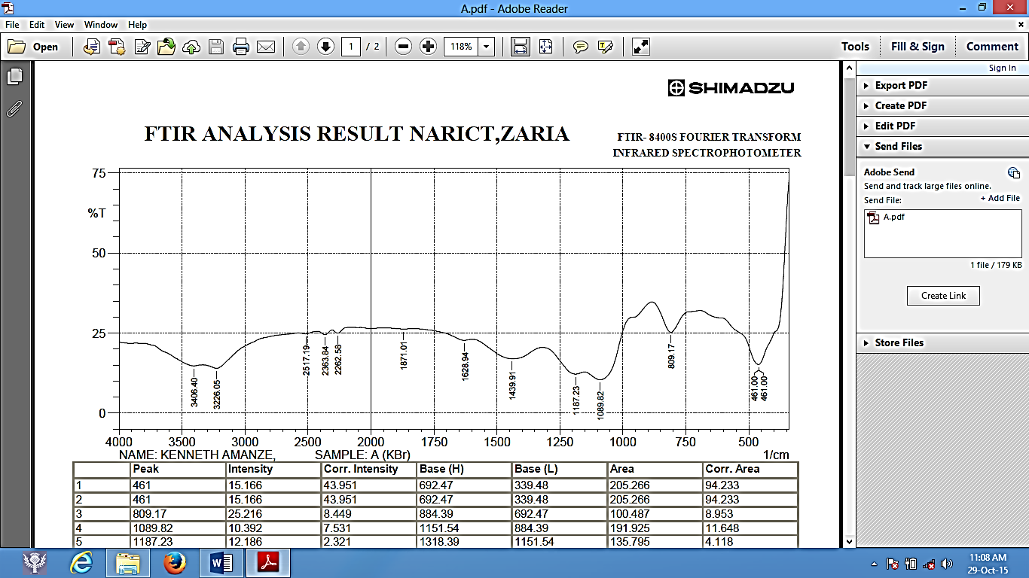1/cm
Figure 1 FTIR Analysis of Pure Silica.

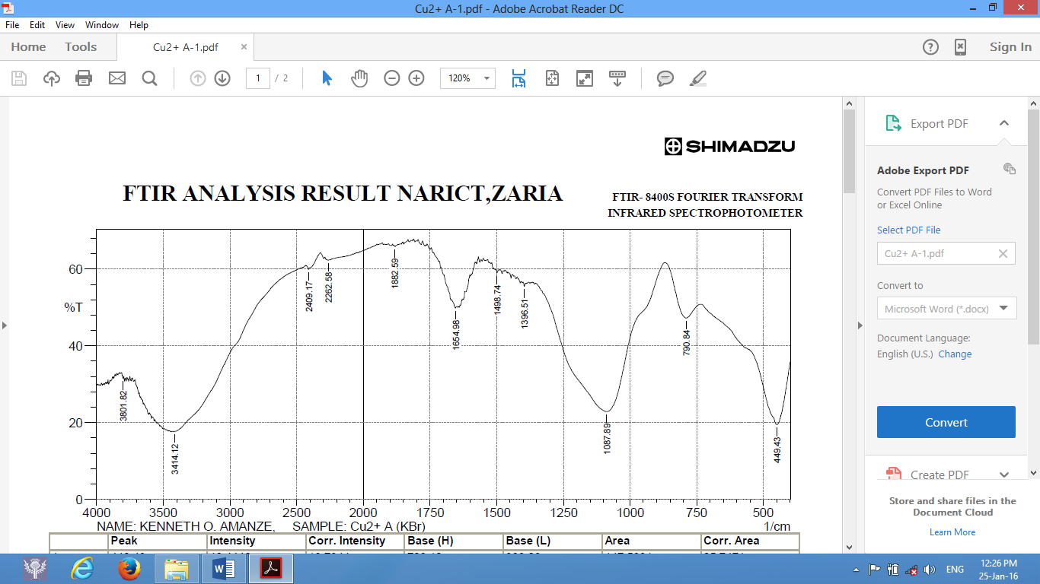1/cm
Figure 2 FTIR Analysis of Copper(II) ions bonded unto pure silica
Effect of pH

The extent of Cu(II)adsorption was strongly influenced by the solution pH. The adsorption capacity increased with increasing pH and reached a maximum at pH 7.0. Beyond pH 7.0, precipitation of copper hydroxide was observed, making adsorption studies unreliable.

Figure 3: Variation of percentage removal of Cu(II)ions with pH onto Silica

Effect of Contact Time
The adsorption process was rapid initially and reached equilibrium within 50 minutes (figure 4). The rapid uptake at the early stage was due to the availability of a large number of vacant active sites on the surface of the silica particles.

Figure 4: Variation of Amount of Cu(II)ions adsorbed with contact time onto Silica

Effect of Initial Concentration and Temperature
An increase in the initial concentration of Cu(II)ions led to an increase in the adsorption capacity (qe) of silica (figure 5), suggesting that the driving force for mass transfer increased with concentration.

Figure 5 Variation of amount of Cu(II)ions adsorbed with initial concentration onto Silica

Adsorption Kinetics
Three Kinetic Models: Elovich, Pseudo first-order and Pseudo second-order were applied in the analyses. But Pseudo first-order gave a very low correlation coefficient, R², values and was not reported here. The Elovich and Pseudo second-order which gave a fair and very high R² values respectively were reported for the kinetic studies.
The Elovich model is guided by the expression:
dqt/dt = α exp(-βqt) 2
Where α is the initial adsorption rate in mg g⁻¹ min⁻¹ and β is the desorption constant (g mg⁻¹) during the experiment. Chien and Clayton (1980) simplified Elovich’s equation by applying the boundary conditions qt = 0 at t = 0 and qt = qt at t = t and equation 2 becomes:
qt = 1/β ln (αβ) + 1/β ln (t) 3
Thus, a plot of qt aqainst ln (t) would give a straight line if adsorption data fit into the model. From the plots, the constants α and β can be determined from the intercept and slope respectively. The Elovich kinetic plot is shown in fiqure 4.

Figure 6 Elovich kinetic model for adsorption of Cu(II)ions unto pure Silica.

The Elovich kinetic data for copper ions adsorption unto pure silica is shown in table 1.

Table 1 Elovich Kinetic data for pure silica
 | α (mg g⁻¹ min⁻¹) | β (g mg⁻¹ ) | R²
 | 12.790 | 0.636 | 0.9945

The pseudo second-order reaction is guided by the expression:
t/qt = 1/(k₂q_{e})² + t/q_{e} 4
where q_{e} is the amount of Cu(ii) ions adsorbed at equilibrium, qt is the amount of Cu(II) ions on the surface of the silica at time t and k₂ is the rate constant of the pseudo second-order adsorption kinetics. A plot of t/qt against t yields a straight line if the pseudo second-order kinetics is applied. The constants qe and k₂ were determined from the slope and intercept of the plots respectively. The plots are shown in figure 7.

Figure 7 Pseudo second-order kinetics of adsorption of Cu(II) ions onto pure silica.
The kinetic data for the Pseudo second-order assessment are listed in table 2

Table 2 Pseudo second-order kinetic data of pure silica
 | k₂[g/ (min mg)] | q_{e}(mg/g) | R²
 | 0.3200 | 0.1023 | 0.9972

The adsorption kinetics were better described by the pseudo-second-order and Elovich models (R² > 0.99) than by the pseudo-first-order (data excluded), suggesting that chemisorption could be the rate-controlling step involving valence forces through sharing or exchange of electrons between adsorbent and adsorbate (figures 6 & 7).
Adsorption Isotherm Study
The Langmuir model fitted the experimental data better than the Freundlich model, with a high correlation coefficient (R²= 0.999), indicating monolayer adsorption of Cu(II)ions onto a homogenous surface (figure 8). The maximum adsorption capacity (qmax) calculated from the Langmuir model was 91.3 mg/g, corroborating the experimental data.

Figure 8: Langmuir isotherm for the adsorption of Cu(II) ions to Silica

Thermodynamic Studies
The result from thermodynamics is in table 3
Table 3: Thermodynamic Parameter for the adsorption process of Cu²⁺ ions
Metal ion | Adsorbent | $$∆H(KJ{mol}^{-1}$$ | $$∆S(JK^{-1}{mol}^{-1})$$ | $$∆G(KJ{mol}^{-1})$$
Cu²⁺ | Silica | -74 | $$4.324$$ | $$-2.050$$
The relatively large negative value of ΔH° suggests that the adsorption not only is spontaneous but also highly favorable, implying strong interaction between Cu²⁺ ions and the silica surface. The positive ΔS° value indicated increased randomness at the solid-liquid interface during the adsorption. The negative ΔG° value indicates that the adsorption process is spontaneous and thermodynamically favorable under the conditions studied. It also suggests a strong affinity between the Cu²⁺ ions and the active sites on the silica surface, indicating that the adsorption process is likely driven by strong electrostatic interactions or chemical bonding mechanisms.

Desorption Studies
The percentage of copper(II) ions desorption by different eluting agents is in table 4. The desorption efficiencies were generally low, ranging from 23.90% to 24.20% across all the eluting agents. Slightly higher desorption percentages were observed for the acid agents than for the bases. No significant difference was found among the eluting agents. The results suggest that metal binding to the adsorbents was strong and not easily reversible under the tested conditions

Table 4: Percentage of copper(II) ions desorbed by different Eluting agents
Adsorbents | Eluting agents | C_{i}(mg/l) | C_{e}(mg/l) | % desorption
Pure silica | HCl | 50 | 12.00 | 24.00
 | H₂SO₄ | 50 | 12.10 | 24.20
 | NaCl | 50 | 12.10 | 24.20
 | Na₂CO₃ | 50 | 11.95 | 23.90
 | NaOH | 50 | 11.95 | 23.90

DISCUSSION
The results show that the optimum amount of Cu(II)ions adsorbed by pure silica was 91.3 mg/g representing 98.86 % at the optimum pH of 7.0. Thus, silica provides an excellent surface for the attachment of copper(II) ion, because of the peak ionization of the functional groups on the silica surface. The fitting of adsorption kinetic data into Pseudo second-order model generally explains that the rate-limiting step of the adsorption typifies chemisorption mechanism. The results from Figures 4 and 5 with Tables 1 and 2 show that there is a good adsorbent-adsorbate interaction at the interface. It therefore suggests a possible exchange of valencies or sharing of electrons between Cu(II)ions and the silica silanol surface leading to a chemical reaction. The low value of the desorption constant, β, from Elovich (equation 2 and Table 1), show that adsorption process is irreversible and further buttressed the earlier prediction that the rate-limiting step of the process is chemical reaction. Desorption reports showed that about 24.0 % of the Cu(II)ions were desorbed with appropriate eluting agents. The experimental results showed that pure silica is a good adsorbent for the removal of Cu(II)ions from aqueous solutions and may possibly be useful for treating industrial waste waters and may be useful in detoxifying our already polluted environment. Saddik et al., (2022) produced maximum adsorption of 100 mg/g for the removal of copper from aqueous medium at pH 6 using functionalized silica base adsorbent. The present work achieved a maximum adsorption capacity of 91.3 mg/g with pure silica at pH 7. Bilgiç et al., (2022) used silica and pillar [5] arene adsorbent to obtain maximum adsorption of 79.3651 mg/g for the removal of copper(II) ions at temperature of 328 K. Zhang et al., (2019) obtained maximum values of 35.87 and 48.26 mg/g for copper(II) ion removal with two adsorbents: SBA-15 functionalized with N-propyl-2-pyridylamine and ethylenediaminepropyl-2-pirydylamine respectively at pH 5.0. Ahmadpoor et al., (2019) achieved a maximum adsorption of 97.4 % for copper(II) ions and its consequent removal from aqueous medium at pH range of 3-4 with the aid of novel bead of Fe₅C₂@SiO₂ nanoparticles.

CONCLUSION
This study demonstrated that pure silica is an effective adsorbent for the removal of Cu(II)ions from aqueous solutions under batch conditions. The adsorption process was found to be highly pH-dependent, rapid, and best described by the pseudo-second-order kinetic model and the Langmuir isotherm. The thermodynamic analyses confirmed that the adsorption was spontaneous and highly favorable. The desorption rate was relatively low, suggesting that metal binding to the adsorbents was strong and not easily reversible under the tested conditions. The high adsorption capacity (91.3 mg/g) suggests that pure silica could serve as a potential low-cost material for treating industrial wastewater contaminated with copper ions.
Disclaimer (Artificial intelligence)
Option 1:
Author(s) hereby declare that NO generative AI technologies such as Large Language Models (ChatGPT, COPILOT, etc.) and text-to-image generators have been used during the writing or editing of this manuscript.
Option 2:
Author(s) hereby declare that generative AI technologies such as Large Language Models, etc. have been used during the writing or editing of manuscripts. This explanation will include the name, version, model, and source of the generative AI technology and as well as all input prompts provided to the generative AI technology
Details of the AI usage are given below:
1.
2.
3.

REFERENCES
Abuhatab, S., El-Qanni, A., Al-Qalaq, H., Hmoudah, M., & Al-Zerei, W. (2020). Effective adsorptive removal of Zn²⁺, Cu^{2+,} and Cr³⁺ heavy metals from aqueous solutions using silica-based embedded with NiO and MgO nanoparticles, Journal of environmental management, 268, 110713, http://dx.doi.org/10.1016/j.jenvman.2020.110713.
Adebayo, G.B, Adegoke, H.I. & Sidiq, F. (2016). Adsorption of Pb (ii) by modified and activated carbon prepared from Daniella oliveri stem bark. Journal of Chemical Society of Nigeria 41(1):19-26, https://journals.chemsociety.org.ng/index.php/jcsn/article/view/41
Ahmadi, M., Kalinin, I., & Tomchuk, V. (2023). Removal of heavy metals using sorbents and biochemical indexes in rats. Ukrainian journal of veterinary sciences, 14 (4): 9-22, http://dx.doi.org/10.31548/veterinary4.2023.09
Ahmadpoor, F., Shojaosadati, S., & Mousavi, S. (2019). Magnetic silica coated iron carbide/alginate beads: Synthesis and application for adsorption of Cu(II)from aqueous solutions, international journal of biological macromolecules, 128, 941-947, https://doi.org/10.1016/j.ijbiomac.2019.01.173
Awual, M. (2017). New type mesoporous conjugate material for selective optical copper(II) ions monitoring & removal from polluted waters. Chemical Engineering Journal, 307, 85-94, https://doi.org/10.1016/J.CEJ.2016.07.110
Bilgiç, A., Cimen, A., Kursunlu, A., Karapınar, H., & Guler, E. (2022). Synthesis, characterization, and application of functionalized pillar[5]arene silica gel (Si-APTMS-pillar[5]arene) adsorbent for selectivity and effective removal of Cu(ii) ion. Journal of Materials Research, 37, 3587-3598, https://doi.org/10.1557/s43578-022-00727-7
Briffa, J., Sinagra, E., & Blundell, R. (2020). Heavy metal pollution in the environment and their toxicological effects on humans, Heliyon 6, e04691,https://doi.org/10.1016/j.heliyon.2020.e04691
Castro, K.; Abejón, R. Removal of Heavy Metals from Wastewaters and Other Aqueous Streams by Pressure-Driven Membrane Technologies: An Outlook on Reverse Osmosis, Nanofiltration, Ultrafiltration and Microfiltration Potential from a Bibliometric Analysis (2024). Membranes, 14, 180. https://doi.org/10.3390/ membranes14080180
Chien, S.H. & Clayton, W.R (1980). Application of Elovich equation to the kinetics of phosphate release and sorption on soils. Soil Science Society American Journal 44:265-268, https://doi.org/10.2136/sssaj1980.03615995004400020013x
Elgarahy, A., Elwakeel, K., Mohammad, S., & El-Shoubaky, G. (2021). A critical review of biosorption of dyes, heavy metals and metalloids from wastewater as an efficient and green process, Cleaner Engineering and Technology 4,100209, https://doi.org/10.1016/j.clet.2021.100209
Humelnicu, D., Zinicovscaia, I., Humelnicu, I., Ignat, M., Yushin, N., & Grozdov, D. (2022). Study on the SBA-15 Silica and ETS-10 Titanosilicate as Efficient Adsorbents for Cu(ii) Removal from Aqueous Solution. Water, 14 (6): 857, https://doi.org/10.3390/w14060857
Ma, J., Qin, G., Zhang, Y., Sun, J., Wang, S., & Jiang, L. (2018). Heavy metal removal from aqueous solutions by calcium silicate powder from waste coal fly-ash. Journal of Cleaner Production, 182, 776-782, https://doi.org/10.1016/j.jclepro.2018.02.115
Kanungo, S., Gupta, N., Rawat, R., Jain, B., Solanki, A., Panday, A., Das, P., & Ganguly, S. (2023). Doped Carbon Quantum Dots Reinforced Hydrogels for Sustained Delivery of Molecular Cargo. Journal of Functional Biomaterials, 14 (3), 166, https://doi.org/10.3390/jfb14030166
Kukwa, R., Kukwa, D., Oklo, A., Ligom, T., Ishwah, B., & Omenka, J. (2020). Adsorption Studies of Silica Adsorbent Using Rice Husk as a Base Material for Metal Ions Removal from Aqueous Solution. Journal of Chemical Engineering, 8 (2), 48-53, http://dx.doi.org/10.11648/j.ajche.20200802.12
Mahatmanti, F., Kusumastuti, E., Rengga, W., N., & Siswanta, D. (2021). Chitosan-silica- polyethylene Glycol (Ch/Si/P) Solid Membrane for Removal of Cu(ii), Zn(ii) and Cd(ii) Ions from Aqueous Solutions. Challenges and Advances in Chemical Science, 1, 54- and 5 .5 for Cd (ii) ions.72, https://doi.org/10.9734/bpi/cacs/v1/8924D
Onojake, M.C., Iwuoha, G. & Osakwe, J.O. (2015). Banana peel as low-cost adsorbent for the removal Ni (ii), Cu(II)and Fe (ii) from industrial effluents. Journal of Chemical Society of Nigeria, 40 (2):59-62, https://www.journals.chemsociety.org.ng/index.php/jcsn/article/view/33
Qin, Y., Jiang, H., Luo, Z., Geng, W., & Zhu, J. (2024). Preparation and Performance Study of Boron Adsorbent from Plasma-Grafted Polypropylene Melt-Blown Fibers. Polymers, 16 (11), 1460, https://doi.org/10.3390/polym16111460
Rashid, A.; Schutte, B.J.; Ulery, A.; Deyholos, M.K.; Sanogo, S.; Lehnhoff, E.A.; Beck, L. (2023). Heavy Metal Contamination in Agricultural Soil: Environmental Pollutants Affecting Crop Health. Agronomy, 13, 1521. https://doi.org/10.3390/ agronomy13061521
Saddik, R., Hammoudan, I., Tighadouini, S., Roby, O., Radi, S., Al-Zaben, M., Bacha, A., Masand, V., & Almarhoon, Z. (2022). Mesoporous Silica Modified with 2-Phenylimidazo[1,2-a] pyridine-3-carbaldehyde as an Effective Adsorbent for Cu(ii) from Aqueous Solutions: A Combined Experimental and Theoretical Study. Molecules, 27 (16), 5168, https://doi.org/10.3390/molecules27165168
Simón, D., Palet, C., Costas, A., & Cristóbal, A. (2022). Agro-Industrial Waste as Potential Heavy Metal Adsorbents and Subsequent Safe Disposal of Spent Adsorbents. Water, 14(20): 3298, https://doi.org/10.3390/w14203298
Wu, K., Wang, B., Tang, B., Luan, L., Xu, W., Zhang, B., & Niu, Y. (2021). Adsorption of aqueous Cu(II)and Ag(I) by silica anchored Schiff base decorated polyamidoamine dendrimers: Behavior and mechanism. Chinese Chemical Letters, 33 (5): 2721-2725, https://doi.org/10.1016/j.cclet.2021.08.126
Yu, N., Jiang, H., Luo, Z., Geng, W., & Zhu, J. (2023). Boron Adsorption Using NMDG-Modified Polypropylene Melt-Blown Fibers Induced by Ultraviolet Grafting. Polymers, 15 (10), 2252, https://doi.org/10.3390/polym15102252
Zafar, S., Khan, M., Lashari, M., Khraisheh, M., Almomani, F., Mirza, M., & Khalid, N. (2020). Removal of copper ions from aqueous solution using NaOH-treated rice husk. Emergent Materials, 3, 857 – 870, https://doi.org/10.1007/s42247-020-00126-w
Zhang, Y., Cao, X., Sun, J., Wu, G., Wang, J., & Zhang, D. (2020). Synthesis of pyridyl Schiff base functionalized SBA-15 mesoporous silica for the removal of Cu(ii) and Pb(ii) from aqueous solution. Journal of Sol-Gel Science and Technology, 94, 658-670, https://link.springer.com/article/10.1007/s10971-019-05205-x
Zhang, Y., Cao, X., Wu, G., Wang, J., & Zhang, T. (2020). Quaternized salicylaldehyde Schiff base modified mesoporous silica for efficiently sensing Cu(ii) ions and their removal from aqueous solution. Applied Surface Science, 527, 146803, https://doi.org/10.1016/j.apsusc.2020.146803

Author Contributions: Conceptualization-Amanze, k. O.; Methodology- Okore, G.; Investigation- Ehirim A. I. & Ngozi-Olehi, L. C; Writing: original draft preparation- Okeke, P. I.; writing review & editing- Amanze, J. O. &. Uchegbu, R. I; Data curation-Gabriel C. Eze. Supervision- Amanze, K.O. All authors have read and agreed to publish the manuscript.
Data Availability Statement: The original contributions presented in this study are included in the 271 articles. Further inquiries can be directed at the corresponding author
Funding: This research received no external funding.
Conflicts of Interest: The authors declare no conflict of interest.

