Cataclysmic Morpho Dynamics of the Lower Damodar River Basin, India

Abstract: Damodar Valley Rivers, the Sorrow of Bengal is a tributary to the Hooghly River but the storehouse of Coal. This river is the lifeline of about 2.2millions people in West Bengal though it emerges from Jharkhand state, India. The valley has been constantly under threat at its lower reaches from devastating floods, poor water quality, inundation and loss of ecology and forests. The present search is to find the causes for regular submerges, sedimentation of reservoirs and planning for a solution to the gaps and spaces though numerous works are done over the basin. The Arc GIS /RS software has been applied by constructing basin, slope, watershed, and land use and land cover map of the Damodar Valley from its satellite imagery. The post-independent dam structures are old, reservoirs are silted up, the river/canal section shrank and the direct efflux of effluent to rivers has transformed the valley topology added by anthropogenic, political, social and economic strategies. The analysis exhibits that the water of the river in summer is not health-impacting. The continuous sedimentation of reservoirs, urbanisation and Industrialisation have reduced the storage volume resulting in the depletion of the culturable command area, energy generation and forest coverage and intensification. The environmental impact assessment (EIA) which was not considered in the 1950’s should be adopted with Real-Time Data Acquisition System (RTDAS) and Real-Time Decision Support System (RTDSS), the Dam Rehabilitation & Improvement Project (DRIP) with the construction of new dams and building up new dams with rehabilitation and renovation of canals and silted up drainage channels.
Keywords: Dams, Damodar Valley, Floods, Pollution, EIA, CSR
1.0.0 Introduction:
West Bengal (WB), the land of Rivers (R.), comprises mainly of the Ganga-Bhagirath-Hugli River basins. The Damodar River is a tributary to Hooghly R. The river emerges from the Chhota Nagpur Plateau in Jharkhand and outfalls in the Hooghly branch. The river receives runoff from the rainfall (SW monsoon, Norwesters), or Tidal waves (Islam, 2018[1], Das, 2024[2]).
The Damodar R. is east flowing that originates from Jharkhand state but causes flood miseries in its lower reaches in West Bengal (WB). WB has a geographical area of 88752 km2, an inland area of 85291 km2, and rivers/creeks cover 3461 km2. The flood-prone areas of the Hooghly R. are 37660 km² in Table 1. The catchment area of Damodar R. of the Ganga-Bhagirathi system is only 5250 km2. Damodar Valley Civilization is datable to 3500YBP. Damodar river flows in Jharkhand and West Bengal. The Damodar valley covers Damodar, Barakar, and Silabati and has an area is 19673Km2.

Table 1: The east-flowing rivers and their catchment area in Damodar Basin, WB, India
River in WB | Damodar | Dwarakeswar | Haldi | Kalia Ghai | Kangsabati | Mundeswari | Pichabani
Unit | Km² | Km² | Km² | Km² | Km² | Km² | Km²
drainage area | 4325 | 4292 | 614 | 1913 | 6324 | 1439 | 791
River | Rasulpur | Rupnarayan | Shilabati | Total area
Unit | Km² | Km² | Km² | Km² | https://wbiwd.gov.in/uploads/anual_flood_ report/Annual-Flood-Report-2023
Drainage area | 1556 | 1226 | 4088 | 26568

The flood risk zone of the Damodar R. shelters 6,472.19km2 (27.69%), out of which the low-risk zone is 3341.02km2 (14.30%), moderate risk zone covers 12647.48km2 (54.12%), and the high-risk zone is 910.29km2 (3.89%) of area (Bera et al, 2018[3]). The Damodar Valley Corporation was formed in 1948, with five Dams and a barrage in the 1950s for flood control, irrigation, hydel power generation and navigation (Fig 2).
  - Damodar River (Study Area):
The various tributaries and drainage channels (d/cs) joining to construct the Damodar River are. Barakar, Konar, Bokaro, Haharo, Jamunia,Ghari, Guaia, Khadia and Bhera. The river touches through Lohar Daga, Latehar, Ranchi, Chatra, Ramgarh, Bokaro, Dhanbad (seven districts of Jharkhand – and five districts of West Bengal – Bankura, Purulia, Burdwan, Howrah and Hooghly, covering a length of 547 kilometres with 23370.98 Km² of the catchment area. The main tributary is the Barker River. The Damodar River emerged from Chandwa village (Elv^{n}. of 610m) in the Palamau district (Chhota Nagpur Plateau), Jharkhand. The river runs east for 592 km before debouching the Hooghly River at Garchumuk (≈50 km) south of Kolkata after joining the River Rupnarayan. (Figure 1).
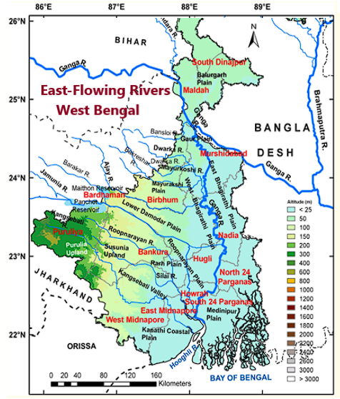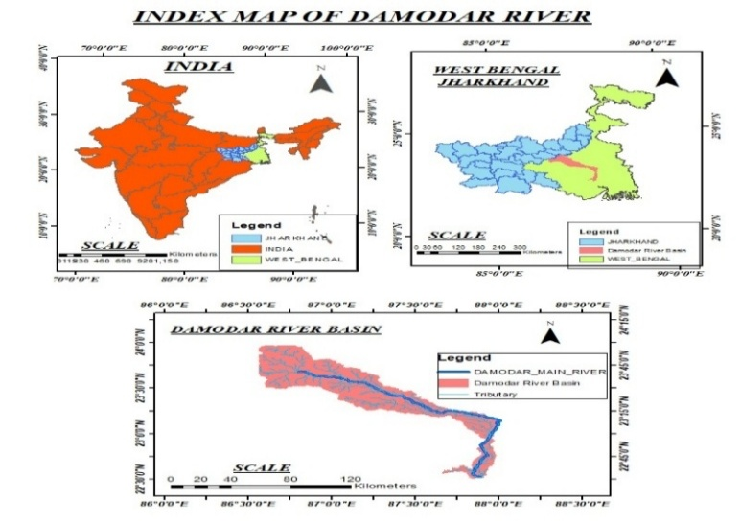
Fig 1: The Index map of the Damodar River basin in West Bengal, Odisha
The Damodar R. is in the news for its frequent pollution due to the inflow of Industrial effluent from Damodar Valley Corporation (DVC’s) Chandrapura. Thermal Power Plant (TPP) with recurrent spills of furnace oil from (i) In 1990 (2 million litres) of Furnace oil from Bokaro TPP, (ii) in 2019 furnace oil spill made the river toxic for 41 days, (iii) The fly ash pond of Bokaro TPP breached. The liquid waste/ effluent from TATA power, in DV and the adjacent industries and towns inflows to Damodar R. causing health Issues at lower reaches. In the field, it is observed that there is an increasing trend in riverbed deposition from Jamalpur to Amarpur in the LDVA.
a.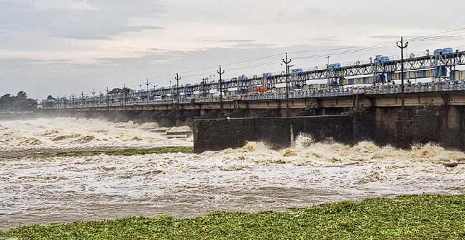b. 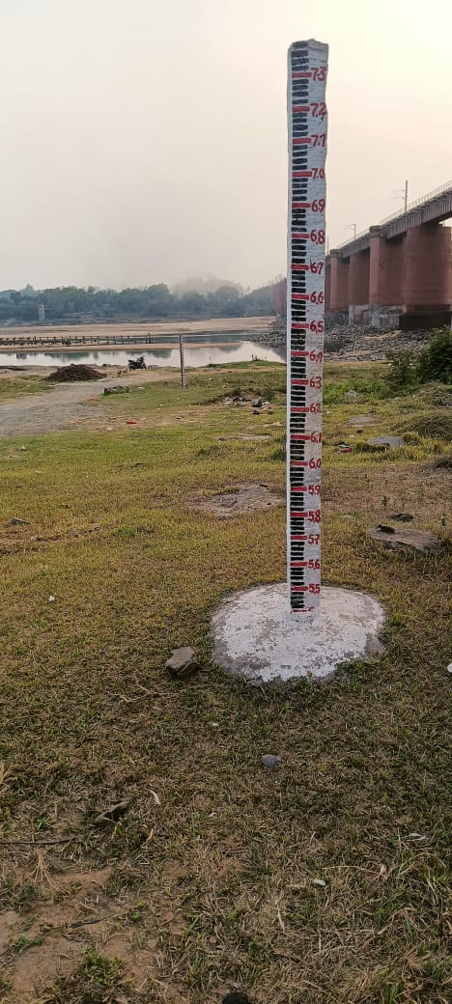
c.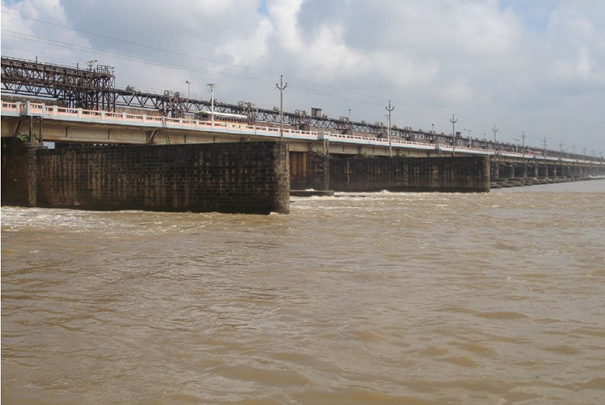d.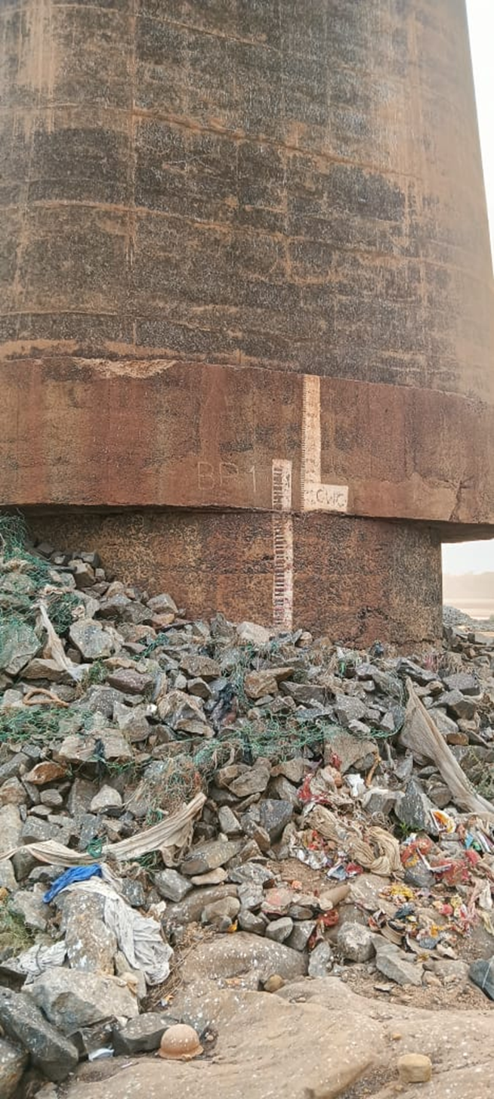
e. 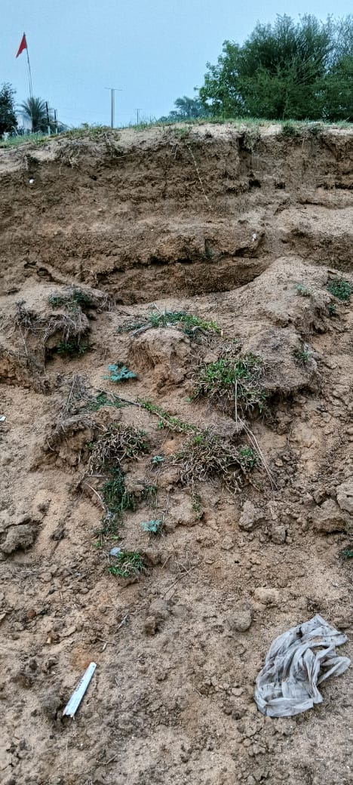f.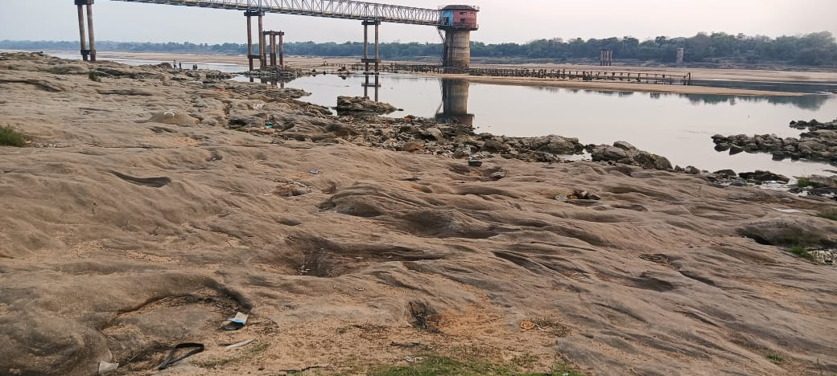
Fig 2(a-f): Photographs (a) Durgapur Barrage, (b) Gauge Post, (c) Flood in Maithon Dam, (d) Source of pollution ( e) Soil erosion at levees, (f)Water supply scheme to Asansol
Paddy is the main crop from the basin extending an area of 13152 km² followed by a forest area of 3486 km2. Mining (mainly coal and mica) and industries are the main sources of livelihood with population and climate (Chattopadhyay et al, 2020[4], Susanth et al, 2023[5], Dasgupta et al, 2024[6], Mishra SP. 2025[7]). The causes of flood in the Lower Damodar Valley Area (LDVA) are due to huge discharges from funnel-shaped mountainous catchment, continuous rainfall due to Indian Summer monsoon (ISM), upper air disturbances, sedimentation in aged dams, barrages, river beds and canals, improper flood routing and unjudged reservoir operation of the dams and reservoirs, (Ghosh and Mistri 2015, Ghosh and Guchhait 2016, Ghosh and Kundu 2023) Fig -2 (a-f)
1.2.0 The Objective of Study
Last seventy years the dams/barrages have served the nation but the rural oustees are still under environmental impacts like health, socioeconomic, migration, marginalisation, and displacement are still under livelihood negotiations. The agglomerations of townships, NH-19 near the Left bank of Damodar protect riverside urban agglomeration from clutches of flood. However, the vulnerable groups are the most sufferers specifically the women.
The objectives of the present study are:
- Detailed knowledge of Water resources projects under Damodar Valley Corporation (DVC) and the flood problems of the lower Damodar Valley Area.
- Sorting out present Issues associated with DVC projects and in its periphery.
- Possible measures of solution to the shortfalls
1.3.0 Methodology:
From the USGS Earth Explorer (https://earthexplorer.usgs.gov/,) website, a 30 m high-resolution Digital Elevation Model (DEM) maps are downloaded. The daily rainfall data is downloaded from the IMD (India Kolkata).) website. A DEM was acquired from USGS and processed using ArcGIS 10.4 software. The Spatial Analyst tool, including sub-tools such as Hydrology, slope, Fill, Flow Direction, watershed and Flow Accumulation, was employed in all stream networks to determine the drainage hierarchy. The river morphology was accomplished in the study by integrating selected component surface-form metrics into ArcGIS. The mythology employed is in Fig 3.
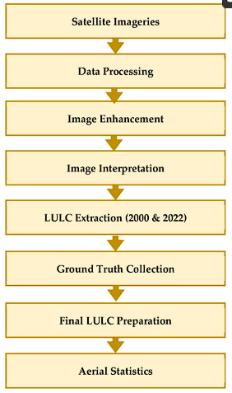
Fig 3. The methodology employed in GIS image analysis
The process involves the collection of satellite imageries of the Damodar Valley basin area, geo-referencing, preparing GIS maps, performing an analysis of the slope, watershed, and drainage maps, and finally interpreting the results. The data preparation involves data acquisition, data cleaning and appropriate coordination of the data (data transformation). Using spatial analysis Techniques the data analysis is done. Later the documentation and presenting are done properly to report and the document has been done as per Arc GIS Tutorial.
The information during the study has been collected or captured from Damodar Valley Planning Atlas, websites of Irrigation and Waterways Department of West Bengal (IWDWB), West Bengal, Board, Indian Meteorological Department (IMD), Geological Survey of India GSI), Google Earth, and previous researches on Damodar River (DR), Damodar Valley (DV) and Damodar Valley Corporation (DVC). The USGS Data, use of GIS, Survey of India (SOI) toposheets (73 M/7, M/11, M/12, M/15, M/16, N/13, and 79 A/4), Landsat Data, National Atlas Thematic Mapping Organization (NATMO), and Geological Survey of India (GSI) are used to study the hydrological, climatological, geographical and anthropologic changes in the basin.
Present study is an attempt to have a through study of the distorted and deteriorated River basin it offers that the detailed geo-environmental assessment of the Damodar Valley (DV) River system. It is the most major sub-basin of Ganga-Brahmaputra-Meghna (GBM) basin since India's first river development project. The DVC (Damodar Valley corporation ) provides current spatial analysis on land use change, sedimentation, and watershed dynamics by utilizing Arc GIS and remote sensing techniques. By emphasizing the long-term effects of poor environmental planning, unchecked urbanization, and outdated infrastructure, the study warrented knowledge gaps and for the management of the sustainable basins. It also suggests contemporary techniques like RTDAS, RTDSS and DRIP which is a resource for future policy plan, infrastructure maintenance, and disaster relief in DV flood-prone areas.
2.0.0 Soil of Damodar Valley
The long and complex basin has six sub-types of soils at lower reaches such as old alluvium, (Ganga alluvium), the Damodar alluvium in WB, and Open Sal forests (Shorea robusta) in laterite copings, and dense Sal forests over red or yellow loams of mountainous region of Jharkhand. (WMO) Tech Report 2003[11]).
2.1.0 Pollution in Damodar Valley
The National Green Tribunal (NGT), India has imposed fines for oil spill in the Damodar River by TPS, Thermal Power station Chandrapura in October 2019, environmental compensation for fly ash spill, violation of stipulations during environmental clearance (EC), Consent to Establish (CTE) and Consent to Operate (CTO) for debouching of effluents pollute the water Damodar River (R.) Jharkhand Kolhan Ranchi, (2021[12]). As per DVC Emta Coal Mines Vs Pollution Control Appellate Authority, W.B. and Others(APPEAL NO. 43/2012) WWF, multiple times penalties have been imposed for polluting the Damodar River.
British rulers constructed Edden Canal in past to divert the flood volume of the Damoder River to the Bhagirathi-Hugli River by jacketing the easterly d/cs and the easterly distributaries slowly missing life-flow, delinked from the parent river Excess rainfall occurs in the DV lower reaches due to Inter tropical conservation zone (ITCZ), trough-line, remainant of Bay of Bengal (BoB) cyclones cause floods and inundation in WB.
Recorded historical high floods above 15000 Cumec in the Damodar River were in 1730, 1823, 1848, 1856, 1882, 1898, 1901, 1916, 1923, 1935 & 1943, 1956, 1965, 1971, 1978, 1987, 1994, 2002, 2000, 2008, 2015, 2021, 2024. The shattering flood was recorded in 1943 that led to serious public resentment against the Govt. https://dvc.gov.in/cms-web/details-pages/13. The G&D records (1933-1970) infer that the peak flood was 18406 Cumec on Aug, 6- to 12, 1913 and the post-dam peak flood was 21900Cumec during Sept 1978 (WMO Tech report 2003 [11]). The flood in Damodar River in 2024 was claimed as manmade, for WB. ( Ghosh S 2014; WB Irrigation AR, 2010-2024[14]; Mondal, 2024[15]).
2.2.1 The Silting in reservoirs in the Damodar valley Area:
The reservoir sedimentation is inevitable which causes loss in storage volume, Mutilation /destruction to turbines depletion of hydropower production and environmental/ ecological impact. All the reservoirs in the Damodar Valley have already been completed for 70-75 years, there is a loss of storage and increased flow in the LDVA Table 2 (a and b).

Table 2(a): Details of sedimentation in the reservoirs over Barkar and Damodar R.

Reservoir | River | Long. | Lat. | MDDL | FRL | FRL area | Res. Capacity | Work | gross loss
 | Name | ⁰E | ⁰N | (m) | (m) | Km² | Mcum | years | Mcum
Konar | Konar | 85.75E | 23.97N | 410.56 | 425.8 | 23.97 | 562.26 | 70 | 71.48
Maithon | Barakar | 86.8E | 23.78N | 132.56 | 146.31 | 107.16 | 1348.8 | 70 | 264.0
Tilaiya | Barkar | 85.52E | 24.32N | 363.32 | 368.8 | 38.44 | 671.66 | 72 | 120.9
Panchet | Damodar | 86.75E | 23.68N | 119.48 | 124.97 | 153.38 | 3162 | 68 | 387.5
Tenughat | Damodar | 85.83E | 23.72E | NA | 268.83 | 63.5 | 1134.36 | 55 | 99.5

Table 2(b): The sedimentation in various reservoirs in DVC in Jharkhand state

Name of Dam/  Barrage | Catchment  area | 1st  impounding | Last Survey | First gross storage | T. loss gross storage | Gross storage | gross storage (Av. ) | Av. actual silting  rate
Pondage | Sq. Km | year | Year | MCum | MCum | % loss | % loss | TCM/km²/yr.
Konar | 997.15 | 1955 | 1996 | 281.13 | 71.48 | 25.43 | 0.62% | 1.75
Maithon | 6294 | 1955 | 1994 | 1348.8 | 264.04 | 19.58 | 0.91 | 1.08
Tilaiya | 984.2 | 1953 | 1997 | 335.83 | 120.92 | 36.01 | 0.76 | 2.79
Panchet | 10966 | 1956 | 2011 | 1581 | 387.54 | 24.51 | 0.45 | 0.64
Tenughat | 4481 | 1970 | 2001 | 592.18 | 99.5 | 16.8 | 0.54 | 0.72
Source: Sedimentation Compendium, CWC 2020[16]

Peak Flood and Annual monsoon flow at Maithon Dam have been collected from the book Sedimentation Report of Maithon _ Reservoir 09.09.2020.pdf of DVC and found that after the 1980’s the peak flood has been reduced in Maithon Dam due to better operation of the Dam, reservoir. But the LDVA channels are constricted for smooth discharge Damodar. Peak flow, Fig-4 (a-c)

a.

b.c.
Fig 4(a-c): a) Peak flow of Barkar R. (1945-2019);b). Total capacity loss in volume and av. C. The annual loss in Volume of the Maithon Dam over Barker River.
2.2.2 Causes of Floods in Damodar Valley:
DVC planned for seven reservoirs at the onset to accommodate a peak flood risk of 28,317 Cumec but only four dams (Tilaiya, Maithon, Konar and Panchet) were completed by 1959, which accomplished 1,291 (only 36% of total) million cubic metres (MCM) of flood storage. Land acquisition is the main glitch that reduced the flood storage capacity at Maithon by 1.5m and Panchet by 3m, exacerbating the issue. The problem has been aggravated which cannot be neglected. Encroachment, over-exploitation of both ground and surface water and damage to embankment, silting up of reservoirs and drainage channels are the causes of flood in the basin. So, an attempt has been made to unveil the issues and find some solutions for the threats (Hooque et al, 2022[17], Bera et al, 2024[18]). The carrying capacity of the drainage channel has shrunk on slope, width and depth and was found more constricted towards the confluence point. There is also a varying section at various reaches like the Mundeswari R. at Harinkhola is 400m, at Digruighat it is 250 m. and at Roop Narayan outfall it is 500m. Also, the sediment conc. The mouth of the Mundeswari River hinders the discharge causing flood upstream (Bera and Mistri 2014[18]).
2.3.0 The Major Dams across Damodar Basin
There are several dams and barrages built for flood control, power generation, and irrigation in the Damodar valley. The major hydraulic interventions over tributaries of Damodar R. are Tilaiya Dam (1953)and Maithon Dam (1957) at confluence of Barkar and Damodar across Barakar River (R.) in 1953, Konar Dam over Konar R., in 1955, Panchet and Tenughat dams over Damodar R. during 1958, and 1974 and a diversion barrage at Durgapur built in 1955 under the Damodar Valley Corporation (DVC) project (Fig 2). As per the Irrigation department, D/S flow to Durgapur barrage above 2000Cumec causes flood situations at the outfall point of Mundeswari R. at Harinkhola Fig 5 (a and b)
The D/S of Durgapur Barrage in WB was bifurcated as the Damodar-Amta branch, and (ii) the Kanka–Mundeswari branch that debouches the Bhagirathi R. and later the River Hooghly. The left embankment protects many industrial towns like Asansol, and Durgapur, and coalmines of areas, Raniganj, Sripur, and adjoining coal belts. The high-level pavement NH-19 (old Grand Trunk Road NH-2) and the rail line connecting Delhi and Kolkata (Kumar et al, 2023[19], Mishra et al, 2024[20]).
a.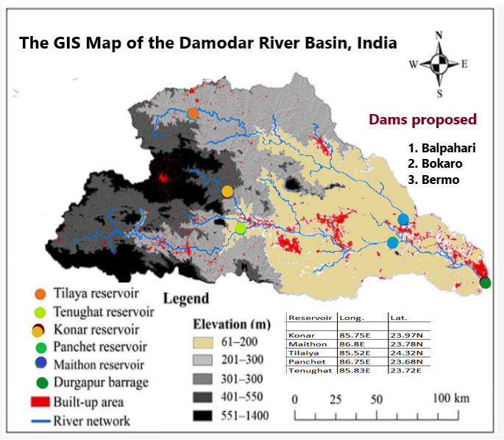 b.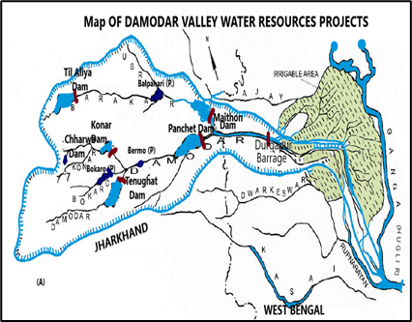
Fig 5 (a and b): Planned Dams/Barrages in Damodar Valley during Post Independence period:
After the operation of the Maithon and Panchet dams, the environmental flow of D/S of the dam was ameliorated, flood control(FC) was bettered, augmented the hydroelectric power generation and raised groundwater level significantly (Fig 6).
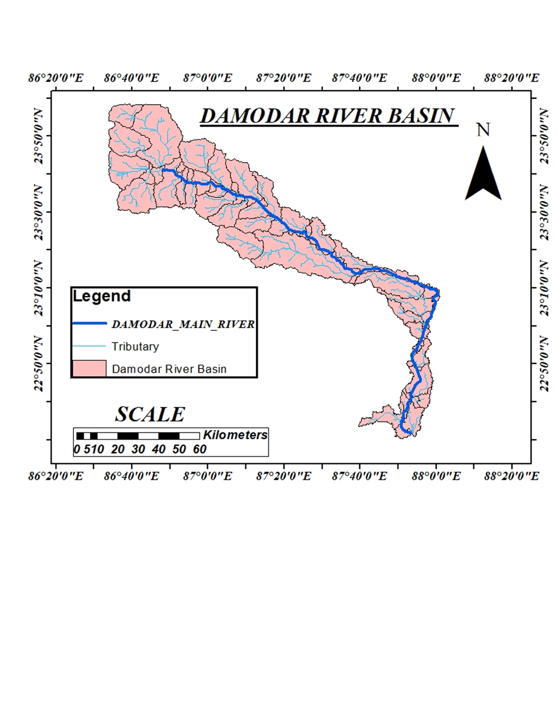
Fig 6: The Damodar basin with distributaries and sub-distributaries in Jharkhand / WB
Adding to regulated river flow during monsoon, the climate change has increased on rainy days, quantum of non-monsoon flow resulting improved in Rabi crops area and yield. The major problem of sedimentation of reservoirs, and erosion in D/S beds and embankments have created breaches along the flood plains., disrupting farming, biodiversity, aquatic environment, and problems in rehabilitative measures.
2.3.1 Salient Features of Maithon and Panchet Dam
Out of five dams constructed in Damodar Valley, the dams Maithon and Panchet contribute the maximum and are the key structures constructed by DVC(Table 3).
Table 3: Salient Features of Maithon Dam at the confluence point of Barkar and Damodar River
Dam | Maithon | Panchet | Dam |  | Maithon | Panchet
Location | Dhanbad; | Dhanbad | Type of Dam |  | Earthen dam | Earthen Dam
State | Jharkhand | Jharkhand | Under sluice type/ No/Size |  | Vertical Lift/5nos/ 1.73m X 3.05m | Vertical Lift/ 5 no /1.73mX 3.05m
Latitude | Lat. 23° 785 N | Lat.23.678N | Type of turbine |  | Francis Hor. shaft | Vert shaft Kaplan
Longitude | Long.86°88.1E | Long 86.746E | Min^{m} Discharge |  | 20Cumec idle PH | Not known
Catchment | 6294Km² | 10966Km | DSL |  | 90MCum | 107MCum
Av R/F / Year | 1140mm | 1140mm | DSL above MSL |  | 132.59m | 119.48m
Yearly Av. Runoff | 2700MCM | 4539MCM | Work flood Level |  | 150.88(m) ≥ MSL | 132.59≥ MSL
Year of erection | 1951-1957 | Dec. 1959 | Flood Storage |  | 326MCum | 592MCum
Over River | Barkar R. fall | Damodar R. | Installed capacity |  | (2X20)+(23.2) W | 2X40MW
Reservoir area | 65Km² | 121.8 Km2 | Spillway |  | Ogee Type | Ogee Type
Type of Dam | Composite | Composite | Gate type |  | Tainter | Tainter
Overall length | (4426.76m.) | 6777m | Crest gate |  | 12Nos | 15Nos
Ht./Energy head | 50m./38.71m | 47.85 | gate No/size |  | 12.19 X 12.5m | 12.19X 12.5m
Purpose of dam | FC/;60MWHP. | FC; 2x40MW | Overall elevation affecting capacity loss
Power-House | UG type | D/S based | Year - 1955 |  | 969.5 | 1281.7
Dam and hydraulic types of machinery |  |  |  | Year - 1965 | 909.7 | 1201.4
Type of Dam | Earthen dam | Earthen Dam | Year - 1975 |  | 844.1 | 1164.0
Nos of gates | 12 lock gates | 15 crest gates | Year-1985 |  | 795.2 | 113.14
Type of gate | Tainter | Tainter | Year- 1995 |  | 755.2
No of Turbines | Three | Two | Year- 2005 |  | 704.1 | 1140.0
HP: Hydropower; UG: Underground; MCM: million cubic meters; MW: Megawatt HP: hydro power ; DSL:;(Dead storage Volume); PH: Power House;
Source: https://www.dvc.gov.in/cms-web/details-pages/113; Ghosh 2014[13]; DVC 2025[21]
The outflow from the Maithon dams meets the Damodar River about four km D/S but the tailrace flow from the Panchet dam meets the main stream still below. In the present climatic change scenario, even a 4300-cumec flood in the Damodar River alarms flood in LDVA in West Bengal. The salient features of the DVP with Maithon and Panchet projects are in Table 1.
2.3.2 Durgapur barrage: Location-Durgapur, (Burdwan)- Damodar R; Catchment area19.547 Km; Barakar Basin, length of barrage -692 m; No of bays (Weir Bays)-24; No of gates -54 (including under sluices; Each width 18.29 m+ Under Sluice Bays – 10 (Each width 18.3 m); Waterway-622m with design discharge of 15574Cumec. Optimum Pond Level/Design U/S Left and right: 64.48 m and 64.08 m respectively.
2.3.3 Durgapur Barrage Canal System: The length of the canal originating from Durgapur LBMC (Left Bank Main Canal) 136.8Km (HR discharge 260Cumec) and the Right bank main canal is 88.5km, where RBHR discharge is 64.3Cumec. The total length of the main and branch canals is 2494km. The GCA during Kharif is 3394Tha and Rabi– 22Tha but CCA potential 333.2Tha. and Rabi is 18.45Tha and Boro 69.79Tha (IT Cell DVC 25.04.2025).
2.4.0 Rainfall in the Damodar R. Basin:
The Barkar tributary of the Damodar R. has a catchment area, of 6914 km² receives an average (av.) rainfall of 1298mm, and at av. Temperature (Temp.) of 30⁰ C, enjoys tropical A_{w} climate. The lower Damodar valley areas (LDVA) from the Maithon dam to the outfall passes through districts Bardhhaman, Hooghly, Howrah and East Medinipur. The CWC, India has G&D stations at Durgapur (West Bardhhaman), Maithon (Dhanbad), Panchet(Dhanbad), Rondia (East Bardhhaman), Tenughat (Bokaro), and Tilalya (Koderma) with an IMD station (Asansol).
a.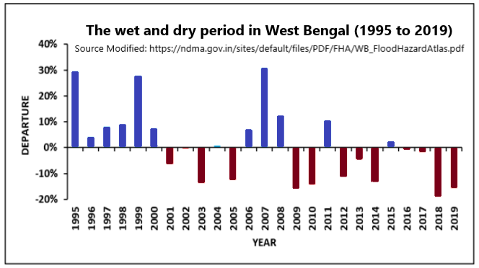
b..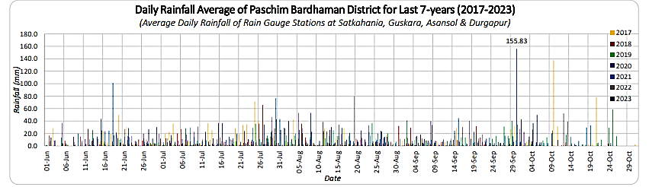
c.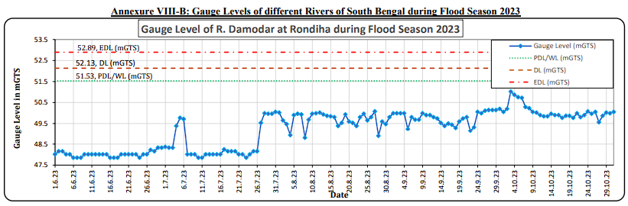
d.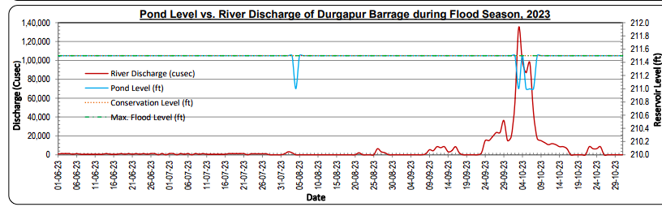
Fig 7 (a & d): a. The dry and wet period West Bengal 1995-2017 (b) Daily r/f in LDVA for 2017 to 2023 (c) the Gauge Level of R. Damodar at Rondiha during Flood Season 2023. (d) pond level/River discharge at Durgapur Barrage (Sou: WB AFR 2023[14])
The Damodar R. is housed on the right bank of the Bhagirathi-Hooghly system and is running below a specific gauge level. The data for Rondiha during the 2023 flood, focuses on the Damodar systems and their drainage flow. The av. daily rainfall in Paschim Bardhhaman, the Gauge level at Rohndia in Purva-Bardhhaman and the pond level at Durgapur barrage during SW-monsoon days are in Fig 7(a-d),
The LDVA receives major channel flow during SW-Monsoon contributing 75%-80% of the total rainfall. The rainfall in LDVA has been increasing in the last decade as the frequency/intensity of cyclonic storms in the Bay of Bengal is surging (Chattopadhyay et al, 2020[4]). The annual rainfall in LDVA is decreasing as observed from current literature in specific areas like Asansol, Durgapur and Bardhhaman districts Guhathakurta et al, 2007[22], Mahato et al, 2023[23]). The impact of global warming, El-Nino, ENSO, ISM, erratic rainfall, climate change vagaries and anthropogenic enactments have influenced the spatial trend of rainfall and extreme floods.
2.5.0 The Dams Panchet and Maithon
The Panchet earthen dam is 40.84 m high, and 6777m. The long is a pre-independence multi-purpose River valley project over the Damodar (Fig 8 (a-f). The reservoir traps from a catchment area of 10.961 Km2. The Yearly av. Basin R/F 1140mm and the av. The yearly runoff is 4540 MCum, and the ever-recorded historical flood at the dam site was about 250 Cumec in June 1949. The dam is designed for 508 Cumec and 2x40MW turbines.
a.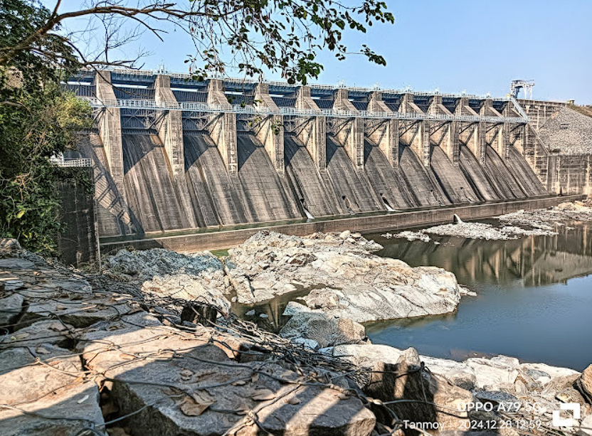b.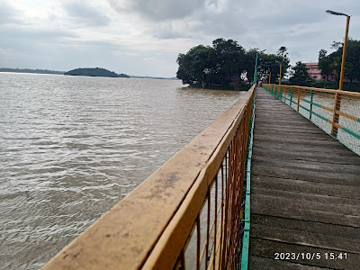
c.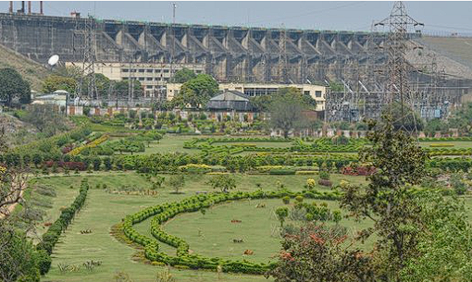d.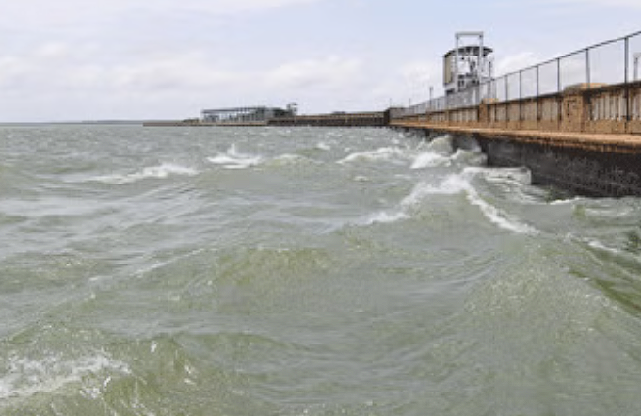
e.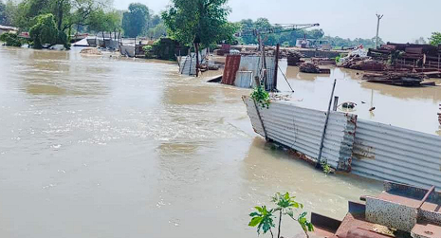f.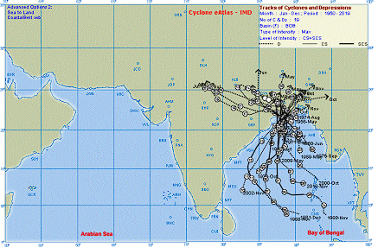
Fig 8 (a-f): (a&b) D/s and U/S of Maithon Dam (Source: Chatterjee et al) (c and d). D/s and U/S Panchet dam; (e) After Flood Inundations 20.9.2024 (State IAG_WB) f. Cyclones influence LDVA (: IMD)
2.5.1 Anthropogenic Flood in LDVA
The Damodar Valley system released about 3950cumec of discharge, which created heavy flood situations Lower Damodar Basin area in WB Aug 3rd 2024. The Hon. CM claimed the manmade unprecedented flood was due to unilateral release from Tenughat Dam, https:// indianexpress.com/article/cities/kolkata/mamata-banerjee-damodar-valley-roject -bengal-floods-9578917/ (21 Sept. 2024). The appeal of CM, WB was negated by Hon. CM, Jharkhand and resulted in a blockade. As a solution to the bottleneck, a dam at Bal Pahari was proposed.
2.5.2 The Pre-independence WR projects in DV:
The operation of the Maithon and Panchet dams, reformed the environmental flow of D/S whereas the dam has solved the problem of flood control, augmented the hydroelectric power generation and raised groundwater level significantly. Adding to regulated river flow during monsoon, the climate change has increased on rainy days, the quantum of non-monsoon flow has improved and the Rabi crops area and yield have raised. The major problem of sedimentation of reservoirs, erosion in D/S bed and embankments have created breech along the flood plains., supporting dry-season agriculture. The biodiversity, aquatic environment, and problem in rehabilitative measures.
2.6.0 Slope Map of DV.
The slope, aspect, elevation, hill shade, drainage, drainage density, watershed and river basin maps of the Damodar Valley using the digital elevation model (DEM) data in the GIS environment decides the morphometric analysis of a basin or the valley. The major part of the basin lies between the slope of .00 to 7.0 in the lower Valley. In the upper part of the basin in Jharkhand state, it is above 7.0 and has drainage on a steep slope.
a.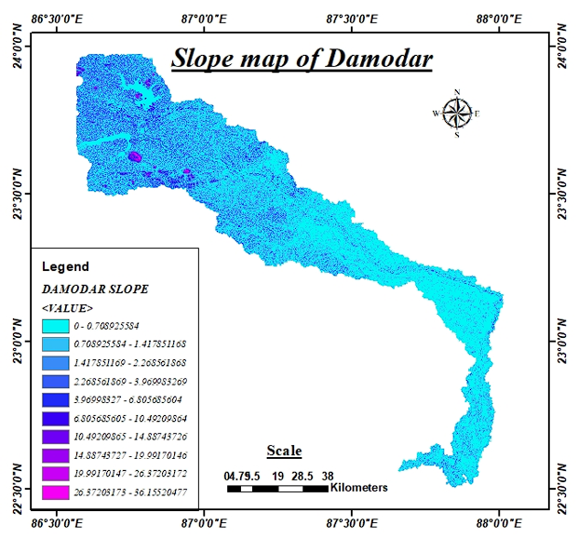b.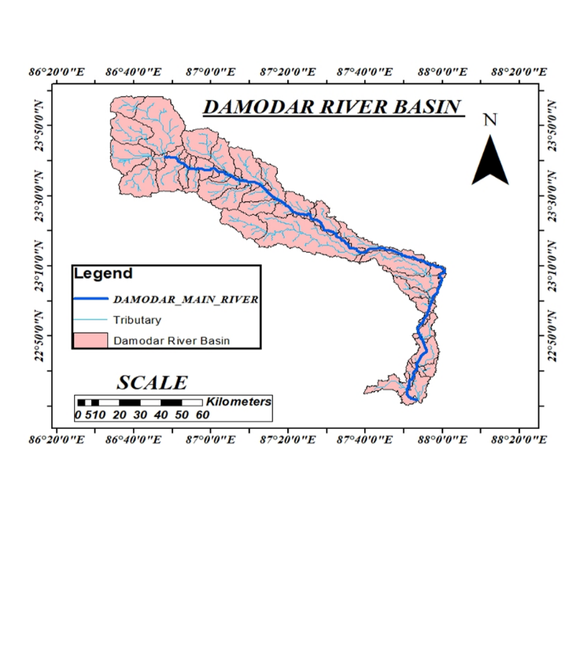
From the various maps, it could be ascertained that the slope is flatter in the catchment and ayacut in the West Bengal portion lying between 00 to 0.7m/km so the area remains submerged and flood impact remains for a long period and is apocalyptic. The system is more anastomosed and braided in the upper reaches than the lower. The fill map indicates the state boundary demarcates higher and lower plains. Watershed maps indicate that the change in LU/LC and drastic climatic variability nut the inflow to the reservoir has surged (Mishra et al, 2022[24], Kumar et al,2023[19], Fig 9 (a-d)
c.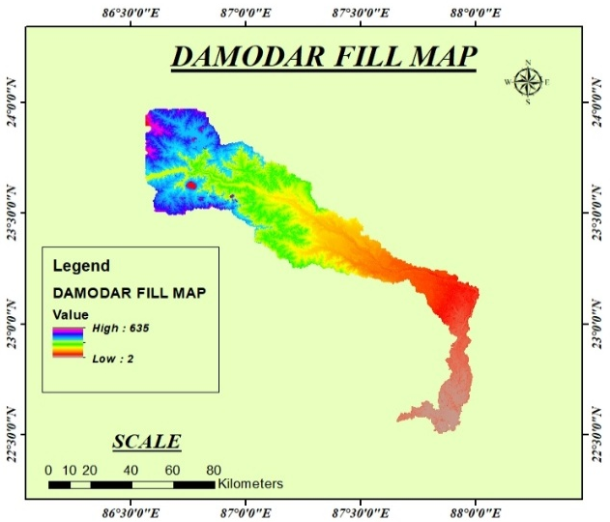d.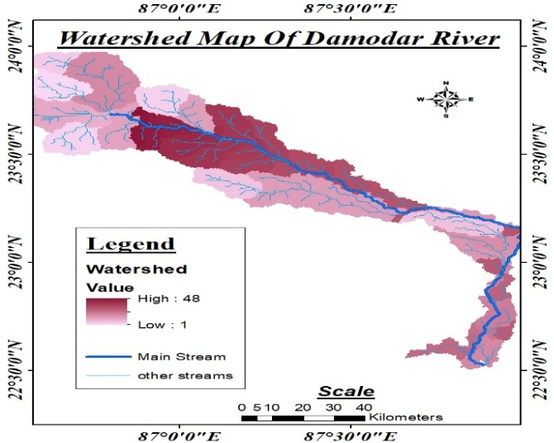
Fig 9 (a-d); The Damodar River (a) Slope map, (b) Basin map (c) The DEM map (d) The watershed map.
2.6.2 Land Use and Land Cover
Influential transformations have been observed in vegetation, land use/land cover, and rainfall on the hydro-morphology of LDVA of Damodar River in WB. There is a wild change in the geomorphology i.e. rapid change of dense forests to sparse, fallow lands to agriculture, mines, Industrial activities, erosion of land and levees, surge in urbanisation etc. (Panda et al., 2020). The LULC of Damodar Valley in the year 2020 and 2024 are compared and found Settlement has surged at the cost of vegetation (Fig 10 (a-b)
a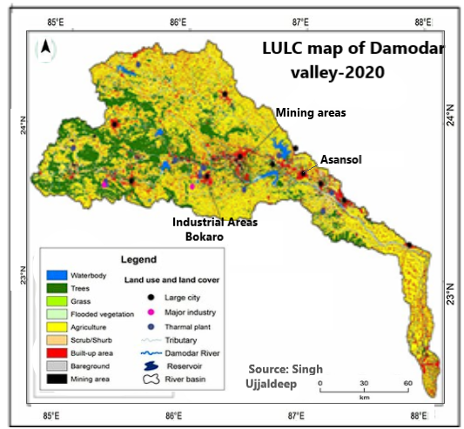.b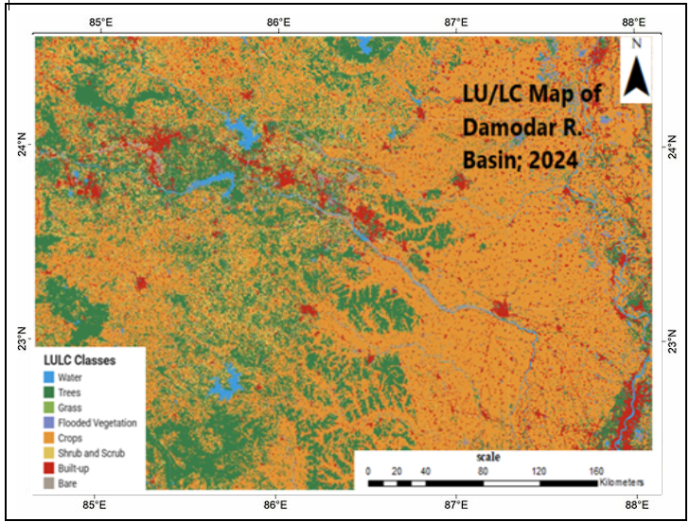.
Fig 10 (a-b): Change in land use downstream of Panchet and Maithon dam (2020-2024).
2.6.3 Water quality of Damodar River D/S Maithon Dam near Asansol city:
A 200km Polluted stretch of the Lower Damodar Valley area (LDVA) and the River from Durgachak to Dishergarh Vill, (Level IV) and the towns/urban agglomerated noticeably in the 21st century. are Udayanarayanpur, Bagnan, Durgapur, and Asansol (Kalyan R., 2018).The water sample was collected from Burnpore, Damodar Railway station, Asansol on 26.04.2025 in CUTM, Odisha Laboratory to find the water quality standards during Summer and found parameters like pH, Conductivity, TDS, Turbidity, Phosphate and Nitrogen oxide are within the allowable limit (Table 4).
Table 4: The water quality index of the Damodar River at Asansol (4/2024)
Sl.No | Parameters | Shiv sir -WB | Limit
1 | pH | 7.71 | 6.5-8.5
2 | Cond (µS) | 271.2 | *
3 | TDS (mg/l) | 138.2 | 500
4 | Turbidity(NTU) | 14 | *
5 | PO₄³⁻(mg/l) | 0.2031 | 1
6 | NO⁻₂ (mg/l) | 0.0494 | 3

2.6.4 Water Allocation: DVC has now 7 dams with reservoirs in operation that can have total existing conservation storage of all four DVC reservoirs is 870 MCM capacity that can allocate 844.56 MGD of water from the Damodar Valley system for Water supply, Irrigation, domestic, Municipal, industrial, and domestic urges of various domestic, irrigation, Municipal and private uses and serves people of West Bengal & Jharkhand.
2.6.5 Irrigation Potential: DVC as a whole Kharif and Rabi irrigation potential is 3, 93,763 and 22,258 hectares respectively in WB. Kharif irrigation potential of 70,019 hectares has been created in Jharkhand from the existing 17172 check dams and small reservoirs like Jamuna, Gonda and Charwa.
2.6.6 Distribution of sediment along CS of Maithon Reservoir:
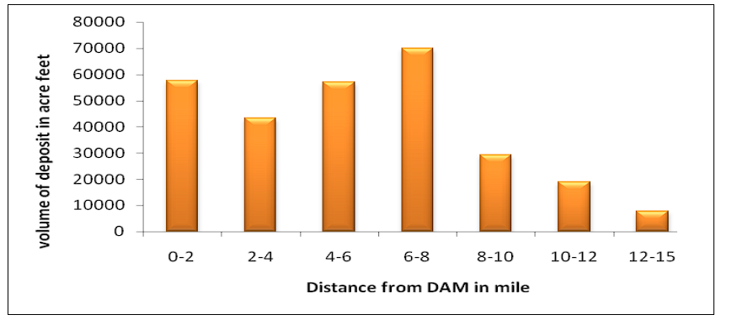
Fig 11: Distribution of sediment along LS of the Maithon Reservoir (DVC report-2020)
As per the longitudinal section of the Maithon Reservoir, the maximum deposit of sediment lies between 0-2km, 4-6km and the optimum between 06-08km (source .Sedimentation Report of Maithon Reservoir, Year 2019 p-87) (Fig 11)
2.6.7 Characteristics of the River Damodar:
The Barkar R. is in a mountainous range until it joins the river Damodar up to Maithon. As the river drops to the Maithon reservoir, there is a sudden decrease in flow area causing energy loss and gearing deposition on the reservoir bed. During flood, the sediment carried from upstream flow to downstream of the dam causes widening and braiding of the tributary channels being influenced by flood quantity, sediment load and flattened slope of the river.
3.0.0 Discussion.
WB is privileged with highly productive natural resources like Minerals, forests (including Mangroves), rivers coast and marine. Being located within India’s Gangetic delta, foot Hills of the Himalayas the people are confronted with many natural disasters like Torrential Rain, cyclones, floods and droughts, landslides, Norwesters and Kalbaisakhi etc. The Damodar River Basin,” the sorrow of West Bengal” whose flood is being moderated/ managed by DVC. For water management, there are interstate triparty issues between DVC, Jharkhand and WB. DVC is frequently criticised during floods in the Damodar R. The land of rivers is suffering regularly from floods and flash floods. They are

3.1.0 Conflict over Dam Release:
There is always discontentment between Jharkhand and WB about sharing and communicating after the 1978 water agreement when Bihar was. Undivided. The agreement needs reviewing and retaliation admitting the riparian rights of both the states. The conflict is continuing and also on the flood release of Maithon and Panchet Dams in 2024 where WB is aimed the high flood is manmade.
3.1.1 Fertility Status of Soil
Afforestation in DV: The Sedimentation retained behind the dam could not reach the flood plains of the LDVA. The river, distributaries and D/c channels are under sinking, shrinking soil degenerative conditions making the land infertile is the major problem in the lower Damodar
3.2.0 Ungauged mid-catchment from D/S Maithon & Panchet dams:

The Barkar R. contribute maximum inflow to the river Damodar, which is 4km from the Maithon Dam and the Panchet dam across the River Damodar. The outflow of both the dams and Power Houses (PHs) flows to the river and is later controlled by a diversion barrage at Durgapur which is about 80km d/s of the dams. However, the ungauged Khudia R. of a catchment area of about 2995 km2 decants before the barrage.

Downstream of the barrage till outfall of the Rupnarayan River, there exists a patch of ungauged and uncontrolled catchment of 2460Km² which can add variable floods up to 6000Cum at the d/s of the two dams, when the basin receives torrential rain from BoB disturbances. Since these ungauged catchments are wild and uncontrolled, pertinent structures can be constructed and used for Irrigation (Banerjee et al, 2021[27]).

These ungauged catchments aggravate flood concerns in the LDVA as in the Mahanadi system after the Hirakud dam. There is a necessity for a dam in the D/S where Roop Narayan joins the Damodar R. or in the Khudia River to ameliorate flood in the Damodar system.
3.2.1 Sediment accrues in DV dams:
The dams, Maithon and Panchet have silted up by ≈14%, lowering the dead storage capacity by ≈55% and live storage capacity by ≈33%. Rapid urbanisation, tidal swelling at confluence points of rivers along with anthropogenic intervention in the levees have constricted the cross-section of D/Cs, reduced the discharge capacity and are polluted by mines/ industries.
3.2.2 Inadequate Reservoir Capacity:
The original DVC water management plan envisages moderation of floods in the Damodar Vally can moderate peak flood of 28317cumec, through seven dams, to reach 7079cumec. Seven numbers of dams were to achieve these reservoirs having a total flood storage of 3598MCum. But during execution. Five dams of storage capacity 1863 MCum were constructed with Durgapur canal (2500Cum) by a diversion Barrage but failed to cater to adequate land acquisition in cases of Maithon and Panchet reservoir. About 1291 MCum flood storage capacity could be created lagging by 64% which may be apocalyptic in future (101 reporters.com Chatterjee 2024[28]);

3.2.3 Construction of Thermal Power Plants (TPPs)
The construction of a 5000MW of Thermal Power Plant (TPP) by DVC between 2007-2017 has raised many conflicting and interstate legal, social, political and economic issues between the DVC and native states Jharkhand and WB related to pollution, floods, water management and structural issues. Several mines and industries grew in the valley polluting the river water.

3.3.0 Modern methods of design and planning
All the DVC dams were designed during the pre-independence period which is ≈70 years before the present. The design fails to be done with modern software, Survey instruments, GIS technology modern dam construction equipment, etc. Moreover, the population of Jharkhand and WB during 1951 was 11.6 million and 26.3 million and during 2024 it is about 100 million and 40 million. From urbanisation, irrigation, industrialisation and deforestation issues have cropped up. The construction methodology, electrical and electronic applications and quality of the material were not at par with modern standards as of date.

4.0.0 Ameliorative action plan for water management:
The Water Management action plan chalked for LDVA without environmental Impact analysis is as follows:
(a). Land acquisition of the Maithon and Panchet dams is to reinitiated to surge flood volume moderation, more hydel generation and increase in Municipal and Industrial uses.
(b) Sedimentation of D/Cs needs renovation and restoration in the LDVA with structural & non-structural measures. By flood plain zoning, flood routing or moderation, flood fights, and, rehabilitation etc. Well-judged reservoir operation rule formation, proper catchment treatment plan, de-sedimentation of reservoirs to augment storage and water management of the DVC dams and reservoirs.
(c) The DPR of DVC in 2012 approved by CWC, about the proposed reservoir at Bal Pahari project that can have live storage of 715.61 MCM, availability of 414.81 MCM water for Municipal and Industrial (M & I) use, and shall create 35,478 Ha of land for Irrigation during the life span of the new project (Banerjee S. 2021[29]).
d) The life span of the five reservoirs has become old and the life span is for a few years only. It is essential to redesign the scope of the reservoirs and to fix a new zero level (as per IS 5477, part 2 -1994) to change the scope of the dam scopes, rehabilitate modern sophisticated hydraulic, electronic and electrical-mechanical (various gates, operation operandi, trash racks, pumps, gantry cranes, Hydraulic system, etc for the present operation system with available water by using Real-Time Data Acquisition System (RTDAS) and Real-Time Decision Support System (RTDSS) as per the Dam Rehabilitation & Improvement Project (DRIP) of initiated by Govt. of India
(e)The water use and Reservoir operation must be rationalised, well planned, and adaptation of water allocation principles etc. for a stabilized balanced water use.
(f) Floods perturb the prevalent cropping pattern and yield from the area. Food security and availability of drinking water are disturbed by floods, particularly by vulnerable groups. It is essential to give education, skill training, and disaster management practices to the focused target group with self-sustenance.
(g) The mitigation measures to the lower reaches of DVPA from floods include identification of vulnerable points debris removal, embankment stabilization, adequate hydraulic structures, plantations, removal of water hyacinth and ipomoeas, and spoil bank design along old breech zones to restore the river’s natural flow (Joshi et al, 2017[30], Dutta et al, 2025[31]),
(h). The flow for the LDVA after the construction of dams at different tributaries has shown significant changes in the flood magnitude(Low), frequency (high) and duration (more) after the operation of various dams. The pollution has surged due to the liquid waste and effluents inflowing into the Damodar River at its lower reaches. It is proposed to have more dams at Chhrawa, Bal Pahari, Gonda, Bokaro and Bermo, prioritizing Bel Pahari on Barker River
5.0.0 Overall inferences:
Increased amplitude of rainfall, river flow, deforestation and anthropogenic interventions have geared recurrent flood and landscape alterations in the LDVA. The urbanisation, Industrialisation and over-exploitation of the resources of the basin have changed the riverine environment and the ecosystem of the area. Food security, landscape changes, marginalisation, flood risk mitigation, and climatic changes, have become challenging as DVC authorities could not ameliorate the odds occurring in the lower Damodar basin (Mishra et al, 2020[32]).
As LDVA is a critically flood-prone zone it is essential to have effective use of available flood quantum by optimisation and maximization of positive flood Integration aspects through Self-help groups (SHGs), local communities, MSME and particularly involving the women communities. It is pertinent to introduce non-structural measures like land and water management to mitigate adverse impacts of floods and landscape alterations (Mishra et al, 2024[33].
The mining activities and urban-industrial growth in the valley have deteriorated the river's health and alteration in the water quality has endangered aquatic fauna. The water hyacinth and Ipomeas have changed fish diversity, societal tranquillity and community structure, Mishra et al 2024[34].
6.0.0 Conclusion
The Damodar Valley Project (DVP), harms the hydrological, morphodynamical, environmental, and ecological sustainability of the Lower Damodar Basin Area in West Bengal. The worst sufferer is the Damodar Valley vulnerable group (Mothers, children, geriatrics and multimorbidity patients and women.
Some innovative flood management action plans along with structural measures like Dam operation strategies, like flood routing, forecasting, diverse cropping, marginalisation, and capacity building through community participation are to be prepared and implemented successfully through community-based approaches, public awareness, reclamation and renovation of embankments, drainage and canal sections.
There should be effective coordination between the Government and the people, early warning, and short- and long-term modalities to combat flood, and drought through Corporate Social Responsibility (CSR) programs such as Social Integration Programme (SIP), active women participation, and job creation. Timely recording data, modern analysis, well-judged water management plans and community involvement only can mitigate cataclysms caused by the environmental flow impacts of the Damodar basin and environmental Impact Assessment (EIA) studies which were not done during the planning stage.
Disclaimer (Artificial intelligence)
Option 1:
Author(s) hereby declare that NO generative AI technologies such as Large Language Models (ChatGPT, COPILOT, etc.) and text-to-image generators have been used during the writing or editing of this manuscript.
Option 2:
Author(s) hereby declare that generative AI technologies such as Large Language Models, etc. have not been used during the writing or editing of manuscripts. This explanation will include the name, version, model, and source of the generative AI technology as well as all input prompts provided to the generative AI technology.
Reference:
- Islam R, (2018). Analysis of Drainage System of West Bengal. JETIR, 5(8 ), 1-3.
- Das, G.K. (2024). River Systems of West Bengal: Water Quality and Environment. In: River Systems of West Bengal. Springer Water. https://doi.org/10.1007/978-3-031-53480-5_1
- Bera S., Ahmad M, Alisha Prasad, (2018). Multi-Criteria Analysis for Flood Risk Assessment using Remote Sensing & GIS Technique-A Case Study of Damodar River Basin.https://imanagerpublications.com/assets/htmlfiles/JFET14%281%29August- October201815256.html
- Chattopadhyay, S, Acharya R., and Sen A. K. (2020). Analysis of Rainfall Trends in Damodar Valley Area. Vayu Mandal 46(2), 61-72.
- Sushanth, K., Behera, A., Mishra, A., & Singh, R. (2023). Assessment of Irrigation Demands Based on Soil Moisture Deficits Using a Satellite-Based Hydrological Model. Remote Sensing, 15(4), 1119. https://doi.org/10.3390/rs15041119
- Dasgupta, M., & Das, S. (2024). Extreme Flood Flow Routing for Panchet and Maithan Reservoirs of India Using Modified Puls Technique. Water, 16(5), 663. https://doi.org/10.3390/w16050663
- Mishra SP., Padhi S., Manna SJ., Mandol I. and Mondal T. (Mar. 2025). Fluvio-geomorphologic Analysis of Lower Ajoy River, West Bengal, India. CJAST, 44(4):66-90, DOI: 10.9734/cjast/2025/v44i44516
- Ghosh S., Mistri BR., (2015). Geographic Concerns on Flood Climate and Flood Hydrology in Monsoon-Dominated Damodar River Basin, Eastern India, 2015, Geographical Journal. https://doi.org/10.1155/2015/486740
- Ghosh, S., Guchhait, SK., (2016) Dam-induced changes in flood hydrology and flood frequency of tropical river: a study in Damodar River of West Bengal, India, Arabian Journal of Geosciences, 10.1007/s12517-015-2046-6, 9, 2, (2016).
- Ghosh, S., Kundu, S., (2023). Flood Risk Assessment and Numerical Modelling of Flood Simulation in the Damodar River Basin, Eastern India, Floods in the Ganga–Brahmaputra–Meghna Delta, 10.1007/978-3-031-21086-0_13, (303-349).
- WMO Tech Report, (2003). Integrated Flood Management Case Study, India: Flood Management – Damodar River Basin. The Associated Programme On Flood Management, 1-11
- Jharkhand Kolhan Ranchi, (2021). NGT imposed second-time penalties on DVC for derelict duties. News Desk, Tuesday, 3 August 2021, 22:23:27 IST
- Ghosh, S. (2014). The Impact of the Damodar Valley Project On the Environmental Sustainability of the Lower Damodar Basin in West Bengal, Eastern India (May 24, 2014). OIDA International Journal of Sustainable Development, 07(02), 47-54, 2014, https://ssrn.com/abstract=2441593
- Irrigation and Waterways Dept, WB. (1991 to 2023). Annual Flood report Irrigation and waterways West Bengal 1991-2023. https://wbiwd.gov.in/
- Mondal L., (2024). Experiences of Sufferings from Flood Hazard in Lower Damodar Basin, Eastern India – A Theorical Review. IJFMR, 6(3) 1-5, , May-June 2024
- Central Water Commission, (2020).Compendium on Sedimentation of Reservoirs in India. Wate shed & Reservoir Sedimentation, Directorate Environment Management Organisation Water Planning and Projects Wing, CWC.1-460.
- Hoque, M.M., Islam, A. & Ghosh, S. (2022). Environmental flow in the context of dams and development with special reference to the Damodar Valley Project, India: a review. Sustain. Water Resour. Manag. 8, 62 https://doi.org/10.1007/s40899-022-00646-9
- Bera s., Mistri B., (2014).Flood in the Lower Damodar Basin and channel morphology: a case study at the bifurcation zone into Damodar and Mundeswari River, West Bengal,
Intl J. of Geology, Earth & Env. Sci., 4(2),172-181, http://www.cibtech.org/ jgee. htm2014
- Kumar, S., Mishra, A., & Singh, U. K. (2023). Assessment of Land Cover Changes and Climate Variability Effects on Catchment Hydrology Using a Physically Distributed Model. Sustainability, 15(13), 10304. https://doi.org/10.3390/su151310304
- Mishra SP., Bauri B., (2024), Geo-sustainability Challenges and Remediation Strategies: A GIS-based Assessment of Sripur Coalmine Areas, West Bengal, India. September 2024Advances in Research 25(5):97-119, DOI: 10.9734/air/2024/v25i51142
- Damodar Valley Corporation (2020). Sedimentation Survey Report of Maithon Reservoir under NHP. Hydraulic data division, by Precision Survey Consultancy, “Vichitra” SP -45, (Kolkata West International City)
- Guhakarta P and Rajeevan M, (2008). Trends in the rainfall pattern over India. Int. J. of Climatology, 28(11), 1453-1469.
- Mahato, P.K., Prasad, K. & Maiti, P.R(2023). Assessment of long-term variability in rainfall trends over Damodar River Basin, India. Sustain. Water Resour. Manag. 9, 172. https://doi.org/10.1007/s40899-023-00941-z
- Mishra SP., Chandan Ku., Mishra, A., Mishra, S, (2022). Estimation of Sediments in Rengali Reservoir, Odisha (India) Using Remote Sensing, IJECC, 11(12):205-225, DOI: 10.9734/IJECC/2021/v11i1230572
- Panda S. R.; Barik K. K.; Mishra SP. (2020). Watershed Management of Joda-Barbil Mining Area, Odisha, India: A Geospatial Approach, CJAST, 39(31): 105-115, 2020; DOI:10.9734/CJAST/2020/v39i3130995
- Kalyan, R. (2018). State of India’s Rivers for India Rivers Week, SANDRAP, West Bengal), 1-28,
- Banerjee S., (2921). Damodar basin water management system - A review of critical issues and performance. ICOLD Symposium on Sustainable Dev. of Dams and River Basins, 24th - 27th Feb.. 2021, New Delhi
- 101 Reporters. (2024). Chatterjee S. (2024). Durgapur’s tale of sorrow has the Damodar Valley project at its centre. 22 Aug, 2024, Durgapur, West Bengal
- Banerjee S., (2021), Damodar basin water management system - A review on critical issues and performance. ICOLD Symposium on Sustainable Development of Dams and River Basins, 24th - 27th February 2021, 1-8, New Delhi.
- Joshi A., Mishra S. P., (2017), Anthropocene Effects on the River Daya and the Lagoon Chilika by the Effluents of Bhubaneswar City India: A physicochemical study, Int. J. of Adv. Res., 5(10), 1370-1384, http://dx.doi. org /10.21474/IJAR01/5656
- Dutta, A., Karmakar, S., Das, S., Banerjee, M., Ray, R., Hasher, F. F. B., Mishra, V. N., & Zhran, M. (2025). Modelling the River Health and Environmental Scenario of the Decaying Saraswati River, West Bengal, India, Using Advanced Remote Sensing and GIS. Water, 17(7), 965. https://doi.org/10.3390/w17070965
- Mishra D. P., Mishra S. P.,(2020). Organic Farming: Paradigm Shift during Pandemic to 'Food Safety" Complying 'Food Security" in India; Annual Research & Review in Biology 35(10):63-74, (Oct- 2020); DOI: 10.9734/ARRB/2020/X
- Mishra S.P., Mishra D.P., Mohapatra S., (2024). Women empowerment gaining right trajectory: a perspective from MSME, Odisha, India. Journal of Economics, Management and Trade, 30(3),10-29, 2024; DOI: 10.9734/JEMT/2024/v30i31196
- Mishra, SP., Acharya B, (2024). “Environmental Health Impact Assessments and Eco-Modernity of Sukinda Chromite Ultramafic Belt, India”. JSRR, J. of Sci. Res. and Reports 30 (11):115781. https://doi.org/10.9734/jsrr/2024/v30i112643.

