Stress and Deformation Analysis of Additively Manufactured Spur Gears Using Directed Energy Deposition (DED)

ABSTRACT

Gears are the most fundamental way of transmitting power from one shaft to another shaft accurately. Over the years no other methods have proven that much accurate and efficient. To make sure that the gears are in proper working condition, it is very important to understand the basic methodology used for the manufacturing of gears. This study presents a comprehensive stress analysis of spur gears manufactured through additive manufacturing using Ti-6Al-4V, Inconel 625, 316 Stainless Steel concluding whether they are feasible to manufacture providing the desired properties can also be achieved.
For manufacturing of spur gears, the Direct deposition Energy Method is employed, which is a type of technique used in additive manufacturing. After manufacturing, the gear stress analysis can be performed using Theoretical, Experimental and Finite Element. This work includes the theoretical and Finite Element methods as experimental methods are costly and time-consuming.
Finite element analysis (FEA) is conducted to evaluate root bending stresses, and tooth deformation under identical load conditions for each material to verify the adopted manufacturing approach. The findings reveal that the root bending stress is nearly similar in all three gears as it depends on tooth geometry and tooth deformation is least in case of 316 Stainless steels followed by Inconel 625, Ti-6Al-4V. The additive processes enhanced weight-to-strength ratios and improved overall efficiency.
This study is focused on the growing need for lightweight, high-performance gears in Advanced industries like aerospace and automotive. Traditional gear manufacturing methods, while accurate, are limited in material efficiency and design flexibility. By exploring additive manufacturing using the Directed Energy Deposition (DED) method and analyzing materials such as Ti-6Al-4V, Inconel 625, and 316 Stainless Steel, the research evaluates the structural feasibility and performance of spur gears. The use of theoretical and finite element analysis helps validate this approach, offering insights that support the Adoption of AM for critical gear applications.

Keywords: Stress analysis, Finite Element Analysis (FEA), spur gears, Additive Manufacturing, 3D Printing

INTRODUCTION

Spur gears are considered highly reliable components in power transmission systems due to their ease of manufacturing and high efficiency. Due to their exceptional reliability and compact design, gears play a dominant role in mechanical power transmission systems [1].
Traditionally, spur gears have been produced through subtractive manufacturing techniques such as hobbing, milling, and grinding, using materials like cast iron, stainless steel. The traditional methods offer ease of manufacturing [14]. With a suitable combination of strength, ease of machining, and affordability, these materials are well-suited for typical industrial uses. However, with growing demands for higher performance, rapid manufacturing, lightweight components - particularly in aerospace, automotive, and defense sectors - traditional approaches have come across limitations in terms of material capabilities and design flexibility.
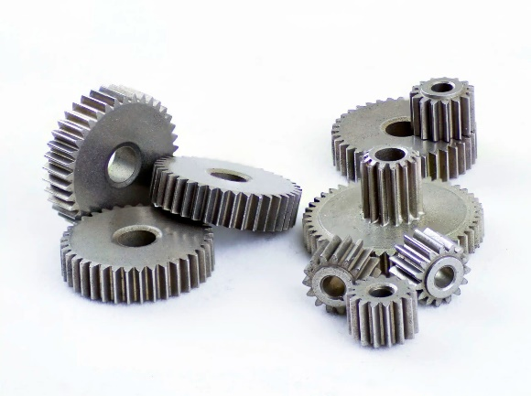
Fig 1. Spur Gears
The recent advancements in additive manufacturing (AM) technologies have opened a new path for producing complex geometries with enhanced material properties [14]. Unlike conventional methods, additive manufacturing builds components layer-by-layer, allowing access to intricate designs and transmission efficiencies that were previously difficult to achieve. Furthermore, the development of advanced metal composites, such as Ti-6Al-4V, Inconel 625, 316L Stainless
Steel, has introduced materials that combine high hardness, low density, and exceptional mechanical strength, presenting a significant leap in gear material engineering.
Stress analysis is a critical aspect of gear design, as gears are subjected to loads that can lead to bending stresses at the tooth roots and contact stresses at the meshing surfaces [7]. Finite Element Analysis (FEA) offers an effective tool to evaluate these stresses under simulated operating conditions, enabling a detailed understanding of the gear's mechanical performance before physical prototyping [5]. FEA works differently depending on the geometry being analyzed. In recent trends, designing gear becomes a highly complicated objective, so it must be accurate and sturdy [13].
Designing of spur gears using equations and performing the analysis part using software has been of current relevance as it saves time and cost both. [15].
Selection of materials for manufacturing any component is very important. The properties imparted in the spur gear completely depend on the materials being used for its manufacturing. Cast iron gives high impact resistance, Stainless Steel provides high thermal resistance, Aluminum and Titanium provide weight benefits. Likewise, different materials give different properties, and that is why three different materials are used for our analysis.

316 Stainless Steel is a highly useful material in aerospace and nuclear industries due to excellent formability, corrosion resistance and mechanical properties over a wide temperature range. For manufacturing of 316 Stainless steel, the Laser Power Direct Energy Method (LP-DED) is used [12]. The spur gear after being manufactured undergoes post-manufacturing treatments of stress relieving (899° C/2 h), hot isostatic pressing (1163°C/3 h under 103MPa) and solution annealing (1100°/2 h) followed by surface machining [12].

Ti-6Al-4V is an α + β titanium alloy known for its low density, impressive yield and tensile strength, outstanding resistance to corrosion, and excellent biocompatibility [17]. Directed Energy Deposition (DED) is typically performed in an inert atmosphere, commonly using argon gas, where oxygen concentrations are carefully maintained below 5-10 parts per million (ppm) [11].

Inconel 625 is a nickel-based super alloy that gains its strength through solid solution hardening, primarily due to the presence of refractory elements like niobium and molybdenum within a nickel-chromium matrix [18]. It is utilized across various industries for specialized applications, operating effectively in a wide temperature spectrum from cryogenic conditions below -150°C to high-temperature environments exceeding 1000°C. [19].

The conventional manufacturing methods use traditional materials that impose limitations on the design and manufacturing of mechanical components such as spur gears. It is very difficult to produce intricate shapes using conventional methods, and if we still want to manufacture the cost of manufacturing will not be justified. Our work proposes a different viewpoint towards the existing methods. In our work, we have utilized different materials like Ti-6Al-4V, Inconel 625, 316 Stainless Steel for the manufacturing of spur gears using the DED Additive manufacturing technique. This advanced manufacturing method will give a different approach for manufacturing of spur gears and mass production can be achieved, which is difficult with traditional ways to achieve. There are works available in this area, but they are limited to practical application part in real life scenario, our work may put an inspiration for practical application part also.

ADDITIVE MANUFACTURING

Additive Manufacturing (AM) is a modern fabrication method that constructs components layer by layer using digital 3D models as a guide [20]. Also referred to as rapid prototyping or freeform fabrication, AM creates three-dimensional structures by precisely depositing ultra-thin layers of material in succession In subtractive manufacturing the desired component is achieved by removing the material using some tool but in AM no such type of tooling operation is required. Computer-aided design (CAD) software is used
to digitally model objects and generate .stl files, which break the design into extremely thin cross- sectional layers. These files direct the movement of a print head or nozzle that deposits material layer by layer, or they guide a laser or electron beam to selectively melt material within a powder bed. As each layer solidifies either by cooling or curing it bonds with the previous one, gradually forming a complete
3D object [20].

Fig 2. Data path for Additive Manufacturing

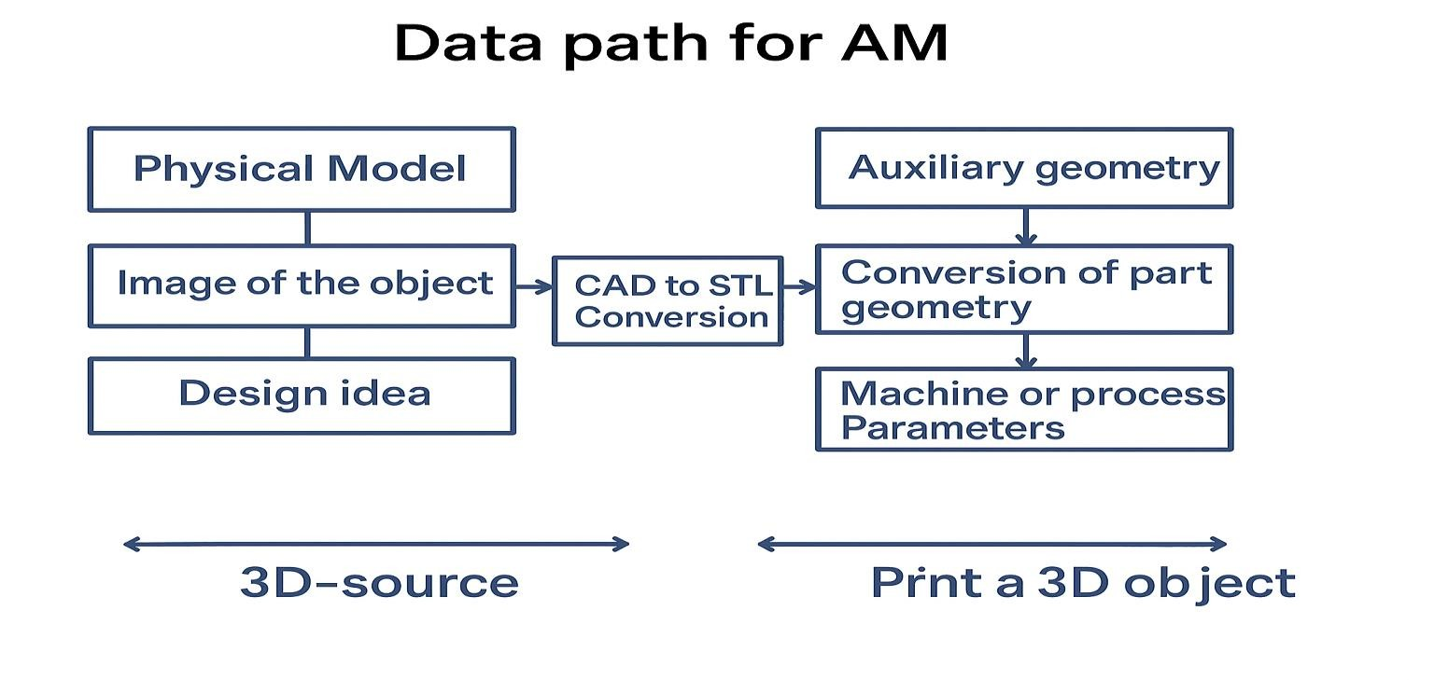

There are two basic methods of doing this:

1) Triangulation, which leads to the STL format

This method converts the 3D CAD model into a mesh made up of tiny triangles. Each triangle approximates the surface of the object. The final design is stored as an STL (Stereolithography) file. This is the most common file format used in 3D printing because it's simple and widely supported.
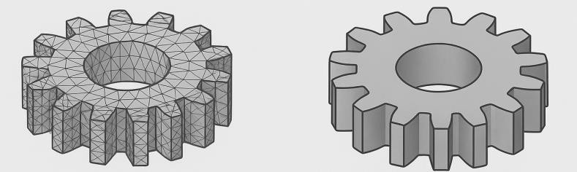
Fig 3. Triangulation, which leads to the STL format

2) Direct cutting within the CAD software produces the CL (SLI) file format

Instead of creating a triangular mesh, this method slices the 3D CAD model directly into horizontal layers within the CAD system itself. It generates CL (Contour Lines) or SLI (Slice) files, which contain the
exact paths or contours for each layer. This method can offer more precise control over the printing process.

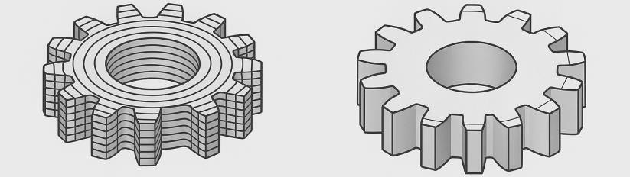

Fig 4. Direct cutting within the CAD software produces the CL (SLI) file format

CAD Model into STL Format

To 3D print any object, we first need to convert its CAD model into a format that a 3D printer can understand. One of the most common formats used is called STL (Stereolithography) uses triangles to describe the surfaces to be built. Each triangle is defined by three vertices along with a normal vector that points outward, representing the triangle’s orientation. This process of dividing a surface into small triangular segments is known as tessellation. Tessellation refers to the method of covering a surface using one or more geometric shapes in a way that ensures there are neither gaps nor overlaps. The shapes used can range from basic geometric forms to highly intricate and creative designs.
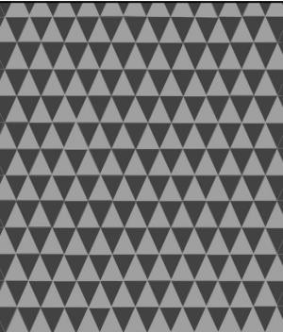

Fig 5. Tessellation

STL files come in two distinct formats:

ASCII (text): ASCII is human-readable but can become very large for complex models. The ASCII format is human-readable, meaning you can open it in a text editor and see the model’s details written out in
plain text, such as the coordinates of each triangle's vertices and its normal vector.

Binary (compressed): binary STL format stores the same information in a compressed, machine-readable way, resulting in a much smaller file size. This makes binary STL files faster for computers and 3D printers to process and more suitable for actual 3D printing tasks.

ASCII STL File Format

File starts with mandatory line:

Solid <name> File ends with mandatory line:
end solid<name>

The file stores information about the covering triangles. When tessellation uses numerous small triangles, the ASCII STL file size can grow significantly, which is why a more efficient binary format was developed.

For layer-based additive manufacturing, the 3D CAD model needs to be mathematically divided into layers that correspond exactly to the physical layers created by the AM machine. This process is known as “slicing”.

The slicing software translates the layered model into G-code, a series of commands that guide the 3D

printer’s movements and material deposition.
The 3D printer follows the G-code instructions to print the object layer by layer, usually from bottom to top using the specific Additive Manufacturing technique depending on the application of the component being manufactured.

Additive Manufacturing Techniques

In 2010, the American Society for Testing and Materials (ASTM) group “ASTM F42 – Additive Manufacturing”, formulated a set of standards that classify the range of Additive Manufacturing processes into 7 categories

1. VAT Photopolymerization: Vat photopolymerization is an additive manufacturing technique in which a model is constructed layer by layer using a vat of liquid photopolymer resin that solidifies when exposed to light. An ultraviolet (UV) light source emits wavelength at a rate of
355 - 405 nm, selectively cures the resin according to the CAD Model geometry. The curing process is driven by precise exposure parameters, such as exposure time of 5 - 15 seconds per layer and light intensity ranging from 10 to 20 mW/cm². The build platform gradually moves downward by a layer thickness ranging from 25 to 100 microns (0.025 to 0.1 mm), after each layer is solidified. Control parameters like resin viscosity 100 - 1000 centiPoise, ambient temperature around 25 - 30°C, and oxygen inhibition are crucial to ensure proper polymerization and high-quality surface finish.
Fig 6. VAT Photopolymerization

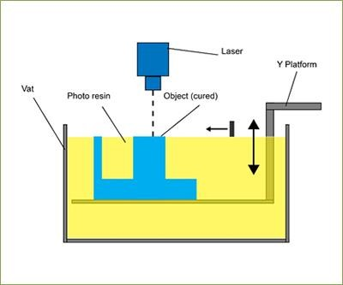
2. Material jetting: Material jetting is an additive manufacturing process that builds objects in a way like a two-dimensional inkjet printer, by depositing material layer by layer to form a 3D structure. This method involves depositing materials like photopolymers or wax onto a build surface by employing either Continuous Inkjet or Drop-on-Demand (DOD) technologies. The material is dispensed through nozzles at a resolution ranging from 300 to 600 dpi (dots per inch), forming successive layers with a typical layer thickness between 16 and 32 microns (0.016–
0.032 mm). UV lamps mounted near the print head immediately cure the deposited material, solidifying it layer by layer. The print head operates at a temperature range of approximately 70–
90°C to maintain the viscosity of the material generally between 10–20 centipoise. The build platform may also be maintained at a controlled temperature to ensure dimensional stability and adhesion between layers. Support materials are simultaneously jetted and later removed using water jets or chemical solutions.

Fig 7. Material jetting

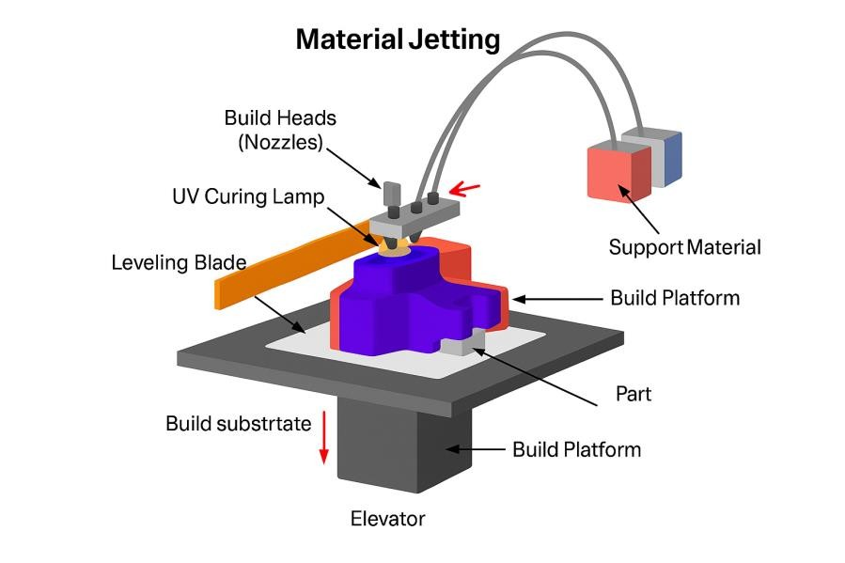

3. Biner Jetting: Binder jetting is an additive manufacturing technique that combines a powder material like metal, ceramic, or sand with a liquid binder, which serves to bond the powder particles layer by layer. The process starts by spreading a thin layer of powder between 50 and 200 microns thick, over the build platform. A print head then moves along the X and Y axes to selectively deposit the binder onto specific areas, according to the digital model. The binder droplet size usually ranges from 20 to 80 microns, with a droplet velocity of about 5–10 m/s. The binder saturation level (the volume of binder per volume of powder) is commonly set between 60% and 100% depending on the material and desired part density. Once a layer is finished, the build platform moves down by the thickness of one layer, and a fresh layer of powder is evenly distributed on top. The printed part is typically in a “green” state after printing and may
require post-processing, such as curing, sintering, or infiltration, to achieve its final mechanical properties.
Fig 8. Biner Jetting

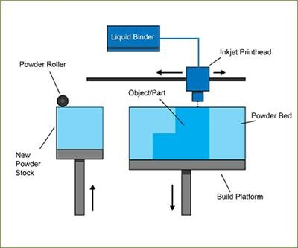

4. Material Extrusion: Fused Deposition Modelling (FDM), a widely used material extrusion process trademarked by Stratasys, involves the deposition of thermoplastic material in a layer- by-layer fashion to build 3D objects. A filament made of materials such as PLA, ABS, or PETG is drawn into a heated nozzle where it is melted at temperatures ranging from 190°C to 260°C, depending on the material. The molten material is pushed out through a nozzle, typically between 0.2 and 0.6 mm wide, and laid down on the build platform according to a specific, programmed route. The nozzle moves in the horizontal X-Y plane, while the build platform lowers incrementally in the Z-axis after each layer typically 100 to 300 microns thick (0.1 - 0.3 mm). Print speeds generally range from 40 to 100 mm/s, and the build plate may be heated to around 50 - 110°C to ensure good adhesion and reduce warping. This process is commonly used in low-cost desktop 3D printers for domestic and prototyping applications due to its simplicity and affordability.
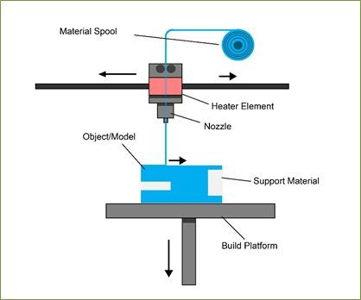
Fig 9. Material Extrusion

5.Powder Bed Fusion: Powder Bed Fusion (PBF) is an additive manufacturing technique where a laser or electron beam is used to selectively melt and fuse specific areas within a powder bed. In all PBF methods, a thin layer of powder material usually 20 - 100 microns thick is evenly spread across the build area using a recoating system such as a roller or blade. A hopper or powder container positioned next to or beneath the build platform provides new powder for each successive layer. Electron Beam Melting (EBM), which employs an electron beam for heating, operates in a vacuum environment ranging from 10⁻⁴ to 10⁻⁵ mbar and maintains elevated temperatures between approximately 600 and 1000°C. It is commonly used with metals and
high-performance alloys to produce fully dense, functional parts. Direct Metal Laser Sintering (DMLS) and Selective Laser Melting (SLM) both use a high-powered fiber laser, 200 - 400 W to selectively fuse metal powders. In DMLS, powders are sintered heated just below their melting point - while SLM fully melts the powder. Both processes operate under an inert gas atmosphere nitrogen or argon to prevent oxidation. Selective Heat Sintering (SHS) differs from laser-based methods by using a heated thermal print head, usually operating between 120°C and 200°C, to selectively fuse polymer powders such as nylon.
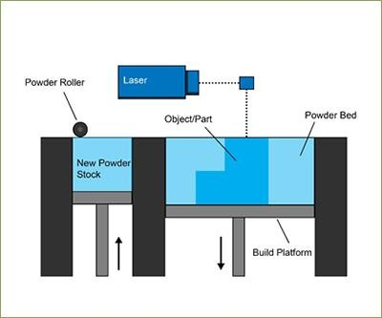
Fig 10 . Powder Bed Fusion

6. Sheet Lamination: Sheet lamination includes methods like Ultrasonic Additive Manufacturing (UAM) and Laminated Object Manufacturing (LOM). UAM bonds thin metal sheets or ribbons such as aluminum, copper, stainless steel, and titanium using ultrasonic welding at frequencies around 20 kHz with amplitudes of 20 - 40 microns. The process operates at low temperatures below 500°C to avoid melting and enables the creation of complex internal geometries. Post-welding CNC machining or removal of unbonded metal is often necessary. UAM efficiently bonds dissimilar metals and consumes relatively low energy. LOM builds parts by stacking and bonding layers of adhesive-coated paper sheets, typically 100 - 200 microns thick. A heated roller applies pressure and heat ~100 - 150°C to bond layers, while a cross- hatching cutting pattern allows easy removal of excess material. LOM is primarily used for aesthetic or visual models rather than structural parts.
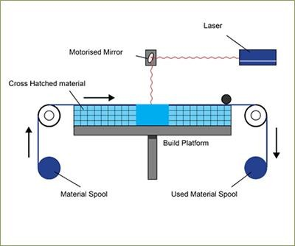
Fig 11. Sheet Lamination

7. Directed Energy Deposition: Directed Energy Deposition (DED) machines consist of a nozzle mounted on a multi-axis arm that deposits melted material onto a specified surface where it solidifies. Unlike traditional material extrusion, the nozzle can move freely in multiple directions commonly 4 or 5 axes allowing material to be deposited from various angles. The feedstock, available as metal powder or wire, is melted upon deposition using a focused laser
500 - 1000 W. The process operates with powder feed rates of 5 - 20 grams per minute or wire feed rates of 1 - 10 meters per minute. DED is primarily used for metals but can also work with polymers and ceramics. This flexibility enables precise repair, cladding, and near-net-shape manufacturing with complex geometries.
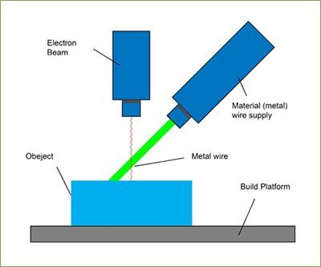
Fig 12. Directed Energy Deposition
Additive Manufacturing presents various techniques which can be utilized for spur gear manufacturing. Each technique has its own pros and cons & it totally depends on the application part which manufacturing technique should be used. For our work we have considered the Direct Energy Deposition technique as the most useful because of the versatile nature of this technique with different types of metals and non- metals. The properties achieved by this technique is quite good. Spur Gears are under the impact of sudden loading hence they are needed to be tough to bear that impact. With DED Technique 50-55 HRC hardness can be achieved very easily. Moreover, DED technique requires less skilled labor as it is controlled via Computers. The required to produce gear is less and mass production can be achieved.

Process | Materia l Type | Energy Source / Mechanism | Layer Thick ness | Build Platform Movement | Key Process  Parameters | Typical  Applications
Vat  Polymerization | Liquid  photopoly mer resin | UV light (355 -  405 nm wavelength) | 25 - 100  microns | Platform moves  downward after curing each layer | Exposure time: 5 -  15 sec  Light intensity:  10 - 20 mW/cm² Resin viscosity:  100 - 1000 cP Temp: 25 - 30°C | High-detail  prototypes, dental, jewelry
Material  Jetting | Photopoly  mers, wax | Inkjet - like  jetting + UV  curing | 16 - 32  microns | Platform lowers  layer by layer | Resolution: 300 -  600 dpi  Print head temp:  70 - 90°C Material viscosity: 10 - 20 cP | Full-color models,  prototypes, tooling
Binder Jetting | Metal,  sand, ceramic powders + liquid  binder | Nozzle deposits  liquid binder on powder | 50 - 200  microns | Platform lowers  after each layer | Binder droplet  size: 20 - 80 microns  Droplet velocity:  5 - 10 m/s  Binder saturation:  60 - 100% | Sand casting  molds, metal parts, ceramics
Fused  Deposition  Modeling  (FDM) | Thermoplas  tic filaments (PLA, ABS, PETG) | Heated nozzle  extrusion | 100 -300  microns | Platform lowers  after each layer | Nozzle diameter:  0.2 - 0.6 mm  Temp: 190 -  260°C  Print speed: 40 -  100 mm/s  Build plate temp:  50 - 110°C | Prototyping,  functional parts
Powder Bed  Fusion (PBF) | Metal,  polymer powders | Laser (200–400  W) or electron beam (EBM) | 20 - 100  microns | Platform lowers  layer by layer | EBM vacuum:  ~10⁻⁵ mbar; EBM  temp: 600 -  1000°C Inert gas (argon/nitrogen) atmosphere | Aerospace,  medical implants, tooling
Selective Heat  Sintering  (SHS) | Polymer  powders  (nylon) | Heated thermal  print head (120 -  200°C) | 50 - 150  microns | Platform lowers  after each layer | Thermal print  head temp: 120 -  200°C Layering with roller | Functional  polymer parts, prototypes
Sheet  Lamination  (UAM & LOM) | Metals (Al,  Cu, Ti, SS) for UAM; paper for  LOM | Ultrasonic  welding (UAM), adhesive & heat (LOM) | Sheets/rib  bons 20 -  150 microns  (UAM);  100 - 200 microns (LOM) | Platform lowers  after each bonded layer | UAM freq: ~20  kHz, amplitude 20  - 40 microns  LOM bonding temp: 100 - 150°C | Metal parts with  internal features (UAM); visual models (LOM)
Chart 1. Comparison of different AM Techniques
MANUFACTURING OF SPUR GEARS

Directed Energy Deposition (DED) is a form of additive manufacturing that fabricates components by melting material either in powder or wire form and depositing it layer by layer onto a substrate. This process is typically used with metals and is also referred to by various other names such as Laser Engineered Net Shaping (LENS), Direct Metal Deposition (DMD), Directed Light Fabrication, Laser Deposition Welding (LDW), and 3D Laser Cladding.
Among the various additive manufacturing (AM) techniques DED stands out as the most suitable method for fabricating spur gears using high-performance metallic alloys such as Ti-6Al-4V, Inconel 625, and 316 Stainless Steel because of its versatile nature for different range of materials including Metals, Ceramics, Nonmetals. Other Methods put their limitation on their application to polymers. With feed rates ranging from 5-20 g/min for powders or 1-10 m/min for wire, DED enables faster fabrication compared to Powder Bed Fusion (PBF), which is limited by recoating times and finer powder spreading. Binder Jetting produces parts in a “green state” requires post-processing (e.g., sintering or infiltration), DED can achieve near full-density parts directly during the build process. DED systems employ 4- or 5-axis deposition heads, allowing the creation of complex geometries and non-planar surfaces. This capability is especially advantageous for manufacturing precision gear profiles which are challenging to produce using techniques like Sheet Lamination or Material Extrusion (FDM) due to their limited resolution and planar layer-by-layer approach. With a laser power range of 500-1000 W and localized heat input, DED enables better control over the solidification rate and microstructure, minimizing thermal stresses and warping. EBM requires vacuum chambers and high temperatures (600–1000°C), making it more energy-intensive and less flexible for rapid prototyping. The material wastage is also less in case of DED Technique as compared to other methods.

In addition to building new parts from raw material often done using a hybrid system that combines additive manufacturing with CNC milling or turning DED is highly effective for repairing complex high-value parts like turbine blades or marine propellers. Most DED systems are large-scale industrial machines that require an enclosed and tightly controlled operating environment. The setup generally involves a multi-axis robotic arm fitted with a nozzle that precisely delivers the molten material onto the part surface, where it quickly solidifies.

Although the method shares similarities with extrusion-based 3D printing (like FFF/FDM), DED offers a greater range of motion. Unlike the three-axis movement typical in basic extrusion printers, DED systems can operate across as many as five axes, allowing for the creation and repair of more intricate geometries.

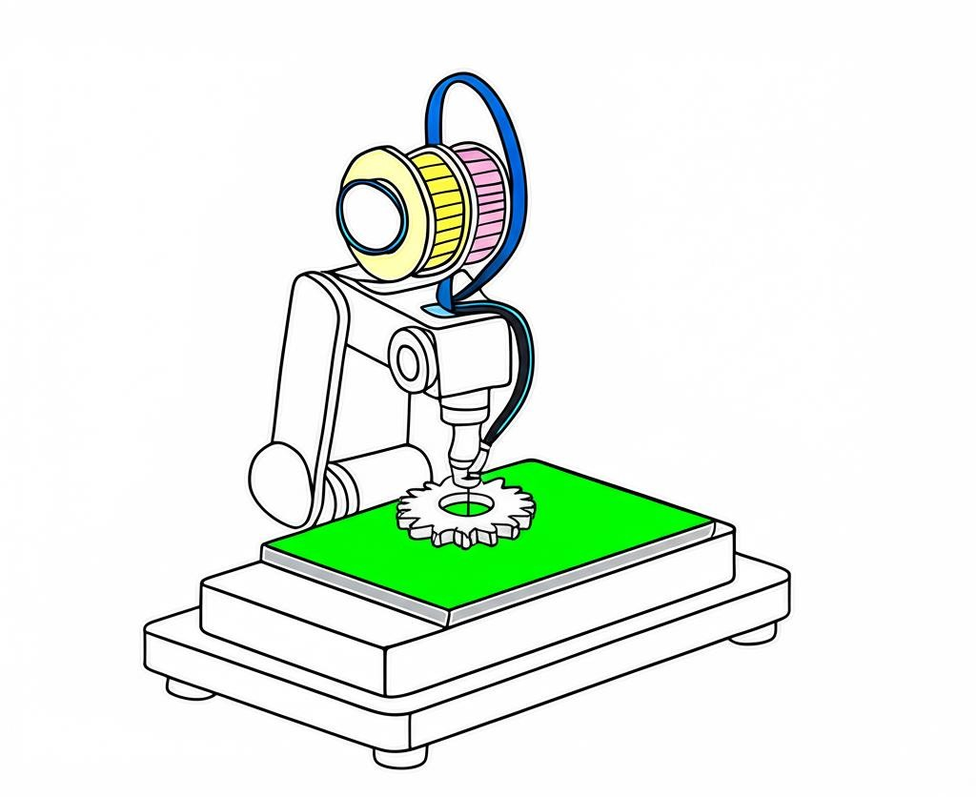

Fig 13. DED Manufacturing of Spur Gear
The method used for the manufacturing of spur gear of this alloy for our project work is Directed Energy Deposition which a highly efficient additive manufacturing process. In the DED process, a laser beam generates a molten pool where material powders are delivered through an inert gas usually argon and precisely injected to melt and solidify into a bead [9]. Once a single layer is completed, the laser and material delivery head moves upward along the Z-axis by a predetermined vertical distance, after which it proceeds to construct the next layer in the same manner [10]. The Directed Energy Deposition (DED) process typically takes place in an argon- filled inert atmosphere, maintaining oxygen levels below 5-10 ppm. Any powder that is not used during deposition can be collected and reused [11].
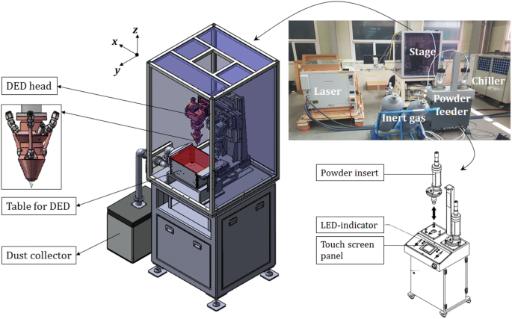
Typical DED Machine [21]

Procedure for Fabricating a Spur Gear Using DED

- CAD Design of Spur Gear
The initial step involves creating the model of spur gear using SolidWorks software. It can be done by creating a model from scratch or applying reverse engineering on already existing product to scan the product parameters and then create a 3-D CAD model with that information. The gear parameters, including number of teeth (18), pitch diameter (180 mm), pressure angle (20°), and tooth profile (full depth involute), are defined.
- Slicing and Tool Path Generation
The 3D model is sliced into 2D layers of 0.3-1.0 mm depending on material and resolution needs, using a CAM software such as Siemens NX or Autodesk Power Mill. Slicing is an important perimeter in determining the thickness of layer being deposited during printing. A tool path is generated to guide the deposition head in building the geometry layer-by-layer. Layer Thickness for Ti-6Al-4V varies in the range 0.3-0.6 mm.For Inconel 625 anD316 Stainless Steel it varies between 0.4 - 0.7 mm and 0.5 - 1.0 mm respectively.
- Substrate Preparation
A metallic substrate, often made from a material like the deposition metal, is fixed to the build platform. It must be cleaned and possibly preheated to ensure strong bonding and reduce thermal stresses. Preheat temperature ranges between 200° - 300°C, 150° - 250° C, 100° - 200° C for Ti-6Al-4V, Inconel 625, 316 Stainless Steel respectively.
- Material Feeding and Deposition
Metal powder or wire is continuously fed into the laser or energy source. The heat melts the feedstock and a small portion of the substrate, forming a molten pool where the material solidifies rapidly.
  - Deposition occurs layer by layer as the print head or build platform moves according to the generated toolpath.
  - In gear fabrication, particular care is taken in contouring the tooth profile with high accuracy, often using multi-axis systems.
Parameter | Ti-6Al-4V | Inconel 625 | 316 Stainless Steel
Laser Power (W) | 800–1200 | 900–1300 | 800–1200
Scan Speed (mm/min) | 300–600 | 250–500 | 300–700
Powder Feed Rate (g/min) | 5–10 | 7–12 | 6–10
Shielding Gas | Argon or Helium | Argon | Argon
- Monitoring and Cooling
Real-time sensors and closed-loop control systems monitor temperature, deposition rate, and geometry to ensure consistent quality. The cooling rated for all the materials should be slow to avoid residual stress and cracks on the surface. It will also help in improving the toughness of spur gear.
- Post-Processing
After deposition, the gear undergoes several post-processing steps:
  - Machining to improve surface finish and achieve dimensional tolerance.
  - Heat treatment to enhance hardness and mechanical properties.
From a design standpoint, the integration of CAD modeling, slicing, and toolpath generation
enables full digital control over the manufacturing process. Combined with the possibility of
post-processing such as machining and heat treatment this method delivers gears with high
surface quality and mechanical strength. These qualities make DED not only a viable alternative to traditional methods but a forward-looking solution for advanced applications in aerospace and automotive sectors.
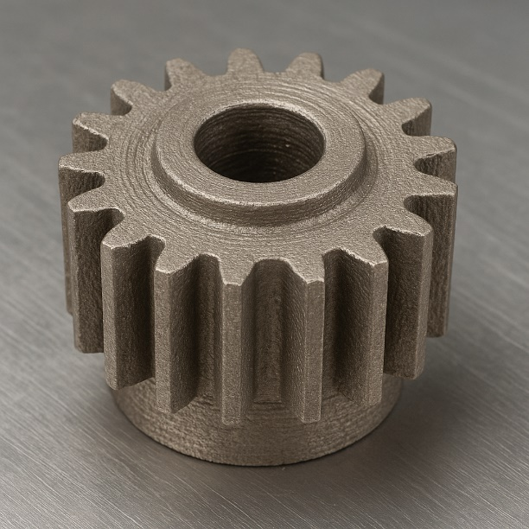
Spur Gear using AM Technique [21]

RESEARCH PROBLEM

Performance of spur gears are critically dependent on both the material properties and the manufacturing methods used in their production. Traditional subtractive manufacturing processes, such as milling and hobbing, predominantly employ materials like cast iron, stainless steel, which, while offering acceptable strength and cost advantages, impose limitations on
design complexity and weight optimization. These conventional materials also face challenges in high-stress, lightweight, or high-temperature applications where advanced performance is essential.

The rapid growth of additive manufacturing technologies and advanced composite materials such as Ti-6Al-4V, Inconel 625, 316L Stainless Steel presents new opportunities for producing gears with enhanced mechanical properties, complex geometries, and superior weight-to-strength
ratios. The practical stress-handling capabilities, long-term durability, and manufacturing

feasibility of these additively manufactured gears compared to traditionally produced gears remain underexplored.

Existing comparative studies often focus either on material performance or manufacturing methods independently, with limited integrated analysis considering both factors simultaneously under identical mechanical loading conditions. This gap in the current literature makes it difficult for engineers and manufacturers to make informed decisions regarding material and process selection for optimal gear performance.

Therefore, there is a clear need to conduct a detailed stress analysis on spur gears made using additive manufacturing. This will enable the identification of the strengths, limitations, and potential trade-offs associated with this approach, paving the way for the development of next- generation gear systems optimized for high-performance applications.
LITERATURE REVIEW

K Vigneshwaran, Dinesh Shanmugam, C Balasuthagar et. al. [1] analyzed the bending stress in spur gear pairs made of C15 Steel/CI30 and C45 Steel/CI30 through theoretical calculations and Finite Element Analysis (FEA). Replacing C15 steel with C45 reduces stress and enhances gear life due to its superior properties. Increasing the module from 2 to 7 lowers bending stress, making higher modules ideal for large power transmission.

M. Keerthi, K Sandya, K. Srinivas et. al. [2] analyzed that composite materials exhibit stress, deformation, and weight characteristics like structural steel, gray cast iron, and aluminum alloy spur gears and can be effectively used in automobile gearboxes as an alternative to cast steel gears. The natural frequencies of the analyzed materials exceed the critical frequency (41.66 Hz), confirming the design's safety.

R. Siva, K.A. Vimalson, P. Yogesh kumar, Nivin Joy, M. Sangeetha, Kaja bantha navas et. al. [3] examined Al-TiC composites with 5%, 10%, and 15% reinforcement, produced via the stir-casting technique, for use in spur gear applications. Mechanical testing—including tensile, impact, and hardness tests—showed that the composite with 15% TiC exhibited the superior properties. Due to its higher strength-to-weight ratio, the study recommends using Al-TiC15% composite for spur gear manufacturing over conventional materials.

Joginder Singh, Dr. M R Tyagi et. al. [4] studied the stress and deformation analysis of spur gears, a key component in power transmission systems, particularly in automotive vehicles. Using ANSYS software, the analysis is conducted on gears made from different materials, based on the torque specifications and dimensions of gears from three commercial car models in the Indian market.

D. Apparao, M. V.Jagannadha Raju et. al. [5] work aimed to manufacture a spur gear using the advanced technique of Direct Metal Laser Sintering (DMLS), focusing on the gearbox of a TATA Super ACE Mint vehicle and the gear is produced using maraging steel powder with optimized DMLS parameters, demonstrating the suitability of such gears for power transmission applications.

Mr. Manish Tiwari, Mr. Amit Ekka et. al. [6] Analyzed the root-bending stress and overall deformation of a spur gear employed in the gearbox of TATA Motors' commercial vehicles. The
gear, made of alloy steel, is analyzed under varying torque conditions using ANSYS Workbench. Analytical methods, including the cantilever beam concept and Castigliano’s theorem, are also employed to validate the results.

Nannan GUO, Ming C. LEU et. al. [7] work aimed that additive Manufacturing (AM) has been researched for over 20 years and builds 3D parts directly from CAD models by adding material layer by layer, unlike traditional subtractive methods. This allows the creation of complex geometries and materials.

Tugce Tezel et.al. [8] examined the 420 steel gears produced by both conventional and additive manufacturing processes under identical test parameters and compared them to each other. It was observed that gears manufactured through additive methods exhibited density and hardness comparable to those produced using conventional hobbing techniques; however, their surface characteristics differed significantly.

N. Rajesh et. al. [9] discussed the advantages of 3d printing. Modeled an automobile wind wiper gear using Autodesk Fusion 360 and used the Fused Deposition Modelling process for printing the gear. Used Polylactic acid material to print the gear and found operable speed.

Ye Zhang et. al. [10] examined that the choice of printing parameters has a significant influence on the dynamic behavior of gears. The four key parameters identified were printing temperature, printing speed, bed temperature, and infill density. Optimization of these factors led to a threefold improvement in gear performance.

Mary Kathryn Thompson et. al. [11] the success of engineering design to take the edge of the possibilities recorded by additive manufacturing technology. this paper presents the major opportunities for designs for additive manufacturing at show speed production for industrial applications outlines future challenges with promising direction for research in the additive manufacturing industry.
Timothy J. Horn, et. al. [12] this frame of reference explains the use of additive manufacturing for the fabrication of the variety of components and their functions, which was limited from the traditional edition.

Wei Gao. et.al. [13] This paper highlights the growing interest in additive manufacturing (AM) from both academia and industry, driven by its capability to produce complex shapes with tailored material properties. However, because of the wide range of AM technologies, there is currently no comprehensive set of design guidelines or standardized best practices. The objective is to consolidate existing knowledge on AM, outline key challenges and recent advancements, and emphasize future directions for researchers—particularly focusing on concepts like the emerging "print-it-all" paradigm.

Mostafa Yakout et. al. [14] discussed the key technologies for metal additive manufacturing. Surveyed additive manufacturing and found that FDM, DED, SLM, and EBM are widely used processes for metal fabrications.

Kapil Gupta [15] discussed various additive layer manufacturing techniques for fabricating gears using both metal and plastic materials. The study also covered multiple additive manufacturing methods, including Fused Deposition Modeling (FDM), 3D Printing, and Stereolithography (SLA), for gear production.
MATHEMATICAL FORMULATION

In this project effort is made to redesign a spur gear of Maruti Suzuki Brezza of 1462cc Engine. The engine used in vehicle is K15C Type, BSVI model. The specifications of the engine are as follows:
Fuel efficiency = 25.51 km/kg (Petrol Type)
Maximum Power = 74 kw @ 6000 RPM
Maximum Torque = 137.1 N-m @ 4300 RPM
Chart 2. Design Specification of Spur gear [5]

S. No. | Parameter | Symbol | Value | Units
1 | Module | m | 10 | mm
2 | Number of Teeth | Z | 18 | --
3 | Pitch Circle Diameter | d | 180 | mm
4 | Base Circle Diameter | Db | 169.145 | mm
5 | Outer Circle Diameter | Do | 200 | mm
6 | Clearance | -- | 1.57 | mm
7 | Thickness of Tooth | t | 15.71 | mm
8 | Face Width | b | 54 | mm
9 | Circular Pitch | -- | 31.4 | mm
10 | Pressure Angle | Φ | 20 | Degree

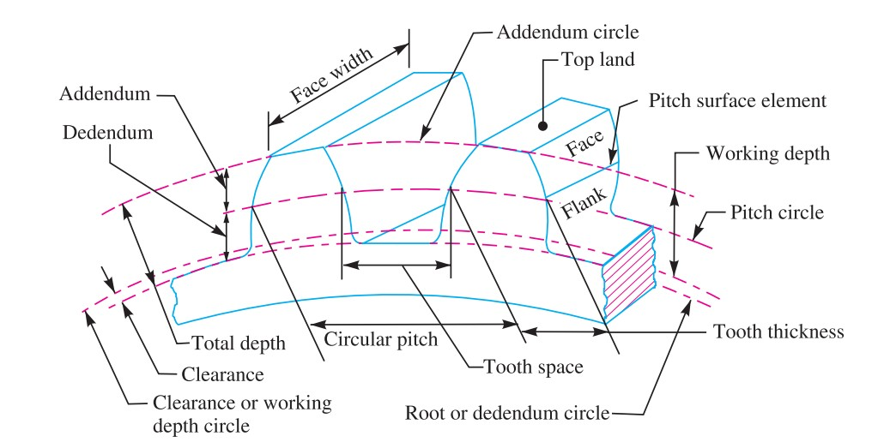

Fig 14. Gear Nomenclature [8]

Properties of Materials

Ultimate Tensile Strength (MPa) | 900
Yield Strength (MPa) | 829
Young’s Modulus (GPa) | 135
Poisson’s Ratio | 0.34
Table1 Properties of Ti-6Al-4V (stress relieved, HIPed, machined) [3]

Ultimate Tensile Strength (MPa) | 558
Yield Strength (MPa) | 248
Young’s Modulus (GPa) | 240
Poisson’s Ratio | 0.3
Table2 Properties of 316L Stainless Steel [4]

Ultimate Tensile Strength (MPa) | 733
Yield Strength (MPa) | 500
Young’s Modulus (GPa) | 207
Poisson's Ratio | 0.3
Table3 Properties of Inconel 625 [16]

CALCULATIONS

Torque(T) = 137.1 N-m = 137100 N-mm

N = 4300 RPM

Power (P) = (2 * 3.14 * 4300 * T) / 60

P = (2 * 3.14 * 4300 * 137100) / 60

P = 61704.14 Watt = 61.704 kw
Bending Stress Calculation

Lewis assumed that during the transmission of load between two gears, the entire load is carried by a single tooth, as it is not always reliable to assume load sharing among multiple teeth. The tangential component of the load (WT) generates a bending stress that tends to break the tooth, while the radial component (WR) produces a relatively small compressive stress, which can be considered negligible in its effect on the tooth [8].

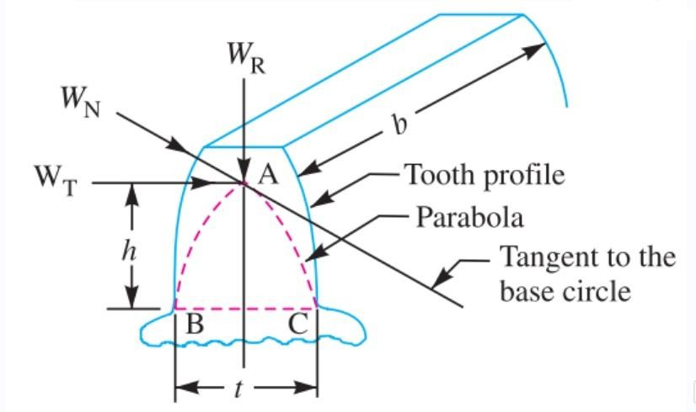

Fig. 15. Gear Tooth [8]

The bending stress is used as the basis for design calculations. In our work we have assumed WT = F for sake of convenience.
We know that bending stress at tooth tip is calculated using Lewis Bending Equation which is given by

Sb = F / (b* Y * m)

where,

Sb = Maximum bending tooth stress (N/mm² or MPa) F = Maximum transmitted load (N)
b = Face width of the gear (mm)

Y = Lewis form factor (accounts for tooth geometry)

m = Module (m or mm) Torque(T) = (F*d)/2
F = (2T)/d

F = 137100 / 90 =1523.33 N

For 18 teeth and 20 deg pressure angle, Y = 0.308 [2] Sb = 1523.33 / (54 * 10 *0.308) = 9.159 MPa
For Ti-6Al-4V (Annealed, Machined) [3] Su (Ultimate tensile strength) = 900MPa Considering a Factor of safety (F.O.S) = 3
Allowable stress = 300MPa > Sb

Hence, this design is safe.

For Inconel 625 (DED Manufacturing Technique) Su (Ultimate tensile strength) = 733 MPa [1] Considering a Factor of safety (F.O.S) = 3
Allowable stress = 244.33 MPa > Sb

Hence, this design is safe.

For 316 Stainless Steel

Su (Ultimate tensile strength) = 561 MPa [4] Considering a Factor of safety (F.O.S) = 3
Allowable stress = 187 MPa > Sb

Hence, this design is safe.

Tooth Deformation Calculation

Deformation of tooth is calculated using Castigliano's Theorem. Castigliano’s theorem is one of the energy methods (based on strain energy) and it can be used for solving a wide range of deflection problems [14].
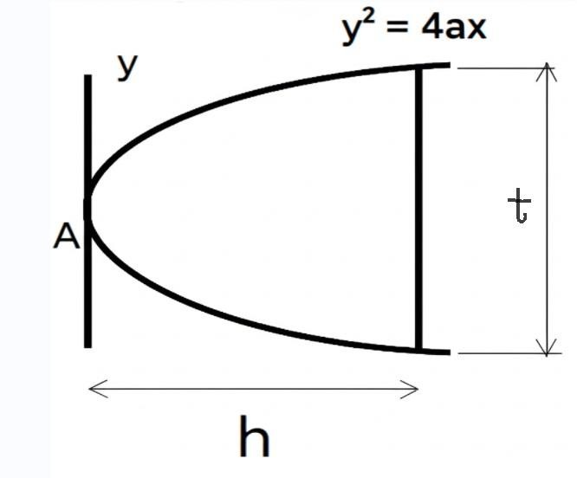

Fig. 16. ParabolicTeeth [14]

Castigliano’s theorem states that when a body undergoes elastic deformation under a system of loads, the deflection at any point "P" in given direction "a" is equal to the partial derivative of the strain energy (U) with respect to the applied load "F" in that same direction "a".

The theory applies to both linear and rotational deflections δ = δU/ δF
Castigliano’s theorem is used to determine the deflection at the point where a load is applied, specifically in the direction of that load
Strain energy is given by U = ∫ (M^2) / (2∗E∗I) dx
Consider the parabolic teeth of height ‘h’ and tooth thickness ‘t’

Equation of parabola is y^2 = 4 * a * x

At x = h, y = t/2

Equation of parabola becomes (t/2) ^2 = 4 * a * h
a = t ^ 2 / (16 ∗ h)
Thus, equation of parabolic teeth is y ^ 2 = (t ^ 2 / (4 ∗ h)) * x and y ^ 3 = (t/2) ^ 3 * (x/h) ^ 1.5
Thus, strain energy of teeth becomes, U = ∫ (M ^ 2) / (2∗E∗I) dx
M = Ft * x & I = b * (2 ∗ y) ^ 3 /12 = (2/3) * b * y ^ 3
U = ∫ ((P ∗ x) ^ 2) / (2 ∗ E ∗ (2/3 ∗ b ∗ y ^ 3)) dx
U = ∫ (3(P ∗ x) ^ 2) / (4 ∗ E ∗ (b ∗ y ^ 3)) dx
Substituting value of y ^ 3 we get
U = ∫ (12 ∗ P ^ 2 ∗ h ^ 1.5 ∗ x ^ 0.5) / (E ∗ b ∗ t ^ 3) dx
U = (8∗P ^ 2 ∗h ^ 3) / (E ∗ b ∗ t ^ 3)
Now by Castigliano's theorem

δ = δU/ δF
δ = (𝟏𝟔∗𝐏∗𝐡 ^ 𝟑) / 𝐄 ∗ 𝐛 ∗ 𝐭 ^ 3)
This is the expression for the maximum deflection of spur gear teeth tip when tangential load is

applied at the teeth tip

δ = (16 * F * L^3) / (E * b * t^3)

Where E = Young’s Modulus of material δ = (16 * F * L^3) / (E * b * t^3)
For Ti-6Al-4V

Young’s Modulus = 135 GPa

δ = (16 * 1523.33 * 13.33^3) / (135 * 10^3 * 54 * 15.71^3) = 0.002042 mm

For Inconel 625

Young’s Modulus = 207 GPa

δ = (16 * 1523.33 * 13.33^3) / (207 * 10^3 * 54 * 15.71^3) = 0.001322 mm

For 316 Stainless Steel

Young’s Modulus = 240 GPa

δ = (16 * 1523.33 * 13.33^3) / (193 * 10^3 * 54 * 15.71^3) = 0.001149 mm
MODELLING

Modelling of the desired spur gear is made using Solid Works toolbox feature. SolidWorks is a CAD software which allows an individual to create 3-D Models and allows simulation feature also.

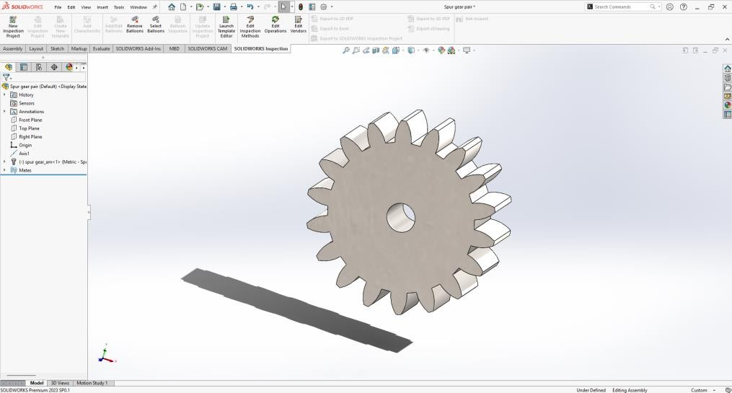
Fig 17. 3-D Models

SIMULATION

For simulation purpose Ansys Workbench 2025 R1 Software is used. Ansys Workbench is a tool which allows an individual to perform real life scenario analysis on differently designed components. The results obtained may not be 100% accurate but gives a good picture about the analysis we aim to perform. For our analysis we have considered a single tooth from the designed spur gear and assuming the tooth as a cantilever beam static structural analysis is performed on the gear tooth. Bending Stress (Equivalent Von-Mises Stress) and Tooth deflection (Total Deformation) are obtained after the analysis which is then compared with the mathematical values to cross check the accuracy of the analysis being performed.

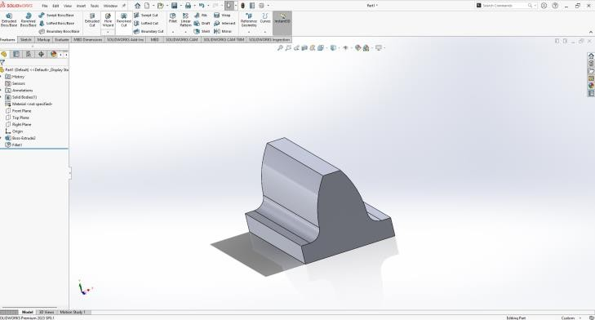

Fig 18. Bending Stress
STATIC ANALYSIS

The motivation which lies behind this analysis is to find out the bending stress and tooth deflection of spur gear within the allowable working limits otherwise the failure of gear is possible. After modelling the design in SolidWorks Software, it is saved in .IGES format which is then transferred to Ansys Workbench for stress analysis.

Boundary Conditions

Based on the assumptions of Lewis equation, the boundary conditions are set in ANSYS Workbench. A fixed support is applied at the base of the gear tooth, while the load is exerted on the tooth surface with components acting along both the Y and Z axes. Force of 1523.33 N is applied tangentially at the face of the tooth and then the stress and deformation limit values are observed.

Fig 19. Ti-6Al-4V

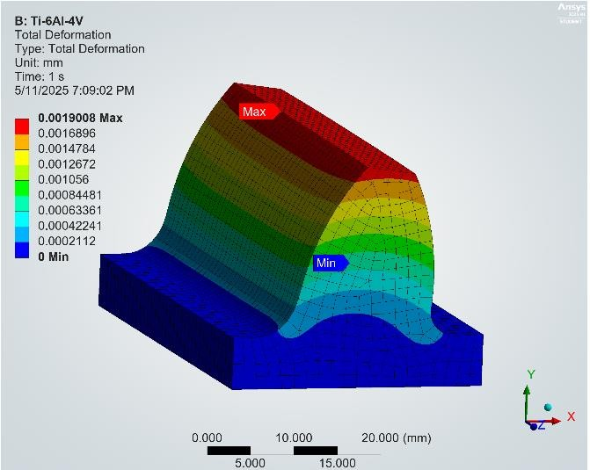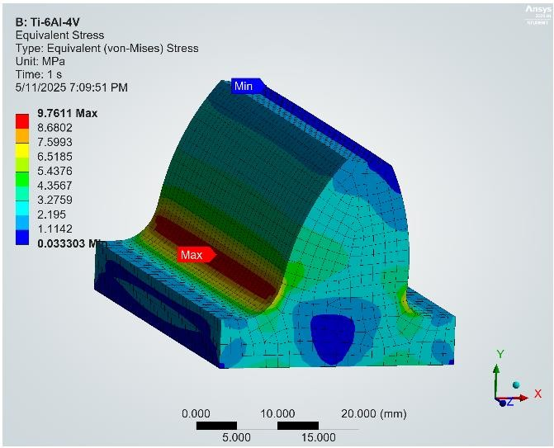

Equivalent Von-Mises Stress Total Deformation
Fig 20. 316 Stainless Steel

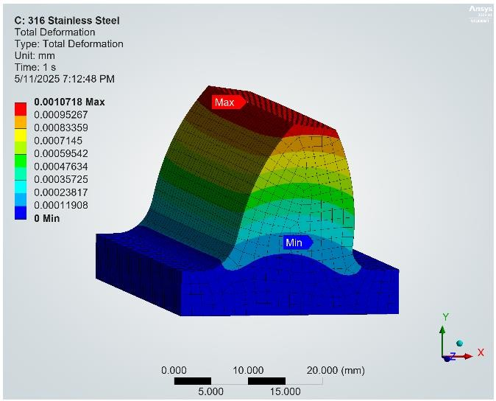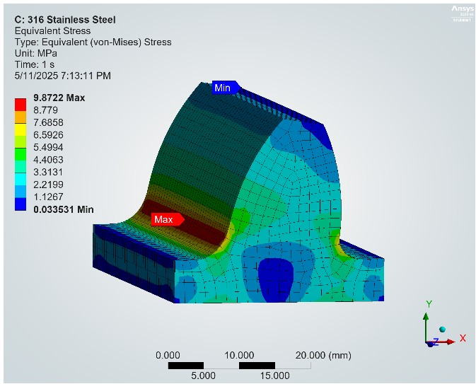

Equivalent Von-Mises Stress Total Deformation

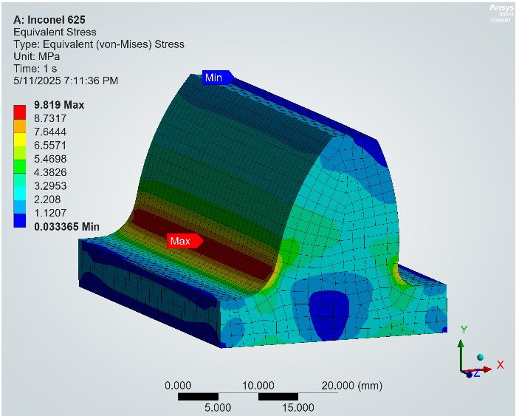fig 21. Inconel 625

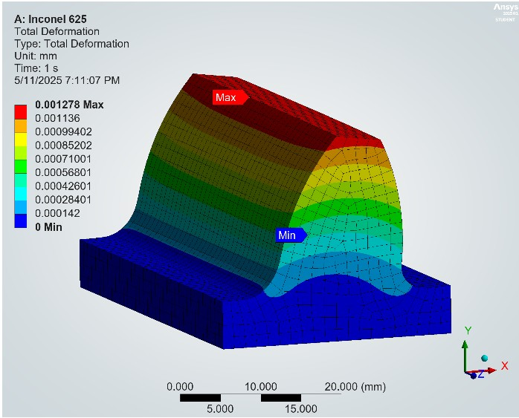

Equivalent Von-Mises Stress Total Deformation
RESULTS

S.  No. | Material | Theoretical  Equivalent Von- Mises Stress | FEA  Equivalent Von- Mises Stress | %Error in stress
1 | Ti-6Al-4V | 9.159 MPa | 9.7611 MPa | 6.16 %
2 | Inconel 625 | 9.159 MPa | 9.8190 MPa | 6.72 %
3 | 316 Stainless Steel | 9.159 MPa | 9.8722 MPa | 7.22 %
Table4 Comparison of Theoretical Bending Stress with Ansys Based Bending Stress

S. No. | Material | Theoretical  Tooth Deflection | FEA  Tooth Deflection | %Error in  deformation
1 | Ti-6Al-4V | 0.002042 mm | 0.0019008 mm | 6.91 %
2 | Inconel 625 | 0.001322 mm | 0.0012780 mm | 3.32 %
3 | 316 Stainless Steel | 0.001149 mm | 0.0010718 mm | 6.71 %
Table5 Comparison of Theoretical tooth deflection with Ansys Based tooth deflection

From the comparison of theoretical and FEA (Finite Element Analysis) results, it is evident that the analytical and simulation methods are in good agreement, with an acceptable percentage of error in both stress and deformation values. The results obtained after analysis suggest that it is feasible to manufacture a spur gear using additive Manufacturing which can have practical applications. Among the three materials studied: Ti-6Al-4V, Inconel 625, and 316 Stainless Steel, the value of bending stress is nearly the same for all three materials because bending stress depends on the geometry of the tooth which is similar in all cases. Tooth deflection depends on the material property (Young’s Modulus). The least value of tooth deformation in case of stainless steel suggests it has highest stiffness among all three materials, and it is suitable for impact loading applications. Though the tooth deformation in case of Ti-6Al-4V is highest it holds its application where weight optimization is our prime concern like in aerospace industries.

The results for different values of Torque 110 N-m, 125 N-m, 137.1 N-m, 140 N-m, 150 N-m have been obtained using the similar analysis that is being performed above. Bending Stress versus Torque and Tooth Deflection versus torque curves are plotted according to the results obtained for different values of torque.

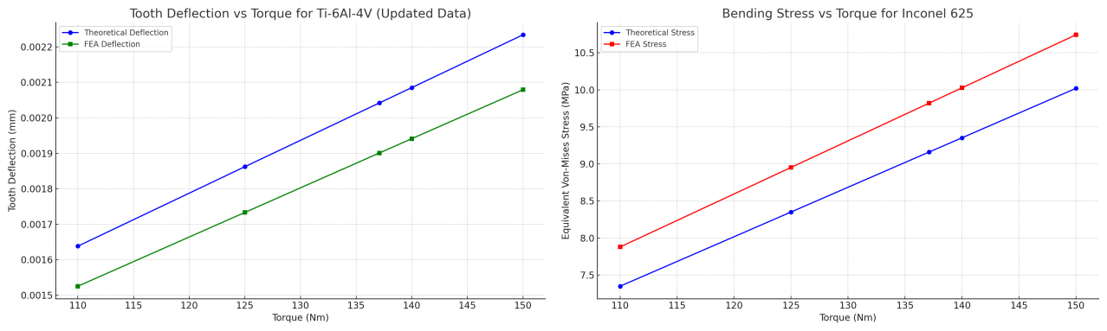

Fig 21. Inconel 625

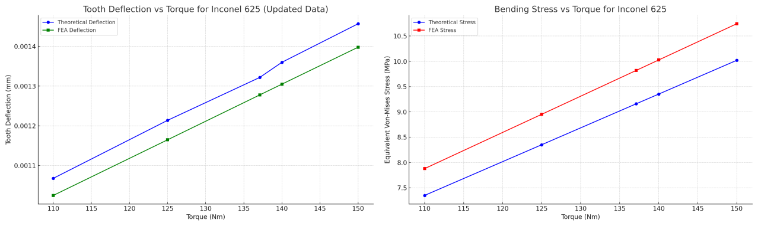

Fig 22. 316 Stainless Steel

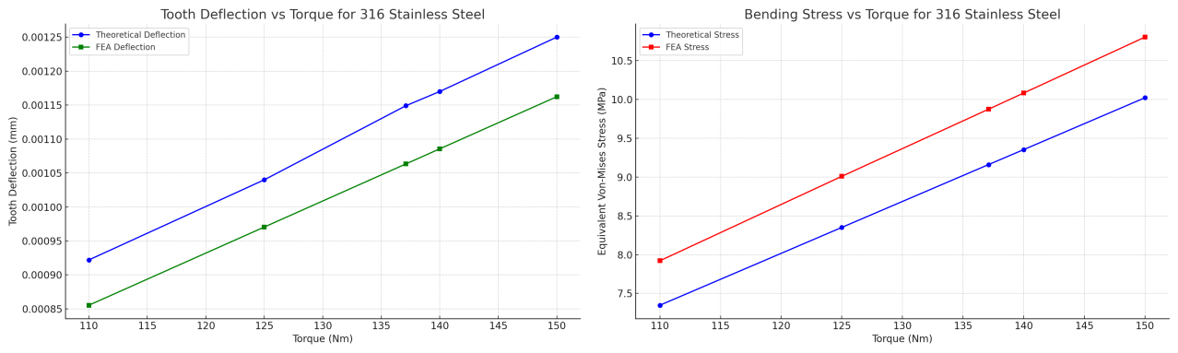
CONCLUSION

In the present work, the spur gear tooth is modelled in SolidWorks and same is analyzed in the Static structural domain of ANSYS software. The results are discussed in the preceding section, and it is concluded that, for the given design specifications, the maximum root bending stresses for three different materials are well within the safe limits, considering the factor of safety as 3. For the torque specification of 137.1 N-m @4300 rpm the root bending stress (Von Mises stress) is found to be 9.159 MPa. Future scope of this work involves the validation of results using experimental methods. Different AM techniques can also be used for manufacturing of different gears and comparing the results which is best method.

NO generative AI tools were used for the writing and no such image to text generators have been used for this work.

REFERENCES

1. Shubham A. Badkas and Nimish Ajmera ,“Static and Dynamic Analysis of Spur

Gear”,2016

2. “Design of Machine Elements by V.B. Bhandari”, Third Edition

3. Shunyu Liu, Yung C. Shin, “Additive manufacturing of Ti6Al4V alloy: A review”, 2018

4. Seungjong Lee, Reza Ghiaasiaan, Paul R. Gradl, Shuai Shao, Nima Shamsaei,“Additively manufactured 316L stainless steel via laser powder directed energy deposition (LP- DED): Mechanical properties at cryogenic and elevated temperatures”,2024
5. Joginder Singh and Dr. M R Tyagi, Analysis of Stresses and Deflections in Spur Gear,

2017

6. D. Apparao, M. V.Jagannadha Raju, “Design and Analysis of Spur Gear Manufactured by

DMLS Process”, 2020

7. Mr. Manish Tiwari, Mr. Amit Ekka, “Investigation and Structural Analysis of Spur Gear

Using Ansys”, 2019

8. “A textbook of machine design by R.S. Khurmi & J.K. Gupta” 2005 Edition

9. S.M. Thompson, L. Bian, N. Shamsaei, A. Yadollahi,“An overview of direct laser deposition for additive manufacturing”, 2015
10. Y.C. Shin, N. Bailey, C. Katinas, W. Tan, “Predictive modeling capabilities from incident powder and laser to mechanical properties for laser directed energy deposition”, 2018
11. R. O'Leary, R. Setchi, P. Prickett, G. Hankins, N. Jones, “An investigation into the recycling of Ti-6Al-4V powder used within SLM to improve sustainability”, 2015
12. Seungjong Lee, Reza Ghiaasiaan, Paul R. Gradl, Shuai Shao, Nima Shamsaei,“Additively manufactured 316L stainless steel via laser powder directed energy deposition (LP- DED): Mechanical properties at cryogenic and elevated temperatures”, 2024
13. K Vigneshwaran, Dinesh Shanmugam, C Balasuthagar, “Experimental and analytical stress analysis of spur gear”, 2020
14. Dr. K. Ramakotaiah, J. Koteswara Rao, CH. Sai Ganesh,“Comparative Analysis of

Additive Vs Conventional Manufacturing (Gear)”,2022

15. Tanmay Kotkar, Prashant Masure, Pundalik Modake, Chirag Lad, Basanagouda

Patil,“Modelling and Testing of Spur Gear made of Different 3D Printed Materials”,2018

16. S. Pratheesh Kumar, S. Elangovan, R. Mohanraj, J.R. Ramakrishna,“A review on properties of Inconel 625 and Inconel 718 fabricated using direct energy deposition”,2021
17. M. J. Donachie, “Titanium: A technical Guide”, second ed. ASM International, Material

Park, OH, 2004

18. G. P. Dinda, A. K. Dasgupta, J. Mazumder, “Laser aided direct metal deposition of Inconel 625 Superalloy: Microstructural evolution and thermal stability”, Mater Sci. Eng. A 509 (2009) 98-104
19. V. Shankar, K. Bhanu Sankara Rao, “Microstructural changes in alloy 625 during high

temperature creep”, Mater. Charact., vol. 59, no. 5, (2008), 508-513

20. “A Complete Guide to Additive Manufacturing”, textbook by R. B. Chaudary, K. Ravi

Kumar
21. Wan-Sik Woo Eun-Jung Kim, Ho-In Jeong Choon-Man Lee, "Laser-Assisted Machining of Ti-6Al-4V Fabricated by DED Additive Manufacturing”, 2020

