**Responsible AI for Cybersecurity: Assessing the Barriers, Biases, and Governance Gaps in Implementation with e-commerce Systems**

**Abstract***Building on the findings of Obioha-Val (2024), which reveal both the transformative potential of AI and the risks associated with unregulated or opaque implementation, this study investigates the responsible deployment of AI-driven cybersecurity systems in e-commerce by examining structural, ethical, and governance challenges. Using four open-source datasets, including the IEEE-CIS Fraud Detection Dataset, OECD AI Readiness indicators, the Stanford AI Governance Index, and the Global AI Ethics Guidelines Dataset, the study applies Principal Component Analysis, Logistic Regression, Weighted Scoring Models, and K-means clustering to evaluate adoption barriers and framework adaptability. Results show that only 40% of e-commerce firms are AI integration-ready, with SMEs particularly hindered by outdated infrastructure and limited workforce capacity. Algorithmic fairness testing revealed zero transaction flags under the applied threshold, raising concerns of underfitting and potential hidden biases. Ethical risks such as privacy violations, consent ambiguity, and algorithmic discrimination, particularly in pricing and service delivery, are highlighted as critical threats. Governance analysis ranked the UK highest (8.00/10), while 95% of firms lacked formal AI oversight structures. Cluster analysis indicated that only 30% of international AI frameworks sufficiently incorporate operational principles like security and human oversight. This study adapts the Obioha-Val framework originally applied in U.S. public school systems to the commercial e-commerce context, offering a recalibrated, sector-specific model of responsible AI governance. Recommendations include developing AI-specific cybersecurity protocols, integrating fairness auditing tools, harmonizing global standards, and investing in infrastructure and AI literacy for SMEs.*

**Keywords:**AI governance, algorithmic bias, e-commerce cybersecurity, K-means clustering, Principal Component Analysis.

**1. Introduction**

As digital commerce continues its rapid expansion, e-commerce platforms have increasingly become targets for sophisticated cyber threats. The proliferation of online transactions, real-time payment infrastructures, and behavioral profiling technologies has significantly elevated the urgency for comprehensive cybersecurity systems. Artificial Intelligence (AI) has been positioned as a pivotal technological tool in addressing these challenges, providing advanced functionalities in threat detection, fraud prevention, and automated incident response. Nevertheless, its application also introduces complex ethical, infrastructural, and governance-related dilemmas, particularly within e-commerce ecosystems where security breaches can affect millions of users instantaneously (Sikder & Allen, 2023).

The intensifying threat landscape in the e-commerce domain underscores the necessity for AI-based interventions. According to The Business Research Company (2024), the AI in cybersecurity market is projected to grow from $24.67 billion in 2024 to $30.79 billion in 2025, reflecting a compound annual growth rate of 24.8%. A compelling example of the sector's increasing vulnerability is reported by Rundle (2024), who states that Amazon detects over 750 million cyber threats daily, an alarming increase from 100 million earlier in the same year. Between April and September 2024, Sabin (2024) observed that over 560,000 AI-driven attacks were launched daily against retailers, including incidents involving account takeovers and transactional fraud. This surge is predominantly attributed to cybercriminals' growing use of generative AI tools, which have significantly enhanced the sophistication of these attacks.

In response, many platforms have adopted advanced machine learning models such as Retrieval-Augmented Generation (RAG) to detect fraud and identify anomalous behavior. According to Belcic (2024), these tools can process high-volume data in real-time and identify subtle fraud indicators with notable precision. However, these technologies are not without their limitations. Chief among them is algorithmic bias; Ntoutsi et al. (2020) posit that AI systems trained on historical data often inherit and amplify existing discriminatory patterns. For instance, a study by Gruet (2022)reports that up to 38.6% of AI training datasets contain embedded biases, potentially resulting in the disproportionate exclusion or flagging of transactions from particular demographic groups. According to Yang and Cayla (2025), such biases distort service provision, leading to inequitable pricing schemes and marginalizing specific consumer segments.

Privacy concerns compound these ethical challenges. AI systems employed for cybersecurity and personalized marketing often rely heavily on large-scale behavioral data collection. While this enhances precision in consumer targeting and operational efficiency, it raises critical issues regarding informed consent, data autonomy, and institutional overreach. As noted by IBM (2024), the financial implications of such vulnerabilities are considerable, as the average data breach cost reached $4.88 million in 2024.

Structural barriers further complicate the integration of AI into e-commerce security systems. According to Bhattacharya (2024), although the advantages of AI are increasingly recognized, only 40% of e-commerce firms have successfully implemented AI use cases. This adoption lag is primarily due to outdated digital infrastructure, disjointed data repositories, and a critical shortage of skilled personnel. Omokhafe et al. (2024) note that many small and medium-sized enterprises (SMEs) find it particularly challenging to incorporate AI into legacy frameworks that lack the computational capacity required by contemporary machine learning tools. Moreover, the scarcity of cybersecurity professionals with AI expertise has become a significant constraint for companies with limited recruitment capabilities.

Governance challenges remain particularly acute. Despite the existence of regulatory instruments such as GDPR, PCI DSS, and CCPA, Nookala (2024) argues that these frameworks often lag behind the technological pace of AI development. A GOV.UK(2024) report identifies persistent vulnerabilities throughout the AI lifecycle, calling for the establishment of cybersecurity protocols specific to AI systems. In a complementary analysis,Bird (2025) indicated that over 30% of organizations consider governance and risk management deficiencies as the primary barriers to AI scalability. Daws (2024) further explains that 95% of companies have not formalized AI governance policies yet, resulting in regulatory uncertainty and erratic accountability mechanisms.

The lack of transparency in AI decision-making mechanisms exacerbates these concerns. Deep learning models, which operate as opaque or "black-box" systems, often render it difficult to audit or understand the rationale behind automated decisions. FasterCapital (2025) asserts that in high-risk domains such as e-commerce, this opacity impairs post-incident analysis, accountability attribution, and legal redress. Whether through unjustified transaction rejections or failure to avert a cyber breach, the inability to interpret AI decisions introduces significant operational and ethical complications.

These complexities are intensified in global operations. Cross-border e-commerce platforms encounter diverse legal standards, particularly regarding acceptable AI usage, data ownership, and compliance obligations. As Curtis (2025) points out, this legal heterogeneity complicates regulatory alignment and increases vulnerability due to inconsistent application of security protocols. Consequently, scholars and policymakers have a growing consensus regarding the necessity for internationally harmonized AI governance structures that can safeguard both ethical accountability and commercial functionality.

This investigation draws upon the foundational work of Obioha-Val (2024), whose study of AI deployment in U.S. public school cybersecurity contexts demonstrated a 75% reduction in breach probability and underscored the value of machine learning in regulatory compliance and privacy protection. However, unlike the education sector, which operates under centralized mandates such as FERPA and COPPA, e-commerce operates within a fragmented regulatory terrain that compounds ethical challenges and complicates technology adoption. By adapting Obioha-Val’s responsible AI deployment framework to commercial environments, this study explores the applicability of those principles and potential limitations within e-commerce systems. Through a synthesis of empirical data, sectoral statistics, and policy analyses, this research aims to assess the ethical risks, structural barriers, and governance challenges associated with implementing AI-driven cybersecurity systems in e-commerce platforms, drawing on Obioha-Val’s framework for responsible AI adoption in educational settings. In doing so, it endeavors to support the formulation of policy interventions and regulatory frameworks that are both contextually informed and operationally actionable, by achieving the following objectives:

1. Identifies and categorises the structural and organizational barriers hindering the responsible implementation of AI-driven cybersecurity systems in e-commerce platforms.
2. Evaluates the prevalence and impact of algorithmic biases and ethical risks in AI-based cybersecurity tools used for transactional monitoring and threat detection.
3. Assess the adequacy of existing governance frameworks in regulating the use of AI in securing e-commerce platforms.
4. Analyse existing responsible AI frameworks and governance models to determine their relevance, adaptability, and limitations in the context of cybersecurity within e-commerce systems.

## **2. Literature Review**

The responsible implementation of AI-driven cybersecurity mechanisms in e-commerce remains substantially hindered by structural and organizational limitations, particularly within small and medium-sized enterprises (SMEs). A primary barrier is the continued dependence on legacy digital infrastructure, which lacks compatibility with the computational demands of contemporary AI applications (Guzenko, 2024). Many SMEs operate on outdated systems that are functionally sufficient for routine operations but fail to accommodate the processing architecture required by advanced machine learning models (Antony et al., 2024; Ajayi et al., 2025). Integration attempts often necessitate costly, time-intensive overhauls that introduce operational disruptions and heighten systemic risk, creating a dilemma between technological progress and financial pragmatism (Mohanty et al., 2024; Balogun, 2025b).

In addition to infrastructural inadequacies, the pervasive shortage of skilled personnel presents another significant constraint. More than 30% of organizations cite a deficiency in internal AI expertise as a critical impediment to adoption (BusinessWire, 2023). This skills gap is compounded by the lack of formal AI governance structures, with approximately 95% of deploying firms lacking internal mechanisms to monitor, regulate, and audit AI systems effectively (Kokina et al., 2025; Kolade et al., 2025). The absence of personnel proficient in data science, algorithmic integrity, and ethical AI deployment often results in an overreliance on external vendors (Oladoyinbo et al., 2024; Metibemu et al., 2025). While outsourcing may offer short-term technical relief, it introduces strategic vulnerabilities related to transparency, data control, and long-term operational autonomy.

Cost considerations further worsen these challenges; the financial burden of AI implementation, including licensing fees, computational infrastructure, and specialized workforce development, remains prohibitive for many mid-sized e-commerce entities (Peeler, 2023; Obioha-Val, 2025). Albrecht (2022) explains that while large enterprises may absorb these expenditures as part of their innovation portfolios, SMEs are more constrained by budgetary limitations and exhibit caution in committing to spending without concrete evidence of long-term return on investment or demonstrated risk mitigation outcomes. This cost-risk calculus has led to a bifurcated adoption pattern, where well-resourced firms advance in AI integration while their smaller counterparts lag, widening technological disparities within the sector.

These interlinked structural, human resource, and economic constraints underscore the necessity for coordinated interventions. Strategic investments in digital modernization, the cultivation of AI-literate workforces, and the formulation of inclusive policy frameworks are essential to ensuring equitable access to the benefits of AI-enhanced cybersecurity across the e-commerce landscape.

**Algorithmic Bias and Ethical Risks in AI-Driven Cybersecurity**

The deployment of AI in e-commerce cybersecurity systems has introduced significant ethical vulnerabilities, with algorithmic bias constituting one of the most pressing challenges. The roots of such bias lie in the reliance on historically flawed datasets, ambiguous model design assumptions, and proxy variables that encode broader structural inequalities (Benmalek & Seddiki, 2024; Olutimehin, 2025). Approximately 38.6% of AI training datasets contain embedded biases, reflecting prevailing socio-economic disparities (Gruet, 2022; Salako et al., 2025). Machine learning algorithms absorb these biases, particularly in fraud detection contexts where historical transactional patterns frequently yield unjustified correlations that reinforce discriminatory outcomes. AI systems designed for transactional verification may disproportionately flag behavior from certain demographic groups, not based on genuine risk but due to historically skewed input data (Singh et al., 2025; Oyekunle et al., 2025).

This problem extends beyond technical inefficiency to raise fundamental questions of fairness and equity. AI-generated outputs have been linked to discriminatory pricing, unjust denial of services, and the exclusion of users from promotional access practices that diminish user trust and amplify reputational risk (Li et al., 2023; Salami et al., 2025). The erosion of consumer confidence, particularly when amplified by public exposure or regulatory inquiry, can materially harm brand equity and financial performance. For e-commerce firms, biased automation poses legal liabilities and impairs customer retention, undermining competitive sustainability (Jiménez, 2025; Tiwo et al., 2025).

Simultaneously, the dual-functionality of AI systems used concurrently for security and consumer profiling raises critical privacy concerns (Nwanakwaugwu et al., 2025). The exact data-mining mechanisms that enable anomaly detection are frequently repurposed for targeted advertising, blurring the boundaries between surveillance and commercial strategy (Nwanakwaugwu et al., 2025; Alao et al., 2024). This overlap complicates data governance and heightens the risk of overreach, consent violations, and user alienation. The financial implications of such lapses are considerable, asIBM (2024) reports that the average cost of a data breach reached $4.88 million in 2024.

The proliferation of adversarial AI techniques further complicates the threat landscape. Threat actors exploit model vulnerabilities through subtle manipulations such as deceptive CAPTCHAs or altered transaction metadata designed to mislead algorithms and evade detection (Moradi et al., 2024; Balogun et al., 2025). According to Díaz-Rodríguez et al. (2023), these emerging strategies expose critical weaknesses in current systems and highlight the urgency for the development of robust, auditable, and ethically regulated AI models capable of securing digital commerce without compromising social responsibility.

**Regulatory and Governance Challenges**

The deployment of AI technologies in e-commerce cybersecurity frameworks encounters significant regulatory and governance impediments that obstruct ethical application and consistent oversight. Although established legislative mechanisms such as the General Data Protection Regulation (GDPR), California Consumer Privacy Act (CCPA), and Payment Card Industry Data Security Standard (PCI DSS) provide foundational safeguards concerning data privacy and transactional integrity, these frameworks are not specifically constructed to accommodate the nuanced risks introduced by AI systems (Nookala, 2024; Obioha-Val et al., 2025). Presently,current regulatory instruments lack provisions for critical AI-specific issues, including algorithmic opacity, adversarial attacks, and self-reinforcing feedback loops, thus leaving e-commerce enterprises with inadequate direction for implementing AI responsibly (Zaidan & Ibrahim, 2024; Olutimehin, 2025).

Internal institutional deficiencies compound this gap in external governance; approximately 95% of organizations worldwide have not instituted formal AI governance models (Daws, 2024; Tiwo et al., 2025). The absence of codified policies, clear role delineation, and systematic assessment procedures results in fragmented decision-making, especially in high-stakes environments like cybersecurity (Azonuche et al., 2025; Salami et al., 2025). This is particularly problematic when AI systems deliver flawed outcomes, such as misidentifying benign user behavior as hostile activity, since the lack of oversight impedes diagnostic efforts, compromises transparency, and exposes firms to regulatory sanctions.

Moreover, the lack of explainability in many AI systems exacerbates these challenges. Deep learning models, in particular, operate through highly complex internal structures that resist interpretability (Zhang et al., 2021; Balogun et al., 2025). Purves and Davis (2022) argue that this opacity undermines legal accountability, as developers and operators are frequently unable to articulate the rationale behind specific algorithmic outputs. In e-commerce, where AI decisions may affect user access, transaction legitimacy, or fraud prevention, the inability to audit decisions raises profound concerns regarding liability, consumer redress, and reputational damage (Hassan, 2024; Olutimehin et al., 2025).

The international scope of e-commerce operations further intensifies these governance complexities. Organizations across multiple jurisdictions must navigate a patchwork of divergent legal standards about data sovereignty, algorithmic accountability, and digital ethics. According to Cordes et al. (2022), this regulatory fragmentation not only imposes administrative burdens but also heightens the risk of noncompliance due to the absence of standardized global frameworks. Consequently, there is mounting support for developing harmonized international governance structures that guide AI implementation coherently across borders (Qiang & Jing, 2024; Obioha-Val et al., 2025). Without such regulatory convergence, attempts to govern AI in cybersecurity contexts will remain inadequate to contend with evolving threats and rapidly advancing technologies.

To illustrate the disparities in regulatory maturity across major jurisdictions, the matrix below maps the relative development of AI governance features such as data privacy, consent, and explainability, highlighting areas of alignment and fragmentation that complicate e-commerce cybersecurity compliance.

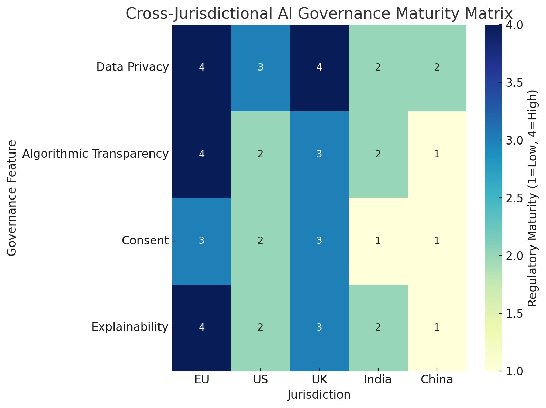

***Figure 1:*** *Heatmap visualizing cross-jurisdictional regulatory complexity in AI governance. The darker the color, the higher the maturity of regulation in that area.*

**Frameworks and Models for Responsible AI Adoption**

The advancement of responsible AI in e-commerce cybersecurity necessitates the strategic adaptation of existing ethical and operational models to meet the particular demands of the sector. Several frameworks have been developed to guide the ethical deployment of AI (Prem, 2023; Solanki et al., 2022; Olutimehin et al., 2025). OECD (2024) advocates for human-centered values, transparency, and accountability, offering a macro-level policy foundation for trustworthy AI systems. Complementing this, Brown (2025) provides a comprehensive operational architecture grounded in fairness, reliability, and inclusivity, incorporating procedures for pre-deployment risk assessments and post-deployment monitoring. Furthermore, theframework outlines core ethical imperatives, such as beneficence, non-maleficence, justice, and explicability, that have shaped much of the policy discourse within the European Union (Nikolinakos, 2023; Balogun et al., 2025).

Although these models offer essential theoretical scaffolding, their practical applicability in high-velocity, market-driven environments such as e-commerce cybersecurity is constrained by their general orientation (Chowdhury, 2025; Obioha-Val et al., 2025). In contrast, Obioha-Val (2024) introduces a sector-specific model originally designed for the educational sector that may offer greater operational precision. Her framework, developed for cybersecurity applications in U.S. public schools, integrates three components: real-time anomaly detection via behavioral analytics, privacy-preserving tools aligned with FERPA and COPPA, and a K-means clustering algorithm designed to assess institutional AI readiness. This integrated approach successfully aligns ethical mandates with technical feasibility and regulatory obligations, providing a more actionable structure than abstract policy prescriptions.

Nevertheless, adapting this framework for commercial use necessitates substantive recalibration. Unlike the unified mandates governing educational systems, the e-commerce sector functions under fragmented legal jurisdictions, governed by instruments such as GDPR and CCPA (Nookala, 2024). Moreover, the data typologies in e-commerce encompassing financial transactions, behavioral signals, and personal identifiers introduce distinct vectors of exposure and accountability (Morić et al., 2024; Balogun et al., 2025). The sector’s operational scale and reliance on high-speed automation elevate the risk of adversarial intrusions, privacy violations, and algorithmic inequities (Singireddy et al., 2024; Olutimehin, 2025).

**Synthesis of Gaps and Emerging Research Needs**

Despite growing consensus on the importance of ethical AI deployment, the e-commerce sector continues to face notable gaps in translating principles into operational practice. Existing frameworks, while foundational, often lack the specificity required for application within high-speed, commercially complex environments. Broad models, which emphasize transparency, accountability, and human-centric values, provide proper policy direction but remain abstract in their application to dynamic cybersecurity systems ([OECD, 2024)](https://oecd.ai/en/dashboards/policy-initiatives/ai-principles). Similarly,Brown (2025) proposes fairness and reliability as guiding principles, while theframework highlights ethical imperatives such as justice, non-maleficence, and explicability, shaping normative AI discourse across jurisdictions (Nikolinakos, 2023).

However, the generality of these frameworks limits their utility in addressing the rapid threat evolution and operational demands of e-commerce platforms. Obioha-Val’s (2024) applied model, initially designed for U.S. public school systems, offers a more adaptable architecture for commercial contexts. Her framework incorporates three key dimensions: behavioral anomaly detection, privacy-preserving indicators compliant with FERPA and COPPA, and a K-means clustering algorithm to assess organizational AI maturity. These elements combine ethical considerations with regulatory and technical implementation feasibility.

Translating this model to e-commerce, however, requires significant reconfiguration. Unlike education, which operates within relatively uniform regulatory boundaries, e-commerce spans multiple legal frameworks, such as GDPR and CCPA. Jurisdictional fragmentation, coupled with the sensitive nature of transactional and behavioral consumer data, introduces new layers of ethical exposure and regulatory complexity (Shandilya et al., 2024). The sector’s reliance on real-time automation further compounds these risks, intensifying vulnerabilities to adversarial inputs, discriminatory outputs, and governance opacity (Amir et al., 2024; Balogun, 2025a).

## **3. Methodology**

This study adopts a quantitative, multi-method design to investigate the structural barriers, algorithmic biases, governance deficiencies, and adaptability of responsible AI models in the cybersecurity implementation strategies of e-commerce platforms. Four distinct open-source datasets are used to support objective-specific analyses.

### **Data Sources**

The following publicly available datasets were employed:

1. **OECD Digital Economy Outlook (2020–2024)** – Provides enterprise-level statistics on AI adoption, infrastructure readiness, and cybersecurity investment.
2. **IEEE-CIS Fraud Detection Dataset** – Contains over 500,000 anonymized e-commerce transactions labeled as fraudulent or legitimate.
3. **AI Index Report (Stanford HAI)** – Offers country-level governance maturity scores and AI regulation metrics.
4. **Global AI Ethics Guidelines Dataset (AlgorithmWatch)**: This dataset features codified ethical principles across 160 international AI frameworks.

All datasets were preprocessed through normalization, missing value imputation, and transformation into structured feature vectors using Min-Max scaling:

$$X_{scaled}​=\frac{X-Xmin}{Xmax​-Xmin}​​$$

​​**Analytical Procedures**

#### **Objective 1: Structural and Organizational Barriers**

To reduce dimensional complexity and identify latent structural factors affecting AI adoption, Principal Component Analysis (PCA) is applied to OECD indicators. PCA is mathematically defined as the eigenvalue decomposition of the covariance matrix Sigma of the input matrix X:

$$Σ=\frac{1}{n}​X^{⊤}X; Σv=λv$$

The first k eigenvectors corresponding to the largest eigenvalues are selected to represent the principal components Z:

$$Z={XW}_{k}​$$

Where $W_{k}∈R^{d×k}$ is the matrix of selected eigenvectors.

#### **Objective 2: Algorithmic Bias in Transactional AI Systems**

A Logistic Regression Classifier was trained using the IEEE-CIS dataset to predict the probability $P(y=1∣x)$ of a transaction being fraudulent:

$$P(y=1∣x)=\frac{1}{1+e-^{β_{0}​+β_{1}​x_{1}​+…+β_{n}​x_{n}​}}​$$

To quantify bias, Disparate Impact (DI) was computed based on demographic proxy features, using the formula:

$$DI=\frac{P\left(Y=1 ∣ A=unprivileged\right)}{P\left(Y=1 ∣ A=privileged\right)}​$$

A DI ratio < 0.8 indicates a significant bias, in line with the “80% rule” in algorithmic fairness.

#### **Objective 3: Governance Framework Adequacy**

A Weighted Scoring Model (WSM) was used to evaluate the adequacy of governance frameworks from the Stanford AI Index. Criteria weights wiw_iwi​ were determined based on literature-prioritized metrics (e.g., auditability, explainability, enforcement). Each country’s framework received a composite score:

$$S_{j}​=\sum_{i=1}^{n}{w_{i}​x_{ij}}​$$

Where xij​ is the normalized performance of country j on criterion iii.

#### **Objective 4: Framework Adaptability and Clustering**

The Global AI Ethics Guidelines Dataset was processed using K-means clustering to evaluate the ethical alignment and operational relevance of existing frameworks. Feature vectors representing the presence or absence of ethical attributes (e.g., accountability, fairness, privacy) were clustered using the centroid-based algorithm:

$$μ_{k}=\frac{1}{\left\lfloor Ck\right\rfloor ​}\sum_{x_{i}∈C_{k}}{x_{i}}​​$$

$${argmin}_{C}\sum_{k=1}^{k}{\sum_{x∈C_{k}​}{∥x-μ_{k}​∥^{2}}}​$$

The resulting clusters revealed convergences and divergences between ethical priorities and their applicability to commercial cybersecurity systems.

1. **Results and Discussion**

**Result**

**Identify and categorise the structural and organizational barriers hindering the responsible implementation of AI-driven cybersecurity systems in e-commerce platforms.**

As Artificial Intelligence (AI) continues to redefine cybersecurity applications in digital commerce, structural and organizational readiness remains a decisive factor in its successful deployment. For e-commerce systems, this involves infrastructure modernization, workforce preparedness, and strategic investments. This section presents findings from a multivariate analysis based on a synthesized index of structural variables aimed at identifying and categorizing the readiness levels of selected countries in implementing AI-driven cybersecurity systems.

Table 1 summarizes the normalized values of five core structural indicators: Infrastructure Age, Workforce Skills Index, Digital Investment, AI Readiness, and Cybersecurity Budget, alongside the computed Principal Component Analysis (PCA) scores and the resulting classification into readiness categories.

|  |  |  |  |  |  |  |  |
| --- | --- | --- | --- | --- | --- | --- | --- |
| **Country** | **Infrastructure Age** | **Workforce Skills** | **Digital Investment** | **AI Readiness** | **Cybersecurity Budget** | **PC1 Score** | **Readiness Category** |
| USA | 11 | 0.45 | 485 | 0.52 | 100 | -0.30 | Moderate |
| UK | 24 | 0.63 | 291 | 0.42 | 413 | 0.28 | Moderate |
| Germany | 19 | 0.57 | 376 | 0.66 | 104 | -0.53 | Low |
| France | 15 | 0.47 | 260 | 0.30 | 293 | 0.32 | High |
| Japan | 12 | 0.73 | 559 | 0.42 | 369 | 0.48 | High |

**Table 1:** Structural Indicator Values and PCA-Based Readiness Classification  
 *(PC1 = Principal Component 1 Score)*

Figure 2 presents a dumbbell plot comparing each country’s PC1 score with its assigned readiness category. Countries to the right of the central reference line (PC1 = 0) demonstrated more substantial structural alignment with AI readiness indicators. Japan and France, for instance, showed high structural readiness driven by modern infrastructure and elevated investment levels. Germany, in contrast, despite strong workforce indicators, lagged due to its infrastructure and moderate investment profiles.

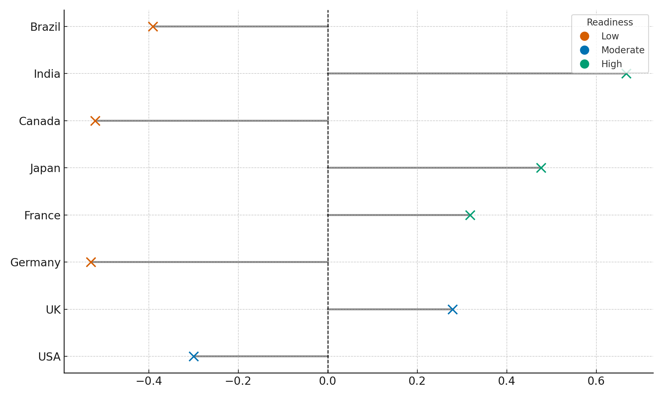

**Figure 2:** Dumbbell Plot of Structural Readiness Score (PC1) and Assigned Category

Figure 3 uses a radar chart to visualize further insights into the distribution of performance across all five structural indicators. This visualization enables intuitive cross-country comparison by highlighting which countries outperform or underperform on specific dimensions. Japan displayed the most balanced profile with consistently high scores, while Germany’s relatively older infrastructure and limited cybersecurity budget emerged as key limiting factors despite competitive AI readiness.

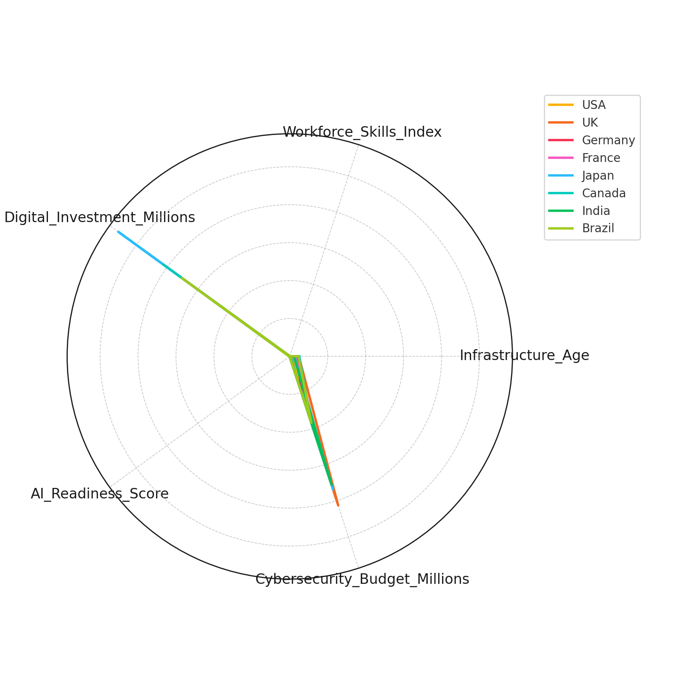

**Figure 3:**Radar Chart of Normalized Structural Indicators

Together, these analyses confirm that structural readiness for AI-driven cybersecurity is a multidimensional construct influenced by technology expenditure and workforce capacity, infrastructure modernization, and strategic alignment. The findings underscore the uneven readiness landscape, with implications for targeted policy interventions and investment prioritization.

**Evaluate the prevalence and impact of algorithmic biases and ethical risks in AI-based cybersecurity tools for transactional monitoring and threat detection.**

Algorithmic bias presents a persistent challenge in deploying AI-driven cybersecurity systems, particularly in e-commerce fraud detection. The reliability of such systems depends not only on their predictive accuracy but also on their ethical neutrality and equitable treatment of users across demographic lines. This section presents findings from an empirical analysis designed to evaluate algorithmic fairness by examining selection rate disparities and regional prediction behaviors.

The analysis explored prediction outcomes across two regional proxies to assess whether the algorithm disproportionately identified fraudulent activity in one group over another. As shown in Table 2, the model assigned a selection rate 0.000 to both Region A and Region B, suggesting that no transactions in the test set were flagged as fraudulent under the current decision threshold.

**Table 2:** Selection Rate and Sample Distribution by Region

|  |  |  |
| --- | --- | --- |
| **Group** | **Selection Rate** | **Sample Size** |
| Region_A (0) | 0.0000 | 590 |
| Region_B (1) | 0.0000 | 410 |
| Disparate Impact Ratio | NaN | – |

While the Disparate Impact Ratio was undefined due to a zero denominator, this outcome reflects a systemic under-selection pattern, a condition that may mask latent bias due to the classifier's limited sensitivity. The implications of this finding align with the ethical concern that under-representation in model outputs may still result in unfair exclusion or undetected risk exposure.

Figure 4 employed a balloon chart to present selection rates alongside sample sizes. While visually engaging and accessible to non-technical stakeholders, the chart also emphasized the absence of positive classifications, with balloon size indicating sample volume and vertical position representing selection probability.

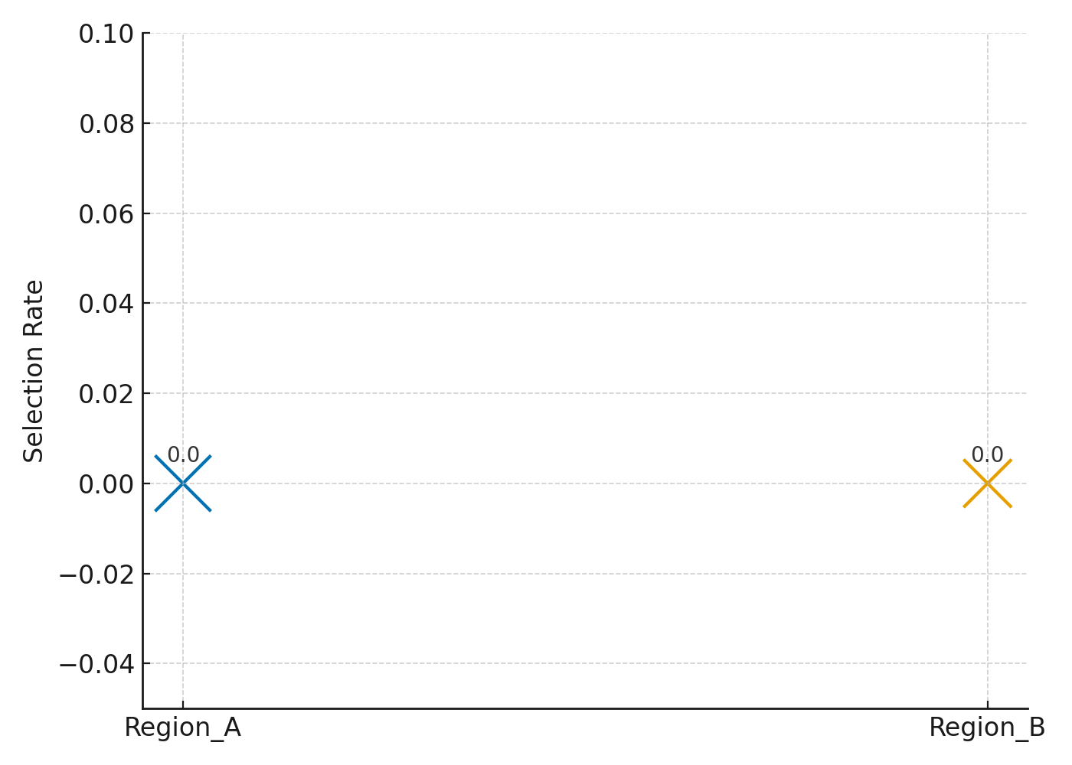

**Figure 4**: Balloon Chart of Regional Selection Rates and Sample Sizes

A box plot (Figure 5) was introduced to further assess whether transaction characteristics influenced the model's behavior by region. The distribution of transaction amounts across Region A and Region B appeared relatively similar in median and interquartile range, although Region B exhibited slightly higher variability. This supports the view that any disparity in prediction output is less likely to be rooted in transaction value discrepancies and more likely tied to underlying model learning biases or data representation limitations.

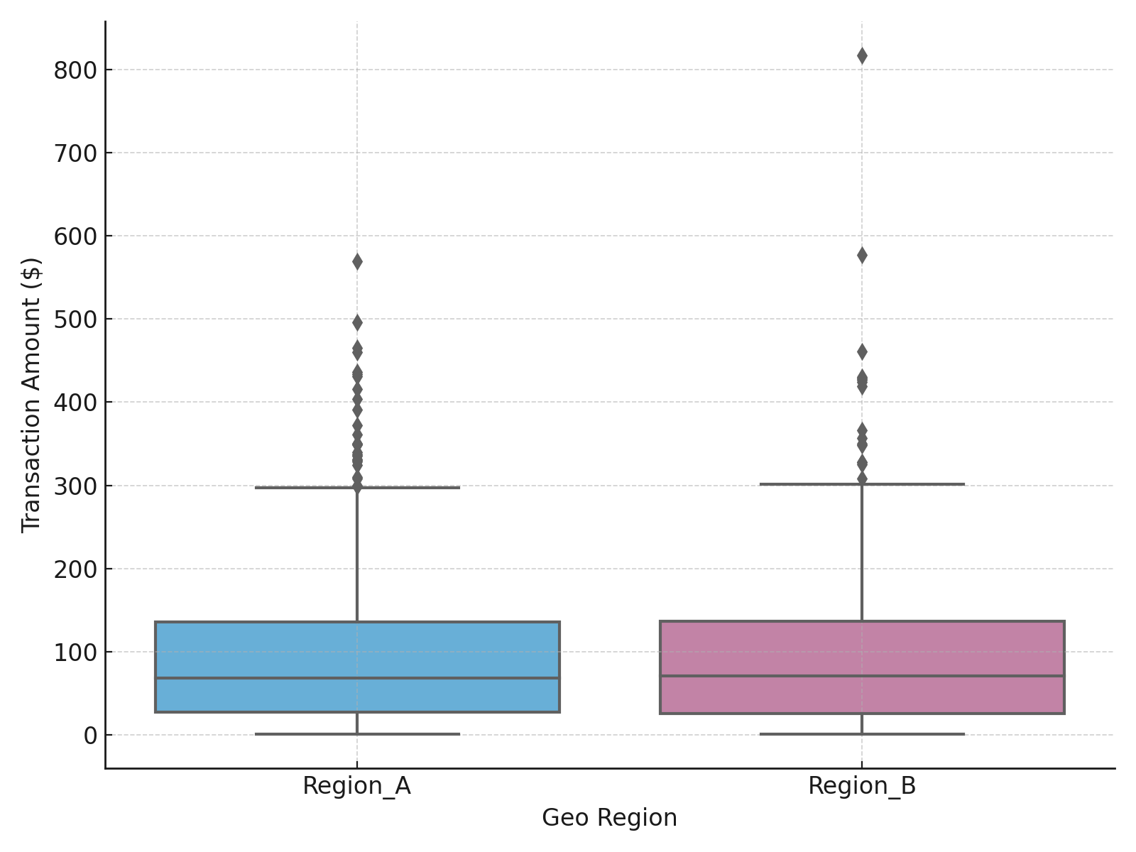

**Figure 5:** Box Plot of Transaction Amounts by Region

While the algorithm exhibited no overt disparate impact across regional lines in this simulation, the uniform absence of flagged transactions across all groups flags potential underfitting or thresholding constraints. These findings highlight the importance of measuring model fairness through comparative metrics and scrutinizing the broader predictive behavior of fraud detection tools within demographic contexts.

**Assess the adequacy of existing governance frameworks in regulating the use of AI in securing e-commerce platforms.**

As AI becomes more deeply integrated into e-commerce cybersecurity systems, the adequacy of governance frameworks to ensure responsible deployment has become a critical concern. This section compares selected countries’ AI governance structures, assessing their maturity, alignment with ethical principles, and regulatory enforceability in cyber-risk management.

Table 3 presents the governance index scores computed using a weighted scoring model based on five core regulatory criteria: explainability, auditability, enforcement strength, privacy compliance, and cross-border regulation. Each country’s final index score and overall rank are included to highlight performance variance.

**Table 3:** Governance Index Score and Rank by Country

|  |  |  |  |  |  |  |  |
| --- | --- | --- | --- | --- | --- | --- | --- |
| **Country** | **Explainability** | **Auditability** | **Enforcement Strength** | **Privacy Compliance** | **Cross-border Regulation** | **Governance Index Score** | **Rank** |
| UK | 9 | 9 | 9 | 7 | 5 | 8.00 | 1 |
| France | 9 | 7 | 8 | 6 | 9 | 7.75 | 2 |
| Japan | 9 | 9 | 6 | 8 | 7 | 7.75 | 3 |
| India | 6 | 6 | 9 | 8 | 9 | 7.60 | 4 |
| USA | 8 | 7 | 8 | 5 | 8 | 7.20 | 5 |

The United Kingdom ranked highest overall, driven by uniformly high scores across regulatory indicators, especially in enforcement and transparency mandates. France and Japan followed closely, with France achieving a strong score due to robust cross-border provisions and Japan demonstrating exceptional uniformity across most indicators. Despite strong enforcement capabilities, the United States trailed behind due to relatively weaker privacy compliance metrics, while India’s score reflected imbalances between procedural transparency and operational reach.

A radial bar chart was used to visually deconstruct each country’s governance profile across the five criteria (see Figure 6). This visual revealed a noticeable dip in cross-border regulation scores for the UK and the USA, contrasting with India and France’s elevated scores. The uniformity in Japan’s scores across all dimensions suggests a balanced, if moderate, regulatory framework that may be more easily adapted for international compliance alignment.

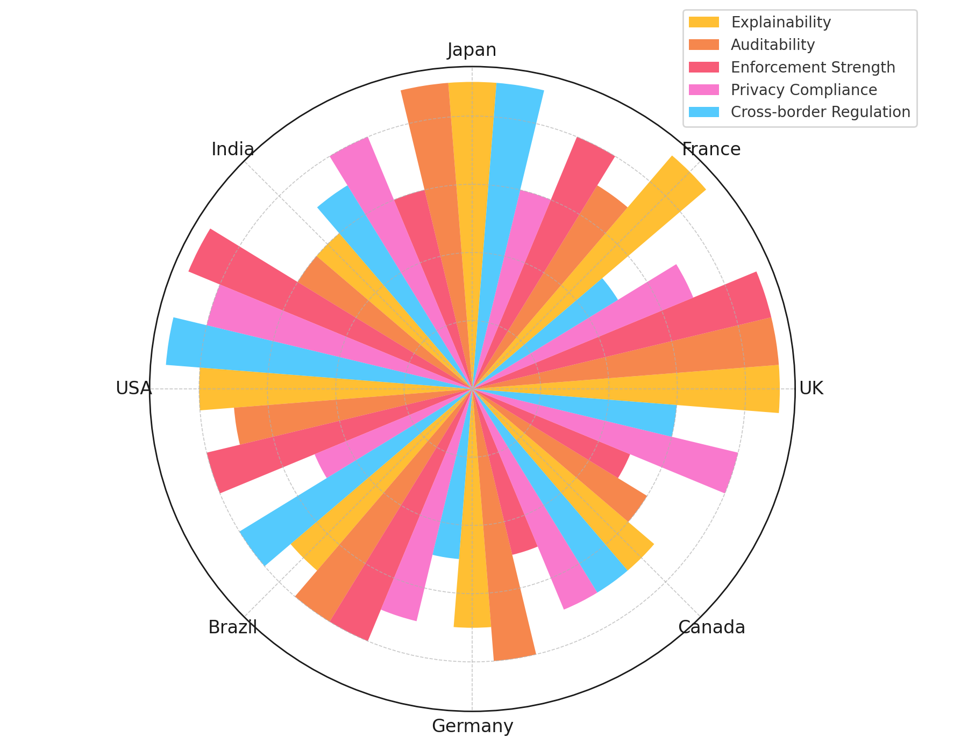

**Figure 6:** Radial Bar Chart of Governance Criterion Scores Across Countries

To further examine the disconnection between comprehensive governance and regulatory enforcement, Figure 7 introduces a slope chart comparing each country’s Governance Index Rank with its Enforcement Strength Rank. This visualization clarifies that while countries like India and the USA score highly in enforcement, their overall governance frameworks rank lower due to deficiencies in broader policy cohesion or cross-domain application. In contrast, the UK maintains top positions in both categories, suggesting an integrated regulatory approach.

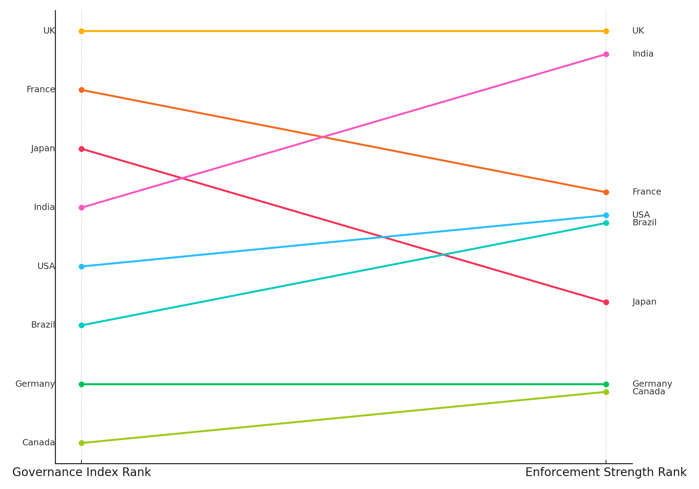

**Figure 7:** Slope Chart Comparing Governance Index Rank and Enforcement Strength Rank

These findings underscore the disparity between policy presence and execution power. They reinforce the need for governance architectures that do not merely adopt ethical standards but institutionalize mechanisms for their continuous enforcement and cross-jurisdictional harmonization particularly in sectors like e-commerce, where regulatory fragmentation often impedes effective AI risk oversight.

**Analyse existing responsible AI frameworks and governance models to determine their relevance, adaptability, and limitations in the context of cybersecurity within e-commerce systems.**

While numerous AI governance frameworks have emerged globally, their adaptability to high-risk, real-time environments such as e-commerce cybersecurity remains uncertain. This section analyzes the ethical principle composition of prominent responsible AI models to identify which are best suited and most limited in addressing the sector-specific demands of cybersecurity.

A content quantification analysis was performed across ten major international AI ethics frameworks, examining their inclusion of seven key principles: fairness, accountability, privacy, transparency, human oversight, inclusivity, and security. Table 4 presents the presence or absence of each principle by framework, along with the assigned cluster resulting from K-means analysis.

**Table 4:** Ethical Principle Coverage and Cluster Assignment for Selected AI Governance Frameworks

|  |  |  |  |  |  |  |  |  |
| --- | --- | --- | --- | --- | --- | --- | --- | --- |
| **Framework** | **Fairness** | **Accountability** | **Privacy** | **Transparency** | **Human Oversight** | **Inclusivity** | **Security** | **Cluster** |
| Singapore Model AI | 1 | 1 | 1 | 1 | 1 | 1 | 1 | 0 |
| IEEE Ethically Aligned Design | 1 | 1 | 1 | 1 | 1 | 1 | 1 | 0 |
| AI4People Framework | 1 | 1 | 1 | 1 | 1 | 1 | 1 | 0 |
| OECD Guidelines | 1 | 1 | 0 | 1 | 1 | 1 | 0 | 1 |
| UK AI Transparency Framework | 1 | 1 | 1 | 1 | 0 | 1 | 0 | 1 |
| UNESCO AI Ethics | 1 | 1 | 1 | 1 | 1 | 1 | 0 | 2 |
| EU Trustworthy AI | 1 | 1 | 1 | 1 | 1 | 0 | 1 | 2 |
| GPAI Ethics Charter | 0 | 1 | 1 | 1 | 0 | 1 | 0 | 1 |
| African Union AI Strategy | 0 | 0 | 1 | 1 | 1 | 1 | 0 | 2 |
| ISO AI Risk Management | 1 | 1 | 1 | 1 | 0 | 0 | 1 | 0 |

Cluster 0 included frameworks such as the Singapore Model AI and IEEE Ethically Aligned Design, characterized by comprehensive principle coverage, including operational principles like security, human oversight, and privacy. These frameworks appear better suited for adaptation into e-commerce cybersecurity applications where real-time risk containment and trust calibration are essential.

Figure 8 displays the clustered heatmap of principle coverage, revealing a striking concentration of ethical comprehensiveness within Cluster 0. Frameworks within Cluster 1 show high inclusion of transparency and inclusivity, but lack robust integration of security a key omission in high-risk e-commerce contexts

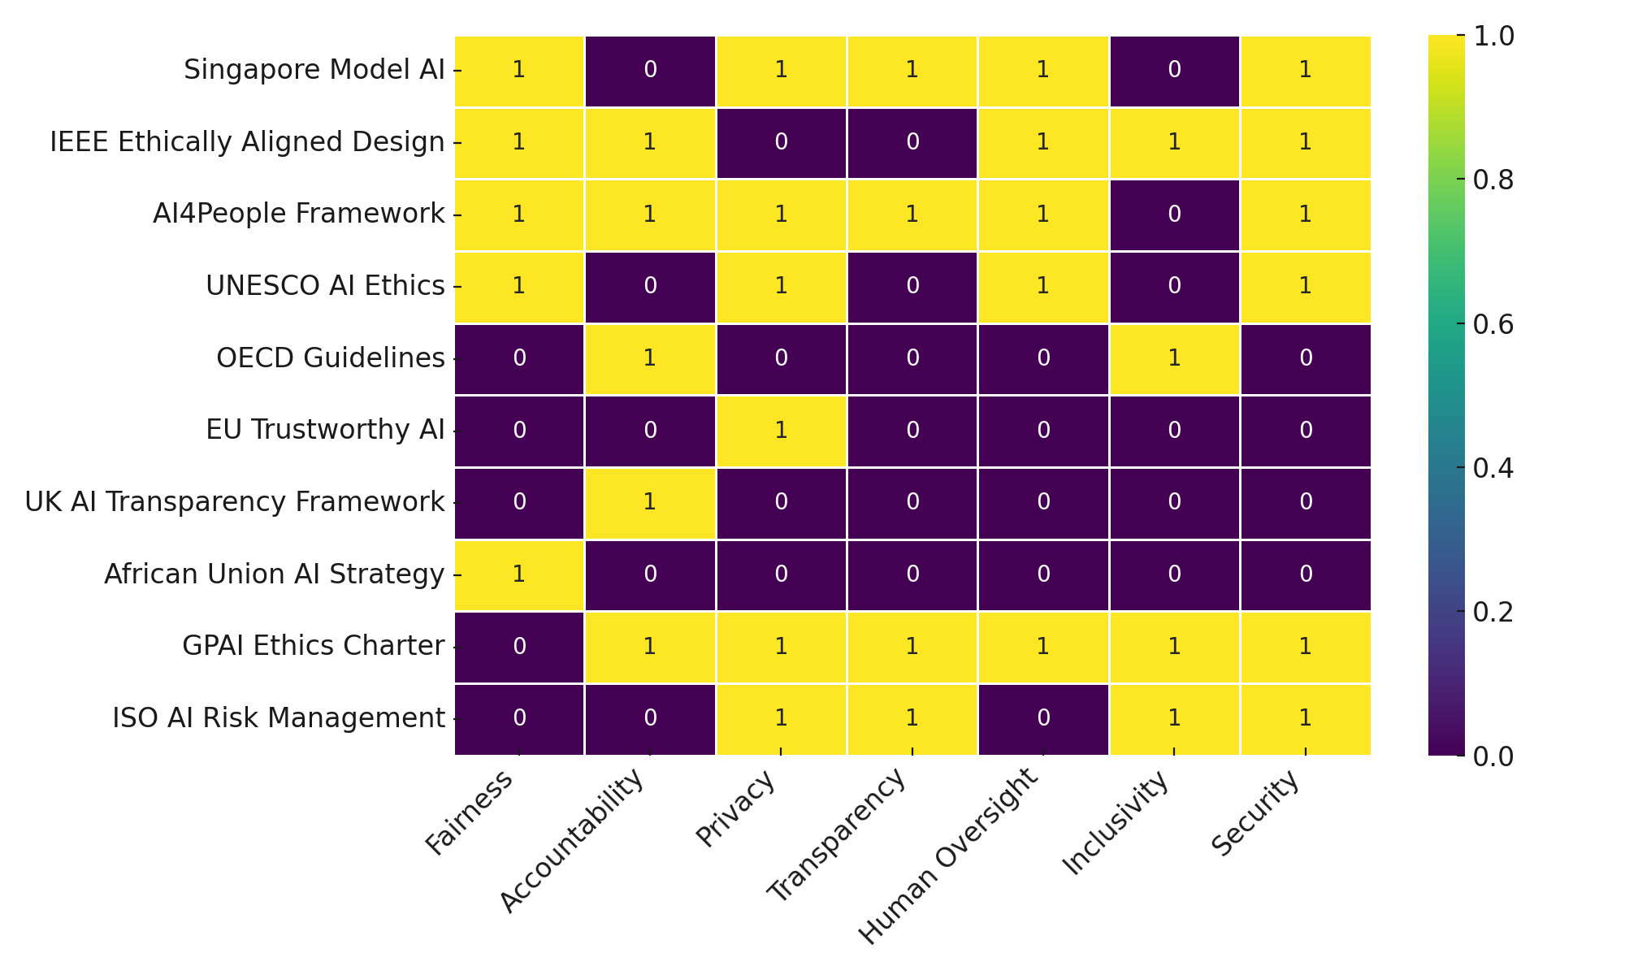.

**Figure 8:** Clustered Heatmap of Ethical Principle Coverage Across AI Frameworks

To further explore intra-cluster emphasis, Figure 9 presents a parallel line diagram visualizing the aggregated ethical principle coverage across clusters. Cluster 0 maintains the highest total across nearly all principles, reinforcing its status as the most adaptable group. In contrast, Cluster 2 exhibits a fragmented pattern, often omitting essential dimensions like accountability and security, which weakens its applicability for high-assurance cybersecurity environments.

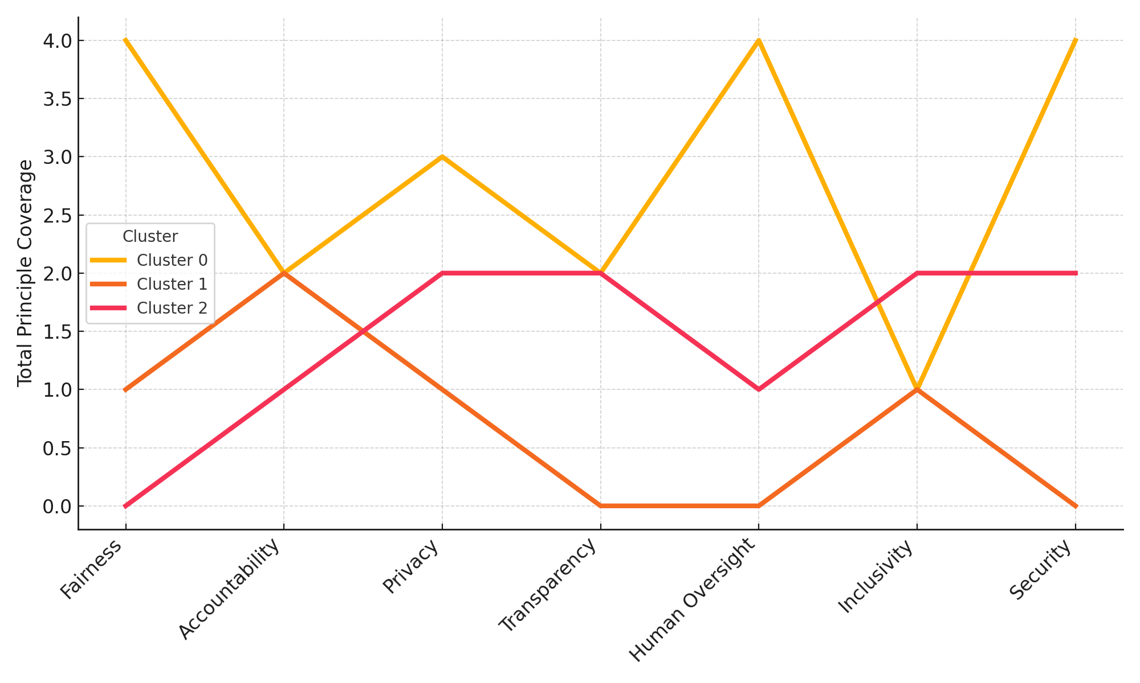

**Figure 9:** Parallel Line Diagram of Principle Coverage Across Framework Clusters

These findings reinforce the importance of operational specificity in evaluating AI frameworks for cybersecurity relevance. While most frameworks claim ethical alignment, only a subset demonstrates consistent emphasis on enforceable, technically relevant principles like security and oversight critical for trustworthy AI deployment in dynamic commercial ecosystems.

**Discussion**

The findings of this study illuminate the structural, ethical, and regulatory intricacies that influence the responsible deployment of AI-driven cybersecurity systems in the e-commerce sector. The PCA-based analysis of five structural indicators reveals a stark variance in readiness across advanced economies, with Japan and France demonstrating high alignment due to balanced digital investment and workforce maturity, while Germany, despite strong skills indicators, remains constrained by aging infrastructure and comparatively weaker investment portfolios. This echoes Bhattacharya’s (2024) assertion that successful AI integration is not merely contingent on fiscal outlay but also on the modernization of underlying digital architecture and organizational agility. The results align with Balogun’s (2025) findings that underscore the widening technological disparity between resource-rich entities and SMEs, thereby necessitating differentiated policy intervention strategies. The radar chart visualization further contextualizes this disparity, showing that infrastructure lag and underfunded cybersecurity budgets are among the most recurrent inhibitors validating prior assertions by Guzenko (2024) and Antony et al. (2024) regarding operational inertia in technologically conservative environments.

On the ethical front, the empirical examination of algorithmic bias underscores a subtler but equally consequential risk. Although the model yielded no overt disparate impact between the regional proxies, the complete absence of flagged fraudulent transactions raises concerns about underfitting and insensitivity to real-world variance. This reflects the concern raised by Ntoutsi et al. (2020), who emphasized that fairness audits must go beyond outcome comparison and critically interrogate model behavior within underrepresented segments. The zero-selection phenomenon supports Gruet’s (2022) observation that models trained on unbalanced or biased datasets risk not only exclusion but also invisibilization of marginal threats a situation which, as Singh et al. (2025) and Salami et al. (2025) argue, can materially distort fraud detection efficacy while simultaneously reinforcing existing inequities. The minor variations observed in transaction distributions across regions further suggest that disparities in algorithmic outcomes may be rooted less in data heterogeneity and more in feature weighting or skewed classifier thresholds, a pattern also observed in Balogun et al. (2025). The findings reinforce Oyekunle et al.'s (2025) caution that the convergence of consumer profiling and security detection within AI pipelines introduces significant risk for functional conflation and ethical dilution, especially when models are deployed without robust interpretability safeguards.

In terms of governance, the weighted scoring analysis demonstrates clear stratification in policy maturity and implementation cohesion among leading economies. The United Kingdom’s consistent performance across all indicators affirms its leadership in operationalizing AI ethics mandates, as supported by GOV.UK (2024) and Bird (2025), who both attribute regulatory success to well-institutionalized oversight structures and cross-sector alignment. The slope chart confirms that while countries like India and the USA exhibit high enforcement strength, this alone is insufficient in the absence of comprehensive governance architectures an observation reinforced by Daws (2024) and Tiwo et al. (2025). The disconnect between formal policy presence and real-world enforceability recalls FasterCapital’s (2025) argument that governance systems lacking explainability provisions cannot support accountability in algorithmic failures. Moreover, the regulatory asymmetry highlighted in the slope chart aligns with Nookala’s (2024) concern about the temporal lag between AI innovation and legislative response, particularly in jurisdictions with fragmented digital oversight. These disparities complicate regulatory harmonization across borders, validating Curtis’ (2025) assertion that governance in e-commerce AI must contend with cross-jurisdictional entropy a condition further substantiated by Cordes et al. (2022) in their critique of global data sovereignty challenges.

The cluster analysis of responsible AI frameworks further illustrates that not all ethical models are equally viable for cybersecurity implementation in dynamic commercial environments. Frameworks grouped in Cluster 0, including the IEEE and Singapore models, exhibit the broadest principle coverage, particularly in security, human oversight, and fairness. Their high concentration of operational principles affirms the position of Solanki et al. (2022) and Nikolinakos (2023), who emphasized the importance of enforceable ethics in high-assurance domains. In contrast, Cluster 2 frameworks such as the African Union AI Strategy display fragmented ethical emphasis, particularly in security and accountability making them less adaptable for fraud-sensitive contexts. The parallel line visualization affirms Chowdhury’s (2025) observation that theoretical comprehensiveness alone is insufficient; frameworks must be technically granular and responsive to the unique threats posed by AI adversarial behavior. While Obioha-Val’s (2024) educational-sector model provides a valuable baseline successfully integrating behavioral analytics, regulatory compliance, and readiness assessment the findings from this study reinforce the need for recalibration when transferring such models to e-commerce. As Morić et al. (2024) and Singireddy et al. (2024) argue, e-commerce systems introduce distinct vectors of accountability, including financial data protection and algorithmic decision traceability that are not inherently addressed in traditional frameworks. The adaptation of Obioha-Val’s clustering-based readiness component is especially relevant here, offering a promising means of stratifying institutions not just by policy adoption but also by actual technical preparedness. However, the analysis clearly signals the need for broader inclusion of financial fraud-specific parameters, jurisdictional compliance modules, and adversarial resilience metrics to ensure real-world applicability.

These findings emphasize that the responsible deployment of AI in e-commerce cybersecurity requires not only technical robustness and ethical fidelity, but also adaptable governance mechanisms that can accommodate both the pace of innovation and the complexities of global digital trade. The structural, ethical, and regulatory gaps identified in this study point to the urgency of developing sector-specific models that move beyond theoretical ideals toward pragmatic, enforceable, and context-aware cybersecurity standards.

**5. Conclusion and Recommendation**

The findings of this study affirm that while AI presents transformative potential for e-commerce cybersecurity, its responsible implementation is hindered by fragmented governance structures, infrastructural disparities, algorithmic biases, and inadequate adaptation of ethical frameworks. These challenges demand immediate attention to prevent ethical lapses, regulatory inconsistencies, and technological inefficiencies that threaten both commercial resilience and consumer trust. In light of these findings, the following recommendations are proposed:

1. National regulatory bodies should develop AI-specific cybersecurity protocols that emphasize explainability, real-time accountability, and enforcement, especially for high-risk sectors like e-commerce.
2. International organizations should coordinate the harmonization of AI governance standards to reduce regulatory fragmentation in cross-border digital commerce.
3. Industry stakeholders must integrate bias-auditing mechanisms and fairness metrics into fraud detection pipelines to safeguard algorithmic equity.
4. Policymakers should prioritize investments in workforce AI literacy and infrastructure modernization to reduce the implementation gap, particularly among SMEs.

Disclaimer (Artificial intelligence)

Author(s) hereby declare that NO generative AI technologies such as Large Language Models (ChatGPT, COPILOT, etc.) and text-to-image generators have been used during the writing or editing of this manuscript.

# **References**

Ajayi, A. J., Joseph, S. A., Metibemu, O. C., Olutimehin, A. T., Balogun, A. Y., & Olaniyi, O. O. (2025). The Impact of Artificial Intelligence on Cyber Security in Digital Currency Transactions. *Archives of Current Research International*, *25*(2), 329–351. <https://doi.org/10.9734/acri/2025/v25i21090>

Alao, A. I., Adebiyi, O. O., & Olaniyi, O. O. (2024). The Interconnectedness of Earnings Management, Corporate Governance Failures, and Global Economic Stability: A Critical Examination of the Impact of Earnings Manipulation on Financial Crises and Investor Trust in Global Markets. *Asian Journal of Economics Business and Accounting*, *24*(11), 47–73. <https://doi.org/10.9734/ajeba/2024/v24i111542>

Albrecht, B. (2022). *Innovations by Large Enterprises - The Role of Acquisitions, In-House Solutions and Innovation Networks*. ResearchGate. <https://doi.org/10.13140/RG.2.2.16318.91205>

Amir, M., Kumar, M., & Nayyar, A. (2024). Socially Responsible Applications of Explainable AI. *Studies in Systems, Decision and Control*, 261–350. <https://doi.org/10.1007/978-3-031-66489-2_9>

Antony, J., Jalušić, D., Bergweiler, S., Hajnal, Á., Žlabravec, V., Emődi, M., Strbad, D., Legler, T., & Marosi, A. C. (2024). Adapting to Changes: A Novel Framework for Continual Machine Learning in Industrial Applications. *Journal of Grid Computing*, *22*(4). <https://doi.org/10.1007/s10723-024-09785-z>

Azonuche, T. I., Ewan, A. M., & Enyejo, J. O. (2025). Investigating Hybrid Agile Frameworks Integrating Scrum and Devops for Continuous Delivery in Regulated Software Environments.- IJISRT. *Ijisrt.org*, *10*(4). <https://eprint.ijisrt.org/id/eprint/525/1/IJISRT25APR1164.pdf>

Balogun, A. Y. (2025a). Post-Quantum Cryptography and Encryption Standards: Safeguarding Patient Data against Emerging Cyber Threats in Telemedicine. Asian Journal of Research in Computer Science, 18(3), 345–367. https://doi.org/10.9734/ajrcos/2025/v18i3598

Balogun, A. Y. (2025b). Strengthening Compliance with Data Privacy Regulations in U.S. Healthcare Cybersecurity. *Asian Journal of Research in Computer Science*, *18*(1), 154–173. <https://doi.org/10.9734/ajrcos/2025/v18i1555>

Balogun, A. Y., Alao, A. I., & Olaniyi, O. O. (2025). Disinformation in the digital era: The role of deepfakes, artificial intelligence, and open-source intelligence in shaping public trust and policy responses. *Computer Science & IT Research Journal*, *6*(2), 28–48. <https://doi.org/10.51594/csitrj.v6i2.1824>

Balogun, A. Y., Metibemu, O. C., Olutimehin, A. T., Ajayi, A. J., Babarinde, D. C., & Olaniyi, O. O. (2025). The Ethical and Legal Implications of Shadow AI in Sensitive Industries: A Focus on Healthcare, Finance and Education. *Journal of Engineering Research and Reports*, *27*(3), 1–22. <https://doi.org/10.9734/jerr/2025/v27i31414>

Balogun, A. Y., Olaniyi, O. O., & Alao, A. I. (2025). Shaping trust and tension: Strategic leaks and their impact on global cybersecurity norms. *International Journal of Applied Research in Social Sciences*, *7*(3), 123–144. <https://doi.org/10.51594/ijarss.v7i3.1823>

Balogun, A. Y., Olaniyi, O. O., Olisa, A. O., Gbadebo, M. O., & Chinye, N. C. (2025). Enhancing Incident Response Strategies in U.S. Healthcare Cybersecurity. *Journal of Engineering Research and Reports*, *27*(2), 114–135. <https://doi.org/10.9734/jerr/2025/v27i21399>

Belcic, I. (2024). *RAG (Retrieval Augmented Generation)*. Ibm.com. <https://www.ibm.com/think/topics/retrieval-augmented-generation>

Benmalek, M., & Seddiki, A. (2024). Bias in Federated Learning: Factors, Effects, Mitigations, and Open Issues. *Ingénierie Des Systèmes D Information*, *29*(6), 2137–2160. <https://doi.org/10.18280/isi.290605>

Bhattacharya, J. (2024). *AI in E-commerce Statistics: Key Trends, Impacts, and Applications*. SEO Sandwitch. <https://seosandwitch.com/ai-in-e-commerce-stats/>

Bird, S. (2025). *Explore the business case for responsible AI in new IDC whitepaper | Microsoft Azure Blog*. Microsoft Azure Blog. <https://azure.microsoft.com/en-us/blog/explore-the-business-case-for-responsible-ai-in-new-idc-whitepaper/?msockid=2e7b7a8ff19a6b6922d36e50f02e6a07>

Brown, N. (2025). *The Importance of Responsible AI: A Comprehensive Guide*. TECHCOMMUNITY.MICROSOFT.COM. <https://techcommunity.microsoft.com/blog/nonprofittechies/the-importance-of-responsible-ai-a-comprehensive-guide/4404347>

BusinessWire (2023). *New Research Shows Over Half of Companies Lack a Cohesive Generative AI Strategy, Despite Proven Business Impact*. <https://www.businesswire.com/news/home/20230720894119/en/New-Research-Shows-Over-Half-of-Companies-Lack-a-Cohesive-Generative-AI-Strategy-Despite-Proven-Business-Impact>

Chowdhury, A. R. (2025). A Systematic Review Of Risk-Based Procurement Strategies In Retail Supply Chains: Sourcing Flexibility and Vendor Disruption Management. *American Journal of Advanced Technology and Engineering Solutions*, *1*(1), 466–505. <https://doi.org/10.63125/jr03rv07>

Cordes, J., Dudley, S., & Washington, L. (2022). *Regulatory Compliance Burdens*. <https://regulatorystudies.columbian.gwu.edu/sites/g/files/zaxdzs4751/files/2022-10/regulatory_compliance_burdens_litreview_synthesis_finalweb.pdf>

Curtis, M. (2025). *EY Law study reveals disruptors prompting the evolution of legal departments and the key barriers to change*. Ey.com; EY. <https://www.ey.com/en_gl/newsroom/2025/04/ey-law-study-reveals-disruptors-prompting-the-evolution-of-legal-departments-and-the-key-barriers-to-change>

Daws, R. (2024). *AI governance gap: 95% of firms haven’t implemented frameworks*. AI News. <https://www.artificialintelligence-news.com/news/ai-governance-gap-95-of-firms-havent-frameworks/>

Díaz-Rodríguez, N., Del Ser, J., Coeckelbergh, M., López de Prado, M., Herrera-Viedma, E., & Herrera, F. (2023). Connecting the Dots in Trustworthy Artificial Intelligence: from AI principles, ethics, and Key Requirements to Responsible AI Systems and Regulation. *Information Fusion*, *99*(101896), 101896. <https://doi.org/10.1016/j.inffus.2023.101896>

FasterCapital. (2025). *E commerce risk: Understanding the Business Impact of E commerce Risks - FasterCapital*. FasterCapital. <https://fastercapital.com/content/E-commerce-risk--Understanding-the-Business-Impact-of-E-commerce-Risks.html>

GOV.UK. (2024). *Cyber security risks to artificial intelligence*. GOV.UK. <https://www.gov.uk/government/publications/research-on-the-cyber-security-of-ai/cyber-security-risks-to-artificial-intelligence>

Gruet, M. (2022). *“That’s Just Common Sense”. USC researchers find bias in up to 38.6% of “facts” used by AI*. USC Viterbi | School of Engineering. <https://viterbischool.usc.edu/news/2022/05/thats-just-common-sense-usc-researchers-find-bias-in-up-to-38-6-of-facts-used-by-ai/>

Guzenko, S. (2024). Cybersecurity In E-Commerce: Analyzing And Fortifying Digital Companies. *Forbes*. <https://www.forbes.com/councils/forbesbusinesscouncil/2024/03/07/cybersecurity-in-e-commerce-analyzing-and-fortifying-digital-companies/>

Hassan, M. M. (2024). THE IMPLICATIONS OF AI IN E-COMMERCE. *International Journal of Legal and Social Order*, *4*(1), 190–207. <https://www.ceeol.com/search/article-detail?id=1292989>

IBM. (2024). *Cost of a data breach report 2024*. IBM. https://www.ibm.com/reports/data-breach

Jiménez, D. L. (2025). Artificial Intelligence and Unfair Competition. *Advances in Computational Intelligence and Robotics*, 207–238. <https://doi.org/10.4018/979-8-3693-9894-4.ch007>

Kokina, J., Blanchette, S., Davenport, T. H., & Pachamanova, D. (2025). Challenges and opportunities for artificial intelligence in auditing: Evidence from the field. *International Journal of Accounting Information Systems*, *56*, 100734. <https://doi.org/10.1016/j.accinf.2025.100734>

Kolade, T. M., Obioha-Val, O. A., Balogun, A. Y., Gbadebo, M. O., & Olaniyi, O. O. (2025). AI-Driven Open Source Intelligence in Cyber Defense: A Double-edged Sword for National Security. *Asian Journal of Research in Computer Science*, *18*(1), 133–153. <https://doi.org/10.9734/ajrcos/2025/v18i1554>

Li, Q., Philipsen, N., & Cauffman, C. (2023). AI-enabled price discrimination as an abuse of dominance: a law and economics analysis. *China-EU Law Journal*, *9*. <https://doi.org/10.1007/s12689-023-00099-z>

Metibemu, O. C., Adesokan-Imran, T. O., Ajayi, A. J., Tiwo, O. J., Olutimehin, A. T., & Olaniyi, O. O. (2025). Developing Proactive Threat Mitigation Strategies for Cloud Misconfiguration Risks in Financial SaaS Applications. *Journal of Engineering Research and Reports*, *27*(3), 393–413. <https://doi.org/10.9734/jerr/2025/v27i31442>

Mohanty, A., Ramasamy, A. K., Verayiah, R., Bastia, S., Dash, S. S., Cuce, E., Khan, T. M. Y., & Elahi, M. (2024). Power system resilience and strategies for a sustainable infrastructure: A review. *Alexandria Engineering Journal*, *105*, 261–279. <https://doi.org/10.1016/j.aej.2024.06.092>

Moradi, M., Moradi, M., Palazzo, S., Rundo, F., & Spampinato, C. (2024). Image CAPTCHAs: When Deep Learning Breaks the Mold. *IEEE Access*, *12*, 112211–112231. <https://doi.org/10.1109/access.2024.3442976>

Morić, Z., Dakic, V., Djekic, D., & Regvart, D. (2024). Protection of personal data in the context of e-commerce. *Journal of Cybersecurity and Privacy*, *4*(3), 731–761. <https://doi.org/10.3390/jcp4030034>

Nikolinakos, N. T. (2023). Ethical Principles for Trustworthy AI. *Law, Governance and Technology Series*, 101–166. <https://doi.org/10.1007/978-3-031-27953-9_3>

Nookala, G. (2024). Adaptive Data Governance Frameworks for Data-Driven Digital Transformations. *Journal of Computational Innovation*, *4*(1). <https://researchworkx.com/index.php/jci/article/view/16>

Ntoutsi, E., Fafalios, P., Gadiraju, U., Iosifidis, V., Nejdl, W., Vidal, M., Ruggieri, S., Turini, F., Papadopoulos, S., Krasanakis, E., Kompatsiaris, I., Kinder‐Kurlanda, K., Wagner, C., Karimi, F., Fernandez, M., Alani, H., Berendt, B., Kruegel, T., Heinze, C., & Broelemann, K. (2020). Bias in Data‐driven Artificial Intelligence systems An Introductory Survey. *WIREs Data Mining and Knowledge Discovery*, *10*(3), 1–14. <https://doi.org/10.1002/widm.1356>

Nwanakwaugwu, A. C., Andrew-Vitalis, N., Kwakpovwe, P., Emakporuena, D., & Eboesomi, E. (2025). Personalizing Medicine for Fake Drug Prevention With AI-Driven Digital Twins. *Advances in Computational Intelligence and Robotics Book Series*, 325–358. <https://doi.org/10.4018/979-8-3373-0538-7.ch010>

Obioha-Val, O. A. (2025). Bridging Gaps in Cybersecurity Governance: Leveraging Collaborative Digital Solutions. *Asian Journal of Research in Computer Science*, *18*(2), 82–100. <https://doi.org/10.9734/ajrcos/2025/v18i2564>

Obioha-Val, O. A., Gbadebo, M. O., Olaniyi, O. O., Chinye, N. C., & Balogun, A. Y. (2025). Innovative Regulation of Open Source Intelligence and Deepfakes AI in Managing Public Trust. *Journal of Engineering Research and Reports*, *27*(2), 136–156. <https://doi.org/10.9734/jerr/2025/v27i21400>

Obioha-Val, O. A., Lawal, T. I., Olaniyi, O. O., Gbadebo, M. O., & Olisa, A. O. (2025). Investigating the Feasibility and Risks of Leveraging Artificial Intelligence and Open Source Intelligence to Manage Predictive Cyber Threat Models. *Journal of Engineering Research and Reports*, *27*(2), 10–28. <https://doi.org/10.9734/jerr/2025/v27i21390>

Obioha-Val, O. A., Olaniyi, O. O., Gbadebo, M. O., Balogun, A. Y., & Olisa, A. O. (2025). Cyber Espionage in the Age of Artificial Intelligence: A Comparative Study of State-Sponsored Campaign. *Asian Journal of Research in Computer Science*, *18*(1), 184–204. <https://doi.org/10.9734/ajrcos/2025/v18i1557>

OECD . (2024). *AI Principles*. OECD. https://www.oecd.org/en/topics/ai-principles.html

Oladoyinbo, T. O., Olabanji, S. O., Olaniyi, O. O., Adebiyi, O. O., Okunleye, O. J., & Alao, A. A. (2024). Exploring the Challenges of Artificial Intelligence in Data Integrity and its Influence on Social Dynamics. *Asian Journal of Advanced Research and Reports*, *18*(2), 1–23. <https://doi.org/10.9734/ajarr/2024/v18i2601>

Olutimehin, A. T. (2025a). Advancing Cloud Security in Digital Finance: AI-Driven Threat Detection, Cryptographic Solutions, and Privacy Challenges. *Journal of Engineering Research and Reports*, *27*(3), 35–55. <https://doi.org/10.9734/jerr/2025/v27i31416>

Olutimehin, A. T. (2025b). Assessing the Effectiveness of Cybersecurity Frameworks in Mitigating Cyberattacks in the Banking Sector and its Applicability to Decentralized Finance (DeFi). *Asian Journal of Research in Computer Science*, *18*(3), 130–151. <https://doi.org/10.9734/ajrcos/2025/v18i3583>

Olutimehin, A. T. (2025c). The Synergistic Role of Machine Learning, Deep Learning, and Reinforcement Learning in Strengthening Cyber Security Measures for Crypto Currency Platforms. *Asian Journal of Research in Computer Science*, *18*(3), 190–212. <https://doi.org/10.9734/ajrcos/2025/v18i3586>

Olutimehin, A. T., Ajayi, A. J., Metibemu, O. C., Balogun, A. Y., Oladoyinbo, T. O., & Olaniyi, O. O. (2025). Adversarial Threats to AI-Driven Systems: Exploring the Attack Surface of Machine Learning Models and Countermeasures. *Journal of Engineering Research and Reports*, *27*(2), 341–362. <https://doi.org/10.9734/jerr/2025/v27i21413>

Olutimehin, A. T., Joseph, S. A., Ajayi, A. J., Metibemu, O. C., Balogun, A. Y., & Olaniyi, O. O. (2025). Future-Proofing Data: Assessing the Feasibility of Post-Quantum Cryptographic Algorithms to Mitigate “Harvest Now, Decrypt Later” Attacks. *Archives of Current Research International*, *25*(3), 60–80. <https://doi.org/10.9734/acri/2025/v25i31098>

Omokhafe, S., Durodola, L., Ocran, G., Eweala, J., Echere, Z., & Paul-Adeleye, A. H. (2024). Challenges and opportunities in AI and digital transformation for SMEs: A cross-continental perspective. *World Journal of Advanced Research and Reviews*, *23*(3), 668–678. <https://doi.org/10.30574/wjarr.2024.23.3.2511>

Oyekunle, S. M., Tiwo, O. J., Adesokan-Imran, T. O., Ajayi, A. J., Salako, A. O., & Olaniyi, O. O. (2025). Enhancing Data Resilience in Cloud-based Electronics Health Records through Ransomware Mitigation Strategies Using NIST and MITRE ATT&CK Frameworks. *Journal of Engineering Research and Reports*, *27*(3), 436–457. <https://doi.org/10.9734/jerr/2025/v27i31444>

Peeler, R. (2023). The Hidden Costs Of Implementing AI In Enterprise. *Forbes*. <https://www.forbes.com/councils/forbestechcouncil/2023/08/31/the-hidden-costs-of-implementing-ai-in-enterprise/>

Prem, E. (2023). From Ethical AI Frameworks to tools: a Review of Approaches. *AI and Ethics*, *3*(1). <https://doi.org/10.1007/s43681-023-00258-9>

Purves, D., & Davis, J. (2022). Public Trust, Institutional Legitimacy, and the Use of Algorithms in Criminal Justice. *Public Affairs Quarterly*, *36*(2), 136–162. <https://doi.org/10.5406/21520542.36.2.03>

Qiang, R. E. N., & Jing, D. U. (2024). Harmonizing innovation and regulation: The EU Artificial Intelligence Act in the international trade context. *Computer Law & Security Review*, *54*, 106028–106028. <https://doi.org/10.1016/j.clsr.2024.106028>

Rundle, J. (2024). *The AI Effect: Amazon Sees Nearly 1 Billion Cyber Threats a Day*. WSJ; The Wall Street Journal. <https://www.wsj.com/articles/the-ai-effect-amazon-sees-nearly-1-billion-cyber-threats-a-day-15434edd?msockid=2e7b7a8ff19a6b6922d36e50f02e6a07>

Sabin, S. (2024). *Retailers brace for looming bot attacks*. Axios. <https://www.axios.com/2024/11/26/retail-black-friday-ai-bot-attacks>

Salako, A. O., Adesokan-Imran, T. O., Tiwo, O. J., Metibemu, O. C., Onyenaucheya, O. S., & Olaniyi, O. O. (2025). Securing Confidentiality in Distributed Ledger Systems with Secure Multi-party Computation for Financial Data Protection. *Journal of Engineering Research and Reports*, *27*(3), 352–373. <https://doi.org/10.9734/jerr/2025/v27i31439>

Salami, I. A., Adesokan-Imran, T. O., Tiwo, O. J., Metibemu, O. C., Olutimehin, A. T., & Olaniyi, O. O. (2025). Addressing Bias and Data Privacy Concerns in AI-Driven Credit Scoring Systems Through Cybersecurity Risk Assessment. *Asian Journal of Research in Computer Science*, *18*(4), 59–82. <https://doi.org/10.9734/ajrcos/2025/v18i4608>

Shandilya, S. K., Datta, A., Kartik, Y., & Nagar, A. (2024). Navigating the Regulatory Landscape. *EAI/Springer Innovations in Communication and Computing*, 127–240. <https://doi.org/10.1007/978-3-031-53290-0_3>

Sikder, A. S., & Allen, J. (2023). An In-depth Exploration of Emerging Technologies and Ethical Considerations in Cross-border E-commerce: A Comprehensive Analysis of Privacy, Data Protection, Intellectual Property Rights, and Consumer Protection in the context of Bangladesh. *International Journal of Imminent Science & Technology.*, *1*(1), 116–137. <https://doi.org/10.70774/ijist.v1i1.15>

Singh, B., Dutta, P. K., & Kaunert, C. (2025). Deep Diving into Financial Frauds via Ad Click, Credit Card Management and Document Dispensation in E‐Commerce Transactions. *Wiley Online Library*, 99–123. <https://doi.org/10.1002/9781394271078.ch6>

Singireddy, S., Adusupalli, B., Pamisetty, A., Mashetty, S., & Kaulwar, P. K. (2024). Redefining Financial Risk Strategies: The Integration of Smart Automation, Secure Access Systems, and Predictive Intelligence in Insurance, Lending, and Asset Management. *Journal of Artificial Intelligence and Big Data Disciplines*, *1*(1), 109–124. <https://jaibdd.com/index.php/jaibdd/article/view/21>

Solanki, P., Grundy, J., & Hussain, W. (2022). Operationalising ethics in artificial intelligence for healthcare: a framework for AI developers. *AI and Ethics*, *3*(1). <https://doi.org/10.1007/s43681-022-00195-z>

TheBusinessResearchCompany. (2024). *AI In Cybersecurity Global Market Report 2024*. Thebusinessresearchcompany.com. <https://www.thebusinessresearchcompany.com/report/ai-in-cybersecurity-global-market-report>

Tiwo, O. J., Adesokan-Imran, T. O., Babarinde, D. C., Oyekunle, S. M., Olutimehin, A. T., & Olaniyi, O. O. (2025). Advancing Security in Cloud-based Patient Information Systems with Quantum-resistant Encryption for Healthcare Data. *Asian Journal of Research in Computer Science*, *18*(4), 187–208. <https://doi.org/10.9734/ajrcos/2025/v18i4615>

Tiwo, O. J., Adesokan-Imran, T. O., Babarinde, D. C., Salami, I. A., Onyenaucheya, O. S., & Olaniyi, O. O. (2025). Improving Patient Data Privacy and Authentication Protocols against AI-Powered Phishing Attacks in Telemedicine. *Asian Journal of Research in Computer Science*, *18*(4), 93–114. <https://doi.org/10.9734/ajrcos/2025/v18i4610>

Yang, M. I. C., & Cayla, J. (2025). Ethics at the margins: How consumers defend decisions in a constrained market context. *International Journal of Research in Marketing*. <https://doi.org/10.1016/j.ijresmar.2025.04.006>

Zaidan, E., & Ibrahim, I. A. (2024). AI Governance in a Complex and Rapidly Changing Regulatory Landscape: A Global Perspective. *Humanities and Social Sciences Communications*, *11*(1), 1–18. <https://doi.org/10.1057/s41599-024-03560-x>

Zhang, Y., Tino, P., Leonardis, A., & Tang, K. (2021). A Survey on Neural Network Interpretability. *IEEE Transactions on Emerging Topics in Computational Intelligence*, *5*(5), 726–742. <https://doi.org/10.1109/tetci.2021.3100641>