Original Research Article

DSP Implemented One Cycle Control for Duty Cycle Optimization in Wide Input Voltage Range Boost Converters

.
ABSTRACT

Aims: To design and implement an optimized non-linear DSP-based control strategy using one-cycle control (OCC) for a boost converter aimed at mitigating voltage fluctuations in renewable energy systems integrated with DC microgrids, and to evaluate its performance under dynamic load and input voltage conditions.
Study design: Experimental validation with simulation-based pre-testing.
Place and Duration of Study: Department of Electrical Engineering, [Ankara Yildirim Beyazit University], simulations conducted using MATLAB/Simulink, and hardware implementation tested using the TMS320F28069M digital signal processor. The study was carried out over a 6-month period in 2024.
Methodology: An OCC duty cycle pre-calculation method was implemented on a DSP-based controller (TMS320F28069M) to enable real-time adjustments to the boost converter’s duty cycle in response to variations in input voltage and load conditions. MATLAB/Simulink simulations were first used to evaluate performance, followed by experimental testing under input transitions from 13V to 24V and vice versa, and load shifts from half to full load and reverse.

Results: The proposed controller achieved a steady-state voltage with minimal ripple and overshoot: 0.3 Vpp / 14.3% for 13–24V and 0.5 Vpp / -12.31% for 24–13V transitions, with settling times of 3.6 ms and 1.9 ms, respectively. Load transition tests (half to full and full to half) resulted in settling times of 1.2 ms and 1.6 ms, with voltage overshoots of 8.33% and -6.64%, respectively. The system reached a peak efficiency of 90.26%.
Conclusion: The study demonstrates that OCC-based non-linear DSP control methods offer fast, stable, and efficient regulation of boost converters in renewable energy applications, making them highly suitable for DC microgrid integration.

Keywords: One-cycle control, Boost converter, Nonlinear control, DC-DC converters

1. INTRODUCTION

The intermittent nature of the output power of renewable energy sources (RES), such as solar and wind, presents significant challenges when utilized in distributed energy generation systems (Bose, 2017; Fang et al., 2019; Mukesh Kumar, 2015; Olabi, 2017; Zhong & Hornik, 2012). DC-DC converters provide an effective means of mitigating these drawbacks by effectively regulating the output voltage to a desired reference bus voltage by using various control methodologies to drive the system to the desired steady state(Bayoumi, 2003; Gupta & Bhatnagar, 2017; Odhafa et al., 2021). Since the output voltage of these RES is widely dependent on the environmental conditions that are beyond our control, the control method and the converter topology dictate the type of response that is achievable(Gorji et al., 2016; Maroti et al., 2018; Shanbog & Pushpa, 2019). The boost converter, among the wide range of converter topologies, is often utilized in DC microgrids to couple various RES to a common DC-bus due to its simple design, efficiency, and relatively high power density(Banaei et al., 2014; Varghese et al., 2019).

Although the boost converter topology is effective for renewable energy generation applications, the control technique implemented plays a significant role in the overall system stability, thereby influencing the robustness and fast response of the converter to rapid changes in environmental factors that impact the system output(Krein, 2007; Meesala, 2012; Neethu et al., 2016; Yazici et al., 2009). Various control methods are employed for the effective control of DC-DC converter topologies with varying degrees of complexity, taking into account the nonlinearities associated with these converters(İskender & Karaarslan, 2005; Lešo et al., 2018; Silva & Pinto, 2007; Wan et al., 2007). The primary objective is controlling the output voltage, inductor, and/or load currents under varying operating conditions(Lešo et al., 2018). Linear controllers use linear approximations of system state variables and feedback loops to achieve a control objective based on well-defined control theory. They have less complexity, making them simple to design and implement. Voltage mode control with a PID controller(Ellabban & Van Mierlo, 2009), as well as current(Chattopadhyay & Das, 2006; Jang et al., 2015) and hysteresis controllers(Karaarslan & Iskender, 2010; Kiran et al., 2016; Nisantasi, 2013), are examples of commonly used linear control methods. Nonlinear and digital control methods, such as sliding mode control and intelligent digital control, are used in DC-DC converters due to their robust performance and ability to handle system nonlinearities effectively (Alonge et al., 2022; Bevrani et al., 1999; Chan, 2007; Kratmüller, 2009; Lenz & Pagano, 2013). More robust and intelligent control methods, such as neural network-based systems like artificial neural networks (ANN), model predictive, and fuzzy logic (Neethu et al., 2016) control methods are also gaining traction in converter control applications

(Ćuk, 1995; Cuk, 1995) presented a novel nonlinear control method as applied to a buck converter to adjust the duty cycle of the switch with the average value of the chopped waveform at the output diode matching the control reference during each cycle. The proposed controller depends on the resettable integrator, and its resetting accuracy with experimental validation of the controller indicates an input voltage perturbation rejection in a switching cycle resulting in a faster system response(Dhara et al., 2024; Karaarslan & Shaibu, 2022; Mathew & Rani*, 2020; Zhang et al., 2023).

This paper presents a digital signal processing (DSP) based cycle control (OCC) method as applied to the boost converter in an effort to control the output voltage. The work focuses on theoretical analysis and simulation analysis of the controller using MATLAB/Simulink and actual implementation of the proposed circuit for the specified parameters12 V input, 25 kHz switching frequency, load of 50 W.

2. Boost Converter

The boost converter as depicted in Figure 1 has a simple design, comprising of a single switch, a diode, an inductor, and a capacitor. During the non-conductive phase, both the switch and the diode are subjected to a voltage stress equal to the output voltage. Considering a continuous conduction mode the topology has two distinct modes of operation comprising the turn and turn off period of switch for a give duty cycle for a fixed frequency PWM signal.
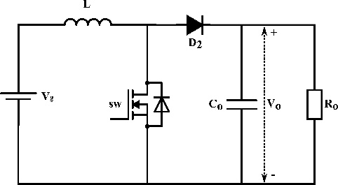
Fig. 1. Conventional boost converter topology

2.1 Mode 1(DTs)
During the switch's turn-on period, the input voltage energizes the inductor, while the diode is reverse-biased and non-conductive, allowing the capacitor to provide the load current, as depicted in the equivalent circuit in Figure 2.
$$\left\{\begin{aligned}\begin{aligned}V_{L}=L\frac{di_{L}}{dt}=V_{g}\end{aligned} \\ C_{O}\frac{dv_{co}}{dt}=i_{co}=-i_{O}\end{aligned}\right.$$ | (1)
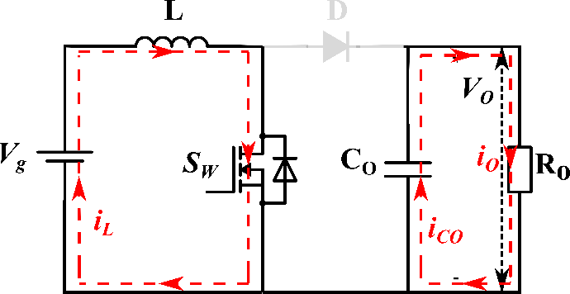
Fig. 2 Equivalent circuit for mode 1

In contrast, during the turn-off period, the diode is forward biased by the resultant voltage of the input Vg and inductor voltage, and the capacitor is charged while the load is supplied simultaneously, as depicted in the equivalent circuit in Figure 3.
$$\left\{\begin{aligned}\begin{aligned}V_{L}^{'}=L\frac{di_{L}}{dt}=V_{g}-\end{aligned}V_{o} \\ C_{O}\frac{dv_{co}}{dt}=i_{co}=i_{L}-i_{O}\end{aligned}\right.$$ | (2)
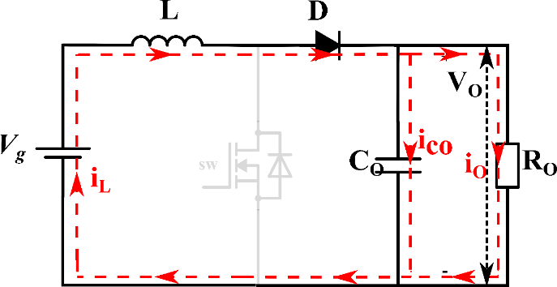
Fig. 3 Equivalent circuit for mode 2
The derived input out voltage relationship is express as:
$$V_{O}=\frac{V_{g}}{\left(1-D\right)}$$ | (3)

3. One Cycle Control
The OCC method is also known as the integration-reset technique, and the major component of this control method is the resettable integrator(Boloor & Halvaei, 2014). The OCC as depicted in figure 4 is a nonlinear control theory that consists of a constant frequency clock, comparator and integrator that is used to control some form of signals(Benli et al., 2017).
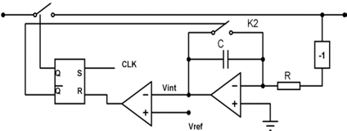
Fig. 4. Constant frequency one cycle control implementation circuitry
Observing the switched variables of the boost converter, such as the switch voltage Vsw, indicates that the input voltage is an average value of the switched variable, hence the area under voltage pulse divided by the period gives the input voltage and hence a control scheme for a constant frequency converter can be implemented using by reciprocating this idea of the relationship between Vsw and Vin. Equation 4 expresses the negligible switch voltage during the conduction period.
$$\left.\begin{aligned}\begin{aligned}V_{sw}=0…\left(DT_{s}\right)\end{aligned}\end{aligned}\right.$$ | (4)
Equation 6 describes the non-conduction phase of the switch, which indicates that the switch's voltage stress is equal to the output voltage.
$$\left\{\begin{aligned}\left.\begin{aligned}\begin{aligned}V_{sw}^{'}=V_{g}-\end{aligned}V_{L}^{'}… \end{aligned}\right.\left(1-D\right)T_{s} \\ \begin{aligned}V_{sw}^{'}=V_{g}-\left(V_{g}-V_{o}\right)\end{aligned} \\ \begin{aligned}V_{sw}^{'}=V_{o}\end{aligned}\end{aligned}\right.$$ | (5)

By substituting equation 3 into equation 5, we obtain equation 6, which outlines the relationship between the input voltage Vg the switch voltage Vsw, and the duty cycle D.
$$\left.\begin{aligned}\begin{aligned}V_{sw}^{'}=\end{aligned}V_{O}=\frac{V_{g}}{\left(1-D\right)}\end{aligned}\right.$$ | (6)
Over the switching period Ts the area under the switch voltage Vsw divided by the period is equivalent to the average input voltage Vg
$$\left.\begin{aligned}\left\{\begin{aligned}\begin{aligned}V_{sw}^{'}\left(1-D\right)=\end{aligned}V_{g} \\ \frac{1}{T_{s}}\int_{0}^{D^{'}T_{s}}{V_{sw}dt=Vg}\end{aligned}\right.\end{aligned}\right.$$ | (7)
Alternatively, given that Vsw is equal to Vo, equation 7 can be rearranged to derive equation 8. This equation demonstrates that the area under the output voltage Vo during the turn-on period DTs is equal to the average area of the difference between Vo and Vg
$$\left.\begin{aligned}\left\{\begin{aligned}\begin{aligned}V_{o}\left(1-D\right)=\end{aligned}V_{g} \\ V_{o}-V_{g}=DV_{o}\end{aligned}\right.\end{aligned}\right.$$ | (8)
$$\left.\begin{aligned}\left.\begin{aligned}V_{o}-V_{g}=\frac{1}{T_{s}}\int_{0}^{D^{'}T_{s}}{V_{o} dt}\end{aligned}\right.\end{aligned}\right.$$ | (9)
In a closed-loop system, the desired output Vo must be equal to the reference value Vref. The mathematical representation of the one cycle control technique can thus be given by the following equations 10.
$$\left.\begin{aligned}\left.\begin{aligned}V_{ref}-V_{g}=\frac{1}{T_{s}}\int_{0}^{D^{'}T_{s}}{V_{ref} dt}\end{aligned}\right.\end{aligned}\right.$$ | (10)
During the clock period Ts, the integration of Vref is carried out and the results are compared with the right-hand side of equation 11. When the integral of Vref is less than or equal to Vref - Vg, the PWM signal is set high. Once the integral value reaches or exceeds Vref - Vg, the comparator resets the flip-flop, the PWM signal is set low, and the integrator is reset, as shown in the flowchart in Figure 5.
$$\left.\begin{aligned}\left.\begin{aligned}V_{ref}-V_{g}≥\frac{1}{T_{s}}\int_{0}^{D^{'}T_{s}}{V_{ref} dt}\end{aligned}\right.\end{aligned}\right.$$ | (11)

Fig. 5. Controller Flowchart
Figure 6 illustrates the OCC waveform, displaying the integrator output, Vref - Vg, the clock, flip-flop reset, and the PWM signal.
Fig. 6. Controller Signal Waveform
4. SIMULATION STUDIES
The equivalent model of the converter is simulated in the MATLAB/Simulink environment using the design parameters in Table 1, and the results are provided in this section. The theoretical values and simulation results are congruent, the simulation shows the viability of the suggested control mechanism. Simulation results were consistent with theoretical values, validating the controller for practical implementation.
Table 1 Simulation and Experimental Parameters.
Parameter |  | Specifications
Input Voltage | Vg | 12 V
Output Voltage | Vo | 24 V
Output Power | Po | 50 W
Output Current | Io | 2.08 A
Switching Frequency | fs | 25 kHz
Inductance | L | 120 µH
Output Capacitor | Co | 350 µF
Max Duty Cycle | d | 0.5
The system demonstrated stable performance by achieving a steady output voltage of 24V, within a settling time of 6ms, a peak-to-peak voltage ripple of 0.43V and an overshoot of 13.75%. This was observed for a constant input voltage of 12 V, duty ratio of 0.5, and a switching frequency of 25 kHz, as shown in figures 7.

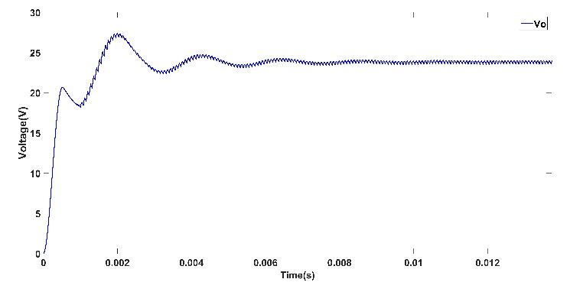
Fig. 7. Output Voltage of OCC controlled boost converter
The output voltage response of the converter is simulated by varying the input voltage parameters. Figure 8 depicts the response observed for voltage variations from 13 V to 24 V. The simulation result for the 13 V to 24 V transition indicates an overshoot of 27.08%, considering ideal components and a settling time of 4.5 ms.
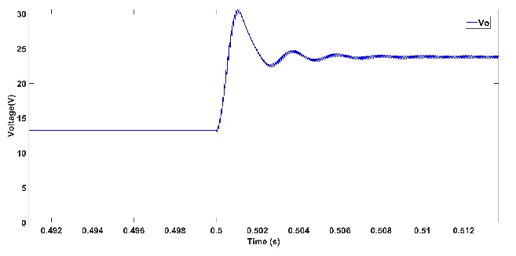

Fig. 8 Output voltage for a step reference voltage variation13V - 24V
The step change in reference voltage from 24 V to 13 V as depicted in Figure 9 and is characterized by an undershoot o 12.8% and a corresponding settling time of 3.8 ms.
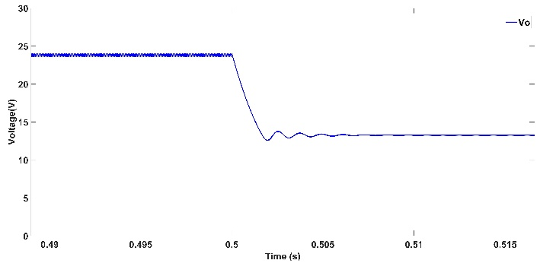

Fig. 9 Output voltage for a step reference voltage variation 24V - 13V
The output load response is observed by varying the output load of the system at a constant switching frequency, reference and input voltage value. Figure 10 and 11 shows the converter's response to load changes, specifically from full load to half load and from half load to full load in order to observe the controller response. The figure shows the output voltage (Vo), input voltage (Vg), reference voltage (Vref) and load currents (Io). The over and undershoot during the transitions were found to be 4.92% and -5.08%, respectively, with corresponding settling times of 1.92 ms and 5.06 ms.
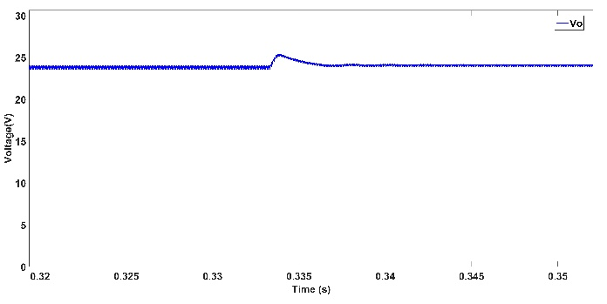

Fig. 10 Output Voltage for full to half load variation

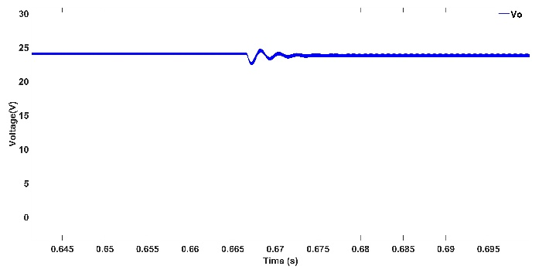
Fig. 11 Output Voltage for half to full load variation
5. EXPERIMENTAL STUDIES
The experimental validation of the control method is applied to the boost converter with the experimental setup displayed in Figure 12 below. The control method was implemented in the MATLAB/Simulink environment with the TMS320F28069M microcontroller utilizing the DSP 12-bit ADC channels ADCINA0 and ADCINB0 for the measurement of the input and output voltages respectively. Also the PWM output is accomplished through the enhanced PWM channel ePWM1 at a fixed frequency of 25 kHz.

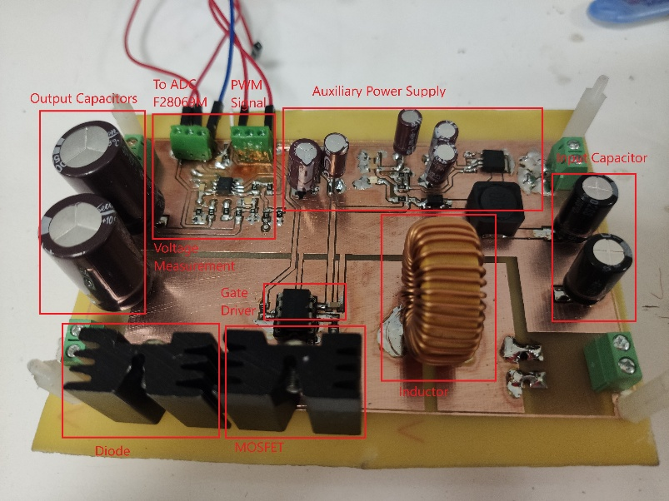
Fig. 12 Experimental prototype of OCC controlled boost converters
Figure 13 indicates a step response of the OCC-controlled boost converter for a reference voltage transition from 13 V to 24 V under constant load conditions, with an input voltage of 11.88 V from a standard 12 V battery supply and a current of 4.78 A. The steady-state output voltage of 24 V and a ripple voltage of 0.3 Vpp was recorded at a load of 11.52 Ω, an overshoot of 14.3% was observed under this transition, and Vo settles in 3.6 ms. The system efficiency under this operation condition is calculated to be 90.26%.
Fig. 13 Experimental output voltage for reference voltage variation (13V-24V)
Similarly, figure 14 shows the step response of the converter with the OCC control for a reference voltage transition of 24 V to 13 V under constant load conditions and an input voltage of 11.95 V and an input current of 1.53 A, with a steady-state output voltage of 13 V and 0.5 Vpp ripple voltage recorded at load resistance of 11.52 Ω, and voltage sag of 12.31% was observed under this transition, the output voltage settle to a steady state value in 1.9 ms. The system efficiency was calculated to be 86.52%
Fig. 14 Experimental output voltage for reference voltage variation (24V-13V)
The step load response of the OCC-controlled converter for a load transition full-half load and half-full load was also observed under a constant input voltage and output voltage reference of 24 V. Figure 15 and 16 show the converter's output voltage for the step changes in load. Under a full load of 11.52 Ω to a half load of 23.04 Ω, an overshoot of 8.33% was observed following a step change with the system reaching steady-state condition in 1.2 ms.

Fig. 15 Experimental output voltage for load variation (full to half load)
Figure 16 depicts the transition of half to full load step response, which indicates a voltage sag of 6.64 % with a settling time of 1.6 ms.The half-load operation is characterized by an input voltage of 11.91 V with an input current of 2.42 A, output voltage of 24 V and 0.3 Vpp. The overall system efficiency of 88.92% was recorded. In contrast to the simulation results, the experimental results demonstrated smaller overshoots and faster settling times, attributed to the resistance in PCB traces and other parasitic elements

Fig. 16 Experimental output voltage for load variation (half to full load)
6. CONCLUSION
The DSP-implemented OCC method for pre-calculating and optimizing the duty cycle of a boost converter has demonstrated fast response times and improved system stability. For an input voltage transition from 13V to 24V, the system achieved a settling time of 3.6 ms with a 14.3% overshoot, while for a transition from 24V to 13V, it settled in 1.9 ms with a -12.31% overshoot. Voltage ripple was well-controlled, staying within 0.3Vpp to 0.5Vpp. In load variation tests, the settling times were 1.2 ms and 1.6 ms for full-to-half load and half-to-full load transitions, with overshoots of 8.33% and sags of -6.64%, respectively. The converter efficiency peaked at 90.26% under steady-state conditions. These results highlight the effectiveness of OCC in ensuring fast dynamic responses, minimal voltage ripple, and high efficiency, making it a valuable control strategy for renewable energy systems. Future work can explore parameter tuning and application to different converter topologies to broaden its usage.

COMPETING INTERESTS DISCLAIMER:
Authors have declared that they have no known competing financial interests OR non-financial interests OR personal relationships that could have appeared to influence the work reported in this paper.

Disclaimer (Artificial intelligence)
Option 1:
Author(s) hereby declare that NO generative AI technologies such as Large Language Models (ChatGPT, COPILOT, etc.) and text-to-image generators have been used during the writing or editing of this manuscript.
Option 2:
Author(s) hereby declare that generative AI technologies such as Large Language Models, etc. have been used during the writing or editing of manuscripts. This explanation will include the name, version, model, and source of the generative AI technology and as well as all input prompts provided to the generative AI technology
Details of the AI usage are given below:
1.
2.
3.

References

Alonge, F., Busacca, A., Calabretta, M., D’Ippolito, F., Fagiolini, A., Garraffa, G., Messina, A. A., Sferlazza, A., & Stivala, S. (2022). Nonlinear Robust Control of a Quadratic Boost Converter in a Wide Operation Range, Based on Extended Linearization Method. Electronics 2022, Vol. 11, Page 2336, 11(15), 2336. https://doi.org/10.3390/ELECTRONICS11152336
Banaei, M. R., Ardi, H., & Farakhor, A. (2014). Analysis and implementation of a new single-switch buck-boost DC/DC converter. IET Power Electronics, 7(7), 1906–1914. https://doi.org/10.1049/iet-pel.2013.0762
Bayoumi, E. H. E. (2003). A simplified method for controlling DC-DC converters using sliding mode control. IASTED International Conference on Modelling Identification and Control, 1–6.
Benli, M., Karaarslan, A., & Şeker, M. (2017). The Analysis of One Cycle Control Method using DC-DC Isolated Forward Converter. 8th International Advanced Technologies Symposium (IATS’17), 3582–3589.
Bevrani, H., Abrishamchian, M., & Safari-shad, N. (1999). Nonlinear and linear robust control of switching power converters. IEEE Conference on Control Applications - Proceedings, 1, 808–813. https://doi.org/10.1109/cca.1999.807765
Boloor, K. E., & Halvaei, N. A. (2014). Implementation of a novel brushless DC motor drive based on one-cycle control strategy. PEDSTC 2014 - 5th Annual International Power Electronics, Drive Systems and Technologies Conference, 55–60. https://doi.org/10.1109/PEDSTC.2014.6799343
Bose, B. K. (2017). Power Electronics in Smart Grid and Renewable Energy Systems. Proceedings of the IEEE, 105(11), 2007–2010. https://doi.org/10.1109/JPROC.2017.2752538
Chan, C. (2007). A Nonlinear Control for DC – DC Power Converters. 22(1), 216–222.
Chattopadhyay, S., & Das, S. (2006). A digital current-mode control technique for dc-dc converters. IEEE Transactions on Power Electronics, 21(6), 1718–1726. https://doi.org/10.1109/TPEL.2006.882929
Cuk, S. (1995). Dynamics of One-Cycle Controlled Cuk Converters. IEEE Transactions on Power Electronics, 10(6), 634–639. https://doi.org/10.1109/63.471282
Ćuk, S. (1995). One-Cycle Control of Switching Converters. IEEE Transactions on Power Electronics, 10(6), 625–633. https://doi.org/10.1109/63.471281
Dhara, D., Paul, R., & Dalapati, S. (2024). An Improved Non-Inverting Integrator Resetting Circuit for One Cycle Control Strategy. International Conference on Distributed Computing and Optimization Techniques, ICDCOT 2024. https://doi.org/10.1109/ICDCOT61034.2024.10515869
Ellabban, O., & Van Mierlo, J. (2009). Comparative Evaluation of PID Voltage Mode, PI Current Mode, Fuzzy and PWM Based Sliding Mode Control for DC-DC converters. The 13th International Middle East Power System Conference MEPCON 2009, January, 6.
Fang, X., Ding, X., Zhong, S., & Tian, Y. (2019). Improved Quasi-Y-Source DC-DC Converter for Renewable Energy. CPSS Transactions on Power Electronics and Applications, 4(2), 163–170. https://doi.org/10.24295/cpsstpea.2019.00016
Gorji, S. A., Ektesabi, M., & Zheng, J. (2016). Double-input boost/Y-source DC-DC converter for renewable energy sources. 2016 IEEE 2nd Annual Southern Power Electronics Conference, SPEC 2016, 1–6. https://doi.org/10.1109/SPEC.2016.7846020
Gupta, K. K., & Bhatnagar, P. (2017). Multilevel inverters: Conventional and emerging topologies and their control. Multilevel Inverters: Conventional and Emerging Topologies and Their Control, 1–209. https://doi.org/10.1016/C2016-0-03360-0
İskender, İ., & Karaarslan, A. (2005). On The Comparison of Fuzzy Logic and State Space Averaging based Sliding Control Methods Applied on an Arc Welding Machine. Engineering and Technology, 8(October), 100–105.
Jang, J., Pidaparthy, S. K., & Choi, B. (2015). Current mode control for LLC series resonant DC-to-DC converters. Energies, 8(6), 6098–6113. https://doi.org/10.3390/en8066098
Karaarslan, A., & Iskender, I. (2010). TPE-Conference THE COMPARISON OF AVERAGE AND HYSTERESIS CURRENT MODE CONTROL TECHNIQUE OF SINGLE PHASE BOOST POWER FACTOR CORRECTION CONVERTER. September, 444–448.
Karaarslan, A., & Shaibu, A. (2022). Performance Analysis and Comparison of Non-Inverting Buck-Boost Converter Using PI, OCC, and Hybrid OCC-PI Control. Journal of Electrical Technology UMY, 6(2), 57–66. https://doi.org/10.18196/JET.V6I2.15756
Kiran, B., Parthiban, P., Jena, D., & Prakash, P. S. (2016). Design and implementation of sliding mode voltage controller for DC to DC buck converter by using hysteresis modulation and pulse width modulation. 2016 - Biennial International Conference on Power and Energy Systems: Towards Sustainable Energy, PESTSE 2016, 1–6. https://doi.org/10.1109/PESTSE.2016.7516439
Kratmüller, M. (2009). The adaptive control of nonlinear systems using the T-S-K fuzzy logic. Acta Polytechnica Hungarica, 6(2), 5–16.
Krein, P. T. (2007). Digital control generations - Digital controls for power electronics through the third generation. Proceedings of the International Conference on Power Electronics and Drive Systems, 1–5. https://doi.org/10.1109/PEDS.2007.4487667
Lenz, E., & Pagano, D. J. (2013). Nonlinear Control for Bidirectional Power Converter in a dc Microgrid. In IFAC Proceedings Volumes (Vol. 46, Issue 23). IFAC. https://doi.org/10.3182/20130904-3-FR-2041.00121
Lešo, M., Žilková, J., Biroš, M., & Talian, P. (2018). Survey of Control Methods for Dc-Dc Converters. Acta Electrotechnica et Informatica, 18(3), 41–46. https://doi.org/10.15546/aeei-2018-0024
Maroti, P. K., Padmanaban, S., Wheeler, P., Blaabjerg, F., & Rivera, M. (2018). Modified high voltage conversion inverting cuk DC-DC converter for renewable energy application. Proceedings - 2017 IEEE Southern Power Electronics Conference, SPEC 2017, 2018-Janua, 1–5. https://doi.org/10.1109/SPEC.2017.8333675
Mathew, D., & Rani*, C. N. (2020). One Cycle Controlled Single Stage Transformerless Buck Boost Inverter. International Journal of Innovative Technology and Exploring Engineering, 9(5), 58–63. https://doi.org/10.35940/IJITEE.E1982.039520
Meesala, S. R. (2012). Designing Flyback Converters Using Peak-Current-Mode Controllers. 5504.
Mukesh Kumar, A. K. verma,. (2015). Design of Boost Converter with Fuzzy Logic Controller for Renewable Energy Sources. International Journal of Advanced Research in Electrical, Electronics and Instrumentation Engineering, 04(06), 5078–5085. https://doi.org/10.15662/ijareeie.2015.0406025
Nisantasi, K. K. (2013). Hysteresis Control of a Boost PFC Converter Circuit. December, 587–590.
Odhafa, T. A., Abed, I. A., & Obed, A. A. (2021). Controlling of Boost Converter by Proportional Integral Controller. 1–8. https://doi.org/10.14456/ITJEMAST.2021.66
Olabi, A. G. (2017). Renewable energy and energy storage systems. Energy, 136, 1–6. https://doi.org/10.1016/j.energy.2017.07.054
Neethu, R., Albert, S., & Purushothaman. (2016). Fuzzy Controllers for Boost DC-DC Converters. Journal of Electronics and Communication Engineering, 12–19.
Shanbog, N. S., & Pushpa, K. R. (2019). Double Input Boost/Y-Source DC-DC Converter for Renewable Energy Sources. Proceedings of the 2019 2nd International Conference on Power and Embedded Drive Control, ICPEDC 2019, 13–17. https://doi.org/10.1109/ICPEDC47771.2019.9036696
Silva, J. F., & Pinto, S. F. (2007). Control methods for switching power converters. In Power Electronics Handbook (pp. 935–998). Academic Press. https://doi.org/10.1016/B978-012088479-7/50052-3
Varghese, A., Paul, S., & John, N. (2019). Fuzzy Logic Based High Gain DC-DC Boost Converter for Microgrid Application. International Journal of Engineering Science, 9(6), 22922–22928.
Wan, K., Liao, J., & Ferdowsi, M. (2007). Control methods in DC-DC power conversion - A comparative study. PESC Record - IEEE Annual Power Electronics Specialists Conference, 2007, 921–926. https://doi.org/10.1109/PESC.2007.4342111
Yazici, I., Özdemir, A., & Erdem, Z. (2009). Real time implementation of a digital controlled boost converter. ELECO 2009 - 6th International Conference on Electrical and Electronics Engineering, 437–441.
Zhang, D., Gao, C., Chen, J., & Wang, Z. (2023). Digital One-Cycle Control Method Based on Current Prediction. 2023 26th International Conference on Electrical Machines and Systems, ICEMS 2023, 5109–5113. https://doi.org/10.1109/ICEMS59686.2023.10344577
Zhong, Q. C., & Hornik, T. (2012). Control of Power Inverters in Renewable Energy and Smart Grid Integration. In Control of Power Inverters in Renewable Energy and Smart Grid Integration. https://doi.org/10.1002/9781118481806

