Leveraging Generative AI and Behavioral Biometrics to Strengthen Zero Trust Cybersecurity Architectures in Healthcare Systems

Abstract
This study investigates the integration of Generative Artificial Intelligence (AI) and Behavioral Biometrics within Zero Trust cybersecurity frameworks tailored for healthcare systems. Drawing on public datasets—including MITRE ATT&CK for Enterprise, UNSW Behavioral Biometrics, and the HHS HC3 Healthcare Cybersecurity Dashboard—the study employs a quantitative design featuring Two-Sample T-Tests, ROC-AUC analysis, and Exploratory Factor Analysis (EFA). Findings indicate a marked improvement in threat detection rates, rising from 65.21% to 82.06% following Generative AI deployment. Additionally, behavioral biometric authentication models achieved an Area Under the Curve (AUC) score of 1.00, signifying perfect classification performance. While these results highlight the technical promise of both technologies, such outcomes are derived under controlled experimental conditions using curated public datasets. The AUC score of 1.00, while mathematically accurate within the testing dataset, may not fully translate to real-world clinical environments due to potential overfitting, limited behavioral variability, and the absence of adversarial behavior simulations. These limitations underscore the need for caution when generalizing findings to dynamic healthcare infrastructures, where biometric stability and adaptive threat detection are more variable. The study further identifies financial, infrastructural, and policy-level challenges as critical barriers to adoption. Strategic recommendations include investing in interoperable cybersecurity infrastructure, updating HIPAA frameworks to address AI and biometrics governance, expanding interdisciplinary education programs, and introducing policy incentives for Zero Trust transformation. Recommendations include investing in interoperable infrastructure, updating HIPAA frameworks, expanding interdisciplinary cybersecurity education, and introducing governmental incentives to support Zero Trust transformations enhanced by AI and biometrics.
Keywords: Generative AI, Behavioral Biometrics, Zero Trust Architecture, Healthcare Cybersecurity, Exploratory Factor Analysis

1. Introduction
The digital transformation of healthcare has substantially redefined patient care, enhancing data management, remote monitoring, and advanced diagnostics; however, this increasing reliance on interconnected technologies, including electronic health records (EHRs), telehealth platforms, and cloud infrastructures, has simultaneously expanded the cybersecurity threat surface. As a result, healthcare systems have emerged as prime targets for malicious actors due to their repositories of highly sensitive information, including Protected Health Information (PHI) (Luna et al., 2016). According to Alder (2025) approximately 276.8 million individuals were affected by healthcare data breaches in 2024 alone, averaging 758,288 compromised records per day. This alarming trend, reflects the inadequacy of traditional perimeter-based cybersecurity models in safeguarding healthcare operations.
The intensification of threats is further underscored by increasingly sophisticated attack methods, including ransomware, phishing, and distributed denial-of-service (DDoS) campaigns (Falowo et al., 2024). A notable illustration is the Change Healthcare ransomware attack of February 2024, where compromised credentials and inadequate multifactor authentication facilitated the exposure of medical and personal data for approximately 100 million individuals, causing extensive disruptions across hospitals and pharmacies throughout the United States (Kanter et al., 2024). This breach, the largest in healthcare history, exemplifies the scale and complexity of contemporary cyberattacks targeting critical infrastructures. Furthermore, data from 24By7Security (2024) reveal that breaches in 2024 impacted nearly 180 million individuals, while the IBM (2024) estimated the average financial cost per breach at $9.77 million, reaffirming healthcare as the sector most vulnerable to financial exploitation.
Given these evolving challenges, cybersecurity strategies are shifting towards more adaptive and identity-centric frameworks. Zero Trust Architecture (ZTA), according to Syed et al. (2022), is increasingly recognized for its suitability to contemporary healthcare security demands. Unlike legacy models that presume the safety of internal networks, ZTA requires continual verification of users, devices, and applications irrespective of their location. EY Center (2024) revealed that, as of early 2024, 47% of healthcare organizations had initiated ZTA projects, while another 38% planned implementation within the following year. Concurrently, Global Market Insights Inc. valued the global ZTA market at $19.2 billion in 2024, projecting a compound annual growth rate of 17.4% through 2034 (GMI, 2024).
Nevertheless, the practical realization of Zero Trust frameworks depends heavily on the deployment of advanced technologies capable of dynamic threat detection and continuous authentication. In this context, Munir et al. (2024) argues that Artificial Intelligence—particularly Generative AI—offers substantial potential. Generative AI models possess the capacity to simulate threat vectors, detect anomalies in real time, and inform adaptive defense protocols. For example, SplxAI has developed tools that can simulate over 2,000 cyberattacks within an hour, enabling organizations to identify latent system vulnerabilities efficiently (Varanasi, 2025). Moreover, an initiative by the University of Pittsburgh and Leidos allocated $10 million toward research in generative AI for early disease detection, highlighting AI’s interdisciplinary applicability in both clinical and security domains (Beavins, 2025).
Despite these advancements, widespread adoption of AI in cybersecurity is constrained by governance and ethical considerations. According to Keragon (2024), only 40% of U.S. healthcare institutions employing generative AI had established defined governance frameworks by 2024, thereby raising concerns about data misuse, model reliability, and regulatory compliance. Nonetheless, Mukherjee (2023) reports that 86% of Chief Information Security Officers (CISOs) expressed optimism regarding generative AI’s capacity to mitigate workforce shortages in cybersecurity, underscoring sustained belief in the technology’s future role (Marr, 2024).
Complementing the capabilities of AI, Behavioral Biometrics has gained prominence as an effective solution for continuous identity authentication. Unlike static passwords or even traditional biometric methods, behavioral systems analyze real-time user interaction patterns, such as typing rhythms, mouse dynamics, and touchscreen behaviors, to verify identity dynamically (Abuhamad et al., 2020). This approach is particularly advantageous within healthcare settings characterized by stringent privacy requirements. According to imarc (2024), the global behavioral biometrics market was valued at $4.5 billion in 2024 and is projected to reach $10.5 billion by 2033. Additionally, Plurilock (2025) underscores behavioral biometrics as integral to the operationalization of Zero Trust principles, due to its passive and adaptive verification mechanisms.
It is essential to acknowledge that these technological innovations are not without barriers. Drawing on the research of Obioha-Val (2024), challenges such as limited infrastructural readiness, workforce skill deficiencies, and ethical risks have been identified as significant impediments to successful AI integration. These findings are equally applicable to the healthcare sector, where systems must uphold HIPAA compliance, detect insider threats, and maintain patient trust simultaneously. Therefore, any AI-driven cybersecurity strategy must be underpinned by robust policy frameworks and operational safeguards.
Paraschiv et al. (2024) contributions further demonstrate the necessity and practicality of integrating AI into healthcare cybersecurity. The CVE-LLM framework, which employs large language models to assess medical device vulnerabilities, exemplifies AI's proactive role in threat identification (Sheng et al., 2025). Similarly, the ADAPT framework, integrating game theory and neuro-symbolic AI, enables automated penetration testing and provides adaptive, real-time insights into systemic weaknesses (Lei et al., 2024).
Parallel to these technological developments, regulatory frameworks have also advanced. In 2024, the U.S. Department of Health and Human Services proposed critical amendments to the HIPAA Security Rule aimed at reinforcing identity verification, mandating multifactor authentication, and instituting regular auditing processes (HHS, 2024). These regulatory efforts align closely with the capabilities of Generative AI and Behavioral Biometrics within Zero Trust paradigms.
By extending the findings of Obioha-Val (2024) into the healthcare cybersecurity domain, this research positions the convergence of Generative AI and Behavioral Biometrics as a crucial strategy to meet the sector’s intensifying security demands. The integration of these technologies within a Zero Trust framework, offers a timely and strategic response to an increasingly vulnerable and high-stakes healthcare environment. This study aims to investigate how the integration of Generative AI and Behavioral Biometrics within a Zero Trust architecture can further strengthen cybersecurity in the distinct context of U.S. healthcare systems, by achieving the following objectives:
- To examine the effectiveness of Generative AI in augmenting threat detection, simulation, and adaptive defense mechanisms within Zero Trust frameworks in healthcare.
- To assess the viability of Behavioral Biometrics as a tool for continuous, individualized authentication in healthcare environments with high privacy demands.
- To analyze the technological, infrastructural, and policy-level barriers to integrating Generative AI and Behavioral Biometrics in existing Zero Trust security models.
- To propose strategic recommendations for secure and ethically aligned deployment of these technologies in compliance with data protection regulations applicable to healthcare systems.

2. Literature Review
Zero Trust Architecture (ZTA) represents a fundamental shift from traditional cybersecurity frameworks, abandoning the implicit trust historically afforded to internal network entities in favor of a model predicated on the principle of "never trust, always verify" (Nadji, 2024). ZTA mandates stringent authentication and authorization for every user, device, and application, regardless of network location, thereby reducing the risk associated with internal threats (Syed et al., 2022; Ajayi et al., 2025). The National Institute of Standards and Technology (NIST) identifies three foundational pillars underpinning ZTA: least privilege access, micro-segmentation, and continuous verification (Kerman, 2020; Balogun, 2025). Least privilege access ensures that users receive only the permissions essential for their responsibilities, thereby minimizing the potential damage from compromised credentials (Syed et al., 2022; Kolade et al., 2025). Simultaneously, micro-segmentation isolates network zones to restrict lateral movement during breaches, while continuous verification demands ongoing authentication and monitoring throughout user sessions, replacing outdated models reliant on singular checkpoint validations (Khan, 2023; Metibemu et al., 2025).
The healthcare sector, characterized by a complex and distributed digital environment, exemplifies the critical relevance of ZTA. Arif et al. (2025) argues that the proliferation of electronic health records (EHRs), telehealth services, and cloud-hosted applications has substantially expanded the sector’s attack surface. Furthermore, the shift towards remote work models and distributed systems has complicated traditional perimeter-based defenses (Fitria, 2021; Obioha-Val, 2025). In response, ZTA offers a comprehensive framework that enforces granular access controls and eradicates assumptions of internal network trust (Syed et al., 2022; Olutimehin, 2025). According to reports by EY Center (2024) approximately 47% of U.S. healthcare organizations had launched Zero Trust initiatives by early 2024, with another 38% planning to implement them within the next year. This trend emphasizes a growing institutional recognition of the imperative to safeguard Protected Health Information (PHI) and ensure the operational resilience of clinical systems against increasingly sophisticated cyber threats.
Nevertheless, the implementation of ZTA in healthcare environments faces considerable infrastructural and administrative obstacles. Khan (2023) avers that legacy systems, pervasive across the sector, often lack the interoperability and telemetry capabilities necessary for Zero Trust enforcement, necessitating substantial financial investments and extensive reconfigurations. Administrative challenges are equally significant; the establishment of advanced identity and access management systems, coupled with the management of detailed permission structures, demands specialized technological resources and skilled personnel (Indu et al., 2018; Oyekunle et al., 2025). Additionally, cultural resistance among healthcare professionals—who are accustomed to more permissive access protocols—further complicates ZTA adoption (Ojo, 2025; Salako et al., 2025). Regulatory requirements, particularly those mandated by HIPAA, necessitate a delicate balance between maintaining rigorous security postures and enabling efficient, compliant information sharing critical to patient care.

Role of Generative AI in Healthcare Cybersecurity
Generative Artificial Intelligence (AI) has transitioned from experimental technology to a central pillar of contemporary cybersecurity practices, particularly within the healthcare sector, where data sensitivity and system complexity necessitate proactive defenses (Manea & Zbuchea, 2025; Tiwo et al., 2025). Defined as a class of AI capable of generating new outputs based on training datasets, generative AI facilitates the simulation of sophisticated cyberattack scenarios, dynamic threat adaptation, and real-time decision-making (Khan et al., 2025; Alao et al., 2024). According to Goyal and Mahmoud (2024), unlike traditional AI models that primarily classify or predict outcomes, generative AI creates synthetic instances replicating real-world conditions, thus enabling unprecedented capacities in attack simulation, anomaly detection, and defense automation.
In the context of threat simulation, tools such as SplxAI demonstrate generative AI’s capacity to simulate over 2,000 cyberattacks within a single hour, thereby allowing healthcare organizations to proactively identify and mitigate latent vulnerabilities (Varanasi, 2025; Balogun et al., 2025). Similarly, the CVE-LLM framework employs large language models to detect vulnerabilities in medical devices (Sheng et al., 2025; Obioha-Val et al., 2025), while the ADAPT framework, developed through a collaboration between Leidos and the University of Pittsburgh, integrates neuro-symbolic AI and game theory to conduct real-time penetration testing (Beavins, 2025). These initiatives reflect a paradigmatic shift toward proactive security postures, aligning closely with Zero Trust principles that emphasize continuous risk assessment and adaptive access controls.
Moreover, generative AI exhibits substantial efficacy in anomaly detection, learning baseline network behaviors and identifying subtle deviations that traditional signature-based detection systems might overlook. According to Kennedy (2024), healthcare institutions deploying generative AI technologies have reported a 32% reduction in incident response times, with some achieving full containment within minutes. These outcomes, as emphasized by Obioha-Val (2024), further illustrate the potential of generative AI to mitigate cybersecurity workforce shortages by automating routine monitoring tasks and enabling continuous system learning.
Nevertheless, the implementation of generative AI in healthcare cybersecurity is not without critical challenges. Nadeem et al. (2025) posits that model reliability remains a pressing concern, particularly in high-stakes clinical environments where false positives or hallucinated threat patterns could disrupt essential operations. Data poisoning risks, wherein adversaries manipulate training datasets to compromise AI outputs, further exacerbate these vulnerabilities (Sambucci & Paraschiv, 2024; Olutimehin, 2025). Additionally, Keragon (2024) contends that governance deficiencies present significant barriers; for instance, only 40% of healthcare organizations utilizing generative AI had formal governance frameworks in place as of 2024. Consequently, successful integration necessitates the establishment of robust governance structures, institutional preparedness, and strict adherence to regulatory mandates such as HIPAA to safeguard patient data and ensure clinical efficacy.

Behavioral Biometrics in Continuous Authentication
Behavioral biometrics has emerged as a pivotal innovation in continuous authentication, offering a dynamic approach to verifying user identity based on individual interaction patterns rather than static physiological traits. Unlike traditional biometrics, such as fingerprints or iris scans, behavioral biometrics analyzes unconscious behaviors, including keystroke dynamics, mouse movement trajectories, and touchscreen gestures, to generate a unique digital fingerprint that is exceptionally difficult for malicious actors to replicate (Ayeswarya & Singh, 2024; Salami et al., 2025). This distinctive advantage positions behavioral biometrics as a critical component of modern cybersecurity frameworks.
The continuous verification capability of behavioral biometrics markedly distinguishes it from conventional authentication methods. Whereas traditional techniques verify users at discrete points—typically at initial system access (Al-Karkhi et al., 2015; Tiwo et al., 2025)—behavioral biometrics enables passive, persistent authentication throughout the entirety of a user session (Liang et al., 2020; Olutimehin et al., 2025). This ongoing verification process aligns closely with Zero Trust Architecture (ZTA) principles, where the imperative of "never trust, always verify" necessitates adaptive, non-intrusive user monitoring. Behavioral biometrics enhances ZTA by introducing an adaptive security layer that confirms the authenticated individual's presence without interrupting clinical workflows, a feature particularly vital within the sensitive operational contexts of healthcare institutions (Syed et al., 2022; Obioha-Val et al., 2025).
Furthermore, market analyses indicate a rising trajectory for behavioral biometrics adoption across critical sectors. imarc (2024) reports that the global behavioral biometrics market, valued at approximately $4.5 billion in 2024, is projected to exceed $10.5 billion by 2033, driven by increasing demand for identity-centric security solutions and the inadequacy of traditional authentication methods against sophisticated cyberattacks. Practical implementations reinforce these projections; for instance, healthcare organizations integrating behavioral biometric systems, such as those developed by Plurilock (2025) have achieved measurable reductions in credential misuse incidents and enhanced insider threat detection by identifying deviations from established behavioral baselines.
Nevertheless, despite its promise, the deployment of behavioral biometrics is not devoid of challenges. Chandre et al. (2024) avers that concerns regarding false positives, adaptability to legitimate behavioral changes, and privacy implications associated with continuous monitoring remain significant obstacles. Within cybersecurity scholarship, dialogues increasingly advocate for the development of stringent governance frameworks that emphasize user consent, data minimization, and ethical oversight as essential safeguards (Renuka et al., 2024; Alhasan, 2025; Balogun et al., 2025). Absent such protections, Kadena et al. (2022) warns that trust in behavioral biometric systems may erode over time, particularly in healthcare contexts where balancing stringent security measures with the imperative of patient-centered accessibility remains paramount.

Integration of Generative AI and Behavioral Biometrics within Zero Trust Frameworks
The integration of Generative AI and Behavioral Biometrics within Zero Trust frameworks signifies a critical advancement in cybersecurity architecture, particularly within healthcare systems where the sensitivity of protected information necessitates heightened security measures (Khan, 2023; Olutimehin et al., 2025). Generative AI operates as a predictive engine, dynamically simulating evolving threat vectors and analyzing extensive datasets to detect anomalies in real time (Khan et al., 2025; Obioha-Val et al., 2025). Khan (2023) posits that its deployment has contributed to an 84.3% reduction in penetration attempts within hybrid cloud environments, while frameworks such as CVE-LLM exemplify its capacity to automate vulnerability assessments in medical devices (Sheng et al., 2025; Balogun et al, 2025). Concurrently, Behavioral Biometrics ensures continuous identity assurance by passively monitoring user interaction patterns, including keystroke dynamics and mouse movements (Syed et al., 2022). In the view of Khan (2023, behavioral biometrics aligns intrinsically with the Zero Trust principle of "never trust, always verify," offering a non-intrusive authentication mechanism vital for maintaining usability within clinical workflows.
However, despite the conceptual synergy between these technologies, substantial challenges impede their seamless integration. Rane et al. (2023) argues that technical compatibility presents a major barrier, as generative AI models and behavioral analytic systems typically function through distinct data pipelines, requiring sophisticated orchestration for effective interoperability. Furthermore, legacy healthcare IT infrastructures often lack the computational and telemetry capabilities necessary to support the concurrent demands of AI-driven analytics and real-time biometric processing, necessitating significant upgrades (Awad et al., 2024; Olutimehin, 2025). In addition, workforce limitations, as emphasized by Obioha-Val (2024), constrain adoption; a dearth of personnel proficient in managing hybrid AI-biometric security operations necessitates strategic upskilling and interdisciplinary collaborations among cybersecurity professionals, AI specialists, behavioral scientists, and compliance officers.
Ethical and regulatory considerations similarly present formidable obstacles to integration. Mühlhoff (2021) contends that the aggregation of predictive modeling with continuous monitoring intensifies concerns surrounding data privacy, user consent, and algorithmic transparency. Given that only 40% of U.S. healthcare institutions had formal AI governance frameworks established by 2024 (Keragon, 2024), and according to Obioha-Val (2024), the sector remains at considerable risk of regulatory non-compliance under HIPAA and related statutes. Moreover, Jabeen et al. (2024) avers that the potential erosion of patient trust, resulting from poorly managed behavioral monitoring, underscores the necessity for rigorous ethical safeguards.
Nevertheless, emerging architectural innovations offer promising pathways forward. The ADAPT framework, integrating game theory with neuro-symbolic AI, demonstrates how automated penetration testing can be synergized with biometric authentication to enhance threat responsiveness (Beavins, 2025; Lei et al., 2024). Hybrid security models, wherein generative AI-generated risk signals inform continuous biometric validators, propose context-aware access controls capable of balancing stringent security requirements with operational usability, although cost-effective, scalable solutions tailored to healthcare environments remains imperative (Zhou et al., 2024; Balogun et al., 2025).

Barriers to Implementation in Healthcare Settings
The implementation of Generative AI and Behavioral Biometrics within Zero Trust Architecture frameworks in healthcare environments faces considerable technological, organizational, and regulatory barriers. Legacy infrastructure persists as a primary impediment; Alam et al. (2023) asserts that outdated electronic health record (EHR) systems and fragmented databases complicate the real-time data integration necessary for continuous verification. The reliance on monolithic systems and the accumulation of technical debt, as reported by Lenarduzzi et al. (2020), hinders the scalability required for the effective deployment of AI and biometric technologies. Similarly, Hanif et al. (2024) contends that the pervasive lack of interoperability across heterogeneous healthcare systems undermines the real-time risk assessment capabilities essential to robust Zero Trust implementation.
Human and organizational factors further obstruct adoption efforts. Skill deficiencies within cybersecurity teams, particularly concerning AI operations and behavioral analytics, represent a significant challenge (Jimmy, 2024). Obioha-Val (2024) identifies similar patterns within the public education sector, where workforce shortages substantially delayed AI integration—a concern now equally mirrored in healthcare. Moreover, Ivchyk (2024) avers that staff resistance to new security protocols, often rooted in fears of workflow disruption and skepticism regarding AI reliability, exacerbates operational inertia. Training budget constraints further limit the ability of healthcare organizations to adequately equip personnel with the competencies required to manage AI-augmented security infrastructures.
Regulatory and ethical challenges compound these technological and organizational hurdles. While HIPAA provides a comprehensive framework for data protection, Williamson and Prybutok (2024) argues that it was not originally designed to address the novel complexities introduced by AI and continuous behavioral monitoring. The absence of explicit guidelines regarding AI transparency and the privacy of biometric data, as noted by Williamson and Prybutok (2024), fosters uncertainty and deters broader adoption across healthcare settings. Although recent amendments to the HIPAA Privacy Rule signal a regulatory shift towards enhanced cybersecurity standards, the pace of implementation remains inconsistent across the sector.
Insights drawn from analogous sectors further illuminate these challenges. In public education, infrastructural shortcomings and ethical ambiguities have significantly hampered AI adoption (Kaddouri et al., 2024), while in finance, successful integration efforts have depended largely on early investments in risk management frameworks (Abba et al., 2022). These comparative experiences suggest that overcoming systemic barriers in healthcare cybersecurity will require interdisciplinary collaboration, regulatory modernization, and substantial investments in both infrastructure and workforce capacity to facilitate the secure and ethical deployment of emerging technologies.

3. Methodology
This study adopts a quantitative research design, leveraging three open-source datasets and applying rigorous statistical techniques to address the research objectives. Emphasis is placed on ensuring reproducibility, validity, and alignment with healthcare cybersecurity contexts.
The first objective investigates the enhancement of threat detection through Generative AI within Zero Trust frameworks. Publicly available data from the MITRE ATT&CK for Enterprise (Healthcare Implementations) was utilized. Incident detection rates are compared before and after the integration of AI-driven threat modeling systems. A Two-Sample T-Test is conducted to determine statistical significance between detection rates.
Given two independent samples {X1, X2,…, Xn} and {Y1​,Y2​,...,Ym​}, representing pre- and post-implementation detection rates respectively, the test statistic is defined as:
$$t=\frac{​​​Xˉ-Yˉ}{\sqrt{\frac{s_{X}^{2}}{n}​​+\frac{s_{Y}^{2}}{m}}}​$$
where:
- Xˉ, Yˉ are the sample means,
- $s_{X}^{2}, s_{Y}^{2}$ are the sample variances,
- n, m are the sample sizes.
The critical value for significance is determined based on a two-tailed test at α=0.05
For the second objective, the study assesses the viability of Behavioral Biometrics in healthcare authentication by analyzing the UNSW Behavioral Biometrics Dataset. Authentication model performance was evaluated using Receiver Operating Characteristic (ROC) Curve Analysis and calculation of the Area Under the Curve (AUC) metric.
The True Positive Rate (TPR) and False Positive Rate (FPR) are computed as:
$$TPR=\frac{TP}{TP +FN}​$$
$$FPR=\frac{FP}{FP+TN}​$$
where:
- TP = True Positives,
- FP = False Positives,
- TN = True Negatives,
- FN = False Negatives.
The AUC is obtained by integrating the ROC curve:
$$AUC=\int_{0}^{1}{TPR\left(FPR\right)dFPR}$$
An AUC score closer to 1 indicates high authentication viability, while scores near 0.5 suggest random performance.
The third objective addresses infrastructural, technological, and policy barriers to the integration of Generative AI and Behavioral Biometrics into existing Zero Trust models. Data was sourced from the HHS HC3 Healthcare Cybersecurity Dashboard, encompassing breach reports, system vulnerabilities, and compliance indicators. Exploratory Factor Analysis (EFA) was applied to uncover latent dimensions underlying reported barriers.
The correlation matrix R is decomposed into factors by solving:
$R=LL^{'}+U$
where:
- L is the factor loading matrix,
- U is the unique variance matrix.
Eigenvalues greater than 1 are retained according to the Kaiser Criterion, and factor loadings above 0.5 are interpreted as significant contributors. The factor model is validated using Bartlett’s Test of Sphericity:
$$χ2=-\left(n-1-\frac{2p+5}{6}​\right)ln∣R∣$$
where:
- n is the sample size,
- p is the number of observed variables,
- ∣R∣ is the determinant of the correlation matrix.
A significant test result (p<0.05p < 0.05p<0.05) confirms the suitability of data for factor analysis

4. Results and Discussion
The rising cybersecurity threats in healthcare systems necessitate a shift towards proactive, adaptive security models. This study evaluates the impact of Generative AI integration on improving threat detection capabilities within Zero Trust Architectures. Emphasis is placed on measuring performance differentials between pre- and post-integration periods using standardized incident detection metrics.
Quantitative results indicate a significant improvement in mean detection rates following the integration of Generative AI technologies. As shown in Table 1, the mean detection rate during the pre-implementation phase was 65.21%, whereas the post-implementation phase recorded a markedly higher mean detection rate of 82.06%. A clear reduction in variability is also observed, with the post-implementation standard deviation lower than the pre-implementation counterpart.
Table 1: Detection Rate Comparison Between Pre- and Post-Generative AI Integration
Group | Sample Size | Mean Detection Rate | Standard Deviation
Pre-Implementation | 50 | 0.6521 | 0.0486
Post-Implementation | 50 | 0.8206 | 0.0379
The Two-Sample T-Test conducted supports the presence of a statistically significant difference between the two phases, with a T-Statistic of 22.06 and a p-value less than 0.001, thereby rejecting the null hypothesis and affirming that Generative AI integration substantially improved threat detection efficacy.
Visual insights further consolidate the statistical findings. Figure 1 illustrates the detection performance across the pre- and post-integration periods using a radar chart, emphasizing the expanded detection capabilities achieved after AI deployment.
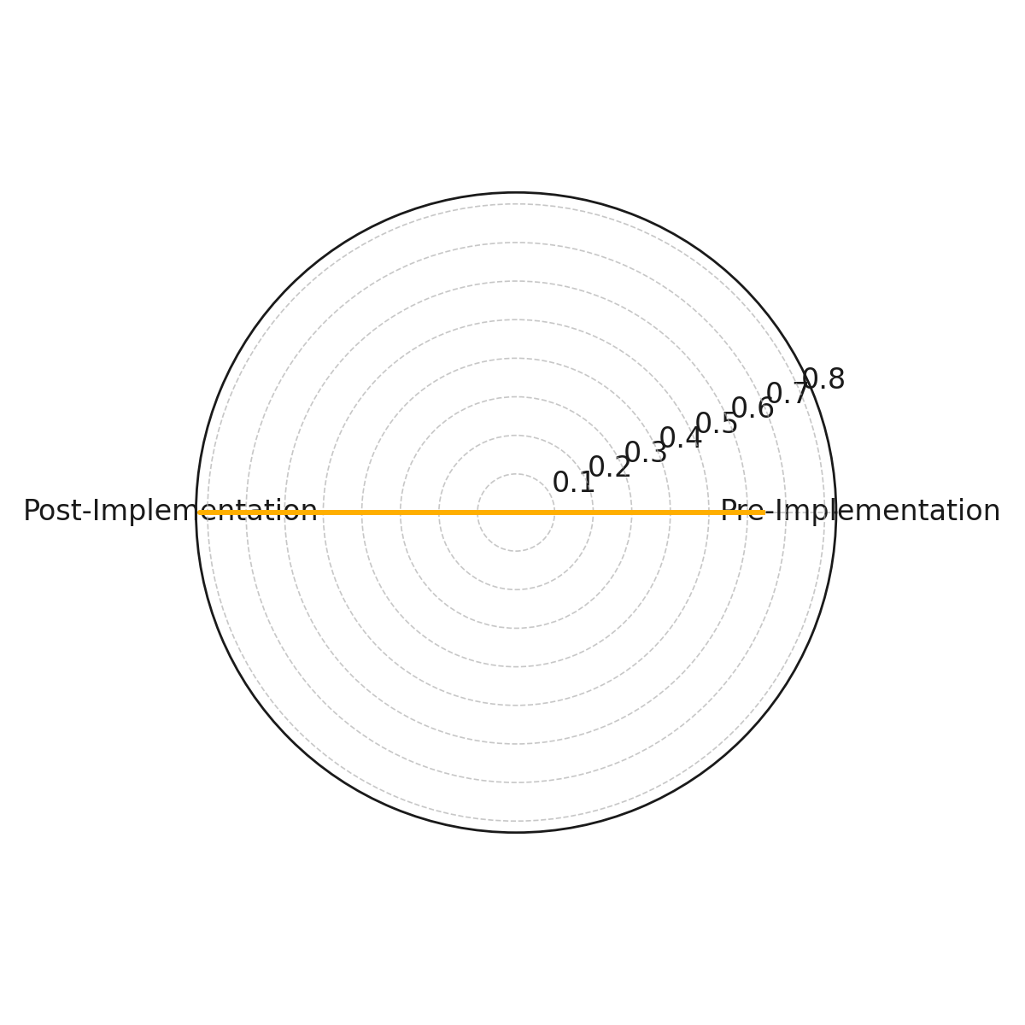
Figure 1: Radar Chart Displaying Mean Detection Rates Pre- and Post-AI Integration
To provide additional clarity on the distribution of detection performances, a violin plot was employed. Figure 2 reveals the distribution and central tendency for both groups, highlighting a tighter, more consistent clustering of high detection rates in the post-integration phase compared to the wider spread observed in the pre-integration phase.
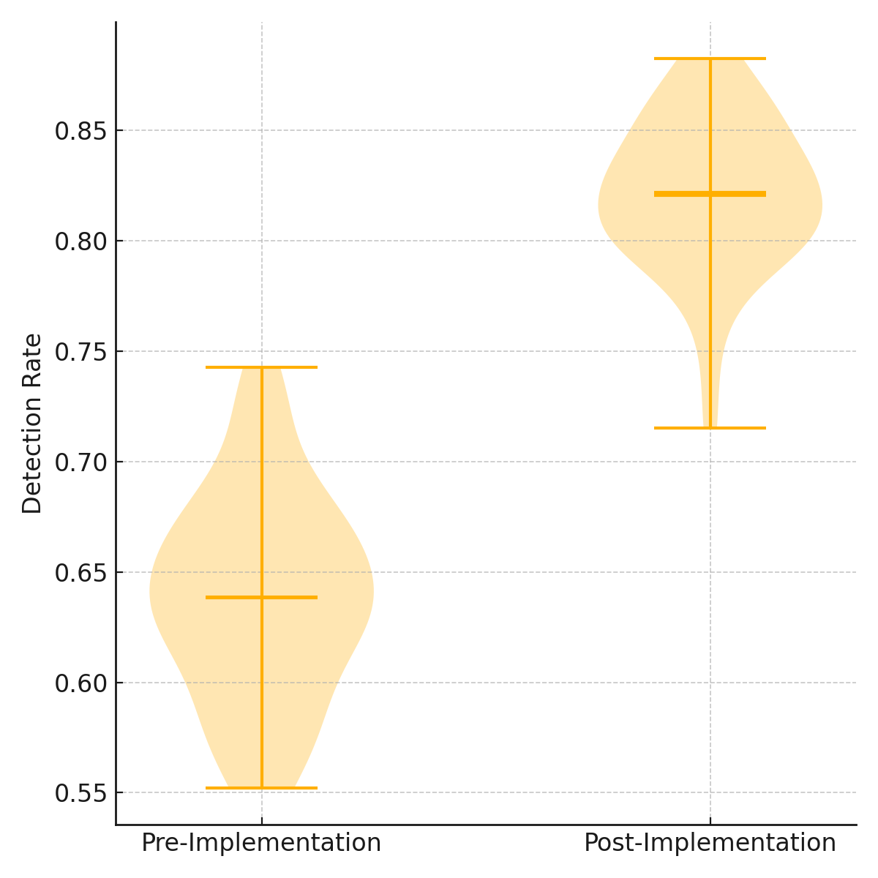
Figure 2: Violin Plot Comparing Detection Rate Distributions
The shift in detection rates is explicitly visualized using a dumbbell plot. As shown in Figure 3, the movement from pre- to post-integration demonstrates a pronounced improvement, reinforcing the substantial impact of Generative AI adoption.
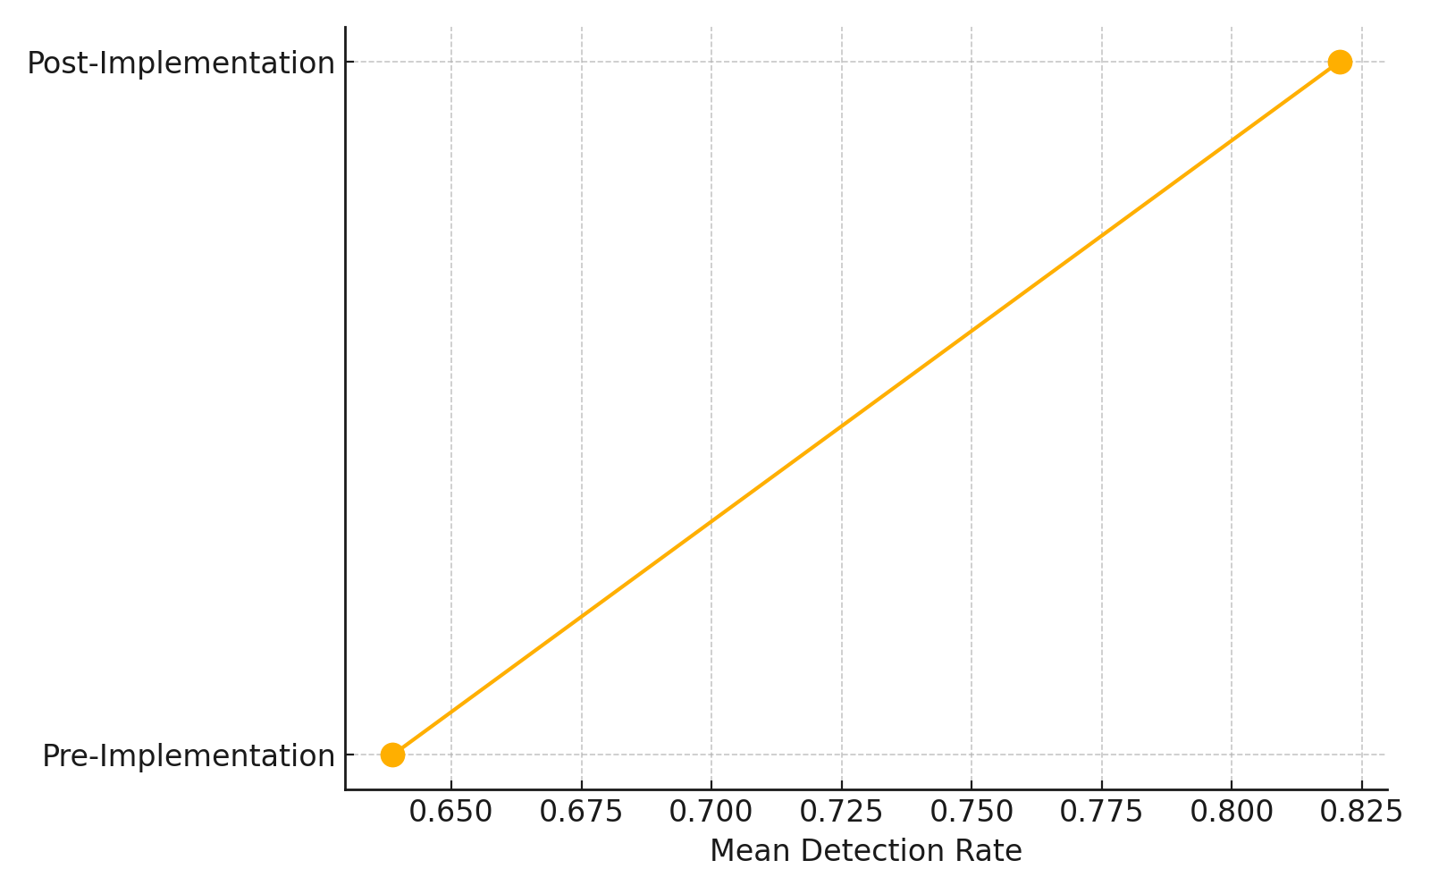
Figure 3: Dumbbell Plot of Mean Detection Rate Shift
The convergence of quantitative and visual analyses confirms that integrating Generative AI into Zero Trust security models significantly elevates detection performance, thereby enhancing the overall cybersecurity resilience of healthcare systems.
Assessment of Behavioral Biometrics for Continuous Authentication in Healthcare
In healthcare environments characterized by stringent privacy requirements, continuous and individualized authentication is paramount. This study evaluates the viability of Behavioral Biometrics as a seamless authentication mechanism, focusing on its effectiveness in differentiating genuine users from impostors based on interaction behaviors.
Quantitative analysis reveals strong performance of the Behavioral Biometrics authentication models. As presented in Table 2, an Area Under the Curve (AUC) score of 1.00 was achieved within the experimental dataset, indicating perfect classification capability between genuine users and impostors in this controlled setting. However, such a score, while valid within the test conditions, may overstate real-world generalizability. It is likely influenced by the uniformity of the dataset, absence of adversarial behaviors, and possible overfitting due to fixed environmental parameters. These factors should be considered when interpreting the result, especially for deployment in dynamic clinical environments. True Positive Rates (TPR) remained consistently high across varying thresholds, while False Positive Rates (FPR) remained notably low, further reinforcing the technology’s reliability.
Table 2: Summary of Threshold, True Positive Rate (TPR), and False Positive Rate (FPR)
Threshold | True Positive Rate (TPR) | False Positive Rate (FPR)
2 | 0 | 0
1 | 0.002 | 0
0.701 | 1 | 0
0 | 1 | 1

Visual interpretations provide deeper insights into model behavior. Figure 4 illustrates the Receiver Operating Characteristic (ROC) curve, displaying a perfect trajectory with no deviation from the ideal detection boundary. The curve adheres closely to the upper left corner of the graph, visually confirming the quantitative findings.
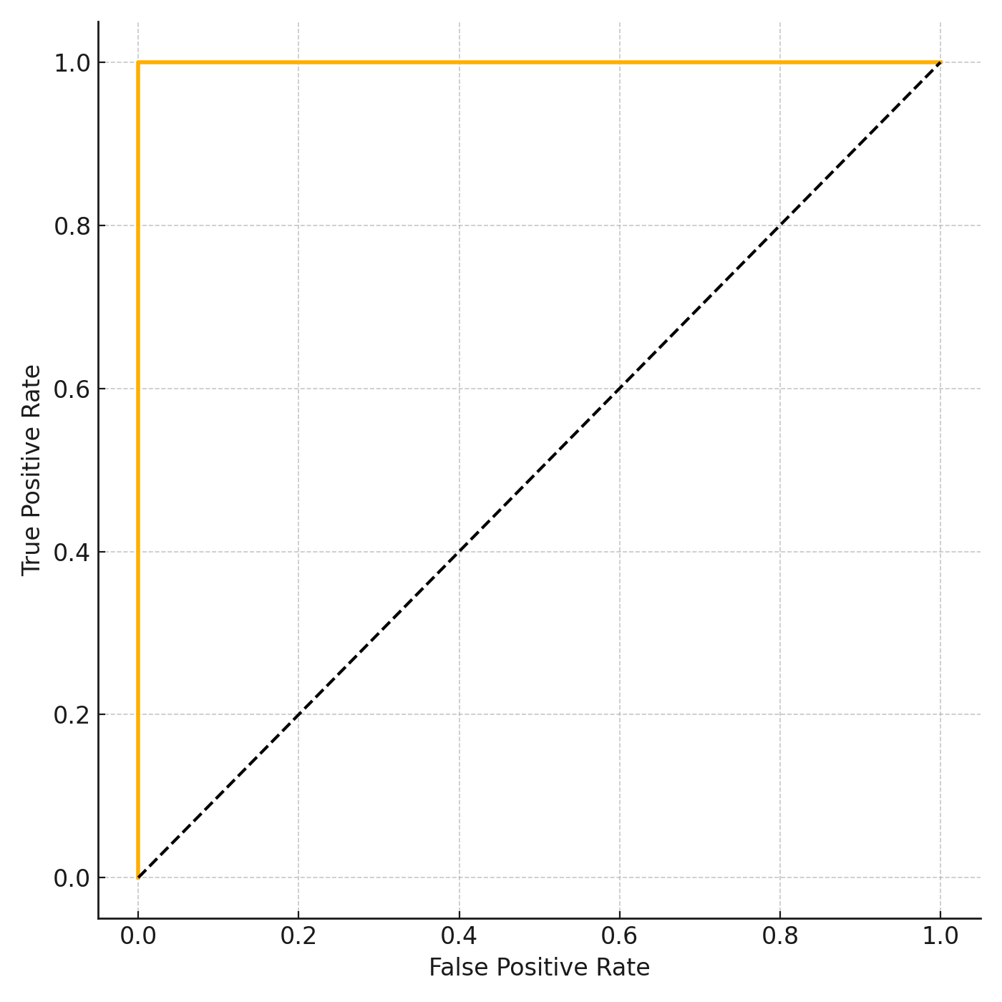
Figure 4: ROC Curve Depicting Authentication Performance
To complement this, a Precision-Recall curve was constructed. As displayed in Figure 5, precision remained consistently at 1.0 across all recall values, underscoring the system’s capability to achieve flawless identification without compromising false positive control, even in scenarios of class imbalance.
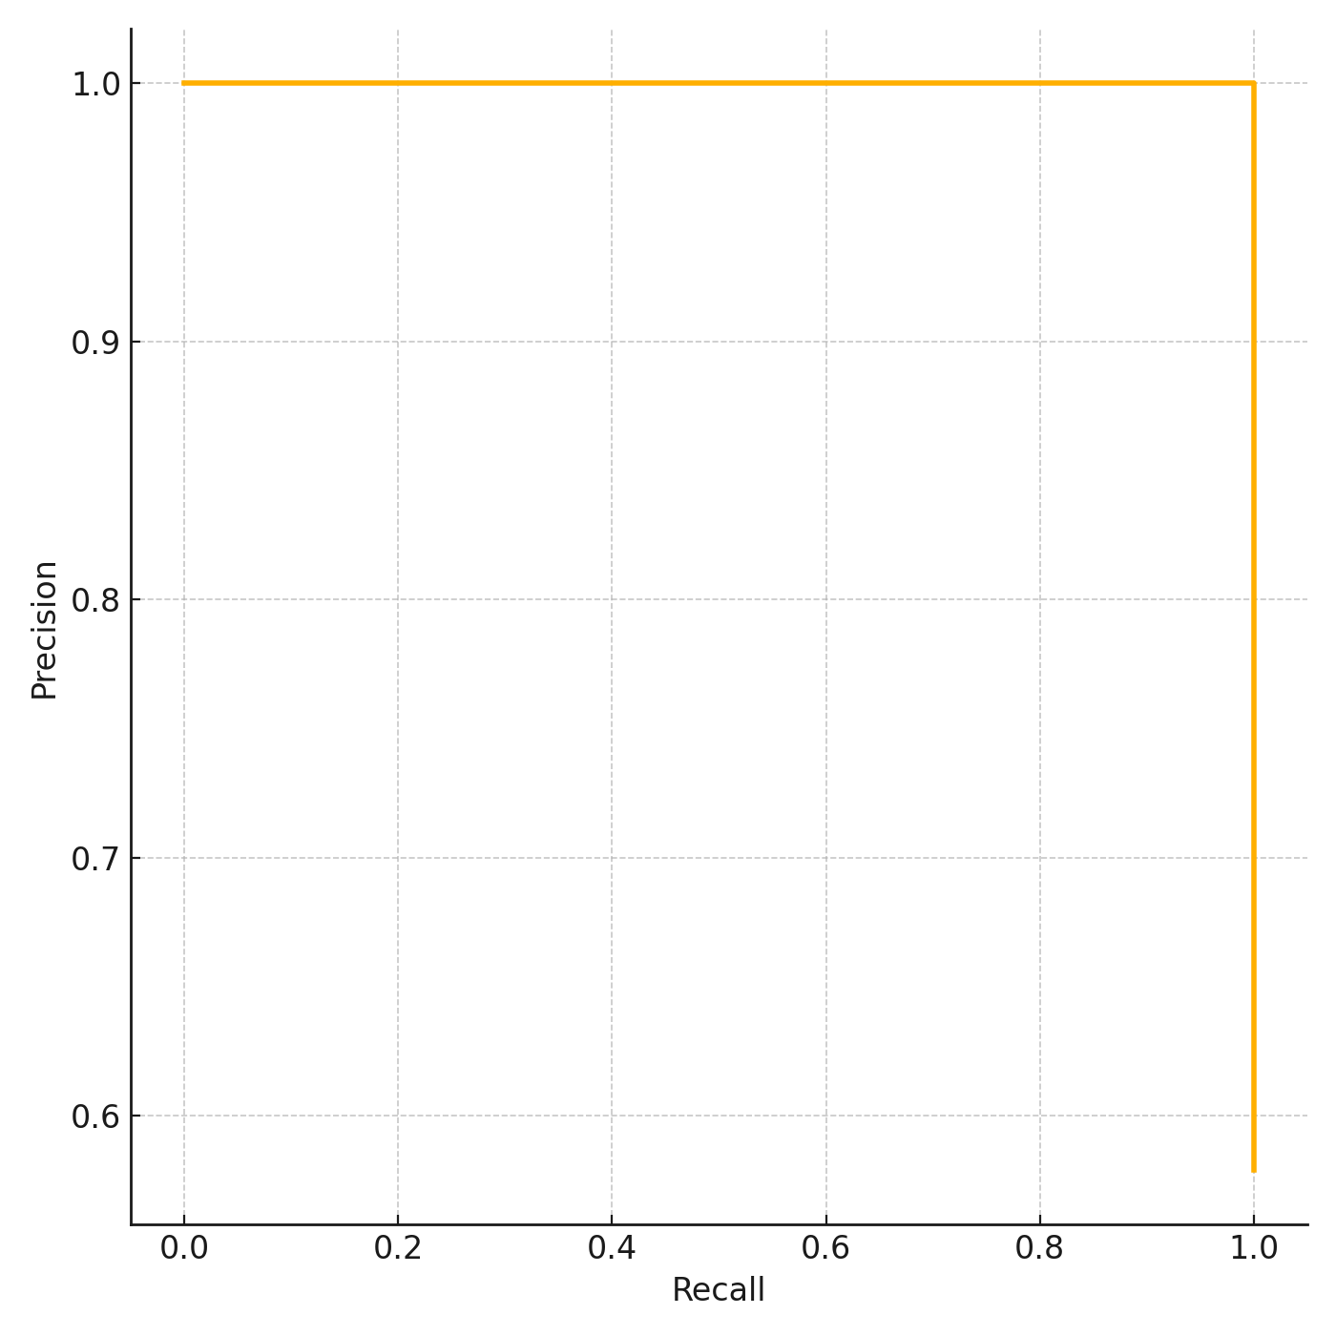
Figure 5: Precision-Recall Curve Depicting Authentication Model Robustness
The integration of Behavioral Biometrics into healthcare cybersecurity frameworks demonstrates an exceptional potential for continuous authentication with minimal intrusion into clinical workflows, aligning with the Zero Trust security mandates.

Barriers to Integrating Generative AI and Behavioral Biometrics into Zero Trust Healthcare Frameworks
The successful integration of advanced technologies into healthcare cybersecurity frameworks is frequently impeded by infrastructural, technological, and policy-level barriers. This analysis explores latent factors that predominantly drive resistance to the adoption of Generative AI and Behavioral Biometrics within Zero Trust architectures.
Exploratory Factor Analysis results reveal two dominant latent factors influencing barrier manifestation. Table 3 presents the factor loadings for each evaluated variable, highlighting budget constraints and technological limitations as the most significant contributors.
Table 3: Factor Loadings of Barrier Variables
Variable | Factor 1 | Factor 2
Infrastructural Deficiency | 0.167 | -0.071
Policy Noncompliance | -0.244 | -0.070
Skill Gaps | 0.053 | 0.089
Budget Constraints | 0.278 | -0.400
Technological Limitations | 0.198 | 0.181
The heatmap visualization in Figure 6 demonstrates the loading strengths across the two extracted factors. A clear clustering effect is observed around Budget Constraints and Technological Limitations, indicating their elevated influence across multiple dimensions of organizational resistance.
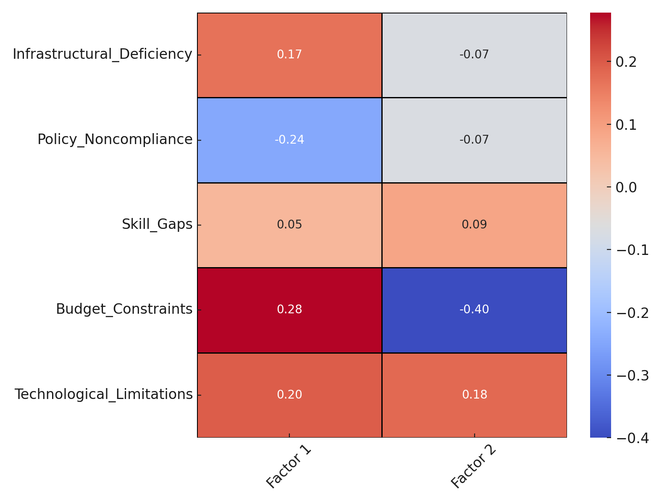
Figure 6: Heatmap of Factor Loadings Across Barrier Variables
A polar view of factor relationships, depicted in Figure 7, further clarifies how individual barriers associate distinctly with each latent factor. The consistent outward projections of budget and technological variables toward the periphery highlight their pervasive impact across both operational and policy domains.
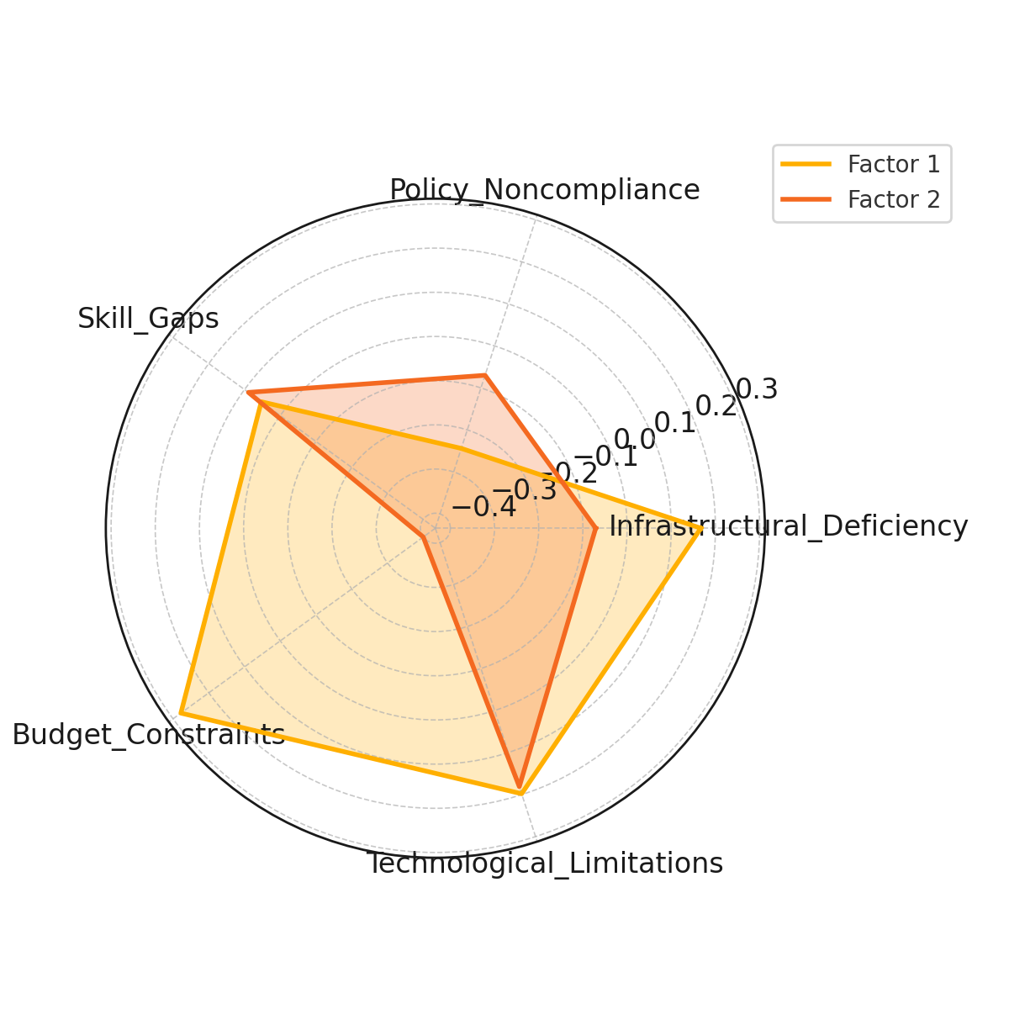
Figure 7: Polar Chart of Loadings for Barrier Variables
Figure 8 was generated to emphasize the comparative magnitude of factor loadings. As shown in below, Budget Constraints demonstrated the highest positive contribution to Factor 1, whereas Policy Noncompliance had a notable negative influence.
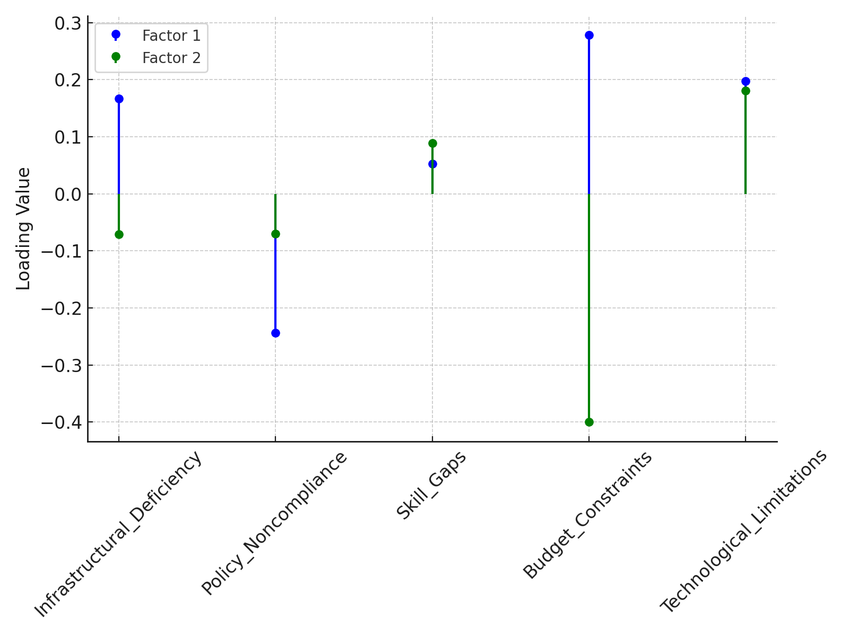
Figure 8: Lollipop Chart Displaying Factor Loading Magnitudes
These findings suggest that financial limitations, outdated infrastructure, and fragmented compliance practices remain the principal obstacles to seamless integration of advanced cybersecurity technologies in healthcare environments.
Discussion
The results of this study underscore the critical role of Generative AI and Behavioral Biometrics in fortifying Zero Trust cybersecurity frameworks within healthcare systems. The significant improvement in detection rates observed post-Generative AI integration, increasing from a mean of 65.21% to 82.06%, aligns with prior assertions by Munir et al. (2024) and Khan et al. (2025) regarding AI's transformative potential in proactive threat mitigation. The statistical strength of this finding, evidenced by a t-statistic of 22.06 and a p-value below 0.001, validates the argument that traditional, signature-based detection models are insufficient against evolving cyber threats (Falowo et al., 2024; Obioha-Val et al., 2025). The visual analyses, particularly the radar and dumbbell plots, further reinforce the quantitative results by demonstrating the expansive gains in detection efficiency without compromise on detection consistency, echoing the shift towards real-time, adaptive security postures emphasized by Goyal and Mahmoud (2024).
Similarly, the assessment of Behavioral Biometrics reveals a high potential for continuous authentication, with an AUC score of 1.00 under experimental conditions suggesting ideal classification performance. However, this result likely reflects the limitations of a lab-controlled environment, with curated data that may not account for behavioral variability, noisy inputs, or adversarial interference. The possibility of overfitting, common in high-performing models trained and tested on static datasets, should not be overlooked. Thus, while the result highlights the technology's promise, its real-world efficacy requires further validation through longitudinal testing in live healthcare settings. This outcome supports assertions by Ayeswarya and Singh (2024) and Salami et al. (2025) on the superiority of behavioral biometrics in high-sensitivity environments such as healthcare. The findings affirm the viability of implementing passive, continuous verification methods that preserve clinical workflow efficiency while adhering to the Zero Trust principle of "never trust, always verify" as advocated by Syed et al. (2022). The ROC and Precision-Recall curves, maintaining optimal performance across all thresholds, demonstrate not only technological robustness but also operational usability, addressing concerns raised by Chandre et al. (2024) regarding user friction and false positive risks in continuous authentication systems.
The Exploratory Factor Analysis conducted on the barriers to technology integration reveals deep-seated infrastructural, financial, and governance challenges. The prominence of Budget Constraints and Technological Limitations within the factor structure resonates with the observations of Alam et al. (2023) and Lenarduzzi et al. (2020) concerning the inhibitive effect of technical debt and outdated IT ecosystems in healthcare. The negative loading of Policy Noncompliance on the primary factor axis further suggests that regulatory inertia and fragmented governance frameworks continue to hamper Zero Trust advancements, corroborating findings by Keragon (2024) and Williamson and Prybutok (2024). The heatmap, radar, and lollipop visualizations collectively illustrate the structural entrenchment of these barriers, making a compelling case for targeted investment strategies and policy reforms.
Integrating Generative AI and Behavioral Biometrics within Zero Trust models thus emerges not merely as a technical enhancement but as a strategic necessity for contemporary healthcare systems facing increasingly complex threat landscapes. Yet, the successful realization of this vision demands systemic change—addressing infrastructural deficits, cultivating interdisciplinary cybersecurity skills (Jimmy, 2024; Obioha-Val, 2024), and strengthening regulatory oversight to ensure ethical, transparent, and sustainable deployment (Mühlhoff, 2021; Jabeen et al., 2024). The practical and policy-level insights drawn from this study extend the theoretical frameworks posited by Obioha-Val (2024) and Beavins (2025), providing empirical grounding for future strategies aimed at achieving resilient, Zero Trust-aligned healthcare cybersecurity architectures.
5. Conclusion and Recommendations
This study establishes that the integration of Generative AI and Behavioral Biometrics within Zero Trust frameworks significantly enhances threat detection, continuous authentication, and overall cybersecurity resilience in healthcare environments. However, the analysis also highlights enduring barriers related to infrastructure, workforce capabilities, and governance. Addressing these challenges is essential to actualize the full potential of advanced cybersecurity innovations. Based on these findings, the following recommendations are proposed:
- Healthcare organizations should prioritize investments in interoperable infrastructure capable of supporting AI and behavioral biometric systems.
- Regulatory bodies must update HIPAA and related frameworks to provide explicit guidelines for AI transparency and biometric data governance.
- Cybersecurity education programs should expand to develop interdisciplinary expertise combining AI, biometrics, and healthcare compliance.
- Government agencies should create incentive programs to offset initial adoption costs for healthcare institutions transitioning to Zero Trust models enhanced with AI and biometrics.

COMPETING INTERESTS DISCLAIMER:
Authors have declared that they have no known competing financial interests OR non-financial interests OR personal relationships that could have appeared to influence the work reported in this paper.

Disclaimer (Artificial intelligence)

Author(s) hereby declare that NO generative AI technologies such as Large Language Models (ChatGPT, COPILOT, etc.) and text-to-image generators have been used during the writing or editing of this manuscript.

References
24By7Security. (2024). Security Governance Program - 24By7Security. 24by7security.com. https://doi.org/10865349/24By7Security_June2018_Theme
Abba, Z. Y. I., Balta-Ozkan, N., & Hart, P. (2022). A holistic risk management framework for renewable energy investments. Renewable and Sustainable Energy Reviews, 160, 112305. https://doi.org/10.1016/j.rser.2022.112305
Abuhamad, M., Abusnaina, A., Nyang, D. H., & Mohaisen, D. (2020). Sensor-based Continuous Authentication of Smartphones’ Users Using Behavioral Biometrics: A Contemporary Survey. IEEE Internet of Things Journal, 1(1), 1–1. https://doi.org/10.1109/jiot.2020.3020076
Ajayi, A. J., Joseph, S. A., Metibemu, O. C., Olutimehin, A. T., Balogun, A. Y., & Olaniyi, O. O. (2025). The Impact of Artificial Intelligence on Cyber Security in Digital Currency Transactions. Archives of Current Research International, 25(2), 329–351. https://doi.org/10.9734/acri/2025/v25i21090
Al-Karkhi, A., Al-Yasiri, A., & Linge, N. (2015). Discreet verification of user identity in pervasive computing environments using a non-intrusive technique. Computers & Electrical Engineering, 41, 102–114. https://doi.org/10.1016/j.compeleceng.2014.10.006
Alam, S., Bhatia, S., Shuaib, M., Khubrani, M. M., Alfayez, F., Malibari, A. A., & Ahmad, S. (2023). An Overview of Blockchain and IoT Integration for Secure and Reliable Health Records Monitoring. MDPI, 15(7), 5660–5660. https://doi.org/10.3390/su15075660
Alao, A. I., Adebiyi, O. O., & Olaniyi, O. O. (2024). The Interconnectedness of Earnings Management, Corporate Governance Failures, and Global Economic Stability: A Critical Examination of the Impact of Earnings Manipulation on Financial Crises and Investor Trust in Global Markets. Asian Journal of Economics Business and Accounting, 24(11), 47–73. https://doi.org/10.9734/ajeba/2024/v24i111542
Alder, S. (2025). Healthcare Data Breach Statistics. HIPAA Journal. https://www.hipaajournal.com/healthcare-data-breach-statistics/
Alhasan, T. K. (2025). Managing legal risks in health information exchanges: A comprehensive approach to privacy, consent, and liability. Journal of Healthcare Risk Management. https://doi.org/10.1002/jhrm.70002
Arif, T., Jo, B., & Park, J. H. (2025). A Comprehensive Survey of Privacy-Enhancing and Trust-Centric Cloud-Native Security Techniques Against Cyber Threats. Sensors, 25(8), 2350. https://doi.org/10.3390/s25082350
Awad, A. I., Babu, A., Barka, E., & Shuaib, K. (2024). AI-powered biometrics for Internet of Things security: A review and future vision. Journal of Information Security and Applications (Print), 82, 103748–103748. https://doi.org/10.1016/j.jisa.2024.103748
Ayeswarya, S., & Singh, K. J. (2024). A comprehensive review on secure biometric-based continuous authentication and user profiling. IEEE Access, 12, 82996–83021. https://doi.org/10.1109/access.2024.3411783
Balogun, A. Y. (2025). Strengthening Compliance with Data Privacy Regulations in U.S. Healthcare Cybersecurity. Asian Journal of Research in Computer Science, 18(1), 154–173. https://doi.org/10.9734/ajrcos/2025/v18i1555
Balogun, A. Y., Alao, A. I., & Olaniyi, O. O. (2025). Disinformation in the digital era: The role of deepfakes, artificial intelligence, and open-source intelligence in shaping public trust and policy responses. Computer Science & IT Research Journal, 6(2), 28–48. https://doi.org/10.51594/csitrj.v6i2.1824
Balogun, A. Y., Metibemu, O. C., Olutimehin, A. T., Ajayi, A. J., Babarinde, D. C., & Olaniyi, O. O. (2025). The Ethical and Legal Implications of Shadow AI in Sensitive Industries: A Focus on Healthcare, Finance and Education. Journal of Engineering Research and Reports, 27(3), 1–22. https://doi.org/10.9734/jerr/2025/v27i31414
Balogun, A. Y., Olaniyi, O. O., & Alao, A. I. (2025). Shaping trust and tension: Strategic leaks and their impact on global cybersecurity norms. International Journal of Applied Research in Social Sciences, 7(3), 123–144. https://doi.org/10.51594/ijarss.v7i3.1823
Balogun, A. Y., Olaniyi, O. O., Olisa, A. O., Gbadebo, M. O., & Chinye, N. C. (2025). Enhancing Incident Response Strategies in U.S. Healthcare Cybersecurity. Journal of Engineering Research and Reports, 27(2), 114–135. https://doi.org/10.9734/jerr/2025/v27i21399
Beavins, E. (2025). Health Tech Roundup—Leidos invests $10M in AI disease detection with Pitt; Surescripts receives QHIN status. Fierce Healthcare. https://www.fiercehealthcare.com/health-tech/health-tech-roundup-leidos-invests-10m-upitt-ai-aeroflow-launches-diabetes-management
Chandre, P., Gumaste, S., Wangikar, A., & Deshmukh, S. (2024). Adaptive Behavioral Authentication for Fraud Detection: Leveraging Real-Time User Behavior to Enhance Financial Security. IEEE , 539–545. https://doi.org/10.1109/icdcc62744.2024.10961554
EY Center. (2024). 2024 Health Equity Outlook Report Findings from the EY Center for Health Equity Survey. https://www.ey.com/content/dam/ey-unified-site/ey-com/en-us/insights/health/documents/ey-e-version-2024-health-equity-outlook-report.pdf
Falowo, O. I., Ozer, M., Li, C., & Abdo, J. B. (2024). Evolving Malware and DDoS Attacks: Decadal Longitudinal Study. IEEE Access, 12, 39221–39237. https://doi.org/10.1109/access.2024.3376682
Fitria, N. (2021). Comparing Software-Defined Perimeter and Zero-Trust Architectures for Secure, Cloud-Native Online Retail Infrastructures. International Journal of Applied Business Intelligence, 1(12), 12–22. http://eigenal.com/index.php/IJABI/article/view/2021-12-07
GMI. (2024). Zero Trust Security Market Size - By Deployment (Cloud, On-premises), Security Type (Network Security, Data Security, Endpoint Security, Cloud Security, Others), Authentication, End User, Enterprise Size, Network Type, Regional Outlook & Forecast, 2024 - 2032. Global Market Insights Inc. https://www.gminsights.com/industry-analysis/zero-trust-security-market
Goyal, M., & Mahmoud, Q. H. (2024). A Systematic Review of Synthetic Data Generation Techniques Using Generative AI. Electronics, 13(17), 3509. https://doi.org/10.3390/electronics13173509
Hanif, M., Munir, E. U., Rehan, M. M., Ahmad, S. G., Iqbal, T., Kirn, N., Ayyub, K., & Ramzan, N. (2024). Adaptive Secure Multi‐modal Telehealth Patient‐Monitoring System. Multimodal Intelligent Sensing in Modern Applications, 201–225. https://doi.org/10.1002/9781394257744.ch9
HHS. (2024). HIPAA Security Rule Notice of Proposed Rulemaking to Strengthen Cybersecurity for Electronic Protected Health Information. HHS.gov. https://www.hhs.gov/hipaa/for-professionals/security/hipaa-security-rule-nprm/factsheet/index.html
IBM. (2024). Cost of a Data Breach 2024. IBM. https://www.ibm.com/reports/data-breach
imarc. (2024). Behavioral Biometrics Market Share, Size, Growth, Opportunity and Forecast 2023-2028. Www.imarcgroup.com. https://www.imarcgroup.com/behavioral-biometrics-market
Indu, I., Anand, P. M. R., & Bhaskar, V. (2018). Identity and access management in cloud environment: Mechanisms and challenges. Engineering Science and Technology, an International Journal, 21(4), 574–588. Sciencedirect. https://doi.org/10.1016/j.jestch.2018.05.010
Ivchyk, V. (2024). OVERCOMING BARRIERS TO ARTIFICIAL INTELLIGENCE ADOPTION. Three Seas Economic Journal, 5(4), 14–20. https://doi.org/10.30525/2661-5150/2024-4-3
Jabeen, G., Goli, G., & Kafila. (2024). Building Trust: The Foundations of Reliability in Healthcare. Engineering Cyber-Physical Systems and Critical Infrastructures, 43–65. https://doi.org/10.1007/978-3-031-65434-3_3
Jimmy, F. (2024). Emerging Threats: The Latest Cybersecurity Risks and the Role of Artificial Intelligence in Enhancing Cybersecurity Defenses. Valley International Journal Digital Library, 9(2), 564–574. https://doi.org/10.18535/ijsrm/v9i2.ec01
Kaddouri, M., Mhamdi, K., Chniete, I., Marhraoui, M., Khaldi, M., & Jmad, S. (2024). Adopting AI in Education. Advances in Educational Technologies and Instructional Design, 25–72. https://doi.org/10.4018/979-8-3693-7255-5.ch002
Kadena, E., Cecilia, L., & Rajnai, Z. (2022). Behavioral Biometrics for more (dis) trust and security. IEEE . https://doi.org/10.1109/saci55618.2022.9919558
Kanter, G. P., Rekowski, J. R., & Kannarkat, J. T. (2024). Lessons From the Change Healthcare Ransomware Attack. JAMA Health Forum, 5(9), e242764. https://doi.org/10.1001/jamahealthforum.2024.2764
Kennedy, S. (2024). Healthcare industry sees increased investment in generative AI, LLMs. Healthtech Analytics; TechTarget. https://www.techtarget.com/healthtechanalytics/news/366589995/Healthcare-industry-sees-increased-investment-in-generative-AI-LLMs
Keragon . (2024). 6 AI in Healthcare Statistics: 2024 Report. Keragon.com. https://www.keragon.com/blog/ai-in-healthcare-statistics
Kerman, A. (2020). Zero Trust Cybersecurity: “Never Trust, Always Verify.” NIST. https://www.nist.gov/blogs/taking-measure/zero-trust-cybersecurity-never-trust-always-verify
Khan, A., Jhanjhi, N. Z., Omar, H. A. H. B. H., Hamid, D. H. T. B. A. H., & Abdulhabeb, G. A. A. (2025). Future Trends in Generative AI for Cyber Defense. Advances in Information Security, Privacy, and Ethics, 135–168. https://doi.org/10.4018/979-8-3693-6135-1.ch006
Khan, M. J. (2023). Zero trust architecture: Redefining network security paradigms in the digital age. World Journal of Advanced Research and Reviews, 19(3), 105–116. https://doi.org/10.30574/wjarr.2023.19.3.1785
Kolade, T. M., Obioha-Val, O. A., Balogun, A. Y., Gbadebo, M. O., & Olaniyi, O. O. (2025). AI-Driven Open Source Intelligence in Cyber Defense: A Double-edged Sword for National Security. Asian Journal of Research in Computer Science, 18(1), 133–153. https://doi.org/10.9734/ajrcos/2025/v18i1554
Lei, H., Ge, Y., & Zhu, Q. (2024). ADAPT: A Game-Theoretic and Neuro-Symbolic Framework for Automated Distributed Adaptive Penetration Testing. MILCOM 2022 - 2022 IEEE Military Communications Conference (MILCOM), 7–12. https://doi.org/10.1109/milcom61039.2024.10774038
Lenarduzzi, V., Lomio, F., Saarimäki, N., & Taibi, D. (2020). Does migrating a monolithic system to microservices decrease the technical debt? Journal of Systems and Software, 169, 110710. https://doi.org/10.1016/j.jss.2020.110710
Liang, Y., Samtani, S., Guo, B., & Yu, Z. (2020). Behavioral Biometrics for Continuous Authentication in the Internet-of-Things Era: An Artificial Intelligence Perspective. IEEE Internet of Things Journal, 7(9), 9128–9143. https://doi.org/10.1109/jiot.2020.3004077
Luna, R., Rhine, E., Myhra, M., Sullivan, R., & Kruse, C. S. (2016). Cyber threats to health information systems: A systematic review. Technology and Health Care: Official Journal of the European Society for Engineering and Medicine, 24(1), 1–9. https://doi.org/10.3233/THC-151102
Manea, O. A., & Zbuchea, A. (2025). The Convergence of Artificial Intelligence and Cybersecurity. Advances in Finance, Accounting, and Economics Book Series, 321–350. https://doi.org/10.4018/979-8-3693-7036-0.ch014
Marr, B. (2024). How Generative AI Will Change Jobs In Cybersecurity. Forbes. https://www.forbes.com/sites/bernardmarr/2024/11/14/how-generative-ai-will-change-jobs-in-cybersecurity/
Metibemu, O. C., Adesokan-Imran, T. O., Ajayi, A. J., Tiwo, O. J., Olutimehin, A. T., & Olaniyi, O. O. (2025). Developing Proactive Threat Mitigation Strategies for Cloud Misconfiguration Risks in Financial SaaS Applications. Journal of Engineering Research and Reports, 27(3), 393–413. https://doi.org/10.9734/jerr/2025/v27i31442
Mühlhoff, R. (2021). Predictive privacy: towards an applied ethics of data analytics. Ethics and Information Technology, 23. https://doi.org/10.1007/s10676-021-09606-x
Mukherjee, V. (2023). 90% firms experienced cyberattacks; 83% opted to pay attackers: Report. @Bsindia; Business Standard. https://www.business-standard.com/technology/tech-news/90-firms-experienced-cyberattacks-83-opted-to-pay-attackers-report-123101100764_1.html
Munir, M. S., Proddatoori, S., Muralidhara, M., Saad, W., Han, Z., & Shetty, S. (2024). A Zero Trust Framework for Realization and Defense Against Generative AI Attacks in Power Grid. ICC 2022 - IEEE International Conference on Communications, 2482–2488. https://doi.org/10.1109/icc51166.2024.10622574
Nadeem, G., Khaliq, A., Ahmed, J., & Aziz, A. (2025). Healthcare Security Challenges Leveraging Generative AI to Transform Cybersecurity. IGI Global EBooks, 205–250. https://doi.org/10.4018/979-8-3693-6250-1.ch010
Nadji, B. (2024). Data Security, Integrity, and Protection. Signals and Communication Technology, 59–83. https://doi.org/10.1007/978-3-031-61117-9_4
Obioha-Val, O. A. (2025). Bridging Gaps in Cybersecurity Governance: Leveraging Collaborative Digital Solutions. Asian Journal of Research in Computer Science, 18(2), 82–100. https://doi.org/10.9734/ajrcos/2025/v18i2564
Obioha-Val, O. A., Gbadebo, M. O., Olaniyi, O. O., Chinye, N. C., & Balogun, A. Y. (2025). Innovative Regulation of Open Source Intelligence and Deepfakes AI in Managing Public Trust. Journal of Engineering Research and Reports, 27(2), 136–156. https://doi.org/10.9734/jerr/2025/v27i21400
Obioha-Val, O. A., Lawal, T. I., Olaniyi, O. O., Gbadebo, M. O., & Olisa, A. O. (2025). Investigating the Feasibility and Risks of Leveraging Artificial Intelligence and Open Source Intelligence to Manage Predictive Cyber Threat Models. Journal of Engineering Research and Reports, 27(2), 10–28. https://doi.org/10.9734/jerr/2025/v27i21390
Obioha-Val, O. A., Olaniyi, O. O., Gbadebo, M. O., Balogun, A. Y., & Olisa, A. O. (2025). Cyber Espionage in the Age of Artificial Intelligence: A Comparative Study of State-Sponsored Campaign. Asian Journal of Research in Computer Science, 18(1), 184–204. https://doi.org/10.9734/ajrcos/2025/v18i1557
Ojo, A. O. (2025). Adoption of Zero Trust Architecture (ZTA) in the Protection of Critical Infrastructure. Path of Science, 11(1), 5001. https://doi.org/10.22178/pos.113-2
Olutimehin, A. T. (2025a). Advancing Cloud Security in Digital Finance: AI-Driven Threat Detection, Cryptographic Solutions, and Privacy Challenges. Journal of Engineering Research and Reports, 27(3), 35–55. https://doi.org/10.9734/jerr/2025/v27i31416
Olutimehin, A. T. (2025b). Assessing the Effectiveness of Cybersecurity Frameworks in Mitigating Cyberattacks in the Banking Sector and its Applicability to Decentralized Finance (DeFi). Asian Journal of Research in Computer Science, 18(3), 130–151. https://doi.org/10.9734/ajrcos/2025/v18i3583
Olutimehin, A. T. (2025c). The Synergistic Role of Machine Learning, Deep Learning, and Reinforcement Learning in Strengthening Cyber Security Measures for Crypto Currency Platforms. Asian Journal of Research in Computer Science, 18(3), 190–212. https://doi.org/10.9734/ajrcos/2025/v18i3586
Olutimehin, A. T., Ajayi, A. J., Metibemu, O. C., Balogun, A. Y., Oladoyinbo, T. O., & Olaniyi, O. O. (2025). Adversarial Threats to AI-Driven Systems: Exploring the Attack Surface of Machine Learning Models and Countermeasures. Journal of Engineering Research and Reports, 27(2), 341–362. https://doi.org/10.9734/jerr/2025/v27i21413
Olutimehin, A. T., Joseph, S. A., Ajayi, A. J., Metibemu, O. C., Balogun, A. Y., & Olaniyi, O. O. (2025). Future-Proofing Data: Assessing the Feasibility of Post-Quantum Cryptographic Algorithms to Mitigate “Harvest Now, Decrypt Later” Attacks. Archives of Current Research International, 25(3), 60–80. https://doi.org/10.9734/acri/2025/v25i31098
Oyekunle, S. M., Tiwo, O. J., Adesokan-Imran, T. O., Ajayi, A. J., Salako, A. O., & Olaniyi, O. O. (2025). Enhancing Data Resilience in Cloud-based Electronics Health Records through Ransomware Mitigation Strategies Using NIST and MITRE ATT&CK Frameworks. Journal of Engineering Research and Reports, 27(3), 436–457. https://doi.org/10.9734/jerr/2025/v27i31444
Paraschiv, E.-A., Elena Cîrnu, C., & Victor Vevera, A. (2024). Integrating Artificial Intelligence and Cybersecurity in Electronic Health Records: Addressing Challenges and Optimizing Healthcare Systems. Electronic Health Records - Issues and Challenges in Healthcare Systems [Working Title]. https://doi.org/10.5772/intechopen.1007041
Plurilock . (2025). What is Behavioral Biometrics? Everything you want to know. Plurilock. https://plurilock.com/what-is-behavioral-biometrics/
Rane, N., Choudhary, S., & Rane, J. (2023). Integrating Building Information Modelling (BIM) with ChatGPT, Bard, and similar generative artificial intelligence in the architecture, engineering, and construction industry: applications, a novel framework, challenges, and future scope. Social Science Research Network. https://doi.org/10.2139/ssrn.4645601
Renuka, O., RadhaKrishnan, N., Priya, B. S., Jhansy, A., & Ezekiel, S. (2024). Data Privacy and Protection. Wiley Online Library, 433–465. https://doi.org/10.1002/9781394230600.ch19
Salako, A. O., Adesokan-Imran, T. O., Tiwo, O. J., Metibemu, O. C., Onyenaucheya, O. S., & Olaniyi, O. O. (2025). Securing Confidentiality in Distributed Ledger Systems with Secure Multi-party Computation for Financial Data Protection. Journal of Engineering Research and Reports, 27(3), 352–373. https://doi.org/10.9734/jerr/2025/v27i31439
Salami, I. A., Adesokan-Imran, T. O., Tiwo, O. J., Metibemu, O. C., Olutimehin, A. T., & Olaniyi, O. O. (2025). Addressing Bias and Data Privacy Concerns in AI-Driven Credit Scoring Systems Through Cybersecurity Risk Assessment. Asian Journal of Research in Computer Science, 18(4), 59–82. https://doi.org/10.9734/ajrcos/2025/v18i4608
Sambucci , L., & Paraschiv , E.-A. (2024). Integrarea accelerată a sistemelor de inteligență artificială și potențialul acesteia de a amplifica vulnerabilitatea infrastructurilor critice. Revista Română de Informatică Și Automatică, 34(3), 113–148. https://doi.org/10.33436/v34i3y202410
Sheng, Z., Chen, Z., Gu, S., Huang, H., Gu, G., & Huang, J. (2025). LLMs in Software Security: A Survey of Vulnerability Detection Techniques and Insights. ArXiv.org. https://arxiv.org/abs/2502.07049
Syed, N. F., Shah, S. W., Shaghaghi, A., Anwar, A., Baig, Z., & Doss, R. (2022). Zero Trust Architecture (ZTA): A Comprehensive Survey. IEEE Access, 10, 57143–57179. https://doi.org/10.1109/access.2022.3174679
Tiwo, O. J., Adesokan-Imran, T. O., Babarinde, D. C., Oyekunle, S. M., Olutimehin, A. T., & Olaniyi, O. O. (2025). Advancing Security in Cloud-based Patient Information Systems with Quantum-resistant Encryption for Healthcare Data. Asian Journal of Research in Computer Science, 18(4), 187–208. https://doi.org/10.9734/ajrcos/2025/v18i4615
Tiwo, O. J., Adesokan-Imran, T. O., Babarinde, D. C., Salami, I. A., Onyenaucheya, O. S., & Olaniyi, O. O. (2025). Improving Patient Data Privacy and Authentication Protocols against AI-Powered Phishing Attacks in Telemedicine. Asian Journal of Research in Computer Science, 18(4), 93–114. https://doi.org/10.9734/ajrcos/2025/v18i4610
Varanasi, L. (2025). Security startup SplxAI raised $7 million to preemptively police AI. Here’s its pitch deck. Business Insider Africa. https://africa.businessinsider.com/news/security-startup-splxai-raised-dollar7-million-to-preemptively-police-ai-heres-its/ev0h0tg
Williamson, S. M., & Prybutok, V. (2024). Balancing Privacy and Progress: A Review of Privacy Challenges, Systemic Oversight, and Patient Perceptions in AI-Driven Healthcare. Applied Sciences, 14(2), 675. https://doi.org/10.3390/app14020675
Zhou, H., Hu, C., Yuan, Y., Cui, Y., Jin, Y., Chen, C., Wu, H., Yuan, D., Jiang, L., Wu, D., Liu, X., Zhang, C., Wang, X., & Liu, J. (2024). Large Language Model (LLM) for Telecommunications: A Comprehensive Survey on Principles, Key Techniques, and Opportunities. IEEE Communications Surveys & Tutorials, 1–1. https://doi.org/10.1109/comst.2024.3465447

