Mitigating Cybersecurity Risks In Financial Institutions through Strategic Third- Party Risk Governance Frameworks

Abstract
This study investigates how strategic third-party risk governance frameworks can mitigate cybersecurity threats in financial institutions. Using data from the Verizon Data Breach Investigations Report, the Basel Committee’s Quantitative Impact Study, and the Privacy Rights Clearinghouse breach database, the research applies descriptive statistics, multivariate regression, and event study analysis. Key findings reveal that third-party software vulnerabilities and vendor credential theft account for 18.08% and 16.10% of breaches respectively. Regression results show that continuous monitoring and third-party audits significantly reduce incident frequency, while real-world breach events highlight governance lapses tied to delayed disclosure and inadequate oversight. The study recommends enforcing continuous vendor performance monitoring, mandating software supply chain audits, embedding cybersecurity clauses in vendor contracts, and promoting cross-institutional threat intelligence hubs. These insights offer targeted solutions to strengthen oversight and enhance cybersecurity resilience in increasingly complex vendor ecosystems.
Keywords: Third-party risk governance, cybersecurity breaches, financial institutions, vendor monitoring, software supply chain.

1. Introduction
In the current digital economy, financial institutions are increasingly reliant on third-party vendors and service providers to facilitate a wide array of core operations, including cloud computing, payment processing, customer support, and data analytics. Although these partnerships contribute significantly to operational efficiency and technological advancement, they concurrently expose financial organizations to heightened cybersecurity threats. These risks, which compromise the confidentiality, integrity, and availability of sensitive financial data, have become more severe as institutional digital infrastructures grow increasingly complex and interconnected. This complexity expands the attack surface of financial entities, thereby necessitating the adoption of comprehensive and adaptive third-party risk governance frameworks.
The financial services industry has remained a prime target for cyberattacks, a status attributable to the inherently high value of the information it manages and the substantial financial rewards available to malicious actors. The sector's attractiveness to attackers is emphasized by recent data: reported that 82% of financial institutions experienced a cybersecurity breach within the past year. Adrian and Ferreira (2023) further highlighted a 56% increase in cyberattacks on financial institutions between 2022 and 2023. These incidents are not only frequent but also financially devastating; the average cost per cybersecurity incident within the financial sector stands at $5.9 million, markedly exceeding the global average (IBM, 2023).
A substantial portion of these breaches originate from vulnerabilities in third-party ecosystems. According to Breachsense (2024), approximately 62% of all breaches in 2023 were attributable to third-party vendors. Supporting this, Security Scorecard (2023) revealed that over 98% of surveyed organizations engaged with at least one third party that had experienced a security incident in the preceding two years. However, a mere 36% of financial institutions engage in continuous cybersecurity monitoring of their third-party vendors (Evans, 2024). Further compounding this gap in oversight, IBM (2023) disclosed that financial organizations share sensitive data with an average of 583 third parties, 59% of which are not subjected to any cybersecurity compliance checks. These statistics indicate a critical misalignment between the scale of third-party integration and the governance mechanisms instituted to manage associated risks. The statistics below provide a visual summary of the current state of cybersecurity exposure and third-party risk governance among financial institutions, highlighting the significant disparity between the scale of third-party dependencies and the maturity of oversight mechanisms in place.
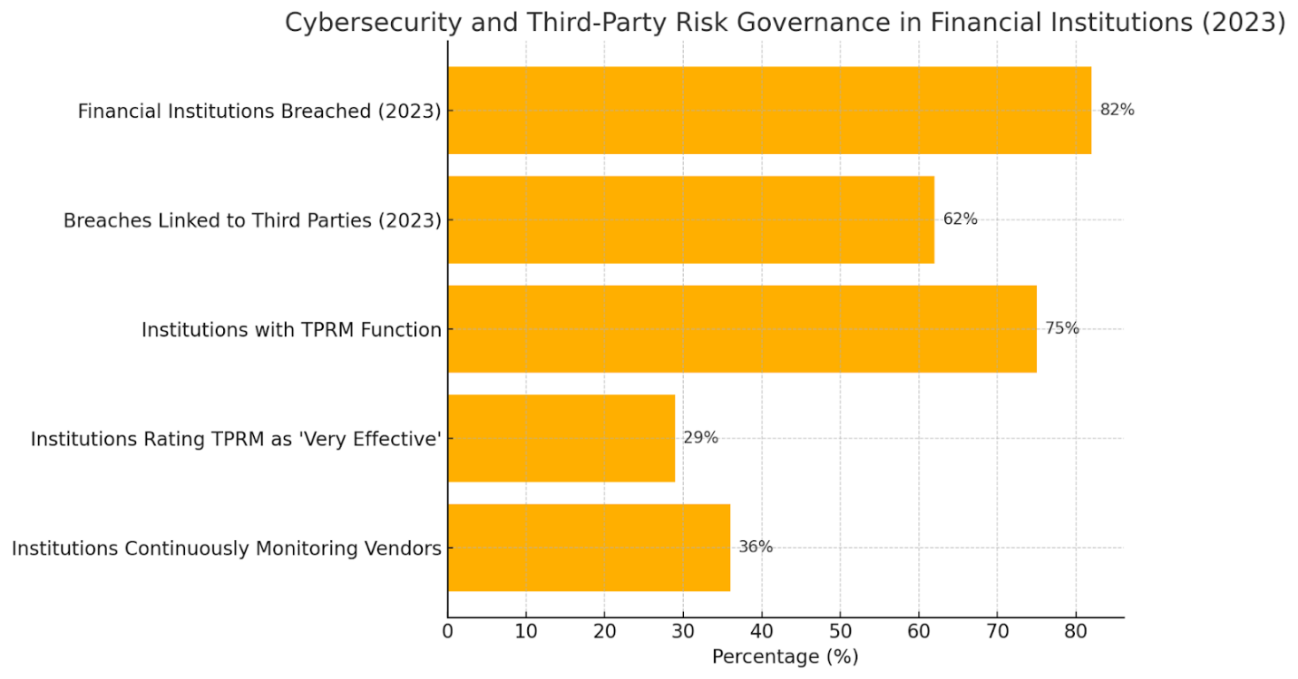
Figure 1. Cybersecurity and Third-Party Risk Governance in Financial Institutions (2023)
Several prominent cybersecurity incidents have demonstrated the tangible consequences of inadequate third-party risk governance. One such case is the 2019 Capital One data breach, which resulted from a misconfigured firewall within Amazon Web Services (AWS), exposing sensitive data from over 100 million customers (Khan et al., 2022). This incident illustrates the necessity for rigorous assessments of cloud infrastructure and robust configuration management practices. Similarly, the 2013 Target breach highlighted the dangers of extending network access to seemingly low-risk third parties. Attackers gained entry via stolen credentials from an HVAC contractor, compromising the credit and debit card data of over 40 million customers (Barnum, 2014). This breach underscores the importance of vendor classification systems, risk-based access controls, and periodic assessments of cybersecurity maturity.
Equally significant is the 2020 SolarWinds attack, in which compromised code was embedded into an update of the Orion IT management platform. The update was subsequently distributed to nearly 18,000 organizations, including major financial institutions and U.S. federal agencies (Fromdev, 2025). This event brought to the fore the emerging challenge of fourth-party risk and the need for software supply chain oversight, including verification of software bills of materials (SBOM) and upstream vendor monitoring. Another noteworthy incident is the 2017 Equifax breach, where the exploitation of an unpatched vulnerability in Apache Struts, a third-party web application component, resulted in the exposure of personal and financial data from approximately 147 million individuals (Fruhlinger, 2020). These cases highlight the criticality of continuous vulnerability assessments, timely patch management, and stringent third-party software audits.
The 2016 Bangladesh Bank heist further exemplifies systemic weaknesses in financial infrastructure. Attackers exploited the SWIFT interbank messaging system to initiate fraudulent transfers, culminating in the loss of $81 million (Reuters Editorial, 2024). This breach illuminated deficiencies in authentication protocols and the necessity for integrated oversight within shared financial networks. More recently, the 2023 MOVE it software breach exploited a zero-day vulnerability to compromise the data of over 2,500 organizations, affecting approximately 66.4 million individuals, including those in the financial sector (Dosumu, 2025). This incident reaffirms the importance of proactive risk assessments for commonly used third-party tools and the implementation of layered security controls to address emerging threats.
Regulatory frameworks have evolved in response to these threats. The European Union’s Digital Operational Resilience Act (DORA), effective between 2022 and 2025, mandates that financial institutions develop and enforce comprehensive third-party ICT risk management strategies, encompassing vendor risk classification, contractual safeguards, incident reporting, and continuous monitoring (EIOPA, 2023). Simultaneously, the United States Office of the Comptroller of the Currency (OCC) introduced updated guidance in 2023 requiring enhanced vendor lifecycle management, cybersecurity provisions in contracts, structured exit strategies, and rigorous risk tiering methodologies (OCC, 2023).
Despite these advancements, implementation remains uneven. According to the EY (2025), 75% of financial institutions now operate dedicated third-party risk management units. However, the PWC (2024) reports that only 29% of institutions consider their governance models to be highly effective, and 68% of financial organizations have not yet developed mechanisms to address fourth-party risks, reflecting a significant oversight. Nevertheless, a growing awareness is evident, with Deloitte (2023) reporting that 60% of global banks increased their investment in Third-Party Risk Management (TPRM) technologies during 2023. The following chart illustrates recent trends in cybersecurity risk escalation and organizational responses, including fourth-party oversight gaps, high breach costs, and increased investment in Third-Party Risk Management (TPRM) solutions.

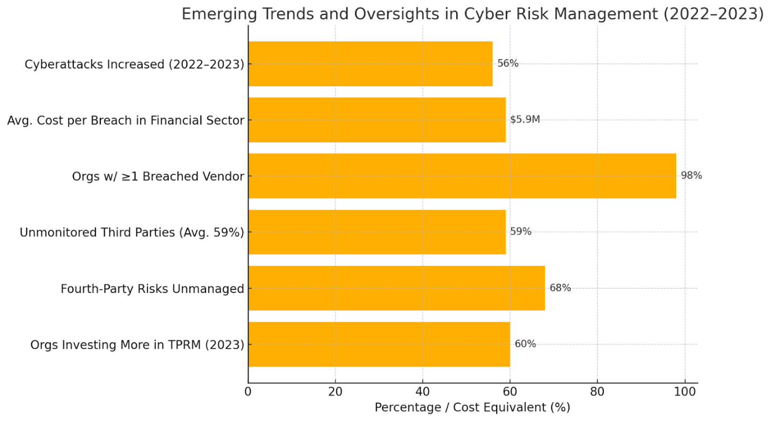
Figure 2. Emerging Trends and Oversights in Cyber Risk Management (2022–2023)
This study investigates how financial institutions can effectively operationalize strategic third-party risk governance frameworks in order to mitigate escalating cybersecurity threats. By examining prevailing industry practices, regulatory mandates, and empirical case studies, the research aims to offer targeted strategies to strengthen vendor oversight and improve cybersecurity resilience across the financial services landscape. This research provides timely empirical insights into cybersecurity vulnerabilities stemming from third-party integrations in financial institutions. It bridges quantitative analysis with real-world case studies to offer actionable governance strategies. Its contributions advance academic discourse, inform regulatory practices, and serve as a foundation for future research on systemic cybersecurity resilience. This study aims to critically examine how strategic third-party risk governance frameworks can be implemented to effectively mitigate cybersecurity risks in financial institutions, by achieving the following objectives:
- Identification and analysis of the cybersecurity risks associated with third-party relationships in financial institutions.
- Evaluates the current third-party risk governance frameworks adopted by financial institutions and their effectiveness in mitigating cyber threats.
- Examines real-world case studies of cybersecurity breaches linked to third-party vendors and extract lessons for strategic governance improvement.
- Provides informed recommendations for enhancing third-party risk governance frameworks in financial institutions based on existing literature and case-based insights.

2. Literature Review
Cybersecurity, defined as the deployment of integrated strategies, technologies, and procedures to protect networks, systems, and data from malicious intrusions, constitutes a critical strategic function within the financial sector. Financial institutions manage vast volumes of personally identifiable information (PII) and considerable monetary assets, making them prominent targets for cybercriminals (Olabanji et al., 2024). Successful breaches not only precipitate severe financial losses and regulatory sanctions but also erode institutional credibility and customer confidence. Cybersecurity in finance extends beyond operational necessity and represents a foundational requirement for maintaining systemic trust and stability (Hyz & Gikas, 2024; Ajayi et al., 2025).
The sector is continually subjected to multifaceted cyber threats, notably phishing, ransomware, Distributed Denial of Service (DDoS) attacks, and large-scale data breaches (Pomerleau & Lowery, 2020; Balogun, 2025). Phishing attacks, now leveraging generative AI and deepfakes, deceive employees and clients into surrendering access credentials (Akeiber, 2025; Kolade et al., 2025). Ransomware incidents lock critical data, paralyzing operations until ransom payments are rendered (Halikias, 2024; Metibemu et al., 2025), whereas DDoS attacks overwhelm systems to inhibit service availability (De Neira et al., 2023; Obioha-Val, 2025). According to IBM (2023), data breaches compromise confidential client information, engendering regulatory infractions and jeopardizing business continuity.
Quantitative findings highlight the intensifying nature of these risks. IBM (2023) reported that 82% of financial institutions experienced a cybersecurity breach in the past twelve months. Complementing this, Adrian and Ferreira (2023) identified a 56% increase in sector-specific attacks between 2022 and 2023. IBM (2023) report further indicated that the average financial-sector breach cost reached $6.08 million, significantly exceeding global norms.
Much of this vulnerability is worsened by the sector’s dependence on third-party vendors (Darem et al., 2023). Breachsense (2024) attributed 62% of breaches to third-party access, while SecurityScorecard (2023) reported that 98% of firms had at least one vendor suffer a breach within the past two years. Despite these trends, only 36% of institutions maintain continuous monitoring of vendor cybersecurity compliance (Evans, 2024; Olutimehin, 2025).
Moreover, the threat landscape has become increasingly volatile due to the prevalence of zero-day vulnerabilities, security flaws unknown to developers, and the integration of AI-driven offensive tools (Gavrila & Zacharis, 2024; Oyekunle et al., 2025). In 2023, the majority of the most widely exploited vulnerabilities were zero-day (Waldman, 2023; Salako et al., 2025). This dynamic threat vector necessitates a proactive cybersecurity architecture, incorporating AI-powered defenses, continuous system surveillance, personnel training, and stringent third-party governance mechanisms (Tanikonda et al., 2025; Tiwo et al., 2025)
Third-Party Risk: Concepts, Classifications, and Implications
Third-party risk in the financial services sector encompasses the potential adverse consequences stemming from dependencies on external entities, including vendors, service providers, and business partners that furnish operationally critical or technology-based solutions (Zekos, 2021; (Alao et al., 2024). As financial institutions increasingly integrate such entities to optimize efficiency and accelerate digital transformation, they simultaneously assume multifaceted risks, spanning cybersecurity, operational continuity, compliance, and reputational exposure (FDIC, 2021). George et al. (2024) argues that due to the interdependent architecture of modern financial systems, vulnerabilities within even a peripheral vendor's infrastructure may propagate systemic threats to core institutional functions .
An effective third-party risk management strategy commences with accurate vendor classification. Financial institutions commonly categorize vendors based on the criticality of their services, data access levels, and potential for operational disruption. Critical vendors, such as cloud infrastructure providers and payment processors must be integrated into business continuity and disaster recovery strategies, while non-critical vendors, though seemingly low-risk, may still introduce latent threats (Cormack & Leverett, 2023; (Balogun et al., 2025). Additionally, IT vendors, which often possess system-level access, and non-IT vendors, whose services, though external to IT infrastructure, have nonetheless been implicated in high-profile breaches (Vigren & Eriksson, 2025; Obioha-Val et al., 2025). The 2013 Target compromise, originating from an HVAC contractor, exemplifies such risk spillover (Barnum, 2014).
Fourth-party risk, an increasingly salient dimension of supply chain vulnerability, refers to risks posed by subcontractors engaged by primary vendors (Stewart, 2024; Olutimehin, 2025). According to ABA (2025), institutions must expand their oversight to include not only direct third parties but also the security practices of these downstream actors. Neglecting this layer of risk magnifies the institution’s overall threat surface and may undermine resilience.
Cybersecurity threats commonly leverage third-party relationships as vectors for exploitation. Phishing, malware propagation, and insecure Application Programming Interfaces (APIs) remain frequent attack methods (Kamruzzaman et al., 2024; Salami et al., 2025). Incidents such as the Carbanak campaign—which used phishing emails to facilitate the theft of over $900 million (Constantin, 2019), and the CardSystems Solutions breach affecting 40 million cardholders highlight the gravity of third-party vulnerabilities (Zetter, 2005; Tiwo et al., 2025). More recent breaches, including the 2025 compromise of the U.S. Office of the Comptroller of the Currency and Equifax’s failure to patch a known flaw in a web application component, reaffirm the persistent challenge of managing both third- and fourth-party exposures (Fruhlinger, 2020; OCC, 2023).
Mitigating these risks necessitates comprehensive governance structures, incorporating due diligence processes, real-time monitoring, strict access management, and vulnerability remediation protocols. Repeated failures in this domain not only invite cybersecurity breaches but also compromise the integrity and public trust of financial institutions.
Strategic Governance Frameworks for Third-Party Risk Management
Third-party risk governance in financial institutions refers to the systematic application of policies, procedures, and control mechanisms to manage risks associated with external vendors, suppliers, and service providers (Harju et al., 2024; Balogun et al., 2025). According to Pierides and Mulligan (2025), this framework is vital to safeguarding institutional data, ensuring operational resilience, and meeting regulatory obligations. Essential elements include risk tiering, pre-engagement due diligence, clearly defined contractual safeguards, continuous performance monitoring, and exit strategies designed to preserve continuity and data integrity (Chetty & Deodutt, 2021; Obioha-Val et al., 2025).
Internationally recognized frameworks offer structured guidance for designing and implementing third-party governance. The NIST Cybersecurity Framework outlines five functional domains—Identify, Protect, Detect, Respond, and Recover—that collectively provide a lifecycle approach to cybersecurity management across institutional and vendor systems (Möller, 2023; Olutimehin, 2025). Similarly, ISO/IEC 27036 emphasizes information security in supplier relationships, with provisions for vendor assessment, contractual controls, and ongoing oversight (Yoo et al., 2025; Balogun et al., 2025). The COSO Enterprise Risk Management (ERM) Framework adopts a holistic stance, integrating third-party considerations into broader risk management and strategic planning through governance alignment, risk appetite definition, and performance measurement (COSO, 2023; Obioha-Val et al., 2025).
In addition to these global models, region-specific regulatory directives reinforce the need for rigorous vendor governance. In the United States, the Federal Financial Institutions Examination Council (FFIEC) provides prescriptive guidance for managing third-party risk throughout the vendor lifecycle, including planning, selection, contracting, and continuous supervision (USAGov, 2024). The Monetary Authority of Singapore (MAS) enforces similar mandates through its Technology Risk Management Guidelines, particularly emphasizing cybersecurity controls for outsourced services (Monetary Authority of Singapore, 2021). Meanwhile, the Central Bank of Nigeria requires financial institutions to embed third-party oversight into broader cybersecurity policies under its Risk-Based Cybersecurity Framework (CBN, 2023).
Across all these frameworks, consistent governance practices prevail. Risk classification allows prioritization based on criticality. Due diligence and onboarding protocols identify vulnerabilities before contract initiation. Service Level Agreements (SLAs) define compliance expectations. Regular audits track risk evolution, and formal exit strategies ensure operational continuity when vendor disengagement occurs (Sissodia et al., 2024; Olutimehin et al., 2025). While these frameworks offer a foundational structure, their success depends on tailored implementation and dynamic adjustment to contextual realities. Regulatory divergence, complex global vendor networks, and a rapidly evolving threat landscape necessitate strategic, proactive, and adaptive governance of third- and fourth-party risks. Figure 3 presents a strategic third-party risk governance model, illustrating a continuous lifecycle approach Assess, Monitor, Manage, Respond, and Refine, designed to enhance cybersecurity resilience across complex vendor ecosystems in financial institutions.

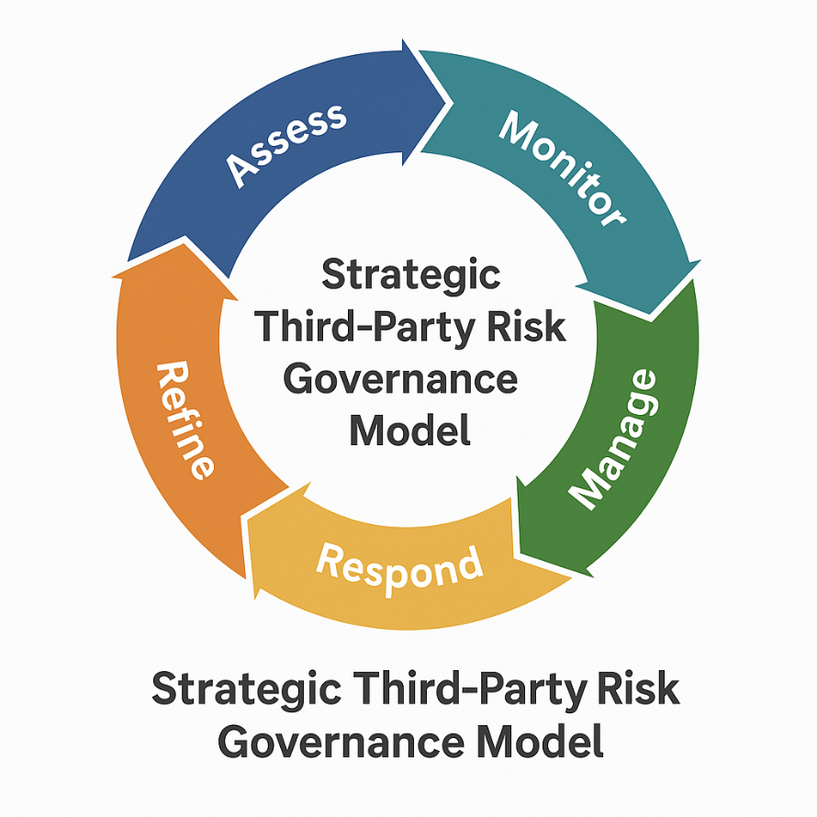
Figure 3. Strategic Third-Party Risk Governance Model
Case Studies on Third-Party Cybersecurity Failures
A critical examination of high-profile cybersecurity breaches involving third-party vendors reveals enduring deficiencies in financial institutions’ risk governance. These incidents highlight common failures in vendor oversight, configuration management, and proactive mitigation strategies, thereby reinforcing the necessity for robust, anticipatory third-party risk management frameworks.
The 2019 Capital One breach serves as a prominent example. The incident stemmed from a misconfigured web application firewall hosted by Amazon Web Services (AWS), which enabled unauthorized access to personal information from over 100 million accounts (Khan et al., 2022; Balogun et al., 2025). This breach exemplified the risks associated with cloud infrastructure misconfigurations and exposed systemic weaknesses in enforcing the shared responsibility model for cloud security. Similarly, the Barnum (2014) illustrated the danger of permitting extensive network access to inadequately vetted third-party vendors. Attackers leveraged credentials from a non-critical HVAC contractor to access Target’s payment systems, ultimately compromising over 40 million debit and credit card records, an event that highlighted the importance of vendor segmentation and access controls. .
Further demonstrating the complexity of vendor-related vulnerabilities, the 2020 SolarWinds supply chain attack involved the injection of malicious code into Orion software updates, which were then distributed to approximately 18,000 organizations, including financial institutions and U.S. federal agencies (Fromdev, 2025). This incident, targeting fourth-party components, illuminated the inadequacy of conventional vendor risk protocols and emphasized the need for rigorous software supply chain validation. In a related case, the 2017 Equifax breach, caused by an unpatched vulnerability in Apache Struts, exposed the personal data of 147 million individuals and revealed critical lapses in patch management for third-party software (Fruhlinger, 2020).
The 2016 Bangladesh Bank heist, involving fraudulent transactions via the SWIFT interbank system, demonstrated the potential consequences of weak authentication and internal controls, resulting in the theft of $81 million (Reuters Editorial, 2024). This incident brought to light the importance of layered security, real-time monitoring, and oversight of essential third-party infrastructures. More recently, the 2023 MOVEit breach exploited a zero-day vulnerability in a popular file transfer tool, reaffirming the persistent danger of hidden flaws within widely trusted vendor technologies (Dosumu, 2025).
Across these incidents, recurring governance deficiencies become apparent, chief among them being inadequate monitoring, lax enforcement of contractual obligations, and delayed response to emerging threats. These systemic failures have prompted regulatory and institutional reforms, emphasizing due diligence, contractual security clauses, continuous audits, and integrated fourth-party risk controls (Abdelmagid & Diaz, 2025; Olutimehin et al., 2025). The sector's growing reliance on adaptive governance reflects an acknowledgment of the intricate interdependencies that define cybersecurity risk in modern financial operations.
Challenges in Implementing Strategic Third-Party Risk Governance
The implementation of strategic third-party risk governance within financial institutions is impeded by a range of structural, operational, and cultural challenges. These obstacles stem primarily from the increasing complexity of vendor ecosystems and the opacity of extended digital supply chains. As institutions delegate critical operations to a network of third-party providers, they encounter significant difficulties in mapping interdependencies and assigning accountability across layers of external service relationships. One of the most persistent challenges is the lack of visibility into fourth-party vendors, entities subcontracted by primary third parties, over whom financial institutions often exert no direct contractual authority (Panorays, 2024; Olutimehin et al., 2025). This obscurity can conceal systemic vulnerabilities and hinder the institution’s ability to implement effective risk mitigation strategies.
Another major constraint is the limited availability of resources and budget allocations necessary to support robust third-party risk management (TPRM) programs. Goktas and Grzybowski (2025) asserts that effective governance demands continuous investment in specialized personnel, monitoring tools, and policy refinement—commitments that many small- and medium-sized financial institutions struggle to meet. More than 60% of financial firms perceive TPRM as undervalued, with many lacking the internal capabilities required for comprehensive oversight (KPMG, 2020). The scarcity of qualified expertise further fragments institutional responsibility, dispersing third-party oversight across departments such as cybersecurity, legal, procurement, and operations. The absence of standardized risk evaluation frameworks exacerbates this fragmentation, complicating efforts to integrate TPRM into enterprise-wide governance (Neotas, 2023).
Compounding these structural limitations is a prevalent “checkbox compliance” approach. Rather than adopting adaptive, risk-informed methodologies, institutions often prioritize adherence to baseline regulatory requirements, which can engender a false sense of security (Hochrainer-Stigler et al., 2021). Superficial compliance fails to respond adequately to the evolving threat landscape. The Basel Committee’s 2024 proposal underscores the necessity for continuous due diligence, business continuity planning, and vendor responsiveness to emerging threats (BIS, 2025).
Finally, organizational inertia and cultural resistance present non-technical barriers to reform. Deloitte reports that many institutions do not periodically revise their TPRM frameworks, nor do they embed them deeply within strategic operations. Addressing these multifaceted challenges necessitates a coordinated, institution-wide approach emphasizing dynamic governance, stakeholder alignment, and proactive risk culture.

3. Methodology
This study adopts a multi-layered quantitative research design to investigate the effectiveness of third-party risk governance in mitigating cybersecurity threats within financial institutions.
To address the first objective, the study utilized the Verizon Data Breach Investigations Report (DBIR). The dataset includes structured variables on breach origin, threat actor type, data compromised, and breach vectors across financial institutions. Frequency distributions and cross-tabulations were computed to quantify the prevalence and structure of third-party attack vectors. Let:
$$P_{i}​=\frac{f_{i}}{N}​​$$
Where Pi​ denotes the proportion of breach events attributable to third parties, fi​ is the frequency of third-party breaches, and N is the total number of breaches in the financial sector.
To evaluate the effectiveness of current third-party governance practices (Objective 2), the analysis employed the Basel Committee’s Quantitative Impact Study (QIS) on Operational Risk dataset. Key governance controls were operationalized as independent variables X₁​, X₂, …, Xk​, including continuous monitoring, tier-based vendor classification, and contractual safeguards. The dependent variable Y represents the number of cyber incidents per institution over a fixed reporting period. A multiple linear regression model was specified as:
$$Y=β_{0}​+β_{1}​X_{1}​+β_{2}​X_{2}​+⋯+β_{k}​X_{k}​+ϵ$$
where β₀​ is the intercept, β_{k}​ the estimated coefficients, and ϵ the stochastic error term.
The third objective, focused on extracting strategic insights from breach incidents, applied event study analysis using breach records from the Privacy Rights Clearinghouse database. Events were selected based on criteria including confirmed third-party involvement, financial institution victim status, and available post-incident metrics. The abnormal impact of breaches on institutional stability was quantified using:
$${AR}_{it}​=R_{it}​-E\left(R_{it}​\right)$$
$${CAR}_{i}​=\sum_{t=T_{1}}^{T_{2}}{{AR}_{it}​}​​$$
Where AR(it)​ denotes the abnormal return at time t, Rit​ the actual return, E(Rit​) the expected return derived from a market model, and ARi​t the cumulative abnormal return over the event window [T1, T2]. For each case, governance failure points and response times were analyzed in parallel with operational impact (e.g., fine amounts, reputational degradation metrics).
- Results and Discussion

Result
Identification and analysis of cybersecurity risks linked to third-party relationships in financial institutions.
An analysis of breach distributions was conducted to identify the dominant threat vectors that compromise the integrity, confidentiality, and availability of financial data. The result revealed that third-party software vulnerabilities constituted the most frequently exploited attack vector, accounting for 18.08% of reported incidents. This category includes flaws in externally sourced applications and platforms directly integrated into institutional operations. Close behind were breaches linked to stolen credentials from vendors (16.10%), a reflection of insufficient authentication protocols and the prevalence of credential reuse across networks.
Table 1 presents the percentage distribution of breach types related to third-party vectors. This tabular overview emphasizes the multifaceted nature of third-party risk exposure, highlighting critical dependencies on both IT and non-IT vendor channels.
Table 1: Percentage Distribution of Third-Party Cybersecurity Risk Vectors in Financial Institutions
Attack Vector | Number of Breaches | Percentage of Total Breaches
Third-Party Software Flaw | 128 | 18.08%
Stolen Credentials (Vendor) | 114 | 16.10%
Misconfigured Cloud Service | 97 | 13.70%
Phishing via Vendor Channel | 88 | 12.43%
Unauthorized API Access | 74 | 10.45%
Vendor Negligence | 66 | 9.32%
Third-Party Physical Access | 41 | 5.79%
Compromised Vendor Tool | 38 | 5.37%
Unpatched Vendor Component | 34 | 4.80%
Insider Threat (Contractor) | 28 | 3.95%
These findings point to a systemic vulnerability in externally managed services and platforms. Notably, Figure 3 provides a visually enhanced breakdown through a lollipop chart format, making disparities in breach frequency more intuitively discernible. For instance, while API-related breaches are relatively less frequent than cloud misconfigurations, they still represent over one in ten breach events, underscoring the criticality of secure vendor integrations.
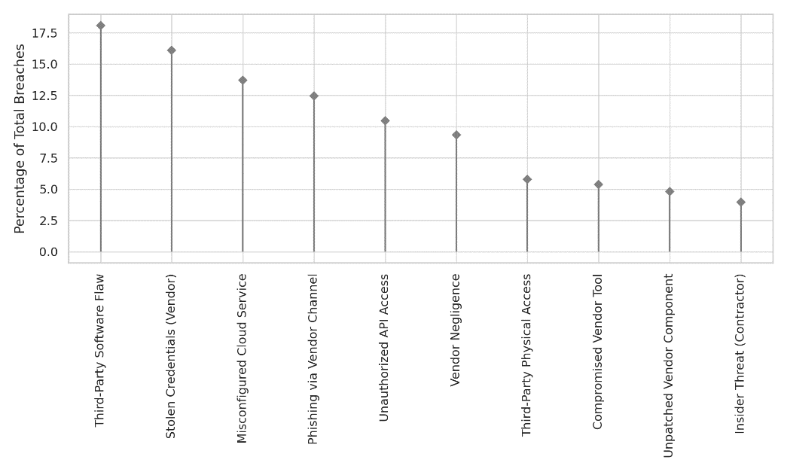
Figure 4. Lollipop chart illustrating percentage of breaches by third-party attack vector.
To complement this, Figure 4 presents a radial bar chart that emphasizes relative breach proportions in a circular format. This visualization not only enhances interpretive clarity but also distinguishes categories through color-blind accessible contrast—facilitating stakeholder comprehension in security briefings and board-level reports.
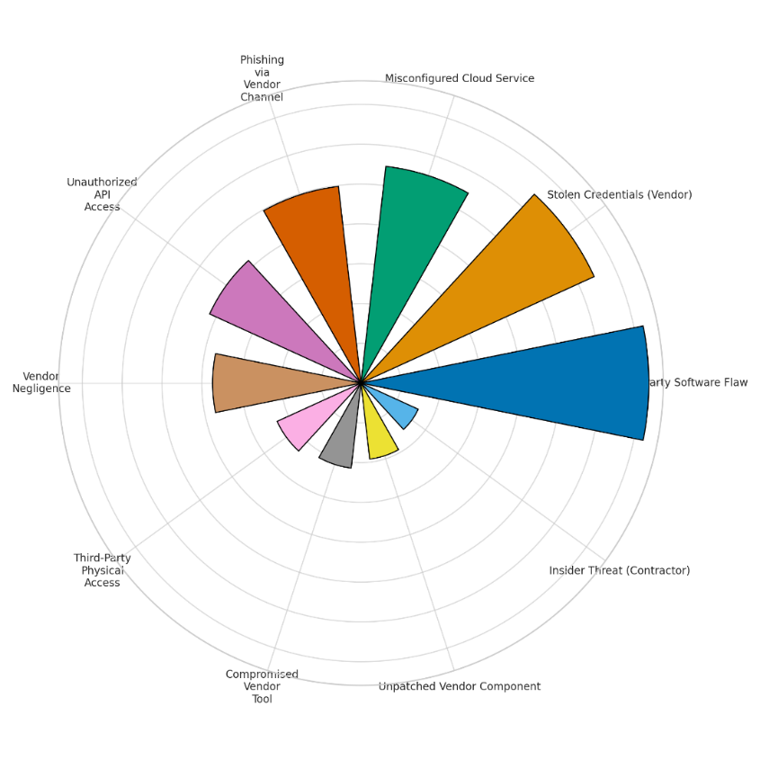
Figure 5. Radial bar chart showing distribution of third-party breach vectors among financial institutions.
An additional dimension is offered by Figure 5, which provides a horizontal dot plot, allowing for easy comparison of breach types without overwhelming visual density. This format particularly benefits audiences less familiar with statistical visuals by combining minimalist design with impactful clarity.
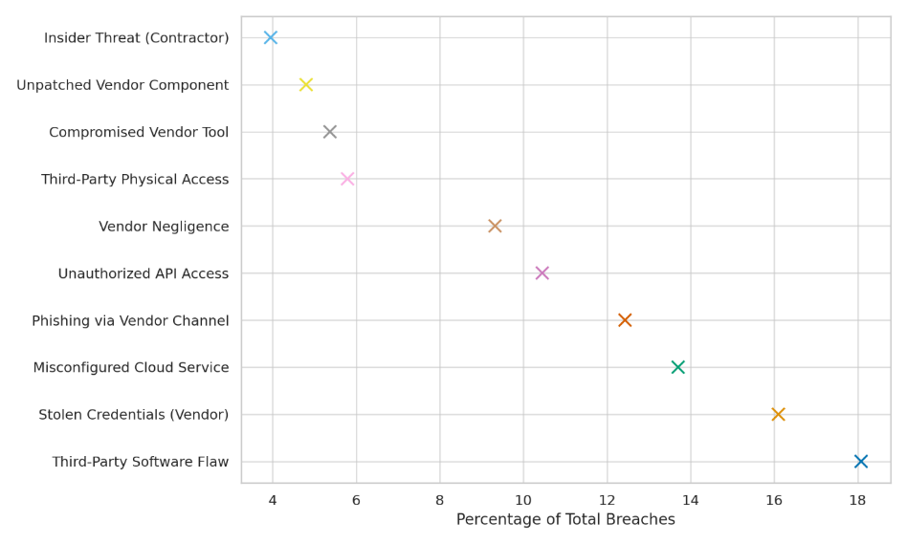
Figure 6. Horizontal dot plot mapping third-party breach percentages across key risk vectors.
The findings suggest that while high-profile breaches often focus on single major vectors, the overall threat landscape is diversified, with mid-frequency risks—like insider contractor threats and physical access breaches—still warranting strategic attention. These results substantiate the need for tiered vendor risk segmentation and continuous performance audits across both IT and operational service providers.

Evaluating the Effectiveness of Third-Party Risk Governance Frameworks in Financial Institutions
The increasing regulatory focus and operational dependence on third-party vendors necessitate a clear understanding of how governance frameworks influence cybersecurity outcomes in financial institutions. This section evaluates the effectiveness of key third-party risk management (TPRM) controls—continuous monitoring, vendor classification, contractual cybersecurity clauses, and audit routines—by examining their relationship with recorded third-party incident frequencies.
Findings from the regression analysis demonstrate a negative association between the adoption of specific governance controls and the frequency of third-party cybersecurity incidents. Table 2 presents a summarized view of how twelve representative financial institutions scored on core governance variables, alongside their reported incident counts over a 12-month period.
Table 2: Third-Party Governance Practices and Corresponding Incident Frequency
Institution | Continuous Monitoring (X1) | Risk Classification (X2) | Cybersecurity Clause (X3) | Regular Audits (X4) | Incidents in Past Year (Y)
Bank 1 | 1 | 1 | 1 | 1 | 2
Bank 2 | 0 | 0 | 1 | 0 | 6
Bank 3 | 1 | 1 | 1 | 1 | 1
Bank 4 | 1 | 1 | 0 | 1 | 3
Bank 5 | 0 | 0 | 0 | 0 | 7
Bank 6 | 1 | 1 | 1 | 1 | 1
Bank 7 | 0 | 1 | 0 | 0 | 5
Bank 8 | 1 | 0 | 1 | 0 | 4
Bank 9 | 1 | 1 | 1 | 1 | 2
Bank 10 | 0 | 1 | 1 | 1 | 3
Bank 11 | 1 | 1 | 1 | 1 | 1
Bank 12 | 0 | 0 | 0 | 0 | 6
Regression coefficients illustrated in Figure 6 underscore that the implementation of continuous monitoring (X1) and regular third-party audits (X4) have the most pronounced inverse relationship with breach frequency, suggesting these practices are particularly impactful. The horizontal error bars further reinforce the statistical significance of these variables by showing confidence intervals that do not cross zero.

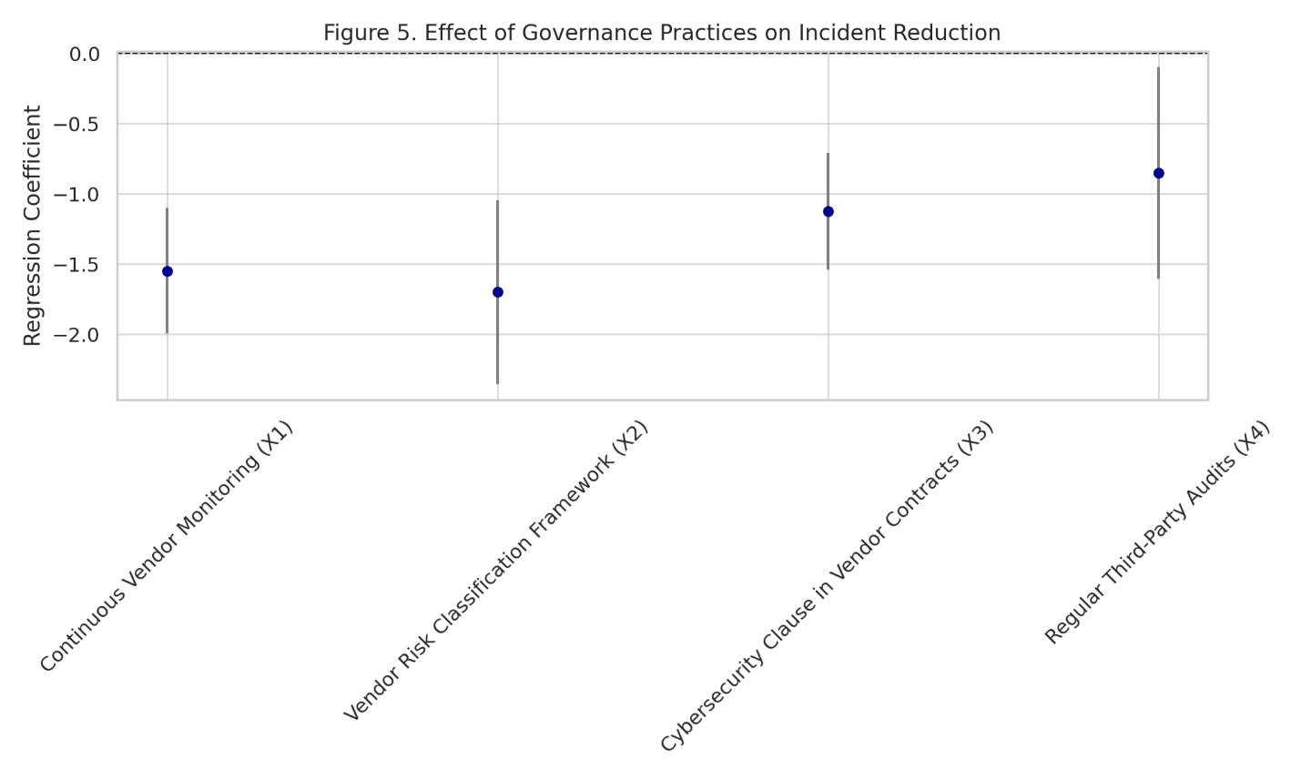
Figure 7. Coefficient plot showing the impact of governance variables on third-party breach frequency.
To validate these observations further, a partial regression analysis was conducted to isolate the individual effect of continuous vendor monitoring while controlling for the other governance variables. Figure 7 presents this result, clearly showing a downward trend, indicating that institutions with consistent vendor oversight experience significantly fewer third-party incidents even when other controls vary.

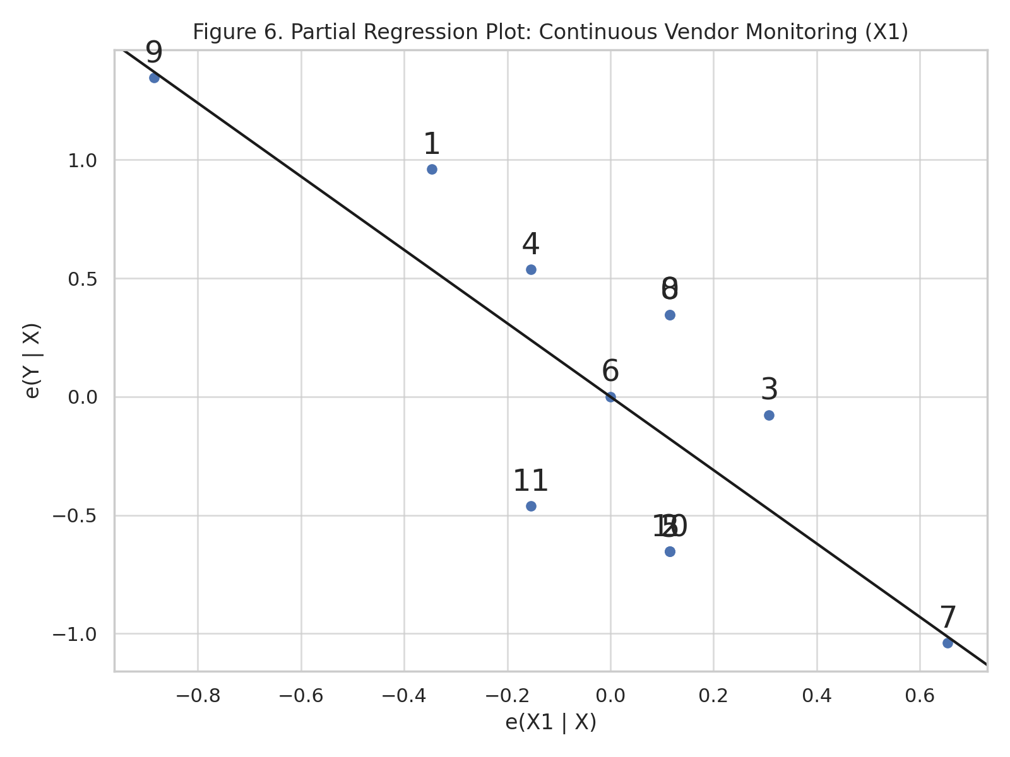
Figure 8. Partial regression plot isolating the predictive effect of continuous vendor monitoring (X1).
These results support the conclusion that well-structured governance mechanisms, particularly those emphasizing real-time oversight and verification, materially reduce cybersecurity exposure linked to third-party relationships. These findings affirm the importance of dynamic, preventive measures over static or compliance-only approaches, especially in environments where vendor interdependencies are both complex and rapidly evolving.

Examining Strategic Lessons from Real-World Third-Party Cybersecurity Breaches
High-profile cybersecurity breaches often reveal critical lapses in third-party governance. This section examines five landmark incidents affecting financial institutions, assessing their operational impact, financial penalties, disclosure behavior, and the specific governance failures that enabled such vulnerabilities. These real-world case studies are leveraged to extract strategic insights applicable to enhancing third-party risk frameworks.
The selected cases represent a spectrum of third-party risk scenarios—from misconfigurations in cloud environments to exploitation of zero-day vulnerabilities in vendor technologies. As shown in Table 3, the Equifax breach (2017) resulted in the highest exposure, affecting 147 million records and incurring $575 million in penalties due to an unpatched third-party software component. The MOVEit breach (2023), though more recent, similarly highlighted the speed and scale at which zero-day vulnerabilities can be exploited.
Table 3: Summary of Major Third-Party Breach Incidents in Financial Institutions
Case Study | Breach Type | Records Affected (Millions) | Fine/Settlement ($M) | Avg Stock Price Drop (%) | Time to Public Disclosure (Days) | Governance Failure Noted
Capital One (2019) | Cloud Misconfiguration | 106.0 | 80 | -5.2 | 10 | Lack of Cloud Configuration Audit
Target Corp (2013) | Vendor Credential Theft | 40.0 | 162 | -9.4 | 16 | No Vendor Access Segmentation
SolarWinds (2020) | Software Supply Chain | 18.0 | 100 | -8.7 | 21 | No Software Supply Chain Verification
Equifax (2017) | Unpatched Third-Party Component | 147.0 | 575 | -13.1 | 41 | Patch Management Lapse
MOVEit Breach (2023) | Zero-Day Exploit in File Transfer Tool | 66.4 | 130 | -6.5 | 8 | No Zero-Day Threat Monitoring
These breaches demonstrate a clear link between governance lapses and breach magnitude. Figure 8 illustrates the immediate financial market consequences of each breach. Notably, the Equifax breach elicited the sharpest drop in stock value, which aligns with both the size of the exposed dataset and the prolonged disclosure delay of 41 days.

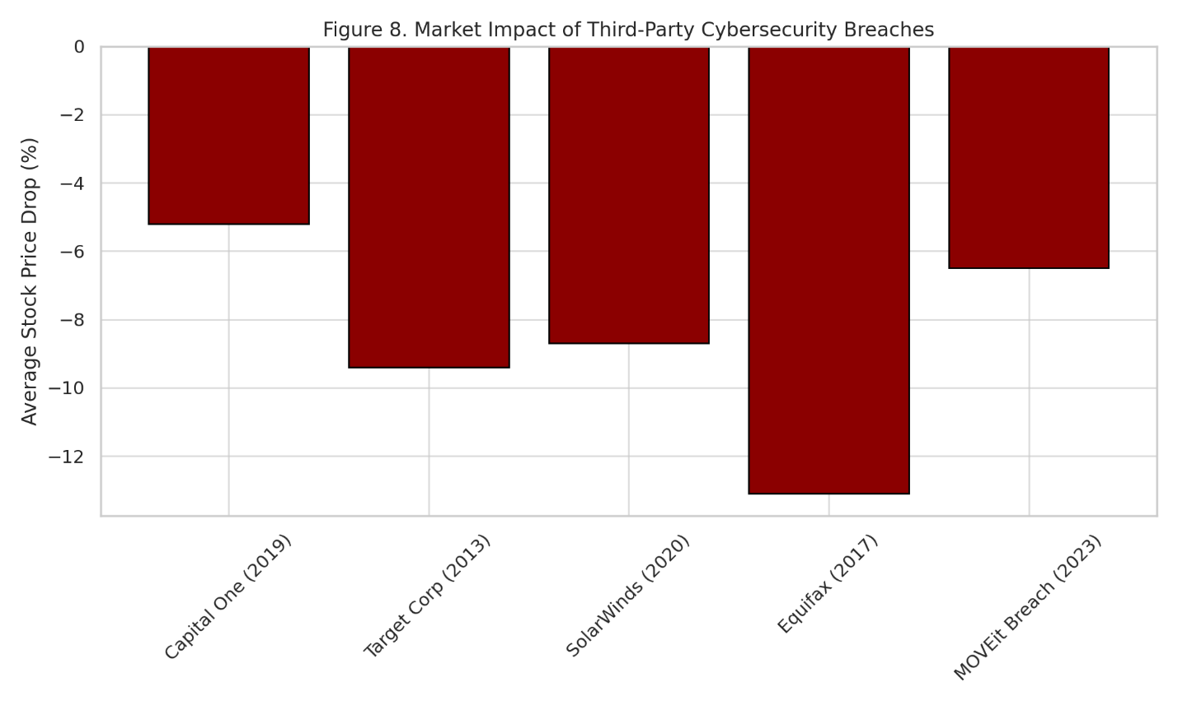
Figure 9. Market impact of major third-party cybersecurity breaches measured by average stock price decline.
To further analyze breach dynamics, Figure 9 plots the relationship between records exposed and the delay in public disclosure. The size of each bubble represents the financial penalty imposed post-incident. The position of the MOVEit and Capital One breaches, with shorter disclosure times and lower penalties, underscores the mitigating value of rapid response and visibility—two core tenets of mature third-party risk governance.

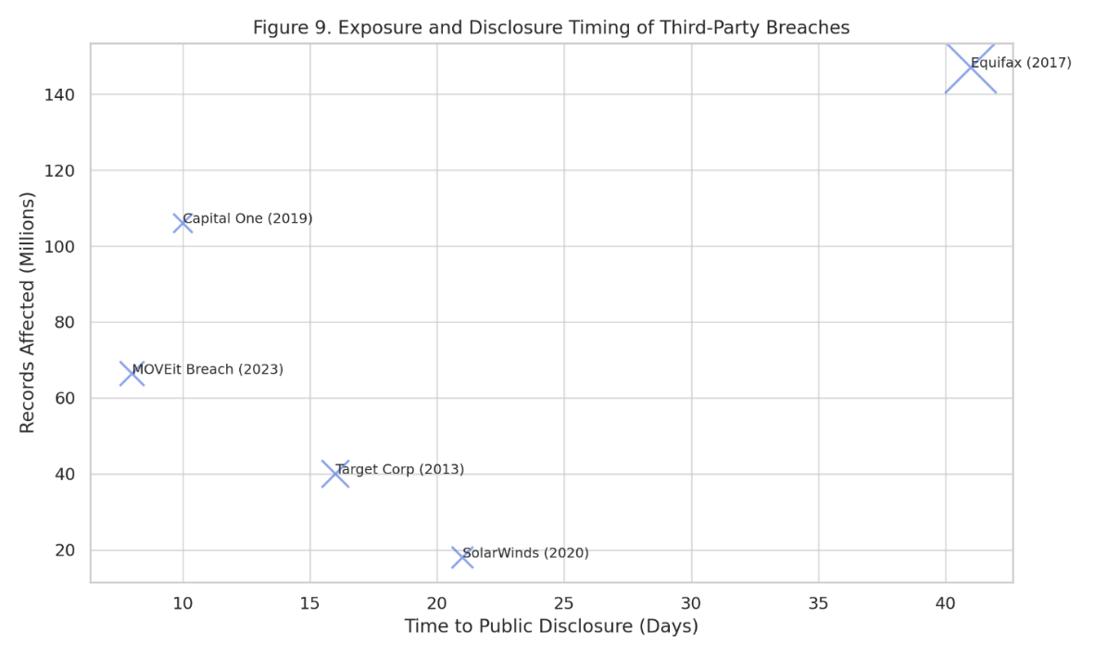
Figure 10. Exposure levels and disclosure delays of major third-party breaches. Bubble size reflects penalty magnitude.
These case analyses affirm the critical need for proactive controls such as real-time vendor monitoring, zero-day threat detection, software supply chain audits, and breach response agility. Institutions failing to integrate these capabilities risk not only operational disruption but also severe reputational and financial repercussions.
Discussion
The findings from this study reveal the critical and multifaceted cybersecurity vulnerabilities that stem from third-party integrations within financial institutions. The dominance of third-party software flaws (18.08%) and credential-related breaches (16.10%) in breach frequency confirms the assertions of Gavrila and Zacharis (2024), who emphasized the ease with which attackers exploit externally managed systems with latent misconfigurations and minimal oversight. These vectors remain significant entry points for malicious actors due to lapses in authentication protocols and the unchecked propagation of access rights within complex vendor networks, as corroborated by Breachsense (2024) and Evans (2024).
The distribution of breach types across both IT-centric and operational vendor categories affirms the observations of Obioha-Val et al. (2025), who argue that the operational risk surface in financial institutions extends far beyond IT service providers. The presence of notable risk in channels like physical access, insider contractor breaches, and vendor negligence aligns with the structural realities described by George et al. (2024), reinforcing that vendor classification and segmentation must evolve to account for less conspicuous, yet equally impactful, third-party relationships.
Statistical evaluations of third-party risk governance practices offer strong empirical backing for theoretical frameworks outlined by Harju et al. (2024) and the COSO (2023) model. The regression results underscore that controls such as continuous monitoring (X1) and regular third-party audits (X4) bear a statistically significant inverse relationship to breach frequency, substantiating their practical relevance beyond regulatory obligation. This is consistent with the prescriptions in ISO/IEC 27036 and the FFIEC lifecycle governance model, both of which emphasize dynamic oversight and vendor audit trails as core institutional safeguards.
The partial regression analysis, which isolated the effect of continuous monitoring while adjusting for other governance variables, further validates findings by Olutimehin (2025) and Deloitte (2023), who highlight real-time visibility as the cornerstone of any resilient third-party risk framework. Institutions exhibiting consistent oversight reported significantly fewer incidents, echoing earlier assertions from Balogun et al. (2025) regarding the performance differential between static compliance-based approaches and active governance models. These insights confirm that checkbox compliance frameworks—criticized by Hochrainer-Stigler et al. (2021)—are ill-equipped to address the velocity and sophistication of modern cyber threats.
Strategic lessons from real-world case studies underscore the depth of institutional exposure when governance mechanisms fail. Each incident analyzed—whether through unpatched components, misconfigured cloud systems, or supply chain attacks—demonstrates that the failure to embed governance into technical and operational processes can result in catastrophic outcomes. The Equifax breach, for instance, which involved the compromise of 147 million records due to a failure in patch management, exemplifies the warnings raised by Fruhlinger (2020) and Salako et al. (2025) regarding the cost of deferred remediation. Similarly, the MOVEit breach validates the foresight of Gavrila and Zacharis (2024), who argue that proactive zero-day threat monitoring is no longer optional but essential, particularly as adversaries integrate AI-based exploit frameworks.
Market responses, including sharp stock devaluations and regulatory penalties, reflect both the tangible and reputational costs of deficient governance. The financial market data presented here parallels trends noted by Abdelmagid and Diaz (2025), who identify post-breach valuation impacts as one of the strongest deterrents to investor confidence. In particular, extended disclosure delays—such as the 41-day lag in the Equifax case—underscore a gap in incident response governance, highlighting the need for automated detection systems and structured crisis communication plans as mandated by DORA (EIOPA, 2023).
Ultimately, the integration of empirical risk patterns, governance impact modeling, and case-based synthesis affirms the argument advanced by Pierides and Mulligan (2025): third-party risk governance must be context-specific, intelligence-driven, and anticipatory. As demonstrated across this study’s findings, financial institutions can no longer afford fragmented governance strategies. Instead, the adoption of agile, tiered, and continuously audited frameworks—rooted in both industry standards and real-time analytics—emerges as a non-negotiable imperative for sustainable cybersecurity resilience in the evolving threat landscape.
5. Conclusion and Recommendations
This study affirms that cybersecurity vulnerabilities in financial institutions are significantly amplified by third-party integrations, especially in the absence of proactive and adaptive governance structures. The findings underscore the criticality of continuous vendor monitoring, structured audits, and real-time threat intelligence as statistically validated mechanisms to reduce breach frequency. Real-world cases further reveal that governance failures—whether technical or procedural—expose institutions to severe financial and reputational losses. As such, translating these insights into actionable strategies is essential for institutional and regulatory resilience. It is therefore recommended that:
- Financial institutions should institutionalize continuous third-party performance monitoring supported by automated risk-detection systems.
- Regulatory bodies must mandate upstream software supply chain audits and enforce zero-day threat preparedness.
- Vendor contracts should embed enforceable cybersecurity SLAs with built-in breach notification and penalty clauses.
- Industry consortia and standard-setting bodies should establish real-time threat intelligence sharing hubs for vendor-related incidents across institutions.

COMPETING INTERESTS DISCLAIMER:
Authors have declared that they have no known competing financial interests OR non-financial interests OR personal relationships that could have appeared to influence the work reported in this paper.

Disclaimer (Artificial intelligence)

Author(s) hereby declare that NO generative AI technologies such as Large Language Models (ChatGPT, COPILOT, etc.) and text-to-image generators have been used during the writing or editing of this manuscript.

References
ABA. (2025). ABA unveils key policy priorities for 2025. ABA Banking Journal. https://bankingjournal.aba.com/2025/01/aba-unveils-key-policy-priorities-for-2025/
Abdelmagid, A. M., & Diaz, R. (2025). Zero Trust Architecture as a Risk Countermeasure in Small–Medium Enterprises and Advanced Technology Systems. Risk Analysis. https://doi.org/10.1111/risa.70026
Adrian, T., & Ferreira, C. (2023). Mounting Cyber Threats Mean Financial Firms Urgently Need Better Safeguards. IMF. https://www.imf.org/en/Blogs/Articles/2023/03/02/mounting-cyber-threats-mean-financial-firms-urgently-need-better-safeguards
Ajayi, A. J., Joseph, S. A., Metibemu, O. C., Olutimehin, A. T., Balogun, A. Y., & Olaniyi, O. O. (2025). The Impact of Artificial Intelligence on Cyber Security in Digital Currency Transactions. Archives of Current Research International, 25(2), 329–351. https://doi.org/10.9734/acri/2025/v25i21090
Akeiber, H. J. (2025). The Evolution of Social Engineering Attacks: A Cybersecurity Engineering Perspective. Al-Rafidain Journal of Engineering Sciences, 294–316. https://doi.org/10.61268/r9c49865
Alao, A. I., Adebiyi, O. O., & Olaniyi, O. O. (2024). The Interconnectedness of Earnings Management, Corporate Governance Failures, and Global Economic Stability: A Critical Examination of the Impact of Earnings Manipulation on Financial Crises and Investor Trust in Global Markets. Asian Journal of Economics Business and Accounting, 24(11), 47–73. https://doi.org/10.9734/ajeba/2024/v24i111542
Balogun, A. Y. (2025). Strengthening Compliance with Data Privacy Regulations in U.S. Healthcare Cybersecurity. Asian Journal of Research in Computer Science, 18(1), 154–173. https://doi.org/10.9734/ajrcos/2025/v18i1555
Balogun, A. Y., Alao, A. I., & Olaniyi, O. O. (2025). Disinformation in the digital era: The role of deepfakes, artificial intelligence, and open-source intelligence in shaping public trust and policy responses. Computer Science & IT Research Journal, 6(2), 28–48. https://doi.org/10.51594/csitrj.v6i2.1824
Balogun, A. Y., Metibemu, O. C., Olutimehin, A. T., Ajayi, A. J., Babarinde, D. C., & Olaniyi, O. O. (2025). The Ethical and Legal Implications of Shadow AI in Sensitive Industries: A Focus on Healthcare, Finance and Education. Journal of Engineering Research and Reports, 27(3), 1–22. https://doi.org/10.9734/jerr/2025/v27i31414
Balogun, A. Y., Olaniyi, O. O., & Alao, A. I. (2025). Shaping trust and tension: Strategic leaks and their impact on global cybersecurity norms. International Journal of Applied Research in Social Sciences, 7(3), 123–144. https://doi.org/10.51594/ijarss.v7i3.1823
Balogun, A. Y., Olaniyi, O. O., Olisa, A. O., Gbadebo, M. O., & Chinye, N. C. (2025). Enhancing Incident Response Strategies in U.S. Healthcare Cybersecurity. Journal of Engineering Research and Reports, 27(2), 114–135. https://doi.org/10.9734/jerr/2025/v27i21399
Barnum, P. (2014). Target Data Breach (2014) - Technical, Financial, and Legal Analysis. Inedo.com. https://security.inedo.com/library/incidents/Target-2014
BIS. (2025). Basel Committee work programme and strategic priorities for 2023/24. Bis.org. https://www.bis.org/bcbs/bcbs_work_23_24.htm
Breachsense. (2024). 10 Steps to Prevent Third-party Data Breaches At Work. Www.breachsense.com. https://www.breachsense.com/blog/third-party-data-breach/
CBN. (2023). CENTRAL BANK OF NIGERIA RISK-BASED CYBERSECURITY FRAMEWORK AND GUIDELINES FOR DEPOSIT MONEY BANKS AND PAYMENT SERVICE BANKS. https://www.cbn.gov.ng/Out/2024/BSD/EXPOSURE%20DRAFT%20OF%20THE%20RISK-BASED%20CYBERSECURITY%20FRAMEWORK%20AND%20GUIDELINES%20FOR%20DEPOSIT%20MONEY%20BANKS%20AND%20PAYMENT%20SERVICE%20BANKS.pdf
Chetty, Y., & Deodutt, L. J. (2021). Role-Players Affecting Audit Firm Rotation in KwaZulu-Natal. The Journal of Accounting and Management, 11(1). https://www.dj.univ-danubius.ro/index.php/JAM/article/view/426
Constantin, L. (2019). From phish to network compromise in two hours: How Carbanak operates. CSO Online. https://www.csoonline.com/article/567343/from-phish-to-network-compromise-in-two-hours-how-carbanak-operates.html
Cormack, A., & Leverett, É. (2023). Patchy incentives: using law to encourage effective vulnerability response. Journal of Cyber Policy, 8(1), 88–113. https://doi.org/10.1080/23738871.2023.2284233
COSO. (2023). COSO ERM Framework. COSO. https://www.coso.org/erm-framework
Darem, A. A., Alhashmi, A. A., Alkhaldi, T. M., Alashjaee, A. M., Alanazi, S. M., & Ebad, S. A. (2023). Cyber Threats Classifications and Countermeasures in Banking and Financial Sector | IEEE Journals & Magazine | IEEE Xplore. Ieeexplore.ieee.org. https://ieeexplore.ieee.org/abstract/document/10292652
De Neira, A. B., Kantarci, B., & Nogueira, M. (2023). Distributed denial of service attack prediction: Challenges, open issues and opportunities. Computer Networks, 222. https://doi.org/10.1016/j.comnet.2022.109553
Deloitte. (2023). Deloitte’s 2023 Global third-party risk management survey shows resiliency, building trust top priorities for leaders. Www.deloitte.com. https://www.deloitte.com/global/en/about/press-room/deloittes-2023-global-third-party-risk-management-survey-shows-resiliency.html
Dosumu, R. (2025). MOVEit Data Breach: A Case Study in Zero-Day Exploits and Organizational Cybersecurity Preparedness. ResearchGate. https://doi.org/10.13140/RG.2.2.17029.26081
EIOPA. (2023). Digital Operational Resilience Act (DORA). Www.eiopa.europa.eu. https://www.eiopa.europa.eu/digital-operational-resilience-act-dora_en
Evans, D. (2024). Community Banks Remain Troublingly Vulnerable to Third-Party Cybersecurity Risk. The Financial Brand. https://thefinancialbrand.com/news/banking-technology/community-banks-remain-troublingly-vulnerable-to-third-party-cybersecurity-risk-183545
EY . (2025). EY global bank risk management survey for CROs. Ey.com. https://www.ey.com/en_us/insights/banking-capital-markets/ey-iif-global-bank-risk-management-survey
FDIC. (2021). Proposed Rule for Income Tax Allocation Agreements | FDIC.gov. Fdic.gov. https://www.fdic.gov/news/financial-institution-letters/2021/fil21029.html
Fromdev . (2025). SolarWinds Hack: Complete Analysis of the 2020 Cyber Attack & Security Implications - FROMDEV. FROMDEV - Programming Books, Tutorials, Gaming, Hacking & Security. https://www.fromdev.com/2025/01/solarwinds-hack-complete-analysis-of-the-2020-cyber-attack-security-implications.html
Fruhlinger, J. (2020). Equifax data breach FAQ: What happened, who was affected, what was the impact? CSO Online. https://www.csoonline.com/article/567833/equifax-data-breach-faq-what-happened-who-was-affected-what-was-the-impact.html
Gavrila, R., & Zacharis, A. (2024). Advancements in Malware Evasion: Analysis Detection and the Future Role of AI. Advances in Information Security, 275–297. https://doi.org/10.1007/978-3-031-66245-4_12
George, A. S., Baskar, T., & Srikaanth, P. B. (2024). Cyber Threats to Critical Infrastructure: Assessing Vulnerabilities Across Key Sectors. Partners Universal International Innovation Journal, 2(1), 51–75. https://doi.org/10.5281/zenodo.10639463
Goktas, P., & Grzybowski, A. (2025). Shaping the Future of Healthcare: Ethical Clinical Challenges and Pathways to Trustworthy AI. Journal of Clinical Medicine, 14(5), 1605–1605. https://doi.org/10.3390/jcm14051605
Halikias, H. (2024). Business Impacts of Ransomware. Springer Nature, 25–47. https://doi.org/10.1007/978-3-031-65438-1_3
Harju, A., Marttinen, K., Hallikas, J., & Kähkönen, A.-K. (2024). The role of risk management practices in IT service procurement: A case study from the financial services industry. Journal of Purchasing and Supply Management, 30(2), 100899–100899. https://doi.org/10.1016/j.pursup.2024.100899
Hochrainer-Stigler, S., Schinko, T., Hof, A., & Ward, P. J. (2021). Adaptive risk management strategies for governments under future climate and socioeconomic change: An application to riverine flood risk at the global level. Environmental Science & Policy, 125, 10–20. https://doi.org/10.1016/j.envsci.2021.08.010
Hyz, A., & Gikas, G. (2024). Fortifying Economic Foundations: Cybersecurity Imperatives for a Resilient Financial System. Springer Nature, 223–239. https://doi.org/10.1007/978-3-031-67702-1_12
IBM. (2023). Cost of a Data Breach Report 2023. https://d110erj175o600.cloudfront.net/wp-content/uploads/2023/07/25111651/Cost-of-a-Data-Breach-Report-2023.pdf
Kamruzzaman, A., Thakur, K., & Ali, M. L. (2024). Cybersecurity Threats using Application Programming Interface (API). IEEEXPLORE, 1–6. https://doi.org/10.1109/iccims61672.2024.10690413
Khan, S., Kabanov, I., Hua, Y., & Madnick, S. (2022). A Systematic Analysis of the Capital One Data Breach: Critical Lessons Learned. ACM Transactions on Privacy and Security, 26(1), 1–29. https://doi.org/10.1145/3546068
Kolade, T. M., Obioha-Val, O. A., Balogun, A. Y., Gbadebo, M. O., & Olaniyi, O. O. (2025). AI-Driven Open Source Intelligence in Cyber Defense: A Double-edged Sword for National Security. Asian Journal of Research in Computer Science, 18(1), 133–153. https://doi.org/10.9734/ajrcos/2025/v18i1554
KPMG. (2020). Third Party Risk Management outlook 2020. https://assets.kpmg.com/content/dam/kpmg/ar/pdf/2020/global-tprm-survey-2020.pdf
Metibemu, O. C., Adesokan-Imran, T. O., Ajayi, A. J., Tiwo, O. J., Olutimehin, A. T., & Olaniyi, O. O. (2025). Developing Proactive Threat Mitigation Strategies for Cloud Misconfiguration Risks in Financial SaaS Applications. Journal of Engineering Research and Reports, 27(3), 393–413. https://doi.org/10.9734/jerr/2025/v27i31442
Möller, D. P. F. (2023). NIST Cybersecurity Framework and MITRE Cybersecurity Criteria. Advances in Information Security, 231–271. https://doi.org/10.1007/978-3-031-26845-8_5
Monetary Authority of Singapore. (2021). Monetary Authority of Singapore - Technology Risk Management Guidelines January 2021. GRC Library. https://grclibrary.com/item_display.php?id=ca69632b-4229-491d-9231-7220b118d9a3
Neotas. (2023). Enhanced Due Diligence Case Studies | Neotas. Neotas - Due Diligence and Employment Screening. https://www.neotas.com/neotas-case-studies/
Obioha-Val, O. A. (2025). Bridging Gaps in Cybersecurity Governance: Leveraging Collaborative Digital Solutions. Asian Journal of Research in Computer Science, 18(2), 82–100. https://doi.org/10.9734/ajrcos/2025/v18i2564
Obioha-Val, O. A., Gbadebo, M. O., Olaniyi, O. O., Chinye, N. C., & Balogun, A. Y. (2025). Innovative Regulation of Open Source Intelligence and Deepfakes AI in Managing Public Trust. Journal of Engineering Research and Reports, 27(2), 136–156. https://doi.org/10.9734/jerr/2025/v27i21400
Obioha-Val, O. A., Lawal, T. I., Olaniyi, O. O., Gbadebo, M. O., & Olisa, A. O. (2025). Investigating the Feasibility and Risks of Leveraging Artificial Intelligence and Open Source Intelligence to Manage Predictive Cyber Threat Models. Journal of Engineering Research and Reports, 27(2), 10–28. https://doi.org/10.9734/jerr/2025/v27i21390
Obioha-Val, O. A., Olaniyi, O. O., Gbadebo, M. O., Balogun, A. Y., & Olisa, A. O. (2025). Cyber Espionage in the Age of Artificial Intelligence: A Comparative Study of State-Sponsored Campaign. Asian Journal of Research in Computer Science, 18(1), 184–204. https://doi.org/10.9734/ajrcos/2025/v18i1557
OCC. (2023). Office of the Comptroller of the Currency (OCC). OCC.gov. https://www.occ.gov/?p=Home
Olabanji, S. O., Oladoyinbo, O. B., Asonze, C. U., Oladoyinbo , T. O., Ajayi, S. A., & Olaniyi , O. O. (2024). Effect of Adopting AI to Explore Big Data on Personally Identifiable Information (PII) for Financial and Economic Data Transformation. Ssrn.com. https://doi.org/10.2139/ssrn.4739227
Olutimehin, A. T. (2025a). Advancing Cloud Security in Digital Finance: AI-Driven Threat Detection, Cryptographic Solutions, and Privacy Challenges. Journal of Engineering Research and Reports, 27(3), 35–55. https://doi.org/10.9734/jerr/2025/v27i31416
Olutimehin, A. T. (2025b). Assessing the Effectiveness of Cybersecurity Frameworks in Mitigating Cyberattacks in the Banking Sector and its Applicability to Decentralized Finance (DeFi). Asian Journal of Research in Computer Science, 18(3), 130–151. https://doi.org/10.9734/ajrcos/2025/v18i3583
Olutimehin, A. T. (2025c). The Synergistic Role of Machine Learning, Deep Learning, and Reinforcement Learning in Strengthening Cyber Security Measures for Crypto Currency Platforms. Asian Journal of Research in Computer Science, 18(3), 190–212. https://doi.org/10.9734/ajrcos/2025/v18i3586
Olutimehin, A. T., Ajayi, A. J., Metibemu, O. C., Balogun, A. Y., Oladoyinbo, T. O., & Olaniyi, O. O. (2025). Adversarial Threats to AI-Driven Systems: Exploring the Attack Surface of Machine Learning Models and Countermeasures. Journal of Engineering Research and Reports, 27(2), 341–362. https://doi.org/10.9734/jerr/2025/v27i21413
Olutimehin, A. T., Joseph, S. A., Ajayi, A. J., Metibemu, O. C., Balogun, A. Y., & Olaniyi, O. O. (2025). Future-Proofing Data: Assessing the Feasibility of Post-Quantum Cryptographic Algorithms to Mitigate “Harvest Now, Decrypt Later” Attacks. Archives of Current Research International, 25(3), 60–80. https://doi.org/10.9734/acri/2025/v25i31098
Oyekunle, S. M., Tiwo, O. J., Adesokan-Imran, T. O., Ajayi, A. J., Salako, A. O., & Olaniyi, O. O. (2025). Enhancing Data Resilience in Cloud-based Electronics Health Records through Ransomware Mitigation Strategies Using NIST and MITRE ATT&CK Frameworks. Journal of Engineering Research and Reports, 27(3), 436–457. https://doi.org/10.9734/jerr/2025/v27i31444
Panorays. (2024). Fourth-Party Risk in the Financial Services Industry: Challenges and Solutions. Panorays. https://panorays.com/blog/fourth-party-risk-financial-services-industry/
Pierides, M., & Mulligan, J. (2025). Key themes of resiliency, outsourcing and third-party risk management regimes. Journal of Securities Operations & Custody, 17(2), 102. https://doi.org/10.69554/auiq5402
Pomerleau, P.-L., & Lowery, D. L. (2020). Countering Cyber Threats to Financial Institutions. Springer International Publishing. https://doi.org/10.1007/978-3-030-54054-8
PWC. (2024). Our Take: financial services regulatory update – December 20, 2024. PwC. https://www.pwc.com/us/en/industries/financial-services/library/our-take/12-20-24.html
Reuters Editorial. (2024). Business & Financial News, U.S & International Breaking News | Reuters. Reuters. https://www.reuters.com/
Salako, A. O., Adesokan-Imran, T. O., Tiwo, O. J., Metibemu, O. C., Onyenaucheya, O. S., & Olaniyi, O. O. (2025). Securing Confidentiality in Distributed Ledger Systems with Secure Multi-party Computation for Financial Data Protection. Journal of Engineering Research and Reports, 27(3), 352–373. https://doi.org/10.9734/jerr/2025/v27i31439
Salami, I. A., Adesokan-Imran, T. O., Tiwo, O. J., Metibemu, O. C., Olutimehin, A. T., & Olaniyi, O. O. (2025). Addressing Bias and Data Privacy Concerns in AI-Driven Credit Scoring Systems Through Cybersecurity Risk Assessment. Asian Journal of Research in Computer Science, 18(4), 59–82. https://doi.org/10.9734/ajrcos/2025/v18i4608
SecurityScorecard. (2023). SecurityScorecard Research Shows 98% of Organizations Globally Have Relationships With At Least One Breached Third-Party. SecurityScorecard. https://securityscorecard.com/company/press/securityscorecard-research-shows-98-of-organizations-globally-have-relationships-with-at-least-one-breached-third-party/
Sissodia, R., Rauthan, M. S., & Barthwal, V. (2024). Service Level Agreements (SLAs) and Their Role in Establishing Trust. Www.igi-Global.com; IGI Global. https://www.igi-global.com/chapter/service-level-agreements-slas-and-their-role-in-establishing-trust/340597
Stewart, G. (2024). Fourth parties: Concentration risk and its mitigation: Ingenta Connect. Ingentaconnect.com. https://www.ingentaconnect.com/content/hsp/jscm/2024/00000006/00000003/art00003
Tanikonda, A., Pandey, B. K., Peddinti, S. R., & Katragadda, S. R. (2025). Advanced AI-Driven Cybersecurity Solutions for Proactive Threat Detection and Response in Complex Ecosystems. SSRN Electronic Journal, 3(1). https://doi.org/10.2139/ssrn.5102358
Tiwo, O. J., Adesokan-Imran, T. O., Babarinde, D. C., Oyekunle, S. M., Olutimehin, A. T., & Olaniyi, O. O. (2025). Advancing Security in Cloud-based Patient Information Systems with Quantum-resistant Encryption for Healthcare Data. Asian Journal of Research in Computer Science, 18(4), 187–208. https://doi.org/10.9734/ajrcos/2025/v18i4615
Tiwo, O. J., Adesokan-Imran, T. O., Babarinde, D. C., Salami, I. A., Onyenaucheya, O. S., & Olaniyi, O. O. (2025). Improving Patient Data Privacy and Authentication Protocols against AI-Powered Phishing Attacks in Telemedicine. Asian Journal of Research in Computer Science, 18(4), 93–114. https://doi.org/10.9734/ajrcos/2025/v18i4610
USAGov. (2024). Federal Financial Institutions Examination Council (FFIEC) | USAGov. Usa.gov. https://www.usa.gov/agencies/federal-financial-institutions-examination-council
Vigren, O., & Eriksson, K. (2025). A multilayer network model for studying business ecosystems: insights from enterprise architectures in the real estate sector. Journal of European Real Estate Research. https://doi.org/10.1108/jerer-04-2024-0027
Waldman, A. (2023). Most widely exploited vulnerabilities in 2023 were zero days. Search Security; TechTarget. https://www.techtarget.com/searchsecurity/news/366615444/CISA-Most-widely-exploited-2023-vulnerabilities-were-zero-days
Yoo, H., Chung, M., Jang, M., & Kim, W.-N. (2025). Exploratory Trend Analysis of Supply Chain Cybersecurity Management. Lecture Notes in Computer Science, 64–83. https://doi.org/10.1007/978-3-031-84260-3_4
Zekos, G. I. (2021). Risk Management Developments. Economics and Law of Artificial Intelligence, 147–232. https://doi.org/10.1007/978-3-030-64254-9_5
Zetter, K. (2005). CardSystems’ Data Left Unsecured. Wired. https://www.wired.com/2005/06/cardsystems-data-left-unsecured/

