COMPARATIVE EVALUATION OF INTELLIGENT AGENT BASED IMPROVED CONTROL DESIGNS OF ELECTRO-PNEUMATIC CLUTCH ACTUATION SYSTEM FOR HEAVY DUTY VEHICLES

Abstract
The comparative performances of electro-pneumatic clutch actuation system in heavy-duty vehicles by the use of intelligent agent-based control adaptation technique is presented. Conventional control techniques in clutch actuation uses on/off, servo mechanism and other non-intelligent methods of actuation control. 23. These conventional techniques demand for calibration of clutch actuators 1. To eliminate calibration and its defects, intelligent control methods of clutch actuation are implemented. The specific methodology was predicated on three intelligent agent systems of Fuzzy logic, Neural Network and Hybrid Neuro-Fuzzy. The design started with the development of an intelligent agent-based actuation control rule modelled in a forty-nine fuzzy logic rules pattern for improving the clutch actuation process. A backpropagation standard training algorithm of weight adjustment in a neural network architecture was also designed. The developed fuzzy and neural network models were combined in a hybrid neuro-fuzzy model. Simulink models for Conventional, Fuzzy Logic, ANN and hybrid Neuro-Fuzzy controllers were also developed. Finally, the models were simulated in a Simulink platform and the levels and percentages of improvements determined and compared in order to justify the study. The mean improvements on Conventional controllers compared to that of the Neuro-Fuzzy improved controllers stood at an error reduction in clutch travel from 0.720mm to 0.0244mm given a percentage decrease of 96.6% thereby reducing error to a tolerable level of only 3.39 % while that for torque was increased from 0.1786 NM to 0.4166 NM given a percentage increase of 133.26%. Similarly, increases were recorded for angular speed which also increased from 1005 RPM to 2344 RPM given an increase of 133.23% and power which increased from 16.88 kilowatts to 26.03 kilowatts resulting in 54.21% increase. The fuzzy and ANN controllers also recorded some degrees of improvements over the conventional controllers but to a lesser extent comparatively. It is thus recommended that the use of intelligent agent-based controllers be adopted in the design of clutch actuator system control for its effective improvements
Key words: Actuation, calibration, Fuzzy-logic, Neural Network, Neuro-Fuzzy

1.0 Introduction
The need of heavy-duty vehicles in our environments for transportation purposes cannot be over emphasized. The ability of the vehicles to initiate movements and accomplish a given assignment is based on its production of rotary motions or torque. The requirements for engine torque differ for different work needs, hence, provisions are made for mechanical amplifications. Gearing mechanisms are used to achieve this purpose. Smooth mechanical amplifications or transitions between several gearing positions would have been impossible without a clutch actuation system. A clutch actuation mechanism acts as an isolator between the drive shaft linked to the engine and the driven shaft connected to the load or wheels. The clutch safeguards the gear system from teeth grinding during the transition periods. The effectiveness and smoothness of the coupling of the drive and driven shafts during the gearing transition or amplification is an indication of perfect match in clutch mechanism and power transmission between the engine and the load. The gear shift quality of a vehicle is a measure for accessing how good a clutch system is. 4. The processes in clutching mechanism cannot be smooth without control system mechanisms. It is through control process that the clutch activates instruction to the automobile or machine to move or stop.

Any physical process that requires mechanical movement, linear or rotary must be subjected to a transformation or actuation process. Actuation process is thus a mechanical transformation system that uses its outputs to achieve a control action on a machine or device, with the ultimate aim of converting a linear motion to rotary motion or vice versa. A device or element deployed for this purpose is an actuator. 2. Enhancement in clutch actuation controls is critical for automobile developments. The present conventional control methods in the electrical control unit, appear inadequate owing to observed failures of heavy-duty vehicles on the roads especially on hilly terrains. 24. Some of the problems associated with clutch system in heavy-duty vehicles include; clutch wearing, torsional spring weakening, clutch vibrations, fibre rebating, friction forces, weakening piston springs and weakening of clutch release bearing. 9. There are also problems related to clutch diaphragm weakening and clutch sticking. 11 disclosed that wears are often seen in gear-based travel sensors. Clutch defects manifest in clutch actuation positional errors in actuation chambers with resultant effects on poor clutch engagement and disengagement.

Conventional control designs are in the forms of; off/on control, proportional control, servo mechanism control, integral control, and a combination of Proportional and Integral (PI) control. These designs accommodate in its clutch actuation control, the provision for frequent calibration of clutch load as a means of correcting inherent actuation problems to ensure better operation. Calibrations of clutch actuations are provided for during installations and routine maintenance operations. 1. Calibration also ensures quicker responsiveness of the actuator control as well as manoeuvring driving situations in slick roads and launching on hilly terrain with heavy loads among others. 10. Workshop Tips on Clutch from ZF Aftermarket on the topic Overview of all Workshop Tips on Clutches and repair Tips for Clutch System 10. observed that inability to effect routine calibration manifests in problems within the clutch actuation. Clutch calibration adjustments can be achieved in several ways. Firstly, calibration can be realised by disengaging the output or load shaft for a reference engine or input shaft speed is met. Secondly, it can be approached by increasing the pressures on the actuator piston while monitoring the engine speed for a low torque transmission to the load shaft or wheals. The essence of calibration is for variation in the fill time for clutch engagement and disengagement routines. Calibration can also result from the narrowing of the clutch travel distance in the actuator or by increasing pressure on the piston through the variation of the energizing current in the electrical control module of the clutch system. 4. The practices of calibration are often neglected by the heavy-duty vehicle operators; a neglect that leads to tales of woes.

A dynamic process for self-adjustment of calibration is the way out of this malady. The process will checkmate the weakening piston springs and weakening of clutch release bearings and similar prominent calibration faults responsible for piston positional error in clutch actuation. An intelligent agent-based controller technique composed of Fuzzy Logic Control, ANN Control and Hybrid Neuro-Fuzzy Control are advocated as a substitute for conventional controller for the dynamic process to handle this calibration problem and hence improve efficiency in heavy duty vehicles.5. The levels of improvements made by these intelligent agent-based controllers are compared for effectiveness in terms of error reduction and improvements in angular speed, torque and power respectively.

2.0 Materials and Methods.
This section is devoted to the materials used in the study, the apparatus deployed and the procedure adopted in the study.
2.1 Materials.
The study materials for this work includes the actuation chamber, clutch plate, static and dynamic gearing parameters of a Mercedes Benz Actros Truck model MP 2, 2031 from which conventional actuation parameters were sourced empirically. Fuzzy inference editor using MATLAB environment was explored in the fuzzy logic design while Artificial Neural Network module was also selected in the same environment and deployed in the design.

  - Methods.
The method of design encompasses conventional controller, Fuzzy logical controller, Neural Network controller and Hybrid Neuro-Fuzzy controller. They are discussed below.
2.2.1 Conventional Controller design
Empirical research method was used to obtain the initial data prevalent in the actuator chamber of an Actros Truck model MP 2, 2031. This formed the characterised conventional control data. The details of the characterisation are contained in 5. Simulink models for conventional controller was designed in a MATLAB 7.5 system. Longitudinal vehicle dynamics building blocks were connected accordingly in the design. The characterised data for error, speed, torque and power were inserted into the conventional modelled Simulink and read. The designed Simulink is shown in fig.1 below.

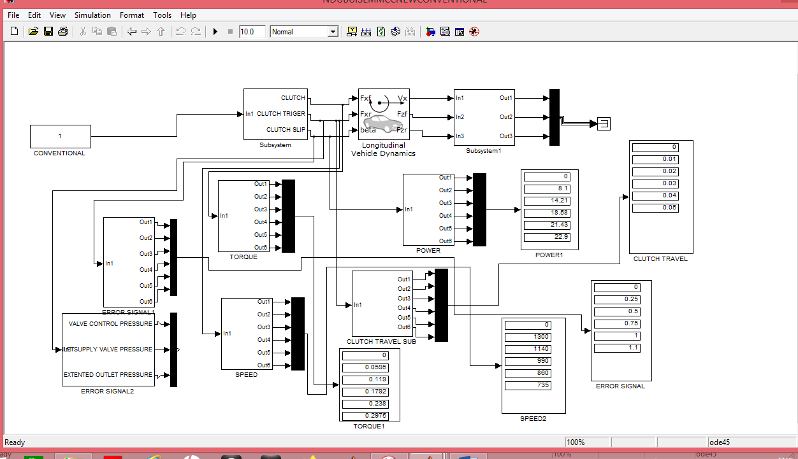
Fig. 1: Conventional Controller Simulink Model for electro-pneumatic clutch actuation.
The simulated output is presented in table 1.

2.2.2: Fuzzy Logic Controller design.
The details of the Fuzzy Logic design are presented in 6. Simulink model for Fuzzy Logic Controller was designed in a MATLAB 7.5 system. Longitudinal vehicle dynamics building blocks were connected in the design. Subsystem building blocks for error, angular speed, torque power and clutch travel parameters were connected. A conventional controller model block with its data input/output subsystem where relevant analytical data for error, power, torque, speed and clutch travel parameters were connected to the Fuzzy-Logic Simulink design. The design is shown in fig.2 below. The simulated output is presented in table 2.

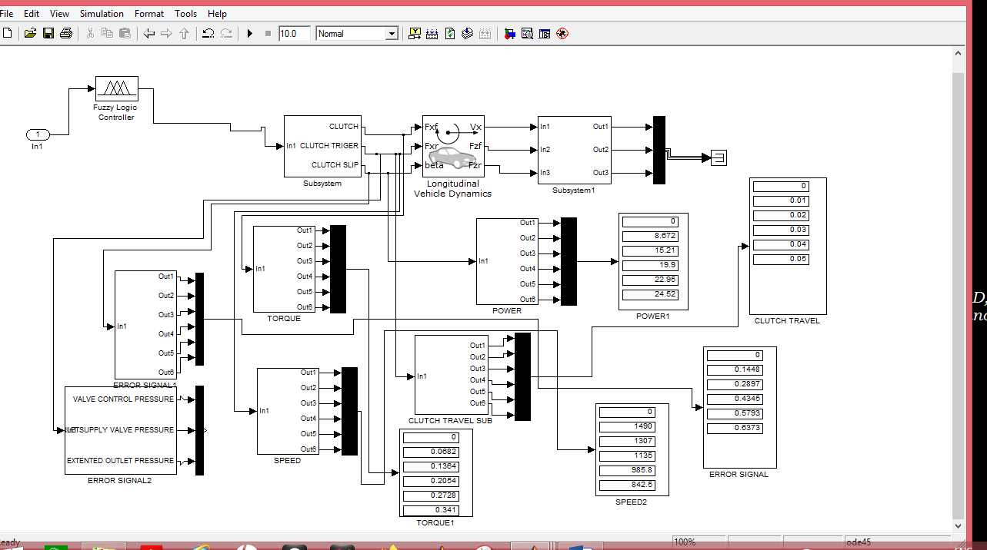
Fig. 2: Fuzzy Logic Controller Simulink model for electro-pneumatic clutch actuation.

2.2.3. ANN Controller design.
The details of the ANN design are presented in Ndubuisi et al (2024). Relevant design parameters were extracted and accommodated in the Simulink model for ANN controller design in a MATLAB 7.5 system. Longitudinal vehicle dynamics building blocks were connected in the design. Subsystem building blocks for error, power, torque, speed and clutch travel parameters were connected. A Conventional controller data input/output subsystem where relevant analytical data for error, power, torque, speed and clutch travel parameters were fed and read, was also connected as input to the ANN Simulink model. The design is shown in fig.3 while the simulated output is presented in table 3.

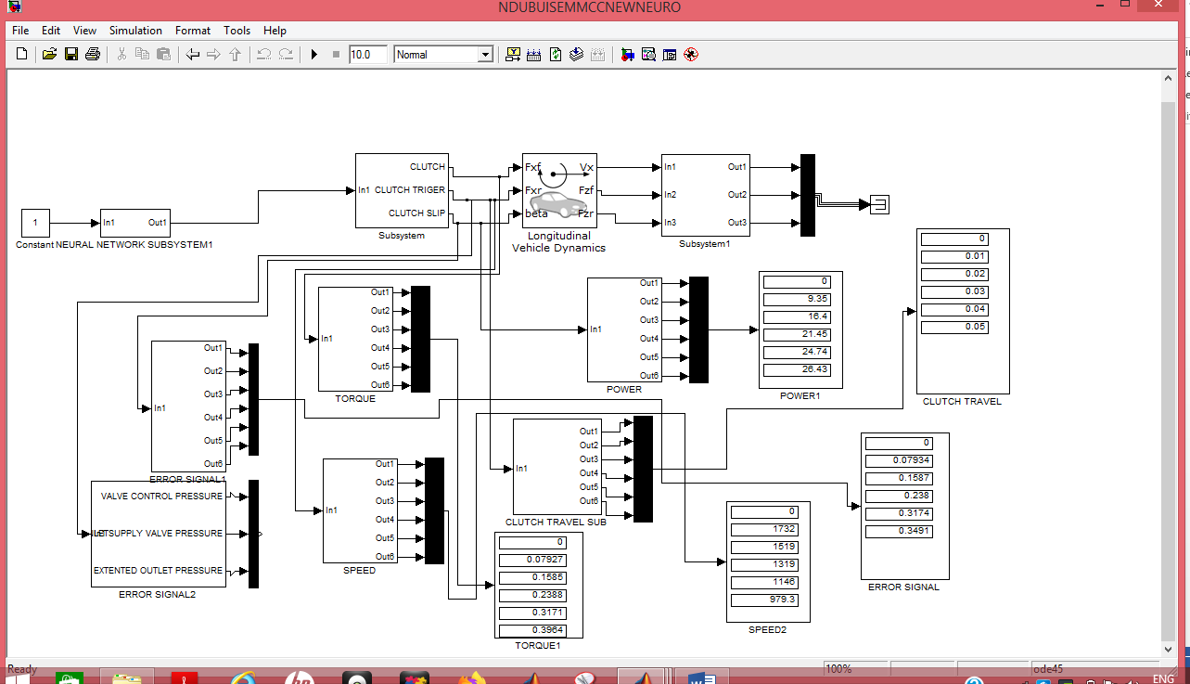
Fig. 3: ANN Controller Simulink Model for an electro-pneumatic clutch actuation system
2.2.4: Hybrid Neuro-Fuzz Controller design
The merging together of both the Fuzzy-Logic block and the ANN block in a Simulink platform yielded the Hybrid Neuro-Fuzzy system. It is an infusion or a combination of a normal fuzzy logic and neural network. This integrated system harnesses the combined advantages of both. Hence the learning capability advantage of the ANN and formation of linguistic rule base advantage of the fuzzy system are fused together. The details of the Hybrid Neuro-Fuzzy design are contained in 7. Relevant Fuzzy Logic and Neural Network design parameters were extracted and accommodated in the Simulink model for Hybrid Neuro-Fuzzy controller design in a MATLAB 7.5 system. Longitudinal vehicle dynamics building blocks were connected in the design. Subsystem building blocks for error, power, torque, speed and clutch travel parameters were connected. A Conventional controller data input/output subsystem where relevant analytical data for error, power, torque, speed and clutch travel parameters were fed and read, were also connected as input to the Fuzzy Logic and ANN block models. The Simulink design is shown in fig.4 whereas the simulated data is also presented in table 5.

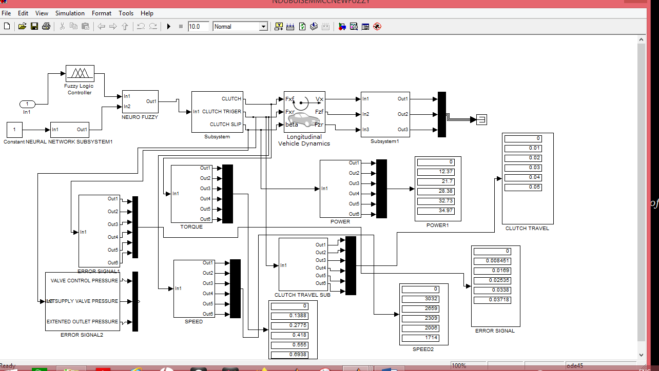
Fig. 4: Neuro-Fuzzy controller Simulink model for an improved electro-pneumatic clutch Actuation system.

3.0 Results and Discussions
The results obtained from the simulations of the designed Simulink for conventional controller, fuzzy logic controller, ANN controller and hybrid neuro-fuzzy controller are presented in the tables below.

3.1. Simulink Model Data for Conventional Controller
The result obtained from simulation of the designed Simulink model for the conventional controller is presented in table 1 below. The data is similar to the characterised data for error signal, angular speed, engine torque and power respectively obtained from empirical study of the Mercedes Benz Actros Truck model MP 2 that was used for the study.
Table 1: Conventional Controller Simulink model Data.

Clutch travel (M) | Error signal (mm) | Speed (RV/M) | Torque (NM) | Power (kw)
0 | 0 | ∞ | 0.0000 | 0.00
0.01 | 0.25 | 1300 | 0.0595 | 08.10
0.02 | 0.50 | 1140 | 0.1190 | 14.21
0.03 | 0.75 | 990 | 0.1792 | 18.58
0.04 | 1.00 | 860 | 0.2380 | 21.43
0.05 | 1.10 | 735 | 0.2975 | 22.09

3.2 Simulink model Data for Fuzzy Logic controller

The data obtained from simulation of the designed Simulink model for fuzzy logic controller is presented in table 2.
Table 2: Fuzzy Logic controller Simulink model Data
Clutch travel (M) | Error signal (mm) | Speed (RV/M) | Torque (NM) | Power (kw)
0 | 0 | ∞ | 0.0000 | 0.00
0.01 | 0.1448 | 1490 | 0.0682 | 08.67
0.02 | 0.2897 | 1307 | 0.1364 | 15.21
0.03 | 0.4345 | 1135 | 0.2054 | 19.90
0.04 | 0.5793 | 985.8 | 0.2728 | 22.95
0.05 | 0.6373 | 842.5 | 0.3410 | 24.52

3.3 Simulink model Data for Artificial Neural Network (ANN) controller
The result of simulation of the Simulink model for ANN controller is presented in table 3.
Table 3: Artificial Neural Network (ANN) controller Simulink model Data

Clutch travel (M) | Error signal (mm) | Speed (RV/M) | Torque (NM) | Power (kw)
0 | 0 | ∞ | 0.0000 | 0.00
0.01 | 0.0793 | 1732 | 0.0792 | 09.35
0.02 | 0.1587 | 1519 | 0.1585 | 16.40
0.03 | 0.2380 | 1319 | 0.2378 | 21.45
0.04 | 0.3174 | 1146 | 0.3171 | 24.74
0.05 | 0.3964 | 979.3 | 0.3964 | 26.43

3.4 Simulink model Data for Hybrid Neuro-Fuzzy Controller
The presentation of the simulated data obtained from the designed Simulink model for Hybrid Neuro-Fuzzy controller is shown in table 4.
Table 4: Hybrid Neuro-Fuzzy Controller Simulink model Data
Clutch travel (M) | Error signal (mm) | Speed (RV/M) | Torque (NM) | Power (kw)
0 | 0 | ∞ | 0.0000 | 0.00
0.01 | 0.0085 | 3032 | 0.1388 | 12.37
0.02 | 0.0169 | 2659 | 0.2775 | 21.70
0.03 | 0.0254 | 2309 | 0.4180 | 28.38
0.04 | 0.0338 | 2006 | 0.5550 | 32.73
0.05 | 0.0372 | 1714 | 0.6938 | 34.97

The data collated from conventional controller and intelligent agent-based controllers for error signal, engine angular speed, torque and power are tabulated, plotted and illustrated with bar charts for comparative analysis.
3.5 Comparison of error signal in electro-pneumatic clutch actuation control system.

The analysis of error signal in piston positioning as the piston transverses the actuator chamber during clutch actuation for conventional controller and intelligent agent-based controllers are recorded in table 5. The table is used to plot the graph in fig. 5(a). Bar chart of fig. 5(b) is used to further elucidate the percentage average differences with 100 % as refence point for conventional controller. In the graph and bar chart, the conventional controller error signal is indicated with a red plot, the fuzzy Logic controller error signal with yellow plot, the ANN controller error signal with blue plot while the Neuro-Fuzzy controller error signal is shown in green plot respectively.
Table 5: Comparing error signals in electro-pneumatic clutch actuation control system
Clutch travel (M)/ Error Analysis | Conventional error (mm) | Fuzzy error (mm) | ANN error (mm) | Neuro-Fuzzy error (mm)
0 | 0 | 0 | 0 | 0
0.01 | 0.25 | 0.1448 | 0.0793 | 0.0085
0.02 | 0.50 | 0.2897 | 0.1587 | 0.0169
0.03 | 0.75 | 0.4345 | 0.2380 | 0.0254
0.04 | 1.00 | 0.5793 | 0.3174 | 0.0338
0.05 | 1.10 | 0.6373 | 0.3964 | 0.0372
Average | 0.72 | 0.4171 | 0.2379 | 0.0244
% diff. / base 100 | 100 | 57.93 | 33.04 | 3.39
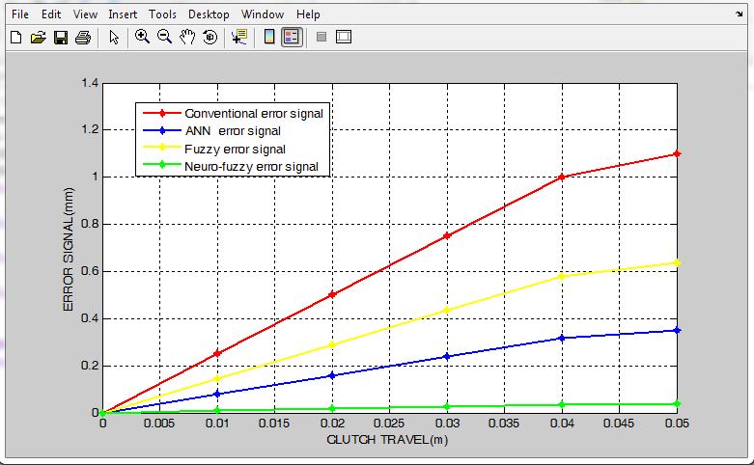
(a) Graph (b) Bar Chart Fig. 5: Conventional and Intelligent agent-based controller compared for error signal.

The table and figures above show the different error signals for the conventional controller of an average of 0.72mm or 100%, fuzzy Logic controller showed that error is reduced to an average of 0.4171mm or 57.93%. It is further reduced to 0.2379mm or33.04 % in ANN controller and 0.0244mm or 3.39% in Neuro-Fuzzy controller scheme. This shows that the Neuro-fuzzy scheme had the least error signal when used in the control of electro-pneumatic clutch actuation system and is dynamic enough to sustain weakening clutch load.
3.6 Comparison of Engine Angular Speed in Electro-Pneumatic Clutch Actuation Control
Using the data in table 6, the graph and bar chart of Fig. 6(a) and 6(b) were plotted. Similarly, the conventional controller angular speed is presented with a red plot, the fuzzy Logic controller angular speed with yellow plot, the ANN controller angular speed with blue plot while the Neuro-Fuzzy controller angular speed is in green plot in both the graph and bar chart respectively.
Table 6: Comparing engine angular speed in electro-pneumatic clutch actuation control

Clutch travel (M)/ Speed Analysis | Conventional Speed (RPM) | Fuzzy speed (RPM) | ANN speed (RPM) | Neuro-Fuzzy speed (RPM)
0.00 | ∞ | ∞ | ∞ | ∞
0.01 | 1300 | 1490 | 1732 | 3032
0.02 | 1140 | 1307 | 1519 | 2659
0.03 | 990 | 1135 | 1319 | 2309
0.04 | 860 | 985.8 | 1146 | 2006
0.05 | 735 | 842.5 | 979.3 | 1714
Average | 1005 | 1152.1 | 1339.1 | 2344
% diff. / base 100 | 100 | 114.64 | 133.24 | 233.23

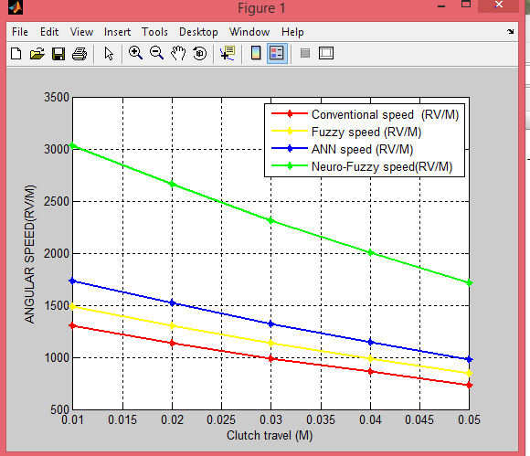
(a) Graph (b) Bar Chart
Fig. 6: Conventional and Intelligent agent-based controller compared for Angular Speed.

Similarly, the average engine angular revolution per minute or engine speed during clutch actuation is also affected. The degree of the effect for conventional controller and intelligent agent-based controllers are analysed as shown above in table 6 and figures 6(a) and 6(b). The comparison shows that the average conventional speed stood at1005RPM or a reference point of 100%, while fuzzy speed resulted in 1152.1 RPM or an increase of 14.64% above the referenced mark. 1339.1 RPM or 33.4% increase above the referenced point was realised by ANN controller while the highest increase was recorded by Neuro-Fuzzy controller with an average speed of 2344 RPM amounting to 133.23 increase over the datum in an electro-pneumatic clutch actuation control system. As shown in the linear portion of the graph of Figure 6, the Neuro-fuzzy scheme has the best speed even though other intelligent agent-based controller have better speeds than that achieved with the conventionally controlled actuation.
3.7 Comparison of engine torque in electro-pneumatic clutch actuation control system.
The engine torque is also involved during clutch actuation. The outputs for conventional controller and intelligent agent-based controllers are compared in table 7 and figures 7(a) and 7(b) below. The data presented in the graph and bar chart of figure 7 compares conventional torque, fuzzy torque, ANN torque and Neuro-fuzzy torque in an electro-pneumatic clutch actuation control system.
Table 7: Comparing engine torque in electro-pneumatic clutch actuation control system.
Clutch travel (M) /Torque Analysis | Conventional torque (NM) | Fuzzy torque (NM) | ANN torque (NM) | Neuro-Fuzzy torque (NM)
0.00 | 0.0000 | 0.0000 | 0.0000 | 0.0000
0.01 | 0.0595 | 0.0682 | 0.0792 | 0.1388
0.02 | 0.1190 | 0.1364 | 0.1585 | 0.2775
0.03 | 0.1792 | 0.2054 | 0.2388 | 0.4180
0.04 | 0.2380 | 0.2728 | 0.3171 | 0.5550
0.05 | 0.2975 | 0.3410 | 0.3964 | 0.6938
Average | 0.1786 | 0.2048 | 0.2380 | 0.4166
% diff. / base 100 | 100 | 114.67 | 133.26 | 233.26
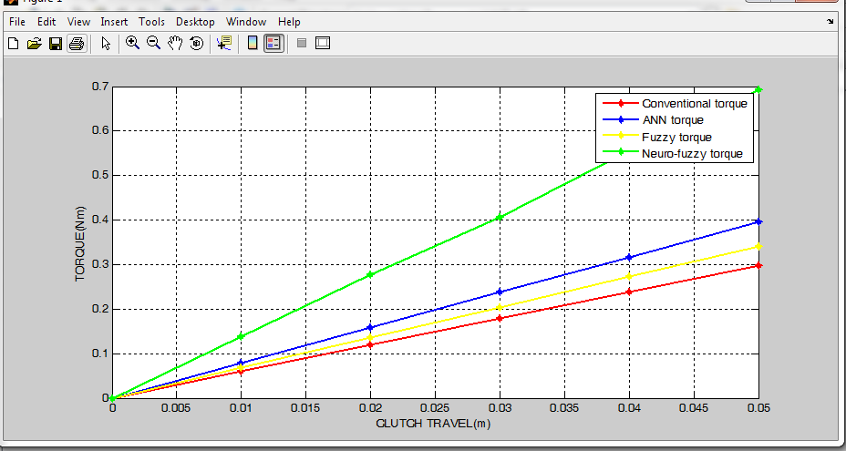
(a) Graph (b) Bar Chart
Fig. 7: Conventional and Intelligent agent-based controller compared for Torque.
The preference of Neuro-fuzzy scheme over the others persists. 0.1786 NM was the average torque recorded with conventional controller or 100% reference illustrated in the bar chart. The intelligent agent-based controllers recorded various levels of improvement over the conventional controllers as indicated in the figure under reference with fuzzy logic system producing an average of 0.2048 NM or 14. 67% increase. The ANN and Neuro-Fuzzy controllers yielded averages of 0. 2380 NM and 0. 4166 NM which translates to 33.26% and 133.26% increases respectively. With improved torque, effective compression is assured.
3.8 Comparing engine power in electro-pneumatic clutch actuation control system.
Table 8 and figures 8 (a) and 8 (b) below presents the data and its analysis. The result shown in the graph and percentages presented in the bar chart, evidently justifies intelligent agent-based controllers as having better power values over the conventional actuator control. The comparison shows that the average conventional power stood at 16.88 kw or a reference point of 100%, while fuzzy power resulted in 18.15 kw or an increase of 8. 12% above the referenced mark. 19.67kw or 16.57% increase above the referenced point was realised by ANN controller while the highest increase was recorded by Neuro-Fuzzy controller with an average power of 26.03kw amounting to 54.21% increase over the datum in an electro-pneumatic clutch actuation control system.
Table 8: Comparing engine power in electro-pneumatic clutch actuation control system.

Clutch travel (M) /Power Analysis | Conventional power (kw) | Fuzzy power (kw) | ANN power(kw) | Neuro-Fuzzy power(kw)
0.00 | 0.00 | 0.00 | 0.00 | 0.00
0.01 | 08.10 | 08.67 | 09.35 | 12.37
0.02 | 14.21 | 15.21 | 16.40 | 21.70
0.03 | 18.58 | 19.90 | 21.45 | 28.38
0.04 | 21.43 | 22.95 | 24.74 | 32.73
0.05 | 22.09 | 24.52 | 26.43 | 34.97
Average | 16.88 | 18.15 | 19.67 | 26.03
% diff. / base 100 | 100 | 108.12 | 116.53 | 154.21
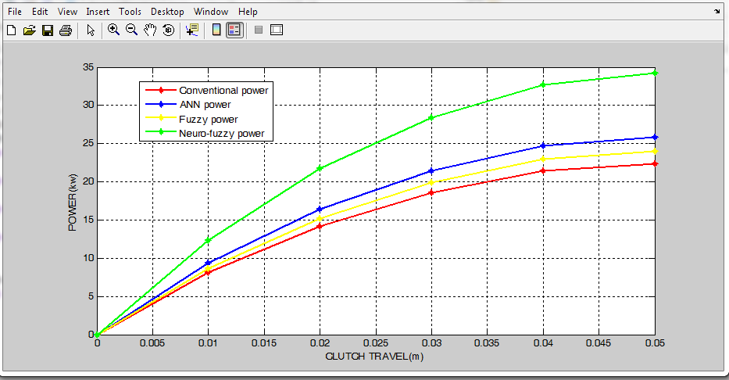
(a) Graph (b) Bar Chart
Fig. 8: Conventional and Intelligent agent-based controller compared for Power.

4.0 Conclusion
The different percentages of improvement recorded in the various categories of the intelligent agent-based controllers show clear improvements over the conventional controller. The mean improvement on conventional controllers were remarkable. Even among the intelligent agent-based controllers, there are distinctions. The neuro-fuzzy improved controllers stood at an error reduction in clutch travel from 0.720mm to 0.0244mm given a decrease of 96.6% or error reduction to a level of only 3.39 %. The speed increased from 1005 RPM to 2344 RPM or an increase of 133.23%. The torque was increased from 0.1786 NM to 0.4166 NM or 133.26%. Similarly, power increased from 16.88 kilowatts to 26.03 kw or 54.21% increase. The fuzzy and ANN controllers also recorded some lesser degrees of improvements. ANN improved by 33.04 % decrease for error, increases of 33 % for angular speed, 33.26 % for torque and 16.53 % for power respectively. The fuzzy logic produced 58 % reduction for error, 14.6%, 14.67% and 8.12 % increases for angular speed, torque and power respectively. From these results, one can conclude that the performances of the controllers are ranked from Hybrid Neuro-Fuzzy controller, ANN controller, Fuzzy controller and lastly the conventional controllers. Thus, the operation of heavy-duty vehicles imbibing the three intelligent agent-based controllers in clutch actuation technology will experience improved clutch engagements and disengagement operation with comparative ease and comfort as calibration challenges are progressively and completely eliminated in comparative terms.

COMPETING INTERESTS DISCLAIMER:
Authors have declared that they have no known competing financial interests OR non-financial interests OR personal relationships that could have appeared to influence the work reported in this paper.

Disclaimer (Artificial intelligence)
Option 1:
Author(s) hereby declare that NO generative AI technologies such as Large Language Models (ChatGPT, COPILOT, etc.) and text-to-image generators have been used during the writing or editing of this manuscript.
Option 2:
Author(s) hereby declare that generative AI technologies such as Large Language Models, etc. have been used during the writing or editing of manuscripts. This explanation will include the name, version, model, and source of the generative AI technology and as well as all input prompts provided to the generative AI technology
Details of the AI usage are given below:
1.
2.
3.

5.0 References.
- Calibrating the Clutch Actuator (2019): Sachs Workshop Tip: Calibrating ConAct, the Pneumatic Clutch Actuation System, ZF Vision Magazine. Retrieved from. https://aftermarket.zf.com/go/en/sachs/technology-in-practice/workshop-tips/clutch-s
- Carlos, G. (2016). What is the Difference between Pneumatic, Hydraulic and Electrical Actuators, Machine Design.com.Powered by Penton, Retrieved from https://www.htlgroup.com/general/the-difference-between-pneumatic-hydraulic-and-electrical
- Clutch Problems, Trouble Shooting and Service (2019): The Good heart-Willcox co.Inc. Retrieved from https://docplayer.net/2728280-Clutch-problems-troubleshooting-and-service.html
- Li-kun Y, He-yan L, Mehdi A and Biao M (2015): Analysis of the influence of engine torque excitation on clutch judder, Journal of Vibration and Control 1–11, sagepub.co.uk/journals DOI: 10.1177/1077546315582291, jvc.sagepub.com, https://www.researchgate.net/publication/281316562
- Ndubuisi, P.D.I., Mbabuike I.U., Isaac R. O., Agwo, J. N. and Arua J. E. (2023): Physiological Characterisation of Electropneumatic Clutch Actuation System for Heavy Duty Vehicles, World Journal of Engineering Research and Technology WJERT www.wjert.org wjert, 2023, Vol. 9, Issue 5,pp 09-21. SJIF Impact Factor: 5.924, April.

- Ndubuisi, P.D.I, Nwoke, O. N and Arua, J. E (2023): Fuzzy Logic Improved Control Design for Electro-Pneumatic Clutch Actuation System in Heavy Duty Vehicles, International Journal of Innovations in Engineering and Science ,Innovative Research for Development. Website:www.ijiesonline.org e-ISSN: 12616–1052, Volume 2, Issue 1, pp78 – 90, |October, 2023.
- Ndubuisi, P.D.I, Nwoke, O. N Arua, J. E and Elujoba, O. I (2024): Improving the electro-pneumatic clutch actuation control system of a heavy-duty vehicles using artificial neural network,GSC Advanced Research and Reviews, Volume 19 issue3, pp018–030, DOI:https://doi.org/10.30574/gscarr.2024.19.3.0175, June
- Ndubuisi, P.D.I, Nwoke O. N., Arua J. E., Babalola A. D., Anunwa, A. A., Bassey, A. K. . and Igwe L. U. (2024): Hybrid Neuro-Fuzzy Based Improved Control Design of Electro-Pneumatic Clutch Actuation Control System for Heavy Duty Vehicles, Journal of Engineering Research and Reports Volume 26, Issue 10, PP 199-216, Article no.JERR.124244 ISSN: 2582-2926, DOI: https://doi.org/10.9734/jerr/2024/v26i101299, October
- Nice, K. and Bryant, C. W. (2019): How Clutches Work. Howsffsworks Auto. Retrieved from https://www.howstuffwork.com/clutch 2.htm
- Overview of all Workshop Tips on Clutches and Repairs Tips for clutch Systems (2019): Workshop Tips on Clutch from ZF Aftermarket, Sachs Technology. Retrieved from https://aftermarket.zf.com/go/en/sachs/technology-in-practice/workshop-tips/clutch-system
- Samson A. G. (2019): Control Valve Accessories, Electro-pneumatic positioner. Samson Controls, Samson Product Group, Texas, USA. Retrieved from https://www.samsongroup.com/document/k00200en.pd

- Irawan, A., Sulaiman, M. H., Ramli, M. S., & Azahar, M. I. P. (2024). Pneumatic servo position control optimization using adaptive-domain prescribed performance control with evolutionary mating algorithm. Results in Control and Optimization, 15, 100434.

- Huang, W., Ahmadian, M., Rahimi, A., & Steiginga, L. (2023). Dynamics performance of long combination vehicles with active control systems. Vehicle system dynamics, 61(7), 1831-1880.

- Irawan, A., Sulaiman, M. H., Ramli, M. S., & Azahar, M. I. P. Results in Control and Optimization.

- Bell, D. (2023). Evaluation of a Pneumatic Cylinder for Ankle Exoskeleton Actuation (Master's thesis).

- Bell, D. S. (2023). Evaluation of a Pneumatic Cylinder for Actuation of an Ankle Exoskeleton (Master's thesis, Auburn University).

- Altenburg, S., Bause, K., & Albers, A. (2022, March). Validation Environment for Deep Reinforcement Learning Based Gear Shift Controllers. In 22. Internationales Stuttgarter Symposium: Automobil-und Motorentechnik (pp. 354-368). Wiesbaden: Springer Fachmedien Wiesbaden.

- Yin, S., Yao, D. R., Song, Y., Heng, W., Ma, X., Han, H., & Gao, W. (2024). Wearable and Implantable Soft Robots. Chemical Reviews, 124(20), 11585-11636.

- PO, P., & PO, P. P. REGULATIONS–2015 CHOICE BASED CREDIT SYSTEM BE MECHANICAL ENGINEERING.

- Jiang, J., Zeng, Y., Yu, X., Wu, D., & Guo, Y. (2021). Hopping Robot: Current Status and Future Perspectives. Recent Patents on Mechanical Engineering, 14(4), 440-455.

- Brandstetter, R., Deubel, T., Scheidl, R., Winkler, B., & Zeman, K. (2017). Digital hydraulics and “Industrie 4.0”. Proceedings of the Institution of Mechanical Engineers, Part I: Journal of Systems and Control Engineering, 231(2), 82-93.

- Chao, C. T., Sutarna, N., Chiou, J. S., & Wang, C. J. (2019). An optimal fuzzy PID controller design based on conventional PID control and nonlinear factors. Applied Sciences, 9(6), 1224.

- Uma, J., & Jeevanandham, A. (2016). Conventional controller design for switched reluctance motor drives. International Journal of Computer Applications, 134(7), 38-42.

- Nigerian Annual Report of the Federal Road Safety Corps, 2011

