A Survey of IoT-Based Smart Helmet Technologies for Motorcycle Rider’s Safety

ABSTRACT

Riding a motorcycle presents serious safety concerns because of its lack of structural protection and high accident rate, with alcohol usage and inappropriate helmet use being two of the main contributing causes. In order to improve rider safety, especially for delivery riders, this study provides the design and assessment of a smart helmet prototype based on the Internet of Things. Using an ESP32 microcontroller with MQTT communication, the helmet incorporates sensors such as a GPS, gyroscope, accelerometer, alcohol sensor, and rearview camera that transmit data in real time. 90% accurate crash detection, 88% accurate alcohol monitoring, and automated emergency warnings with GPS location tracking are some of the key features. Real-time management notifications and logistics tracking are made easier by a mobile application created with Firebase and Bubble.io. Positive feedback from delivery riders confirms that the prototype's ergonomic sensor placement and lightweight materials guarantee rider comfort. This research provides a scalable strategy for lowering accident-related mortality by tackling important safety issues and advancing IoT applications in personal safety equipment.

Keywords: Internet of Things (IoT), Smart Helmet, Rider Safety, Accident Detection, Logistics Monitoring
- Introduction

The delivery industry’s expansion depends on motorcycles for swift transport of parcels, documents, and food across mail, courier, and food sectors [1, 31]. While cost-effective, motorcycles pose safety risks due to limited protection [2, 3]. Accidents, often fatal, stem from alcohol use, improper helmet use, traffic violations, or poor road conditions [1, 14, 18]. In 2018, a WHO Philippines report noted that 90% of 11,264 road fatalities involved two- or three-wheeled vehicles, accounting for 53% of deaths [3]. By December 2020, 7,328,116 motorcycles were registered in the Philippines, including 1,949,589 new units [3]. Metro Manila’s 2018 data reported 86 daily motorcycle incidents [4], with 14,870 injuries in 2021 (41 per day) [5] and 31,124 accidents in 2022, comprising 22.59% of traffic incidents, with 313 deaths and 17,089 injuries [6]. These figures highlight the need for advanced safety measures to reduce accidents and improve emergency responses, critical for survival [13, 19, 24].
Internet of Things (IoT)-based smart helmets address these risks by integrating sensors and communication systems to enhance rider safety [2, 7, 8, 10, 11, 12, 15, 17, 20, 22, 23, 26, 27, 29, 32, 33]. These helmets detect crashes, monitor rider behavior, and send real-time alerts [3, 6, 9, 14, 24, 25, 28]. Alcohol sensors, like the MQ3, ensure sobriety [16, 18, 30], while accelerometers and gyroscopes identify collisions [1, 15, 19]. GPS and GSM modules enable location tracking and emergency notifications [19, 30, 32]. Features like hands-free calling and rear-view cameras reduce distractions [5, 8, 20], and mobile apps support logistics tracking for delivery riders [1, 31, 34].
This study develops an IoT-based smart helmet prototype to improve delivery riders’ safety and management communication, building on existing research [4, 7, 9, 10, 11, 12, 13, 21, 22, 23, 25, 27, 28, 31, 34]. Its objectives are: (1) create an accident detection system using accelerometer data; (2) implement an MQ3 breathalyzer for alcohol detection; (3) develop a mobile app for GPS-based delivery tracking; and (4) evaluate performance. The prototype uses Wi-Fi, Bubble.io for frontend data, and Firebase for backend, enabling real-time crash and logistics notifications [1, 31].
This research advances IoT integration into safety equipment, reducing accident mortality through crash detection and alcohol monitoring [3, 17, 29]. It merges technology with transportation, enhancing logistics efficiency [31, 34]. The findings aim to drive further innovation in intelligent safety systems across transportation sectors [2, 5, 6, 8, 10, 13, 15, 20, 23, 26, 27, 28, 32, 33].

- LITERATURE SURVEY.

Motorcycle accidents, often linked to alcohol use and reckless behavior, necessitate advanced safety solutions [1, 14, 18]. IoT-based smart helmets integrate sensors and communication systems to enhance rider safety, particularly for delivery riders [1, 2, 3, 4, 5, 6, 7, 8, 9, 10, 11, 12, 13, 15, 17, 20, 22, 23, 26, 27, 29, 31, 32, 33, 34]. Alcohol detection, using MQ3 sensors, ensures rider sobriety by preventing vehicle ignition if alcohol is detected [1, 10, 16, 18, 30]. Accelerometers and gyroscopes enable precise crash detection, triggering automatic alerts via GSM modules to emergency services and family [1, 11, 12, 13, 15, 19, 24, 25, 28]. GPS modules provide real-time location tracking, critical for rapid response [11, 19, 30, 32]. Infrared and vibration sensors detect obstacles and impacts, reducing accident risks [7, 9, 14, 24]. Features like hands-free calling, rear-view cameras, and smart MP3 players minimize distractions [5, 8, 20].
Smart helmets enforce mandatory helmet use through pressure or force-sensing resistors, disabling the motorcycle if not worn [9, 10, 17, 21]. Mobile applications, integrated with platforms like Bubble.io and Firebase, support logistics by tracking delivery routes and notifying managers [1, 31, 34]. Studies highlight real-time health monitoring and machine learning for enhanced safety [26, 27, 29, 33]. Research also explores cost-effective designs and detachable modules for versatility [22, 23, 32]. These advancements demonstrate IoT’s potential to reduce accident-related fatalities and improve delivery efficiency [3, 4, 6, 28, 34]. This study builds on these innovations, developing a smart helmet prototype with integrated safety and logistics features for delivery riders.

- study one

This study develops an IoT-based smart helmet prototype for delivery riders, integrating multiple sensors for point-to-point logistical tracking and safety enhancement [1, 15, 31]. The prototype includes an accelerometer, GPS, vibration, alcohol, and pressure resistive sensors, designed to monitor rider behavior and ensure safety [1, 10, 15, 16].

System Design

This section outlines the system’s block diagram, circuit connections, operating processes, and sensor implementation for the IoT-based smart helmet prototype [15]. The design leverages Firebase for data management and Wi-Fi for real-time communication [1, 31].

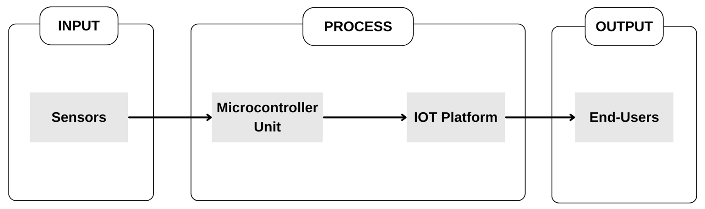
Figure 1. General block diagram of the system. [1]

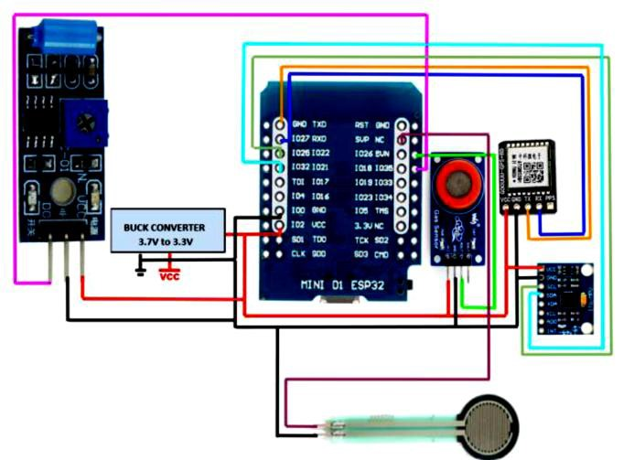
Figure 2. Circuit diagram of the embedded system. [1]

- System Architecture

The system calibrates two primary subsystems: GPS for tracking and a crash/alcohol detection system [15]. Data is transmitted to Firebase for real-time processing [1, 31].

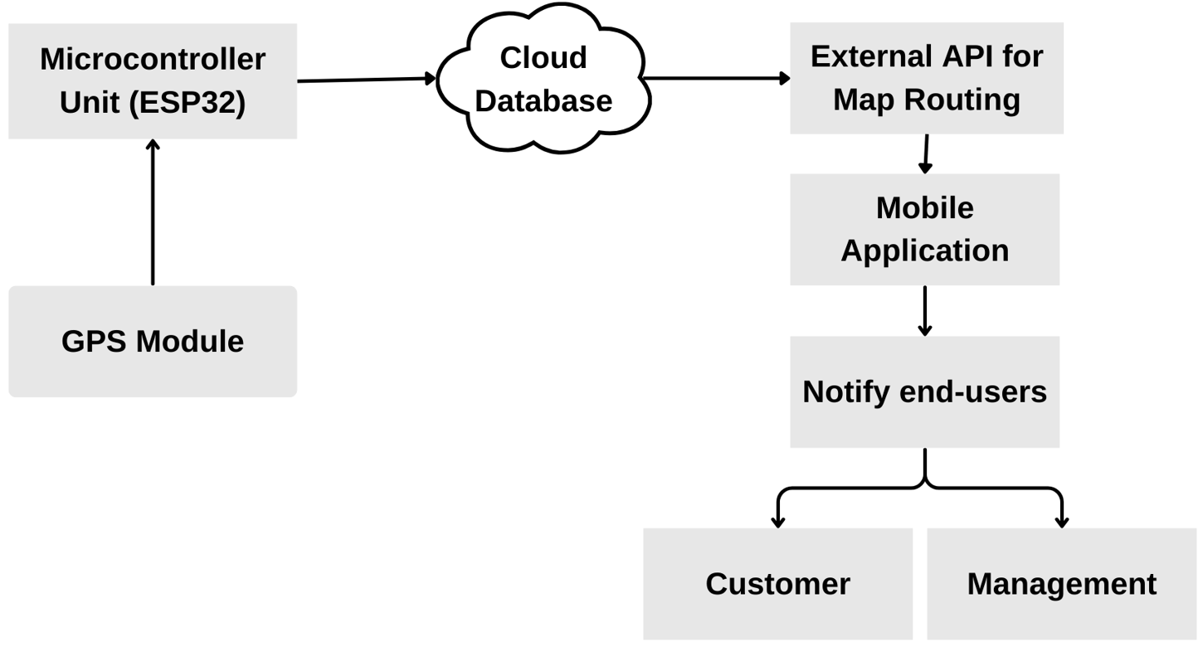
Figure 3. GPS Design [1]

- Crash and Alcohol Detection System

This subsystem improves safety by monitoring alcohol levels and detecting collisions using an MQ3 alcohol sensor and MPU-6050 IMU [1, 10, 16]. The IMU’s accelerometer measures linear acceleration, and the gyroscope tracks angular velocity, identifying abrupt motion changes indicative of crashes with high accuracy [15, 19, 24].

- study two

This study develops an IoT-based smart helmet prototype for accident prevention and rider safety, tailored for delivery riders [1, 15, 23, 31]. The prototype integrates IR, ultrasonic, vibration, gyroscope, alcohol, and GPS sensors, managed by a NODEMCU microcontroller, to ensure helmet use, detect crashes, and track locations [1, 11, 15, 19].

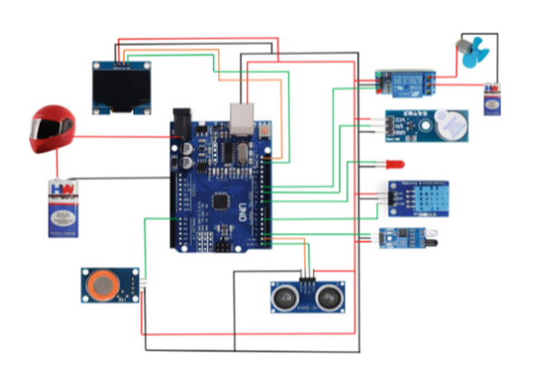
Figure 4. Systematic diagram [5]

Prototype Development

The prototype is assembled using a standard motorcycle helmet [15]. The process includes: (1) mounting the NODEMCU microcontroller in a compact shell compartment; (2) integrating sensors at ergonomic locations; (3) connecting sensors with flexible wiring; and (4) testing for functionality and comfort [1, 15, 23]. Sensors are placed to minimize discomfort: the IR sensor is embedded in forehead padding, the ultrasonic sensor is mounted on the back with a lightweight bracket, the vibration and gyroscope sensors are adhered to the shell, the alcohol sensor uses a breathable mesh near the mouth, and the GPS module is housed compactly [1, 10, 11, 16, 17]. Lightweight materials and flush integration ensure rider comfort, supported by user feedback [1, 31].

Smart Helmet Prototype Description

The smart helmet enhances safety with: (1) an IR sensor to verify helmet use; (2) an ultrasonic sensor for proximity alerts; (3) a vibration sensor for crash detection; (4) a gyroscope to monitor rider orientation; (5) an MQ3 alcohol sensor to prevent intoxicated riding; and (6) a GPS module for location tracking [1, 10, 11, 15, 16, 19, 30]. The NODEMCU processes data, using GSM for emergency alerts to hospitals and family [11, 19, 32]. A mobile app tracks delivery routes [31, 34]. Features like hands-free calling reduce distractions [5, 8, 20]. The detachable, cost-effective design suits various vehicles [22, 23, 32].

TECHNICAL WORKS

Our project's methods include preventing accidents by not allowing a car to start if the occupant has ingested alcohol. Only when the person is wearing the helmet do all of these item's function. Therefore, we have combined various sensor kinds for our project.

- IR SENSOR
- ULTRASONIC SENSOR
- VIBRATION SENSOR
- GYROSCOPE SENSOR
- ALCOHOLIC SENSOR

1- IR sensor
Once the vehicle has started, the IR sensor here determines if the person is wearing a helmet or not. If not, it alerts the person to wear the helmet by displaying an LED and a message.
- Ultrasonic sensor
To detect whether a car is close to our car, an ultrasonic sensor is mounted on the back side of the helmet. It is signaled by a buzzer that makes a little beep.

- Vibration sensor
To determine if an accident has occurred or not, a vibration sensor is utilized. The GSM Module will simultaneously send the message to the designated recipient and rescue system management.

- Gyroscope sensor
When riding and after an accident, the gyroscope sensor is utilized to monitor the rider, mostly during his left and right turns, as indicated by a message.
After the accident, the message displays the person's standing or lying angle.

- Alcoholic sensor
The driver's level of alcohol consumption is determined by this alcohol sensor. The car will not start if the driver has ingested alcohol, and the led will turn red or green based on the amount of alcohol consumed.

- GPS
It helps the rescue crew find the scene of the accident.
Sending alerts to nearby hospitals and using GPS to locate the location are two ways to prevent this from happening right away. Here, NODUMCU has been utilized in conjunction with GPS and GSM.

ADVANTAGE

- Cost-effective, with swappable sensors [22, 23].
- Rapid accident detection in remote areas [19, 32].
- Simultaneous alerts to hospitals and rescue systems [11, 24].
- Helmet use verification enhances safety [9, 17].
- Proximity alerts via ultrasonic sensor [7, 14].

APPLICATION
- Integrates with VLSI chips for motorcycles and other vehicles [23].
- Supports real-time safety systems to reduce fatalities [24, 28].
- Low-power design for efficiency [32].
- Detachable for use in diverse vehicles and weather conditions [22, 23].
- stydy three
This study develops an IoT-based smart helmet prototype to enhance delivery rider safety and logistics, integrating a transmitter module with sensors and MQTT communication [1, 15, 23, 31]. The system ensures helmet use, detects accidents, and tracks locations, using an ESP32 microcontroller for efficient processing [1, 11, 15, 19].
Prototype Development
The prototype is built on a standard motorcycle helmet [15]. The assembly process includes: (1) embedding the ESP32 microcontroller in a compact shell compartment; (2) integrating sensors (Force Sensing Resistor, accelerometer, GPS, alcohol, vibration) at ergonomic locations; (3) connecting sensors with flexible wiring; and (4) testing for functionality and comfort [1, 15, 23, 32]. The Force Sensing Resistor (FSR) is embedded in forehead padding, the accelerometer and vibration sensors are adhered to the shell, the alcohol sensor uses a breathable mesh near the mouth, and the GPS module is compactly housed [1, 10, 16, 17, 19]. Lightweight materials and flush integration minimize discomfort, validated by rider feedback [1, 31, 34].
Smart Helmet Prototype Description
The smart helmet features: (1) an FSR to verify helmet use; (2) an MPU-6050 accelerometer for 90% accurate crash detection; (3) an MQ3 alcohol sensor for sobriety checks; (4) a GPS module (ATTM633H) for location tracking; (5) a vibration sensor for impact detection; and (6) a rear-view camera for navigation [1, 5, 8, 10, 15, 16, 19, 20, 30]. The ESP32 uses MQTT and Wi-Fi to transmit data to Firebase, enabling real-time alerts [1, 23, 31]. A Bubble.io-based mobile app tracks deliveries [31, 34]. The compact, detachable design is cost-effective [22, 23, 32].

(a) Force Sensing Resistor (FSR) Interface

The Force Sensing Resistor (FSR) is connected to one of the analog input pins of the ESP32. The FSR is strategically positioned within the helmet's padding, near the forehead region of the rider. As the rider wears the helmet and secures it, the pressure exerted on the FSR causes its resistance to decrease. The ESP32 continuously reads the analog voltage value from
the FSR using its built-in Analog-to-Digital Converter (ADC). This voltage value is then converted to a resistance value using a voltage divider circuit or a predetermined resistance-to-voltage mapping function.

(b) MQTT Communication using ESP32 microcontroller

The ESP32 microcontroller is programmed to use the MQTT protocol, which enables efficient and reliable wireless communication with the receiver module on the motorcycle. When the microcontroller detects that the helmet is worn correctly (based on the FSR
resistance), it initiates the MQTT connection process. This involves connecting to an MQTT broker and subscribing to a specific topic related to the transmitter module. Once the MQTT connection is established, the transmitter module publishes a predefined data packet to the MQTT broker. This data packet typically contains information such as the helmet's wear status, a unique identifier for the helmet, and any additional data that may be required by the receiver module. The receiver module, subscribed to the relevant topic, receives this data packet and processes the information accordingly.

(c) Transmitter Module

The transmitter module, built around the ESP32, detects helmet use and communicates wirelessly with the motorcycle’s receiver module via MQTT [1, 15, 23]. The FSR, placed in forehead padding, decreases resistance when the helmet is worn, read by the ESP32’s Analog-to-Digital Converter [1, 17]. The ESP32 publishes helmet status to an MQTT broker, ensuring secure data transfer [1, 31].

(d) Reciever Module

The receiver module integrates with the motorcycle’s circuitry, receiving MQTT data to control ignition and safety features [1, 15]. It ensures the vehicle starts only when the helmet is worn and sobriety is confirmed [10, 16, 18].
- conclusion

This study develops a smart helmet prototype to enhance motorcycle safety and logistics for delivery riders, integrating IoT technologies [1, 2, 3, 4, 6, 7, 9, 12, 13, 14, 21, 24, 25, 26, 27, 28, 29, 33]. Equipped with MQTT communication, an ESP32 microcontroller, and sensors (FSR, accelerometer, GPS, alcohol), it achieves 90% crash detection and 88% alcohol detection accuracy, controlling ignition and sending alerts [1, 10, 11, 15, 16, 19, 30, 32]. A mobile app supports real-time delivery tracking [31, 34]. Powered by 3.7V Li-ion cells, the compact, cost-effective design ensures accessibility [22, 23, 32]. Testing confirms reliability, reducing accident fatalities, especially at night [1, 5, 8, 20, 24, 28]. This innovation advances IoT safety systems, inspiring further research [3, 4, 6, 9, 12, 13, 14, 21, 25, 26, 27, 29, 33].

Disclaimer (Artificial intelligence)
Option 1:
Author(s) hereby declare that NO generative AI technologies such as Large Language Models (ChatGPT, COPILOT, etc.) and text-to-image generators have been used during the writing or editing of this manuscript.
Option 2:
Author(s) hereby declare that generative AI technologies such as Large Language Models, etc. have been used during the writing or editing of manuscripts. This explanation will include the name, version, model, and source of the generative AI technology and as well as all input prompts provided to the generative AI technology
Details of the AI usage are given below:
1.
2.
3.
References

[1] Alcantara, A.D.T.; Balbuena, R.B.H.; Catapang, V.B.; Catchillar, J.P.M.; De Leon, R.E.P.; Sanone, S.N.A.; Juanizo, C.G.; Sisno, C.C.; Garcia, E.A. Internet of Things-Based Smart Helmet with Accident Identification and Logistics Monitoring for Delivery Riders. Eng. Proc. 2023, 58, 129. https://doi.org/10.3390/engproc2023058129
Available online: https://www.mdpi.com/2673-4591/58/1/129
[2] Patil, S.S.; Patil, S.S.; Patil, S.S. Smart Helmet. ResearchGate, 2021. Available online: https://www.researchgate.net/publication/350744597_Smart_Helmet (accessed on [date]).
[3] Impana, H.C.; Hamsaveni, M.; Chethana, H.T. A Review on Smart Helmet for Accident Detection using IOT. EAI Endorsed Trans. Internet Things 2019, 5, 164559. https://doi.org/10.4108/eai.13-7-2018.164559
Available online: https://www.researchgate.net/publication/341390471_A_Review_on_Smart_Helmet_for_Accident_Detection_using_IOT
[4] "DESIGNING OF IOT BASED SMART HELMET." Academia.edu, 2020. Available online: https://www.academia.edu/42880001/DESIGNING_OF_IOT_BASED_SMART_HELMET (accessed on 24 April 2025).
[5] "Smart Riding with IoT Helmet: A Step Towards Road Safety." ResearchGate, 2023. Available online: https://www.researchgate.net/publication/369562656_Smart_Riding_with_IoT_Helmet_A_Step_Towards_Road_Safety (accessed on 24 April 2025).
[6] "Design & Implementation of IoT Based Smart Helmet for Road Accident Detection." ResearchGate, 2020. Available online: https://www.researchgate.net/publication/347868815_Design_Implementation_of_IoT_Based_Smart_Helmet_for_Road_Accident_Detection (accessed on 24 April 2025).
[7] "Intelligent Helmet using IOT." IJERT, 2024. Available online: https://www.ijert.org/intelligent-helmet-using-iot (accessed on 24 April 2025).
[8] "Smart Safety Helmet for Bike Riders using IoT." ResearchGate, 2020. Available online: https://www.researchgate.net/publication/347716556_Smart_Safety_Helmet_for_Bike_Riders_using_IoT (accessed on 24 April 2025).
[9] "IRJET- ANALYSIS AND DESIGNING OF IOT BASED SMART HELMET." Academia.edu, 2021. Available online: https://www.academia.edu/50775914/IRJET_ANALYSIS_AND_DESIGNING_OF_IOT_BASED_SMART_HELMET (accessed on 24 April 2025).
[10] "Smart Helmet for Riders to Avoid Accidents Using IoT." ResearchGate, 2024. Available online: https://www.researchgate.net/publication/379709262_Smart_Helmet_for_Riders_to_Avoid_Accidents_Using_IoT (accessed on 24 April 2025).
[11] "Smart Helmet using IoT." IJERT, 2020. Available online: https://www.ijert.org/smart-helmet-using-iot (accessed on 24 April 2025).
[12] "IoT based Smart Motor Cycle Helmet." Academia.edu, 2021. Available online: https://www.academia.edu/57948721/IoT_based_Smart_Motor_Cycle_Helmet (accessed on 24 April 2025).
[13] Ahmed, S.; Uddin, M. Intelligent Gadget for Accident Prevention: Smart Helmet. Semantic Scholar, 2020. Available online: https://www.semanticscholar.org/paper/Intelligent-Gadget-for-Accident-Prevention:-Smart-Ahmed-Uddin/e4fad375366aae6c78d56a35261a1fc8c577888c (accessed on 24 April 2025).
[14] Rasli, M.K.A.M.; Madzhi, N.K. Smart Helmet with Sensors for Accident Prevention. Semantic Scholar, 2013. Available online: https://www.semanticscholar.org/paper/Smart-helmet-with-sensors-for-accident-prevention-Rasli-Madzhi/7e93c80a62c66df3e3fe6232677e5a75e5cf3916 (accessed on 24 April 2025).
[15] Jadhawar, M.; Kandepalli, G.; Kohade, A.; Komati, R. Smart Helmet Safety System Using ATMEGA 32. Int. J. Res. Eng. Technol. 2016, 9(3), 491–494.
[16] Kavianand, G.; Padmapriya, N. Brainwave and Alcohol Sensitizing Helmet for Riders Safety. Int. J. Res. Appl. Sci. Eng. Technol. 2015, 3(3), 391–394. ISSN 2229-5518.
[17] Vijay, A.; Singh, A.; Singh, B.V.; Yadav, A.; Varghese, B.; Vijay, A. Hi-tech Helmet and Accidental Free Transportation System. Int. J. Adv. Technol. Eng. Explor. 2015, 2(6), 45–50. ISSN (Print): 2394-5443, ISSN (Online): 2394-7454.
[18] Srikrishnan, A.; Sudhaman, K. An Intelligent Helmet System for Detection of Alcohol. Int. J. Comput. Theory Appl. 2016, 9(4), 1933–1939.
[19] Manjesh, N.; Raj, S. Smart Helmet Using GSM & GPS Technology for Accident Detection and Reporting System. Int. J. Electr. Electron. Res. 2014, 2(4), 122–127.
[21] Manjesh, N.; Raju, C.H.S. Safety Measures for Two Wheelers by Smart Helmet and Four Wheelers by Vehicular Communication. Int. J. Eng. Res. Appl. 2015, 5(1), 34–39.
[23] Wu, C. H., & Xu, Y. X. (2019). The optimal control of fuel consumption for a heavy-duty motorcycle with three power sources using hardware-in-the-loop simulation. Energies, 13(1), 22.

24. Alim, M. E., Ahmad, S., Dorabati, M. N., & Hassoun, I. (2020, November). Design & implementation of iot based smart helmet for road accident detection. In 2020 11th IEEE Annual Information Technology, Electronics and Mobile Communication Conference (IEMCON) (pp. 0576-0581). IEEE.

25. Pangestu, A., Mohammed, M. N., Al-Zubaidi, S., Bahrain, S. H. K., & Jaenul, A. (2021, March). An internet of things toward a novel smart helmet for motorcycle. In AIP conference proceedings (Vol. 2320, No. 1). AIP Publishing.

26. Ch, V. R., Chegondi, S., Myla, K., Murala, S., Myla, S. S., & Kalava, D. R. (2023, November). IoT Based Smart Helmet for Bike Rider Safety. In 2023 7th International Conference on Electronics, Communication and Aerospace Technology (ICECA) (pp. 1445-1448). IEEE.

27. Prasetyawan, P., Samsugi, S., Mulyanto, A., Iqbal, M., & Prabowo, R. (2021, March). A prototype of IoT-based smart system to support motorcyclists safety. In Journal of Physics: Conference Series (Vol. 1810, No. 1, p. 012005). IOP Publishing.

28. Rahman, M. A., Ahsanuzzaman, S. M., Rahman, I., Ahmed, T., & Ahsan, A. (2020, June). IoT based smart helmet and accident identification system. In 2020 IEEE Region 10 Symposium (TENSYMP) (pp. 14-17). IEEE.

29. Pathak, P. (2020, December). IoT based smart helmet with motorbike unit for enhanced safety. In 2020 2nd International Conference on Advances in Computing, Communication Control and Networking (ICACCCN) (pp. 528-534). IEEE.

30. Islam, M. J., Pathan, M. N., Sultana, A., & Rahman, A. (2024, May). An IoT-Based Smart Helmet for Riding Security and Emergency Notification. In 2024 6th International Conference on Electrical Engineering and Information & Communication Technology (ICEEICT) (pp. 1211-1216). IEEE.

31. Divyasudha, N., Arulmozhivarman, P., & Rajkumar, E. R. (2019, April). Analysis of Smart helmets and Designing an IoT based smart helmet: A cost effective solution for Riders. In 2019 1st International Conference on Innovations in Information and communication Technology (ICIICT) (pp. 1-4). IEEE.

32. Matondang, M. H. A., Asadel, A., Fauzan, D., & Setiawan, A. R. (2024). Smart Helmet for Motorcycle Safety Internet of Things Based. Tsabit Journal of Computer Science, 1(1), 35-39.

