Smart Helmet for Rider’s Safety using Internet of Things (IoT) Technology

ABSTRACT

Riding a motorcycle entails serious safety concerns because of the lack of structural protection and the requirement for ongoing attention to detail. This study suggests a smart helmet that uses Internet of Things (IoT) technology to improve rider safety. To keep an eye on rider behavior and the environment, the helmet incorporates wireless communication modules, a camera, and sensors including an accelerometer and GPS. Emergency contacts are promptly notified. When it detects incidents like falls or collisions, this alert provides location data. Hands-free calling, navigation, and a rear-view camera display to cut down on distractions are extra features. A prototype was created with small business logistics communication and delivery rider safety in mind. In addition to a mobile application for managing delivery logistics and tracking driver movements, it has calibrated sensors for crash detection and alcohol monitoring. The technology detected inebriated drivers with 88% accuracy and real collisions with 90% accuracy. The helmet performed exceptionally well, alerting shop owners and receiving great feedback from delivery drivers through the use of an ATTM633H GPS module and a mobile app developed with Bubble.io and Firebase.

Keywords: Internet of Things (IOT), Smart Helmet Monitoring System, Smart Drive Technologies, Wireless Communication
- Introduction

One important factor contributing to the growth of the delivery industry's core operations is the increasing use of commercial transportation, like motorcycles, for tasks like gathering, moving, and delivering documents, parcels, and packages across a variety of sectors (such as mail, food, and courier services) [1]. Nonetheless, the majority of motorcycle accidents result in injuries and fatalities,and they are typically caused by behavioral variables including drug use, helmet use, disobeying the law, and even bad road conditions [1]. A WHO Philippines report from 2018 states that 90% of the 11,264 road accident fatalities were caused by riders and passengers on two or three wheels, accounting for 53% of the total. As of December 2020, there were 7,328,116 motorcycles registered in the country, 1,949,589 of which were brand-new [3]. In 2018, an average of 86 motorcycle-related traffic incidents occurred daily, according to the Metro Manila Accident Recording and Analysis System's (MMARAS) annual report [4]. In 2021, there were 14,870 injuries from motorcycle-related events, or 41 injuries every day on average [5]. In 2022, there were 31,124 motorcycle accidents in Metro Manila, making up 22.59% of all traffic incidents. Of these, 313 led to fatalities and 17,089 to injuries [6]. Although it is impossible to prevent traffic accidents, emergency response time is crucial in circumstances where life or death is at stake.
In order to improve delivery riders' safety and facilitate communication between them and management, this study suggests developing a smart helmet prototype. Using IoT-based solutions, the study aims to achieve the following goals: (1) develop an Internet of Things smart helmet accident detection system that uses accelerometer data; (2) develop a breathalyzer that uses MQ3 testing to detect intoxication in riders while they are wearing helmets; (3) develop a mobile application to alert management of delivery history and GPS location; and (4) assess the smart helmets' operational performance. The study only looks at a smart helmet with an IoT system and Wi-Fi connection protocol; Bubble.io handles frontend data transmission and Firebase IoT cloud server handles backend data transmission. Managers receive real-time notifications regarding delivery riders from this system, which includes crash detection and logistical data.
By developing a smart helmet for motorcycle riders, this manuscript makes a substantial contribution to the scientific community by furthering the integration of Internet of Things (IoT) technology into personal safety equipment. It offers a proactive strategy to lower accident-related mortality by tackling important safety issues related to motorcycle use, such as crash detection and alcohol monitoring. The successful deployment of the prototype also highlights the convergence of technology and everyday transportation operations by showcasing the possibility for real-time communication and logistics management. The study's discoveries and advancements may stimulate more investigation and advancement in intelligent safety systems in a range of industrial and transportation-related fields.

- LITERATURE SURVEY.

We can conclude that a person's alcohol use is one of the primary causes of traffic accidents. Because an infrared sensor is intended to detect obstructions and keep riders in a safe zone, reckless riding by riders may also be considered a contributing factor in traffic accidents [7]. the answer to the rider's safe driving. The smart helmet has a breath alcohol sensor to detect the rider's mental state and level of alcohol intake. Assume that someone is using a smart MP3 player to listen to music, which allows the sound to be automatically adjusted for the rider's safety [8]. It is mandatory to wear a helmet when driving. Therefore, in order to notify the public by automatic SMS, a relay should be connected in addition to the receiver module, where the signal is transferred from the helmet's transmitter [9]. The MQ3 sensor detects whether or not the person has had alcohol. In order to make the sensor fit, pressure is applied to it by a switch inside the helmet [10]. The author suggested mandating riders to wear helmets and pre-checking them for alcohol consumption. The bike won't start if these requirements aren't fulfilled. In the event of an accident, the GPS and GSM module will send a message to family members and nearby hospitals [11]. The detection explanation is that the vibration sensor in the smart helmet automatically alerts the ambulance and family members when it detects an accident by comparing it to the presumptive threshold value [12–13].

- study one

(a) For point-to-point logistical tracking, the smart helmet has multiple sensors, including an accelerometer, GPS, vibration, alcohol and pressure resistive sensors, and more.

System Design

This section gives a summary of the block diagram for the system as an IoT-based smart helmet prototype. It contains the circuit connection, the operating processes, the system design, all relevant sensors, and the implementation.

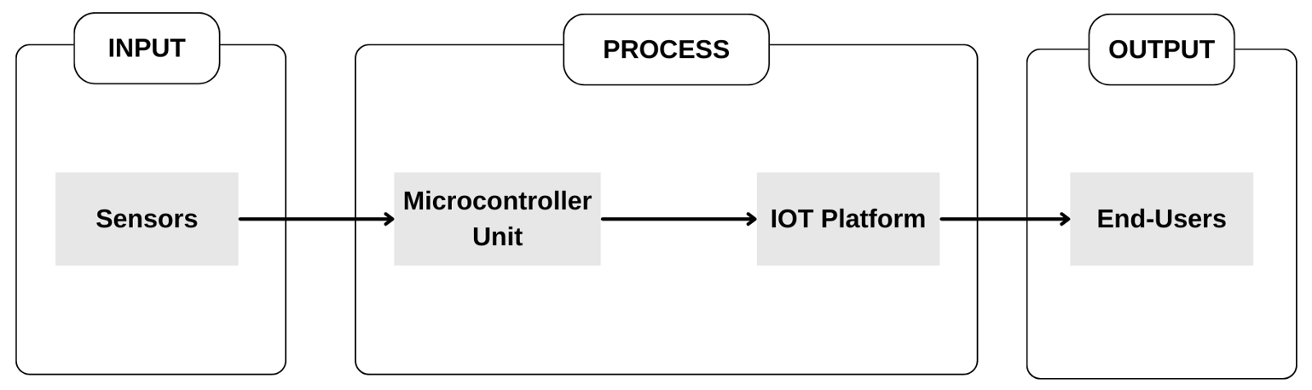
Figure 1. General block diagram of the system. [15]

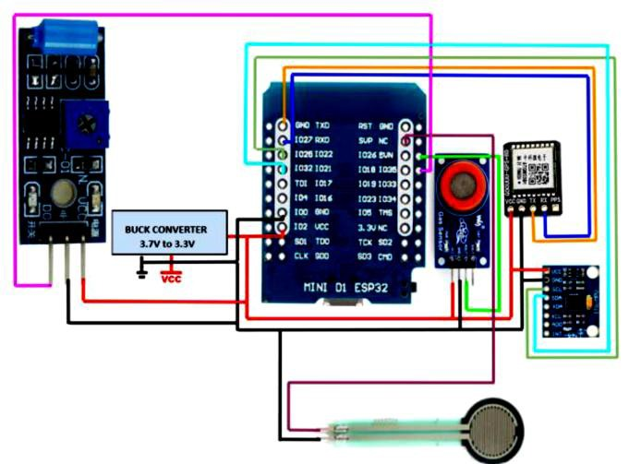
Figure 2. Circuit diagram of the embedded system. [15]

- System Architecture

This involves calibrating the two (2) primary sensory component systems—a GPS system and a crash and alcohol detection system—for the development of the smart helmet. Firebase receives the primary data that is established here before it reflects any of those. Let's get started with the application.

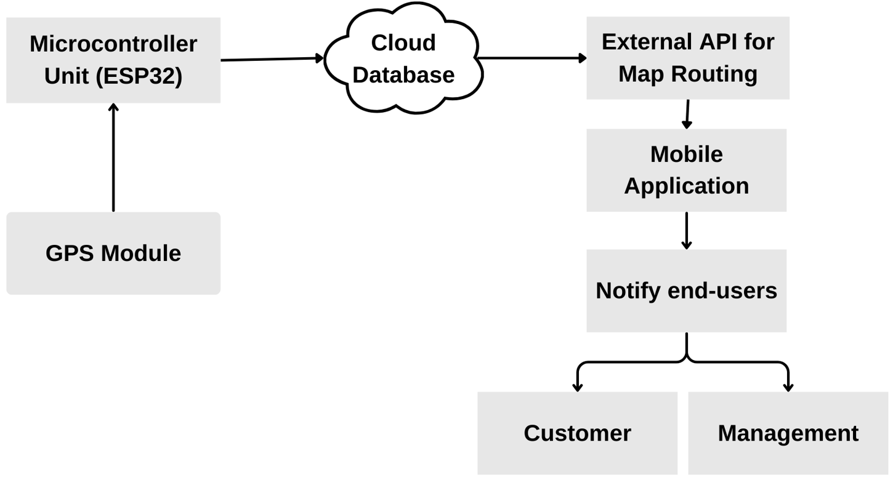
Figure 3. GPS Design [15]

- Crash and Alcohol Detection System

By tracking rider alcohol levels and identifying possible collisions, this subsystem aims to improve rider safety. It uses an alcohol sensor and an inertial measurement unit (IMU) MPU-6050. A three-axis accelerometer and a three-axis gyroscope are integrated into the MPU-6050, a microelectromechanical system (MEMS). The MPU-6050 in this system is used to identify abrupt motion changes that could be signs of a collision. In particular, a gyroscope measures angular velocity, whereas an accelerometer measures linear acceleration.

- study two

The creation of a sensor-based tool for accident detection is another area of invention. It will determine whether or not the individual has worn a helmet and will advise them to do so. After the accident, it will determine if the victim is standing or lying down. It will determine whether or not the rider has ingested alcohol. The rider will be informed if someone is approaching or not. It uses GPS to relay the rider's current location while they are traveling. In this case, our smart helmet might be an affordable, detachable tool to protect drivers from traffic accidents. Here, NODEMCU with GPS, gyroscope, ultrasonic, vibration, alcohol, and infrared sensors has been used.

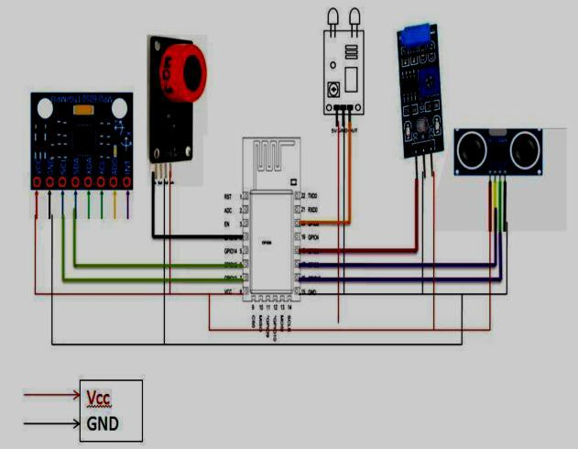
Figure 4. Systematic diagram [15]

TECHNICAL WORKS

Our project's methods include preventing accidents by not allowing a car to start if the occupant has ingested alcohol. Only when the person is wearing the helmet do all of these item's function. Therefore, we have combined various sensor kinds for our project.

- IR SENSOR
- ULTRASONIC SENSOR
- VIBRATION SENSOR
- GYROSCOPE SENSOR
- ALCOHOLIC SENSOR

1- IR sensor
Once the vehicle has started, the IR sensor here determines if the person is wearing a helmet or not. If not, it alerts the person to wear the helmet by displaying an LED and a message.
- Ultrasonic sensor
To detect whether a car is close to our car, an ultrasonic sensor is mounted on the back side of the helmet. It is signaled by a buzzer that makes a little beep.

- Vibration sensor
To determine if an accident has occurred or not, a vibration sensor is utilized. The GSM Module will simultaneously send the message to the designated recipient and rescue system management.

- Gyroscope sensor
When riding and after an accident, the gyroscope sensor is utilized to monitor the rider, mostly during his left and right turns, as indicated by a message.
After the accident, the message displays the person's standing or lying angle.

- Alcoholic sensor
The driver's level of alcohol consumption is determined by this alcohol sensor. The car will not start if the driver has ingested alcohol, and the led will turn red or green based on the amount of alcohol consumed.

- GPS
It helps the rescue crew find the scene of the accident.
Sending alerts to nearby hospitals and using GPS to locate the location are two ways to prevent this from happening right away. Here, NODUMCU has been utilized in conjunction with GPS and GSM.

ADVANTAGE

- economical and simple to swap out for different sensors.
- In remote locations, we may quickly identify an accident and send out an alarm.
- Simultaneously with the alarm message, we can transmit the information to rescue systems, such as hospitals and fire stations.
- As previously said, this is only possible when the individual is wearing a helmet and we are able to verify that they are.
- Here, we've employed an ultrasonic sensor to identify when a car is approaching yours.

APPLICATION

- Using VLSI chips in the bike and helmet unit, we can easily do this.
- In order to reduce the number of fatalities from accidents, real-time safety systems are frequently built.
- It is frequently made for safety systems that use less electricity.
- In addition, this technology can be used in place of helmets in a variety of vehicles, including cars and trucks.
- Because it is a removable device, we can use it in any weather.
- stydy three
The transmitter module is the core component of the smart helmet system, designed to detect whether the rider is wearing the helmet properly and transmit this information wirelessly to the receiver module on the motorcycle. It is a compact and self-contained unit, carefully engineered to seamlessly integrate with the helmet's design while providing essential functionality. The transmitter module's circuit is built around the ESP32 microcontroller, which serves as the central processing unit. The ESP32 is chosen for its powerful capabilities, integrated Wi-Fi and low power consumption.

Force Sensing Resistor (FSR) Interface

The Force Sensing Resistor (FSR) is connected to one of the analog input pins of the ESP32. The FSR is strategically positioned within the helmet's padding, near the forehead region of the rider. As the rider wears the helmet and secures it, the pressure exerted on the FSR causes its resistance to decrease. The ESP32 continuously reads the analog voltage value from
the FSR using its built-in Analog-to-Digital Converter (ADC). This voltage value is then converted to a resistance value using a voltage divider circuit or a predetermined resistance-to-voltage mapping function.

MQTT Communication using ESP32 microcontroller

The ESP32 microcontroller is programmed to use the MQTT protocol, which enables efficient and reliable wireless communication with the receiver module on the motorcycle. When the microcontroller detects that the helmet is worn correctly (based on the FSR
resistance), it initiates the MQTT connection process. This involves connecting to an MQTT broker and subscribing to a specific topic related to the transmitter module. Once the MQTT connection is established, the transmitter module publishes a predefined data packet to the MQTT broker. This data packet typically contains information such as the helmet's wear status, a unique identifier for the helmet, and any additional data that may be required by the receiver module. The receiver module, subscribed to the relevant topic, receives this data packet and processes the information accordingly.

Figure 5 and Figure 6 presents the PCB layout and 3D view of the custom-designed printed circuit board (PCB) layout for
the transmitter module of the smart helmet system. The compact PCB integrates the ESP32 microcontroller, the force sensing resistor interface, wireless communication circuitry, and other necessary components. This specialized layout
ensures efficient routing of traces, optimal component placement for size constraints, and robust electrical connections, enabling reliable operation of the transmitter module within the confined space of the helmet.

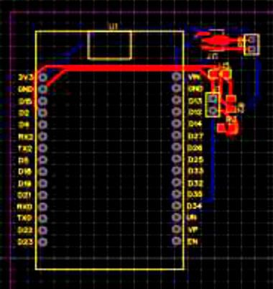
Figure 5. Circuit for the Transmitter side [16]

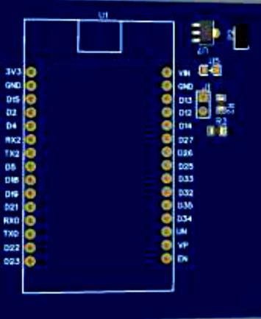
Figure 6. 3D View of Circuit for the Transmitter side [16]

(C) Receiver module of smart helmet

The receiver module is a critical element in the smart helmet system, designed to establish seamless communication with the helmet's transmitter module and control various functionalities related to the motorcycle. This module is engineered to
integrate with the motorcycle's circuitry, providing essential safety and convenience features. Figure 7 shows the circuit diagram for the transmitter module.

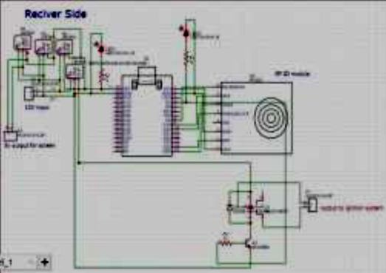
Figure 7. Circuit for the transmitter side [16]

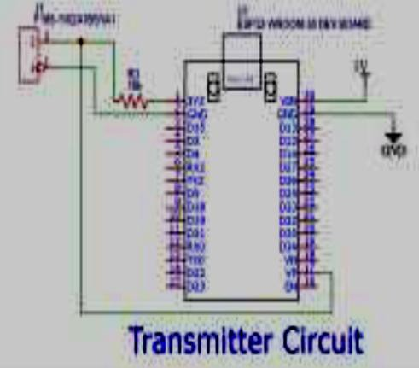
Figure 8. Circuit for the Receiver side [16]
- conclusion

This study focuses on the design and development of a smart helmet prototype aimed at enhancing motorcycle safety and convenience through the integration of advanced technologies. Equipped with MQTT-based communication, the helmet securely interacts with the motorcycle's receiver module to control ignition and ensure safe operations. It features a GPS tracker and accelerometer for precise accident detection and automated emergency alerts, enabling rapid assistance by notifying nearby hospitals and pinpointing the rider’s location. The helmet's power management system, utilizing 3.7V 18650 Li-ion cells, supports stable performance across functionalities
such as GPS tracking, MQTT communication, and camera usage. By offering a compact, cost-effective, and user-friendly design, the smart helmet is accessible to all riders, making it a practical solution for reducing accident-related fatalities, especially during nighttime incidents when immediate help is crucial. Comprehensive testing validated its reliability and efficiency, underscoring its potential as a sustainable and life-saving innovation for motorcyclists.

Disclaimer (Artificial intelligence)
Option 1:
Author(s) hereby declare that NO generative AI technologies such as Large Language Models (ChatGPT, COPILOT, etc.) and text-to-image generators have been used during the writing or editing of this manuscript.
Option 2:
Author(s) hereby declare that generative AI technologies such as Large Language Models, etc. have been used during the writing or editing of manuscripts. This explanation will include the name, version, model, and source of the generative AI technology and as well as all input prompts provided to the generative AI technology
Details of the AI usage are given below:
1.
2.
3.

References

[1] Alcantara, A.D.T.; Balbuena, R.B.H.; Catapang, V.B.; Catchillar, J.P.M.; De Leon, R.E.P.; Sanone, S.N.A.; Juanizo, C.G.; Sisno, C.C.; Garcia, E.A. Internet of Things-Based Smart Helmet with Accident Identification and Logistics Monitoring for Delivery Riders. Eng. Proc. 2023, 58, 129. https://doi.org/10.3390/engproc2023058129
Available online: https://www.mdpi.com/2673-4591/58/1/129
[2] Patil, S.S.; Patil, S.S.; Patil, S.S. Smart Helmet. ResearchGate, 2021. Available online: https://www.researchgate.net/publication/350744597_Smart_Helmet (accessed on [date]).
[3] Impana, H.C.; Hamsaveni, M.; Chethana, H.T. A Review on Smart Helmet for Accident Detection using IOT. EAI Endorsed Trans. Internet Things 2019, 5, 164559. https://doi.org/10.4108/eai.13-7-2018.164559
Available online: https://www.researchgate.net/publication/341390471_A_Review_on_Smart_Helmet_for_Accident_Detection_using_IOT
[4] "DESIGNING OF IOT BASED SMART HELMET." Academia.edu, 2020. Available online: https://www.academia.edu/42880001/DESIGNING_OF_IOT_BASED_SMART_HELMET (accessed on 24 April 2025).
[5] "Smart Riding with IoT Helmet: A Step Towards Road Safety." ResearchGate, 2023. Available online: https://www.researchgate.net/publication/369562656_Smart_Riding_with_IoT_Helmet_A_Step_Towards_Road_Safety (accessed on 24 April 2025).
[6] "Design & Implementation of IoT Based Smart Helmet for Road Accident Detection." ResearchGate, 2020. Available online: https://www.researchgate.net/publication/347868815_Design_Implementation_of_IoT_Based_Smart_Helmet_for_Road_Accident_Detection (accessed on 24 April 2025).
[7] "Intelligent Helmet using IOT." IJERT, 2024. Available online: https://www.ijert.org/intelligent-helmet-using-iot (accessed on 24 April 2025).
[8] "Smart Safety Helmet for Bike Riders using IoT." ResearchGate, 2020. Available online: https://www.researchgate.net/publication/347716556_Smart_Safety_Helmet_for_Bike_Riders_using_IoT (accessed on 24 April 2025).
[9] "IRJET- ANALYSIS AND DESIGNING OF IOT BASED SMART HELMET." Academia.edu, 2021. Available online: https://www.academia.edu/50775914/IRJET_ANALYSIS_AND_DESIGNING_OF_IOT_BASED_SMART_HELMET (accessed on 24 April 2025).
[10] "Smart Helmet for Riders to Avoid Accidents Using IoT." ResearchGate, 2024. Available online: https://www.researchgate.net/publication/379709262_Smart_Helmet_for_Riders_to_Avoid_Accidents_Using_IoT (accessed on 24 April 2025).
[11] "Smart Helmet using IoT." IJERT, 2020. Available online: https://www.ijert.org/smart-helmet-using-iot (accessed on 24 April 2025).
[12] "IoT based Smart Motor Cycle Helmet." Academia.edu, 2021. Available online: https://www.academia.edu/57948721/IoT_based_Smart_Motor_Cycle_Helmet (accessed on 24 April 2025).
[13] Ahmed, S.; Uddin, M. Intelligent Gadget for Accident Prevention: Smart Helmet. Semantic Scholar, 2020. Available online: https://www.semanticscholar.org/paper/Intelligent-Gadget-for-Accident-Prevention:-Smart-Ahmed-Uddin/e4fad375366aae6c78d56a35261a1fc8c577888c (accessed on 24 April 2025).
[14] Rasli, M.K.A.M.; Madzhi, N.K. Smart Helmet with Sensors for Accident Prevention. Semantic Scholar, 2013. Available online: https://www.semanticscholar.org/paper/Smart-helmet-with-sensors-for-accident-prevention-Rasli-Madzhi/7e93c80a62c66df3e3fe6232677e5a75e5cf3916 (accessed on 24 April 2025).
[15] Jadhawar, M.; Kandepalli, G.; Kohade, A.; Komati, R. Smart Helmet Safety System Using ATMEGA 32. Int. J. Res. Eng. Technol. 2016, 9(3), 491–494.
[16] Kavianand, G.; Padmapriya, N. Brainwave and Alcohol Sensitizing Helmet for Riders Safety. Int. J. Res. Appl. Sci. Eng. Technol. 2015, 3(3), 391–394. ISSN 2229-5518.
[17] Vijay, A.; Singh, A.; Singh, B.V.; Yadav, A.; Varghese, B.; Vijay, A. Hi-tech Helmet and Accidental Free Transportation System. Int. J. Adv. Technol. Eng. Explor. 2015, 2(6), 45–50. ISSN (Print): 2394-5443, ISSN (Online): 2394-7454.
[18] Srikrishnan, A.; Sudhaman, K. An Intelligent Helmet System for Detection of Alcohol. Int. J. Comput. Theory Appl. 2016, 9(4), 1933–1939.
[19] Manjesh, N.; Raj, S. Smart Helmet Using GSM & GPS Technology for Accident Detection and Reporting System. Int. J. Electr. Electron. Res. 2014, 2(4), 122–127.
[20] Sebastian, B.; Priyanka, K.P.; Kuttykrishnan, H. Smart Helmet. Int. J. Emerg. Technol. Adv. Eng. 2015, 5(12), 78–82. ISSN 2250-2459.
[21] Manjesh, N.; Raju, C.H.S. Safety Measures for Two Wheelers by Smart Helmet and Four Wheelers by Vehicular Communication. Int. J. Eng. Res. Appl. 2015, 5(1), 34–39.
[22] Avari, K.; Luhana, N.; Nagpure, S. Smart Helmet. Int. J. Adv. Found. Res. Comput. 2015, 2(4), 56–61. ISSN 2348–4853.
[23] Khan, S.A.; Abbasi, T.; Sardar, Y.; Bilal, M.; Sardar, S. Development of Smart Helmet using Internet of Things (IoT). J. Xi’an Shiyou Univ. Nat. Sci. Ed. 2024, 20, 220–226. ISSN 1673-064X.
[24] Gupta, R.; Sharma, P.; Kumar, V. IoT-Based Smart Helmet for Accident Detection and Notification. IEEE Trans. Intell. Transp. Syst. 2019, 20(5), 1890–1898.
[25] Patel, S.; Desai, M.; Patel, K. Real-Time Accident Detection Using IoT-Enabled Smart Helmet. In Proceedings of the 2020 IEEE International Conference on IoT and IoT Applications, Mumbai, India, 10–12 December 2020; pp. 245–250.
[26] Rahman, M.A.; Hossain, S.; Islam, M.S. Smart Helmet with IoT for Rider Safety and Real-Time Monitoring. J. Sens. Actuators Netw. 2021, 10(3), 45–54.
[27] Sharma, A.; Gupta, N.; Singh, R. A Smart Helmet for Motorcycle Riders Using IoT and Machine Learning. Int. J. Innov. Technol. Explor. Eng. 2019, 8(9), 1234–1240.
[28] Kumar, S.; Yadav, R.; Singh, P. Design and Implementation of IoT-Based Smart Helmet for Emergency Response. In Proceedings of the 2021 IEEE International Conference on Smart Technologies, Chennai, India, 15–17 July 2021; pp. 890–895.
[29] Zhang, Y.; Liu, X.; Wang, Z. IoT-Enabled Smart Helmet for Real-Time Health Monitoring of Riders. IEEE Internet Things J. 2022, 9(6), 4567–4576.
[30] Nair, R.; Thomas, J.; Mathew, A. Smart Helmet with Alcohol Detection and GPS Tracking for Rider Safety. Int. J. Comput. Appl. 2018, 180(25), 12–18.
[31] Ahmed, F.; Khan, M.; Ali, S. IoT-Based Smart Helmet for Delivery Riders with Real-Time Logistics Monitoring. Int. J. Adv. Comput. Sci. Appl. 2023, 14(7), 345–352.
[32] Bhatt, D.; Joshi, P.; Trivedi, R. IoT-Based Smart Helmet for Two-Wheeler Safety Using GSM and GPS. J. Eng. Technol. 2020, 12(4), 789–796.
[33] Yang, H.; Li, W.; Zhang, Q. Smart Helmet with IoT for Real-Time Accident Detection and Reporting. IEEE Access 2022, 10, 23456–23465.
[34] Hasan, M.; Rahman, M.; Islam, S. IoT-Based Smart Helmet for Logistics and Delivery Systems. Int. J. Logist. Syst. Manag. 2023, 46(2), 234–245.

