Formulation and Performance Evaluation of Sustainable Bio-Hydraulic Fluid from Spent Palm Kernel Oil Glycerin and Anacardium occidentale Leaf Extract as a Corrosion Inhibitor

ABSTRACT
This study explores a novel method for producing sustainable bio-hydraulic fluid by utilizing and optimizing the glycerin from spent palm kernel oil (PKO) using a bio-based corrosion inhibitor from Anacardium occidentale leaves (AO). PKO was utilized to mitigate its inadequate disposal and was treated by filtration and an esterification process. The saponification value of 193.22 mg/g of the PKO decreased to 174.87 mg/g after treatment. The glycerin obtained was characterized using a gas chromatography mass spectrophotometer (GC-MS) and Fourier transform infrared spectrophotometer (FT-IR), and Response Surface Methodology (RSM) was employed to optimize the glycerin yield. FT-IR and phytochemical analysis of the AO leaf revealed it was rich in alkaloids (212.45 ± 0.02 mg/100 g) and a high number of tannins (98.44 ± 0.14 mg/100 g), which demonstrate suitable corrosion inhibition characteristics. Functional groups of glycerin include polar atoms, and single and double bond structures, which indicate that the glycerin is suitable for bio-hydraulic fluid formulation. The optimum glycerin yield was obtained at 89.95% with an oil/methanol ratio of 6.10, time of 71.17 min, temperature of 91.30 °C, and catalyst dosage of 1.06. The percentage deviation was below 0.2%. As a result, The suggested Model is significant. The bio-hydraulic fluid's functional groups include heteroatoms and double and triple bonds. Its pour point is -43.9°C, its flash point is 253°C, its viscosity is 36.53 cP, and its BOD is 8.51 ppm, according to the FT-IR and physicochemical analysis. This indicates that the bio-hydraulic fluid is suitable for various automotive and industrial hydraulic functions.

Keywords: Bio-hydraulic, Palm kernel oil, Anacardium occidentale, Glycerin, Corrosion inhibitor, Characterization,

1 INTRODUCTION
The increasing global demand for eco-friendly lubricants, including hydraulic fluids, grease, transmission fluids, gear oils, and automotive engine oils, has intensified exploration into bio-lubricants. With a compound annual growth rate (CAGR) of 13.75% anticipated from 2025 to 2030, the bio-lubricant market increased from USD 3.55 billion in 2023 to USD 3.76 billion in 2024 (Grand View Research., 2024). Biodegradable fluids are becoming more popular as sustainable solutions as people become more conscious of the negative effects hydraulic system leaks and spills have on the environment. In many countries nowadays, the use of vegetable oils as lubricants has increased. Converting non-edible vegetable oil into bio-lubricants, which are sustainable substitutes for mineral oil-based lubricants, is the best way to use it as a lubricant due to sustainability and environmental concerns (Fox, et al., 2007).
Hydraulic fluid serves as a medium for energy transmission, lubrication, and cooling in hydraulic systems, which are integral to a wide range of machinery and components (Cerón, et al., 2018; Syaima, et al., 2015; Hussein, et al., 2021). Petroleum-based hydraulic fluids, commonly used for machine lubrication, are typically formulated with additives of petroleum origin. These fluids and their additives are toxic and hazardous to the environment, containing substances such as polyoxyalkylene glycol ethers and petroleum derivatives. This environmental impact highlights the need for sustainable alternatives.
This study aims to develop and characterize a sustainable bio-hydraulic fluid using transesterified glycerin from spent palm kernel oil, with Anacardium occidentale leaf as an antioxidant. The objective is to provide a biodegradable and environmentally friendly alternative to conventional petroleum-based hydraulic fluids and antioxidants.
Palm kernel oil (PKO) is widely used in industries such as food, and biodiesel production. However, used (spent) PKO from households (Said, et al., 2018), confectionery, and the food industry is often improperly disposed of, leading to environmental challenges such as climate change, water pollution, and soil contamination (Alang, 2018). There is much promise for sustainable lubricant manufacturing using bio-lubricants made from vegetable oils, including both edible and non-edible sources like neem oil (Khan, et al., 2023).
For easy modification of the fluid friction, materials such as graphite are required. The outcome of this study will help to develop an efficient method for the proper disposal and recycling of used palm kernel oil into sustainable hydraulic fluid. This paper focuses on the production and characterization of multi-grade bio-hydraulic fluid from the transesterification of glycerin from spent palm kernel oil using Anacardium occidentale leaf as an antioxidant.

2 Materials and methods
2.1 Materials
Rotational viscometer, glass measuring cylinder, electronic weighing balance, separating funnel, beakers, stopwatch, water bath with thermostat, conical flask and cork, Erlenmeyer flask, filter paper, spatula, retort stand, oven, volumetric flasks, Soxhlet extractor, condenser, and UV spectrometer.
2.1.1 Oil Source
A bean cake vendor in Agbani Town, Nkanu West Local Government Area, Enugu State, provided the spent palm kernel oil.
2.1.2 Chemicals
The chemicals used was of analytical grades. Methanol, graphite, diethylene glycol, polyethylene oxide, monoethylene glycol, ammonium hydroxide, acetic acid, ethanol, H₂SO₄, AlCl₃, petroleum ether, sodium chloride, NaOH, butanol, acetone, and distilled water.
2.2 Methodology
2.2.1 Treatment of spent palm kernel oil
In accordance with accepted practices, the spent palm kernel oil was filtered and esterified (Akinpelu, et al., 2021; Kurańska, et al., 2019; Khan, et al., 2023; Leung, et al., 2006).). A beaker containing 750 milliliters of spent palm kernel oil was heated to 60 °C on a hot plate. A separating funnel was used to further purify the filtrate after the heated oil was first filtered through muslin cloth before being transferred into a reaction flask. Using a magnetic stirrer, the oil was heated to 60 °C.
Before adding the sample to the heated oil, 150 milliliters of methanol and 1.5 milliliters of sulfuric acid were carefully combined. The mixture was maintained at 60 °C; at the end of 1.5 hours, the mixture was filtered. The filtrate was washed with warm distilled water and further heated at 100 °C to evaporate the remaining water and methanol. The treated oil was collected for the experimental study.
2.2.2 Glycerin production process
Glycerin was produced via the transesterification method. We measured out 100 g of the oil in a beaker, heated it to approximately 60 °C in a heating mantle, and then transferred it into another conical flask. To create a sodium methoxide solution, 0.9 g of NaOH (as a catalyst) was weighed and thoroughly dissolved in the necessary quantity of methanol (in an oil/methanol ratio of 6:1) using a hot plate and magnetic stirrer. The oil was carefully filled with the conical flask's prepared methanol and NaOH mixture. A Soxhlet extractor workstation assisted in heating the oil, NaOH, and methanol mixture using a hot plate at 75 °C with a magnetic stirrer. The magnetic stirrer's agitation was sustained for 60 minutes at 250 rpm. A separating funnel was filled with the reaction mixture after it had been in the conical flask for 12 hours. Gravity settling caused phase separation. We separated the glycerin from the biodiesel. The proportion of glycerin generated relative to the amount of reactant utilized was calculated as the glycerin yield.
2.2.3 Extraction of Anacardium occidentale Leaf Extract
After being carefully cleaned with tap water, dried Anacardium occidentale leaves were rinsed with distilled water alone. Previous research produced the leaf extract of Anacardium occidentale (Khan, et al., 2023).We weighed out 25 g of pulverized Anacardium occidentale leaf and let it soak for 48 hours in 1000 ml of ethanol. The mixture underwent filtration after the 48-hour period. The resulting filtrate was a blend of ethanol and leaf extract from Anacardium occidentale. Evaporating the mixture's ethanol resulted in a concentrated extract. For the experimental investigation, the leaf extract from Anacardium occidentale was gathered and preserved.
2.2.4 Production of the Bio-Hydraulic Fluid
The materials/chemicals listed in Table 1 were used to produce the bio-hydraulic fluid in accordance with the usual procedure (Eze., 2016). The base material for creating the bio-hydraulic fluid was glycerin, which was produced by the oil's transesterification process. Methanol served as the blend's solvent. As shown in Table 1, the raw materials were added in descending order. After all of the components had been added, the beaker was heated to 60 °C while being stirred for 30 minutes.
Table 1: Materials and chemicals for the bio-hydraulic fluid formulation
S/N | Materials/chemicals | Function in fluid | Volume (ml) | Mass (g)
1 | Glycerin | Recipe base chemical | 100 | 80.15
2 | Methanol | Formulation solvent | 4.00 | 2.8
3 | Graphite | Friction modifier, anti-wear |  | 0.6
4 | Diethylene glycol | Diluent | 1.2 | 1
5 | Anacardium occidentale leaf | Corrosion inhibitor |  | 0.3
6 | polyethylene oxide | Anti-foam solvent | 1.1 | 0.23
7 | Monoethylene glycol | Anti-freezer, coolant | 1.5 | 1
2.3 Characterization of Glycerin, Anacardium occidentale Leaf, and Bio-Hydraulic Fluid
2.3.1 Characterization of the Glycerin
Gas chromatography mass spectrophotometer (GC-MS) (Agilent 7890B coupled with Agilent 5977A Mass Selective Detector (MSD)) examination identified the glycerin chemical components.
Using established techniques from earlier research, the glycerin physicochemical characteristics, including its moisture content, refractive index, and kinematic viscosity, were determined (Jonah, et al., 2021; Chitra, et L., 2005).
2.3.2 Characterization of Anacardium occidentale Leaf
Alkaloids, cardiac glycosides, flavonoids, phenols, phytates, saponins, and tannins were among the phytochemicals identified in the Anacardium occidentale leaf. The functional groups of the Anacardium occidentale leaf were identified using a Fourier transform infrared spectrophotometer (Benchtop FTIR spectrometer, (ATR-FTIR)). Standard procedures used by earlier authors (Omotioma, et al., 2024; Omotioma, et al., 2017; Onukwuli, et al., 2016). Were utilized to analyze the phytochemicals in the leaf extract of Anacardium occidentale.
2.3.3 Characterization of the Bio-Hydraulic Fluid
The bio-hydraulic fluid's pour point, flash point, viscosity, and biochemical oxygen demand was characterized.
2.3.3.1 Determination of Pour Point of the Bio-Hydraulic Fluid
The pour point of the bio-hydraulic fluid was determined according to ASTM D97 standard, measured as the lowest temperature at which the fluid flows when cooled under the specified test conditions. A hot specimen was cooled inside a cooling bath to allow the formation of wax crystals. At a temperature slightly above the expected pour point, and for every subsequent X °C decrease, the test jar was removed and tilted to check for surface movement. When the specimen did not flow when tilted, the jar was held horizontally for 5s. When it did not flow, the result was recorded as the pour point temperature.
2.3.3.2 Determination of Flash Point of the Bio-Hydraulic Fluid
The flash point of the bio-hydraulic fluid was determined according to ASTM D93 standard. The temperature at which the vapor over the bio-hydraulic fluid ignited upon exposure to an ignition source. The Cleveland Open Cup (COC) was used to determine the flash point. The sample was contained in an open cup, which was heated, and at intervals, a flame was brought over the surface. The measured flash point varied with the height of the flame above the fluid surface, and at a sufficient height, the measured flash point temperature was recorded.
2.3.3.3 Determination of Viscosity of the Bio-Hydraulic Fluid
The dynamic viscosity of the bio-hydraulic fluid was determined according to ASTM D2983 standard, measured with a rotational viscometer by Brookfield at 40℃, which uses a spinning probe immersed in the sample of the bio-hydraulic fluid. Viscosity is a measure of a fluid’s resistance to flow, which is caused by the internal resistance to motion. The viscosity was determined by the force needed to rotate the probe at a chosen speed.
2.3.3.4 Determination of Biochemical Oxygen Demand (BOD) of the Bio-Hydraulic Fluid
The biodegradability of the bio-hydraulic fluid was examined in terms of BOD. The BOD of the bio-hydraulic fluid was determined as the amount of oxygen used by microorganisms as they decompose the organic matter in the sample over a period of time and at a particular temperature. It was carried out in line with the standard method described by Awoyale et al. (2011). In this test, the standard period and temperature required were five days and 20 °C, respectively. Triplicates of 20 ml of the produced bio-hydraulic fluid, labeled, were mixed with pond water, which contains microorganisms, in incubation bottles, each of which did not allow the passage of light through them. Three other incubation bottles were also filled with 20 ml of mineral bio-hydraulic fluid (controls); 1 ml each of iron (II) chloride, phosphate buffer, calcium chloride, and magnesium sulphate were mixed in 1 liter of distilled water.
The diluted water prepared was added to each of the incubation bottles for about two hours at room temperature, after which the dissolved oxygen was measured using an oxygen meter. The incubation bottles were kept at the same temperature of 20 °C for five (5) days, after which the dissolved oxygen was recorded. The difference in the dissolved oxygen was calculated and recorded. The biodegradability of the bio-hydraulic fluid produced was calculated using Equation (1):
$BOD= \frac{DOi-DOf}{P}*\frac{300}{1000}$ (1)
$P= \frac{v}{1000}$ (2)
Where BOD (ppm) is the biochemical oxygen demand, DOi is the initial dissolve oxygen, DOf is the final dissolve oxygen after five days, P is the fraction of the sample, and v= volume of sample (cm³).
Fourier transform infrared (FTIR) spectrophotometer (Benchtop FTIR spectrometer, (ATR-FTIR)) was used to identify the fluids functional groups.
2.4 Modelling and Optimization
2.4.1 RSM Design Matrix and Optimization of the Glycerin Yield
To design the experiment and determine the interaction effects of catalyst dosage, temperature, time, and oil/methanol molar ratio on glycerin production, Response Surface Methodology (RSM) used the Central Composite Design of Design-Expert software. Table 2 present the design matrix, information, and considerations taken into account. The yields of glycerin were optimized, and the outcome was validated. Multiple regression was used to fit the coefficients of the polynomial model of the response in order to relate the response variable to the independent factors. Analysis of variance (ANOVA) and a test of significance were used to assess the model's fit quality. The following equation describes the fitted quadratic response model:
$Y= b_{0}+ \sum_{i=1}^{k}{b_{i}}x_{i}+ \sum_{i=1}^{k}{b_{ii}x_{i}^{2}+ \sum_{i<j}^{k}{b_{ij}x_{i}x_{j}+e}}$ (3)
Where;
Y is the response variable, bo is the intercept value, bi (i = 1, 2,..., k) is the first-order model coefficient, bij is the interaction effect, and bii represents the quadratic coefficients of Xi, and e is the random error (Esonye, et al., 2019; Patel, et al., 2016).
Table 2. Experimental design matrix for glycerin yield
Std | Run | Factor 1  A: Oil  /methanol ratio | Factor 2  B: Catalyst dosage  (wt%) | Factor 3  C: Temperature  (⁰C) | Factor 4  D: Time  (minutes) | Response  Glycerin yield %
10 | 1 | 10 | 0.5 | 55 | 80
15 | 2 | 2 | 1.3 | 95 | 80
20 | 3 | 6 | 1.3 | 75 | 60
5 | 4 | 2 | 0.5 | 95 | 40
13 | 5 | 2 | 0.5 | 95 | 80
24 | 6 | 6 | 0.9 | 75 | 80
14 | 7 | 10 | 0.5 | 95 | 80
2 | 8 | 10 | 0.5 | 55 | 40
26 | 9 | 6 | 0.9 | 75 | 60
3 | 10 | 2 | 1.3 | 55 | 40
17 | 11 | 2 | 0.9 | 75 | 60
11 | 12 | 2 | 1.3 | 55 | 80
23 | 13 | 6 | 0.9 | 75 | 40
27 | 14 | 6 | 0.9 | 75 | 60
6 | 15 | 10 | 0.5 | 95 | 40
22 | 16 | 6 | 0.9 | 95 | 60
18 | 17 | 10 | 0.9 | 75 | 60
8 | 18 | 10 | 1.3 | 95 | 40
9 | 19 | 2 | 0.5 | 55 | 80
7 | 20 | 2 | 1.3 | 95 | 40
21 | 21 | 6 | 0.9 | 55 | 60
30 | 22 | 6 | 0.9 | 75 | 60
12 | 23 | 10 | 1.3 | 55 | 80
25 | 24 | 6 | 0.9 | 75 | 60
28 | 25 | 6 | 0.9 | 75 | 60
29 | 26 | 6 | 0.9 | 75 | 60
16 | 27 | 10 | 1.3 | 95 | 80
4 | 28 | 10 | 1.3 | 55 | 40
1 | 29 | 2 | 0.5 | 55 | 40
19 | 30 | 6 | 0.5 | 75 | 60
2.4.2 RSM Design Matrix for the Biohydraulic fluid.
The Interactive effects of process variables of glycerin/methanol ratio (10 – 30), graphite (0.2 - 1.0), temperature (50 ºC – 70 ºC) and time (20 min. – 40 min.) on the viscosity of bio-hydraulic fluid were determined. Design Expert software version 11 was used to design the experiment. The experimental design matrix is shown in Tables 3.
Table 3. Design matrix for the bio-hydraulic fluid
Std | Run | Factor 1  A: Glycerin/ methanol ratio | Factor 2  B: Graphite dosage (g) | Factor 3  B: Temp.  (ºC) | Factor 4  C: Time  (min) | Response  Viscosity (cP)
14 | 1 | 30 | 0.2 | 70 | 40
24 | 2 | 20 | 0.6 | 60 | 40
3 | 3 | 10 | 1 | 50 | 20
5 | 4 | 10 | 0.2 | 70 | 20
8 | 5 | 30 | 1 | 70 | 20
6 | 6 | 30 | 0.2 | 70 | 20
9 | 7 | 10 | 0.2 | 50 | 40
15 | 8 | 10 | 1 | 70 | 40
1 | 9 | 10 | 0.2 | 50 | 20
2 | 10 | 30 | 0.2 | 50 | 20
21 | 11 | 20 | 0.6 | 50 | 30
16 | 12 | 30 | 1 | 70 | 40
25 | 13 | 20 | 0.6 | 60 | 30
17 | 14 | 10 | 0.6 | 60 | 30
19 | 15 | 20 | 0.2 | 60 | 30
28 | 16 | 20 | 0.6 | 60 | 30
11 | 17 | 10 | 1 | 50 | 40
20 | 18 | 20 | 1 | 60 | 30
10 | 19 | 30 | 0.2 | 50 | 40
13 | 20 | 10 | 0.2 | 70 | 40
26 | 21 | 20 | 0.6 | 60 | 30
12 | 22 | 30 | 1 | 50 | 40
29 | 23 | 20 | 0.6 | 60 | 30
27 | 24 | 20 | 0.6 | 60 | 30
4 | 25 | 30 | 1 | 50 | 20
30 | 26 | 20 | 0.6 | 60 | 30
18 | 27 | 30 | 0.6 | 60 | 30
22 | 28 | 20 | 0.6 | 70 | 30
7 | 29 | 10 | 1 | 70 | 20
23 | 30 | 20 | 0.6 | 60 | 20

3. Results and discussion
3.1 Results of the Characterization of the Untreated and Treated Spent Palm Kernel Oil
The characteristics of the untreated and treated spent palm kernel oil are described by physicochemical analyses in Table 4, which also shows differences in the values of the measured parameters (density, saponification, acid, free fatty acid, iodine, and peroxide values) of the spent and treated oil samples. The saponification value of the spent palm kernel oil dropped to 183.76 mg/g following treatment, and these recorded values of the treated oil samples' saponification status imply that the treated palm kernel oil is appropriate for glycerin synthesis (Akinpelu, et al., 2021; Azinta, et al., 2021; Hussein, et al., 2021).
Table 4. Features of the Untreated and Treated Spent Palm Kernel Oil
Properties | Waste palm kernel oil | Treated palm kernel oil
Density (g/cm³) | 0.8975 | 0.8960
Saponification value (mg/g) | 193.22 | 174.87
Acid value (mg/g) | 5.52 | 3.10
Free fatty Acid (%) | 2.76 | 1.55
Iodine value (g/100g) | 20.54 | 26.28
Peroxide value (meq/kg) | 0.23 | 0.28
3.2 Results of the Qualitative and Quantitative Analysis of Phytochemicals of Anacardium occidentale Leaf
Table 5 shows the findings of the phytochemical study, both qualitative and quantitative, of Anacardium occidentale leaves. Alkaloids are abundant in Anacardium occidentale leaves (212.45 ± 0.02 mg/100 g). Additionally, they have a high concentration of tannins (98.44 ± 0.14 mg/100 g). The phytochemicals' presence suggests that the leaf extract from Anacardium occidentale has corrosion-inhibiting properties. This finding is consistent with other observations (Mada, et al., 2012; Omotioma, et al., 2017; Onukwuli, et al., 2016). which state that the presence of corrosion-inhibiting features controls metal corrosion. Therefore, the leaf extract from Anacardium occidentale is a suitable corrosion inhibitor for the production of bio-hydraulic fluid.
Table 5. Phytochemicals of Anacardium occidentale leaf
Phytochemicals | Qualitative sign | Quantitative value
Tannins (mg/100g) | ++ | 98.44 ±0.14
Saponins (mg/100g) | + | 60.54 ±0.15
Phytates (mg/100g) | + | 36.61 ±0.03
Phenolics (GAE/g) | - | 7.30 ±0.12
Flavonoids (mg/100g) | + | 21.94 ±0.15
Cardiac glycosides (mg/100g) | + | 14.37 ±0.21
Alkaloids (mg/100g) | +++ | 212.45 ±0.02
–. (too little to be observed qualitatively), + (in traces), ++ (concentrated) and +++ (highly concentrated)
3.2.1 Results of the FTIR Analysis of the Anacardium occidentale Leaf
Figure 1 shows the results of the FTIR analysis of the Anacardium occidentale leaf. Table 6 lists the relevant functional groups. The identified functional groups include the O-H stretch, N-H symmetric, C-H stretch, CH₃ C-H bend, and C-F stretch. The presence of heteroatoms (N and O) indicates that the Anacardium occidentale leaf extract is a suitable corrosion-inhibiting additive for bio-hydraulic fluid synthesis (Mayuri, et al., 2012).
Table 6. Functional groups of the Anacardium occidentale leaf (plant inhibitor)
Peak | Intensity | Functional  Groups | Class of  Compound
3280.1 | 59.786 | C-H stretch  O-H stretch  N-H symmetric | Alkynes.  Carboxylic Acid.  Amides (R-C_{(O)—}NH₂
2922.2 | 66.299 | C-H stretch.  O-H stretch | Alkane and Alkyls.  Carboxylic Acids
2128.3 | 96.553 | NIL | NIL
1595.8 | 59.352 | NIL | NIL
1379.1 | 62.768 | CH₃ C-H bend  CH { CH₃}₂ bend | Alkane and Alkyls.  Alkane and Alkyls.
1334.4 | 64.272 | NIL | NIL
1013.8 | 32.465 | C-F stretch | R-F (Alkyl halides)
3.3 Results of the Gas Chromatography Mass Spectrophotometer (GC-MS) of Glycerin
Figure 2 shows the chromatograms of the glycerin. Dihydro-2-methyl-3-furanone, neopentyl glycol, 4-ethoxy-4-oxobutanoic acid, methyl ester, pentaerythritol, and linoleic acid were identified as the chemical cototients of the glycerin. These constituents demonstrate that glycerin derived from palm kernel oil is suitable for the production of lubricants and related fluids (Alang, 2018; Esonye et al., 2019; Nazrah et al., 2021).
3.4 Characterization of the Bio-hydraulic Fluid
Table 7 shows the bio-hydraulic fluid's physicochemical characteristics: moderate viscosity, flash point, and related property values indicate that the bio-hydraulic fluid is appropriate for a range of industrial uses. Selecting a fluid with the right viscosity grade is crucial for the energy efficiency of any given application. The fluid's component composition may be the cause of slight discrepancies in the results (Eze, 2016).
Table 7. Physicochemical properties of the bio-hydraulic fluid
Parameters | Bio-hydraulic fluid
Pour point (ºC) | -43.9
Flash point (ºC) | 253
Viscosity (cP) | 36.53
BOD (ppm) | 8.51
3.4.1 Results of the FTIR analysis of the bio-hydrualic fluid
The bio-hydraulic fluid's spectra are shown in Figure 3. With different peaks signifying the functional groups, each spectrum displays the relationship between transmittance and wavenumber. The bio-hydraulic fluid's functional groups were identified in Table 8. Each of them has heteroatoms and double bond structures. For lubrication and related purposes, the bio-hydraulic fluid is appropriate (Awoyale et al., 2011; Deuster et al., 2021).
Table 8. Functional groups bio-hydraulic fluid
Peak | Intensity | Functional  Groups | Class of  Compound
2918.5 | 61.695 | C-H stretch.  O-H stretch | Alkane and Alkyls.  Carboxylic Acids
2851.4 | 69.069 | C-H stretch.  O-H stretch | Alkane and Alkyls.  Carboxylic Acids
1695.9 | 99.865 | NIL | NIL
1461.1 | 79.396 | C-H bend  Ring c=c stretch | AlkaneandAlkyls Aromaticcompound
1375.4 | 87.525 | CH3 C-H bend  -CH(CH3)2 | Alkane and Alkyls.  Alkane and Alkyls.
1013.8 | 98.124 | C-F stretch | R-F{Alkyl halides}
969.1 | 97.624 | =C-H bend  =C-H bend | trans-RCH=CHR’{Alkenes}  RCH=CH2 { Alkenes}
864.7 | 97.699 | NIL | NIL
812.6 | 97.400 | =C-H bend  C-Cl stretch  C-H bend | RCH=CR’R”{Alkenes}  R-CL {Alkyl halides}  p-disubstituted{Aromatic compound}
723.1 | 92.161 | -(CH2)n bend  =C-H bend | Alkane and Alkyls  cisRCH=CHR’{Alkenes}
3.5 Model Fit Summary and Analysis of Variance (ANOVA) for the Glycerin Yield
Table 9 presents the RSM results of the glycerin yield. It demonstrated how the independent variables temperature, time, catalyst concentration, and oil/methanol ratio affect glycerin production. In order to maximize the interactive effects of the process factors on the glycerin yield, the best-suited model among the four models examined was the quadratic model. Finding the quadratic model of the glycerin yield and its optimal reaction conditions included analyzing the ANOVA data. Equation 4 offers a quadratic model of the glycerin in terms of coded components (Nnanwube et al., 2020; Minodora et al., 2010).
$Glycerin yield= +87.77 + 16.01A + 7.12B + 3.91C +4.78D + 3.11AB +1.19AC +1.25AD + 0.9731BC + 2.35BD +1.25CD - 25.52A^{2}-4.48 B^{2}- 3.81 C^{2}-16.56D^{2} (4)$
Table 9. Result of the RSM for glycerin yield
Std | Run | Factor 1  A: Oil  /methanol ratio | Factor 2  B: Catalyst dosage  (wt%) | Factor 3  C: Temperature  (⁰C) | Factor 4  D: Time  (min) | Response  Glycerin yield %
10 | 1 | 10 | 0.5 | 55 | 80 | 40.28
15 | 2 | 2 | 1.3 | 95 | 80 | 37.02
20 | 3 | 6 | 1.3 | 75 | 60 | 86.32
5 | 4 | 2 | 0.5 | 95 | 40 | 16.87
13 | 5 | 2 | 0.5 | 95 | 80 | 21.03
24 | 6 | 6 | 0.9 | 75 | 80 | 75.32
14 | 7 | 10 | 0.5 | 95 | 80 | 50.95
2 | 8 | 10 | 0.5 | 55 | 40 | 36.76
26 | 9 | 6 | 0.9 | 75 | 60 | 89.14
3 | 10 | 2 | 1.3 | 55 | 40 | 19.28
17 | 11 | 2 | 0.9 | 75 | 60 | 42.86
11 | 12 | 2 | 1.3 | 55 | 80 | 25.41
23 | 13 | 6 | 0.9 | 75 | 40 | 64.38
27 | 14 | 6 | 0.9 | 75 | 60 | 89.14
6 | 15 | 10 | 0.5 | 95 | 40 | 43.07
22 | 16 | 6 | 0.9 | 95 | 60 | 87.15
18 | 17 | 10 | 0.9 | 75 | 60 | 78.92
8 | 18 | 10 | 1.3 | 95 | 40 | 58.98
9 | 19 | 2 | 0.5 | 55 | 80 | 17.63
7 | 20 | 2 | 1.3 | 95 | 40 | 22.95
21 | 21 | 6 | 0.9 | 55 | 60 | 78.05
30 | 22 | 6 | 0.9 | 75 | 60 | 89.14
12 | 23 | 10 | 1.3 | 55 | 80 | 65.47
25 | 24 | 6 | 0.9 | 75 | 60 | 89.14
28 | 25 | 6 | 0.9 | 75 | 60 | 89.14
29 | 26 | 6 | 0.9 | 75 | 60 | 89.14
16 | 27 | 10 | 1.3 | 95 | 80 | 80.41
4 | 28 | 10 | 1.3 | 55 | 40 | 50.77
1 | 29 | 2 | 0.5 | 55 | 40 | 14.39
19 | 30 | 6 | 0.5 | 75 | 60 | 77.53
3.5.1 ANOVA (analysis of variance) for quadratic model of glycerin yield
Table 10 displays the corresponding ANOVA for the glycerin yield quadratic model. According to Table 10, the model's F-value of 326.03 indicates that it is significant. An F-value this large could only be the result of noise in 0.01% of cases. Model terms are considered significant when the P-value is less than 0.0500. A, B, C, D, AB, AC, AD, BD, CD, A², B², C², and D² are significant model terms in this instance. The difference is less than 0.2, meaning that the adjusted R² of 0.9937 and the predicted R² of 0.9845 are in reasonable agreement. Adequate precision quantifies the signal-to-noise ratio. A ratio greater than four is desirable. A 48.5806 ratio denotes an adequate signal. This model can be used to navigate the design space (Dumancas et al., 2016).
Table 10. ANOVA for Quadratic model of Glycerin yield
Source | Sum of Squares | Df | Mean Square | F-value | p-value
Model | 21652.83 | 14 | 1546.63 | 326.03 | < 0.0001 | significant
A-Oil/methanol ratio | 4613.44 | 1 | 4613.44 | 972.51 | < 0.0001
B-Catalyst conc. | 911.65 | 1 | 911.65 | 192.17 | < 0.0001
C-Temperature | 275.26 | 1 | 275.26 | 58.03 | < 0.0001
D-Time | 411.56 | 1 | 411.56 | 86.76 | < 0.0001
AB | 155.19 | 1 | 155.19 | 32.71 | < 0.0001
AC | 22.49 | 1 | 22.49 | 4.74 | 0.0458
AD | 24.83 | 1 | 24.83 | 5.23 | 0.0371
BC | 15.15 | 1 | 15.15 | 3.19 | 0.0941
BD | 88.03 | 1 | 88.03 | 18.56 | 0.0006
CD | 24.88 | 1 | 24.88 | 5.24 | 0.0369
A² | 1687.06 | 1 | 1687.06 | 355.63 | < 0.0001
B² | 52.06 | 1 | 52.06 | 10.97 | 0.0047
C² | 37.56 | 1 | 37.56 | 7.92 | 0.0131
D² | 710.30 | 1 | 710.30 | 149.73 | < 0.0001
Residual | 71.16 | 15 | 4.74
Lack of Fit | 71.16 | 10 | 7.12
Pure Error | 0.0000 | 5 | 0.0000
Cor Total | 21723.99 | 29
Std. Dev. | 2.18 |  | R² |  | 0.9967
Mean | 57.55 |  | Adjusted R² |  | 0.9937
C.V. % | 3.78 |  | Predicted R² |  | 0.9845
 |  |  | Adeq Precision |  | 48.5806
3.5.2 Optimum RSM results of the glycerin yields and the results validation
Table 11 contains the data used to validate the RSM results. The oil/methanol ratio of 6.10, time of 71.17 minutes, temperature of 91.30 °C, and catalyst dosage of 1.06 resulted in the optimal glycerin yield of 89.95%. Using the statistical method of percentage deviation, the experimental and predicted glycerin yields were compared. The percentage deviation is below the 5% threshold. As a result, the developed model was able to accurately predict the experimental results. The 3D plots, Figures 4–8, presented the RSM graphical results. Each one shows a parabolic curve, typical of a quadratic model. The diagnostic report revealed straight-line (linear) graphs in Figures 9 and 10. The points on the graph clustered along the line of best fit. Thus, the experimental data were effectively predicted by the generated RSM model (Omotioma et al., 2021; Patel et al., 2016). Figure 11 shows residuals scattering randomly across the predictions.
Table 11. Validation of results of the glycerin yield
Glycerin source | Oil / methanol | Time (min.) | Temp. (ºC) | Catalyst dosage (wt%) | Optimum yield (%) | Exp. yield  (%) | %tage deviation (%)
Palm oil kernel | 6.10 | 71.17 | 91.30 | 1.06 | 89.95 | 89.12 | 0.93
3.6 Bio-hydraulic fluid characteristics and comparison with mineral base hydraulic fluid
Table 12 shows the results of the RSM for the viscosity of the bio-hydraulic fluid produced from glycerin derived from palm kernel oil, and Table 13 shows the physicochemical analysis of the bio-hydraulic fluid, which yielded a pour point of -43.9 °C, a flash point of 253 °C, a viscosity of 34.78 cP, and a BOD of 8.23 ppm. These results fall within the range of the mineral-based hydraulic fluid: pour point > -20 °C, flash point of 180 to -350 °C, viscosity > 25 cP, and biochemical oxygen demand > 15 ppm. These properties show that the bio-hydraulic fluid is suitable for various hydraulic industrial applications.
Table 12. Result of the RSM for viscosity of bio-hydraulic fluid of glycerin produced from palm kernel oil
Std | ERN | Glycerin/ methanol ratio | Graphite dosage, g | Temp., ºC | Time, min. | Viscosity, cP
14 | 1 | 30 | 0.2 | 70 | 40 | 32.71
24 | 2 | 20 | 0.6 | 60 | 40 | 35.98
3 | 3 | 10 | 1 | 50 | 20 | 31.75
5 | 4 | 10 | 0.2 | 70 | 20 | 30
8 | 5 | 30 | 1 | 70 | 20 | 33.62
6 | 6 | 30 | 0.2 | 70 | 20 | 31.21
9 | 7 | 10 | 0.2 | 50 | 40 | 30.83
15 | 8 | 10 | 1 | 70 | 40 | 31.27
1 | 9 | 10 | 0.2 | 50 | 20 | 30.63
2 | 10 | 30 | 0.2 | 50 | 20 | 30.92
21 | 11 | 20 | 0.6 | 50 | 30 | 36.01
16 | 12 | 30 | 1 | 70 | 40 | 35.99
25 | 13 | 20 | 0.6 | 60 | 30 | 36.53
17 | 14 | 10 | 0.6 | 60 | 30 | 32.68
19 | 15 | 20 | 0.2 | 60 | 30 | 33.7
28 | 16 | 20 | 0.6 | 60 | 30 | 36.53
11 | 17 | 10 | 1 | 50 | 40 | 32.91
20 | 18 | 20 | 1 | 60 | 30 | 35.99
10 | 19 | 30 | 0.2 | 50 | 40 | 32.2
13 | 20 | 10 | 0.2 | 70 | 40 | 29.25
26 | 21 | 20 | 0.6 | 60 | 30 | 36.53
12 | 22 | 30 | 1 | 50 | 40 | 35.95
29 | 23 | 20 | 0.6 | 60 | 30 | 36.53
27 | 24 | 20 | 0.6 | 60 | 30 | 36.53
4 | 25 | 30 | 1 | 50 | 20 | 33.45
30 | 26 | 20 | 0.6 | 60 | 30 | 36.53
18 | 27 | 30 | 0.6 | 60 | 30 | 36.01
22 | 28 | 20 | 0.6 | 70 | 30 | 36.12
7 | 29 | 10 | 1 | 70 | 20 | 29.68
23 | 30 | 20 | 0.6 | 60 | 20 | 34.31
Table 13. Physiochemical properties of bio-hydraulic fluid and mineral base hydraulic fluid.
Parameters | Bio-hydraulic fluid | Mineral base  hydraulic fluid (Lubmax)
Pour point (ºC) | -43.9 | -20 to -80
Flash point (ºC) | 253 | -180 to -350
Viscosity (cP) | 34.78 | 10 to 35
BOD (ppm) | 8.23 | >15

4. CONCLUSION
The saponification value of 202.45 mg/g of the spent palm kernel oil decreased to 183.76 mg/g after treatment. This greatly improved the physicochemical properties of the treated palm kernel oil, making it highly suitable for glycerin production. The phytochemical and FTIR analyses of Anacardium occidentale leaf show that it is rich in alkaloids (212.45 ± 0.02 mg/100 g), contains a high concentration of tannins (98.44 ± 0.14 mg/100 g), and heteroatoms (N and O); these indicate that the cashew leaf extract possesses corrosion-inhibiting characteristics for bio-hydraulic fluid synthesis. The optimum glycerin yield was obtained as 89.95% at an oil/methanol ratio of 6.10, a time of 71.17 min, a temperature of 91.30 °C, and a catalyst dosage of 1.06. The percentage deviation is below the 5% threshold. As a result, the developed model was able to accurately predict the experimental results. Each of the functional groups identified by the bio-hydraulic fluid's physicochemical and FTIR analyses contains heteroatoms and double bond structures. This suggests that the bio-hydraulic fluid may be used in a variety of industrial bio-hydraulic applications.

Disclaimer (Artificial intelligence)
Option 1:
Author(s) hereby declare that NO generative AI technologies such as Large Language Models (ChatGPT, COPILOT, etc.) and text-to-image generators have been used during the writing or editing of this manuscript.
REFERENCE
Akinpelu K.B., Okechukwu, D.O., Eluno E.E., 2021. Optimizing process parameters of palm oil bleaching on locally prepared animal bone based activated carbon using response surface methodology. Environmental Quality Management. 30(5), 224-234. http://dx.doi.org/10.1002/tqem.21729.
Alang, M.B., Ndikontar, M.K., Sani, Y.M., Ndifon, P.T. 2018. Synthesis and characterisation of a biolubricant from cameroon palm kernel seed oil using a locally produced base catalyst from plantain peelings. Green and Sustainable Chemistry, 8(3), 275-287.
Awoyale A.A., Odubiyi O.A., Eloka-Eboka A.C. 2011. Production and Testing of Biodegradable Grease from Black-Date (Canarium schweinfurthii) Oil. Journal of Innovative Research in Engineering and Sciences. 2(4), 223-233.
Azinta C.O., Mbah G.O., Omotioma M., 2021. Analysis of Effects of Foreign Clay and Local Clay Additives on Viscosity of Water Based Drilling Mud. Journal of Engineering Research and Reports. 21(4), 60-67.
Cerón, A.A., Boas, R.N.V., Biaggio, F.C., De Castro, H.F., 2018. Synthesis of biolubricant by transesterification of palm kernel oil with simulated fusel oil: Batch and continuous processes. Biomass and Bioenergy. 119, 166-172.
Chitra, P., Venkatachalam, P., Sampathrajan, A., 2005. Optimization of experimental conditions for biodiesel production from alkali-catalyzed transesterification of jatropha curcus oil. Energy for sustainable development. 9(3), 13 – 18.
Dumancas, G., Patel, V., Viswanath, L., Maples, R., Subong, B. J. 2016. Castor Oil: Properties, Uses, and Optimization of Processing Parameters in Commercial Production. Lipid Insights, 1-12.
Deuster, S., Schmitz, K., 2021. Bio-Based Hydraulic Fluids and the Influence of Hydraulic Oil Viscosity on the Efficiency of Mobile Machinery. Sustainability. 13, 7570, 1-22.
Eevera, T., Rajendran, K., Saradha, S., 2009. Biodiesel production process optimization and characterization to assess the suitability of the product for varied environmental conditions. Renewable energy. 34, 762 – 765.
Esonye, C., Onukwuli, O.D., Ofoefule A.U., 2019. Optimization of methyl ester production from Prunus Amygdalus seed oil using response surface methodology and artificial neural networks. Renewable Energy. 130, 61-72.
Eze, C.C.,2016. Formulation and Production of Bio-Hydraulic Fluid as an Alternative to Mineral fluids for Automobiles. American Journal of Engineering Research (AJER). 5 (10), 147-151.
Fan, X., Wang, X., Chen, F., 2011. Biodiesel Production from Crude Cottonseed Oil: An optimization Process Using Response Surface Methodology. The Open Fuels & Energy Science Journal. 4, 1-8.
Fox, N.J.; Stachowiak, G.W. Vegetable Oil-Based Lubricants: A Review of Oxidation. Tribol. Int. 2007, 40, 1035–1046. [Google Scholar] [CrossRef].
Grand View Research., 2024. Lubricants Market Size, Share Industry Report. 2021-2028 Lubr.Mark. Size, Share Trends Anal. Rep. By Appl. (Industrial, Mar. Automotive, Aerospace), ByReg. (Asia Pacific, North Am. Eur. MEA), Segm. Forecast. 2021 – 2028.
Hussein, R.Z., Attia, N.K., Fouad, M.K., ElSheltawy, S.T. 2021. Experimental investigation and process simulation of bio-lubricant production from waste cooking oil. Biomass and Bioenergy, 144, 1058.
Jonah, C. U., Stanley, O., Chidozie C.W., Okechukwu, D.O., 2021. Computational modeling and multi-objective optimization of engine performance of biodiesel made with castor oil. Elsevier. DOI: 10.1016/j.heliyon.2021.e06516.
Khan, N., Mushtaq, A., Khan, R.M., Ali, Z.U. 2023. Production of Bio-lubricant from Neem Oil. Pakistan Journal of Scientific & Industrial Research Series A: Physical Sciences, 66(3), 281-290.
Kurańska, M., H. Beneš., A. Prociak., O. Trhlíková., Z. Walterová., W.Stochlińska., 2019. “Investigation of Epoxidation of Used Cooking Oils with Homogeneous and Heterogeneous Catalysts. Journal of Cleaner Production 236: 117615. https://doi.org/10.1016/j.jclepro.2019.117615.
Leung, D.Y.C., Guo, Y., 2006. Transesterification of neat and used frying oil: optimization for biodiesel production. Fuel processing technology. 87(10), 883 – 890.
Mada, S.B., Garba, A., Muhammad, A., Adekunle, D.O., 2012. Phytochemical Screening and Antimicrobial Efficacy of Aqueous and Methanolic Extract of Magnifera Indica (mango stem bark). World Journal of Life, Science and Medical Research. 2(2), 81-85.
Mayuri, P.N., (2012). Screening of Ailanthus Excelsa Roxb for Secondary Metabolites. Journal of Current Pharmaceutical Research. 10 (1), 19-219.
Minodora L., Luminiţa T., Marin M., Teodora S., 2010. Optimization of biodiesel production by transesterification of vegetable oils using lipases. Romanian Biotechnological Letters. 15 (5), 5618-5630.
Miyuranga, K.V., Arachchige, U.S., Marso, T.M.M., Samarakoon, G., 2023. Biodiesel production through the transesterification of waste cooking oil over typical heterogeneous base or acid catalysts. Catalysts. 13(3), 546.
Nazrah Hirzin, R.S.F., S.N. Shahdan. 2021. pre-treatment of Used Cooking Oil Followed by Transesterification Reaction in the Production of Used Cooking Oil-Based Polyol. Scientific Research Journal. 18 (2): 129–146.https://doi.org/10.24191/srj.v18i2.13749.
Nnanwube I.A., Onukwuli D.O., 2020. Modeling and optimization of galena dissolution in a binary solution of nitric acid and ferric chloride using artificial neural network coupled with genetic algorithm and response surface methodology. South African Journal of Chemical Engineering. 32, 68-77.
Omotioma, M., Onukwuli, O.D., Nnanwube, I.A. 2024. Testing the inhibition efficiency of the castor oil leaf as corrosion inhibitor of mild steel in H₂SO₄. Heliyon. DOI:https://doi.org/10.1016/j.heliyon.2024.e31168.
Omotioma M., Onukwuli O.D., 2017. Evaluation of Pawpaw Leaves Extract as Anti-Corrosion Agent for Aluminium in Hydrochloric Acid Medium. Nigerian Journal of Technology (NIJOTECH). 36(2), 496-504.
Onukwuli O.D., Omotioma M., 2016. Optimization of the Inhibition Efficiency of Mango Extract as Corrosion Inhibitor of Mild Steel in 1.0M H₂SO₄ using Response Surface Methodology. Journal of Chemical Technology and Metallurgy. 51 (3), 302 – 314.
Patel, V.R., Dumancas, G.G., Kasi-Viswanath, C.L., Maples, R., Subong, J. J. 2016. Castor oil: properties, uses and optimization of processing parameters in commercial production. Lipids insights. 9, 1 – 12.
Said, MM., El-Sayed, AA., 2018. The use of palm oil fatty acid methyl ester as a base fluid for a flat rheology high-performance drilling fluid. Journal of Petroleum Science and Engineering. Jul 1;166:969-83.
Syaima, M.T.S., Ong, K.H., Noor, I.M., Zamratul, M.I.M., Brahim, S.A., Hafizul, M.M., 2015. The synthesis of bio-lubricant based oil by hydrolysis and non-catalytic of palm oil mill effluent (POME) using lipase. Renewable and Sustainable Energy Reviews. 44, 669-675.

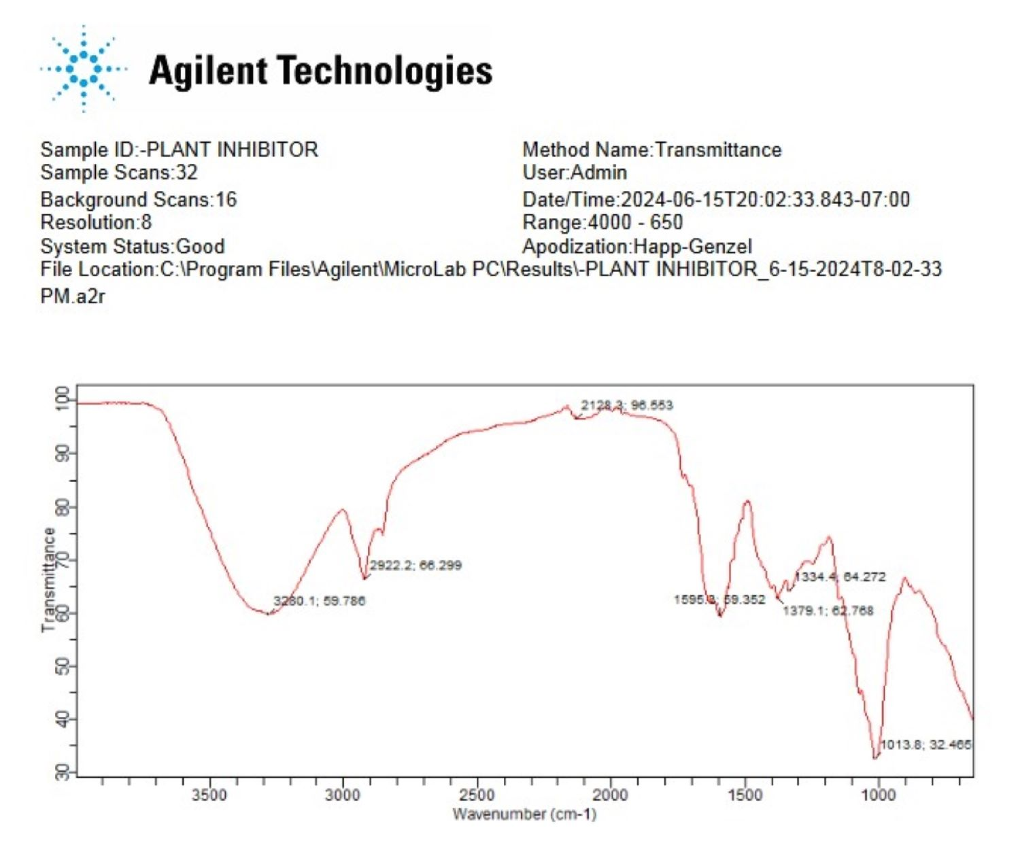
Figure 1. FTIR spectrum of the Anacardium occidentale leaf

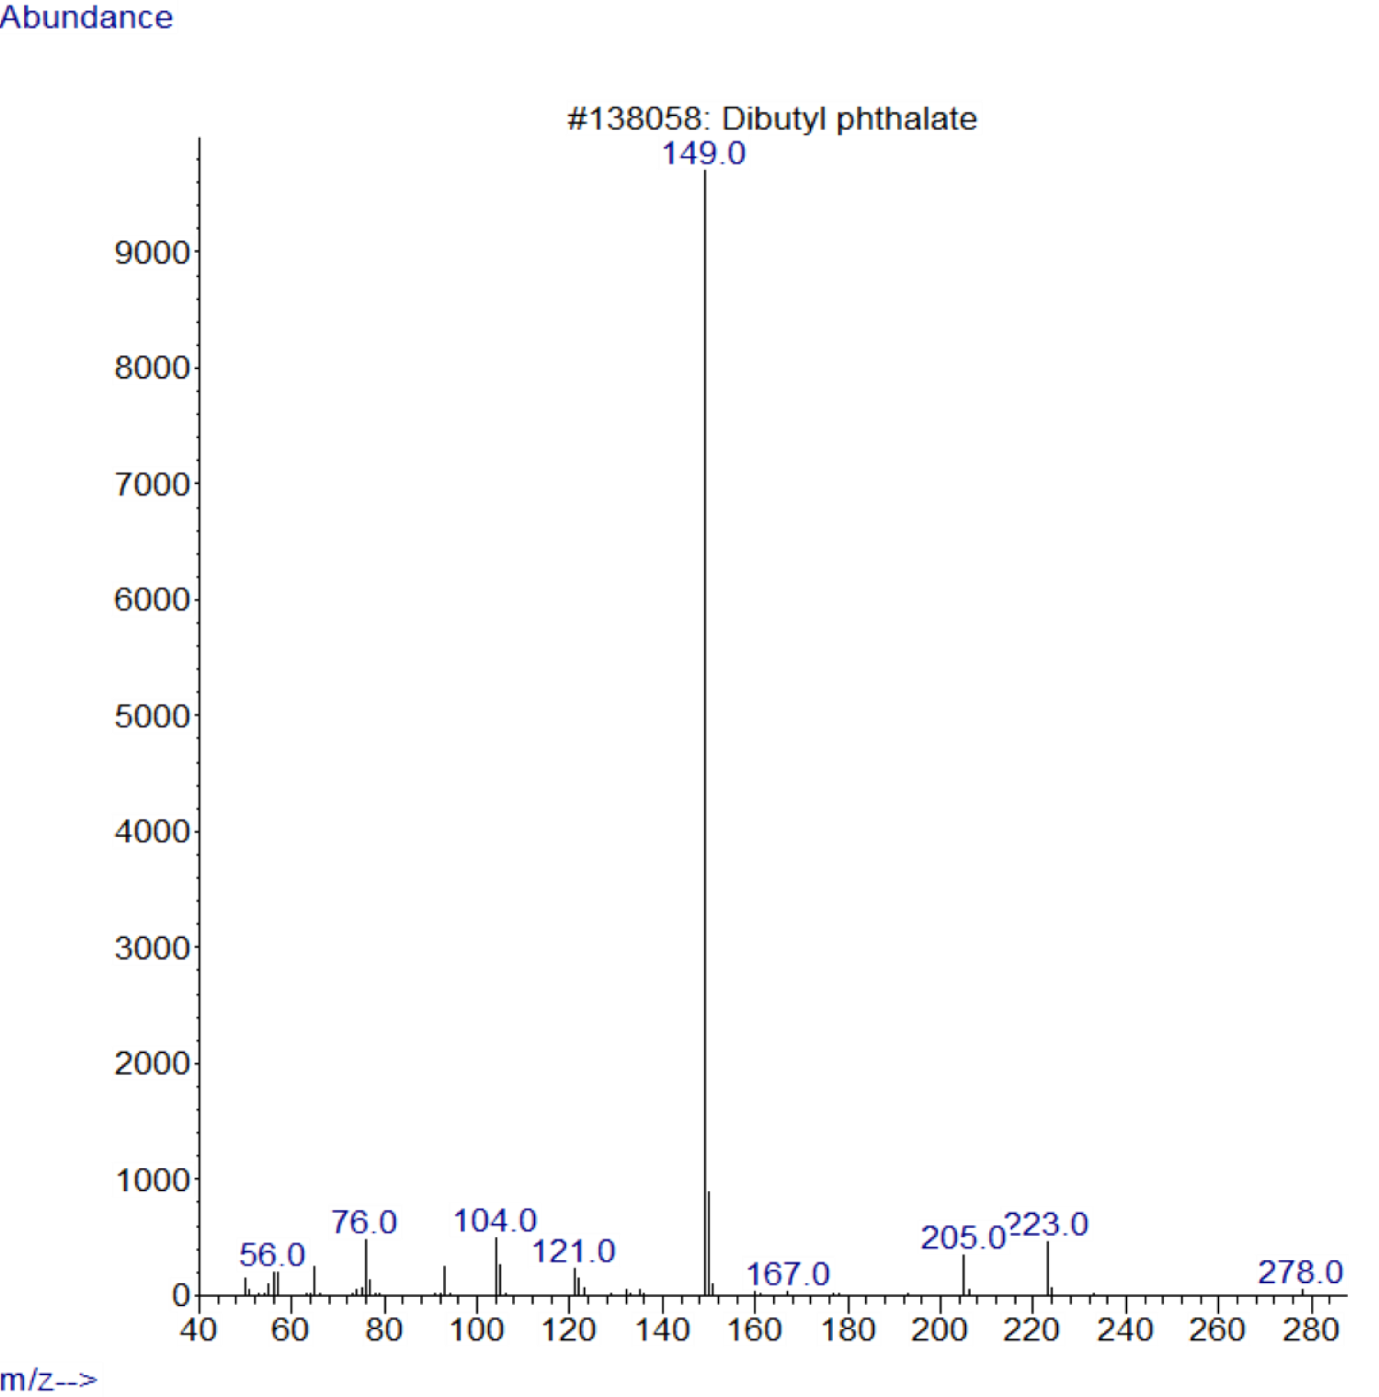
Figure 2. Chromatogram of glycerin

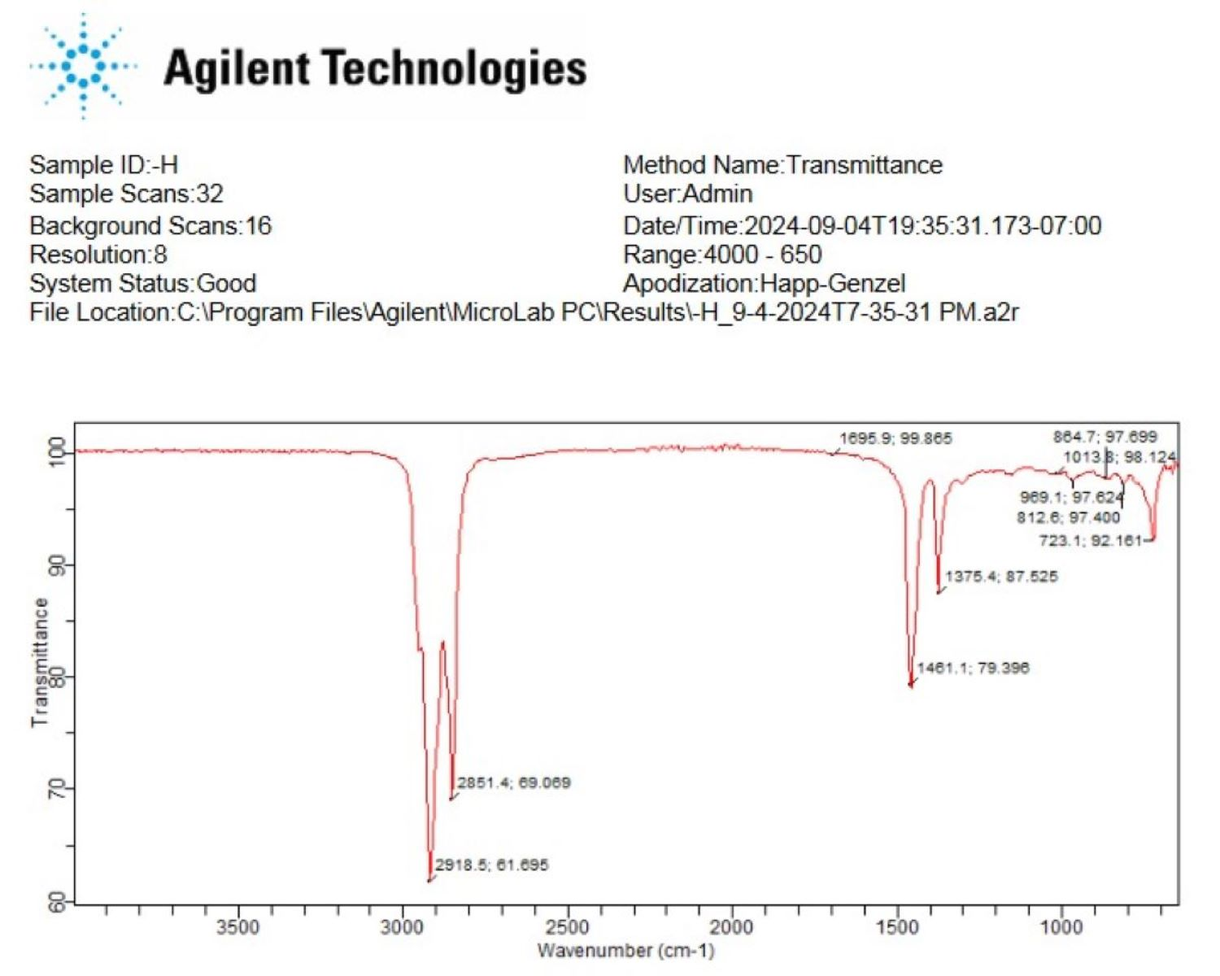 Figure 3. Spectrum of bio-hydraulic fluid

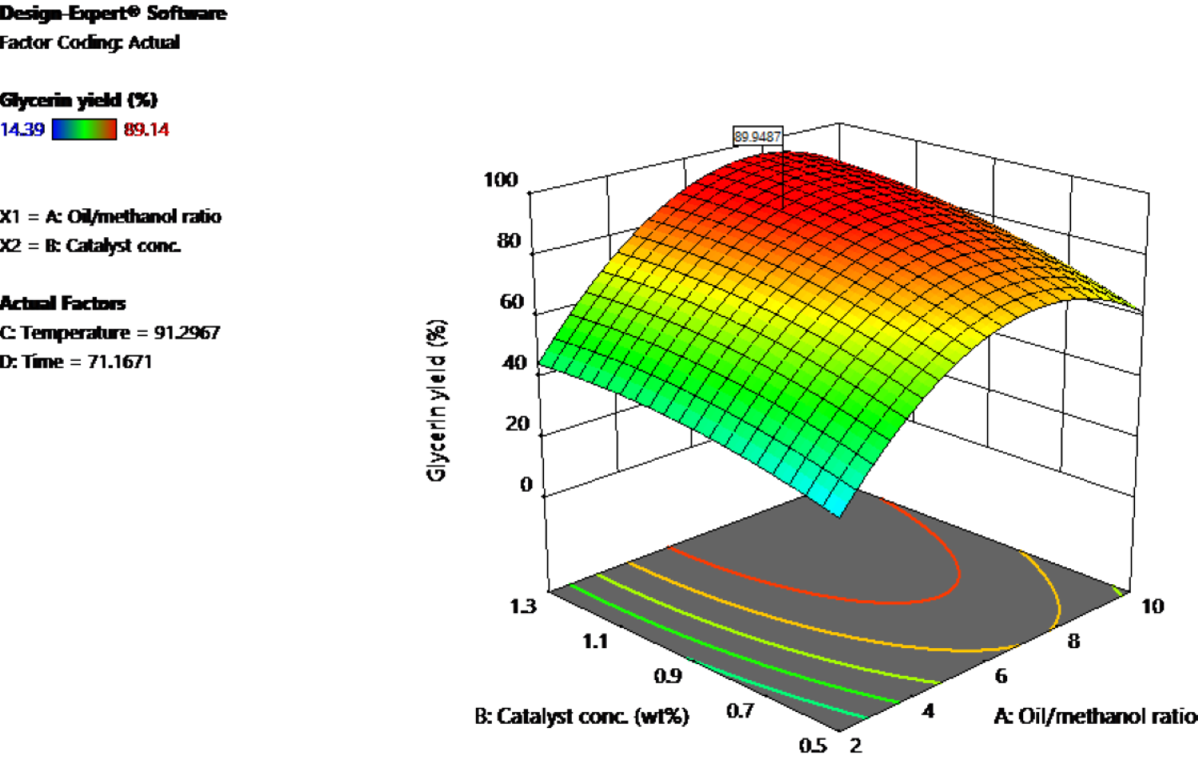
Figure 4. Glycerin yield as function of palm kernel oil / methanol ratio and catalyst conc.

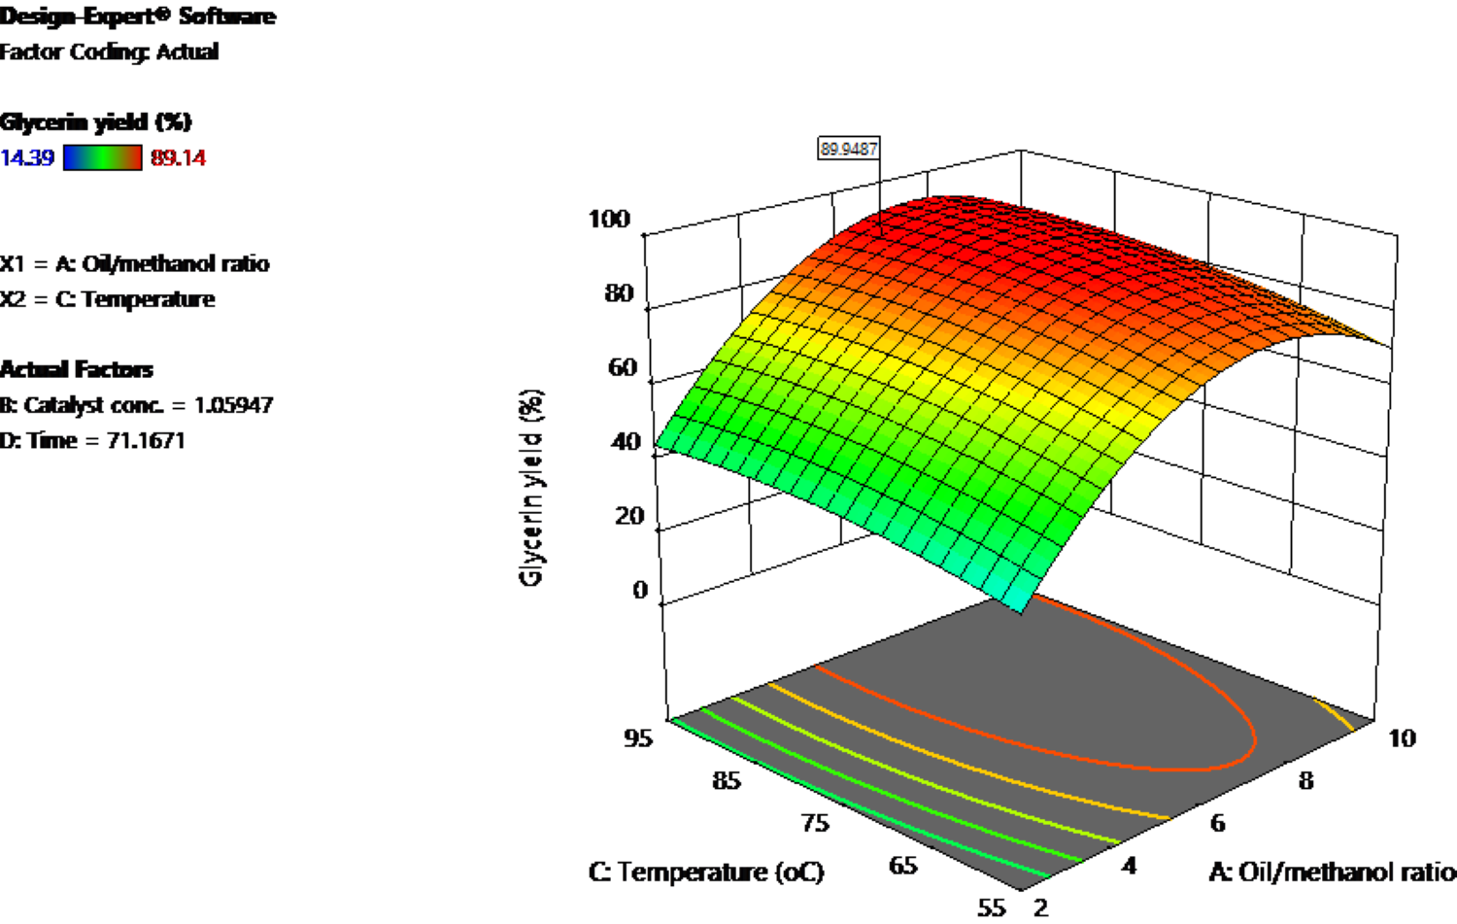
Figure 5. Glycerin yield as function of palm kernel oil / methanol ratio and temp.

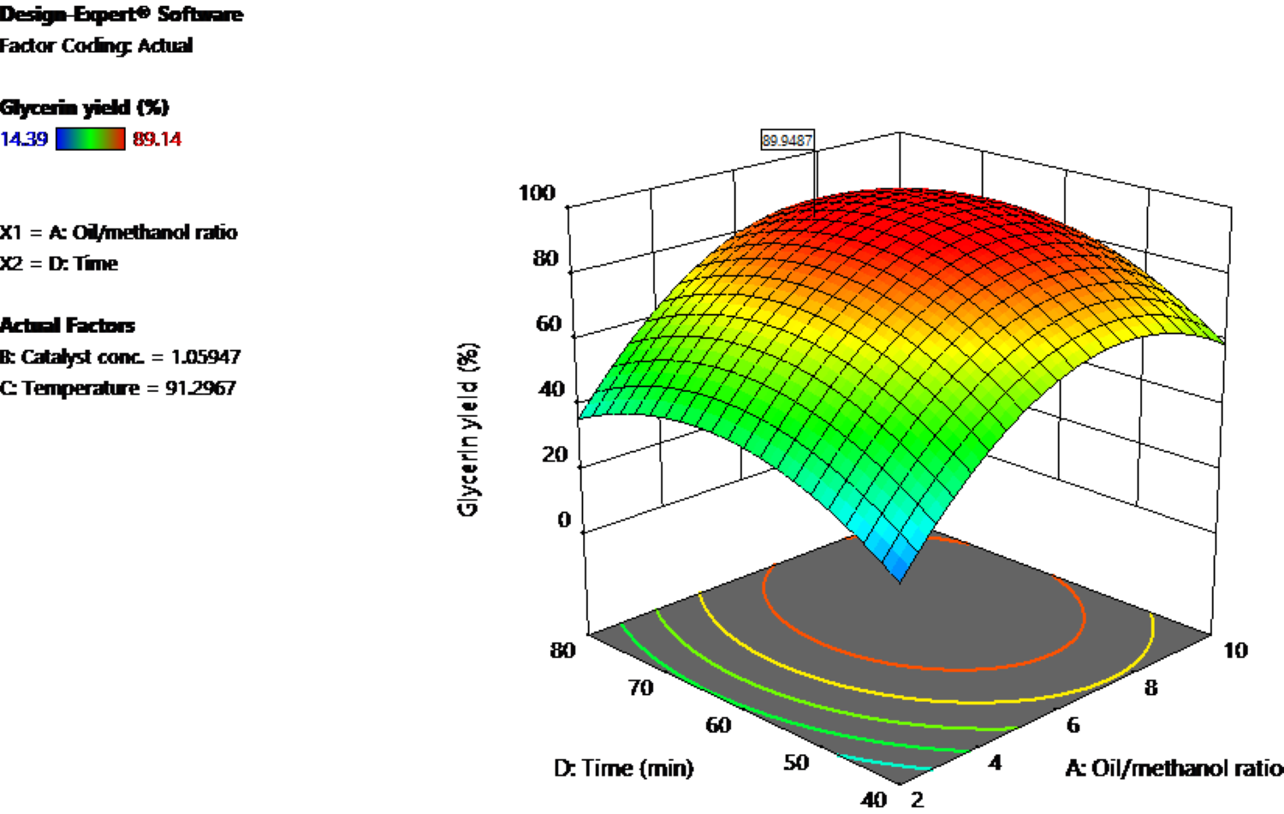
Figure 6. Glycerin yield as function of palm kernel oil / methanol ratio time

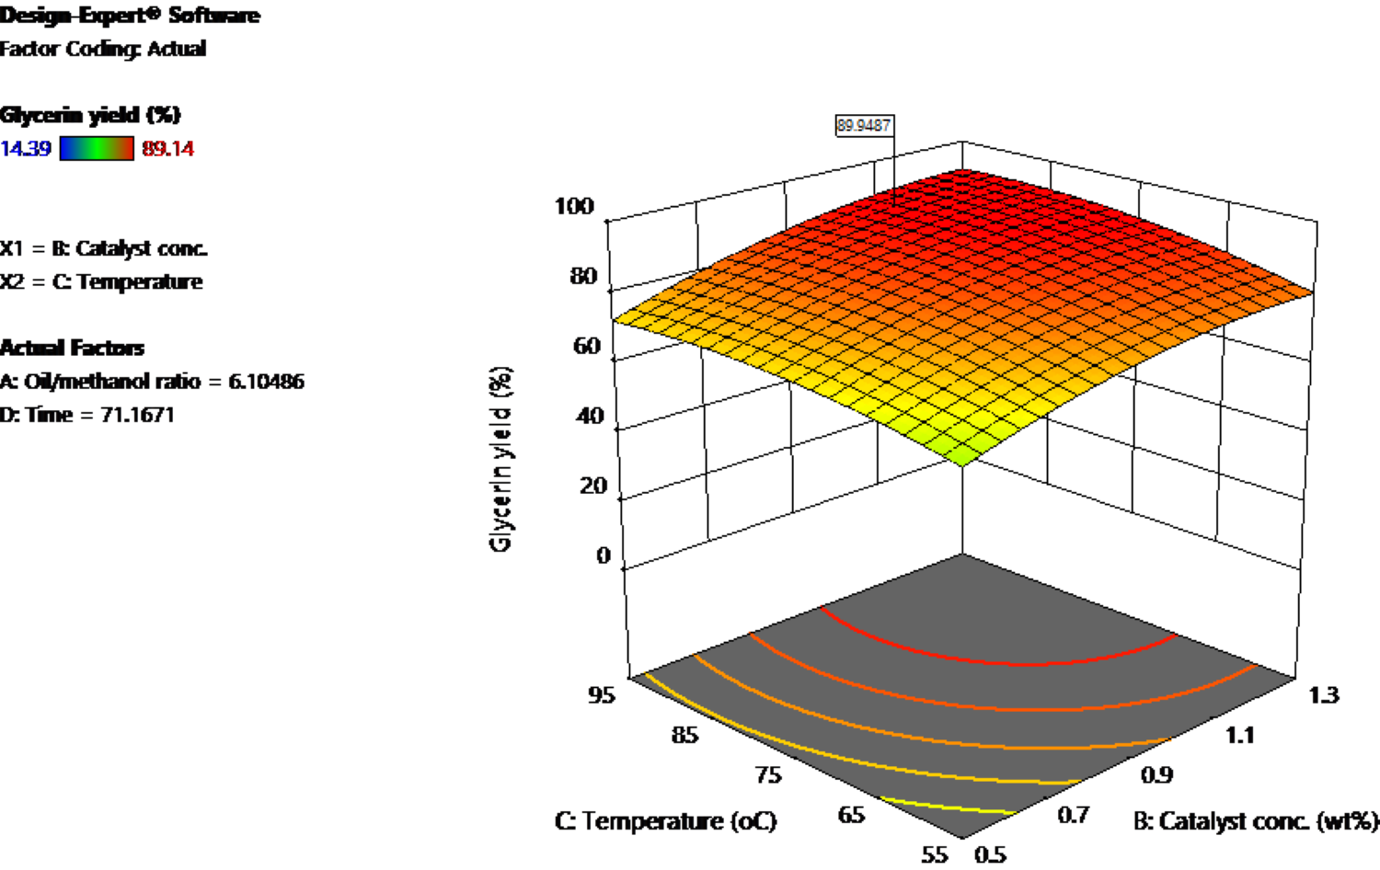
Figure 7. Glycerin yield from palm kernel oil as function of catalyst conc. and temp.

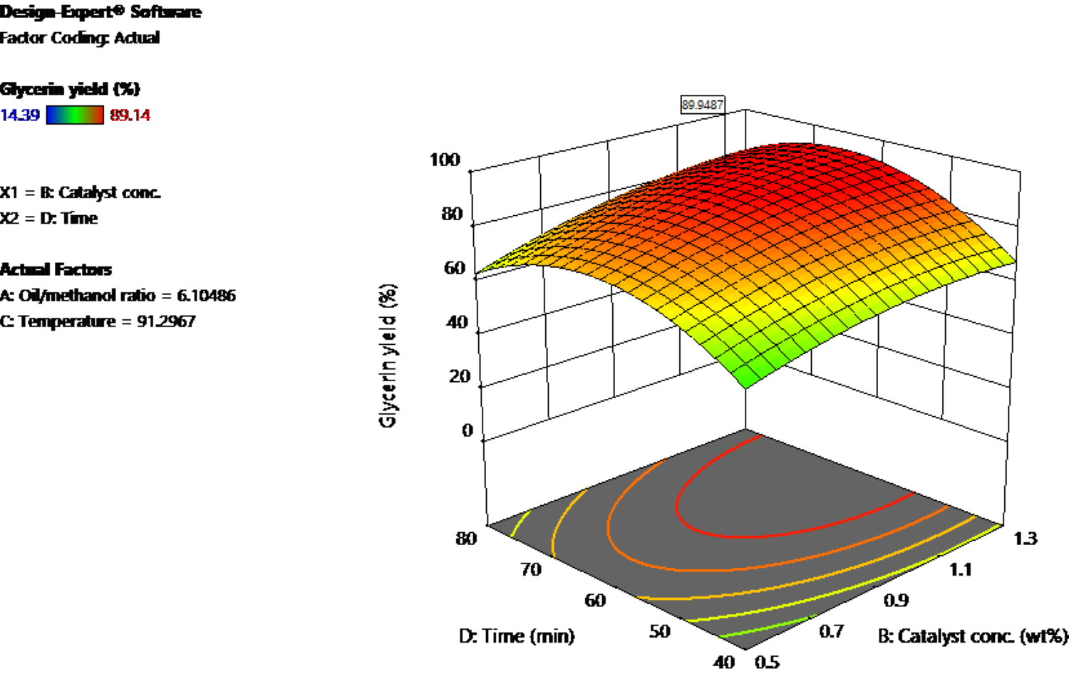
Figure 8. Glycerin yield from palm kernel oil as function of catalyst conc. and time.

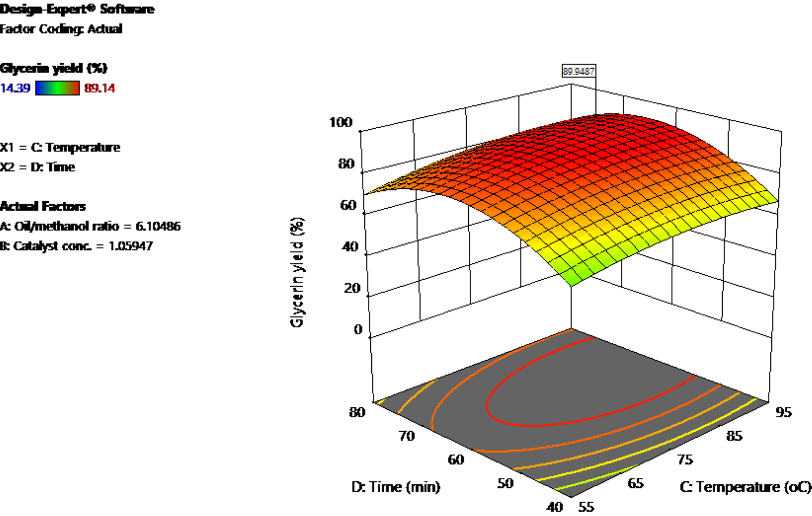
Figure 9. Glycerin yield from palm kernel oil as function of temp. and time

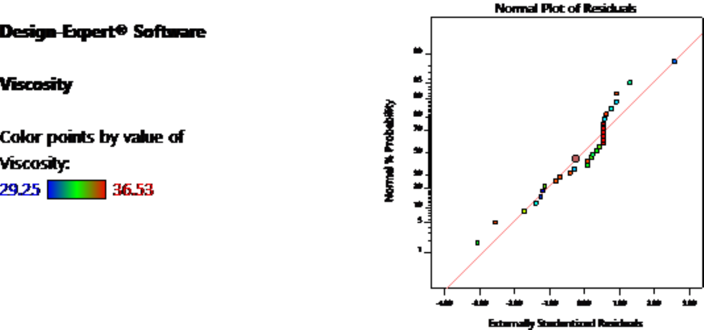
Figure 10. Residuals verses run of the viscosity of the viscosity of bio-hydraulic fluid of glycerin produced from palm kernel oil

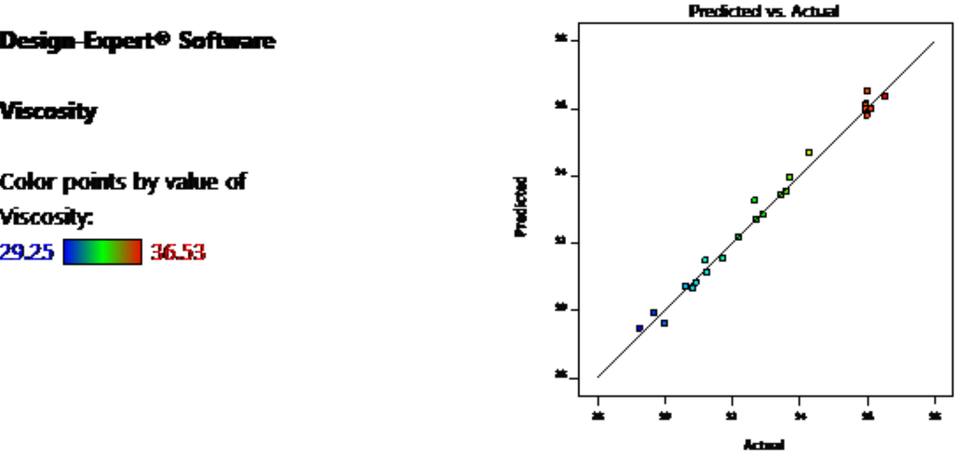
Figure 11. Normal plot of residual of the viscosity of bio-hydraulic fluid of glycerin produced from palm kernel oil

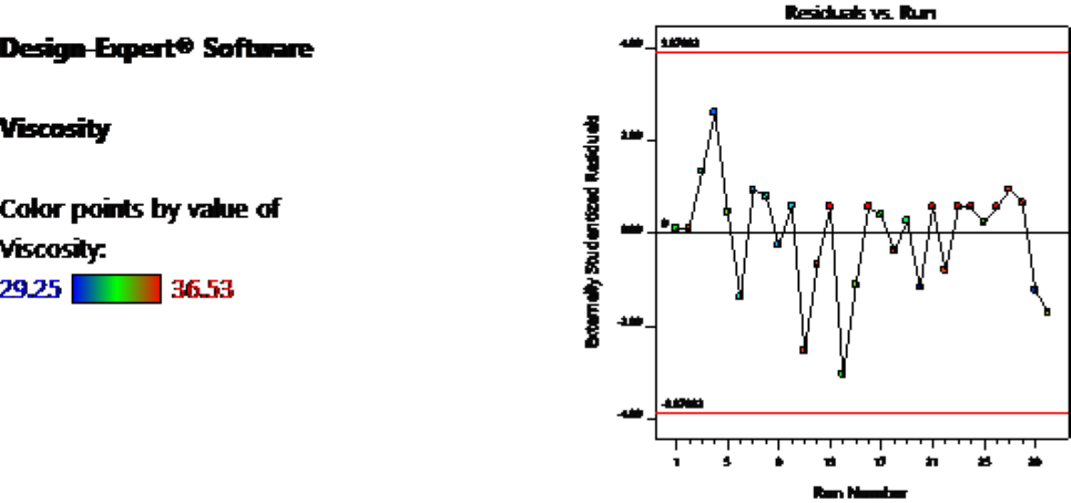
Figure 12. Residuals verses run of the viscosity of the viscosity of bio-hydraulic fluid of glycerin produced from palm kernel oil

