An optimized Deep Wavelet Autoencoder System for Detecting Tumors in Brain

.

ABSTRACT

In recent years, brain imaging techniques have gained substantial prominence in enhancing anatomical understanding and informing medical diagnostic planning, particularly in the domain of brain tumor analysis. Among these, Magnetic Resonance Imaging (MRI) stands out for its ability to provide high-resolution images critical for the identification and evaluation of diverse brain tumor types. This study proposes a comprehensive architecture for automated MRI image processing and brain tumor detection, leveraging the robust classification and segmentation capabilities of Deep Neural Networks (DNN). Central to this approach is the introduction of a novel Deep Wavelet Autoencoder (DWAE), which synergistically combines the multi-resolution analysis strength of wavelet transforms with the dimensionality reduction efficacy of autoencoders, thereby improving feature extraction and classification performance. The integration of preprocessing techniques further enhances diagnostic precision by delineating and isolating relevant brain regions while minimizing noise and irrelevant features. The proposed DNN-DWAE model was empirically validated on a publicly available dataset from Kaggle, comprising 7,000 MRI images categorized into four classes: Glioma, Meningioma, Pituitary, and No Tumor. Each image was resized to 256 × 256 pixels to ensure uniformity in input dimensions. The dataset was partitioned into 70% for training and 30% for testing to facilitate robust model evaluation. Experimental results demonstrate that the DNN-DWAE model achieves a classification accuracy of 96%, outperforming several existing methods and underscoring its potential for enhancing automated tumor detection in clinical MRI analysis. The findings suggest that the proposed framework may offer substantial support to radiologists and medical professionals by improving the accuracy, consistency, and efficiency of brain tumor diagnosis.

Keywords: Magnetic Resonance Imaging (MRI), Computed Tomography (CT), Deep Neural Networks, Image Classification, Tumor Segmentation.

INTRODUCTION

In the Early identification of brain tumors is mostly important for patient diagnosis and treatment, which minimizes death rates. Magnetic Resonance Imaging (MRI) is the optimal method for brain scanning since it is non-invasive, gives sharp images, and reflects detailed information regarding the anatomy. However, separating brain images to identify tumors accurately is still very difficult to process medical images. The difficulty of brain anatomy, different tumor shapes, and noise in MRI images make precise separation difficult. Deep learning methods have emerged as popular techniques for automatic brain tumor detection in the last few years. Deep autoencoders are extensively applied as they can extract important features from medical images. Deep Wavelet Autoencoders (DWAEs) use a combination of wavelet transformations and deep learning to improve feature extraction, segmentation accuracy, and minimize the need for computing resources. Wavelet transformations are good at extracting features at different scales, which is essential for investigating complex structures like brain tumors. The current technique uses Deep Wavelet Autoencoders to separate and detect brain tumors automatically from pixel brightness, anatomical information, and knowledge from medical image datasets. The automated classification process not only enhances diagnostic accuracy but also minimizes the need for human expertise, which makes

it valuable in clinical practice. It also meets the increasing demand for efficient, dependable, and scalable tools for the detection of brain tumors in medical research and healthcare. By applying wavelet integration for feature extraction and training with deep learning, this technique will enhance the precision of tumor segmentation, facilitate early detection, and assist in more effective treatment planning. This technique may have a profound impact on patient care and medical image diagnosis

MATERIAL AND METHODS
  - EASE OF USE

Brain imaging techniques are the backbone of medical diagnosis and neuroscience research, especially in the identification and examination of brain tumors. Brain imaging techniques offer precise visualization of brain anatomy, thereby enabling early detection of abnormalities that could indicate the existence of a growth. Nevertheless, the complexity of brain anatomy and the diversity of tumor characteristics complicate accurate detection and classification. In addressing these, this project introduces an advanced system for brain tumor detection and MRI image analysis by integrating Deep Neural Networks (DNNs) with Deep Wavelet Autoencoders. MRI images are preprocessed before classification to improve quality and extract the most informative brain regions. The process includes noise reduction, contrast enhancement and skull-stripping procedures aimed at eliminating non-brain tissues, thereby ensuring that the system concentrates only on essential parts. The preprocessing operation is vital in minimizing errors and enhancing the accuracy of tumor detection. Deep Wavelet Autoencoder (DWAE) is fundamental in feature extraction through the integration of autoencoders, which reduce the complexity of data, and wavelet transformations, which preserve detailed complexity and enable detection. The integrated system enhances pattern detection while reducing redundant information, leading to improved classification performance. Following MRI image processing, a Deep Neural Network (DNN) is used for segmentation and classification. The DNN is particularly trained to detect tumorous from normal brain scans using the optimized features obtained from DWAE. Through extensive training on medical imaging data, the model attains a high classification accuracy of 96, outperforming traditional tumor detection methods. This enhanced accuracy ensures accurate identification of brain tumors, thereby reducing the likelihood of misdiagnosis and false negatives. The combination of DWAE and DNN provides superior benefits in brain tumor detection. By maximizing accuracy through deep learning and complex feature extraction, the system minimizes the amount of human effort involved in diagnosis, thereby allowing medical professionals to focus more effectively on patient treatment. The use of automated classification ensures quicker analysis, making it highly effective in clinical scenarios where rapid diagnosis is critical. Furthermore, early detection of brain tumors significantly improves the outcome of treatment by allowing timely medical intervention. The accuracy and efficiency of the system allow for informed clinical decision-making, ultimately benefiting both healthcare providers and patients. This project provides a new method for brain tumor detection using deep learning and wavelet-based feature ex traction. The combination of DNN and DWAE maximizes tumor segmentation and classification accuracy, making it a highly effective solution for automated medical diagnosis. With its ability to maximize early detection and simplify clinical workflows, this approach has tremendous potential to transform MRI based brain tumor analysis and support improved healthcare solutions

PROBLEM STATEMENT
Brain tumor identification in MRI scans is a stimulating task because of complexity of brain structures, diversity of tumors, and noisy images that result in incorrect diagnoses and delayed treatment. Conventional approaches rely primarily on manual verification, which is time- consuming and prone to errors. Most existing automated approaches are not able to detect features accurately and classify tumors. This project introduces a Deep Neural Network (DNN)with a Deep Wavelet Autoencoder (DWAE) to enhance feature extraction and classification accuracy. The proposed system identifies tumors automatically with high accuracy of 96.

RELATED WORK

The wavelet transformation he enhancing the model’s capability to accurately identify tumors extract important features while reducing noise, Intensify the model’s capacity to accurately recognize tumors. Franz Hosseini followed an approach aims to make brain tumor detection more accurate and reliable. vasu Mathi devi proposed model operates in three stages. Initially, it applies a high pass filter and a median filter to enhance the quality of MRI brain images. Next, it applies a seed growing method to associate and separate the brain tumor from the rest of the brain. Finally, the segmented images are input into the Deep Wavelet Auto-Encoder model, which has two hidden layers connected to a SoftMax layer for classifying the images. illustrates these three stages of the approach. applies Discrete Wavelet Transform (DWT) to reduce the volume of data while preserving key details. Deelip Rajan Nayak found Lastly, a dense layer is employed to compressively extract features and classify the tumor images. The experiment demonstrates that this new approach can achieve high accuracy. Utilizing a convolutional autoencoder with convolutional layers rather than dense layers. The model obtains significant features from the final layer and compresses them using a variance threshold algorithm. To classify the data, several methods are employed, including support vector machines, decision trees, k-nearest neighbors,]and ensemble techniques. The top performance was obtained by the SVM classifier with a radial basis function kernel. The performance of the new method was compared with other methods To classify brain MRI images with emphasis on key Challenges in pattern classification, including feature extraction in training. The authors present a novel approach with the incorporation of a Deep Wavelet Transform Network and deep learning methods for enhanced feature extraction Their proposed design employs a deep stacked SGWTN- Autoencoder formulti-classclassificationinthedataset.

These unsupervised approaches tend to have lower error rates and better performance, making them a promising option for brain tumor classification The Hunger Games Search algorithm is an efficient optimization method inspired by animal behavior, designed to find the best solutions for various problems. While it works well for many tasks, it struggles with slow convergence and getting stuck in local optima, especially in complex situations.To improve its performance, researchers suggest adding techniques like the Local Escaping Operator and Brownian motion .In the field of medicine, Precisely Detecting and categorizing brain tumors from MRI scan images is challenging due to data variability and the need for precision This study proposes a hybrid model that combines a deep learning architecture called ResNet50 with an improved version of the HGS algorithm to enhance classification accuracy and efficiency. The new approach aims to overcome common issues in existing algorithms, making it easier and faster to classify brain tumors from MRI scans.

PROPOSED METHODOLOGY
The proposed architecture for detecting tumors in brain MRI scans using Deep Wavelet Autoencoders (DWAEs) consists of four layers: input, wavelet transform, feature extraction, and classification. The input layer processes pre-processed MRI images, which undergo a discrete wavelet transform (DWT) to capture essential features. The feature extraction layer uses convolutional operations, while the classification layer employs a fully connected neural network to categorize images into tumor and non-tumor classes. The training process includes a loss function for evaluation and incorporates regularization and dropout to prevent overfitting. The final output provides a probability score for tumor presence, enhancing diagnostic capabilities

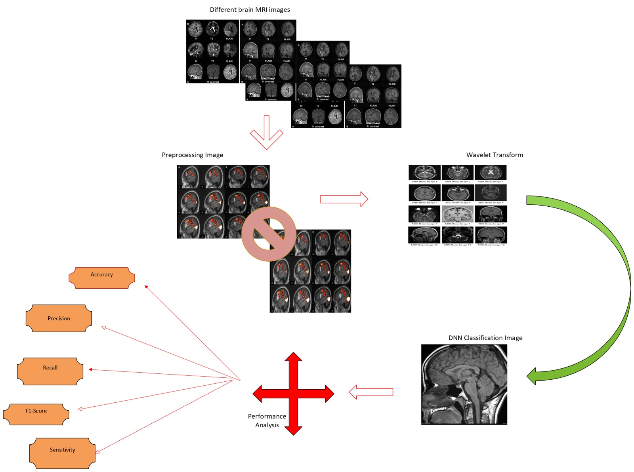

Figure 1: System Architecture

  - EQUATIONS
In the first the MRI image will be taken as an input and next preprocess the image the and next continue the fallowing steps

preprocessing
Preprocessed Image = f(MRI) = D(W(I))+N (1) Where:
  - I = Input MRI image
  - W =Wavelet transform function
  - D =Denoising function
  - N =Normalization function
f = Overall preprocessing function that combines these operations

Training the model

Training a deep wavelet autoencoder using an MRI image dataset, the model training process can be shown by the following equation where
L=1\Ni=1∑NIi−I^i2

- L = Loss function (mean squared error)
- N =Total number of MRI images in the dataset
- Ii = Original input MRI image (2)
- ˆ Ii = Reconstructed MRI image produced by the deep wavelet autoencoder after training
- ∥·∥2 = L2 norm (Euclidean distance) which measures the difference between the original and
- reconstructed images

c.feature extraction
feature extraction using a deep wavelet autoencoder from an MRI brain image dataset, the process can be represented by the following equation

F=ϕ(W(I))

  - F=Extracted feature representation from the MRI image
  - W(I) = Wavelet transform function applied to the input MRI image I
  - ϕ=Non-linear activation function (e.g., ReLU, sigmoid) applied to the wavelet coefficients Wavelet Transform ( W(I) ): This step decomposes the input MRI image into different frequency components, allowing for the extraction of relevant features at various scales.

D.High pass filter
Due to variations in the magnetic field during the acquisition of MRI images, noise can be introduced, adversely affecting image quality.
shI(x,y) = I(x,y) +hpI(x,y)

To further refine the intensity levels of the sharper image, a median filter with a 3×3 window size is applied. This median filtering process smooths the intensities, effectively reducing any residual noise while preserving critical structural details. The combination of high-pass filtering and median filtering significantly enhances The clarity and resolution of MRI scans, thereby improving the detection and analysis of brain lesions.

3.RESULTS AND DISCUSSION

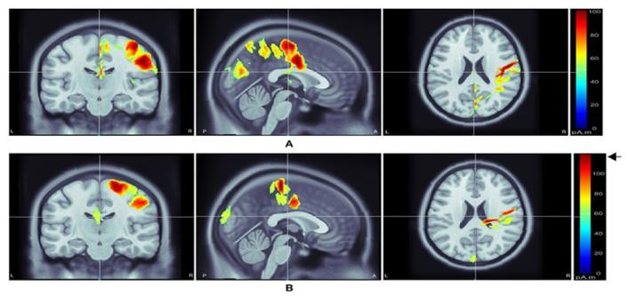

Figure 2 : wavelet transformed MRI images

The brain MRI images are transformed by wavelet trans formation as mentioned in the fig 2 Wavelet transformation is a mathematical process by which brain MRI images can be processed and analyzed by breaking them down into different frequency components. Wavelet transformation is useful in the capture of spatial and frequency information, therefore appropriate for feature detection like tumors or abnormalities in the images. With wavelet transformation, important information can be emphasized while removing noise, thereby improving the quality of the images. Wavelet transformation is applied in medical imaging because it can assist in feature extraction and analysis with better efficiency, thereby facilitating proper diagnosis and treatment planning. The wavelet transformed images are next given as an input for classification The next classification gives output as pituitary glioma meningioma and no tumor The example some Predicted out puts are
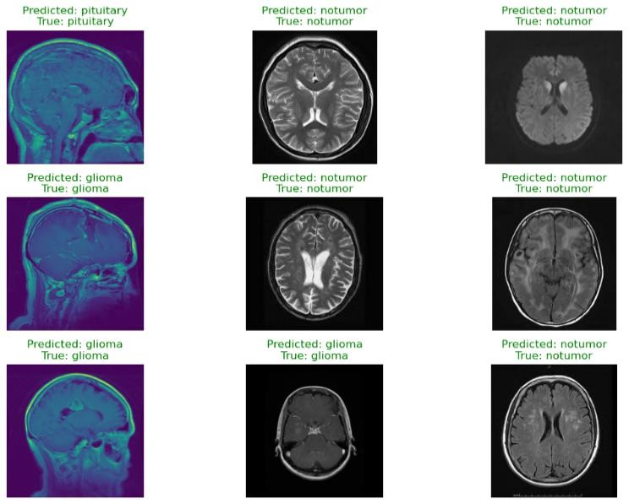

Figure 3: Predicted outputs

In brain tumor analysis classification with a deep wavelet autoencoder, a confusion matrix is a helpful tool to verify the accuracy with which the model classifies various types of tumor. These are gliomas, meningioma, pituitary tumors, and non-tumor cases. The confusion matrix indicates how many tumors were correctly identified, how many non-tumor cases were correctly identified, and where the model erred. By examining this matrix, scientists can compute significant performance measures such as precision, precision, and recall for each type of tumor. This helps them to observe the strengths and weaknesses of the model. This information is significant in improving the model and ensuring that it can correctly identify and classify brain tumors.
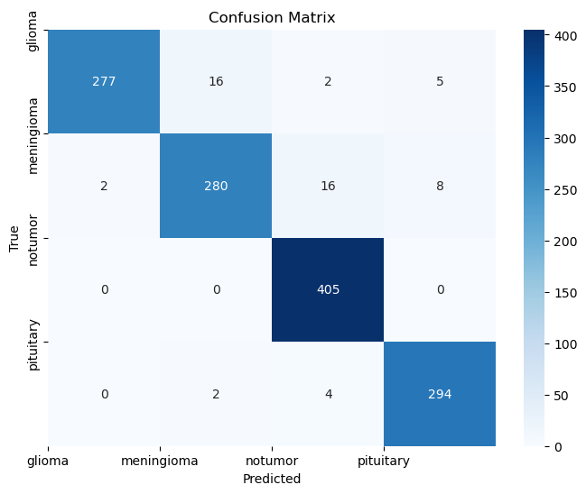

Figure 4 : confusion matrix

The model loss for proposed model Comparative analysis precision is very important in detecting brain tumors with deep wavelet autoencoders because it defines the validity of tumor detection. High accuracy means that the model is able to detect tumors correctly and has very few false positives, which is very important in hospitals to prevent unnecessary treatments and stress for patients.

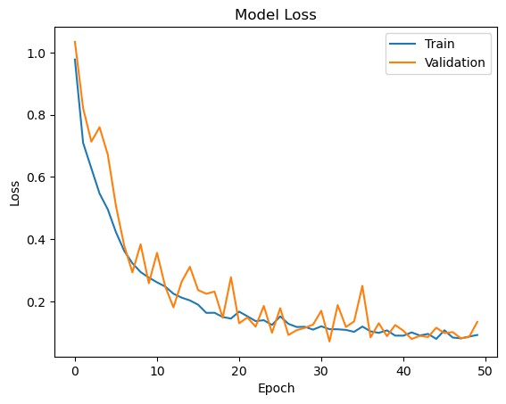
Figure 5 :Model loss

Performance analyses of different types of tumor data sets.The performance analysis of an distinguish MRI images as having a tumor or not. Key measures such as precision, recall, and F1-score are commonly used to examine how well the model works, and what it does best and where it can be better to identify tumors.
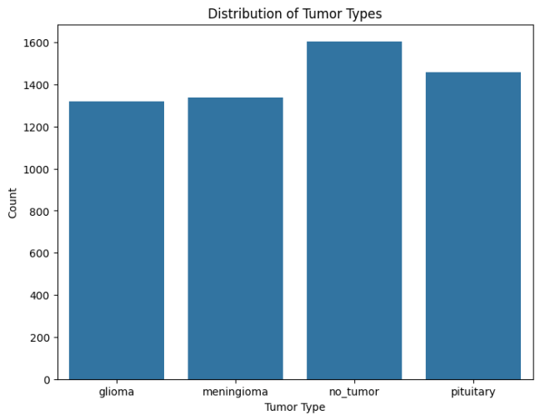
Figure 6. Distribution of data

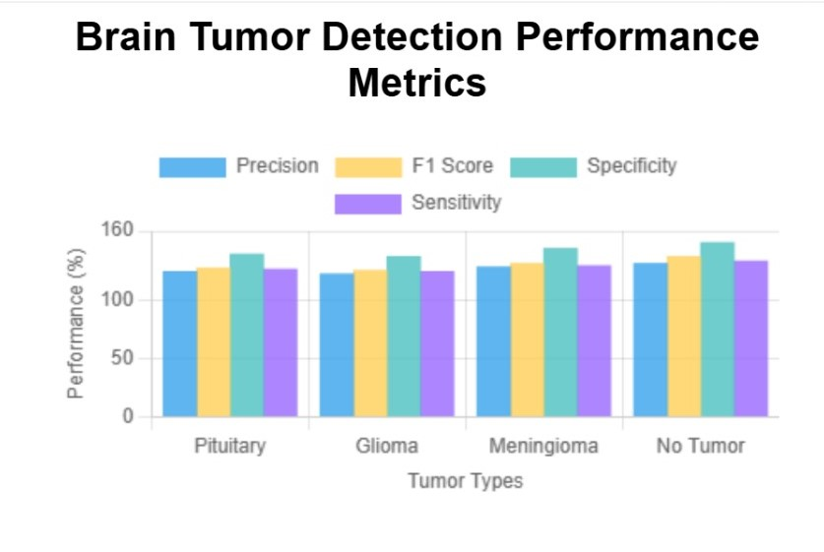
Figure 7: Measuring performance

CONCLUSION
This deep wavelet autoencoder with a deep neural network (DNN) to identify brain tumors holds significant potential to enhance the degree to which and the accuracy with which tumors can be identified. By training the model with a di verse dataset of four types of tumor classification pituitary tumors, glioma, meningioma, and no-tumor cases the model separated the classes well. The results indicate that the deep wavelet autoencoder not only assists in attaining better features from MRI images but also enhances the overall performance of the DNN classification. With good accuracy and high performance measures. This approach is a valuable tool for aiding radiologists in diagnosing brain tumors, leading to improved patient care and more informed clinical decision-making Future studies could try to enhance the model further, expand the dataset, and discover real-time applications in clinical practice to further advance its effectiveness in medical imaging.

REFERENCES

- Isselmou Abd El Kader, Guizhi Xu, Zhang Shuai, Sani Saminu, ImranJavaid, Isah Salim Ahmad, and Souha Kamhi. Brain tumor detectionand classification on mr images by a deep wavelet auto-encoder model.diagnostics, 11(9):1589, 2021.

- Abdullah A Asiri, Toufique Ahmed Soomro, Ahmed Ali Shah, GannaPogrebna, Muhammad Irfan, and Saeed Alqahtani. Optimized braintumor detection: A dual-module approach for mri image enhancementand tumor classification. IEEE Access, 12:42868–42887, 2024.

- Umair Muneer Butt, Rimsha Arif, Sukumar Letchmunan, Babur HayatMalik, and Muhammad Adil Butt. Feature enhanced stacked autoencoder for diseases detection in brain mri. Computers, Materials &Continua, 76(2), 2023.

- S Champakamala and K Karunakara. Brain tumor detection and classifi-cation on mri using variable wise weighted stack auto-encoder and socialsky driver optimization algorithm. NeuroQuantology, 20(22):1612, 2022.

- Fatih Demir. Deep autoencoder-based automated brain tumor detectionfrom mri data. In Artificial Intelligence-Based Brain-Computer Inter-face, pages 317–351. Elsevier, 2022.

- E Dhiravidachelvi, T Joshva Devadas, PJ Sathish Kumar, and S SenthilPandi. Enhancing image classification using adaptive convolutionalautoencoder-based snow avalanches algorithm. Signal, Image and VideoProcessing, 18(10):6867–6879, 2024.

- Marwa M Emam, Nagwan Abdel Samee, Mona M Jamjoom, andEssam H Houssein. Optimized deep learning architecture for braintumor classification using improved hunger games search algorithm.Computers in Biology and Medicine, 160:106966, 2023.

- Farnaz Hoseini, Shohreh Shamlou, and Milad Ahmadi-Gharehtoragh.Segmentation of mr images for brain tumor detection using autoencoderneural network. Discover Artificial Intelligence, 4(1):1–20, 2024.

- Parvathy Jyothi and A Robert Singh. Deep learning models andtraditional automated techniques for brain tumor segmentation in mri: areview. Artificial intelligence review, 56(4):2923–2969, 2023.

- IAE Kader, G Xu, Z Shuai, S Saminu, I Javaid, IS Ahmad, and S Kamhi.Brain tumor detection and classification on mr images by a deep waveletauto-encoder model. diagnostics 2021, 11, 1589, 2021.

- Pendela Kanchanamala, KG Revathi, and M Belsam Jeba Ananth.Optimization-enabled hybrid deep learning for brain tumor detectionand classification from mri. Biomedical Signal Processing and Control,84:104955, 2023.

- T Sathies Kumar, C Arun, and Periyathambi Ezhumalai. An approach forbrain tumor detection using optimal feature selection and optimized deepbelief network. Biomedical Signal Processing and Control, 73:103440,2022.

- Fakhri lahmood HAMEED and Omar DAKKAK. Brain tumor detectionand classification using convolutional neural network (cnn). In 2022International Congress on Human-Computer Interaction, Optimizationand Robotic Applications (HORA), pages 1–7. IEEE, 2022.

- Dillip Ranjan Nayak, Neelamadhab Padhy, Pradeep Kumar Mallick, andAshish Singh. A deep autoencoder approach for detection of brain tumorimages. Computers and Electrical Engineering, 102:108238, 2022.

- Soheila Saeedi, Sorayya Rezayi, Hamidreza Keshavarz, and ShararehR. Niakan Kalhori. Mri-based brain tumor detection using convolutionaldeep learning methods and chosen machine learning techniques. BMCMedical Informatics and Decision Making, 23(1):16, 2023.

- V Sujatha, Vasumathi Devi Majety, Satya Sandeep Kanumalli, andVS Komanduri. Brain tumour detection using auto-encoder and multi-layer perception. In AIP Conference Proceedings, volume 2724. AIPPublishing, 2023.

- Muhammad Sami Ullah, Muhammad Attique Khan, Nouf AbdullahAlmujally, Majed Alhaisoni, Tallha Akram, and Mohammad Shabaz.Brainnet: a fusion assisted novel optimal framework of residual blocksand stacked autoencoders for multimodal brain tumor classification.

- Revathi Vankayalapati and Akka Lakshmi Muddana. Denoising ofimages using deep convolutional autoencoders for brain tumor classi-fication. Revue d’Intelligence Artificielle, 35(6), 2021.

- Takrouni Wiem and Douik Ali. Deep second generation wavelet au-toencoders based on curvelet pooling for brain pathology classification.Biomedical Signal Processing and Control, 83:104675, 2023.

- Sonal Yadav, R Murugan, and Tripti Goel. H-deep-net: A deep hybridnetwork with stationary wavelet packet transforms for retinal detachmentclassification through fundus images. Medical Engineering & Physics,

